How do I Submit a New Lodgement for Temporary Importation - Carnet?

This task card demonstrates how to submit a new lodgement for temporary importation – carnet via the Cargo Online Lodgement System (COLS). The new lodgement will include the document/s required to accompany your consignment for assessment by the department. This process allows you to create a request for assessment of your import documentation.

Submitting a New Lodgement

TIP: If you already have documents lodged and would like to add further documents to an existing lodgement, you can do so by following the add documents pathway found via the COLS home page. Refer to the task card: How do I add additional documents to my lodgement, for further guidance.

*NOTE: This task card is relevant for those whose type of consignment is for Temporary Importation – Carnet.*

*If your type of consignment is for either of the below options, refer to the relevant task cards:*

* *Commercial Goods – Full Import Declaration (FID)/Entry Number*
  + *Task Card: How do I submit a new lodgement for commercial goods*
* *Transhipment of Ship or Aircraft Stores*
  + *Task Card: How do I submit a new lodgement for the transhipment of ship or aircraft stores*

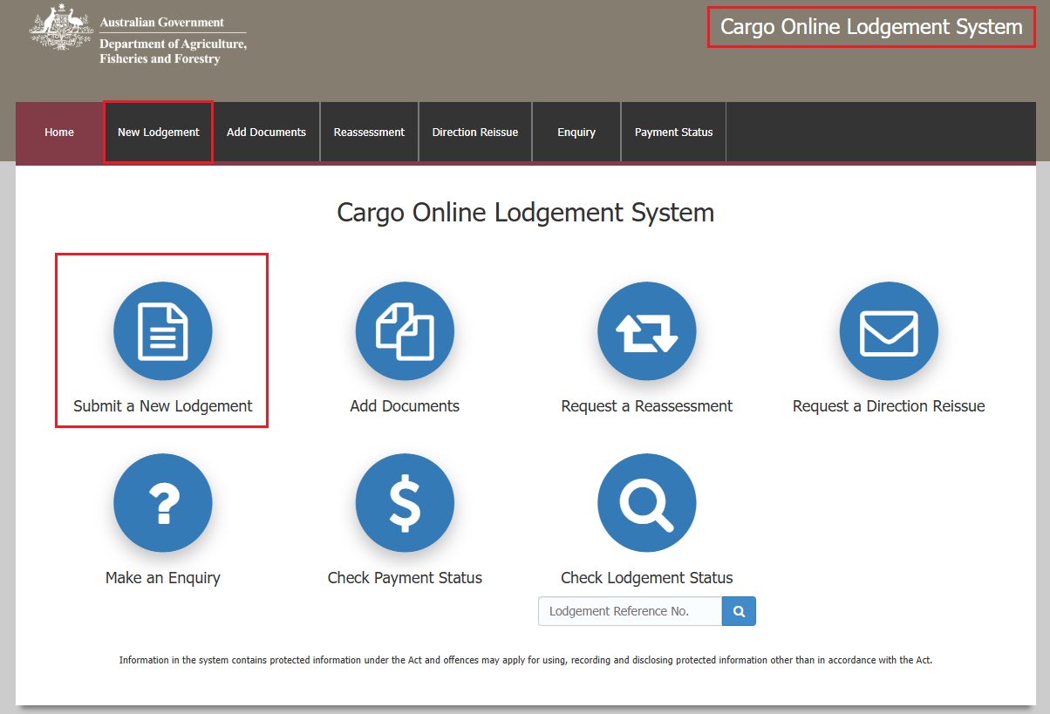Go to **COLS** and select the **Submit a New Lodgement** icon or **New Lodgement** from the main toolbar.

Declaration Screen

In this section you will need to determine the declaration type by specifying what type of consignment is being imported.

Select **Temporary Importation – Carnet** by selecting the wording or the radio button.

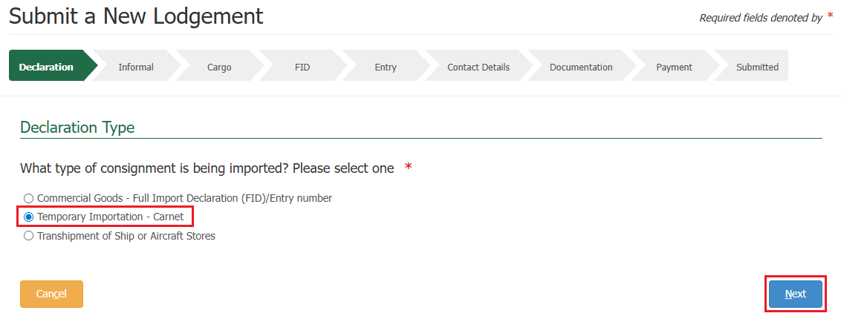Select **Next**.

Informal Screen

In this section you can add in broker and account holder details if appropriate.

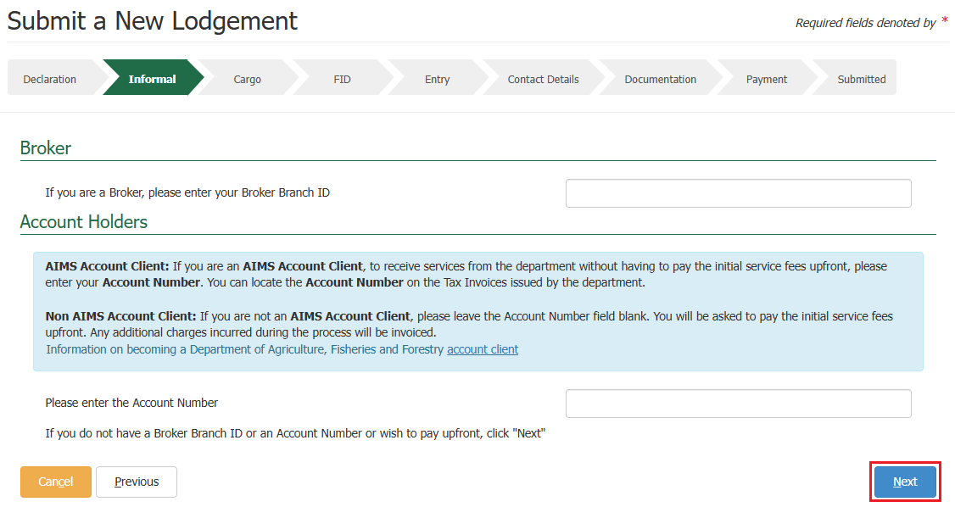Select **Next**.

Cargo Screen

In this section you will need to specify the freight mode. Below is the page that is presented when selecting **Air Freight**. See on the next page of this task card for sea freight selection.

You must fill out the **Master Airway Bill** and the **Arrival date**.

Fill in other sections where appropriate and select **Next**. The information you provide will be used to create your AIMS entry.

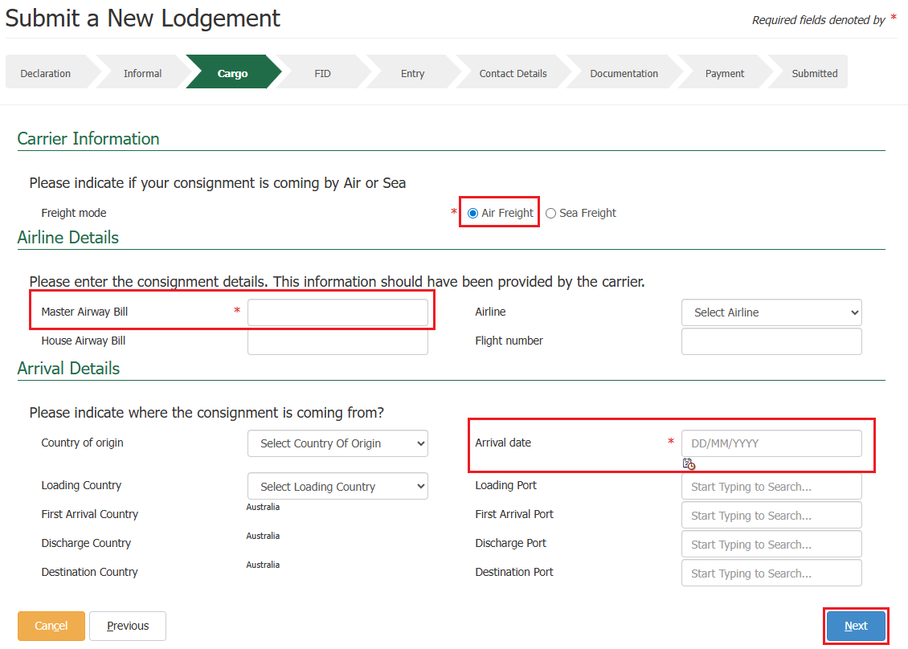

Below is the page that is presented when selecting **Sea Freight**.

You must select a **Container Type** (by selecting the wording or the radio button), the mandatory fields within the **Vessel Details** section, and the **Arrival date**.

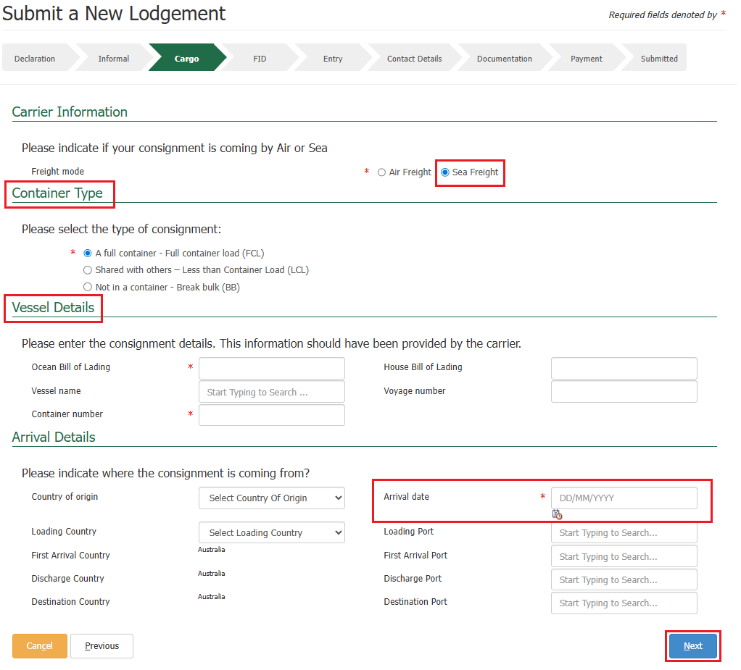Fill in other sections where appropriate and select **Next**. The information you provide will be used to create your AIMS entry.

Entry Screen

This section allows you to provide any additional information that may help the assessing officer with the assessment.

Information you may add include:

* **BICON link**: The URL reference for the BICON import case, relevant to your consignment.
* **Import permit number:** If your consignment requires an import permit, record the number in this field.
* **Inspection Location**: Your consignment may need to be inspected before it can be cleared. Inspections are performed at an authorised location. Your carrier should have notified you where the consignment will or has been sent once it reaches Australia. Use the approved arrangement link provided to get the arrangement ID for the location to enter it. If you wish to, enter your AA number and select the **magnifying glass icon** to search. The system will automatically validate the entered number and will populate the name and address of the site, if validated.
* **Delivery / Unpack Details:** The final destination for the consignment. If it is a rural destination, you will be required to provide the unpack location details for the consignment.
* **Direction Request**: To request a direction to be applied, select the **+ icon** within the **Actions** column, then select your requireddirection from the drop-down menu and complete the other fields as required.

NOTE: The AA Number field becomes mandatory when a direction other than release on documents is selected.

TIP: If an AA Number is not applicable for the requested direction, enter N/A into the field.

* **Lodgement Date:** (For sea freight only), this field will only appear if your lodgement is being made less than two business days from the estimated date of arrival. Select one of the following reasons from the drop-down menu.

*NOTE: Some options will require you to provide additional information in a free text field.*

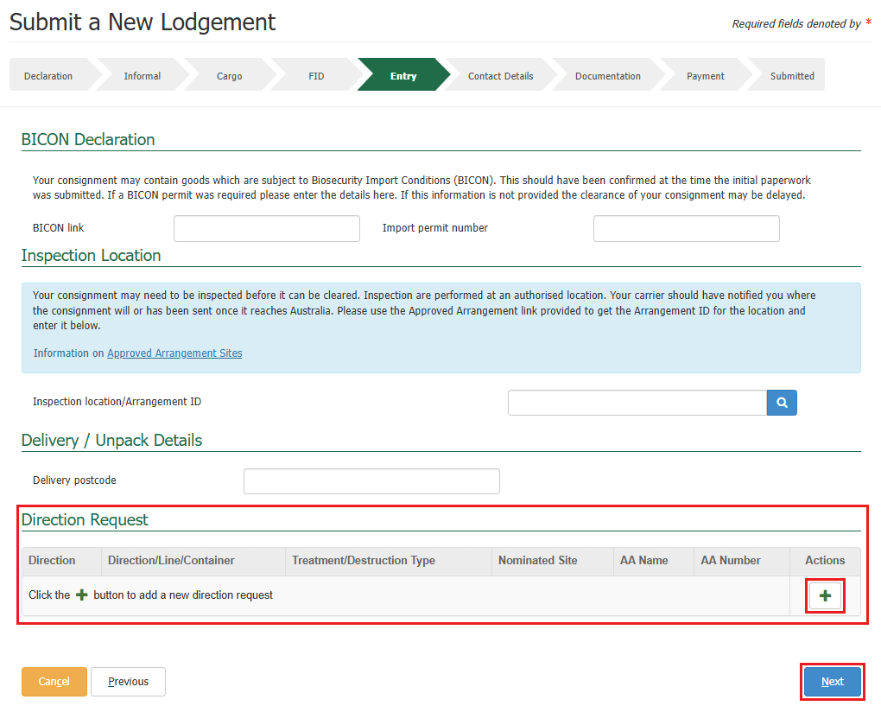

If you wish to remove a direction request you have just added, select the **bin** icon within the action’s column against that direction request.

Select the **+ icon** within the action’s column to add another direction request.

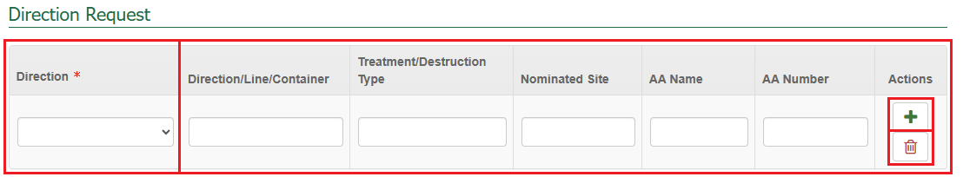Select **Next.**

Contact Details Screen

Enter the contact details for the **Responsible Party**.

NOTE: The department may contact you using the phone number provided here, in the instance the assessment does not align with your expected outcome.

TIP: If you are using the responsible party details for future lodgements, select the save button at the top, and the information will be saved to your browser, to load again when making future lodgements.

If athird partyrequires assessment status notifications, select the **Third Party Notification** check box and complete the email field.

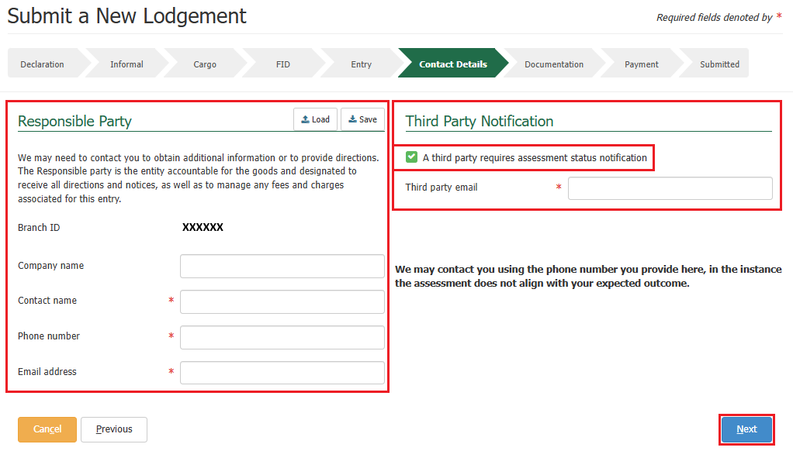Select **Next**.

Documentation Screen

This section allows you to upload documents required for your lodgement.

Select the **+ icon** within the actionscolumnto add documents to your lodgement.

*NOTE: These are the required documents, as mandated by the import conditions in BICON.*

*TIP: You can upload as many files as required if the documents do not exceed 20MB in total.*

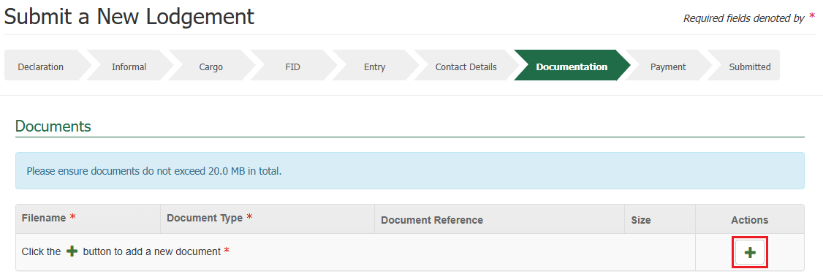

* COLS supports the drag and drop feature meaning you can drag a file from your computer and drop it into the **Add Files** section.
* Alternatively, you can select the **Choose Files** option in the **Add Files** section to select a file to download.

Select **Save**.

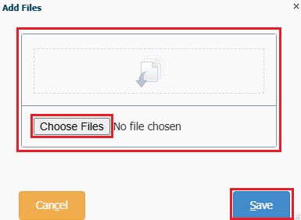

Once your document is added, it will display in the documentssection.

Select a **Document** **Type** from the drop down (choose ‘other’ if your document type is not listed). If you wish to, you can add any additional information in the **Document Reference** field against each document that will help department staff when interpreting the document.

If you would like to remove a document you have just uploaded, select the **bin** icon within the action’s column against that document.

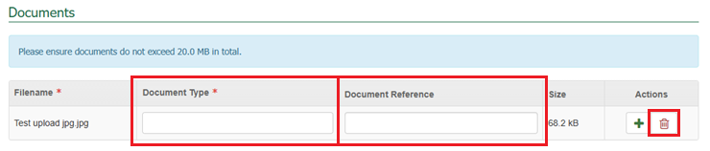

Additional Comments

You can provide any **Additional Comments** related to your lodgement that may help the department in assessing the documentation, e.g. If you have multiple import permit numbers relating to the lodgement.

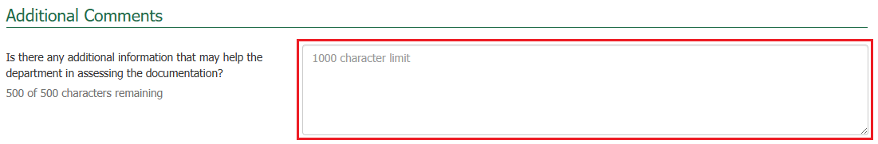

Declaration

The general declaration checkbox will need to be ticked to proceed, if you agree to the declaration, select the **General Declaration checkbox** to proceed. If you do not agree, you cannot continue.

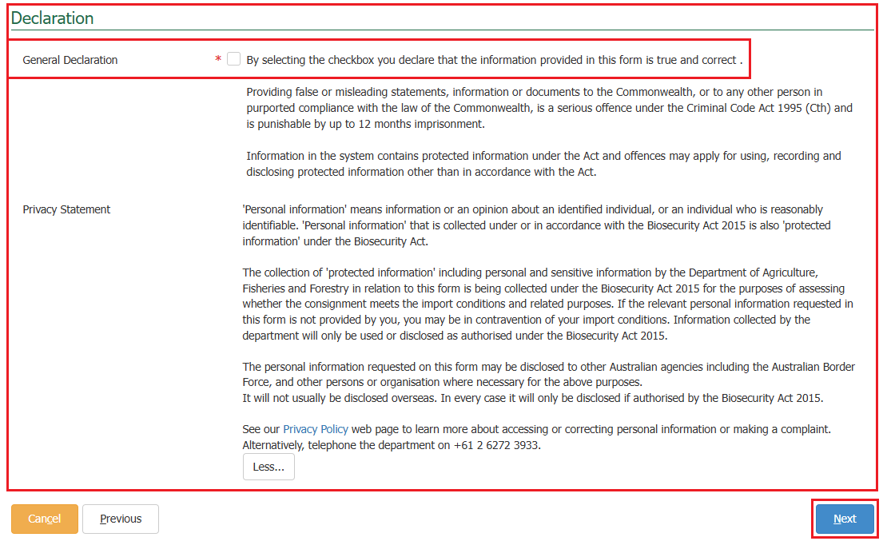Select **Next.**

* If you are an account client with the department and have credit in your AIMS account, or you have pre-paid against your entry through the Integrated Cargo System, you will not see the payment screen. Your account will be charged, and you will be taken straight to the submitted screen as seen below.
* If you are an account client with the department and you do not have enough credit in your AIMS account, you will be taken to the payment screen. See the next steps below, under the services screen – making payment section in this task card.
* If you are not an account client with the department, see the next steps below, under the services screen – making payment section in this task card.

Submitted Screen

You will be presented with a submission confirmation screen confirming the submission of your lodgement.

You will be provided with your **Lodgement Reference Number (LRN)**. This number is a unique number that identifies your lodgement when using other parts of COLS.

*TIP: Please quote your LRN during your communications with the department.*

An email confirming the lodgement has been received will be sent to the email you specified at the time of creating your lodgement.

* If you wish to complete another new lodgement, select **New Lodgement** and repeat the above steps.
* 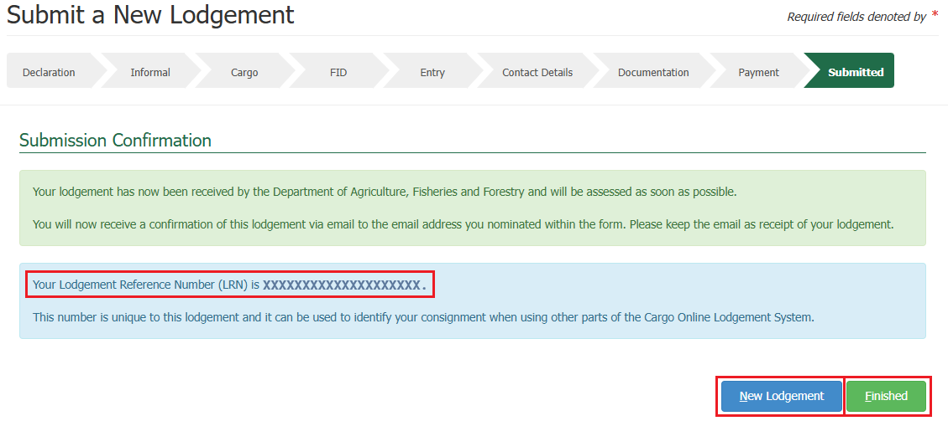Alternatively, selecting **Finished** will take you back to the COLS home screen.

Services Screen – Making Payment

You will be expected to make a lodgement payment. The system will present you with a service summary screen containing:

* The **reference** which is the COLS entry number for this lodgement creation.
* The **description** which includes your consignment type, what pathway is applicable to your consignment, the quantity, and the additional information which is based on what pathway is applicable to your consignment.
* The **service description** which outlines the services for the lodgement that the charges are for, the quantity and pricing.

Select **Next.**

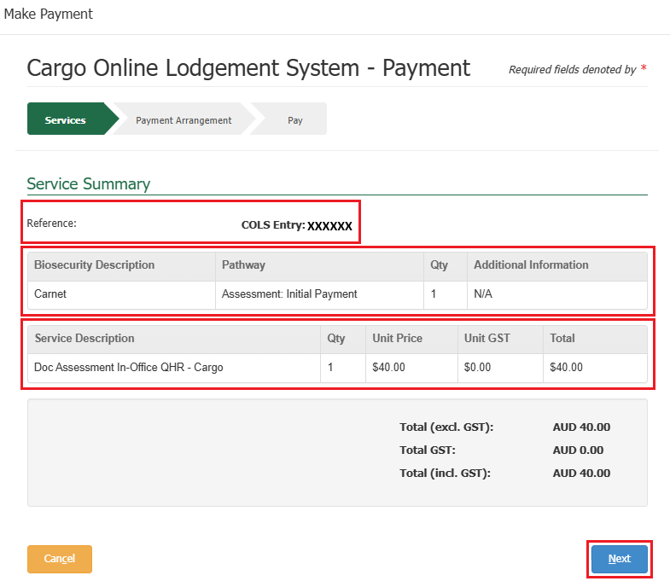

Payment Arrangement Screen

This section allows you to enter an account number if you have one.

*NOTE: If you are an AIMS account client with the Department of Agriculture, Fisheries and Forestry, your invoice will be sent to the email address nominated against your account number. Questions regarding account clients can be directed to* [*ARhelpdesk@aff.gov.au*](mailto:ARhelpdesk@aff.gov.au)*.*

* If you have an account number, select **Yes**, provide the account number, and select **Continue to Payment.**
* If you do not have an account number, select **No** and select **Continue to Payment.**

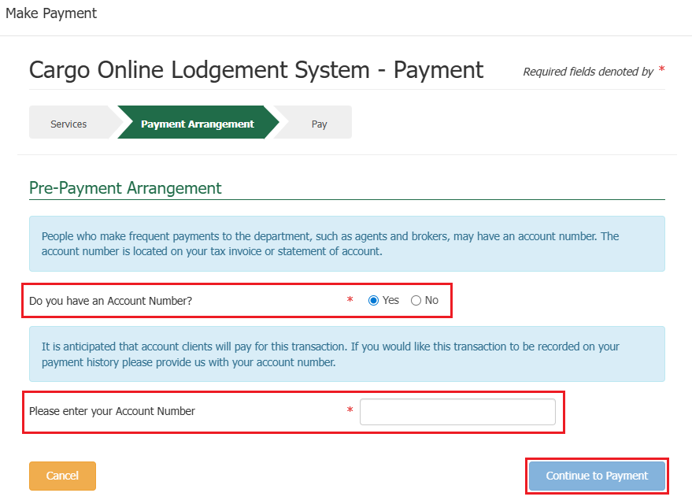

Pay Screen

Upon selecting continue to payment, you will be presented with the payment screen. You will be prompted for your card details.

Fill in the details as required and select **Pay Now**.

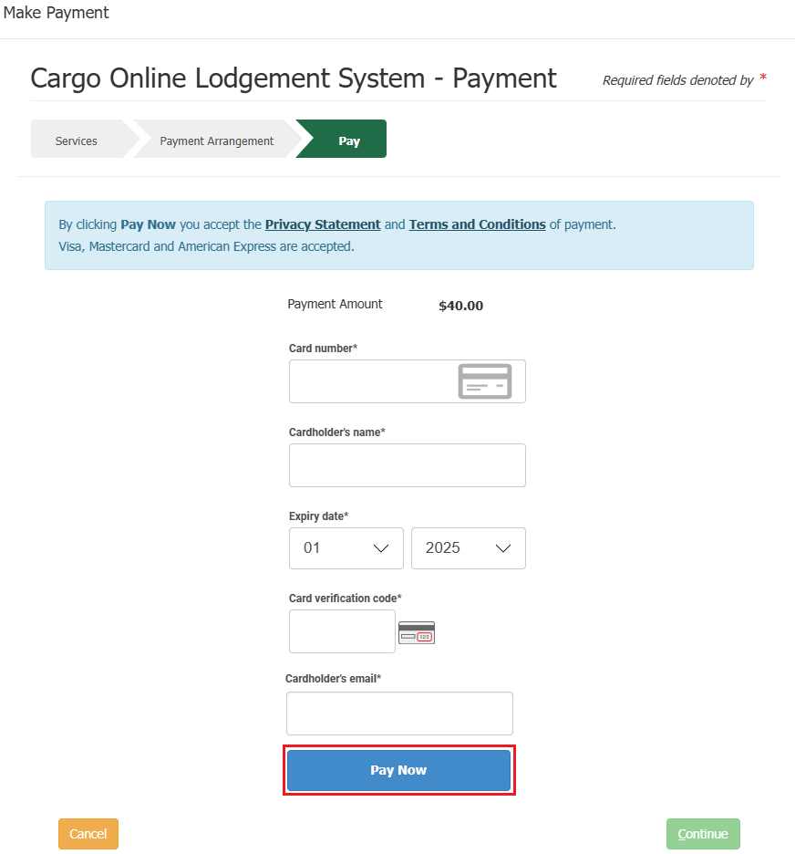

Upon selecting pay now, you will be presented with a payment confirmation screen.

Select **Continue**.

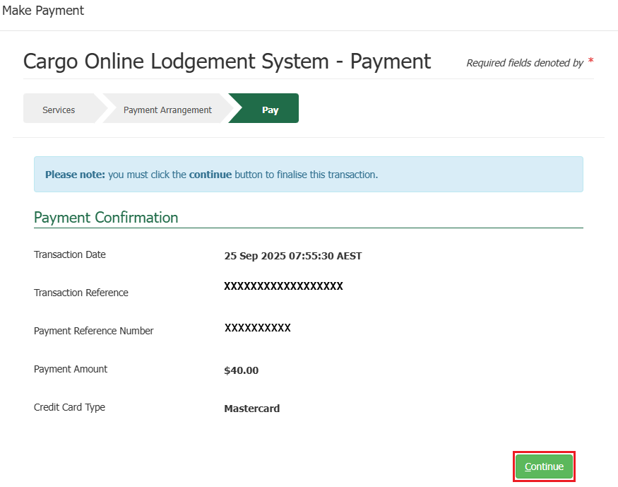

Submitted Screen

You will be presented with a submission confirmation screen confirming the submission of your lodgement.

You will be provided with your **Lodgement Reference Number (LRN)**. This number is a unique number that identifies your lodgement when using other parts of COLS.

*TIP: Please quote your LRN during your communications with the department.*

An email confirming the lodgement has been received will be sent to the email you specified at the time of creating your lodgement.

The system will send you an automatic email containing a Tax Invoice / Receipt for this transaction.

* If you are an account client, the email will be sent to the email nominated against the account number.
* If you are not an account client, the email will be sent to the email you specified at the time of creating your lodgement.
* If you wish to complete another new lodgement, select **New Lodgement** and repeat the above steps.
* ****Alternatively, selecting **Finished** will take you back to the COLS home screen.