How do I Update or Cancel my Reservation?

This task card demonstrates how to update or cancel your reservation via the Post Entry Biosecurity System (PEBS).

Update Your Reservation

You will have received an email to the email address you specified at the time of creating your reservation, which will provide your PEQ Reference Number.

Once your reservation has been created, you will then be able to make certain updates to your reservation online.

The updates that can be made include:

* Modifying your consignments requested PEQ arrival date prior to you confirming your reservation.
* Adding additional documentation to your reservation.
* Adding additional authorisations for your reservation.
* Adding additional information to your reservation.

*TIP: The documentation, authorisation and declaration (additional information) sections can be used to upload documents, add, edit or remove authorisations and add additional information all throughout your reservations life cycle, until your consignment is no longer at PEQ.*

*NOTE: Once you confirm your reservation, you will not be able to modify your consignments requested PEQ arrival date. If you wish to change this date after confirmation, you will need to contact the Department directly by emailing PEQServices@aff.gov.au.*

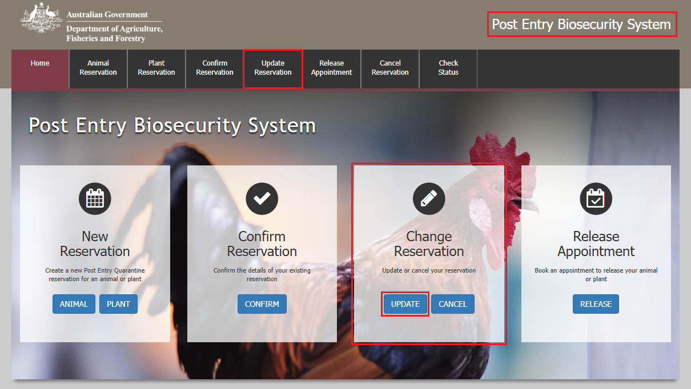Go to **PEBS** and select **Update** within the **Change Reservation** box or **Update Reservation** from the main toolbar.

Reference Screen

Enter your **PEQ Reference Number (PRN)**, which was emailed to you at the time of creating your reservation.

Enter the **Reservation email** you specified at the time of creating your reservation.

Select **Next.**

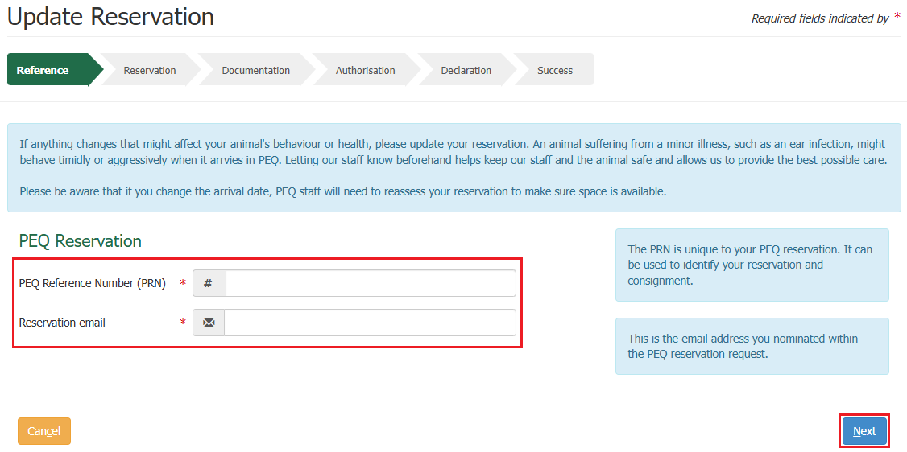

Reservation Screen

A summary of your reservation will be displayed.

*NOTE: If you have not yet confirmed your reservation, you will be able to input a new requested PEQ arrival date if that is the update you are wishing to make. If changing the arrival date, PEQ staff will need to reassess your reservation to make sure space is available. The requested PEQ arrival date must be 7 days greater than the current day, after your eligible for export date, and prior to your permit expiry date.*

*If you need to have an arrival date earlier than 7 days of the current day or have already confirmed your reservation and wish to change the requested PEQ arrival date, you will need to contact the Department directly by emailing PEQServices@aff.gov.au.*

Select **Next**.

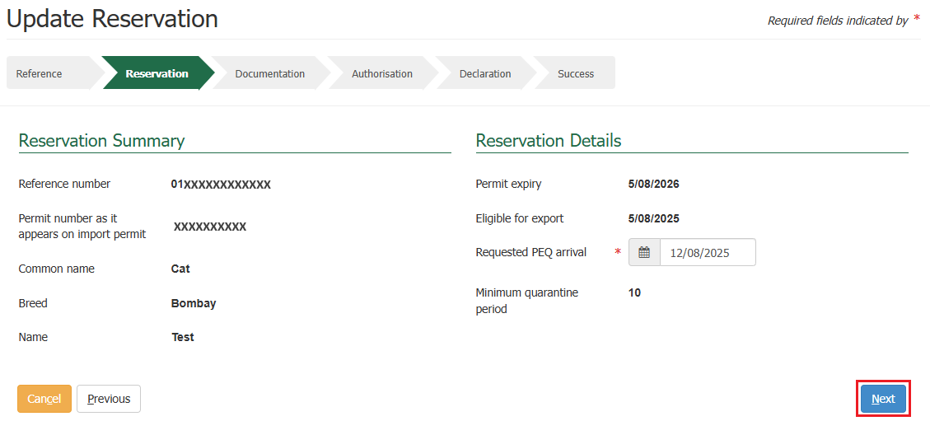

Documentation Screen

This section allows you to upload documents required for your reservation.

*TIP: You can upload as many files as required. The system supports the uploading of files and images with extensions of TIF, JPG, JPEG, PDF, DOC, DOCX, PNG, MSG, PST and OST.* It is recommended that you upload readable images (e.g. 100dpi).

You will need to ensure each file is limited to 20MB.

PEBS supports the drag and drop feature meaning you can drag a file from your computer and drop it into the **File Upload** section.

Alternatively, you can select the **Choose Files** option in the **File Upload** section to select a file to download.

Once your document is added, it will display in the **Document Details** section where you will have the option to select a **Type** from the drop down and add **Additional Information** against each document.

If you want to remove a file you have just uploaded, select the **bin** icon within the action’s column against that document.

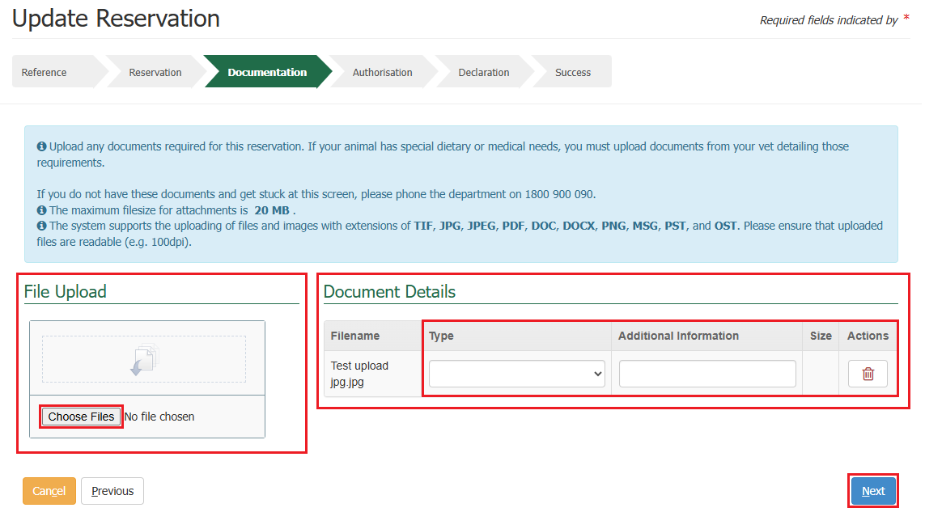Select **Next.**

Authorisation Screen

This section allows you to add or update authorisation details of a third party, either a company or personnel to provide authorisation to act on behalf of the consignment while at the PEQ facility, and to allow collection of the consignment at the end of the quarantine period.

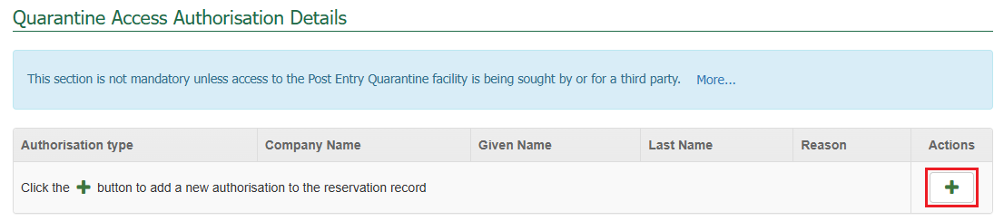If you wish to add any authorisation details, select the **+** **icon** within the action’s column.

Fill in the details as required and select **Save**.

*NOTE: Based on the authorisation type, the details required will vary.*

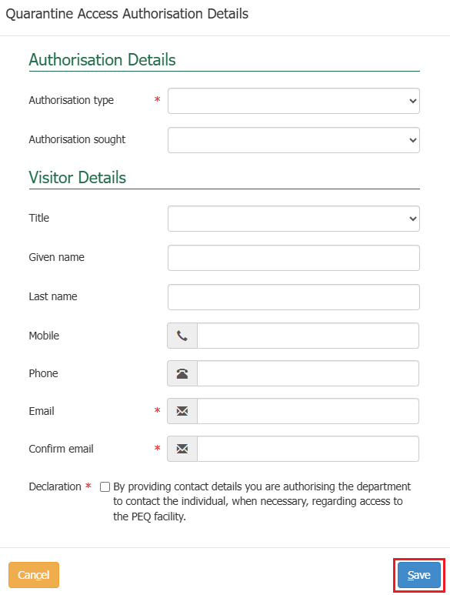

Upon selecting save, the details will populate in a table on the screen.

Multiple icons will appear in the action’s column in the table for each row where an authorisation is added. These icons indicate different actions that can be performed against each authorisation detail that you have added.

* The **+** **icon** allows you to add multiple authorisation details.
* The **pencil** icon allows you to make edits to the current authorisation details that you have added.
* The **bin** icon allows you to remove that row if you would like to remove a row of authorisation details.

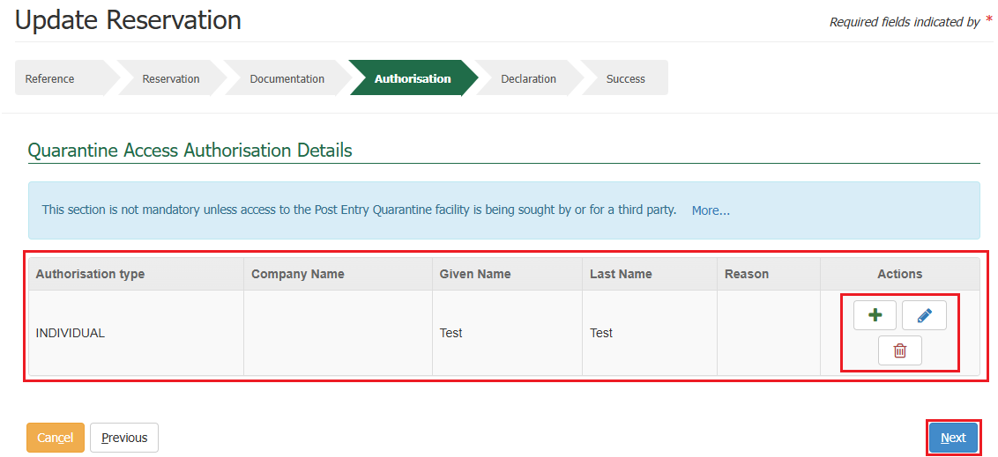Select **Next.**

Declaration Screen

This section allows you to provide any **Additional Information** related to your consignment and to be added as a record to the reservation.

The general declaration checkbox will need to be ticked to proceed, if you agree to the declaration, select the **General Declaration checkbox** to proceed. If you do not agree, you cannot continue with the reservation.

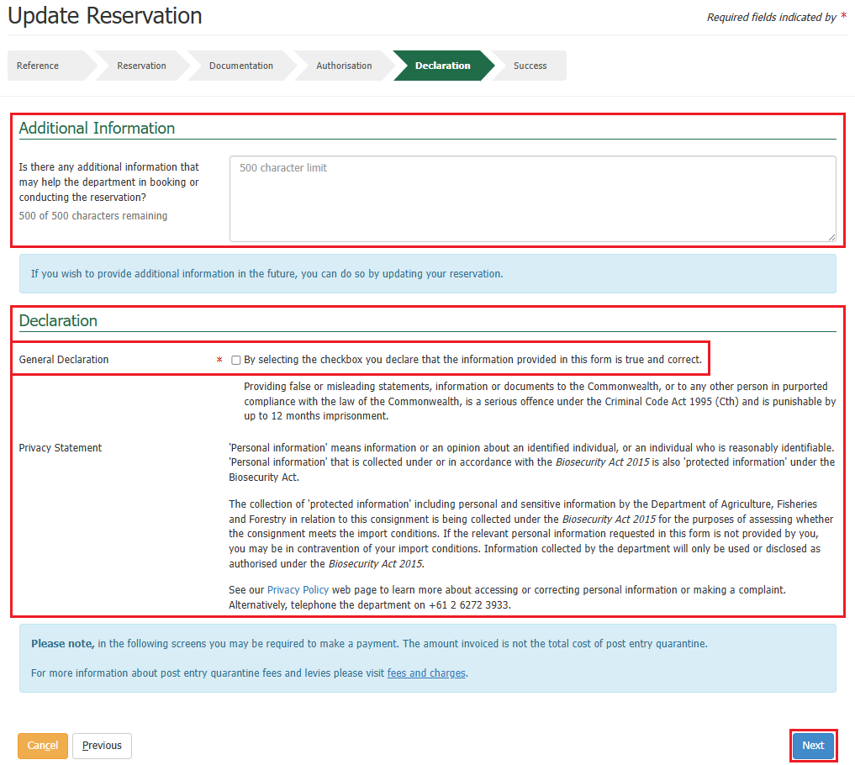Select **Next**.

Success Screen

You will be presented with a success screen confirming the submission regarding the updates you have made to your reservation with your **PRN** listed.

An email advising your reservation updates have been received will be sent to the reservation email you specified at the time of creating your reservation.

Selecting **Finished** will take you back to the PEBS home screen.

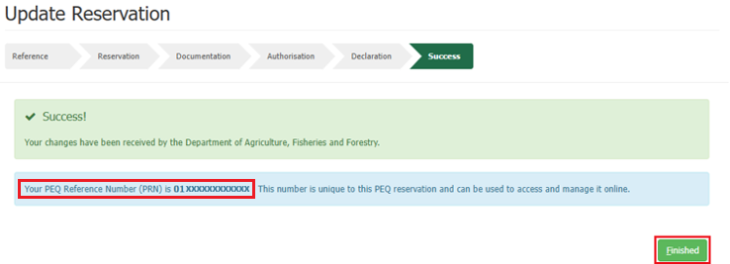

Cancelling Your Reservation

*NOTE: You can only cancel your reservation prior to your consignment arriving at the PEQ facility. After a reservation is cancelled, it cannot be reinstated.*

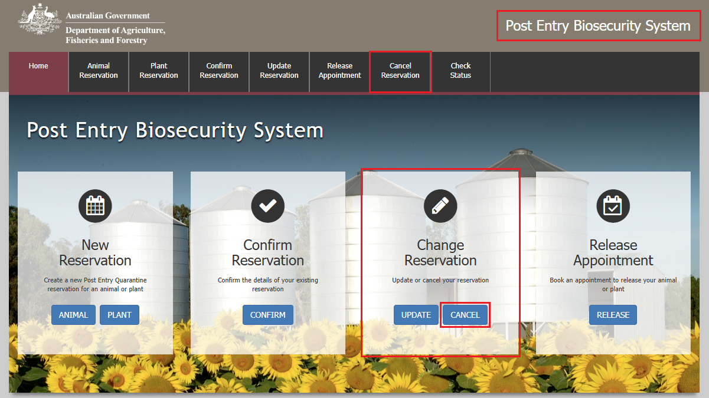Go to **PEBS** and select **Cancel** within the **Change Reservation** box or **Cancel Reservation** from the main toolbar.

Reference Screen

Enter your **PEQ Reference Number (PRN)**, which was emailed to you at the time of creating your reservation.

Enter the **Reservation email** you specified at the time of creating your reservation.

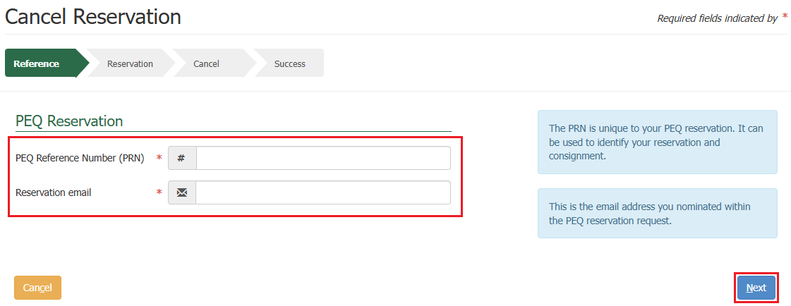Select **Next.**

Reservation Screen

A summary of your reservation will be displayed.

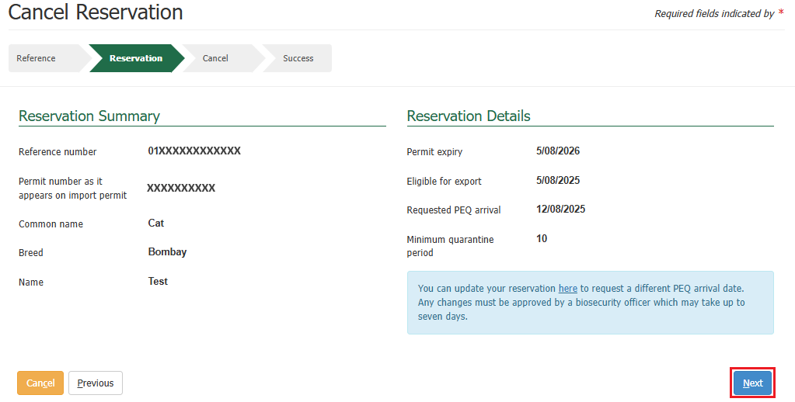Select **Next**.

Cancel Screen

This section allows you to provide **Additional Comments** related to your reservation cancellation, and to be added as a record to the reservation.

The general declaration checkbox will need to be ticked to proceed, if you agree to the declaration, select the **General Declaration checkbox** to proceed. If you do not agree, you cannot continue.

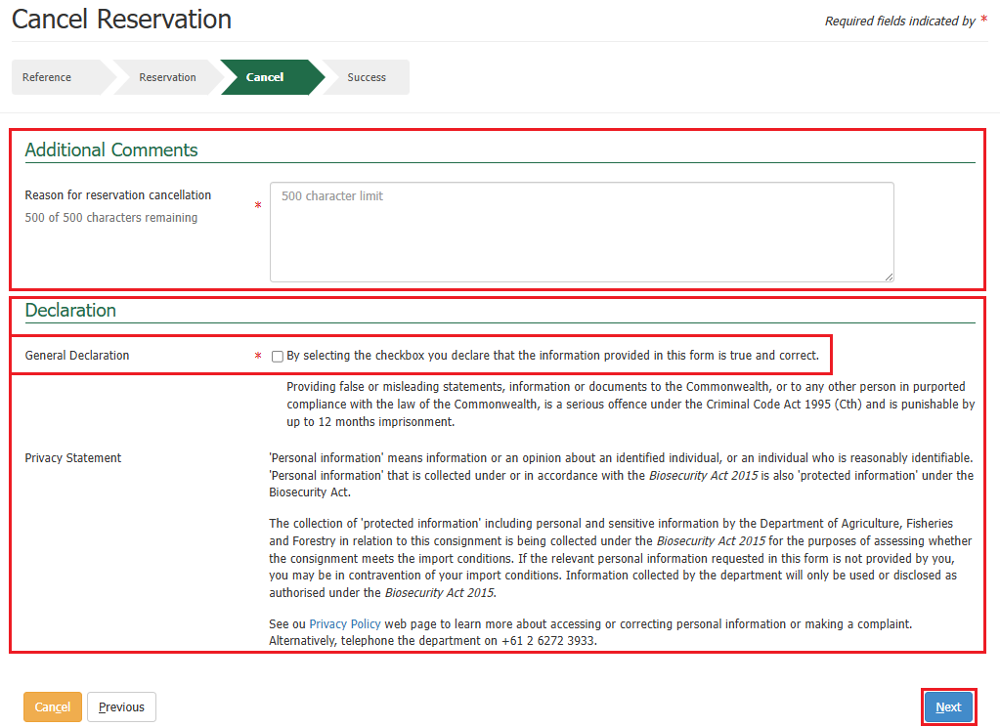Select **Next**.

Success Screen

You will be presented with a success screen confirming your reservation has been cancelled with the PRN listed.

An email confirming the cancelation of your reservation will be sent to the reservation email you specified at the time of creating your reservation.

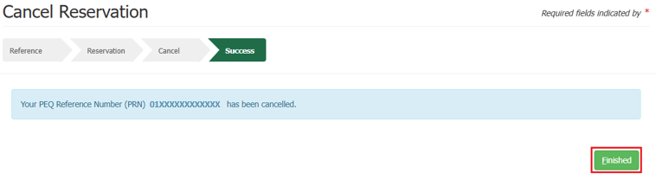Selecting **Finished** will take you back to the PEBS home screen.