USER GUIDE

NEXDOC
How to view my Exporter ID in the NEXDOC portal

__________________________________________________________________________________
In this document
This document contains the following topics.
Purpose of this document 2
How to view my Exporter ID in the NEXDOC portal 2
Contact the NEXDOC help desk. 3

Purpose of this document
The purpose of this document is to provide guidance on how to view your Exporter ID in the NEXDOC portal.
Note: You must register via the online service portal before you can use the NEXDOC portal. Please refer to Create and Manage your account user guide for instructions on how to complete this registration.

How to view my Exporter ID in the NEXDOC portal
Step 1  Log in to the Online services portal | 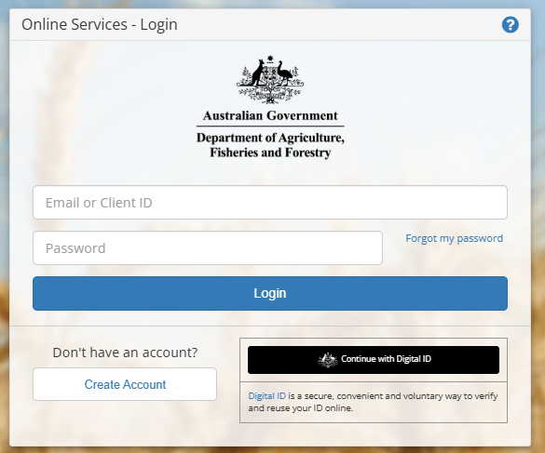
Step 2  Select Go to NEXDOC Homepage | 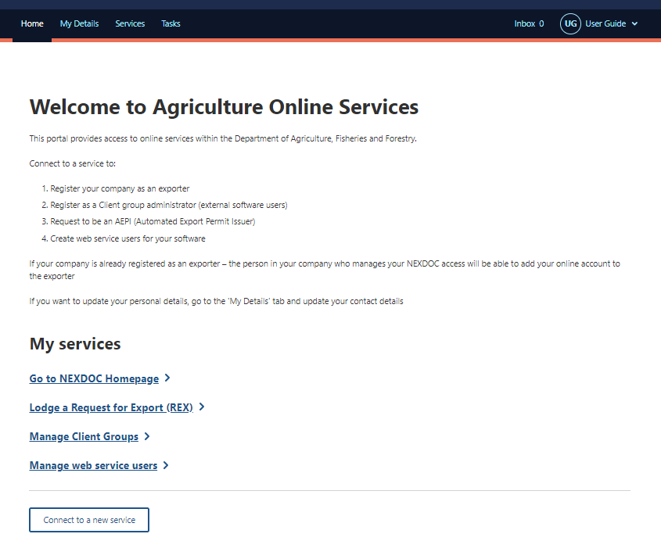
Step 3  Select your user profile at the top right side of the screen.  You will be able to view your Exporter ID/s here. | 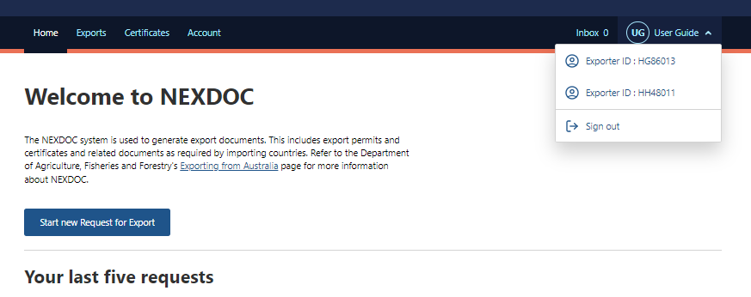

Contact the NEXDOC help desk.
For more information or assistance, please contact NEXDOC@aff.gov.au

