How to lodge a replacement request
The guide below outlines the steps to replace a certificate for a REX in NEXDOC for meat.
You may need to replace a certificate if:
- information on the certificate is incorrect or incomplete
- export or shipment details change after the certificate is issued
- the importing country requests a correction or update
- an error is identified after the REX is completed
- additional information needs to be included on a new certificate
Once a REX is completed, changes can only be made by requesting a replacement certificate through NEXDOC. Additional certificate charges will apply.
This guide assumes that you have already registered as a Meat exporter or are a member of a Client Group in NEXDOC.
- If you have not yet registered as a NEXDOC exporter or as a member of a Client Group, please refer to the Create a NEXDOC Exporter Account pdf or docx guide.
- If you are registered as a NEXDOC exporter or are a member of a Client Group but need to add Meat to your exporter account, please refer to the Add or Remove Exporter to Exporter Account pdf or docx guide.

Log in to the Online Services Portal
Go to the Online Services Portal and click on the Login button. | 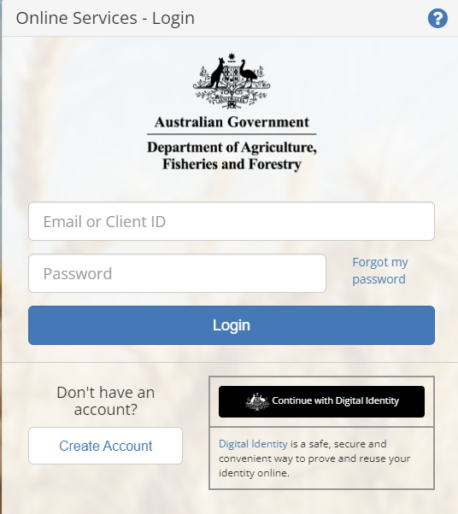
Step 1  Select the Go to NEXDOC Homepage link to display your REX applications. | 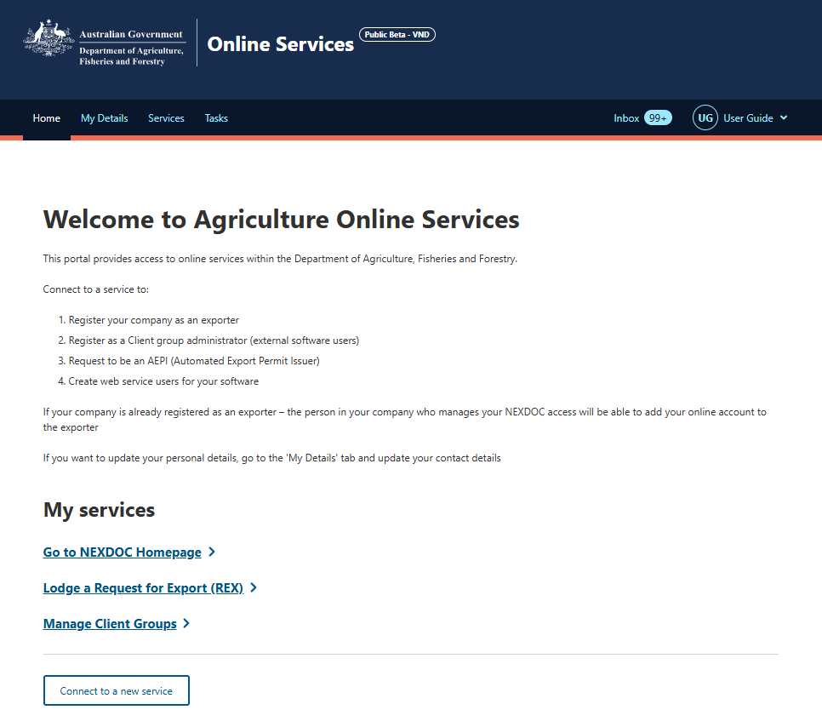

Step 2  Select the REX number for the one you need to replace.  Note: You will need to replace your REX if your REX status is  ‘Completed’.  Step 2(a)  If the REX you wish to amend is more than five entries prior, you will need to Select the Exports tab and use the REX number to search | 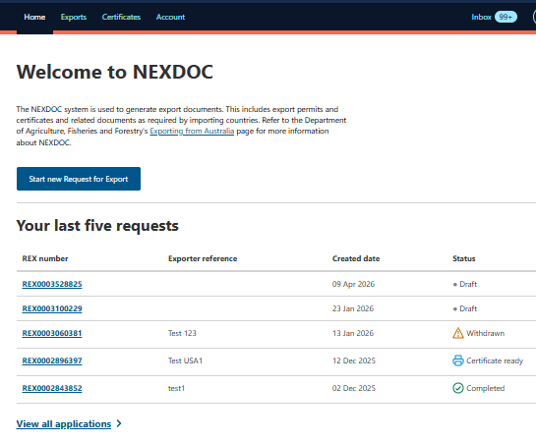  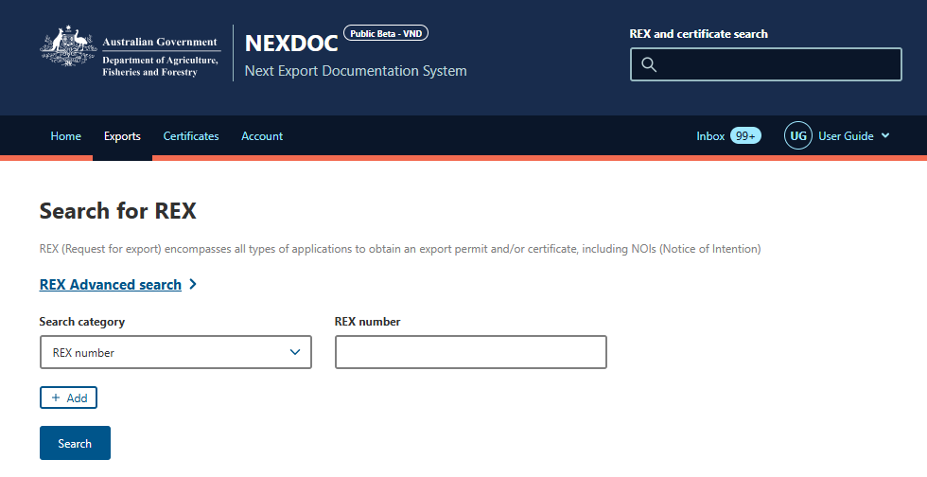
Step 2  Select the More Actions drop-down and select Request for replacement. | 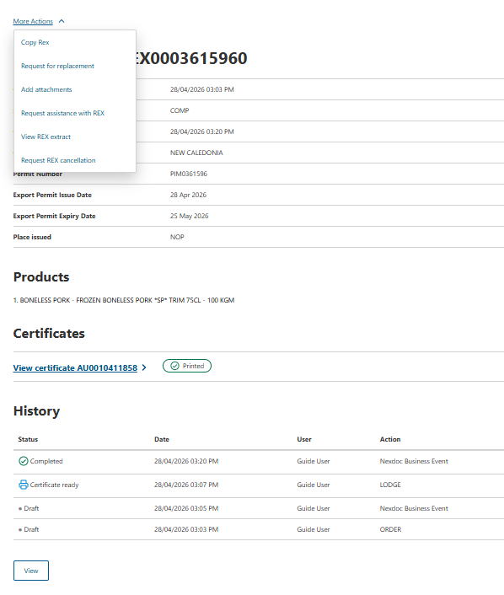
Step 3  Select the Re-submit button. | 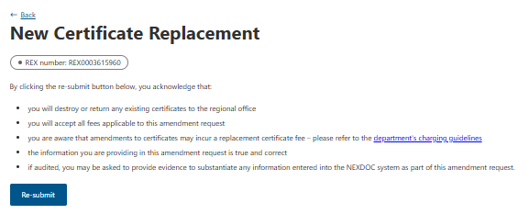
Step 4  Select the appropriate option from this screen:  - Amend existing data  - Add new line item (that will print on a new certificate). | 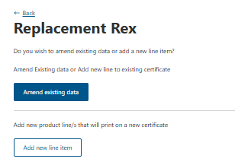
Step 5  Select the relevant blue tab on the left-hand side to navigate to the section requiring amendment. Amend relevant details. | 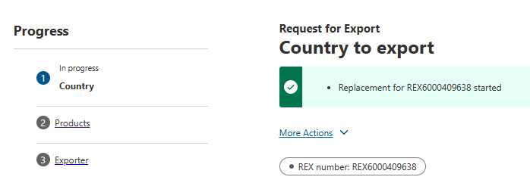
Step 6  Once the amendments have been made, select Submit from the left-hand menu.  Step 7  Read the export declaration and select I agree. | 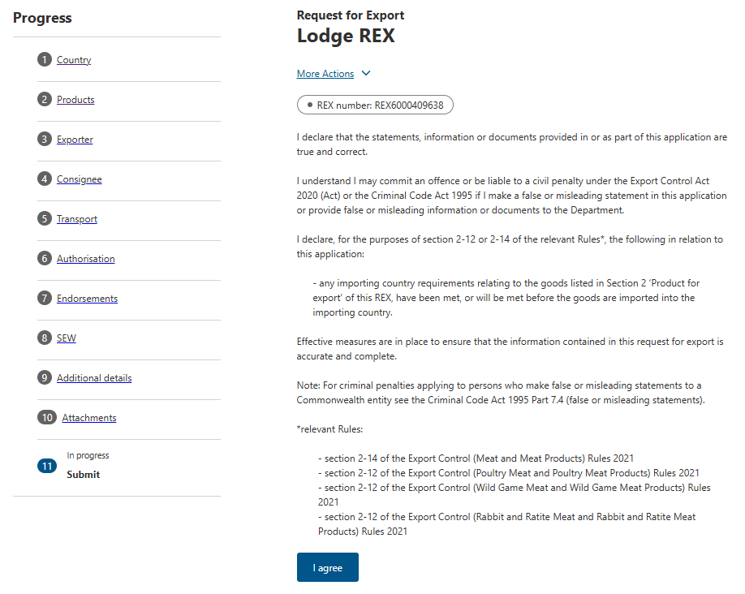
Step 7  Enter an Amendment reason to the free text field and select Lodge replacement REX. | 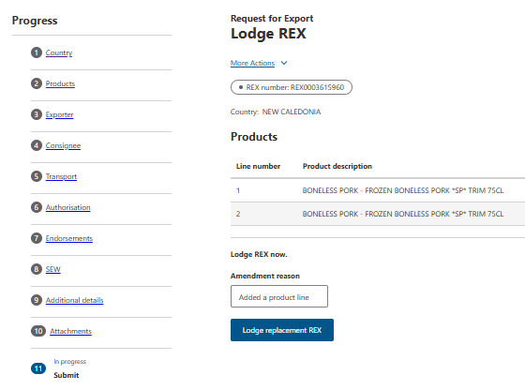
Step 8  Select the tick box for each exporter declaration (where required) and select Next.  Note: Not all REXs will have exporter declarations so this screen may not appear. | 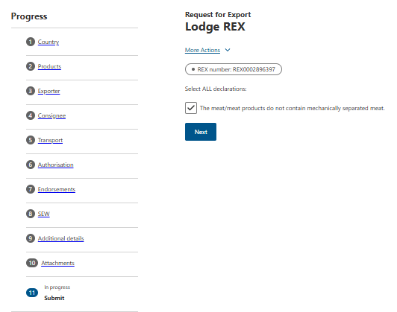
Step 9  Additional declaration questions may appear depending on the consignment. Select the appropriate answers and I agree. | 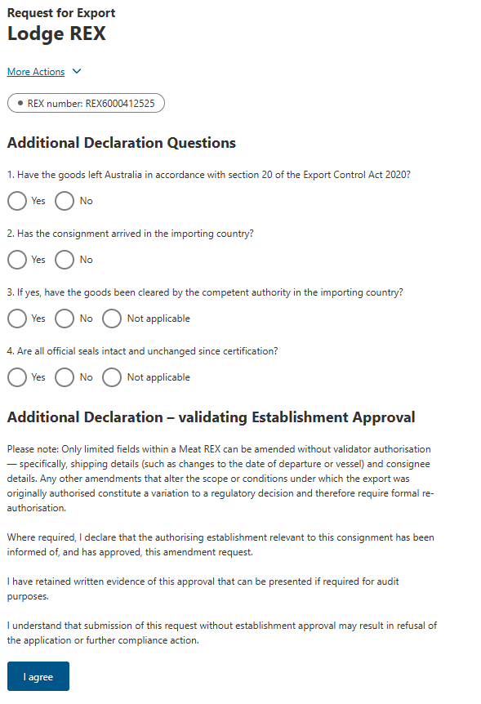
Step 10  A confirmation message will appear.  If relevant, a Service ID will also appear. | 