Lodge a Request for Export
You must lodge a Request for Export (REX) if you need export documentation issued by the department.
Lodge your REX using the Next Export Documentation (NEXDOC) system.
The department will then:
- assess whether you have met all export requirements
- issue an export certificate, if approved.
Application workflow
When you start a request, you will be guided through the application workflow. The workflow will be different depending on the commodity you are exporting.
Start a new request
There are two options in which you can lodge a REX.
You can start a new Request for Export through:
1. | Log onto Online services
2a. | Select ‘Lodge a Request for Export (REX)’ from the Online services  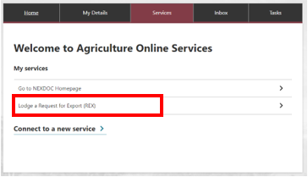  Or

2b. | Select NEXDOC Homepage  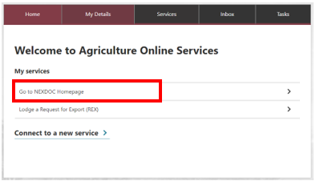
3. | Select Start new Request for Export  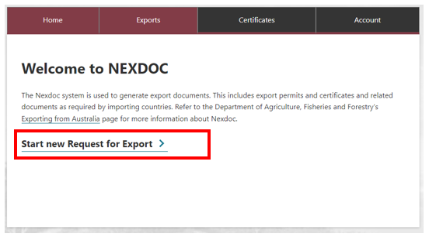

4. | Select the dropdown arrow icon in the Commodity type of your export.  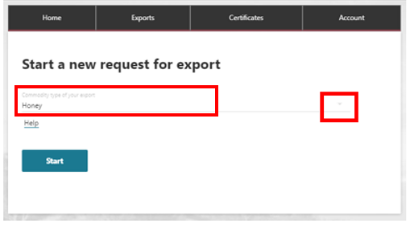
5. | Select the required commodity and select Start  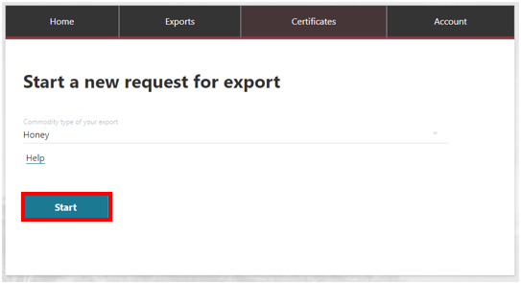

6. | The Country to export screen will display.  Type the country name you wish to export to.  - Select ‘Next’.  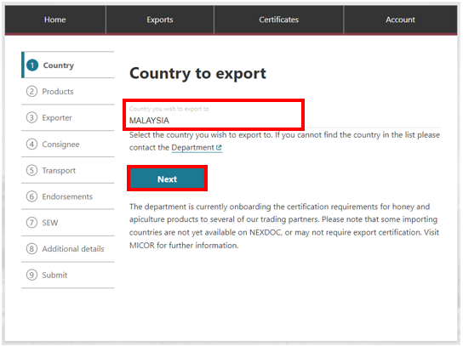
8. | Select ‘Add a product for export’.  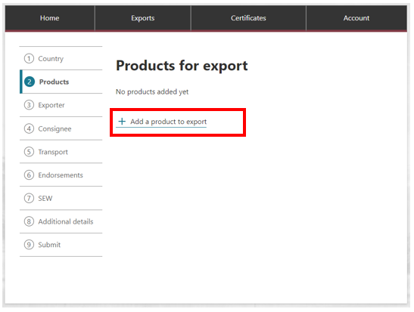
9. | Begin typing the product you wish to export.  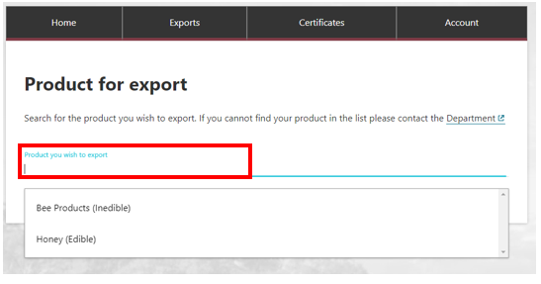
10. | Complete relevant fields within Add details for the product  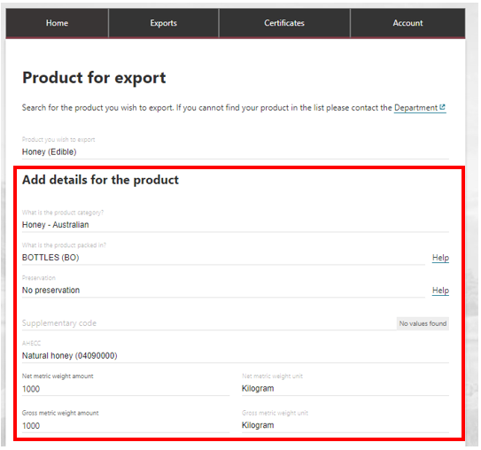  Once your product information is inserted, you can input information into the below tabs.

11. | Complete relevant fields within Outer packaging  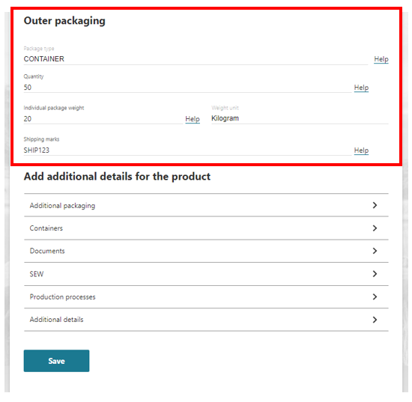
12. | You are required to fill in the manufacturer details within the Production Processes tab.  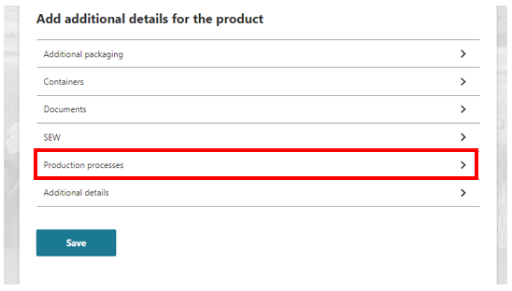

13. | To add your manufacturer details, go into the Production Process tab and select Add Production process.  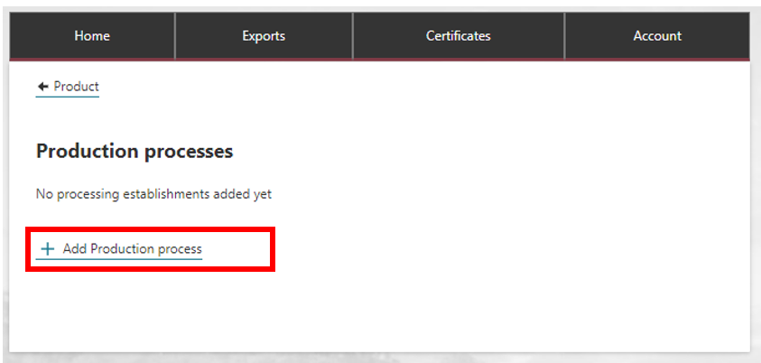
14. | Enter the manufacturer name into the free text field and then select Add.  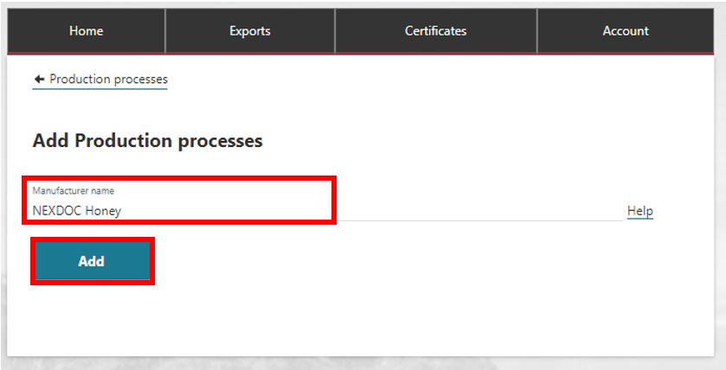
15. | The Production porcesses screen will display. To return to your product line, select < Product.  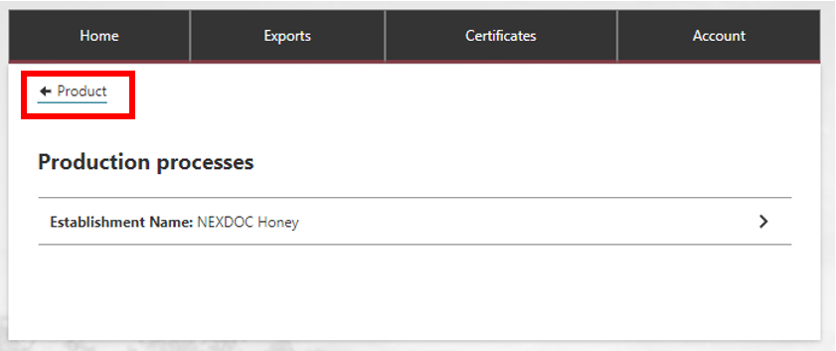

16. | You will notice that once details are saved in each tab, they appear on the product screen. This will give you an indication of which fields you have completed.  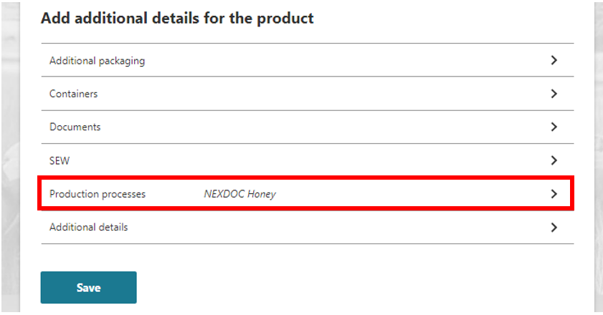
17. | If you wish to insert a manual description for your product, this is found in the Additional Details tab.  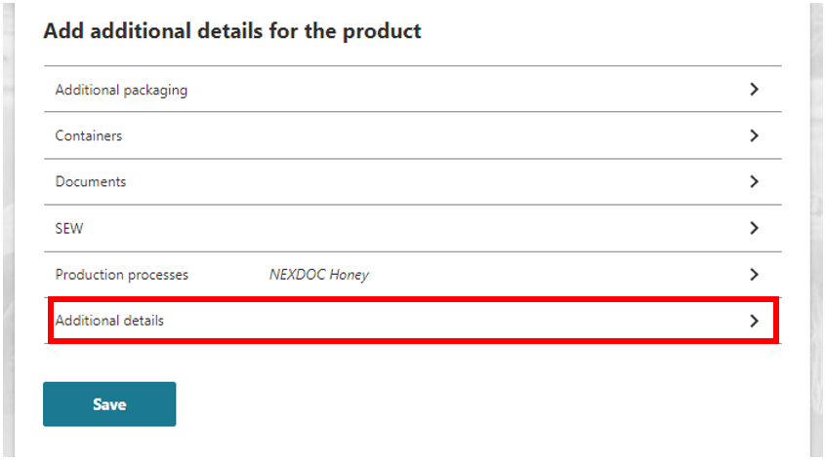

18. | Type your manual description in the Manual product description field. Once completed select Save.  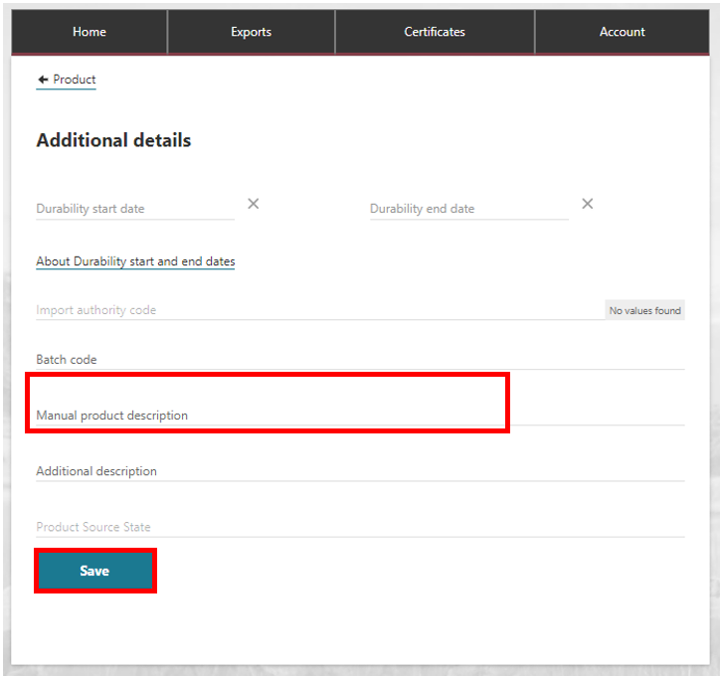
19. | Complete the relevant information for your REX. Select Save.  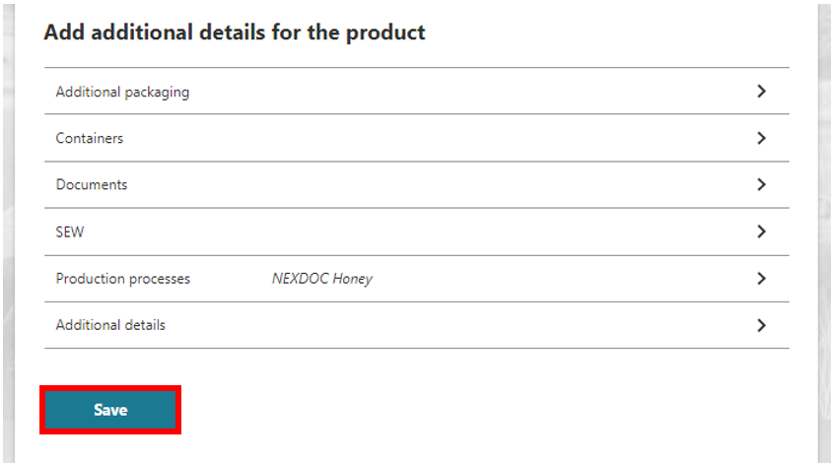

20. | You will receive a notification that your REX application has started.  You have two options:  add another product for export (repeat steps 8 – 19) or  select Next.  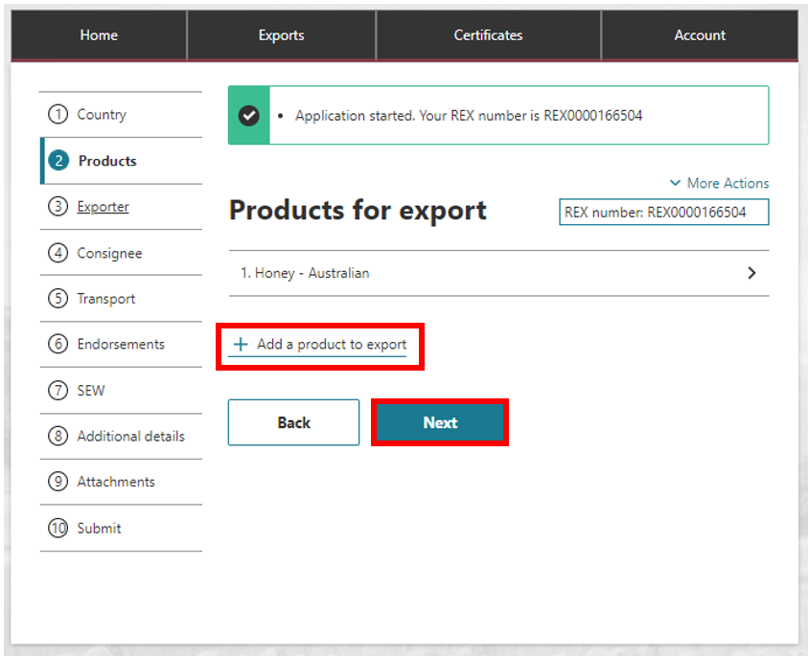
21. | The third tab holds information pertaining to the exporter. The exporter details in the blue box will render on the certificate. It is mandatory to provide a reference for the REX.  Your reference will display what appears on your invoice from the department.  Once completed select Save and next.  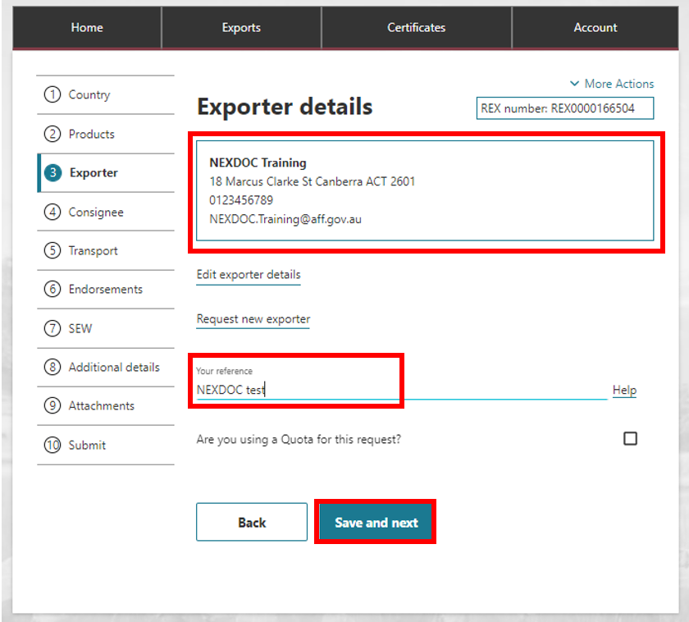
22. | The fourth tab displays consignee details. Once the necessary details are added, select Save and next.  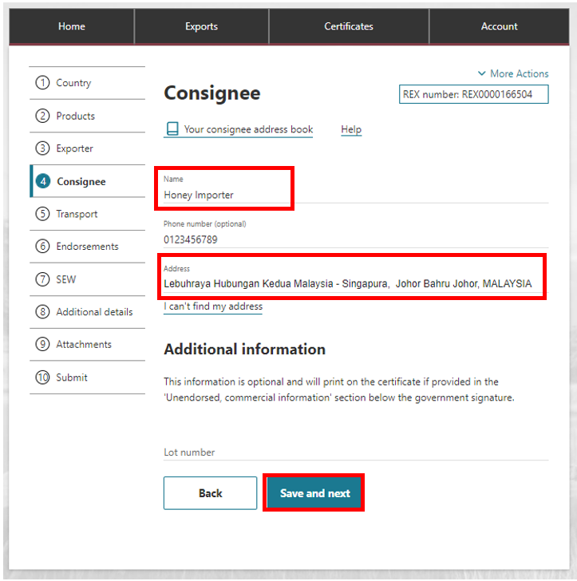

23. | The fifth tab displays Transport details. Once the necessary details are added, select Save and next.  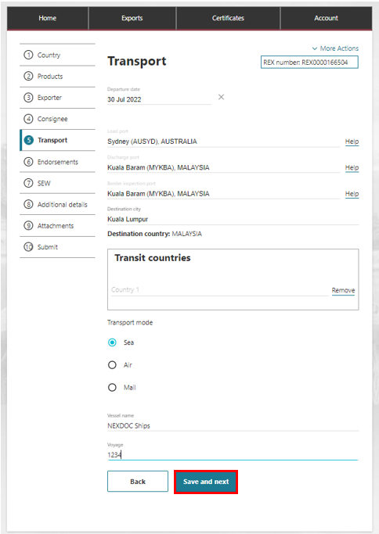

24. | The Country Defaults table has been set up to allocate the appropriate template and endorsement for your product type and category code. If it is the correct endorsement you can select Next.  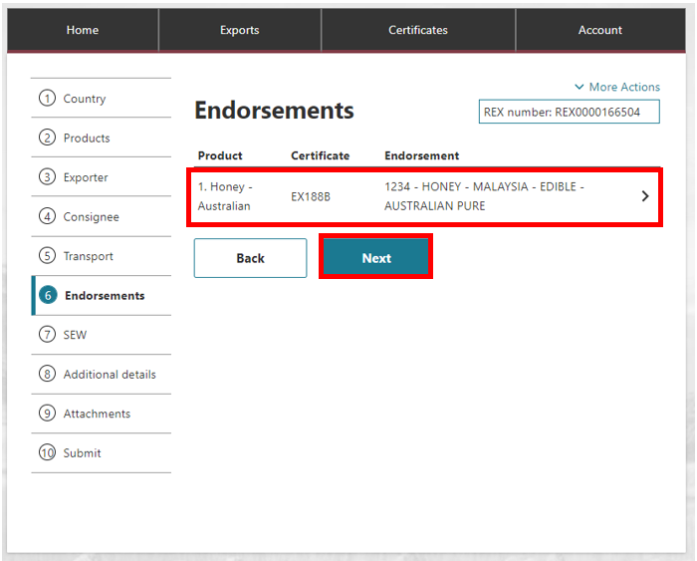
25. | If it is not the correct endorsement you can add one.  Select the product line.  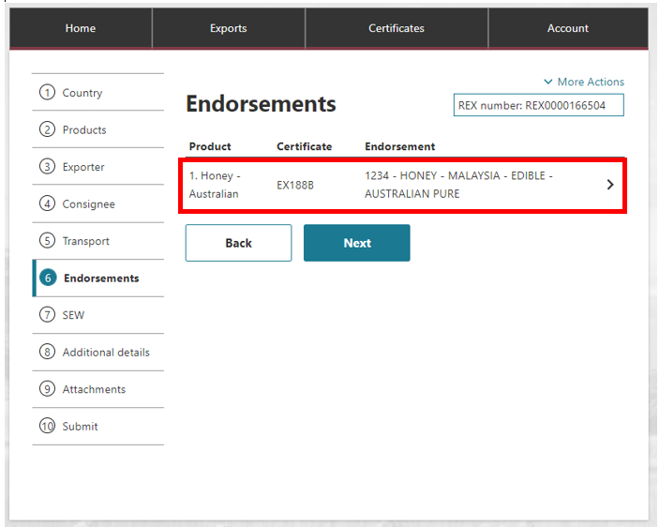

26. | The Endorsement screen will display.  Select + Add Fre Text Endorsement.  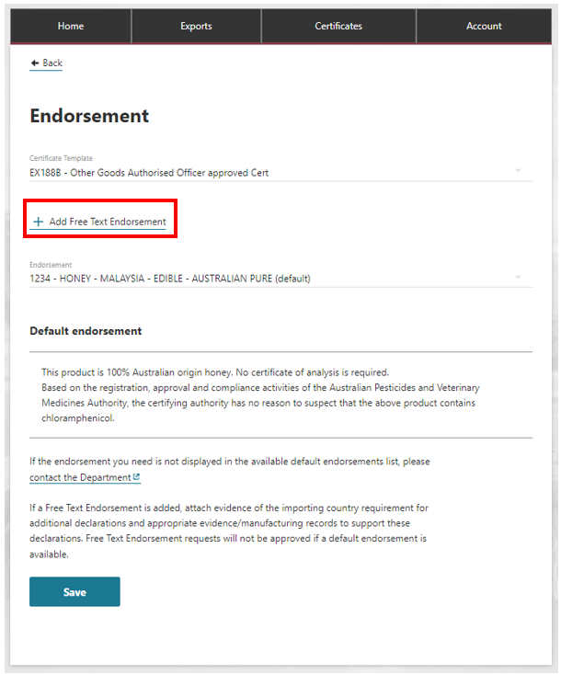  Note: If a Free Text Endorsement is added, attach evidence of the importing country requirement for additional declarations and appropriate evidence/manufacturing records to support these declarations. Free Text Endorsement requests will not be approved if a default endorsement is available.
27. | The Free Text Endorsement screen will display.  Type in the endorsement you require. This will appear on the certificate. Once completed select Save.  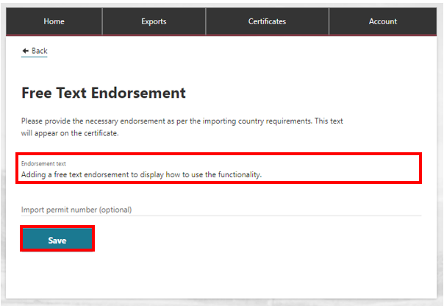
28. | You will receive a message advising the endorsement has been saved.  Select < Back.  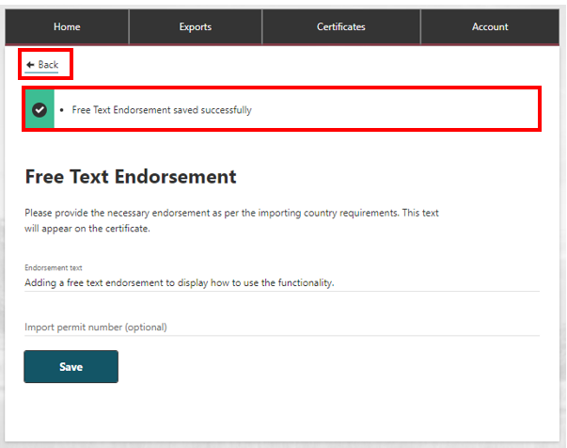
29. | The Endorsement screen will display. You will see the certificate template and the new endorsement.  If this is correct select Save.  If you need to amend select Edit Free Text Endorsesment.  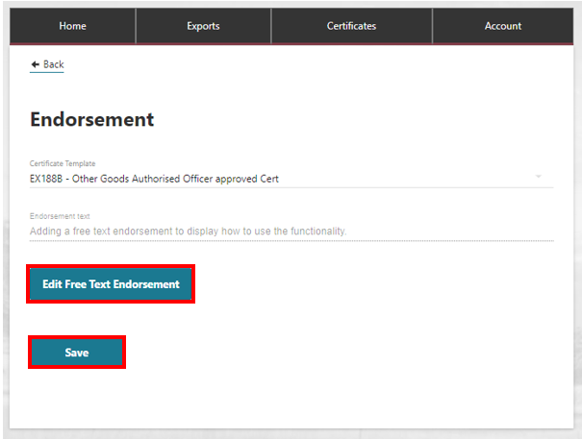

30. | The Endorsements screen will display, select Next.  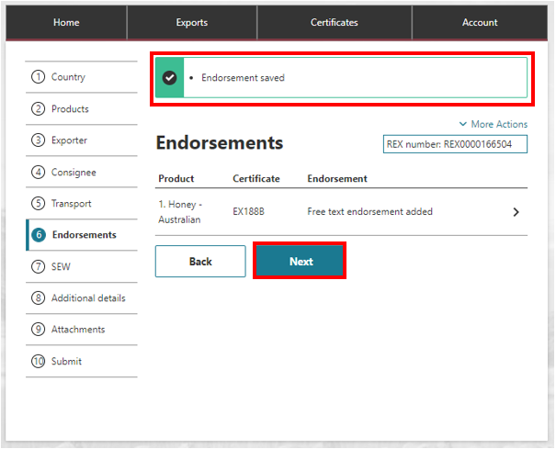
31. | Select if you would like to use the Single Electnoric Window (SEW) in the Intergrated Cargo System (ICS).  Please note you have a choice to select this with every REX lodgement. You can refer to NEXDOC_Obtain your EDN through SEW user guide.  Fill in the required fields and select Save and next.  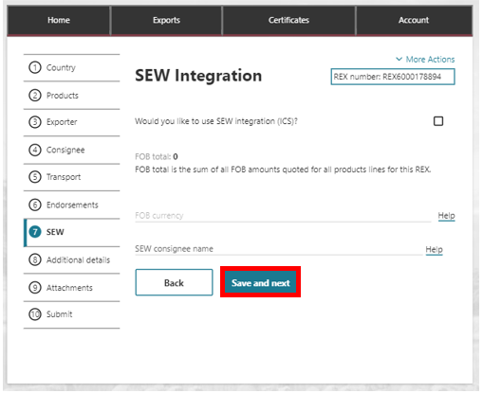

32. | The Additional details screen displays. This screen contains the additional details associated with your REX such as your print indication.  Fill in the required fields and once completed select Save and next.  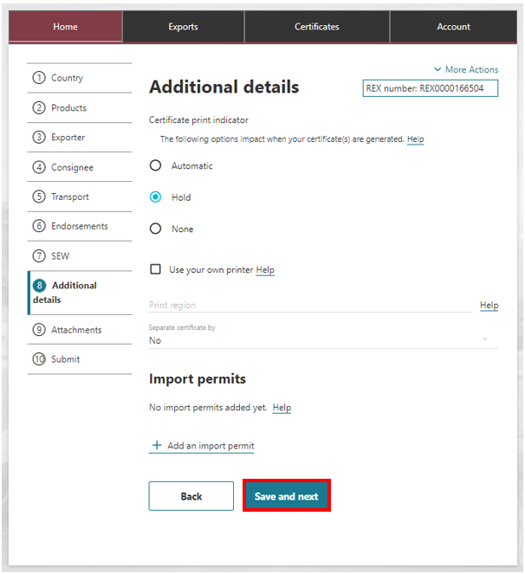
33. | This screen displays the Attachments tab. If you would like to add an attachment Select Add attachment otherwise select Next.  Note: If you have added a Free Text Endorsement you will need to attach supporting documention.  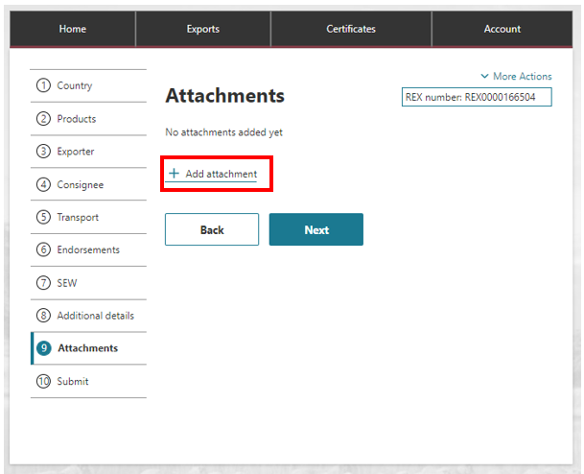

34. | You will select your type of attachment from a list of drop-down options.  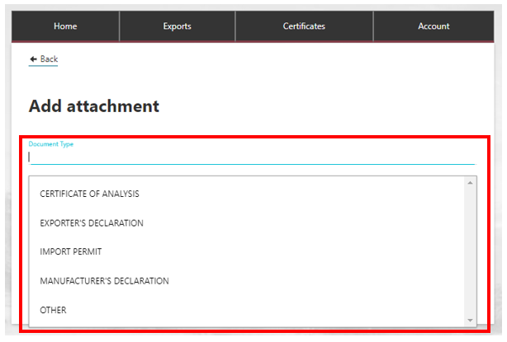  Select the file you want to attach.  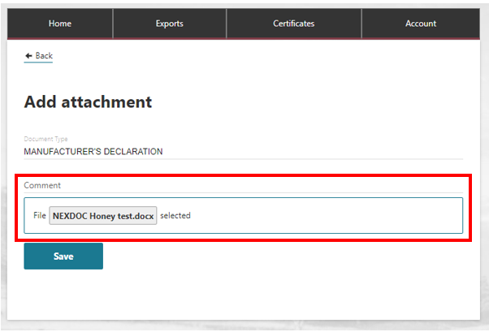  Select Save.  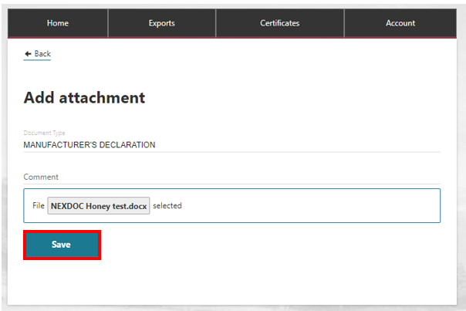

35. | A message will appear advising the attachment has been saved successfully.  If you want to attach more documentation repeat step 32 – 34.  Once the necessary documentation is attached, select Next.  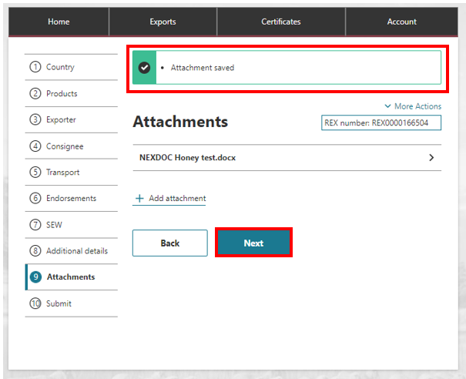
36. | The declaration screen will display. You will need to read the declaration. If you agree select  I agree.  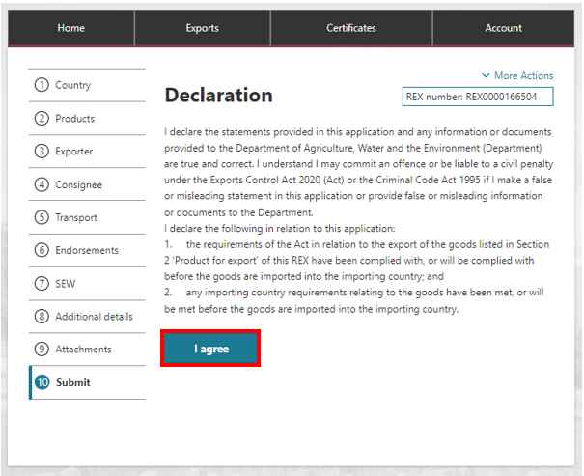

37. | If you would like to lodge your REX with the department, Select Lodge REX.  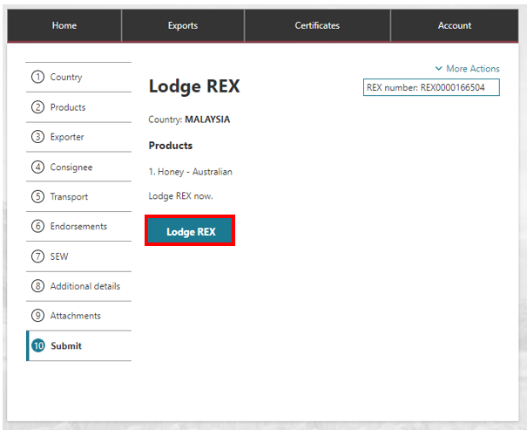
38. | You will receive confirmation that your REX has been lodged, and if applicable, notification that your REX is being reviewed by the department.  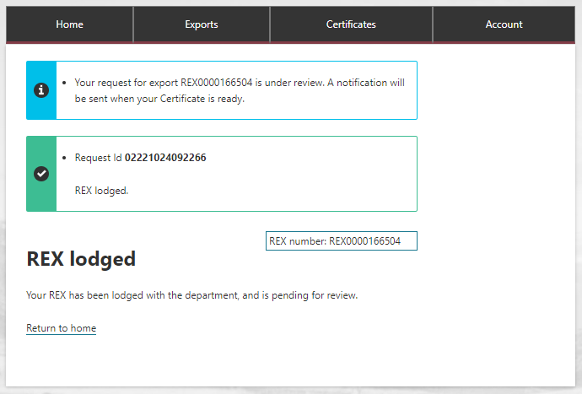

39. | Once approved, your certificate will progress to Certificate Ready or Complete. This will depend upon your print indicator.  