Lodge a Request for Export
You must lodge a Request for Export (REX) if you need export documentation issued by the department.
Lodge your REX using the Next Export Documentation (NEXDOC) system.
The department will then:
- assess whether you have met all export requirements
- issue an export certificate, if approved.
Application workflow
When you start a request, you will be guided through the application workflow. The workflow will be different depending on the commodity you are exporting.
Start a new request
There are two options in which you can lodge a REX.
You can start a new Request for Export through:
1. | Log onto Online services
2a. | Select ‘Lodge a Request for Export (REX)’ from the Online services  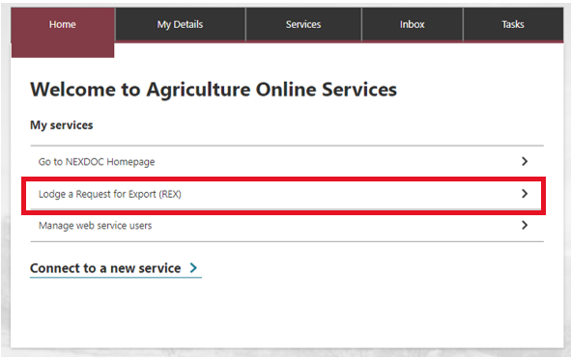  Or
2b. | Select NEXDOC Homepage  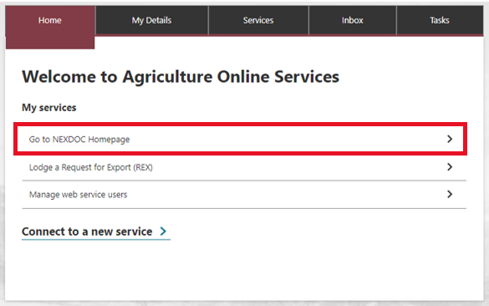
3. | Select Start new Request for Export  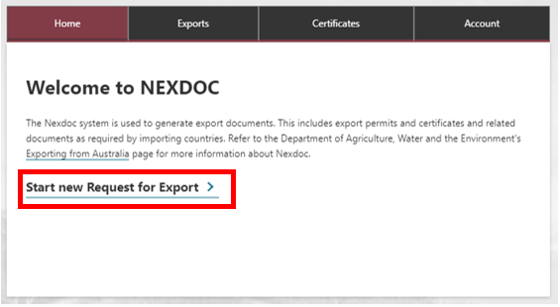
4. | Select the dropdown arrow icon in the Commodity type of your export.  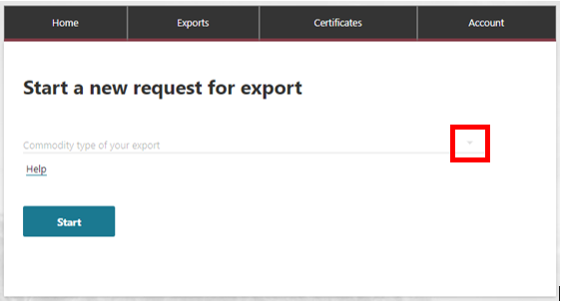
5. | Select the required commodity and select Start  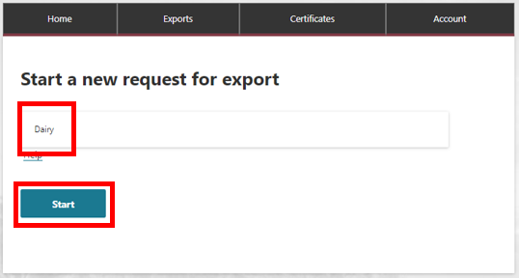  Questions may appear after you have selected the commodity. (i.e. for Dairy you will see:  - Are you using a Quota for this request?  - Do these products contain any imported dairy ingredients?  If these questions apply, please select the tick box next to the relevant question and fill in any additional information requested.  If not, continue to step 6.
6. | Select the ‘Start’ button.  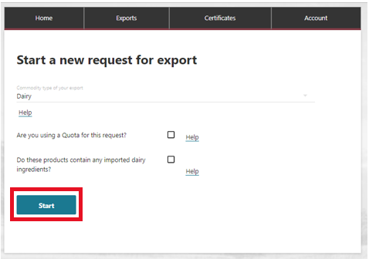
7. | The Country to export screen will display.  Type the country name you wish to export to.  - Select ‘Next’.  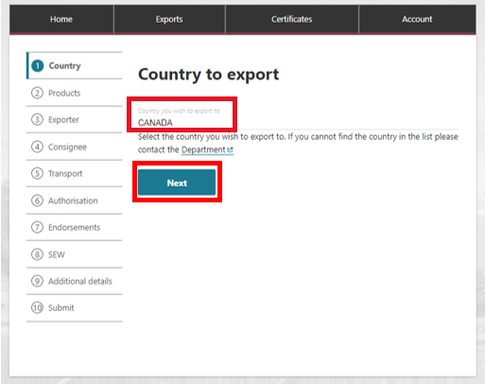
8. | Select ‘Add a product for export’.  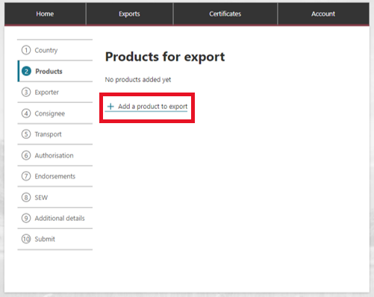
9. | Begin typing the product you wish to export.  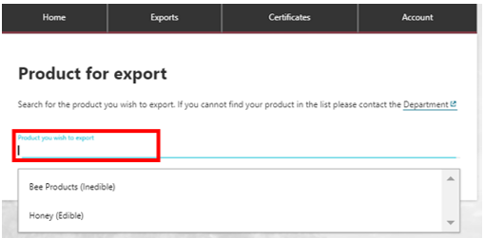
10. | Complete relevant fields within Add details for the product  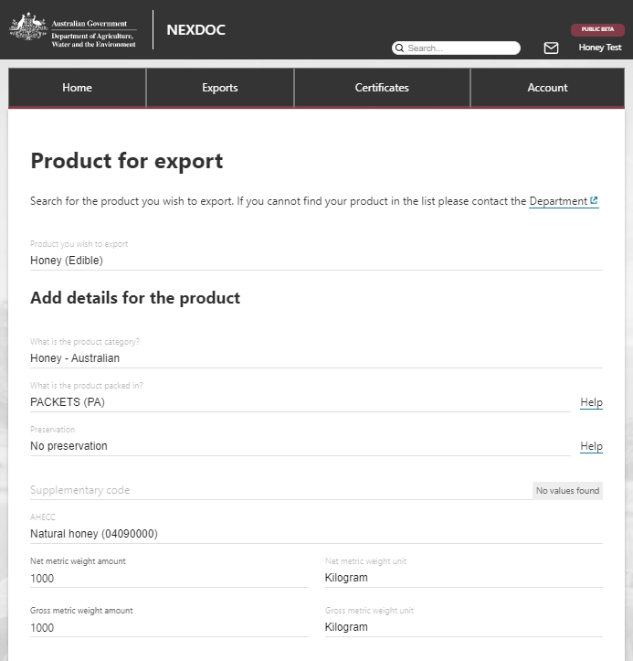
11. | Complete relevant fields within Outer packaging  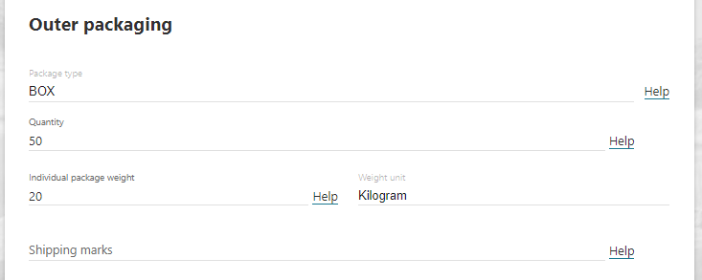
12. | Complete relevant fields within Add additional details for the product.  To update additional packaging details, select the ‘Additional packaging’ tab.  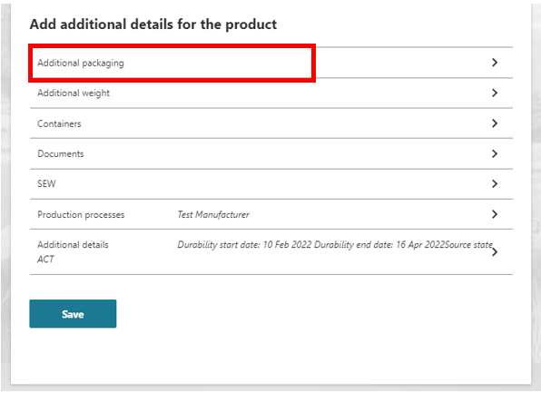
13. | The Packaging screen will display.  Complete the relevant field and select ‘Save’.  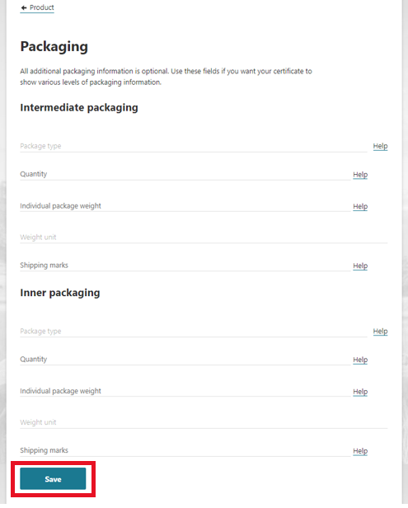
14. | The Product for export screen will display.  Select the ‘Containers’ tab.  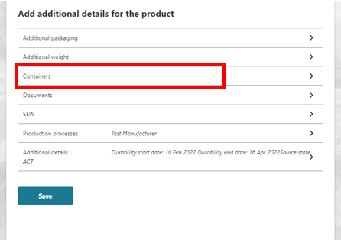
15. | The Containers screen will display.  Select the relevant freight container.  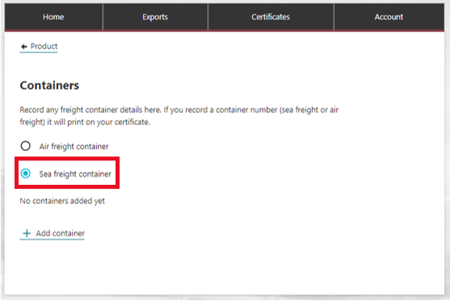  Select ‘Add container’ if required.  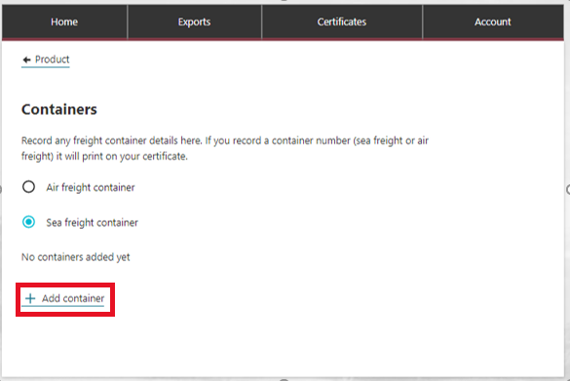
16. | The Containers screen will display.  Add the container number and select ‘Add seal number’.  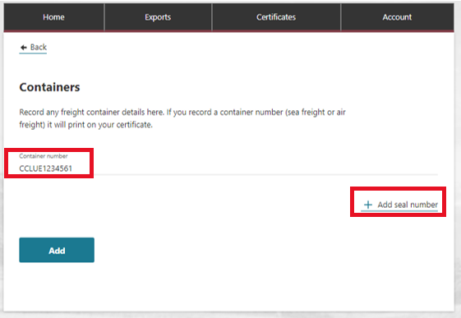
17. | Type seal number and select ‘Add’.  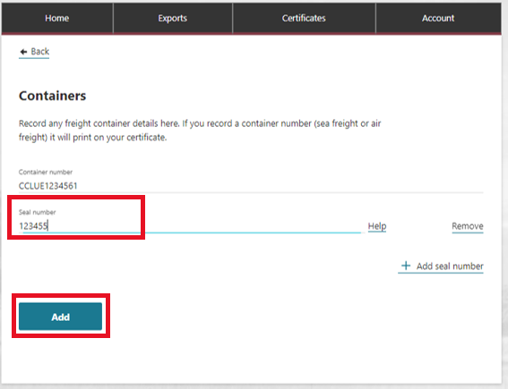
18. | The Containers screen will display.  Select ‘Product’ to go back.  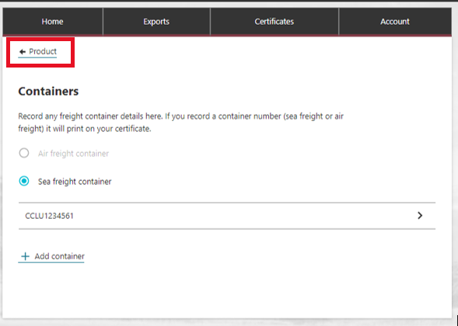
19. | The Product for export screen will display.  Select the ‘Documents’ tab.  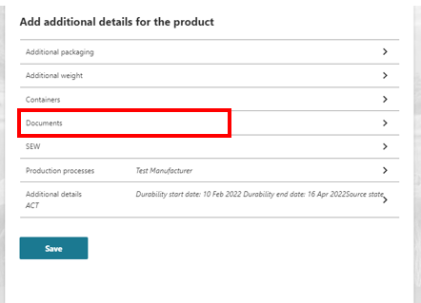
20. | The Attach relevant supporting documents screen will display.  To attach a document, select ‘Add document’.  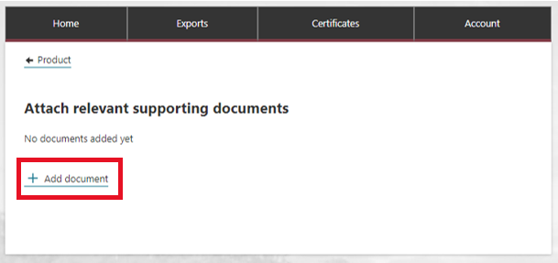
21. | The Attach document screen will display.  Type a description and attach the relevant file from your computer.  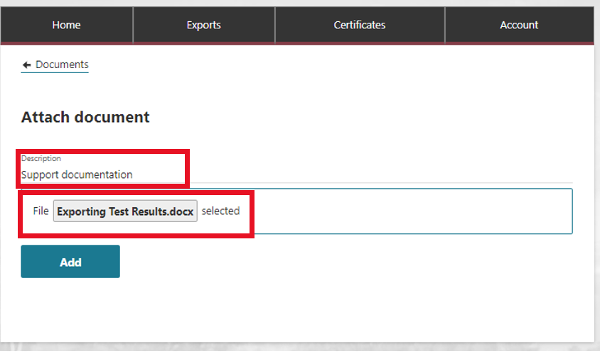
22. | Select ‘Add’.  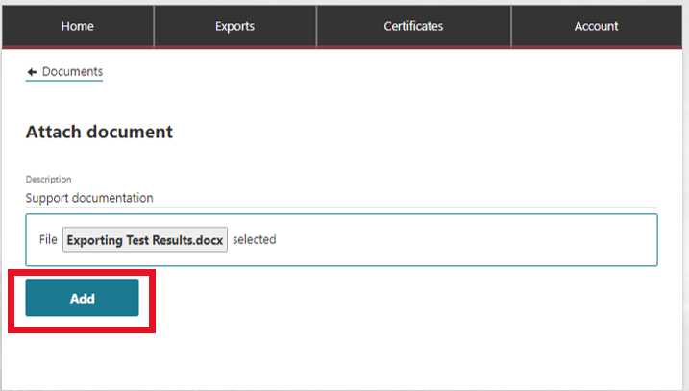
23. | The Attach relevant supporting documents will display.  Select ‘Product’ to go back.  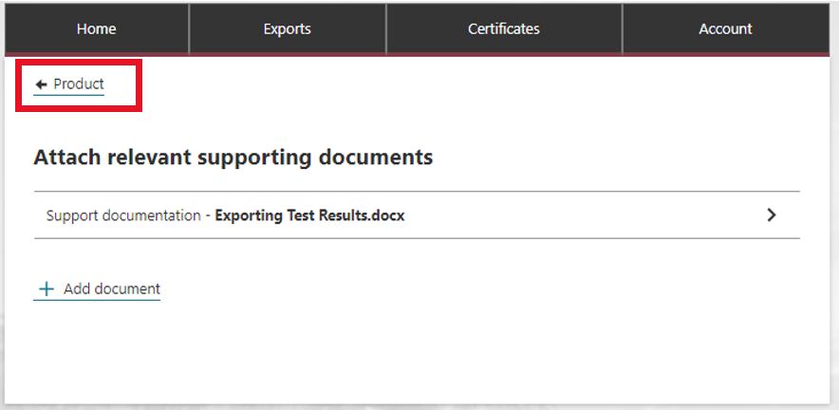
24. | The Product for export screen will display.  Select the ‘SEW’ tab.  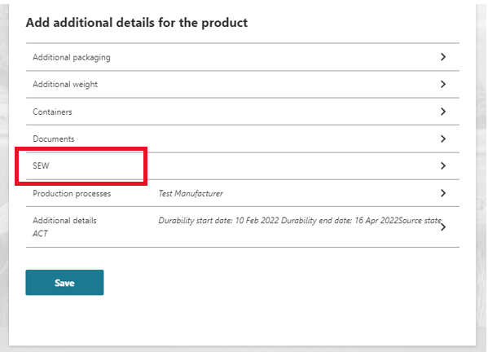
25. | The SEW information screen will display.  Complete required fields and select ‘Save’.  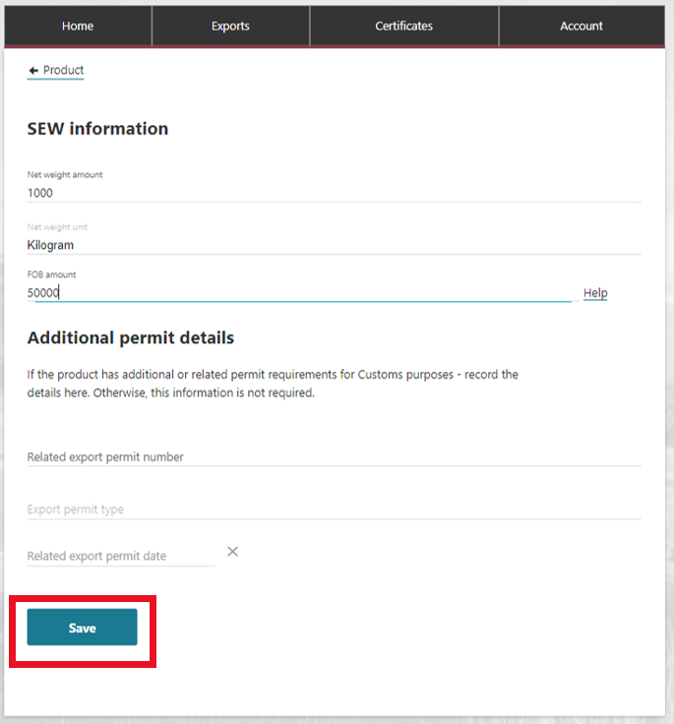
26. | The Product for export screen will display.  Select the ‘Production processes’ tab.  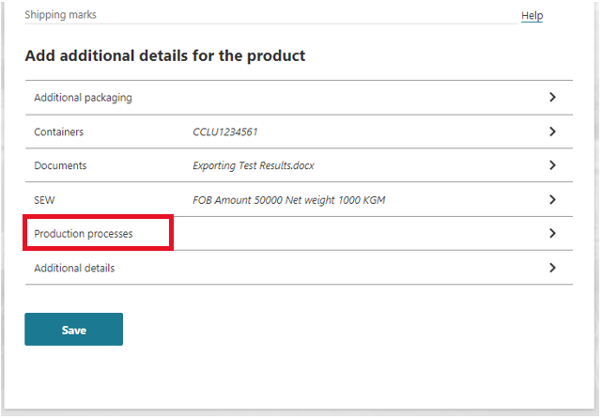
27. | The Processing Establishment Details screen will display.  Select ‘Add Production process’.  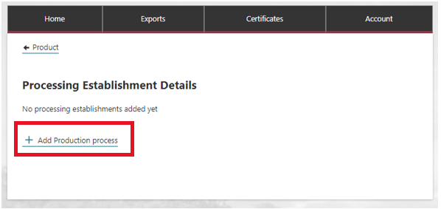
28. | The Add Production processes screen will display.  Complete the required fields at select ‘Add’.  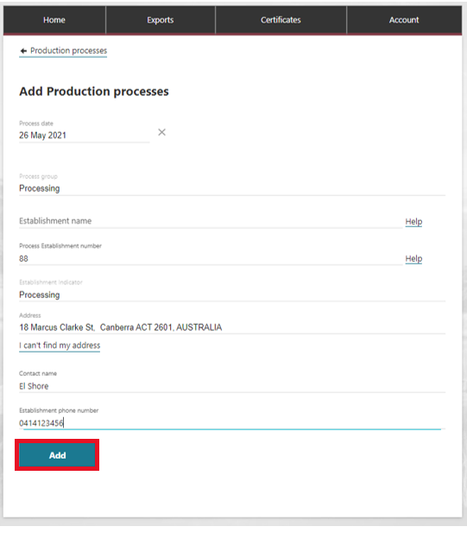
29. | The Processing Establishment Details screen will display.  Select ‘Product’ to go back.  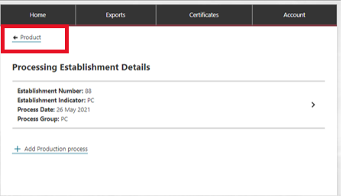
30. | The Product for export screen will display.  Select the ‘Additional details’ tab.  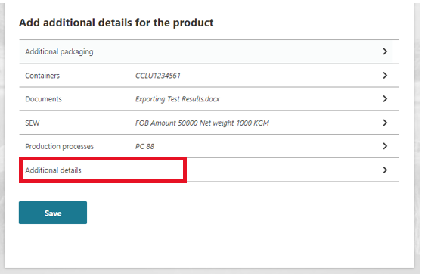
31. | The Additional details screen will display.  Complete the required fields and select ‘Save’.  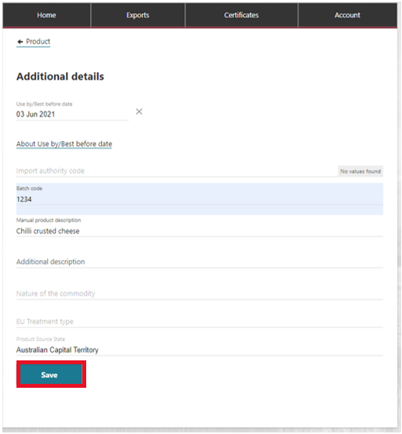
32. | The Product for export screen will display.  Select ‘Save’.  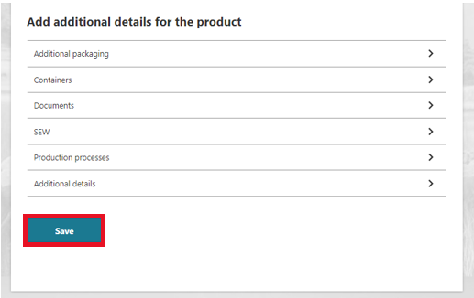
33. | This will take you back to the Products for export page.  If you have more than one product repeat steps 8-33.
34. | Select ‘Next’.  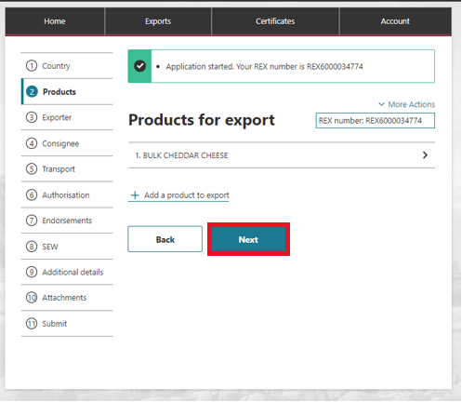
35. | The Exporter details screen will display.  At the top of this page, you will see your exporter details that are linked to your account.  Confirm details are correct and edit where required.  NOTE: If certain details are amended, this will generate a task to be approved by the department.  Select ‘Save and Next’.  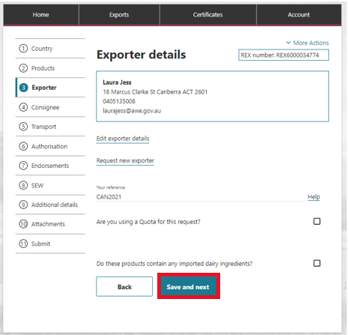
36. | The Consignee screen will display.  You can select Your consignee address book link at the top of the screen to select a consignee from your account or fill in the required fields.  Select ‘Save and Next’.  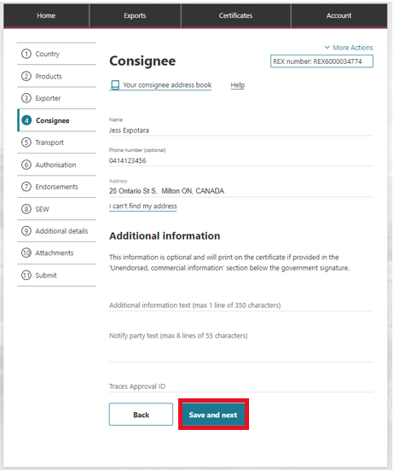
37. | The Transport screen will display.  Fill in required fields.  Select ‘Save and Next’.  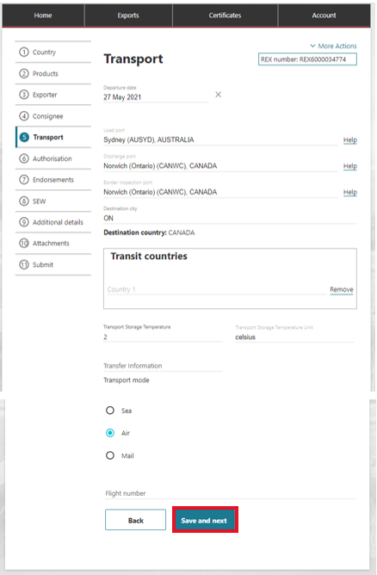
38. | The Authorisation screen will display.  Fill in required fields.  Select ‘Save and Next’.  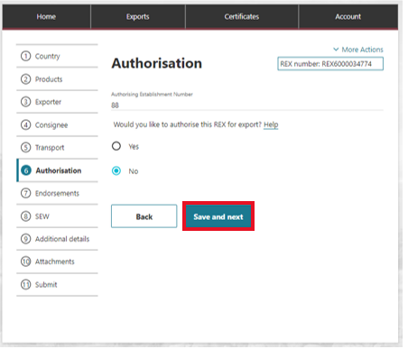  Note:  If you select No, the department will review your REX for authorisation. Select Save and next.  If you select Yes, the below fields will display. You must insert an Authorisation Date for the REX to be authorised.  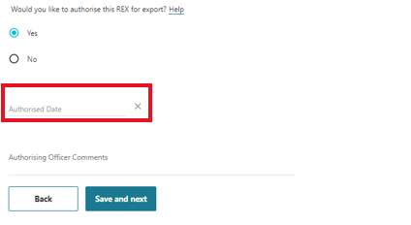  This date must be before or equal to today’s date. If you do not wish to authorise the REX yet, leave it blank. You can amend your REX and input the Authorisation Date after submitting. Select Save and next.
39. | The Endorsement screen will display.  If you need to update or amend the template or endorsement:  Select the product link.  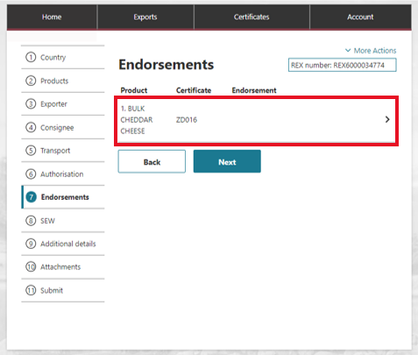
40. | Update fields as required.  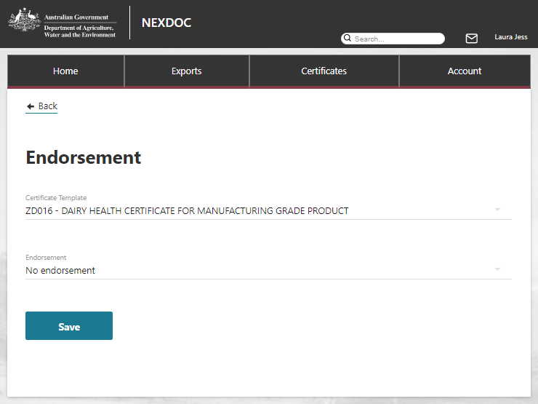
41. | Select ‘Save’.  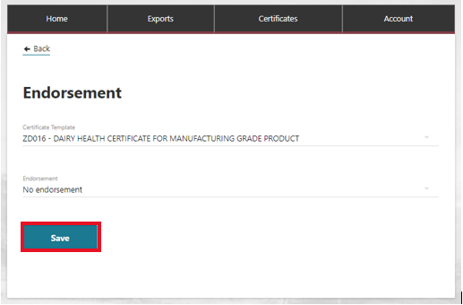
42. | Select ‘Next’.  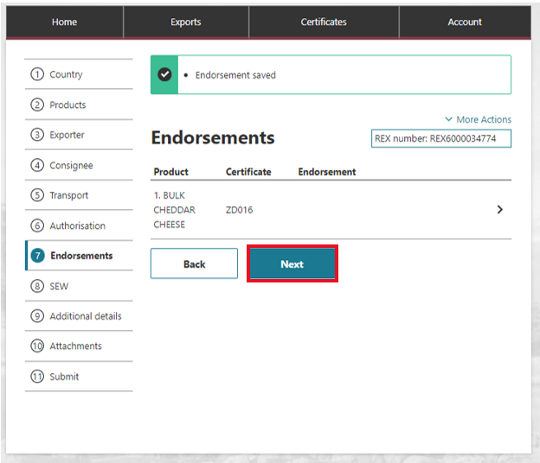
43. | The SEW Integration screen will display.  Fill in required fields.  Select ‘Save and Next’.  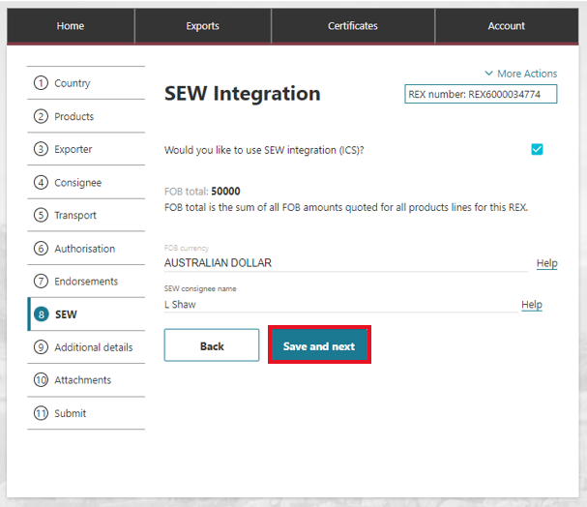
44. | The Additional details screen will display.  Fill in required fields.  Select ‘Save and Next’.  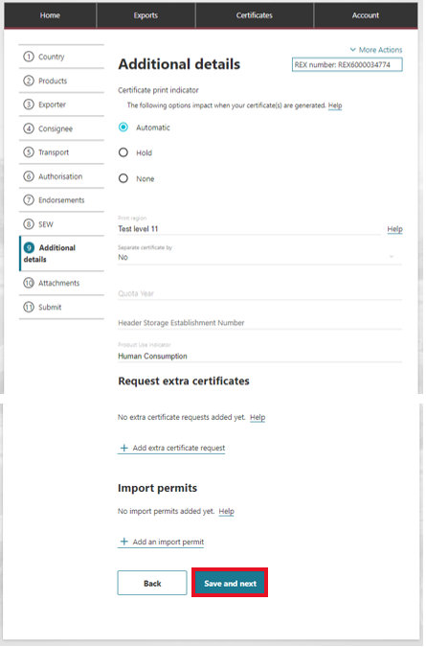  Note: For more information about your print indicator, please view the NEXDOC Printing FAQ on the NEXDOC help page.
45. | The Attachments screen will display.  Select Add attachment.  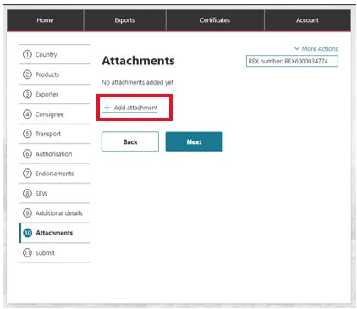
46. | Select or drag and drop the required attachment.  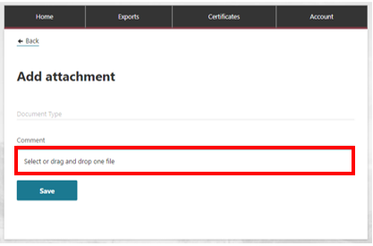
47. | Select ‘Save’.  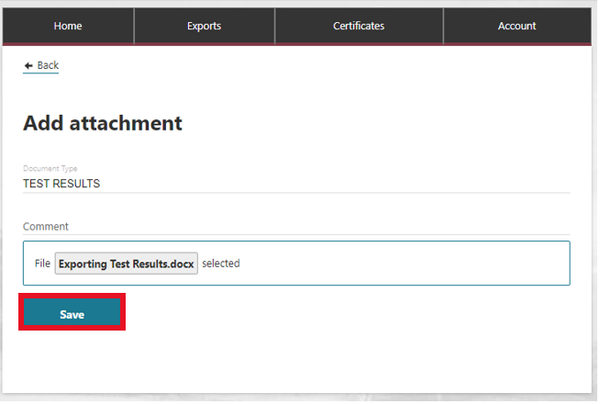
48. | Select ‘Next’.  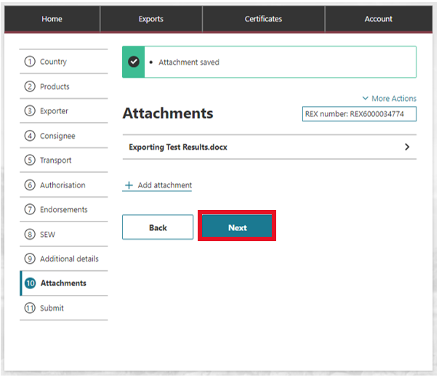
49. | The Declaration screen will display.  Read the declaration.  If you agree, select I agree.  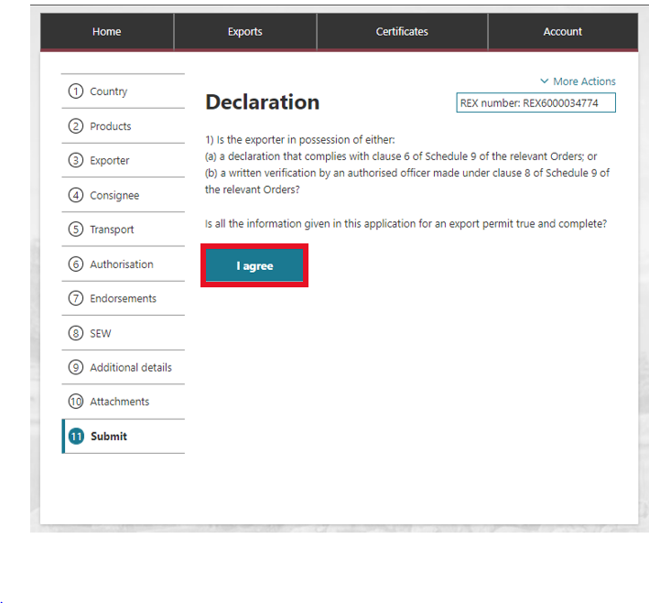
50. | The Lodge REX screen will display.  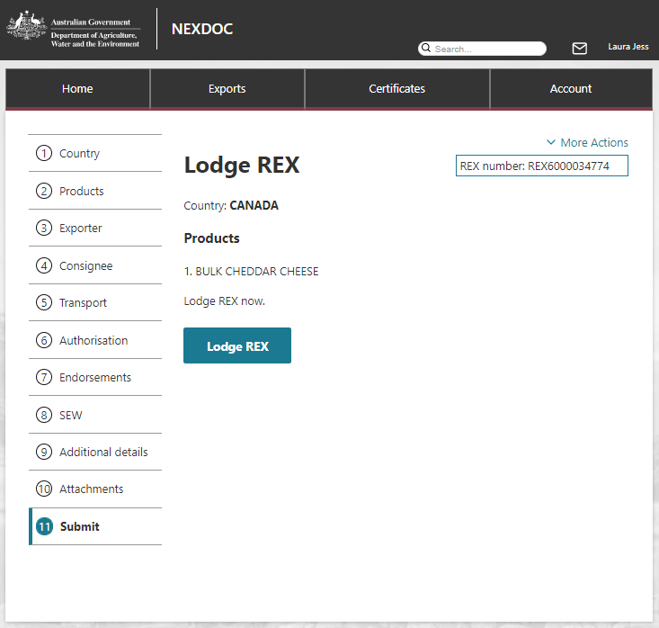
51. | Review details displayed.  If you confirm, select Lodge REX to submit your application.  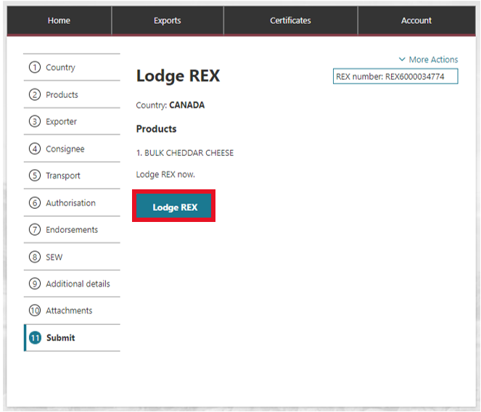
52. | You can save and edit your REX until you submit it for approval.  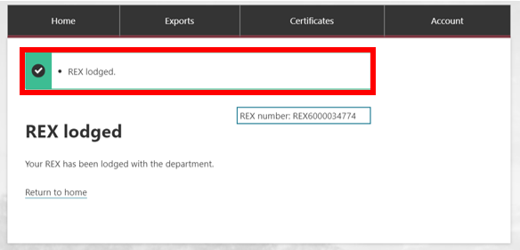
 | End of process.

