USER GUIDE

NEXDOC
How to obtain web service token in the NEXDOC portal

__________________________________________________________________________________
In this document
This document contains the following topics.
Purpose of this document 2
How to obtain a web service token in the NEXDOC portal 2
How to view a web service token in the NEXDOC portal 5
Contact the NEXDOC help desk. 8

Purpose of this document
The purpose of this document is to provide guidance on how to obtain a web service token in the NEXDOC portal.

How to obtain a web service token in the NEXDOC portal
Step 1  Log in to the Online services portal | 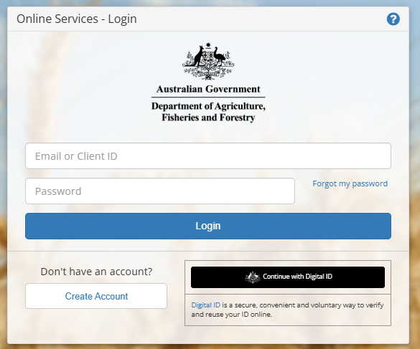
Step 2  Select Connect to a new service | 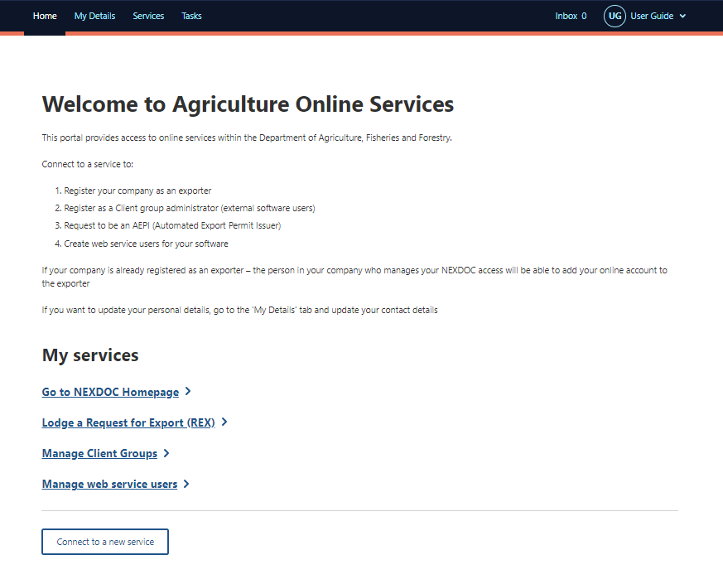
Step 3  Select Create web service users for your software installations tab. | 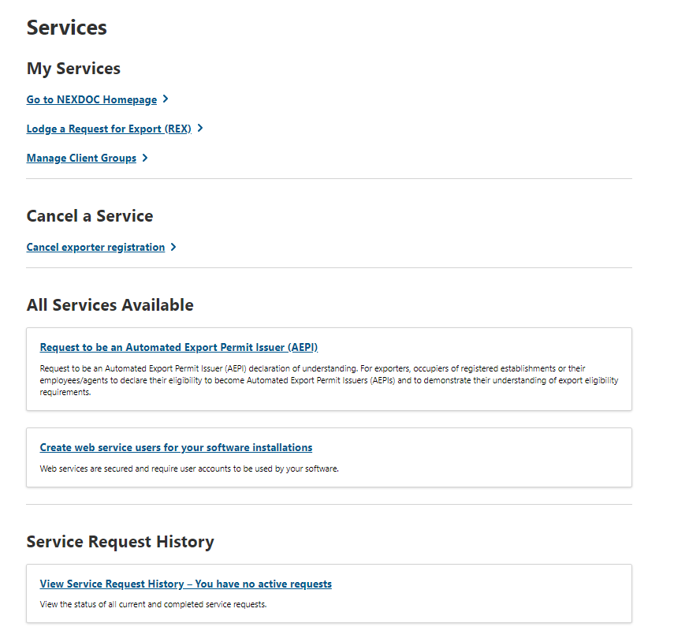
Step 4  Type the reason for your request in the Reason field | 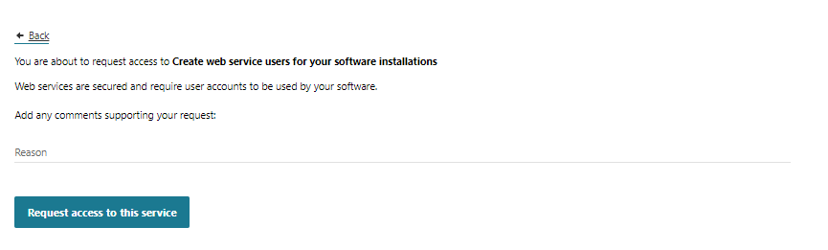
Step 5  Select Request access to this service | 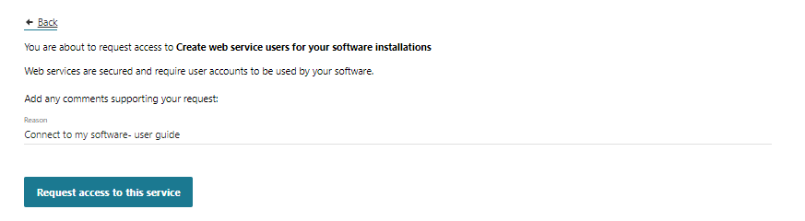
Step 6  Once submitted a confirmation will display. | 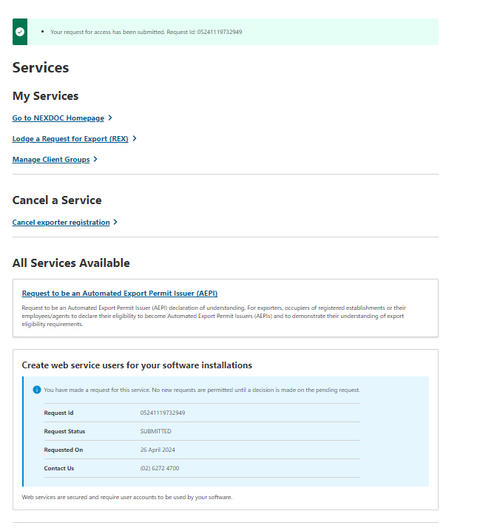
The request is now with the Department for review.

How to view a web service token in the NEXDOC portal
Step 1  An alert will be sent to your NEXDOC inbox once a decision has been made on your request  The message states Register as a software installation administrator is approved. | 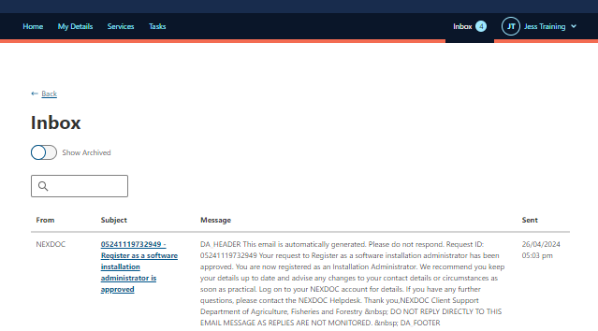
You will need to wait 10minutes for your software installation access to become available on your homepage.
Step 2  Log out of the Online Services Portal | 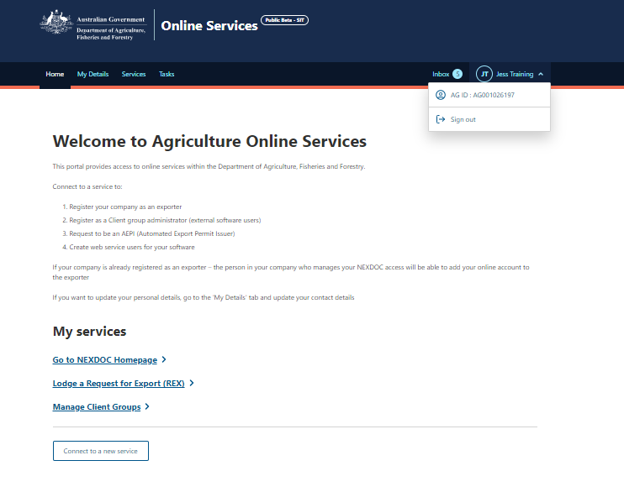
Step 3  Log into the Online Services Portal | 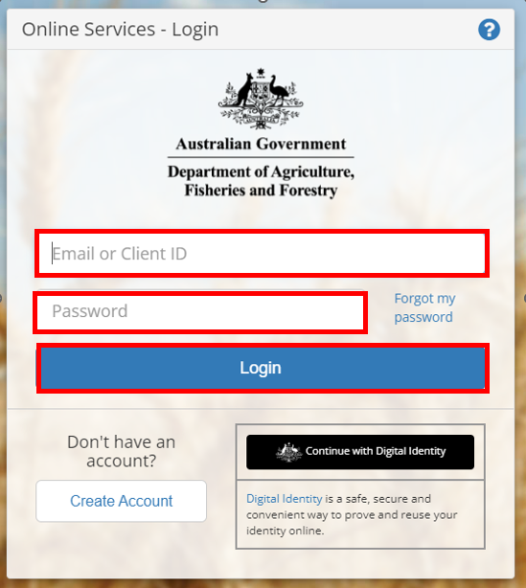
Step 4  Select Manage web services users | 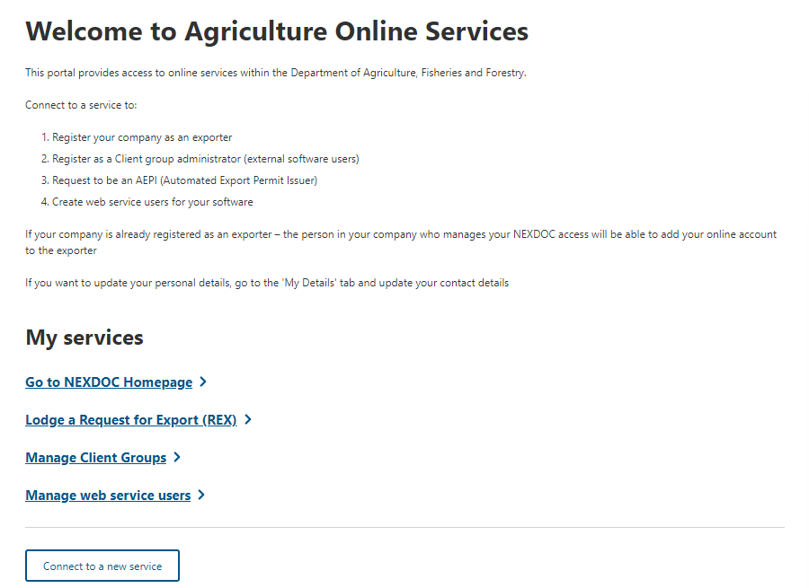
Step 5  Select + Create a new token | 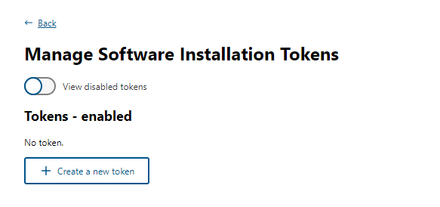
Step 6  Type in the Token Description field the software provider.  Type a password in the Set Password field. | 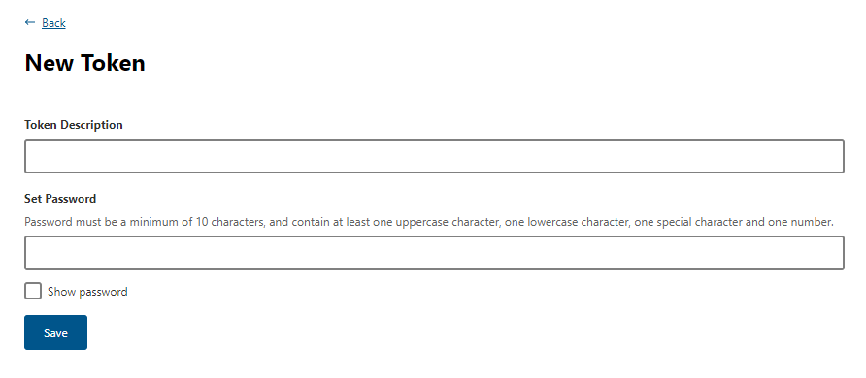
Step 7  Select Save | 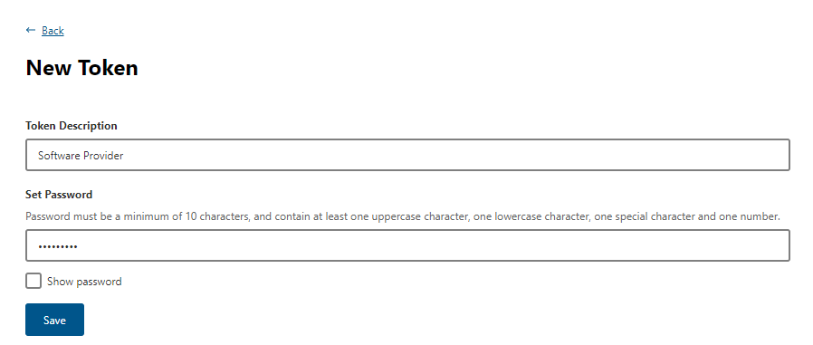
Step 8  A confirmation message will display with the token ID. | 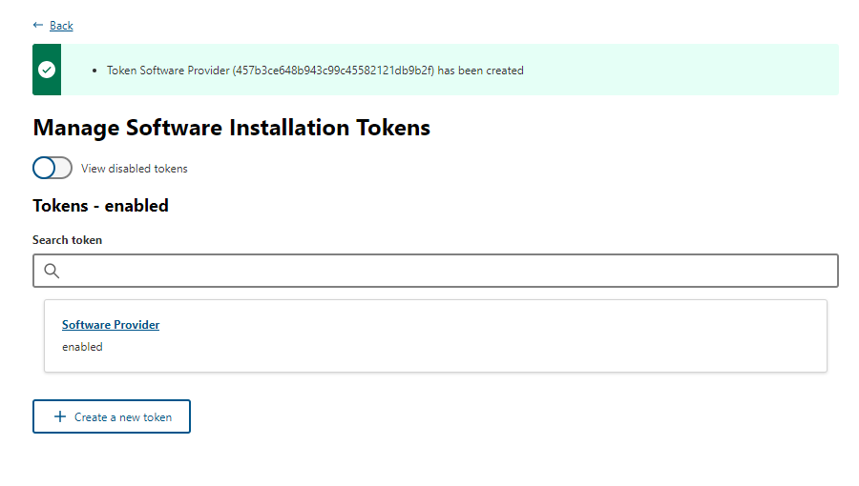
Step 9
Select the Software Provider tab.

Step 10  The exporters software token is found in the Installation Token field. | 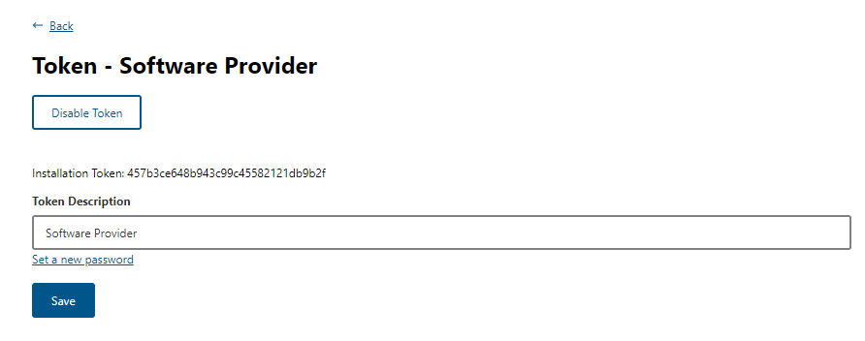

Contact the NEXDOC help desk.
For more information or assistance, please contact NEXDOC@aff.gov.au

