USER GUIDE

NEXDOC:
How to register as a Client Group

__________________________________________________________________________________
In this document
This document contains the following topics.
Purpose of this document 2
Register for Online Services portal 2
Apply to register as a client group administrator 6
Contact the NEXDOC help desk 13

Purpose of this document
The below information will guide you through how to create your NEXDOC exporter account.
Applying to be an exporter in the NEXDOC system is a two-step process.

Register for Online Services portal
If you’re not registered in the Agriculture Online Services Portal, you will need to create an account.
You can create an account two ways:
- with a Digital ID - an electronic authentication tool used by the Australian Government for organisations seeking to access a number of Government online services.
- Directly with the department.
To register directly with the department for the below.
Step 1  Log in to the Online services portal  Select Create Account | 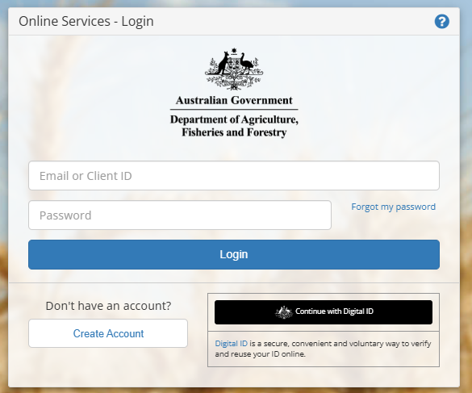
Step 2  Enter your email address | 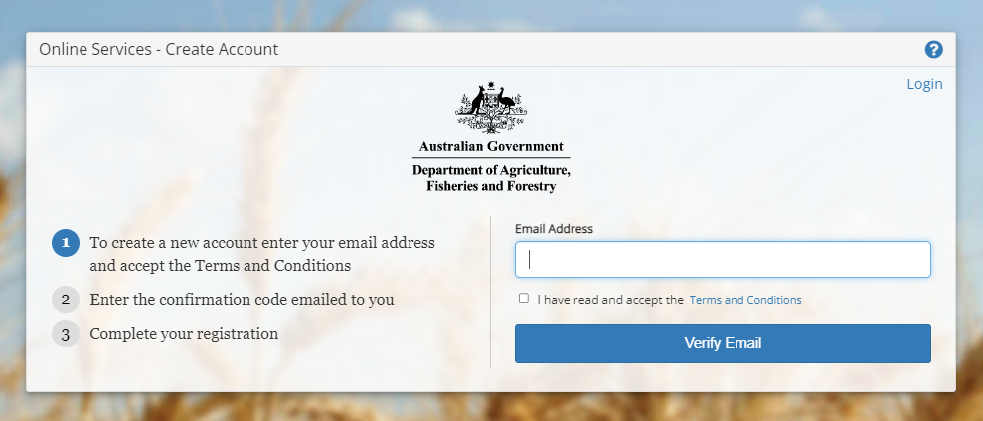
Step 3  Read the terms and conditions and if agreed, select the tick box.  Select Verify Email | 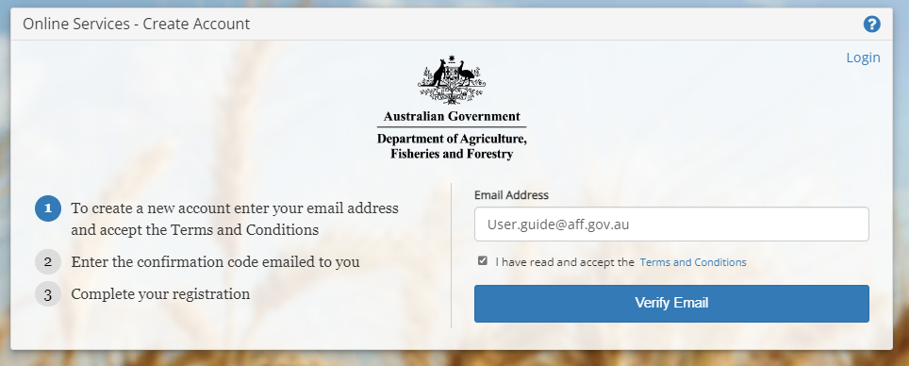
Step 4  A confirmation code has been sent to your email.  Type the confirmation code into the into the box. | 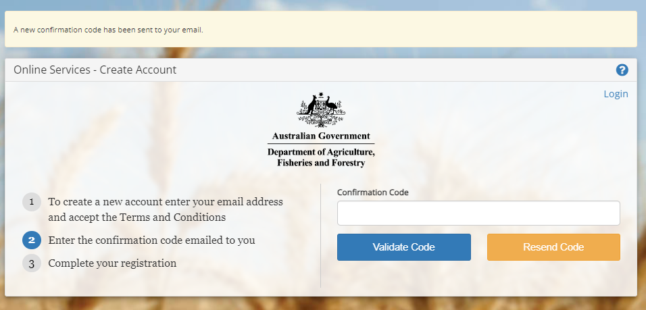
Step 5
Select Validate Code

Step 6  Type in your password.  Retype the same Password. | 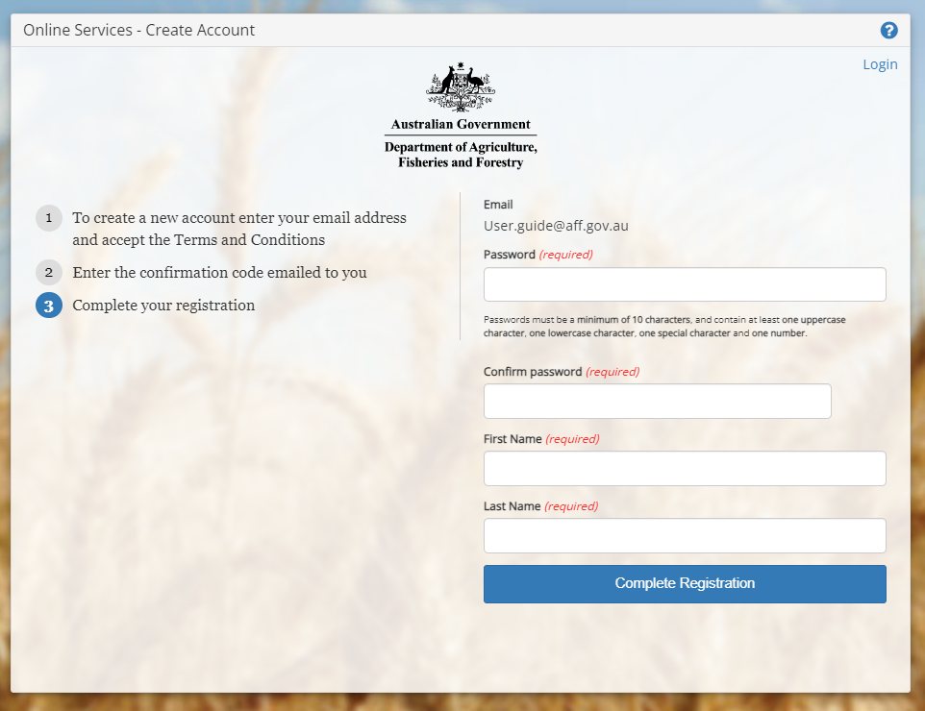
Step 7
Retype the same Password in Step 6.

Step 8
Type your first name

Step 9
Type your Last name

Step 10
Select Complete Registration

Apply to register as a client group administrator
Once you’ve logged into Online services, you will need to connect to NEXDOC.

Step 1  Select Connect to a service | 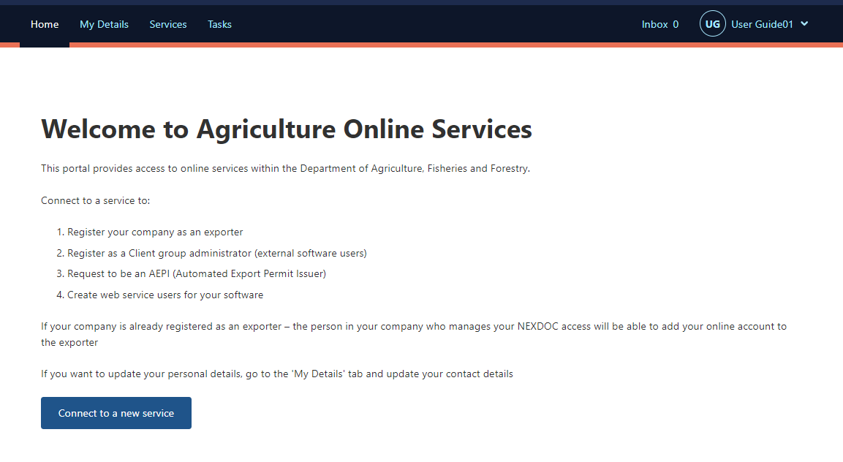
Step 2  Select Client Group Administrator for External Software Users. | 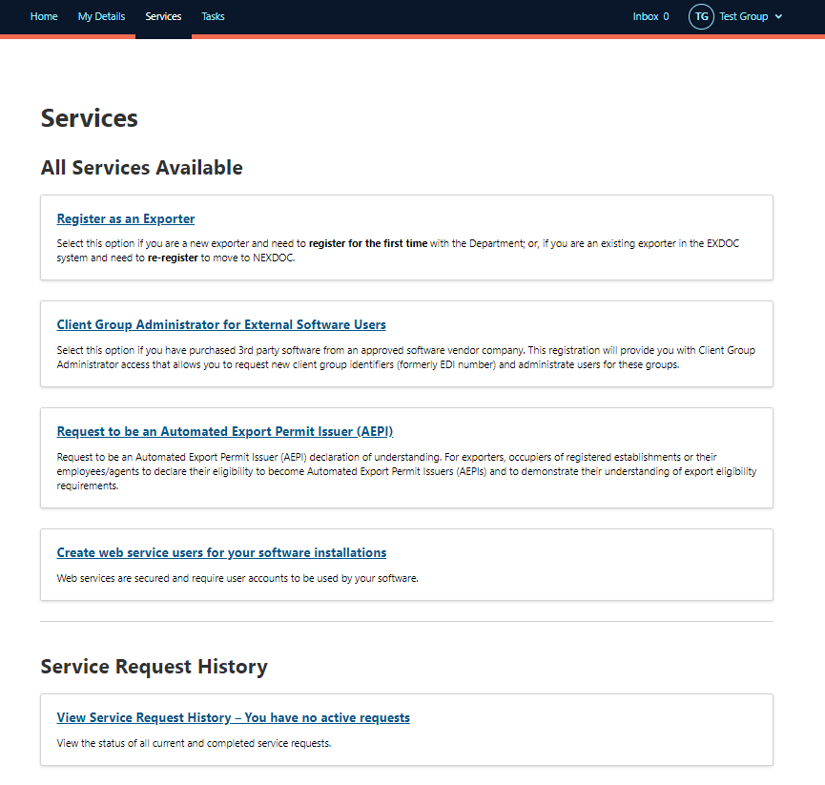
Step 3  Enter the name and contact details of the organisation.  - Exporter/ company ABN  - Company name  Please note that the ‘Company Name’ is the name of the export business.  - Company email  - Company phone number  - Company physical address  - Exporter number  Most of the above details will appear on documentation. | 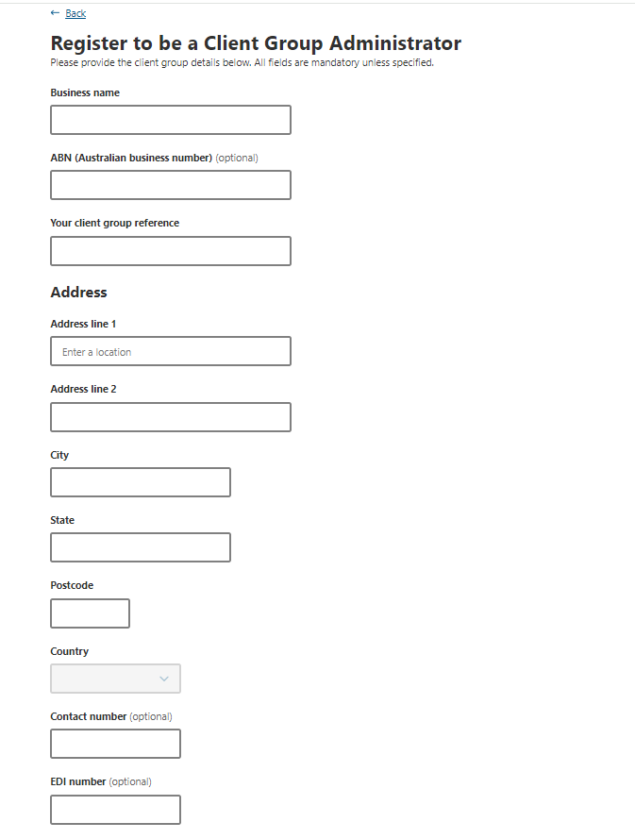
Step 4  Select the commodity/ies your business will export.  When certain commodities are selected you may be given an option to share your export data with relevant industry bodies.  This is an optional tick box. | 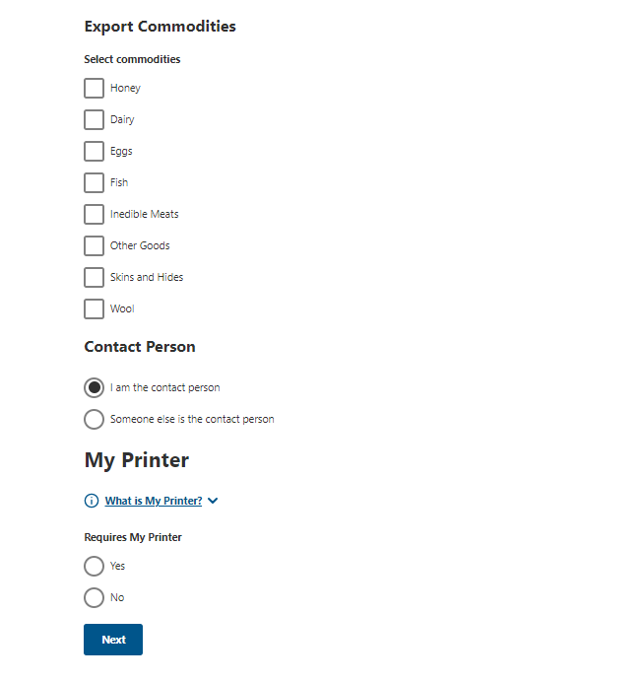
Step 5  The system will default for you to be the contact person.  If this is correct select Save and next.  Proceed to My Printer section. | 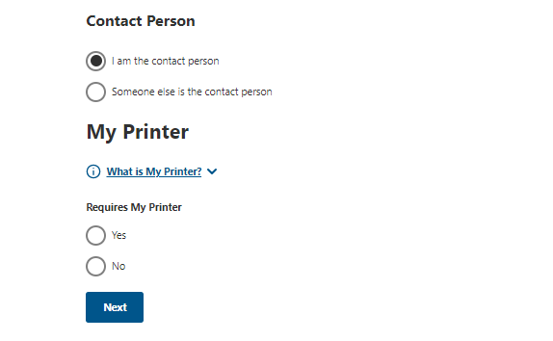
Step 5a  If you are not the best contact, you will need to:  - enter the email or Client ID of the contact person  - select ‘Search for existing client’.  NEXDOC will search our records for an existing client record. | 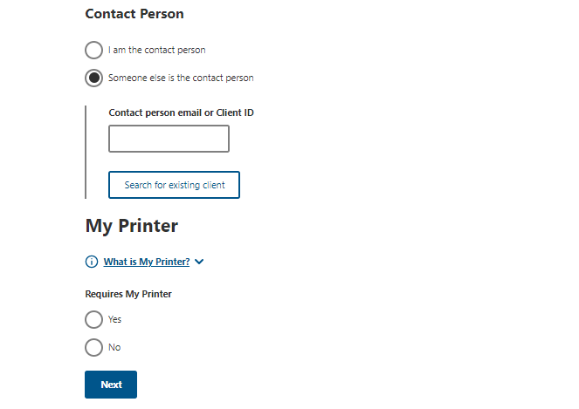
Step 5b  If the client record is found, you can select from two options:  use this existing client as the contact person. Selecting this option will use the contact details stored on NEXDOC for this person. | 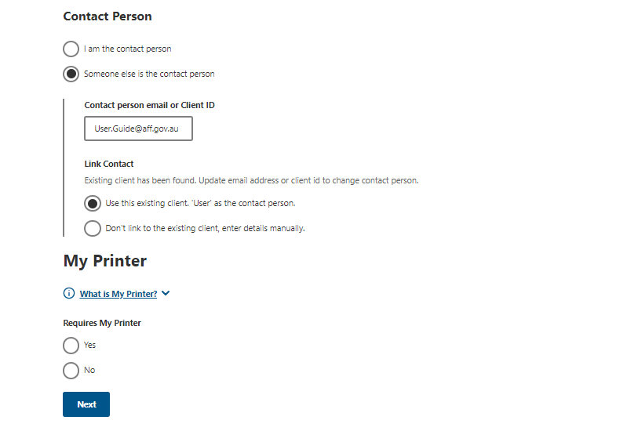
don’t link the existing client, enter details manually. Select this option to manually insert the contact details. | 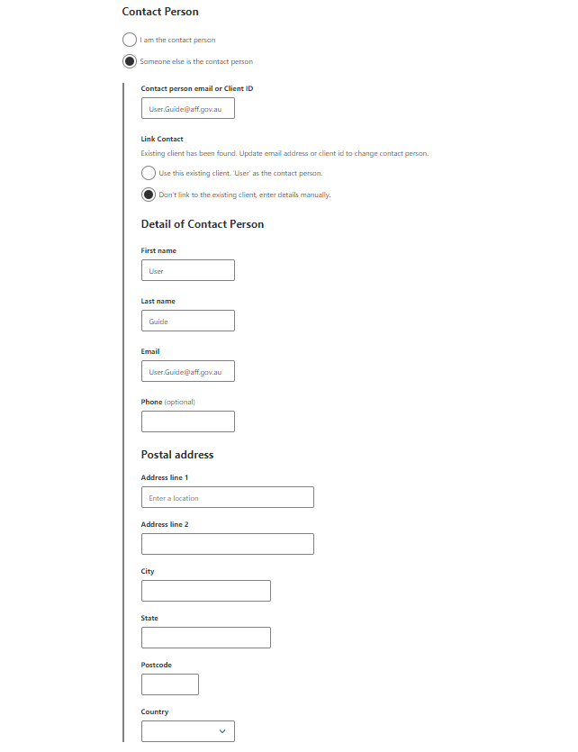
Step 6  You can request to use My Printer to print your certificates outside of the department’s offices.  To enable remote print in your office, select Yes and proceed to Step 2.  If you select No, then select Next. | 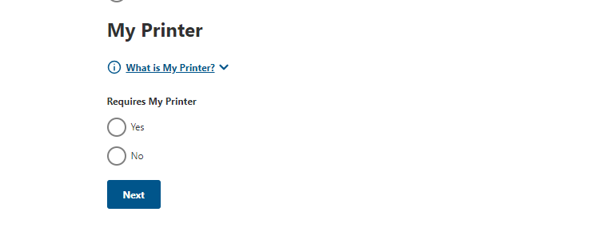
Step 7  Tick the box of which commodity/ies you would like to enable remote print for.  Select Next.  Your request for My Printer permissions will then be sent to the department for decision. | 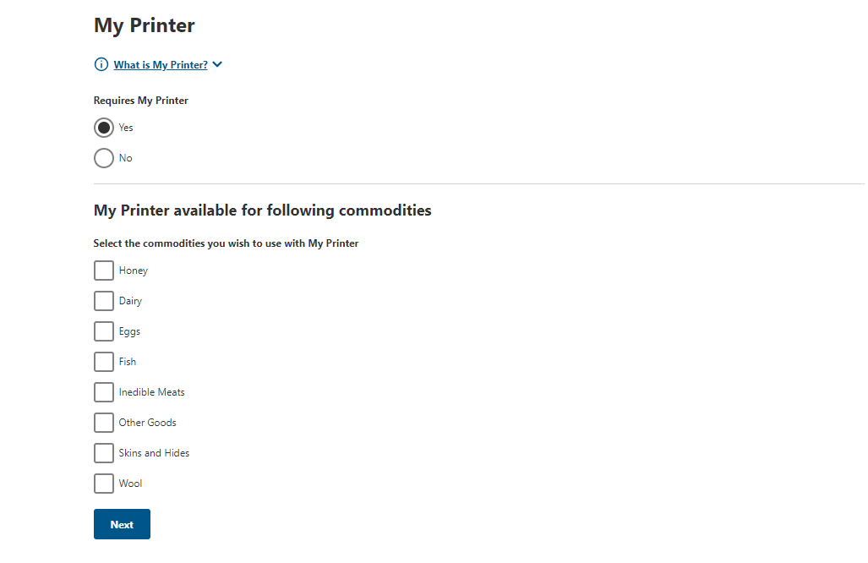
Step 8  Read the declaration and privacy notice.  If you agree, tick the box next to I agree.  Select Submit. | 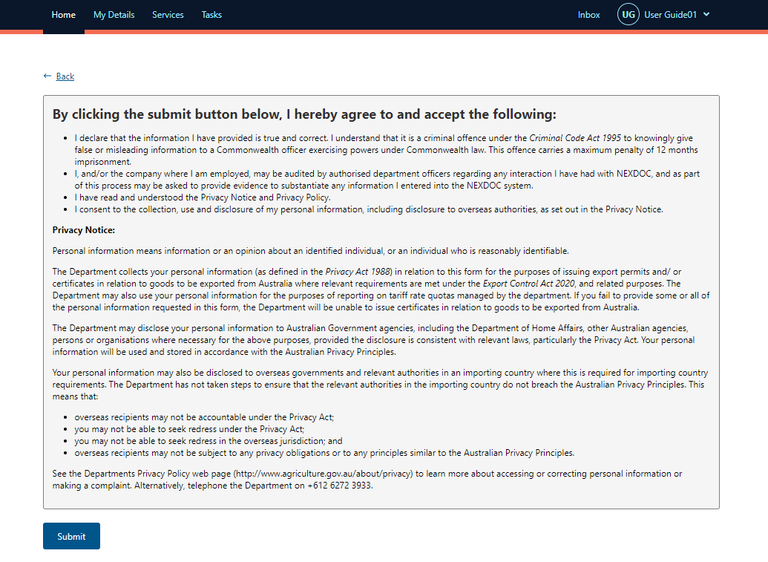
The department will review your application. Once your application has been assessed you will be notified of the decision through the NEXDOC inbox within the NEXDOC portal. | 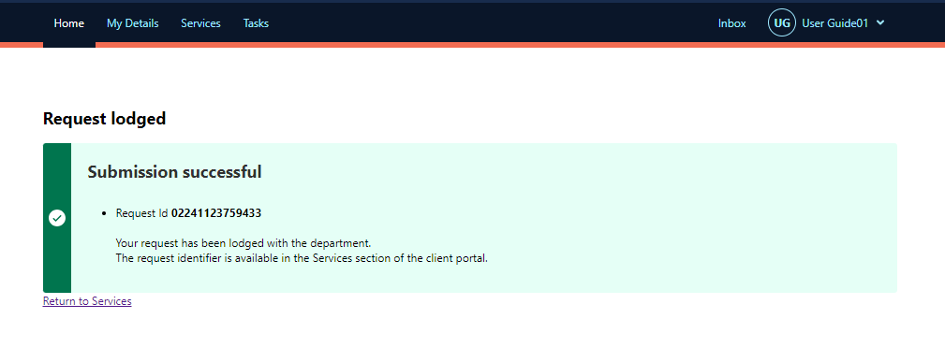

Contact the NEXDOC help desk
For more information or assistance, please contact NEXDOC@aff.gov.au

