How do I Check the Payment Status of my Lodgement?

This task card demonstrates how to check the payment status of your lodgement in the Cargo Online Lodgement System (COLS).

Check Payment Status

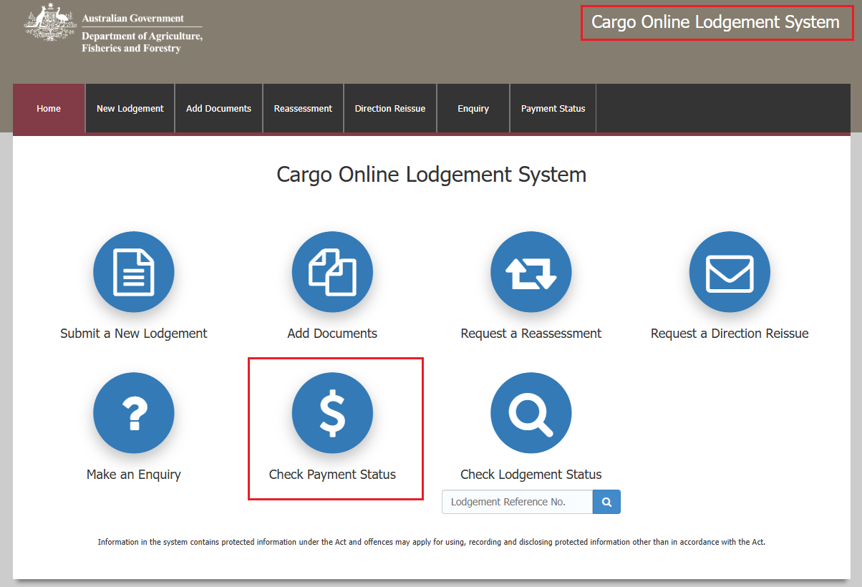Go to **COLS** and select the **Check Payment Status** icon.

Enquiry screen

You will be redirected to the departments **Online Payments** system**.**

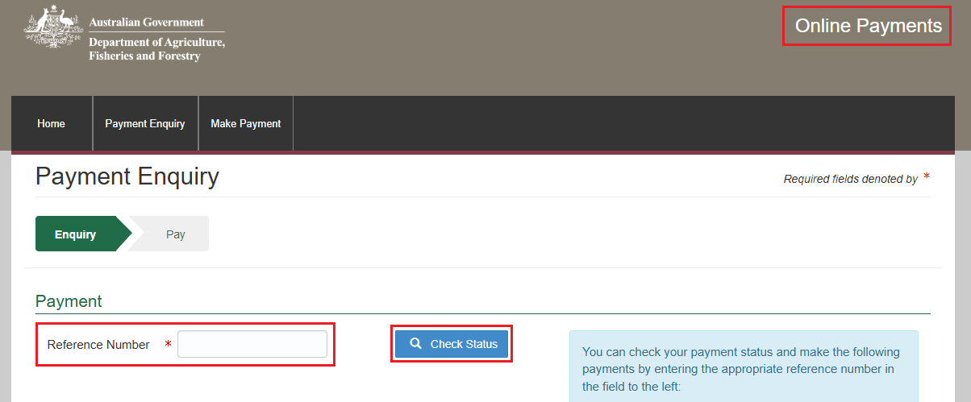Enter your invoice number into the **Reference Number** fieldand select **Check Status.**

Invoice status

Here you will be able to see your **Payment Status**.

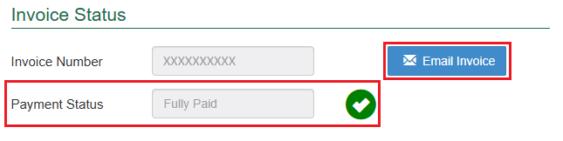You can click on the **Email Invoice** buttonto send an email to the nominated recipient.

Once the email has been sent, the following notification will appear on your screen.

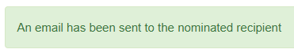

*NOTE: Please allow two hours to receive copies of invoices, statements and receipts as they do not get transmissted instantly upon request.*