Hydrological impacts of water management arrangements on low flows in the Barwon Darling River system

Advice to the Commonwealth Environmental Water Office
Dr Paul Carlile (Oct 2017)
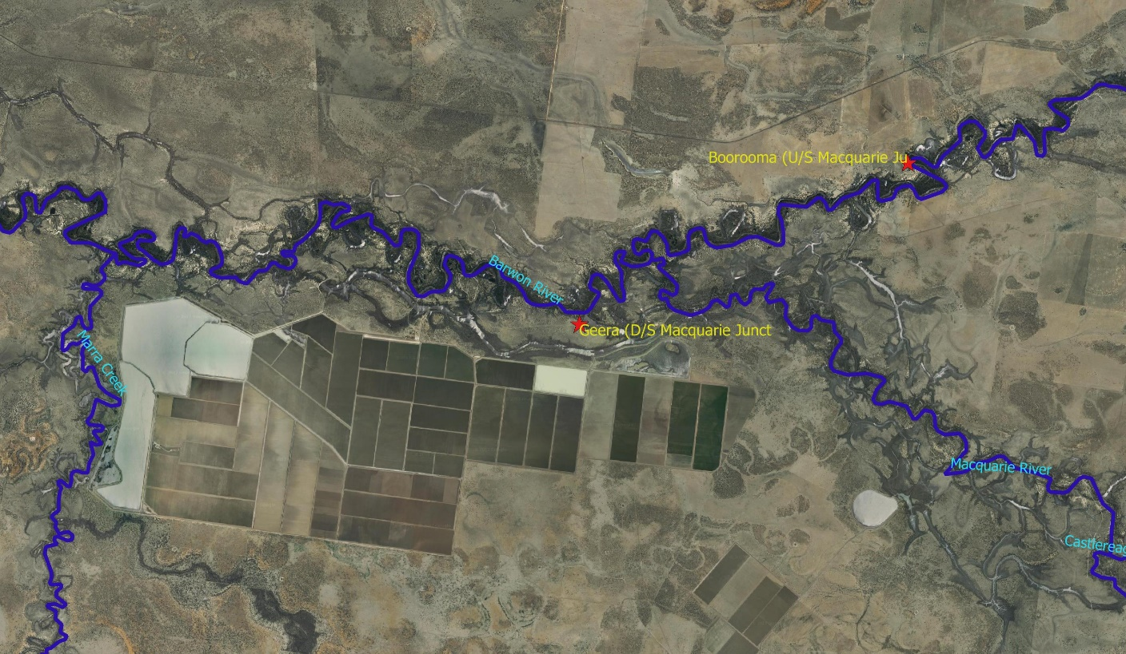

Disclaimer

The views and opinions expressed in this report do not necessarily represent the views of the Commonwealth Environmental Water Office (CEWO). This publication does not indicate commitment by Commonwealth government to a particular course of action nor has the CEWO made any decision on options identified in this study.

The CEWO reserves the right to, in the future, further consider any of the options proposed in the report or options in addition to those identified.

The content of this report does not constitute advice to any third party. Although due care and skill has been applied in the preparation and compilation of the information and data in this publication, no reliance may be placed on it by any other party. No representation expressed or implied is made as to the currency, accuracy, reliability, completeness or fitness for purpose of the information contained in this publication. Readers should rely on their own inquiries to independently confirm any information and comment on which they may intend to act.

The Commonwealth of Australia, its officers, employees, agents and the other parties involved in creating this report disclaim, to the maximum extent permitted by law, responsibility to any other party for any liability, including liability for negligence, loss howsoever caused, damage, injury, expense or cost incurred by any person as a result of accessing, using or relying upon any of the information or data in the report.

The Department acknowledges the traditional owners of country throughout Australia and their continuing connection to land, sea and community. We pay our respects to them and their cultures and to their elders both past and present.

Contents
1 Background 11
2 Environmental water purchased in Northern Basin 12
3 Hydrological analysis of Barwon Darling flows to characterise consumptive extractions by Management zone 12
3.1 Methodology and assumptions used in the analysis 12
3.2 Results 13
3.2.1 Times when there is access to Low Flow, A, B and C Class entitlements 13
3.2.2 Estimating Reduction in flow and uncertainty 17
3.2.3 Reduction in flow results 19
3.2.4 Examples of flow events showing significant attenuation 24
3.3 Limitations of the methodology and analysis undertaken 26
3.4 Key MDBA Results 26
3.4.1 Hydrological analysis of achievement of Environmental Flow Indicators 26
3.4.2 Dry Spell Analysis 27
3.4.3 MDBA examples of unexplained flow attenuation 29
3.4.4 Event Peak Analysis 29
4 References 31
Appendix A – % Days there was access to various entitlement classes under the WSP 32
Appendix B – Flow Classes for the Barwon Darling from the 2012 WSP 33
Appendix C - Relevant Clauses of the Current Barwon Darling WSP 2012 45
Clause 26, 27, 28 45
Clause 42 45
Clause 45 45
Clause 46 46
Clause 52 46
Appendix D – 80th Percentile flows under modelled without development vs gauge data from 1990-2017 48

Exec Summary
This report examines the hydrological impacts of water management arrangements on low flows. More specifically, historical hydrological flow gauge data available from January 1990 to September 2017 was examined in an attempt to characterise the impacts of extractions on daily flow rates, particularly low flow events within and between river sections from Mungindi to Menindee. This project is Stage two of a three stage process. Stage one being “Characterise the ecological value of low flows” and Stage three being “Characterise the effects of take during low flows on the ecology of the Barwon-Darling”. Of particular interest was the impact since the introduction of the 2012 Barwon Darling Water Sharing Plan (WSP).
There has been suggestions by some that the 2012 WSP provides less protection to low flows. Work by the MDBA “suggests that rule changes in recent years may have reduced the protection of low flows, but this reduction will not be reflected in the Northern Basin Review modelling results. The Authority have therefore recommended (as part of the ‘toolkit’) improvements to state water management arrangements to safeguard low flows across the North (MDBA 2016).”
The Author agrees that both the current 2012 WSP for the Barwon Darling and the previous draft plan both contained rules that will be ineffective in protecting low flow events. The rules that have been developed are based on a IQQM model that has great difficultly replicating actual diversions and stream flows due to the nature of the catchment and inadequate river gauging at inflow points.
To determine if low flows have been more heavily impacted since the introduction of the 2012 Barwon Darling Water Sharing Plan an attempt was made to estimate extractions associated with the various classes of entitlement available in the Barwon Darling (i.e. Low Flow, A, B and C-Class entitlements). In the analysis undertaken low flows ecologically coincide with flows associated with the Low Flow and A-Class entitlement flow access rules.
In summary, the process used to estimate extractions in this project based on daily river flow data was as follows:
- Gather together the available historical flow data at stream gauges relevant to the various Management zones in the 2012 Barwon Darling WSP including inflow data.
- In each Management zone (Appendix B) determine times when access would be permitted for Low Flow, A, B and C Class entitlements.
- Adjust the downstream flow to allow for travel time.
- Based on daily differences in flows at the upstream (plus any gauged inflows) and downstream gauges determine the average daily and aggregated volume reduction in flow between the upstream and downstream gauge during Low Flow, A, B and C Class access times.
- Using some assumptions for transmission losses estimate daily extraction during Low Flow, A, B and C Class access times.
Due to some uncertainties (described below) Step 5 above was not completed (i.e. estimate daily extraction), however reductions in flow from upstream to downstream within each NSW Management zone were estimated. This was then adjusted by the length of the river in each zone to give the percent reduction in flow per km of river in each management zone. This was so a 40% loss in a zone 200 km long did not have the same weighting as a 40% loss in a zone 50km long. From this and analysis by the MDBA, some interesting patterns emerged. These were:
- 80 Percentile flows generally regarded as low flows essential for river ecology (Source: Sheldon, 2017) have been reduced by more than 70% across most sections of the Barwon Darling. An average of 74% lost from 1990-2017 and 70% from 2012-2017 (Appendix D).
- The percentage of days with extremely low flows (flows associated with Low Flow entitlement flow access) moving from upstream to downstream largely followed the climatic pattern. The greatest access to extremely low flows were observed during the period including the Millennium drought (2000-2012). This was followed by the period since the introduction of the 2012 Barwon Darling WSP (2012-2017), while the period with the lowest percentage of days with extremely low flow were observed during the 1990’s (1990-2000) which was an extremely wet period (Figure 3).
- This is in contrast to the percentage of days that allowed A-Class entitlement flow access which was highest in the period 1990-2000, followed by the period 2012-2017. The Millenium drought (2000-2012) saw the lowest percentage of days with access to A-Class entitlement (Figure 4).
- Low flow reductions increased significantly post 2012 compared to the pre-2012 period in NSW management zones Mungindi to Presbury, between Mogil and Tara and between Warraweena and Bourke, This analysis excluded periods of gains from upstream to downstream to overcome the problem of ungauged inflows and adjusted the percent reduction in flows by dividing by the length of the river (km) for each zone. (Figure 13 and 14).
- Management zones between Mungindi and Collarenebri followed by Collarenbri to Tara and Warraweena to Bourke have the largest relative reductions in low flows when the length of the river in each zone is considered. (Figure 12).
- Generally, there were lower percent reductions in flow at higher flows compared to lower flows. This may be indicative of a higher capacity to capture low flows and or higher transmission losses at lower flows as waterholes are filled etc..
- Many high reductions in flow occurred both pre and post flow events and between events and there were significantly higher reductions in low flows in summer compared to winter (Figure 11).
- Particular hydrographs displaying significant reduction in flow (attenuation) between upstream and downstream flow gauges that could not be explained by transmission losses alone were identified (Section 3.2.4). In some cases, this would be because the first flow event in a while is more likely to be heavily extracted and this corresponds to when irrigators would have empty storage. Also there is a greater ability for irrigators to capture low flows completely.

- Most low flow environmental flow indicators for the Barwon Darling are not achieved for the period from 1990-2017 (Section 3.4.1). This is particularly true for low flow events required almost every year, or twice a year.
- Average dry spell length increases as you move from upstream to downstream, while the percent of days that are dry is highest at Mungindi and Wilcannia and lowest at Geera downstream of Macquarie confluence.
Despite these findings the analysis carried out was unable to characterise extractions due to significant uncertainties. Uncertainties with the estimates of reduction in flow meant that it would have been unwise to then compound this uncertainty with assumptions of transmission losses to estimate extraction in a rapid, narrow scope project such as this. The main sources of this uncertainty were:
- There are too many ungauged inflows (Table 1) and unaccounted gains when comparing upstream and downstream daily gauge data
- Travel time varied with not just flow rate but also antecedent moisture condition making adjustments for travel time difficult and daily reduction in flow estimates less reliable. (Easier on regulated rivers like the Murray – always wet)
- Loss rates within zones vary dramatically. No two flow events are the same. No standard transmission loss based on flow rate. Multiple factors sum to flow reduction (re-filling of waterholes, re-connection to aquifers, diversions – some which may be unmetered) that vary along the river and through time.
These uncertainties associated with data would also be reflected in hydrological models. The IQQM model may be useful as a hydrological model for some river systems as a long term planning tool, but the Author considers its ability to estimate flows and extractions on a short term basis, particularly at low flows questionable. As already mentioned the MDBA “suggests that rule changes in recent years may have reduced the protection of low flows, but this reduction will not be reflected in the Northern Basin Review modelling results” (MDBA, 2016). This also raises the question as to whether they are suitable to determine compliance with the SDL or the Cap. The CSIRO sustainable yields project also noted the following regarding the Barwon Darling IQQM model – “While the model is well suited for the purpose of this project, it is noted that changes in low flows are not simulated well by the model” CSIRO (2008).

The best way to estimate consumptive extraction is through accurate metering of all A-Class, B-Class and C-Class entitlement extractions, including releasing combined extractions for each of these classes annually in the public domain for each management zone.
If it was desired to independently check these numbers the following is suggested:
- Gauging every inflow point and outflow point including moving or investing in new inflow gauges closer to the confluence with the Barwon Darling (e.g. the Macquarie downstream of Wombat Creek)
- Possibly use rainfall runoff models combined with remote sensing. For example the AWRA-R river model currently used by CSIRO and BOM. More information is at the following links
- https://ewater.org.au/uploads/files/Source2012_day1_CSIRO_Stenson.pdf
- https://e.bom.gov.au/pub/pubType/EO/pubID/zzzz59d2f615324a1393/?aid=70ab29715e10e894&#70ab29715e10e894
- Invest in better understanding transmission losses and travel times based on antecedent moisture conditions.
- This is also needed to be able to accurately estimate reduction in flows between two points.
- Better information on natural losses could then be used to estimate extractions.
The Author was also asked to comment on key aspects of the 2012 Barwon Darling WSP and the implications for environmental flow protection, particularly low flows. The first important question here was will the use of long-term annual average diversions rather than climatic conditions limit extractions?
In the Barwon Darling, the environment has no storage capacity and any increases in flow can be taken up by downstream users based on their commence to pump thresholds, cease to pump thresholds and their storage capacity. Also, the previous area based entitlements in the Barwon Darling have been converted to a share of the diversions (use or unit shares) based on modelled 1993/94 levels of development (i.e. a share of Cap). The best available estimate of these 1993/94 diversions is contained in the 1995 Ministerial Council Audit report into water use across the Basin (MDBMC, 1995). This report shows diversions were 189 GL not accounting for floodplain harvesters.
The purchase of unit shares by the Commonwealth means the CEWO now owns a share of diversions. These unit shares (as defined in clause 26,27 and 28 of the 2012 Barwon Darling WSP) are unlikely to change as a result of the environmental water purchase. What should change in any WSP plan that includes the Sustainable Diversion Limit is the amount that can be diverted against those unit shares at clause 33 (2) and its note (Currently 189 GL, previous model estimate was 173). The purchase by the environment of 26.8 GL of Cap diversions means this number should reduce from 189 GL to 162.2 GL not allowing for any changes to the Cap model. This may protect diversions over the long term assuming the NSW Minister takes appropriate action and the estimate of Cap diversions by the IQQM model is accurate and stops increasing. This Ministerial action and the IQQM estimates of diversions bring up issues of compliance. Will breaches be based on metered diversions in that year taking account of the recommendations by Mathews (2017) and compared to an SDL model reflecting 162.2 GL of allowable long term diversion or will breaches be based on IQQM long term average estimate of diversions (prior to the purchase by the Commonwealth) compared to a modelled estimate of diversions in that year. At the moment it is the later (Clause 34 (b)) and the Author has little confidence in this process due to the inaccuracy of the IQQM model.
This is also inconsistent with the recommendations of Mathews (2017) who stated: My principal finding is that water-related compliance and enforcement arrangements in NSW have been ineffectual and require significant and urgent improvement.” Mathews also stated “It will be critical that the new Water Resource Plans are assessed by the MDBA and the Commonwealth against the criterion of adequacy of their arrangements for protecting environmental flows.”
Additionally, the Current WSP will not protect environmental water on an event by event basis, particularly low flow events. In unregulated systems the purchase of entitlement by the environment should result in additional water (flow) in the river. However, under unregulated entitlement access conditions this then allows for greater opportunity for remaining irrigators (who have storage) to take more water on an event by event basis than they did previously. This is particularly true for low flows which can be more easily captured in on farm storages or directly applied to crops. The effect of Long Term Diversion controls on the environment in unregulated systems is a bit like asking someone to go without water for a year or two or three, with the promise that they will get a drink eventually. The work by Sheldon (2017) has characterised the importance of low flows to riverine ecology (Stage 1 of this project). Indeed, most low flows are required every year (Table 4) so the use of the long term diversions controls as contained in the 2012 Barwon Darling WSP will not sustain low flow riverine ecology.
Other statements / questions the Author was asked to comment on are show in Table 1 below. Additional recommendations are made below with regards to water management arrangements to protect environmental flows (particularly low flows) in the Barwon Darling:
- Clause 33 (2) and the note in the 2012 WSP are adjusted to refer to the SDL rather than Cap and the 189 gigalitres from ‘within channel’ extractions be reduced by the unit shares purchased for the environment by the Commonwealth.
- Any adjustment to the Cap model should be independently reviewed and there should be public release of information used to update the model.
- That diversions in any year be estimated based on a robust, accurate and transparent observations and metering in that year rather than an IQQM estimate of diversions in that year. Floodplain harvesters should be included in this.
- Clauses 48, 49, 50 relating to irrigator access to no flow and low flow events when flows are imminent be removed or replaced with provisions that better protect low flows. Access should be limited to stock and domestic use with some monitoring of this use.
- Pumping thresholds could be adjusted as a way of protecting events and ensuring long term diversions are controlled.
- The Commonwealth consider selling some of its B and C-Class entitlements (unit shares) and buy up all A-Class licenses. This would essentially prevent access to most low flow events. A-Class entitlements held by the CEWO could then be temporarily traded to irrigators during hard times when this was deemed not to impact on ecological values to an unacceptable level.
The figure below is used as an example of when low flows have potentially been extracted. This follows an inflow event from the Gwydir into the Barwon Darling when there was little flow upstream of the Gwydir in the Barwon Darling so the entire event was due primarily to Gwydir inflows. In this event the CEWO contributed approximately 17 GL from the Gwydir into the Barwon Darling. It is used here as an example of water that should be protected, but may not have been once in the Barwon Darling.
This is not to say that water owned in the Barwon Darling itself should not be protected, but rather there is a stronger case here because it was obviously CEWO water.
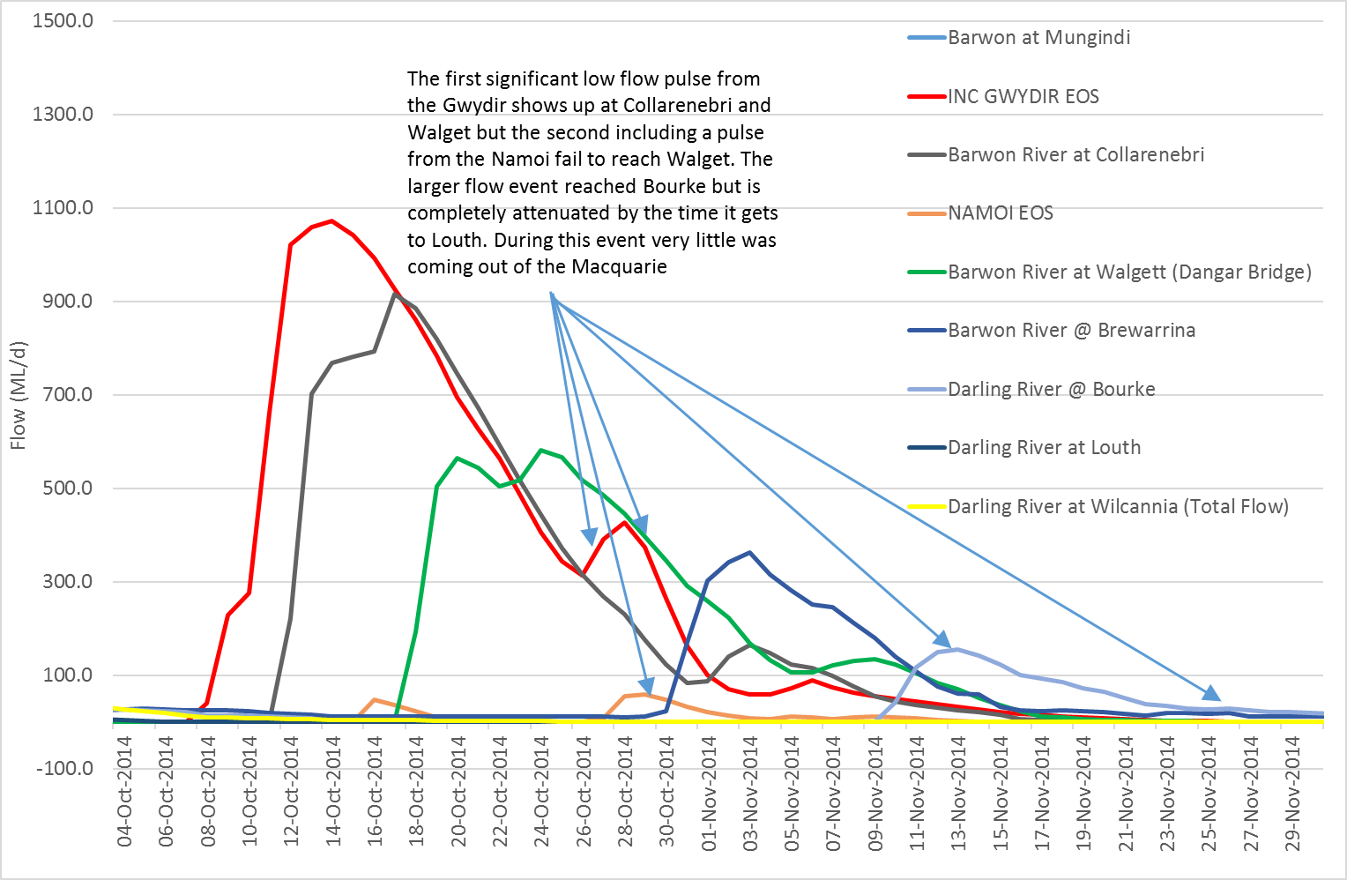

Table 1: Response to Key water management issues in the Barwon Darling

Background
This report examines the historical hydrological flow gauge data available from January 1990 to September 2017 in an attempt to characterise the impacts of extractions on daily flow rates, particularly low flow events within and between river sections from Mungindi to Menindee. Where possible tributary inflows have been considered in the analysis combined with consideration of water management legislation and policies since the introduction of the Cap. In particular, the period since the 2012 Barwon-Darling Water Sharing Plan commenced.
This analysis is also informed by Findings from Stage 1 – ecological analysis of environmental water requirements for the Barwon Darling River system.
A schematic of the Barwon Darling River system under investigation is given in Figure 1.
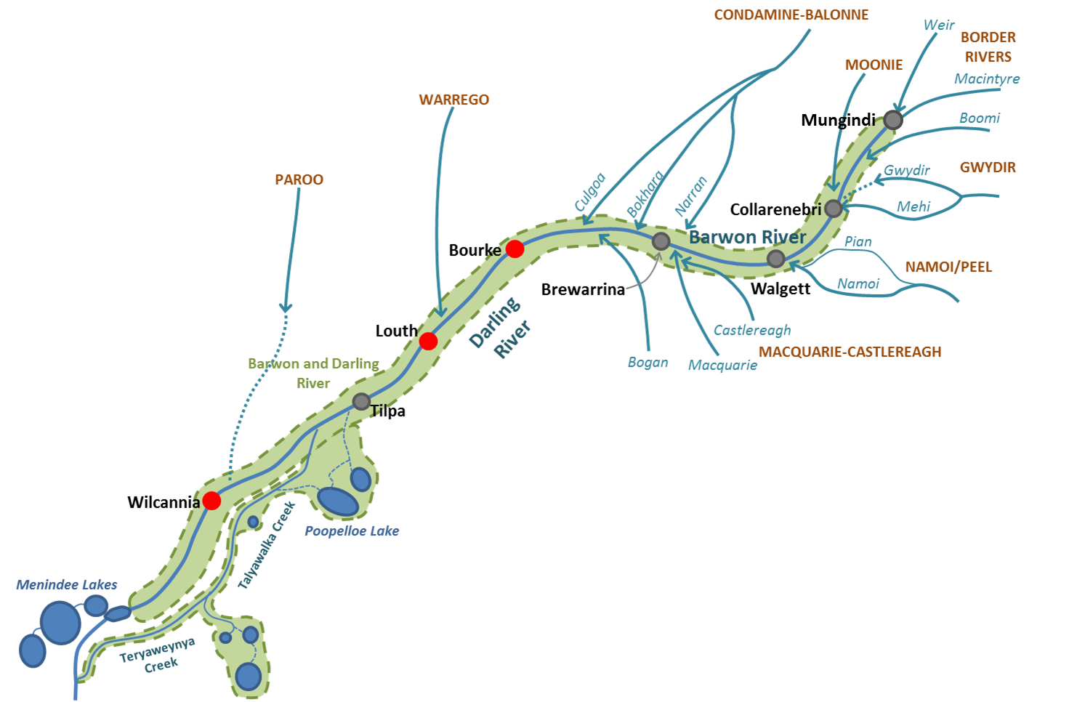 Figure 1: Stylised map of the Barwon–Darling river system (Source: MDBA)
There are three very distinctive flow patterns required by river systems like the Barwon Darling.
- the disconnected or low-flow phase where there is either no flow along a connected channel or water is restricted to disconnected sections of river channel, refugial waterholes and pools;
- (ii) the flow phase, determined by the passage of flow pulses of varying magnitude and duration, where sections of the channel are connected by flowing water and, finally,
- (iii) the flood phase where the water level is high enough to inundate high level channels, floodplain waterbodies, and even the floodplain proper.
- (Source: Sheldon, 2017)
The flow rates, flow duration and timing that characterise these important parts of the flow regime (Environmental Flow Indicators (EFI’s)) vary between sections of the river system from upstream to downstream. Generally, greater flow rates are required to meet environmental objectives as water flows further downstream because of the natural geomorphology of the river. This is also true for flow rates that define different unregulated flow diversion entitlements some of which the Commonwealth Environmental Water Holder now owns. A key question in this report is how well will low flows and low flow EFI’s be met under the Current Barwon Darling Water Sharing Plan (WSP) and how effective will this water sharing plan be in ensuring environmental water remains in the river particularly at low flows.

Environmental water purchased in Northern Basin
Table 2 shows the current CEWO entitlement holdings. While this project was initially focused on low flows there appears to be little low flow entitlement purchased (i.e. Low Flow or A-Class). For this reason and for reasons of analytical efficiency the analysis in the following section also contains results for Low Flow, A, B and C Class flow windows. There is also CEWO water in the tributaries. If this water was released from storages in the tributaries when no other events are occurring it would not be difficult to argue that this water should be protected from extraction on an event basis.
Table 2: CEWO Entitlement Holdings in the Barwon Darling

Hydrological analysis of Barwon Darling flows to characterise consumptive extractions by Management zone
In undertaking this analysis if you can first determine when access is permitted to various entitlement classes, then estimate reductions in flow between upstream and downstream gauges attributable to natural transmission losses, some assumptions on transmission losses may then allow you to estimate extractions by each entitlement class over various periods.

Methodology and assumptions used in the analysis
The steps taken for this analysis were:
- Gather together the available historical flow data (1990-2017) was chosen based on availability of gauge data at stream gauges relevant to the various Management zones in the 2012 Barwon Darling WSP.
- Based on the Barwon Darling daily flows specified at the upstream and downstream gauges in each Management zone (Appendix B) determine times when access would be permitted for Low Flow, A, B and C Class entitlements. This uses the flow access rules in Clause 45, Table A of the 2012 Barwon Darling Water Sharing Plan (Appendix B). Note the WSP specifies to use same day flows at the upstream and downstream flow gauge when determining access to flows.
- Adjustments to the downstream flow to allow for travel time were done using the following criteria:
- the travel time that gave the best correlation,
- a visual inspection of the daily flow timeseries (both upstream and downstream),
- and a preference for getting the travel time for low flow peaks to correspond at both the upstream and downstream gauges.
- If both the upstream and downstream gauge exist determine the reduction in flow between the upstream and downstream gauge.
- Using the daily estimated volume reduction above calculate the percent reduction in flow between the upstream and downstream daily flow taking into account estimated travel time.
- Using some assumptions for transmission losses estimate daily extraction during Low Flow, A, B and C Class access times.
- Compare the average reduction in flow and extraction percentage for the following time periods for each Management zone and for each flow class.
- 1990-2017
- 1990-2000
- 2000-2012
- 2012-2017

Results

Times when there is access to Low Flow, A, B and C Class entitlements
Figure 2 shows an example of applying the entitlement flow access rules for the upstream and downstream gauged flow specified for the NSW Management Zone, Mogil to Collarenebri. Appendix A shows the percentage of days access was permitted in each entitlement class for various periods for all management zones. The percentage of days with zero flow upstream or downstream is also shown in Appendix A.
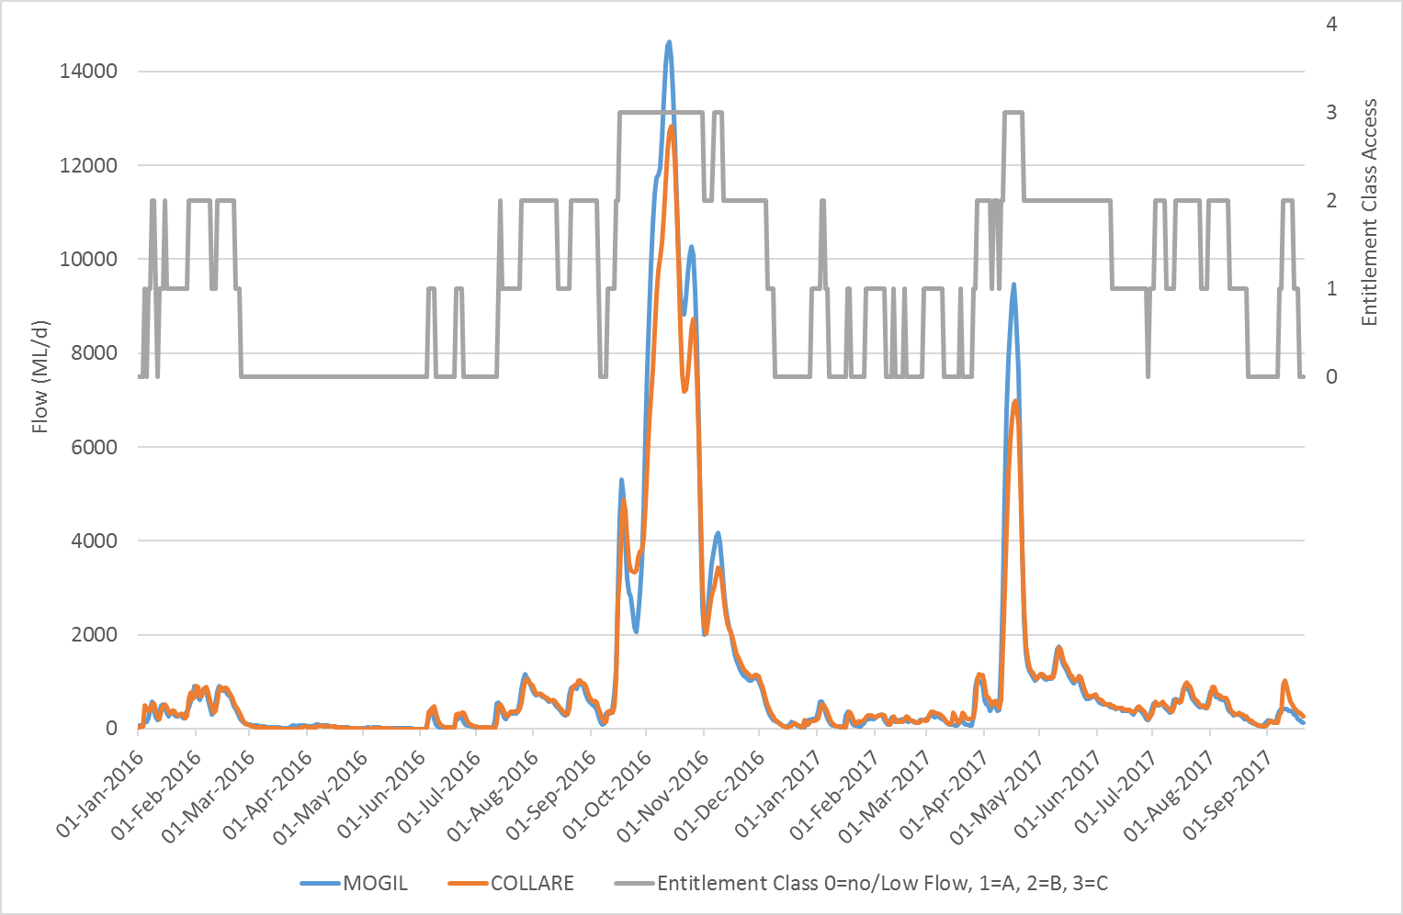
Figure 2: Times when various entitlement classes in the Barwon Darling have access between Mogil and Collarenebri (0=Low Flow Access, 1-A-Class Access, 2=B-Class Access, 3=C-Class Access)
Figure 3 shows the opportunities for Low Flow entitlement holders to take water, while Figure 4 shows the opportunities for A-Class entitlement holders to take water. Both Low Flow and A-Class flow access windows correspond with what is typically regarded as low flows ecologically. These flows range from >0 ML/d at Mungindi to 850 ML/d at Wilcannia. Both Figure 3 and Figure 4 show access opportunities for 1990-2017 (Entire period), 1990-2000 (Very wet period), 2000-2012 (Dry period) and 2012-2017 (Medium to wet period). 2012-2017 is also the period since the introduction of the 2012 Barwon Darling WSP.
Access to Low Flows was greatest during the dry period (2000-2012), followed by the period since the introduction of the 2012 Barwon Darling WSP. Overall this pattern of access to low flow entitlement windows follows the prevailing climate. In other words, there is less access to extremely low flows when it is wet and greater access when it is dry.
This is in contrast to the percentage of days there is access to A-Class entitlement flows which requires slightly higher flows that the Low Flow licenses for access (but still regarded as low flows ecologically). As expected there is greater access to A class during the 1990's (Very wet) compared to the period 2012-2017 (Wet). The Millenium drought had the lowest number of days in the A-Class flow window. The variation in access to low flows in each Management zone is also observable in Figure 3 and 4. Figures 5 and 6 show the percentage days access to all license classes for the periods 1990-2012 and 2012-2017.

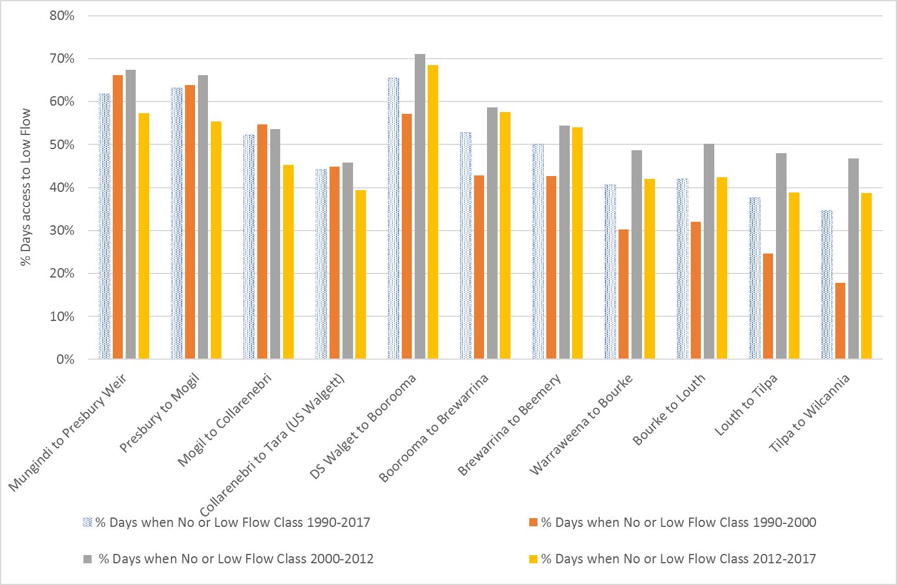
Figure 3: % Days with Low flow entitlement access
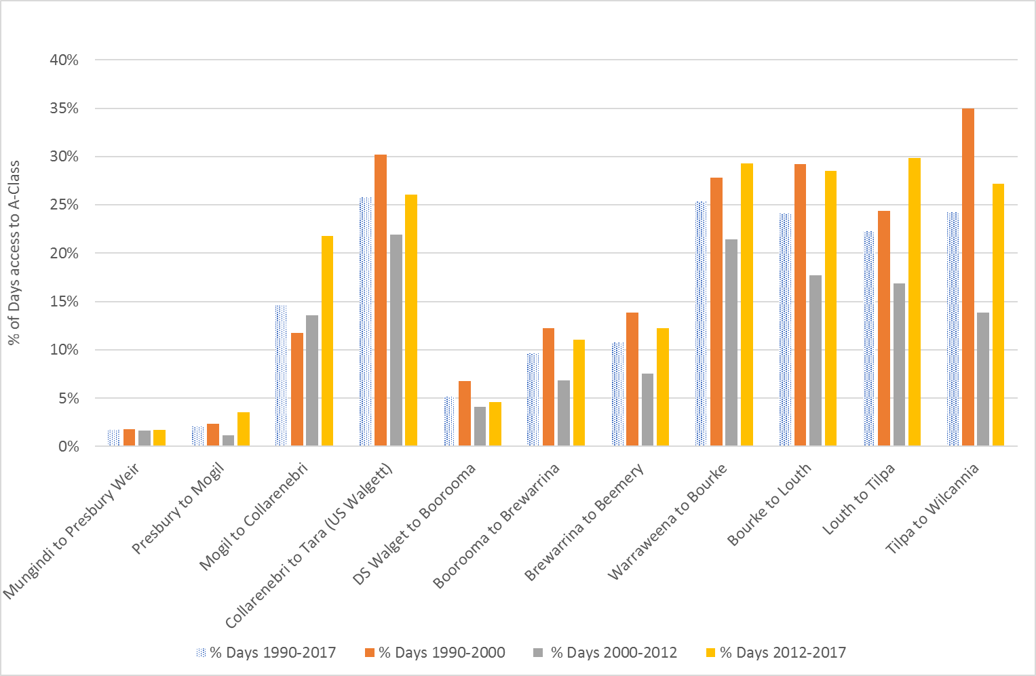
Figure 4: % Days with A-Class entitlement access

Figure 5 shows the % days access was permitted for all license classes from 1990-2012 while Figure 6 shows access for the period 2012-2017
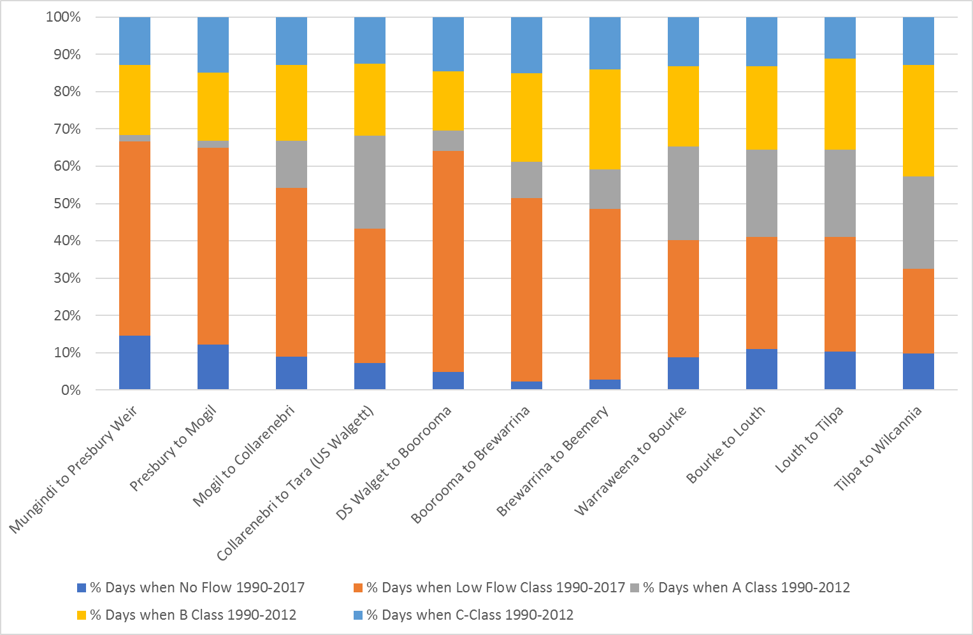
Figure 5: % Days access to all entitlement classes 1990-2012
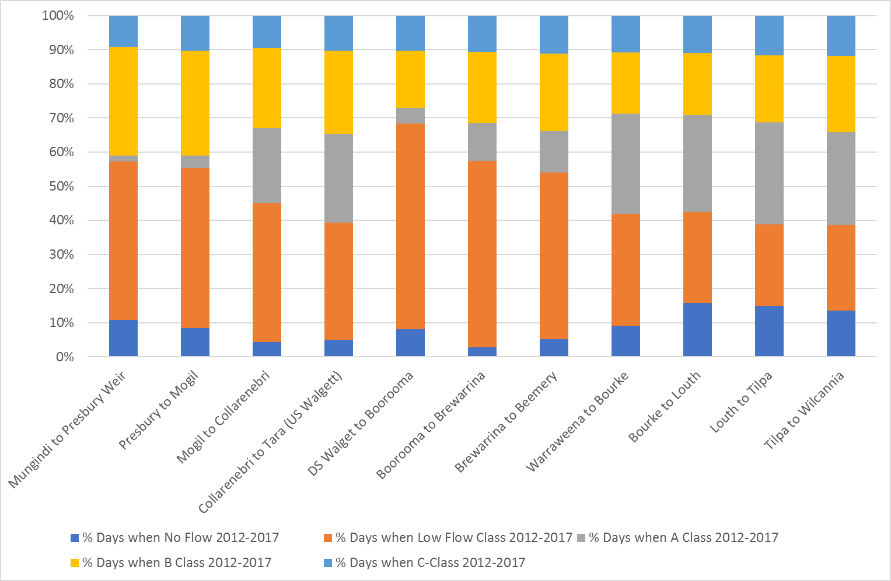
Figure 6: % Days access to all entitlement classes 2012-2017

Estimating Reduction in flow and uncertainty
When considering reductions in flow from upstream to downstream it is important to consider conceptual models of changes in flow from upstream to downstream that take into account an inflowing tributary, as shown in Figure 7 below.
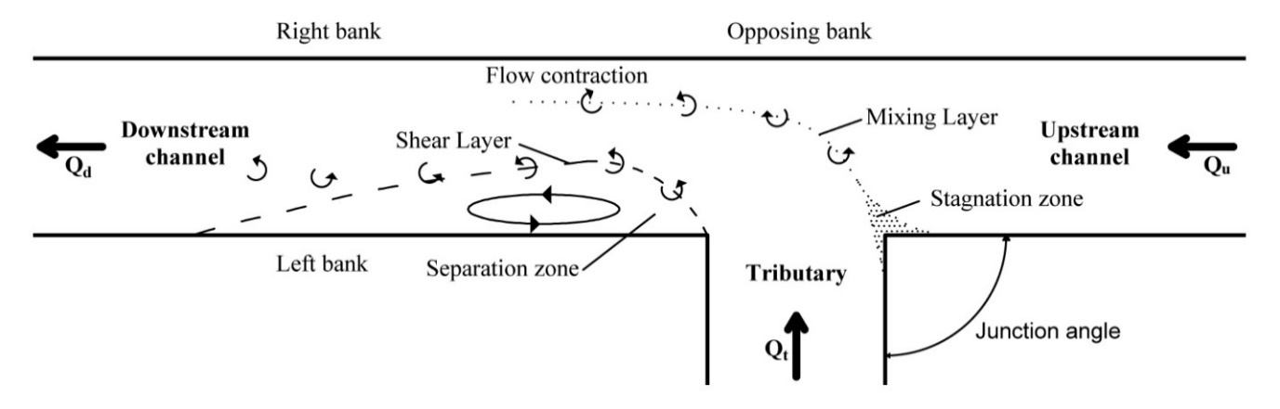
Figure 7: Conceptual model of open channel confluence (Best, 1985)
Using Figure 7 the reduction in flow can be considered a ratio of the upstream to downstream flow given as:
Qu Qu
q = = (1)
Qd Qu+Qt
A ratio of the upstream flow (Qu ) to the downstream flow (Qd) (adjusted for travel time) is the same as saying a ratio of the upstream flow to the upstream flow plus any inflows (Qt). Therefore, the reduction in flow is the upstream flow plus any tributary inflows minus what actually made it to the downstream gauge. However, as the Barwon Darling has many ungauged inflows (Table 3) it is difficult to determine accurately the reduction in flow from upstream to downstream. For instance, Figure 8 below shows the reduction in flow as percentage of the upstream flow plus any tributary inflows when moving from upstream to downstream between NSW management zones. Figure 8 shows that for low flows associated with Low Flow and A-Class entitlement flow access conditions there is a reduction in flow as you move downstream. This is not the case for B and C-Class entitlements which are associated with higher flows. This is because there are generally more ungauged inflows at higher flows. Higher flows are generally associated with rainfall events that not only occur in the Barwon Darling but also the tributaries.
Because of the many ungauged inflows in the Barwon Darling it is therefore not possible to determine reductions in flow accurately, particularly when there are tributary inflows. Separate to this, investigation of the travel times between gauges revealed that travel time varies with not just flow rate but also antecedent moisture condition (Figure 9). This resulted in the travel time adjustment sometimes under or over estimating travel time. This also gives some uncertainty in the estimated reduction in flow between upstream and downstream gauges. Due to these issues an attempt was then made to only estimate reduction in flow based on the difference in the overall volume of flow in each entitlement class between the upstream and downstream gauge while allowing for any inflows. This may have overcome some of the travel time issues as we are looking at the total volume over a longer period rather than reductions in daily flow. However, this produced similar issues to those shown in Figure 8 because, again, there are too many ungauged inflows.

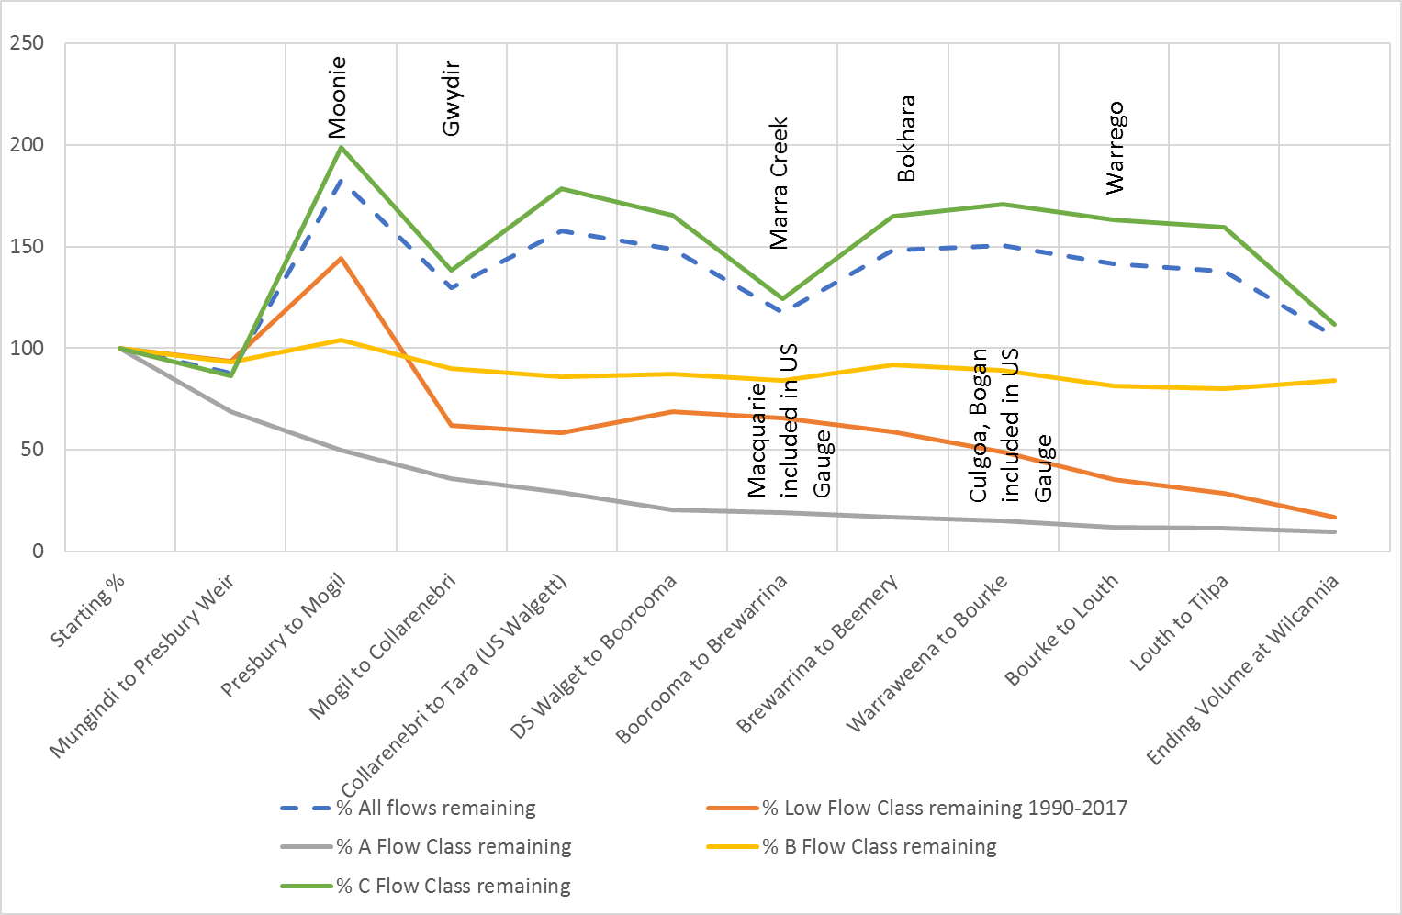
Figure 8: % Reductions in flow for flows associated with each entitlement class subtracting known inflows from the downstream gauge.
Table 3: Known Gauged and Un-gauged inflows for each management zone

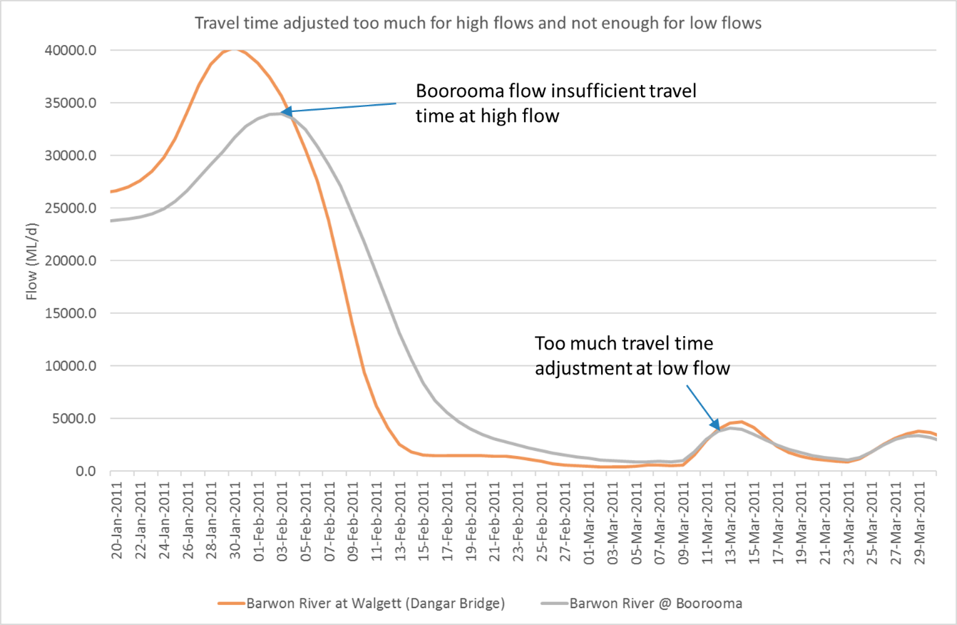
Figure 9: Problems with estimating travel time. In general travel time is slower at low flows but not in this example.
The Author considers the uncertainty associated with ungauged inflows to be significantly larger than the uncertainty associated with travel time. For this reason, it was decided to only examine the daily reduction in flow when there were reductions in flow while ignoring days with gains in flow. This means the data presented below is the average percentage reduction in flow for all days with a reduction in flow. The reason for doing this is so it is possible to at least identify which NSW Management zones and which periods had the highest relative reductions in flow. This also aided in identifying periods where flow had been significantly attenuated (lost) from the upstream to downstream gauge specified for each management zone.
Despite the inability to accurately determine reductions in flow associated with transmission losses and extractions due to travel time and ungauged inflows, the relative reductions in flow between zones gives an indication where significant reductions in flow are occurring for each entitlement class across all management zones.

Reduction in flow results
Figure 10 shows these reductions in flow for flows associated with Low Flow and A-Class entitlements from 1990-2017. It can be seen that the Presbury to Mogil, Mogil to Collarenebri, Bourke to Louth and Tilpa to Wilcannia management zones have the largest reductions in low flows. Overall the Tilpa to Wilcannia management zone had the highest average daily reduction in low flow.

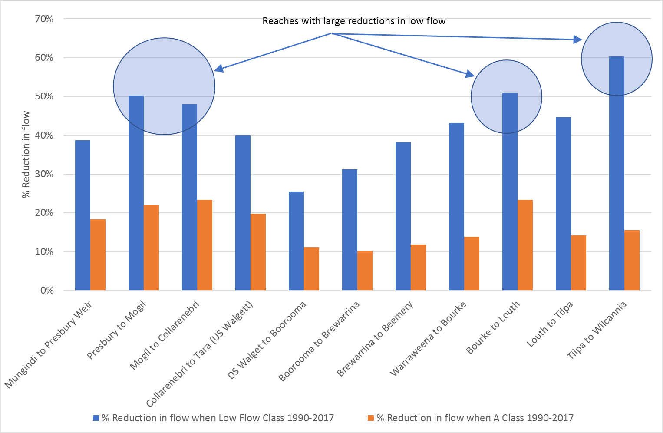
Figure 10: Relative reductions in flow for flows associated with Low Flow and A-Class entitlements from 1990-2017 (ignoring days with gains).
Figure 11 shows the monthly reductions in flow for the Mogil to Collarenbri zone. It can be seen that high reductions in flow are associated with summer months and low reductions in flow are associated with winter months.
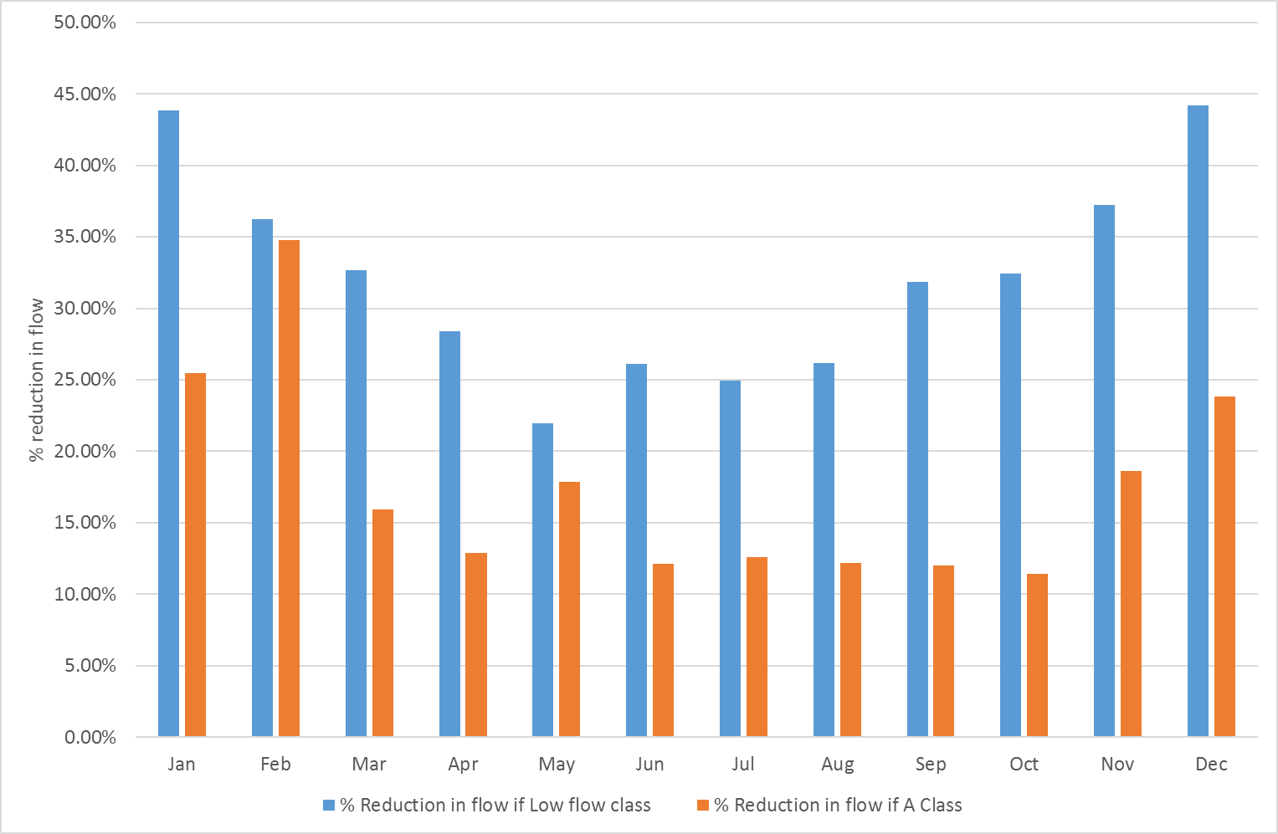
Figure 11: Average monthly percent reductions in flow between Mogil and Collarenebri for flows associated with Low Flow and A-Class entitlements
Despite the results presented in Figure 10 and 11 it is difficult to compare between zones because each zone varies in length. Longer zones will have higher transmission losses as part of their reduction in flow estimates. To allow for this the length of each Management zone was estimated using a Geographic Information System (Table 4). This was used to adjust the results based on the length of the river the reduction in flow occurred over. The result for Low Flow entitlement and A-Class entitlement flows is shown in Figure 12 and represents the reduction in flow per kilometre of river.
Table 4: NSW Management zones for the Barwon Darling and the length of the stream used to weight reduction in flow estimates
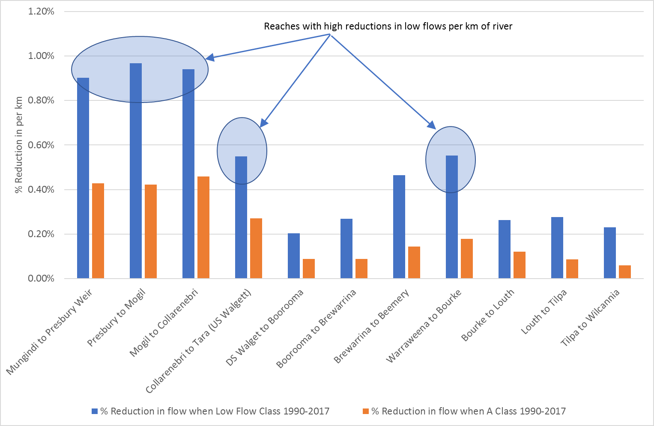
Figure 12: Reductions in flow per km of river associated with Low Flow and A-Class entitlements 1990-2017. This is the reduction in flow from upstream to downstream for each management zone divided by the length of each management zone (km).
Figure 12 the Mungindi to Presbury, Presbury to Mogil, Mogil to Collarenebri, and the Warraweena to Bourke management zones have the largest reductions in low flows. The Tilpa to Wilcannia zone now has relatively low reduction in flow per kilometre. This is because its reduction in flow is over 262 km (i.e. the longest zone/river reach). The changes in reduction in flow per kilometer between different time periods was also examined. Figure 13 and 14 show the results for Low Flow and A-Class entitlement flow access windows.
For flows associated with Low Flow access it can be seen here there is little difference in the reduction in flow estimates when comparing the period since the introduction of the 2012 Baron Darling WSP (i.e. 2012-2017). The exception would be in the Collarenebri to Tara and Warraweena to Bourke management zones which saw the largest reductions in flow in the 2012-2017 period. The same results for flows associated with A-Class licenses is shown in Figure 14 below. This shows a very similar pattern to the reduction in flow per kilometre results for Low Flow license access. The only difference being that there are larger reductions in flow since 2012 at the top of the river with respect to A-Class flows in the management zones from Mungindi to Collarenebri.

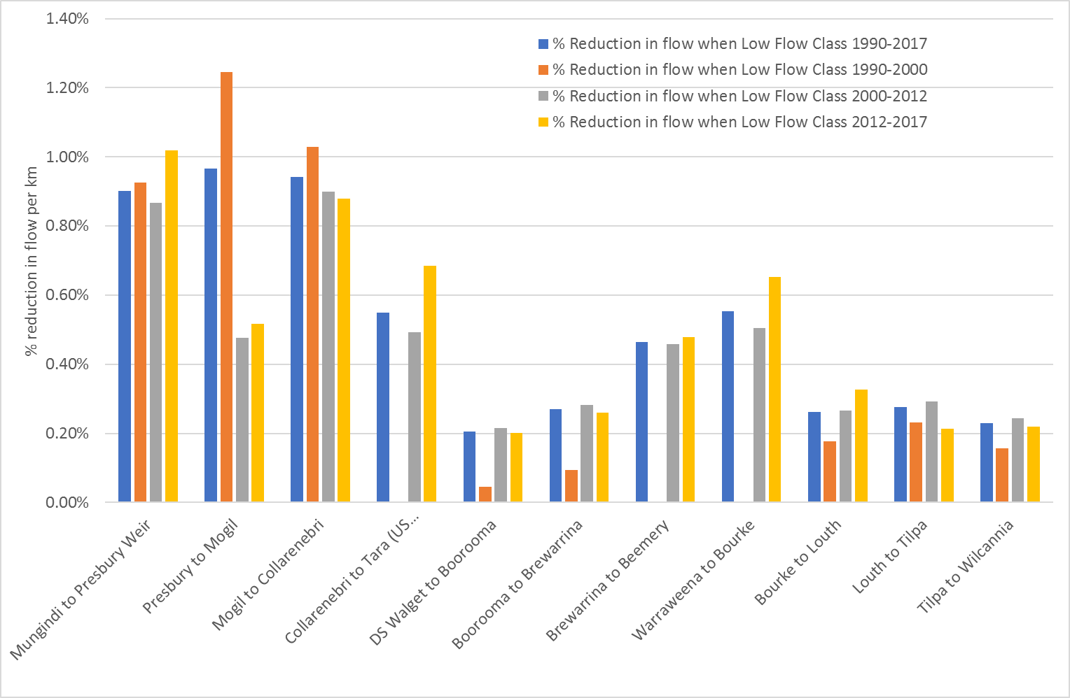
Figure 13: Reductions in flow per km of river associated with Low Flow and A-Class entitlements for all periods. This is the reduction in flow from upstream to downstream for each management zone divided by the length of each management zone (km).
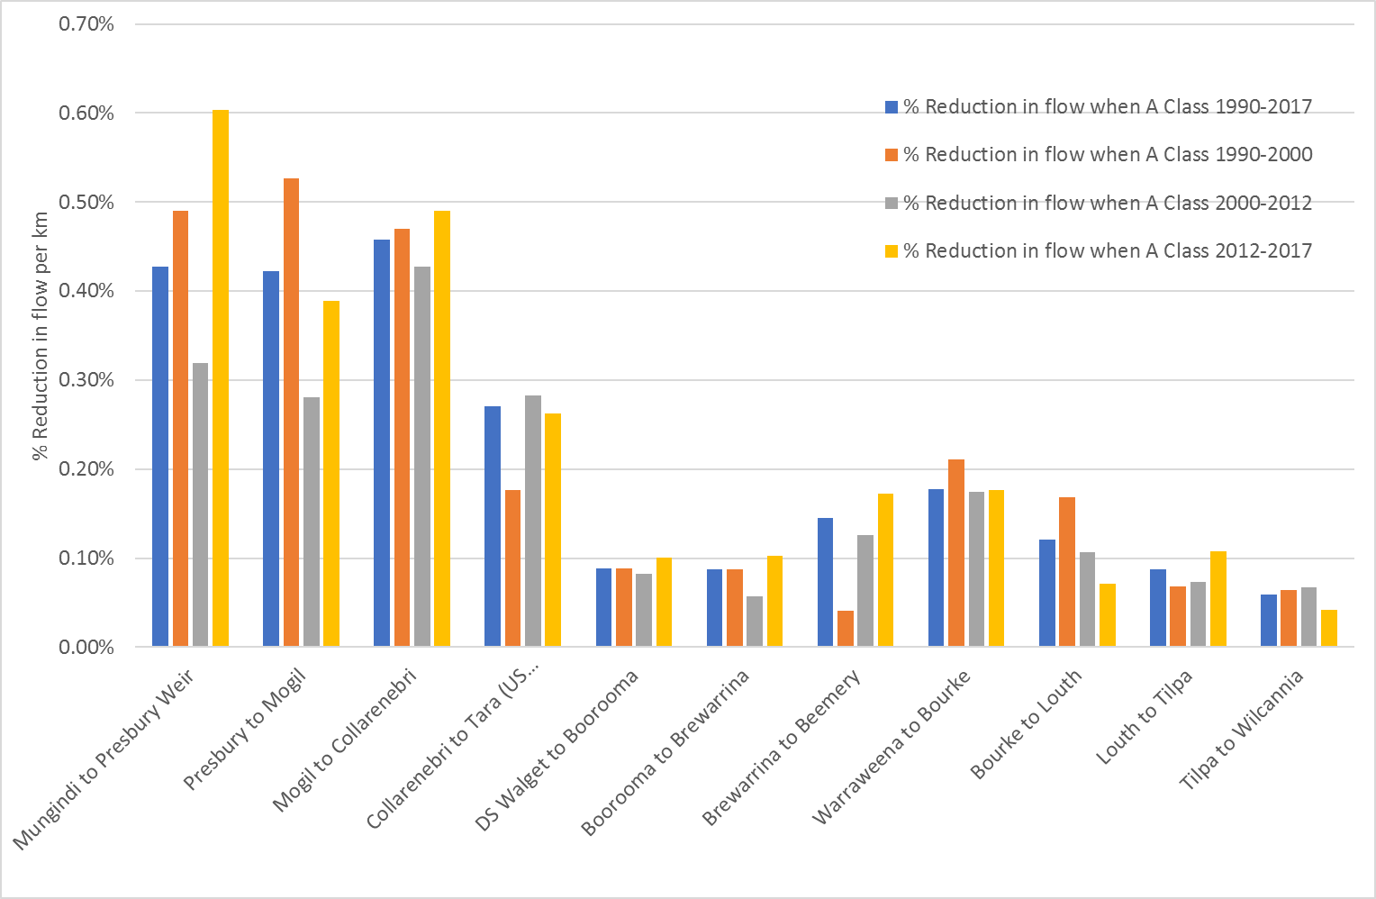
Figure 14: Reductions in flow per km of river associated A-Class entitlements for all periods. This is the reduction in flow from upstream to downstream for each management zone divided by the length of each management zone (km).
It is interesting to note that the Boorooma to Brewarrina management zone is actually specified in the WSP as using the Geera gauge or Geera to Brewarrina. This means there is no management zone from Boorooma to Geera even though this is the zone where the Macquarie meets the Barwon Darling. It is possible extractions could be occurring before the Geera gauge accessing Macquarie inflows with no access rules specified in the WSP. This potentially missing management zone is shown in Figure 15 below.
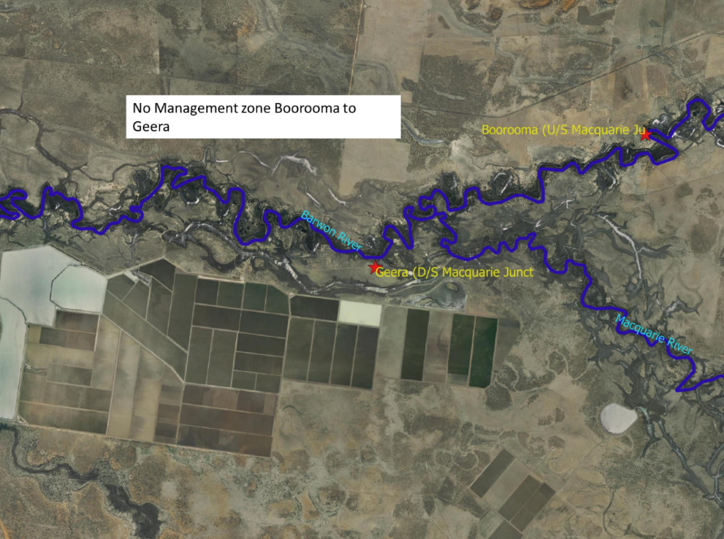
Figure 15

Examples of flow events showing significant attenuation
Figures 16-20 show examples of reductions in flow (attenuation) that are unlikely to be explained by transmission losses. This combined with the work above could be used to focus any future investigations of extractions on particular reaches / management zones.
Figure 16: Flow event from the Gwydir containing 17 GL of CEWO water that appears not to be protected by the time it gets to Walgett. This is not time travel corrected.
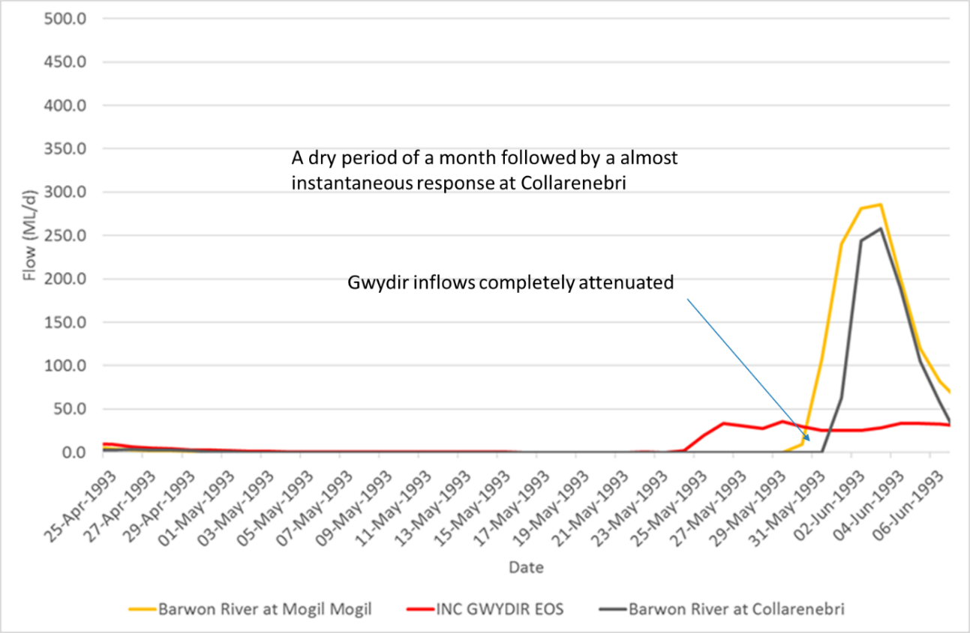
Figure 17

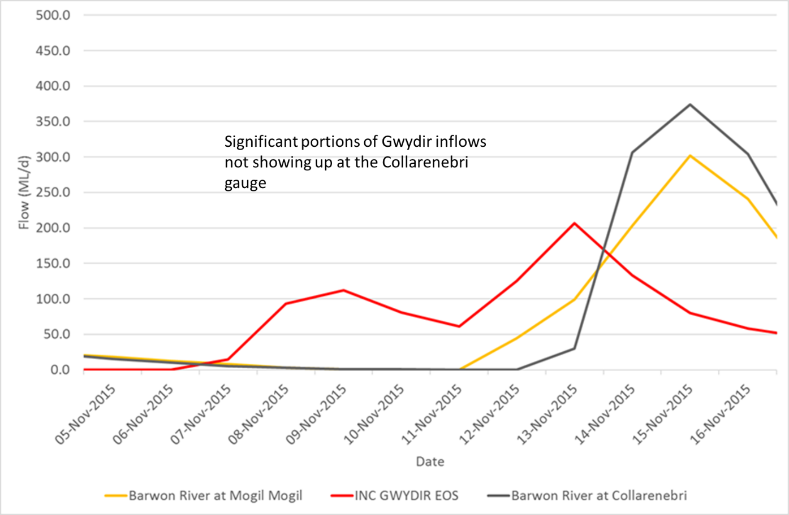
Figure 18
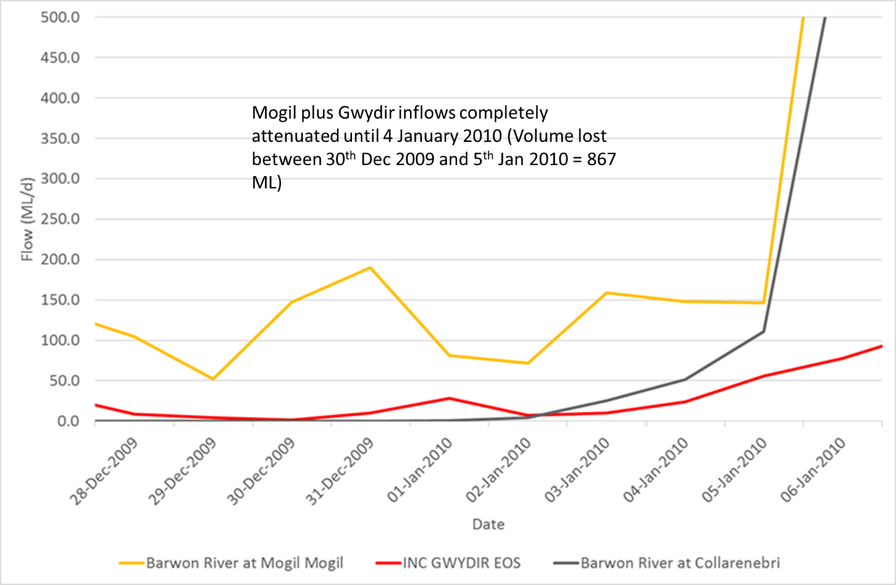
Figure 19

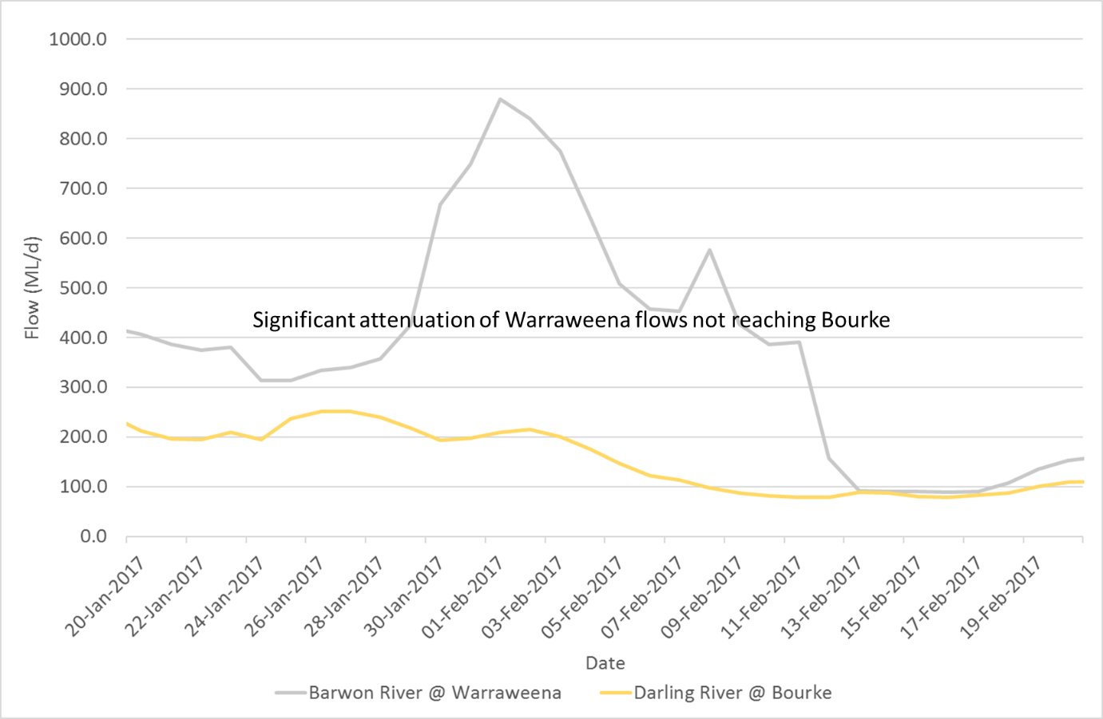
Figure 20

Limitations of the methodology and analysis undertaken
There are some key limitations to the analysis undertaken. The key limitations in the methodology and analysis undertaken are:
- The available gauge data is not always complete and some inflow data was missing. Where possible periods of missing upstream and/or downstream flow data are ignored.
- There are some unexpected increases in flow at the downstream gauge possibly due to ungauged inflows, missing data or local rainfall/runoff.
- The Barwon Darling has highly variable flows, with extreme dry periods that mean antecedent moisture conditions, losses, attenuation and therefor travel times are highly variable. Assumed constant travel time.
- Because of the limitations above the estimates of reduction in flow and extraction have a high degree of uncertainty

Key MDBA Results

Hydrological analysis of achievement of Environmental Flow Indicators
Environmental Flow Indicators is the terminology given to known environmental water requirements at particular sites (Hydrological Indicator Sites) that define the environmental water requirements for a river reach. The analysis by the MDBA of the Environmental Low Flow Indicator performance of the last 27 years is shown in Table 5. While the Author has not re-calculated these numbers, he is confident that the tools used by MDBA to estimate these indicators is robust. The author has simply coloured them orange if not achieved. Table 5 clearly shows that most environmental low flow indicators have not been met over the period from 1990-2017. This is particularly true for low flow events required almost every year, or twice a year.

Table 5: Environmental low flow indicator performance (Orange means the indicator was not met)

Dry Spell Analysis
The MDBA also undertook analysis of dry spells from Mungindi to Wilcannia. The author has recalculated these numbers and can confirm they are correct. The results have been plotted in Figure 21 and 22 below. It can be seen that dry spell length increases from upstream to downstream (Figure 21) while the percent of dry days (Figure 22) shows there are more dry days at the top and bottom of the Barwon Darling.
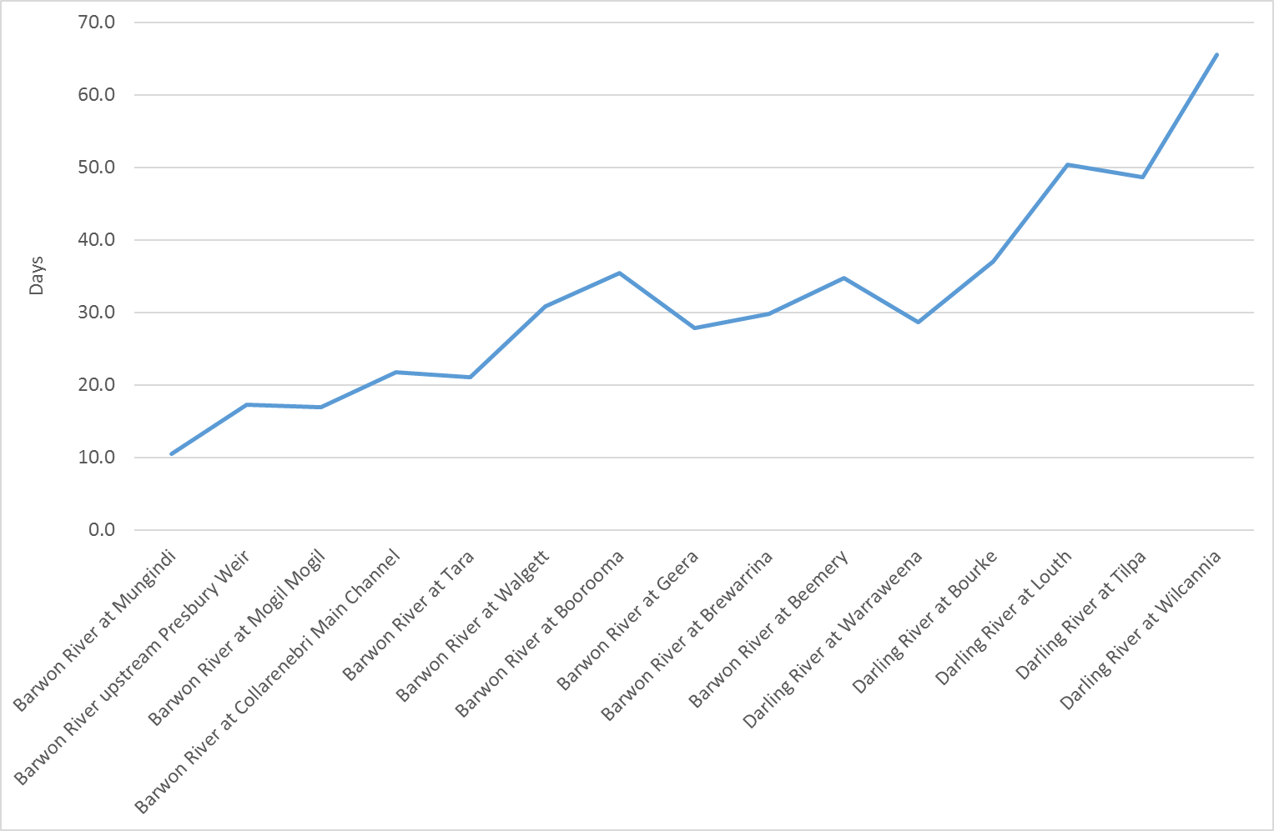
Figure 21: Average dry spell length (<20ML) Mungindi to Wilcannia 1990-2017
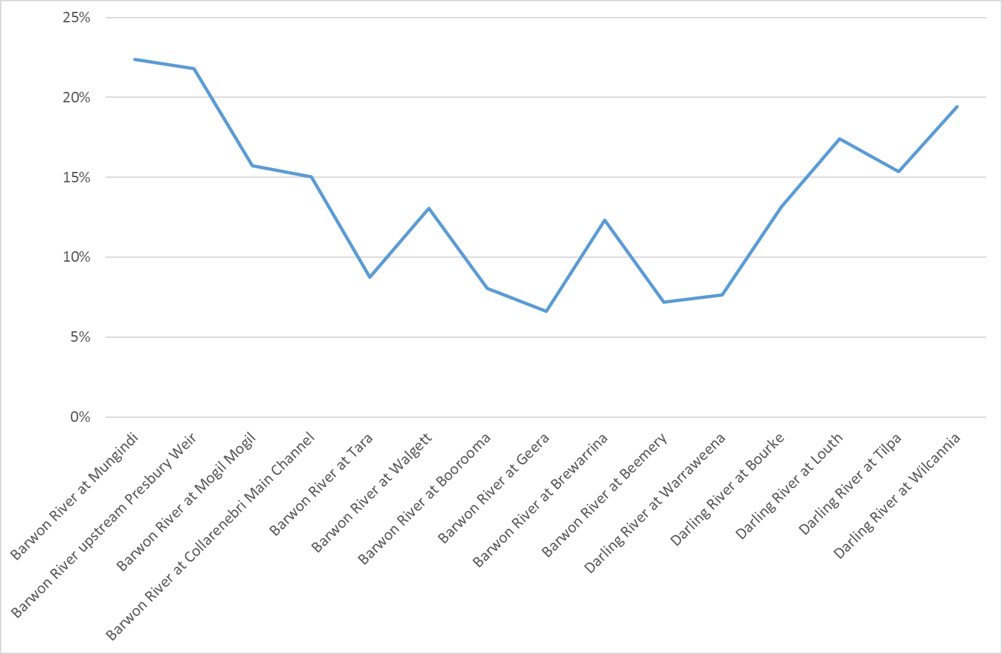
Figure 22: Percent of days <20ML Mungindi to Wilcannia 1990-2017

MDBA examples of unexplained flow attenuation
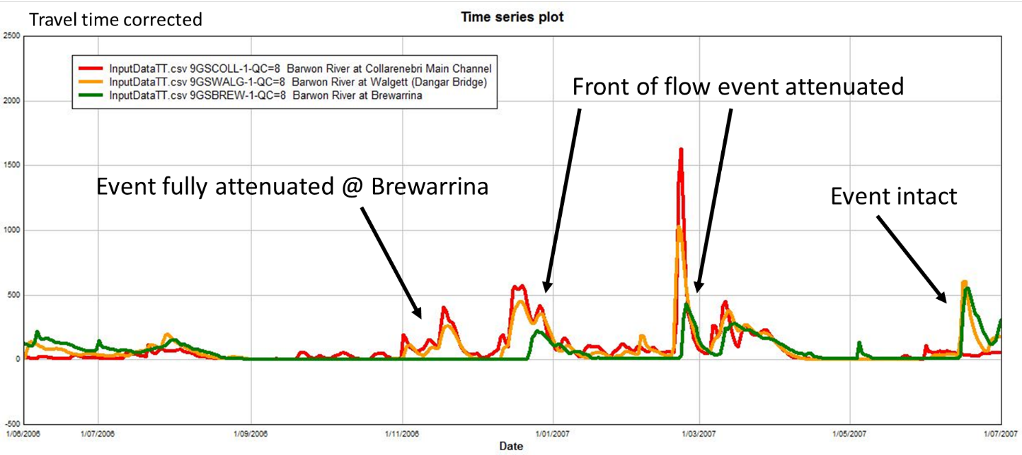
Figure 23: MDBA examples of extreme flow attenuation
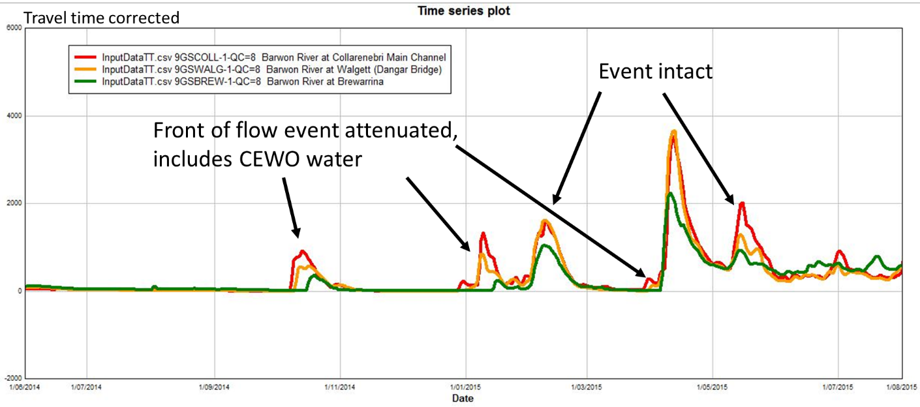

Event Peak Analysis
This analysis by the MDBA looked at all flow events that were defined by a peak and a rising/falling limb. The peak values from the downstream gauge is subtracted from the upstream gauge to determine the percentage reduction in flow. 100% being complete attenuation. This analysis looked at 5 zones.
- Mungindi to Collarenebri
- Collarenebri to Walgett
- Walgett to Brewarrina
- Brewarrina to Bourke
- Bourke to Wilcannia
The findings of this analysis were that there was a apparent change to hydrological behaviour from 2001 onwards in the Walgett to Brewarrina reach, with many flow events in dry periods attenuated to zero, also cluster of heavily attenuated events post 2012. Only flows less than 2000 ML/d were plotted. This equates to Low, A and B class entitlements. In other reaches no obvious pattern was observed. The author believes that most if not all of the observed pattern can be attributed to the millennium drought between 2000-2009. Post 2009 things start to return to the pre-drought condition. While this peak flow analysis overcomes some of the travel time issues it cannot attribute any patterns of reduction in flow to extraction. Also, it appears this analysis did not pick up all flow events less than 2000 ML/d (e.g. there appears to be 12 events less than 2000 ML/d in 2012 compared to the 9 identified here) and the analysis does not consider reductions in flow during flows not associated with peak flow events. Despite this, peak flow analysis using this tool developed for Basin Plan purposes is very useful in identifying events that seem unusual.
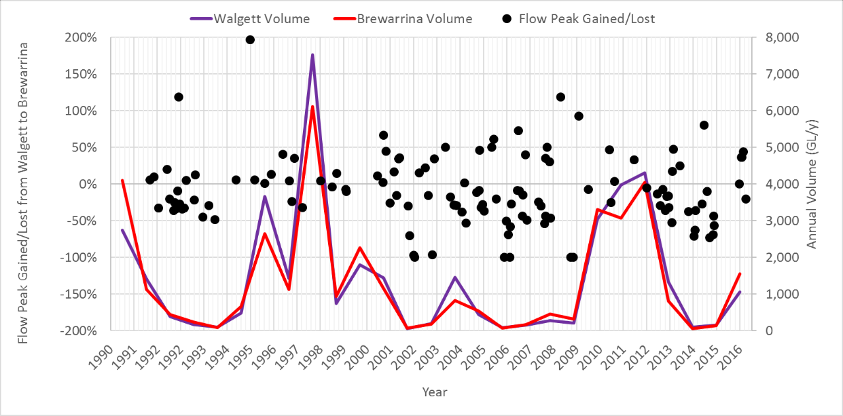

References
Best, J.L. Flow Dynamics and Sediment Transport at River Channel Confluences. Ph.D. Thesis, University of London, London, UK, 1985.
CSIRO (2008) Water Availability in the Barwon-Darling: A report to the Australian Government from the CSIRO Murray-Darling Basin Sustainable Yields Project
Mathews (2017) INTERIM REPORT | KEN MATTHEWS AO Independent investigation into NSW water management and compliance. NSW Government.
MDBA (2016) Hydrologic Modelling for the Northern Basin Review, MDBA publication no.: 35/16
MDBMC (1995) An audit of water use in the Murray Darling Basin, Murray Darling Basin Ministerial Council.
NSW (2012) Water Sharing Plan for the Barwon-Darling Unregulated and Alluvial Water Sources 2012 under the Water Management Act 2000
Sheldon (2017) Characterising the ecological effects of changes in the ‘low-flow hydrology’ of the Barwon-Darling River
Thoms, Martin & Sheldon, Fran & Roberts, Jane & Harris, John & Hillman, Tj. (1996). Scientific Panel Assessment of Environmental Flows for the Barwon-Darling River. .

Appendix A – % Days there was access to various entitlement classes under the WSP

Appendix B – Flow Classes for the Barwon Darling from the 2012 WSP

- For the purpose of Table A, Year 1 of this Plan means from the date of commencement of this Plan.

Table A — Flow Classes
Column 1  Water source | Column 2  Management zone | Column 3  Flow class | Column 4  Commencement | Column 5  Flow (ML/day) | Column 6  Flow reference point | Column 7  Day on which flow class applies
Barwon-  Darling  Unregulated  River Water Source | Mungindi to  Boomi River  Confluence  Management  Zone | No Flow Class | Year 1 of this Plan | 0 ML/day at  Mungindi gauge or  0 ML/day at  Presbury gauge | Barwon River at Mungindi gauge  (416001) and  Barwon River upstream of Presbury  Weir gauge  (416050) | Same day
Barwon-  Darling  Unregulated  River Water Source | Mungindi to  Boomi River  Confluence  Management  Zone | Low Flow Class | Year 1 of this Plan | - More than 0  ML/day at Mungindi gauge and more than 0 ML/day at Presbury gauge, and  - Less than or equal to 230 ML/day at Mungindi gauge or less than or equal to 220 ML/day at Presbury gauge |  | Same day
Barwon-  Darling  Unregulated  River Water Source | Mungindi to  Boomi River  Confluence  Management  Zone | A Class | Year 1 of this Plan | - More than 230  ML/day at Mungindi gauge and more than 220 ML/day at Presbury gauge, and  - Less than or equal to 270 ML/day at Presbury gauge |  | Same day

Column 1  Water source | Column 2  Management zone | Column 3  Flow class | Column 4  Commencement | Column 5  Flow (ML/day) | Column 6  Flow reference point | Column 7  Day on which flow class applies
 |  | B Class | Year 1 of this Plan | - More than 230  ML/day at Mungindi gauge and more than 270 ML/day at Presbury gauge, and  - Less than or equal to 1,500 ML/day at Presbury gauge |  | Same day
 |  | C Class | Year 1 of this Plan | More than 230  ML/day at Mungindi gauge and more than 1,500 ML/day at  Presbury gauge |  | Same day
 | Boomi River  Confluence to Upstream  Mogil Mogil  Weir Pool  Management  Zone | No Flow Class | Year 1 of this Plan | 0 ML/day at  Presbury gauge or  0 ML/day at Mogil  Mogil gauge | Barwon River upstream of Presbury  Weir gauge  (416050) and  Barwon River at Mogil  Mogil gauge  (422004) | Same day
 |  | Low Flow Class | Year 1 of this Plan | - More than 0  ML/day at Presbury gauge and more than 0 ML/day at Mogil  Mogil gauge, and  - Less than or equal to 220 ML/day at Presbury gauge or less than or equal to 190 ML/day at Mogil Mogil gauge |  | Same day
 |  | A Class | Year 1 of this Plan | - More than 220 ML/day at Presbury gauge and more than 190 ML/day at  Mogil Mogil, and  - Less than or equal to 270 ML/day at Presbury gauge or less than or equal to 230 ML/day at Mogil Mogil gauge |  | Same day
 |  | B Class | Year 1 of this Plan | - More than 270  ML/day at Presbury gauge and more than 230 ML/day at Mogil Mogil gauge, and  - Less than or equal to 1,800 ML/day at Mogil Mogil gauge |  | Same day
 |  | C Class | Year 1 of this Plan | More than 270  ML/day at Presbury gauge and more than 1,800 ML/day at  Mogil Mogil gauge |  | Same day
 | Mogil Mogil Weir Pool | No Flow Class | Year 1 of this Plan | 0 ML/day | Barwon River at Mogil | Same day

Column 1  Water source | Column 2  Management zone | Column 3  Flow class | Column 4  Commencement | Column 5  Flow (ML/day) | Column 6  Flow reference point | Column 7  Day on which flow class applies
 | Management Zone | Low Flow Class | Year 1 of this Plan | More than 0 ML/day and less than or equal to 190 ML/day | Mogil gauge (422004) | Same day
 | Management Zone | A Class | Year 1 of this Plan | More than 190 ML/day and less than or equal to 570 ML/day | Mogil gauge (422004) | Same day
 | Management Zone | B Class | Year 1 of this Plan | More than 570 ML/day and less than or equal to 1,800 ML/day | Mogil gauge (422004) | Same day
 | Management Zone | C Class | Year 1 of this Plan | More than 1,800 ML/day | Mogil gauge (422004) | Same day
 | Downstream  Mogil Mogil to  Collarenebri  Management  Zone | No Flow Class | Year 1 of this Plan | 0 ML/day at Mogil  Mogil gauge or 0  ML/day at Collarenebri gauge | Barwon River at Mogil Mogil  (422004) and  Barwon River at  Collarenebri  Main  Channel gauge  (422003) | Same day
 | Downstream  Mogil Mogil to  Collarenebri  Management  Zone | Low Flow Class | Year 1 of this Plan | - More than 0 ML/day at Mogil Mogil gauge and more than 0 ML/day at Collarenebri gauge, and  - Less than or equal to 190 ML/day at Mogil Mogil gauge or less than or equal to 165 ML/day at Collarenebri gauge |  | Same day
 | Downstream  Mogil Mogil to  Collarenebri  Management  Zone | A Class | Year 1 of this Plan | - More than 190 ML/day at Mogil Mogil gauge and more than 165 ML/day at Collarenebri gauge, and  - Less than or equal to 570 ML/day at Mogil Mogil gauge or less than or equal to 500 ML/day at Collarenebri gauge |  | Same day
 | Downstream  Mogil Mogil to  Collarenebri  Management  Zone | B Class | Year 1 of this Plan | - More than 570 ML/day at Mogil Mogil gauge and more than 500 ML/day at Collarenebri gauge, and  - Less than or equal to 2,900 ML/day at Collarenebri gauge |  | Same day

Column 1  Water source | Column 2  Management zone | Column 3  Flow class | Column 4  Commencement | Column 5  Flow (ML/day) | Column 6  Flow reference point | Column 7  Day on which flow class applies
 |  | C Class | From year 1 of this plan | More than 570  ML/day at Mogil Mogil gauge and more than 2,900  ML/day at Collarenebri gauge |  | Same day
 | Collarenebri to Upstream  Walgett Weir Pool  Management  Zone | No Flow Class | Year 1 of this Plan | 0 ML/dayat Collarenebri gauge (422003) or 0 ML/day at Tara gauge (422025) | Barwon River at  Collarenebri  Main  Channel gauge  (422003) and  Barwon River at Tara gauge  (422025) | Same day
 |  | Low Flow Class | Year 1 of this Plan | - More than 0 ML/day at  Collarenebri gauge and more than 0 ML/day at Tara gauge, and  - Less than or equal to 165 ML/day at Collarenebri gauge or less than or equal to 100 ML/day at Tara gauge |  | Same day
 |  | A Class | Year 1 of this Plan | - More than 165  ML/day at  Collarenebri gauge and more than 100 ML/day at Tara gauge, and  - Less than or equal to 500 ML/day at Collarenebri gauge or less than or equal to 430 ML/day at Tara gauge |  | Same day
 |  | B Class | Year 1 of this Plan | - More than 500  ML/day at  Collarenebri gauge and more than 430 ML/day at Tara gauge, and  - Less than or equal to 3,050 ML/day at  Tara gauge |  | Same day
 |  | C Class | Year 1 of this Plan | More than 500  ML/day at  Collarenebri gauge and more than 3,050 ML/day at Tara gauge |  | Same day
 | Walgett Weir Pool  Management  Zone | No Flow Class | Year 1 of this Plan | 0 ML/day | Barwon River at Dangar  Bridge gauge  (422001) | Same day
 | Walgett Weir Pool  Management  Zone | Low Flow Class | Year 1 of this Plan | More than 0 ML/day and less than or equal to 600 ML/day or less | Barwon River at Dangar  Bridge gauge  (422001) | Same day

Column 1  Water source | Column 2  Management zone | Column 3  Flow class | Column 4  Commencement | Column 5  Flow (ML/day) | Column 6  Flow reference point | Column 7  Day on which flow class applies
 |  | A Class | Year 1 of this Plan | More than 600 ML/day and less than or equal to 900 ML/day |  | Same day
 |  | B Class | Year 1 of this Plan | More than 900 ML/day and less than or equal to 5,650 ML/day |  | Same day
 |  | C Class | Year 1 of this Plan | More than 5,650 ML/day |  | Same day
 | Downstream  Walgett to  Boorooma  Management  Zone | No Flow Class | Year 1 of this Plan | 0 ML/day at Dangar Bridge gauge or 0 ML/day at Boorooma gauge | Barwon River at Dangar  Bridge gauge  (422001) and  Barwon River at Boorooma gauge  (422026) | Same day
 | Downstream  Walgett to  Boorooma  Management  Zone | Low Flow Class | Year 1 of this Plan | - More than 0 ML/day at Dangar Bridge gauge and more than 0  ML/day at Boorooma gauge, and  - Less than or equal to 600 ML/day at Dangar Bridge gauge or less than or equal to 530 ML/day at  Boorooma gauge |  | Same day
 | Downstream  Walgett to  Boorooma  Management  Zone | A Class | Year 1 of this Plan | - More than 600 ML/day at Dangar Bridge gauge and more than 530 ML/day at Boorooma gauge, and  - Less than or equal to 900 ML/day at Dangar Bridge gauge or less than or equal to 870 ML/day at  Boorooma gauge |  | Same day
 | Downstream  Walgett to  Boorooma  Management  Zone | B Class | Year 1 of this Plan | - More than 900 ML/day at Dangar Bridge gauge and more than870  ML/day at  Boorooma gauge , and  - Less than or equal to 5,500 ML/day at Boorooma gauge |  | Same day
 | Downstream  Walgett to  Boorooma  Management  Zone | C Class | Year 1 of this Plan | More than 900  ML/day at Dangar Bridge gauge and more than 5,500 ML/day at  Boorooma gauge |  | Same day

Column 1  Water source | Column 2  Management zone | Column 3  Flow class | Column 4  Commencement | Column 5  Flow (ML/day) | Column 6  Flow reference point | Column 7  Day on which flow class applies
 | Boorooma to Brewarrina  Management  Zone | No Flow Class | Year 1 of this Plan | 0 ML/day at Geera gauge or 0 ML/day at Brewarrina gauge | Barwon River at Geera  gauge  (422027) and Barwon River at Brewarrina gauge  (422002) | Same day
 | Boorooma to Brewarrina  Management  Zone | Low Flow Class | Year 1 of this Plan | - More than 0 ML/day at Geera gauge and more than 0 ML/day at Brewarrina gauge, and  - Less than or equal to 530 ML/day at Geera gauge or less than or equal to 460 ML/day at Brewarrina gauge |  | Same day
 | Boorooma to Brewarrina  Management  Zone | A Class | Year 1 of this Plan | - More than 530 ML/day at Geera gauge and more than 460 ML/day at Brewarrina gauge, and  - Less than or equal to 870 ML/day at Geera gauge or less than or equal to 840 ML/day at Brewarrina gauge |  | Same day
 | Boorooma to Brewarrina  Management  Zone | B Class | Year 1 of this Plan | - More than 870 ML/day at Geera gauge and more than 840 ML/day at Brewarrina gauge, and  - Less than or equal to 6,800 ML/day at Brewarrina gauge |  | Same day
 | Boorooma to Brewarrina  Management  Zone | C Class | Year 1 of this Plan | More than 870 ML/day at Geera gauge and more than 6,800 ML/day at Brewarrina gauge |  | Same day
 | Brewarrina to  Culgoa River Junction  Management  Zone | No Flow Class | Year 1 of this Plan | 0 ML/day at Brewarrina gauge or 0 ML/day at Beemery gauge | Barwon River at Brewarrina gauge  (422002) and  Barwon River at Beemery gauge  (422028) | Same day
 | Brewarrina to  Culgoa River Junction  Management  Zone | Low Flow Class | Year 1 of this Plan | - More than 0  ML/day at Brewarrina gauge and more than 0 ML/day at Beemery gauge, and  - Less than or equal to 460 ML/day at Brewarrina gauge or less than or equal to 400 ML/day at  Beemery gauge |  | Same day

Column 1  Water source | Column 2  Management zone | Column 3  Flow class | Column 4  Commencement | Column 5  Flow (ML/day) | Column 6  Flow reference point | Column 7  Day on which flow class applies
 |  | A Class | Year 1 of this Plan | - More than 460  ML/day at Brewarrina gauge and more than 400 ML/day at Beemery gauge, and  - Less than or equal to 840 ML/day at Brewarrina gauge or less than or equal to 760  ML/day at  Beemery gauge |  | Same day
 |  | B Class | Year 1 of this Plan | - More than 840  ML/day at Brewarrina gauge and more than 760 ML/day at Beemery gauge, and  - Less than or equal to 8,250 ML/day at Beemery gauge |  | Same day
 |  | C Class | Year 1 of this Plan | More than 840  ML/day at Brewarrina gauge and more than 8,250 ML/day at  Beemery gauge |  | Same day
 | Culgoa River  Junction to  Bourke  Management  Zone | No Flow Class | Year 1 of this Plan | 0 ML/day at Warraweena gauge or 0 ML/day at Bourke Town gauge | Darling River at  Warraweena gauge  (425029) and  Darling River at Bourke  Town gauge  (425003) | Same day
 | Culgoa River  Junction to  Bourke  Management  Zone | Low Flow Class | Year 1 of this Plan | - More than 0  ML/day at  Warraweena gauge and more than 0 ML/day at Bourke Town gauge, and  - Less than or equal to 400 ML/day at Warraweena gauge or less than or equal to 350 ML/day at Bourke  Town gauge |  | Same day

Column 1  Water source | Column 2  Management zone | Column 3  Flow class | Column 4  Commencement | Column 5  Flow (ML/day) | Column 6  Flow reference point | Column 7  Day on which flow class applies
 |  | A Class | Year 1 of this Plan | - More than 400  ML/day at  Warraweena gauge and more than 350 ML/day at Bourke Town gauge, and  - Less than or equal to 1,330 ML/day at Warraweena gauge or less than or equal to 1,250 ML/day at Bourke  Town gauge |  | Same day
 |  | B Class | Year 1 of this Plan | - More than 1,330  ML/day at  Warraweena gauge and more than 1,250 ML/day at Bourke Town gauge, and  - Less than or equal to 11,000 ML/day at Bourke Town gauge |  | Same day
 |  | C Class | Year 1 of this Plan | More than 1,330  ML/day at  Warraweena gauge and more than 11,000 ML/day at Bourke  Town gauge |  | Same day
 | Bourke to  Louth  Management  Zone | No Flow Class | Year 1 of this Plan | 0 ML/day at Bourke Town gauge or 0 ML/day at Louth gauge | Darling River at Bourke  Town gauge  (425003) and  Darling River at Louth gauge  (425004) | Same day
 | Bourke to  Louth  Management  Zone | Low Flow Class | Year 1 of this Plan | - More than 0 ML/day at Bourke Town gauge and more than 0 ML/day at Louth gauge, and  - Less than or equal to 350 ML/day at Bourke Town gauge or less than or equal to 260 ML/day at Louth gauge |  | Same day
 | Bourke to  Louth  Management  Zone | A Class | Year 1 of this Plan | - More than 350 ML/day at Bourke Town gauge and more than 260 ML/day at Louth gauge, and  - Less than or equal to 1,250 ML/day at Bourke Town gauge or 1,130 ML/day at Louth gauge |  | Same day

Column 1  Water source | Column 2  Management zone | Column 3  Flow class | Column 4  Commencement | Column 5  Flow (ML/day) | Column 6  Flow reference point | Column 7  Day on which flow class applies
 |  | B Class | Year 1 of this Plan | - More than 1,250 ML/day at Bourke Town gauge and more than 1,130 ML/day at Louth gauge, and  - Less than or equal to 11,150 ML/day at Louth gauge |  | Same day
 |  | C Class | Year 1 of this Plan | More than 1,250  ML/day at Bourke Town gauge and more than 11,150 ML/day at Louth gauge |  | Same day
 | Louth to Tilpa  Management  Zone | No Flow Class | Year 1 of this Plan | 0 ML/day at Louth gauge or 0 ML/day at Tilpa gauge | Darling River at Louth  gauge  (425004) and  Darling River at Tilpa gauge  (425900) | Same day
 | Louth to Tilpa  Management  Zone | Low Flow Class | Year 1 of this Plan | - More than 0 ML/day at Louth gauge and more than 0 ML/day at Tilpa gauge, and  - Less than or equal to 260 ML/day at Louth gauge or less than or equal to 215 ML/day at  Tilpa gauge |  | Same day
 | Louth to Tilpa  Management  Zone | A Class | Year 1 of this Plan | - More than 260 ML/day at Louth gauge and more than 215 ML/day at Tilpa gauge, and  - Less than or equal to 1,130 ML/day at Louth gauge or less than or equal to 1,010 ML/day at  Tilpa gauge |  | Same day
 | Louth to Tilpa  Management  Zone | B Class | Year 1 of this Plan | - More than 1,130 ML/day at Louth gauge and more than 1,010 ML/day at Tilpa gauge, and  - Less than or equal to 11,000 ML/day at Tilpa gauge |  | Same day
 | Louth to Tilpa  Management  Zone | C Class | Year 1 of this Plan | More than 1,130 ML/day at Louth gauge and more than 11,000 ML/day at Tilpa gauge |  | Same day
 | Tilpa to  Wilcannia  Management  Zone | No Flow Class | Year 1 of this Plan | 0 ML/day at Tilpa gauge or 0 ML/day at Wilcannia gauge | Darling River at Tilpa gauge  (425900) and | Same day
Column 1  Water source | Column 2  Management zone | Column 3  Flow class | Column 4  Commencement | Column 5  Flow (ML/day) | Column 6  Flow reference point | Column 7  Day on which flow class applies
 |  | Low Flow Class | Year 1 of this Plan | - More than 0 ML/day at Tilpa gauge and more than 0 ML/day at Wilcannia gauge, and  - Less than or equal to 215 ML/day at Tilpa gauge or less than or equal to 123 ML/day at Wilcannia gauge | Darling River at Wilcannia Main  Channel gauge  (425008) | Same day
 |  | A Class | Year 1 of this Plan | - More than 215 ML/day at Tilpa gauge and more than 123 ML/day at Wilcannia gauge, and  - Less than or equal to 1,010 ML/day at Tilpa gauge or less than or equal to 850 ML/day at Wilcannia gauge | Darling River at Wilcannia Main  Channel gauge  (425008) | Same day
 |  | B Class | Year 1 of this Plan | - More than 1,010 ML/day at Tilpa gauge and more than 850 ML/day at Wilcannia gauge, and  - Less than or equal to 12,000 ML/day at Wilcannia gauge | Darling River at Wilcannia Main  Channel gauge  (425008) | Same day
 |  | C Class | Year 1 of this Plan | More than 1,010 ML/day at Tilpa gauge and more than 12,000  ML/day at  Wilcannia gauge | Darling River at Wilcannia Main  Channel gauge  (425008) | Same day
 | Wilcannia to  Upstream Lake  Wetherell  Management  Zone | No Flow Class | Year 1 of this Plan | 0 ML/day | Darling River at Wilcannia Main  Channel gauge  (425008) | Same day
 | Wilcannia to  Upstream Lake  Wetherell  Management  Zone | Low Flow Class | Year 1 of this Plan | More than 0 ML/day and less than or equal to 123 ML/day | Darling River at Wilcannia Main  Channel gauge  (425008) | Same day
 | Wilcannia to  Upstream Lake  Wetherell  Management  Zone | A Class | Year 1 of this Plan | More than 123 ML/day and less than or equal to 850 ML/day | Darling River at Wilcannia Main  Channel gauge  (425008) | Same day
 | Wilcannia to  Upstream Lake  Wetherell  Management  Zone | B Class | Year 1 of this Plan | More than 850 ML/day and less than or equal to 12,000 ML/day | Darling River at Wilcannia Main  Channel gauge  (425008) | Same day
 | Wilcannia to  Upstream Lake  Wetherell  Management  Zone | C Class | Year 1 of this Plan | More than 12,000 ML/day | Darling River at Wilcannia Main  Channel gauge  (425008) | Same day

Notes.
- For the Mungindi to Boomi River Confluence Management Zone, flows greater than:
  - the top of the Low Flow Class are estimated to occur in excess of 39% of all days,
  - the top of A Class are estimated to occur in excess of 34% of all days, and
  - the top of B Class are estimated to occur in excess of 9% of all days.
- For the Boomi River Confluence to Upstream Mogil Mogil Weir Pool Management Zone, flows greater than:
  - the top of the Low Flow Class are estimated to occur in excess of 39% of all days,
  - the top of A Class are estimated to occur in excess of 33% of all days, and
  - the top of B Class are estimated to occur in excess of 12% of all days.
- For the Mogil Mogil Weir Pool Management Zone, flows greater than:
  - the top of the Low Flow Class are estimated to occur in excess of 49% of all days,
  - the top of A Class are estimated to occur in excess of 33% of all days, and
  - the top of B Class are estimated to occur in excess of 12% of all days.
- For the Downstream Mogil Mogil to Collarenebri Management Zone, flows greater than:
  - the top of the Low Flow Class are estimated to occur in excess of 48% of all days,
  - the top of A Class are estimated to occur in excess of 26% of all days, and
  - the top of B Class are estimated to occur in excess of 11% of all days.
- For the Collarenebri to Upstream Walgett Weir Pool Management Zone, flows greater than:
  - the top of the Low Flow Class are estimated to occur in excess of 64% of all days,
  - the top of A Class are estimated to occur in excess of 35% of days, and
  - the top of B Class are estimated to occur in excess of 11% of all days.
- For the Walgett Weir Pool Management Zone, flows greater than:
  - the top of the Low Flow Class are estimated to occur in excess of 45% of all days,
  - the top of A Class are estimated to occur in excess of 37% of all days, and the top of B Class are estimated to occur in excess of 13% of all days.
- For the Downstream Walgett to Boorooma Management Zone, flows greater than:
  - the top of the Low Flow Class are estimated to occur in excess of 43% of all days,
  - the top of A Class are estimated to occur in excess of 35% of all days, and
  - the top of B Class are estimated to occur in excess of 13% of all days.
- For the Boorooma to Brewarrina Management Zone, flows greater than:
  - the top of the Low Flow Class are estimated to occur in excess of 52% of all days,
  - the top of A Class are estimated to occur in excess of 40% of all days, and the top of B Class are estimated to occur in excess of 12% of all days.
- For the Brewarrina to Culgoa River Junction Management Zone, flows greater than:
  - the top of the Low Flow Class are estimated to occur in excess of 56% of all days,
  - the top of A Class are estimated to occur in excess of 42% of all days, and the top of B Class are estimated to occur in excess of 12% of all days.
- For the Culgoa River Junction to Bourke Management Zone, flows greater than:
  - the top of the Low Flow Class are estimated to occur in excess of 56% of all days,
  - the top of A Class are estimated to occur in excess of 42% of all days, and
  - the top of B Class are estimated to occur in excess of 12% of all days.
- For the Bourke to Louth Management Zone, flows greater than:
    - the top of the Low Flow Class are estimated to occur in excess of 76% of all days,
    - the top of A Class are estimated to occur in excess of 42% of all days, and
    - the top of B Class are estimated to occur in excess of 11% of days.
- For the Louth to Tilpa Management Zone, flows greater than:
    - the top of the Low Flow Class are estimated to occur in excess of 80% of all days,
    - the top of A Class are estimated to occur in excess of 42% of all days, and
    - the top of B Class are estimated to occur in excess of 11% of all days.
- For the Tilpa to Wilcannia Management Zone, flows greater than:
    - the top of the Low Flow Class are estimated to occur in excess of 88% of all days,
    - the top of A Class are estimated to occur in excess of 38% of all days, and the top of B Class are estimated to occur in excess of 11% of all days.
- For Wilcannia to Upstream Lake Wetherell Management Zone, flows greater than:
    - the top of the Low Flow Class are estimated to occur in excess of 91% of all days,
    - the top of A Class are estimated to occur in excess of 43% of all days, and
    - the top of B Class are estimated to occur in excess of 11% of all days.
The percentages of days specified in the above notes have been calculated using the Barwon-Darling IQQM based on simulated flows over the 1895–2009 period. The Barwon-Darling IQQM computer model that simulates these flows is based on 2009/2010 development levels and access conditions together with simulated tributary flows that would occur as a result of Queensland’s Resource Operation Plans and NSW Water Sharing Plans.

Appendix C - Relevant Clauses of the Current Barwon Darling WSP 2012

Clause 26, 27, 28
26 Share components of unregulated river (A Class) access licences
It is estimated that at the time of commencement of this Plan the share components of unregulated river (A Class) access licences authorised to take water from the BarwonDarling Unregulated River Water Source total 8,996 unit shares.
27 Share components of unregulated river (B Class) access licences
It is estimated that at the time of commencement of this Plan the share components of unregulated river (B Class) access licences authorised to take water from the BarwonDarling Unregulated River Water Source total 119,288 unit shares.
28 Share components of unregulated river (C Class) access licences
It is estimated that at the time of commencement of this Plan the share components of unregulated river (C Class) access licences authorised to take water from the BarwonDarling Unregulated River Water Source total 44,754 unit shares.
Clause 33
(2) Subject to any variation under subclause (4), the long-term average annual extraction limit for the Barwon-Darling Unregulated River Water Source is the long-term average annual extraction from this water source that would occur under Cap baseline conditions as agreed under the Murray-Darling Basin Agreement in Schedule 1 of the Water Act 2007 (Cth) at the commencement of this Plan.
Notes.
1 At the commencement of this Plan, an assessment of the long-term average annual extraction that would occur under the conditions specified in subclause (2) is 223 gigalitres per year. The component of this long-term average annual extraction that would be taken by irrigation and industry under the conditions specified in subclause (2) has been assessed using the Barwon-Darling IQQM computer model with system file LT92_30.sqq. This computer model indicates a long-term average annual extraction volume of 214 gigalitres per year (189 gigalitres from ‘within channel’ extractions). This figure may change if the Barwon-Darling Cap IQQM is recalibrated with new observed data as a result of more accurate metering data.

Clause 42
(3) In any water year in which this Plan has effect, water taken under an unregulated river (A Class) access licence, unregulated river (B Class) access licence or unregulated river (C Class) access licence must not exceed a volume equal to:
(a) three times the share component of the access licence at the commencement of that water year multiplied by 1ML/unit share, plus

Clause 45
Reproduced at Appendix B

Clause 46
(3) The volume of water taken under a domestic and stock access licence must not exceed 0.6 ML/day when flows in the management zone specified in the extraction component of the access licence are in the Low Flow Class.
Notes.
1 An order under section 324 of the Act may be made by the Minister to restrict or prohibit the taking of water under unregulated river (B Class) access licences and/or unregulated river (C Class) access licences if the Minister is satisfied that is it necessary to do so in the public interest to meet the requirements of the Interim Unregulated Flow Management Plan for the North-West.
2 The requirements of the Interim Unregulated Flow Management Plan for the North-West are:
(a) a flow of 14,000 ML/day in the Darling River at Brewarrina for five consecutive days, or 10,000 ML/day in the Darling River at Bourke for five consecutive days, during September to February inclusive, providing two such flow events have not already occurred during that period in that water year,
(b) a flow of 2,000 ML/day in the Darling River at Wilcannia for five consecutive days during October to April, inclusive, providing flows of this quantity have not already been reached during the preceding three months within the October to April period, and
(c) a flow of:
(i) 150 ML/day in the Darling River at Wilcannia,
(ii) 280 ML/day in the Darling River at Louth,
(iii) 390 ML/day in the Darling River at Bourke,
(iv) 550 ML/day in the Darling River at Brewarrina,
(v) 700 ML/day in the Barwon River at Walgett,
(vi) 760 ML/day in the Barwon River at Collarenebri, and
(vii) 850 ML/day in the Barwon River at Mungindi.
3 The intention of the flow requirement in 2 (a) above is to provide opportunity for the passage of fish across the major weirs in the Barwon-Darling.
4 The intention of the flow requirement in 2 (b) above is to protect flows needed to suppress blue green algae blooms.
5 The intention of the flow requirement in 2 (c) above is to protect flows needed to meet basic landholder rights requirements along the Barwon-Darling River

Clause 52
(2) Subject to subclause (7), the Minister may amend the extraction component of an unregulated river (A Class) access licence, an unregulated river (B Class) access licence or an unregulated river (C Class) access licence under section 68A of the Act that arose from a Water Act 1912 entitlement (excluding 85SL105065) to impose an IDEL subject to the IDEL being equal to the maximum of Xor Yspecified in ML/day or specified as a share and applying only in the River Section that the access licence was in at the commencement of this Plan. For the purpose of this subclause:
X is the sum of average pump capacities for all pumps authorised to be located on the Barwon River, Darling River or Collymongle lagoon that were attached to the Water Act 1912 entitlement at the commencement of this Plan, as determined by the Minister, and
Y is the sum of State Water Corporation’s agreed pumping rates for any installed pumps located on the Barwon River, Darling River or Collymongle lagoon that were attached to the Water Act 1912 entitlement at the commencement of this Plan, as determined by the Minister.
(3) (3) Subject to subclause (7), the Minister may amend the extraction component of an access licence under section 68A of the Act that arose from the Water Act 1912 entitlement 85SL105065 to impose an IDEL on that access licence subject to the IDEL applying only in the River Section that the access licence was in at the commencement of this Plan and being equal to the sum of average pump capacities for all pumps authorised to be located on the Barwon River or Collymongle lagoon that were attached to the following Water Act 1912 entitlements at 1 December 2010, as determined by the Minister:
Note. During the life of this Plan, it is intended that IDELs will be issued to water access licences that arose from Water Act 1912 entitlements in accordance with the formula specified in clause 52(2) or (3). These will not be adjusted as the result of a dealing under section 71O, 71Q or 71S of the Act. Access licence holders should be aware that new access licences that result from a dealing will not receive an IDEL and that where an access licence holder reduces the share component of an access licence to zero as part of a dealing, the access licence holder should continue to hold the access licence with a zero share component in order to receive an IDEL. Where an access licence is cancelled as the result of a dealing, the IDEL associated with that access licence will not be assigned to any access licence.
(4) Subject to subclause (7), on application the Minister may amend an IDEL imposed under subclause (2) or (3) if the Minister determines that the sum of pump capacities for pumps that were authorised to be located on the Barwon River, Darling River or Collymongle lagoon by the Water Act 1912 entitlement is greater than the IDEL imposed.
Note. The purpose of subclause (4) is to allow an IDEL to be amended where the sum of pump capacities for pumps that were authorised by the Water Act 1912 entitlement has increased because of the replacement or refurbishment of pumps resulting in greater pumping efficiency and/ora change in metering device and/or installation of new pumps that were authorised by the Water Act 1912 entitlement.
(5) For the purpose of subclause (4), the Minister may require the applicant to submit a hydraulics study, to demonstrate to the Minister’s satisfaction that the sum of pump capacities for pumps that were authorised to be located on the Barwon River, Darling River or Collymongle lagoon by the Water Act 1912 entitlement is greater than the IDEL imposed.
(6) The Minister may amend the extraction component of an unregulated river (A Class) access licence, an unregulated river (B Class) access licence or an unregulated river (C Class) access licence under section 68A of the Act that did not arise from a Water Act 1912 entitlement to impose an IDEL subject to the IDEL being equal to 0 ML/day or 0 shares.

Appendix D – 80th Percentile flows under modelled without development vs gauge data from 1990-2017
Table 6: 80th Percentile flows under without development vs gauge data from 1990-2017

