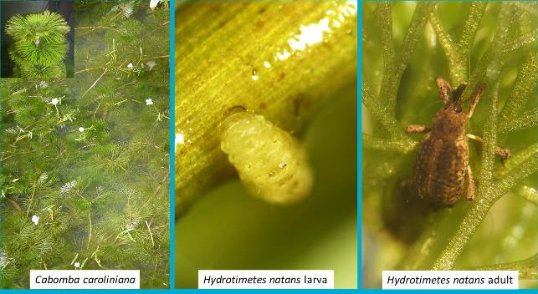
Application to release the cabomba weevil Hydrotimetes natans for the biological control of Cabomba caroliniana in Australia | i
Australia’s National Science Agency

Application to release the cabomba weevil Hydrotimetes natans for the biological control of Cabomba caroliniana in Australia
21 May 2020

Contents

Acknowledgments vi
Executive summary vii
- Information on the target species, Cabomba caroliniana 10
  - Taxonomy 10
  - Description 12
  - Distribution 13
  - Ecology 15
  - Importance 16
  - Current control methods 17
  - Information on all other relevant Commonwealth, State, Territory legislative controls of the target species 18
  - Stakeholder consultation 18
  - When the target species was approved for biological control 19
  - History of biological control of C. caroliniana 19
- Information on the potential agent, Hydrotimetes natans 20
  - Taxonomy 20
  - Description 20
  - Brief biology of the agent 21
  - Native range of the agent 23
  - Related species to the agent and a summary of their host range 23
  - The proposed source of the agent 23
  - Possible interactions with existing biological control programs (of same or related targets, and other targets) 24
  - The agent’s potential for control of the target 24
  - Details of the quarantine facility and methods of containment 26
  - When, when and how initial release will be made 27
  - Non-target organisms at risk 27
- Host-specificity testing 28
  - Introduction 28
  - Surveys of plant use under natural conditions in the native range 28
  - Laboratory host-specificity tests 29
  - Discussion 42
- References 44
Copies of any references referred to in the application 48
- Appendices 49
Appendix I. Members of the Nymphaeales in Australia, their distribution, origin status and economic importance 49
Appendix II. Source of test plant species used in the host-specificity testing of
Hydrotimetes natans and their locations 52
Appendix III. R Code and results of statistical analyses 53
Appendix IV. Raw data for comprehensive laboratory host-specificity testing 59
Appendix V. Summary statistics of logistic regression analyses performed with Cabomba caroliniana as a reference species 63

Figures
Figure 1 Phylogeny indicating the relationships with the order Nymphaeales and its relationships to other angiosperm groups (Stevens 2001 onwards; Chase et al. 2016) 11
Figure 2 Native range of Brasenia schreberi (Source: Royal Botanic Gardens, Kew; http://plantsoftheworld.online/taxon/urn:lsid:ipni.org:names:605270-1#distribution-map) 12
Figure 3 Cabomba caroliniana: (A) Oppositely arranged feathery fan-shaped leaves, (B) elongate floating leaves on distal end of the plant, (C) thin and long stems submerged, and (D) white flower with yellow centre (Source: CSIRO) 13
Figure 4 Global distribution of Cabomba caroliniana (Source: https://www.gbif.org/occurrence/map?taxon_key=2882443) 14
Figure 5 (A) Current distribution of Cabomba caroliniana in Australia (source: Atlas of Living Australia), (B) Potential distribution represented as Ecoclimatic index (EI) with temperature parameters derived from the growth experiment and stress parameters derived from the global distribution of C. caroliniana (Kriticos et al. unpublished). Redder colours indicating areas of greater climatic suitability for C. caroliniana. The masked areas do not present perennial water bodies based on National Surface Water Information (https://www.ga.gov.au/scientific- topics/national-location-information/national-surface-water-information), and hence unlikely to be invaded by C. caroliniana, (C) infestation in Lake MacDonald, Queensland (Source: CSIRO),
(D) infestation in Siebs Dam, Cooroy, Queensland (Source: CSIRO) 15
Figure 6 Life stages of Hydrotimetes natans (A) Egg laid singly on leaf, (B) first instar larvae, (C) mature larva (D) pupae, (E) mature pupae with adult ready for eclosion, and (F) Adult (Source: CSIRO) 21
Figure 7 Lifecycle of Hydrotimetes natans (Source: CSIRO) 23
Figure 8 Hydrotimetes natans larval damage on Cabomba caroliniana (A) tunnelling of leaves by early instar larvae, (B) larva inside the stem tunnelling, (C) late instar larva and tunnelling damage, (D & E) tunnelling visible through naked eye, (F) tissue decay along the tunnelling (source for all photos: CSIRO) 25
Figure 9 Regions of Australia that match the climate of the area in the native range (Iberá wetlands, Argentina) where H. natans was sourced to establish the quarantine colony according to the climate matching model developed. The highest climate matches are represented by red squares, and the moderate and lowest matches are represented by orange and yellow respectively (CMI – Composite Match Index) 26
Figure 10 Surveys for occurrence of Hydrotimetes natans on non-target aquatic plants cooccurring in the native range (A&B) Survey in Iberá Wetlands, Corrientes, Argentina, (C&D) Pilar wet grasslands, Paraguay (Source: CSIRO) 29
Figure 11 Molecular phylogeny of Nymphaeales with the taxonomic relationships between C. caroliniana and other non-target species used in the host-specificity testing of Hydrotimetes natans shown in boxes. Australian native species are indicated by an asterisk (Stevens 2001 onwards; Chase et al. 2016) 30

Figure 12 Test of larval development of Hydrotimetes natans leaf discs or cut plant material in the laboratory in Argentina. (A) Nymphaea prolifera leaf discs, (B & C) Victoria cruziana leaf discs and detached whole leaf of V. cruziana , (D) Cabomba caroliniana sprig in a container: larvae can be seen curled around the stems, and (E) A H. natans larva can be observed in the process of entering a C. caroliniana stem (Source: FuEDEI) 33
Figure 13 Host testing setup (A, B, C & D) Large food grade polypropylene crate with live plants in quarantine glasshouse, (E) Host testing setup of Trithuria sp. and (F) Setup of choice trials with Cabomba caroliniana and Brasenia schreberi (Source: CSIRO) 35
Figure 14 Observations made on the control Cabomba caroliniana at the end of each trial. (A) Adults recovered, (B) larvae exiting at the base of a plant, (C) Visible larval tunnelling on a stem and (D) live pupae (Source: CSIRO) 37
Figure 15 Hydrotimetes natans adult feeding damage on Cabomba caroliniana (CC) compared with that on non-target plant species in no-choice trials (BS – Brasenia schreberi, NAL – Nymphaea alba, NC – N. caerulea, NG – N. gigantea, NI – N. immutabilis, NM – N. mexicana, NP
– N. pubescens, NV – N. violacea, TA – Trithuria austinensis, TF – T. fitzgeraldii, TL – T. lanterna, TS – T. submersa). The error bar on each column corresponds to the standard error 39
Figure 16 Number of replicate choice trials performed with Cabomba caroliniana (CC) and Brasenia schreberi (BS) in which oviposition, larval development, pupation and lifecycle completion by Hydrotimetes natans was recorded 41

Tables
Table 1 Plant species tested# in Australia and Argentina as part of the risk assessment of Hydrotimetes natans, a candidate biological control agent for Cabomba caroliniana. Accessions of C. caroliniana from Lake MacDonald, QLD and Burringbar Creek, NSW were used as controls in tests 31
Table 2 Host-specificity testing of Hydrotimetes natans: number of replications tested in each type of trials for each non-target species from different families 36
Table 3 Number of replicates in which oviposition, larval development, pupation and lifecycle completion by Hydrotimetes natans were recorded on Cabomba caroliniana (CC) and non- target species in no-choice trails (BS – Brasenia schreberi, NAL – Nymphaea alba, NC – N. caerulea, NG – N. gigantea, NI – N. immutabilis, NM – N. mexicana, NP – N. pubescens, NV – N. violacea, TA – Trithuria austinensis, TF – T. fitzgeraldii, TL – T. lanterna, TS – T. submersa) 40
Table 4 One proportion z-test comparing proportion of successful oviposition, larval development, pupation and lifecycle completion by Hydrotimetes natans between Cabomba caroliniana and Brasenia schreberi 41

Acknowledgments

People associated with the preparation of this application are acknowledged.

Executive summary

Cabomba caroliniana (Cabombaceae) is a submerged aquatic weed of permanent and slow- moving freshwater bodies. This weed affects water quality, recreational activities and public safety, and is a Weed of National Significance. It has a wide distribution in Australia from Melbourne to Darwin and can grow in a range of climate conditions from monsoonal tropics to cold temperate environments.
The existing control options for C. caroliniana are either unfeasible or expensive. For instance, herbicides are highly restricted around public/potable water supplies and mechanical removal using machines is generally prohibitively expensive. The Australian Weed Committee (now subsumed under the Environment and Invasives Committee) endorsed C. caroliniana as a target for biological control in Australia in 2005. Biological control (biocontrol) may be the only viable option for management of C. caroliniana given the difficulty with existing control options and their safety to use in water supplying dams.
The cabomba weevil, Hydrotimetes natans has been identified as a potential biocontrol agent for
C. caroliniana. We imported H. natans from Paraguay and Argentina under quarantine conditions in Australia to conduct comprehensive host-specificity testing on a broad range of plant species, including native Australian species, selected based on their phylogenetic relationships to the target weed. A total of 17 plant species from the families Cabombaceae, Nymphaeaceae and Hydatellaceae were tested − 14 in the laboratory in Australia and 3 in the laboratory in Argentina. In addition, field host-specificity assessments were performed at four sites in Argentina and Paraguay where the weevil was recorded on C. caroliniana. Co-occurring non-target aquatic species with C. caroliniana (e.g. Egeria najas, Nymphoides indica, Nymphaea prolifera, Salvinia minima and Ludwigia grandiflora) were examined for the presence of H. natans and any sign of feeding by larvae and adults.
Results from field observations and laboratory trials are briefly outlined below:
Field host-specificity: In the field in Argentina and Paraguay, observations revealed the presence of H. natans almost exclusively on C. caroliniana except for a single H. natans adult observed on N. prolifera adjacent to C. caroliniana. However, no feeding on N. prolifera was noticed which suggested that it was likely a casual occurrence.
Adult and larval feeding on leaf discs/sprigs: Feeding lesions caused by adult H. natans were observed on C. caroliniana, Brasenia schreberi, Nymphaea caerulea, N. gigantea, N. nouchali, N. prolifera and Victoria cruziana but not on N. mexicana and C. caroliniana var flavida. Most of the feeding lesions on non-target plants were superficial and exploratory. Larval feeding trials on C. caroliniana var. flavida, Nymphaea prolifera, N. caerulea and V. cruziana demonstrated larvae are highly specific and unable to feed on non-target species. All larvae on non-target species died within four to five days of exposure to these species.
No-choice trials: Larval feeding, oviposition and larval development to adult occurred consistently on C. caroliniana. No oviposition occurred on any of the Nymphaea or Trithuria test plant species and hence no progeny development was observed. In B. schreberi, oviposition occurred on four of

the six replicates tested. Among the four replicates that showed evidence of oviposition, larval feeding was noticed on three replicates, and pupation and adult emergence was observed in only one replicate.
Choice and continuation trials: Choice trials with C. caroliniana and B. schreberi suggested partial lifecycle development of H. natans on B. schreberi. Oviposition and larval development were observed on two of the five replicates tested. However, larval development to pupation was observed on only one replicate of B. schreberi with two pupae recorded. Only one of the two pupae metamorphosed into an adult, which however died soon after emergence, and the other pupa did not emerge as adult. In continuation trials, despite its exposure for 150 days (a duration equivalent to three generations of the weevil on C. caroliniana), B. schreberi did not sustain a H. natans population. Only one pupa was observed on one replicate of B. schreberi despite egg laying observed in three replicates. In contrast, a healthy and reproducing colony of H. natans was maintained on C. caroliniana, which has yielded five generations in the eight-month period between April 2019 to December 2019, the same period over which the laboratory testing was undertaken.
In summary, results from a suite of laboratory-based host-specificity testing in the native range and in a quarantine glasshouse and laboratory in Australia, as well as field observations in the native range demonstrated that H. natans has a high degree of specificity towards the target weed
C. caroliniana. Only the native species, B. schreberi supported partial development of H. natans, with the insect completing its lifecycle in only one replicate and F1 adults neither surviving nor developing through to the F2 generation. In a subsequent continuation trial with this species, H. natans could not sustain its population beyond the F1 generation of offspring. Further, the feeding damage caused by H. natans (adults and larvae) on B. schreberi was minimal compared to that occurring on C. caroliniana. Based on the series of trials undertaken in this study, we conclude that the level of risk H. natans poses to non-target native and introduced species in Australia is negligible and that H. natans will potentially be an effective biological control agent for C. caroliniana.
The decision tree presented below shows the rationale behind the series of trials undertaken in this study and summarizes the level of risk likely to occur for each test plant species.

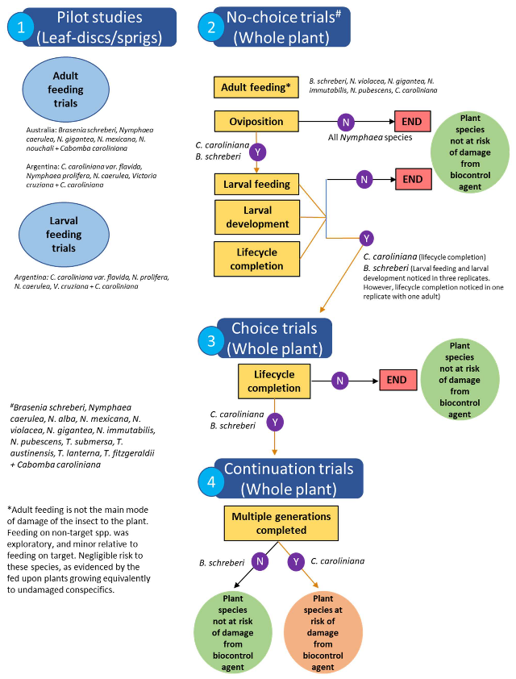

Decision tree used to determine the types of host-specificity tests to be undertaken for Hydrotimetes natans for the target species, Cabomba caroliniana. The types of tests carried out, the outcome of host plant testing on each non-target plant species and conclusions made based on outcome is shown above

- Information on the target species, Cabomba caroliniana

Taxonomy

Botanical name

Cabomba caroliniana A. Gray

Common name

The plant is usually referred to as cabomba or water fanwort in Australia, as Carolina watershield, water fanwort, Washington grass or fish grass in the USA, and cabomba or water nettle in South America.

Relationships

Cabomba caroliniana is a member of the Order Nymphaeales, a basal clade of angiosperms, which is distantly related to the rest of the angiosperm clade (Saarela et al. 2007; Iles et al. 2014). There are only two species in the Cabombaceae family in Australia; one being C. caroliniana, the other in another genus Brasenia schreberi J.F. Gmel (watershield). Other families in the Nymphaeales are Nymphaeaceae (the water lilies) which is comprised of 23 species of Nymphaea L. and the Hydatellaceae which is comprised of 10 species of its only genus Trithuria Hook.f. in Australia (Jacobs & Porter 2007; Löhne et al. 2008; Sokoloff et al. 2011) (Figure 1).

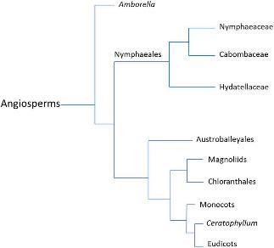

Figure 1 Phylogeny indicating the relationships with the order Nymphaeales and its relationships to other angiosperm groups (Stevens 2001 onwards; Chase et al. 2016)

Close relatives native in Australia

Cabombaceae contains only two genera in Australia, Cabomba Aubl. (the genus of the target weed, C. caroliniana) and Brasenia Schreb (Appendix I). Brasenia is a monotypic genus with only one species B. schreberi. Brasenia schreberi is distributed across all continents (eastern Asia, Australia, Africa, the West Indies, and South, Central, and North America) except Europe (extinct) and Antarctica (Drzymulska 2018). It occurs in shallow lakes and ponds, as well as slow moving streams and has a range extending from tropical to nearly boreal habitats but is typically more abundant at higher latitudes (Drzymulska 2018). It is considered native to north America, central America, Africa, Asia and Australia (Figure 2). In Australia, B. schreberi has a scattered/localized distribution in Queensland (QLD), VIC (Victoria) and NSW (New South Wales), tending to occur in greater abundance in temperate water bodies (Orgaard 1991).

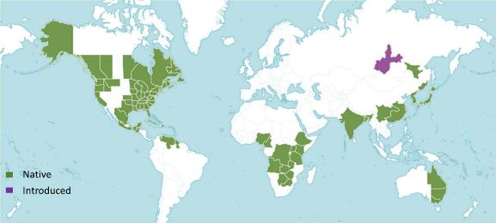

Figure 2 Native range of Brasenia schreberi (Source: Royal Botanic Gardens, Kew; http://plantsoftheworld.online/taxon/urn:lsid:ipni.org:names:605270-1#distribution-map)
Within the family Nymphaeaceae, the only genus present in Australia is Nymphaea (Appendix I). Plants of this genus are known commonly as water lilies, and are present in temperate, subtropical, and tropical regions in all continents except Antarctica (Heslop-Harrison 1955).
Numerous hybrids and cultivars have been developed and are popular as ornamentals in water gardens. In Australia, several species (e.g. N. mexicana Zucc., N. caerulea Sav., N. alba L.) are regarded as environmental weeds (Hussey et al. 2007).
The Hydatellaceae family is only represented by the genus Trithuria. Trithuria are diminutive, moss-like, subaquatic plants; most of the Trithuria are native to Australia, but some are native to India (T. konkanensis S.R. Yadav & Janarth) and New Zealand (T. inconspicua Cheeseman). In Australia, Trithuria is found in Western Australia (WA), Northern Territory (NT), QLD, South Australia (SA), VIC, some parts of NSW and Tasmania (TAS) (Atlas of Living Australia, 2020a). Some Trithuria species are endemic to certain localities and listed as endangered or threatened species (Appendix I). For example, T. submersa Hook.f. occurs in WA, SA, VIC and NSW, and is listed as a threatened species. In Tasmania, T. submersa occurs in marshy habitat in the Midlands, Central Highlands and the north-east of the State. Trithuria occidentalis Benth. is endemic and strictly confined to Ellenbrook and possibly to Upper Swan in WA and is ranked as a critically endangered species.

Description
Cabomba caroliniana is a perennial submerged aquatic macrophyte. Leaves are oppositely arranged and are finely divided, forming feathery, fan-shaped structures (Figure 3A). It has small, elongate floating leaves at distal ends of the plant usually borne on flowering branches (Figure 3B). Slender, round or slightly compressed stems are usually 2–4 mm in diameter and about 1–2 m long but may be up to 10 m (Figure 3C). The young stems are usually pubescent with short white or rust-coloured hairs. Bisexual and protogynous (having female reproductive organs come to maturity before the male) long-stemmed flowers are white in colour and borne just above the water surface on pubescent stalks (Figure 3D). The sepals and petals are about 1.25 cm across. The

petals are auriculate at their bases, and obovate in shape. Roots arise from the rhizome and adventitious roots are often produced at lower stem nodes (Wilson et al. 2007).
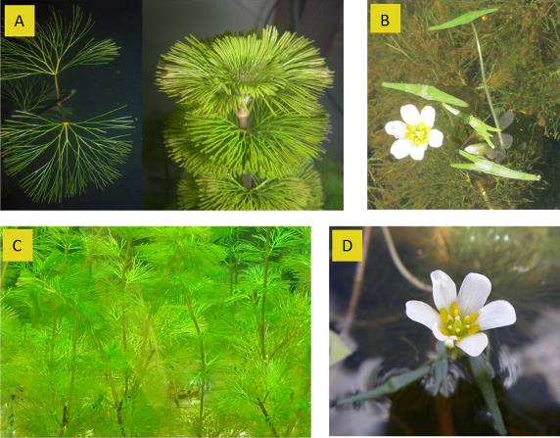
Figure 3 Cabomba caroliniana: (A) Oppositely arranged feathery fan-shaped leaves, (B) elongate floating leaves on distal end of the plant, (C) thin and long stems submerged, and (D) white flower with yellow centre (Source: CSIRO).

Distribution

Native range

Cabomba caroliniana is native to South America occurring in southern Brazil, Uruguay, Paraguay and north-eastern Argentina at the Parana river floodplain in South America (Figure 4). Occurrence in the southeast coast of Brazil is considered as part of the native range (Ørgaard 1991). Cabomba caroliniana was considered native to the south-eastern United States, however, the disjunct nature of this population from the native range population suggests that it was perhaps introduced and subsequently naturalized in the United States (Mackey & Swarbrick 1997).

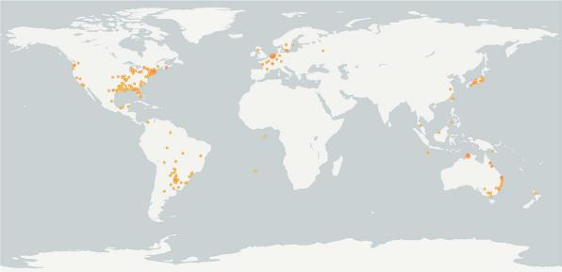

Figure 4 Global distribution of Cabomba caroliniana (Source: https://www.gbif.org/occurrence/map?taxon_key=2882443)

Australian range

The current distribution of C. caroliniana in Australia extends along the east coast from the Atherton Tablelands to Melbourne, and there are localized infestations near Darwin (Figure 5A). The potential distribution in Australia is much greater than the current distribution. Most of coastal Australia, except for the north-west, is predicted to be excellent habitat for C. caroliniana based on CLIMEX model (Mackey 1996). Recently, we developed a model using an Ecoclimatic Index (based on minimum and maximum temperature) in CLIMEX (Kriticos et al. 2015), which predicted that much of coastal Australia would be highly suitable for C. caroliniana establishment (Figure 5B); this is similar to previous CLIMEX predictions. The Ecoclimatic Index map shows the suitability of Australian regions where permanent water bodies are present. This map includes all perennial water bodies, including those of marginal suitability in terms of water quality for C. caroliniana, and should be viewed as an outer limit of projected distribution of C. caroliniana (Figure 5B).
In Australia, most C. caroliniana infestations occur in southern QLD and the northern NSW hinterland. In QLD it occurs in shallow, permanently flowing creeks and deep, slow-flowing pools of coastal river systems. The largest and most dense infestations occur in Lake MacDonald and Lake Kurwongbah on the Sunshine Coast, but significant infestations also occur in northern QLD (Figure 5C & D).
Cabomba caroliniana is also growing in numerous creeks and river systems on the NSW North Coast and in lakes in central VIC. In NSW, C. caroliniana in commonly recorded in Grafton, and occasional and localised populations were recorded along the coast from Grafton to Sydney. At Lake Nagambie in VIC, the infestation has spread and covers about 50–60 ha. Cabomba caroliniana has also been the subject of an expensive eradication campaign at Marlow Lagoon at Palmerston in the NT. Two major infestations have been recorded in the NT. The first at Marlow Lagoon, Palmerston, was successfully eradicated in 2003. A second, and persisting, infestation was located in an isolated section of Darwin River in 2004. The eradication effort continues in the NT.

Cabomba caroliniana infestations have not yet been found in WA, SA, TAS or the ACT. However, based on climate and the availability of suitable freshwater bodies, it could easily spread beyond its current distribution, especially across southern and eastern Australia. It can potentially infest waterways from Cape York to Hobart and from Sydney to Melbourne, Perth and the Ord River irrigation systems. Most freshwater floodplains, billabongs and water reservoirs in the NT are potentially susceptible to C. caroliniana invasion (Department of Land Resource Management, 2015).
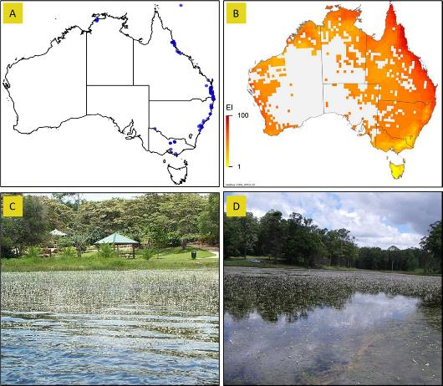

Figure 5 (A) Current distribution of Cabomba caroliniana in Australia (source: Atlas of Living Australia), (B) Potential distribution represented as Ecoclimatic index (EI) with temperature parameters derived from the growth experiment and stress parameters derived from the global distribution of C. caroliniana (Kriticos et al. unpublished). Redder colours indicating areas of greater climatic suitability for C. caroliniana. The masked areas do not present perennial water bodies based on National Surface Water Information (https://www.ga.gov.au/scientific-topics/national-location-information/national-surface-water-information), and hence unlikely to be invaded by C. caroliniana, (C) infestation in Lake MacDonald, Queensland (Source: CSIRO), (D) infestation in Siebs Dam, Cooroy, Queensland (Source: CSIRO).

Ecology
Cabomba caroliniana grows well in standing water and can grow in slow flowing streams as well. It is often found along the margins of deeper water. It can grow at the rate of 5 cm a day under ideal conditions and can adapt to and survive under a wide range of environmental conditions (Tarver and Sanders 1977, Sanders 1979). In its native range, C. caroliniana prefers habitats with slow moving water and a thick substrate of organic matter. In Australia, it has been found growing in shallow reservoirs with silt substrates (Garraty et al.1996; Mackey and Swarbrick 1997; Diatloff

and Anderson 1995). Cabomba caroliniana is not usually found on sand or hard substrates (Sheldon 1994) and if so, grows with reduced vigour (Garraty et al. 1996; Mackey and Swarbrick 1997).
Sexual reproduction of C. caroliniana is not well understood and probably a secondary mode of reproduction. There is much uncertainty surrounding flowering, seed production, seed viability and germination. In north QLD C. caroliniana flowers continuously throughout the year but it is unknown if flowers set seeds or not. Seeds and seedlings have been found near Darwin (NT), and it was hypothesised that only the populations in Darwin (NT) reproduce by seed (Schooler et al.
2006; Dugdale et al. 2013). However, a QLD population was recently observed to set seeds in the laboratory; germination and viability of these seeds are being studied (TO Bickel pers. comm.).

Importance

Beneficial aspects

Cabomba caroliniana has no beneficial aspects. It was used as an aquarium plant and sold through the aquarium and nursery industry. However, it is prohibited now in all states and territories (except VIC, where it is classified as a high-risk environmental weed) because of its invasiveness.

Detrimental aspects

Cabomba caroliniana is a Weed of National Significance and regarded as one of the worst weeds in Australia (Thorpe & Lynch 2000). It forms dense monocultures in aquatic ecosystems, which reduces light availability through the water column to native species. Extensive infestations have been shown to displace submerged vegetation, including native species such as Vallisneria nana R.Br., Hydrilla verticillata (L.f.) Royle, Najas spp., Potamogeton spp. and Ceratophyllum spp. in QLD (Mackey and Swarbrick 1997). Cabomba caroliniana reduces the water holding capacity of dams supplying drinking water and water for agriculture. It also reduces water quality through discolouration and tainting and changes the nutrient profile, which is detrimental to aquatic fauna (Mackey and Swarbrick 1997). Dense infestations of C. caroliniana are associated with declines of platypus and water rat populations in northern QLD and Mary River Cod populations in Lake Macdonald, QLD (GHD, 2008). Elsewhere in Canada, the United States and China, C. caroliniana is suspected to negatively affect fish and invertebrate populations in addition to displacing native vegetation (Mackey & Swarbrick 1997; Wilson et al. 2007; Hogsden et al. 2007).
Recreational activities are also negatively affected by C. caroliniana, making swimming activities unsafe and creating a workplace health and safety issue for individuals working in and around water bodies infested by the weed (Mackey 1996; Mackey & Swarbrick 1997). The tourism potential of lakes infested with C. caroliniana (fishing, paddling and boating) and land values of properties surrounding infestations are greatly reduced (Mackey 1996; Mackey & Swarbrick 1997; Schooler et al. 2009).
The cost of managing C. caroliniana is substantial because it invades freshwater and potable water systems, where the use of chemical herbicides is restricted due to risks of non-target impacts.

Current control methods

Mechanical control

Using harvesters to clear thick mats of C. caroliniana can temporarily manage this weed but repeated removal is often necessary as plants grow quickly after removal. Such mechanical removal is expensive and hence only used in recreational areas to improve public access. For example, the cost of managing C. caroliniana using mechanical removal in infested dams in QLD is estimated to be more than $250,000/year (SEQ Water, pers. comm). Further, mechanical removal should be practiced with caution because it can potentially spread the weed beyond the infested water body, as C. caroliniana can easily break into stem fragments when disturbed and recolonise the treated area or invade adjacent non-infested areas. Hand pulling by divers is also practiced in Lake Macdonald, QLD. While it is suitable method for isolated plants and small areas, regrowth in the cleared area has been noticed to occur within two weeks.

Drying or shading

Shading created by floating blankets made from builders’ black plastic has been suggested as a control option for C. caroliniana (Schooler 2008). However, shading needs to be in place for a long time (3 or 4 months) and is feasible only in small infestations like farm dams. The cost of this management tactic is prohibitive for large infestations.

Chemical control

Several herbicides (e.g. endothall, 2,4-D, 2,3,5-T, Fenoprop, diquat) have been tested and found to kill C. caroliniana along with other aquatic weeds. In Ewen Maddock Dam in south-east QLD, 2,4-D n-butyl ester plus diatomaceous earth mixed at 1 part to 20 parts of water, injected 2 m below the water surface (final concentration of 10 ppm clay/2,4-D active ingredient) has been found to provide effective control of C. caroliniana (Diatloff and Anderson 1995). In QLD, application of 2 ppm (2 mg/L) of carfentrazone-ethyl over/into the water is also recommended for controlling C. caroliniana. It is noteworthy that herbicides are difficult to apply to submerged plants, re- treatment is often necessary to maintain the control and herbicide use is highly restricted in potable water systems (Madsen 1996).

Drawdown

Lowering of the water level (drawdown) to expose stems and leaves of C. caroliniana is effective in drying out the weed. In combination with herbicides and shading, draw down can be effective to manage C. caroliniana in smaller water bodies. However, drawdown needs to be in place for several months and is not suitable during the wet season or for large water bodies.

Information on all other relevant Commonwealth, State, Territory legislative controls of the target species
Cabomba caroliniana is prohibited entry to Australia for the end use of seeds for sowing or nursery stock (BICON 2020). It is prohibited in all states and territories. In VIC, it has been declared a noxious weed under the Catchment and Land Protection Act 1994; movement and sale are prohibited anywhere in the state. In the ACT, C. caroliniana is a class 1 notifiable pest plant and class 4 prohibited pest plant under the Pest Plants and Animals Act 2005. It is on the potential pest plant list and is under ongoing monitoring; its importation, propagation and supply are prohibited in the ACT. In NSW, it is classified among ‘priority weeds’ under the Biosecurity Act 2015; restrictions on trade and movement apply to all parts of the plant including cuts, cultivars and hybrids. It must not be sold anywhere in NSW, and people that buy or sell are committing an offence under the Biosecurity Act 2015 that carries large penalties. In QLD, C. caroliniana is a restricted invasive plant under the Biosecurity Act 2014. Under the general biosecurity obligation, everyone is responsible to take all reasonable and practical steps to minimise the risks associated with C. caroliniana in QLD and not to do anything that might make the risks worse. It is not permitted to be sold or released into the environment without a permit (BQ, 2016).
Cabomba caroliniana is an eradication target in all areas of NT (Class A) and is not to be introduced to any areas (Class C) under section 7 of the Weeds Management Act 2001. Eradication is targeted on small infestations where feasible. It is illegal to transport, sell, buy or propagate C. caroliniana plants or seeds in NT. In WA, it is classified as a Declared Pest, Prohibited -s12 under the Biosecurity and Agriculture Management Act 2007; may only be imported and kept subject to permits. Permit conditions applicable to some species may only be appropriate or available to research organisations or similarly secure institutions. Introduction or movement and supply or advertising supply are prohibited, and plants are to be eradicated from part or all of WA. In SA, C. caroliniana is declared in category 1 under the Natural Resources Management Act 2004. The movement or transport of the plant on a public road by itself or as a contaminant, its entry to SA, or sale by itself or as a contaminant are prohibited. Notification of infestations is necessary to ensure these are destroyed. Landowners are required to destroy any C. caroliniana plants growing on their properties (Declared Plant Policy 2004). In TAS, C. caroliniana is a Declared weed under the Weed Management Act 1999; importation, sale, distribution, movement and storage are prohibited; plants/infestations are to be reduced, eradicated or restricted. In VIC, this weed is classified as a high-risk environmental weed (White et al. 2018) and declared a noxious weed (Agriculture Victoria 2019).

Stakeholder consultation
Cabomba caroliniana has been traded by aquarium nurseries previously in Australia but now it is declared as either a prohibited or noxious weed throughout Australia. Aquarium traders are aware of the legal status of the weed in their respective states and not selling C. caroliniana. It was clear from consultations with aquarium traders that C. caroliniana is not a preferred aquarium plant and hence there is no trade implications because the weed is under active management across the nation.

When the target species was approved for biological control
The Australian Weeds Committee (now subsumed under the Environment and Invasives Committee) endorsed C. caroliniana as a target for biological control in Australia in 2005 (https://weeds.ala.org.au/target.html).

  - History of biological control of C. caroliniana
No agents have been released in Australia for the biological control of C. caroliniana thus far. In 2004, CSIRO and the USDA-ARS South American Biological Control Laboratory (currently, Fundación para el Estudio de Especies Invasivas (FuEDEI)) Hurlingham, Argentina, began surveys for natural enemies of C. caroliniana in South America. Three candidate agents; the cabomba weevil Hydrotimetes natans Kolbe, and the moth species Paracles sp. and Paraponyx diminutalis (Snellen) were prioritized for further investigation. Paracles sp. and P. diminutalis were rejected because of non-target feeding on other aquatic plants in laboratory no-choice and preference tests conducted in Argentina (Schooler et al. 2012).
Preliminary no-choice feeding and oviposition tests with H. natans on Egeria densa Planch., Ceratophyllum demersum L. and Myriophyllum aquaticum (Vell.) Verdc. were performed under laboratory conditions in Argentina. Eggs and several feeding punctures were found on C. caroliniana tips during these tests, but none were found on the other species (Cabrera-Walsh et al. 2011). Species cooccurring with C. caroliniana in the field in the native; E. densa, E. naias Planch., Najas sp. L., Cabomba haynesii Wiersema, Nymphoides indica (L.) Kuntze, Potamogeton illinoensis Morong and P. gayi A.Benn, C. demersum L., Urticularia platensis Speg. and U. foliosa L. were also surveyed for presence of H. natans. Hydrotimetes natans was recorded only on C. caroliniana and not on any other species (Cabrera-Walsh et al. 2011). These native range studies demonstrated that H. natans was host specific to C. caroliniana. Based on these field observations and results from preliminary laboratory tests, H. natans was imported into quarantine in Australia for further testing but rearing of the weevil was not successful, and the project was put on hold in 2006.

Information on the potential agent,
Hydrotimetes natans

Hydrotimetes natans is native to South America and is observed to persist solely on C. caroliniana in its native range (Cabrera-Walsh et al. 2011). Adults feed on the tips and stems of the plant, causing only limited damage to the plant. Larvae are stem-miners that can cause considerable damage to the stems of the plant and tissue necrosis. Adult weevils are dark brown dorsally with light brown-cream venters and are around 4.6mm in length. They spend the majority of their time clinging to the submerged parts of the plant, although they are observed often in nature resting or mating on the flowers.

Taxonomy
Order: Coleoptera
Tribe: Bagoini
Family: Curculionidae
Subfamily: Erirhininae
Genus: Hydrotimetes
Species: natans

Description
The Erirhininae subfamily, to which H. natans belongs, has the following features (Kuschel, 1971). Aedeagus: the aedeagal body frequently divided into a dorsal and a ventral plate by a lateral membrane (as in Orthoceri or primitive weevils). Apodemes are broad and long, usually with a bifurcation at base, whose dorsal branch frequently fused with the opposite one thus forming a dorsal bridge or arch; this bridge separates from or fused to the median dorsal portion of the aedeagal body. These features that are usually a characteristic of the Orthoceri families (and Rhynchophorinae) show that Erirhininae share most characters of the last abdominal segments and genitalia of the males with the Orthoceri families. Tegmen: very large, nearly as long as or longer than aedeagus (including apodemes). Apodeme always long and broad. Ring strongly proclinate in lateral aspect. Parameres often very large and fringed with abundant long hairs (as in Orthoceri), seldom somewhat reduced or even absent. Tergite 8: hidden under to well exposed beyond tergite 7. Sternite 8: often similar to that of the females in that the median apodeme is present in a number of Erirhinine genera as in many Orthoceri weevils. Tergite 9: supposedly absent as in all Curculionidae. A detailed description of H. natans is provided by Kolbe (1911; in German).

Brief biology of the agent
Female H. natans lay eggs singly near the apical tip of the plant stem; oviposition typically occurs on the first division of foliage from the petiole. Eggs have been occasionally also observed oviposited closer to the tips of the foliage, in the petiole itself and once in the floating leaf associated with a flower. Eggs are usually oviposited in a small divot in the plant tissue so that they are around 50% exposed. But this divot can be shallower, so that the egg is more exposed with a thin layer of plant tissue covering the egg, or deeper (Figure 6A). Eggs are shaped like elongate capsules and are creamy in colour, with a length of 855.34 ± 50.17 µm (mean ± SD) and a width of
292.24 ± 25.51µm (mean ± SD). Eggs hatch about 6 days after oviposition (Kumaran et al. unpublished).
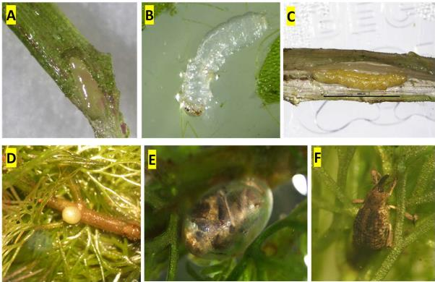
Figure 6 Life stages of Hydrotimetes natans (A) Egg laid singly on leaf, (B) first instar larvae, (C) mature larva (D) pupae, (E) mature pupae with adult ready for eclosion, and (F) Adult (Source: CSIRO)
The larval phase of H. natans lasts for 25-27 days. Larval head capsule widths have three distinct sizes, indicating three larval instar stages. Larvae have an average head capsule width of 190.31 ± 15.68µm (mean±SD), 293.52 ± 16.07µm and 448.98 ± 25.00µm for first, second and third instar, respectively (Kumaran et al. unpublished). First instar larvae are usually found feeding in tunnels in the foliage and petioles of the plant but eventually transition into the main stem. First instar larvae are found as early as 7 days and as late as 24 days after plants are exposed to adults (although only one first instar larva has been found as late as day 24 in our observations). Larvae have a translucent body immediately after hatching from the egg (Figure 6B), which gradually becomes a creamy white colour as they feed. Second instar larvae can be difficult to distinguish morphologically from late first instar larvae but are only found in the main stem of the plant from day 17 to day 29 of development. Third instar larvae are always found in the main stem of the plant from day 18 to day 32 of development. As they develop, their body transitions from a

creamy white to a yellow or green colour and becomes more scarabaeiform (grub shape) as they near pupation (Figure 6C). Prepupae then exit the stem to pupate at a node near the apical tip of the plant (Figure 5D). Pupae turn into darker colour as adults develop (Figure 6E) and adult emergence ensues (Figure 6F).
Larval feeding commences immediately after egg-hatch. As eggs are partially sunken into the plant tissue at oviposition, larvae perhaps chew through the end of their egg case directly into their first tunnel in the plant tissue. First instar larvae feed through the foliage and petiole where their egg was laid, and tunnel through the main stem as they develop into late instar. Their tunnelling causes heavy damage to the foliage and petiole, which is easily observable under a dissecting microscope. Once larvae move into the main stem of the plant, external observations of tunnelling become difficult until they reach third instar. Necrosis of the main stem can be seen by dissecting the plant. Larvae show no preference for which direction they tunnel in the main stem and numerous entry/exit holes are observed on the stem, suggesting that larvae readily exit their tunnels and begin new ones when necessary. Multiple larvae of different instars have been observed feeding in the same section of stem. The presence of larval exuviae within the tunnels suggests that larval moulting occurs within feeding tunnels. Third instar larvae in their feeding tunnels are externally visible as an elongate creamy patch in the main stem.
The average time from oviposition to pupation in our culture has been 33.8 ± 5.8 days, with a further 14.3 ± 2.7 days on average for pupal developmental before adult eclosion (Kumaran et al. unpublished). The average duration of the lifecycle from oviposition to adult emergence has been
46.5 ± 4.4 days (Figure 7). Larval feeding is the principal mode by which the insect damages the plant. Adult feeding, observable through a dissection microscope, is usually focussed on the petioles at the apical growing tip of the plant. Adults produce a single, deep feeding hole each time they feed as they insert their proboscis into the plant tissue. Necrosis is occasionally observed around these feeding scars, but adults seem to otherwise inflict little damage to the plant. Adults are able to persist for several weeks with little or no feeding, suggesting a slow metabolism. No sexual dimorphism has been observed thus far in adult H. natans, although females may be slightly larger than males.

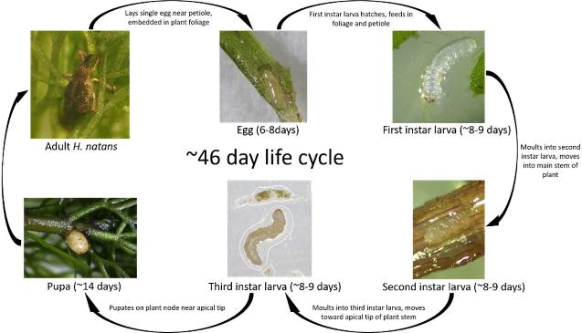

Figure 7 Lifecycle of Hydrotimetes natans (Source: CSIRO)

Native range of the agent
Hydrotimetes natans has only been recorded in field surveys from Argentina and Paraguay, but possibly occurs in neighbouring countries in South America.

Related species to the agent and a summary of their host range
The genus Hydrotimetes has three known species H. natans, H. striatus Hust. and H. tibialis Hust. The other two Hydrotimetes species were described by Hustache in 1926 (http://insecta.pro/taxonomy/195575), but their host records are unknown. Other genera in the Erirhininae are restricted to aquatic plants or are endophagous in roots, stems, leaves, and fruits (Kuschel 1971). Notable species of Erirhininae include the rice weevil Lissorhoptrus oryzophilus Kuschel which infests rice crops, and a range of existing or potential biocontrol agents of aquatic weeds: Cyrtobagous salviniae Calder & Sands and C. singularis Hust. on Salvinia; Neochetina eichhorniae Warner and N. bruchi Hust. on water hyacinth and Bagous hydrillae O'Brien on hydrilla.

The proposed source of the agent
The colony of H. natans in quarantine in Australia that has been used for host-specificity testing was established with adults sourced from Iberá wetlands, Corrientes province, Argentina and from wet grasslands in southern Paraguay. Cabomba caroliniana plants with H. natans collected were air dried in Berlese funnels to extract adult H. natans and the adults were hand carried into quarantine in Australia. The imported adult H. natans were identified and confirmed by Dr. Rolf Oberprieler (specialist on Coleoptera: Curculionidae, Australian National Insect Collection).

Voucher specimens have been deposited in the Australian National Insect Collection. Colonies of different genetic material will continue to be maintained until permission to release the insect is granted. Additional importations of H. natans from S. America may be required to incorporate more genetic diversity in the colony to overcome possible genetic bottlenecks.
Guillermo Cabrera Walsh, Director, FuEDEI is our key South American collaborator for the cabomba biological control project. His details are: Website: www.fuedei.org. Address: Bolívar 1559 (B1686EFA), Hurlingham, Buenos Aires, Argentina. Tel: 54-11-4662-0999 (ext. 107). Email: gcabrera@fuedei.org.

Possible interactions with existing biological control programs (of same or related targets, and other targets)
No biocontrol agent has been released in Australia for the biocontrol of C. caroliniana.

The agent’s potential for control of the target
Cabomba caroliniana larvae cause severe damage in the form of necrosis of stem tissue around larval tunnels (Figure 8). Under intense feeding, stems become disintegrated and detached from plants; these decaying stem fragments are not viable, thereby reducing the overall growth and biomass of the plant. This can have a significant effect on the reproduction and spread, as C. caroliniana reproduce through healthy stems detaching/fragmenting from the parent plant. Adult feeding is usually concentrated on the petioles at the apical growing tip of the plant. Localised necrosis was occasionally observed around these feeding scars, but otherwise adult feeding does not appear to have a major impact on the plant.

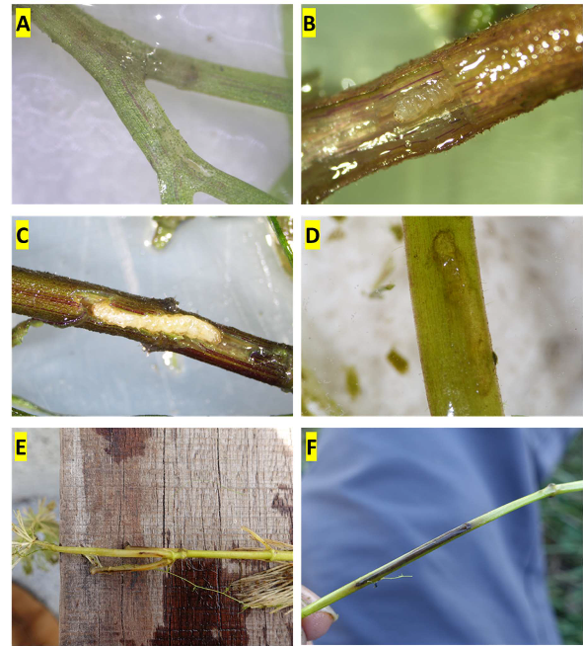

Figure 8 Hydrotimetes natans larval damage on Cabomba caroliniana (A) tunnelling of leaves by early instar larvae,
(B) larva inside the stem tunnelling, (C) late instar larva and tunnelling damage, (D & E) tunnelling visible through naked eye, (F) tissue decay along the tunnelling (source for all photos: CSIRO)
A climate matching model was developed using the Composite Match Index in CLIMEX (Kriticos et al. 2015) to predict regions in Australia that most closely match temperatures in the Iberá wetlands of Argentina where H. natans is abundant and was collected to establish our colony. The model suggests that regions in south-east QLD and northern NSW that have major infestations of
C. caroliniana should be highly suitable for H. natans (Figure 9). It must be noted however, that the model was developed using only the ambient temperature index in the native range and that other factors could affect establishment of H. natans after release. Water temperature, acidity and light penetrability are not taken into account in the model predictions (D Kriticos pers. comm.) and these characteristics of water bodies are believed to affect the abundance of H. natans in the native range.

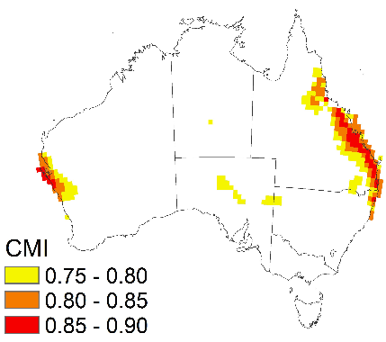

Figure 9 Regions of Australia that match the climate of the area in the native range (Iberá wetlands, Argentina) where H. natans was sourced to establish the quarantine colony according to the climate matching model developed. The highest climate matches are represented by red squares, and the moderate and lowest matches are represented by orange and yellow respectively (CMI – Composite Match Index)
Biocontrol of aquatic plants using specialist weevils as biological control agents, has a long legacy of success in weed biological control. Examples include significant control of Salvinia by C. salviniae, and control of water hyacinth by N. bruchi and N. eichorniae in Australia. For example, after the first release of C. salviniae on an infestation of Salvinia at Lake Moondarra, Mt Isa, Qld in June 1980, the weevils caused severe damage and significantly reduced the weed population within 15 months.

Details of the quarantine facility and methods of containment
Imported H. natans are being held within the Approved Arrangements. All the quarantine-based host- specificity tests were performed in this facility.
Containment and handling of all imported insects, including killing of required specimens, is being done according to the Department of Agriculture, Water and the Environment (DAWE) guidelines for Approved Arrangements. All staff are experienced and strictly follow the Standard Operating Procedures developed for the facility.

When, when and how initial release will be made

Release from quarantine

A protocol will be developed with entomologists from DAWE, for the removal of H. natans from quarantine. This will likely be similar to protocols developed for previous releases of similar aquatic weevils for weed biocontrol. Once approval for release is obtained, adults will be carefully inspected to ensure that no other associated organisms such as parasite or pathogen are taken from the quarantine. All requirements imposed by DAWE on the release permit will be followed. Once removed from quarantine, H. natans will be maintained on C. caroliniana in non-quarantine glasshouses while mass rearing protocols are being optimized.

Distribution in the field

Hydrotimetes natans will be released initially into Lake MacDonald and Lake Kurwongbah (QLD), where major infestations of C. caroliniana occur. It is expected that water asset managers (e.g. SEQ Water) and council groups (Noosa Landcare) will contribute to releases and distribution of H. natans. After initial releases in QLD, subsequent releases will be planned in NSW and NT should C. caroliniana infestations there require long term control and providing biocontrol is compatible with any other ongoing management activities already in place at those sites.

Non-target organisms at risk
See section 1.1.4. Close relatives native in Australia.

Host-specificity testing

Introduction
The host range of H. natans was explored by surveying non-target plants in the field in the native range at sites where C. caroliniana occurs and undertaking a series of laboratory host-specificity tests on non-target species in Argentina and Australia, including (i) pilot studies of adult feeding on leaf discs or cut sprigs; and (ii) comprehensive trials with whole plants to assess the life cycle development of H. natans. A total of 17 plant species from the Cabombaceae (including the target target (C. caroliniana)), Nymphaeaceae and Hydatellaceae families were included in host- specificity tests.

Surveys of plant use under natural conditions in the native range
Field surveys were undertaken in March and April 2018 to find sites with H. natans, study its biology and behavior on its host C. caroliniana, examine non-target plants for presence of H. natans and collect adults (Figure 10). Observations on the presence of H. natans and feeding damage on non-target plants were made at Iberá wetlands in Argentina and three other sites in Paraguay (Encarnación, San Ignacio and Pilar). Aquatic species co-occurring with C. caroliniana at these sites were: Egeria najas Planch., N. indica (L.) Kuntze, N. prolifera (Wiersema), Salvinia minima Baker and Ludwigia grandiflora (Michx.) Greuter & Burdet). Field surveys revealed that H. natans was primarily found on C. caroliniana, except for a single adult observed on N. prolifera on one occasion. However, no feeding damage on N. prolifera was noticed, suggesting that it was likely a casual occurrence of the insect on this plant. The other aquatic plants co-occurring with C. caroliniana at Iberá wetlands were N. jamesoniana Planch., L. peploides (Kunth) P.H.Raven, Utricularia spp., S. adnata D.Mitch., Eichhornia azurea (Swartz) Kunth, E. crassipes, Hydrocotyle ranunculoides L.f. and Potamogeton spp. While systematic examinations were not made on these species during the surveys, H. natans has not been recorded on any of them in the initial native range surveys made for natural enemies of C. caroliniana (see section 1.10).

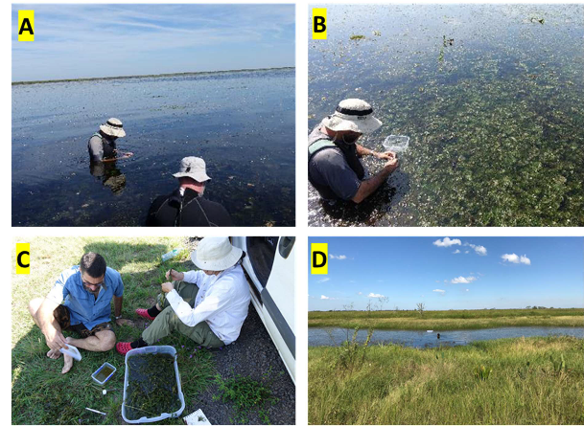

Figure 10 Surveys for occurrence of Hydrotimetes natans on non-target aquatic plants cooccurring in the native range (A&B) Survey in Iberá Wetlands, Corrientes, Argentina, (C&D) Pilar wet grasslands, Paraguay (Source: CSIRO)

Laboratory host-specificity tests

Test plant list

The test plant list was developed based on currently accepted phylogenetic information available in the literature (e.g. Löhne et al. 2008; Borsch et al. 2014) and on the most current angiosperm phylogeny (Chase et al. 2016; Puttick et al. 2020). Test plant species have been selected based on their phylogenetic relationship to C. caroliniana, according to the centrifugal phylogenetic method (Briese 2003, 2006; Gilbert et al. 2012; Wapshere, 1974). This method is underpinned by the evidence that specialist herbivores are evolutionarily more likely to feed on non-target species closely related to the target weed than those that are more distantly related. Within the phylogenetic/evolutionary framework, selection of representative test species placed an emphasis on native species, species of economic importance and those that are likely to overlap biogeographically with the target weed, where possible (Figure 11). As previously outlined in section 1.1.4, C. caroliniana belongs to the family Cabombaceae within the order Nymphaeales, a basal angiosperm order (Puttick et al. 2020). There are only two species in Cabombaceae in Australia; one being C. caroliniana, the other, in another genus, is B. schreberi. Brasenia is a monotypic genus and has a worldwide distribution (Figure 2) and is not endemic to Australia (Ørgaard 1991). The only other families in the Nymphaeales are Nymphaeaceae (the water lilies) and Hydatellaceae (Puttick et al. 2020). Representatives from all three families of Nymphaeales

(Cabombaceae, Nymphaeaceae and Hydatellaceae) present in Australia have been included for risk assessment of H. natans (Figure 11, Table 1).

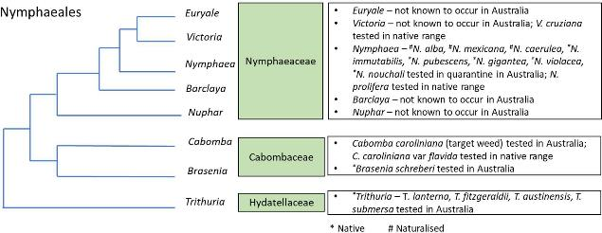

Figure 11 Molecular phylogeny of Nymphaeales with the taxonomic relationships between C. caroliniana and other non-target species used in the host-specificity testing of Hydrotimetes natans shown in boxes. Australian native species are indicated by an asterisk (Stevens 2001 onwards; Chase et al. 2016)

Table 1 Plant species tested# in Australia and Argentina as part of the risk assessment of Hydrotimetes natans, a candidate biological control agent for Cabomba caroliniana. Accessions of C. caroliniana from Lake MacDonald, QLD and Burringbar Creek, NSW were used as controls in tests

Family | Relationship to the target weed | Species | Status in Australia | Biogeography (overlap with C. caroliniana) | Test location
Cabombaceae | Same family | Brasenia schreberi | Native/non- endemic | Yes | Australia (quarantine)
 | Sub species | Cabomba caroliniana  var flavida | Not present in Australia | N/A | Argentina (native range)
Nymphaeaceae | Same order | Nymphaea species
 |  | Nymphaea alba | Exotic | Yes | Australia (quarantine)
 |  | Nymphaea caerulea | Exotic | Yes | Australia (quarantine)
 |  | Nymphaea gigantea | Native | Yes | Australia (quarantine)
 |  | Nymphaea immutabilis | Native | Yes | Australia (quarantine)
 |  | Nymphaea mexicana | Exotic | Yes | Australia (quarantine)
 |  | Nymphaea nouchali | Native | Yes | Australia (quarantine)
 |  | Nymphaea pubescens | Native | Yes | Australia (quarantine)
 |  | Nymphaea violacea | Native | Yes | Australia (quarantine)
 |  | Nymphaea prolifera | Not present in Australia | N/A | Argentina (native range)
 |  | Victoria cruziana | Not present in Australia | N/A | Argentina (native range)
Hydatellaceae | Same order | Trithuria species
 |  | Trithuria austinensis* | Native | No | Australia (quarantine)
 |  | Trithuria fitzgeraldii* | Native | No | Australia (quarantine)
 |  | Trithuria lanterna | Native | Yes | Australia (quarantine)
 |  | Trithuria submersa | Native | Yes | Australia (quarantine)
# The plant test list was submitted to Department of Agriculture, Water and the Environment and made available for feedback from stakeholders and the public for three months (from 10/12/2018 to 01/03/2019).
*Replacement for Trithuria cookeana. Sourcing of T. cookeana was unsuccessful despite several field trips made. Hence, this species was replaced with T. austinensis and T. fitzgeraldii.

Source of Cabomba caroliniana and other test plants

Cabomba caroliniana plants were propagated from stem cuttings (Lake MacDonald, QLD; - 26.402859, 152.947240 and -26.402848, 152.947338; Burringbar Creek, NSW -28.439028,
153.489248) by planting four to six node apical segments into a 1:1 mixture of ADA Nature Aquarium Aquasoil Amazonia (Aqua Design Amano Co. Ltd. Niigata, Japan) and fine, white, washed sand (Richgrow Garden Products, Jandacot, Western Australia). The segments were grown in 160L aquaria at 23°C ± 2°C under T5 fluorescent aquarium plant lights with an 8 hour photoperiod for 4 to 6 weeks or until ready for use in host-specificity testing. Each aquarium was filled with reverse osmosis water and 4g KH buffer (Seachem Laboratories, Madison, GA., USA), 12.5mL of Rexolin

APN (Yara Australia Pty. Ltd., McMahons Point, NSW) into which 40mL of a solution containing ammonium sulphate (6.1g/L), potassium nitrate (1.0g/L), magnesium sulphate (1.0g/L) and monopotassium phosphate (0.1g/L) were added. The water was maintained at a pH of 6.2 ± 0.2 using a computer-controlled CO2 injection system (Aquatronica S.R.L., Reggio Emilia, Italy; Dohse Aquaristik GmbH & Co. KG, Gelsdorf, Germany).
The various non-target plant species tested were either grown from corms supplied by commercial Nymphaea growers (N. immutabilis S.W.L. Jacobs, N. pubescens Willd., N. violacea Lehm.) or collected from the field from natural waterbodies (B. schreberi, N. alba, N. caerulea, N. gigantea Hook., N. mexicana, Trithuria spp.,), under relevant state and territory permits for collection (Appendix II).
All Nymphaea species were maintained in 300L fibreglass tanks filled with tap water treated to remove chlorine and amines using Seachem Prime (Seachem Laboratories, Madison, GA, USA) and maintained at a temperature of 29°C ± 5°C in rooftop glasshouses under ambient light conditions. Brasenia schreberi was maintained in 160L aquaria at 23°C and pH 6.2 as described for C. caroliniana above. All plants were transferred to the quarantine facility for host-specificity testing.

Pilot studies: tests of adult Hydrotimetes natans feeding on cut leaf discs or on excised whole leaves

Trials using a leaf-disc or detached plant parts are extremely conservative by design; these trials were setup to gather preliminary information on whether cut plant material of non-target species would be fed upon by the weevil, and to observe and characterise feeding behaviour of adults.
AUSTRALIA: A preliminary adult feeding trial was performed in the quarantine laboratory using cut leaf discs or excised plant material. It included C. caroliniana and the following non-target native and introduced species: B. schreberi, N. caerulea, N. gigantea, N. mexicana and N. nouchali Burm.f. Leaf discs were used for most species, except for N. nouchali and C. caroliniana where each replicate consisted of a whole leaf and small sprig, respectively due to the small size of the leaves of the former and the leaf structure of the latter. Each leaf disc or a whole leaf or a sprig of
C. caroliniana was kept in a round takeaway container (700 ml) with slightly acidic water (pH 6.5) and a pair of H. natans was released into each container. After 10 days of the trial, leaves were observed under microscope for feeding lesions and tissue damage. Six replicates per species were studied in this manner.
Feeding lesions caused by H. natans adults were observed on C. caroliniana, B. schreberi, N. caerulea, N. nouchali and N. gigantea, but not on N. mexicana. Number of feeding scars (mean ± 1SE) recorded on C. caroliniana, B. schreberi, N. caerulea, N. nouchali and N. gigantea were 4.50±1.34, 8.00±3.61, 1.00±1.00, 4.80±1.32 and 2.60±1.47 respectively. Though the average number of adult feeding scars recorded on C. caroliniana were fewer than on B. schreberi and N. nouchali these means were not statistically different. Furthermore, our observations suggested that H. natans feeding on these non-target species was exploratory. As noted above, the use of cut foliage to test for feeding preference is extremely conservative. In addition, cut C. caroliniana sprigs are not ideal tissues for adult feeding as adult H. natans tend to feed on the petioles at the apical growing tip, a fact which was evident on subsequent trials that used live growing plants (see section 3.3.4).

ARGENTINA: Similar trials to that mentioned above were performed with C. caroliniana var. caroliniana, C. caroliniana var. flavida, N. prolifera, N. caerulea and Victoria cruziana Orb. in the laboratory in Argentina (Figure 12). Superficial feeding by adults, and stem tunnelling by larvae, as well as larval survival, were recorded. Larvae did not feed on any of the Nymphaeaceae offered to them. All the larvae died within four or five days on non-target plants. On the other hand, a significant proportion of the larvae (36%) re-entered fresh stems of C. caroliniana var. caroliniana and completed larval development. Larvae did not complete development on C. caroliniana var. flavida.
As for adult feeding, mortality was not recorded because we know from previous attempts of laboratory rearing of weevils, that adults can live without food for many weeks. Several feeding lesions by H. natans adults were observed on N. prolifera and one lesion on V. cruziana. In contrast, adult feeding damage was extensive on both C. caroliniana varieties.
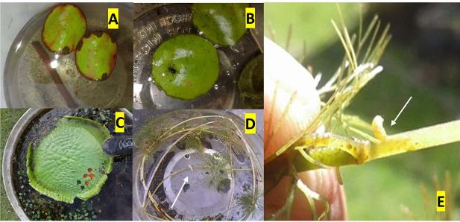
Figure 12 Test of larval development of Hydrotimetes natans leaf discs or cut plant material in the laboratory in Argentina. (A) Nymphaea prolifera leaf discs, (B & C) Victoria cruziana leaf discs and detached whole leaf of V. cruziana , (D) Cabomba caroliniana sprig in a container: larvae can be seen curled around the stems, and (E) A H. natans larva can be observed in the process of entering a C. caroliniana stem (Source: FuEDEI)

Comprehensive tests on whole plants

Rationale and methods
A life history-based host-specificity testing approach (i.e. making only those observations that can be recorded without destructive sampling) was adopted for H. natans for the following reasons. An adult H. natans has a largely aquatic life only surfacing for brief periods of time. It feeds by inserting the proboscis into plant tissue and leaves a small hole, visible only under the microscope. This is also true for oviposition sites and such sites are difficult to locate without staining the plants with food dye (to detect eggs) due to their small size and location (semi-embedded into a plant tissue). Only the stem tunnelling and entry and exit holes of the third instar larvae can be observed without destructive sampling. Observation of damage caused by the first and second instar larvae requires removal of plant parts and dissection and examination under a microscope.

All non-target test plants included in tests, except for the Hydatellaceae, are submerged aquatic species with only the terminal leaves reaching the water surface. Cabomba caroliniana and the non-target plants are all fragile and can be damaged when removed frequently from the water for examination. Such removal can have significant negative impacts on the structural integrity and overall health and condition of the plant, which in turn can affect any larval development.
Furthermore, it is not easy to distinguish between damage caused by handling plants during such removal and those caused by H. natans feeding and development. Consequently, to overcome such difficulties, host-specificity testing with H. natans on whole plants focussed on documenting the likelihood of lifecycle completion on non-target plants and on C. caroliniana. Observations on adult and larval feeding and larval development were left to the end of each of the tests when dissections of each plant were undertaken. However, observations for oviposition were made on plants in situ during the tests, with extreme care to ensure plants were not damaged (detailed below), because this data could not be collected otherwise and was important to fully assess the host range of H. natans.
All comprehensive host-specificity tests were conducted within the quarantine facility in a temperature and humidity-controlled glasshouse maintained at a temperature of 27°C ± 4°C with a relative humidity of approximately 40%. All test plant species were subjected to no-choice tests in which potted plants were introduced to either a 68L food grade polypropylene crate or 8L food grade container filled with reverse osmosis water which was treated as described above (in section 3.3.2). Number of plants used in these tests was dependent on size of the plant species and the experimental arenas used; a single plant of Nymphaea species but two control plants (C. caroliniana) were maintained in 68L crate to match with the larger size of Nymphaea species (Figure 13A-D). For tests with Trithuria species, a single plant was used for both test plants and the control in 8L container (Figure 13E).
In addition to no-choice trials, choice and continuation trials were also setup with B. schreberi (only species on which H. natans development was recorded in no-choice trials were progressed to choice and continuation trials). For choice trials, potted plants of both C. caroliniana and B. schreberi were maintained in a single polypropylene crate (Figure 13F); this experimental set-up allowed H. natans to choose between plant species for feeding, oviposition and lifecycle completion. For continuation trials, two potted B. schreberi plants were maintained in a polypropylene crate, and additional plants were provided as required to ensure that host plant availability was not a limiting factor for life-cycle completion. This continuation trial was run for
~150 days to determine the ability of B. schreberi to sustain a population of the weevil; this duration corresponds to the developmental time of three generations (~42 days per generation) of
H. natans on C. caroliniana.

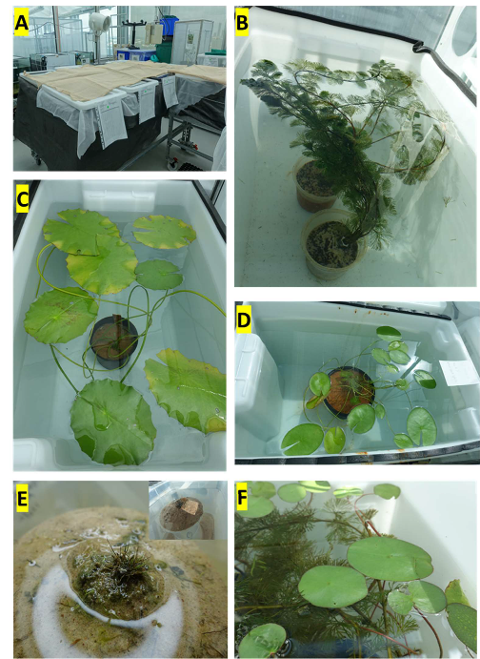

Figure 13 Host testing setup (A, B, C & D) Large food grade polypropylene crate with live plants in quarantine glasshouse, (E) Host testing setup of Trithuria sp. and (F) Setup of choice trials with Cabomba caroliniana and Brasenia schreberi (Source: CSIRO)
Each non-target plant species was tested in six replicates for no-choice tests, except for T. fitzgeraldii D.D. Sokoloff et al. (four replicates) and T. austinensis D.D. Sokoloff et al. (three replicates) because of difficulties in growing these species (Table 2). For B. schreberi, five replicate choice trials and four replicate continuation trials were also setup. In all tests, each replicate of the target (control) or test plant or both in the case of choice trials was randomly allocated to six H. natans adults. All adults used in the tests were from a H. natans colony maintained on C. caroliniana. Since H. natans is not sexually dimorphic (determining sex is possible only through dissection of reproductive organs), adults pairing (in copula) with each other were used for testing, and equal number of males and females were assumed. Adults were introduced by having them in

a Petri dish and gently submerging the Petri dish in the centre of testing arenas. Upon release, adults were found swimming down towards the bottom of testing arenas both in control and test plant replicates. Further observations showed adults holding on to plant parts and on to the rim of the plant pots both in control and test plant replicates.
Table 2 Host-specificity testing of Hydrotimetes natans: number of replications tested in each type of trials for each non-target species from different families

Family | Species | No-choice trial replicates | Choice trial replicates | Continuation trials
Cabombaceae | Cabomba caroliniana | 7 | 5 | 4
Cabombaceae | Brasenia schreberi | 6 | 5 | 4
Nymphaeaceae | Nymphaea caerulea | 6 | - | -
Nymphaeaceae | Nymphaea alba | 6 | - | -
Nymphaeaceae | Nymphaea mexicana | 6 | - | -
Nymphaeaceae | Nymphaea violacea | 6 | - | -
Nymphaeaceae | Nymphaea gigantea | 6 | - | -
Nymphaeaceae | Nymphaea immutabilis | 6 | - | -
Nymphaeaceae | Nymphaea pubescens | 6 | - | -
Hydatellaceae | Trithuria submersa | 6 | - | -
Hydatellaceae | Trithuria austinensis | 3 | - | -
Hydatellaceae | Trithuria lanterna | 6 | - | -
Hydatellaceae | Trithuria fitzgeraldii | 4 | - | -
Observations on oviposition were made three times a week for the duration of each replicate in each trial. If, during the course of the testing, any plant material had to be removed due to decay, it was examined under microscope to check for presence of oviposition marks, eggs, larvae and feeding, to determine whether the cause of the decay was damage from insect activity and observations were recorded. Each trial of host-specificity testing ran for greater than 42 days to correspond with the duration of life cycle of H. natans on C. caroliniana and multiple trials were run over a three-year period to complete testing of all plant species. A control containing C. caroliniana was used in each trial of host-specificity testing. At the end of the testing period, each replicate was broken down and all plant material was microscopically examined (Figure 14).
Observations on (1) presence of adult feeding and number of adult feeding scars, (2) presence of oviposition, (3) presence of larval feeding, (4) number of pupae formed and (5) number of adults emerged were recorded. This life history-based host testing has allowed us to assess the risk to non-target species from feeding through to lifecycle completion.

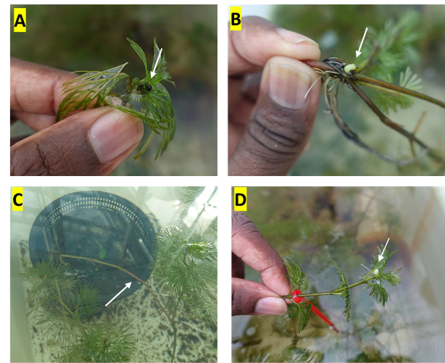

Figure 14 Observations made on the control Cabomba caroliniana at the end of each trial. (A) Adults recovered, (B) larvae exiting at the base of a plant, (C) Visible larval tunnelling on a stem and (D) live pupae (Source: CSIRO)

Statistical analyses and interpretation
For continuous data (i.e. number of adult feeding scars) a one-way ANOVA was used with test species as a fixed effect (Zar 1999). For binomial data (i.e. presence/absence of oviposition, larval feeding and development, pupation and lifecycle completion) a logistic regression analysis was used to calculate the likelihood of H. natans ovipositing or completing its lifecycle on the non- target test plants (Agresti 2018). For the logistic regression model, C. caroliniana was denoted as the reference level, and comparison of non-target species was made against it. In the logistic regression model, the model estimates the log odds of H. natans to lay eggs, develop and complete its lifecycle on non-target species. Negative log-odds (‘estimate’ in the output; See Appendix III) indicates the likelihood of oviposition is lower on the non-target species, while a positive value indicates it is higher, than on C. caroliniana.
For the choice trials with C. caroliniana and B. schreberi, the data were subjected to a binomial test (Zar 1999) to calculate the observed proportion of successful oviposition, larval development, pupation and lifecycle completion on B. schreberi (against hypothesised probability of success of 100%). The number of pupae recorded from C. caroliniana and B. schreberi was subjected to a Welch’s t-test (Zar 1999).

All analyses were performed in R3.6.2 (R Core Team 2019) via the RStudio interface (v 1.2.5033) (R Studio Team 2019) using the packages brglm2 (logistic regression; Kosmidis 2019) and ggplot2 (for graphs; Wickham, 2016). For ANOVA, binomial tests and Welch’s t-test, R’s base functions were used (R Core Team 2019). The R functions, codes and summary output of all analyses are provided as Appendix III. The raw data of host-specificity tests are presented as Appendix IV.

Results
No-choice trials
Nymphaea species:
Feeding by H. natans adults was observed on some of the replicates of N. gigantea, N. immutabilis, N. pubescens and N. violacea in the no-choice trials. However, the feeding intensity on C. caroliniana was far greater compared to that observed on these Nymphaea species (F12,61 = 5.724, p < 0.0001); 217.14 ± 78.05 (mean ± SE) feeding scars on C. caroliniana compared to 1.5 ±
0.85 to 16.83 ± 7.70 on the aforementioned Nymphaea species (Figure 15). Oviposition by H. natans was not observed on any of the replicates of these Nymphaea species (Table 5). Neither adult feeding nor oviposition were observed on the other Nymphaea species tested: N. caerulea,
N. alba and N. mexicana (Figure 15). The logistic regression analyses revealed that H. natans is far less likely to lay eggs and complete its lifecycle on Nymphaea species than on C. caroliniana (Appendix V).
Trithuria species:
No feeding and oviposition, and thus no development, by H. natans was observed on any of the Trithuria species tested (T. laterna D.A. Cooke, T. austinensis, T. submersa and T. fitzgeraldii) under no-choice conditions (Figure 15, Table 3). The logistic regression models fitted for oviposition, larval feeding, larval development, pupation and lifecycle completion suggested that H. natans is far less likely to lay eggs and complete its lifecycle on Trithuria species than on C. caroliniana (Appendix V).

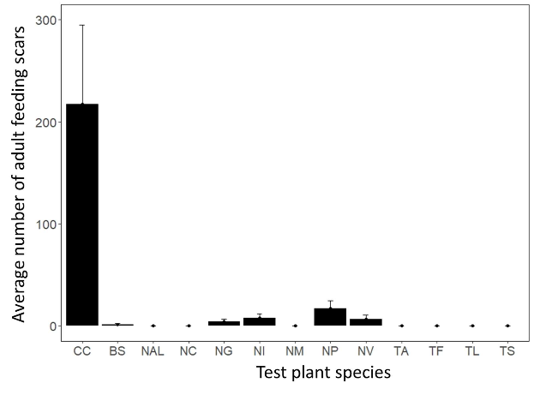

Figure 15 Hydrotimetes natans adult feeding damage on Cabomba caroliniana (CC) compared with that on non- target plant species in no-choice trials (BS – Brasenia schreberi, NAL – Nymphaea alba, NC – N. caerulea, NG – N. gigantea, NI – N. immutabilis, NM – N. mexicana, NP – N. pubescens, NV – N. violacea, TA – Trithuria austinensis, TF
– T. fitzgeraldii, TL – T. lanterna, TS – T. submersa). The error bar on each column corresponds to the standard error

Brasenia schreberi:
Adult feeding, oviposition and partial development of H. natans were observed on B. schreberi in no-choice trials. The intensity of adult feeding was significantly lower on B. schreberi than on C. caroliniana (Figure 15). Oviposition was observed on four of the six replicates tested. Larval development and feeding were observed in three replicates, but development of larvae through to pupation and lifecycle completion was only recorded on one of these replicates (Table 3). The logistic regression model fitted for oviposition and larval feeding suggested that the odds of H. natans laying eggs, and larval feeding are likely. However, the log odds for larval development, pupation and lifecycle completion indicates a significantly lower likelihood for pupation and lifecycle completion by H. natans on B. schreberi relative to C. caroliniana (Appendix V).

Table 3 Number of replicates in which oviposition, larval development, pupation and lifecycle completion by Hydrotimetes natans were recorded on Cabomba caroliniana (CC) and non-target species in no-choice trails (BS – Brasenia schreberi, NAL – Nymphaea alba, NC – N. caerulea, NG – N. gigantea, NI – N. immutabilis, NM – N. mexicana, NP – N. pubescens, NV – N. violacea, TA – Trithuria austinensis, TF – T. fitzgeraldii, TL – T. lanterna, TS –
T. submersa)

 | CC | BS | NAL | NC | NG | NI | NM | NP | NV | TA | TF | TL | TS
Oviposition
Yes | 7 | 4 | 0 | 0 | 0 | 0 | 0 | 0 | 0 | 0 | 0 | 0 | 0
No | 0 | 2 | 0 | 0 | 0 | 0 | 0 | 0 | 0 | 0 | 0 | 0 | 0
Larval feeding
Yes | 7 | 3 | 0 | 0 | 0 | 0 | 0 | 0 | 0 | 0 | 0 | 0 | 0
No | 0 | 3 | 0 | 0 | 0 | 0 | 0 | 0 | 0 | 0 | 0 | 0 | 0
Larval development
Yes | 7 | 1 | 0 | 0 | 0 | 0 | 0 | 0 | 0 | 0 | 0 | 0 | 0
No | 0 | 5 | 0 | 0 | 0 | 0 | 0 | 0 | 0 | 0 | 0 | 0 | 0
Pupation
Yes | 7 | 1 | 0 | 0 | 0 | 0 | 0 | 0 | 0 | 0 | 0 | 0 | 0
No | 0 | 5 | 0 | 0 | 0 | 0 | 0 | 0 | 0 | 0 | 0 | 0 | 0
Lifecycle completion
Yes | 7 | 1 | 0 | 0 | 0 | 0 | 0 | 0 | 0 | 0 | 0 | 0 | 0
No | 0 | 5 | 0 | 0 | 0 | 0 | 0 | 0 | 0 | 0 | 0 | 0 | 0
Choice trials:
Because of oviposition and partial development of H. natans on B. schreberi in no-choice trials, choice trials were setup to determine if the weevil shows preference towards this species over C. caroliniana. While oviposition and larval development were recorded on B. schreberi in two replicates, H. natans did not complete its lifecycle on this species in choice trials.

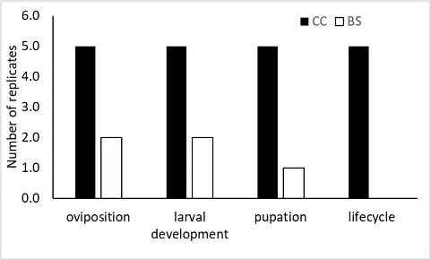

Figure 16 Number of replicate choice trials performed with Cabomba caroliniana (CC) and Brasenia schreberi (BS) in which oviposition, larval development, pupation and lifecycle completion by Hydrotimetes natans was recorded
The results of a binomial test showed that the probability of lifecycle completion by H. natans on
B. schreberi is 0% compared to 100% in C. caroliniana (Table 4 & Figure 16). The decrease in the probability from oviposition (40%) through to pupation (20%), and ultimately lifecycle completion (0%) in B. schreberi supported the results obtained in no-choice trials. The number of pupae recorded from B. schreberi was 0.40±0.40 (mean±SE), which is significantly lower (t = -3.9323; df = 4.22; p <0.05) than that recorded from C. caroliniana (10.0±2.41).
Table 4 One proportion z-test comparing proportion of successful oviposition, larval development, pupation and lifecycle completion by Hydrotimetes natans between Cabomba caroliniana and Brasenia schreberi

Brasenia schreberi Cabomba caroliniana

Variables

Probability p value of success
 |  |  |  |  |  | interval
Oviposition | 0.40 | <0.0001 | 0.0527, 0.8533 | 1.00 | <0.0001 | 0.4782, 1.0000
Larval development | 0.40 | <0.0001 | 0.0527, 0.8533 | 1.00 | <0.0001 | 0.4782, 1.0000
Pupation | 0.20 | <0.0001 | 0.0051, 0.7164 | 1.00 | <0.0001 | 0.4782, 1.0000
Lifecycle completion | 0.00 | <0.0001 | 0.0000, 0.5218 | 1.00 | <0.0001 | 0.4782, 1.0000

95% confidence interval

Probability p value of success
95%
confidence

Continuation trials:
Among the four replicates of B. schreberi, oviposition was observed on three replicates and larval development and pupation was observed on one replicate; a single pupa was recorded on this replicate and an adult emerged from this pupa. The results of the continuation trials indicated that
B. schreberi could not sustain multiple generations of H. natans, and further strengthened the inference from the no-choice and choice trials.

3.4 Discussion
Insect herbivores are evolutionarily more likely to feed on species that are phylogenetically closely related to host plants than those that are more distantly related. Most insect herbivore species tend to specialise and feed on one or a small number of plant species belonging to the same genus, subfamily or family (Jaenike 1990). The centrifugal phylogenetic method is therefore an effective method to explore the host range limit of a species to determine the extent of its host specialisation; its use in classical biological control therefore has a long and strong history (Wapshere 1974; Briese 2003; 2006; Gilbert et al. 2012).
We selected representative non-target plant species of increasing phylogenetically distance to the target weed C. caroliniana, to assess the risks that the introduction of the cabomba weevil H. natans into Australia would pose to other species. Our studies included species within the Cabombaceae, a family to which the target weed and only one other species, B. schreberi, belong in Australia. Since the Cabombaceae family is not well-represented in Australia, the risk assessment was extended to representative species from the two other families in order Nymphaeales, viz. the Nymphaeaceae (Nymphaea spp.) and Hydatellaceae (Trithuria spp.) that are known to occur in Australia.

Risk to Nymphaea species
The results of our no-choice studies showed minor feeding by H. natans adults only on some replicates of four of the seven Nymphaea species tested: N. gigantea, N. immutabilis, N. pubescens and N. violacea. This feeding, however, was negligible compared to that observed on C. caroliniana and can be only interpreted as exploratory feeding considering the low number of feeding scars and the fact that no oviposition was observed on any of these Nymphaea species. In contrast, adult feeding, oviposition and lifecycle completion were observed in all replicates of C. caroliniana. Based on these findings, we do not expect ornamental or native Nymphaea species to be at risk of attack from H. natans in the field.

Risk to Trithuria species
There was no adult feeding damage nor oviposition on any of the Trithuria species tested. Trithuria species perhaps lack fundamental feeding and/or oviposition cues necessary to elicit feeding and oviposition by H. natans. In addition, Trithuria differs greatly in its morphology and growth habits from C. caroliniana and it was therefore not surprising that it failed to support oviposition by H. natans despite its phylogenetic proximity to the target weed. The leaves of Trithuria which are non-tubular sheaths may not be ideal for oviposition and early instar larval development as H. natans insert eggs inside the plant tissue, and the early instar larvae tunnel through the leaves of its host plant C. caroliniana. Likewise, second and third instar larvae feed inside the stem and larval development lasts for approx. 30 days in C. caroliniana which is unlikely to be supported by the short and slender stems of Trithuria. The difference in the growth habits of the two species, Tithuria being partially submerged while C. caroliniana is completely submerged, is also a likely influence on their relative suitability for H. natans which is adapted to fully submerged conditions.

Risk to Brasenia schreberi
Despite oviposition and larval development in a few replicates in both no-choice and choice trials, lifecycle completion by H. natans on B. schreberi was observed in only one replicate in no-choice trials. This indicated that the possibility of development and lifecycle completion by H. natans on
B. schreberi was significantly lower than on C. caroliniana, which supported lifecycle completion in all replicates tested in both choice and no-choice trials. These results suggest B. schreberi is physiologically unsuitable for H. natans development despite the elicitation of oviposition in some occasions. The fact that B. schreberi did not sustain a population of H. natans in continuation trials is further evidence that it is an unsuitable host, especially considering that a healthy and productive colony of H. natans was maintained on C. caroliniana, which has yielded five generations over an eight-month period in our colony. These results suggest that H. natans poses negligible risks to B. schreberi.
There are additional factors that further lower the risks to B. schreberi from H. natans. Abundant populations of B. schreberi tend to be restricted to higher latitudes (Lloyd & Kershaw 1997), but the bioclimatic models of H. natans predict a more subtropical and tropical potential distribution (Figure 9). Therefore, only negligible risks are predicted to the populations of B. schreberi that tend to be more abundant in temperate freshwater bodies in south-eastern Australia. Brasenia schreberi is of minor importance as an aquarium or ornamental species in Australia (Tropical Plants Database 2020), and hence the risk to commercial aquarium or ornamentals trade is unlikely to occur. Finally, in a global context, B. schreberi is not endemic to Australia and has a native range spanning from the Americas through to the Old World. Together, this suggests that the negligible risks posed by H. natans are highly unlikely to have significant negative impact on the abundance of B. schreberi in natural settings or on its trade by the aquarium or ornamental sectors.
The high level of host-specificity of H. natans is not surprising given its phylogenetic position. Weevils in Erirhininae subfamily (marsh weevils) are highly host specific. Notable examples include the biological control agents for water hyacinths, N. eichhorniae and N. bruchiae, for watermilfoil, Euhrychiopsis lecontei, and Salvinia, C. salviniae, and monophagous pest species such as the rice water weevils Lissorhoptrus spp. and Afroryzophilus spp. The biological control agents in the Erirhininae have proven to be extremely effective in managing aquatic weeds.
Overall, our results have showed no risks to phylogenetically proximate species in the genera Nymphaea and Trithuria, and negligible risk to the more closely related B. schreberi. Brasenia schreberi is the only species within the Cabombaceae and hence the likelihood of risks to other species in the family Cabombaceae is non-existent in an Australian context. Collectively, our results indicate that H. natans will be a highly specific biological control agent. If approved for release, H. natans is likely to contribute to the management of C. caroliniana, a significant aquatic weed in Australia.

References

Agresti, A. (2018). Introduction to Categorical Data Analysis, Wiley, Hoboken, New Jersey.
Agriculture Victoria (2019). Victorian Resources Online: Cabomba (Cabomba caroliniana). http://vro.agriculture.vic.gov.au/dpi/vro/vrosite.nsf/pages/weeds_aquatic_cabomba (accessed December 2019).
Atlas of Living Australia (2020a). https://bie.ala.org.au/species/https://id.biodiversity.org.au/node/apni/7022437. Accessed 18
February 2020.
Atlas of Living Australia (2020b). http://www.ala.org.au. Accessed 20 January 2020.
BICON (2020). Australian Biosecurity Import Conditions. Department of Agriculture, Water and the Environment.
Borsch, T., Wiersema, J. H., Hellquist, C. B., Löhne, C., & Govers, K. (2014). Speciation in North American water lilies: evidence for the hybrid origin of the newly discovered Canadian endemic Nymphaea loriana sp. nov.(Nymphaeaceae) in a past contact zone. Botany, 92(12), 867-882.
Briese, D.T. (2003). The centrifugal phylogenetic method used to select plants for host-specificity testing of weed biological control agents: Can and should it be modernised? In: Spafford Jacob, H., Briese, D.T. (eds.), Improving the selection, testing and evaluation of weed biological control agents. CRC Tech. Ser. No. 7, pp 23-33. http://www.weeds.crc.org.au/documents/tech_series_7.pdf.
Briese, D. T. (2006). Host-specificity testing of weed biological control agents: initial attempts to modernize the centrifugal phylogenetic method. In Proceedings of the fifth California conference on biological control (pp. 25-27).
BQ, 2016. Biosecurity Queensland Fact sheet: Cabomba. Department of Agriculture and Fisheries.
Cabrera-Walsh, G., Schooler, S., & Julien, M. (2011). Biology and preliminary host range of Hydrotimetes natans Kolbe (Coleoptera: Curculionidae), a natural enemy candidate for biological control of Cabomba caroliniana Gray (Cabombaceae) in Australia. Australian Journal of Entomology, 50(2), 200-206.
Chase, M. W., Christenhusz, M. J. M., Fay, M. F., Byng, J. W., Judd, W. S., Soltis, D. E., ... & Stevens,
P. F. (2016). An update of the Angiosperm Phylogeny Group classification for the orders and families of flowering plants: APG IV. Botanical Journal of the Linnean Society, 181(1), 1-20.
Declared Plant Policy (2004). Cabomba caroliniana. Declared Plant Policy under the Natural Resources Management Act 2004. Government of South Australia. (https://www.pir.sa.gov.au/)
Department of Land Resource Management (2015). Weed management plan for Cabomba (Cabomba caroliniana). Rangeland divisions, Northern Territory Government.

Diatloff, G. and Anderson, T. (1995). Chemical control of Cabomba. Pages 3–6 in M. Hannan-Jones, ed. Technical highlights 1994/5: Reports of weed and pest animal control research conducted by the Land Protection Branch, Queensland Department of Lands. Queensland Department of Lands, Brisbane, Australia.
Drzymulska, D. (2018). On the history of Brasenia Schreb. in the European Pleistocene. Vegetation History and Archaeobotany, 27(3), 527-534.
Garraty, K., Anderson, T. and Diatloff, G. 1996. Mechanical harvesting of cabomba weed.
Unpublished report, Noosa Shire Council, Queensland, Australia.
GHD (2008). Goulburn Broken Catchment Management Authority Cabomba Management Report.
December 2008.
Gilbert, G. S., Magarey, R., Suiter, K., & Webb, C. O. (2012). Evolutionary tools for phytosanitary risk analysis: phylogenetic signal as a predictor of host range of plant pests and pathogens. Evolutionary Applications, 5(8), 869-878.
Heslop-Harrison, Y. (1955). Nymphaea L. Journal of Ecology, 43(2), 719-734.
Hogsden, K. L., Sager, E. P., & Hutchinson, T. C. (2007). The impacts of the non-native macrophyte Cabomba caroliniana on littoral biota of Kasshabog Lake, Ontario. Journal of Great Lakes Research, 33(2), 497-504.
Hussey, B. M. J., Keighery, G. J., Dodd, J., Lloyd, S. G., & Cousens, R. D. (2007). Western weeds. A guide to the weeds of Western Australia. https://wswa.org.au/ww_update.pdf
Iles W.J.D., Lee C, Sokoloff D.D., Remizowa M.V., Yadav S.R., Barrett M.D., Barrett R.L., Macfarlane T.D., Rudall P.J., Graham S.W. (2014). Reconstructing the age and historical biogeography of the ancient flowering-plant family Hydatellaceae (Nymphaeales). BMC Evol Biol 14:102.
Jacobs, S. W. L. & Porter, C. L. (2007). Nymphaeaceae. In: A. J. G. Wilson (ed.), Flora of Australia 2.
Melbourne. pp. 259–275.
Jacobs, S.W.L. & Hellquist, C.B. (2011). New species, possible hybrids and intergrades in Australian Nymphaea (Nymphaeaceae) with a key to all species. Telopea 13(1-2):233-243.
Jaenike, J. (1990). Host specialization in phytophagous insects. Annual Review of Ecology and Systematics, 21(1), 243-273.
Kuschel (1971). Entomology of the Aucklands and other Islands south of New Zealand: coleoptera: Curculionidae. Pacific Insects Monograph, 27: 225-259.
Kolbe, H.J. (1911). Ein neuer hygrophiler Rüsselkäfer aus Argentinien. (Col.). Deutsche Entomologische Zeitschrift 3: 315–317.
Kosmidis, I. (2019). brglm2: Bias Reduction in Generalized Linear Models. R package version 0.6.0,
<URL:https://CRAN.R-project.org/package=brglm2>.
Kriticos, D.J., Maywald, G.F., Yonow, T., Zurcher, E.J., Herrmann, N.I. and Sutherst, R.W. (2015). CLIMEX Version 4: Exploring the effects of climate on plants, animals and diseases. CSIRO, Canberra. 184 pp

Lloyd, P. J., & Kershaw, A. P. (1997). Late Quaternary vegetation and early Holocene quantitative climate estimates from Morwell Swamp, Latrobe Valley, south-eastern Australia. Australian Journal of Botany, 45(3), 549-563.
Löhne, C., Borsch, T., Jacobs, S. W., Hellquist, C. B., & Wiersema, J. H. (2008). Nuclear and plastid DNA sequences reveal complex reticulate patterns in Australian water-lilies (Nymphaea subgenus Anecphya, Nymphaeaceae). Australian Systematic Botany, 21(4), 229-250.
Mackey, A. P. (1996). Cabomba (Cabomba spp.) in Queensland. Pest status review series – Land protection branch. Department of Natural Resources and Mines, Qld.
Mackey, A. P., & Swarbrick, J. T. (1997). The biology of Australian weeds. 32. Cabomba caroliniana
Gray. Plant Protection Quarterly, 12, 154-165.
Madsen, J.D. (1996). Cabomba caroliniana information request. US Army Corps of Engineers, Waterways Experiment Station, Lewisville Aquatic Ecosystem Research Facility, Texas. pp. 2.
NSW DPI, 2009. Cabomba control manual Current management and control options for cabomba (Cabomba caroliniana) in Australia.
Ørgaard, M. (1991). The genus Cabomba (Cabombaceae)–a taxonomic study. Nordic Journal of Botany, 11(2), 179-203.
PlantNET (2020) (The NSW Plant Information Network System). Royal Botanic Gardens and Domain Trust, Sydney. http://plantnet.rbgsyd.nsw.gov.au [accessed January 2020].
Puttick, M. N, Morris, J. L., Williams, T. A., Edwards, D., Kenrick, P., Pressel, S., Wellman, C. H., Schneider, H., Pisani, D. and Onoghue, P. C. J. (February 2020). How Advances in Phylogenetic Methods Change Our Understanding of the Evolutionary Emergence of Land Plants (Embryophyta). In: eLS. John Wiley & Sons, Ltd, Chichester. DOI: 10.1002/9780470015902.a0003361.pub2.
R Core Team (2019). R: A language and environment for statistical computing. R Foundation for Statistical Computing, Vienna, Austria. URL https://www.R-project.org/.
RStudio Team (2019). RStudio: Integrated Development for R. RStudio, Inc., Boston, MA URL http://www.rstudio.com/.
Sanders, D. R. (1979). The ecology of Cabomba caroliniana. Weed Control Methods for Public Health Applications. CRC Press, Boca Raton, Florida, 133.
Saarela J, Rai H, Doyle J, Endress P, Mathews S, Marchant A, Briggs B, Graham S (2007) Hydatellaceae identified as a new branch near the base of the angiosperm phylogenetic tree. Nature 446:5–8.
Schooler, S. S. (2008). Shade as a management tool for the invasive submerged macrophyte,
Cabomba caroliniana. Journal of Aquatic Plant Management, 46, 168-171.
Schooler, S., Cabrera-Walsh, W., & Julien, M. (2009). Cabomba caroliniana Gray (Cabombaceae). In: Biological control of tropical weeds using arthropods (eds. Muniappan, R., Reddy, G. V. & Raman, A.). Cambridge University Press, Cambridge. pp. 88-107.

Schooler, S., Cabrera-Walsh, W., & Julien, M. (2012). Cabomba caroliniana Gray - cabomba. In: Biological control of weeds in Australia (eds. Julien, M., McFadyen, R & Cullen, J). CSIRO Publishing, Collingwood, Victoria, Australia. pp 108-117.
Sheldon, S. P. (1994). Invasions and declines of submersed macrophytes in New England, with particular reference to Vermont lakes and herbivorous invertebrates in New England. Lake and Reservoir Management, 10(1), 13-17.
Sokoloff, D. D., Remizowa, M. V., Macfarlane, T. D., Yadav, S. R., & Rudall, P. J. (2011).
Hydatellaceae: a historical review of systematics and ecology. Rheedea, 21(2), 115-138.
Städler, E., Hilker, M., & Meiners, T. (2002). Plant chemical cues important for egg deposition by herbivorous insects. In: Chemoecology of Insect Eggs and Egg Deposition: An Introduction (eds. Hilker, M. & Meiners, T). Blackwell publishing, Berlin. pp171-204.
Stevens, P. F. (2001 onwards). Angiosperm Phylogeny Website. Version 14, July 2017 [and more or less continuously updated since]." will do. http://www.mobot.org/MOBOT/research/APweb/.
Tarver, D. P., & Sanders, D. R. (1977). Selected lifecycle features of fanwort. Journal of Aquatic Plant Management, 15, 18-22.
Thorp, J. R., and Lynch, R. (2000). Determination of weeds of national significance (National Weeds Strategy Executive Committee, Launceston). https://weeds.ala.org.au/WoNS.html; https://www.environment.gov.au/biodiversity/invasive/weeds/weeds/lists/wons.html
Tropical Plants Database (2020). Ken Fern. tropical.theferns.info. 2020-02-17.
<tropical.theferns.info/viewtropical.php?id=Brasenia+schreberi>
Wapshere, A. J. (1974). A strategy for evaluating the safety of organisms for biological weed control. Annals of applied biology, 77(2), 201-211.
Western Australian Herbarium (1998–). FloraBase—the Western Australian Flora. Department of Biodiversity, Conservation and Attractions. https://florabase.dpaw.wa.gov.au/
White, M., Cheal, D., Carr, G. W., Adair, R., Blood, K. and Meagher, D. (2018). Advisory list of environmental weeds in Victoria. Arthur Rylah Institute for Environmental Research Technical Report Series No. 287. Department of Environment, Land, Water and Planning, Heidelberg, Victoria.
Wickham, H. (2016). ggplot2: Elegant Graphics for Data Analysis. Springer-Verlag New York, 2016.
Wilson, C. E., Darbyshire, S. J., & Jones, R. (2007). The biology of invasive alien plants in Canada. 7.
Cabomba caroliniana A. Gray. Canadian Journal of Plant Science, 87(3), 615-638.
WoNS, 2003. Cabomba caroliniana weed management guide. Weeds of National Significance.
Australian Department of Environment and Energy.
Xiao, H., Cai, X., Fan, Y., & Luo, A. (2016). Antioxidant activity of water-soluble polysaccharides from Brasenia schreberi. Pharmacognosy magazine, 12(47), 193.
Zar, J. (1999). Biostatistical Analysis, 4th edition. Prentice-Hall, Upper Saddle River, NJ.

As Australia’s national science agency and innovation catalyst, CSIRO is solving the greatest challenges through innovative science and technology.
64 | CSIRO Australia’s National Science Agency
CSIRO. Unlocking a better future for everyone.

Contact us
1300 363 400
+61 3 9545 2176
csiroenquiries@csiro.au csiro.au

