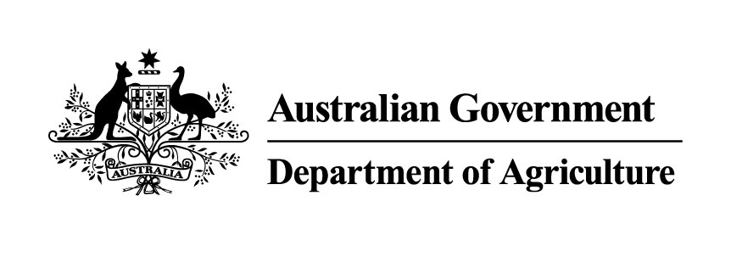
Imported Food Inspection Data
Report for July - December 2013
Imported Food
Biosecurity


© Commonwealth of Australia 2014
Ownership of intellectual property rights
Unless otherwise noted, copyright (and any other intellectual property rights, if any) in this publication is owned by the Commonwealth of Australia (referred to as the Commonwealth).
Creative Commons licence
All material in this publication is licensed under a Creative Commons Attribution 3.0 Australia Licence, save for content supplied by third parties, logos and the Commonwealth Coat of Arms.

Creative Commons Attribution 3.0 Australia Licence is a standard form licence agreement that allows you to copy, distribute, transmit and adapt this publication provided you attribute the work. A summary of the licence terms is available from creativecommons.org/licenses/by/3.0/au/deed.en. The full licence terms are available from creativecommons.org/licenses/by/3.0/au/legalcode.
This publication (and any material sourced from it) should be attributed as Imported Food Inspection Data Report for July-December 2013, Imported Food, Department of Agriculture, Canberra, June 2014. CC BY 3.0.
Cataloguing data
Imported Food 2014, Imported Food Inspection Data Report for July–December 2013, Department of Agriculture, Canberra, June.2014.
Internet
Imported Food Inspection Data Report is available at daff.gov.au/biosecurity/import/food/inspection-data
Department of Agriculture
Postal address GPO Box 1563 Canberra ACT 2601
Switchboard +61 2 6272 2010
Facsimile +61 2 6272 2001
Email foodimp@agriculture.gov.au
Web agriculture.gov.au
Inquiries about the licence and any use of this document should be sent to copyright@agriculture.gov.au.
The Australian Government acting through the Department of Agriculture has exercised due care and skill in preparing and compiling the information and data in this publication. Notwithstanding, the Department of Agriculture, its employees and advisers disclaim all liability, including liability for negligence, for any loss, damage, injury, expense or cost incurred by any person as a result of accessing, using or relying upon any of the information or data in this publication to the maximum extent permitted by law.
Contents
Summary 1
Imported Food Inspection Scheme 2
Food Import Compliance Agreement notifications 2
Summary for July to December 2013 3
Application of tests to imported food 3
Commodity groups 3
Country of origin 4
Testing data 6
Analytical testing data, China 9
Analytical testing data, Thailand 11
Analytical testing data, United States 12
Appendixes 14
Appendix 1: Analytical tests applied to food 14
Appendix 2: Tariff codes included in each food commodity group 15
Appendix 3: No. of inspections per country 16
Glossary 18

Tables
Table 1 Inspection and test data, by commodity group 4
Table 2 Number of inspections, by country of origin 5
Table 3 Compliance for all tests 6
Table 4 Compliance for BSE certificate checks 7
Table 5 Compliance for visual assessments 7
Table 6 Compliance for oysters ex Korea/Japan 8
Table 7 Compliance for analytical testing 8
Table 8 Compliance for chemical tests 8
Table 9 Compliance for contaminant tests 9
Table 10 Compliance for food additive tests 9
Table 11 Compliance for microbiological tests 9
Table 12 Compliance for chemical tests, China 10
Table 13 Compliance for contaminant tests, China 10
Table 14 Compliance for food additive tests, China 10
Table 15 Compliance for microbiological testing, China 10
Table 16 Compliance for chemical tests, Thailand 11
Table 17 Compliance for contaminant tests, Thailand 11
Table 18 Compliance for microbiological tests, Thailand 11
Table 19 Compliance for chemical tests, United States 12
Table 20 Compliance for contaminant tests, United States 12
Table 21 Compliance for microbiological tests, United States 13

Figures
Figure 1 Percentage of tests applied to each commodity group 4
Figure 2 Percentage of inspections, by country of origin 5
Figure 3 Non-compliant test results 6
Figure 4 Non-compliant labelling 7

Summary
The Department of Agriculture is responsible for managing Australia’s biosecurity system. Every year the department helps millions of people, goods, vessels and aircraft move into and out of Australia without harming the environment, animal, plant and human health.
The Department of Agriculture is one of many Australian Government agencies responsible for regulating imported food. Its role includes ensuring imported food meets Australia’s biosecurity requirements and the requirements of the Imported Food Control Act 1992.
This report provides summary data from imported food inspections for the period 1 July to 31 December 2013. The department has published these reports every six months since July 2006; previous reports are available from the department’s website.
During the period covered by this report, the three countries whose food was subject to the most food inspections under the Imported Food Inspection Scheme were China, Thailand and the United States. The 10 most frequently inspected countries accounted for 61.4 per cent of food inspections with the remaining 38.6 per cent of food inspections being on food from a further 108 countries.
The overall compliance rate was 98.6 per cent based on the tests applied under the inspection scheme being similar to 2012. Non-compliant food labelling accounted for most failures, which if removed from the test data, would increase the overall compliance rate to 99.4 per cent. Follow-up action is taken when a food fails inspection.
The department periodically reviews the monitoring of imported food. Through this review, tests may be added or removed to monitor imported food for compliance with Australian food standards as published in the Australia New Zealand Food Standards Code.
More information on the tests applied to surveillance food is available from the Department of Agriculture website www.daff.gov.au/biosecurity/import/food.

Imported Food Inspection Scheme
The Department of Agriculture administers two sets of requirements with which imported food must comply. Food imported into Australia is subject to requirements under the Quarantine Act 1908 (Cwlth) to address quarantine concerns and the Imported Food Control Act 1992 (Cwlth) to monitor compliance with sourcing food that meets Australia’s food standards. Quarantine requirements must be met before food standards are considered.
To monitor importers’ compliance with sourcing food that meets Australia’s food standards, the Department of Agriculture operates a risk-based border inspection scheme—the Imported Food Inspection Scheme.
Food Standards Australia New Zealand (FSANZ), within the Department of Health portfolio, develops and maintains the Australia New Zealand Food Standards Code (the Code). The Code lists Australia’s food standards requirements including contaminants (such as microbiological, chemical), additives, labelling and genetically modified food as well as production and processing standards.
FSANZ provides advice to the Department of Agriculture on food that pose a medium to high risk to public health. The department classifies these as risk under the inspection scheme, and classifies all other food as surveillance.
To identify which food is of interest, and the rate at which they should be referred (that is, whether at 100 per cent or 5 per cent of consignments), the department applies electronic profiles in the Australian Customs and Border Protection Service’s Integrated Cargo System (ICS).
Once food is referred, the department’s systems apply relevant tests and inspection rates based on the risk the food may pose and for some food the compliance history of the producer and supplier.
When imported food fails inspection, follow-up action such as treatment of the food to bring it to compliance, destruction or export is undertaken. Additionally, subsequent imports of the same food are subject to inspection at the rate of 100 per cent of consignments until a history of compliance is again demonstrated.

Food Import Compliance Agreement notifications
Food Import Compliance Agreements offer food importers an alternative regulatory arrangement to inspection and testing of their products under the Imported Food Inspection Scheme. Compliance agreements are an assurance-based arrangement undertaken through formal recognition and audit of an importer’s documented food safety management system by the Department of Agriculture.
Importers under a compliance agreement must report non-compliant analytical test results to the department, which will then consider what further action is needed.
During the reporting period (July to December 2013), one non-compliant food notification was reported for an analytical result. The food was subject to disposal by destruction and the importer implemented corrective action including an increased level of analytical testing for this product. The fail was also reported to the relevant state government authority.

Summary for July to December 2013
The data contained in this report was obtained from imported food inspection data for the period 1 July to 31 December 2013. During this period:
- 9 683 entries of imported food were referred for inspection under the Imported Food Inspection Scheme
- 15 258 lines of imported food were inspected
- 50 410 tests were applied, including label and visual checks
- 19 559 label and composition assessments
- 11 509 analytical tests
- 19 342 other tests
More detailed analysis of data is provided based on
- commodity groups
- country of origin
- inspection data tests applied and compliance rates.
See Glossary for explanation of terms used in this document.

Application of tests to imported food
The number of lines of food referred for inspection under the Scheme and the number of tests applied to those lines of food may differ. This is because food subject to inspection is sampled and tested based on the number of:
- batches and lots within each batch of food on the line referred for inspection
- tests to be applied to each sample of that food taken during inspection.
For example, one line of a cooked and processed meat product may be referred for inspection under the Scheme. The line contains two batches of the product, each with one lot. An officer will take one sample from each batch and apply the microbiological tests relevant to this food. The test for cooked and processed meat products are E. coli, standard plate count, coagulase positive Staphylococci, Listeria monocytogenes and Salmonella. As a result, two samples have been taken from this one line of imported food and five microbiological tests have been applied to each sample.
This will be reported as:
- number of lines – 1
- number of tests applied – 10.

Commodity groups
While risk food is specifically targeted for inspection, surveillance food is subject to random inspection at the rate of 5 per cent of consignments. The numbers of tests applied reflects this approach with those commodity groups that contain more risk food and/or that are imported more frequently having a higher representation under the inspection activity. It may also reflect where goods have previously failed and the inspection rate has increased to 100 per cent until compliance has again been demonstrated. These data cannot be used to indicate volumes of trade.

Test data by commodity groups
During the reporting period the single commodity subject to most testing was seafood which accounted for 20 per cent of tests applied (Figure 1) under the Imported Food Inspection Scheme. Captured under this category are fresh, chilled, frozen and processed seafood products.
Horticulture (including fresh and processed fruit and vegetables) was the next highest single commodity inspected and was subject to 13.8 per cent of all tests applied to imported food under the Imported Food Inspection Scheme.
Figure 1 Percentage of tests applied to each commodity group
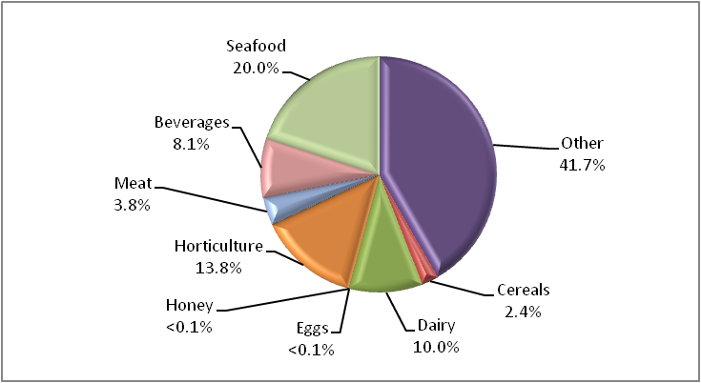
Data source: AIMS database
Appendix 1 provides an overview of the analytical tests applied to the commodity groups and Appendix 2 provides a list of the tariff codes associated with each commodity grouping used for this report.
Table 1 Inspection and test data, by commodity group
Commodity group | No. of tests applied | No. compliant / non-compliant | Compliance rate (%)
Beverages | 4 106 | 4 008 / 98 | 97.6
Cereals, flours and milled products | 1 192 | 1 186 / 6 | 99.5
Dairy | 5 061 | 4 989 / 72 | 98.6
Eggs | 16 | 16 / 0 | 100
Honey | 10 | 10 / 0 | 100
Horticulture | 6 969 | 6 877 / 92 | 98.7
Meat | 1 938 | 1 936 / 2 | 99.9
Seafood | 10 073 | 9 975 / 98 | 99.0
Other (incl. processed food) | 21 045 | 20 715 / 330 | 98.4
Total | 50 410 | 49 712 / 698 | 98.6
Source: AIMS database

Country of origin
Under the Imported Food Inspection Scheme, food is inspected based on its risk and/or frequency of importation. Country of origin is not generally targeted under routine inspections, but exceptions include where a food has previously failed inspection.
The numbers of inspections reflect those countries from which importers source food and/or import more regularly from those countries to Australia. The countries from whom importers more frequently source food will have a higher representation in inspection activity for food safety. This data cannot be used to indicate volumes of food imported to Australia.
For the period 1 July to 31 December 2013:
- China, Thailand and the United States were the countries whose food was subject to most inspections
- 61.4 per cent of food inspections were on food from 10 countries; the remaining 38.6 per cent were on food from 108 countries.
The Australian Food Statistics (published annually by the Department of Agriculture) indicates that a significant proportion of food imports are from New Zealand. However, under the Trans-Tasman Mutual Recognition Arrangement, most food from New Zealand is not subject to the Imported Food Control Act 1992 and is not inspected under the Imported Food Inspection Scheme.
Table 2 Number of inspections, by country of origin
Country of origin | No. of lines inspected | % of total lines inspected
China | 1 442 | 9.5
France | 691 | 4.5
India | 828 | 5.4
Italy | 1 094 | 7.2
Japan | 783 | 5.1
Korea, Republic of | 768 | 5.0
Malaysia | 574 | 3.8
Vietnam | 526 | 3.4
Thailand | 1 338 | 8.8
United States | 1 332 | 8.7
Other | 5 882 | 38.6
Total | 15 258 | 100.0
Note: For details of all countries of origin see Appendix 3.
Source: AIMS database
Figure 2 Percentage of inspections, by country of origin
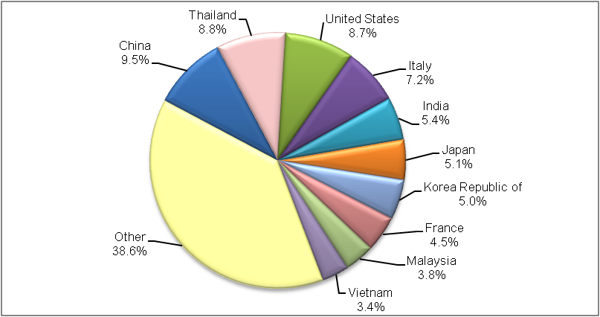
More detailed information about Thailand, China and the United States is provided in the analytical testing data section.

Testing data

Summary for July to December 2013
- 98.6 per cent of all tests applied to imported food samples under the Imported Food Inspection Scheme complied with Australian standards for these tests.
- Incorrect labelling accounted for most non-compliance (71.6 per cent of failures).
- When labelling non-compliances are removed from testing data, the compliance rate for analytical and other tests applied to imported food rises to 99.4 per cent.
Table 3 Compliance for all tests
Test group | No. of tests applied | No. compliant / non-compliant | Compliance rate (%)
Analytical | 11 509 | 11 318 / 191 | 98.3
Labelling | 19 559 | 19 059 / 500 | 97.4
Other | 19 342 | 19 335 / 7 | 99.9
Total | 50 410 | 49 712 / 698 | 98.6
Figure 3 provides a summary of the 698 non-compliant tests from the 50 410 tests applied, with details of each specific test and the proportion each test contributed to the total.
Figure 3 Non-compliant test results
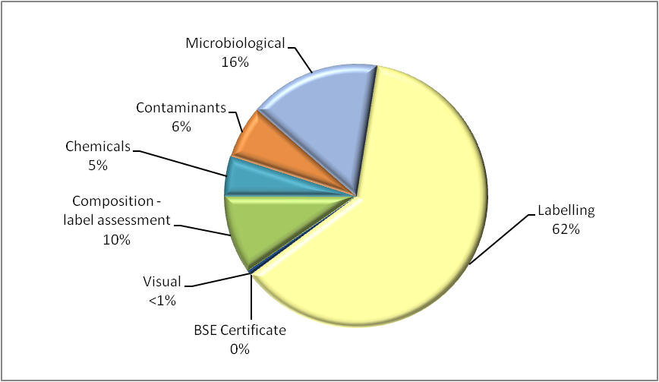
Note: Of 50 410 tests applied, 698 were non-compliant.

Labelling data
Figure 4 provides a detailed summary of labelling non-compliances against Australian food standards. Absence or incomplete importer details on labelling is the largest contributor to non-compliant labelling, accounting for 29.1 per cent of non-compliances. Country of origin, lot codes and ingredients lists account for a further 45.9 per cent of label non-compliances.
Figure 4 Non-compliant labelling
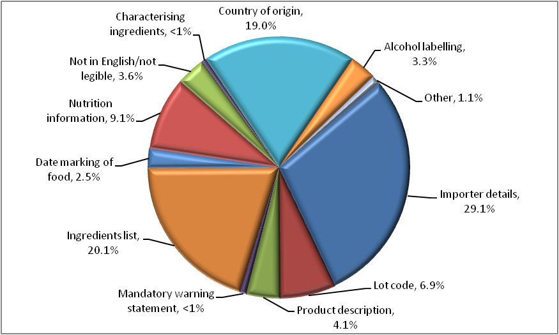

Other test data
Composition assessments
Additives or ingredients that are not permitted, or are in excess of permitted levels may be identified during a label assessment. Of the 19 559 label assessments conducted, 67 were found to be non-compliant with these requirements.
Note: Where a food fails, composition is given a separate test code in the database and is applied for the purpose of holding order inspections. This adds 158 tests to the overall test data in this report but does not represent the actual test and compliance rate.
Food may also be sampled and tested for the presence and level of additives under the surveillance program. These tests are reported under the analytical data.
BSE certificate checks
Food containing beef is referred as risk and government certification is assessed to determine compliance to Australia’s BSE policy. A fail is assigned when no compliant certificate is presented.
Table 4 Compliance for BSE certificate checks
Type of test | No. of tests applied | No. compliant / non-compliant | Compliance rate (%)
BSE Certificate | 339 | 339 / 0 | 100
Visual assessments
At every inspection the food is assessed for signs of unsafe or unsuitable condition such as foreign objects or deterioration.
Table 5 Compliance for visual assessments
Type of test | No. of tests applied | No. compliant / non-compliant | Compliance rate (%)
Visual | 18 999 | 18 995 / 4 | 99.9

Assessment of oysters ex. Korea/Japan
Oysters sourced from the Republic of Korea and specific marine areas of Hiroshima Prefecture, Japan are not permitted to be imported into Australia. The source of the oysters must be verified in writing by the national competent authority in Japan or Korea. A fail is recorded when the origin of the oysters is not able to be verified.
Table 6 Compliance for oysters ex Korea/Japan
Type of test | No. of tests applied | No. compliant / non-compliant | Compliance rate (%)
Oysters ex Korea/Japan | 4 | 1 / 3 | 25.0

Analytical testing data
Within the analytical test category, tests are grouped according to four main types: chemical, contaminant, food additive and microbiological (Table 4). Each category consists of several tests which are reported in detail in Tables 6, 7, 8 and 9
Analytical test results show a 98.3 per cent compliance rate with the tests applied under the Imported Food Inspection Scheme.
Of the 11 509 analytical tests applied, 191 (1.7 per cent) of the products being tested failed against the standards.
Table 7 Compliance for analytical testing
Type of test | No. of tests applied | No. compliant/non-compliant | Compliance rate (%)
Chemicals | 2 475 | 2 441 / 34 | 98.6
Contaminants | 2 777 | 2 732 / 45 | 98.4
Food additives | 1 | 1 / 0 | 100
Microbiological | 6 256 | 6 144 / 112 | 98.2
Total | 11 509 | 11 318 / 191 | 98.3
Table 8 Compliance for chemical tests
Chemical | No. of tests applied | No. compliant / non-compliant | Compliance rate (%) | Types of food
Carbendazim | 21 | 21 / 0 | 100 | Orange juice
Chloramphenicol | 1 | 1 / 0 | 100 | Honey
Ethylene chlorohydrin | 3 | 1 / 2 | 33.3 | Herbs and spices
Fluoroquinolones | 329 | 322 / 7 | 97.9 | Farmed fish and prawns
Malachite Green | 209 | 209 / 0 | 100 | Farmed fish
Nitrofurans | 93 | 88 / 5 | 94.6 | Farmed prawns, honey
Pesticides | 1 816 | 1 796 / 20 | 98.9 | Fruit, vegetables, meat
Streptomycin | 1 | 1 / 0 | 100 | Honey
Sulphonamides | 1 | 1 / 0 | 100 | Honey
Tetracycline | 1 | 1 / 0 | 100 | Honey
Total | 2 475 | 2 441 / 34 | 98.6 | –

Table 9 Compliance for contaminant tests
Contaminant | No. of tests applied | No. compliant / non-compliant | Compliance rate (%) | Types of food
Aflatoxins | 567 | 545 / 22 | 96.1 | Nuts
Caesium 134 a | 23 | 23 / 0 | 100 | Seafood and tea
Caesium 137 a | 23 | 23 / 0 | 100 | Seafood and tea
Domoic acid | 332 | 332 / 0 | 100 | Bivalve molluscs
Histamine | 1 380 | 1 370 / 10 | 99.3 | Fish
Hydrocyanic acid | 10 | 5 / 5 | 50.0 | Cassava chips
Iodine | 112 | 104 / 8 | 92.9 | Seaweed (brown algae)
PSP Toxin | 330 | 330 / 0 | 100 | Bivalve molluscs
Total | 2 777 | 2 732 / 45 | 98.4 | –
a: Following damage to Japan’s Fukushima Dai-ichi nuclear facility in March 2011, the Department of Agriculture implemented a precautionary monitoring program at the border. Monitoring and testing was based on assessment policy from FSANZ and the Australian Radiation Protection and Nuclear Safety Agency.

Border testing of food from Japan for radionuclides ceased in January 2014 after updated risk assessment advice from FSANZ that the risk to human health posed by radionuclides in food from Japan remains negligible. More information can be found on the department website www.daff.gov.au/biosecurity/import/food/notices/2009/2014/ifn01.
Table 10 Compliance for food additive tests
Food additive | No. of tests applied | No. compliant / non-compliant | Compliance rate (%) | Types of food
Sulphur dioxide | 1 | 1 / 0 | 100 | Preserved vegetables
Total | 1 | 1 / 0 | 100 | –
Table 11 Compliance for microbiological tests
Microbial agent | No. of tests applied | No. compliant / non-compliant | Compliance rate (%) | Types of food
E. coli | 1 252 | 1 198 / 54 | 95.7 | Processed meats, water, seafood, and cheese
Salmonella | 2 495 | 2 482 / 13 | 99.5 | Processed meats, seafood, dried coconut, dried chilli and pepper, sesame seeds, cheese
Listeria monocytogenes | 1 489 | 1 459 / 30 | 98.0 | Cheese, ready-to-eat seafood, processed meats
Standard plate count | 334 | 329 / 5 | 98.5 | Cooked prawns
Bacillus cereus | 20 | 17 / 3 | 85.0 | Bean curd, tofu
Vibrio cholerae | 221 | 215 / 6 | 97.3 | Cooked prawns
Coagulase positive Staphylococcus | 445 | 444 / 1 | 99.8 | Processed meats and cooked prawns
Total | 6 256 | 6 144 / 112 | 98.2 | –

Analytical testing data, China
In the period July to December 2013, food from China was subject to the highest number of inspections in comparison with other countries inspected under the Imported Food Inspection Scheme; representing 9.5 per cent of all food lines inspected.
Of the 1 042 analytical tests applied to imported food from China, 10 were found to be non-compliant, giving a 99 per cent compliance rate for tests applied.
Contaminants tests were the most frequently applied followed by tests for microbiological, chemical and food additive content.
Table 12 Compliance for chemical tests, China
Chemical | No. of tests applied | No. compliant / non-compliant | Compliance rate (%)
Fluoroquinolones | 39 | 38 / 1 | 97.4
Malachite Green | 9 | 9 / 0 | 100
Nitrofurans | 36 | 34 / 2 | 94.4
Pesticides | 160 | 159 / 1 | 99.4
Streptomycin | 0 | n/a | n/a
Sulphonamides | 0 | n/a | n/a
Tetracycline | 0 | n/a | n/a
Total | 244 | 240 / 4 | 98.4
Note: n/a = not available – no tests applied
Table 13 Compliance for contaminant tests, China
Contaminant | No. of tests applied | No. compliant/non-compliant | Compliance rate (%)
Aflatoxins | 132 | 130 / 2 | 98.5
Domoic acid | 94 | 94 / 0 | 100
Histamine | 56 | 56 / 0 | 100
Hydrocyanic acid | 0 | n/a | n/a
Iodine | 28 | 26 / 2 | 92.9
PSP toxin | 94 | 94 / 0 | 100
Total | 404 | 400 / 4 | 99.0
Note: n/a = not available – no tests applied
Table 14 Compliance for food additive tests, China
Food additive | No. of tests applied | No. compliant / non-compliant | Compliance rate (%)
Sulphur dioxide | 1 | 1 / 0 | 100
Total | 1 | 1 / 0 | 100
Table 15 Compliance for microbiological testing, China
Microbial agent | No. of tests applied | No. compliant / non-compliant | Compliance rate (%)
Bacillus cereus | 4 | 4 / 0 | 100
Coagulase positive Staphylococcus | 47 | 47 / 0 | 100
E. coli | 38 | 38 / 0 | 100
Listeria monocytogenes | 22 | 22 / 0 | 100
Salmonella | 196 | 195 / 1 | 99.5
Standard plate count | 42 | 41 / 1 | 97.6
Vibrio cholerae | 44 | 44 / 0 | 100
Total | 393 | 391 / 2 | 99.5

Analytical testing data, Thailand
In the period July to December 2013, food from Thailand was subject to the second highest number of inspections in comparison with other countries inspected under the Imported Food Inspection Scheme; representing 8.8 per cent of all food lines inspected.
Of the 894 analytical tests applied to imported food from Thailand, eight were found to be non-compliant, giving a 99.1 per cent compliance rate for tests applied.
Contaminants tests were the most frequently applied followed by tests for microbiological and chemical content. There were no food additive tests applied to food from Thailand.
Table 16 Compliance for chemical tests, Thailand
Chemical | No. of tests applied | No. compliant / non-compliant | Compliance rate (%)
Fluoroquinolones | 6 | 6 / 0 | 100
Malachite Green | 2 | 2 / 0 | 100
Nitrofurans | 4 | 4 / 0 | 100
Pesticides | 179 | 179 / 0 | 100
Streptomycin | 0 | n/a | n/a
Sulphonamides | 0 | n/a | n/a
Tetracycline | 0 | n/a | n/a
Total | 191 | 191 / 0 | 100
Note: n/a = not available – no tests applied
Table 17 Compliance for contaminant tests, Thailand
Contaminant | No. of tests applied | No. compliant / non-compliant | Compliance rate (%)
Aflatoxins | 32 | 26 / 6 | 81.3
Domoic acid | 21 | 21 / 0 | 100
Histamine | 425 | 423 / 2 | 99.5
Hydrocyanic acid | 0 | n/a | n/a
Iodine | 0 | n/a | n/a
PSP Toxin | 21 | 21 / 0 | 100
Total | 499 | 491 / 8 | 98.4
Note: n/a = not available – no tests applied
Table 18 Compliance for microbiological tests, Thailand
Microbial agent | No. of tests applied | No. compliant / non-compliant | Compliance rate (%)
Bacillus cereus | 0 | n/a | n/a
Coagulase positive Staphylococcus | 44 | 44 / 0 | 100
E. coli | 7 | 7 / 0 | 100
Listeria monocytogenes | 12 | 12 / 0 | 100
Salmonella | 76 | 76 / 0 | 100
Standard plate count | 38 | 38 / 0 | 100
Vibrio cholerae | 27 | 27 / 0 | 100
Total | 204 | 204 / 0 | 100
Note: n/a = not available – no tests applied

Analytical testing data, United States
In the period July to December 2013, food from the United States was subject to the third highest number of inspections in comparison with other countries inspected under the Imported Food Inspection Scheme; representing 8.7 per cent of all food lines inspected.
Of the 1 038 analytical tests applied to imported food from the United States, four were found to be non-compliant, giving a 99.6 per cent compliance rate for tests applied.
Chemical tests were the most frequently applied followed by tests for microbiological and contaminants content. There were no food additive tests applied to food from the United States.
Table 19 Compliance for chemical tests, United States
Chemical | No. of tests applied | No. compliant / non-compliant | Compliance rate (%)
Carbendazim | 6 | 6 / 0 | 100
Fluoroquinolones | 7 | 7 / 0 | 100
Malachite Green | 1 | 1 / 0 | 100
Nitrofurans | 6 | 6 / 0 | 100
Pesticides | 437 | 437 / 0 | 100
Streptomycin | 0 | n/a | n/a
Sulphonamides | 0 | n/a | n/a
Tetracycline | 0 | n/a | n/a
Total | 457 | 457 / 0 | 100
Note: n/a = not available – no tests applied
Table 20 Compliance for contaminant tests, United States
Contaminant | No. of tests applied | No. compliant / non-compliant | Compliance rate (%)
Aflatoxins | 118 | 117 / 1 | 99.2
Domoic acid | 19 | 19 / 0 | 100
Histamine | 19 | 19 / 0 | 100
Hydrocyanic acid | 0 | n/a | n/a
Iodine | 0 | n/a | n/a
PSP Toxin | 19 | 19 / 0 | 100
Total | 175 | 174 / 1 | 99.4
Note: n/a = not available – no tests applied

Table 21 Compliance for microbiological tests, United States
Microbial agent | No. of tests applied | No. compliant / non-compliant | Compliance rate (%)
Bacillus cereus | 2 | 2 / 0 | 100
Coagulase positive Staphylococcus | 53 | 53 / 0 | 100
E. coli | 109 | 106 / 3 | 97.2
Listeria monocytogenes | 95 | 95 / 0 | 100
Salmonella | 128 | 128 / 0 | 100
Standard plate count | 19 | 19 / 0 | 100
Vibrio cholerae | 0 | n/a | n/a
Total | 406 | 403 / 3 | 99.3
Note: n/a = not available – no tests applied

Appendixes

Appendix 1: Analytical tests applied to food
Food group | Risk / Surveillance test | Analytical test
Dairy products | Risk | Listeria monocytogenes  Salmonella  E. coli
Dairy products | Surveillance | Salmonella  E. coli
Fruit | Surveillance | Pesticide screen
Fruit juices | Surveillance | Pesticide screen  Carbendazim (orange juice only)
Herbs and spices | Risk | Salmonella
Honey | Surveillance | Chloramphenicol  Nitrofurans  Streptomycin  Tetracycline  Sulphonamides
Meat | Risk | BSE government certification  Coagulase positive Staph  E. coli  Listeria monocytogenes  Salmonella
Meat | Surveillance | Pesticide screen
Nuts and nut products | Risk | Salmonella  Aflatoxin
Seafood | Risk | Histamine  Listeria monocytogenes  Coagulase positive Staph  E. coli  Salmonella  Standard plate count  Paralytic shellfish poison (PSP)  Domoic acid
Seafood | Surveillance | Histamine  Malachite green  Nitrofurans  Fluoroquinolones
Vegetables | Risk | Salmonella (Sesame seeds)  Inorganic arsenic (Hijiki seaweed)  Iodine (Seaweed (brown algae))
Vegetables | Surveillance | Pesticide screen  Bacillus cereus (tofu, soy bean / milk curd)

Appendix 2: Tariff codes included in each food commodity group
Commodity group | Tariff code
Beverages | 2009  2201 – 2208
Cereals | 1001 – 1008  1101 – 1109
Dairy | 0401 – 0406
Eggs | 0407 – 0408
Honey | 0409
Horticulture | 0701 – 0714  0801 – 0814  0904 – 0910  1201 – 1208  1210 – 1212  1801 – 1802
Meat | 0201 – 0212  0504  1601 - 1602
Seafood | 0302 – 0307  1603 – 1605
Other | 0410  0901 – 0903  1301 – 1302  1501 – 1504  1506 – 1517  1520 – 1521  1701 – 1704  1803 – 1806  1901 – 1905  2001 – 2008  2101 – 2106  2209  2501  3501 – 3503  3505  3507

Appendix 3: No. of inspections per country

Country | No. of inspections
Argentina | 27
Australia | 10
Austria | 48
Bahrain | 4
Bangladesh | 40
Barbados | 1
Belarus | 3
Belgium | 183
Bolivia | 9
Bosnia and Herzegovina | 7
Brazil | 45
Bulgaria | 26
Cambodia | 1
Canada | 130
Chile | 79
China | 1442
Colombia | 19
Costa Rica | 7
Côte d’Ivoire | 3
Croatia | 29
Cuba | 4
Cyprus | 20
Czech Republic | 12
Denmark | 148
Dominican Republic | 1
Ecuador | 6
Egypt | 29
El Salvador | 3
Estonia | 1
Ethiopia | 15
Fiji | 79
Finland | 4
France | 691
Georgia | 3
Germany | 332
Ghana | 6
Greece | 143
Guatemala | 16
Guinea | 1
Honduras | 4
Hong Kong | 185
Hungary | 12
Iceland | 4
India | 828
Indonesia | 314
Iran | 32
Ireland | 72
Israel | 75
Italy | 1094
Jamaica | 1
Japan | 783
Jordan | 14
Kenya | 9
Korea, Republic of | 768
Latvia | 3
Lebanon | 89
Liberia | 6
Lithuania | 2
Macedonia | 17
Madagascar | 1
Malawi | 2
Malaysia | 574
Maldives | 7
Malta | 1
Mauritius | 10
Mexico | 72
Morocco | 4
Myanmar | 36
Namibia | 2
Nepal | 10
Netherlands | 250
New Zealand | 130
Nicaragua | 7
Nigeria | 4
Norway | 80
Oman | 1
Pakistan | 70
Panama | 3
Papua New Guinea | 8
Peru | 52
Philippines | 265
Poland | 90
Portugal | 16
Puerto rico | 5
Romania | 8
Russian Federation | 24
Samoa | 4
Saudi Arabia | 20
Serbia | 12
Seychelles | 7
Singapore | 208
Slovenia | 9
Solomon Islands | 6
South Africa | 267
Spain | 259
Sri Lanka | 231
St Helena | 1
Suriname | 1
Swaziland | 14
Sweden | 71
Switzerland | 79
Taiwan | 517
Tanzania | 2
Thailand | 1338
Tonga | 6
Trinidad and Tobago | 3
Tunisia | 1
Turkey | 115
Uganda | 2
Ukraine | 11
United Arab Emirates | 28
United Kingdom | 502
United States | 1332
Uruguay | 3
Vanuatu | 9
Venezuela | 2
Vietnam | 526
Zimbabwe | 1
Total | 15 258

Glossary
AIMS
AIMS is the computer system that receives data on imported goods from the Integrated Cargo System (ICS) and processes entries for both imported food and quarantine purposes.
Australia New Zealand Food Standards Code
The Code details food standards applicable to food for human consumption in Australia and is available from the FSANZ website.
Batch
Batch means food of a particular kind made or packed in a distinct manner which may include one or more lots.
Entry
A Customs and Border Protection Services electronic document generated using the ICS. An entry may contain one or more lines/food.
Food
Section 3 of the Imported Food Control Act 1992 describes food as:
(a) Any substance or thing of a kind used or capable of being used as food or drink by human beings; or
(b) any substance or thing of a kind used or capable of being used as an ingredient or additive in, or substance used in the preparation of, a substance or thing referred to in paragraph (a); or
(c) any other substance or thing that is prescribed; whether or not it is in a condition fit for human consumption, but does not include a therapeutic good within the meaning of the Therapeutic Goods Act 1989.
FSANZ
Food Standards Australia New Zealand is a bi-national government agency responsible for developing food standards and administering the Australia New Zealand Food Standards Code. FSANZ conducts the food risk assessment and advises the Department of Agriculture about food that poses a medium to high risk to human health and safety.
Holding Order
An order made under the Imported Food Control Act 1992 increasing the rate of inspection of a surveillance food that has failed an imported food inspection. Targets the specific food from the specific manufacturer in a specific country at a rate of 100 per cent of consignments.
Imported Food Inspection Scheme
The inspection scheme, established under the Imported Food Control Regulations 1993, provides for inspection of food at the border to assess importer compliance with sourcing food that meets Australian food standards.
Inspection
Includes inspection (visual and label assessment), or inspection and analysis (samples taken and sent for analysis), as the case requires.

Line
Items of food being imported are recorded within the ICS as lines within the import entry. An import entry may consist of one line or many lines of products.
Lot
A quantity of a food prepared or packed under essentially the same conditions (ordinarily from a particular preparation or packing unit and during a particular time ordinarily not exceeding 24 hours).
Lot Code
A unique code that identifies a lot and can be used for recall purposes if necessary.
Risk food
Food that FSANZ has assessed as representing a medium to high potential risk to consumer health are referred to AIMS by the ICS for inspection at the rate of 100 per cent of imports, reducing with a history of compliance.
Surveillance food
All other food not classified as risk. Referred to AIMS by the ICS for inspection at the rate of 5 per cent of consignments.
Trans-Tasman Mutual Recognition Arrangement
This is an arrangement between the Australian, state and territory governments and the government of New Zealand. It allows goods (including food) to be traded freely between New Zealand and Australia and enhances the freedom of individuals to work in both countries.

