
Imported Food Inspection Data
Report for January – June 2013
Imported Food Program
Biosecurity


© Commonwealth of Australia 2013
Ownership of intellectual property rights
Unless otherwise noted, copyright (and any other intellectual property rights, if any) in this publication is owned by the Commonwealth of Australia (referred to as the Commonwealth).
Creative Commons licence
All material in this publication is licensed under a Creative Commons Attribution 3.0 Australia Licence, save for content supplied by third parties, logos and the Commonwealth Coat of Arms.

Creative Commons Attribution 3.0 Australia Licence is a standard form licence agreement that allows you to copy, distribute, transmit and adapt this publication provided you attribute the work. A summary of the licence terms is available from creativecommons.org/licenses/by/3.0/au/deed.en. The full licence terms are available from creativecommons.org/licenses/by/3.0/au/legalcode.
This publication (and any material sourced from it) should be attributed as Imported Food Inspection Data Report for January–June 2013, Department of Agriculture. Imported Food Program, Department of Agriculture, Canberra, October 2013. CC BY 3.0.
Cataloguing data
Imported Food Program 2013, Imported Food Inspection Data Report for January–June 2013, Department of Agriculture, Canberra, October.
Internet
Imported Food Inspection Data Report is available at daff.gov.au/biosecurity/import/food/inspection-data
Department of Agriculture
Postal address GPO Box 1563 Canberra ACT 2601
Switchboard +61 2 6272 2010
Facsimile +61 2 6272 2001
Email foodimp@daff.gov.au
Web daff.gov.au
Inquiries about the licence and any use of this document should be sent to copyright@daff.gov.au.
The Australian Government acting through the Department of Agriculture has exercised due care and skill in preparing and compiling the information and data in this publication. Notwithstanding, the Department of Agriculture, its employees and advisers disclaim all liability, including liability for negligence, for any loss, damage, injury, expense or cost incurred by any person as a result of accessing, using or relying upon any of the information or data in this publication to the maximum extent permitted by law.

Contents
Summary 1
Imported Food Inspection Scheme 2
Food Import Compliance Agreement notifications 2
Summary for January to June 2013 3
Application of tests to imported food 3
Commodity groups 3
Country of origin 4
Testing data 6
Analytical testing data, Thailand 10
Analytical testing data, China 11
Analytical testing data, United States 12
Appendixes 15
Appendix 1: Analytical tests applied to food 15
Appendix 2: Tariff codes included in each food commodity group 16
Appendix 3: No. of inspections per country 17
Glossary 19

Tables
Table 1 Inspection and test data, by commodity group 4
Table 2 Number of inspections, by country of origin 5
Table 3 Compliance for the three groups of tests 6
Table 4 Compliance for BSE certificate checks 7
Table 5 Compliance for visual assessments 8
Table 6 Compliance for analytical testing 8
Table 7 Compliance for chemical tests 8
Table 8 Compliance for contaminant tests 9
Table 9 Compliance for food additive tests 9
Table 10 Compliance for microbiological tests 9
Table 11 Compliance for chemical tests, Thailand 10
Table 12 Compliance for contaminant tests, Thailand 10
Table 13 Compliance for food additive tests, Thailand 11
Table 14 Compliance for microbiological testing, Thailand 11
Table 15 Compliance for chemical tests, China 11
Table 16 Compliance for contaminant tests, China 12
Table 17 Compliance for food additive tests, China 12
Table 18 Compliance for microbiological tests, China 12
Table 19 Compliance for chemical tests, United States 13
Table 20 Compliance for contaminant tests, United States 13
Table 21 Compliance for food additive tests, United States 13
Table 22 Compliance for microbiological tests, United States 14

Figures
Figure 1 Percentage of tests applied to each commodity group 4
Figure 2 Percentage of inspections, by country of origin 5
Figure 3 Non-compliant test results 6
Figure 4 Non-compliant labelling 7

Summary
The Department of Agriculture is responsible for managing Australia’s biosecurity system. Every year the department helps millions of people, goods, vessels and aircraft move into and out of Australia without harming the environment, animal, plant and human health.
The Department of Agriculture is one of many Australian Government agencies responsible for regulating imported food. Its role includes ensuring imported food meets Australia’s biosecurity requirements and the requirements of the Imported Food Control Act 1992.
This report provides summary data from imported food inspections for the period 1 January to 30 June 2013. The department has published these reports every six months since July 2006; previous reports are available from the department’s website.
During the period covered by this report, the top three countries whose food was subject to the most food inspections under the Imported Food Inspection Scheme were Thailand, China and the United States. The top 10 most frequently inspected countries accounted for 61.8 per cent of food inspections with the remaining 38.2 per cent of food inspections being on food from a further 105 countries.
The overall compliance rate was 98.7 per cent based on the tests applied under the inspection scheme being similar to 2012. Non-compliant food labelling accounted for most food failures, which if removed from the test data, would increase the overall compliance rate to 99.2 per cent. Follow-up action is taken when a food fails inspection.
The department periodically reviews the monitoring of imported food. Through this review, tests may be added or removed to monitor imported food for compliance with Australian food standards as published in the Australia New Zealand Food Standards Code.
A review occurred during 2012 and, as a result, the tests applied to imported food at the surveillance rate changed on 29 March 2013. One of the changes was to introduce testing for carbendazim residues in imported orange juice and orange juice concentrate.
More information on the tests applied to surveillance foods is available from the Department of Agriculture website daff.gov.au/biosecurity/import/food.

Imported Food Inspection Scheme
The Department of Agriculture administers two sets of requirements with which imported food must comply. Food imported into Australia is subject to requirements under the Quarantine Act 1908 (Cwlth) to address quarantine concerns and the Imported Food Control Act 1992 (Cwlth) to monitor compliance with sourcing food that meets Australia’s food standards. Quarantine requirements must be met before food standards are considered.
To monitor importers’ compliance with sourcing food that meets Australia’s food standards, the Department of Agriculture operates a risk-based border inspection scheme—the Imported Food Inspection Scheme.
Food Standards Australia New Zealand (FSANZ), within the Department of Health portfolio, develops and maintains the Australia New Zealand Food Standards Code (the Code). The Code lists Australia’s food standards requirements including contaminants (such as microbiological, chemical), additives, labelling and genetically modified foods as well as production and processing standards.
FSANZ provides advice to the Department of Agriculture on the foods that pose a medium to high risk to public health. The department classifies these foods as risk foods under the inspection scheme, and classifies all other foods as surveillance.
To identify which foods are of interest, and the rate at which they should be referred (that is, whether at 100 per cent or 5 per cent of consignments), the department applies electronic profiles in the Australian Customs and Border Protection Service’s Integrated Cargo System (ICS).
Once food is referred, the department’s systems apply relevant tests and inspection rates based on the risk the food may pose and for some foods the compliance history of the producer and supplier.
When imported food fails inspection, follow-up action such as treatment of the food to bring it to compliance, destruction or export is undertaken. Additionally, subsequent imports of the same food are subject to inspection at the rate of 100 per cent of consignments until a history of compliance is again demonstrated.

Food Import Compliance Agreement notifications
Food Import Compliance Agreements offer food importers an alternative regulatory arrangement to inspection and testing of their products under the Imported Food Inspection Scheme. Compliance agreements are an assurance-based arrangement undertaken through formal recognition and audit of an importer’s documented food safety management system by the Department of Agriculture.
Importers under a compliance agreement must report non-compliant analytical test results to the department, which will then consider what further action is needed. During the reporting period (January to June 2013), three non-compliances were reported. The importer’s documented food management systems managed these foods by implementing corrective action in consultation with the department.

Summary for January to June 2013
The data contained in this report was obtained from imported food inspection data for the period 1 January to 30 June 2013. During this period:
- 8240 entries of imported food were referred for inspection under the Imported Food Inspection Scheme
- 13 195 lines of imported foods were inspected
- 45 204 tests were applied, including label and visual checks
- 16 726 label and composition assessments
- 11 721 analytical tests
- 16 757 other tests
More detailed analysis of data is provided based on
- commodity groups
- country of origin
- inspection data tests applied and compliance rates.
See Glossary for explanation of terms used in this document.

Application of tests to imported food
The number of lines of food referred for inspection under the Scheme and the number of tests applied to those lines of food may differ. This is because food subject to inspection is sampled and tested based on the number of:
- batches and lots within each batch of food on the line referred for inspection
- tests to be applied to each sample of that food taken during inspection.
For example, one line of a cooked and processed meat product may be referred for inspection under the Scheme. The line contains two batches of the product, each with one lot. An officer will take one sample from each batch and apply the microbiological tests relevant to this food. The test for cooked and processed meat products are E. coli, standard plate count, coagulase positive Staphylococci, Listeria monocytogenes and Salmonella. As a result, two samples have been taken from this one line of imported food and five microbiological tests have been applied to each sample.
This will be reported as:
- number of lines – 1
- number of tests applied – 10.

Commodity groups
While risk foods are specifically targeted for inspection, surveillance foods are subject to random inspection at the rate of 5 per cent of consignments. The numbers of tests applied reflects this approach with those commodity groups that contain more risk foods and/or that are imported more frequently having a higher representation under the inspection activity. It may also reflect where goods have previously failed and the inspection rate has increased to 100 per cent until compliance has again been demonstrated. These data cannot be used to indicate volumes of trade.

Test data by commodity groups
During the reporting period the single commodity subject to most testing was seafood which accounted for 16.7 per cent of tests applied (Figure 1) under the Imported Food Inspection Scheme. Captured under this category are fresh, chilled, frozen and processed seafood products.
Horticulture (including fresh and processed fruit and vegetables) was the next highest single commodity inspected and was subject to 13.4 per cent of all tests applied to imported food under the Imported Food Inspection Scheme.
Figure 1 Percentage of tests applied to each commodity group
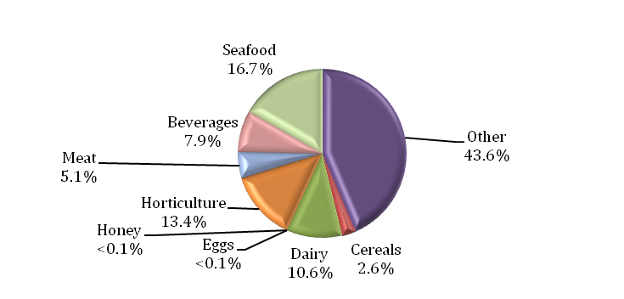
Data source: AIMS database
Appendix 1 provides an overview of the analytical tests applied to the commodity groups and Appendix 2 provides a list of the tariff codes associated with each commodity grouping used for this report.
Table 1 Inspection and test data, by commodity group
Commodity group | No. of tests applied | No. compliant / non-compliant | Compliance rate (%)
Beverages | 3 584 | 3 502 / 82 | 97.7
Cereals, flours and milled products | 1 172 | 1 165 / 7 | 99.4
Dairy | 4 803 | 4 753 / 50 | 99.0
Eggs | 16 | 16 / 0 | 100.0
Honey | 4 | 4 / 0 | 100.0
Horticulture | 6 039 | 5 974 / 65 | 98.9
Meat | 2 293 | 2 288 / 5 | 99.8
Seafood | 7 562 | 7 505 / 57 | 99.2
Other (incl. processed foods) | 19 731 | 19 388 / 343 | 98.3
Total | 45 204 | 44 595 / 609 | 98.7
Source: AIMS database

Country of origin
Under the Imported Food Inspection Scheme, food is inspected based on its risk and/or frequency of importation. Country of origin is not generally targeted under routine inspections, but exceptions include where a food has previously failed inspection.
The numbers of inspections reflect those countries from which importers source food and/or import more regularly from those countries to Australia. The countries from whom importers more frequently source food will have a higher representation in inspection activity for food safety. These data cannot be used to indicate volumes of food imported to Australia.
For the period 1 January to 30 June 2013:
- Thailand, China and the United States were the countries whose food was subject to most inspections
- 61.8 per cent of food inspections were on food from 10 countries; the remaining 38.2 per cent were on food from 105 countries.
The Australian Food Statistics (published annually by the Department of Agriculture) indicates that a significant proportion of food imports are from New Zealand. However, under the Trans-Tasman Mutual Recognition Arrangement, most foods from New Zealand are not subject to the Imported Food Control Act 1992 and are not inspected under the Imported Food Inspection Scheme.
Table 2 Number of inspections, by country of origin
Country of origin | No. of lines inspected | % of total lines inspected
China | 1 190 | 9.0
France | 588 | 4.5
India | 795 | 6.0
Italy | 1 071 | 8.1
Japan | 642 | 4.9
Korea, Republic of | 594 | 4.5
Malaysia | 505 | 3.8
Taiwan | 454 | 3.4
Thailand | 1 218 | 9.2
United States | 1 103 | 8.4
Other | 5 035 | 38.2
Total | 13 195 | 100.0
Note: For details of all countries of origin see Appendix 3.
Source: AIMS database
Figure 2 Percentage of inspections, by country of origin
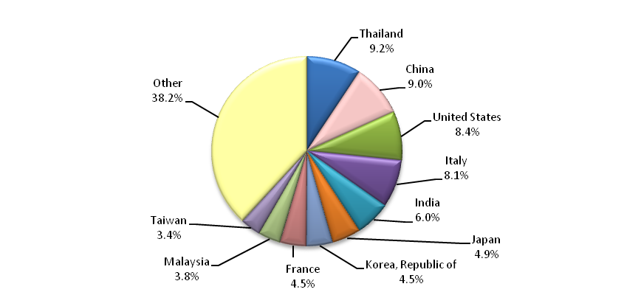
More detailed information about Thailand, China and the United States is provided in the analytical testing data section.

Testing data

Summary for January to June 2013
- 98.7 per cent of all tests applied to imported food samples under the Imported Food Inspection Scheme complied with Australian standards for these tests.
- Incorrect labelling accounted for most non-compliance (61.6 per cent of failures).
- When labelling non-compliances are removed from testing data, the compliance rate for analytical and other tests applied to imported food rises to 99.2 per cent.
Table 3 Compliance for the three groups of tests
Test group | No. of tests applied | No. compliant / non-compliant | Compliance rate (%)
Analytical | 11 721 | 11 579 / 142 | 98.8
Labelling | 16 726 | 16 351 / 375 | 97.8
Other | 16 757 | 16 665 / 92 | 99.5
Total | 45 204 | 44 595 / 609 | 98.7
Figure 3 provides a summary of the 609 non-compliant tests from the 45 204 tests applied, with details of each specific test and the proportion each test contributed to the total.
Figure 3 Non-compliant test results
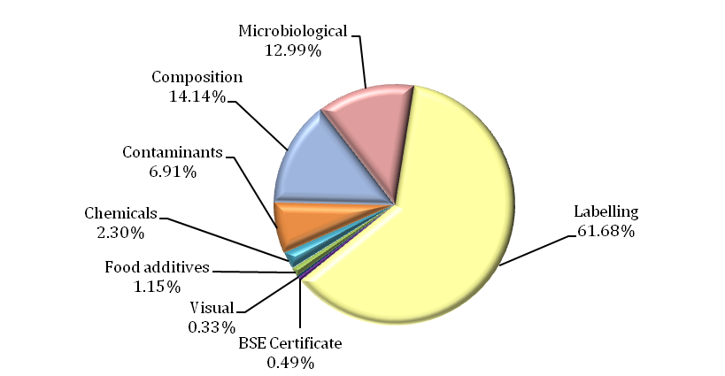
Note: Of 45 204 tests applied, 609 were non-compliant.

Labelling data
Figure 4 provides a detailed summary of labelling non-compliances against Australian food standards. Absence or incomplete importer details on labelling is the largest contributor to non-compliant labelling, accounting for 31 per cent of non-compliances. Country of origin, lot codes and ingredients lists account for a further 32 per cent of label non-compliances.
Figure 4 Non-compliant labelling
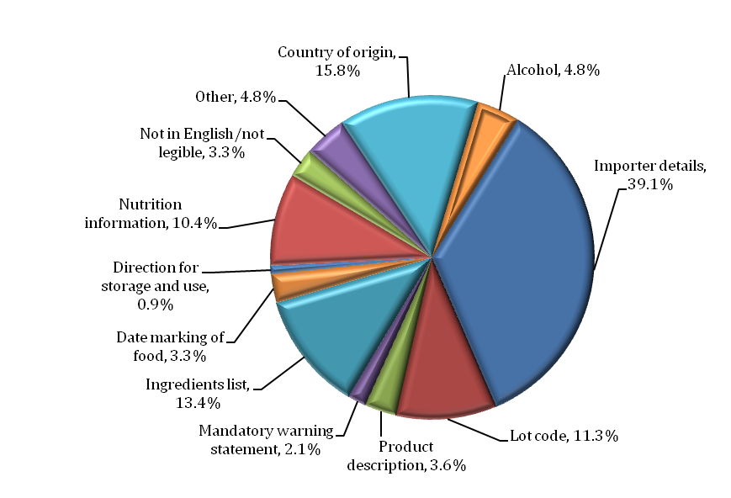

Other test data
Composition assessments
Additives or ingredients that are not permitted, or are in excess of permitted levels may be identified during a label assessment. Of the 16 726 label assessments conducted, 86 foods were found to be non-compliant with these requirements.
Note: Where a food fails, composition is given a separate test code in the database and is applied for the purpose of holding order inspections. This adds 155 tests to the overall test data in this report but does not represent the actual test and compliance rate.
Foods may also be sampled and tested for the presence and level of additives under the surveillance program. These tests are reported under the analytical data.
BSE certificate checks
Food containing beef is referred as risk and government certification is assessed to determine compliance to Australia’s BSE policy. A fail is assigned when no compliant certificate is presented.
Table 4 Compliance for BSE certificate checks
Type of test | No. of tests applied | No. compliant / non-compliant | Compliance rate (%)
BSE Certificate | 288 | 285 / 3 | 99.0
Visual assessments
At every inspection the food is assessed for signs of unsafe or unsuitable condition such as foreign objects or deterioration.
Table 5 Compliance for visual assessments
Type of test | No. of tests applied | No. compliant / non-compliant | Compliance rate (%)
Visual | 16 314 | 16 311 / 3 | 99.9

Analytical testing data
Within the analytical test category, tests are grouped according to four main types: chemical, contaminant, food additive and microbiological (Table 4). Each category consists of several tests which are reported in detail in Tables 5, 6, 7 and 8.
Analytical test results show a 98.8 per cent compliance rate with the tests applied under the Imported Food Inspection Scheme.
Of the 11 721 analytical tests applied, 142 (1.2 per cent) of the products being tested failed against the standards.
Table 6 Compliance for analytical testing
Type of test | No. of tests applied | No. compliant/non-compliant | Compliance rate (%)
Chemicals | 2824 | 2810 / 14 | 99.5
Contaminants | 2833 | 2791 / 42 | 98.5
Food additives | 223 | 216 / 7 | 96.9
Microbiological | 5841 | 5762 / 79 | 98.6
Total | 11 721 | 11 579 / 142 | 98.8
Table 7 Compliance for chemical tests
Chemical | No. of tests applied | No. compliant / non-compliant | Compliance rate (%) | Types of food
Carbendazim | 4 | 4 / 0 | 100.0 | Orange juice
Chloramphenicol | 0 | n/a | n/a | Honey
Ethylene chlorohydrin | 127 | 122 / 5 | 96.1 | Herbs and spices
Fluoroquinolones | 173 | 171 / 2 | 98.8 | Farmed fish and prawns
Malachite Green | 124 | 124 / 0 | 100.0 | Farmed fish
Nitrofurans | 44 | 44 / 0 | 100.0 | Farmed prawns, honey
Pesticides | 2 352 | 2 345 / 7 | 99.7 | Fruits, vegetables, honey, meats
pH | 1 | 1 / 0 | 100.0 | Fermented milk products
Streptomycin | 0 | n/a | n/a | Honey
Sulphonamides | 0 | n/a | n/a | Honey
Tetracycline | 0 | n/a | n/a | Honey
Total | 2824 | 2810 / 14 | 99.5 | –
Note: n/a = not applicable

Table 8 Compliance for contaminant tests
Contaminant | No. of tests applied | No. compliant / non-compliant | Compliance rate (%) | Types of food
Aflatoxins | 484 | 475 / 9 | 98.1 | Nuts
Cadmium | 291 | 290 / 1 | 99.7 | Peanuts, leafy and tuber vegetables, wheat and rice
Caesium 134 a | 17 | 17 / 0 | 100.0 | Seaweed, seafood, fruit, vegetables and milk
Caesium 137 a | 17 | 17 / 0 | 100.0 | Seaweed, seafood, fruit, vegetables and milk
Chloropropanols | 75  75 | 75 / 0 (DCP)  75 / 0 (3MCPD) | 100.0  100.0 | Soy and oyster sauce
Domoic acid | 217 | 217 / 0 | 100.0 | Bivalve molluscs
Histamine | 1 331 | 1 307 / 24 | 98.2 | Fish
Hydrocyanic acid | 14 | 9 / 5 | 64.3 | Cassava chips
Inorganic arsenic | 1 | 0 / 1 | 0.0 | Vegetables (seaweed)
Iodine | 85 | 83 / 2 | 97.6 | Seaweed (brown algae)
Lead | 9 | 9 / 0 | 100.0 | Dried dates and sultanas
PSP Toxin | 217 | 217 / 0 | 100.0 | Bivalve molluscs
Total | 2 833 | 2 791 / 42 | 98.5 | –
a Following damage to Japan’s Fukushima Dai-ichi nuclear facility in March 2011, the Department of Agriculture implemented a precautionary monitoring program at the border. Monitoring and testing is based on assessment policy from Food Standards Australia New Zealand and the Australian Radiation Protection and Nuclear Safety Agency which aims to provide ongoing assurance that foods imported from Japan are safe.
Table 9 Compliance for food additive tests
Food additive | No. of tests applied | No. compliant / non-compliant | Compliance rate (%) | Types of food
Colours | 88 | 82 / 6 | 93.2 | Confectionery
Sulphur dioxide | 135 | 134 / 1 | 99.3 | Raw prawns, wine and preserved vegetables
Total | 223 | 216 / 7 | 96.9 | –
Table 10 Compliance for microbiological tests
Microbial agent | No. of tests applied | No. compliant / non-compliant | Compliance rate (%) | Types of food
E. coli | 1281 | 1 239 / 42 | 96.7 | Processed meats, water, seafood, and cheese
Salmonella | 2460 | 2 444 / 16 | 99.3 | Processed meats, seafood, dried coconut, dried chilli and pepper, sesame seeds, cheese
Listeria monocytogenes | 1294 | 1 281 / 13 | 99.0 | Cheese, ready-to-eat seafood, processed meats
Standard plate count | 175 | 171 / 4 | 97.7 | Cooked prawns
Bacillus cereus | 217 | 214 / 3 | 98.6 | Bean curd, tofu and pasta
Vibrio cholerae | 96 | 95 / 1 | 99.0 | Cooked prawns
Coagulase positive Staphylococcus | 317 | 317 / 0 | 100.0 | Processed meats and cooked prawns
Total | 5841 | 5 762 / 79 | 98.6 | –

Analytical testing data, Thailand
In the period January to June 2013, food from Thailand was subject to the highest number of inspections in comparison with other countries inspected under the Imported Food Inspection Scheme; representing 9.2 per cent of all food lines inspected.
Of the 1073 analytical tests applied to imported food from Thailand, none were found to be non-compliant, giving a 100 per cent compliance rate for tests applied.
Contaminants tests were the most frequently applied followed by tests for chemical, microbiological and food additive content.
Table 11 Compliance for chemical tests, Thailand
Chemical | No. of tests applied | No. compliant / non-compliant | Compliance rate (%)
Chloramphenicol | 0 | n/a | n/a
Ethylene chlorohydrin | 8 | 8 / 0 | 100
Fluoroquinolones | 13 | 13 / 0 | 100
Malachite Green | 6 | 6 / 0 | 100
Nitrofurans | 7 | 7 / 0 | 100
Pesticides | 239 | 239 / 0 | 100
pH | 0 | n/a | n/a
Streptomycin | 0 | n/a | n/a
Sulphonamides | 0 | n/a | n/a
Tetracycline | 0 | n/a | n/a
Total | 273 | 273 / 0 | 100
Note: n/a = not available – no tests applied
Table 12 Compliance for contaminant tests, Thailand
Contaminant | No. of tests applied | No. compliant/non-compliant | Compliance rate (%)
Aflatoxins | 20 | 20 / 0 | 100
Cadmium | 50 | 50 / 0 | 100
Chloropropanols | 9  9 | 9 / 0 (DCP)  9 / 0 (3MCPD) | 100  100
Domoic acid | 26 | 26 / 0 | 100
Histamine | 420 | 420 / 0 | 100
Hydrocyanic acid | 0 | n/a | n/a
Inorganic arsenic | 0 | n/a | n/a
Iodine | 0 | n/a | n/a
Lead | 0 | n/a | n/a
PSP toxin | 27 | 27 / 0 | 100
Total | 561 | 561 / 0 | 100
Note: n/a = not available – no tests applied

Table 13 Compliance for food additive tests, Thailand
Food additive | No. of tests applied | No. compliant / non-compliant | Compliance rate (%)
Colours | 0 | n/a | n/a
Sulphur dioxide | 5 | 5 / 0 | 100
Total | 5 | 5 / 0 | 100
Note: n/a = not available – no tests applied
Table 14 Compliance for microbiological testing, Thailand
Microbial agent | No. of tests applied | No. compliant / non-compliant | Compliance rate (%)
Bacillus cereus | 30 | 30 / 0 | 100
Coagulase positive Staphylococcus | 33 | 33 / 0 | 100
E. coli | 5 | 5 / 0 | 100
Listeria monocytogenes | 26 | 26 / 0 | 100
Salmonella | 76 | 76 / 0 | 100
Standard plate count | 36 | 36 / 0 | 100
Vibrio cholerae | 28 | 28 / 0 | 100
Total | 234 | 234 / 0 | 100

Analytical testing data, China
In the period January to June 2013, food from China was subject to the second highest number of inspections in comparison with other countries inspected under the Imported Food Inspection Scheme; representing 9.0 per cent of all food lines inspected.
Of the 916 analytical tests applied to imported food from China, six were found to be non-compliant, giving a 99.3 per cent compliance rate for tests applied.
Microbiological tests were the most frequently applied followed by tests for contaminants, chemical and food additive content.
Table 15 Compliance for chemical tests, China
Chemical | No. of tests applied | No. compliant / non-compliant | Compliance rate (%)
Chloramphenicol | 0 | n/a | n/a
Ethylene chlorohydrin | 12 | 12 / 0 | 100.0
Fluoroquinolones | 10 | 10 / 0 | 100.0
Malachite Green | 4 | 4 / 0 | 100.0
Nitrofurans | 7 | 7 / 0 | 100.0
Pesticides | 252 | 250 / 2 | 99.2
pH | 0 | n/a | n/a
Streptomycin | 0 | n/a | n/a
Sulphonamides | 0 | n/a | n/a
Tetracycline | 0 | n/a | n/a
Total | 285 | 283 / 2 | 99.3
Note: n/a = not available – no tests applied
Table 16 Compliance for contaminant tests, China
Contaminant | No. of tests applied | No. compliant / non-compliant | Compliance rate (%)
Aflatoxins | 87 | 87 / 0 | 100.0
Cadmium | 26 | 25 / 1 | 96.2
Chloropropanols | 3  3 | 3 / 0 (DCP)  3 / 0 (3MCPD) | 100.0  100.0
Domoic acid | 51 | 51 / 0 | 100.0
Histamine | 35 | 35 / 0 | 100.0
Hydrocyanic acid | 0 | n/a | n/a
Inorganic arsenic | 0 | n/a | n/a
Iodine | 31 | 30 / 1 | 96.8
Lead | 4 | 4 / 0 | 100.0
PSP Toxin | 51 | 51 / 0 | 100.0
Total | 291 | 289 / 2 | 99.3
Note: n/a = not available – no tests applied
Table 17 Compliance for food additive tests, China
Food additive | No. of tests applied | No. compliant / non-compliant | Compliance rate (%)
Colours | 21 | 19 / 2 | 90.5
Sulphur dioxide | 11 | 11 / 0 | 100.0
Total | 32 | 30 / 2 | 93.8
Table 18 Compliance for microbiological tests, China
Microbial agent | No. of tests applied | No. compliant / non-compliant | Compliance rate (%)
Bacillus cereus | 22 | 22 / 0 | 100
Coagulase positive Staphylococcus | 28 | 28 / 0 | 100
E. coli | 18 | 18 / 0 | 100
Listeria monocytogenes | 17 | 17 / 0 | 100
Salmonella | 172 | 172 / 0 | 100
Standard plate count | 28 | 28 / 0 | 100
Vibrio cholerae | 23 | 23 / 0 | 100
Total | 308 | 308 / 0 | 100

Analytical testing data, United States
In the period January to June 2013, food from the United States was subject to the third highest number of inspections in comparison with other countries inspected under the Imported Food Inspection Scheme; representing 8.4 per cent of all food lines inspected.
Of the 900 analytical tests applied to imported food from the United States, six were found to be non-compliant, giving a 99.3 per cent compliance rate for tests applied.
Chemical tests were the most frequently applied followed by tests for microbiological, contaminants and food additive content.
Table 19 Compliance for chemical tests, United States
Chemical | No. of tests applied | No. compliant / non-compliant | Compliance rate (%)
Chloramphenicol | 0 | n/a | n/a
Ethylene chlorohydrin | 5 | 5 / 0 | 100
Fluoroquinolones | 1 | 1 / 0 | 100
Malachite Green | 1 | 1 / 0 | 100
Nitrofurans | 0 | n/a | n/a
Pesticides | 368 | 368 / 0 | 100
pH | 0 | n/a | n/a
Streptomycin | 0 | n/a | n/a
Sulphonamides | 0 | n/a | n/a
Tetracycline | 0 | n/a | n/a
Total | 375 | 375 / 0 | 100
Note: n/a = not available – no tests applied
Table 20 Compliance for contaminant tests, United States
Contaminant | No. of tests applied | No. compliant / non-compliant | Compliance rate (%)
Aflatoxins | 109 | 109 / 0 | 100
Cadmium | 23 | 23 / 0 | 100
Chloropropanols | 0  0 | n/a (DCP)  n/a (3MCPD) | n/a  n/a
Domoic acid | 6 | 6 / 0 | 100
Histamine | 25 | 25 / 0 | 100
Hydrocyanic acid | 2 | 2 / 0 | 100
Inorganic arsenic | 0 | n/a | n/a
Iodine | 0 | n/a | n/a
Lead | 0 | n/a | n/a
PSP Toxin | 6 | 6 / 0 | 100
Total | 171 | 171 / 0 | 100
Note: n/a = not available – no tests applied
Table 21 Compliance for food additive tests, United States
Food additive | No. of tests applied | No. compliant / non-compliant | Compliance rate (%)
Colours | 25 | 22 / 3 | 88.0
Sulphur Dioxide | 10 | 10 / 0 | 100.0
Total | 35 | 32 / 3 | 91.4

Table 22 Compliance for microbiological tests, United States
Microbial agent | No. of tests applied | No. compliant / non-compliant | Compliance rate (%)
Bacillus cereus | 2 | 2 / 0 | 100.0
Coagulase positive Staphylococcus | 30 | 30 / 0 | 100.0
E. coli | 83 | 81 / 2 | 97.6
Listeria monocytogenes | 71 | 70 / 1 | 98.6
Salmonella | 129 | 129 / 0 | 100.0
Standard plate count | 4 | 4 / 0 | 100.0
Vibrio cholerae | 0 | n/a | n/a
Total | 319 | 316 / 3 | 99.1
Note: n/a = not available – no tests applied

Appendixes

Appendix 1: Analytical tests applied to food
Food group | Risk / Surveillance test | Analytical test
Confectionery | Surveillance | Colour screen
Dairy foods | Risk | Listeria monocytogenes  Salmonella  E. coli  Melamine
Dairy foods | Surveillance | Pesticide screen  Salmonella  E. coli  pH test
Egg and egg products | Surveillance | Salmonella
Fruit | Surveillance | Pesticide screen  Lead  Sulphur dioxide
Fruit juices | Surveillance | Pesticide screen  Carbendazim (orange juice only)
Herbs and spices | Risk | Salmonella
Herbs and spices | Surveillance | Salmonella  Ethylene chlorohydrins
Honey | Surveillance | Pesticide screen  Chloramphenicol  Nitrofurans  Streptomycin  Tetracycline  Sulphonamides
Meat | Risk | BSE government certification  Coagulase positive Staph  E. coli  Listeria monocytogenes  Salmonella
Meat | Surveillance | Pesticide screen
Nuts and nut products | Risk | Salmonella  Aflatoxin
Nuts and nut products | Surveillance | Aflatoxin
Other beverages | Surveillance | Sulphur dioxide
Sauces | Surveillance | Chloropropanols (Soy sauces)
Seafood | Risk | Histamine  Listeria monocytogenes  Coagulase positive Staph  E. coli  Salmonella  Standard plate count  Paralytic shellfish poison (PSP)  Domoic acid
Seafood | Surveillance | Histamine  Malachite green  Nitrofurans  Fluoroquinolones  Sulphur dioxide
Vegetables | Risk | Salmonella (Sesame seeds)  Inorganic arsenic (Hijiki seaweed)  Iodine (Seaweed (brown algae))
Vegetables | Surveillance | Pesticide screen  Cadmium  Sulphur dioxide  Salmonella  Erucic acid (Canola oils)  B.cereus
Water | Surveillance | E. coli

Appendix 2: Tariff codes included in each food commodity group
Commodity group | Tariff code
Beverages | 2009  2201 – 2208
Cereals | 1001 – 1008  1101 – 1109
Dairy | 0401 – 0406
Eggs | 0407 – 0408
Honey | 0409
Horticulture | 0701 – 0714  0801 – 0814  0904 – 0910  1201 – 1208  1210 – 1212  1801 – 1802
Meat | 0201 – 0212  0504  1601 - 1602
Seafood | 0302 – 0307  1603 – 1605
Other | 0410  0901 – 0903  1301 – 1302  1501 – 1504  1506 – 1517  1520 – 1521  1701 – 1704  1803 – 1806  1901 – 1905  2001 – 2008  2101 – 2106  2209  2501  3501 – 3503  3505  3507

Appendix 3: No. of inspections per country

Country | No. of inspections
Afghanistan | 1
American Samoa | 4
Argentina | 16
Australia | 2
Austria | 35
Bahrain | 4
Bangladesh | 20
Belgium | 109
Bermuda | 1
Bolivia | 5
Bosnia and Herzegowina | 6
Brazil | 36
Bulgaria | 18
Cambodia | 2
Canada | 119
Chile | 56
China | 1 190
Colombia | 15
Costa Rica | 4
Croatia (local name Hrvatska) | 37
Cuba | 3
Cyprus | 11
Czech Republic | 17
Denmark | 122
Dominican Republic | 1
Ecuador | 3
Egypt | 29
El Salvador | 3
Estonia | 1
Ethiopia | 8
Fiji | 67
Finland | 5
France | 588
French Polynesia | 4
Georgia | 3
Germany | 287
Ghana | 10
Greece | 102
Guatemala | 7
Honduras | 3
Hong Kong | 113
Hungary | 14
Iceland | 2
India | 795
Indonesia | 377
Iran, Islamic Republic of | 71
Ireland | 37
Israel | 49
Italy | 1071
Jamaica | 5
Japan | 642
Jordan | 11
Kenya | 1
Kiribati | 9
Korea, Republic of | 594
Latvia | 5
Lebanon | 85
Lithuania | 2
Macedonia, former Yugoslav Republic of | 38
Madagascar | 1
Malaysia | 505
Maldives | 28
Mauritius | 4
Mexico | 101
Morocco | 2
Myanmar | 29
Namibia | 5
Nepal | 7
Netherlands | 216
New Zealand | 144
Nicaragua | 4
Nigeria | 1
Norway | 57
Oman | 1
Pakistan | 55
Panama | 3
Papua New Guinea | 6
Peru | 43
Philippines | 230
Poland | 42
Portugal | 14
Romania | 1
Russian Federation | 24
Saudi Arabia | 12
Serbia | 14
Serbia and Montenegro | 1
Seychelles | 2
Singapore | 219
Slovakia Slovak Republic | 2
Slovenia | 9
Solomon Islands | 9
Somalia | 1
South Africa | 185
Spain | 242
Sri Lanka | 219
Swaziland | 6
Sweden | 59
Switzerland | 86
Syrian Arab Republic | 3
Taiwan | 454
Tanzania, United Republic of | 5
Thailand | 1 218
Tonga | 6
Trinidad and Tobago | 2
Tunisia | 4
Turkey | 121
Ukraine | 2
United Arab Emirates | 34
United Kingdom | 390
United States | 1 103
Uruguay | 4
Vanuatu | 8
Venezuela | 1
Vietnam | 375
Zimbabwe | 1
Total | 13 195

Glossary
AIMS
AIMS is the computer system that receives data on imported goods from the Integrated Cargo System (ICS) and processes entries for both imported foods and quarantine purposes.
Australia New Zealand Food Standards Code
The Code details food standards applicable to food for human consumption in Australia and is available from the FSANZ website.
Batch
Batch means food of a particular kind made or packed in a distinct manner which may include one or more lots.
Entry
A Customs and Border Protection Services electronic document generated using the ICS. An entry may contain one or more lines/foods.
Food
Section 3 of the Imported Food Control Act 1992 describes food as:
(a) Any substance or thing of a kind used or capable of being used as food or drink by human beings; or
(b) any substance or thing of a kind used or capable of being used as an ingredient or additive in, or substance used in the preparation of, a substance or thing referred to in paragraph (a); or
(c) any other substance or thing that is prescribed; whether or not it is in a condition fit for human consumption, but does not include a therapeutic good within the meaning of the Therapeutic Goods Act 1989.
FSANZ
Food Standards Australia New Zealand is a bi-national government agency responsible for developing food standards and administering the Australia New Zealand Food Standards Code. FSANZ conducts the food risk assessment and advises the Department of Agriculture about foods that pose a medium to high risk to human health and safety.
Holding Order
An order made under the Imported Food Control Act 1992 increasing the rate of inspection of a surveillance food that has failed an imported food inspection. Targets the specific food from the specific manufacturer in a specific country at a rate of 100 per cent of consignments.
Imported Food Inspection Scheme
The inspection scheme, established under the Imported Food Control Regulations 1993, provides for inspection of food at the border to assess importer compliance with sourcing food that meets Australian food standards.
Inspection
Includes inspection (visual and label assessment), or inspection and analysis (samples taken and sent for analysis), as the case requires.

Line
Items of food being imported are recorded within the ICS as lines within the import entry. An import entry may consist of one line or many lines of products.
Lot
A quantity of a food prepared or packed under essentially the same conditions (ordinarily from a particular preparation or packing unit and during a particular time ordinarily not exceeding 24 hours).
Lot Code
A unique code that identifies a lot and can be used for recall purposes if necessary.
Risk food
Foods that FSANZ has assessed as representing a medium to high potential risk to consumer health are referred to AIMS by the ICS for inspection at the rate of 100 per cent of imports, reducing with a history of good compliance.
Surveillance foods
All other foods not classified as risk foods. Referred to AIMS by the ICS for inspection at the rate of 5 per cent of consignments.
Trans-Tasman Mutual Recognition Arrangement
This is an arrangement between the Australian, state and territory governments and the government of New Zealand. It allows goods (including foods) to be traded freely between New Zealand and Australia and enhances the freedom of individuals to work in both countries.

