Improving Australia's reporting on hazardous waste under the Basel Convention

Final report

prepared for

17 June 2014

Improving Australia's reporting on hazardous waste under the Basel Convention

report:

17 June 2014

Disclaimer

This report has been prepared for in accordance with the terms and conditions of appointment dated , and is based on the assumptions and exclusions set out in our scope of work. Information in this document is current as of . This report has been compiled based on secondary information and data provided by other parties; as such it relies on the accuracy of the provided material. Although the data has been reviewed, the information provided was assumed to be correct unless otherwise stated.

While all professional care has been undertaken in preparing this report, Blue Environment Pty Ltd cannot accept any responsibility for any use of or reliance on the contents of this report by any third party.

©

Blue Environment prints on 100% recycled content paper

Author

Geoff Latimer, Joe Pickin, Paul Randell

Blue Environment Pty Ltd

ABN 78 118 663 997

Suite 212B, 757 Bourke Street, Docklands Vic 3008

email: [blue@blueenvironment.com.au](mailto:blue@blueenvironment.com.au)

web: [www.blueenvironment.com.au](http://www.blueenvironment.com.au)

Phone +61 3 8102 9372

+61 3 5426 3536

Reviewer

Joe Pickin

CONTENTS

1. Introduction 1

1.1 Project background 1

1.2 Project scope 2

1.3 Project approach 2

1.4 Project deliverables 3

2. Improving the Basel reporting process 4

2.1 Translation of jurisdictional codes to Basel Y-codes 4

2.2 Guidance materials 5

3. Jurisdictional consultation 6

4. Data presentation 8

4.1 Limitations 8

4.2 Hazardous waste generation data 9

4.3 Hazardous waste fate data 10

4.4 Assessment against historical data and projects 13

5. Lessons learned 16

6. Recommendations 17

References 18

Appendices

Appendix A Reporting hazardous waste under the Basel Convention – guidance to jurisdictions

Appendix B Reporting & translation templates

Appendix C National hazardous waste data 2011-12 and 2012 – by NEPM code

Appendix D National hazardous waste data 2012 – by Basel Y code

Appendix E National hazardous waste data 2012 – Analysis & Key Issues

Appendix F Update of Hazardous Waste Data Summary Report (2010-11 data)

Figures

Figure 1: Mapping Hazardous Waste: Jurisdiction codes 🡪 NEPM codes 🡪 Basel Y-codes 5

Figure 2: Hazardous waste treatment/disposal (New South Wales 2010–11) 11

Figure 3: Hazardous waste treatment/disposal (Queensland 2010–11) 12

Figure 4: Hazardous waste treatment/disposal (Victoria 2010–11) 12

Tables

Table 1: National hazardous waste data 2012 – by high-level NEPM code 10

Table 2: National hazardous waste data 2012 – by state and territory totals 10

Glossary

|  |  |
| --- | --- |
| Basel Convention | *The Basel Convention on the Control of Transboundary Movements of Hazardous Wastes and their Disposal*. The Convention puts an onus on exporting countries to ensure that hazardous wastes are managed in an environmentally sound manner in the country of import. |
| Controlled Waste | Waste that falls under the control of the Controlled Waste National Environment Protection Measure. Generally equivalent to hazardous waste, although definitional differences of the latter exist across jurisdictions |
| Controlled Waste NEPM | National Environment Protection (Movement of Controlled Waste between States and Territories) Measure. |
| Hazardous waste | A hazardous waste, as defined in the Australian Government’s *National Waste Policy: Less waste, more resources* (2009), is a substance or object that exhibits hazardous characteristics, is no longer fit for its intended use and requires disposal.  Hazardous waste means:  (a) waste prescribed by the regulations, where the waste has any of the characteristics mentioned in Annex III to the Basel Convention; or  (b) wastes covered by paragraph 1(a) of Article 1 of the Basel Convention; or  (c) household waste; or  (d) residues arising from the incineration of household waste; but does not include wastes covered by paragraph 4 of Article 1 of the Basel Convention. |
| Interstate data | Data collected about hazardous waste generated in one jurisdiction and treated in another, through cross-border transport under the Controlled Waste NEPM |
| Intrastate data | Data collected about hazardous waste generated, transported and treated within the one jurisdiction |
| NEPC | National Environment Protection Council |
| NEPM | National Environment Protection Measure |
| Tracked data | Hazardous waste collected under the arrangements of a tracking system |
| Tracking system | Jurisdiction-based hazardous waste tracking systems, which are in place in New South Wales, Queensland, South Australia, Western Australia and Victoria. These tracking systems can be either online, paper-based, or a combination of both these mechanisms. |
| Treatment | Treatment of waste is the removal, reduction or immobilisation of a hazardous characteristic to enable the waste to be reused, recycled, sent to an energy from waste facility or disposed. |
| Waste | (For data collation purposes) is materials or products that are unwanted or have been discarded, rejected or abandoned. Waste includes materials or products that are recycled, converted to energy, or disposed. Materials and products that are reused (for their original or another purpose without reprocessing) are not solid waste because they remain in use. |
| Waste Code | Three-digit code typically used by jurisdictions to describe NEPM-listed wastes. These are also referred to as ’NEPM codes’ although it is noted that the actual codes do not appear in the NEPM itself. |
| Waste generation | Typically, waste generation = resource recovery (recycling + energy recovery) + disposal. For the purposes of this report however, waste generation means what has been reported by jurisdictional data providers as waste generation. |

Executive summary

### Introduction

In November 2013, the Department of Environment (DoE) engaged Blue Environment Pty Ltd, in association with ENVIRON Australia Pty Ltd and Randell Environmental Consulting Pty Ltd (REC), to undertake a project titled *Improving Australia's reporting on hazardous waste under the Basel Convention*.

The Basel Convention, which regulates the movement of hazardous wastes across international boundaries, came into force in 1992. The Convention puts an onus on exporting countries to ensure that hazardous wastes are managed in an environmentally sound manner in the country of import, as well as at their point of origin.

The Australian Government provides an annual report to the Secretariat of the Basel Convention on the occurrence and trans-boundary movements of hazardous wastes in Australia. This report includes a national account of tonnages of these wastes expressed using the Basel Convention’s classification system known as Y-codes. State and territory governments collect this data as part of their regulatory role in managing hazardous waste and its potential for impact on the environment and human health.

DoE has flagged multiple areas where compliance with Basel requirements can be improved, including: improvements to timeliness, completeness, consistency, accuracy, verifiability and generally meeting common principles of data quality.

The DoE defined the project scope as follows:

1. The development of descriptive guidance about the Basel Convention reporting requirements
2. Developing guidance for the states and territories on how to take their input data and use it to populate the Y-Code categories of Basel’s hazardous waste classification
3. Provision of guidance on how other aspects of the Basel spreadsheet can be populated in a standardised way
4. Delivery of the guidance to state and territory reporters, supporting their reporting activity through an assisted validation process
5. Compilation of a standardised jurisdictional and national report, suitable for both Australian Government publication and provision to the Basel Convention Secretariat
6. Delivery of a final project report, containing the guidance, the national and jurisdictional data, and supporting commentary/analysis, suitable for publication on the Department’s website.

### Improving the Basel reporting process

Collation of high quality national data on hazardous waste in Australia is in its infancy.

The first step in improving Australia’s hazardous waste data and reporting is to address the different jurisdictional approaches and systems of classification and coding of hazardous wastes types. The project team tackled this by mapping Basel Y-code waste categories back to original jurisdiction-based waste codes, typically used in waste tracking and management systems employed at the jurisdictional level.

The Y-code mapping involved a 2-step translation protocol:

1. A jurisdiction-specific mapping of each waste category or code to the Controlled Waste NEPM 75 category list, (Schedule A, List 1 of the NEPM).
2. Common for all jurisdictions, mapping each of the NEPM 75 codes into the most appropriate of the 47 Basel Y-codes. In cases where no clear Y-code accommodated a NEPM code translation, one of the following alternatives were applied:
   1. multiple NEPM codes mapped to a single Y-code
   2. splitting a NEPM code into more than one Y-code
   3. creation of a limited number of ‘new’ Basel categories, additional to Y-codes, to ensure that hazardous waste recognised in Australia’s national data set are not excluded from that reported to the Basel Secretariat (as required under the Convention).

The above translation forms the basis of two sets of guidance materials developed as part of this project:

1. A document titled *Reporting hazardous waste under the Basel Convention - guidance to states and territories*, provided as Appendix A and
2. the reporting and translation Microsoft Excel-based templates used to compile the Basel data (provided as Appendix B).

### Jurisdictional consultation

The project team consulted with all jurisdictional environment agencies across the states and territories. Those jurisdictions whose hazardous data issues (in the view of the project team) were perceived as having the potential to be complex or unique were visited for face to face discussions, while the remainder were consulted through email and phone discussion. The findings of the consultation process are set out in section 3.

### Data presentation

Table 1: National hazardous waste data 2012 – by high-level NEPM code

|  |  |  |
| --- | --- | --- |
| **Hazardous waste classification** | | **Waste generated** |
| Code | Waste description | tonnes |
| A | Plating and heat treatment | 6,585 |
| B | Acids | 44,725 |
| C | Alkaline wastes | 335,371 |
| D | Inorganic chemicals | 266,221 |
| E | Reactive chemicals | 259 |
| F | Paints, lacquers, varnish, etc. | 63,373 |
| G | Organic solvents, solvent residues | 34,014 |
| H | Pesticides | 4,584 |
| J | Oils, hydrocarbons, emulsions | 758,575 |
| K | Putrescible/organic wastes | 783,297 |
| L | Industrial washwaters | 0 |
| M | Organic chemicals | 22,415 |
| N | Solid/sludge wastes | 3,799,667 |
| R | Clinical and pharmaceutical wastes | 70,678 |
| T | Miscellaneous | 424,262 |
| **Total** | | **6,614,029** |

Table 2: National hazardous waste data 2012 – by state and territory totals

|  |  |
| --- | --- |
| **State/ Territory** | **Waste generated** (tonnes) |
| ACT | 68,309 |
| NSW | 1,768,996 |
| NT | 24,516 |
| QLD | 1,733,396 |
| SA | 880,292 |
| TAS | 172,781 |
| VIC | 1,359,529 |
| WA | 606,211 |
| **Total** | **6,614,029** |

This project did not seek to obtain new data on fates of hazardous waste, such as disposal, recycling or energy recovery, as this is not required for Basel reporting. However, detailed fate information was obtained as part of the *Hazardous Waste Data Assessment Final Report*, prepared by KMH Environmental (2013) on the 2010-11 data set. Given the relative agreement in generation data from 2010-11 to the current period (2012), and the closeness of the data set years, this reference provides a good indication of the likely fate tonnages for 2012. Extracts from this report, showing hazardous waste fate tonnages across Australia in 2010-11, are shown in section 4.3. The findings of this work are compared with those of both the *Hazardous Waste Data Assessment* and *Waste Generation and Resource Recovery in Australia* in section 4.4.

### Lessons learned

* Keep it simple for the jurisdictions
* provide firm reporting deadlines
* provide jurisdictions time for post-submission review
* classification differences are nuanced
* more consideration is needed in relation to simultaneous collection of NEPM interstate transfer data.

### Recommendations

1. Adopt the 75 NEPM code classification system as a national framework for collecting, collating and reporting on hazardous waste in Australia, via the utility of the translation guidance and templates provides as appendices A and B.
2. Consider mechanisms for obtaining ongoing data on the fate of hazardous wastes in order to eliminate the discrepancies between the data presented for Basel and the proposed National Waste Data System.
3. Align the data collection task and reporting timeframes with those of the proposed National Waste Data System. In particular explore the feasibility of combining the data collection templates and timing developed for this project with any future data collection mechanisms developed under the National Waste Data System project.
4. Update the reporting and translation template for Western Australia to be consistent with its new waste classification approach, which is currently under development (the new approach will closely align with the 75 NEPM categories).
5. Examine the potential to combine the data collection tasks for the Basel Convention and the Controlled Waste NEPM.
6. Conduct further investigation into the key waste stream issues of contaminated soils and asbestos, to address clear deficiencies in their data recording and tracking in:
   * Western Australia and New South Wales (for asbestos)
   * all jurisdictions outside of Victoria (for contaminated soils).
7. Investigate the feasibility, effort requirement, accuracy of, and extent to which any commercial confidentiality could be breached if jurisdictions provided generation data by ANZSIC Code (Australian and New Zealand Standard Industry Classification). (ANZSIC Code breakdown would provide more useability to the data; for example if linking to other data sets such as economic, labour figures and other environmental performance data, as reported by the Australian Bureau of Statistics.)

### 

# Introduction

## Project background

In November 2013, the Department of Environment (DoE) engaged Blue Environment Pty Ltd, in association with Environ Pty Ltd and Randell Environmental Consulting Pty Ltd (REC), to undertake a project titled *Improving Australia's reporting on hazardous waste under the Basel Convention*.

The Basel Convention, which regulates the movement of hazardous wastes across international boundaries, came into force in 1992. These obligations are placed on countries that are party to the Convention. One hundred and fifty-one countries have ratified the Basel Convention as at December 2002. The Convention puts an onus on exporting countries to ensure that hazardous wastes are managed in an environmentally sound manner in the country of import. Their obligations are to:

* minimise generation of hazardous waste
* ensure adequate disposal facilities are available
* control and reduce international movements of hazardous waste
* ensure environmentally sound management of wastes
* prevent and illegal traffic and punish perpetrators.

Australia signed the Basel Convention in 1992. The Convention is implemented in Australia by the *Hazardous Waste (Regulation of Exports and Imports) Act 1989*, which regulates the export, import and transit of hazardous waste to ensure that exported, imported or transited waste is managed in an environmentally sound manner.

The Australian Government provides an annual report to the Secretariat of the Basel Convention on the details of the trans-boundary movements of hazardous wastes from Australia, including a national account of tonnages of these wastes expressed using the Basel Convention’s classification system known as Y-codes. This data provides a baseline and backdrop to qualitative and (preferably) quantitative discussions about Australia’s progress with efforts to better manage its hazardous waste.

State and territory governments collect this data as part of their regulatory role in managing hazardous waste and its potential for impact on the environment and human health. As part of co-operative arrangements between states and territories and the Australian Government, this data has historically been supplied to the Australian Government, which has have then forwarded nationally collated numbers to the Basel Secretariat in Switzerland.

Australia is, however, not currently fully compliant with its waste related reporting requirements under the Basel Convention. DoE has flagged multiple areas where compliance can be improved, including: improvements to timeliness, completeness, consistency, accuracy, verifiability and generally meeting common principles of data quality.

## Project scope

The DoE defined the project scope as follows:

1. The development of descriptive guidance about the Basel Convention reporting requirements
2. Developing guidance for the states and territories on how to take their input data and use it to populate the Y-Code categories of Basel’s hazardous waste classification
3. Provision of guidance on how other aspects of the Basel spreadsheet can be populated in a standardised way
4. Delivery of the guidance to state and territory reporters, supporting their reporting activity through an assisted validation process
5. Compilation of a standardised jurisdictional and national report, suitable for both Australian Government publication and provision to the Basel Convention Secretariat
6. Delivery of a final project report, containing the guidance, the national and jurisdictional data, and supporting commentary/analysis, suitable for publication on the Department’s website.

## Project approach

The project approach adopted to deliver the project is summarised in the diagram below.

Preparatory work

Inception meeting

Final project plan

Initial Y-code mapping

Initial consultation

Y-code map test

Confirm Y-code map with DoE

Data collection

Data collation & submission

Draft data template and guidance (Y-code mapping, other data, descriptive)

Project report

Finalise guidance

## Project deliverables

The deliverables for the project included the following:

* an account of the project (included in the main body of this report)
* an account of the lessons learned (included in the main body of this report)
* detailed guidance for the states and territories on the reporting of hazardous waste under the Basel Convention (refer to Appendix A)
* reporting and translation templates for compiling the Basel data (refer to Appendix B)
* the National hazardous waste data 2011-12 and 2012 – by NEPM code (refer to Appendix C)
* the National hazardous waste data 2012 – by Basel Y code (refer to Appendix D)
* National hazardous waste data 2012 – Analysis & Key Issues (refer to Appendix E)
* an update of the key aspects of the *Hazardous Waste Data Summary Report[1]* (2010-11 data) (refer to Appendix F).

# Improving the Basel reporting process

## Translation of jurisdictional codes to Basel Y-codes

There are fundamental differences in the way jurisdictions manage hazardous wastes. Inconsistencies in waste classification, regulation, data collection, waste tracking systems, management priorities and the resourcing of hazardous waste management have a marked effect on data quality.

Jurisdictions do not collect hazardous waste data for the sake of annual collation and analysis. They do so to manage the risks to human health and the environment posed by hazardous waste, primarily through ‘cradle to grave’ tracking of road transport movement on a consignment by consignment basis, from point of generation to treatment destination. As a consequence of this focus, a jurisdiction’s purpose for the data supplied by the waste consignment has essentially been met once the transaction has been successfully and verifiably completed. There is a different perspective to those managing the tracking of waste movements and those looking for strategic messages and information from analysis of the sum of this data.

Although the general approach to classification and management across jurisdictions is consistent, differences have evolved over time that make data collection, collation and comparison difficult. These inconsistencies, if left unresolved, can lead to large gaps in data which could, on the surface at least, lead to misleading conclusions about comparative waste management across Australia.

For the most part the states and territories use waste categorisation codes and descriptions similar to those adopted by the *National Environment Protection (Movement of Controlled Waste between states and territories) Measure* (Controlled Waste NEPM). There are, however, many instances where the waste descriptions vary from NEPM descriptions, and this can make it difficult to match corresponding waste types across jurisdictions and to aggregate data for Basel reporting.

The first step in improving Australia’s hazardous waste data and reporting is to address these different jurisdictional approaches and systems of classification and coding of hazardous wastes types. The project team tackled this by mapping Basel Y-code waste categories back to original jurisdiction-based waste codes, typically used in waste tracking and management systems employed at the jurisdictional level.

The Y-code mapping involved a 2-step translation protocol:

1. A jurisdiction-specific mapping of each waste category or code to the Controlled Waste NEPM 75 category list (Schedule A, List 1 of the NEPM).
2. Common for all jurisdictions, mapping each of the NEPM 75 codes into the most appropriate of the 47 Basel Y-codes. In cases where no clear Y-code accommodated a NEPM code translation, one of the following alternatives were applied:
   1. multiple NEPM codes mapped to a single Y-code
   2. splitting a NEPM code into more than one Y-code
   3. creation of a limited number of ‘new’ Basel categories, additional to Y-codes, to ensure that hazardous wastes recognised in Australia’s national data set are not excluded from that reported to the Basel Secretariat (as required under the Convention).

The mapping from jurisdiction system to NEPM coding to Basel coding is depicted in Figure 1.

Figure 1: Mapping Hazardous Waste: Jurisdiction codes 🡪 NEPM codes 🡪 Basel Y-codes

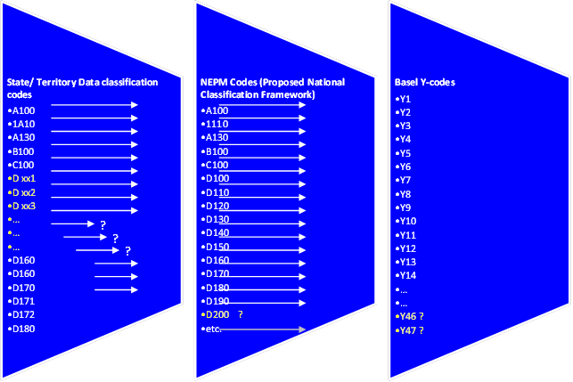

## Guidance materials

The above translation forms the basis of two sets of guidance materials developed as part of this project:

1. A document titled *Reporting hazardous waste under the Basel Convention - guidance to states and territories*, provided as Appendix A and
2. the reporting and translation Microsoft Excel-based templates used to compile the Basel data (provided as Appendix B).

The guidance document provides both the justification for, and the outcomes of, the translation process, as adopted by all Microsoft Excel templates in the guidance material suite. This approach is specific to each jurisdiction. It also provides guidance to the Australian Government on how to assure quality, fill data gaps and compile the data for submission to the Basel Secretariat.

The guidance document’s logic forms the basis of the reporting templates designed to collect hazardous waste data from jurisdictions in their classification system, and automatically populate this data into both the NEPM system and the Basel classification framework.

This approach fulfils a number of the project’s objectives relating to improved guidance tools, ease of jurisdictional reporting, improved data quality and consistency of approaches across jurisdictions.

# Jurisdictional consultation

The project team consulted with all jurisdictional environment agencies across the states and territories. Those jurisdictions whose hazardous data issues (in the view of the project team) were perceived as having the potential to be complex or unique were visited for face to face discussions, while the remainder were consulted through email and phone discussion.

Those jurisdictions visited face to face were:

* Western Australia (3 December 2013)
* New South Wales (5 December 2013)
* Victoria (29 January 2014).

The purpose of consultation was to listen to the jurisdiction’s experience in previous years with the process of Basel data reporting, with a view to tailoring the guidance materials to best assist them.

A core premise of the project was the difficulty jurisdictions previously had with translating from their own hazardous waste coding system to Basel Y codes, and the inconsistency of decisions made in this regard from jurisdiction to jurisdiction. To this end the project team decided to tackle the translation process at the outset, prior to consultation, and use an early draft of the guidance spreadsheet template (which contained the draft translations) as a basis for state and territory discussion.

The key views expressed by the state and territory agency contacts were:

* All states and territories agreed (where the individuals consulted had previously worked on providing Basel data) that the translation from their waste codes to Y codes was the most challenging and time consuming part of their task, and that making this clearer was the major improvement that could be made to the process.
* There was a strong endorsement of the project team’s proposed translation approach, which uses the principle that a state or territory need only worry about their own coding system, and the translation spreadsheet takes care of the rest.
* It was felt by the majority of state and territories that the translation template would save them significant time and markedly increase the comparability of reported data between jurisdictions.
* In the vast majority of cases, the project team’s proposed translation decisions were accepted by states and territories as being a reasonable approach to the task of taking their data and realigning it in a Y code framework.
* Western Australia was in the process of regulatory transition from their current hazardous waste classification system to one much more closely aligned to the NEPM codes. However, since the new legislation required to make this happen would not be in place until later in 2014, the translation template for WA needed to retain the old codes.
* Western Australia provided a full review of the project team’s translation of its waste codes, resulting in minor changes to the spreadsheet.
* The Northern Territory indicated that given its lack of a tracking system, it would have to undertake an onerous manual task of working through individual paper controlled waste transport certificate copies to tally up waste generation numbers. As hazardous waste from the Territory is generally exported interstate, it was agreed that a more efficient approach was to collate transfer figures collected from the jurisdictions that receive NT waste under the controlled waste NEPM.
* South Australia indicated its interest in a feedback mechanism once all jurisdictions’ data had been collated and compared, which led to the development of the automated QA approach outlined in the Australian Government’s guidance/ collation spreadsheet. It is important that the feedback process occurs before data was sent to the Basel Secretariat so any errors can be addressed.
* New South Wales echoed the value of reporting both generation data and interstate transfer data, as a means of covering data requirements for both Basel and NEPM reporting at the same time, while having the added benefit of providing a quality check on smaller jurisdictions’ waste generation estimates.
* While most jurisdictions are able to extract data on both waste generation and waste received over borders, some had more difficulty with the latter task. Queensland, for example, was able to supply waste transferred across borders, but was unable to distinguish the originating jurisdiction for the transfer data. This had an effect of lowering the reported generation figure for the Northern Territory (as discussed in section 2.2), since the Northern Territory’s generation estimates relied on the collation of interstate movement transfer figures from the NT into other jurisdictions, reported by those jurisdictions.

# Data presentation

Data was collected in six-monthly blocks, allowing aggregation by either 2011-12 financial year or 2012 calendar year. The bulk of the analysis used for the purposes of this section is based on the 2012 calendar year data set, because:

* Basel’s reporting period requirement is calendar year
* 2012 data provides the most currency for readers of this report and
* the difference between calendar year collation and financial year collation is minor.

However, 2011-12 data is also provided.

## Limitations

Hazardous waste data in Australia is built from the ‘bottom up’ in the main, through tonnages captured by licensed waste transporters as part of the chain of custody requirements of hazardous waste tracking systems implemented in the major Australian states. For compilation of a national data set of hazardous waste generation, broken down to a jurisdiction-level scale, this level of fineness of data is unique in relation to other inventory development style exercises in environmental data.

However, despite having such a detailed base to work from, the ultimate quality of the dataset is constrained somewhat by fundamental differences in the way jurisdictions manage hazardous wastes, which leads to:

* Inconsistencies in waste classification
* Inconsistencies in data collection, since some wastes may be tracked in one state’s waste tracking system but not another’s
* Inconsistencies in jurisdiction management priorities and the resourcing for hazardous waste management, meaning data may be collected with poor or no quality assurance or enforcement.

Data provided in this report is limited by the quality and availability of data collected by state and territory environment agencies responsible for hazardous waste tracking from generation through its pathway to management fate. Gaps in state and territory data have, wherever possible, been filled through the estimation techniques described in the jurisdictional guidance document at Appendix A.

The assumptions, possible explanations, reasoning and potential conclusions drawn in this report are limited by the extent of available data and collective knowledge of the report’s authors. Much of the opinion expressed in the report is based on the authors’ experience and knowledge of the hazardous waste industry.

Any interpretative advice based on the analysis and opinions expressed in this report should first be verified with the relevant state or territory hazardous waste management agency before being relied upon as factually correct.

Due to the extensive gaps in treatment/disposal data—for some jurisdictions there is no information available at the destination end—and the potential for double-counting where wastes undergo primary treatment before secondary treatment/disposal, this report focuses primarily on analysis of waste quantities generated. While not a direct focus of the data collection process of this report, an overview of hazardous waste fate data is provided in section 4.3.

## Hazardous waste generation data

Hazardous waste generation data for Australia has been collected, collated and presented in detail, against individual NEPM and Basel classification systems, in the appendices to this report as follows:

* Appendix C:
  + National hazardous waste data 2011-12 – by NEPM code
  + National hazardous waste data 2012 – by NEPM code and
* Appendix D: National hazardous waste data 2012 – by Basel Y code.

Appendix data is summarised for the 2012 calendar reporting year in terms of the 15 high-level NEPM waste description headings (Table 1) and total reported wastes for each state and territory (Table 2) below.

An analysis of this data, including a focus on some of the largest generating waste types across jurisdictions is provided in Appendix E.

Table 1: National hazardous waste data 2012 – by high-level NEPM code

|  |  |  |
| --- | --- | --- |
| **Hazardous waste classification** | | **Waste generated** |
| Code | Waste description | tonnes |
| A | Plating and heat treatment | 6,585 |
| B | Acids | 44,725 |
| C | Alkaline wastes | 335,371 |
| D | Inorganic chemicals | 266,221 |
| E | Reactive chemicals | 259 |
| F | Paints, lacquers, varnish, etc. | 63,373 |
| G | Organic solvents, solvent residues | 34,014 |
| H | Pesticides | 4,584 |
| J | Oils, hydrocarbons, emulsions | 758,575 |
| K | Putrescible/organic wastes | 783,297 |
| L | Industrial washwaters | 0 |
| M | Organic chemicals | 22,415 |
| N | Solid/sludge wastes | 3,799,667 |
| R | Clinical and pharmaceutical wastes | 70,678 |
| T | Miscellaneous | 424,262 |
| **Total** | | **6,614,029** |

Table 2: National hazardous waste data 2012 – by state and territory totals

|  |  |
| --- | --- |
| **State/ Territory** | **Waste generated**  tonnes |
| ACT | 68,309 |
| NSW | 1,768,996 |
| NT | 24,516 |
| QLD | 1,733,396 |
| SA | 880,292 |
| TAS | 172,781 |
| VIC | 1,359,529 |
| WA | 606,211 |
| **Total** | **6,614,029** |

## Hazardous waste fate data

The *Improving Australia's reporting on hazardous waste under the Basel Convention* project did not seek to obtain new data on fates of hazardous waste, such as disposal, recycling or energy recovery, as this is not required for Basel reporting. However, detailed fate information was obtained as part of the *Hazardous Waste Data Assessment Final Report*, prepared by KMH Environmental (2013) on the 2010-11 data set.

Given the relative agreement in generation data from 2010-11 to the current period (2012), and the closeness of the data set years, this reference provides a good indication of the likely fate tonnages for 2012. Extracts from this report, showing hazardous waste fate tonnages across Australia in 2010-11, are shown below.

*Notes regarding this section:*

1. A number of (smaller) jurisdictions do not collect hazardous waste fate data, due to some of the management priority differences outlined in section 4.1, as indicated below.

2. Fate types labels (storage, recycled, treated etc.) on the figures in this section may vary. This is because the KMH project was constrained by the variation in categorisations that were collected by each of these states, as part of their tracking systems.

3. Absent values (represented by “-“) or absent chart bars in Figures 2-4 indicate that, while a particular fate category was relevant in that state, data is not tracked.

**Australian Capital Territory**

The Australian Capital Territory has no licensed facility for hazardous waste treatment or disposal; therefore most hazardous wastes generated within the Australian Capital Territory are exported to New South Wales for disposal/ treatment.

**New South Wales**

Figure 2: Hazardous waste treatment/disposal (New South Wales 2010–11)

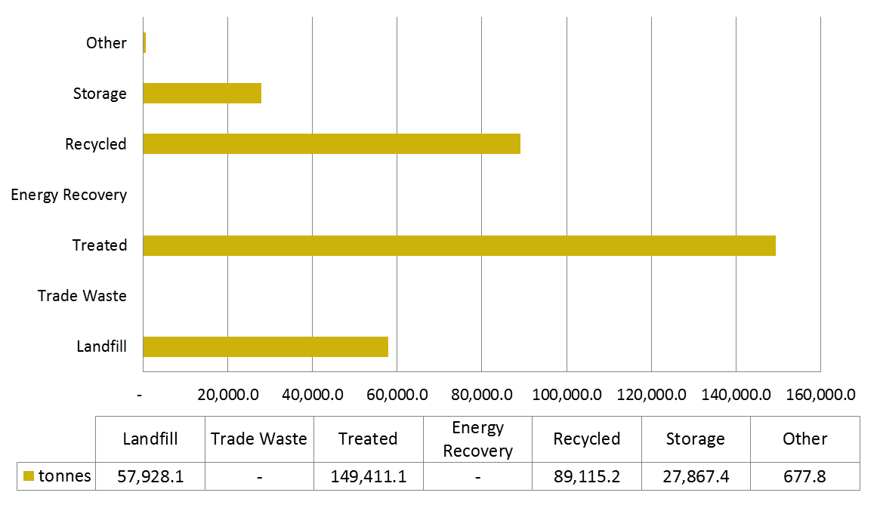

(Source: Hazardous Waste Data Assessment Final Report, KMH Environmental [2013], page 26.)

**Northern Territory**

All hazardous wastes generated in the Northern Territory is either stored or exported for treatment in other jurisdictions.

**Queensland**

Figure 3: Hazardous waste treatment/disposal (Queensland 2010–11)

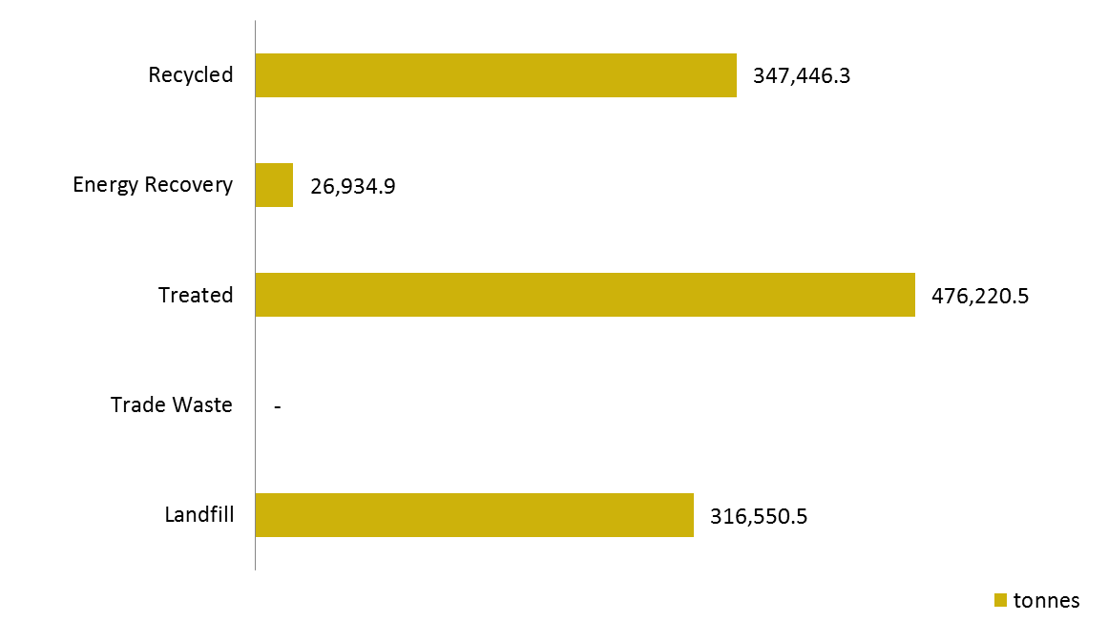

(Source: Hazardous Waste Data Assessment Final Report, KMH Environmental [2013], page 35.)

**South Australia**

South Australia’s waste tracking system does not record data on the treatment or disposal of wastes. This information is contained within consignment notes for interstate movements but not for intrastate movements.

**Tasmania**

Waste treatment and disposal data is not recorded in Tasmania.

**Victoria**

Figure 4: Hazardous waste treatment/disposal (Victoria 2010–11)

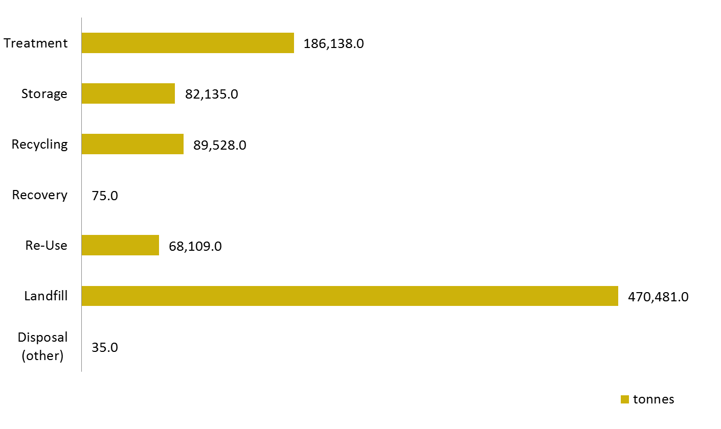

(Source: Hazardous Waste Data Assessment Final Report, KMH Environmental [2013], page 31.)

Notes:

1. The ‘other’ treatment category is a catch-all for waste transport certificates that were filled out incorrectly and as a result contain errors or omissions in the treatment category.
2. Victoria is the only jurisdiction to report tonnages for re-use as a treatment pathway.

**Western Australia**

Waste treatment and disposal data was not available from Western Australia’s waste tracking system for the *Hazardous Waste Data Assessment* project.

## Assessment against historical data and projects

Collation of high quality national data on hazardous waste in Australia is in its infancy. There are, however, two recent projects commissioned by the DoE that have collected hazardous waste data at the state and territory level:

1. The *Hazardous Waste Data Assessment*, prepared by KMH Environmental (2013), based on data collected for the 2010-11 year. This work also incorporates the companion analysis report: *Hazardous Waste Data Summary*, KMH Environmental (2013).
2. *Waste Generation and Resource Recovery in Australia*, Reporting Period 2010-11 (WGRRA), prepared by Blue Environment in association with Randell Environmental Consulting (2014).

### Hazardous Waste Data Assessment

The *Hazardous Waste Data Assessment* project (HWDA) collected hazardous waste tonnages from generation, import, export and where possible fate for the 2010-11 year, reported at the state and territory level. This establishes a good baseline year to compare the 2012 data against. Notable differences compared to the approach of this report are:

* HWDA collected an annual data set only (2010-11 financial year), as opposed to six-monthly spans.
* In addition to generation data, the HWDA collected data on waste movement across state/ territory borders, and estimated treatment and disposal fates where data was available, incorporating landfill, treatment, energy recovery, recycling and storage. Because it collected waste generation data only, *Improving Australia's reporting on hazardous waste under the Basel Convention* includes these tonnages, since generation does not concern itself with type or location of fate.
* The HWDA used the waste categories from Victoria’s waste tracking system and regulatory arrangements, which differ in some respects from the NEPM codes. This project, on the other hand, translates differences such as these into a common and fully mapped set of national classification codes (the NEPM 75 list).
* While this difference in classification does not materially affect many of the year to year comparisons, particularly at the 15 NEPM code level, there are some new classification/ aggregation decisions made as part of this project that re-allocate key wastes to new codes. A particular example of this is the re-classification of sewage sludge/ biosolids from the quasi NEPM code of K130 in 2010-11 data to the legitimate NEPM code of N205 (*Residues from industrial waste treatment/disposal operations*) in 2011-12 and 2012 data. The basis for this decision is set out in the jurisdictional guidance document at Appendix A and noted as part of the data analysis in Appendix E.

Despite these differences, the HWDA report has proven to be a useful comparison point for quality assurance, data analysis and key issues establishment for the 2012 data set, as outlined in Appendix E. Appendix E also reproduces a table of the ‘key messages’ from the HWDA Summary Report (2010-11 data), and uses the current report’s data to assess the currency and relevance of these messages for 2012.

The 2012 data set incorporates a number of data method improvements on the previous report, due to publication of other reports that serve as more reliable data sources than those previously used, as well as a more rigorous approach to filling data gaps. Consequently, Appendix F contains a re-cast of 2010-11 data with these improvements in mind, in the form of a high-level update of key points of the *Hazardous Waste Data Summary Report*, where the source year is applicable for use in a 2010-11 dataset.

Updated 2010-11 data has been provided for:

* Contaminated soils (NSW, Qld) – HWDA used WRiA data but WGRRA data is better quality
* Asbestos (NSW) – HWDA used WRiA data but WGRRA data is better quality
* Asbestos (WA) – not reported in HWDA; to be replaced with national average for Basel 2012 data (technically an incompatible year but this is a better option than having a hole in the 2010-11 data)
* Tyres (all jurisdictions) – not present at all in HWDA as Victoria does not classify tyres as a hazardous waste
* Biosolids (all jurisdictions) – HWDA did not split out combined data (ACT from NSW and NT from WA)
* Removal of Victoria’s ‘industrial washwaters’ from HWDA as this is not counted explicitly in Basel Project data and not collected by any other jurisdictions.
  + NEPM description *Industrial Washwater* is not listed in Schedule A List 1 of NEPM (therefore has no NEPM code), but is listed as part of the "15" high level headings in jurisdictional NEPM annual reporting. Only Victoria and Western Australia classify this waste and in practice only Victoria reported this category under NEPM reporting for the 2010-11 year.
  + (Appendix A) recommends that this category not to be included as part of the common Australian coding approach, and subsequent Basel (and other hazardous waste) reporting, since it is largely not collected and typically counted as part of the waste code that best describes what the wash water is contaminated with.

### Waste Generation and Resource Recovery in Australia

*Waste Generation and Resource Recovery in Australia* (WGRRA) was prepared for DoE by Blue Environment and Randell Environmental Consulting (2013). It provides an authoritative national view of solid waste and its management in Australia.

The tonnage figures for hazardous waste in WGGRA differ significantly from those given here. WGGRA (p.14) reports 2.35 Mt of hazardous waste in 2010-11 whereas this exercise finds 3.73 Mt in Basel categories Y1-Y45, and 6.61 Mt including non-Y-code hazardous wastes (in 2012). The main reasons for these discrepancies relate to differences in scope, method and filling of data gaps.

In relation to scope, this project includes some waste types that are not included in WGGRA (particularly liquids) and classifies some waste types as hazardous that are not so classified by WGRRA (particularly biosolids, which adds 1.35 Mt).

In relation to method, WGRRA focuses on waste fate, asking ‘how much is landfilled and how much is recovered?’ and summing these to derive waste generated. This works well for non-hazardous waste, but produces a less comprehensive and lower resolution data set for hazardous waste because:

* Some jurisdictions do not specifically record some types of hazardous waste sent to landfill. Whereas the total tonnage figures may be accurate, the categorisation may incorrectly allocate some hazardous waste into a non-hazardous category (e.g. asbestos in WA).
* Some hazardous waste data is overlooked by the WGGRA approach because it is sent for treatment prior to disposal. Treatments may significantly reduce the mass of material, for example through dewatering, so that the material is subsequently recorded as a lesser amount.

In relation to filling of data gaps, the fine resolution of the approach used for this project resulted in examination of data for very specific waste types. Some gaps in jurisdictional data could be readily identified, and reasonable extrapolations applied to fill those gaps. This was not possible in WGGRA because gaps were more difficult to identify.

It is understood that DoE is developing the WGRRA approach into a National Waste Data System. It would be sensible for this data system to resolve the discrepancies between the WGRRA and Basel data systems.

# Lessons learned

Below are a collection of lessons learned by the consultants in undertaking the project, particularly as they relate to future efforts (by the Australian Government or consultants they may appoint) in compiling national hazardous waste datasets, such as Basel reporting.

### Keep it simple for the jurisdictions

Keep the classifications maze simple by using the data collection and translation template. Focusing jurisdictional resources on supplying their own waste data in their own classification language saves time, effort and stress for the jurisdiction, while improving data quality, submission timeliness, data comparability between jurisdictions, transparency, completeness and clarity of task.

### Provide firm reporting deadlines

Allow plenty of time and provide clear deadlines for data submission by jurisdictions. This project suffered from a lack of forceful deadlines from the outset, so that some jurisdictions lagged as much as two months behind.

### Provide jurisdictions time for post-submission review

Allow a quality assurance loop after the data has been submitted, gaps filled, overarching quality assurance conducted at the Commonwealth level and all jurisdictional data has been compiled into a national report. States and territories should be given good opportunity to review their data again in this broader context. This is also an opportunity to engage them in discussions about data interpretation and jurisdiction-specific aspects to their data that might help explain anomalies.

### Classification differences are nuanced

It was understood at the outset that jurisdictions took different approaches to hazardous waste classification, but the exact nature of these differences was not fully appreciated until this project’s comprehensive comparison was carried out. This project has demonstrated where the commonality and differences lie in classifications, which should lead to better comparison and cross-jurisdiction use of data in the future.

### More consideration is needed in relation to simultaneous collection of Basel (generation) data and Controlled Waste NEPM data (cross-border receipt)

All jurisdictions were requested to, and provided templates for, reporting of hazardous wastes under the Controlled Waste NEPM, which covers the transfer of hazardous wastes into a state or territory from another state or territory. Only Victoria, New South Wales and South Australia provided this NEPM transfer data separately by each source jurisdiction. All jurisdictions are required to report this data under the Controlled Waste NEPM (albeit aggregated to the higher level of the 15 NEPM codes) and logically it should be achievable to combine this with Basel reporting. However, the results from this project indicate that it may be more difficult for some to obtain this information than the generation data. In the cases where this data was supplied, it was useful in constructing the data set for the Northern Territory.

# Recommendations

1. Adopt the 75 NEPM code classification system as a national framework for collecting, collating and reporting on hazardous waste in Australia, via the utility of the translation guidance and templates provides as appendices A and B.
2. Consider mechanisms for obtaining ongoing data on the fate of hazardous wastes in order to eliminate the discrepancies between the data presented for Basel and the proposed National Waste Data System.
3. Align the data collection task and reporting timeframes with those of the proposed National Waste Data System. In particular explore the feasibility of combining the data collection templates and timing developed for this project with any future data collection mechanisms developed under the National Waste Data System project.
4. Update the reporting and translation template for Western Australia to be consistent with its new waste classification approach, which is currently under development (the new approach will closely align with the 75 NEPM categories).
5. Examine the potential to combine the date collection tasks for the Basel Convention and the Controlled Waste NEPM.
6. Conduct further investigation into the key waste stream issues of contaminated soils and asbestos, to address clear deficiencies in their data recording and tracking in:
   * Western Australia and New South Wales (for asbestos)
   * all jurisdictions outside of Victoria (for contaminated soils).
7. Investigate the feasibility, effort requirement, accuracy of, and extent to which any commercial confidentiality could be breached if jurisdictions provided generation data by ANZSIC Code (Australian and New Zealand Standard Industry Classification). (ANZSIC Code breakdown would provide more useability to the data; for example if linking to other data sets such as economic, labour figures and other environmental performance data, as reported by the Australian Bureau of Statistics.)

Additional outstanding recommendations from the KMH *Hazardous Waste Data Assessment* report are given in Appendix F.

# References

Basel Convention, *Methodological guide for the development of inventories of hazardous wastes and other wastes under the Basel Convention*, (Draft, October 2013)

Blue Environment (in association with Randell Environmental Consulting) (2013) *Waste generation and resource recovery in Australia Reporting period 2010/11 (WGRRA),* Department of Sustainability, Environment, Water, Population and Communities, available from: <http://www.environment.gov.au/resource/waste-generation-and-resource-recovery-australia-report-and-data-workbooks>

DECCW (NSW Department of Environment, Climate Change and Water 2009) *Waste Classification Guidelines Part 1: Classifying Waste*, available from: <http://www.environment.nsw.gov.au/resources/waste/08202classifyingwaste.pdf>

EPA Tasmania *Solid Waste Classification System,* available from: <http://epa.tas.gov.au/regulation/document?docid=640>

Hyder Consulting (2011a) *National waste and recycling reporting A more uniform approach to data (the method report)*, Department of Sustainability, Environment, Water, Population and Communities (not publically available).

Hyder Consulting (2011b) *Waste and Recycling in Australia 2011 (WRiA2011),* Department of Sustainability, Environment, Water, Population and Communities, available from: <http://www.environment.gov.au/wastepolicy/publications/waste-recycling2011.html>

Hyder Consulting (2011c) *Liquid Waste Assessment* 2011, prepared for the Department of Sustainability, Environment, Water, Population and Communities, available from: <http://www.environment.gov.au/system/files/resources/fd8e59bd-b64d-42b3-8a73-5021d21310be/files/liquid-waste.pdf>

KMH Environmental (2013) *Hazardous Waste Data Assessment Final Report*, on the 2010-11 data set, prepared for the Department of Sustainability, Environment, Water, Population and Communities, available from:

<http://www.environment.gov.au/resource/hazardous-waste-data-assessment>

KMH Environmental (2013) *Hazardous Waste Data Assessment Summary Report*, on the 2010-11 data set, prepared for the Department of Sustainability, Environment, Water, Population and Communities, available from:

<http://www.environment.gov.au/resource/hazardous-waste-data-assessment>

Net Balance*, National Waste Data System Requirements Study*, 2009:

<http://www.environment.gov.au/resource/national-waste-data-system-requirements-study>

US EPA (United States Environmental Protection Agency 2011) *Municipal Solid Waste Generation, Recycling, and Disposal in the United States, Tables and Figures for 2010*, December, available from: <http://www.epa.gov/epawaste/nonhaz/municipal/pubs/2010_MSW_Tables_and_Figures_508.pdf>

1. Reporting hazardous waste under the Basel Convention – guidance to states and territories

(Provided as a separate Microsoft Word file)

1. Guidance reporting & translation templates

(Provided to DoE as eight separate Microsoft Excel files: one for each jurisdiction except the Northern Territory, plus a data collation template)

1. National hazardous waste data 2011-12 and 2012 – by NEPM code

| **National Environment Protection (Movement of Controlled Waste between States and Territories) Measure** | | | | **Tonnes generated** | | | | |
| --- | --- | --- | --- | --- | --- | --- | --- | --- |
| **"15" code** | **NEPM 15 waste description** | **"75" code** | **Waste description (NEPM Schedule A, List 1)** | **Jul-Dec 2011** | **Jan-Jun 2012** | **Jul-Dec 2012** | **2011-12** | **2012** |
| A | Plating and heat treatment | A100 | Waste resulting from surface treatment of metals and plastics | 1,176 | 3,080 | 2,871 | 4,256 | 5,951 |
|  |  | A110 | Waste from heat treatment and tempering operations containing cyanides | 6 | 0 | 0 | 6 | 0 |
|  |  | A130 | Cyanides (inorganic) | 16 | 298 | 336 | 314 | 634 |
| B | Acids | B100 | Acidic solutions or acids in solid form | 18,784 | 22,377 | 22,348 | 41,161 | 44,725 |
| C | Alkalis | C100 | Basic solutions or bases in solid form | 197,846 | 168,603 | 166,769 | 366,449 | 335,371 |
| D | Inorganic chemicals | D100 | Metal carbonyls | 8 | 58 | 109 | 66 | 167 |
|  |  | D110 | Inorganic fluorine compounds excluding calcium fluoride | 11 | 128 | 729 | 138 | 856 |
|  |  | D120 | Mercury; mercury compounds | 954 | 477 | 385 | 1,431 | 862 |
|  |  | D130 | Arsenic; arsenic compounds | 545 | 469 | 508 | 1,014 | 977 |
|  |  | D140 | Chromium compounds (hexavalent and trivalent) | 7,711 | 1,210 | 963 | 8,922 | 2,173 |
|  |  | D150 | Cadmium; cadmium compounds | 11 | 31 | 31 | 42 | 62 |
|  |  | D160 | Beryllium; beryllium compounds | 11 | 0 | 8 | 11 | 8 |
|  |  | D170 | Antimony; antimony compounds | 32 | 0 | 27 | 32 | 27 |
|  |  | D180 | Thallium; thallium compounds | 0 | 1 | 6 | 1 | 7 |
|  |  | D190 | Copper compounds | 131 | 527 | 745 | 658 | 1,272 |
|  |  | D200 | Cobalt compounds | 18 | 18 | 34 | 36 | 52 |
|  |  | D210 | Nickel compounds | 142 | 190 | 254 | 332 | 444 |
|  |  | D220 | Lead; lead compounds | 14,608 | 24,987 | 14,472 | 39,595 | 39,459 |
|  |  | D230 | Zinc compounds | 16,363 | 64,346 | 80,116 | 80,709 | 144,462 |
|  |  | D240 | Selenium; selenium compounds | 11 | 0 | 0 | 11 | 0 |
|  |  | D250 | Tellurium; tellurium compounds | 0 | 0 | 0 | 0 | 0 |
|  |  | D270 | Vanadium compounds | 237 | 31 | 16 | 268 | 47 |
|  |  | D290 | Barium compounds (excluding barium sulphate) | 7 | 1 | 5 | 8 | 6 |
|  |  | D300 | Non-toxic salts | 15,401 | 32,947 | 41,226 | 48,349 | 74,173 |
|  |  | D310 | Boron compounds | 6 | 3 | 87 | 9 | 90 |
|  |  | D330 | Inorganic sulfides | 69 | 182 | 179 | 251 | 361 |
|  |  | D340 | Perchlorates | 10 | 13 | 48 | 23 | 61 |
|  |  | D350 | Chlorates | 11 | 102 | 102 | 113 | 204 |
|  |  | D360 | Phosphorus compounds excluding mineral phosphates | 1 | 216 | 234 | 218 | 451 |
| E | Reactive chemicals | E100 | Waste containing peroxides other than hydrogen peroxide | 113 | 136 | 123 | 249 | 259 |
| F | Paints, resins, inks, organic sludges | F100 | Waste from the production, formulation and use of inks, dyes, pigments, paints, lacquers and varnish | 17,971 | 25,308 | 26,258 | 43,279 | 51,565 |
|  | F110 | Waste from the production, formulation and use of resins, latex, plasticisers, glues and adhesives | 3,349 | 3,909 | 7,898 | 7,258 | 11,808 |
| G | Organic solvents | G100 | Ethers | 1,138 | 611 | 913 | 1,749 | 1,524 |
|  |  | G110 | Organic solvents excluding halogenated solvents | 7,807 | 8,147 | 8,641 | 15,954 | 16,787 |
|  |  | G150 | Halogenated organic solvents | 295 | 596 | 577 | 890 | 1,173 |
|  |  | G160 | Waste from the production, formulation and use of organic solvents | 853 | 7,205 | 7,325 | 8,058 | 14,530 |
| H | Pesticides | H100 | Waste from the production, formulation and use of biocides and phytopharmaceuticals | 1,312 | 1,816 | 2,181 | 3,128 | 3,997 |
|  |  | H110 | Organic phosphorous compounds | 52 | 67 | 89 | 119 | 156 |
|  |  | H170 | Waste from manufacture, formulation and use of wood-preserving chemicals | 762 | 277 | 155 | 1,039 | 431 |
| J | Oils | J100 | Waste mineral oils unfit for their original intended use | 120,889 | 196,709 | 148,896 | 317,598 | 345,605 |
|  |  | J120 | Waste oil/water, hydrocarbons/water mixtures or emulsions | 113,985 | 206,824 | 204,283 | 320,809 | 411,107 |
|  |  | J160 | Waste tarry residues arising from refining, distillation, and any pyrolytic treatment | 374 | 868 | 994 | 1,242 | 1,862 |
| K | Putrescible/ organic waste | K100 | Animal effluent and residues (abattoir effluent, poultry and fish processing wastes) | 81,274 | 103,284 | 108,685 | 184,558 | 211,969 |
|  |  | K110 | Grease trap waste | 193,153 | 262,620 | 268,644 | 455,773 | 531,264 |
|  |  | K140 | Tannery wastes (including leather dust, ash, sludges and flours) | 264 | 3,313 | 3,395 | 3,577 | 6,707 |
|  |  | K190 | Wool scouring wastes | 264 | 16,638 | 16,720 | 16,902 | 33,357 |
| M | Organic chemicals | M100 | Waste substances and articles containing or contaminated with polychlorinated biphenyls, polychlorinated naphthalenes, polychlorinated terphenyls and/or polybrominated biphenyls | 1,248 | 2,360 | 2,401 | 3,608 | 4,761 |
|  |  | M150 | Phenols, phenol compounds including chlorophenols | 116 | 561 | 540 | 676 | 1,100 |
|  |  | M160 | Organo halogen compounds—other than substances referred to in this Table or Table 2 | 127 | 205 | 135 | 332 | 339 |
|  |  | M170 | Polychlorinated dibenzo-furan (any congener) | 0 | 0 | 0 | 0 | 0 |
|  |  | M180 | Polychlorinated dibenzo-p-dioxin (any congener) | 0 | 0 | 0 | 0 | 0 |
|  |  | M210 | Cyanides (organic) | 1 | 0 | 0 | 1 | 0 |
|  |  | M220 | Isocyanate compounds | 110 | 82 | 106 | 192 | 188 |
|  |  | M230 | Triethylamine catalysts for setting foundry sands | 130 | 316 | 2,779 | 446 | 3,095 |
|  |  | M250 | Surface active agents (surfactants), containing principally organic constituents and which may contain metals and inorganic materials | 7,234 | 7,317 | 5,563 | 14,551 | 12,880 |
|  |  | M260 | Highly odorous organic chemicals (including mercaptans and acrylates) | 21 | 8 | 44 | 29 | 52 |
| N | Soil/ sludge | N100 | Containers and drums that are contaminated with residues of substances referred to in this list | 17,811 | 18,259 | 20,124 | 36,070 | 38,383 |
|  |  | N120 | Soils contaminated with a controlled waste | 618,111 | 833,550 | 707,677 | 1,451,660 | 1,541,227 |
|  |  | N140 | Fire debris and fire wash waters | 604 | 1,136 | 1,532 | 1,740 | 2,667 |
|  |  | N150 | Fly ash, excluding fly ash generated from Australian coal fired power stations | 628 | 3,000 | 2,882 | 3,628 | 5,882 |
|  |  | N160 | Encapsulated, chemically-fixed, solidified or polymerised wastes referred to in this list | 23,036 | 26,061 | 39,553 | 49,097 | 65,614 |
|  |  | N190 | Filter cake contaminated with residues of substances referred to in this list | 8,058 | 7,784 | 7,258 | 15,841 | 15,042 |
|  |  | N205 | Residues from industrial waste treatment/disposal operations | 564,066 | 818,709 | 834,790 | 1,382,776 | 1,653,499 |
|  |  | N220 | Asbestos | 166,227 | 231,209 | 246,048 | 397,435 | 477,257 |
|  |  | N230 | Ceramic-based fibres with physico-chemical characteristics similar to those of asbestos | 83 | 52 | 44 | 135 | 96 |
| R | Clinical and pharmaceutical | R100 | Clinical and related wastes | 15,284 | 27,783 | 27,742 | 43,067 | 55,526 |
|  |  | R120 | Waste pharmaceuticals, drugs and medicines | 6,023 | 6,592 | 6,920 | 12,616 | 13,512 |
|  |  | R140 | Waste from the production and preparation of pharmaceutical products | 785 | 755 | 886 | 1,540 | 1,641 |
| T | Miscellaneous | T100 | Waste chemical substances arising from research and development or teaching activities, including those which are not identified and/or are new and whose effects on human health and/or the environment are not known | 1,903 | 2,714 | 2,809 | 4,617 | 5,523 |
|  |  | T120 | Waste from the production, formulation and use of photographic chemicals and processing materials | 640 | 793 | 699 | 1,433 | 1,492 |
|  |  | T140 | Tyres | 144,875 | 193,874 | 221,537 | 338,748 | 415,411 |
|  |  | T200 | Waste of an explosive nature not subject to other legislation | 45 | 928 | 909 | 973 | 1,837 |
| **TOTAL** | | | | 2,395,148 | 3,342,667 | 3,271,361 | 5,737,815 | 6,614,028 |

1. National hazardous waste data 2012 – by Basel Y code

| **Basel Convention** | | **Tonnes generated** | | | |
| --- | --- | --- | --- | --- | --- |
| **Code** | **Waste description (Annex 1)** | **Jul-Dec 2011** | **Jan-Jun 2012** | **Jul-Dec 2012** | **2012** |
| **Y1** | Clinical wastes from medical care in hospitals, medical centres and clinics | 15,284 | 27,783 | 27,742 | 55,526 |
| **Y2** | Wastes from the production and preparation of pharmaceutical products | 785 | 755 | 886 | 1,641 |
| **Y3** | Waste pharmaceuticals, drugs and medicines | 6,023 | 6,592 | 6,920 | 13,512 |
| **Y4** | Wastes from the production…... of biocides and phytopharmaceuticals | 1,312 | 1,816 | 2,181 | 3,997 |
| **Y5** | Wastes from the manufacture…... of wood preserving chemicals | 762 | 277 | 155 | 431 |
| **Y6** | Wastes from the production, formulation and use of organic solvent | 853 | 7,205 | 7,325 | 14,530 |
| **Y7** | Wastes from heat treatment and tempering operations containing cyanides | 6 | 0 | 0 | 0 |
| **Y8** | Waste mineral oils unfit for their originally intended use | 120,889 | 196,709 | 148,896 | 345,605 |
| **Y9** | Waste oils/water, hydrocarbons/water mixtures, emulsion | 113,985 | 206,824 | 204,283 | 411,107 |
| **Y10** | Waste substances ….containing or contaminated with PCBs, PCTs, PBBs | 1,248 | 2,360 | 2,401 | 4,761 |
| **Y11** | Waste tarry residues ... from refining, distillation and any pyrolytic treatment | 374 | 868 | 994 | 1,862 |
| **Y12** | Wastes from production…... of inks, dyes, pigments, paints, etc. | 17,971 | 25,308 | 26,258 | 51,565 |
| **Y13** | Wastes from production……resins, latex, plasticizers, glues, etc. | 3,349 | 3,909 | 7,898 | 11,808 |
| **Y14** | Waste chemical substances arising ….. environment are not known | 1,903 | 2,714 | 2,809 | 5,523 |
| **Y15** | Wastes of an explosive nature not subject to other legislation | 179 | 1,179 | 1,183 | 2,361 |
| **Y16** | Wastes from production, formulation and use of photographic chemicals… | 640 | 793 | 699 | 1,492 |
| **Y17** | Wastes resulting from surface treatment of metals and plastics | 1,176 | 3,080 | 2,871 | 5,951 |
| **Y18** | Residues arising from industrial waste disposal operations | 587,813 | 847,822 | 877,269 | 1,725,091 |
|  | **Wastes having as constituents …** |  |  |  |  |
| **Y19** | Metal carbonyls | 8 | 58 | 109 | 167 |
| **Y20** | Beryllium; beryllium compounds | 11 | 0 | 8 | 8 |
| **Y21** | Hexavalent chromium compounds | 7,711 | 1,210 | 963 | 2,173 |
| **Y22** | Copper compounds | 131 | 527 | 745 | 1,272 |
| **Y23** | Zinc compounds | 16,363 | 64,346 | 80,116 | 144,462 |
| **Y24** | Arsenic; arsenic compounds | 545 | 469 | 508 | 977 |
| **Y25** | Selenium; selenium compounds | 11 | 0 | 0 | 0 |
| **Y26** | Cadmium; cadmium compounds | 11 | 31 | 31 | 62 |
| **Y27** | Antimony; antimony compounds | 32 | 0 | 27 | 27 |
| **Y28** | Tellurium; tellurium compounds | 0 | 0 | 0 | 0 |
| **Y29** | Mercury; mercury compounds | 954 | 477 | 385 | 862 |
| **Y30** | Thallium; thallium compounds | 0 | 1 | 6 | 7 |
| **Y31** | Lead; lead compounds | 14,608 | 24,987 | 14,472 | 39,459 |
| **Y32** | Inorganic fluorine compounds excluding calcium fluoride | 11 | 128 | 729 | 856 |
| **Y33** | Inorganic cyanides | 16 | 298 | 336 | 634 |
| **Y34** | Acidic solutions or acids in solid form | 18,784 | 22,377 | 22,348 | 44,725 |
| **Y35** | Basic solutions or bases in solid form | 197,846 | 168,603 | 166,769 | 335,371 |
| **Y36** | Asbestos (dust and fibres) | 166,227 | 231,209 | 246,048 | 477,257 |
| **Y37** | Organic phosphorus compounds | 52 | 67 | 89 | 156 |
| **Y38** | Organic cyanides | 1 | 0 | 0 | 0 |
| **Y39** | Phenols; phenol compounds including chlorophenols | 116 | 561 | 540 | 1,100 |
| **Y40** | Ethers | 1,138 | 611 | 913 | 1,524 |
| **Y41** | Halogenated organic solvents | 295 | 596 | 577 | 1,173 |
| **Y42** | Organic solvents excluding halogenated solvents | 7,807 | 8,147 | 8,641 | 16,787 |
| **Y43** | Any congenor of polychlorinated dibenzo-furan | 0 | 0 | 0 | 0 |
| **Y44** | Any congenor of polychlorinated dibenzo-p-dioxin | 0 | 0 | 0 | 0 |
| **Y45** | Organohalogen compounds other than …(e.g. Y39, Y41, Y42, Y43, Y44) | 127 | 205 | 135 | 339 |
|  | **Categories of wastes requiring special consideration (Annex II)** |  |  |  |  |
| **Y46** | Wastes collected from households | 5,045,354 | 6,556,006 | 6,610,719 | 13,166,725 |
| **Y47** | Residues arising from the incineration of household wastes | 0 | 0 | 0 | 0 |
|  | **Additional waste categories not included in Y-Codes** |  |  |  |  |
| 1 | Other metal compounds | 405 | 239 | 309 | 548 |
| 2 | Other inorganic chemicals | 15,478 | 33,349 | 41,726 | 75,075 |
| 3 | Other organic chemicals | 7,379 | 7,607 | 8,372 | 15,978 |
| 4 | Putrescible/ organic waste | 274,955 | 382,779 | 394,368 | 777,147 |
| 5 | Waste packages and containers containing Annex 1 substances in concentrations sufficient to exhibit Annex III hazard characteristics | 17,811 | 18,259 | 20,124 | 38,383 |
| 6 | Soils contaminated with residues of substances in Basel Y-codes 19-45 | 618,111 | 833,550 | 707,677 | 1,541,227 |
| 7 | Sludges contaminated with residues of substances in Basel Y-codes 19-45 | 8,662 | 8,919 | 8,790 | 17,709 |
| 8 | Tyres | 144,875 | 193,874 | 221,537 | 415,411 |
| **TOTAL** | | 7,440,387 | 9,895,481 | 9,878,886 | 19,774,367 |

1. National hazardous waste data 2012 – analysis & key issues

National hazardous waste data 2012 – analysis & key issues

1. Introduction

This report—the *National hazardous waste data 2012 – Analysis & Key Issues* (Data Analysis)—is a companion report (as Appendix E) to *Improving Australia's reporting on hazardous waste under the Basel Convention* (the Main Report)—a report prepared for the Department of the Environment by Blue Environment in association with ENVIRON Australia and Randell Environmental Consulting.

The purpose of this companion report is to provide high level analysis and interpretation of the data presented in the main report.

Data was collected in six-monthly blocks, allowing aggregation by either 2011-12 financial year or 2012 calendar year. This has advantages for data collation and comparison, where other programs or studies use (or have used) different reporting periods.

However, the analysis below is based on the 2012 calendar year data set, because:

* Basel’s reporting period requirement is calendar year
* 2012 data provides the most currency for readers of this report and
* the difference between calendar year collation and financial year collation for 2011-12 and 2012 is minor.

The assumptions, possible explanations, reasoning and potential conclusions drawn in this report are limited by the extent of available data and collective knowledge of the report’s authors. Any interpretative advice based on the analysis and opinions expressed in this report should first be verified with the relevant state or territory hazardous waste management agency before being relied upon as factually correct.

This Data Analysis uses the following structure:

* A comparison with past years:
  + of National data by Basel classification
  + of National data by NEPM classification – firstly looking at jurisdictional totals
  + of National data by NEPM classification – secondly via breakdown into waste types
* A focus on the major wastes by tonnage
  + nationally
  + by jurisdiction
  + per capita, both nationally and by jurisdiction
* A data quality assessment
* A summary of the key messages that can be taken from the 2012 data set.

1. Comparison with past years

Quality hazardous waste data collation in Australia, at the national level at least, is in its infancy. However there is a recent history of provision of this data to the Basel Secretariat, albeit of questionable quality. In terms of a national data report of some detail for hazardous waste data at the state and territory level, the only notable recent project is the *Hazardous Waste Data Assessment*, KMH Environmental (2013), based on data collected for the 2010-11 year.

For these reasons, temporal comparison has been limited to previous submissions (for Basel classified data) and 2010-11 data for NEPM classified data.

2.1 National data by Basel classification

Figure 1 shows the total tonnes of hazardous waste Australia has reported under the Basel Convention, in the classifications (Y-codes) determined by Basel, for each of the past 4 calendar years. 2012 data depicted in this graph, for consistency purposes, includes only hazardous wastes listed under Art. 1 (1)a (Annex I) to the Convention, which correspond to Y1-Y45 waste codes. Reporting by Australia from 2009 to 2011 was limited to these categories.

Figure 1: Tonnes of waste reported under the Basel Convention over the past 4 years (consistently reported categories)

The data shows that for the same categories of waste, there was a dramatic increase in the quantity reported in 2012. The most likely cause for this is an increase in the quality and completeness of the 2012 data provided by states and territories. This is due to the introduction of a translation protocol and associated template – previously jurisdictions were likely to have simply not reported large quantities of wastes if there was not a clear Basel classification which matched their own. Without information to guide mapping of such wastes it is likely a literal assessment was made; that the waste, as specifically classified in Basel’s terms, was not present within their jurisdiction.

This illustrates the outcomes of an ***improved process*** of data collection and collation for 2012 data.

As part of the development of the translation protocol documented in Appendix A to the Main Report, there were a number of wastes that were clearly classified under the Controlled Waste NEPM as hazardous but could not reasonably be mapped to any of the Basel Y-codes. These become a set of 8 new Basel “codes”, simply called 1-8, for which figures were reported to Basel in the 2012 dataset. In addition, *Y46 Wastes collected from households* was estimated and reported for the first time in the 2012 Basel data. These new categories, and their associated tonnages, are shown in Table 1.

When the entire 2012 Basel report tonnages are included, the actual comparison with previous years looks much more dramatic (see Figure 2). This illustrates ***improved data*** for Australia’s 2012 submission, because it is more reflective of a broader range of hazardous wastes generated in Australia compared to previous years’ submissions.

It is also a stark illustration of the significance of *Y46 Wastes collected from households*, a waste not classified or regulated as “hazardous” in Australia, at 13,166,725 tonnes out of a total 19,774,367 tonnes reported for 2012 under Basel.

A footnote to this discussion is the fact that *Y47 Residues arising from the incineration of household wastes* has neither historically nor currently been reported as part of the national data set. This is because household waste is not typically incinerated in Australia at present, like in other parts of the world, but in the main sent to landfill. Reportable amounts are likely to be very small, and are data is not captured at present, or it may even be reported as part of other codes.

Table 1: Additionally reported Basel 2012 waste data categories (tonnes of waste)



Figure 2: Tonnes of waste reported under the Basel Convention over the past 4 years (all reporting categories included)

2.2 National data by NEPM classification – totals

Table 2 below totals all hazardous wastes reported using the Controlled Waste NEPM classification system by each state and territory, for both 2012 and the previous period (2010-11).

Table 2: Jurisdictional hazardous waste (tonnes) by total NEPM categories, 2012 v 2010-11

|  |  |  |
| --- | --- | --- |
|  | **Waste generated (tonnes)** | |
| **State/ Territory** | **Total Waste Generated 2010-11** | **Total Waste Generated 2012** |
| ACT | 66,381 | 68,309 |
| NSW | 1,584,659 | 1,768,996 |
| NT | 45,556 | 24,516 |
| QLD | 1,492,737 | 1,733,396 |
| SA | 624,800 | 880,292 |
| TAS | 45,763 | 172,781 |
| VIC | 1,358,904 | 1,359,529 |
| WA | 722,863 | 606,211 |
| **Total** | **5,941,663** | **6,614,029** |

This data is presented graphically in Figure 3.

Figure 3: Jurisdictional hazardous waste (tonnes) by total NEPM categories, 2012 v 2010-11

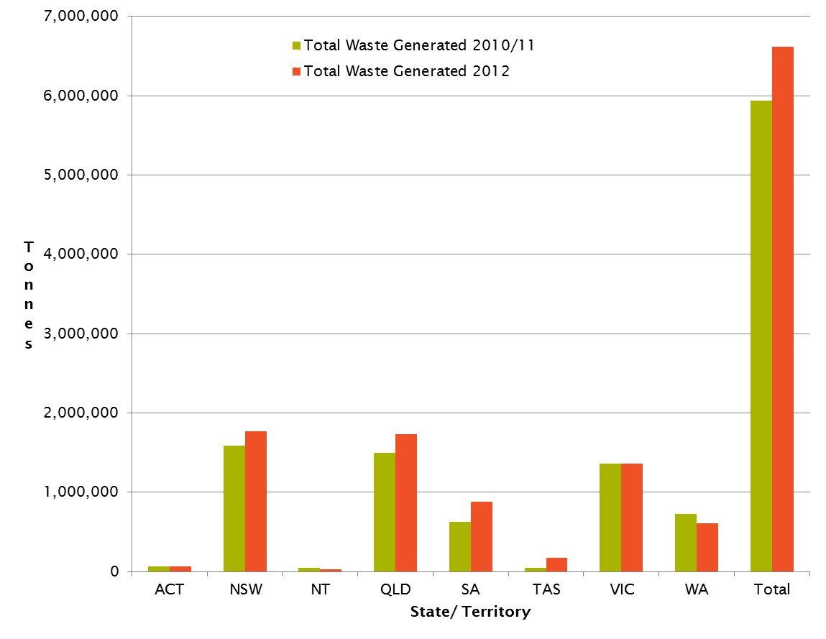

Some key trends from this comparison are:

* The total hazardous waste generated in Australia for 2012 (as reported by NEPM categories) increased by 11.3% overall compared to 2010-11 data, adjusted to reflect a consistent reporting approach between years (as outlined in the update to 2010-11 data detailed at Appendix F).
* Given that each data period was constructed from bottom up data, in an entirely separate collation exercise, this represents reasonable agreement between years.
* Year to year variability, data accuracy limitations, the potential for improved data collection practices (in 2012) and other uncertainties in the data preclude any trend-based conclusions being confidently drawn from one year to the next. However, with a repeatable collection system now in place these years will act as reliable data points in drawing long time series conclusions in future years.
* Of the larger jurisdictions, New South Wales’ and Queensland’s reported quantities rose by 12% and 16% respectively, Victoria’s stayed steady, Western Australia’s dropped by 17% and South Australia’s rose most sharply (41% - due to the impact of contaminated soils from key construction projects; see section 3.3 for further interpretation).
* Of the smaller jurisdictions, the Australian Capital Territory’s reported figures stayed relatively constant; the Northern Territory’s dropped sharply (46%) and Tasmania’s increased dramatically (almost 4-fold).
  + The Northern Territory does not employ a hazardous waste tracking system, at least not in an electronic form. This has made collation of data for 2012 Basel reporting difficult for them. In recognition of this, and of the fact that the NT essentially sends all of its hazardous waste interstate for treatment, the NT data for 2012 was compiled from the Controlled Waste NEPM transfer records from other jurisdictions. For the NT these accepting jurisdictions are Queensland, South Australia and New South Wales. The NT estimate is lower than expected because Queensland record keeping systems were unable to distinguish between all forms of hazardous waste transfers into Queensland and those specifically from the NT; hence none could be attributed as coming from NT.
  + Tasmania also does not employ an electronic hazardous waste tracking system. Its 2012 v 2010-11 data anomaly can be explained through a single and significant data point, which was not reported in 2010-11. Waste category *D230 Zinc compounds* made up 95% of the total reported for the current period. Data on hazardous waste managed within Tasmania, and confidence around it, is a developing space.

2.3 National data by NEPM classification – breakdown

Table 3 reflects national hazardous waste totals across the current and previous reporting years by the 15 high-level NEPM classification categories.

By quantity, the most dominant hazardous waste categories nationally are:

* Solid/sludge wastes, which is an aggregation of a number wastes but includes the key sub-categories of contaminated soils, biosolids and asbestos, in that (quantitative) order
* Putrescible/organic wastes, made up chiefly of grease trap waste and animal effluent and residues
* The category of used oils, hydrocarbons and emulsions.

Quantities of these major categories show reasonable agreement from 2010-11 to 2012.

Table 3: National hazardous waste (tonnes) by high-level NEPM categories, 2012 v 2010-11

|  |  |  |  |
| --- | --- | --- | --- |
| **Hazardous waste classification** | | **Waste generated (tonnes)** | |
| **Code** | **Waste description** | **2010-11** | **2012** |
| A | Plating and heat treatment | 7,917 | 6,585 |
| B | Acids | 37,165 | 44,725 |
| C | Alkaline wastes | 266,759 | 335,371 |
| D | Inorganic chemicals | 295,893 | 266,221 |
| E | Reactive chemicals | 1,462 | 259 |
| F | Paints, lacquers, varnish, etc. | 44,441 | 63,373 |
| G | Organic solvents, solvent residues | 27,985 | 34,014 |
| H | Pesticides | 2,606 | 4,584 |
| J | Oils, hydrocarbons, emulsions | 601,848 | 758,575 |
| K | Putrescible/organic wastes | 779,409 | 783,297 |
| L | Industrial washwaters | 0 | 0 |
| M | Organic chemicals | 18,553 | 22,418 |
| N | Solid/sludge wastes | 3,402,092 | 3,799,667 |
| R | Clinical and pharmaceutical wastes | 59,946 | 70,678 |
| T | Miscellaneous | 395,585 | 424,262 |
| **Total** |  | **5,941,663** | **6,614,029** |

This data is presented graphically in Figure 4.

Figure 4: National hazardous waste generated (tonnes) by high-level NEPM categories, 2012 v 2010-11

Solid/sludge wastes (NEPM category N) dwarf all other high-level categories – it is almost 5-fold higher than its nearest generating category for the 2012 dataset (K Putrescible/organic wastes). For this reason it has been excluded from Figure 5 below, which allows a closer inspection of the other highest contributors.

Figure 5: National hazardous waste generated (tonnes) by high-level NEPM categories, 2012 v 2010-11 (excluding Solid/ sludge wastes)

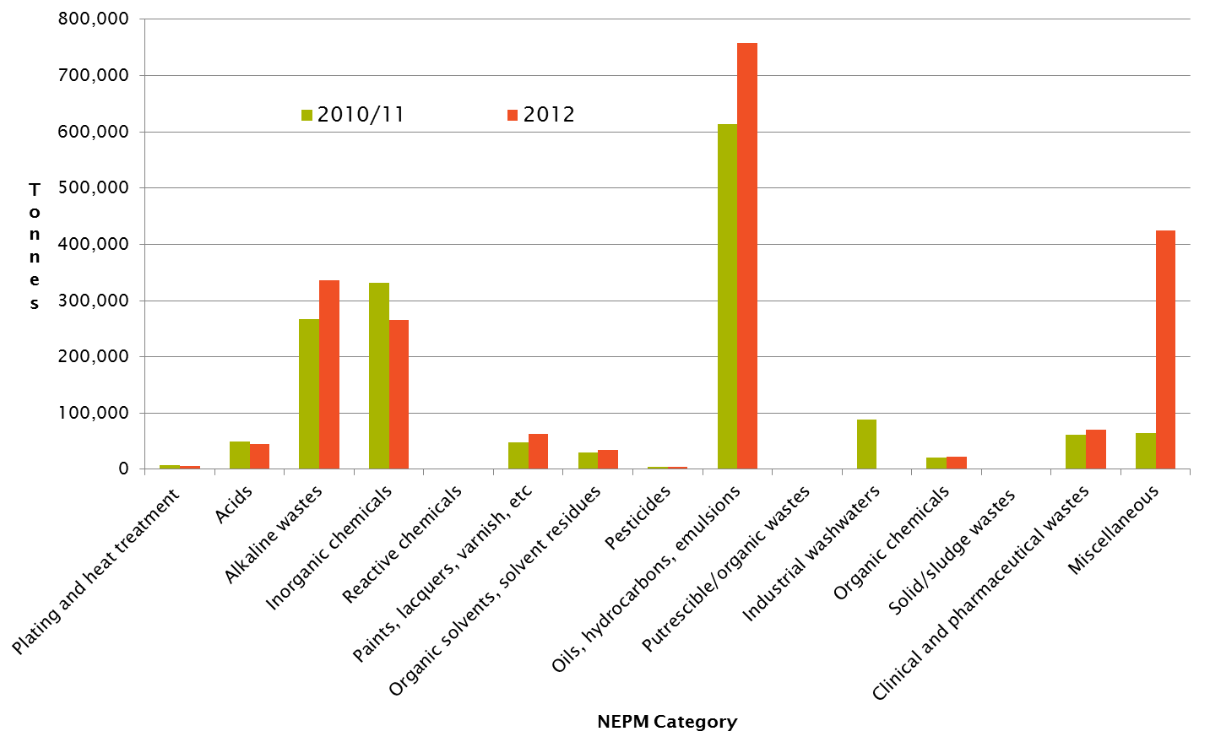

1. Major wastes

3.1 National

The NEPM 15 levels have limitations for data analysis in that they group important waste categories together. For example N Solid/ sludge waste is comprised of such important and different wastes as :

* Contaminated soils
* Asbestos
* Biosolids (recorded as *N205 Residues from industrial waste treatment/disposal operations*)

Drilling beyond the 15 high-level NEPM categories to the 75 provides much more utility. Analysis of this more detailed code set shows that 94% of all reported NEPM-classified wastes generated in Australia for 2012 can be captured by focusing on the following nine wastes:

* Alkalis
* Inorganic chemicals
* Oils
* Animal effluent and residues
* Grease trap waste
* Contaminated soils
* Biosolids
* Asbestos
* Tyres.

These are charted in tonnes for the 2012 dataset in Figure 6 below.

Figure 6: Major hazardous wastes generated (tonnes) - reported nationally for 2012

Figure 6 shows the largest generated amounts are of **biosolids**, followed closely by **contaminated soils**. Although these respective quantities are very similar, biosolids are estimated for all jurisdictions, whereas contaminated soils data is notable by its absence from Western Australian data which, if it was measured, would likely bump it above the national figure for biosolids. Technically Western Australia does report generation of some contaminated soil, but it is so small compared to other jurisdictions as to be negligible. This issue is illustrated by reference to the collection of the largest states’ contaminated soils data in the column graph of Figure 7.

The next range of wastes by volume are **oils**, **grease trap waste**, **asbestos** and **tyres**, in that order, followed at a lower level again in descending order by **alkalis**, **inorganic chemicals** and **animal effluent and residues**, respectively.

3.2 By jurisdiction

This national comparison of major wastes by quantity is split further by each of the largest states: New South Wales, Queensland, South Australia, Victoria and Western Australia, in Figure 7.

Observations from this breakdown include:

* Some waste types follow generation rates that mirror population-based patterns of consumption (and therefore waste production). These include animal effluent and residues, grease trap waste, biosolids and to some extent asbestos and oils, although the South Australian oils figure is notable due to its extremely low quantity relative to other states.
* Alkalis and inorganic chemicals follow a less distinct pattern, which suggests their generation is likely to be from a smaller number of distinct industrial operations present in some jurisdictions but not others, or there are different management or legislative arrangements in place across these states.
* Contaminated soils are unusually high for South Australia, compared to other states’ data.

Figure 7: Major hazardous wastes generated (tonnes) per major state for 2012

3.3 Per capita

When the tonnages of Figure 7 are converted to a per capita basis (Figure 8) this accentuates some of the observations above. The South Australian contaminated soils “outlier” has been removed from the data and recast as Figure 9, to allow closer relative inspection of the remaining per capita data.

Figure 8: Major hazardous wastes reported per major state for 2012, on a kg per capita basis

Figure 9: Major hazardous wastes reported per major state for 2012, on a kg per capita basis (excluding SA contaminated soil data outlier)

### Contaminated soils in South Australia

Contaminated soils are clearly elevated in South Australian generation figures compared to other jurisdictions. This is because of two major construction projects at various stages of progress throughout the data collection period:

* The 2012-2013 renovation and upgrade of the Adelaide Oval
* The new Royal Adelaide Hospital construction on railyards at the west end of Adelaide.

This example well-illustrates the point made in the *Hazardous Waste Data Assessment Summary Report* at Appendix F, about the arbitrary nature of contaminated soils in the context of waste and product consumption patterns:

*“Contaminated soil is a special case in the assessment of hazardous waste data. It is a result of construction and development (including demolition) activities that require the excavation of contaminated material. The level of contamination is an historical legacy issue, whereas the quantity produced in any given year fluctuates with the level of development activity in contaminant prone geographical areas. Influences such as economic climate, industry growth and demographic changes can all impact on the amount of development undertaken.*

*These drivers are quite different from virtually all other hazardous waste categories, perhaps with the exception of asbestos, which exhibits similar drivers. Other wastes are more directly related to current activities and therefore strategies to tackle their reduction can tap into consumption behaviours, including efficiencies and resource recovery. Conversely, contaminated soil quantities can vary widely from year to year due to factors unrelated to the activity that caused the contamination, which overwhelms all other waste data and introduces the potential for misleading messages to be concluded from the data around trend and broader waste producer behaviours.”*

Contaminated soils arising as wastes and being disposed of on site, with or without treatment, are often not included in hazardous waste or broader waste data. This is a broader issue common to other wastes as well, illustrated with some weight by the example of coal-fired power station fly ash[2]

### Waste oils in South Australia

Figure 9 indicates a very low generation rate for waste oils, yet South Australia is known to have a progressive waste oil collection and recycling capacity and program. While the author is not aware of waste oils being exempt from listed waste tracking in South Australia, there may be aspects of the recycling program that do not require certain quantities to be recorded in tracking systems.

### Inorganic chemicals in South Australia

Figure 9 indicates a disproportionately high generation figure for inorganic chemicals in South Australia. This is likely to be correct and an illustration of the impact of large industrial operations with unique waste streams. This is primarily comprised of *D230 zinc compounds* and *D220 lead; lead compounds* waste, likely to be specific to the smelter operations at Port Pirie.

### All Wastes/ all jurisdictions per capita

Figure 10 summarises per capita waste generation for each jurisdiction in Australia in 2012 for all hazardous wastes. The main points evident from this presentation of data are South Australia’s per capita generation is disproportionately high and the Northern Territory’s is disproportionately low, with Tasmania higher than would be expected. The explanations for these are most likely:

* South Australia’s skewed contaminated soil figures from its recent large construction projects previously discussed. Other jurisdictions will be influenced by contaminated soil from construction projects also, which skews this sort of analysis as discussed in “Contaminated soils in South Australia” above
* Data limitations for the Northern Territory’s 2012 submission discussed above and
* Tasmania’s 2012 data is influenced heavily by waste category *D230 Zinc compounds*, which makes up 95% of the total reported as also discussed above.

Perhaps a better way to view per capita waste generation at the overall level is to also remove contaminated soils data from all jurisdictions, as was done for South Australian data in Figure 9. Figure 11 does exactly this, and recasts the chart.

Analysis of Figure 11 shows some correlation to Figure 4 of the *Hazardous Waste Data Assessment Summary Report (2010-11 data)*, which asserts that, in the context of the five “large” population states of New South Wales, Queensland, South Australia, Victoria and Western Australia, the smaller of these (Qld, SA and WA) seem to exhibit higher rates of hazardous waste generation per capita than the largest two; Victoria and New South Wales.

Noting the impact of the *D230 Zinc compounds* data point to Tasmanian data, the under-reporting of Northern Territory data and the lack of asbestos data supplied from Western Australia (something of the elephant in the room), the jurisdictions of the ACT, New South Wales and Victoria appear to produce lower per capita quantities of hazardous waste with Queensland, South Australia and Western Australia the highest.

Figure 10: All hazardous wastes reported per jurisdiction for 2012, on a kg per capita basis

Figure 11: All hazardous wastes reported per jurisdiction for 2012, on a kg per capita basis (excluding all contaminated soil data)

1. Data quality assessment

A consistent set of data quality principles, taken from historical National Waste Policy work on the national waste data system, the Global Reporting Initiative and other international approaches to data and reporting is listed in Table 4 below. Table 4 uses these to assess the overall data quality of the 2012 Basel report, and subsequent national data set. Further assessment at the state and territory level, which could vary, is not provided in this report.

Data management scores against these principles have been applied. These are consistent with approaches by Net Balance (2009) and others in the context of these principles and include:

* **Robust** - Evidence of a sound, mature and rigid reporting system, where room for error is negligible. Examples would include use of spreadsheets, databases and on-line reporting (e.g. banking - accounts).
* **Satisfactory** - Some potential exists for error or loss of data. Examples would include manual, but structured keeping of records, files and results (e.g. household taxation).
* **Questionable** - No logical or structured approach to data or record keeping. High potential for error and/or loss of data. Data may appear to differ from those initially reported (e.g. open crowd estimation).

This assessment has been applied to all data except the Basel category *Y46 Wastes collected from households*, as this is not classified as hazardous waste in Australia and not collected in jurisdictional hazardous waste tracking systems.

Table 4: 2012 data assessment against data quality principles

| **Principle** | **Criteria** | **Assessment of 2012 data against criteria** |
| --- | --- | --- |
| Transparency | Data is documented and verifiable | **ROBUST**. Given that 96% of all reported data in 2012 came from jurisdictions with detailed hazardous waste tracking database systems, built from signed records of daily transactions, the vast majority of reported data is deemed to be highly transparent. |
| Comparability | Data is produced by consistent methodologies and can be compared across jurisdictions, *and between reporting periods* | **SATISFACTORY**. Particularly with regard to the jurisdictions running tracking systems, the method of aggregation of individual waste movement transactions into annual collations is consistent. This has been enhanced substantially in 2014 with the introduction of an agreed mapping approach for translating jurisdictional classifications to an agreed national classification set. The data itself will need more time to mature before comparability between annual periods is reliable, but the infrastructure is in place for this to occur in future. |
| Accuracy | Uncertainty in data values is minimized, *and where estimates are required, an appropriate method is used and clearly documented* | **SATISFACTORY to ROBUST**. Particularly with regard to the data from jurisdictions running tracking systems. This has been enhanced substantially in 2014 with the introduction of an agreed mapping approach for translating jurisdictional classifications to an agreed national classification set, guidelines for its use and templates for calculating estimates. Not quite robust yet but better than satisfactory in comparison with other waste data in Australia. |
| Completeness | All sources within state boundaries are identified and accounted for | **SATISFACTORY**. Within the context of what Basel (and the NEPM classifications) consider hazardous wastes, this ranges from questionable in smaller jurisdictions without tracking systems to robust in larger jurisdictions with tracking systems. There has been a major improvement in completeness as a result of the collation tools of this project. Although jurisdictionally variable, overall it is rated as satisfactory. |
| Clarity | Information is understandable and accessible | **ROBUST**. On account of the very recent efforts of the Department of Environment to publish national hazardous waste data, broken down by jurisdiction and waste classification, including spreadsheets of underlying data, this principle has increased substantially in the last two years. |
| Timeliness | Reporting is occurring on a regular schedule, within a suitable timeframe to enable informed decisions to be made. | **SATISFACTORY**. Again, this rating owes itself to more recent efforts to both improve on Basel data collection and publish national data sets. Timing will improve through the use of the streamlined and simplified reporting tools made available through this project. This principle is likely to improve to a higher rating if reporting arrangements developed now bed down over the next couple of years. |

Overall data quality has improved substantially through the tools and outcomes arising from this project. This is confirmed through assessment of the assessment of Table 4 against the 2009 Net Balance assessment shown in Table 5.

Table 5: 2009 data assessment against data quality principles

|  |  |  |
| --- | --- | --- |
| Principles | Hazardous Waste tracking System | Hazardous Waste Generation |
| Transparency | Robust | Questionable |
| Comparability | Satisfactory | Satisfactory |
| Accuracy | Robust | Questionable |
| Completeness | Satisfactory | Questionable |
| Clarity | Questionable | Questionable |
| Timeliness | Robust | Satisfactory |

Source: Department of the Environment, Water, Heritage and the Arts, *National Waste Data System Requirements Study,* Net Balance 2009 (Table 2-9(d): Summary of Reporting and Quality of other Australian Waste Data)

1. Key Messages

**This project has provided a major improvement to national hazardous waste data quality**

*Improving Australia's reporting on hazardous waste under the Basel Convention* has led to major improvements in the quality and reporting of hazardous waste data in Australia. Templates and guidance tools to translate waste recorded in specific state and territory classification systems into a common national classification schema (provided by the Controlled Waste NEPM) have:

* Dramatically improved data quality in reporting – transparency, comparability, accuracy, completeness, clarity and timeliness have all measurably improved at the national level
* Significantly reduced jurisdictional effort in collecting, quality assuring and forwarding the data to the Australian Government
* Provided a framework, template and increased confidence for the Australian Government to take an active role in gap filling estimation calculations and data quality assurance, prior to report submission
* Provided a robust and replicable method for future reporting.

**Specific differences remain re tracking & regulatory approaches, which impacts some data**

Although the general approach to classification and management of hazardous wastes across jurisdictions is relatively consistent, historically evolved differences can make data collection, collation and comparison difficult. This can still lead to pockets of questionable data quality, particularly at a jurisdictional level, such as:

* Tasmania and Northern Territory have no tracking system, leading to under-reporting of hazardous waste quantities.
* Asbestos data is not tracked (so must be estimated) for New South Wales, whereas Western Australia has no reliable asbestos data at all at present.
* Contaminated soils - due to the combination of a high-volume waste with varied tracking requirements across jurisdictions, there are data quality issues for most jurisdictions, except Victoria. For the purposes of hazardous waste reporting, estimation methods are adopted for many jurisdictions’ contaminated soils, but this would be more accurately obtained through tracking systems such as that employed in Victoria.

**Less populated states appear to produce more waste per capita than more densely populated jurisdictions**

This observation from 2012 data shows reasonable agreement with the same assertion made for the 2010-11 data set, although that was made in the context of the five large states only. Noting the impact of the *D230 Zinc compounds* data point to Tasmanian data, the under-reporting of Northern Territory data and the lack of asbestos data supplied from Western Australia (something of the elephant in the room), the jurisdictions of the ACT, New South Wales and Victoria appear to produce lower per capita quantities of hazardous waste with Queensland, South Australia and Western Australia the highest.

**Analysis of data containing contaminated soils should be treated with caution**

The example of two major construction projects in South Australia causing disproportionate contaminated soils generation rates for 2012 is a case in point that caution should be observed when making observations about hazardous waste data that contains contaminated soils figures.

This waste is a result of construction and development (including demolition) activities that require the excavation of contaminated material. The level of contamination is an historical legacy issue, whereas the quantity produced in any given year fluctuates with the level of development activity in contaminant prone geographical areas. Influences such as economic climate, industry growth and demographic changes can all impact on the amount of development undertaken.

These drivers are quite different from virtually all other hazardous waste categories, perhaps with the exception of asbestos, which are more directly related to current activities and therefore strategies to tackle their reduction can tap into consumption behaviours, including efficiencies and resource recovery.

Contaminated soils, due to their volume and sometimes sporadic rate of generation, can easily skew consumption-based analysis of hazardous waste while, in a similar vein, biosolids can swamp other wastes due to their massive volume.

1. Update of *Hazardous Waste Data Summary Report* (2010-11 data)

(Provided as a separate Microsoft Word file)

1. *Hazardous Waste Summary Final Report*, by KMH Environmental for the Department of Sustainability, Environment, Population and Communities, 2013.
2. *Hazardous Waste Data Assessment Summary Report*, KMH Environmental (2013), p.18.