

REFERENCE

# Plant Exports Management System (PEMS) Authorised officer user guide – In-transit Cold Treatment (ITCT) Calibration Records

**In this document**

This document contains the following topics.

Purpose of this document 2

Initiating an onsite calibration record 2

Calibration page (without RFP) 4

Calibration page (with RFP) 5

Opening the RFP details 7

Returning to the calibration page from the RFP page 8

Recording the onsite calibration details 9

Verifying the container clock is set to GMT 17

Recording the recorder serial number 19

Recording the calibration readings 22

Recording the pre-cooling temperatures 24

Recording the loading details 25

Completing and submitting the calibration record 33

Initiating an offsite calibration record 36

Calibration page (without RFP only) 40

Recording the offsite calibration details 40

Recording the calibration readings 42

Completing and submitting the calibration record 42

Related material 45

Contact information 45

Document information 46

Version history 46

## Purpose of this document

This reference outlines how to use PEMS to record in-transit cold treatment calibration records.

**Note:** An overview of PEMS and general functions can be found in the Reference: *Plant Exports Management System (PEMS) Authorised Officer User Guide – Overview and general functions*.

## Initiating an onsite calibration record

To initiate an onsite calibration record, click the **Home1** PEMS menu tab and then click the ITCT **Calibration2** button.

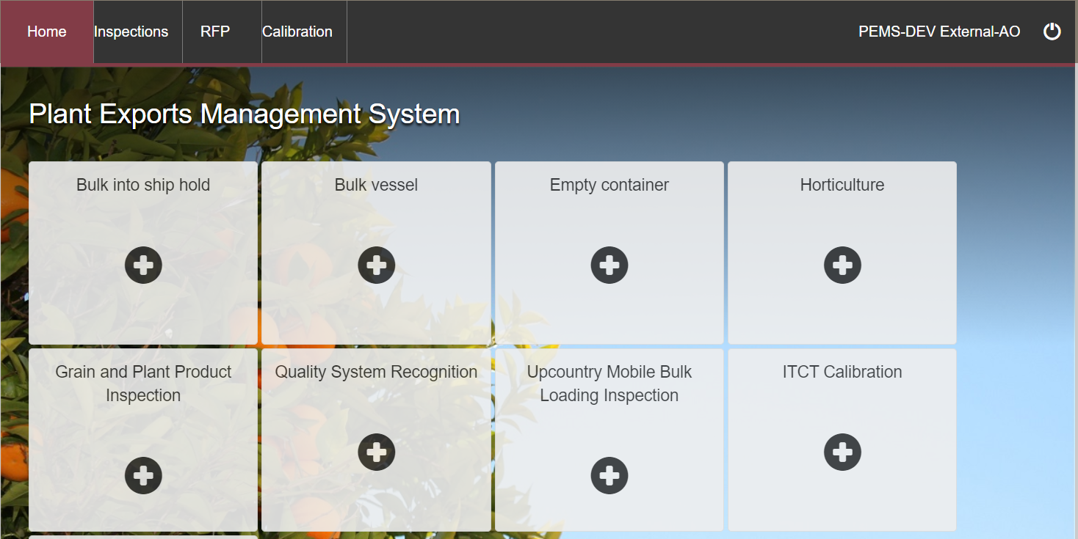

The *Create Calibration* window will display (below).

Enter a **Container number1**. The container number must be four letters and six or seven digits.

From the drop down select the **Container size2**. This will be either 20 or 40 foot.

Enter the **Establishment number3** (mandatory for third party AOs). The establishment number should be three to four digits long.

If known, enter the **RFP number4**. The RFP number should be seven digits long.

Click **Create5**.

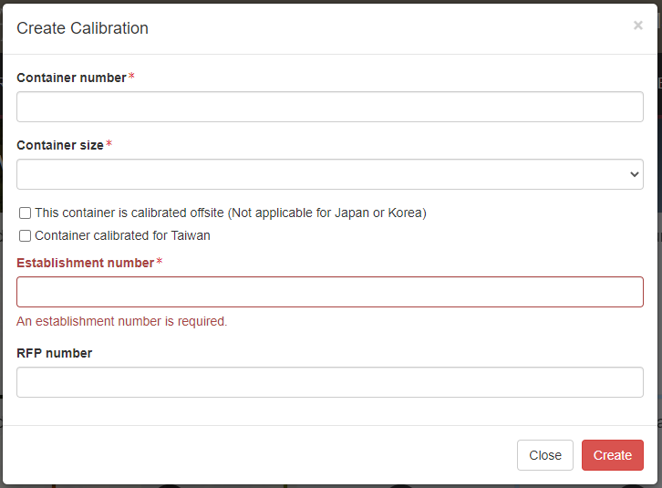

PEMS will populate the *Container Calibration* page. The calibration record will remain **Active1** until the record is withdrawn, submitted, or cancelled.

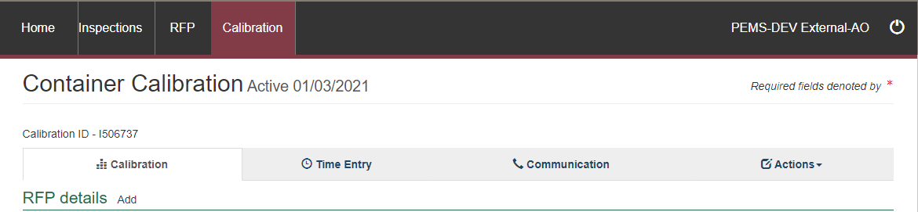

**!** Each container can only have one active calibration associated with it. The system will generate an error message if you try to create another calibration record with the **same container number** or if the other calibration record is in an active status.

**!** While the calibration record is active, the date provided on the calibration record is the date the calibration record was initiated.

#### Calibration page (without RFP)

Where a record is created before an RFP has been raised in EXDOC the *Container Calibration* page will display.

The *Container Calibration* page displays the following sections:

* **RFP details1 –** if the record is created before an RFP number has been raised in EXDOC, the RFP details will be blank. You will need to add the RFP number manually when the RFP number has been created, and the rest of the details in this field will be populated automatically.
* **Calibration details2 –** allows you to confirm the container clock is set to GMT and to record the recorder serial number.
* **Readings3** **–** allows you to record the sensor readings.

**Comments4** – allows you to record general comments regarding the calibration. See **Section 3.6 Adding comments to a record,** Reference: *PEMS AO user guide – Overview and General Functions*.

Step-by-step instruction on how to record or change data on this page is provided below.

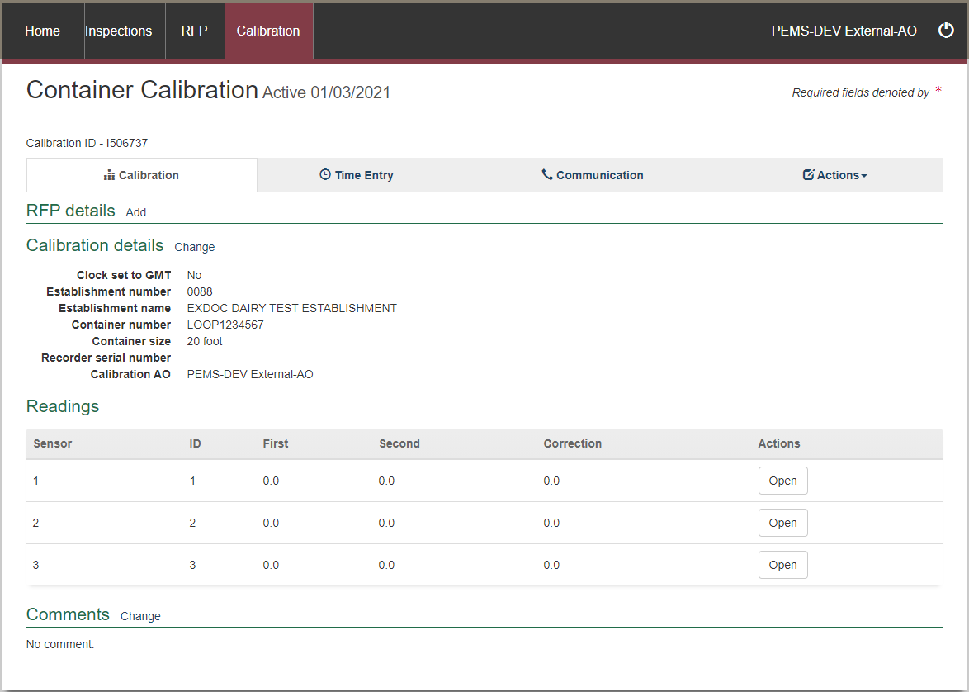

#### Calibration page (with RFP)

Where a record is created with an associated RFP, the *Generic calibration* page will display.

The *Generic Calibration* page displays the following sections:

* **RFP details1 –** populated based on the RFP information extracted from EXDOC. If the entire Exporter name does not appear in PEMS then you need to contact PEMS@awe.gov.au to have the name corrected in the PEMS reference table (see Edit Exporter name in the relevant inspection).
* **Calibration details2 –** allows you to confirm the container clock is set to GMT and to record the recorder serial number (the recorder serial number can include letters, numbers, and special characters).
* **Loading details3–** allows you to record the pulp temperatures and seal details.
* **Readings4** **–** allows you to record the sensor readings.
* **Pre-cooling temperatures5 –** allows you to record the pre-cooling temperatures (minimum requirement of five temperatures).
* **Comments6** **–** allows you to record general comments regarding the calibration. See **Section 3.6 Adding comments to a record,** Reference: *PEMS AO user guide – Overview and General Functions*.

Step-by-step instruction on how to record or change data on this page is provided below.

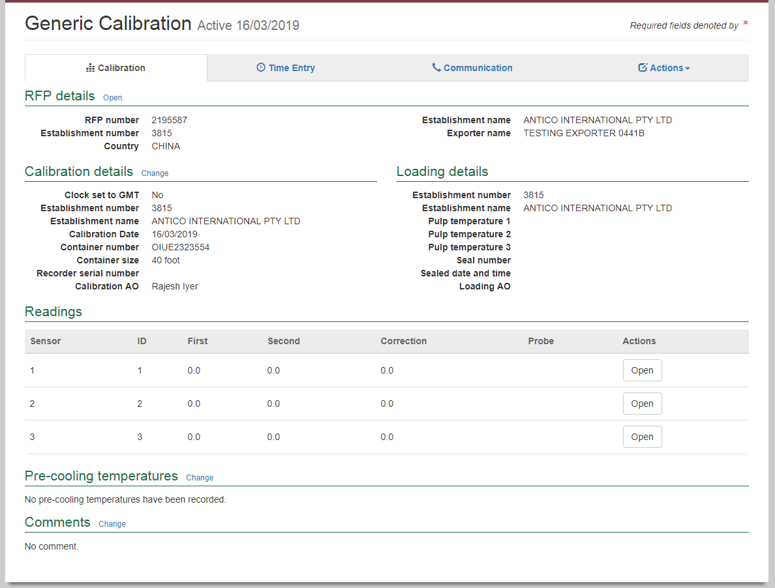

#### Opening the RFP details

To open the RFP record, click the **Calibration1** tab and then click **Open2** under the RFP details section.

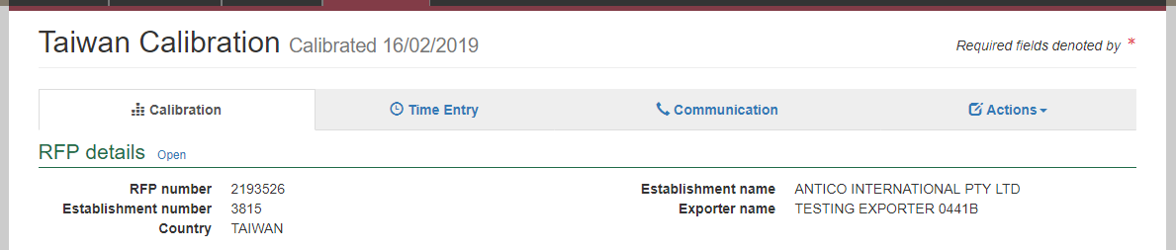

The *Request For Permit* page will display.

The RFP page will display a **Summary1** of the RFP, as well as the **Request for permit lines2**. For more information on the **RFP tabs3** see **Section 4: RFP functions in PEMS,** Reference: *PEMS AO user guide – Overview and General Functions*).

Click **Open4** beside any RFP line to view the details of that line. Select **View containers5** to see the containers linked to the RFP.

For departmental AO’s only, click **Change6** beside *Comments* to record comments at the RFP level.

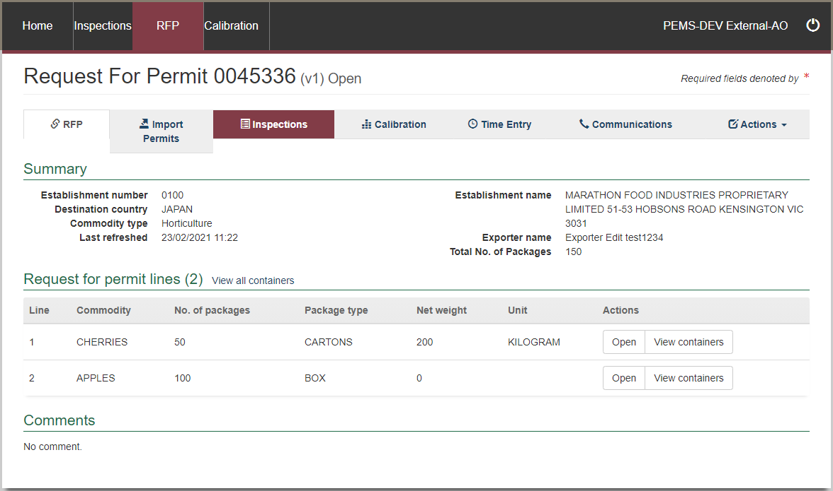

The RFP line window will display the details of the line that were provided on the RFP in EXDOC.

Click **Previous** and **Next1** to navigate between the RFP line windows.

Click **Close2** to exit the RFP line windows at any time and return to the RFP page.

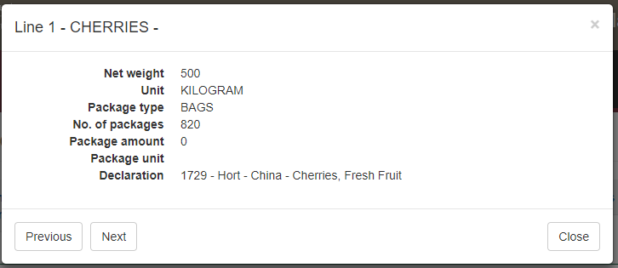

#### Returning to the calibration page from the RFP page

To return to the Calibration page click the **Calibration1** tab. The full list of calibrations relating to the RFP will display. Click **Open2** beside the active calibration record.

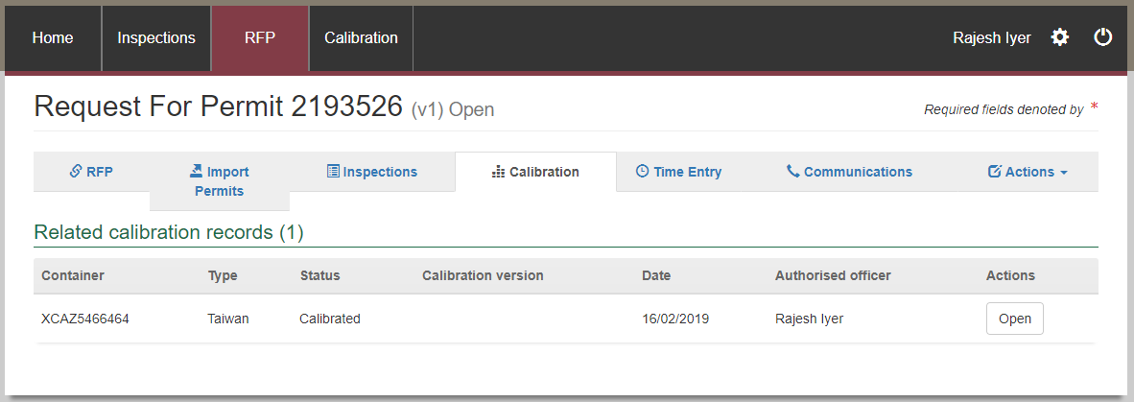

#### Recording the onsite calibration details

Calibration details can be recorded on the *Container Calibration* page.

The information can be either generic that covers the requirements for multiple countries such as Japan, Indonesia, and Thailand, or specific to meet particular country requirements such as Taiwan and USA.

##### Generic, Japan, Indonesia, and Thailand

To edit or record the *Generic Calibration details*, click **Change1.**

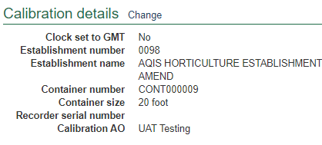

You can edit the **Establishment number1**, select the **Container size2**, **Local date3**, **Local time4**, confirm the **Container clock set to GMT5** and enter the **Recorder serial number6.**

Click **Save7**.

**!** When calibrating 1 probe only for Indonesia, the check box for **Container clock set to GMT** is not applicable. It is required when sensor 2 and 3 readings are applicable.

**!** The local date and time will appear as the calibration date and time, so if you have calibrated the container on another date or time then you need to update this field accordingly.

**!** For Japan, you cannot change the Local date and time for consignments due to importing country requirements.

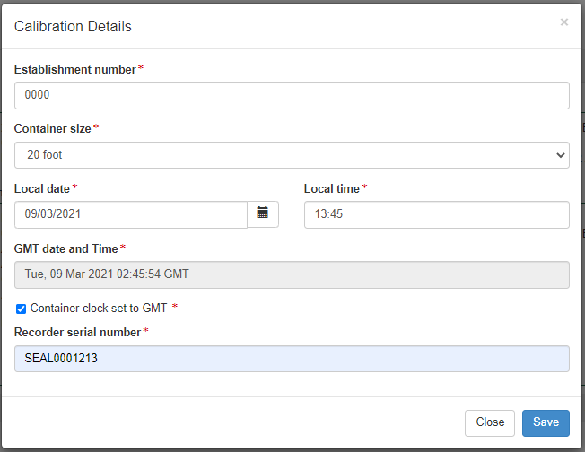

The *Calibration* page will display the updated **Calibration details1.**

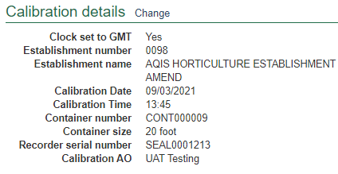

##### Taiwan

If you have selected ‘Container calibrated for Taiwan’ when creating the calibration record, select the appropriate checkbox for **Are you the container technician?1**, enter name of **Calibration technician2**, name of **Calibration company3** and **Address details4** of the calibration company.

Click **Save5**.

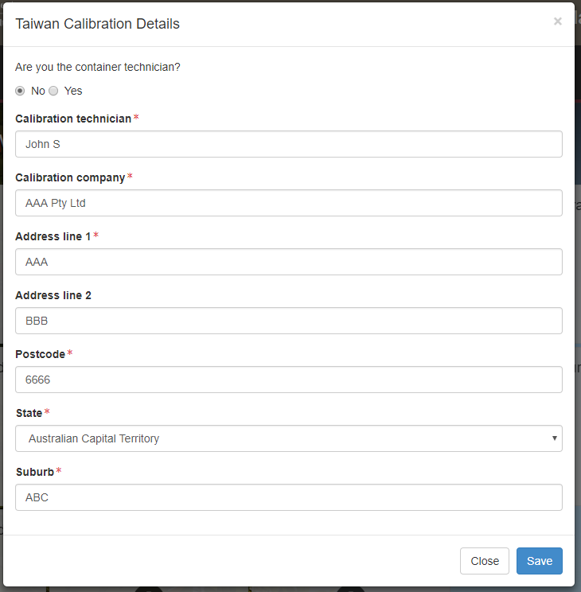

**!** If you are the calibration technician, select *Yes* for **Are you the calibration technician?1**   
PEMS will auto-populate all mandatory details (name, company, and address).

The *Container Calibration* page will display the updated **calibration technician1** information.

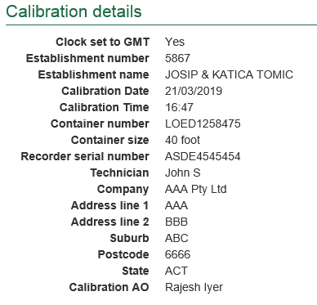

To edit or record the Calibration details, click **Change1.**

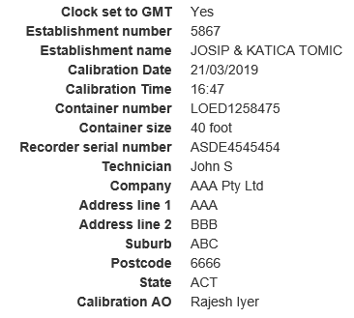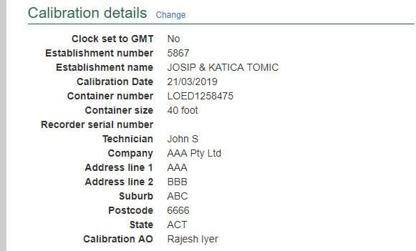

You can edit the **Establishment number1**, select the **Container size2**, **Local date3**, **Local time4**, confirm the **Container clock set to GMT5,** enter the **Recorder serial number6** and if required, **Update Technician7** details.

Click **Save8**.

**!** The local date and time will appear as the calibration date and time, so if you have calibrated the container on another date or time then you need to update this field accordingly.

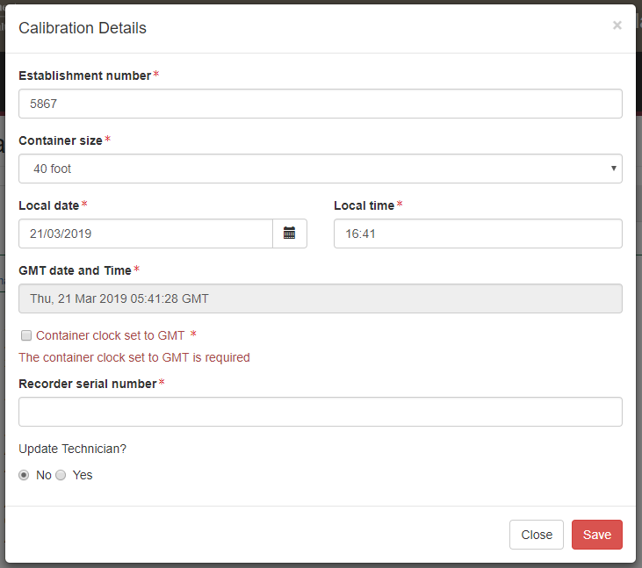

The *Calibration* page will display the updated **Calibration details1.**

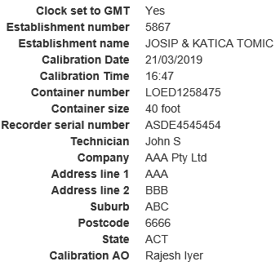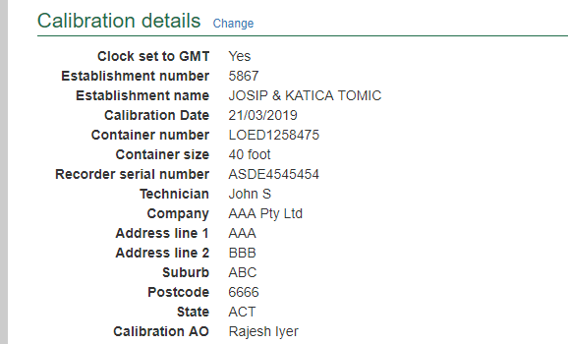

##### United States of America

To edit or record the calibration details specific to the USA, click **change1** next to the Calibration details.

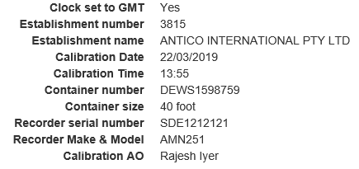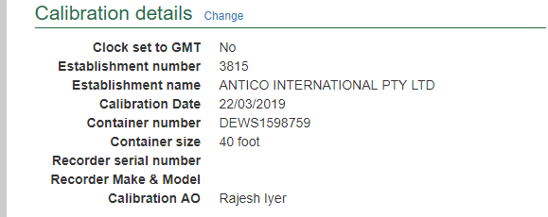

The *Calibration details* dialog box will expand to show all the fields that can be edited or updated.

**!** The local date and time will appear as the calibration date and time, so if you have calibrated the container on another date or time then you will need to update this field accordingly.

You can edit the **Establishment number1**, select the **Container size2**, **Local date3**, **Local time4**, confirm the **Container clock set to GMT5**, enter the **Recorder serial number6** and the **Recorder Make & Model7**. Click **Save8**.

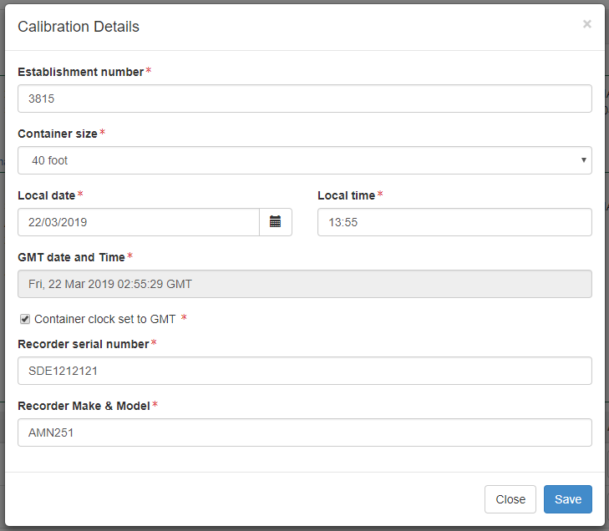

The *Calibration page* will display the updated **Calibration details1.**

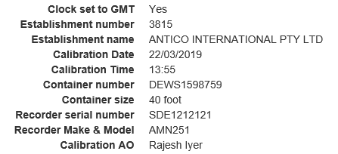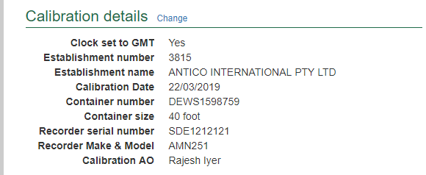

#### Verifying the container clock is set to GMT

For all calibration records, the container **Clock set to GMT1**must be verified. To verify the GMT date and time, click the **Calibration2** tab and then click **Change3** under the Calibration details section.

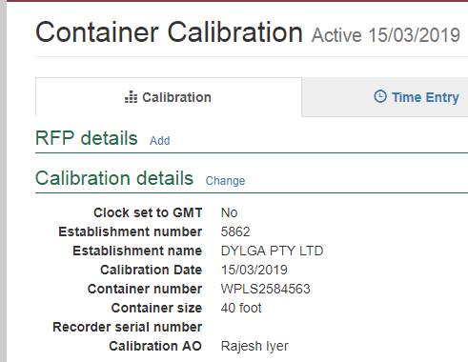

The *Calibration Details* window will display (below).

You should edit the **Local date1** and **Local time2** for PEMS to automatically reflect the **GMT date and Time3**.

Confirm the **Container clock set to GMT4**, after verifying the GMT date and time from the back of the container is within the five minutes tolerance limit.

Click **Save5.**

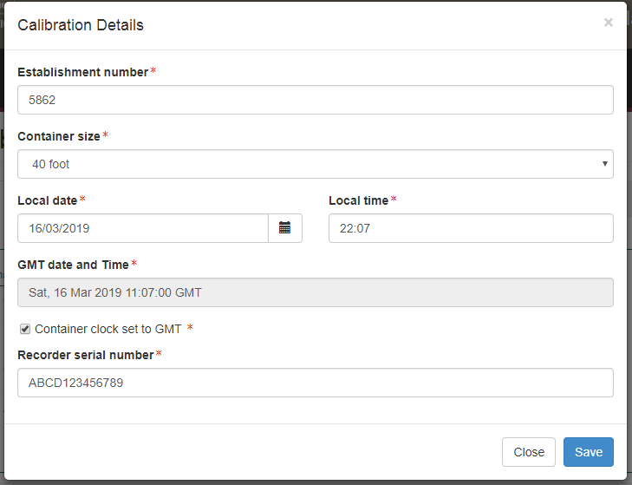

The *Calibration* page will display the updated **Clock set to GMT1** information.

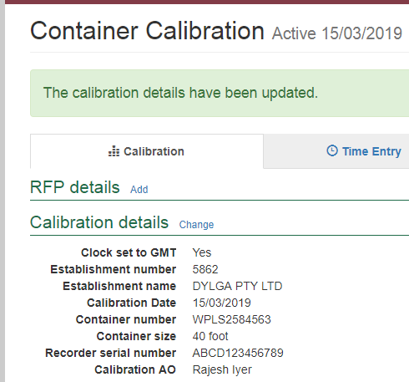

**!** You may choose to edit the local date and time to reflect the correct GMT date and time at the back of the container. The tolerance limit mentioned in the work plan must be adhered to.

#### Recording the recorder serial number

The **Recorder serial number1** information must be recorded for the consignment.

To record the recorder serial number information, click the **Calibration2** tab and then click **Change3** under the Calibration details section.

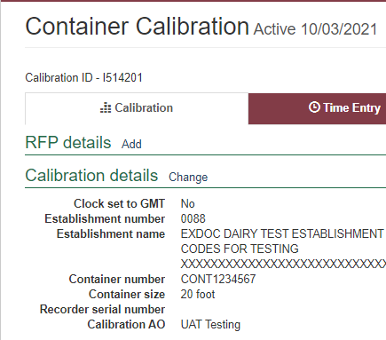

The *Calibration Details* window will display.

You must enter the **recorder serial number1** under calibration details dialog box.

Click **Save2.**

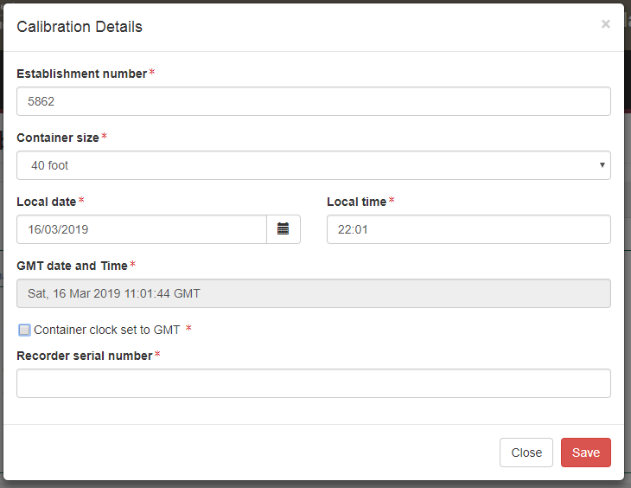

The Calibration page will display the updated **Recorder serial number1** information.

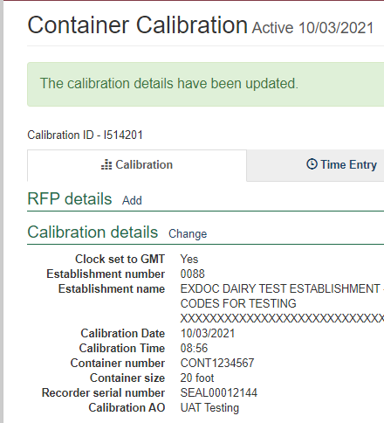

**!** Calibration date is the date on the completed calibration record. The date is set to be the latest time entry record for the calibration activity.

#### Recording the calibration readings

To record the first and second reading under sensor 1, 2 and 3, click **Open1**.

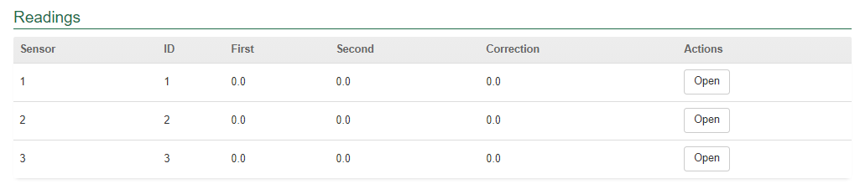

The *Reading for Sensor 1* window will display.

**Sensor ID1** will be displayed by default.

Record the **First** and **second Reading2**. The **Correction factor3** will be auto calculated by PEMS.

Click **Previous** and **Next4** to navigate between the Sensors.

Click **Close5** to exit the Sensor window at any time and return to the Calibration page.

Click **Save6** to record the readings.

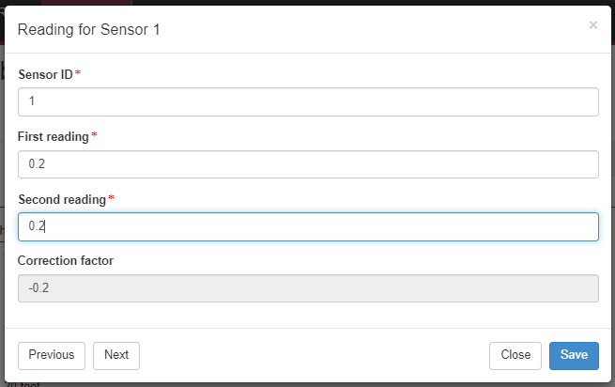

The Calibration page will display the updated **Sensor 1 readings1**.

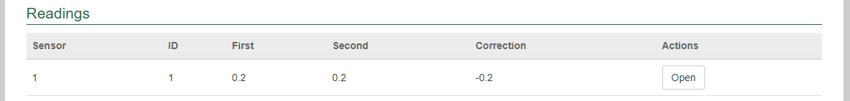

**!** The first and second reading for every sensor must be identical.

**!** For Indonesia, a reading for sensor 1 is mandatory.

**!** For USA and Guam, a first, second and third reading for each sensor is required.

**!** For Japan, probe placement image against every sensor can be viewed under probe.

**!** PEMS will accept readings between -0.0 to 0.3 degrees Celsius.

**!** For Philippines, PEMS will accept a reading of 0.0.

#### Recording the pre-cooling temperatures

To record pre-cooling temperatures, click **Change1**



The *Pre-cooling Temperatures* window will display.

You can enter multiple commas to separate the lists of readings under **Temperatures1** and click **Update2** to automatically get the reading into the **boxes 1–223**.

Click **Clear4** if you wish to remove the readings.

You can also record readings directly into the **boxes 1–223**.

Click **Close5** to exit the pre-cooling temperatures window at any time and return to the Calibration page.

Click **Save6** to record the readings.

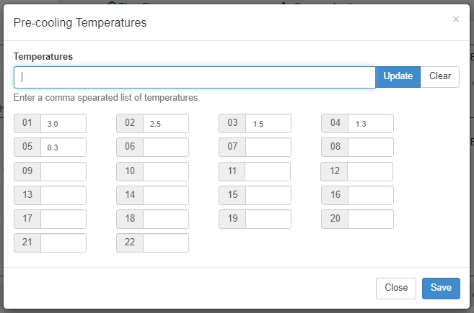

The Calibration page will display the updated **Pre-cooling temperatures1**.

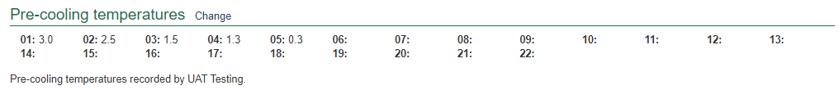

**!** A minimum of five pre-cooling temperatures is mandatory.

**!** PEMS will display a warning message if pre-cooling temperatures are above 3 and less than 4 degrees Celsius.

**!** PEMS will not record pre-cooling temperatures greater than 4 degrees Celsius to meet the importing country requirements.

#### Recording the loading details

##### Generic

To record *Generic Loading details*, click **Change1**.

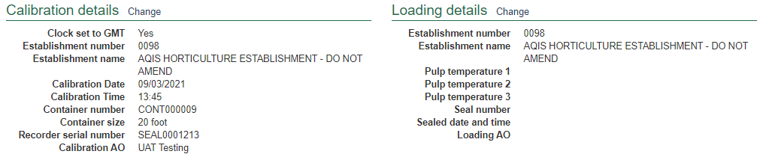

*Loading Details* window will display.

You can edit the **Establishment number1**, confirm **Probes Placed2** andrecord the **Pulp temperature3** for sensors 1, 2 and 3.

Seal the container and enter the **Seal number4**.

Record the **Sealed date5** and **Sealed time6**.

Click **Close7** to exit the Loading Details window at any time and return to the Calibration page.

Click **Save8** to record the readings.

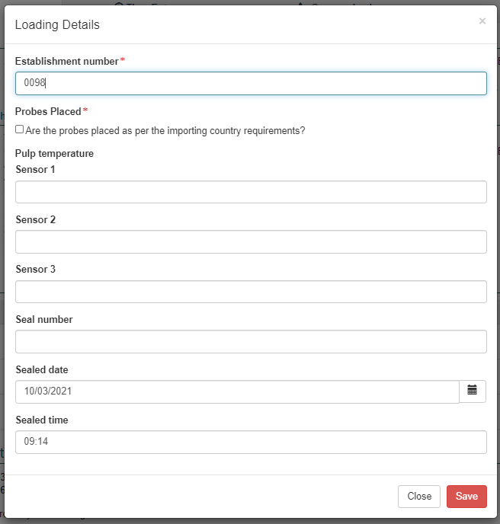

**!** The pulp temperature for each sensor can be entered and saved as the inspection progresses. There is no longer a requirement that all three must be entered at the same time.

**!** All pulp temperatures must be entered prior to submitting the calibration record.

The Calibration page will display the updated **Loading details1.**

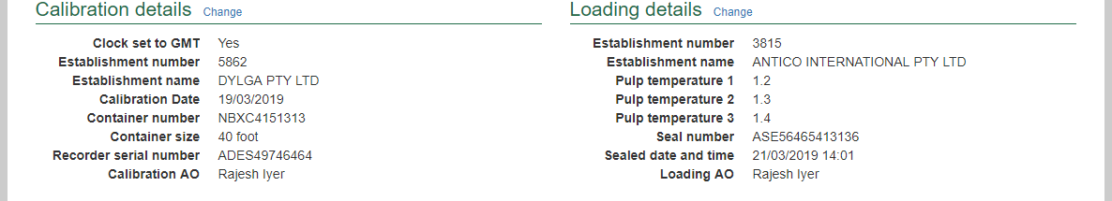

**!** For Indonesia, readings for sensor 1 is mandatory.

**!** PEMS will display a warning message if pulp temperatures, for every sensor, is greater than 3.1 degrees Celsius.

**!** PEMS will accept reading between -0.0 to 0.3 degrees Celsius.

**!** For Philippines, PEMS will accept a reading of 0.0.

**!** Thesealed time/date must be equal to or greater than the start time/date and equal to or less than the end time /date of the calibration record.

##### Taiwan

To record loading details specific to Taiwan, click **Change1.**

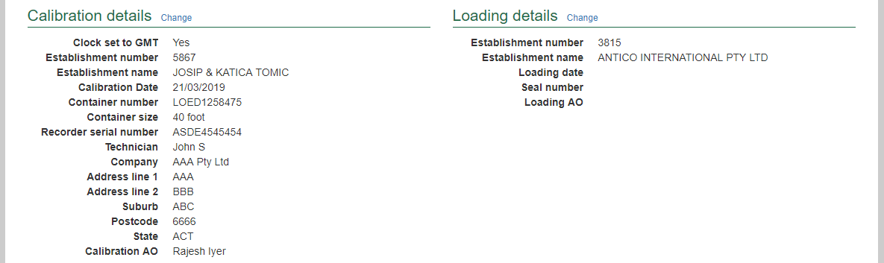

The *Loading Details* window will display.

You can edit the **Establishment number1**, confirm the **Probes Placed2** and record the **Loading date3**.

Seal the container and enter the **Seal number4**. Click **Save5** to record the readings.

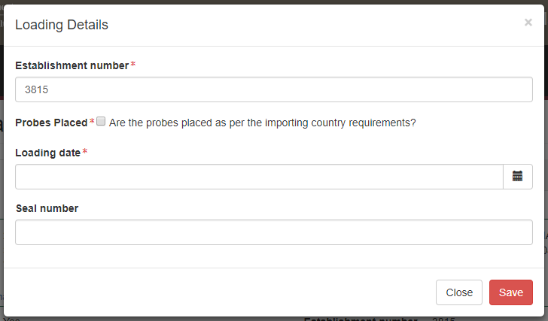

The Calibration page will display the updated **Loading details1.**

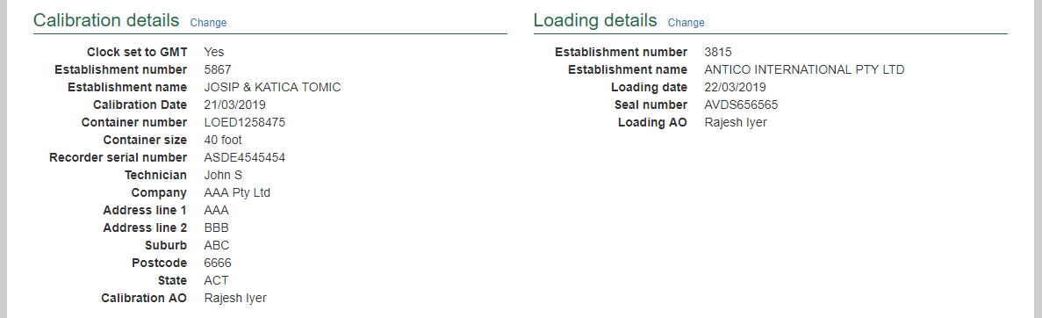

##### United States of America

To record loading details specific to USA, click **Change1.**

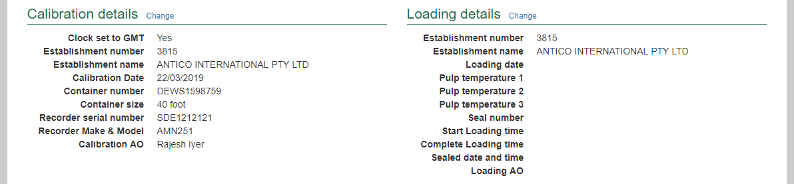

The *Loading Details* window will display.

You can edit the **Establishment number1**, confirm the **Probes Placed2;** and record the **Loading date, Start loading time** and **Complete Loading time3.**

Enter the **Pulp temperature** for **Sensor 1, 2 and 34.**

Seal the container and enter the **Seal number, Sealed date** and **Sealed time5.**

Click **Save6** to record the readings.

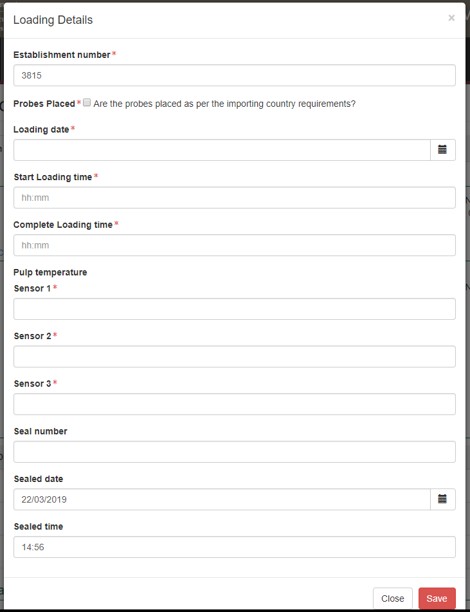

The Calibration page will display the updated **Loading details1.**

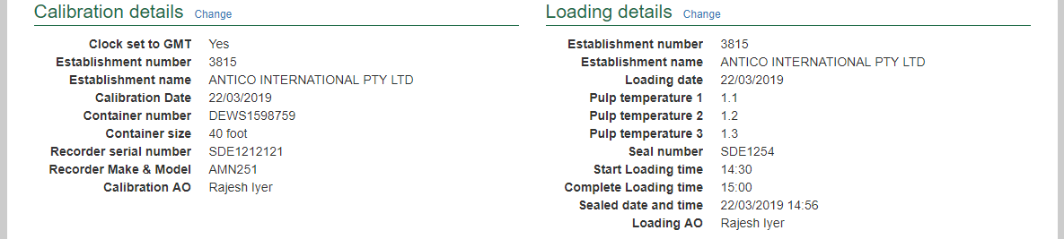

##### Japan

To record loading details, click **Change1.**

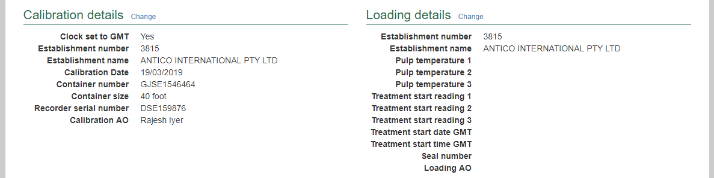

The *Loading Details* window will display. You can edit the **Establishment number1**, confirm the **Probes Placed2**, and enter the **Pulp temperature** for **Sensor 1, 2 and 33.**

After the treatment is complete, record the **Treatment start readings** for **Sensor 1, 2 and 34** and the **Treatment start date GMT** and **Treatment start time GMT5.**

Seal the container and enter the **Seal number6** and confirm the **Australian Government seal applied7**.

Click **Save8** to record the readings.

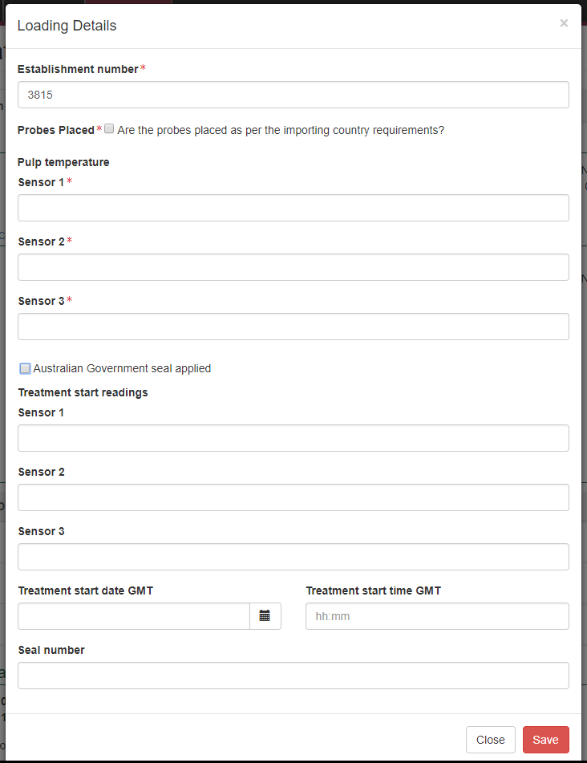

The Calibration page will display the updated **Loading details1.**

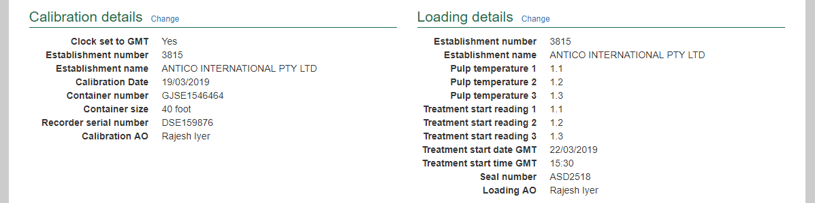

#### Completing and submitting the calibration record

The onsite calibration record can only be submitted after:

* all calibration results and data are recorded appropriately
* a **Time Entry1** is provided for all AOs who recorded calibration results
* if applicable, attachments and correspondence relating to the calibration are recorded under the **Communications2** tab.

Details on the **Time Entry1** and **Communications2** tabs can be found in **Section 3: General PEMS calibration functions,** Reference: *PEMS AO user guide – Overview and General Functions*.

When you are ready to submit the calibration record, click the **Actions3** tab, then click **Submit4**.

For more information on **downloading** the calibration certificate, **cancelling** or **withdrawing5** a calibration, see **Section 3.4 Actions tab,** Reference: *PEMS AO user guide – Overview and General Functions*.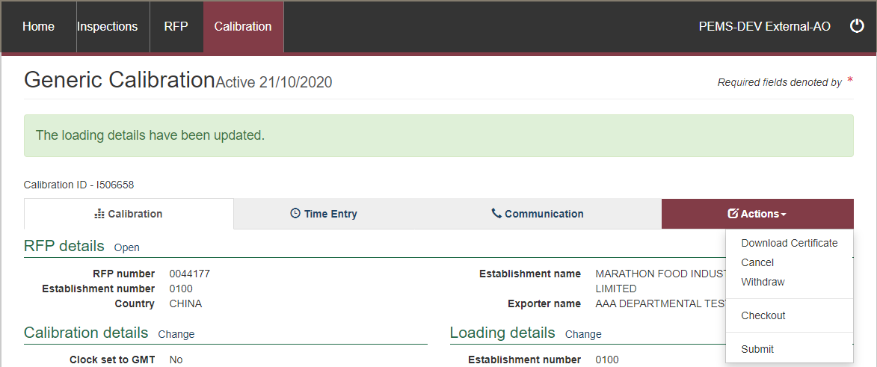

**!** Once the calibration record is submitted the record will become **read-only** and you will be unable to make changes to the data provided.

However, you will be able to attach a new document, and add invoice numbers (for departmental AOs).

**!** All dates and times that are entered in a calibration record including Calibration date and time, Loading date and time, Sealed date and time must be equal to or greater than the time entry start and equal to, or less than the finish times.

**!** The local date and time will appear as the calibration date and time, so if you have calibrated the container on another date or time then you will need to update this field accordingly.

The *Container Approval* window will display.

* Confirm that the container meets all three requirements displayed as **checkboxes1**.
* Select if you want to **email the exporter/EDI user on the submission of the inspection2**. When selecting this option, the Inspection submit confirmation box will expand.
* Enter the **email address3**, this can be multiple email addresses each separated by a comma.
* Enter in any **Comments4** that are to be included in the email.
* Click **Approve5**.

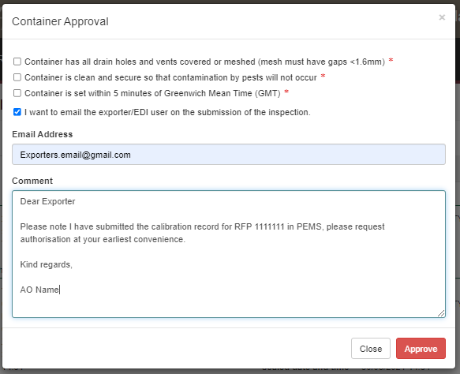

The calibration record will display as **Completed1.**

**!** The date(s) specified on the completed calibration record will be the start date and end date for the calibration. The calibration record date corresponds with the earliest and latest time entry across all AOs for the calibration record.

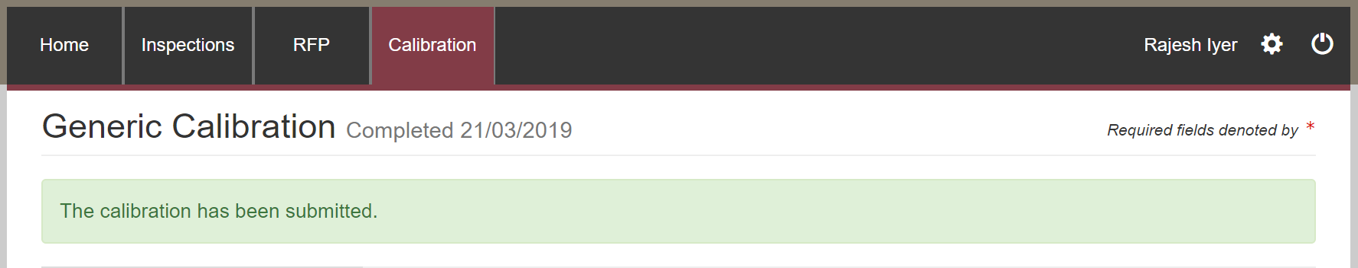

## Initiating an offsite calibration record

To initiate an offsite calibration record, click the **Home1** PEMS menu tab and then click the **ITCT** **Calibration2** button.

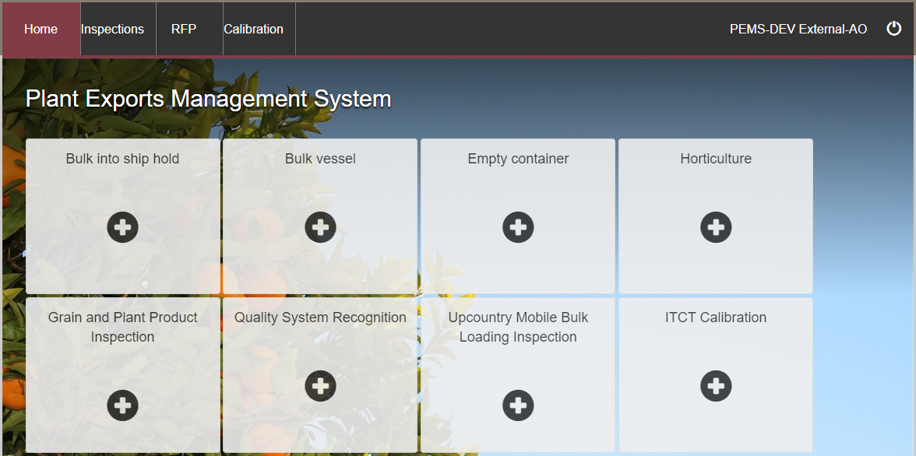

The *Create Calibration* window will display. You can create an offsite calibration record in PEMS by selecting either the establishment number or the establishment address in the *Create Calibration* window.

If you choose to create the calibration record using the establishment number, follow the below steps:

Enter a **Container number1**. The container number must be four letters and six or seven digits.

From the drop down select the **Container size2**. This will be either 20 or 40 foot.

Confirm **This container is calibrated offsite3**.

If the destination country is Taiwan, select **Container calibrated for Taiwan4**.

Select the **Location5** as establishment number. Enter the **Establishment number6**. The establishment number should be three to four digits long.

Click **Create7**.

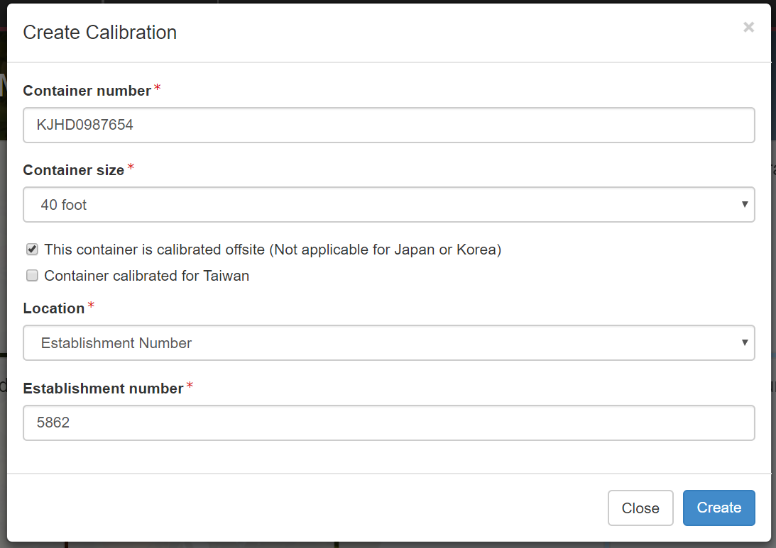

If you choose to create the calibration record using the location as **Address1**, then the window will expand and you must enter the establishment address that the calibration is taking place at, in the **Address line 12**, **Postcode3** and **State4** fields.

Select the relevant **Suburb5**.

Select **Create**6.

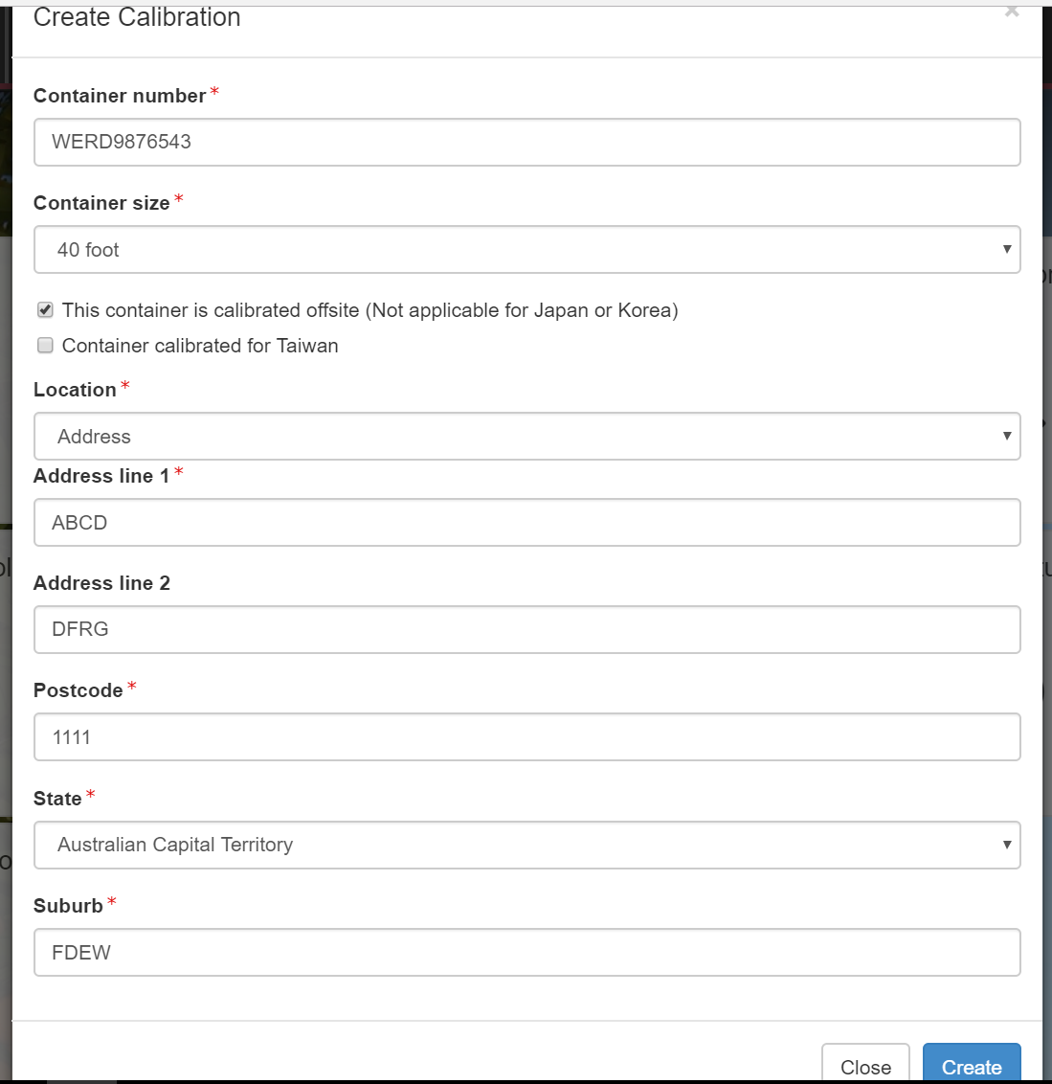

PEMS will populate the *Container Calibration* page.

The calibration record will remain **Active1** until the record is withdrawn, submitted, or cancelled.

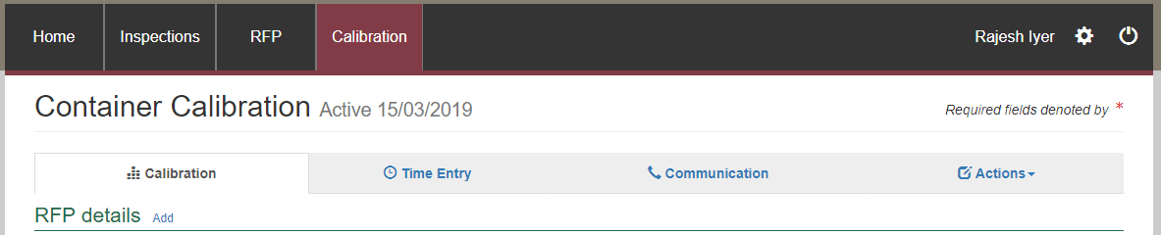

**!** While the calibration record is active, the date provided on the calibration record is the date the calibration record was initiated.

#### Calibration page (without RFP only)

The calibration page displays the following sections:

* **RFP details1 –** not applicable for offsite calibration.
* **Calibration details2 –** allows you to confirm the container clock to GMT and record recorder serial number.
* **Readings3** **–** allows you to record sensor readings.
* **Comments4** **–** general comments regarding the calibration can be recorded here. See **Section 3.6 Adding comments to a record,** Reference: *PEMS AO user guide – Overview and General Functions*.

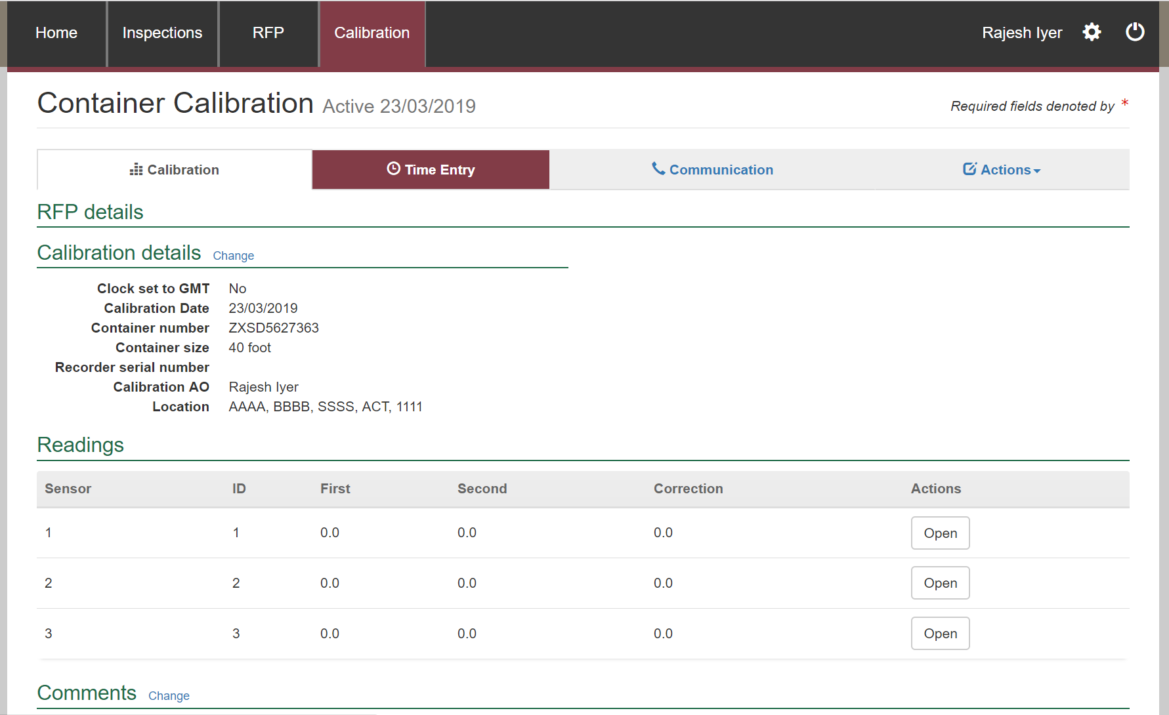

#### Recording the offsite calibration details

##### Generic, Japan, Indonesia and Thailand

Refer to the [onsite steps](#_(Generic,_Japan,_Indonesia)

##### Taiwan

Refer to the onsite steps

##### United States of America

Not Applicable. Instead, enter Make and Model details in the comments section of Container Calibration page.

**!** If the location under create calibration is chosen as address, you cannot edit the establishment number in Calibration Details window.

#### Recording the calibration readings

Refer to the onsite steps

#### Completing and submitting the calibration record

The offsite calibration record can only be submitted after:

* all calibration results and data are recorded appropriately
* a **Time Entry1** is provided for all AOs who recorded calibration results
* if applicable, attachments and correspondence relating to the calibration are recorded under the **Communications2** tab.

Details on the **Time Entry1** and **Communications2** tabs can be found in **Section 3: General PEMS calibration functions,** Reference: *PEMS AO user guide – Overview and General Functions*.

When you are ready to submit the calibration record, click the **Actions3**tab and then click **Submit4**.

For more information on **Downloading** the calibration certificate, **cancelling** or **withdrawing5** the calibration record, see **Section 3.4 Actions tab,** Reference: *PEMS AO user guide – Overview and General Functions*.

**!** Once the calibration record is submitted the record will become read-only and you will be unable to make changes to the data provided. However, you will be able to attach a new document, and add invoice numbers (for departmental AOs).

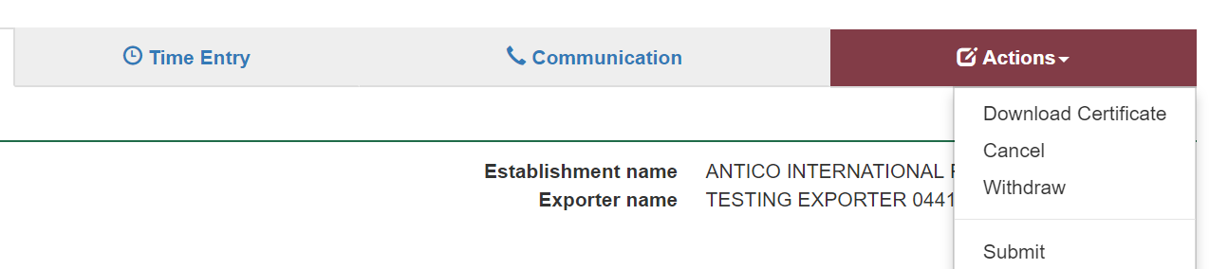

The *Container Approval* window will display.

* Confirm that the container meets all three requirements displayed as **checkboxes1**.
* Enter the **Offsite seal number2.**
* It will also ask if you want to **email the exporter/EDI user on the submission of the inspection3**. When selecting this option, the Inspection submit confirmation box will expand.
* Enter the **email address4**, this can be multiple email addresses each separated by a comma.
* Enter in any **Comments5** that are to be included in the email.
* Click **Approve6**.

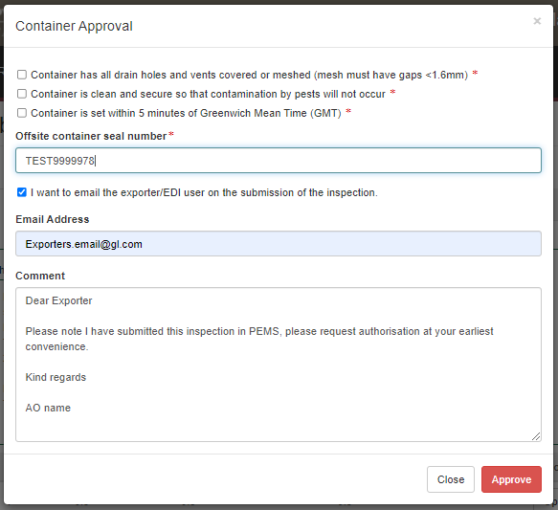

The calibration record will display as **Calibrated1.**

**!** The date(s) specified on the calibrated record will be the start date and end date for the calibration. The calibration record date corresponds with the earliest and latest time entry across all AOs for the calibration record.

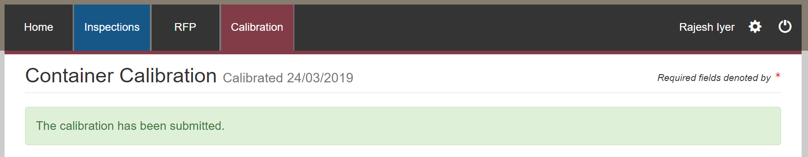

The calibrated container record will have two additional details—the **Container Expiry date1** and the **Offsite seal Number2**.

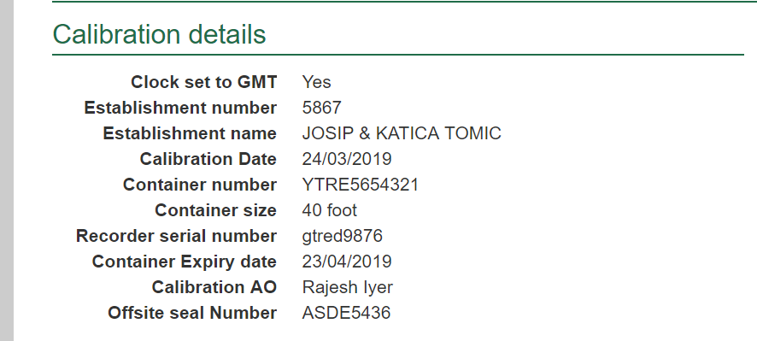

**!** The calibrated container is valid for 30 days.

**!** Third party AOs will be required to enter the offsite seal number to join the calibration record.

## Related material

The following related material is available on the department’s website:

* Manual of Importing Country Requirements (Micor).
* Micor Plants (importing country requirements, protocols and work plans)
* Protocols, work plans
* Plant Export Operations Manual
* Reference: *Plant Exports Management System (PEMS) Authorised Officer User Guide – Overview and general functions*
  + *Horticulture inspections*
* The following related material is available on the department’s Learnhub:
* Plant Export Management System (PEMS) video tutorials

## Contact information

* Authorised Officer Hotline: 1800 851 305
* Authorised Officer Program: PlantExportTraining@awe.gov.au
* PEMS Administration: PEMS@awe.gov.au.

## Document information

The following table contains administrative metadata.

| **Instructional Material Library document ID** | **Instructional material owner** |
| --- | --- |
| IMLS-9-7595 | Director, Congestion Busting Program |

## Version history

The following table details the published date and amendment details for this document.

| **Version** | **Date** | **Amendment details** |
| --- | --- | --- |
| 1.0 | 08/07/2016 | New user guide. |
| 1.1 | 12/07/2016 | Minor variations for accuracy and clarity. |
| 2.0 | 30/09/2016 | * Complete document restructure. * Addition of sections on: * Logging into PEMS * Calibration records * Calibration search. |
| 2.1 | 16/12/2016 | * Minor variations for accuracy and clarity * Removal of Appendix F – Calibrations and loading * Removal of Section 2.3 – Calibration search |
| 3.0 | 09/10/2018 | AO user guide updated with PEMS v2.1 enhancements. |
| 4.0 | 23/05/2019 | AO user guide updated with PEMS v3.1 and v3.2 enhancements. |
| 5.0 | 4/11/2019 | Updated with PEMS v.3.3 and 3.4 enhancements. |
| 6.0 | 3/06/2020 | Updated with PEMS 3.5 enhancements. |
| 7.0 | 28/08/2020 | Removal of appendices from Plant Exports Management System (PEMS) Authorised Officer user guide to make each its own user guide. |
| 8.0 | 10/12/2020 | Updated with PEMS v3.9a enhancements. |
| 9.0 | 28/03/2021 | Updated for commencement of the *Export Control Act 2020* and associated Plant Rules. |
| 10 | 7/06/2021 | Removal of CGI references. |
| 11 | 5/07/2021 | Updated with PEMS July 2021 release. |
| 12 | 13/09/2021 | Updated email notification on submission in line with PEMS September 2021 release. |
| 13 | 17/12/2021 | Updated with PEMS December 2021 release. |