

**INCLUSION STRATEGY 2019 - 2023**

**Our vision for  
inclusion**

*Our success depends on our people feeling   
valued for their differences, respected for who   
they are, and empowered to contribute*

**Diversity and**

**inclusion**

**The difference**

**Diversity** is about the ways we differ. It encompasses how we identify in relation to gender, ethnicity, age, disability, sexual orientation, lived experience with mental health issues, language, socio-economic background, cultural heritage, religious beliefs, education, and family and caring responsibilities. In our Department, it reflects the diverse nature of the work we do, and the range of locations we work from. We consider the diversity of thinking that our difference brings as a success factor in how we learn and grow.

**Inclusion** is about valuing and celebrating our differences, and developing a culture and a sense of community where everyone can participate and thrive. This means individuals are respected, supported, engaged, and have a voice. An inclusive culture also means that everyone feels comfortable to bring their whole and authentic selves to work and never hide who they are.

**The link**

By building an inclusive culture we create a

foundation for people from all backgrounds

to feel that they belong and are welcome in

our diverse community.

*“Diversity is the mix. Inclusion is making the mix work”* ~Andres Tapia

**Why an inclusion  
strategy?**

**Aaff**

**Why does inclusion  
matter?**



~Direct quotes from consultation

Building a more inclusive culture will increase engagement and innovation, and improve decision making. As an inclusive workplace, we will be better placed to recruit and retain a diverse and talented workforce. When we better represent the diverse make-up of the Australian community we will be better placed to support the Government in achieving a healthy environment, strong economy and thriving community.

The success of this strategy relies on all of us embracing the mindset of inclusion and acting on every opportunity to be inclusive, no matter how big or small.

Quotes

*“We will feel like we all have a voice, regardless of our location”*

*“Inclusion will drive performance and give us a competitive edge”*

*“We will have access to the same opportunities as everyone else, which will develop and motivate us to be great at what we do”*

*“Inclusion will give us a sense of community and belonging*”

*“People of all groups, backgrounds and beliefs, will feel valued and be able to contribute to the Department”*

**Our Department’s  
 Inclusion Model**

The Inclusion Model guides our efforts in making our inclusion vision   
a reality. The model identifies the three key levers for impacting inclusion:

**Role modelling**Ensuring our leaders demonstrate commitment to inclusion through   
everything they say, do, prioritise, reward and recognise.

**Systems**Enabling our culture to thrive because our processes, policies and   
procedures support, enable and celebrate inclusion.

**Routines**Building an inclusive culture that is characterised by everyday   
‘moments that matter’, the habits within our teams and our   
unique social practices that make us special.

**Applying the model**

Our Inclusion Model has global application across the Department but   
requires local implementation in order to adapt to our diverse and   
unique workplaces.

**Inclusion  
Model**

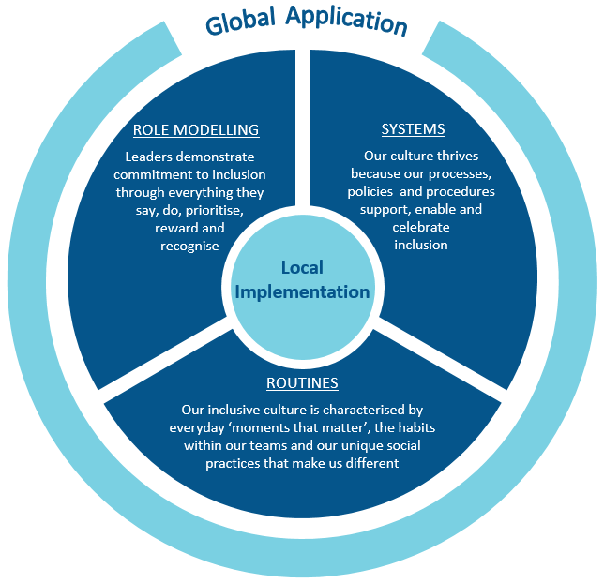

**ROLE MODELLING**

We have the skills to create a safe environment for everyone to believe they can be themselves.

We help people know they are valued by listening and acting on what we hear.

We stand up for those who might otherwise be unheard to ensure everyone has a voice.

**ROUTINES**

We celebrate each other’s past, present and future in big and small ways.

Our interactions are open, transparent, and completely free of fear.

We walk the floor and walk the land to understand all points of view.

**SYSTEMS**

Our people strategies help us build a diverse workforce that represents the broader community we serve.

Our policies and procedures empower and enable our people to fully participate.

People have the information important to them in their roles to enable them to contribute and thrive.

**Roles and   
 responsibilities**

**Executive Board**

As a member of the Executive Board,  
your role is to empower leaders at   
all levels to contribute to our inclusive   
culture. You will be role models,   
signalling to the Department that   
building an inclusive culture is an   
essential aspect of the way we work.

**Inclusion Council**

The Inclusion Council will be the   
Department’s peak body for addressing   
the challenges and acting on the   
opportunities of building an inclusive   
and diverse culture. The Council will   
provide a direct link between the staff-led  
networks and the Department’s senior  
leadership. The Council will invest in,   
and drive changes across the   
organisation that foster diversity and   
inclusion and will regularly communicate   
with staff about new initiatives and share   
our successes.

**SES**

As a senior leader in the Department, your   
role is to create an environment where   
people feel empowered to contribute and   
feel safe to bring their genuine and whole   
self to work. You have a role in leading an  
ongoing conversation about inclusion with  
your teams, and implementing the Inclusion  
Model in a meaningful way at the branch   
and divisional level.

**T’S YOUR  
 ROLE IN THIS?**

**Staff-led networks**

Staff-led networks continue to provide a safe, open forum of support for members to share views and experiences in our quest to build an inclusive environment. The networks have important roles in influencing the development, progress and execution of our Diversity and Inclusion action plans.

**People Branch**

The role of People Branch is to enable and support our people to build an inclusive culture. People Branch also has an important role to play by continuously reviewing our people policies and practices to ensure they promote inclusivity and diversity.

**What can you do?**

You can **ROLE MODEL** inclusion by actively listening to your colleagues and seeking out diverse views, joining a staff-led network, or by calling out bias, discrimination and inappropriate behaviour. You can practice inclusive **ROUTINES** like leading an acknowledgement of Country at the start of meetings, and celebrating days of significance for diverse groups with your colleagues. You can improve **SYSTEMS** by doing things like making sure your business practices allow everyone to contribute and participate fully.