Memorandum

**To:** Commonwealth Environmental Water Office

**Date:** 17 February 2022

**Regarding:** Independent assessment of the price for water released from private storage in the Lower Balonne – February-April 2022

Executive Summary

The Commonwealth Environmental Water Office (CEWO has engaged Marsden Jacob to provide independent assessment of the price for water released from private storage in the Lower Balonne. For the purpose of this analysis, we were advised to assume a purchase within February-April 2022.

The method to derive the price is similar to that used for the Narran Lakes event based mechanism (EBM) pilot project in early 2020, and the previous price advice in December 2020 and March 2021. The method considered surface and groundwater markets, as well as commodity markets, crop margins and the prevailing climate outlook in the Lower Balonne and neighbouring catchments.

Based on our analysis of the commodity markets and the prevailing climate outlook, water released is from private storage in the Lower Balonne in February-March 2022, it appears plausible that released water would otherwise be used to grow either cotton (next year) or a winter crop such as wheat, or a mix of both.

Using the extra water for a winter crop could give the irrigators the quickest way to profit from the additional input with the lowest risk. However, should the domestic cotton cash prices remain buoyant for the 2023 crop, there may be more upside to store the water until the next summer crop.

It is also possible that the irrigators in the Lower Balonne would grow both a winter and a summer crop. Due to the uncertainty around commodity prices and water availability, it may actually be more likely that the irrigators would be planning both partial winter and summer crop programs instead of going all-in on either.

In Marsden Jacob's opinion, the price of unsupplemented (temporary) water released from private storage in the Lower Balonne is expected to be around $240 to $320 per ML. The recommended single price point is $280 per ML (GST exclusive), which is valid till the end of April 2022.

It is important to note that the recommended single price point does not consider the ecological value and importance of the current breeding event at Narran Lakes. The CEWO may want to consider a higher price to reflect the breeding event's importance.

Purpose

The Commonwealth Environmental Water Office (CEWO) has engaged Marsden Jacob Associates (Marsden Jacob) to provide an independent price for water (unsupplemented) released from private storage in the Lower Balonne. For the purpose of this analysis, we were advised to assume a purchase in February-April 2022 to align with the timing of the colonial waterbird breeding event at Narran Lakes.

Key findings

1. In Marsden Jacob's opinion, the value of foregone unsupplemented (temporary) water in the Lower Balonne is expected to be $240 to $320 per ML. The recommended single price point for the CEWO grant opportunity is $280 per ML (GST exclusive), which is valid till the end of April 2022.
2. The method to derive the price is similar to the approach used for previous price analysis of foregone water. Based on our analysis of the commodity markets and the prevailing climate outlook, additional water in the Lower Balonne could either be used to grow cotton (by storing water for the 2023 summer crop) or a winter crop such as wheat this coming winter season. Using the extra water for a winter crop gives the irrigators the quickest way to profit from the additional input with the lowest risk, but there may be slightly more financial upside to store the water until the next summer crop.
3. The recommended price point of this independent advice relates to a flow event during February-April 2022, and reflects the following assumptions:
   1. on-farm storages in the Lower Balonne are currently holding enough water to finalise current year's summer crops (but not enough to fully irrigate a winter crop), with recent overland flow events contributing to water availability; and
   2. that the Lower Balonne irrigator would use any additional water to either;
      1. grow an irrigated wheat winter crop, achieving 5 tonnes per hectare with a price of $350 per tonne; or
      2. hold the water for a 2022/23 summer cotton crop, achieving 10 bales per hectare with a price of between $600-$700 per bale (this factors in cotton seed at a price of $100 per bale, assuming an average of 250kg of cotton seed per bale of lint); or
      3. grow both a winter and a summer crop. Due to the uncertainty around commodity prices and water availability, it may be more likely that the irrigators would be planning both partial winter and summer crop programs instead of going all-in on either.
4. The recommended price point is valid till the end of April 2022.
5. It is important to note that the recommended single price point does not consider the ecological value and importance of the current breeding event at Narran Lakes. The CEWO may want to consider a higher price to reflect the breeding event's importance.

Background

The Lower Balonne is part of the wider Condamine–Balonne region in south-west Queensland. The Shire of Balonne has an area of approximately 31,000 km2 located on the NSW border some 500 km from the east coast of Australia. The Balonne Shire is rich in native flora and fauna.

The term 'Lower Balonne distributary system' (or simply 'Lower Balonne') is generally used to describe the system of interconnected rivers, creeks and watercourses between St George in south-west Queensland and the Barwon River in NSW, that make up the relatively complex floodplain channel system.

The CEWO is considering the purchase of temporary water through a Commonwealth grant from properties in the Lower Balonne to help facilitate the completion of an colonial waterbird breeding event in the Narran Lakes.

Environmental outcomes through collaboration with community

In recent years, a collaborative effort between local water licence holders and the government, has seen enhanced flows through the rivers in the Lower Balonne, leading to improved environmental outcomes at Narran Lakes. Narran Lakes are internationally recognised RAMSAR wetlands fed by upstream catchments, and protecting their wellbeing is a primary objective of the Basin Plan 2012.

Since early 2020, the CEWO has successfully collaborated with local water licence holders through a grant process that reimburses them to not pump water they are legally entitled to from the Narran River. Both grants have successfully helped to demonstrate the importance the local communities have for the Narran Lakes ecosystem. The irrigation community itself recognises the importance of protecting these natural areas and have historically stated that significant degradation of the protected natural areas would be unacceptable to the local community.[1] Thus, participating in the CEWO grant program will help to build and maintain industries social licence.

More recently, significant flows at the end of 2021 (Figure 1 and Figure 2) have helped promote the breeding of several waterbird species, which had not occurred for a decade.

Figure 1: Sentinel-2 image of Narran Lakes on 9th Feb 2022 using SWIR bands

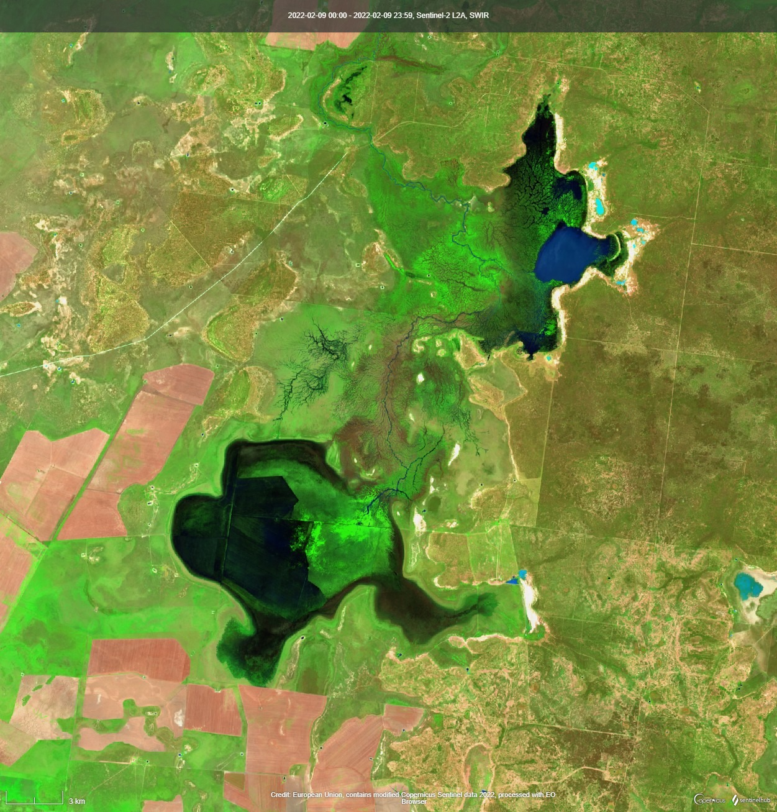

Narran Lakes

Source: Sentinel Hub

The duration of inundation and drying rates are critical factors in supporting waterbird breeding. Floods need to inundate habitats long enough for waterbirds to complete their breeding cycles. At present, water levels are dropping, and if they fall too fast, nests start to become abandoned and eggs and chicks are at risk of predators. Pigs, foxes, and feral cats threaten waterbirds via increased predation, particularly when water levels subside enough to access breeding sites.

The current situation presents a unique opportunity to extend the recent inundations to ensure the waterbird breeding cycles can complete[2]. The challenge is getting sufficient water downriver as water volumes reduce significantly between St George and Narran Lakes (Figure 2).

Figure : River discharge at St George and Wilby Wilby

Source: BoM Water Data Portal

Characteristics of the market

The Lower Balonne temporary water market can be characterised as inactive, with very little trade occurring and no market evidence because transactions are negotiated directly, and prices are not reported. This, coupled with an absence of specialised water market brokers in the region, requires a valuation that draws on neighbouring catchments with similar land and water use characteristics.

The Lower Balonne is a cotton dominated growing region making the market highly seasonal. Whether or not irrigators are likely to participate in the market, depends on the timing of flow events, crop planning decisions, crop water demand and the climatic outlook. Most irrigation needs in the Lower Balonne are met from harvesting water from rainfall events, either directly from overland flows (OLF) or water harvesting (WH) from 'unregulated' flows in the rivers and distributary channels. Irrigators must hold allocations for water harvesting that identify the timing and quantities of water harvested when announced.

Cotton growing dominates water usage and profitability and has driven the development of the irrigation industry in the region. Data from the Australian Bureau of Statistics (ABS) indicates that the clear majority (97%) of water used for irrigation in the Lower Balonne since the year 2000 has been applied to cotton, and provides over 50% of total agricultural production in the Balonne local government area.[3]

The Lower Balonne Water Management Area (WMA) contains 10 separate zones stretching from the upstream extent of the ponded area of EJ Beardmore Dam to downstream into three separate bifurcations, leading to Narran, Ballandool, Bokhara and Culgoa rivers.

Recent local water market activity

There is limited availability of seasonal assignment (also known as allocation or temporary trades) prices for Queensland catchments in the public domain. Still, trade volumes are collected and reported by the Bureau of Meteorology (BoM). Based on the BoM data, temporary water market activity has been confined to the Lower Balonne Zone LBU-01; however, no prices have been reported.

Table : Most recent seasonal assignments in the Lower Balonne WMA

| Date | Volume (ML) | Zone |
| --- | --- | --- |
| 25/06/2021 | 725 | LBU-01 |
| 25/06/2021 | 400 | LBU-01 |
| 25/06/2021 | 61 | LBU-01 |
| 25/06/2021 | 800 | LBU-01 |
| 25/06/2021 | 400 | LBU-01 |
| 25/06/2021 | 400 | LBU-01 |
| 25/06/2021 | 154 | LBU-01 |
| 25/06/2021 | 12380 | LBU-01 |
| 25/06/2021 | 648 | LBU-01 |
| 25/05/2020 | 643 | LBU-01 |
| 25/05/2020 | 12380 | LBU-01 |
| 25/05/2020 | 110 | LBU-01 |
| 25/05/2020 | 837 | LBU-01 |
| 25/05/2020 | 800 | LBU-01 |
| 21/05/2020 | 154 | LBU-01 |

Source: BoM

The main trading activity within the Lower Balonne area traditionally occurs within the supplemented zones of the St George Water Supply Scheme (WSS)[4]. Trading activity for the St George WSS can be seen in Figure 3 Over the last year, approximately 30 GL has been traded within the scheme.

Figure : Trading volume (ML) for the St George Supply Scheme

Source: BoM

According to intermediaries interviewed in preparing this memorandum, plenty of water is available, with some overland flow storage also containing water. It was noted that some water users in the St George WSS have ongoing buy orders to purchase temporary water at $120/ML.

Neighbouring catchments

Due to the lack of market-based evidence in the Lower Balonne area, we reviewed a number of neighbouring catchments and their recent temporary trade prices to determine a price point for Lower Balonne temporary water. We evaluated five predominately cotton-producing NSW catchments: Border Rivers, Gwydir, Lower and Upper Namoi, and Macquarie & Cudgegong. This evidence is summarised in Table 2 and Figure 4.

Table : Most recent temporary water volume weighted average prices (VWAP) for selected neighbouring catchments[5]

| Catchment | VWAP ($/ML) | Month of valuation | General Security allocation % |
| --- | --- | --- | --- |
| NSW Border Rivers | $300 | July 2021 | 128% (B Class) |
| NSW Gwydir | $150 | June 2021 | 263.4% |
| NSW Upper Namoi | $100 | November 2021 | 100% |
| NSW Lower Namoi | $100 | February 2022 | 88.1% |
| NSW Macquarie & Cudgegong | $90 | January 2022 | 100% |

Source: Marsden Jacob Analysis

Figure : Recent temporary market activity in the northern NSW overlaid with aggregate storage levels

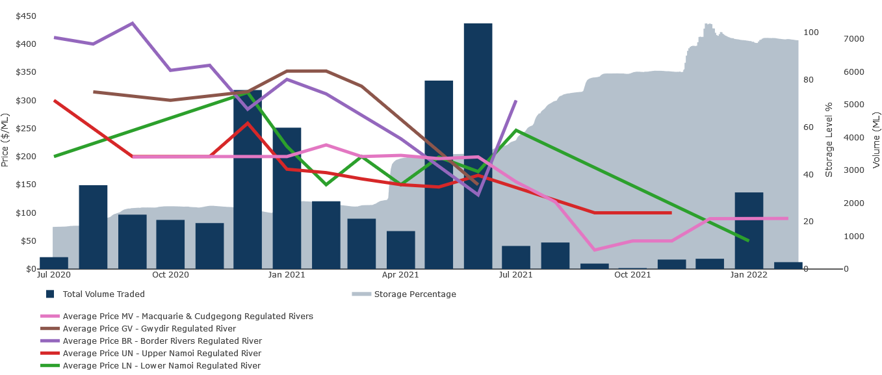

Source: Marsden Jacob Waterflow™

As seen above, the high water availability across all major neighbouring catchments is generally leading to lower temporary water prices and lower market liquidity than experienced last year.

The high water availability has also led to reduced groundwater usage across all neighbouring catchments. Similarly, the groundwater temporary trade market has been subdued throughout the 2021/22 season. Temporary trade prices across the northern NSW and southern Queensland groundwater markets (Table 3) have been broadly in line with the surface water market, acknowledging that the pumping cost for groundwater can be significant[6]. Hence, the trade prices typically tend to be lower compared to surface water. The number of trades per month has been low because sufficient surface water allocations are available during the summer irrigation period. Conversely, groundwater prices have been the highest in areas where most water users do not have access to a regulated surface water source (Central Condamine Alluvium).

Table : Most recent volume weighted average prices (VWAP) for selected neighbouring groundwater sources

| **Water source** | **Jul-21** | **Aug-21** | **Sep-21** | **Oct-21** | **Nov-21** | **Dec-21** | **Jan-22** | **Feb-22** |
| --- | --- | --- | --- | --- | --- | --- | --- | --- |
| Central Condamine Alluvium - Zone 1 | n.a. | n.a. | n.a. | n.a. | n.a. | $200 | n.a. | n.a. |
| Central Condamine Alluvium - Zone 2 | n.a. | $319 | n.a. | $300 | $250 | n.a. | n.a. | $305 |
| Central Condamine Alluvium - Zone 3 | n.a. | n.a. | $150 | $150 | n.a. | n.a. | n.a. | $130 |
| Lower Gwydir Groundwater Source | $125 | $249 | $200 | $220 | n.a. | $160 | n.a. | n.a. |
| Lower Namoi Groundwater Source | n.a. | n.a. | n.a. | $50 | $80 | n.a. | n.a. | n.a. |
| Upper Namoi Zone 2 | n.a. | n.a. | $140 | n.a. | n.a. | n.a. | n.a. | n.a. |
| Upper Namoi Zone 3 | n.a. | n.a. | n.a. | n.a. | n.a. | n.a. | n.a. | n.a. |
| Upper Namoi Zone 4 | $149 | $151 | $75 | n.a. | $150 | n.a. | $150 | n.a. |
| Upper Namoi Zone 5 | $150 | n.a. | n.a. | n.a. | n.a. | n.a. | n.a. | n.a. |

Source: Marsden Jacob Analysis

Overall, the price point comparison between neighbouring catchments and groundwater areas finds that water prices have fallen since this time last year as a result of higher surface water availability. Given current storage volumes, surface water prices appear to be in the range of $90-100 per ML in regions where trades have occurred, but the market liquidity has been low. However, it must be noted that these values reflect water that is likely being opportunistically secured as low prices to undertake final watering or to support winter cropping. In contrast, the water values that have been proposed for the Lower Balonne assume that the water in on-farm storages will most likely be used next water year to support cotton production.

Whilst surface water prices can provide some indication on the value of foregone water for the Lower Balonne, higher groundwater prices ($200-300 per ML) better reflect the willingness to pay to complete this year's summer crop programs in areas where growers do not have access to a regulated surface water source.

Water availability and climate outlook

The Bureau of Meteorology (BOM) seasonal outlook for February to March 2022 indicates an average chance of exceeding median rainfall in the Lower Balonne region (Figure 5). The three-month outlook to May has a 60% chance of exceeding median rainfall of 76mm.

Figure : The chance of above median rainfall for 21 Feb – 6 Mar 2022 near Narran Lakes

Source: BoM

Current El Niño-Southern Oscillation patterns show La Niña event is currently active in the Pacific region. Climate models indicate that La Niña is likely to end in mid-autumn 2022 (Figure 6). This pattern contributes to the wetter than median outlooks for parts of northern and eastern Australia. The other key climate influence, the Indian Ocean Dipole, is likely to remain neutral for the coming months. A neutral IOD has little influence on the Australian climate.

Figure : Monthly sea surface temperature anomalies for ENSO indicators

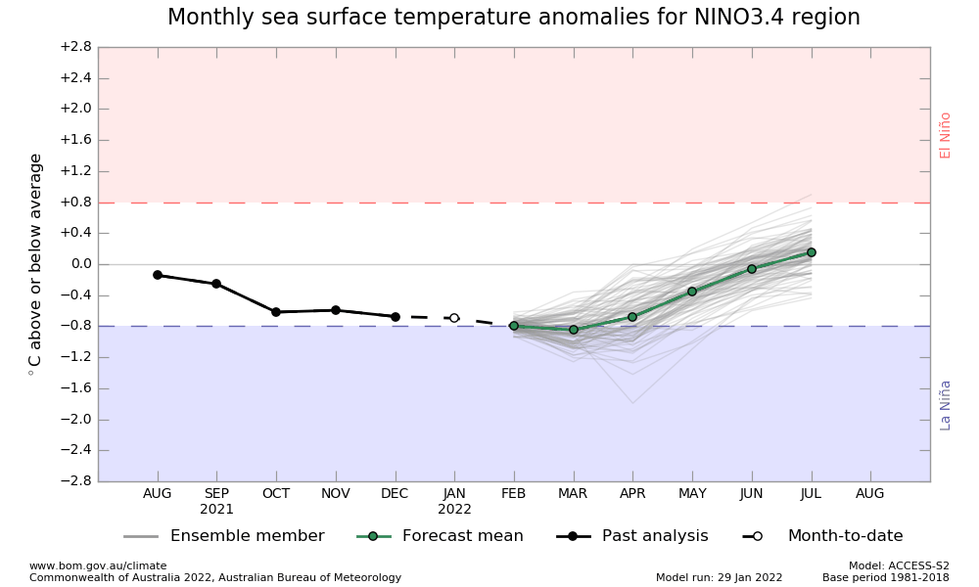

Source: BoM

Above-average rainfall across most of the northern Basin has contributed to the high water availability. Figure 7 below shows the last three-month rainfall deciles.

Figure : Murray-Darling Basin 3-month rainfall deciles to Janary 2022

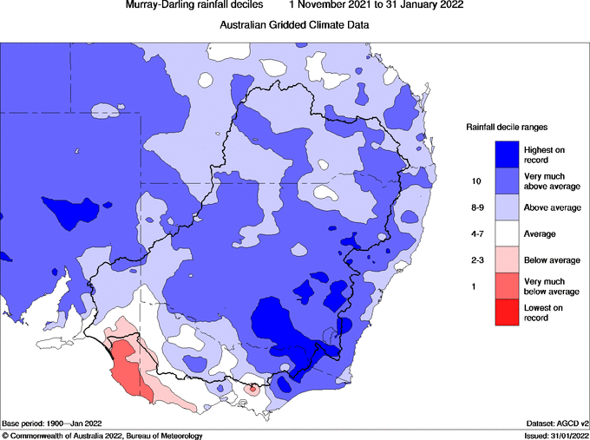

Source: BoM

Current storage levels across the northern NSW catchments are essentially full except for Upper Namoi's Split Rock Dam (Figure 8).

Figure : Storage levels for the five NSW catchments

Source: Marsden Jacob Waterflow™

Figure 9 shows the volume of water stored in Beardmore Dam, the primary water source for the St George WSS[7]. At the time of writing, the storage is effectively full as a result of strong inflows over recent months (and more broadly over the last 12 months – for comparison, at the time of the last price assessment report in March 2021, Beardmore was sitting at 49.5%). The storage has remained largely at maximum capacity over the summer irrigation period, indicating irrigators have had sufficient on-farm storage to complete this season's crops.

Figure : Storage level % of EJ Beardmore Dam since 1 July 2019

Source: BoM

Satellite images below help to confirm the availability of water in storage along the Lower Balonne. The dark blue shows water in on-farm storages, with the bright green showing crop (likely cotton) plantings.

Figure : Satelite image of Lower Balonne under SWIR bands.

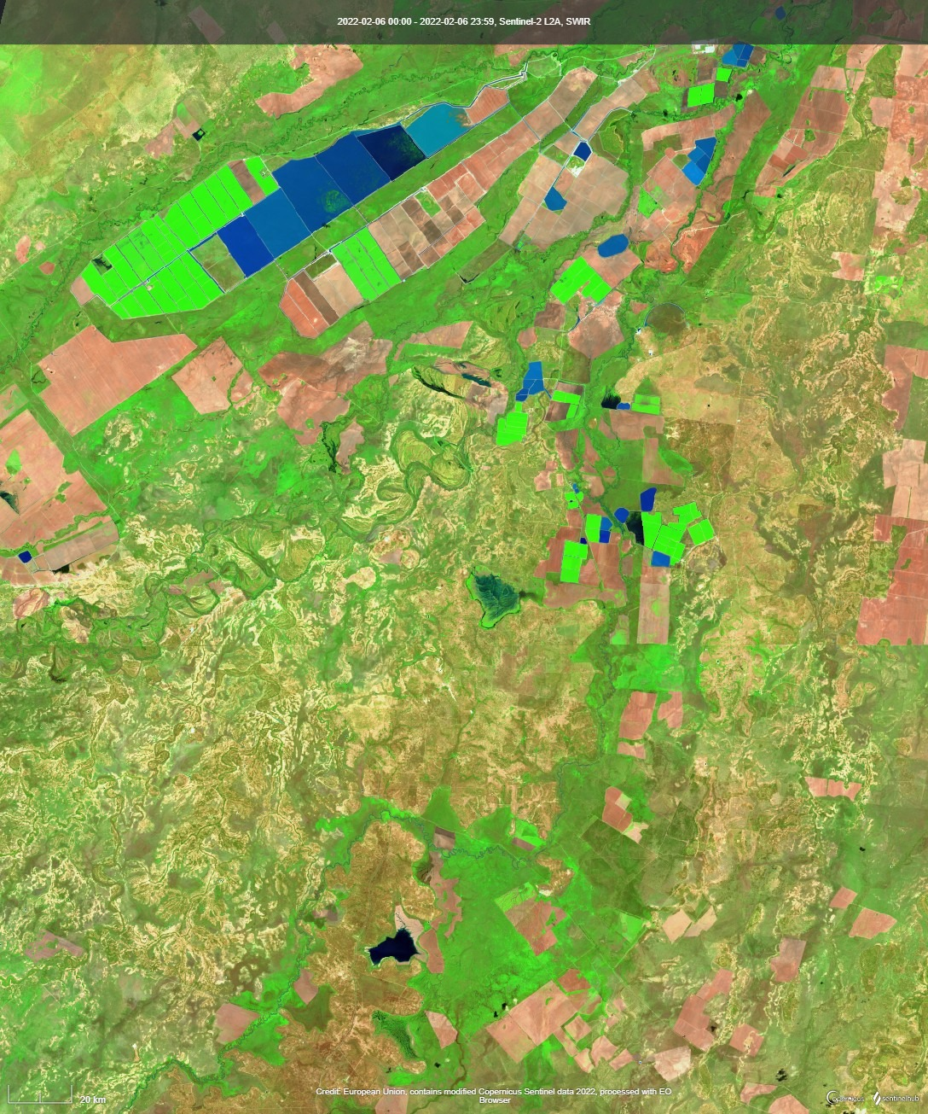

Source: Sentinel Hub

Commodity analysis

Although cotton is by far the dominant water use type in Lower Balonne, in recent years the high evaporation and water loss rates from the drier than average conditions have stimulated an increase in the area of winter cropping (mainly wheat with some chickpeas) and some opportunistic late summer cropping (predominantly mung beans). Cotton planting decisions are typically made in October, with planting taking place in November.

Cotton planting decisions are generally based on an irrigator's best estimate of crop water demand and the amount of water storage on a property. Water use efficiency per hectare and per bale of cotton produced has been measured in the Condamine and Lower Balonne at a lower rate of around 5.9 ML/ha and 1.6 bales/ML, respectively (or 9.5 - 10 bales/ha)[8], although this varies substantially across farms. However, recent discussions with growers have identified that they need between 8-10 ML per hectare (depending on rainfall), leading to 12-13 bales per hectare yield. These rates are in line with the latest Australian cotton industry gross margin budgets[9]. Furthermore, our prior stakeholder consultation with Lower Balonne irrigators has confirmed that they only plant cotton based on the amount of water in storage because flow events are unpredictable.

The current window of opportunity for the potential event-based mechanism (EBM) is from mid-February through to April 2022. At the time of producing this analysis, producers are looking to see through their current cotton crops, which are currently beyond peak flowering period and approaching cutout. Based on market feedback and satellite images, it appears that growers are likely to already have enough water in their storage to finish this year's cotton crop.

Thus, any water in storage would likely be used either to grow a winter crop (such as planting wheat in May or earlier following a cotton harvest), or store for next season's cotton crop, recognising that storing the water can result in significant losses (through evaporation and seepage).

Due to favourable conditions, many Southern Qld irrigators grew a winter crop in 2021/22. Since then, conditions have remained favourable for summer crop plantings. As the climate outlook indicates above-average rainfall in the next three months in combination with recent rain events in the broader St George area, it appears likely that many irrigators would be interested in subsequent winter plantings for 2022/23. It would allow irrigators to benefit from the residual soil moisture, potentially underpinning lower water application rates per hectare.

Commodity markets

The most recent ABARES crop report[10] summarises the key commodity markets in Queensland as follows:

* Winter crop production is estimated to have increased 71% in 2021–22 to 2.9 million tonnes, the second highest on record.
* Summer crop production in Queensland is forecast to be to 2.1 million tonnes, 37% increase to previous year.
* Area planted to **cotton** is estimated to have increased significantly in 2021/22 to 163,000 hectares. An increase in area planted to irrigated cotton is estimated to result from high on-farm storage levels in southern cropping regions.

Based on the commodity market analysis, any water current held in private storage in the Lower Balonne during February-April 2022, would equally be used to grow either cotton (store water until next year) or a winter crop such as wheat.

As the growers will want to be compensated according to the value of the forgone crop growing opportunity (acknowledging that they may need to store the water ahead of the next summer irrigation season and incur losses through evaporation and seepage), we have conducted margin analyses for both cotton and wheat to inform the value of foregone water.

Cotton margin analysis

To inform this price assessment for the CEWO, we have used a gross margin calculator for cotton that has been calibrated to average regional circumstances. This calculator is used to estimate the margin return that the irrigators might have received if they were to use the water to irrigate a cotton crop (either immediately for this year's crop or storing it for next year's crop) rather than forgoing it to participate in the CEWO grant program.

Based on our analysis, cotton lint cash prices for the current 2022 season are around $830 per bale, whereas next season's contract prices are below $700 per bale. The indicative cotton lint prices for Northern NSW and Southern Qld for the current and subsequent seasons are presented in Table 4.

Table : Indicative cotton lint cash price (AUD per bale, as of 11 February 2022)

|  |  |  |
| --- | --- | --- |
| **Year of harvest** | **2022** | **2023** |
| $/bale | $820-835 | $665-680 |

Source: Marsden Jacob Analysis

Strong domestic cash prices are driven by very strong global cotton futures prices (highest since 2011[11]) and softening of the Australian dollar. Global cotton supply deficit is expected to keep stocks-to-use below average, underpinning high global prices, alongside with COVID-related supply chain disruptions. Global cotton consumption is expected to lift another 3% in the current marketing year, on top of last year's 17% recovery.

Trade tensions with China have not impacted Australian cotton cash prices despite China effectively ceasing purchases of Australian cotton in 2020. Instead, Australian cotton exports have successfully been redirected to alternative markets such as Vietnam, Indonesia and South Korea.

Thus, it is expected that cotton lint prices are likely to remain firm over the short term despite high Australian production levels. Rabobank forecasts cash prices to soften from the current highs, but to remain above $700/bale over the course of 2022[12].

Our analysis finds that last season's cotton seed is currently trading at $540 per tonne due to tight stocks and firm domestic buying demand. Once the new season's cottonseed enters the market, prices are expected to decrease. The new season seed will be available for delivery from May onwards and is currently trading at around $350 per tonne[13]. This equates a price range of $85-100 per bale, assuming an average of 250kg of cotton seed per bale of lint. Marsden Jacob's margin analysis incorporates the seed price into the broader model as a source of income.

As the current window of opportunity for the potential EBM is from mid-February through to April 2022, we have therefore provided cotton margin analysis which assumes that water harvested during that period would be stored for next year's crop. The scenario is based on cotton lint prices of between $550 and $700 per bale for the 2023 crop, and accounts for potential evaporation and seepage losses to store water till the next cotton growing window (Table 5).

Table : Cotton margin analysis for the 2023 crop

|  |
| --- |
| **Store until next year – assumes 25% evaporative losses** |
| |  |  |  |  |  | | --- | --- | --- | --- | --- | | **Impact of Yield and Price on Gross Margin ($/ML)** | | |  |  | | **Lint Yield (bales/ha)** | **$550/bale** | **$600/bale** | **$650/bale** | **$700/bale** | | **8** | **$ 122** | **$ 152** | **$ 182** | **$ 212** | | **10** | **$ 206** | **$ 243** | **$ 281** | **$ 318** | | **12** | **$ 289** | **$ 334** | **$ 379** | **$ 424** | | *Assumptions = furrow irrigation, 2*relifts, 10ML/ha application rate, $100/bale seed price* | | | | | |

Source: Marsden Jacob Analysis based on CottonInfo, Cotton Australia and AgMargins

Winter crop margin analysis

To inform this price assessment for the CEWO, we have also used a gross margin calculator for wheat that has been calibrated to average regional circumstances. This calculator is used to estimate the margin return that the irrigators might have received if they were to use the water to irrigate a wheat crop next winter rather than forgoing it to participate in the CEWO grant program.

Domestic wheat prices have recently been softening due to expected record wheat production in 2021/22. For instance, Australian Premium White (APW) wheat prices are currently sitting at $330 per tonne, down from $400 per tonne witnessed earlier this year. However, drought in some of South America's main cropping areas and fears of a conflict between Russia and Ukraine are helping to keep global feed grain prices supported[14]. This, combined with the weakening Australian dollar, is expected to keep domestic wheat prices strong, with Rabobank forecasting APW wheat prices to trade between $330 and 370 per tonne in 2022[15].

If yields of 4-5 tonnes per hectare are achieved, the gross margin estimates for wheat are anticipated to still be relatively strong at current price levels (Table 6). We understand that wheat yields of up to 5 tonnes per hectare have been achieved in the LBU-05 area in the past. The model assumes 15% evaporation and seepage losses as water – should it become available – would be used from the storages relatively soon for crops (assuming wheat is planted from May onwards, with highest water use occurring late winter to mid-spring). It is noteworthy that increased input costs (such as fertiliser prices) offset high crop prices and reduce the gross margins, especially if yields are low.

Table : Wheat margin analysis 2022

**Use for the 2022 winter crop – assumes 15% evaporative losses**

|  |  |  |  |  |
| --- | --- | --- | --- | --- |
| **Effective of Yield and Price on Gross Margin ($/ML)** | | | |  |
| **Yield (t/ha)** | **$300/t** | **$325/t** | **$350/t** | **$375/t** |
| **3** | **-$ 21** | **$ 10** | **$ 32** | **$ 55** |
| **4** | **$ 77** | **$ 107** | **$ 137** | **$ 167** |
| **5** | **$ 167** | **$ 205** | **$ 242** | **$ 280** |
| *Assumptions = furrow irrigation, 2*relifts, 2.5ML/ha application rate* | | | | |

Source: Marsden Jacob Analysis

**Conclusion**

Based on the gross margin analyses for cotton and wheat, the value of temporary water is relatively similar for both options under the prevailing and forecast commodity prices and yield expectations. We estimate the price to range from $240 to $320/ML, with a single price point of $280/ML. These prices are based on wheat yielding 5 t/ha at $350/t and cotton yielding 10 bales/ha at between $600-$700/bale.

The climate outlook indicates wetter than average conditions over the next three months, which will boost the soil moisture levels following the summer irrigation period. As a result, irrigators in the Lower Balonne have several opportunities to use their stored water.

Irrigators may take advantage of available water and plant a winter crop this year as using the extra stored water offers the irrigators the quickest way to profit from the additional input with the lowest risk. In other words, the marginal profit from the additional water could be the highest when using it for winter crop, instead of storing it until next summer and bearing the evaporation and seepage losses.

Alternatively, should the cotton cash prices remain buoyant for the 2023 crop, it may be tempting for growers to lock in those contracts and store the water for the next summer crop.

Furthermore, it is also plausible that the irrigators may grow both a winter and a summer crop. Due to the uncertainty around commodity prices and water availability, it may be more likely that the irrigators would be planning both partial winter and summer crop programs instead of going all-in on either. This aligns with the market feedback and our analysis of the satellite images and crop plantings over the last two seasons, which indicate that many irrigators in the Lower Balonne have used different field blocks within their properties for summer and winter crops.

Price analysis

Marsden Jacob has reviewed the historical data and consulted with industry stakeholders in the preparation of this independent advice. Based on this analysis we reached the following conclusions.

1. Most recent temporary trades for surface water in the neighbouring regions have seen lower prices due to high water availability. Prices for surface water in the broader Northern NSW/Southern Qld region are currently around $100/ML, noting that the market liquidity has been low due to high water availability, and there have been groundwater trades at as high as $300/ML, better reflecting the willingness to pay to finish off this year's summer crop program.
2. Based on our analysis of the commodity markets and the prevailing climate outlook, additional water held in private storages in the Lower Balonne could either be used to grow cotton (by storing water for the 2023 summer crop) or a winter crop such as wheat this coming winter season, or a mix of both. Using the extra water for a winter crop gives the irrigators the quickest way to profit from the additional input with the lowest risk, but there may be slightly more financial upside to store the water until the next summer crop.
3. Marsden Jacob's analysis shows that the value of foregone water is relatively similar for both options under the prevailing and forecast commodity prices and yield expectations for cotton and wheat. This assumption is based on wheat yielding 5 t/ha at $350/t, and cotton yielding 10 bales/ha at between $600-$700/bale.
4. In Marsden Jacob's opinion, should water become available from private storages, the value of foregone temporary water is expected to be from $240 to $320 per ML. The recommended single price point for the CEWO grant opportunity is $280 per ML (GST exclusive).

1. <https://www.mdba.gov.au/sites/default/files/archived/guide_pbp/AppendixC_Lower_Balonne_community_profile.pdf>
2. Ecological Character Description for Narran Lake Nature Reserve 2011
3. BDA Group and CSIRO (2017). A Comparative assessment of event-based mechanisms for providing water to the Narran Lakes’. A report prepared for the Commonwealth Environmental Water Office’
4. Noting that the WSS only overlaps with zones LBU-01 and 02 of the WMA, not zones LBU-04 and 05 that are of specific interest for the CEWO.
5. At the time of writing, no commercial temporary trades have been conducted in the NSW Gwydir in the 2021/22 water year.
6. The groundwater pumping cost ranges between $20-60/ML, but varies significantly by location.
7. Noting that the WSS only overlaps with zones LBU-01 and 02 of the WMA, not with zone 05 which is of specific interest for the CEWO.
8. Montgomery and Wigginton (2012). Benchmarking WUE in the Australian cotton industry in The Australian cotton water story: a decade of Research and Development 2002-2012, Cotton Catchment Communities CRC, Narrabri
9. CottonInfo, 2021. Available here: <https://www.cottoninfo.com.au/publications/australian-cotton-industry-gross-margin-budgets>
10. ABARES 2021. <https://www.awe.gov.au/abares/research-topics/agricultural-outlook/australian-crop-report/queensland>
11. <https://catalyst-insights.com/the-cotton-is-high-literally/>
12. <https://www.rabobank.com.au/knowledge/agribusiness-monthly/>
13. <https://www.graincentral.com/markets/feedgrain-focus-prices-sink-as-market-recalibrates/>
14. <https://www.queenslandcountrylife.com.au/story/7600980/sliding-dollar-offers-support-for-grain-prices/>
15. <https://www.rabobank.com.au/knowledge/agribusiness-monthly/>