# National Environmental Science Program Indigenous partnerships 2020

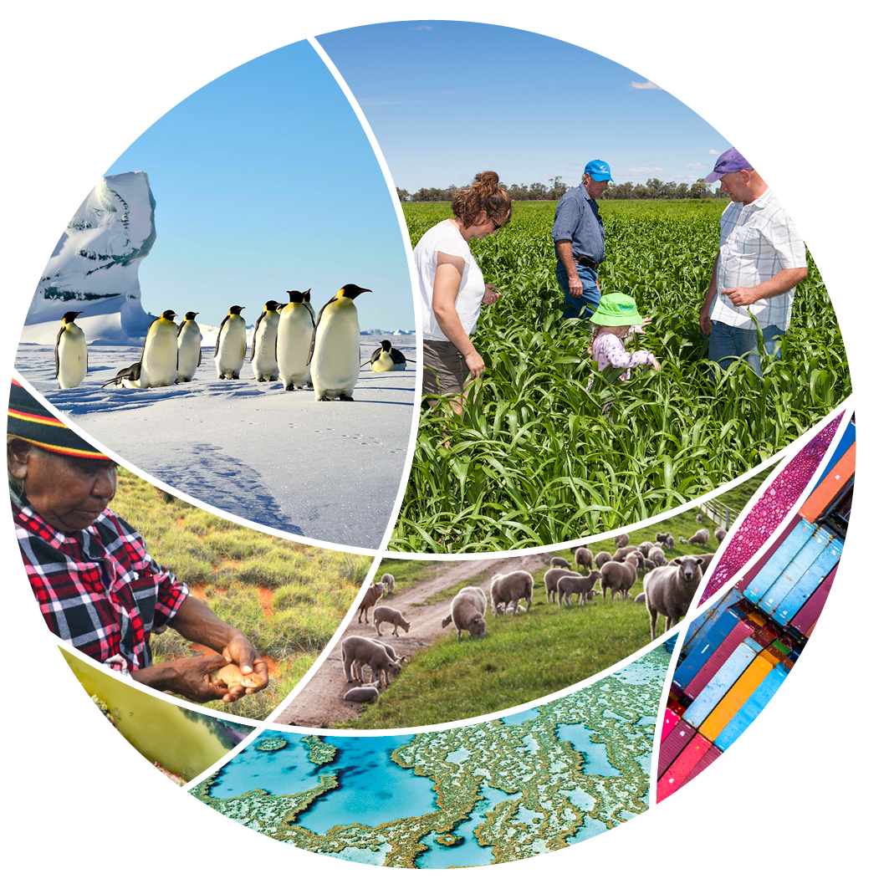

© Commonwealth of Australia 2020

**Ownership of intellectual property rights**

Unless otherwise noted, copyright (and any other intellectual property rights) in this publication is owned by the Commonwealth of Australia (referred to as the Commonwealth).

**Creative Commons licence**

All material in this publication is licensed under a [Creative Commons Attribution 4.0 International Licence](https://creativecommons.org/licenses/by/4.0/legalcode) except content supplied by third parties, logos and the Commonwealth Coat of Arms.

Inquiries about the licence and any use of this document should be emailed to [copyright@awe.gov.au](mailto:copyright@awe.gov.au).



**Cataloguing data**

This publication (and any material sourced from it) should be attributed as: Science Partnerships 2020, *National Environmental Science Program Indigenous partnerships 2020*, Department of Agriculture, Water and the Environment, Canberra, November. CC BY 4.0.

ISBN 978-1-76003-356-9

This publication is available at [environment.gov.au/science/nesp](https://www.environment.gov.au/science/nesp).

Department of Agriculture, Water and the Environment

GPO Box 858 Canberra ACT 2601

Telephone 1800 900 090

Web [awe.gov.au](http://agriculture.gov.au/)

The Australian Government acting through the Department of Agriculture, Water and the Environment has exercised due care and skill in preparing and compiling the information and data in this publication. Notwithstanding, the Department of Agriculture, Water and the Environment, its employees and advisers disclaim all liability, including liability for negligence and for any loss, damage, injury, expense or cost incurred by any person as a result of accessing, using or relying on any of the information or data in this publication to the maximum extent permitted by law.

**Acknowledgements**

The authors thank the National Environmental Science Program research hubs for their input.

Contents

About the program 1

Investment 1

Indigenous partnerships 1

Helping hands for northern sawfish and sharks 2

Indigenous engagement and research leadership 3

Indigenous-led climate-change knowledge and action 4

Boosting Indigenous skills while controlling Crown-of-Thorns Starfish 5

Embedding Indigenous perspectives in Perth urban planning 6

Showing and sharing knowledge through a hands-on map 7

Image credits 8

.

## About the program

### Investment

The National Environmental Science Program (NESP) is a long-term commitment by the Australian Government to environment and climate research.

The program builds on its predecessors – the National Environmental Research Programme and the Australian Climate Change Science Programme – to support decision-makers to understand, manage and conserve Australia's environment with the best available information, based on world-class science.

NESP funding of $145 million over 6 years from 2015 to 2021 supports [6 themed research hubs](https://www.environment.gov.au/science/nesp). A further $149 million will be invested over the next 6 years into 4 new hubs.

Find out about all the projects: [NESP approved projects](https://www.environment.gov.au/system/files/pages/2f561690-b47e-4bf2-b028-d18739b3486f/files/national-environmental-science-program-approved-projects.pdf).

### Indigenous partnerships

The program values partnerships that bring scientists together with Traditional Owners, land managers, policy makers, and a range of government and non-government organisations.

Some examples of these important collaborations include caring for land and sea Country and embedding Indigenous knowledge systems into the protection of biodiversity, including helping threatened species.

This booklet provides a snapshot of some of the important relationships with Indigenous rangers, researchers and Traditional Owners.

## Helping hands for northern sawfish and sharks

Australia’s northern rivers are a last remaining stronghold for the threatened Largetooth Sawfish (*Pristis pristis*), but even in this relatively pristine part of the world sawfish populations are severely depleted.

Indigenous ranger groups and [Marine Biodiversity Hub](https://www.nespmarine.edu.au/) scientists are taking practical steps to conserve the species in these rivers, which may be its only hope for survival. They have collaborated in enduring partnerships to locate, tag, DNA-sample and rescue Largetooth Sawfish. They have also exchanged knowledge, and developed educational materials, including videos, signage and handling protocols.

Indigenous community knowledge of sawfish conservation and the related ranger work is very important. The rangers know the best places and times to find sawfish, and how they are valued and used by the community. Ranger groups in the Northern Territory’s Daly River and Roper River Country – Malak Malak Rangers, Yugul Mangi Rangers and Numbulwar Numburindi Amalahgayag Injung Rangers – have contributed to conservation initiatives.

The Malak Malak name for Largetooth Sawfish is Tyemirerriny. In 2012, the Malak Malak Rangers initiated an annual search for Largetooth Sawfish as a locally driven conservation measure, because the sawfish can become trapped and die in isolated, drying waterholes on the Daly River floodplain.

Working together, the rangers and scientists have successfully relocated more than 60 Largetooth Sawfish. They are also collaborating to learn more about the connectivity of threatened Speartooth Shark (*Glyphis glyphis*) populations.

Read more about northern [sawfish and sharks](https://www.nespmarine.edu.au/project/project-a1-northern-australian-hotspots-recovery-threatened-euryhaline-species) on the Marine Biodiversity Hub’s website.

## Indigenous engagement and research leadership

The participation of Indigenous peoples in NESP’s research is a core focus of the program. The [Threatened Species Recovery Hub](https://www.nespthreatenedspecies.edu.au/) recognises that First Australians have very significant interests in, knowledge of, and responsibilities for Australia’s natural environment. To better support their involvement in its research, the hub has integrated and made explicit roles for Indigenous people in its governance structure.

The hub’s Indigenous Liaison Officer, Brad Moggridge, undertakes a pivotal role in identifying opportunities for Indigenous involvement at all levels of research and shaping how cultural considerations and Indigenous community needs influence research development. Spanning the bridge of cultural knowledge and western science, Brad’s leadership provides a strong pathway for connecting both worlds.

In addition, the hub’s Indigenous Reference Group provides a breadth of guidance and advice for the hub’s research activities.

Indigenous land managers are leading co-development of many hub research projects, ensuring research addresses local priorities.

Groups such as the Karajarri Rangers, who are investigating links between fire patterns and biodiversity on their desert Country, and Martu Traditional Owners, who have co-developed a bilby monitoring method based on traditional ecological knowledge and tracking skills, are playing a key role in carrying out research and sharing the findings.

Read more about [bilby monitoring on Martu Country](https://www.nespthreatenedspecies.edu.au/projects/monitoring-threatened-species-on-indigenous-lands-bilbies-in-the-martu-determination) and [fire and biodiversity research on Karajarri Country](https://www.nespthreatenedspecies.edu.au/projects/contemporary-and-traditional-fire-management-approaches-in-the-desert) at the Threatened Species Recovery Hub website.

## Indigenous-led climate-change knowledge and action

Over the last 5 years the [Earth Systems and Climate Change Hub](http://nespclimate.com.au/) has facilitated the exchange of information between traditional weather and climate knowledge and western climate-change science.

A key activity in this engagement was the 2018 National Indigenous Dialogue on Climate Change. This was a 3-day workshop supporting Indigenous peoples from across Australia to come together to provide recommendations regarding what climate-change information, capacity-building and forms of engagement would be of greatest value to Indigenous communities. The planning of the workshop was guided by a 7-person steering committee to ensure Indigenous leadership of the event.

Outcomes of the workshop included recommendations from Indigenous Australians to:

continue the dialogue between scientific and traditional (2-way) knowledge of climate change

support Indigenous-led projects based on 2-way knowledge about the risk of climate change

ensure opportunities for peer-to-peer learning between Traditional Owners as the best means of strengthening the application of their traditional knowledge

provide Traditional Owners the opportunity to shape the forms of communication and engagement that represent the best value for their communities.

The hub has engaged a 12-member steering committee that includes broader representation of First Nations communities from across Australia to lead the development of the National First Peoples Gathering on Climate Change to be held in Cairns in 2021.

The steering committee also provides important guidance on protocols when working with First Peoples. The gathering is being co-designed with the steering committee and the organising committee.

There are [regular updates and committee meeting communiques](http://nespclimate.com.au/supporting-the-development-of-an-indigenous-led-agenda-on-climate-change-knowledge-and-action/) available on the Earth Systems and Climate Change Hub website.

## Boosting Indigenous skills while controlling Crown-of-Thorns Starfish

Employment and skills for Indigenous peoples are welcome co-benefits from marine pest control. Outbreaks of coral-eating Crown-of-Thorns Starfish are responsible for substantial losses of live coral cover on the Great Barrier Reef. [Tropical Water Quality Hub](https://nesptropical.edu.au/) research is addressing this threat and has also contributed to additional employment training programs.

The program aims for 50% Indigenous trainees, so in addition to the control of the starfish, the program is changing lives in far-north Queensland Indigenous communities. Trainees gain skills to improve their opportunities for employment in the marine and reef tourism industries amongst other careers.

The hub’s research now shows that the program provides significant positive employment outcomes for trainees‘ future endeavours and careers, with one graduate commenting, ‘Everything about my future and my career are because I did the Crown-of-Thorns Starfish program‘.

A report detailing the training, employment and social development outcomes of Indigenous trainees through the Crown-of-Thorns Starfish program is now [available](https://nesptropical.edu.au/wp-content/uploads/2020/07/NESP-TWQ-Project-5.1-Technical-Report-1.pdf)*.*

Crown-of-Thorns Starfish outbreaks are considered one of the worst threats to the health and integrity of the Great Barrier Reef and, in the past, there has been controversy over the effectiveness of control efforts.

Collaborative research, coordinated through the hub, has enabled a revolution in how control is conducted. For the first time there is a scientifically rigorous demonstration that manual control of the starfish outbreaks can successfully defend and even improve, live coral cover.

Read more about the [Crown-of-Thorns Starfish control](https://nesptropical.edu.au/index.php/crown-of-thorns-starfish-control/) program on the Tropical Water Quality Hub’s website.

## Embedding Indigenous perspectives in Perth urban planning

Cities are Indigenous places. Indigenous heritage and perspectives on land management and planning are of immense importance to urban liveability and sustainability. The [Clean Air and Urban Landscapes Hub](https://nespurban.edu.au/) is working on a collaborative project that explores how Indigenous Noongar knowledge should be embedded in urban water and land-use planning in Perth, Western Australia.

The project was planned over 2 years in collaboration with several Noongar leaders who informed the project, as well as individuals within stakeholder organisations.

Noongar knowledge and perspectives about water and land-use planning have been gathered over decades in multiple studies and surveys, often related to urban development proposals. However, this knowledge is scattered across organisations and is not easily accessible. This archived Noongar knowledge is being drawn together for a pilot study in the Canning River catchment.

Cultural workshops and an iterative research practice will be used to map this information and explore culturally appropriate ways of using Noongar knowledge to guide land-use and water planning.

It is hoped this research will contribute to the much-needed inclusion of Indigenous perspectives in urban land and water planning, and in moving towards a shared vision of caring for Country in our urban environment.

Read more about [Indigenous Noongar perspectives in city planning and urban nature](https://nespurban.edu.au/research-projects/urban-greening/) on the Clean Air and Urban Landscapes Hub’s website.

## Showing and sharing knowledge through a hands-on map

A huge 3D map of the Kimberley’s Fitzroy River catchment has facilitated knowledge sharing to inform decision-making about land management. The work has impacted at levels ranging from the Australian Government’s North Australian Indigenous Reference Group, to the personal: ‘[it] brought me back to life, it brought me back to understanding what is important’ (Ngarinyin Traditional Owner, 2019).

In the Kimberley’s Fitzroy River catchment, [Northern Australia Environmental Resources Hub](https://www.nespnorthern.edu.au/) research is supporting Indigenous land managers to use both scientific and Indigenous knowledge to influence decisions to meet their aspirations for Country. And it is happening through co-research, where land managers themselves co-design, use and test a culturally tailored method for showing and sharing knowledge around a topic of their choice.

Traditional Owners from 8 different language groups have come together to build the 3D model of the catchment, identify how different groups influence decisions, and discuss the river’s future.

The process of creating, building and sharing the 3D map, and other best-practice approaches for working with Indigenous people on Country, are included in the new Indigenous-led [*Our Knowledge Our Way Guidelines*](https://www.csiro.au/en/Research/LWF/Areas/Pathways/Sustainable-Indigenous/Our-Knowledge-Our-Way)*.* Facilitated by the North Australian Indigenous Land and Sea Management Alliance and CSIRO, the guidelines are founded on 23 Australia-wide case studies submitted by Indigenous people and their partners.

Key messages are distilled from more than 100 Indigenous contributors, with guiding principles provided for developing partnerships that strengthen and share knowledge for land and sea management.

Real innovation has come from co-owning research with our Bunuba, Gooniyandi, Jaru, Kija, Yi-Martuwarra-Ngurrara, Nyikina-Mangala, Tiya-Tiya, Warrwa, Wilinggin, Yungngora and Kimberley Land Council partners.

The 3D map is augmented with projected GIS data, such as big flood and fire scars. Project outputs are connecting with everyone, including kids, government water planners in the Fitzroy region, and Australian Government officials in Canberra. After seeing a video of a project workshop, a senior government staff member commented, ‘It’s such an engaging way to show Country, to show the complexity, to show systems, to show so much. It’s so powerful‘.

Watch the Northern Australia Environmental Resources Hub’s video on [showing and sharing knowledge in the Fitzroy River Catchment.](https://vimeo.com/278597521)

## Image credits

Page 1: From [Sharks and rays of northern Australian rivers](http://www.nespmarine.edu.au/document/sharks-and-rays-northern-australian-rivers), including Indigenous artwork and [postcard](http://www.nespmarine.edu.au/document/sharks-and-rays-northern-australian-rivers-postcard) with information about the artist, Graham Rostron.

Page 3: Kanyirninpa Jukurrpa Ranger carrying out Mankarr (bilby) [survey](https://www.nespthreatenedspecies.edu.au/media/iejjy2j3/kj-guide-to-mankarr-monitoring-report_web-2.pdf). Credit: Anja Skroblin and Kanyirninpa Jukurrpa.

Page 4: Sunset, Berrigan, New South Wales, Australia. Credit: Victoria Kennedy, Unsplash.

Page 5: Indigenous art. Credit: Paul Bainton, Departmental Image and Video Library.

Page 6: Researchers and Malak Malak Rangers working together to locate Largetooth Sawfish on the Daly River. Credit: Michael Lawrence-Taylor.

Page 7: Largetooth Sawfish released into the Daly River following rescue from drying floodplain waterhole. Credit: Peter Kyne.

Page 8: Dampier Archipelago. Credit: Dragi Markovic, Departmental Video and Image Library.

Page 9: Kanyirninpa Jukurrpa Rangers undertaking Mankarr (bilby) monitoring on Martu Country. Credit: Kanyirninpa Jukurrpa.

Page 10: Karajarri Rangers undertaking biodiversity surveys. Credit: Nicolas Rakotopare and Karajarri Rangers.

Page 11: The steering committee for the National First Peoples Gathering on Climate Change, to be held in Cairns in 2021 (photo taken November 2019). Credit: Karen Pearce, Bloom Communication.

Page 12: Members of the Point Pearce Community Reef Watch checking the reef quality. Credit: Dragi Markovic, Departmental Video and Image Library.

Page 13: Diver performing Crown-of-Thorns Starfish control. Credit: Association of Marine Park Tourism Operators.

Page 14: Cooked yam showing starchy centre on the Cape York Peninsula. Credit: Kerry Trapnell, Departmental Video and Image Library.

Page 15: Native plants in urban greening. Credit: Cristina E Ramalho.

Page 16: Hands holding some quandongs picked from a tree near Banjal Bay on the Anjo Peninsula. Credit: Dragi Markovic, Departmental Video and Image Library.

Page 17: Artwork: Sharing the knowledge for caring for our land. Copyright: Emma Burchill, 2020.

Page 18: Braidwood Waratah in the Monga National Park. Credit: Matthew Bolton, Departmental Video and Image Library.

Page 19: Ngurrara Ranger Jamin Bent with a witchetty grub. Credit: Ruth McPhail, Western Australian Department of Biodiversity, Conservation and Attractions.