Industry Guidelines for Import Cargo System Outages
Department of Agriculture, Fisheries and Forestry (DAFF)
July 2013

This document provides a clear set of instructions to, and expectations of, external stakeholders including brokers and the Australian Customs and Border Protection Service during contingency arrangements.

DAFF Biosecurity in Australia
Business Policy
Industry Guidelines for
Import Cargo System Outages

CONTENTS

1 Purpose 3
2 Scope 3
3 Definitions 3
4 Policy Statement 4
5 Related Material 5
6 Reporting System Issues 5
7 Notification of System Outage and Phases 5
8 Priority of Clearance 7
9 Key Outages and their Impacts 8
9.1 Critical cargo control applications 8
9.2 System Failures affecting Sea Cargo from the Country Action List (CAL) 12
9.3 Support System Failure 12
10 Charging AND Revenue Collection during Contingency 13
11 Inspection Procedures 15
12 Resumption of Normal Business Processes 15
13 Attachment 1: dAFF Regional Office contact details 16
14 Attachment 2: Manual Quarantine Direction Form (MQDF) 18

Purpose
This document details the various actions to be performed by industry to support the clearance of imported cargo subject to DAFF requirements in the event of a declared system outage affecting any combination of:

- Cargo control applications;
- Cargo control support systems; and/or
- The Australian Customs and Border Protection Service (Customs) Integrated Cargo System (ICS).

In the event of an ICS outage, detailed instructions for Industry regarding the ICS Business Continuity Plan (BCP) can be obtained from Customs at Customs Website.

Scope
This document will outline:
- the assessment and notification of system outages;
- the priority for clearance of specified cargo under contingency;
- the key outages that may occur and processes required by DAFF and industry;
- charging and revenue collection during contingency; and
- resumption of normal business processes.

Definitions
In this business policy, the following words are used as defined:
Term | Definition
AEP | Automatic Entry Processing
AIMS | AQIS Import Management System
BCP | Business Continuity Plan
CAL | Country Action List
CSV | Comma Separated Value files that are similar in properties to an Excel file
CTO | Cargo Terminal Operator
Customs | Australian Customs and Border Protection Service
Customs ICS BCP | The Customs Integrated Cargo System Business Continuity Plan, available at Customs Website
FCC | Food Control Certificate
GAS | Giant African snail
HVSO | High Volume Specialist Operator
ICON | Import Conditions Database
ICS | Australian Customs and Border Protection Service Integrated Cargo System
ICS BCP Database | The ICS BCP Database is an information technology application designed to receive and process contingency CSV transaction files and provide DAFF and/or Customs held or clear status to all affected parties
ICT | Information and Communications Technology
IFIS | Imported Food Inspection Scheme
Industry | All sectors of industry that communicate directly with the ICS
MQDF | Manual Quarantine Direction Form
NatCC | National Contingency Council
Quarantine Ruler (QRuler) | Applies automatic quarantine directions for automatic entry processing (AEP). All declarations are automatically run through the ruler upon arrival in the AIMS (state) database
RSS feeds | Really Simple Syndication feeds is a family of web feed formats used to publish frequently updated works
SAC | Self Assessed Clearance. This is a declaration that satisfies the specified ‘low value criteria’. The value must not exceed $1000 (or other prescribed amount) and must be entered into home consumption
S-Cargo | Electronic application for managing the clearance of GAS cargo
SMS | Short Message Service

Policy Statement
DAFF has identified the need to review and implement a national BCP for import cargo clearances that can be used by internal and external stakeholders under a range of DAFF Information and Communications Technology (ICT) outages.

DAFF has identified the need to provide support and instruction to industry clients, including brokers and importers when operating under various systems outages affecting imported cargo. This document outlines the processes that facilitate the clearance of imported cargo under DAFF contingency arrangements.

Related Material
This document should be read in conjunction with the National BCP for Import Cargo Systems document. The National BCP provides a high level overview of DAFF business continuity arrangements for import cargo processing, including DAFF business activities and client and service delivery expectations under contingency arrangements. This document can be found at the DAFF Website.

Reporting System Issues
The following scenarios may indicate a DAFF system issue:

- A DAFF direction or release has been issued however the cargo status in the ICS has not been updated.
- A declaration has been lodged using Automatic Entry Processing (AEP) however no response has been received from DAFF.
- Inability to access the DAFF Website or applications on this site.
- Consignment documentation has been submitted to DAFF via email however receipt of documentation has not been received.
- An import permit has been submitted electronically to DAFF however receipt of the application has not been received.

Where an industry member feels they may have detected a possible system issue prior to receiving notification from DAFF or their relevant industry organisation, they should contact their DAFF regional office to report this issue (see attachment 1).

Notification of System Outage & Phases
In the event of a DAFF critical cargo clearance application failure, ICS outage, or if the messaging link between Customs and DAFF systems is down for an extended period advice regarding the outage will be provided via:
- DAFF notices published on the DAFF Website;
- Industry notification tools such as Short Message Service (SMS), Really Simple Syndication (RSS) feeds and subscription capabilities on the DAFF website;
- the Customs website (where the outage is ICS related); or
- Industry representative bodies.
For DAFF contingency purposes, a system outage of more than 90 minutes in duration will, in most circumstances constitute a critical system failure requiring adoption of contingency operating arrangements. The declared outage phases are outlined below in Diagram 1. In the case of an ICS outage DAFF operations will also be linked to the Customs ICS BCP outage phases.
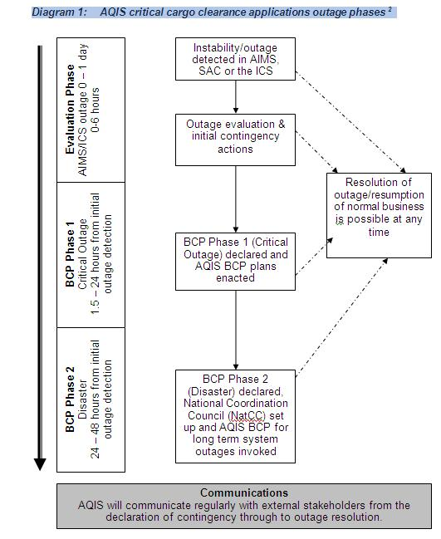

Please note that timeframes given are a guideline only. For example, based on the information at hand, BCP Phase 1 (Critical) may be declared very quickly. Similarly, the decision to move from BCP Phase 1 (Critical) arrangements to BCP Phase 2 (Disaster) arrangements will not be based on the length of an outage but rather on DAFF ability to manage in the outage environment and assessment of the outage situation. DAFF outage phases do not necessarily correspond to Customs BCP outage phases.

Priority of Clearance
In the event that DAFF is required to prioritise cargo for contingency assessment, prioritisation will occur as per Table 1 below:

Table 1: Priority of Clearance

Priority | Type of Cargo | Explanation
1. | Live Animals, such as  - fish  - dogs  - cats  - horses. | Require rapid clearance to limit suffering of live animals.
1. | Genetic material, such as semen and embryos. | Require rapid clearance to ensure the specimen viability.
1. | Urgent medical/emergency freight, such as:  - blood or medication  - fire fighting helicopters  - medical equipment. | To facilitate community protection, natural disasters and medical emergencies. Freighted on an ‘as needs’ basis with goods requiring processing faster than the 24 hour service charter.
1. | Hazardous materials. | Impeding movement of this cargo may present an unacceptable risk.
2. | Perishable air freight, such as  - live plants  - fruit  - vegetables  - chilled finfish. | Goods may be damaged; Cargo Terminal Operators (CTOs) may not have the appropriate facilities to keep goods chilled.
3. | Bulk vessels. | Wharf availability timeframes may be critical and require vessels to be unloaded.
4. | Perishable sea freight, where goods have or are about to arrive in Australia. | Goods usually arrive in reefers and are therefore chilled, priority to be determined on case by case basis.
5. | Previously assessed freight. | Documents already assessed, assisting with the movement of cargo.

Key Outages and their Impacts

Critical cargo control applications

ICS outage

An ICS outage would have the greatest impact on the movement of cargo. Prior to Customs declaring BCP and processing cargo in the ICS BCP Database, DAFF can only provide manual clearance to high priority goods (refer to Table 1, Priority of Clearance).

After Customs declares BCP and industry begins submitting documents electronically to the ICS BCP Database, DAFF will risk assess import cargo through an alternative web based application (refer to Scenario 1). If the ICS BCP Database is unavailable refer to Scenario 2.

Scenario 1 – Using the ICS BCP Database
Industry is to provide relevant commercial documentation (as per the Minimum Documentary Requirements Policy) to DAFF, including some form of cargo identification (including documents such as airway bills and bills of lading).

Upon receipt of the associated documentation, DAFF staff will issue a manual contingency direction or release. Where possible, DAFF will update the consignment status in the ICS BCP Database which will automatically notify all parties via email.

If a depot does not receive an updated notification, or DAFF is unable to access the ICS BCP Database, a manual quarantine direction or release may be presented to the depot to override an existing DAFF hold. In these circumstances it will be the responsibility of the broker or importer to provide the depot or wharf with a copy of a quarantine direction or release when collecting the consignment. Please note, quarantine directions or releases do not override a Customs hold.

DAFF staff will use various forms of manual clearances, including:
- a manual AQIS Import Management System (AIMS) entry (if AIMS is available);
- wet stamping the airway bill, bill of lading or other relevant commercial documentation (for releases only);
- an electronic quarantine direction; or
- a Manual Quarantine Direction Form (MQDF).

Scenario 2 - Hardcopy (paper) contingency data
Industry will be required to manually complete a Customs Contingency Form and provide the document and relevant commercial documents associated with each consignment to Customs. DAFF will investigate co-location options with Customs as cargo will need to be screened manually to identify consignments of concern for quarantine and imported foods.
Other manual screening methods involving the examination of shipping or transport documentation and the physical examination and surveillance of goods at wharves or depots may also be employed. These include:
- Screening electronic and/or hard copy documents such as;
  - Cargo manifests (e.g. contingency Comma Separated Value (CSV) files)
  - Individual consignment documentation
  - Cargo lists at depots followed by physical examination.
- Physical examination;
  - physical examination
  - surveillance
  - x-ray screening.

The nature of the cargo, the transport type, volume and the number of depots within a region will determine which methods may be utilised.

ICS link to DAFF system outages

AIMS & ICS
Full Import Declarations (FIDs) and Full Declaration Format Self Assessed Clearances (SACs) lodged or previously assessed in AIMS will be processed by DAFF staff however the consignment status in the ICS may only be updated manually for high priority goods.

Only high priority clearances for declarations lodged in the ICS (post link down and not available in AIMS) will be processed, refer to Section 9.1.3. AIMS outage below.

SAC Database and ICS
Cargo Report SACs and Short Form SACs lodged or previously assessed in the SAC database will be processed by DAFF staff however the consignment status in the ICS may only be updated manually for high priority goods. Primary screening will still occur in the ICS so non-risk goods will be cleared.

Secondary screening of new SACs (post link down) will be processed as per procedure outlined in Section 9.1.4. SAC outage stated below.

AIMS outage
In instances when the ICS system is operating but AIMS is not, industry are to provide the entry (declaration) number and relevant commercial documentation as per the Minimum Documentary Requirements Policy. Please note that an AIMS outage can occur on a regional or national level.

Upon receipt of the associated documentation, DAFF staff will issue a manual contingency direction or release. DAFF staff will use various forms of manual clearances, including:
- wet stamp the airway bill, bill of lading or other relevant commercial documentation (for releases only);
- electronic quarantine direction; or
- Manual Quarantine Direction Form (MQDF).

DAFF officers will update the ICS manually based on the priority of goods (refer to Table 1, Priority of Clearance).

Automatic Entry Processing (AEP)
There are a variety of outages that can affect AEP. Table 2 below gives an indication of the type of outage, the effect it will have on AEP processing and the contingency arrangements available.

Table 2: Outages affecting AEP
Application (Outage) | Effect/Outcome | Contingency Arrangement/s
Email | Quarantine order/release will not be received via email. | Please contact your regional DAFF office.
Quarantine ruler (AIMS) | AEP entry will not be processed by DAFF system. | Please contact your regional DAFF office⁶. Entries will require manual processing by DAFF staff. In most cases only urgent entries will be processed by submitting documentation via:  - email (if available);  - front counter; or  - facsimile.
AIMS outage | AEP entry will not be processed by DAFF system. | Refer to arrangements listed under quarantine ruler.
ICS link to DAFF systems | Initially the ICS status will not be updated for entries processed via AEP.  Post link down, AEP entries will not be processed by DAFF system. | Short Term – please contact your regional DAFF office⁶.  Long term – refer to arrangements listed under quarantine ruler.
ICS outage | Unable to enter information into ICS. | AEP will be unavailable – refer to Section 9.1.1. ICS outage.

Imported Foods Inspection Scheme (IFIS)
During system outages, DAFF may not be able to determine inspection rates for risk category foods. Consequently, risk food consignments may be held pending system restoration. Alternatively where a consignment is urgent, importers may elect to volunteer the consignments for inspection.

In an extended outage, consignments of surveillance and risk category foods will be assessed by an imported foods officer to determine the need for either an inspection or release.

A Food Control Certificate (FCC) will be issued (ICS outage only) to release the food without the need for an inspection, or allow the food to be moved to a location where it must be held for inspection and/or sampling.

Manual Quarantine Direction Form (MQDF)
Under contingency arrangements, as stated above, Industry may be issued with a MQDF. The MQDF has four carbon copies (quadruplicate); refer to Section 14 – Attachment 2.

Manual Quarantine Direction Form
White (original) | Importer’s copy | To be retained by importer/broker
Green (duplicate) | DAFF office copy | DAFF to retain
Yellow (triplicate) | Quarantine instruction note | To be accompanied with the goods at all times. If inspection/treatment is required, the importer/broker must present to the DAFF officer
Pink (quadruplicate) | Inspection copy | DAFF to retain
In instances when a consignment can be released from DAFF control upon examination of documents only, the broker/importer may be presented with the white (original) copy of the MQDF which will include an indication that the goods are released.

Alternatively, in instances when an inspection or treatment is required on the consignment, the broker/importer will be presented with the white copy of the MQDF and a yellow (triplicate) copy of the MQDF. The yellow copy must be made available to the DAFF officer performing the inspection or to the treatment provider performing the treatment to facilitate the release of the consignment from DAFF control.

SAC outage
In the event of a SAC outage, initial air cargo screening would proceed as usual in the ICS by the SAC National Coordination Centre, Sydney.

The manual SAC worksheet will be accepted from Conference of Asia Pacific Express Carriers (CAPEC) members, including DHL, TNT, UPS and FedEx. Relevant commercial documentation will need to be presented to DAFF for consignments held in the ICS. After DAFF has assessed the documentation the manual SAC worksheet will be updated to identify cargo that can be released or requires further action (such as inspection or treatment). DAFF officers will manually update the ICS based on the priority of goods (refer to Table 1, Priority of Clearance).

The manual SAC worksheet/s will need to be retained for reconciliation once the system is operational.

System Failures affecting Sea Cargo from the Country Action List (CAL)
There are three main outages that would affect DAFF’s ability to risk-assess sea cargo originating from countries on the CAL, the ICS, S-Cargo and the link between the ICS and S-Cargo.

ICS
In the event of a short-term ICS outage, S-Cargo will still be used to release cargo. Messages will be queued and sent to the ICS upon business resumption.
In the event of long term ICS outages, DAFF will rely on electronic bayplans and load port information to risk assess vessels and cargo. Brokers or importers organising a cargo delivery should liaise with the stevedore during a declared outage to ensure that the DAFF inspection of risk cargo has been completed.

S-Cargo or ICS/S-Cargo link down
For short term outages, DAFF inspection staff will manually record inspection results and reconcile with S-Cargo when the system becomes available. DAFF staff may manually update the ICS for urgent holds.
In the event of an extended S-Cargo link to ICS outage, DAFF may revert to electronic bay plans and load port information to assess risk vessels and cargo. If required, DAFF will send inspection lists to stevedores and shipping companies electronically.

Support System Failure
DAFF uses other electronic systems such as email, ICON, eResults and ePermits to support import cargo clearance activities. However, while an outage of these support systems could impact cargo processing, the effect may not be as immediate or serious as an outage affecting the ICS or one of DAFF’s cargo clearance systems outlined above.
Please refer to Table 4 below for an outline of contingency arrangements for various support systems.

Table 3: Contingency arrangements for support systems

Application | Contingency arrangement
eLodgement/ePermits | - Submit a manual import permit application to the appropriate program area. Manual applications can be found on the DAFF Website
eResults (IFIS) | - Laboratory to fax test results to the regional IFIS staff.
Facsimile | - Submit documentation via:  - Email; or  - front counter.
Email | - Submit documentation via:  - Front counter; or  - facsimile .
Broker Reports | - Please contact the Broker Reports Administrator.  - DAFF may manually send reports via email/facsimile and front counter where requested.
DAFF website including:  ICON Query,  Offshore Treatment Providers Lists etc | - Please contact your regional DAFF office, which can be found on the DAFF Website (also see Section 13 for these contact details).  - Information may be obtained via email or phone inquiry or front counter.

Charging & Revenue Collection during Contingency
Fees applicable under normal operating arrangements are still applicable in a DAFF declared outage, however upfront payment of fees will not be required except for:
- manual import permit applications; and
- unaccompanied personal effects (UPEs) (refer to section below).

Where manual AIMS entries are created charges will not be applied to the manual entry for FIDs and Full Declaration Format SACs, under contingency. Fees will be applied to the electronic declarations once systems are restored.

In accordance with Customs legislation governing contingency arrangements, Customs expects all parties to lodge appropriate documentation electronically in the ICS upon notice of the system becoming operative. Therefore, upon resumption of normal business processes all FIDs and Full Declaration Format SACs will be received by DAFF and appropriate charges will be applied to the electronic declaration.

Where manual AIMS entries are created for SAC declarations charges will be applied to the manual AIMS entry.

Manual import permit applications
Clients lodging a manual import permit application will be required to pay DAFF services as per the Charging Schedule for Import Permit Applications.

Unaccompanied Personal Effects (UPEs)
Clients clearing or processing UPEs will be required to pay DAFF services under contingency arrangements on a:
- manual AIMS entry (if AIMS is available);
- electronic quarantine direction; or
- Manual Quarantine Direction Form (MQDF).

Table 5 below illustrates an example of the DAFF lodgement, processing and fees for service that apply under a range of contingency scenarios.

Table 4: DAFF charging under contingency arrangements

Charging Scenarios | Fees Applied Under Contingency Arrangements
1. Where electronic entries are lodged to the ICS  Exceptions:  - AEP (refer to no. 2)  - UPE (refer to no. 3) | Electronic Lodgement Fee | $9.00
 | Entry Processing Fee  (initial processing) | $40.00
Standard Fee for Service (FFS) Fees
(i.e. inspection/fumigation/treatments etc)
2. Where AEP entries are lodged to the ICS | Electronic Lodgement Fee | $9.00
2. Where AEP entries are lodged to the ICS | Compliance Agreement (CA) Assessment Fee | $8.00
2. Where AEP entries are lodged to the ICS | Standard Fee for Service (FFS) Fees  (i.e. inspection/fumigation/treatments etc)
3. Where no electronic entry is lodged to the ICS - UPE | Manual Lodgement Fee | $15.00
3. Where no electronic entry is lodged to the ICS - UPE | Standard Fee for Service (FFS) Fees  (i.e. inspection/fumigation/treatments etc)
Charging Scenarios | Fees Applied Under Contingency Arrangements
4. SAC manual upgrade  Note: If a manual entry has been created for the consignment under contingency arrangements, the SAC entry will not be formally upgraded to AIMS upon system/s resumption. | Manual Lodgement Fee | $15.00
 | Entry Processing Fee  (initial processing) | $40.00
Standard Fee for Service (FFS) Fees
(i.e. inspection/fumigation/treatments etc)

Inspection Procedures
During contingency periods, industry may experience some delays in DAFF bookings. In these instances, high-risk and perishables goods will be given priority (refer to Table 1, Priority of Clearance).

DAFF will prioritise critical import surveillance and inspection activities over personal effects inspection services at High Volume Specialist Operator (HVSOs) establishments to help maximise DAFF staff resource deployment options during the declared operation of the DAFF BCP.

Resumption of Normal Business Processes
When the relevant system outage has been rectified, industry will be advised of arrangements to resume normal entry processing via:
- DAFF Industry Advice Notices published on the DAFF Website;
- the DAFF notification system (currently under development);
- the Customs website (where the outage is ICS related); and/or
- Industry representative bodies.

In the event of BCP Phase 2 outage (disaster), notices may include DAFF entry processing requirements for any transition period between the contingency requirements and normal entry processing. In most cases, the clearance of backlogged cargo will take priority over the reconciliation process for cargo cleared under manual contingency arrangements.

Industry should note that as backlogged messages are processed, DAFF status will change frequently in the ICS. Please contact your DAFF regional office if there are any queries on the final status.

All contingency documentation processed during a contingency period must be kept with the relevant consignment paperwork in accordance with usual government document storage requirements.

Attachment 1: DAFF Regional Office contact details
Up to date DAFF regional office contact details are available on the DAFF Website.

Adelaide (South West Region)
Street Address: Adelaide International Airport, Sir Donald Bradman Drive, EXPORT PARK SA 5950
Postal Address: PO Box 63 EXPORT PARK SA 5950
Phone: +61 8 8201 6000
Fax: +61 8 8201 6111
Email: SA DAFF

Brisbane (North East Region)
Street Address: 42-44 Qantas Drive, EAGLE FARM QLD 4009
Postal Address: PO Box 222 HAMILTON QLD 4007
Phone: +61 7 3246 8755
Fax: +61 7 3246 8639
Email: Qld DAFF

Cairns (Northern Region)
Street Address: Building 114, Catalina Crescent, Airport Business Park, Cairns Airport, CAIRNS QLD 4870
Postal Address: PO Box 96 AAC Building, Cairns International Airport QLD 4870
Phone: +61 7 4030 7800
Fax: +61 7 4030 7843
Email: Nth Qld DAFF

Darwin (Northern Region)
Street Address: 1 Pederson Road (cnr Henry Wrigley rd), MARRARA NT 0812
Postal Address: PO Box 37846 WINNELLIE NT 0821
Phone: +61 8 8920 7000
Fax: +61 8 8920 7011
Email: NT DAFF

Hobart (South East Region)
Street/Postal Address: 3rd Floor, 163—169 Main Road Moonah, Tasmania 7009
Phone: +61 3 6233 3352
Fax: +61 3 6234 6785
Email: Tas DAFF

Mackay (North East Region)
Street Address: Customs House, Mackay Marina Mulherin Drive, MACKAY HARBOUR QLD 4740
Postal Address: PO Box 1517 Mackay QLD 4740

Melbourne (South East Region)
Street Address: c/- Customs/DAFF House, Corner Grant & Centre Road, MELBOURNE AIRPORT VIC 3045
Postal Address: PO Box 1006 Tullamarine VIC 3043
Phone: +61 3 8318 6700
Fax: +61 3 8318 6701
Email: Vic DAFF

Perth (South West Region)
Street Address: 9 Fricker Road, Perth Airport, WA 6105
Postal Address: PO Box 606 Welshpool WA 6106
Phone: +61 8 9334 1555
Fax: +61 8 9334 1666
Email: WA DAFF

Sydney (Central East Region)
Street Address: 1 Crewe Place, ROSEBERY NSW 2018
Postal Address: PO Box 657 MASCOT NSW 1460
Phone: +61 2 8334 7444
Fax: +61 2 8334 7555
Email: NSW DAFF

Townsville (North East Region)

Street Address: Ground Floor—River Quays Building, 7-13 Tomlins Street, TOWNSVILLE, QLD 4810
Postal Address: PO Box 1245 TOWNSVILLE QLD 4810
Phone: +61 7 4789 7888
Fax: +61 7 4789 7821

Attachment 2: Manual Quarantine Direction Form (MQDF)
White (original) – importer’s copy
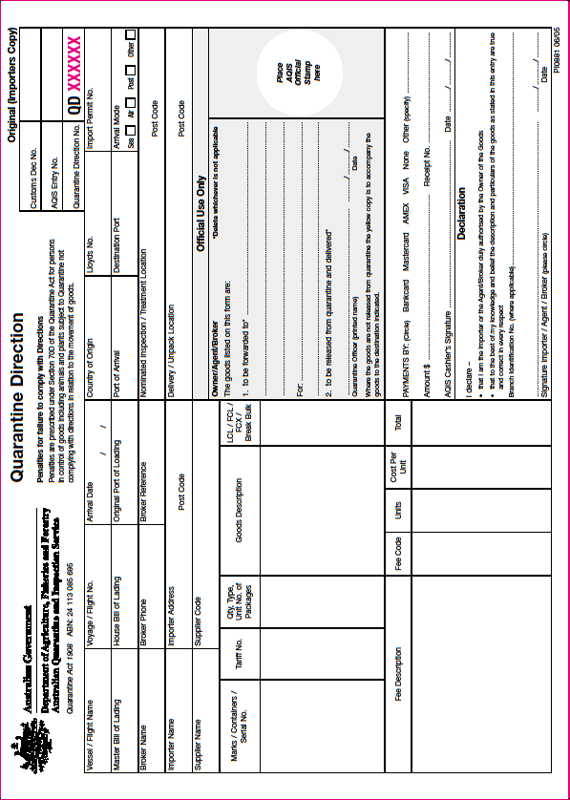
Green (duplicate) – office copy

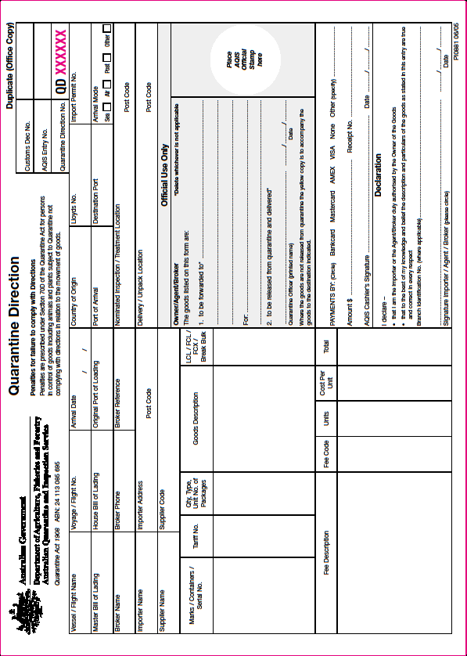
Yellow (triplicate) – quarantine instruction note

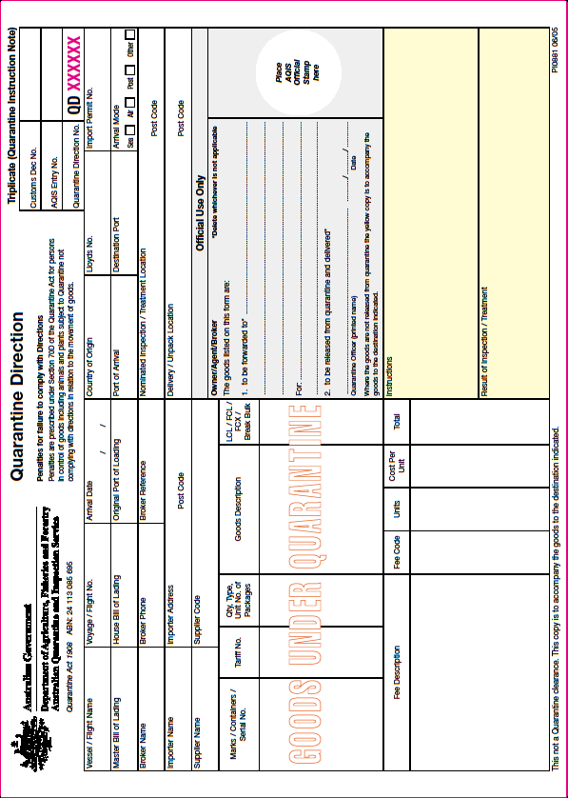
Pink (quadruplicate) – inspection copy

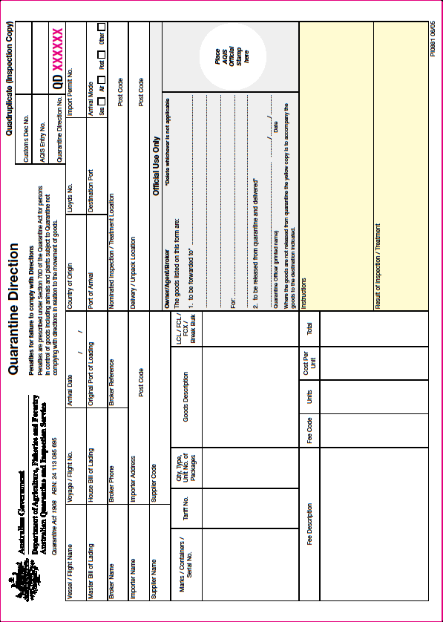

DAFF is currently in the process of making these tools available.
Please note that industry requests that are outside of or lower down on the priority list will be assessed by DAFF staff on a case-by-case basis and may be referred to the Regional BCP Coordinator or Senior Manager for a decision.
The Minimum Documentary Requirements Policy is available on the DAFF Website.
The Minimum Documentary Requirements Policy is available on the DAFF Website.
See Section 13 – Attachment 1.
Countries on the CAL can be found on the DAFF Website.
Please note for extended outages alternative arrangements may be implemented. DAFF notices will be issued to alert industry of any changes to the above arrangements.
? The Charging Schedule for Import Permit Applications is available on the DAFF Website.
See Section 13 – Attachment 1.

