Lodge a Request for Export (REX) for Inedible Meat
The below guide shows how to lodge a Request for Export (REX) in NEXDOC for Inedible Meat.
This guide assumes that you have already registered as an Inedible Meat exporter in NEXDOC.
- If you have not yet registered as an NEXDOC exporter, please refer to the Create a NEXDOC Exporter Account pdf or docx guide.
- If you are registered as a NEXDOC exporter but need to add Inedible Meat to your exporter account, please refer to the Add or Remove Exporter to Exporter Account pdf or docx guide.

Log in to the Online Services Portal
Go to the Online Services Portal and click on the Login button. | 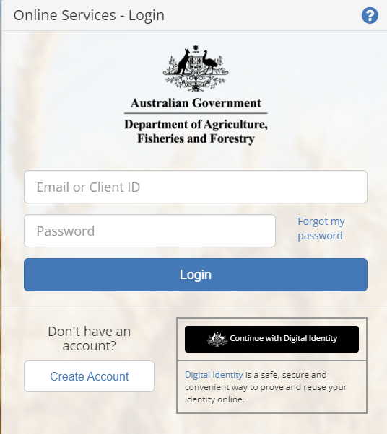

NEXDOC Portal Homepage
Click on the Lodge a Request for Export (REX) link. | 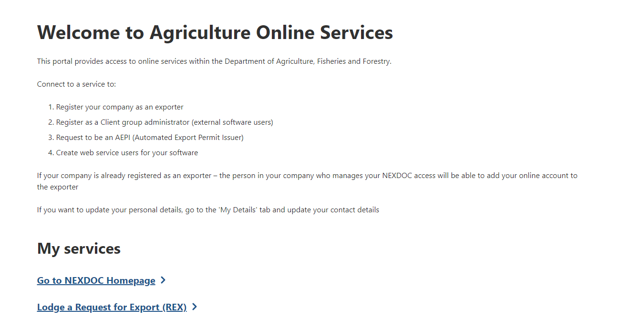

Start a new request for export (REX)
Step 1  Select Inedible Meat from the Commodity type of your export drop-down menu.  Click on the Start button. | 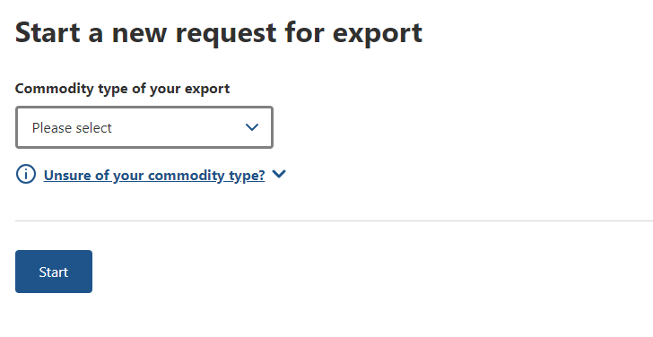

REX Section 1: Country
Select the destination country from the Country you wish to export to drop-down menu.  Select next | 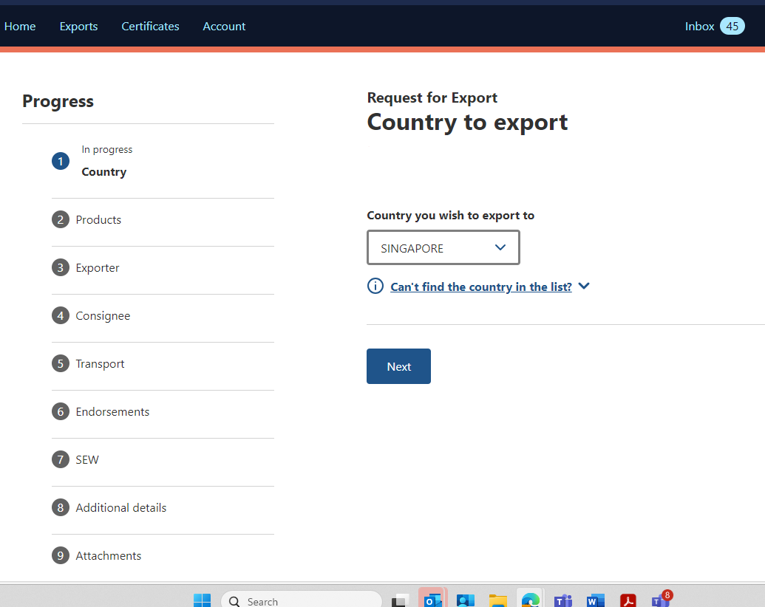

REX Section 2: Products
Step 1  Select + Add a product to export button to add your export products.  Note: Repeat this step to add multiple products. | 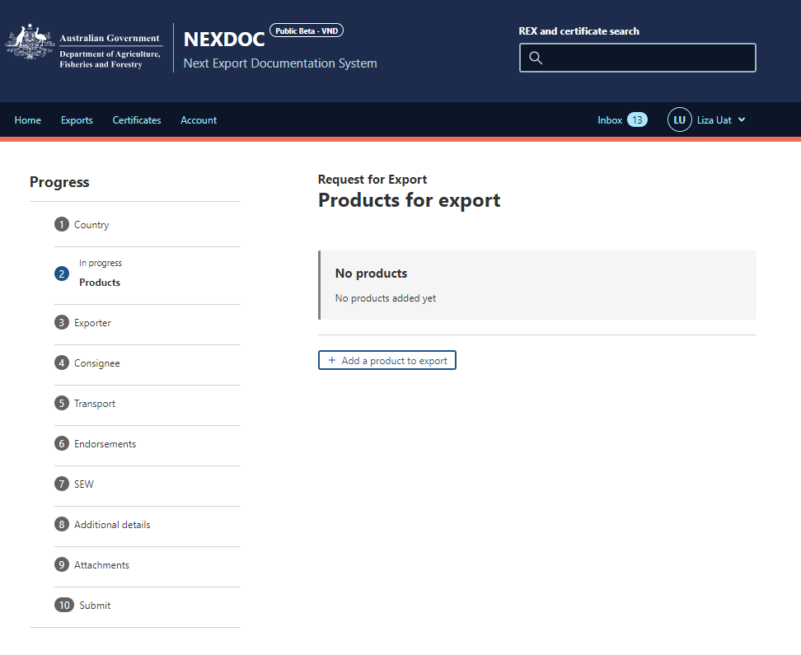
Step 2  Select the product from the Product you wish to export drop-down list.  Note: Start typing to see a smaller group of relevant products. | 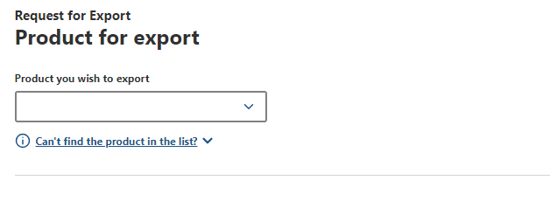
Step 3  Select product details from the drop-down boxes for:  What is the product category? - mandatory  What is the product packed in?-mandatory  Preservation -mandatory  AHECC -optional  Net metric weight amount -mandatory  Net metric weight unit-mandatory  Gross metric weight amount-optional  Gross metric weight unit-optional  Note: Optional fields may be mandatory in certain cases, such as when using SEW, specific pack types (e.g., BP), or for some transit/destination countries. | 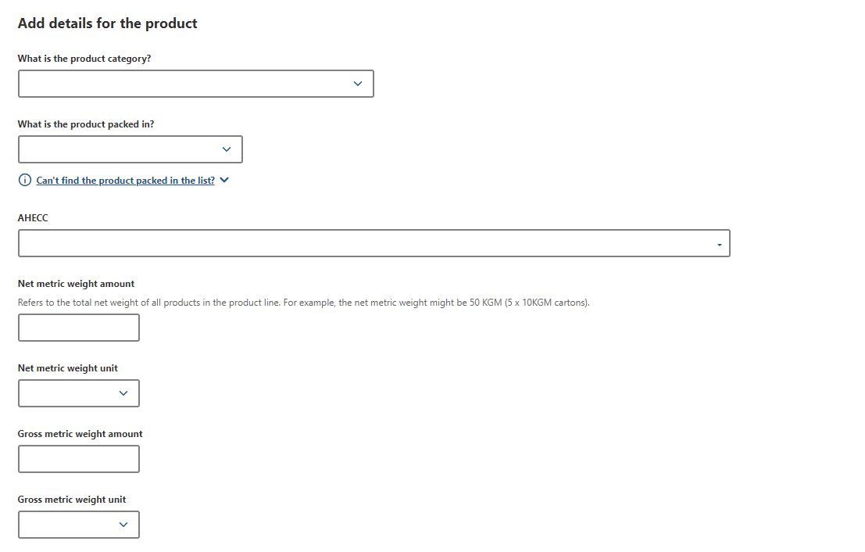
Step 4  Enter optional product details for:  Manual product description  Additional description  Batch code  Note:  These additional details may display on the export certificate.  If a Manual product description is supplied, the REX will go to the department for review. | 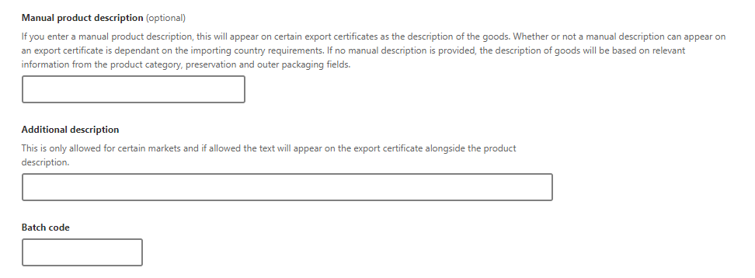
Step 5  Select the Outer packaging details from the drop-down boxes for:  Package type -mandatory  Quantity - mandatory  Individual package weight -optional  Weight unit - optional  Note:  Individual package weight and weight unit may be mandatory in some cases  These details may appear on the export certificate unless you provide a Manual product description. | 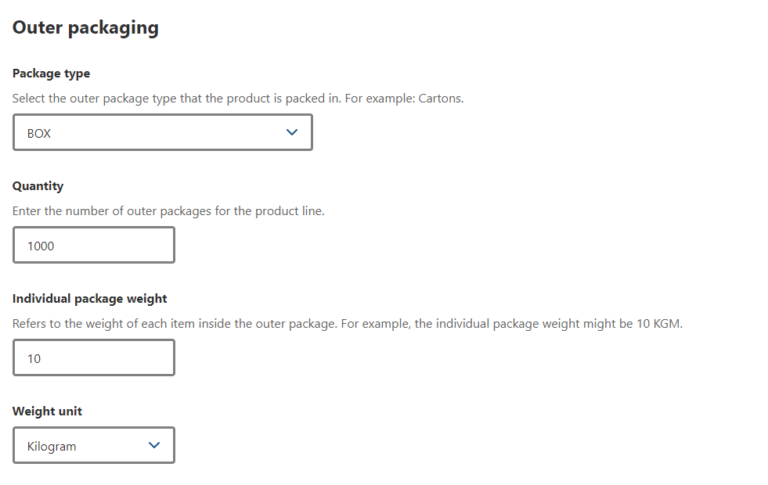
Step 6  If required, provide the Shipping marks.  Note: This field is optional and can be alphanumeric with no more than 20 characters | 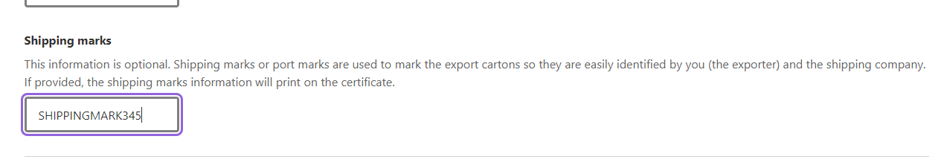
The below information relates to the Add Additional details for the product.

Step 7  Depending on the importing country requirements these tabs can be optional or mandatory.  Additional packaging  Treatments  Containers  SEW  Production Processes  Additional details | 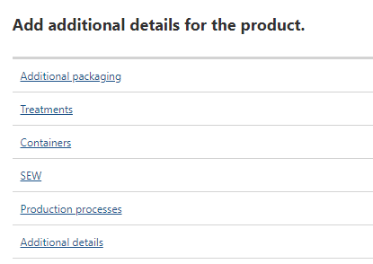
Step 8  If required, enter Additional packaging details for:  Intermediate packaging  - Package Type  - Quantity  - Individual package weight  - Weight unit  Inner packaging  - Package type  - Quantity  - Individual package weight  - Weight unit  Click Save  Note: These details are optional, may be required by some importing country requirements. | 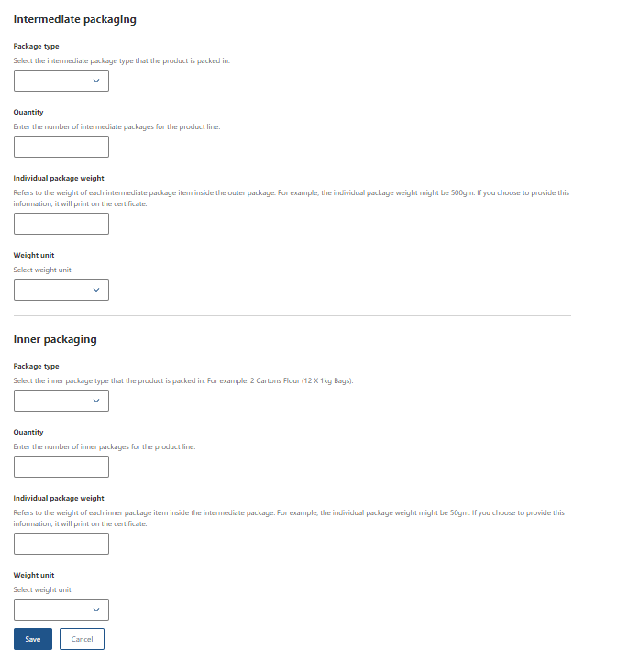
Step 9  If required, enter Treatments.  Click + Add Treatment and enter details for:  Treatment type  Treatment details  Treatment start date  Treatment end date  Click Add  Note: These details are optional but may be required by some importing country requirements. | 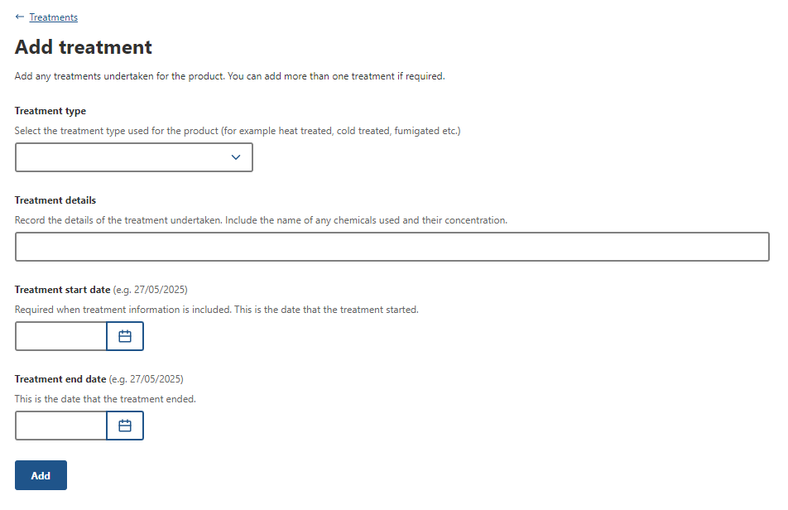
Step 10  If required, enter Containers details for:  Type of freight container – choose Air or Sea  Click + Add Container  Enter Container number  Click + Seal number  Enter Seal number  Click Add  Note:  These details are optional but may be required by some importing country requirements.  If you provide container details for one product line, you must provide containers against all product lines.  Seal number can only be added if there are container numbers. | 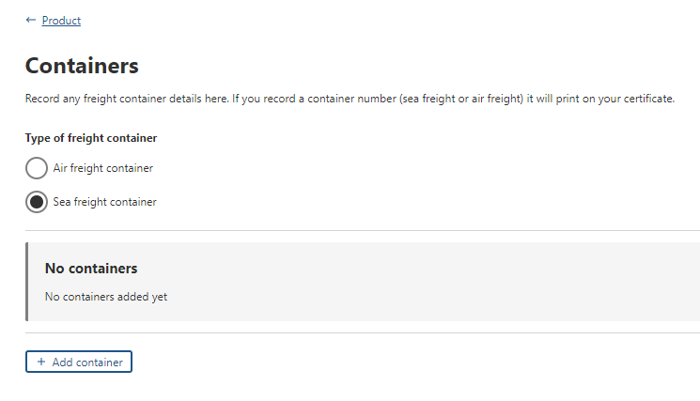  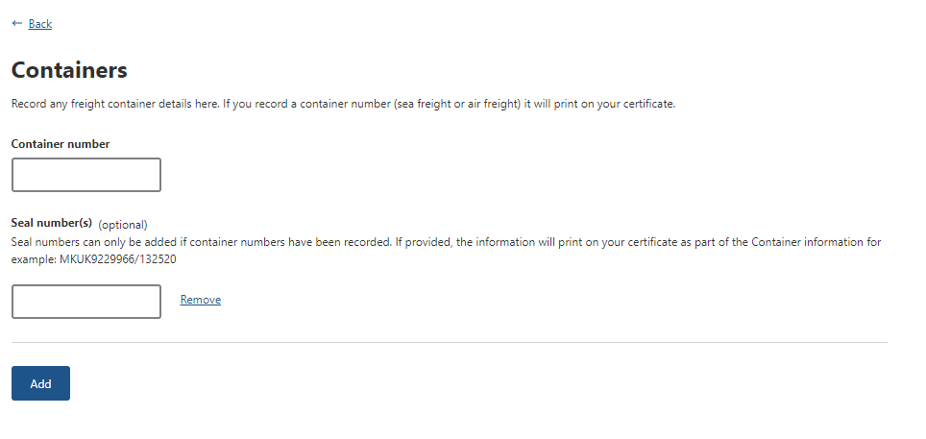
Step 11  If required, enter SEW details in:  FOB amount  Additional permit details  - Related export permit number  - Export permit type  - Related export permit date  Click Save  Note: SEW will need to be selected and completed if you wish to obtain your EDN through NEXDOC. Not all products require additional permit details  These details are optional but may be required by some importing country requirements | 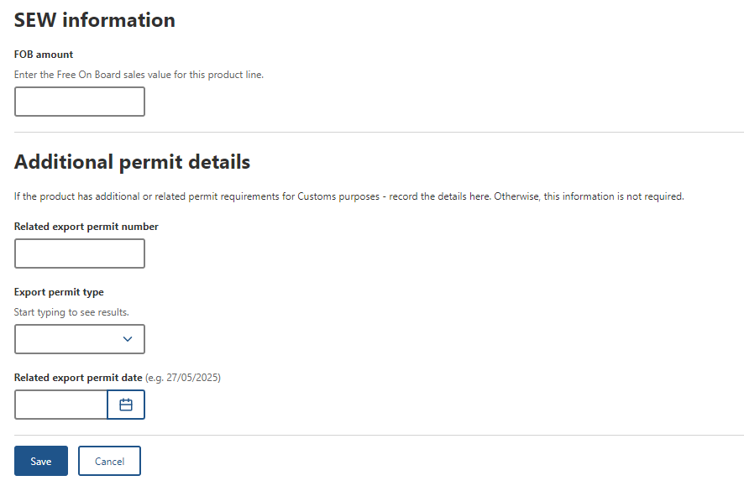
Step 12  If required, enter Production processes details.  Click + Add Production process  Select the Establishment type:  - Registered or Listed establishment – for markets that require an establishment be registered or listed with the department.  - Free text establishment – for markets that require production details but do not require the establishment to be registered or listed with the department.  Select relevant establishment type and click continue  If adding Registered or Listed establishment continue to step 13  If adding free text establishment continue to step 14  Note: production details are conditional. Some markets may not require them | 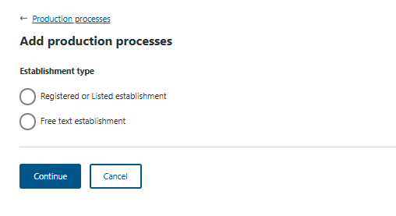
Step 13 (Registered or Listed establishment)  Complete the fields for Registered or Listed establishments including  Process Start and End dates  Process Establishment number  Establishment Indicator  Select Add.  Note: Click + Add Production process to add more than one process details.  These details are optional but may be required by some importing country requirements | 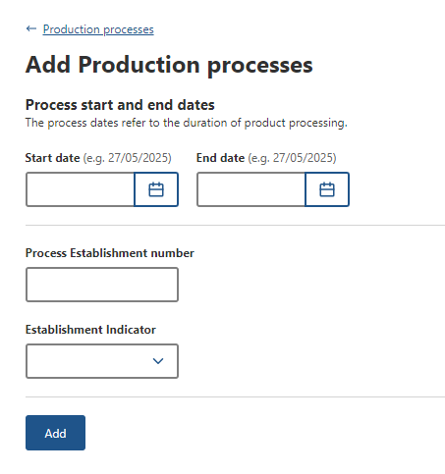
Step 14 (Free text establishment)  Complete fields for free text establishment including  Establishment indicator  Establishment name  Establishment address  Process start and end dates  Party identification code -optional  Select Add.  Note: Click + Add Production process to add more than one process details. | 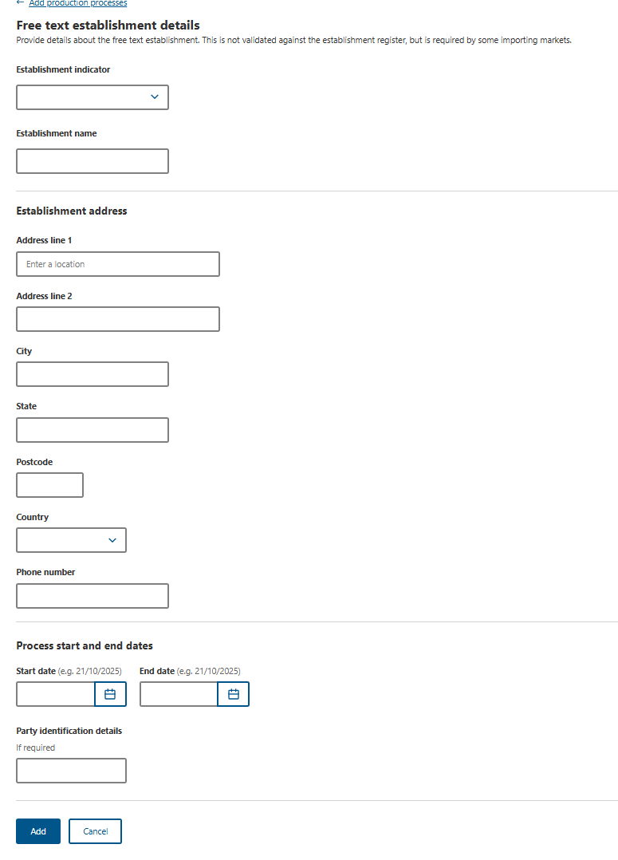
Step 15  If required, enter Additional details.  Durability start and end dates  Import authority code  Product Source State  Click Save  Note: These details are optional but may be required by some importing country requirements | 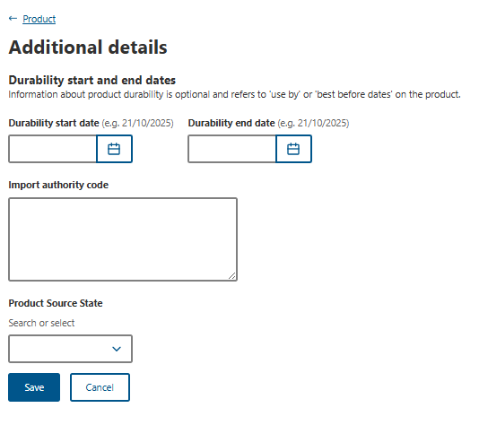
Step 16  Once you have provided all necessary information for the product line, select Save. | 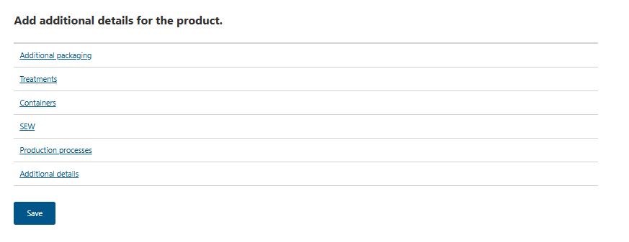
Step 17  Once saved you will return to the Products for exports page  If you need to add another product line, select either Add another product to export or Copy a product line.  If you copy an existing product line, NEXDOC will copy all basic information and allow you to amend any unique information, such as the batch number, weights, packaging etc.  Once you have all product line information saved, select Next. | 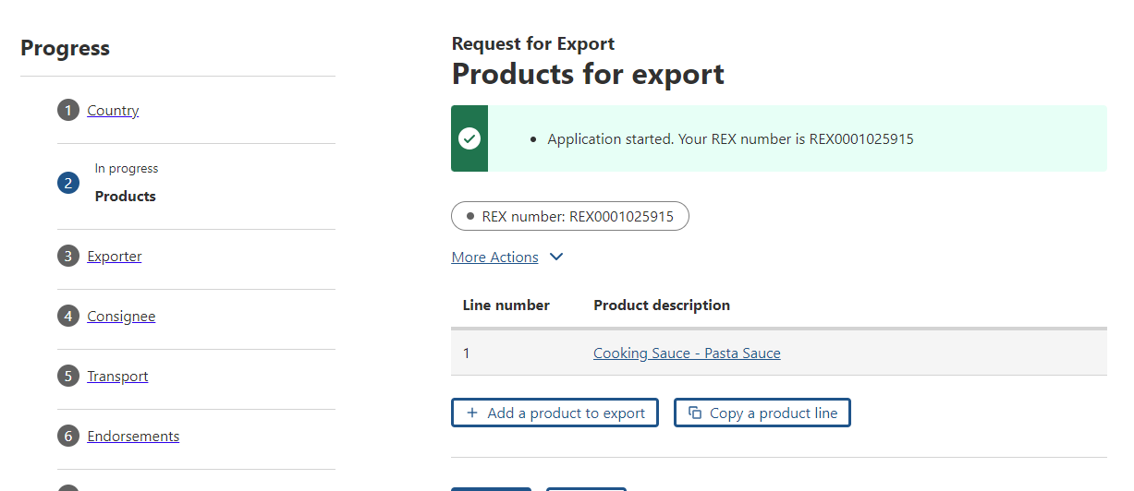

REX Section 3: Exporter Details
Step 1  Exporter details are prepopulated from your NEXDOC exporter registration.  If you need to update these details, select  Edit exporter details or Request new exporter  Provide your  Your reference.  Note: This is a mandatory field and limited to 35 characters. This will assist you in identifying the REX. The exporter reference will also appear on your invoice.  Select Save and next. | 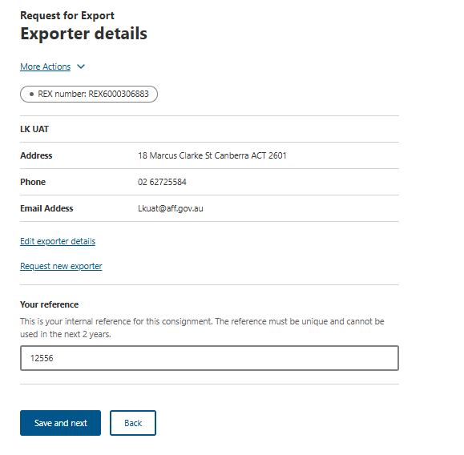

REX Section 4: Consignee Details
Step 1  Enter the consignee details:  Name - mandatory  Consignee Representative – mandatory for Japan and Korea  Phone number optional  Consignee address - mandatory  Note: While you can enter consignee details manually per consignment, you can also add consignee details to the consignee address book for future use.  If you wish to add an address to the consignee address book, go to Step 2. | 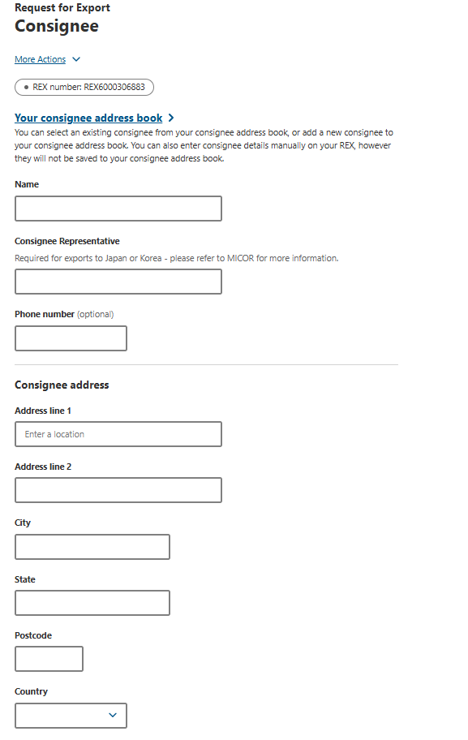
Step 2  To add a consignee, click the Your consignee address book link. | 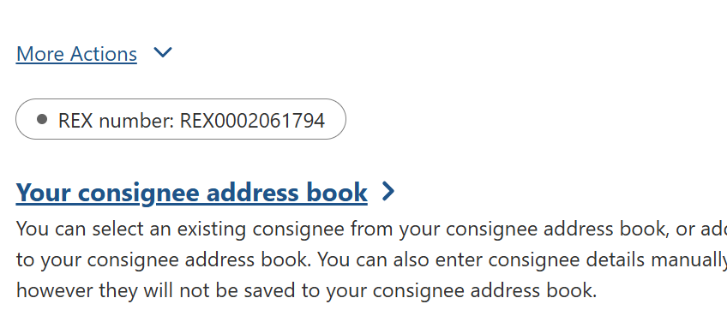
Step 3  Select Add consignee.  Enter all relevant details and select Save. | 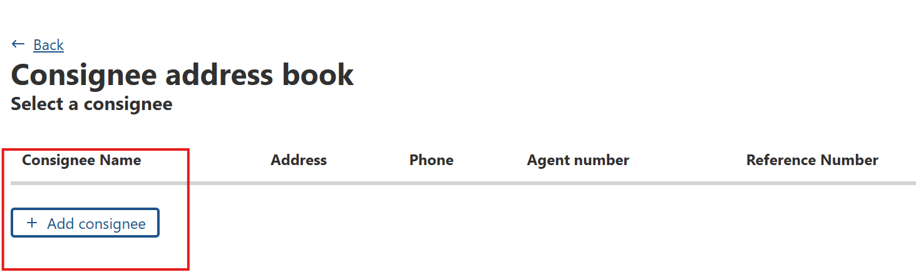
Step 2  If required, enter Additional information.  Additional information text  Notify party text  Click Save and Next  Note: These details are optional but may be required by some importing country requirements | 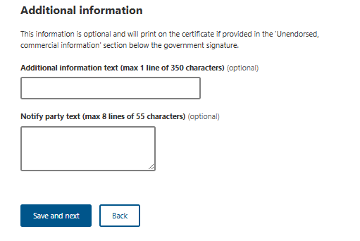

REX Section 5: Transport Details
Step 1  Enter the following details.  Departure date - mandatory  Load port - mandatory  Discharge port - mandatory  Border inspection port - optional  Destination city - mandatory  Transit countries - optional  Note: Fields that are optional may be required by some importing countries | 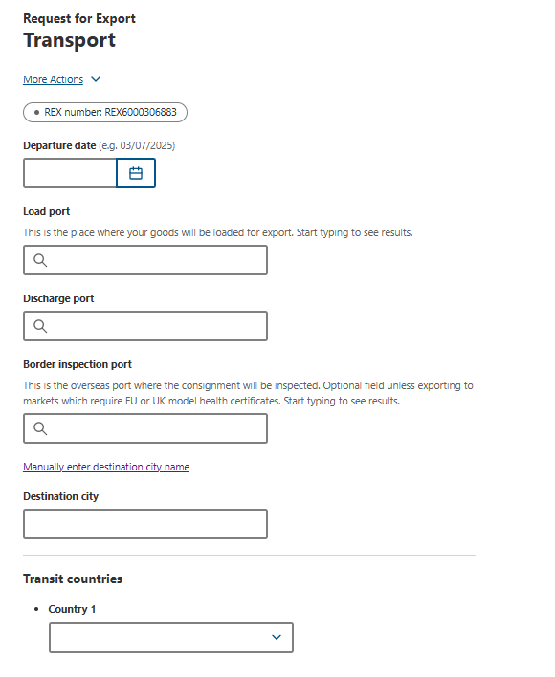
Step 2  Enter the transport details:  Transport storage temperature – optional  Transport Storage minimum temperature – optional  Transport storage temperature unit – optional  Transport information - optional  Transport mode - mandatory  select one  Sea - go to Step 3  Air - go to Step 4  Mail - go to Step 5  Note: Fields that are optional may be required by some importing countries | 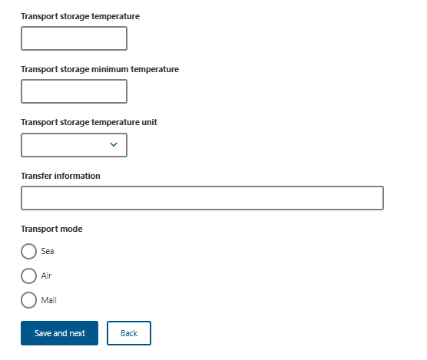
Step 3  Enter transport mode for Sea.  Vessel name - mandatory  Voyage - mandatory  Click Save and Next | 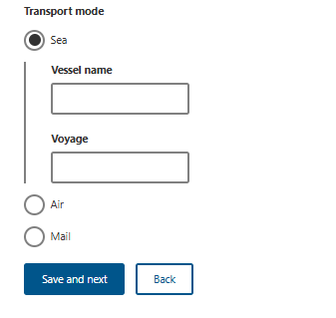
Step 4  Enter transport mode for Air.  Flight number - mandatory  Click Save and Next | 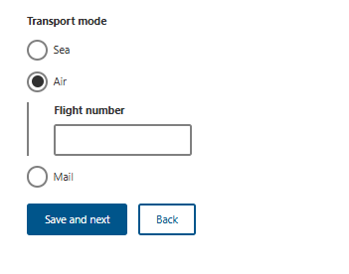
Step 5  Enter transport mode for Mail.  Click Save and Next | 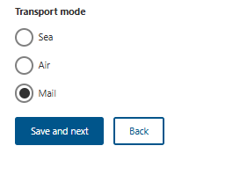

REX Section 6: Endorsements
Step 1  To check or change the allocated endorsement and certificate template  Click Select next to the product line  Note: NEXDOC will automatically allocate you an appropriate certificate template and endorsement.  It is important to check you are allocated the correct certificate template and endorsement. | 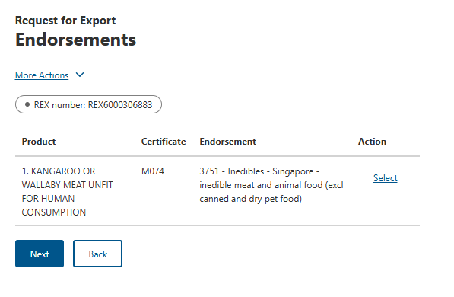
Step 2  Select either or both  Certificate Template Endorsement  drop-down to view available options.  Click on a new template or endorsement if you would like to change from the default.  Click Save. | 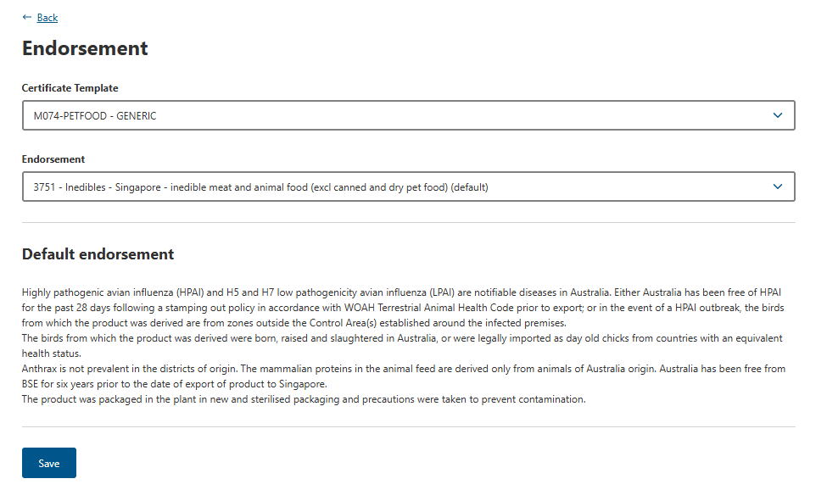
Step 6  Once you have confirmed the template and/or endorsement combination  Click Next. | 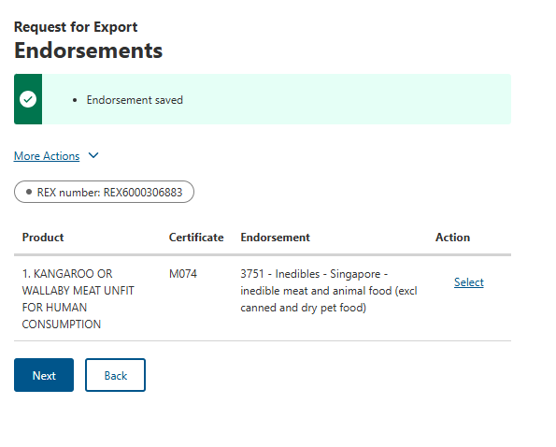

REX Section 7: Single Electronic Window (SEW)
Step 1  Should you wish to use Single Electronic Window (SEW) integration to obtain your EDN (Export Declaration Number),  tick - Would you like to use SEW integration (ICS)?  Note:  - You must have requested access to SEW in your exporter registration for this to be available.  - If you wish to use the SEW connection, you must have SEW details in each of your product lines.  - The FOB total is calculated from the information in the SEW tab of each product line.  - An EDN can only have a consignee name of 35 characters. If the consignee name you provided to appear in the certificate is greater than 35 characters, supply a shorter version here so that you can obtain an EDN. | 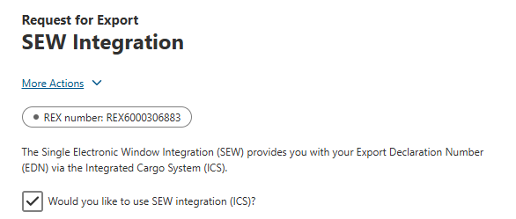
Step 2  Enter the below details:  FOB currency  SEW consignee name  Click Save and Next  Note: The FOB total is drawn from the total amount in the product lines. | 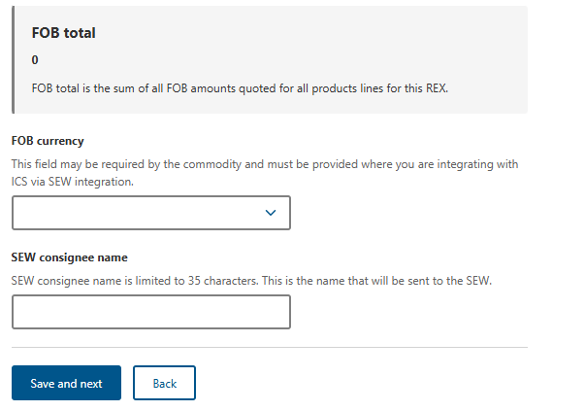

REX Section 8: Additional Details
Step 1  Select one Certificate print indicator value.  Automatic  Hold  None  This selection is mandatory.  Note:  If you select Automatic, a print file will generate as soon as the certificate is ready to print.  If you select Hold, you can preview the certificate prior to finalising it.  If you select None, a certificate will not generate.  Please refer to the NEXDOC Printing FAQ on the NEXDOC Help Page for further information regarding these options. | 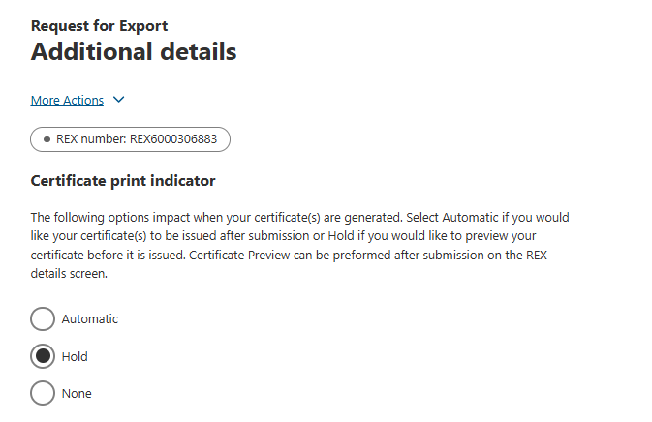
Step 2  Select either  Use your own printer  or  Print to a departmental regional office  This selection is mandatory.  Note:  Use your own printer allow you to print your certificate remotely eg in your own office. However this it not available for all certification and will depend on the importing country requirements.  Print to a departmental regional office will print the certificate to the nominated regional department office, where you will need to collect.  If you do not have the user your own printer option on screen, it may be that this particular certificate cannot be remote printed or that you do not have this option set up on your account.  Please request this permission via your registered NEXDOC exporter account. Refer to the Manage Your Details guide on the NEXDOC help page. | 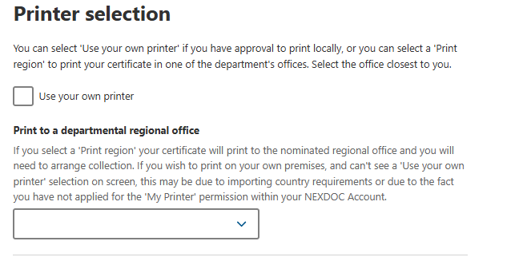
Step 3  If required, enter Other details  Manual EDN  Separate certificate by  Header Storage Establishment Number  Product Use Indicator  Note: These details are optional but may be required by some importing country requirements | 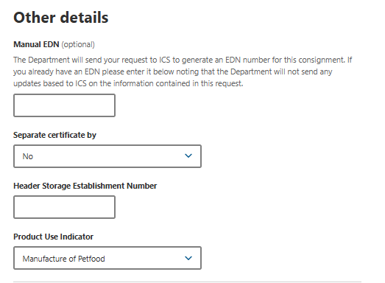
If required, under Request extra certificates, click  + Add extra certificate request – go to Step 4  And/Or  + Add an import permit – go to Step 5 | 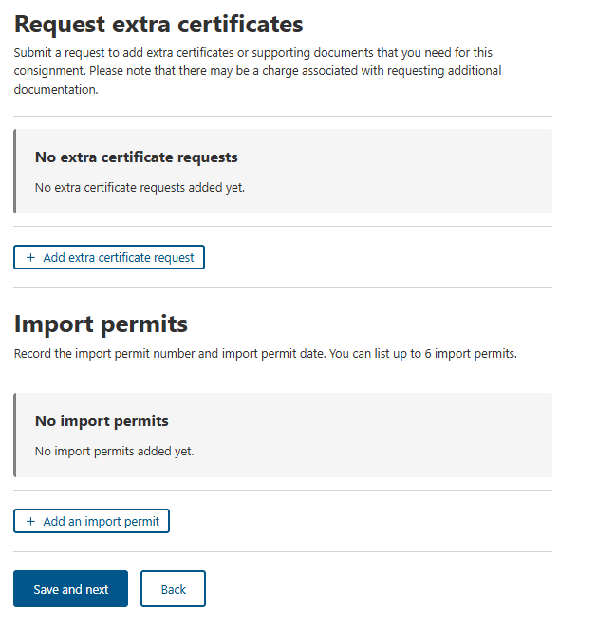
Step 4  If required, enter  Certificate type  Reason  Then select which line the extra certificate applies to.  Click Save | 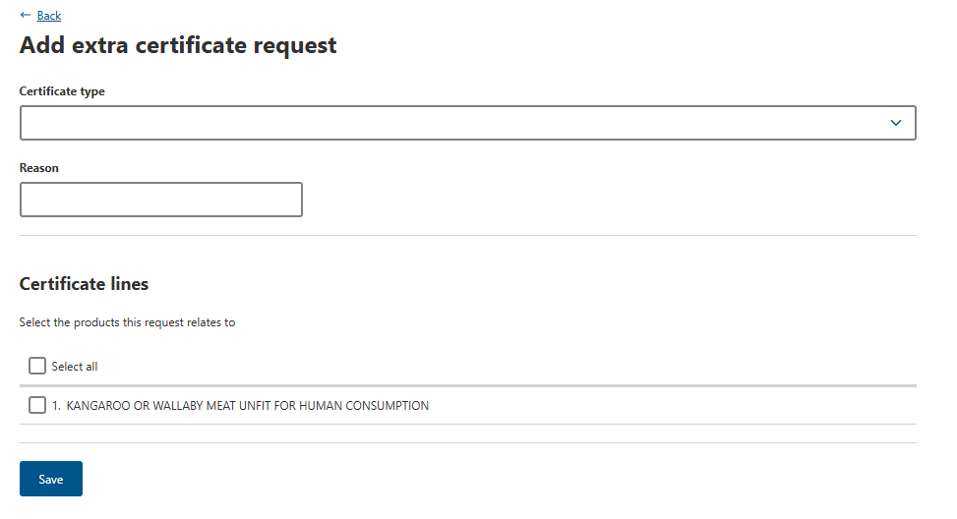
Step 5  If required, enter  Import permit number  Import permit date  Click Save | 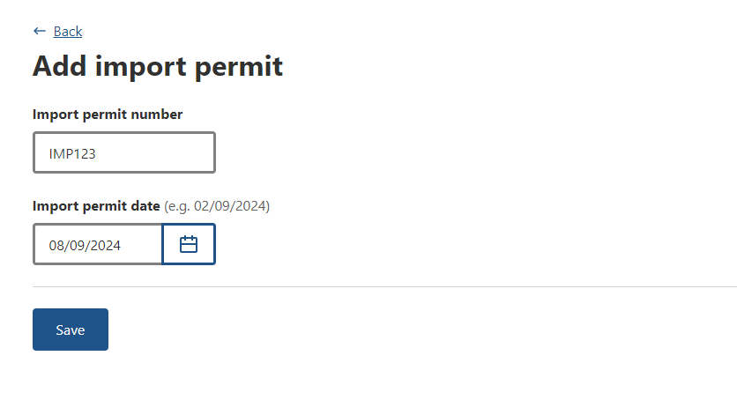
Step 6  Select Save and next. | 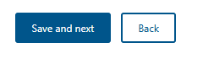

REX Section 9: Attachments
Step 1  Each certificate must comply with importing country requirements. Where required, provide all relevant documentation to support your request. Relevant documentation may include, but is not limited to, import permits and manufacturers declarations.  Select + Add attachment. | 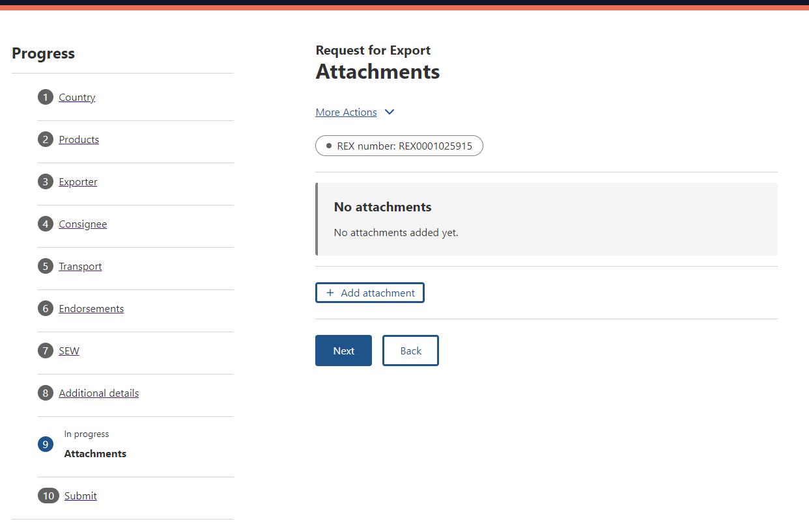
Step 2  Select the Document Type drop-down menu and select the type of attachment. Supported file types include: jpg, tiff, gif, rtf, jfif, png, docx, tif, txt, pdf, xml, jpeg, doc, and jpe.  The Document Type field is mandatory if you are attaching a document.  Provide a Comment in relation to your attachment, if applicable.  The Comment field is optional.  Select Choose Files or drag and drop the file to attach.  Select Save. | 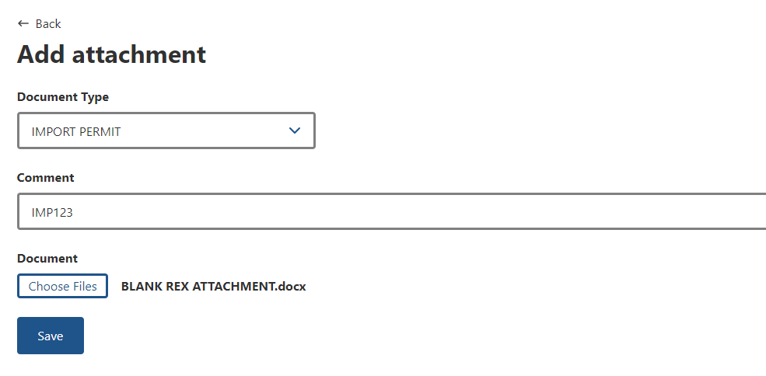
Step 3  Repeat Step 2 until you have attached all necessary documentation to support your application. You must attach all required documents so that the departmental officer has them available to review when assessing your REX.  Select Next. | 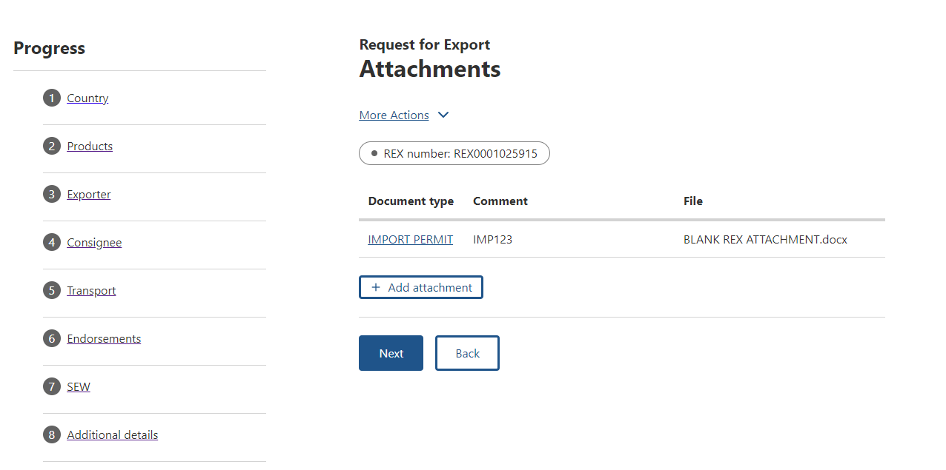

REX Section 10: Submit
Step 1  The Declaration will display.  If you wish to proceed with your lodgement, click I agree. | 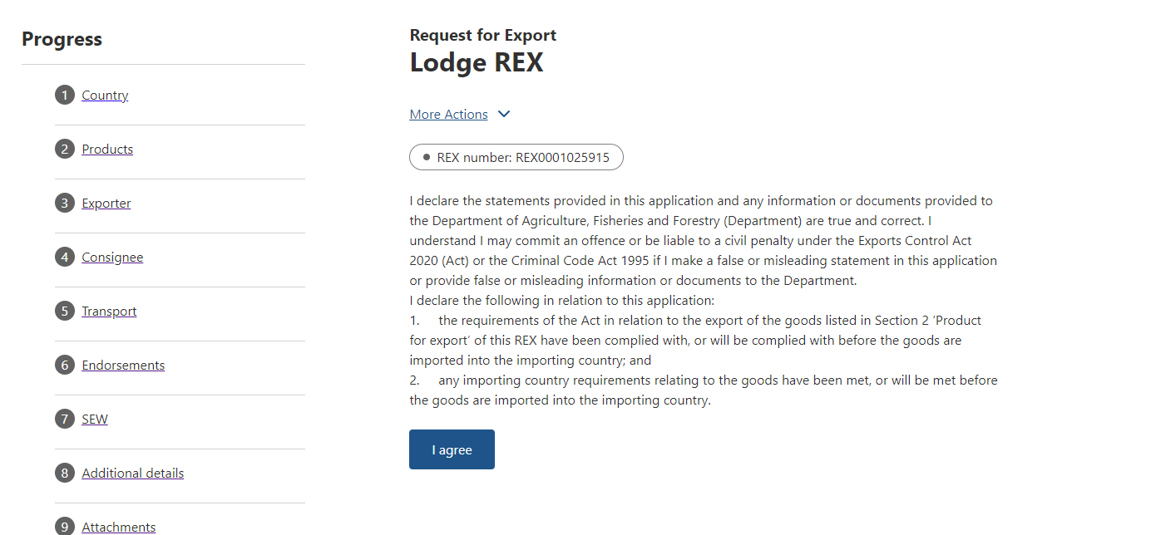
Step 2  If displayed, select declarations.  Click Next  Note: Not all REXs will have declarations, these are determined by importing country requirements. | 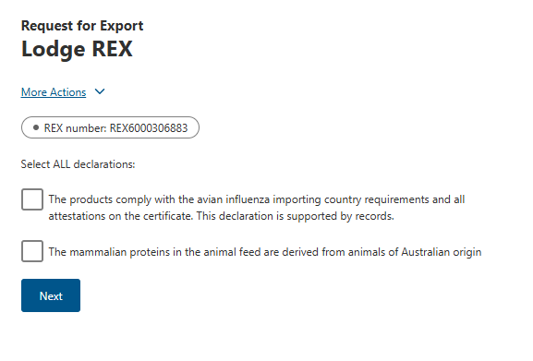
Step 3  The destination country and products will display. If there are no changes required,  Click Lodge REX. | 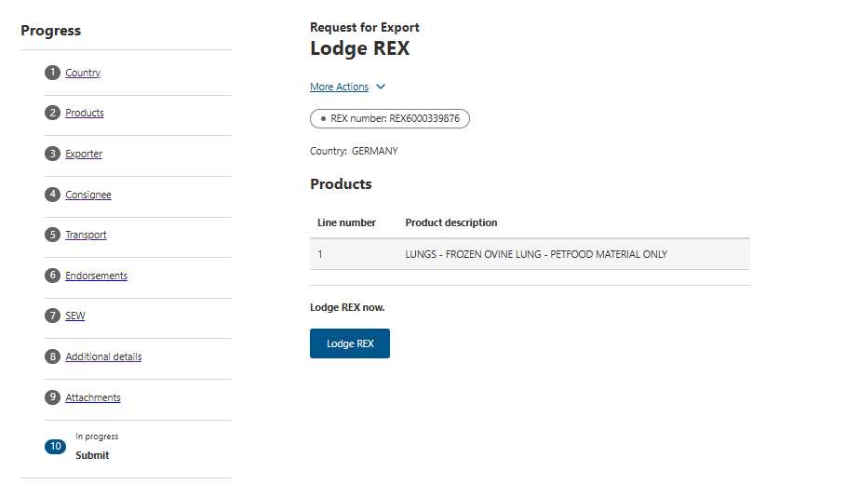
Step 4  A confirmation message will appear, alongside the Service ID associated with your application. Your REX may require assessment from a departmental officer prior to approval. | 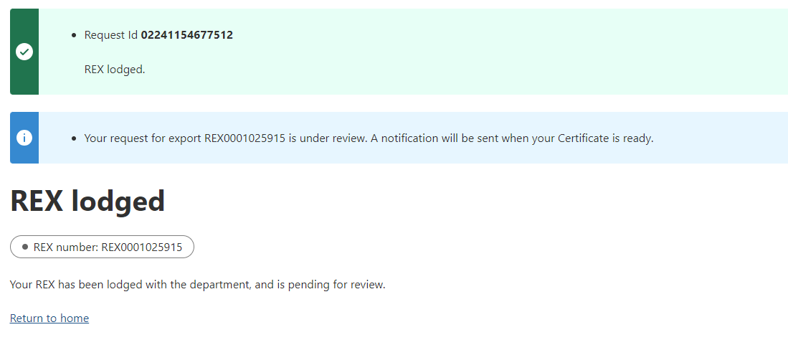
End

