# Infection with Hepatobacter penaei

Also known as necrotising hepatopancreatitis (NHP)

From Aquatic animal diseases significant to Australia: identification field guide, 5th edition

Figure 1 Pacific white shrimp (Penaeus (Litopenaeus) vannamei) infected with Hepatobacter penaei

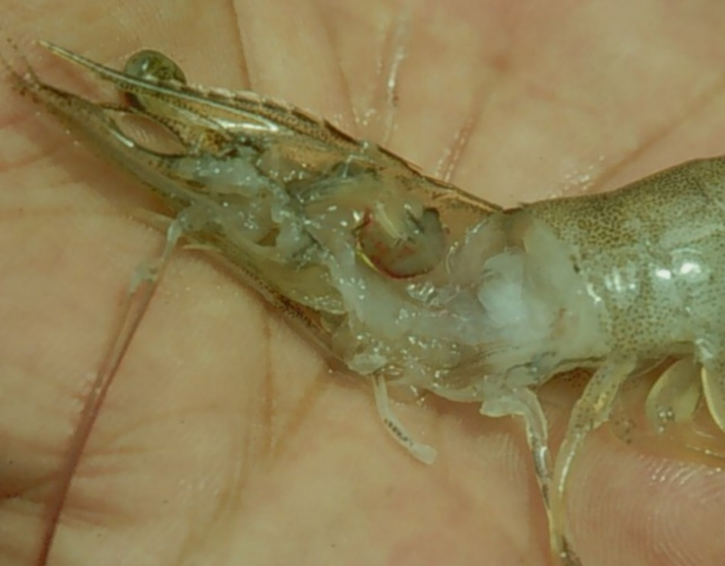

Note: Marked reduction in size and pale colour of the hepatopancreas.

Source: DV Lightner

Figure 2 Swimmerets of a Pacific white shrimp (Penaeus (Litopenaeus) vannamei) infected with Hepatobacter penaei

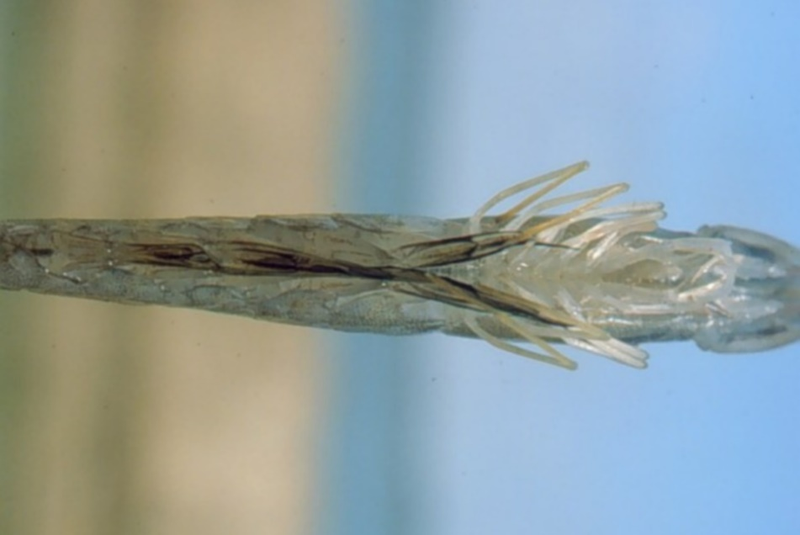

Note: Darkening at base of swimmerets, giving a fouled, ‘dirty’ appearance.

Source: DV Lightner

## Signs of disease

Important: Animals with this disease may show one or more of these signs, but the pathogen may still be present in the absence of any signs.

Disease signs at the farm, tank or pond level are:

* lethargy
* emaciation
* heavy protozoan or bacterial fouling
* reduced growth rate.

Gross pathological signs are:

* soft shell
* flaccid body
* black gills
* empty intestinal tract
* degenerated or atrophied digestive gland (hepatopancreas), which appears pale to white
* black (melanised) streaks in the hepatopancreas.

Microscopic pathological signs are:

* multifocal granulomatous lesions in hepatopancreatic tubules, with atrophy of adjacent hepatopancreatic tubule epithelial cells
* tubular cells within the granulomatous lesions that can be hypertrophied and contain basophilic organisms within the cytoplasm
* sloughing of tubule epithelial cells
* severe haemocytic inflammation of the intratubular spaces.

## Disease agent

NHP is caused by infection with Hepatobacter penaei, a Gram-negative, intracytoplasmic species of alphaproteobacterium that infects the hepatopancreas of prawns. H. penaei is also referred to as the NHP bacterium.

H. penaei exists in two morphological forms:

* rod-shaped, nonflagellated rickettsia-like organism
* helical flagellated form.

## Host range

Table 1 Species known to be susceptible to Hepatobacter penaei

| Common name | Scientific name |
| --- | --- |
| Aloha prawn | Penaeus marginatus |
| American lobster | Homarus americanus |
| Black tiger prawn | Penaeus monodon |
| Gulf banana prawn | Penaeus (Fenneropenaeus) merguiensis |
| Northern brown shrimpa | Penaeus (Farfantepenaeus) aztecus |
| Northern pink shrimpa | Penaeus (Farfantepenaeus) duorarum |
| Northern white shrimpa | Penaeus (Litopenaeus) setiferus |
| Pacific blue shrimpa | Penaeus (Litopenaeus) stylirostris |
| Pacific white shrimpa | Penaeus (Litopenaeus) vannamei |
| Yellow-leg shrimpa | Penaeus (Farfantepenaeus) californiensis |

**a** Naturally susceptible.

## Presence in Australia

Exotic disease—not recorded in Australia.

Map 1 Presence of Hepatobacter penaei, by jurisdiction

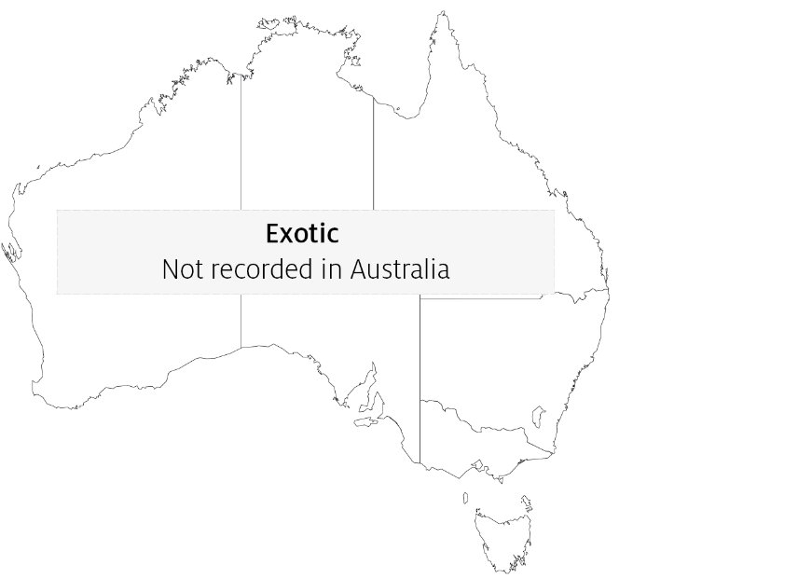

## Epidemiology

* NHP outbreaks are often preceded by lengthy periods of high water temperatures (29°C to 31°C) and elevated salinity (up to 40ppt).
* Mortalities usually occur midway through the grow-out phase and can reach 90% to 95% within 30 days.
* NHP appears to be transmitted by direct ingestion of carrier prawns (survivors of H. penaei infections may carry the bacteria for life) and through contaminated water.
* Hepatobacter penaei may also be shed in faeces and contribute to disease transmission.

## Differential diagnosis

The list of similar diseases in the next section refers only to the diseases covered by this field guide. Gross pathological signs may also be representative of diseases not included in this guide. Do not rely on gross signs to provide a definitive diagnosis. Use them as a tool to help identify the listed diseases that most closely account for the observed signs.

## Similar diseases

Acute hepatopancreatic necrosis disease (AHPND) and infection with Enterocytozoon hepatopenaei (EHP).

## Sample collection

Only trained personnel should collect samples. Using only gross pathological signs to differentiate between diseases is not reliable, and some aquatic animal disease agents pose a risk to humans. If you are not appropriately trained, phone your state or territory hotline number and report your observations. If you have to collect samples, the agency taking your call will advise you on the appropriate course of action. Local or district fisheries or veterinary authorities may also advise on sampling.

## Emergency disease hotline

See something you think is this disease? Report it. Even if you’re not sure.

Call the Emergency Animal Disease Watch Hotline on **1800 675 888**. They will refer you to the right state or territory agency.

## Microscope images

Figure 3 Photomicrograph of hepatopancreas of juvenile Pacific white shrimp (Penaeus (Litopenaeus) vannamei) with severe subacute (grade 3–4) NHP

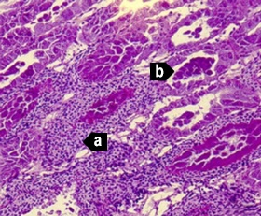

Note: Principal histopathological changes due to the disease include severe haemocytic inflammation (with some melanised foci) of the intratubular spaces (a) in response to necrosis, cytolysis and sloughing of hepatopancreas tubule epithelial cells (b). 150x magnification.

Source: DV Lightner

Figure 4 Photomicrograph of hepatopancreas of juvenile Pacific white shrimp (Penaeus (Litopenaeus) vannamei) with severe subacute (grade 3–4) NHP

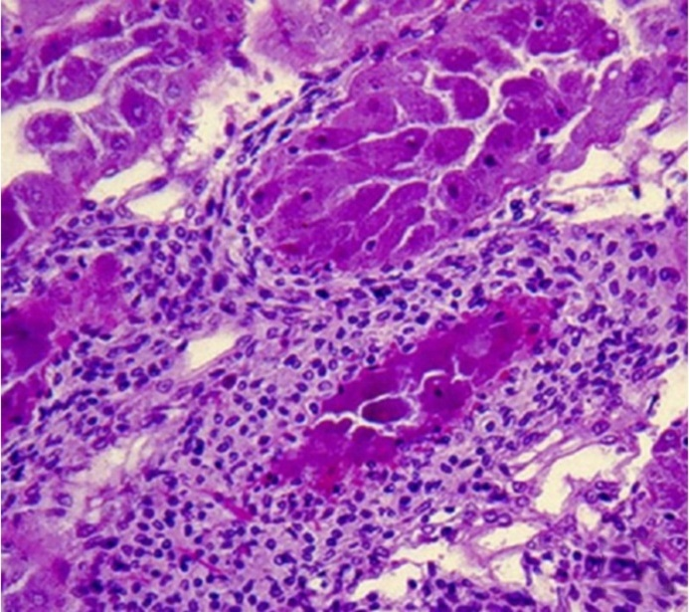

Note: Higher magnification of upper left of Figure 3. 300x magnification.

Source: DV Lightner

Figure 5 Photomicrograph of hepatopancreas of juvenile Pacific white shrimp (Penaeus (Litopenaeus) vannamei) with severe subacute (grade 3–4) NHP

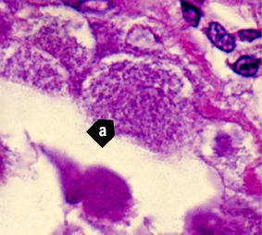

Note: Higher magnification view of Figure 3 and Figure 4. Tubule epithelial cells have no cytoplasmic lipid droplets. Instead, they contain masses of the tiny, non-membrane bound intracytoplasmic H. penaei (a). 1700x magnification.

Source: DV Lightner

Figure 6 Photomicrograph of hepatopancreas of juvenile Pacific white shrimp (Penaeus (Litopenaeus) vannamei) with severe chronic NHP

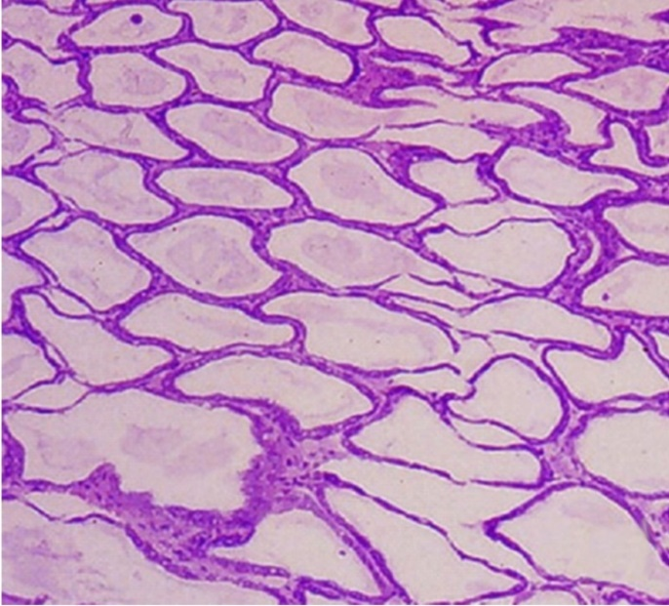

Note: Hepatopancreas tubule epithelium is markedly atrophied, resulting in the formation of large oedematous (fluid-filled or ‘watery’) areas. 100x magnification

Source: DV Lightner

Figure 7 Photomicrograph of atrophied hepatopancreas from juvenile Pacific white shrimp (Penaeus (Litopenaeus) vannamei) with chronic NHP

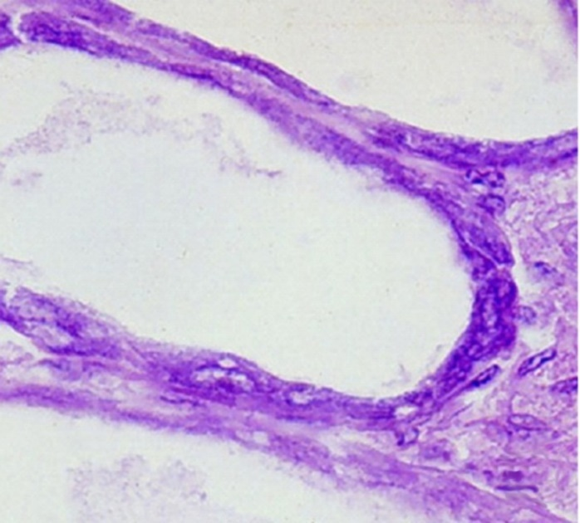

Note: In contrast to the subacute phase of NHP, chronic-phase NHP shows no, or only occasional, foci of haemocytic inflammation of the necrotic or degenerating hepatopancreatic tubules. NHP bacteria may be found in the cytoplasm of an occasional hepatopancreocyte. 900x magnification.

Source: DV Lightner

Figure 8 Hepatopancreocyte containing cytoplasmic masses of the NHP bacterium

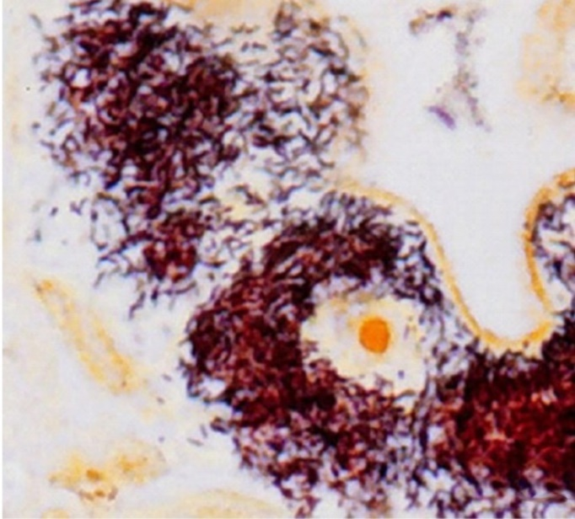

Note: Silver stain has been used to show individual bacteria as brown or black. Unaffected cells and nuclei are pale brown. 1600x magnification.

Source: DV Lightner

Figure 9 Transmission electron microscope micrograph of a hepatopancreocyte of a juvenile Pacific white shrimp (Penaeus (Litopenaeus) vannamei) with NHP

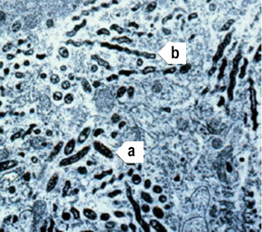

Note: The micrograph shows many intracellular rod-shaped forms (a) and helical forms (b) of the NHP bacterium in the cytoplasm. 10,000× magnification

Source: DV Lightner

Figure 10 Hepatopancreas of juvenile Pacific white shrimp (Penaeus (Litopenaeus) vannamei) with NHP

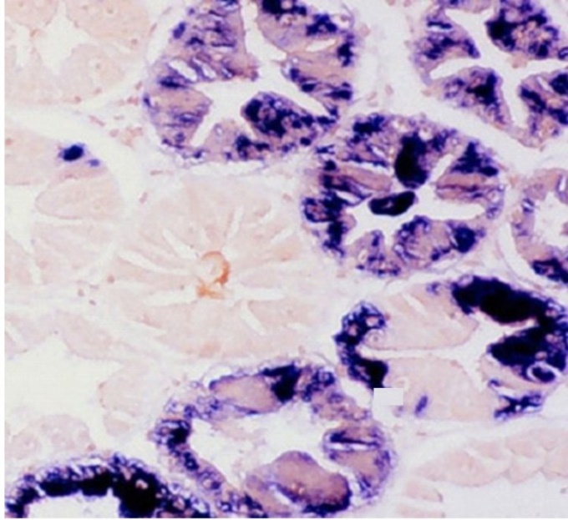

Note: The digoxigenin-labelled DNA probe marks cytoplasmic masses of Hepatobacter penaei blue-black. 250x magnification.

Source: DV Lightner

Figure 11 Hepatopancreas of juvenile Pacific white shrimp (*Penaeus* (*Litopenaeus*) *vannamei*) with NHP

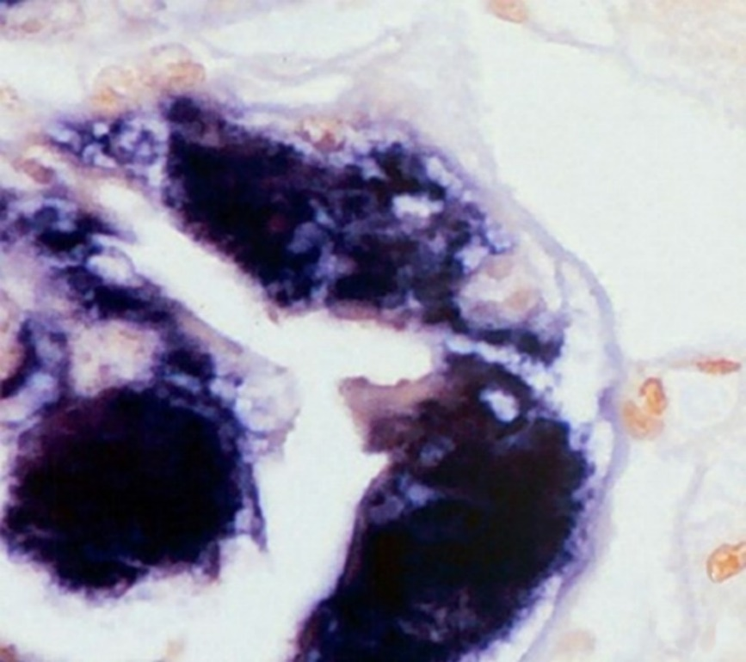

Note: The digoxigenin-labelled DNA probe marks cytoplasmic masses of H. penaei blue-black. 1000x magnification.

Source: DV Lightner

## Further reading

CABI Invasive Species Compendium [Necrotising hepatopancreatitis](https://www.cabi.org/ISC/datasheet/73087)

CEFAS International Database on Aquatic Animal Diseases [‘Hepatobacter penaei’ (Necrotising hepatopancreatitis)](https://www.cefas.co.uk/international-database-on-aquatic-animal-diseases/disease-data/?id=9)

World Organisation for Animal Health [Manual of diagnostic tests for aquatic animals](http://www.oie.int/en/international-standard-setting/aquatic-manual/access-online)

These hyperlinks were correct at the time of publication.

## Contact details

Emergency Animal Disease Watch Hotline 1800 675 888

Email [AAH@agriculture.gov.au](mailto:AAH@agriculture.gov.au)Website [agriculture.gov.au/pests-diseases-weeds/aquatic](http://www.agriculture.gov.au/pests-diseases-weeds/aquatic)

© Commonwealth of Australia 2020

This work is copyright. It may be reproduced in whole or in part subject to the inclusion of an acknowledgement of the source and no commercial usage or sale.