# Infection with Marteilia refringens

Also known as marteiliosis and Aber disease

From Aquatic animal diseases significant to Australia: identification field guide, 5th edition

Figure 1 European flat oyster (Ostrea edulis) infected with Marteilia refringens

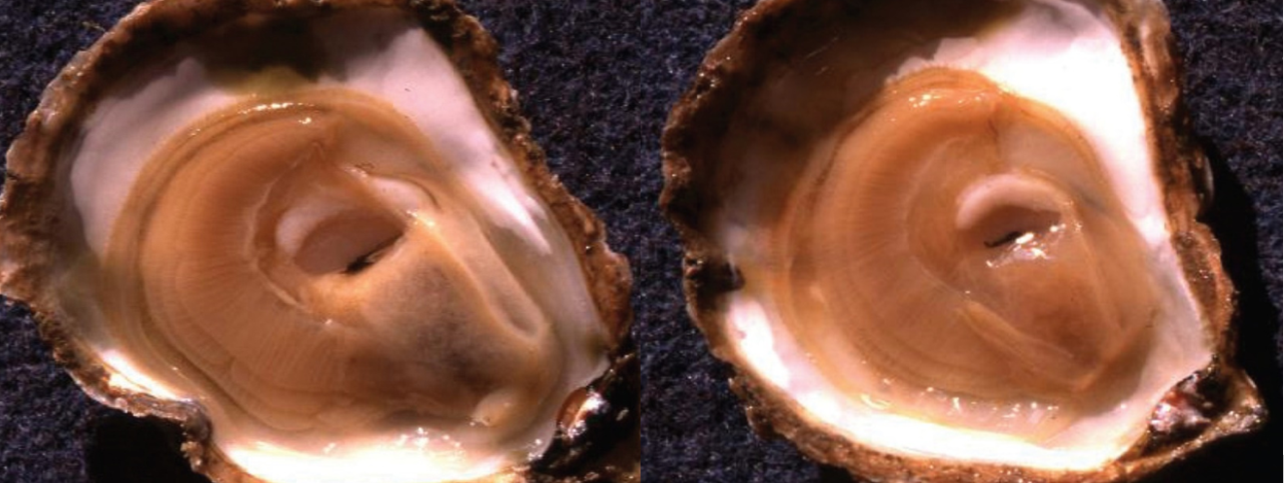

Note: A healthy oyster (left) with full, creamy-coloured digestive gland. The infected oyster (right) has a translucent, watery, shrunken digestive gland.

Source: French Research Institute for Exploration of the Sea

## Signs of disease

Important: Animals with this disease may show one or more of these signs, but the pathogen may still be present in the absence of any signs.

Disease signs at the farm, tank or pond level are:

* high mortality
* reduced growth rate
* gaping shells.

Gross pathological signs are:

* poor condition and emaciation
* pale, watery digestive gland
* inhibited gonad development.

Microscopic pathological signs are:

* tissue necrosis
* massive infection of the digestive gland tubule epithelium with sporogenic stages.

## Disease agent

Marteiliosis (or Aber disease) is caused by infection with Marteilia refringens. This is a protozoan parasite (order Paramyxida, class Ascetosporea) that affects the digestive system of multiple bivalve species, including oysters, mussels, cockles and clams. Other closely related species of Marteilia may cause similar diseases, including M. pararefringens in oysters and mussels, M. cochillia in cockles, M. octospora in razor shells and M. sydneyi in Sydney rock oysters.

## Host range

Table 1 Species known to be susceptible to infection with Marteilia refringens

| Common name | Scientific name |
| --- | --- |
| American oystera | Crassostrea virginica |
| Argentinian flat oyster | Ostrea puelchana |
| Asiatic oystera | Ostrea denselammellosa |
| Blue mussela | Mytilus edulis |
| Calico scallop | Argopecten gibbus |
| Common cocklea | Cerastoderma edule |
| Dwarf oyster | Ostrea stentina |
| European flat oystera | Ostrea edulis |
| European razor clama | Solen marginatus |
| Mediterranean mussela | Mytilus galloprovincialis |
| New Zealand dredge oystera | Ostrea chilensis |
| Olympia oystera | Ostrea conchaphila |
| Pacific oyster | Crassostrea gigas |
| Rock oystera | Saccostrea cucullata |
| Small brown mussel | Xenostrobus securis |
| Southern mud oyster or Australian flat oyster | Ostrea angasi |
| Striped venus clama | Chamelea gallina |
| Planktonic copepodsa | Paracartia grani |

**a** Naturally susceptible. Note: Other species have been shown to be experimentally susceptible.

## Presence in Australia

Exotic disease—not recorded in Australia.

Marteilia refringens has never been recorded in Australia and is considered exotic. However, related species of Marteilia have been detected in various oyster species in Queensland, New South Wales and Western Australia.

Map 1 Presence of Marteilia refringens, by jurisdiction

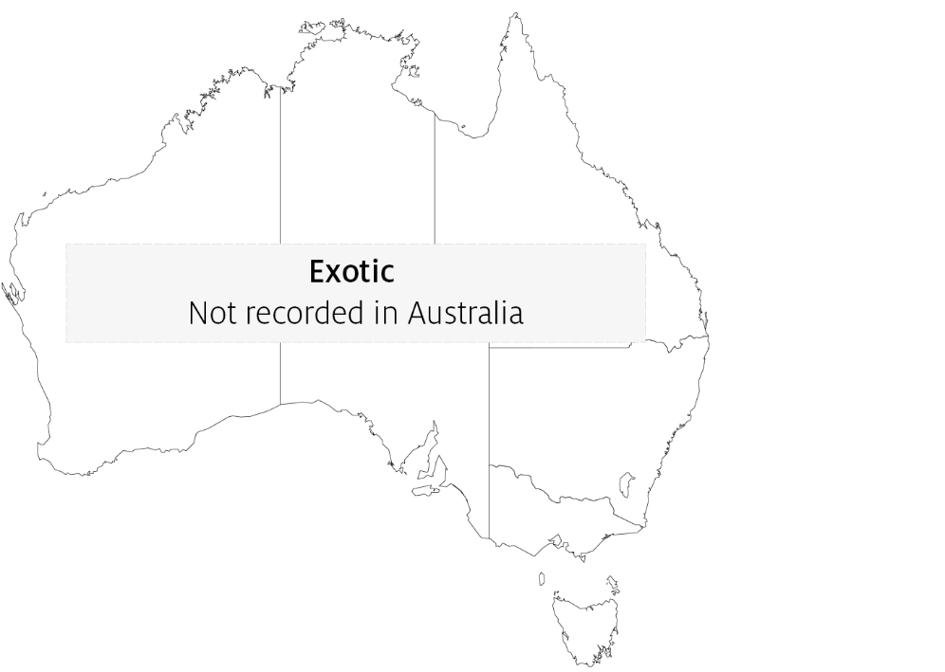

## Epidemiology

* Marteilia refringens infections result in high cumulative mortality (50 to 90%) and is associated with sporulation of the parasite in the epithelial cells of the digestive tubules.
* Highest cumulative mortalities usually occur during summer and autumn.
* Earlier stages of sporulation occur in epithelia of the digestive ducts and possibly the gills.
* Several intermediate hosts or a free-living stage are thought to be required during the life cycle of M. refringens. The planktonic copepod Paracartia grani is one intermediate host and may be involved in transmission of M. refringens between bivalves.
* Marteilia refringens can exist in a carrier state in apparently healthy oysters, which can be potential reservoirs of infection.
* Factors triggering a pathogenic host response are not clearly established. Factors may include environmental stresses and differences in susceptibility to disease between different host populations.
* The temperature threshold for parasite sporulation and transmission is 17°C. However, this is thought to vary with other environmental factors.

## Differential diagnosis

The list of similar diseases in the next section refers only to the diseases covered by this field guide. Gross pathological signs may also be representative of diseases not included in this guide. Do not rely on gross signs to provide a definitive diagnosis. Use them as a tool to help identify the listed diseases that most closely account for the observed signs.

## Similar diseases

Infection with Marteilia sydneyi.

The clinical signs of infection with M. refringens are almost identical to those of infection with other Ascetosporea. These include high mortalities associated with colourless and translucent tissue, poor condition, pale digestive gland and a shrunken body. Any presumptive diagnosis requires further laboratory examination. Light microscopy can contribute diagnostic information, but further laboratory examination and molecular diagnostic techniques are required for a definitive diagnosis.

## Sample collection

Only trained personnel should collect samples. Using only gross pathological signs to differentiate between diseases is not reliable, and some aquatic animal disease agents pose a risk to humans. If you are not appropriately trained, phone your state or territory hotline number and report your observations. If you have to collect samples, the agency taking your call will advise you on the appropriate course of action. Local or district fisheries or veterinary authorities may also advise on sampling.

## Emergency disease hotline

See something you think is this disease? Report it. Even if you’re not sure.

Call the Emergency Animal Disease Watch Hotline on **1800 675 888**. They will refer you to the right state or territory agency.

## Microscope images

Figure 2 Stained digestive gland imprint from European flat oyster (Ostrea edulis) infected with Marteilia refringens

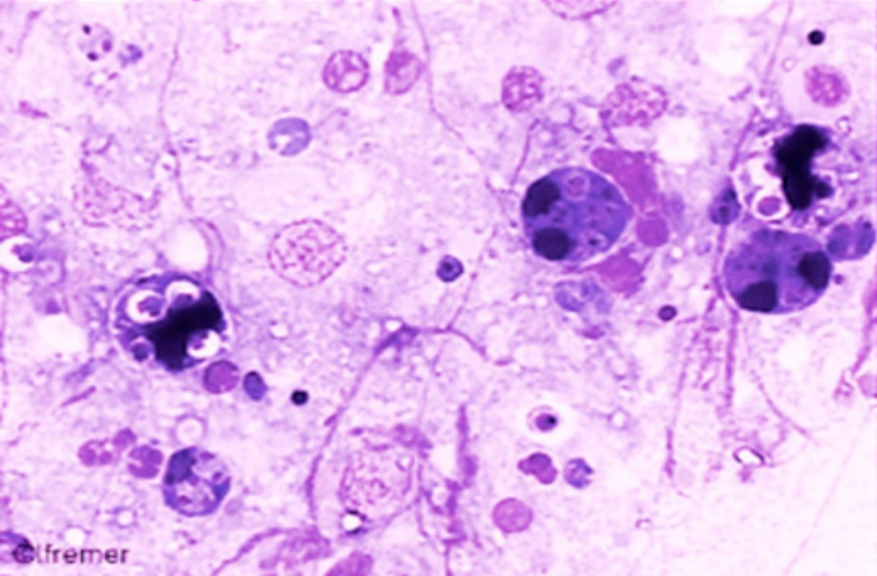

Note: Several dark-staining M. refringens sporonts containing pairs of spores. 120x magnification.

Source: French Research Institute for Exploration of the Sea

Figure 3 Histological section through digestive gland of European flat oyster (Ostrea edulis)

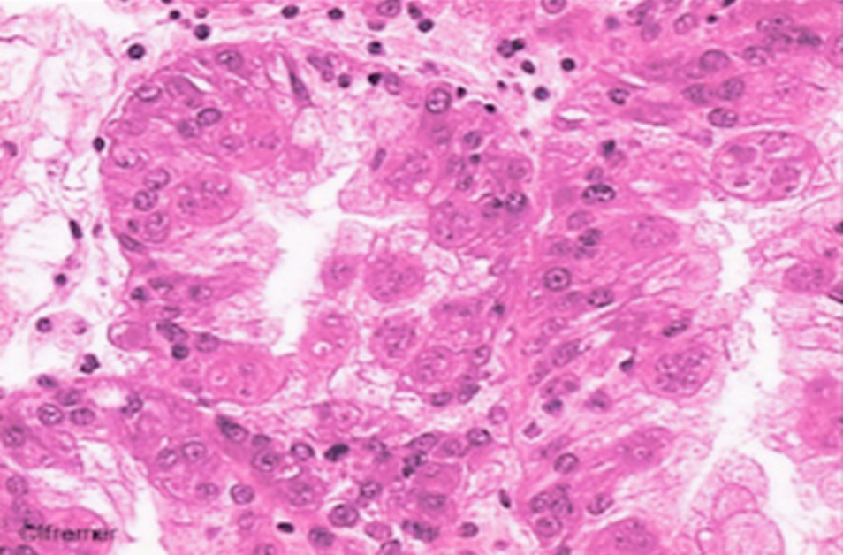

Note: Large numbers of sporogenic stages of M. refringens in the tubule epithelium. 80x magnification.

Source: French Research Institute for Exploration of the Sea

Figure 4 Histological section through digestive gland of European flat oyster (Ostrea edulis)

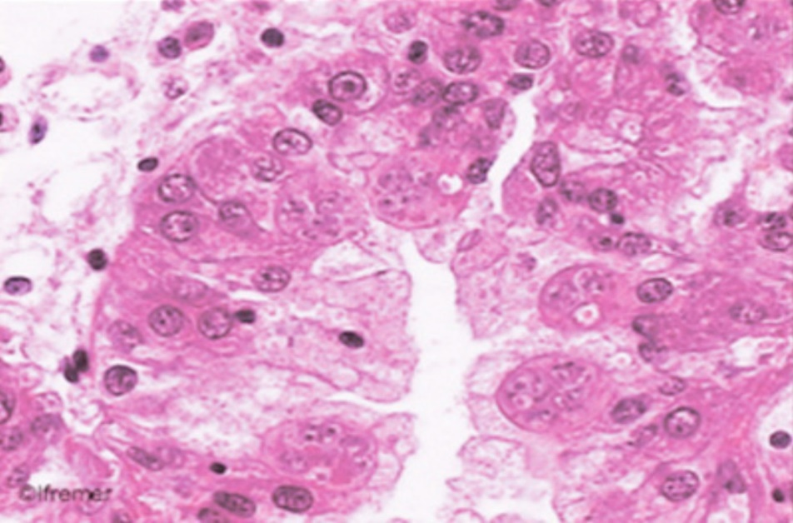

Note: Sporogenic stages of M. refringens in the tubule epithelium. 120x magnification.

Source: French Research Institute for Exploration of the Sea

## Further reading

CABI Invasive Species Compendium [Infection with ‘Marteilia refringens’](https://www.cabi.org/ISC/datasheet/75268)

CEFAS International Database on Aquatic Animal Diseases [Infection with ‘Marteilia refringens’](https://www.cefas.co.uk/international-database-on-aquatic-animal-diseases/disease-data/?id=37)

World Organisation for Animal Health [Manual of diagnostic tests for aquatic animals](http://www.oie.int/en/international-standard-setting/aquatic-manual/access-online)

These hyperlinks were correct at the time of publication.

## Contact details

Emergency Animal Disease Watch Hotline 1800 675 888

Email [AAH@agriculture.gov.au](mailto:AAH@agriculture.gov.au)Website [agriculture.gov.au/pests-diseases-weeds/aquatic](http://www.agriculture.gov.au/pests-diseases-weeds/aquatic)

© Commonwealth of Australia 2020

This work is copyright. It may be reproduced in whole or in part subject to the inclusion of an acknowledgement of the source and no commercial usage or sale.