# Infection with ranavirus

Also known as frog virus 3 (FV-3), Bohle iridovirus (BIV), Ambystoma tigrinum virus (ATV), and Mahaffey Road virus (MHRV)

From Aquatic animal diseases significant to Australia: identification field guide, 5th edition

Figure 1 Hindlimb of magnificent tree frog (Litoria splendida) infected with Mahaffey Road virus

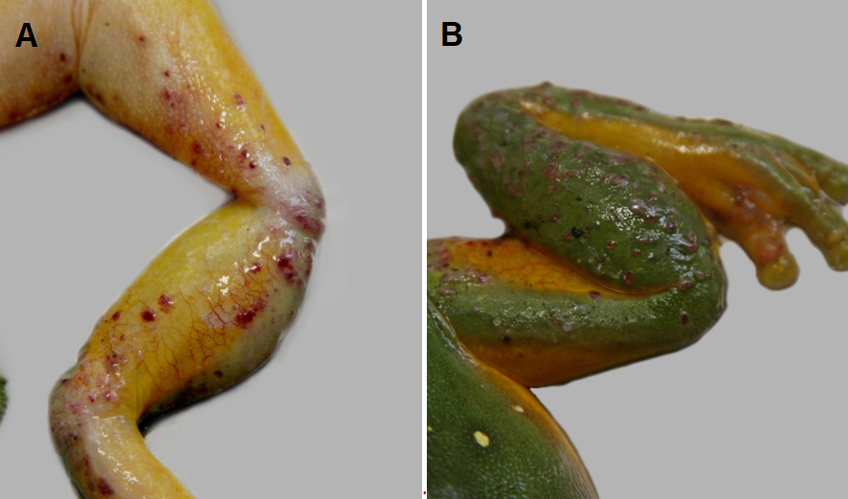

Note: Haemorrhagic skin papules and subcutaneous oedema of the ventral surface (A). Skin papules and erosions on the dorsal surface (B).

Source: Ian Jerrett

Figure 2 Ornate burrowing frog (Platyplectrum ornatus) metamorphs infected with Bohle iridovirus

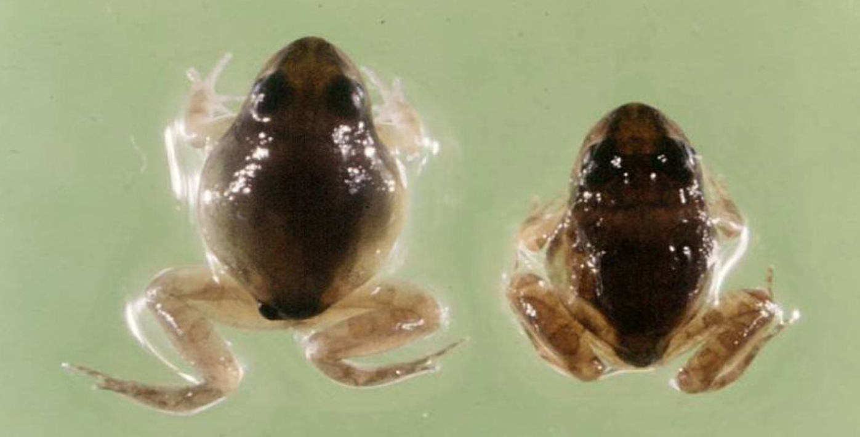

Note: Varying levels of ascites.

Source: R Speare

Figure 3 Green tree frog (Litoria caerulea) infected with Mahaffey Road virus

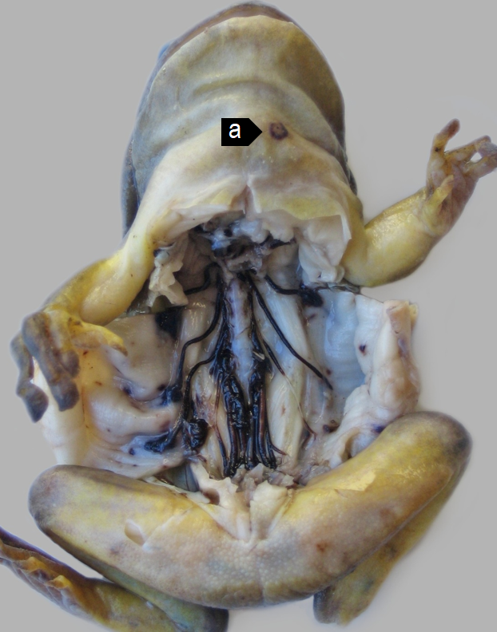

Note: Haemorrhagic perineural tissue and spinal nerves together with petechiation of the parietal coelomic serosa. A skin ulcer (a) is evident on the ventral neck.

## Signs of disease

Important: Animals with this disease may show one or more of these signs, but the pathogen may still be present in the absence of any signs.

Disease signs at the farm, tank or pond level are:

* erratic swimming
* lethargy
* loss of equilibrium
* buoyancy problems
* morbidity
* rapid severe mortality events.

Gross pathological signs are:

* poor body condition
* lordosis (abnormal forward curvature of the spine).

In tadpoles and metamorphs, additional gross pathological signs are:

* ascites (free fluid in the abdominal cavity)
* generalised oedema (fluid swelling) of tissues
* focal haemorrhages.

In adults, additional gross pathological signs are:

* skin ulcers, papules and/or erosions
* focal and systematic haemorrhages
* enlargement of the spleen or liver
* oedema of subcutaneous tissue (particularly around the jaw and head, with the tongue protruding).

Microscopic pathological signs are:

* severe renal, pulmonary, hepatic, splenic and haematopoietic necroses and haemorrhages
* basophilic intracytoplasmic inclusion bodies
* erosion, ulceration and hyperplasia of epithelial epidermal cells.

## Disease agent

This disease is caused by infection with members of the genus Ranavirus (family Iridoviridae). Viruses infecting amphibians include frog virus 3 (FV-3), Bohle iridovirus (BIV), Ambystoma tigrinum virus (ATV), and Mahaffey Road virus (MHRV). There are many other tentative species in this genus. Bohle iridovirus and Mahaffey Road virus are known from northern Australia in native frogs and cane toads.

## Host range

Amphibians (all members of the class Amphibia) are considered to be susceptible to infection with ranavirus. Natural infections are known from most of the major families of the orders Anura (frogs and toads) and Caudata (salamanders, newts and sirens).

Infection with ranaviruses in fish and reptiles can result in asymptomatic infections through to epizootics, depending on species, stress and environmental factors. In challenge experiments, species acutely susceptible to Bohle iridovirus were juvenile green tree frogs (Litoria caerulea), striped burrowing frogs (Cyclorana alboguttata), short-footed frogs (C. brevipes) and red‑backed toadlets (Pseudophryne coriacea). Species less susceptible in trials were adult red tree frogs (Litoria rubella), bumpy rocketfrog (L. inermis), green tree frogs, ornate nursery frogs (Cophixalus ornatus), sharp- snouted day frogs (Taudactylus acutirostris) and cane toads (Bufo marinus).

Table 1 Species known to be susceptible to ranavirus

| Common name | Scientific name |
| --- | --- |
| **Frogs and toads** | **Order Anura** |
| Bumpy rocket froga | Litoria inermis |
| Cane toada | Rhinella marina |
| Great barred frog | Mixophyes fasciolatus |
| Green tree froga | Litoria caerulea |
| Magnificent tree froga | Litoria splendida |
| Ornate burrowing froga | Platyplectrum ornatus |
| Ornate nursery froga | Cophixalus ornatus |
| Red tree frog | Litoria rubella |
| Red-backed toadleta | Pseudophryne coriacea |
| Sharp-snouted day froga | Taudactylus acutirostris |
| Short-footed frog | Cyclorana brevipes |
| Striped burrowing froga | Cyclorana alboguttata |
| **Salamanders newts and sirens** | **Order Caudata** |
| Alpine newt | Ichthyosaura alpestris |
| Blue tailed fire belly newt | Cynops cyanurus |
| Chiang Mai crocodile newt | Tylototriton uyenoi |
| Chinese firebelly newt | Cynops orientalis |
| Clouded salamander | Hynobius nebulosus |
| Eastern newt | Notophthalmus viridescens |
| European cave salamander | Speleomantes spp. |
| Fire salamander | Salamandra salamandra |
| French cave salamander | Hydromantes strinatii |
| Italian newt | Lissotriton italicus |
| Japanese clawed salamander | Onychodactylus japonicas |
| Japanese fire belly newt | Cynops pyrrhogaster |
| Lesser siren | Siren intermedia |
| North African fire salamander | Salamandra algira |
| Northern crested newt | Triturus cristatus |
| Northern spectacled salamander | Salamandrina perspicillata |
| Rough skinned newt | Taricha granulosa |
| Sardinian brook salamander | Euproctus platycephalus |
| Siberian salamander | Salamandrella keyserlingii |
| Smooth newt | Lissotriton vulgaris |
| Spanish ribbed newt | Pleurodeles waltl |
| Sword tailed newt | Cynops ensicauda |
| Vietnamese crocodile newt | Tylototriton vietnamensis |
| Vietnamese salamander | Paramesotriton deloustali |
| Wenxian knobby newt | Tylototriton wenxianensis |
| Yellow spotted newt | Neurergus crocatus |
| Zeigler’s crocodile newt | Tylototriton ziegleri |

**a** Naturally susceptible. Note: other species likely to be susceptible or shown to be experimentally susceptible.

## Presence in Australia

Infection with ranavirus has been officially reported in Australia. Bohle iridovirus was originally isolated from tadpoles of ornate burrowing frogs (Platyplectrum ornatus) in far north Queensland. It has since been isolated from moribund green tree frogs and captive juvenile red-backed toadlets. Another ranavirus, Mahaffey Road virus, was reported from moribund tree frogs in Darwin, Northern Territory. There is serological evidence of ranavirus infection in cane toads across northern Australia.

Map 1 Presence of ranavirus, by jurisdiction

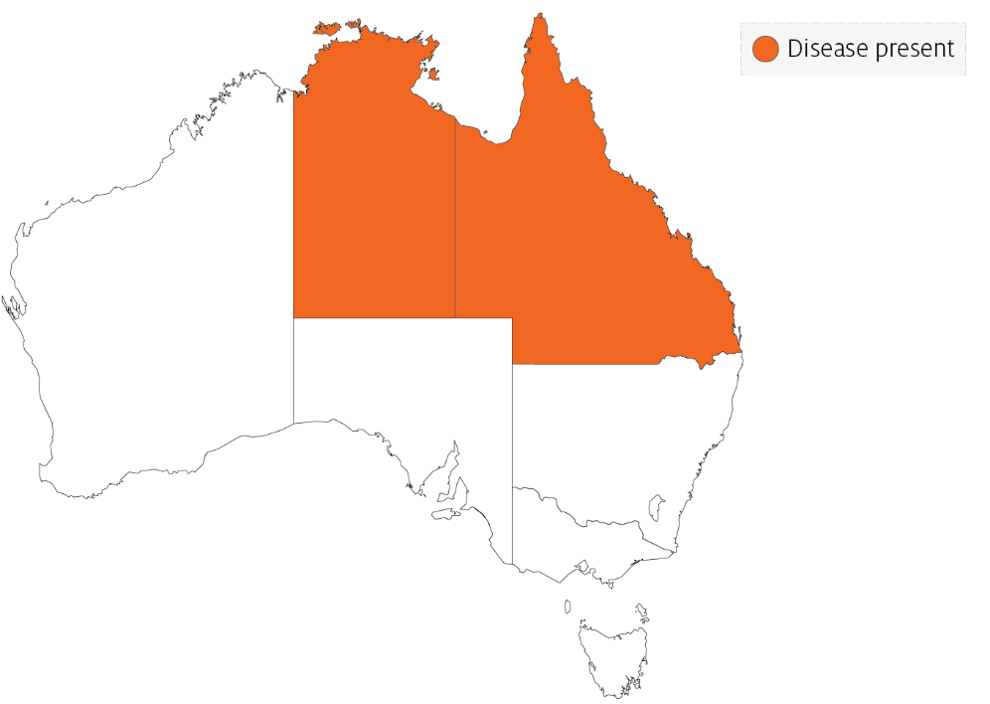

## Epidemiology

* Two syndromes in frogs are associated with ranavirus infection: ulcerative syndrome and haemorrhagic syndrome.
* The most common presentation is a rapid, severe mortality event with death due to peracute systemic haemorrhagic disease. However, in Australia, morbidity is more common.
* Mortality and morbidity vary from species to species (0-100%), and may be variable depending on virus type, and age and health status of the host.
* Horizontal transmission occurs via contaminated water, animal-to-animal contact and predation or cannibalism.
* These viruses can be spread between widely separated river systems and impoundments, which suggests viral persistence and the existence of transmission mechanisms other than direct horizontal transmission.
* Vertical transmission is considered likely, but has not been experimentally documented.
* Possible vectors include nets, boats and other equipment, or amphibians used for bait by recreational fishers. Birds are potential mechanical vectors.
* Temperature is considered a likely factor influencing disease outbreaks, with the prevalence or severity of outbreaks greater during warmer months.

## Differential diagnosis

The list of similar diseases in the next section refers only to the diseases covered by this field guide. Gross pathological signs may also be representative of diseases not included in this guide. Do not rely on gross signs to provide a definitive diagnosis. Use them as a tool to help identify the listed diseases that most closely account for the observed signs.

## Similar diseases

No diseases in this field guide are similar to infection with ranavirus.

## Sample collection

Only trained personnel should collect samples. Using only gross pathological signs to differentiate between diseases is not reliable, and some aquatic animal disease agents pose a risk to humans. If you are not appropriately trained, phone your state or territory hotline number and report your observations. If you have to collect samples, the agency taking your call will advise you on the appropriate course of action. Local or district fisheries or veterinary authorities may also advise on sampling.

## Emergency disease hotline

See something you think is this disease? Report it. Even if you’re not sure.

Call the Emergency Animal Disease Watch Hotline on **1800 675 888**. They will refer you to the right state or territory agency.

## Further reading

Wildlife Health Australia [Ranaviral disease in wild Australian amphibians](https://www.wildlifehealthaustralia.com.au/FactSheets.aspx)

World Organisation for Animal Health [Manual of Diagnostic Tests for Aquatic Animals](http://www.oie.int/en/international-standard-setting/aquatic-manual/access-online)

These hyperlinks were correct at the time of publication.

## Contact details

Emergency Animal Disease Watch Hotline 1800 675 888

Email [AAH@agriculture.gov.au](mailto:AAH@agriculture.gov.au)Website [agriculture.gov.au/pests-diseases-weeds/aquatic](http://www.agriculture.gov.au/pests-diseases-weeds/aquatic)

© Commonwealth of Australia 2020

This work is copyright. It may be reproduced in whole or in part subject to the inclusion of an acknowledgement of the source and no commercial usage or sale.