

The influence of longitudinal hydrological connectivity on resource availability and lower order food web structure in the Murray River

A report to the Commonwealth Environmental Water Office

Deborah Furst1, Kane Aldridge1, Chris Bice2, Brenton Zampatti2 and Qifeng Ye2

1School of Biological Sciences & Environment Institute, University of Adelaide,

2South Australian Research and Development Institute, Aquatic Sciences

March 2019





Disclaimer:

The results and comments contained in this report have been provided on the basis that the recipient assumes the sole responsibility for the interpretation and application of them. The authors give no warranty, expressed or implied, or assumes any legal liability or responsibility for the accuracy, completeness or use of the results and comments contained in this report by the recipient or any third party.

The views and opinions expressed in this publication are those of the authors and do not necessarily reflect those of the Australian Government or the Minister of the Environment. While reasonable efforts have been made to ensure that the contents of this publication are factually correct, the Commonwealth does not accept responsibility for the accuracy or completeness of the contents, and shall not be liable for any loss or damage that may be occasioned directly or indirectly through the use of, or reliance on, the contents of this publication.

Cite as: Furst D., Aldridge K., Bice C., Zampatti B. and Ye Q. (2019). The influence of flow translucency and connectivity on resource availability and lower order food web structure in the Murray River. A report to the Commonwealth Environmental Water Office, Canberra.

# Acknowledgments

Funding of this project was provided by the Commonwealth Environmental Water Office (CEWO) through the South Australian Research and Development Institute (SARDI). We would like to thank SARDI staff members David Short for assistance with field sampling and Luciana Bucater for helping prepare maps/figures. Australian Water Quality Centre conducted water quality and nutrient analysis. Thanks to Irene Wegener and Melissa Head (CEWO) for project management and support to this work. Flow data and background information related to watering actions were provided by the CEWO and the Murray–Darling Basin Authority (MDBA), with assistance from Irene Wegener (CEWO). The authors thank Irene Wegener, Sean Kelly, Alana Wilkes, Andrew Lowes, Brad Hollis and Susan Gehrig for reviewing this report and providing most welcome and constructive feedback.

Contents

Acknowledgments 2

Executive Summary 4

Introduction 6

Study Region 8

Murray River broad region 8

Hattah Lakes 9

Methods 10

Field Sampling 10

System-scale sampling 10

Hattah Lakes sampling 11

River hydraulics 11

Nutrients and phytoplankton 12

Zooplankton 12

Results 13

Hydrology and Hattah Watering 13

Objective 1 –System Scale 16

Longitudinal nutrient, phytoplankton and zooplankton dynamics in the Murray River 16

Nutrient, phytoplankton and zooplankton dynamics in major tributaries 25

Objective 2 – Hattah Lakes 30

Discussion 33

System scale study 34

Hattah Lakes return flows 37

Consistencies with central river concepts 38

Conclusion 40

References 42

Additional data 45

# Executive Summary

The integrity of riverine food webs relies on synchronised responses across trophic levels to a range of natural cues, mostly driven by flow. Thus, alterations to the natural flow regime can remove natural cues or cause spatially and temporally fragmented responses. In the short term, this may lead to misdirection of energy and decreased productivity, but over a longer term may result in population declines. To mitigate the impacts of river regulation and hydrological alteration in the MDB, the *Murray-Darling Basin Plan* aims to recover water for the environment. Planning of environmental water delivery often places large emphasis on supplying given volumes of water (i.e. flow magnitude) and inundation of discrete off-channel sites, but patterns of temporal variability, sources of water and riverine hydraulics are also critical components of flow regimes that influence the structure and function of riverine ecosystems. Therefore, contemporary flow management increasingly considers the delivery of environmental water in a manner that reinstates these additional aspects of the natural flow regime.

This project aimed to improve understanding of the spatial and temporal influence of the delivery of Commonwealth environmental water on the structure of lower trophic levels of the food web in the Murray River, and the implications of translucent delivery of environmental water. Specifically in 2016–2018, the project characterised large-scale longitudinal patterns in physical (hydraulics), chemical (nutrients) and microbiota (phytoplankton and zooplankton) community structure in association with flow (including Commonwealth environmental water) in the Murray River and key tributaries. Secondly in 2017, we quantified patterns in the aforementioned parameters at a finer spatio-temporal scale with regard to return flows from a specific off-channel watering event. The two key objectives were to:

1. Establish the role of hydraulics and water source in determining nutrient availability and structuring lower trophic levels of the food web along the Murray River and selected tributaries, and
2. Assess the contribution of return flows from Hattah Lakes to riverine productivity in the form of nutrients, phytoplankton and zooplankton.

For the first objective, longitudinal trends in nutrients, phytoplankton and zooplankton, were substantially different along the Murray River under different hydrological scenarios and at different times of the year. High spring discharge (~15,000−45,000 ML.day-1 in the Murray River) in 2016 resulted in clear longitudinal trends, high availability of resources, a diatom dominated phytoplankton community and a zooplankton community dominated by diatom consumers. Both of which present a high quality food resource for higher trophic consumers. These results demonstrate that the Murray River was hydrologically and ecologically connected during high flows/flood and the influence of river regulation at its lowest.

In comparison, low summer discharge (~5,000−8,500 ML.day-1 in the Murray River) was characterised by high densities of cyanobacteria, and in the lower Murray region, high abundance of the recently introduced rotifer *Keratella americana*, a species commonly associated with limnetic (open water of freshwater lakes) habitats and of low food quality for higher trophic organisms. During low summer discharge, the Murray River became hydrologically and ecologically fragmented, with factors/processes within the main channel being the primary drivers of zooplankton community dynamics and the lower trophic level of aquatic food webs.

Major tributaries of the Murray River (Darling, Goulburn and Ovens Rivers) had distinct physico-chemical and biological features. However, they showed little influence on lower trophic level community structure and loads in the main channel of the Murray River due to the generally low tributary discharge experienced during the study. Nevertheless, the Goulburn and the Darling Rivers were at times highly productive with high abundances of phytoplankton and zooplankton, and as such, may contribute substantially to the food web in the Murray River when tributary discharge is a relatively high proportion of overall discharge.

For the second objective, floodplain inundation via pumping and the subsequent return flows from Hattah Lakes were associated with localised influence on main channel productivity during the 2017/18 event. This suggests that unlike natural floods, small-scale return flows from floodplains are likely to enhance productivity within a limited distance downstream. Nevertheless, whilst limited in scale, these improvements in productivity may promote the condition of higher trophic level organisms at commensurate spatial scales.

The findings from this study build on our understanding of longitudinal patterns and key drivers of the structure and function of lower trophic levels in the main channel across the Murray River system, including the consideration of potential effects of primary tributaries and returned flows from off-channel watering events. Such insights can be used to inform environmental flow management, particularly regarding translucent flow delivery and promoting longitudinal/lateral connectivity, which can influence resource availability, trophic level responses and energy transfer through the riverine food web.

# Introduction

In riverine ecosystems, the flow regime determines the way in which resources (e.g. carbon and nutrients) are derived and transported. It determines the distribution of habitat elements; resource transformation and transportation; and influences the physiology, distribution and abundance of biota (Poff and Ward, 1990; Walker et al., 1995).Three key models have been proposed to describe ecosystem productivity and the function of large rivers, which differ in their emphasis on the origin of resources and the degree to which these resources sustain the aquatic food web. These are the: River Continuum Concept (Vannote et al., 1980), Flood Pulse Concept (Junk et al., 1989) and Riverine Productivity Model (Thorp and Delong, 1994, 2002). The River Continuum Concept suggests that ecological processes change predictably along the downstream gradient, but downplays the role of floodplain dynamics. In contrast, the Flood Pulse Concept emphasises the importance of lateral connectivity in river floodplain systems, and is most applicable to tropical rivers with predictable flows. The more recent concept, the Riverine Productivity Model, suggests that a large portion of energy assimilated by organisms is sourced from autochthonous (within-channel) production and the riparian zone. A fourth concept, the Serial Discontinuity Concept, builds upon these models by describing the likely disruptions in continuum processes caused by structures such as weirs and dams (Ward and Stanford, 1995; Ward, 1983). Due to inherently variable flow regimes, Australian rivers of arid or semi-arid climates (dryland rivers) are not clearly characterised by any one of these concepts (Robertson et al., 1999; Walker et al., 1995). Under natural conditions, it is likely that they are best described by a combination of the River Continuum Concept, Flood Pulse Concept and the Riverine Productivity Model. Although the relative importance of lateral and longitudinal linkages that previously existed within this hybrid model is still largely unknown (Robertson et al., 1999; Walker et al., 1995).

Population growth, demand for food resources and climate change has placed significant pressure on global water resources, including Australia’s Murray–Darling Basin (MDB). The MDB is a dryland system and despite the variable nature of its flow regime, produces around one-third of the nation’s food supply (MDBA, 2013). To support consumptive water use and navigation, significant hydrological alterations have been made to the Murray River, including the construction of tidal barrages near the Murray Mouth; 13 low level weirs between Blanchetown and Torrumbarry; a large off-stream storage at Lake Victoria; a high-level weir at Yarrawonga; and Hume and Dartmouth dams in the river’s headwater. In the southern Basin, seasonal peaks in flow, driven by rainfall, typically occurred in winter and spring, but now, rainfall is stored and subsequently released to meet irrigation demand during spring, summer and autumn, and overall flow volumes have been substantially reduced (Maheshwari et al., 1995). These alterations to the hydrology and hydraulics of the Murray River have had a major impact on the function and form of the system (e.g. Walker and Thoms, 1993). Subsequently, ecosystem productivity and function in the Murray River are now most likely best described by the Serial Discontinuity Concept.

The integrity of riverine food webs relies on synchronised responses across trophic levels to a range of natural cues, mostly driven by flow. Thus, alterations to the natural flow regime can remove natural cues or cause spatially and temporally fragmented responses. In the short term, this may lead to misdirection of energy and decreased productivity, but over a longer term may result in population declines. To mitigate the impacts of river regulation and hydrological alteration in the MDB, the *Murray-Darling Basin Plan* aims to recover water for the environment. Planning of environmental water delivery, often places emphasis on the supply of given volumes of water (i.e. flow magnitude) and inundation of discrete off-channel sites, but patterns of temporal variability, sources of water and riverine hydraulics are also important to the structure and function of riverine ecosystems. Therefore, contemporary flow management increasingly considers the delivery of environmental water in a manner that creates and drives energy transfer throughout the entire food web, and across spatial scales comparable to natural conditions.

The interaction of flow and energy transfer in the rivers of the MDB is poorly understood, especially at the system scale. Nonetheless, it is implicit that flow is the overarching driver of these patterns and processes in riverine ecosystems. It is anticipated that by reinstating spatial and temporal facets of the natural flow regime, supported by environmental water, it will be possible to achieve a range of ecological benefits. For example, using natural rainfall cues and resulting inflows to trigger and determine environmental water releases from the Hume Dam with the prospect of providing benefits all the way through the system. In cases where environmental water is used to inundate discrete off-channel sites, this may involve facilitating the return of water to the river channel at ecologically appropriate times. Within the aquatic flood web, hydrology and hydraulics are important in determining the structure and dynamics of lower trophic levels. For example, they influence the availability of nutrients for phytoplankton growth, the extent and degree to which growth occurs and subsequent entrainment and transportation. This then has flow-on effects to primary consumers such as zooplankton, which provide a crucial link to a range of higher order consumers within the riverine food web. Hydrology and hydraulics not only affect the availability of food resources for zooplankton but also influence their reproduction and community dynamics. For these reasons, changes to the natural flow regime are likely to have had significant implications for zooplankton communities throughout the MDB, which may subsequently influence the entire food web.

The overall aim of this project was to improve understanding of the spatial and temporal influence of the delivery of Commonwealth environmental water on the structure of lower trophic levels of the food web in the Murray River. Specifically, the project aimed to characterise large-scale longitudinal patterns in physical (hydraulics), chemical (nutrients) and ecological (microbiota) response to flow (including Commonwealth environmental water) across 2016–2018 and improve understanding of the implications of translucent[1] delivery of environmental water for resource availability and food webs in the Murray River and key tributaries. Secondly, it aimed to quantify patterns at a finer spatial scale with regard to return flows from a specific off-channel watering event in 2017. The two key objectives were to:

1. Establish the role of hydraulics and water source in determining nutrient availability and structuring lower trophic levels of the food web using spatio-temporal patterns along the Murray River and selected tributaries, and
2. Assess the contribution of return flows from Hattah Lakes to riverine productivity in the form of nutrients, phytoplankton and zooplankton.

Ultimately, data generated will inform environmental water management by providing insights into the influence of flow translucency and connectivity on riverine hydraulics, resource availability and the aquatic food web.

# Study Region

## Murray River broad region

The Murray–Darling Basin is Australia’s largest and most iconic river system, comprised principally of the Murray and Darling rivers. The major contributor, the Murray River, is 2530 km in length and begins in the Snowy Mountains and flows to the Southern Ocean in South Australia (MDBA, 2013). This project focusses on the Murray River between the Hume Dam in New South Wales and Brenda Park in South Australia (Figure 1). To investigate large-scale longitudinal patterns, (objective 1) the Murray River was divided into three recognised regions: 1) the upper Murray, upstream of the junction with the Goulburn River; 2) the mid Murray, from the Goulburn River Junction downstream to the Darling River junction; and 3) the lower Murray, from the Darling River Junction downstream to the Murray Mouth (Figure 1).

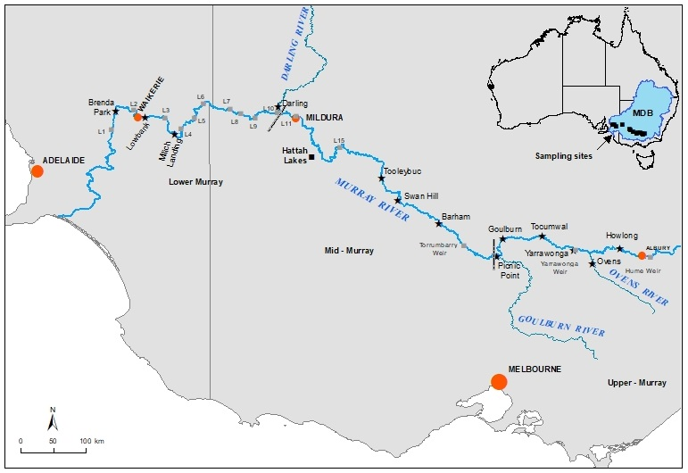

Figure 1: Map of the study area (southern connected Murray River). Grey dashed lines represent the boundaries between the lower, mid and upper Murray regions.

## Hattah Lakes

Hattah Lakes are located in the mid Murray region in north-western Victoria and comprise a complex of approximately 20 ephemeral, temporary and semipermanent freshwater lakes adjacent the Murray River (Figure 2). Historical, flooding of the Hattah Lakes was dependent upon the flow regime of the Murray River, but in 2013, a permanent pump station, and a series of regulators and levees were constructed at to enable environmental water to be delivered to the lakes, and a more frequent inundation regime. Since their construction, Hattah Lakes have been filled every year, excluding the year 2015-16 when the lakes were left to drawdown, yet did not completely dry. To investigate the influence of return flows from Hattah Lakes on riverine productivity, this study component focused on a 306 km reach of the Murray River from Euston (approximately 62 river km upstream of the Hattah Lakes inflow) to Fort Courage (approximately 172 river km downstream of the Hattah Lakes outflow).

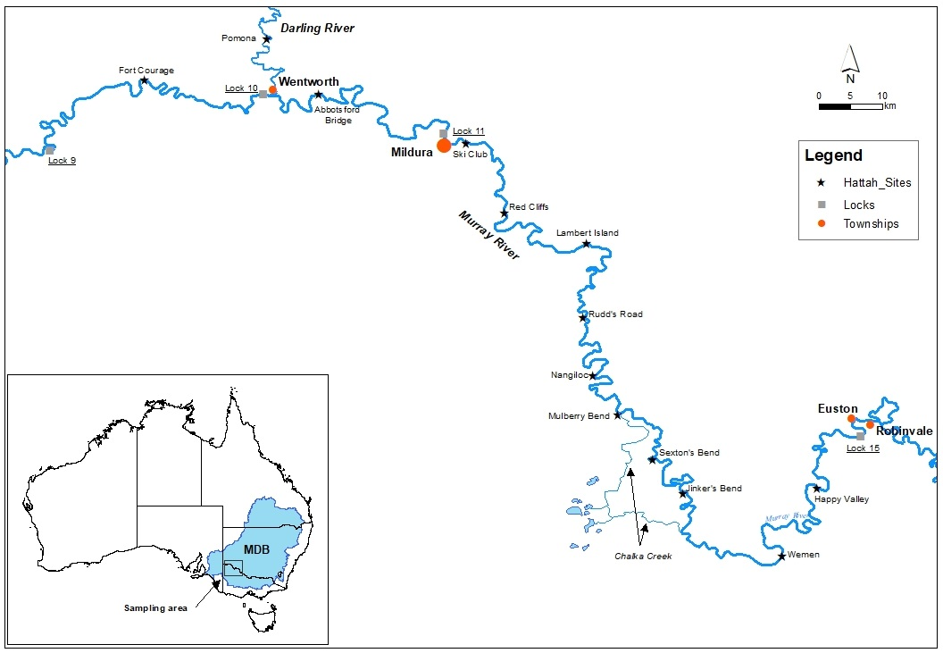

Figure 2: Map of the study area including the area of the Murray River upstream, adjacent to and downstream of Hattah Lakes.

# Methods

## Field Sampling

### System-scale sampling

In 2016–17, field trips were conducted in November 2016, February 2017 and May 2017. During each trip, three sites were sampled within each of the three regions of the Murray River, one site within each of the three major tributaries, and one site downstream of the Hume Dam, but upstream of the upper Murray region (Figure 1). In 2017–18, field trips were conducted in November 2017 and February 2018 (Figure 1). During each of these trips, three sites were sampled within the mid and lower Murray regions. At each site and on each occasion, the following parameters were examined: river hydraulics, nutrients, phytoplankton and zooplankton, with the exception of phytoplankton in November 2017 and February 2018. Methods for collection of data for each parameter are defined below.

### Hattah Lakes sampling

Three field trips were conducted between the beginning of October and the end of December 2017. The first field trip (October) was conducted during the period when water was being pumped into Hattah Lakes and the second (November) and third (December) during the period in which flows were being returned from Hattah Lakes to the main channel of the Murray River. Thirteen sites within the main channel of the Murray River were sampled on each occasion. This included two sites upstream, three sites adjacent to and seven sites downstream of Hattah Lakes (Figure 2). An additional site was sampled at Pomona in the Darling River to allow the differentiation of the influences of Hattah Lakes return flows and Darling River flows, on the Murray River (in the case that influences from Hattah Lakes reached that far downstream). At each site and on each occasion, the following parameters were examined: nutrients, phytoplankton and zooplankton. At Wemen, Jinkers Bend, Nangiloc, Lambert Island and the Ski Club (Figure 2), data on river hydraulics were also collected.

## River hydraulics

Cross-sectional velocity profiles were measured for both Objective 1 and Objective 2, using the same method. A total of three cross-sectional transects, ~2 km apart in the Murray and Darling Rivers and approximately 500 m apart in the Goulburn and Ovens Rivers, were undertaken at each site during each sampling event using a boat mounted SonTek River Surveyor M9 Acoustic Doppler Current Profiler (ADCP). ADCP measure the Doppler shift in acoustic signals as they are reflected off suspended particles in the water column. Transducers on the unit send acoustic pulses vertically into the water column and, after a brief blackout period, begin recording pulses reflected from suspended particles, assuming that the velocity of suspended particles equates to fluid flow velocities (Shields and Rigby, 2005). The water column is divided into depth ‘cells’ and the instrument uses the speed of sound in water to group reflected signals from given depth cells. Data, including water depth, heading, echo intensity and velocity are recorded at intervals of ~1 second and are used to produce measures of mean velocity for each depth cell. The ADCP unit was mounted on the gunwale of the boat and transects driven across a river reach to generate cross-sectional flow velocity profiles.

ADCP generated data were exported to the numerical computing program MATLAB and interpolated across grids with equal cell sizes (0.5 m long x 0.25 m high) using a linear, Delaney triangulation based, scattered interpolation. This processed data was then used to calculate various metrics to characterise hydraulics, including: 1) area of observation (m2); 2) discharge (ML.day-1); 3) mean cross-sectional velocity (m.s-1); and 4) Reynolds number, a dimensionless metric that indicates the level of turbulence in a cross-section.

## Nutrients and phytoplankton

At the halfway point of the second hydraulic transect, samples were collected for nutrient concentration analyses and for identification and counts of phytoplankton. Each sample was generated using a 4 L Haney trap, and transferring a discrete sample from the top, middle and bottom of the water column, to a pre-rinsed 20 L drum to produce a 12 L sample. Sub-samples (1 mL) were taken, processed and stored according to the Australian Water Quality Centre’s (AWQC’s) requirements for the following parameters: dissolved organic carbon (DOC); oxidised nitrogen (NOx); filterable reactive phosphorus (FRP); reactive silica (RSi); ammonia (NH­3); total phosphorus (TP); total Kjeldahl nitrogen (TKN); and phytoplankton identification and counts. If concentrations were below detectable levels, for the purpose of analysis, a concentration of zero was used. To calculate daily loads, nutrient concentrations were multiplied by the daily discharge at the closest location where discharge is measured and expressed as tonnes per day (T.day-1). At the same location, *in situ* measurements were taken for: dissolved oxygen; electrical conductivity; pH; turbidity; and water temperature using TPS 90-FLT water quality meter.

## Zooplankton

Composite zooplankton samples were collected at the halfway point of each of the three hydraulic transects. Each sample was collected as per the nutrient and phytoplankton samples. The total volume of each composite sample was concentrated to approximately 50 mL by filtering through a 30 μm net. Concentrated samples were then transferred to a 200 mL PET jar and preserved with 70% ethanol. Quantitative samples were inverted three times and a 1 mL sub-sample transferred into a pyrex gridded Sedgewick-Rafter cell. The entire sub-sample was counted, and zooplankton identified using a Leica compound microscope. The average number of zooplankton was calculated and expressed as numbers of individuals per litre (individuals L-1). The number of species identified within the sub-samples were used as an indication of species richness to enable comparisons between sites (hereafter ‘number of species/genera identified’). To calculate zooplankton daily load, expressed as numbers of individuals per day (ind.day-1), individuals per litre were multiplied by the daily discharge at the closest location where discharge is measured. Additionally, at each site, a highly concentrated qualitative zooplankton sample was taken using a 35 μm plankton net to assist with species/genus identification.

For objective one, to analyse differences in the zooplankton community structure (i.e. species identity and abundance), sites within the Murray River (excluding the site at Howlong) were treated as replicates for the upper, mid or lower Murray regions. Differences in the zooplankton community structure between trips and region/tributary, was analysed using a two-factor multi-variate PERMANOVA (Anderson et al., 2008). These analyses were performed on square-root transformed abundance data and Bray-Curtis similarity resemblance matrices (Anderson et al., 2008). Spatio-temporal variability in the zooplankton community structure among regions and tributaries was assessed graphically using MDS. When significant differences in main tests, pairwise comparisons of community structure were undertaken, and similarity percentages (SIMPER) analysis used to identify species contributing to these differences. A 40% cumulative contribution cut-off was applied.

# Results

## Hydrology and Hattah Watering

In late 2016, a large flood passed along the Murray River that peaked at approximately 180,000 ML.day-1 in mid-October in the upper Murray region, and 113,254 ML.day-1 in mid-November in the mid Murray (Figure 3 and Figure 4). At the time of the first sampling in November 2016, the flood had passed through the upper and mid Murray regions and was on the rising limb in the lower Murray (~40,000 ML.day-1 at Morgan (about bankfull level) before peaking at 72,501 ML.day-1 in late-December). For the remainder of the study period, discharge was low with the exception of elevated within-channel flow in November–December 2017. At the time of sampling in November 2017, flow was peaking in the upper Murray and on the rising limb in the mid and lower Murray regions.

A total of 112 GL of water was pumped from the Murray River into Hattah Lakes via Messengers pump station between the 3rd of July and the 31st of October 2017 (Figure 5). Of this, 54 GL was returned to the main river channel (33 GL via Messengers regulator and 21 GL via Oatey’s regulator) between the 2nd of November and the 22nd of February 2018. Due to increasing discharge in the Murray River upstream of the study area, discharge measured at Colignan in the Murray River increased over time from 8,108 ML.day-1 in October to 16,855 ML.day-1 in December. Over the sampling period, between 205 and 816 ML.day-1 and 117 and 634 ML.day-1 was released from Messenger’s and Oatey’s regulators, respectively. These discharges combined made up between 3 and 12 per cent of discharge in the Murray River measured downstream of Hattah at Colignan during the study period and approximately 9 and 5 per cent at the time of sampling in November and December 2017.

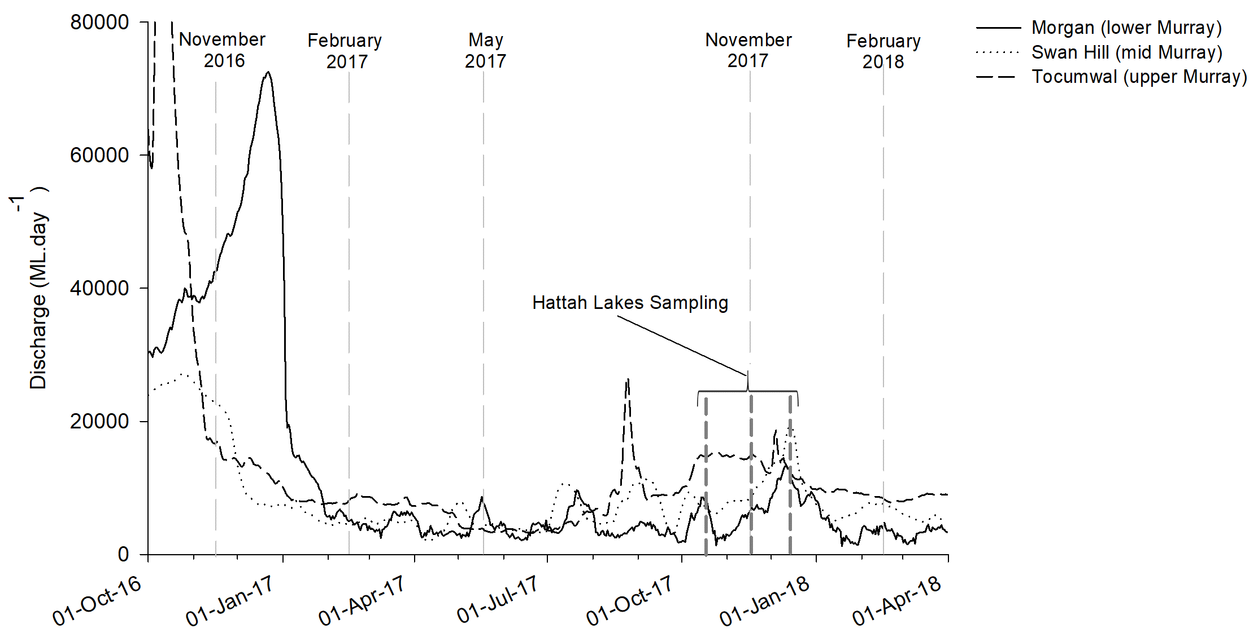

Figure 3: Discharge in the Murray River at Morgan, Swan Hill and Tocumwal during the study period. Light grey broken vertical bars indicate approximate timing of system-scale and dark grey broken vertical bars indicate Hattah Lakes sampling trips.

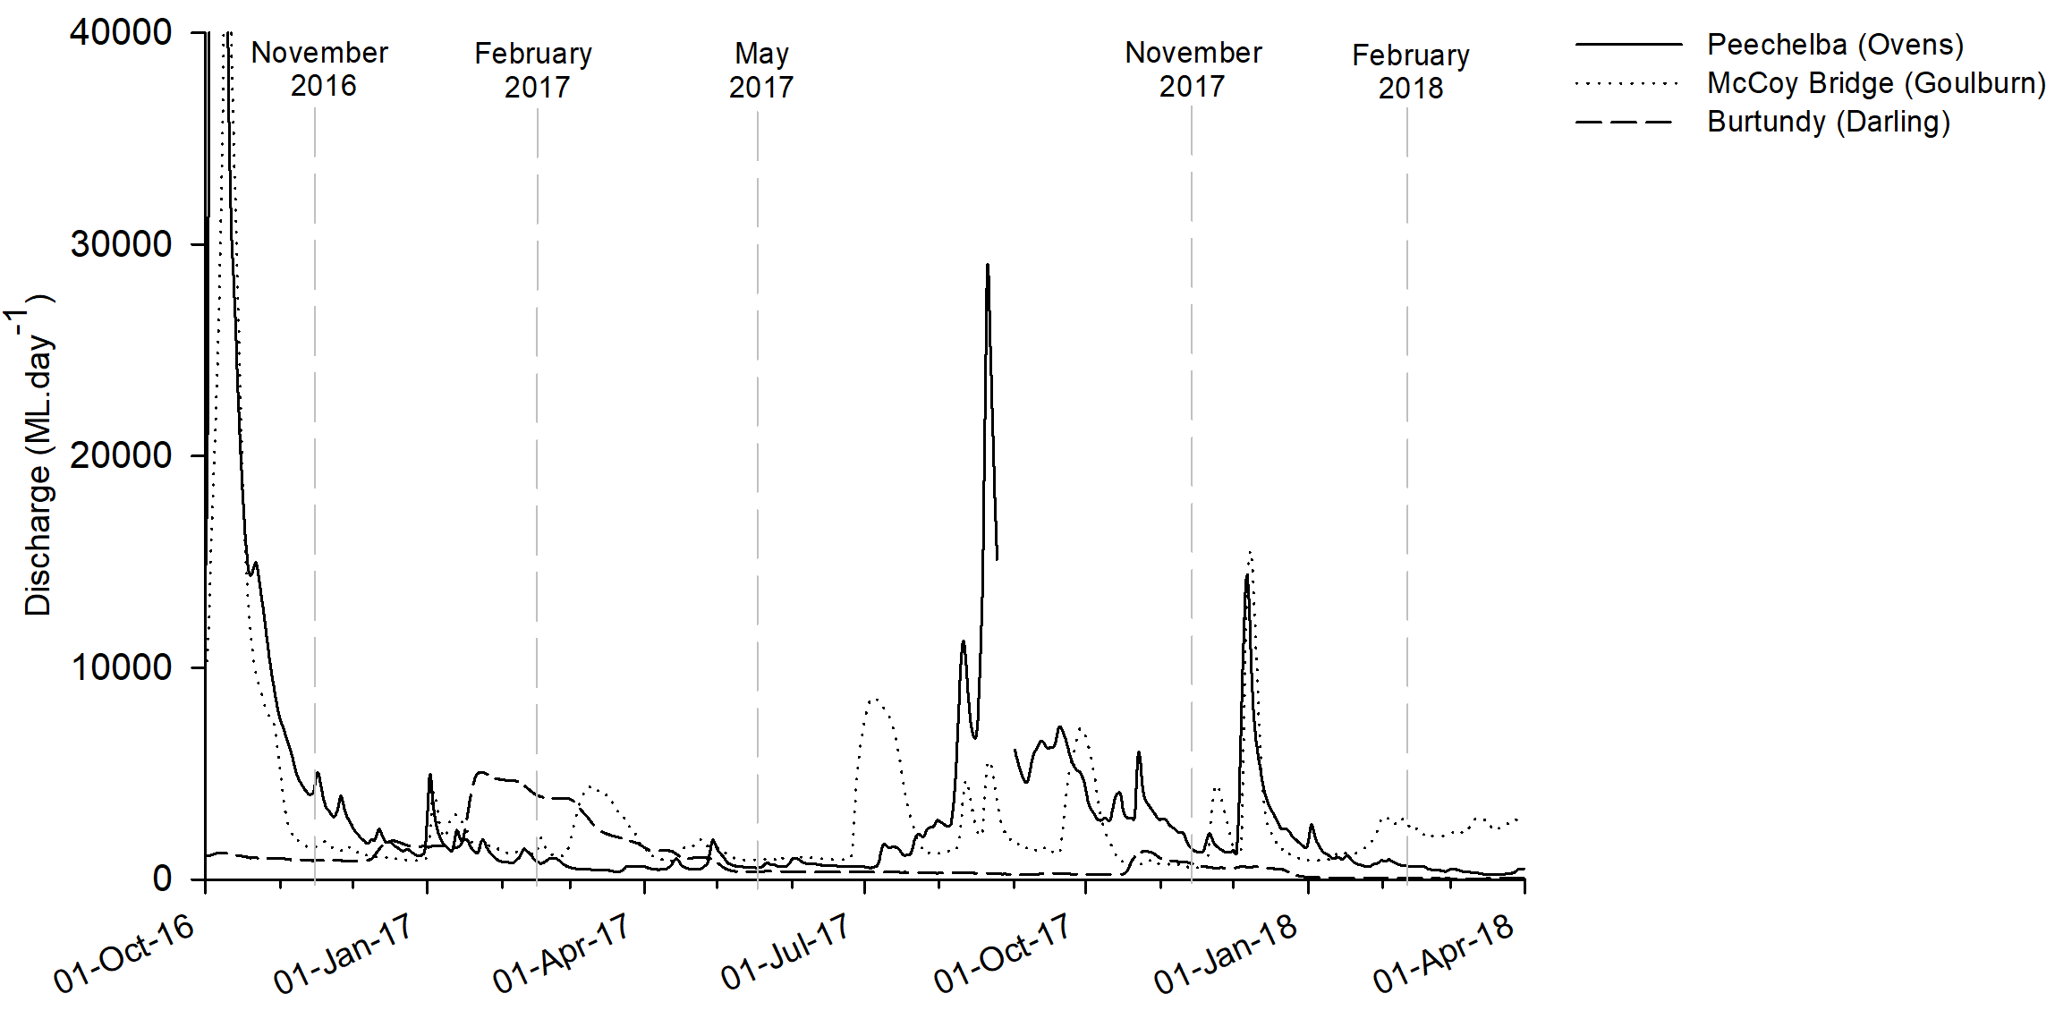

Figure 4: Discharge at Burtundy (Darling), McCoy Bridge (Goulburn) and Peechelba (Ovens) during the study period. Light grey broken vertical bars indicate approximate timing of system-scale sampling trips.

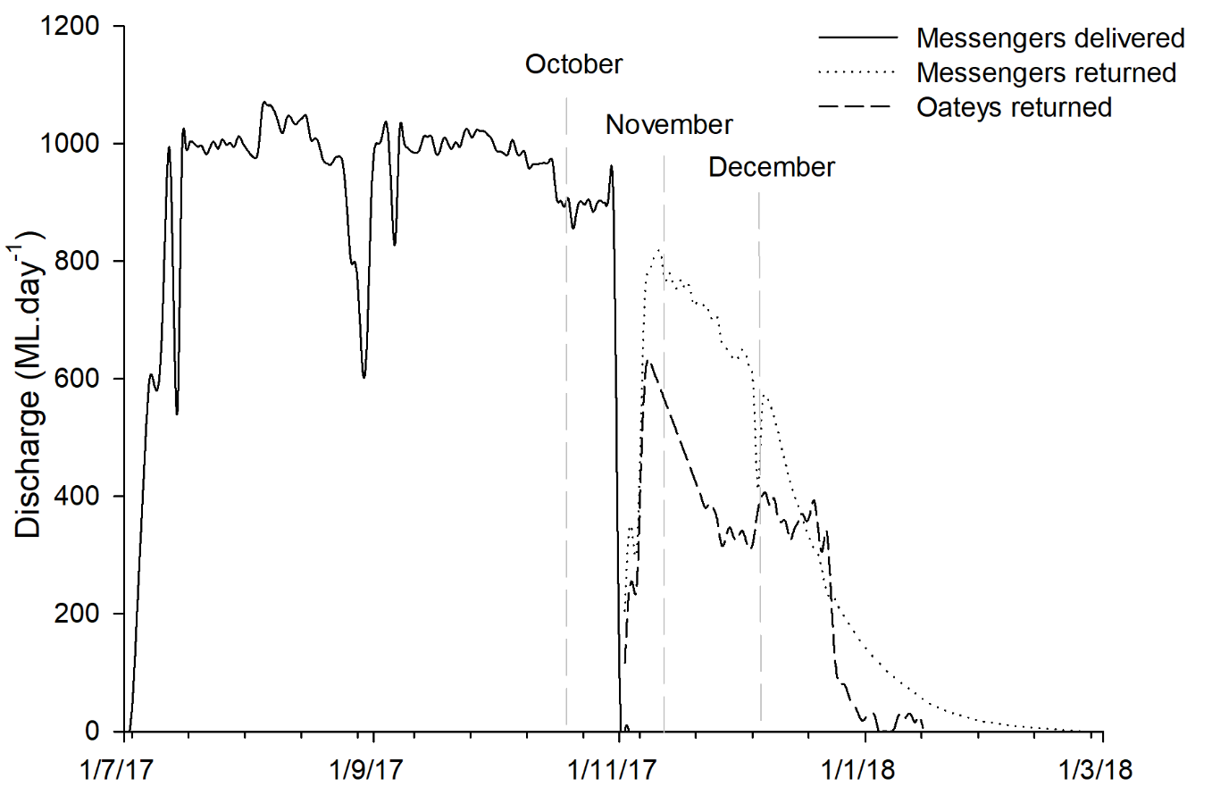

Figure 5: Discharge to Hattah Lakes via Messengers pump station and returning to the Murray River via Messengers and Oateys regulators during the study period. Light grey broken vertical bars indicate approximate timing of sampling trips for Hattah Lakes event.

## Objective 1 –System Scale

### Longitudinal nutrient, phytoplankton and zooplankton dynamics in the Murray River

#### Hydraulics

Throughout the study, riverine hydraulics varied longitudinally from Yarrawonga in the upper Murray to Brenda Park in the lower Murray, but patterns of spatial variability were different among hydraulic parameters and sampling events (Figure 6). As expected, area of observation, which is an indication of river cross-sectional area, increased in a downstream direction during all sampling events, and showed a general positive relationship with discharge. This reflects a general pattern of increasing depth and width of the river in a downstream direction, and the influence of discharge on water level.

Patterns of longitudinal variability in water velocity and turbulence were less consistent across sampling events. During high flow in November 2016, mean water velocity and Reynolds number (*Re*)*,* an indication of turbulence, increased longitudinally from 0.52 m.s-1 to 0.75 m.s-1 and 138,805 to 430,423, respectively, and were the highest for the study. All remaining sampling events occurred during comparatively low flow conditions throughout the Murray River, with associated changes in spatial patterns of variability in hydraulic metrics, characterised by general decreases in mean water velocity and turbulence in a downstream direction. This result is driven by varying degrees of temporal consistency in hydraulic conditions among the regions of the Murray River. For example, despite greatly varying discharge, mean velocity in the mid Murray ranged 0.5-0.64 m.s-1 during high flow in November 2016, and only minor decreases in ranges were observed during low flows in February 2017 (0.3-0.44 m.s-1), May 2017 (0.29-0.48 m.s-1), November 2017 (0.38–0.62 m.s-1) and February 2018 (0.16-0.22 m.s-1). However, in the lower Murray region, discrepancy in mean water velocity among high and low flow periods were stark. During November 2016, mean water velocity in the lower Murray ranged 0.62–0.75 m.s-1, but in February 2018, ranged just 0.081–0.11 m.s-1.

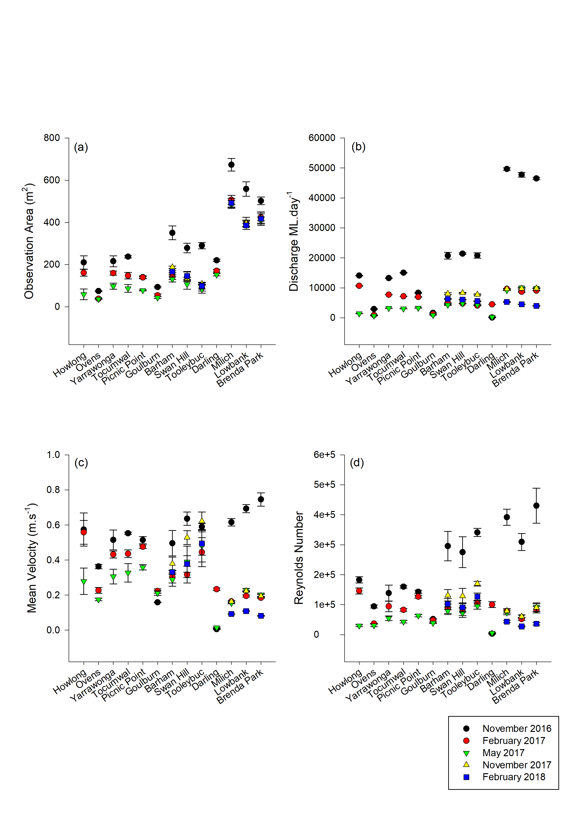

Figure 6: ADCP summary statistic plots including (a) mean cross sectional area (m2), (b) total discharge (ML.day-1), (c) mean velocity (m.s-1) and (d) Reynolds number. Sites are listed in the order in which they occur spatially along the Murray River from the site furthest upstream (Howlong) to the site furthest downstream (Brenda Park). The tributary sites, Darling, Goulburn and Ovens Rivers are between the two sites in which their intersection with the Murray River falls between.

#### Nutrients

In November 2016 when discharge was high, unsurprisingly nutrient concentrations were substantially higher than in February 2017 and May 2017 when discharge was relatively low (Table 1). For example in the lower Murray region, DOC and RSi were up to three-times greater in November 2016 than in November 2017 and February 2018). In November 2016, nutrient concentrations demonstrated consistent longitudinal trends from the upper Murray to the lower Murray (Table 1). Total nutrient (TP and TKN) concentrations increased longitudinally: TP from 0.034 to 0.24 mg.L-1 and TKN from 0.36 to 1.4 mg.L-1. All dissolved nutrients (excluding RSi) increased longitudinally: DOC increased from 4.1 to 18 mg.L-1, NH3 from 0.010 to 0.031 mg.L-1, NOx from 0.077 to 0.11 mg.L-1 and FRP from 0 to 0.070 mg.L-1. RSi was slightly higher in the upper than the mid Murray (5.0 and 3.3 mg.L-1, respectively), but was considerably higher in the lower Murray (8.7 mg.L-1).

Similarly, in February 2017, there was a longitudinal trend of increasing total nutrients (TP and TKN) and dissolved nutrients (DOC and FRP) from the upper Murray to the lower Murray (Table 1): TP increased from 0.045 to 0.087 mg.L-1, TKN from 0.40 to 0.60 mg.L-1., DOC from 3.7 to 8.6 mg.L-1 and FRP from 0 to 0.013 mg.L-1. However, contrary to November 2016, the dissolved nutrients NH­3 NOx and RSi were all considerably greater in the upper Murray than the mid and lower Murray regions: concentrations of NH3 were 0.017 mg.L-1 at the upper Murray and 0.0050 mg.L-1 in the mid and lower Murray, concentrations of NOx were 0.014 mg.L-1 at the upper Murray and 0−0.0017 mg.L-1 in the mid and lower Murray and RSi was only detected in the upper Murray at concentrations of 2.3 mg.L-1.

Similarly, in May 2017, there was a longitudinal trend of increasing total nutrients (TP and TKN) and dissolved nutrients (DOC and FRP) from the upper Murray to the lower Murray (Table 1): TP from 0.020 to 0.093 mg.L-1, TKN from 0.31 to 0.73 mg.L-1, DOC from 2.8 to 8.1 mg.L-1 and FRP from 0 to 0.014 mg.L-1.

In the lower and the mid Murray in November 2017, NH3, NOx and RSi were all below detectable limits (Table 1). All other nutrients were observed in greater concentrations in the lower Murray than the mid Murray. In the lower and the mid Murray in February 2018, RSi was again below detectable limits (Table 1), whilst all other nutrients were observed in greater concentrations in the lower Murray than the mid Murray (excluding NOx).

Table 1: Nutrient concentrations expressed in milligrams per litre (mg.L-1) at Howlong, Peechelba (Ovens), the upper Murray region (average of Yarrawonga, Tocumwal and Picnic Point), Yambuna (Goulburn), the mid Murray region (average of Barham, Swan Hill and Tooleybuc), Pomona (Darling) and the lower Murray (average of Brenda Park, Lowbank and Milich) region in November 2016, February 2017 and May 2017 and at the mid Murray and lower Murray regions in November 2017 and February 2018. FRP = filterable reactive phosphorus as P, TP = total phosphorus, NH3/NH4+ = ammonia as N, NOx = nitrite + nitrate, TKN = total Kjeldahl nitrogen, TKN = total Kjeldahl nitrogen as N, TON = total organic nitrogen, TIN = total inorganic nitrogen, DOC = dissolved organic carbon and RSi = reactive silica. All concentrations are reported to two significant figures. If concentrations were below detectable levels, concentrations of zero were used.

|  |  |  |  |  |  |  |  |  |
| --- | --- | --- | --- | --- | --- | --- | --- | --- |
|  |  | FRP | TP | NH3/NH­4+ | NOx | TKN | DOC | RSi |
| Nov-16 | Howlong | 0.014 | 0.045 | 0.007 | 0.38 | 0.32 | 3.8 | 9.0 |
|  | Ovens | 0.0060 | 0.025 | 0.025 | 0.23 | 0.30 | 2.2 | 10 |
|  | Upper Murray | 0 | 0.034 | 0.010 | 0.077 | 0.36 | 4.1 | 5.0 |
|  | Goulburn | 0 | 0.044 | 0.0080 | 0 | 0.54 | 8.3 | 0 |
|  | Mid Murray | 0.034 | 0.16 | 0.019 | 0.11 | 0.90 | 12 | 3.3 |
|  | Darling | 0.10 | 0.27 | 0.013 | 0.27 | 1.2 | 9.8 | 11 |
|  | Lower Murray | 0.070 | 0.24 | 0.031 | 0.11 | 1.4 | 18 | 8.7 |
| Feb-17 | Howlong | 0.0060 | 0.037 | 0.009 | 0.35 | 0.28 | 3.5 | 9.0 |
|  | Ovens | 0.0080 | 0.033 | 0.023 | 0.074 | 0.22 | 2.6 | 10 |
|  | Upper Murray | 0 | 0.045 | 0.017 | 0.014 | 0.40 | 3.7 | 2.3 |
|  | Goulburn | 0 | 0.052 | 0.007 | 0 | 0.37 | 3.4 | 0 |
|  | Mid Murray | 0.0010 | 0.058 | 0.005 | 0.0017 | 0.48 | 4.4 | 0 |
|  | Darling | 0.16 | 0.31 | 0.049 | 0.16 | 1.3 | 14 | 11 |
|  | Lower Murray | 0.013 | 0.087 | 0.005 | 0 | 0.6 | 8.6 | 0 |
| May-17 | Howlong | 0 | 0.017 | 0.006 | 0.053 | 0.23 | 2.4 | 3.0 |
|  | Ovens | 0.0030 | 0.070 | 0.019 | 0.13 | 0.34 | 1.6 | 8.0 |
|  | Upper Murray | 0.0 | 0.020 | 0.013 | 0 | 0.31 | 2.8 | 0 |
|  | Goulburn | 0.0 | 0.055 | 0.010 | 0 | 0.53 | 4.3 | 1.0 |
|  | Mid Murray | 0.0083 | 0.055 | 0.020 | 0.0030 | 0.46 | 5.3 | 0 |
|  | Darling | 0.17 | 0.28 | 0.014 | 0.0060 | 1.2 | 15 | 12 |
|  | Lower Murray | 0.014 | 0.093 | 0.011 | 0 | 0.73 | 8.1 | 2.3 |
| Nov-17 | Mid Murray | 0.0023 | 0.058 | 0 | 0 | 0.45 | 4.0 | 0 |
|  | Lower Murray | 0.011 | 0.097 | 0 | 0 | 0.64 | 5.5 | 0 |
| Feb-18 | Mid Murray | 0.0013 | 0.032 | 0.0053 | 0.0017 | 0.39 | 4.0 | 0 |
|  | Lower Murray | 0.0063 | 0.047 | 0.018 | 0.0010 | 0.60 | 5.8 | 0 |

#### Phytoplankton

In November 2016, diatoms dominated phytoplankton communities throughout the Murray River. The diatom *Aulacoseira*, was the most abundant phytoplankton, with greatest concentrations in the upper Murray (up to approximately 18,000 cells.mL-1 at Picnic Point) and lowest in the lower Murray (below 1,000 cells.mL-1 at Milich Landing), mirroring the general patterns observed in RSi, an important, and often limiting nutrient for diatoms concentrations (Figure 7 and Table 1). At the same time, the Darling River exhibited a distinct phytoplankton community consisting primarily of the diatoms *Cyclotella* and *Staurosira* and the biflagellate *Cryptomonas*.

In February 2017, phytoplankton concentrations in the Murray were greater than during November 2016, but community structure throughout the system exhibited a shift towards dominance by cyanobacteria of the genera *Anaphanocapsa* and *Cyanogranis*, whilst the diatom *Aulacoseria* remained abundant in the upper Murray (Figure 7). The potentially toxic cyanobacteria *Aphanocapsa* peaked at 143,000 cells.mL-1 in the mid Murray at Tooleybuc. In May 2017, there were no clear longitudinal trends in phytoplankton community structure and abundance, with each region exhibiting disparate communities (Figure 7). The site at Howlong was dominated by green algae from the genera *Chlorella;* the potentially toxic cyanobacteria *Aphanocapsa* was highly abundant at Picnic Point in the upper Murray region at 123,000 cells.mL-1; *Aulacoseria* remained dominant in the mid Murray, while in the lower Murray, *Planctomena* was dominant.

#### Zooplankton

Throughout the study, 2–44 species of zooplankton were identified per trap sample (Table 3), demonstrating high spatio-temporal variability in species richness in the Murray River. Average abundance of zooplankton also varied greatly between trips and sites, ranging from 8.7 (±4.4) ind.L-1 at the Ovens River during trip three to 10,717 (±972) ind.L-1 at the Darling River during trip one (Figure 8a). A PERMANOVA on community structure indicated that there was a significant interaction between region/tributary and trip (P=0.001), signifying that temporal variability in community structure was not consistent among regions/tributaries of the Murray River.

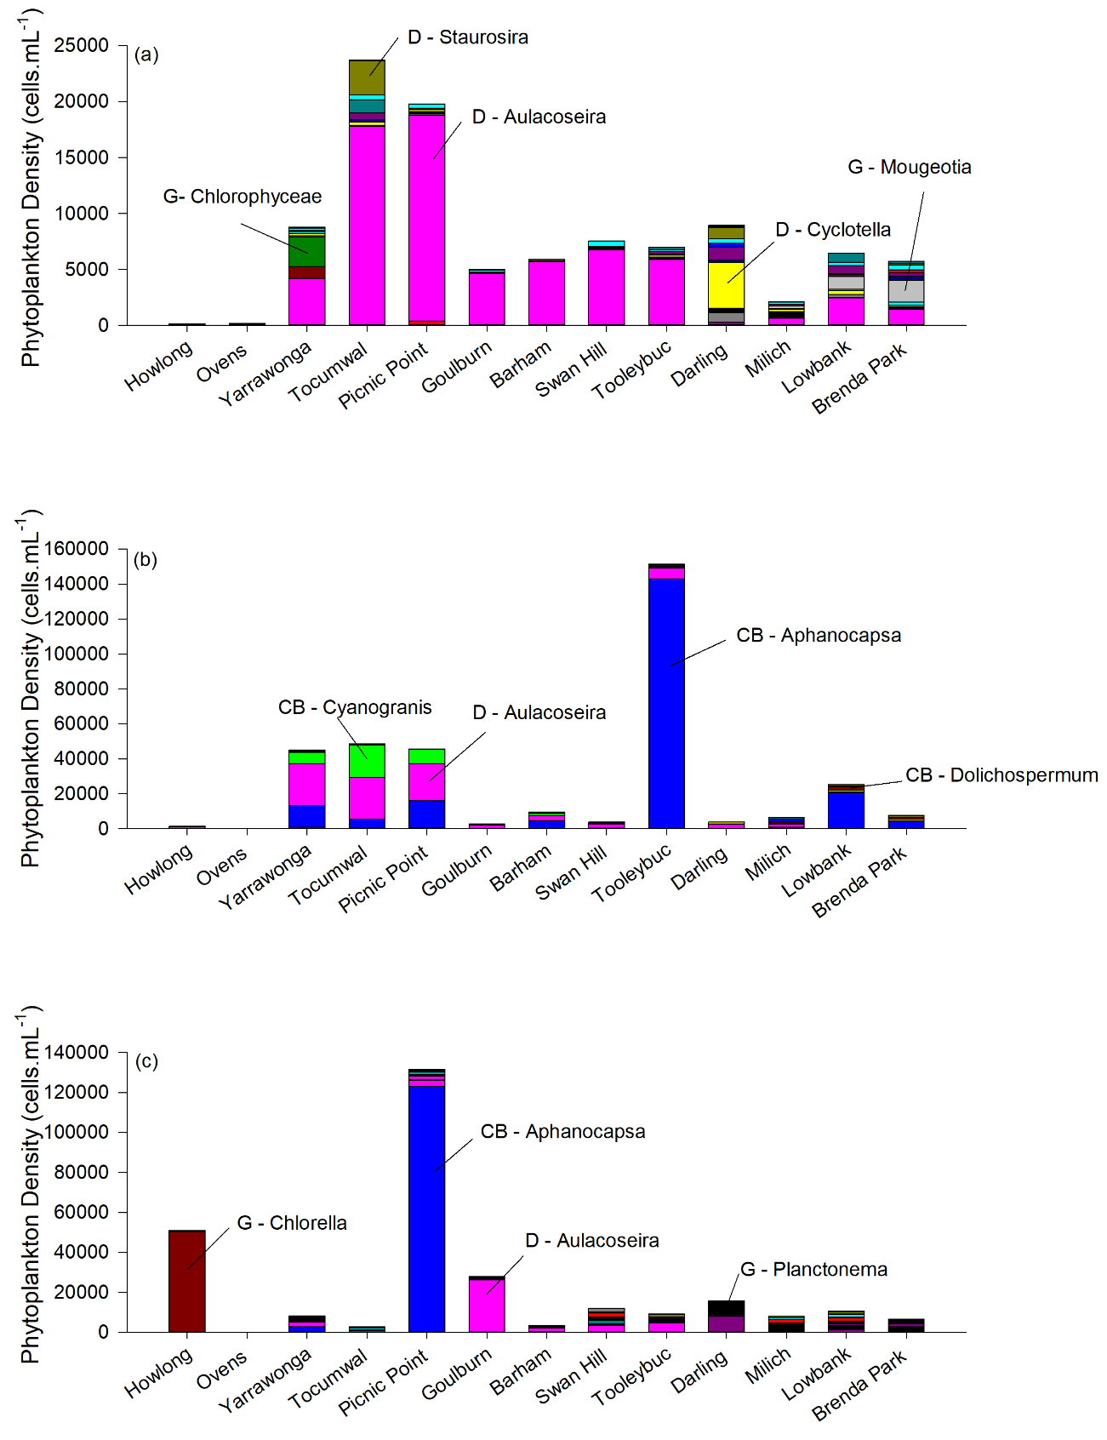

Figure 7: Differences in density (cells.mL-1) of phytoplankton in (a) November 2016, (b) February 2017 and (c) May 2017. Sites are listed in the order in which they occur spatially along the Murray River from the site furthest upstream (Howlong) to the site furthest downstream (Brenda Park). The tributary sites, Darling, Goulburn and Ovens are between the two sites in which their intersection with the Murray River falls between. Trip one (top), Trip two (middle), and Trip three (bottom). The main taxa of phytoplankton are labelled with corresponding D = diatom, CB = cyanobacteria or G = green algae

In November 2016, there was a longitudinal trend in zooplankton community structure as well as a general downstream increase in abundance and total load of zooplankton (Figure 8 and Figure 9). Pairwise comparisons revealed that, the mid Murray community structure was significantly different to the lower Murray region (P = 0.026). SIMPER indicated the primary contributors to variability between the lower and mid Murray during trip one were higher abundances of rotifer species in the lower Murray, including *Anauropsis fissa*, *Trichocerca pusilla/agnatha*, *Brachionus angularis*/*biden*s, *Keratella cochlearis*, *Conochilus dossuarius* cf., *Proalides tentaculatus* and *Brachionus quadridentatus*.

In February 2017, the overall zooplankton community and abundance did not demonstrate the longitudinal trend observed during November 2016 (Figure 8 and Figure 10). Pairwise comparisons revealed that zooplankton community structure between all three Murray River regions were significantly different (P = 0.025, 0.025 & 0.041). SIMPER indicated that the variability among regions was driven by a number of species. This included: (1) a decrease in the abundance of *Trichocerca pusilla/agnatha* in a downstream direction, (2) the presence and high abundance of *Keratella americana* in the lower Murray and the absence of species including *Polyarthra dolichoptera/vulgaris*, *Keratella lenzii*, *Filinia pejleri* and *Keratella cochlearis* in the mid Murray that were prominent in the lower and/or upper Murray. For example, the abundance of *Polyarthra dolichoptera/vulgaris* was 815 ind.L-1 in the upper Murray and 540 ind.L-1 in the lower Murray yet this species was absent in the mid Murray. The absences of species in the mid Murray coincided with the high densities of the cyanobacterium *Aphanocapsa* (Figure 7). The zooplankton community in the lower Murray region was comprised of a much higher percentage of copepods (4.5−5.5%) than the mid (0−3.2%) or upper Murray (0.4−1.7%) despite having similar total zooplankton abundances to the upper Murray sites (both the lower and mid Murray between 3,500 and 4,500 ind.L-1) (Table 3 and Figure 8a).

In May 2017, there was again a longitudinal trend in zooplankton community as well as a general increase in abundance and total load of zooplankton from 956 to 2,149 ind.L-1 and 3.23 x 1012 to 1.86 x 1013 ind.day-1, respectively, from the upper Murray at Yarrawonga to the lower Murray at Brenda Park (Figure 8 and Figure 11). Pairwise comparisons revealed that zooplankton community structure at the mid and upper Murray regions were significantly different to the lower Murray (P = 0.0294 & 0.0119). SIMPER indicated that the primary contributors to variability among regions was due to a longitudinal decrease in abundance of *Trichocerca similis* cf. and a longitudinal increase in the abundance of *Brachionus angularis*, *Proalides*, *Hexarthra intermedia* and *Synchaeta* in a downstream direction.

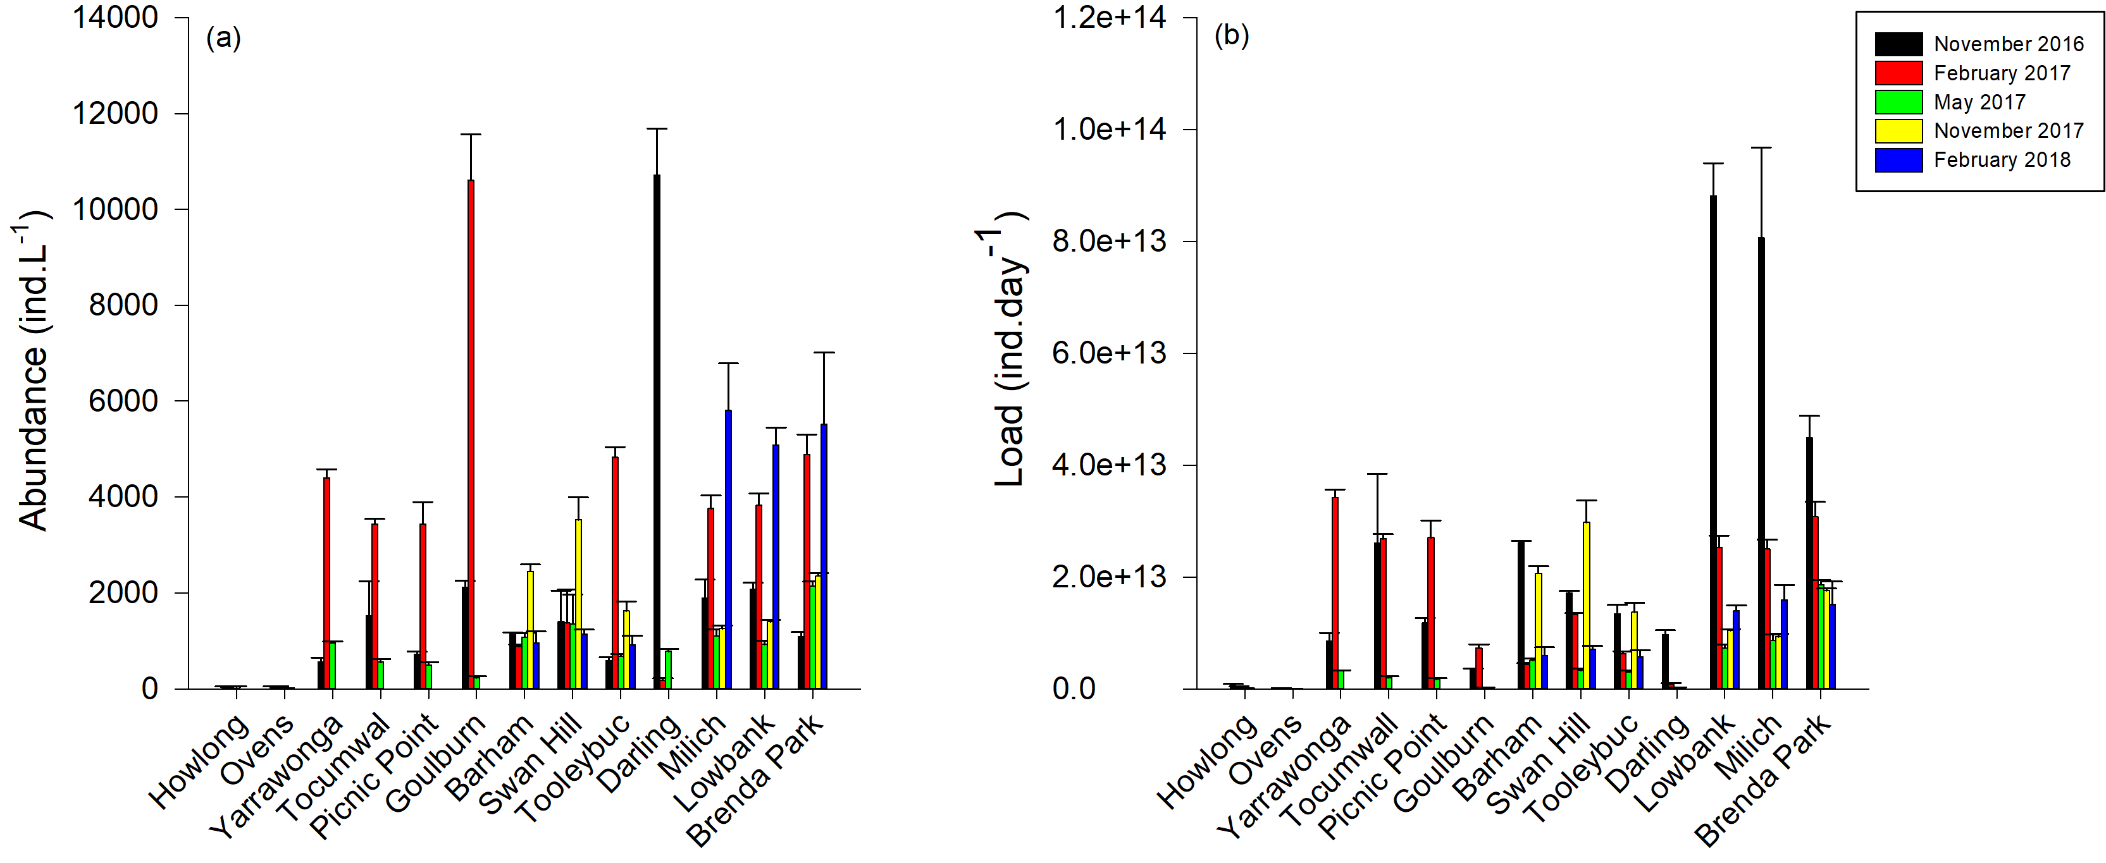

Figure 8: Differences in average number of (a) individuals per litre (ind.L-1) and (b) daily load (ind.day-1) of total zooplankton (±1SE). Sites are listed in the order in which they occur spatially along the Murray River from the site furthest upstream (Howlong) to the site furthest downstream (Brenda Park). The tributary sites, Darling, Goulburn and Ovens are between the two sites in which their intersection with the Murray River falls between.

In November 2017, abundance and total load of zooplankton was greater in the mid Murray region (1,626-3,526 ind.L-1 and 1.4 x 1013-3 x 1013 ind.day-1, respectively) in comparison to the lower Murray (1,253-2,359 ind.L-1 and 9.3 x 1012-1.8 x 1013 ind.day-1, respectively). Pairwise comparisons revealed that zooplankton community structure at the mid Murray region was significantly different to the lower Murray (P = 0.0157). SIMPER indicated that the primary contributors to variability among regions was due to greater abundance of *T.pusilla*/*agnatha*, an unidentified *Trichocera sp.* and *Polyarthra dolichoptera*/*vulgaris* in the mid Murray region and greater abundance of *Brachionus angularis/bidens*, *Keratella americana* and *Keratella tropica* in the lower Murray.

In February 2018, abundance and total load of zooplankton was lower in the mid Murray region (919-1,145 ind.L-1 and 5.7 x 1012-7.1 x 1012 ind.day-1, respectively) in comparison to the lower Murray (5,087-5,812 ind.L-1 and 1.4 x 1013-1.6 x 1013 ind.day-1, respectively). Pairwise comparisons revealed that zooplankton community structure at the mid Murray region was significantly different to the lower Murray (P = 0.0054). SIMPER indicated that the primary contributors to variability among regions was due to greater abundance of *Keratella lenzii cf.*, *Keratella americana*, *Polyarthra dolichoptera/vulgaris* and *Trichocerca similis* in the lower Murray region.

### Nutrient, phytoplankton and zooplankton dynamics in major tributaries

The Ovens River was characterised by high concentrations of RSi, low densities of phytoplankton and low abundance and number of zooplankton species (Table 1, Figure 7, Table 3 and Figure 8). Concentrations of RSi were high in the Ovens River on all occasions in comparison to the Murray River sites and resulted in comparatively large contributions of approximately 34, 11 and 6.1 T.day-1 to the upper Murray in November 2016, February 2017 and May 2017, when loads were approximately 82, 18 and 0 T.day-1, respectively (Table 2). The Ovens River had lower phytoplankton densities (111−442 cells.L-1), zooplankton abundance (9−41 ind.L-1) and number of zooplankton species (2−9 species) than all other tributaries and the three Murray River regions.

The site below the Hume Dam at Howlong was characterised by high concentrations of NOx, low densities of phytoplankton and low abundance and number of zooplankton species (Table 1, Figure 7, Table 3 and Figure 8). Concentrations of NOx were consistently high at the site at Howlong (0.38, 0.35 and 0.053 mg.L-1 in November 2016, February 2017 and May 2017, respectively) in comparison with the upper Murray region (0.077, 0.014 and 0 mg.L-1, respectively) resulting in substantial loads being transported downstream (6.3, 4.2 and 0.078 T.day-1, respectively) (Table 2). Typical of areas downstream of dams where water is released from the hypolimnion (the lower layer of water in a stratified waterbody), water temperature was colder during trip one (18°C) and trip two (20°C) than the upper Murray region (~22°C and 27°C, respectively). These colder waters were associated with very low densities of phytoplankton (161 and 1,519 cells.mL-1, respectively) (Figure 7), low zooplankton species/genera richness (8 and 4 species/genera) and abundance (36 and 25 ind.L1), and zooplankton community structures that were significantly different to all other tributary and Murray River regions during trip one and trip two (P=0.0019−0.044).

Table 2: Nutrient loads per day expressed in metric tonnes per day (T.day-1) at Howlong, Peechelba (Ovens), the upper Murray region (average of Yarrawonga, Tocumwal and Picnic Point), Yambuna (Goulburn), the mid Murray region (average of Barham, Swan Hill and Tooleybuc), Pomona (Darling) and the lower Murray (average of Brenda Park, Lowbank and Milich) region in November 2016, February 2017 and May 2017 and at the mid Murray and lower Murray regions in November 2017 and February 2018. All loads are reported to two significant figures. If concentrations were below detectable levels, concentrations of zero were used.

|  |  |  |  |  |  |  |  |  |
| --- | --- | --- | --- | --- | --- | --- | --- | --- |
|  |  | FRP | TP | NH­4+ | NOx | TKN | DOC | RSi |
| Nov-16 | Howlong | 0.23 | 5.4 | 0.12 | 6.3 | 0.75 | 64 | 150 |
|  | Ovens | 0.020 | 1.0 | 0.085 | 0.77 | 0.085 | 7.5 | 34 |
|  | Upper Murray | 0 | 5.9 | 0.16 | 1.3 | 0.55 | 67 | 82 |
|  | Goulburn | 0 | 0.87 | 0.013 | 0 | 0.071 | 13 | 0 |
|  | Mid Murray | 0.76 | 20 | 0.44 | 2.4 | 3.5 | 270 | 76 |
|  | Darling | 0.092 | 1.0 | 0.012 | 0.25 | 0.24 | 8.8 | 9.9 |
|  | Lower Murray | 2.9 | 55 | 1.3 | 4.7 | 9.8 | 755 | 360 |
| Feb-17 | Howlong | 0.073 | 3.4 | 0.11 | 4.2 | 0.45 | 43 | 110 |
|  | Ovens | 0.0090 | 0.25 | 0.026 | 0.083 | 0.037 | 2.9 | 11 |
|  | Upper Murray | 0 | 3.1 | 0.13 | 0.11 | 0.34 | 29 | 18 |
|  | Goulburn | 0 | 0.49 | 0.0092 | 0 | 0.068 | 4.0 | 0 |
|  | Mid Murray | 0.0050 | 2.4 | 0.025 | 0.0084 | 0.29 | 22 | 0 |
|  | Darling | 0.73 | 6.0 | 0.22 | 0.74 | 1.4 | 62 | 50 |
|  | Lower Murray | 0.082 | 3.8 | 0.032 | 0 | 0.55 | 54 | 0 |
| May-17 | Howlong | 0 | 0.34 | 0.0088 | 0.078 | 0.025 | 3.5 | 4.4 |
|  | Ovens | 0.0023 | 0.26 | 0.015 | 0.10 | 0.054 | 1.2 | 6.1 |
|  | Upper Murray | 0 | 1.1 | 0.046 | 0 | 0.068 | 10 | 0 |
|  | Goulburn | 0 | 0.51 | 0.01 | 0 | 0.053 | 4.1 | 0.96 |
|  | Mid Murray | 0.044 | 2.4 | 0.1 | 0.016 | 0.29 | 28 | 0 |
|  | Darling | 0.062 | 0.43 | 0.005 | 0 | 0.10 | 5.4 | 4.28 |
|  | Lower Murray | 0.12 | 6.3 | 0.095 | 0 | 0.80 | 70 | 20 |
| Nov-17 | Mid Murray | 0.020 | 3.8 | 0 | 0 | 0.49 | 34 | 0 |
|  | Lower Murray | 0.079 | 4.7 | 0 | 0 | 0.72 | 41 | 0 |
| Feb-18 | Mid Murray | 0.0083 | 2.4 | 0.033 | 0.010 | 0.20 | 25 | 0 |
|  | Lower Murray | 0.017 | 1.6 | 0.050 | 0 | 0.13 | 16 | 0 |

The Darling River was characterised by high concentrations of nutrients, a distinct phytoplankton community, high abundance of zooplankton and a distinct zooplankton community (Table 1, Figure 7 and Figure 8). Concentrations of DOC, RSi, FRP, TP and TKN were highest in the Darling during February 2017 and resulted in comparatively large contributions of approximately 62, 50, 0.73, 6 and 1.4 T.day- 1 to the lower Murray, where loads were approximately 54, 0, 0.080, 3.8 and 0.55 T.day-1, respectively (Table 2). Zooplankton abundance was highest during November 2016 (10,717 ind.L-1), but low discharge resulted in only low loads of zooplankton (9.6 x 1012 ind.day-1) in comparison to those in the lower Murray region (8.8 x 1013 ind.day-1). Zooplankton community structure was significantly different in the Darling River to all other tributaries and the three Murray River regions on all occasions excluding Howlong during trip three (P=0.0004−0.026). SIMPER analysis revealed that this was primarily driven by considerable differences in individual rotifer species abundances. For example, during November 2016, the average abundance of the rotifer *Polyarthra dolichoptera/vulgaris* was 5,700 ind.L-1 in the Darling and 158 ind.L-1 in the lower Murray and during February 2017 the abundance of the rotifer *Synchaeta pectinata* was zero in the Darling in comparison to 540 ind.L-1 in the lower Murray.

The Goulburn River was characterised by low concentrations of nutrients and an abundant and distinct zooplankton community (Table 1, Figure 7 and Figure 8). Concentrations of the dissolved nutrients FRP, NOx and RSi were below detectable limits on all occasions, excluding RSi in May 2017. Zooplankton abundance was highest during February 2017 (10,602 ind.L-1). Due to low discharge, these high abundances did not equate to high loads (7.34 x 1012 ind.day-1) in comparison to those in the upper Murray region (2.7−3.43 x 1013 ind.day-1) but did in comparison to those in the mid Murray region (4.39 x 1012–1.33 x 1013) (Table 2). Zooplankton community structure was significantly different to all other tributary and Murray River regions on all occasions excluding Howlong during trip three (P=0.0008−0.033). SIMPER analysis revealed that this was driven by higher abundances of species such as *Filinia* cf. *longiseta*, *Trichocera pusilla/agnatha*, *Keratella cochlearis* and *Conochilus* cf. *dossuarius* during November 2016 and February 2017, the absence of species such as *Keratella* cf. *lenzii* and *Keratella javana* that were present in the upper and lower Murray regions in February 2017, and lower abundances of species present within the Murray River during May 2017.

Table 3: Summary of zooplankton community structure including the number of species/genera identified (No. ID) when processing quantitative counts (species richness) and the percentage of total community abundance of the four main groups of zooplankton, rotifers (R), cladocerans (Cl), copepods (Co) and ostracods (O).

|  |  |  |  |  |  |  |  |  |  |  |
| --- | --- | --- | --- | --- | --- | --- | --- | --- | --- | --- |
|  | **November 2016 (Spring)** | | **February 2017 (Summer)** | | **May 2017 (Autumn)** | | **November 2017 (Spring)** | | **February 2018 (Summer)** | |
|  | **No. ID** | **R | Cl |Co | O** | **No. ID** | **R | Cl |Co | O** | **No. ID** | **R | Cl |Co | O** | **No. ID** | **R | Cl |Co | O** | **No. ID** | **R | Cl |Co | O** |
| **Howlong** | 8 | 51.3|36.5|12.2|0 | 4 | 100|0|0|0 | 8 | 100|0|0|0 | - | - | - | - |
| **Ovens** | 5 | 83.1|0|16.9|0 | 9 | 80.2|19.8|0|0 | 2 | 100|0|0|0 | - | - | - | - |
| **Yarrawonga** | 20 | 99.2|0|0.8|0 | 29 | 99|0.6|0.4|0 | 15 | 98.3|0|1.7|0 | - | - | - | - |
| **Tocumwal** | 32 | 98.3|0|1.7|0 | 28 | 99.2|0|0.8|0 | 15 | 99.1|0|0.9|0 | - | - | - | - |
| **Picnic Point** | 24 | 96.3|1.2|2.5|0 | 35 | 97.7|0.6|1.7|0 | 17 | 99.1|0|0.9|0 | - | - | - | - |
| **Goulburn** | 23 | 98.7|1.3|0|0 | 13 | 99.8|0.2|0|0 | 14 | 100|0|0|0 | - | - | - | - |
| **Barham** | 27 | 97.4|2.2|0.4|0 | 12 | 90.4|6.4|3.2|0 | 22 | 98.9|0|1.1|0 | 11 | 100 | 0 | 0 | 0 | 22 | 234 | 2 | 2 | 0 |
| **Swan Hill** | 33 | 96.4|3.1|0.5|0 | 19 | 97.3|0.5|2.1|0 | 16 | 97.9|0|2.1|0 | 12 | 100 | 0 | 0 | 0 | 19 | 173 | 1 | 1 | 0 |
| **Tooleybuc** | 29 | 98.6|0.7|0.7|0 | 19 | 100|0|0|0 | 20 | 97.8|0|2.2|0 | 12 | 100 | 0 | 0 | 0 | 23 | 143 | 4 | 2 | 0 |
| **Darling** | 21 | 99.3|0.6|0.2|0 | 13 | 37.2|20|42.8|0 | 15 | 79.4|0|20.6|0 | - | - | - | - |
| **Milich** | 26 | 100|0|0|0 | 24 | 93.2|1.3|5.5|0 | 27 | 98.4|1.6|0|0 | 21 | 95 | 4 | 1 | 0 | 22 | 976 | 16 | 33 | 0 |
| **Lowbank** | 34 | 98.7|0.9|0.2|0.2 | 23 | 95.5|0|4.5|0 | 21 | 100|0|0|0 | 44 | 95 | 5 | 0 | 0 | 41 | 902 | 13 | 20 | 0 |
| **Brenda Park** | 24 | 99.1|0|0.9|0 | 26 | 94|0.8|5.2|0 | 29 | 97.1|2.1|0.8|0 | 26 | 95 | 4 | 1 | 0 | 23 | 903 | 16 | 10 | 0 |

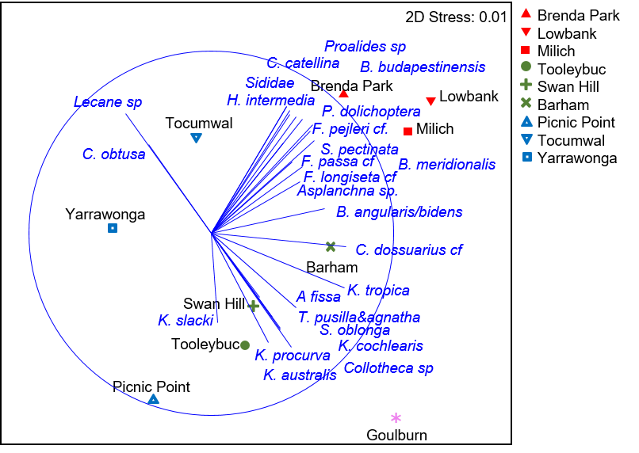

Figure 9: Nonmetric Multidimensional Scaling (MDS) ordination of zooplankton community structure across all upper Murray, mid Murray, lower Murray and tributary sites during November 2016. Differences between sites including Howlong, the Ovens and the Darling masked visual differences between sites within the Murray River, therefore to allow these differences to be shown, these sites fall outside of the bounds of the graph presented. Correlation = 0.4.

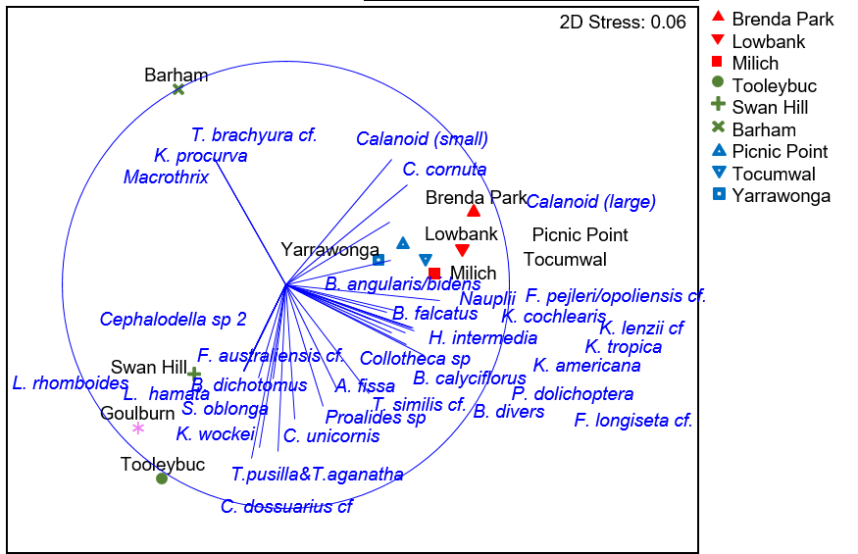

Figure 10: Nonmetric Multidimensional Scaling (MDS) ordination of zooplankton community structure across all upper Murray, mid Murray, lower Murray and tributary sites during February 2017. Differences between sites including Howlong, the Ovens and the Darling masked visual differences between sites within the Murray River, therefore to allow these differences to be shown, these sites fall outside of the bounds of the graph presented. Correlation = 0.4.

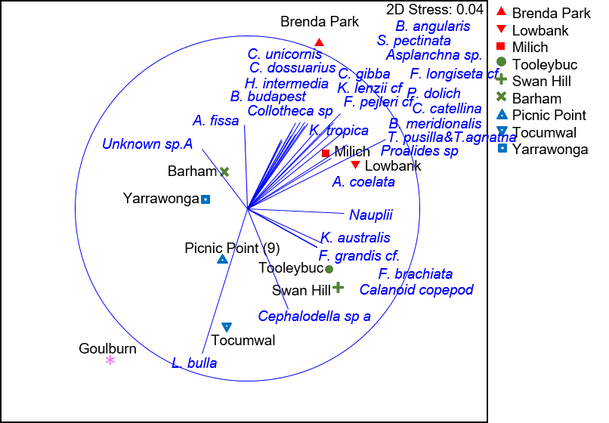

Figure 11: Nonmetric Multidimensional Scaling (MDS) ordination of zooplankton community structure across all upper Murray, mid Murray, lower Murray and tributary sites during May 2017. Differences between sites including Howlong, the Ovens and the Darling masked visual differences between sites within the Murray River, therefore to allow these differences to be shown, these sites fall outside of the bounds of the graph presented. Correlation = 0.4.

## Objective 2 – Hattah Lakes

A PERMANOVA on zooplankton abundance data indicated that there was a significant interaction between site and trip (P=0.001), suggesting spatial patterns of variability were not consistent among October, November and December 2017 sampling events (Figure 12). In October, prior to the release of water from Hattah Lakes, zooplankton abundance in the Murray River was similar at all sites between Happy Valley (~64 river km upstream of the Hattah Lakes) and Lambert Island (~60 river km downstream of the Hattah Lakes), with significant increases observed at the sites further downstream (below Lock 11) at Abbotsford Bridge and Fort Courage (P=0.0001−0.04). In November, during return discharge from Hattah Lakes, zooplankton became increasingly more abundant in a downstream direction from Jinkers Bend (immediately downstream of Messengers Regulator) to Fort Courage. Zooplankton abundances were significantly lower at sites upstream of Hattah (i.e. Happy Valley = 519 ind.L-1 and Wemen = 577 ind.L-1) than all sites downstream of Nangiloc (997−2,686 ind.L-1) (P=0.0001−0.005). Again, in December, zooplankton became increasingly more abundant in a downstream direction. However, contrary to in October and November, an increase was observed at the two sites downstream of Messengers regulator, Jinkers Bend and Sextons Bend and at the second site downstream of Oateys Regulator, Rudd’s Road. This resulted in zooplankton abundance being significantly greater at Sextons Bend (1,796 ind.L-1) and Rudd’s Road (1,936 ind.L-1) than at the two sites upstream of Hattah Lakes, Happy Valley (1,174 ind.L-1) and Wemen (1,136 ind.L-1) (P=0.002−0.02). Also in December, spikes in chlorophyll-a concentration were evident at sites downstream of Messengers and Oateys Regulators at Jinkers Bend and Rudds Road.

A PERMANOVA on zooplankton community structure indicated that there was a significant interaction between site and trip (P=0.001) signifying that temporal variability in community structure was not consistent among sites. Pairwise comparisons, however, revealed no significant difference in community structure between sites upstream of Hattah Lakes (Happy Valley and Wemen) and sites directly downstream of Messengers (excluding Mulberry Bend in October) and Oatey’s Regulators on any occasion. As such, return flow from Hattah Lakes appeared not to influence zooplankton community structure, but had a positive influence on abundance in the Murray River immediately downstream (Figure 13).

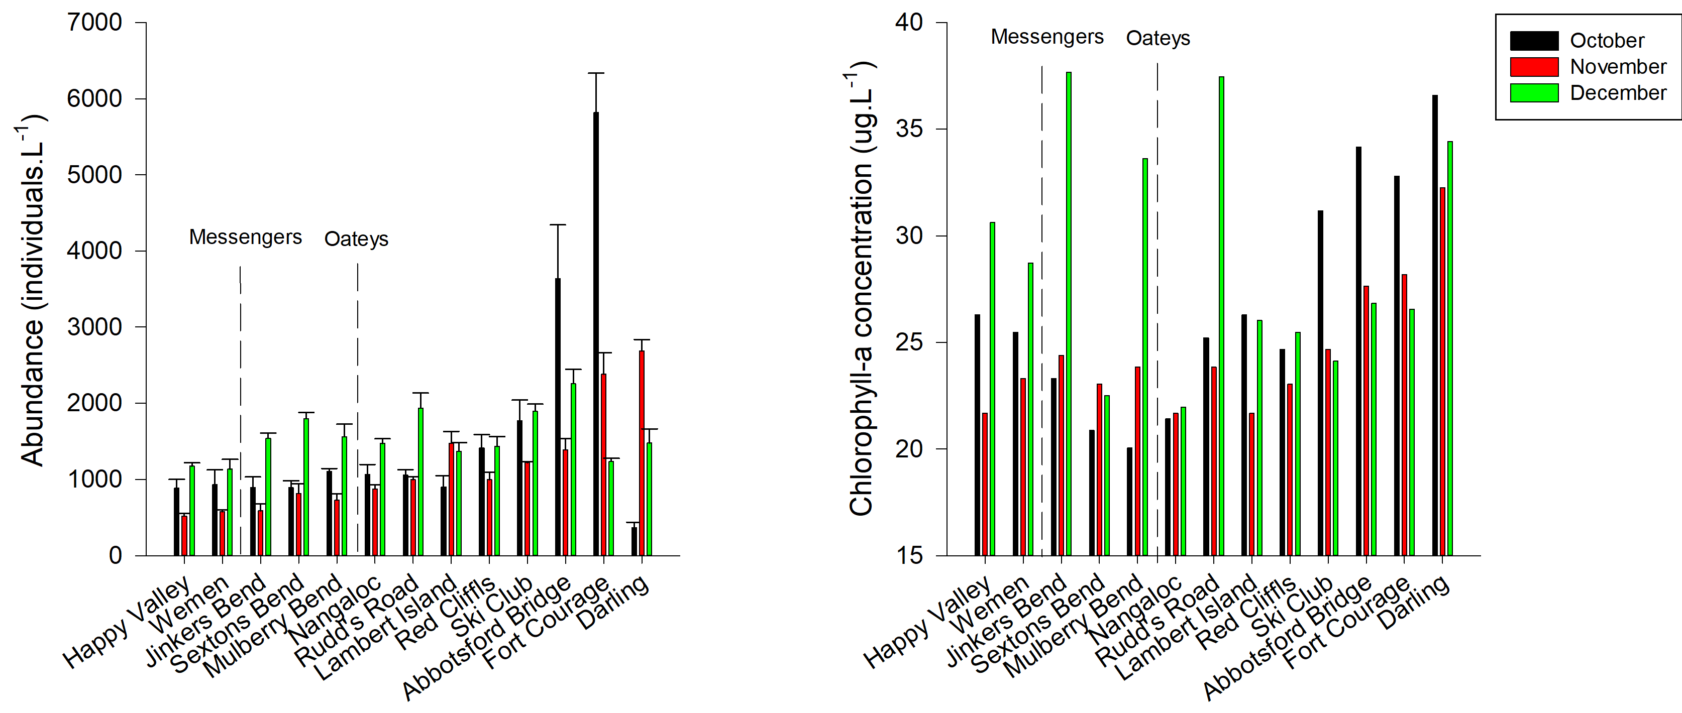

Figure 12: Average total abundance of zooplankton (±1SE) including rotifers, cladocerans and copepods and chlorophyll-a concentration (ug.L-1) at each site at the time of sampling in October, November, and December 2017. Grey broken vertical bars indicate the location of Messengers and Oateys regulators.

A close up of a light

Description generated with high confidence

Figure 13: Nonmetric Multidimensional Scaling (MDS) ordination of zooplankton community structure across all sampling sites for the Hattah Lakes return flow event during October, November and December 2017. Correlation = 0.4.

# Discussion

The primary aim of this study was to investigate longitudinal variability in physico-chemical and ecological parameters along the Murray River under a range of hydrological scenarios. An understanding of the influence of flow on spatial variability in these parameters will provide insights into the drivers of lower trophic level structure and function. This can then be used to inform how translucent flow delivery (water that is allowed to pass downstream unimpeded by regulating structures with the aim of maintaining longitudinal integrity of flow) may influence the transfer of energy throughout the food web and trophic level responses. There were two components to this investigation. The first was a broad spatial and temporal scale study, which investigated longitudinal changes in lower trophic structure within the main river channel. Longitudinal trends in resources, including nutrients, phytoplankton and zooplankton, were substantially different along the Murray River under different hydrological scenarios and at different times of the year. Flooding and high spring discharge (which peaked at ~72,000, 113,000 and 180,000 ML.day-1 in the lower, mid and upper Murray respectively) in 2016 resulted in a broad range of hydraulic conditions, clear longitudinal trends, high availability of resources, a diatom dominated phytoplankton community and a zooplankton community dominated by diatom consumers. In comparison, low summer discharge (~5,000–8,500 ML.day-1 in the Murray River) was characterised by disparate phytoplankton and zooplankton communities among the regions of the Murray, generally with high densities of cyanobacteria, and in the lower Murray region, high abundance of the rotifer *Keratella americana*, a species only recently recorded in the Murray River and commonly associated with limnetic (open water of freshwater lakes) habitats (e.g. Bays and Crisman, 1983; Bērziņš and Pejler, 1989; Frutos et al., 2009; Rocha et al., 2018). The second component of this study was a focused investigation on the influence of return flows from Hattah Lakes. Return flows from Hattah Lakes were 3–12 per cent of main channel discharge and had a localised influence on the structure of lower trophic levels in the main river channel by enhancing the abundance of zooplankton.

## System scale study

Along the Murray River, the diatom, *Aulacoseira*, dominated the phytoplankton community during high spring discharge in November 2016, whilst the species remained common in the free-flowing mid Murray region for much of the study. This is consistent with previous studies in the Lower Murray (Aldridge et al., 2012) and the Murrumbidgee rivers (Sherman et al., 1998) that suggest high nutrient concentrations, and high water velocities and turbulence support the resuspension of sediments and the growth and entrainment of diatom cells (Aldridge et al., 2012). In this study, concentrations of all dissolved and total nutrients were highest during high spring discharge, including reactive silica, an essential nutrient utilised by *Aulacoseira* and commonly the limiting factor for growth (e.g. Egge and Aksnes, 1992).Considerable loads of silica were being sourced from the Ovens River and the Murray River upstream of the study area. Loads increased along the length of the Murray River despite the Goulburn and Darling Rivers contributing comparatively low loads at that time, suggesting the Murray main channel or unsampled tributaries are potential sources. Diatoms such as *Aulacoseira* are regarded as high-quality food for higher trophic organisms due to their high eicosapentaenoic acid (a long-chain polyunsaturated fatty acid) content, essential for physiological functions supporting the maintenance, growth and reproduction of consumers (Guo et al., 2017).

A major consumer of *Aulacoseira* are rotifers from the genus *Trichocerca* (May et al., 2001), which, in association with high abundance of *Aulacoseira,* dominated the zooplankton community throughout the system during high spring discharge in November 2016. *Trichocerca* are typically littoral, and are able to attach themselves to plants and other surfaces, but may at times dominate flowing water communities (e.g. Furst et al., 2017; Holst et al., 2002). Similar to diatoms, their abundance in flowing environments has been found to be associated with high discharge and water velocity (Furst et al., 2017), most likely due to organisms being displaced from their preferred littoral environment and entrained within the river channel. This would explain the high abundances collected in this study during high discharge and the significant longitudinal increases in these taxa.

These simultaneous responses of *Aulacoseira* and *Trichocerca* during high discharge in spring, may demonstrate a vital link in the food web, in particular the transfer of polyunsaturated fatty acid to higher tropic organisms. Invertebrates such as rotifers, have a limited ability to synthesise long-chain polyunsaturated fatty acids and must obtain them from the algae which they consume (Guo et al 2017). *Trichocerca pusilla,* the most abundant species present during high spring discharge, are thought to feed almost solely on *Aulacoseira* and thus would be expected to be a high-quality food resource for higher order consumers (May et al., 2001). Interestingly, *Aulacoseira* was dominant in well-connected wetlands within the Lower Murray River prior to European settlement (Gell et al., 2007). Therefore, historically, this may have been a consistent seasonal process in which native biota evolved to exploit.

Buoyant cyanobacteria and the rotifer *Keratella americana,* dominated the Murray River plankton community during low summer flows. High abundance of cyanobacteria taxa during low summer flows is characteristic of the regulated Murray system (e.g. in the Lower Murray River in Aldridge et al., 2012; the Murrumbidgee River in. Webster et al., 1997) due to high temperatures and water column stratification that promote the development of cyanobacteria blooms (Sherman et al. 1998). High nutrient availability, is also a common contributor to the development of cyanobacteria blooms. The Murray River upstream of Howlong, an area which includes the Hume Dam, contributed considerable quantities of dissolved and total Kjeldahl nitrogen to the upper Murray region and is likely to have contributed to the considerable cyanobacteria community detected in the upper Murray region in this study. Phytoplankton density was lower in the mid and lower Murray regions; however, the community was also dominated by cyanobacteria taxa at the time. Interestingly, *Keratella americana*, a rotifer species only recently recorded in Australia (first recorded in October 2015 in the lower Murray, Ye et al., 2017), was highly abundant in the lower Murray region. This species of rotifer has been found to be associated with lake-like, cyanobacteria dominated environments (e.g. Bays and Crisman, 1983; Bērziņš and Pejler, 1989; Frutos et al., 2009; Rocha et al., 2018). This species is generally similar in morphology to other species from the same genera, common to the Murray River (e.g. *Keratella cochlearis* and *Keratella procurva*), But, specific characteristics including harder lorica and longer posterior spines, likely make the species less easily consumed and digested, and therefore a poorer food resource for higher trophic organisms (Garza-Mouriño et al., 2005; Gilbert and Stemberger, 1984; Williamson, 1987). These results demonstrate that low flow conditions during the warmer months can have significant impacts on lower trophic levels, and that increases in the frequency and duration of such events are likely to have negative implications that permeate higher trophic levels within the aquatic food web.

In 2016/17–2017/18, zooplankton communities in the main channel of the Murray River were primarily driven by in-channel processes, with major tributaries having minimal influence on communities and loads in downstream areas. This was most likely due to a combination of anthropogenic impacts and in general, comparatively low discharge from tributaries during the study. Both the Ovens River and the Murray River upstream of Howlong had low zooplankton abundance and species richness. In the case of the Murray River at Howlong, this was most likely related to its vicinity to the Hume Dam, from which water is released from low layers of the water column that typically have depauperate zooplankton communities. Additionally, the water is atypically cold and likely to limit population growth downstream (e.g. Chang et al., 2008). In comparison, the low zooplankton abundance and species richness in the Ovens River, was most likely related to high concentrations of suspended sediments which are common in the Ovens River (De Rose et al., 2005). High concentrations of suspended sediments limit photosynthesis of phytoplankton as well as inhibit feeding in zooplankton (Hart, 1988) and is a possible driver of limited phytoplankton and zooplankton abundance in the Ovens River. An assessment of macroinvertebrates in the Ovens River at Peechelba also found fewer macroinvertebrate families than expected and was attributed to poor habitat (potentially due to smothering by sediment), high nutrient concentrations and high turbidity (Cottingham et al., 2001). These low invertebrate abundances and diversities indicate a potential gap in the lower food web within this part of the Ovens River.

In contrast, the Darling and Goulburn Rivers were at times highly productive with high abundances of phytoplankton and zooplankton. The Goulburn River exhibited high concentrations of phytoplankton in May 2017 and high abundance of zooplankton in both November 2016 and February 2017. This high productivity in the Goulburn may be related to the high level of regulation and extensive farmland surrounding the Goulburn River between Eildon Dam and its junction with the Murray River (e.g. Walker et al., 2009). The Goulburn River was the only tributary that appeared to influence the Murray River community downstream in February 2017 despite the relatively low discharge at the time. The high productivity observed in the Darling River, however, may primarily be due to its arid and semi-arid nature. Rivers of arid and semi-arid climate are renowned for their high productivity, commonly attributed to high light intensity, low water velocities, high temperatures and greater internal nutrient recycling (Bunn et al., 2006; Busch and Fisher, 1981; Velasco et al., 2003). Indeed, high concentrations of nutrients and abundances of phytoplankton have been observed previously in the Darling (Aldridge et al., 2012; Hötzel and Croome, 1994). However, due to comparative low discharge, the Darling River had minimal influence on downstream communities over the period of this study. Nevertheless, under certain conditions, for example when the Goulburn and Darling contribute considerable proportions of overall discharge to the mid and lower Murray River, respectively, these tributaries may elicit productivity responses in downstream reaches. The spatial-scale of such influences is unknown, and would be dependent on discharge volume, and ratio to Murray flow. Under such conditions, limited re-regulation of flow (e.g. through operation of Lake Victoria) may promote greater longitudinal connectivity and downstream propagation of productivity responses. Nevertheless, the minimal and infrequent influence of upstream areas and tributaries on zooplankton communities in the Murray River, indicate that processes within the main channel, and connected riparian zone and floodplain of the Murray River, were the primary drivers of community dynamics during this study.

## Hattah Lakes return flows

Increased productivity during high discharge is common in river systems and often attributed to floodplain inputs and downstream transport (e.g. Aldridge et al., 2012; Furst et al., 2014; Tockner et al., 1999). Environmental water delivery currently includes the aim of restoring elements of ecosystem function linked to these increases in productivity through the engineered inundation of floodplains, lakes and wetlands in the Murray River. Environmental water returning from these off-channel habitats are assumed to provide additional productivity benefits downstream. However, there are a number of key differences between natural and engineered floodplain inundation which need to be considered, such as the nature of lateral hydrological connectivity (e.g. landscape scale floodplain inundation versus point source connectivity often at a single site).

This study directly quantified such benefits during a specific environmental watering event in which water used to inundate the Hattah Lakes was returned to the Murray River. This particular event involved the pumping of water from the river into the wetland complex where approximately 50 per cent was subsequently gravity fed back to the Murray River channel over two months during spring−summer. Return discharge appeared to have a local influence on main channel productivity, with spatial changes in phytoplankton biomass and zooplankton abundance generally limited to ~50 km of the point of return flows. The scale of downstream influence was likely due to the low ratio of return discharge to main channel discharge (only ~5 and ~9 per cent at the time of sampling), which would have resulted in dilution of return discharge from Hattah Lakes. An additional factor that may have contributed to the magnitude of the response is the recent inundation history of the Hattah Lake complex. The complex has been inundated every year since the construction of regulators in 2013 (except for 2015/16), either through environmental water delivery or natural flooding, and has not completely dried. Wetting and drying cycles can have positive impacts on the oxygenation of lake sediments, the release of nutrients from the sediment and the diversity and abundance of zooplankton diapause eggs in the egg bank upon rewetting (e.g. Baldwin and Mitchell, 2000; Gyllström and Hansson, 2004), and as such, infrequent drying of the Hattah Lakes may have led to comparatively low floodplain productivity. Nonetheless, the detection of localised increases in zooplankton abundance in the main channel, despite the low proportion of return discharge, suggests that the water returning from the Hattah Lakes was relatively productive, and likely to have provided supplementary food resources to the local food web in the Murray River.

Two other studies have investigated the impact of return discharge on downstream food webs in the Murray River. These comprise a study at the Barmah-Millewa forest during a low-level inundation event supported by environmental water delivery in 2005/06 and a study at the Chowilla Floodplain during large scale natural flooding in 2010/11. Both events were of far greater magnitude than the inundation that was investigated at Hattah in 2017, and thus, resulted in substantially greater surface water connection and exchange between off-channel and main channel environments. However, both events resulted in significant increases in resources downstream (soluble and dissolved nutrients, phytoplankton and zooplankton in Furst et al., 2014; soluble nutrients, carbon and littoral microcrustaceans in Gigney et al., 2006). These contrasting results highlight the differences in the scale of instream productivity responses to engineered and natural floodplain inundations (albeit the Barmah-Millewa event was supported by environmental water that raised main channel discharge), and the need for further investigation into the influence of engineered floodplain inundation and return environmental flows on main channel productivity. Such knowledge will be required under different hydrological scenarios at both local and system scales to inform environmental water management to maximise/optimise the benefit to the aquatic food web in the main channel. For example, to increase the contribution of small-scale return environmental flows to main channel productivity, future trialling and monitoring could consider 1) The coordination of multiple small-scale floodplain inundations as a concurrent event to achieve a larger scale (i.e. regional scale) impact on main river channel productivity; and 2) Timing the release of water from off channel environments to achieve the maximum proportion of return to main channel flows which may increase local productivity benefits in the main channel.

## Consistencies with central river concepts

During this study, the Murray River demonstrated consistencies with each of the three central river concepts under different hydrological scenarios. Throughout the main channel of the Murray River, the highest concentrations of total and dissolved nutrients and zooplankton loads were measured during high spring discharge in 2016/17, which included an overbank flood. High concentrations and loads of nutrients, phytoplankton and zooplankton suggest that resources were likely being sourced from off-channel areas such as floodplains (i.e. if resources were not being sourced from off-channel areas, concentrations and abundances would have been low due to dilution). These findings are consistent with the Flood Pulse Concept which emphasises the role of floods in driving main channel–floodplain connectivity and in-channel productivity. In contrast, low summer flows resulted in fragmented responses in the phytoplankton and zooplankton communities consistent with the impacts of discontinuities in the river continuum, as described by the Serial Discontinuity Concept, in the highly regulated Murray River. For example, greater abundances of calanoid copepods, which generally thrive within lakes and reservoirs, were present in higher abundances in the lower Murray River, likely reflecting its highly regulated nature, in comparison to the mid and upper Murray (Ward and Stanford, 1995; Ward, 1983). Additionally, high spring discharge resulted in longitudinal trends in hydraulics, nutrients and biota. Although not a direct assessment of the applicability of the River Continuum Concept to the Murray River, these results demonstrate the presence of a river continuum under conditions of higher discharge and greater longitudinal integrity of flow.

# Conclusion

This study characterised longitudinal patterns in physical and chemical parameters, and ecological responses of lower trophic levels in the Murray River under different hydrological conditions. It demonstrated that the Murray River was hydrologically and ecologically connected during high flows/flood when the influence of river regulation was at its lowest, with consistency in patterns of community structure in a downstream direction. There were increases in nutrient levels, and resource availability (diatoms and associated zooplankton) and loads in the main channel, likely sourced from off-channel floodplains. Some similarity in communities persisted post flooding into February 2017, but following a prolonged period of low flows, the Murray River became fragmented. Internal factors/processes (hydraulics and nutrient dynamics) within the main channel (including the riparian zone) appeared to be the primary drivers of phytoplankton and zooplankton community dynamics, resulting in disparate communities among the upper, mid and lower Murray River. Under low flow conditions, river operation and water management (e.g. increased diversion, water storage in Lake Victoria) may further compromise the longitudinal integrity of flow (Furst et al., 2017). Therefore, flow management should consider to mitigate such risks to promote connectivity and enhance productivity in the Murray River. Meanwhile, environmental water delivery that influences local hydraulic conditions and nutrient dynamics could affect lower trophic community structure and energy transfer through aquatic food web at regional scales.

Major tributaries of the Murray River investigated in this study (Darling, Goulburn and Ovens Rivers) had distinct physico-chemical and biological features. However, at the range of flows during this study, they showed limited influence on lower trophic communities and loads in the Murray River. Nevertheless, the Goulburn and the Darling Rivers were at times highly productive with high abundances of phytoplankton and zooplankton, and these tributaries could provide substantive resource inputs to support the food web in the main channel of the Murray River when tributary discharge is a relatively high proportion of overall discharge.

Furthermore, this study showed that engineered floodplain inundation and provision of return flows from Hattah Lakes had a localised influence on main channel productivity during the 2017/18 event. This suggests that unlike natural floods, small-scale return flows from floodplains are likely to enhance productivity within a limited distance downstream. Nevertheless, whilst limited in scale, these improvements in productivity may promote the condition of higher trophic level organisms at commensurate spatial scales.

This study improves the understanding of longitudinal patterns and key drivers of the structure and function of lower trophic levels in the main channel of the Murray River, including the potential effects by primary tributaries and returned flows from off-channel watering events. Such insights could inform future environmental flow management, particularly providing support for translucent flow delivery and promoting longitudinal/lateral connectivity, and how they influence resource availability, trophic level responses and the energy transfer through the riverine food web.

# References

Aldridge, K., Lorenz, Z., Oliver, R., Brookes, J., 2012. Changes in water quality and phytoplankton communities in the Lower River Murray in response to a low flow-high flow sequence. Goyder Institute for Water Research Technical Report Series 12.

Anderson, M., Gorley, R., Clarke, K.P., 2008. for PRIMER: Guide to software and statistical methods. PRIMER-E, Plymouth, UK.

Baldwin, D.S., Mitchell, A., 2000. The effects of drying and re‐flooding on the sediment and soil nutrient dynamics of lowland river–floodplain systems: a synthesis. Regulated Rivers: Research & Management: An International Journal Devoted to River Research and Management 16, 457-467.

Bays, J., Crisman, T., 1983. Zooplankton and trophic state relationships in Florida lakes. Canadian Journal of Fisheries and Aquatic Sciences 40, 1813-1819.

Bērziņš, B., Pejler, B., 1989. Rotifer occurrence and trophic degree. Hydrobiologia 182, 171-180.

Bunn, S.E., Balcombe, S.R., Davies, P.M., Fellows, C.S., McKenzie-Smith, F.J., 2006. Aquatic productivity and food webs of desert river ecosystems. Ecology of desert rivers, 76-99.

Busch, D.E., Fisher, S.G., 1981. Metabolism of a desert stream. Freshwater Biology 11, 301-307.

Chang, K.-H., Doi, H., Imai, H., Gunji, F., Nakano, S.-i., 2008. Longitudinal changes in zooplankton distribution below a reservoir outfall with reference to river planktivory. Limnology 9, 125-133.

Cottingham, P., Hannan, G., Hillman, T., Koehn, J., Metzeling, L., Roberts, J., Rutherfurd, I., 2001. Report of the Ovens Scientific Panel on the Environmental Condition and Flows of the Ovens River. Cooperative Research Centre for Freshwater Ecology, University of Canberra, ACT 2601.

De Rose, R., Barrett, D., Marks, A., Caitcheon, G., Chen, Y., Simon, D., Lymburner, L., Douglas, G.G., Palmer, M., 2005. Linking Sediment Dynamics, Riparian Vegetation and Aquatic Ecology in the Ovens River, in: CSIRO (Ed.), Client Report to the North East Catchment Management Authority. CSIRO, Canberra, Australia.

Egge, J., Aksnes, D., 1992. Silicate as regulating nutrient in phytoplankton competition. Marine ecology progress series. Oldendorf 83, 281-289.

Frutos, S.M., Poi, A.S.G., Neiff, J.J., 2009. Zooplancton abundance and species diversity in two lakes with different trophic states (Corrientes, Argentina).

Furst, D., Aldridge, K., Ye, Q., Bice, C., Zampatti, B., 2017. A report for the evaluation of the Lake Victoria bypass trial on the ecological response 2016/2017. A draft report. .

Furst, D.J., Aldridge, K.T., Shiel, R.J., Ganf, G.G., Mills, S., Brookes, J.D., 2014. Floodplain connectivity facilitates significant export of zooplankton to the main River Murray channel during a flood event. Inland Waters 4, 413-424.

Garza-Mouriño, G., Silva-Briano, M., Nandini, S., Sarma, S., Castellanos-Paez, M.E., 2005. Morphological and morphometrical variations of selected rotifer species in response to predation: a seasonal study of selected brachionid species from Lake Xochimilco (Mexico). Hydrobiologia 546, 169-179.

Gell, P., Tibby, J., Little, F., Baldwin, D., Hancock, G., 2007. The impact of regulation and salinisation on floodplain lakes: the lower River Murray, Australia. Hydrobiologia 591, 135-146.

Gigney, H., Petrie, R., Gawne, B., Nielsen, D.L., Howitt, J.A., 2006. The Exchange of Material between the Murray River Channel and Barmah-Millewa Forest during the 2005/2006 Floodplain Watering.

Gilbert, J.J., Stemberger, R.S., 1984. Asplanchna-induced polymorphism in the rotifer Keratella slacki1. Limnology and Oceanography 29, 1309-1316.

Guo, F., Bunn, S.E., Brett, M.T., Kainz, M.J., 2017. Polyunsaturated fatty acids in stream food webs–high dissimilarity among producers and consumers. Freshwater Biology 62, 1325-1334.

Gyllström, M., Hansson, L.-A., 2004. Dormancy in freshwater zooplankton: induction, termination and the importance of benthic-pelagic coupling. Aquatic Sciences 66, 274-295.

Hart, R.C., 1988. Zooplankton feeding rates in relation to suspended sediment content: potential influences on community structure in a turbid reservoir. Freshwater Biology 19, 123-139.

Holst, H., Zimmermann-Timm, H., Kausch, H., 2002. Longitudinal and Transverse Distribution of Plankton Rotifers in the Potamal of the River Elbe (Germany) during Late Summer. International Review of Hydrobiology 87, 267-280.

Hötzel, G., Croome, R., 1994. Long-term phytoplankton monitoring of the Darling River at Burtundy, New South Wales: Incidence and significance of cyanobacterial blooms. Marine and Freshwater Research 45, 747-759.

Junk, W.J., Bayley, P.B., Sparks, R.E., 1989. The flood pulse concept in river-floodplain systems. Canadian special publication of fisheries and aquatic sciences 106, 110-127.

Maheshwari, B., Walker, K., McMahon, T., 1995. Effects of regulation on the flow regime of the River Murray, Australia. Regulated Rivers: Research & Management 10, 15-38.

May, L., Bailey-Watts, A., Kirika, A., 2001. The relationship between Trichocerca pusilla (Jennings), Aulacoseira spp. and water temperature in Loch Leven, Scotland, UK, Rotifera IX. Springer, pp. 29-34.

MDBA, 2013. Murray-Darling Basin Authority, in: Government, A. (Ed.). Australian Government, Canberra, ACT.

Poff, N.L., Ward, J., 1990. Physical habitat template of lotic systems: recovery in the context of historical pattern of spatiotemporal heterogeneity. Environmental management 14, 629.

Robertson, A., Bunn, S., Boon, P., Walker, K.F., 1999. Sources, sinks and transformations of organic carbon in Australian floodplain rivers. Marine and Freshwater Research 50, 813-829.

Rocha, M., Recknagel, F., Minoti, R., Huszar, V., Kozlowsky-Suzuki, B., Cao, H., Starling, F., Branco, C., 2018. Assessing the effect of abiotic variables and zooplankton on picocyanobacterial dominance in two tropical mesotrophic reservoirs by means of evolutionary computation. Water research.

Sherman, B.S., Webster, I.T., Jones, G.J., Oliver, R.L., 1998. Transitions between Auhcoseira and Anabaena dominance in a turbid river weir pool. Limnology and oceanography 43, 1902-1915.

Shields, F.D., Rigby, J.R., 2005. River Habitat Quality from River Velocities Measured Using Acoustic Doppler Current Profiler. Environmental Management 36, 565-575.

Thorp, J.H., Delong, M.D., 1994. The riverine productivity model: an heuristic view of carbon sources and organic processing in large river ecosystems. Oikos, 305-308.

Thorp, J.H., Delong, M.D., 2002. Dominance of autochthonous autotrophic carbon in food webs of heterotrophic rivers. Oikos 96, 543-550.

Tockner, K., Pennetzdorfer, D., Reiner, N., Schiemer, F., Ward, J., 1999. Hydrological connectivity, and the exchange of organic matter and nutrients in a dynamic river–floodplain system (Danube, Austria). Freshwater Biology 41, 521-535.

Vannote, R.L., Minshall, G.W., Cummins, K.W., Sedell, J.R., Cushing, C.E., 1980. The river continuum concept. Canadian journal of fisheries and aquatic sciences 37, 130-137.

Velasco, J., Millan, A., Vidal‐Abarca, M., Suarez, M., Guerrero, C., Ortega, M., 2003. Macrophytic, epipelic and epilithic primary production in a semiarid Mediterranean stream. Freshwater Biology 48, 1408-1420.

Walker, B.H., Abel, N., Anderies, J.M., Ryan, P., 2009. Resilience, adaptability, and transformability in the Goulburn-Broken Catchment, Australia. Ecology and society 14.

Walker, K.F., Sheldon, F., Puckridge, J.T., 1995. A perspective on dryland river ecosystems. Regulated Rivers: Research & Management 11, 85-104.

Walker, K.F., Thoms, M.C., 1993. Environmental effects of flow regulation on the lower river Murray, Australia. Regulated Rivers: Research & Management 8, 103-119.

Ward, J., Stanford, J., 1995. The serial discontinuity concept: extending the model to floodplain rivers. Regulated Rivers: Research & Management 10, 159-168.

Ward, J.V., 1983. The serial discontinuity concept of lotic ecosystems. Dynamics of lotic ecosystems.

Webster, I.T., Jones, G.J., Oliver, R.L., Bormans, M., Sherman, B.S., 1997. Control strategies for cyanobacterial blooms in weir pools. Canberra, CSIRO Land and Water.

Williamson, C.E., 1987. Predator‐prey interactions between omnivorous diaptomid copepods and rotifers: The role of prey morphology and behavior 1. Limnology and Oceanography 32, 167-177.

# Additional data

Objective 1 – System scale study

Water quality at system scale sites in November 2016, February, May and November 2017 and February 2018. DO = dissolved oxygen, cond = conductivity, turb = turbidity and temp = temperature

|  |  |  |  |  |  |  |  |
| --- | --- | --- | --- | --- | --- | --- | --- |
|  |  | DO | Cond | pH | Turb | Temp | Secchi Depth |
|  |  | ppm | µS | - | NTU | °C | mm |
| Nov 2016 | Brenda Park | 5.8 | 190 | 6.6 | 69 | 20 | 330 |
|  | Lowbank | 5.5 | 194 | 6.8 | 55 | 20 | 270 |
|  | Milich | 4.7 | 187 | 6.8 | 38 | 21 | 250 |
|  | Darling | 6.1 | 351 | 7.5 | 202 | 22 | 160 |
|  | Tooleybuc | 4.8 | 85 | 6.6 | 30 | 21 | 330 |
|  | Swan Hill | 5.0 | 80 | 6.4 | 34 | 22 | 420 |
|  | Barham | 4.3 | 66 | 6.3 | 30 | 22 | 550 |
|  | Goulburn | 6.8 | 147 | 6.7 | 20 | 23 | 600 |
|  | Picnic Point | 9.9 | 47 | 7.2 | 28 | 22 | 530 |
|  | Tocumwal | 9.1 | 47 | 7.9 | 22 | 22 | 540 |
|  | Yarrawonga | 9.1 | 45 | 7.2 | 17 | 21 | 690 |
|  | Ovens | 6.7 | 55 | 6.6 | 21 | 23 | 670 |
|  | Howlong | 8.4 | 43 | 6.9 | 20 | 18 | 880 |
| Feb 2017 | Brenda Park | 7.7 | 465 | 8.1 | 23 | 26 | 540 |
|  | Lowbank | 8.2 | 358 | 7.6 | 37 | 26 | 430 |
|  | Milich | 8.7 | 385 | 8.1 | 37 | 29 | 450 |
|  | Darling | 5.4 | 407 | 7.6 | 270 | 28 | 120 |
|  | Tooleybuc | 6.9 | 85 | 7.3 | 50 | 28 | 310 |
|  | Swan Hill | 7.5 | 76 | 7.3 | 46 | 30 | 320 |
|  | Barham | 6.5 | 61 | 7.0 | 31 | 29 | 400 |
|  | Goulburn | 5.9 | 68 | 6.9 | 33 | 31 | 400 |
|  | Picnic Point | 6.6 | 47 | 7.0 | 24 | 29 | 510 |
|  | Tocumwal | 7.5 | 48 | 7.4 | 16 | 28 | 700 |
|  | Yarrawonga | 7.2 | 48 | 7.0 | 10 | 25 | 800 |
|  | Ovens | 5.9 | 55 | 6.8 | 17 | 26 | 700 |
|  | Howlong | 8.5 | 41 | 6.7 | 14 | 20 | 760 |
| May 2017 | Brenda Park | 9.3 | 528 | 7.1 | 33 | 20 | 380 |
|  | Lowbank | 9.7 | 472 | 7.1 | 30 | 20 | 380 |
|  | Milich | 9.5 | 384 | 7.3 | 30 | 20 | 400 |
|  | Darling | 7.2 | 507 | 8.0 | 79 | 18 | 200 |
|  | Tooleybuc | 10.3 | 109 | 7.2 | 34 | 17 | 400 |
|  | Swan Hill | 9.3 | 86 | 6.8 | 28 | 19 | 440 |
|  | Barham | 9.4 | 78 | 6.9 | 12 | 17 | 720 |
|  | Goulburn | 11.3 | 79 | 6.7 | 30 | 11 | 400 |
|  | Picnic Point | 11.0 | 49 | 6.8 | 10 | 13 | 800 |
|  | Tocumwal | 10.8 | 49 | 7.1 | 5 | 13 | 1200 |
|  | Yarrawonga | 10.9 | 50 | 7.0 | 3 | 13 | 1460 |
|  | Ovens | 11.1 | 68 | 6.8 | 12 | 11 | 700 |
|  | Howlong | 10.3 | 60 | 6.8 | 4 | 13 | 1550 |
| Nov 2017 | Brenda Park | 8.4 | 335 | 7.5 | 70 | 23 | 200 |
|  | Lowbank | 8.9 | 296 | 7.3 | 61 | 23 | 310 |
|  | Milich | 8.2 | 296 | 7.3 | 36 | 24 | 420 |
|  | Darling | 10.6 | 781 | 8.6 | 25 | 25 | 430 |
|  | Tooleybuc | 7.5 | 58 | 6.1 | 68 | 22 | 270 |
|  | Swan Hill | 7.2 | 58 | 6.5 | 65 | 23 | 290 |
|  | Barham | 7.4 | 55 | 6.3 | 44 | 22 | 350 |
| Feb 2018 | Brenda Park | 6.7 | 337 | 8.5 | 13 | 26 | 960 |
|  | Lowbank | 8.5 | 293 | 8.6 | 24 | 25 | 500 |
|  | Milich | 8.4 | 274 | 8.6 | 22 | 26 | 450 |
|  | Tooleybuc | 7.2 | 96 | 7.6 | 46 | 25 | 380 |
|  | Swan Hill | 7.5 | 98 | 7.7 | 35 | 25 | 400 |
|  | Barham | 8.2 | 76 | 7.9 | 24 | 26 | 480 |

Density (cells.mL-1) of phytoplankton in November 2016. Sites are listed in the order in which they occur spatially along the Murray River from the site furthest upstream (Howlong) to the site furthest downstream (Brenda Park). The tributary sites, Darling, Goulburn and Ovens are between the two sites in which their intersection with the Murray River falls between. Trip one (top), Trip two (middle), and Trip three (bottom).

|  |  |  |  |  |  |  |  |  |  |  |  |  |  |
| --- | --- | --- | --- | --- | --- | --- | --- | --- | --- | --- | --- | --- | --- |
|  | **Howlong** | **Ovens** | **Yarrawonga** | **Tocumwal** | **Picnic Point** | **Goulburn** | **Barham** | **Swan Hill** | **Tooleybuc** | **Darling** | **Milich** | **Lowbank** | **Brenda Park** |
| **Acanthoceras_(=Attheya)** | - | - | - | - | - | 50 | - | - | - | - | - | - | - |
| **Actinastrum** | - | - | - | - | 400 | - | - | - | - | - | - | - | - |
| **Aphanizomenon** | - | - | - | - | - | 32 | - | - | - | - | - | - | - |
| **Aulacoseira** | 24 | - | 4,200 | 17,800 | 18,400 | 4,550 | 5,700 | 6,750 | 5,900 | - | 650 | 2,500 | 1,480 |
| **Chlamydomonas** | - | - | - | - | - | - | 50 | - | - | - | - | - | - |
| **Chlorella** | - | - | 1,050 | - | - | - | - | - | - | - | - | - | - |
| **CHLOROPHYCEAE** | 20 | - | 2,650 | - | - | - | - | - | - | - | - | - | - |
| **Closterium** | 6 | - | - | - | - | - | - | - | - | - | - | 4 | - |
| **Closterium large_spp** | - | - | - | - | - | - | - | - | - | - | 4 | 4 | - |
| **Chroomonas** | - | 25 | - | - | - | - | - | - | - | 300 | - | - | - |
| **Cryptomonas** | - | - | 100 | 100 | 100 | 50 | 50 | - | - | 850 | 100 | 250 | - |
| **Crucigenia** | - | 100 | - | - | 200 | - | - | 200 | 200 | 400 | 500 | - | 200 |
| **Cyclotella** | 25 | - | 250 | 300 | 200 | 100 | - | 50 | 200 | 4,100 | 200 | 350 | 100 |
| **Gymnodinium** | 2 | - | - | - | - | - | - | - | - | - | - | - | - |
| **Gyrosigma** | 3 | 3 | - | - | - | - | - | - | - | - | - | - | - |
| **Monoraphidium** | - | 25 | 150 | - | - | 150 | - | - | - | - | 50 | 150 | 300 |
| **Mougeotia** | 4 | 20 | - | - | - | - | - | - | - | - | 250 | 1,100 | 1,950 |
| **Nitzschia** | 2 | - | 100 | - | 100 | 100 | - | 50 | 50 | - | - | 200 | - |
| **Navicula** | - | 25 | - | - | - | - | - | - | - | - | - | - | - |
| **Oocystis** | - | 2 | - | 200 | - | - | - | - | - | 200 | - | 100 | 400 |
| **Other Organisms** | 25 | - | - | 600 | - | - | - | - | 300 | 1,150 | 150 | 700 | 300 |
| **Pediastrum** | - | - | - | 1,200 | - | - | - | - | - | - | - | - | - |
| **Planktolyngbya** | - | - | - | - | - | - | - | - | - | - | - | - | 225 |
| **Pteromonas** | - | - | - | - | - | - | - | - | - | 350 | - | - | - |
| **Scenedesmus** | - | - | 200 | 400 | 400 | - | - | 500 | 100 | 400 | 200 | 300 | 450 |
| **Staurosira** | 25 | - | - | 3,050 | - | - | 100 | - | - | 1,000 | - | - | 125 |
| **Synedra** | 25 | - | - | 100 | - | - | - | - | 50 | - | - | - | - |
| **Tetrastrum** | - | - | - | - | - | - | - | - | 200 | - | - | 800 | 200 |
| **Trachelomonas** | - | 2 | 100 | - | - | - | - | - | - | 200 | 50 | - | - |
| **Urosolenia** | - | - | - | - | - | 150 | - | - | - | - | - | - | - |

Density (cells.mL-1) of phytoplankton in February 2017. Sites are listed in the order in which they occur spatially along the Murray River from the site furthest upstream (Howlong) to the site furthest downstream (Brenda Park). The tributary sites, Darling, Goulburn and Ovens are between the two sites in which their intersection with the Murray River falls between. Trip one (top), Trip two (middle), and Trip three (bottom).

|  |  |  |  |  |  |  |  |  |  |  |  |  |  |
| --- | --- | --- | --- | --- | --- | --- | --- | --- | --- | --- | --- | --- | --- |
|  | **Howlong** | **Ovens** | **Yarrawonga** | **Tocumwal** | **Picnic Point** | **Goulburn** | **Barham** | **Swan Hill** | **Tooleybuc** | **Darling** | **Milich** | **Lowbank** | **Brenda Park** |
| **Acanthoceras_(=Attheya)** | - | - | - | - | - | - | - | - | - | - | - | - | - |
| **Actinastrum** | - | - | 800 | 300 | 500 | - | - | - | - | - | - | - | - |
| **Aphanocapsa** | - | - | 12,600 | 5,200 | 15,600 | - | 4,750 | 370 | 143,000 | - | 987 | 20,700 | 4,550 |
| **Aulacoseira** | 1,300 | 60 | 23,800 | 23,800 | 21,200 | 2,200 | 2,700 | 2,480 | 6,300 | 2,400 | 1,850 | 375 | - |
| **Closterium** | - | - | - | - | - | - | - | - | - | 25 | - | - | 150 |
| **Closterium large_spp** | - | - | - | - | - | - | 10 | - | - | - | - | 10 | - |
| **Cryptomonas** | 25 | 50 | - | - | - | - | - | 125 | - | - | - | - | - |
| **Crucigenia** | - | - | - | - | - | - | - | - | 400 | 400 | - | - | - |
| **Cuspidothrix** | - | - | - | - | - | - | - | - | - | - | 26 | - | - |
| **Cyanogranis** | - | - | 6,600 | 18,400 | 8,000 | - | 1,300 | - | - | - | - | - | - |
| **Cyclotella** | - | 60 | 400 | 150 | - | 150 | 100 | 225 | 250 | 1,150 | 200 | 900 | 700 |
| **Dictyosphaerium** | - | - | - | 500 | - | - | - | - | - | - | - | - | - |
| **Dolichospermum** | - | - | - | - | 12 | - | 234 | - | 47 | - | 770 | 2,300 | 1,140 |
| **Dolichospermum circinale** | - | - | 61 | - | 95 | - | - | - | - | - | 112 | 260 | 142 |
| **Dolichospermum crassum** | - | - | - | - | - | - | - | - | - | - | 330 | 734 | 654 |
| **Dolichospermum planctonicum** | - | - | - | 4 | 224 | 142 | - | 527 | 1,030 | - | 28 | - | - |
| **Fragilaria** | - | - | - | - | - | 26 | - | - | - | - | - | - | - |
| **Geitlerinema** | - | - | - | - | - | - | - | - | - | - | - | 76 | - |
| **Melosira** | 14 | - | - | - | - | 40 | 80 | - | - | - | - | - | - |
| **Merismopedia** | - | - | - | - | - | - | - | - | - | - | 1,600 | - | - |
| **Microcystis flos-aquae** | - | - | 147 | 123 | 20 | - | - | - | - | - | - | - | - |
| **Monoraphidium** | - | 30 | 600 | 200 | - | 350 | 350 | 125 | 200 | - | 550 | - | 300 |
| **Navicula** | - | 30 | 850 | 600 | 300 | - | - | 200 | 500 | - | - | - | 200 |
| **Oocystis** | - | - | - | - | - | - | - | 75 | - | - | - | - | - |
| **Other Organisms** | 125 | 90 | 1,250 | 800 | 650 | 200 | 900 | 800 | 500 | 400 | 1,950 | 450 | 250 |
| **Pediastrum** | - | - | - | 300 | 800 | 64 | 320 | 630 | 600 | 160 | - | 267 | - |
| **Phormidium** | - | - | - | - | 39 | - | - | - | 15 | - | - | - | - |
| **Planctonema** | - | - | 500 | - | - | - | - | - | - | 525 | - | - | - |
| **Planktolyngbya** | - | - | 6,000 | 6,600 | - | - | - | 120 | - | - | 133 | - | 1,600 |
| **Planktothrix perornata_f_attenuata** | - | - | - | - | - | - | - | - | - | - | 62 | - | - |
| **Pseudanabaena** | 53 | 10 | - | - | - | - | - | 153 | 143 | - | 2,500 | 1,970 | 5,840 |
| **Romeria** | - | - | - | - | - | - | - | 210 | - | - | - | - | - |
| **Scenedesmus** | - | 110 | 600 | 400 | 400 | 133 | 133 | 600 | - | 200 | 1,100 | 600 | - |
| **Sphaerospermopsis** | - | - | - | - | - | - | - | - | - | - | 1,530 | 360 | 242 |
| **Staurastrum** | - | - | - | - | - | - | 50 | - | - | - | - | - | - |
| **Staurosira** | - | - | 550 | 850 | 750 | - | - | - | - | 1,250 | - | - | - |
| **Synedra** | 2 | 2 | - | 250 | - | - | - | - | - | - | - | - | - |
| **Tetrastrum** | - | - | - | - | - | - | - | - | - | - | 400 | - | - |
| **Toxin producing BGA - Total** | - | - | 208 | 123 | 115 | - | - | - | - | - | 112 | 260 | 142 |
| **Treubaria** | - | - | - | - | 100 | - | - | - | 100 | - | - | - | - |

Density (cells.mL-1) of phytoplankton in May 2017. Sites are listed in the order in which they occur spatially along the Murray River from the site furthest upstream (Howlong) to the site furthest downstream (Brenda Park). The tributary sites, Darling, Goulburn and Ovens are between the two sites in which their intersection with the Murray River falls between. Trip one (top), Trip two (middle), and Trip three (bottom).

|  |  |  |  |  |  |  |  |  |  |  |  |  |  |
| --- | --- | --- | --- | --- | --- | --- | --- | --- | --- | --- | --- | --- | --- |
|  | **Howlong** | **Ovens** | **Yarrawonga** | **Tocumwal** | **Picnic Point** | **Goulburn** | **Barham** | **Swan Hill** | **Tooleybuc** | **Darling** | **Milich** | **Lowbank** | **Brenda Park** |
| **Actinastrum** | - | - | - | - | - | - | 400 | - | - | - | - | - | - |
| **Anabaenopsis** | - | - | - | - | - | - | - | - | - | - | 20 | - | 82 |
| **Aphanizomenon** | - | - | 74 | - | - | - | 40 | - | - | - | - | - | - |
| **Aphanocapsa** | - | - | 2,800 | - | 123,000 | - | - | - | - | - | - | - | - |
| **Aulacoseira** | - | - | 2,200 | 900 | 3,050 | 26,200 | 1,550 | 3,450 | 4,650 | - | - | 1,100 | - |
| **Bacillaria** | - | 30 | - | - | - | - | - | - | - | - | - | - | - |
| **Chlorella** | 50,500 | - | - | - | - | - | - | - | - | - | - | - | - |
| **Closterium** | - | - | - | - | 100 | - | 50 | 350 | 200 | - | 150 | - | - |
| **Closterium large_spp** | - | - | - | - | - | 50 | - | - | - | - | - | - | - |
| **Chroomonas** | - | - | - | - | - | - | - | 350 | - | 7,920 | - | - | 300 |
| **Chrysosporum ovalisporum** | - | - | 554 | - | 204 | 462 | 64 | 1,830 | 176 | - | - | - | - |
| **Cryptomonas** | 50 | 25 | 50 | - | 150 | - | - | - | 100 | 350 | - | - | - |
| **Crucigenia** | - | - | 200 | - | - | - | - | - | - | 600 | - | 2,200 | 1,800 |
| **Cuspidothrix** | - | - | - | - | - | - | 122 | 86 | - | - | 156 | - | 46 |
| **Cyclotella** | - | - | 150 | - | - | 150 | - | - | 150 | - | - | - | - |
| **Cyclotella small_spp** | 100 | - | - | - | - | - | - | - | - | - | - | - | - |
| **Dimorphococcus** | - | - | - | - | 1,650 | - | - | - | - | - | - | - | - |
| **Dinobryon** | - | - | 250 | 250 | 500 | - | - | 200 | - | - | - | - | - |
| **Dolichospermum** | - | - | - | - | 102 | - | - | 530 | 74 | - | 546 | 26 | - |
| **Dolichospermum circinale** | - | - | 282 | 132 | 108 | - | - | 114 | 62 | - | - | - | - |
| **Dolichospermum planctonicum** | - | - | - | - | 250 | - | 194 | - | 656 | - | - | 36 | - |
| **Golenkinia** | - | - | - | - | - | - | - | - | 250 | - | - | - | - |
| **Microcystis flos-aquae** | - | - | - | - | - | - | - | - | - | - | - | - | 124 |
| **Monoraphidium** | - | - | 350 | 750 | 900 | 200 | 500 | 450 | 350 | 150 | - | - | 500 |
| **Mougeotia** | - | - | - | - | - | - | - | - | - | - | 500 | - | - |
| **Nitzschia** | - | - | - | - | 150 | - | - | 300 | 350 | - | - | - | - |
| **Navicula** | - | - | - | 50 | - | - | - | - | - | - | - | - | - |
| **Nephrocytium** | - | - | - | 200 | - | - | - | - | - | - | - | - | - |
| **Oocystis** | - | - | - | - | - | - | - | - | - | 200 | 200 | - | - |
| **Other Organisms** | - | - | 300 | 350 | 450 | - | 100 | 200 | 750 | 250 | 300 | 950 | 1,250 |
| **Pediastrum** | 250 | - | - | - | - | - | 400 | - | - | 250 | - | 400 | 200 |
| **Phormidium** | - | - | - | - | - | - | - | - | - | - | - | - | 54 |
| **Planctonema** | - | - | - | - | 500 | - | - | - | - | 5,500 | 2,800 | 800 | 1,150 |
| **Planktolyngbya** | - | - | - | - | - | - | - | 1,750 | - | - | 1,600 | 1,700 | - |
| **Pseudanabaena** | - | - | - | - | - | - | - | - | - | - | 148 | 390 | 226 |
| **Scenedesmus** | - | - | - | - | - | - | - | 400 | - | 200 | 900 | 1,400 | 300 |
| **Schroedaria** | 50 | - | - | - | - | - | - | - | - | - | - | - | - |
| **Sphaerospermopsis** | - | - | - | - | - | - | - | - | - | - | 34 | 40 | 30 |
| **Staurastrum** | - | - | 200 | - | - | - | - | 50 | - | - | - | - | - |
| **Staurosira** | - | - | - | - | - | - | - | - | 1,100 | - | 750 | 1,200 | - |
| **Synedra** | - | 50 | - | 50 | 50 | - | - | - | 50 | - | - | - | 100 |
| **Tetraedron** | 50 | - | - | - | - | 100 | - | - | - | - | - | - | - |
| **Tetrastrum** | - | - | - | - | - | 200 | - | - | - | 400 | - | 400 | 200 |
| **Toxin producing BGA - Total** | - | - | 836 | 132 | 312 | 462 | 64 | 1,940 | 238 | - | - | - | 124 |
| **Trachelomonas** | - | - | - |  | - | - | 50 | - | - | - | - | - | - |

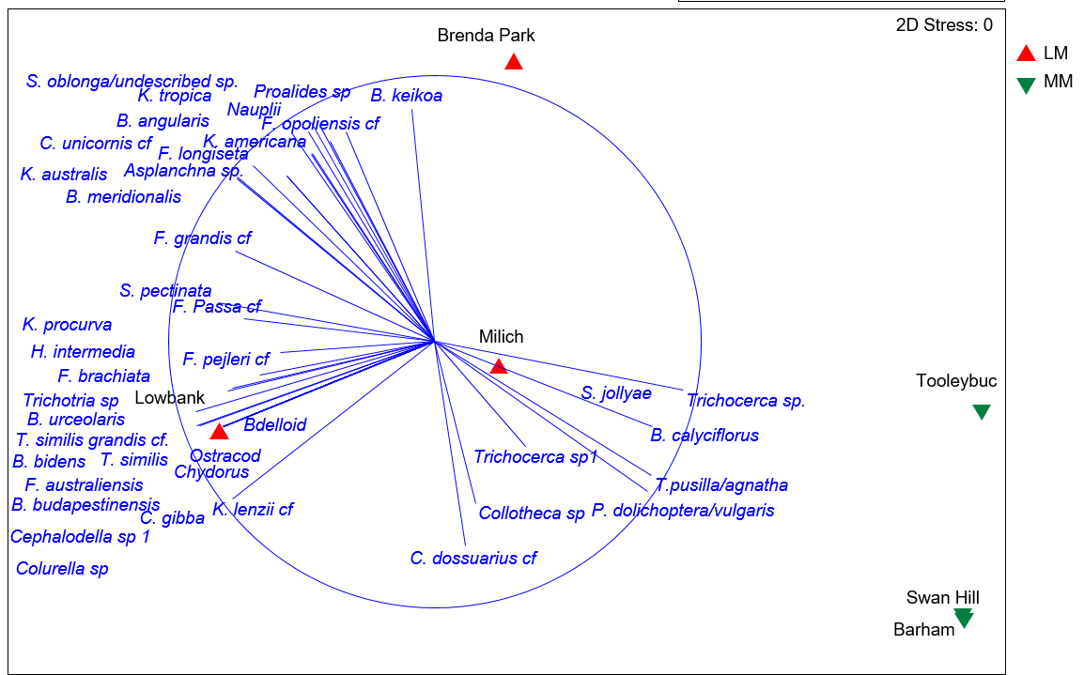

Nonmetric Multidimensional Scaling (MDS) ordination of zooplankton community structure across all mid Murray and lower Murray sites during November 2017. Correlation = 0.4.

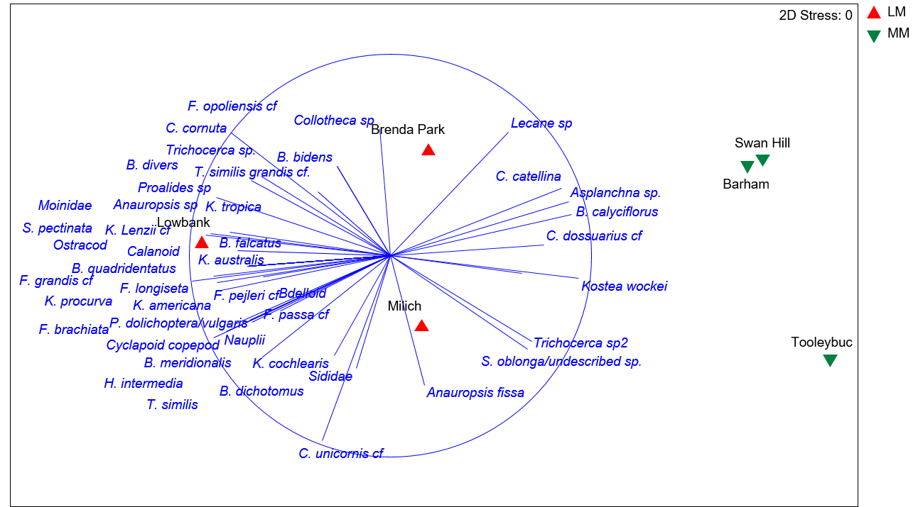

Nonmetric Multidimensional Scaling (MDS) ordination of zooplankton community structure across all mid Murray and lower Murray sites during February 2018. Correlation = 0.4.

Objective 2 – Hattah Lakes

Water quality at Hattah Lakes sites in October, November and December 2017. DO = dissolved oxygen, cond = conductivity, turb = turbidity and temp = temperature.

|  |  |  |  |  |  |  |  |
| --- | --- | --- | --- | --- | --- | --- | --- |
|  |  | DO | Cond | pH | Turb | Temp | Secchi Depth |
|  |  | ppm | µS | - | NTU | °C | mm |
| Oct 2017 | Happy Valley | 7.7 | 98 | 6.7 | 33.9 | 22.2 | 410 |
|  | Wemen | 8.9 | 99 | 6.4 | 35.0 | 21.0 | 430 |
|  | Jinkers Bend | 8.7 | 102 | 6.5 | 38.0 | 22.6 | 450 |
|  | Sextons Bend | 8.5 | 103 | 6.8 | 37.3 | 23.3 | 430 |
|  | Mulberry Bend | 8.0 | 105 | 6.6 | 39.3 | 24.0 | 380 |
|  | Nangiloc | 8.1 | 104 | 6.8 | 38.5 | 21.6 | 450 |
|  | Rudd Road | 7.6 | 111 | 6.8 | 39.0 | 23.7 | 430 |
|  | Lambert Island | 7.6 | 113 | 6.7 | 35.8 | 23.2 | 450 |
|  | Red Cliffs | 7.9 | 127 | 6.8 | 34.0 | 22.2 | 450 |
|  | Ski Club | 6.8 | 128 | 6.5 | 33.8 | 23.0 | 400 |
|  | Abbotsford Bridge | 7.1 | 140 | 6.5 | 39.8 | 24.6 | 400 |
|  | Darling | 9.0 | 640 | 8.3 | 20.8 | 24.8 | 550 |
|  | Fort Courage | 8.5 | 161 | 7.2 | 39.8 | 23.4 | 380 |
| Nov 2017 | Happy Valley | 8.3 | 77 | 6.6 | 44.0 | 21.6 | 340 |
|  | Wemen | 8.6 | 79 | 6.9 | 43.0 | 21.3 | 350 |
|  | Jinkers Bend | 7.0 | 81 | 6.8 | 40.0 | 22.8 | 420 |
|  | Sextons Bend | 7.6 | 81 | 7.0 | 40.0 | 22.8 | 390 |
|  | Mulberry Bend | 7.6 | 80 | 7.0 | 47.0 | 22.7 | 370 |
|  | Nangiloc | 7.4 | 82 | 6.9 | 47.0 | 22.9 | 320 |
|  | Rudd Road | 7.7 | 83 | 6.9 | 48.0 | 22.8 | 280 |
|  | Lambert Island | 7.6 | 84 | 6.8 | 48.0 | 22.8 | 270 |
|  | Red Cliffs | 7.6 | 98 | 6.9 | 30.0 | 23.7 | 430 |
|  | Ski Club | 7.4 | 101 | 7.1 | 35.0 | 23.8 | 360 |
|  | Abbotsford Bridge | 7.9 | 110 | 6.9 | 35.0 | 24.1 | 330 |
|  | Darling | 10.6 | 781 | 8.6 | 24.5 | 24.8 | 430 |
|  | Fort Courage | 8.7 | 150 | 7.7 | 28.8 | 26.3 | 550 |
| Dec 2017 | Happy Valley | 8.1 | 87 | 7.5 | 60.0 | 24.6 | 260 |
|  | Wemen | 8.4 | 77 | 7.5 | 60.0 | 24.2 | 290 |
|  | Jinkers Bend | 8.0 | 81 | 7.5 | 60.0 | 23.4 | 290 |
|  | Sextons Bend | 8.1 | 78 | 7.7 | 60.0 | 23.8 | 250 |
|  | Mulberry Bend | 8.2 | 78 | 7.8 | 60.0 | 23.9 | 290 |
|  | Nangiloc | 8.4 | 80 | 7.8 | 57.0 | 24.2 | 310 |
|  | Rudd Road | 7.8 | 81 | 7.6 | 60.0 | 23.6 | 300 |
|  | Lambert Island | 7.6 | 78 | 7.7 | 60.0 | 23.7 | 300 |
|  | Red Cliffs | 8.0 | 82 | 7.8 | 38.5 | 24.3 | 350 |
|  | Ski Club | 8.1 | 85 | 7.6 | 40.0 | 24.4 | 350 |
|  | Abbotsford Bridge | 8.6 | 94 | 8.0 | 37.0 | 24.9 | 360 |
|  | Darling | 7.0 | 755 | 8.7 | 23.5 | 24.2 | 450 |
|  | Fort Courage | 8.9 | 123 | 7.9 | 38.8 | 24.2 | 450 |

A close up of a piece of paper

Description generated with very high confidence

ADCP summary statistic plots including (a) mean cross sectional area (m2), (b) total discharge (m3.s-1), (c) Reynolds number and (d) mean velocity (m.s-1). Sites are listed in the order in which they occur spatially along the Murray River from the site furthest upstream (Wemen) to the site furthest downstream (Jinkers Bend). The tributary sites, Darling, Goulburn and Ovens Rivers are between the two sites in which their intersection with the Murray River falls between.

Nutrient concentrations in the Murray River near Hattah Lakes in October, November and December 2017. FRP = filterable reactive phosphorus as P, TP = total phosphorus, NH3/NH4+ = ammonia as N, NOx = nitrite + nitrate, TKN = total Kjeldahl nitrogen, TKN = total Kjeldahl nitrogen as N, TON = total organic nitrogen, TIN = total inorganic nitrogen, DOC = dissolved organic carbon and RSi = reactive silica. All concentrations are reported to two significant figures.

|  |  |  |  |  |  |  |  |  |
| --- | --- | --- | --- | --- | --- | --- | --- | --- |
|  |  | **DOC** | **FRP** | **NH4** | **NOx** | **RSi** | **TKN** | **TP** |
| **October** | **Happy Valley Landing** | 3.7 | 0.0030 | 0.0080 | 0.0030 | 1.0 | 0.23 | 0.034 |
|  | **Wemen** | 3.7 | 0.0030 | 0.0050 | 0.0030 | 1.0 | 0.41 | 0.051 |
|  | **Jinkers bend** | 3.8 | 0.0030 | 0.0050 | 0.0030 | 1.0 | 0.49 | 0.058 |
|  | **Sextons bend** | 3.8 | 0.0050 | 0.0050 | 0.0030 | 1.0 | 0.41 | 0.042 |
|  | **Mulberry Bend** | 3.9 | 0.0030 | 0.0050 | 0.0030 | 1.0 | 0.45 | 0.056 |
|  | **Nangiloc** | 3.6 | 0.0030 | 0.0050 | 0.0030 | 1.0 | 0.46 | 0.055 |
|  | **Rudds Road** | 4.0 | 0.0030 | 0.0050 | 0.0030 | 1.0 | 0.61 | 0.064 |
|  | **Lambert Island** | 4.1 | 0.0030 | 0.0050 | 0.0030 | 1.0 | 0.41 | 0.034 |
|  | **Red Cliffs** | 4.2 | 0.0030 | 0.0050 | 0.0030 | 1.0 | 0.25 | 0.035 |
|  | **Ski Club** | 4.4 | 0.0030 | 0.0080 | 0.0030 | 1.0 | 0.50 | 0.056 |
|  | **Abbotsford Bridge** | 4.7 | 0.0030 | 0.0050 | 0.0030 | 1.0 | 0.37 | 0.043 |
|  | **Darling** | 16 | 0.095 | 0.0050 | 0.0030 | 8.0 | 0.87 | 0.16 |
|  | **Fort Courage** | 5.7 | 0.0080 | 0.0050 | 0.0030 | 1.0 | 0.75 | 0.11 |
| **November** | **Happy Valley Landing** | 3.8 | 0.0 | 0.0 | 0.0 | 0.0 | 0.54 | 0.067 |
|  | **Wemen** | 4.4 | 0.0 | 0.0 | 0.0 | 0.0 | 0.18 | 0.017 |
|  | **Jinkers bend** | 7.3 | 0.0 | 0.0 | 0.0 | 0.0 | 0.46 | 0.054 |
|  | **Sextons bend** | 3.9 | 0.0060 | 0.0 | 0.0 | 0.0 | 0.52 | 0.065 |
|  | **Mulberry Bend** | 4.8 | 0.0030 | 0.0 | 0.0 | 0.0 | 0.52 | 0.063 |
|  | **Nangiloc** | 4.1 | 0.0 | 0.0 | 0.0 | 0.0 | 0.45 | 0.055 |
|  | **Rudds Road** | 4.9 | 0.0040 | 0.0060 | 0.0 | 0.0 | 0.45 | 0.057 |
|  | **Lambert Island** | 4.3 | 0.0 | 0.0 | 0.0 | 0.0 | 0.51 | 0.063 |
|  | **Red Cliffs** | 4.0 | 0.0030 | 0.0 | 0.0 | 0.0 | 0.48 | 0.060 |
|  | **Ski Club** | 4.2 | 0.0 | 0.0 | 0.0 | 0.0 | 0.50 | 0.059 |
|  | **Abbotsford Bridge** | 4.3 | 0.0 | 0.0 | 0.0 | 0.0 | 0.46 | 0.061 |
|  | **Darling** | 14.6 | 0.049 | 0.0 | 0.0 | 8.0 | 1.2 | 0.13 |
|  | **Fort Courage** | 4.6 | 0.024 | 0.0070 | 0.0 | 0.0 | 0.32 | 0.019 |
| **December** | **Happy Valley Landing** | 3.9 | 0.0050 | 0.0080 | 0.012 | 0.0 | 0.53 | 0.091 |
|  | **Wemen** | 4.4 | 0.0040 | 0.0 | 0.0 | 0.0 | 0.52 | 0.074 |
|  | **Jinkers bend** | 4.2 | 0.0 | 0.01 | 0.0 | 0.0 | 0.42 | 0.063 |
|  | **Sextons bend** | 5.0 | 0.0040 | 0.01 | 0.0 | 0.0 | 0.43 | 0.067 |
|  | **Mulberry Bend** | 4.1 | 0.0040 | 0.0 | 0.0 | 0.0 | 0.47 | 0.077 |
|  | **Nangiloc** | 4.4 | 0.0040 | 0.0 | 0.0 | 0.0 | 0.54 | 0.078 |
|  | **Rudds Road** | 4.3 | 0.0 | 0.012 | 0.0 | 0.0 | 0.56 | 0.086 |
|  | **Lambert Island** | 3.8 | 0.0050 | 0.0 | 0.0 | 0.0 | 0.54 | 0.087 |
|  | **Red Cliffs** | 4.2 | 0.0030 | 0.0050 | 0.0 | 0.0 | 0.51 | 0.069 |
|  | **Ski Club** | 4.1 | 0.0 | 0.0 | 0.0 | 0.0 | 0.52 | 0.066 |
|  | **Abbotsford Bridge** | 4.1 | 0.0030 | 0.0070 | 0.0 | 0.0 | 0.54 | 0.068 |
|  | **Darling** | 15 | 0.045 | 0.0090 | 0.0 | 5.0 | 1.1 | 0.13 |
|  | **Fort Courage** | 4.2 | 0.0 | 0.010 | 0.0 | 0.0 | 0.50 | 0.073 |

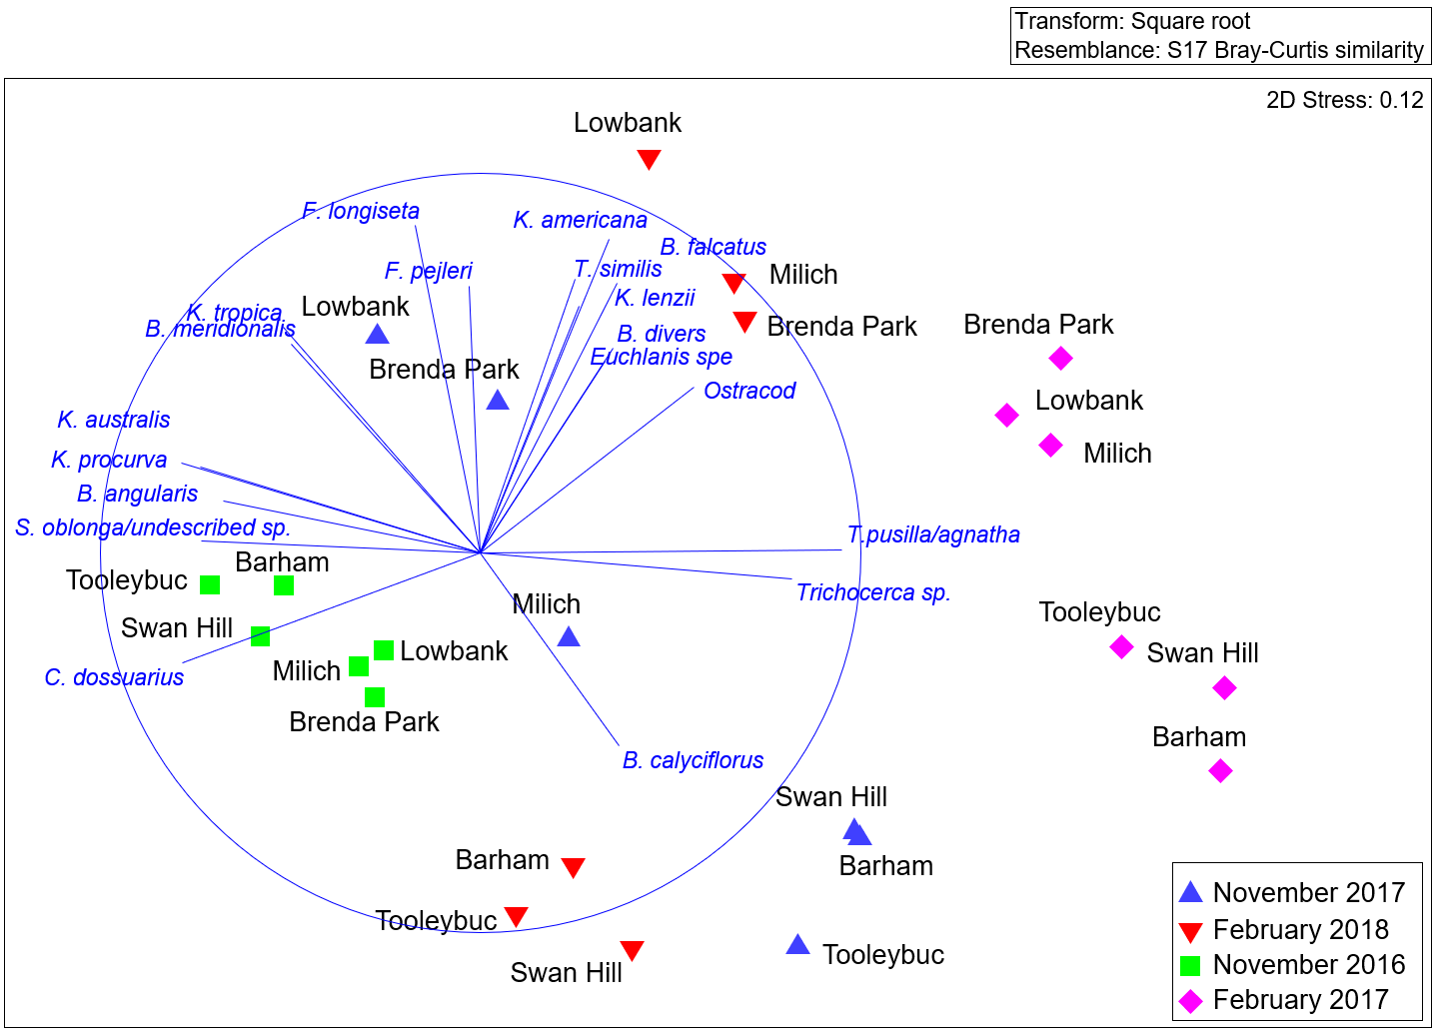

Nonmetric Multidimensional Scaling (MDS) ordination of zooplankton community structure at the mid Murray and lower Murray sites during November 2016, February and November 2017, and February 2018. Correlation = 0.6.

1. For the purpose of this study, translucent flows are flows that are allowed to pass through regulating structures with the aim of reinstating/maintaining aspects of natural flow variability. 