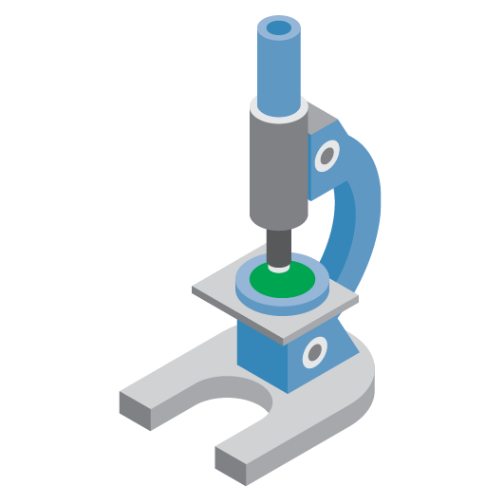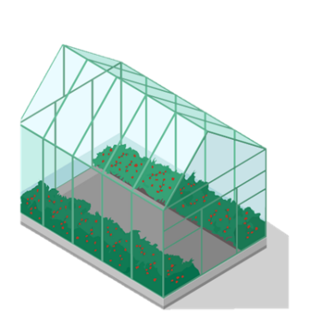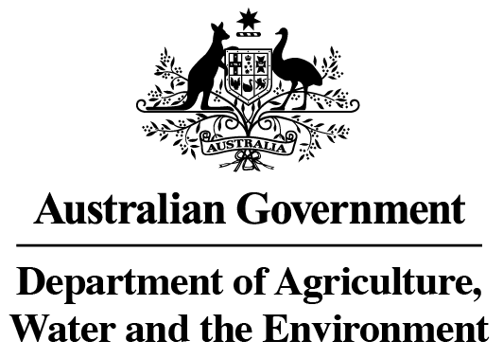

**Fresh produce arrives in Australia**

**Inspection**

1. A biosecurity officer checks the packaging for damage and secures any non-integral cartons if necessary
2. The consignment is then moved to a biosecurity inspection point where it is inspected for live insects, weed seeds, diseases, and other biosecurity risk material
3. The seals securing the container or aircan, and the labelling on the cartons are reconciled with documentation.

**A biosecurity risk**

Where live insects, disease or other biosecurity risk material are detected and deemed to be of concern, the results and management action options are delivered via the biosecurity officer to the importer for decision.

Depending on the risk posed, options for addressing the biosecurity risk may include:

* Importer arranges for the fresh produce to be treated or reconditioned so they are safe to enter the market, or
* The department directs the goods to be destroyed or exported out of Australia

**Fresh produce grown and prepared for Australia**

Australia’s import conditions require that consignments:

* Are permitted species and from permitted countries for

import into Australia

* Be for human consumption only
* Comply with all recommended phytosanitary measures
* Be packed in clean, new, pest-proof packaging and clearly

labelled

An Australian importer may also require an import permit depending on the country they source from and the commodity being imported.

**Pre-export inspection**

Australia’s import conditions require the exporting country’s National Plant Protection Organisation (NPPO) to inspect the fresh produce and confirm if it is free from live insects, disease symptoms, weed seeds and other contaminants, and that it has met all requirements for import into Australia.

**NPPO certification**

If the NPPO is satisfied that the fresh produce meets Australia’s import requirements they

will issue

a phytosanitary

certificate.

**Document verification**

A Departmental biosecurity officer checks the importer’s documentation including the phytosanitary certificate and if required, treatment

certificates,

manufacturer’s

declarations and

permit paperwork.

Where valid

documentation

is not supplied,

the consignment will be held (at importers cost) until the correct paperwork is provided to the department.

**Live insects or biosecurity**

**risk material**

**found**

**Insects and biosecurity risk material sent for identification**

The live insects and biosecurity risk

material is sent to the department’s

laboratory for identification to

determine if they are a biosecurity risk for Australia.

**Not a biosecurity risk**

Results confirming the live insects and material

are not a biosecurity risk are provided to the biosecurity officer.

**Fresh produce not released**

Fresh produce sent for destruction or export is not released into the

Australian market.

**Post treatment verification**

Once the fresh produce has been treated or reconditioned a biosecurity officer will verify through documentation or re-inspection that the goods meet import requirements.

**Fresh produce released**

Biosecurity officer will release the fresh

produce from biosecurity control

into the Australian market.

**Fresh produce grown and prepared for export to Australia**

Fresh produce is unprocessed or partially processed fresh fruit and vegetables. Partial processing may include slicing or removing the peel.

**No live insects or Biosecurity risk material found**