21 February 2022
ANNOUNCEMENT INFORMATION PAPER – Commencement of a review of biosecurity import requirements FOR fresh dragon FRUIT FROM the philippines
The commencement of this risk analysis is in response to a market access request for fresh dragon fruit from the Philippines.
There are two types of risk analyses used by the department:
- a Biosecurity Import Risk Analysis (BIRA) which is conducted through a regulated process provided for in the Biosecurity Act 2015 and the Biosecurity Regulation 2016
- a review of biosecurity import requirements for the purposes of Section 174 of the Biosecurity Act.
A preliminary assessment of the pests associated with dragon fruit from the Philippines has identified that the potential pests of biosecurity concern are the same as, or of the same pest groups, as those pests that have been assessed previously by Australia on dragon fruit from Indonesia and Vietnam, and/or other horticultural commodities from various countries, and are not expected to pose significantly different biosecurity risks. These pests include fruit flies, thrips and mealybugs.
Given the similar pests of concern, and that there are appropriate risk management measures already established for these pests or pest groups, the risk analysis for dragon fruit from the Philippines will be progressed as a review of biosecurity import requirements and not a BIRA, consistent with the Biosecurity Act 2015 and Biosecurity Import Risk Analysis Guidelines 2016.
Dragon fruit
Dragon fruit is a flowering plant in the cacti family (Cactaceae). Dragon fruit is also referred to as pitaya or pitahaya. In the Philippines, it is locally known as saniata, which means light and wealth. The fruit has become popular because of its purported health benefits and is cultivated on a commercial scale in many tropical regions around the world.
Commodity to be assessed
The risk analysis will cover several species/varieties of fresh dragon fruit (Selenicereus spp.) identified by the Philippines as being commercially produced for human consumption. All edible dragon fruit were previously classified in the genus Hylocereus, however, recent DNA analysis has revised these species to be part of the broader flowering cacti Selenicereus genus.
Different dragon fruit varieties vary in skin and flesh colour. The three species most commonly cultivated are Selenicereus undatus (red skin and white flesh), Selenicereus costaricensis (red skin and red flesh) and Selenicereus megalanthus (yellow skin and white flesh). The fruits can be eaten raw or processed for use in ice cream, wine, confectionary, beverages, cosmetics or used in various recipes.

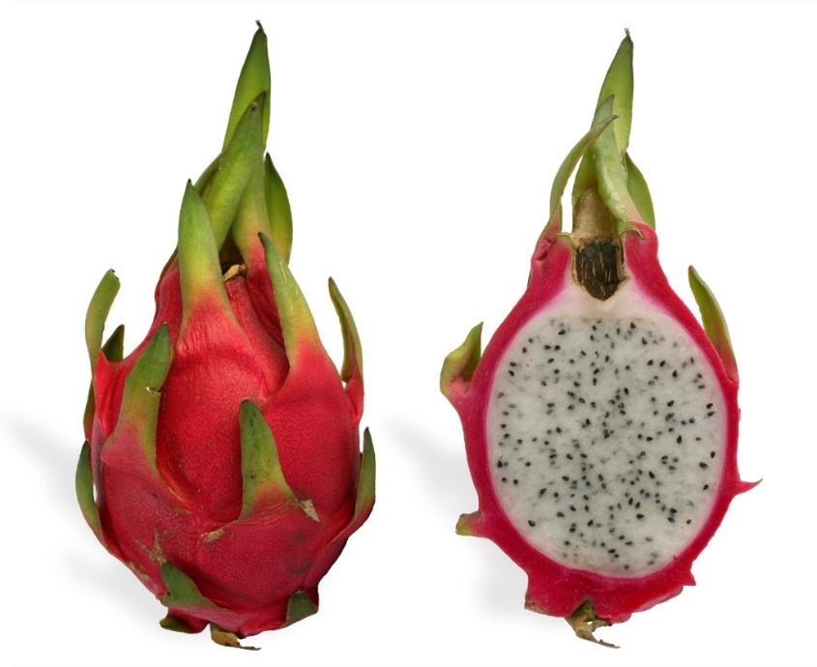
Figure 1: Cross-sections of dragon fruit varieties

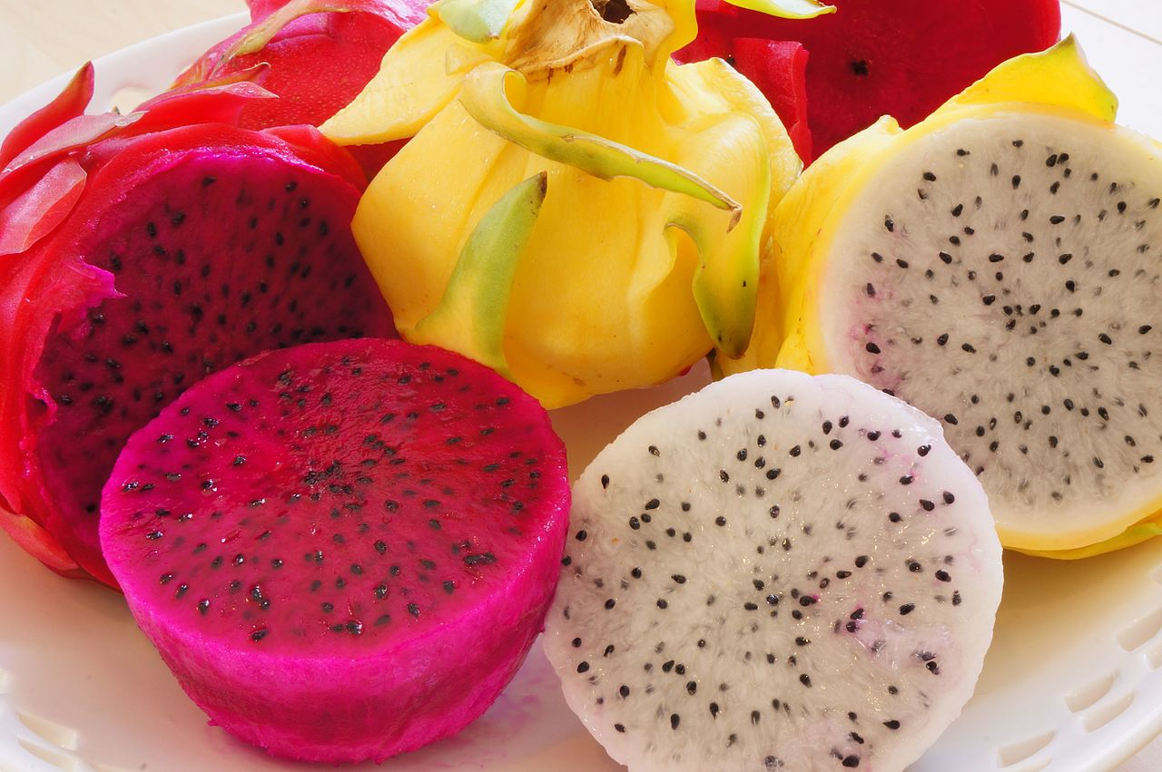
Source: wikipedia.org

Dragon fruit industry in the Philippines
The Philippines’ dragon fruit industry is a growing industry, with production increasing from 256 to 1462 tonnes between 2012 and 2017. The number of commercial growers across the Philippines is gradually increasing.
The production period for dragon fruit is between May and October, although it can extend into December. The Philippines have indicated that year-round production may also be possible with investment in technology to extend the growing season.
Currently, the Philippines exports dragon fruit to a small number of international markets, with most fruit exported to Japan. However, there is a focus to expand production with the intention to increase supply to the global market.
Table 1: Top five dragon fruit production regions in the Philippines (2017)
Region | Production (tonnes)
Ilocos | 507
Cagayan Valley | 364
Calabarzon | 205
Central Luzon | 199
Central Visayas | 105
Source: Philippine Statistic Authority (PSA).
Australian dragon fruit imports
Australia has import policies in place for fresh dragon fruit from Vietnam and Indonesia. All imports must meet Australia’s biosecurity import conditions. While imports from Vietnam have commenced, the import conditions for Indonesia are yet to be finalised.
The risk analysis for dragon fruit from Vietnam was published in 2017 and trade commenced the same year. Between 2017 and 2020, Australia imported approximately 1,584 tonnes of dragon fruit from Vietnam.
Dragon fruit industry in Australia
In 2017 Australian dragon fruit production was estimated to be approximately 740 tonnes per annum. Most of Australia’s dragon fruit is grown in the Northern Territory and Far North Queensland, with smaller-scale production occurring in northern New South Wales and Western Australia. The Australian-grown dragon fruit production period is between October and April.
The Australian dragon fruit industry is focussed on domestic supply mainly to major city markets.
Trade between Australia and the Philippines
The Philippines is a comprehensive trading partner with a longstanding agricultural trade relationship, supported by the ASEAN Australian New Zealand Free Trade Agreement. In 2019–20 two-way goods and services trade totaled $5.1 billion.
Preliminary assessment of Philippine dragon fruit
A preliminary assessment of the pests associated with dragon fruit from the Philippines has identified (to date) 12 pest species of potential biosecurity concern likely to require further consideration. These are 2 fruit flies, 4 thrips and 6 mealybugs. Further assessment of these potential pests will determine the risk management measures required to achieve Australia’s appropriate level of protection.
Next steps
A draft report of this review of biosecurity import requirements is expected to be published on our website by the end of 2022. Stakeholders will have an opportunity to submit comments on the draft report during a 60-calendar day consultation period.
We will consider all stakeholder comments in the preparation of the final report.
The recommendations in the final report will reflect the completion of the risk analysis for fresh dragon fruit from the Philippines. The recommended measures will have been assessed as scientifically sound and appropriate to manage any potential risks to Australia’s biosecurity presented by the importation of fresh dragon fruit from the Philippines.
If you would like to know more about this risk analysis or the risk analysis review process please email plantstakeholders@awe.gov.au or phone +61 2 6272 5094.

