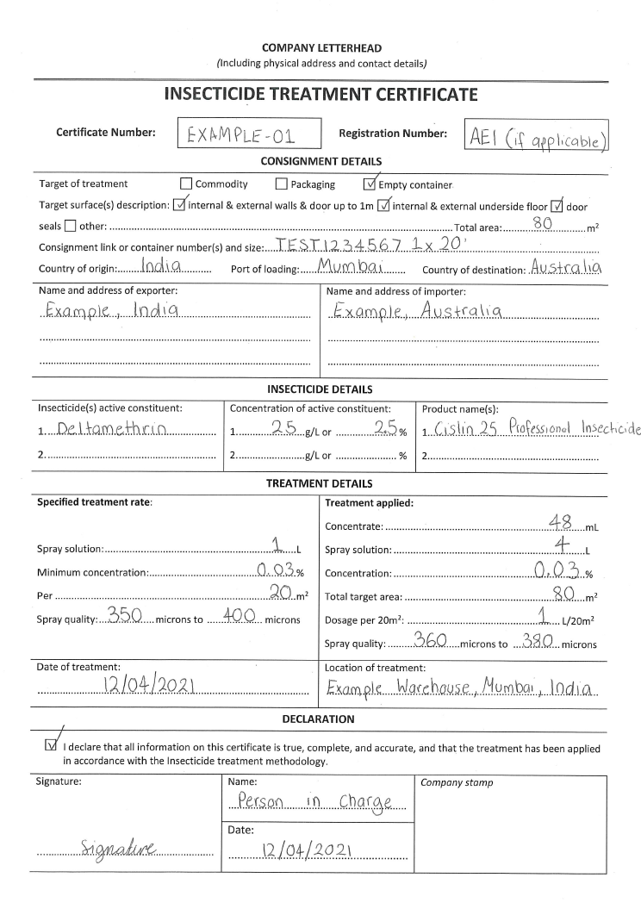

**31.. **

**17.**

**18.**

**21. **

**22... **

**7.**

**13.. **

**9.**

**5.**

**15. **

**26.. **

**24.. **

**23.. **

**20.. **

**8.**

**11.**

**12. **

**14. **

**6.**

**10.**

**30.. **

**29.. **

**28.. **

**27.. **

**19.**

**25.**

**16.**

**1.**

**2.**

**4.**

**3.**

1. **Company letterhead**

Letterhead of the company that conducted the treatment and must include the name and physical address. Must comply with the requirements outlined in the [Minimum documentary and import declaration requirements policy](https://www.agriculture.gov.au/import/arrival/clearance-inspection/documentary-requirements/minimum-document-requirements-policy).

1. **Certificate number**

Each certificate must have an individual identifier number. This is an internal reference number for the company.

1. **Registration number**

Where the treatment provider has a registration number, it must be provided. Where treatment provider is not registered under a scheme, this field can be left blank.

**Consignment Details**

1. **Target of treatment**

The ‘target of treatment’ refers to the specific areas or locations that are required to be treated. For the khapra beetle treatments, the target of treatment is the empty container and the ‘empty container’ box must be indicated. To verify, compare the date of treatment with the date of loading/packing (where provided).

1. **Target surfaces description**

The ‘target surfaces description’ refers to the surfaces that need to be treated for the treatment to be successful. This is determined by the treatment schedule. For khapra beetle treatments, “internal and external walls and door up to 1m”, “internal and external underside floor” and “door seals” must be ticked.

1. **Total area (m2).**

The ‘total area’ is the total surface area of the target surface of treatment (m2). Multiple containers can be captured on one treatment certificate, in which case the area of all treatment surfaces must be added together. The department has determined the following treatment surface areas apply:

* Each 20ft container must be at least 80m2
* Each 40ft container must be at least 140m2

1. **Consignment link or container number**

This identifies the consignment after treatment and during subsequent transport to the

destination. This must include container number/s and size.

1. **Country of Origin**

The country of origin must be listed on the certificate. This is the country the sea container originated from and should match the country the goods were packed in.

1. **Port of loading**

The port of loading must be listed on the certificate. This is the location of the port in which the consignment was loaded and should match the port of loading on the Bill of Lading.

1. **Country of destination**

The country that the consignment is being exported to must be listed on the certificate.

1. **The name and address of exporter**

The name and address of the exporter must be listed on the certificate.

1. **The name and address of importer**

The name and address of the importer must be listed on the certificate.

**Insecticide Details**

1. **Insecticide active constituent**

The insecticide product used must contain the active constituent specified in the treatment schedule. For khapra beetle treatments, the insecticide product must contain the active ingredient deltamethrin.

1. **Concentration of active constituent**

The concentration of active constituent will vary between products, including products with the same active constituent. Some products will express the concentration in grams per litre and others will express it as a percentage. The formula for converting grams per litre to percentage is:

**Percentage (%) = grams per litre (g/L) / 10**

1. **Product name**

The brand name of the insecticide spray used to conduct the treatment must be listed. The department doesn’t maintain a list of approved or not approved products for khapra beetle treatments, however the insecticide product used must be a suspension concentrate containing deltamethrin. Some product names will include “SC” (to signify suspension concentrate) and some will reference the concentration of active consistent. It should not contain EC in the name, any product that does is not suitable for khapra beetle treatments.

**Treatment Details**

**Specified treatment rate:** This section must include the requirements that are to be met as per the treatment schedule.

1. **Spray solution**

The amount of spray solution required over a given surface area. For khapra beetle treatments, the rate must be exactly 1 litre of spray solution per 20m2 as per BICON requirements.

1. **Minimum concentration**

The minimum concentration of the active constituent in the spray solution. For khapra beetle treatments, the minimum concentration percentage for the spray solution applied must be 0.03% or above.

1. **Spray quality**

‘Spray quality’ describes the droplet size distribution in the spray produced by a nozzle. For khapra beetle treatments, the spray solution must be applied as a coarse spray of 350 to 400 microns.

**Treatment Applied:** This is the most crucial section of the certificate to ensure the acceptability of the treatment. The department has created an **Insecticide Application Calculator** to assist in the calculation of the requirements.

1. **Concentrate (mL)**

The amount of concentrate used for the treatment must be recorded here. This will vary based on the concentration of the insecticide product used and the volume of spray solution used (which is determined by total treatment area). The volume of concentrate required can be determined using the following formula:

**Volume of concentrate required (mL) = spray solution concentration required (%) / concentration of active constituent in product (%) x volume of spray solution required (mL)**

1. **Spray solution (L)**

The amount of spray solution applied during the treatment must be recorded here. For every 20m2, 1L of spray must be used. For example, an 80 m2 container 4L of spray solution must be used. The following formula can be used to determine the required amount of spray solution:

**Spray solution (L) = Total target area (m2) / 20.**

1. **Concentration (%)**

The percentage of active constituent in the spray solution must be recorded here. For khapra beetle treatments, the spray solution must contain a concentration of deltamethrin of 0.03%, or above to be acceptable. The following formula can be used to determine concentration:

**Concentration % = (concentrate mL x concentration of active constituent %) / spray solution mL**

1. **Total target area (**m2**)**

The total target area must be recorded here. This must match the area recorded under ‘total area’.

1. **Dosage per 20m2**

This is how many litres of spray is used for every 20m2 . For a khapra beetle treatment, the mixed solution must be applied at a rate of 1L per 20m2. If the rate is below 1L, not enough insecticide has been applied and the treatment has failed. If the rate is above 1, too much spray has been applied, indicating it was applied past the point of run off) and the treatment has failed. The formula for determining dosage per 20m2 is:

**Dosage per 20m2 = (Total target area / 20) / spray solution applied**

1. **Spray quality (microns)**

‘Spray quality’ is related to the microns and the droplet size distribution in the spray produced. The spray quality produced by any nozzle system depends on the type of nozzle, the orifice size, spray angle and operating pressure. For khapra beetle treatments, the insecticide must be applied within the range of 350 to 400 microns.

1. **Date of treatment**

The date the treatment took place must be recorded here.

1. **Location of treatment**

The location the treatment took place must be recorded here.

**Declaration**

*By completing this declaration, the declarant confirms that all information provided is true and accurate. If it is found that any false or misleading information has been provided, the department may take appropriate actions. This includes, but is not limited to the re-export of the consignment, or the treatment provider made unacceptable to conduct treatments for export to Australia.*

1. **Treatment compliance declaration**

This declares the treatment was conducted in accordance with the insecticide treatment methodology.

1. **Signature**

The signature of the of the insecticide treatment provider in charge. The declaration must be signed to be valid.

1. **Printed name**

The printed name of the of the insecticide treatment provider in charge.

1. **Date**

The date in which the treatment certificate was signed/issued.

1. **Company stamp**

This is an optional stamp of the company that conducted the treatment.

**Insecticide Application Calculator Instructions**

1. Confirm your specified treatment rate.

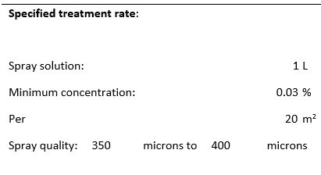

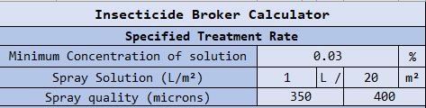

1. Enter the number of containers being treated next to the corresponding container size. *Please note- this calculator will only work for standard 20” and 40” containers. For all other containers, please refer to* [*offshoretreatments@awe.gov.au*](mailto:offshoretreatments@awe.gov.au)
2. Enter the Concentration of the active constituent. This can be found in the *“Insecticide Details”* field. If concentrate is expressed in g/L, then the *g/L to % Converter* provided can be used to find the percentage.

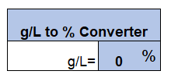

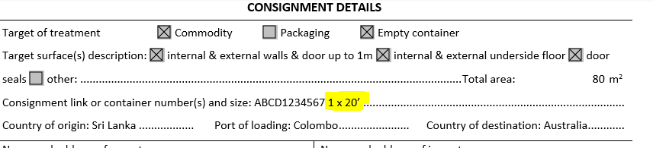

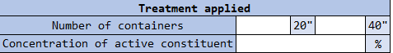

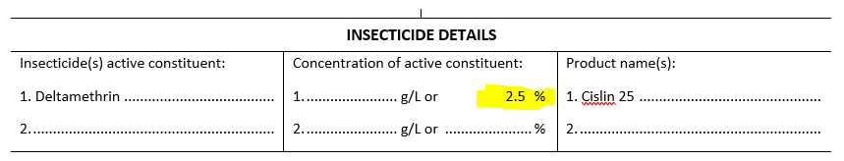

**Steps 1-3 will populate the calculated requirements, which treatment providers may refer to when preparing for a treatment. Continue with steps 4-5 if assessing a previously conducted treatment meets the requirements.**

1. Enter all remaining fields from the “*Treatment applied*” section of the certificate. This will populate the calculated requirements.

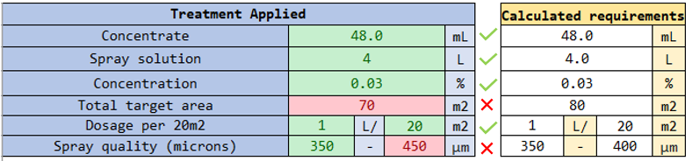

1. Check that all fields are compliant.

Refer to Offshore Treatments at [offshoretreatments@awe.gov.au](mailto:offshoretreatments@awe.gov.au) if the treatment is non-compliant.