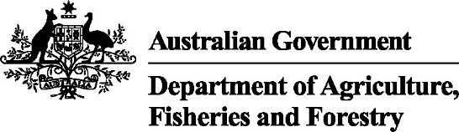

REFERENCE

Plant exports guide—bulk woodchips inspection techniques

In this document
This document contains the following topics:
Purpose of this document 2
General notes on inspecting bulk woodchips 2
Inspecting bulk woodchips 2
Related material 5
Contact information 5
Document information 5
Version history 5

Purpose of this document
This document has been written for authorised officers (AOs) as a reference guide on techniques to use when inspecting bulk woodchips for export.

General notes on inspecting bulk woodchips
Bulk woodchips presented for export inspection can only be sampled during the loading of containers or vessels.
Subsamples can be combined, provided that no more than one litre is screened at any time.
Inspect all samples using suitable equipment.
Perform the inspection in an area that has adequate light and is not compromised by the environment.

Inspecting bulk woodchips
The following table illustrates and describes various methods of taking samples of bulk woodchips for inspection.
What does this look like | Description
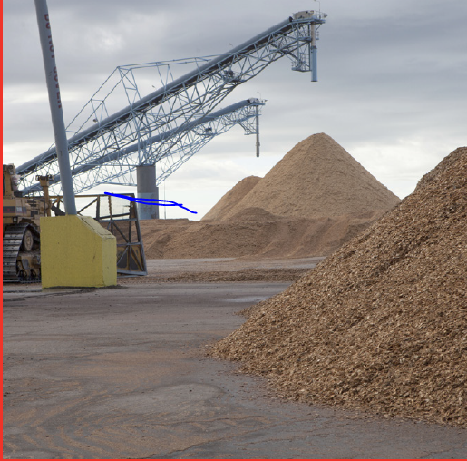 | Bulk woodchips  Bulk woodchips in piles from which they are loaded.
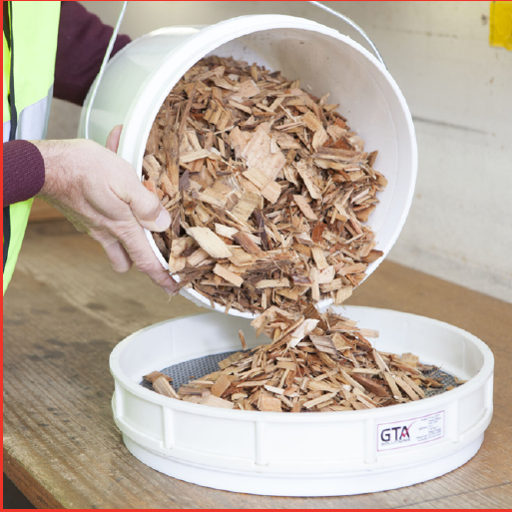 | Sampling  An authorised officer poured the woodchips sample from a white plastic bucket into a sieve.
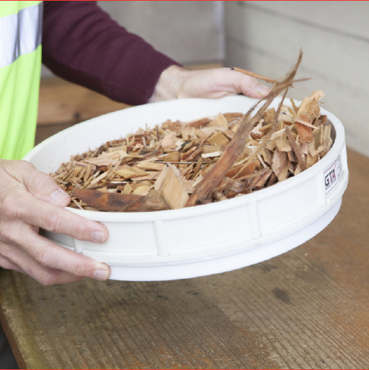 | Sieving technique  The sieve is sufficiently shaken to enable the woodchips to move across the mesh for effective sieving.
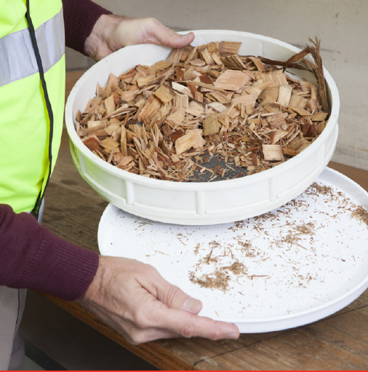 | Inspection of material on the pan  Shaking allows small particles to fall through the sieve to the pan.
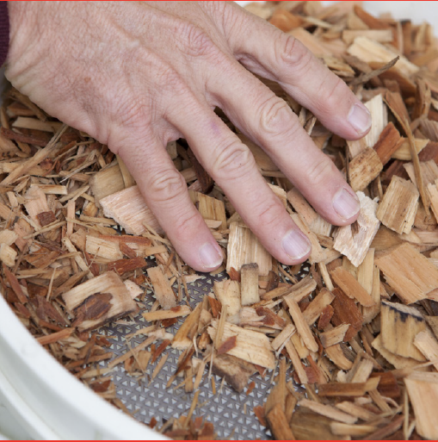 | Surface examination of woodchips  The surface of the woodchips is examined to identify any pests or contaminants that have not passed through the sieve.
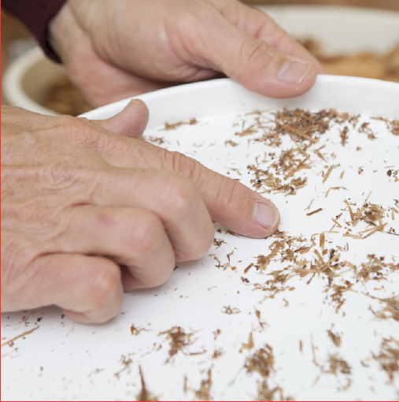 | Examination of pan contents  All contents in the pan are examined for pests and contaminants.
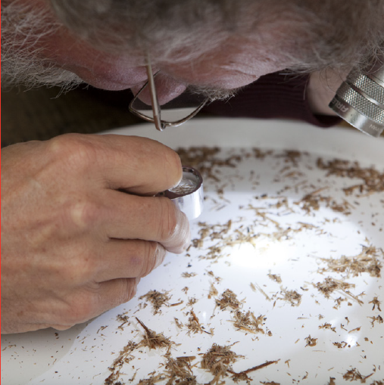 | Pest examination  Small pests are examined closely by using a torch and hand lens.
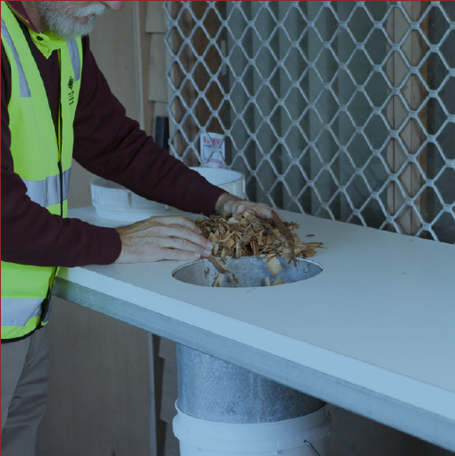 | Return samples to product source  The inspected samples are returned to the product source, if requested by the client.

Related material
- Export Control Act 2020
- Export Control (Plants and Plant Products) Rules 2021
- Manual of Importing Country Requirement (Micor– Plants)
- Plant exports operations manual (PEOM)
- Guideline: Inspection of forest products for export
- Work Instruction: Inspecting forest products for export
- Reference: Plant exports guide – equipment
- Reference: Plant exports guide – specimen collection

Contact information
- Authorised Officer Hotline: 1800 851 305
- Authorised Officer Program: PlantExportTraining@aff.gov.au
- Grain and Seed Exports Program Hotline: 02 6272 3229
- Grain and Seed Exports Program: Grain.Export@aff.gov.au

Document information
The following table contains administrative metadata.
Instructional Material Library document ID | Instructional material owner
IMLS-12-5128 | Director, Grain and Seed Exports

Version history
The following table details the published date and amendment details for this document.
Version | Date | Amendment details
1.0 | 11/03/2020 | First publication of this reference.
2.0 | 2/07/2021 | Document re-published from IML Archive with no changes.
3.0 | 20/12/2016 | Updated document to match current template. Updated related materials section to current documents.
4 | 18/01/2024 | Updated document formatting, department branding and emails.

