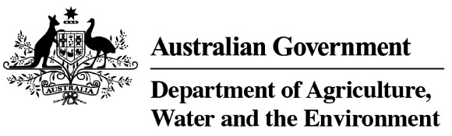

REFERENCE

# Plant exports guide—hay and straw inspection techniques

**In this document**

This document contains the following topics:

Purpose of this document 2

Inspecting hay and straw 2

Related material 5

Contact information 5

Document information 5

Version history 5

## Purpose of this document

This document has been written for authorised officers (AOs) as a reference guide on techniques to use when inspecting hay and straw for export.

## Inspecting hay and straw

The following table illustrates and describes methods of taking samples of hay and straw bales for inspection.

| **What does this look like** | **Description** |
| --- | --- |
| An officer looking at the surface of a bale for live peats, vermin and their waste. | **Surface inspection**  The surface of the bale is inspected for live pests, vermin and their waste and contaminants. |
| An officer cutting the strap of a bale. | **Surface inspection**  The straps of the bale are cut. |
| An officer is splitting the bale into biscuits for further inspection. | **Subsamples**  The bale is split into subsamples (‘biscuits’) from across the bale. |
| An officer looking at the all surfaces of a biscuit for live peats, vermin and their waste. | **Inspection of biscuit**  All the surfaces and sides of the biscuit are inspected for live pests, vermin and their waste and contaminants. |
| An officer breaking the biscuit into small pieces so they can fit into a sieve for further inspection. | **Preparing sample**  The AO breaks the biscuit into pieces to fit into a sieve. The broken pieces can be shaken over the inspection bench to remove the loose particles. |
| An officer placing the sample in the seive. | **Sieving sample**  The remainder of the sample is placed in the sieve. |
| An officer shaking the sieve and moving it in all directions until all fine are in the pan. | **Sieving sample**  The sieve is shaken vigorously for at least 30 seconds, but preferably longer (to 1 minute). The sieve is moved in all directions until all fines are in the pan. |
| An officer inspecting the sample in both the top section and lower pan of the sieve. | **Inspect contents and fines**  The contents of the top section of the sieve and the lower pan of the sieve are inspected separately for live pests, vermin waste and contaminants. |
| An officer is using a magnifying lens and torch and inspecting the sample by spreading it over at the inspection bench. | **Closer examination**  The sample in the sieve pan is spread over a large, clean area on the inspection bench for detailed examination using a magnifying lens and torch, if necessary. |

## Related material

* *Export Control Act 2020*
* Export Control (Plants and Plant Products) Rules 2021
* Manual of Importing Country Requirement (Micor – Plants)
* Plant exports operations manual (PEOM)
* Guideline: *Inspection of hay and straw for export*
* Work Instruction: *Inspecting hay and straw bales for export in-line and end point*
* Reference: *Plant exports guide – equipment*
* Reference: *Plant exports guide – specimen collection*

## Contact information

* Authorised Officer Hotline: 1800 851 305
* Authorised Officer Program: PlantExportTraining@awe.gov.au
* Grain and Seed Exports Program Hotline: 02 6272 3229
* Grain and Seed Exports Program: Grain.Export@awe.gov.au

## Document information

The following table contains administrative metadata.

| **Instructional Material Library document ID** | **Instructional material owner** |
| --- | --- |
| IMLS-9-8033 | Director, Grain and Seed Exports |

## Version history

The following table details the published date and amendment details for this document.

| **Version** | **Date** | **Amendment details** |
| --- | --- | --- |
| 1 | 16/11/2021 | First publication of this reference. |