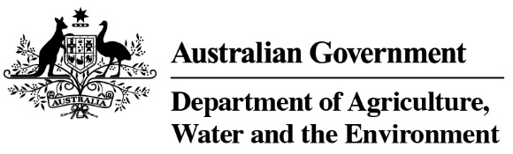

REFERENCE

# Plant exports guide—inspection techniques for bulk processed timber products

**In this document**

This document contains the following topics:

Purpose of this document 2

Before you start 2

Inspecting processed timber products 2

Related material 4

Contact information 4

Document information 4

Version history 4

## Purpose of this document

This document has been written for authorised officers (AOs) as a reference guide on techniques to use when inspecting processed timber products for export, such as:

* plywood
* chipboard
* particleboard
* laminated veneer lumber
* other panel products.

## Before you start

Before starting their inspection, the AO ensures that they:

* check the importing country requirements to determine the requirements for the inspection
* have the correct inspection equipment
* have access to PEMS
* wear appropriate personal protective equipment
* have the current relevant instructional and reference material.

## Inspecting processed timber products

The following table illustrates and describes methods of taking samples of processed timber products for inspection.

| **What does this look like** | **Description** |
| --- | --- |
| An officer visually inspecting by walking around the entire consignment including the exposed sides and ends, looking for pests and diseases. | The entire consignment, including the exposed sides and ends is visually inspected by walking around, looking for pests or signs of pests and diseases. |
| An officer inspecting the timber surfaces following the request made to the exporter to remove the plastic wrapped around the sample. | Where samples are wrapped in plastic, the exporter is asked to remove the plastic to inspect the timber surfaces. |
| An officer inspecting the timber surface of all samples using suitable equipment. | The timber surface of all samples is inspected using suitable equipment. If required, the exporter is asked to split the sample before inspecting. |
| An officer inspecting the ends of all samples using suitable equipment. | The ends are inspected using suitable equipment. |
| An officer checking the ends of all samples for pest damage. | The ends are checked for pest damage. |

## Related material

* *Export Control Act 2020*
* Export Control (Plants and Plant Products) Rules 2021
* Manual of Importing Country Requirement (Micor – Plants)
* Plant exports operations manual (PEOM)
* Guideline: *Inspection of forest products for export*
* Work Instruction: *Inspecting forest products for exports*
* Reference: *Plant exports guide – equipment*
* Reference: *Plant exports guide – specimen collection*

## Contact information

* Authorised Officer Hotline: 1800 851 305
* Authorised Officer Program: PlantExportTraining@awe.gov.au
* Grain and Seed Exports Program Hotline: 02 6272 3229
* Grain and Seed Exports Program: Grain.Export@awe.gov.au

## Document information

The following table contains administrative metadata.

| **Instructional Material Library document ID** | **Instructional material owner** |
| --- | --- |
| IMLS-9-8010 | Director, Grain and Seed Exports |

## Version history

The following table details the published date and amendment details for this document.

| **Version** | **Date** | **Amendment details** |
| --- | --- | --- |
| 1 | 16/11/2021 | First publication of this reference. |