

REFERENCE

Plant exports guide – In-transit cold treatments

Purpose of this document
This document has been written for authorised officers (AOs) as a reference guide to supervising an in-transit cold treatment of horticulture products for export.

In this document
This document contains the following topics.
Purpose of this document 1
Registered establishment environment 2
Inspecting and verifying the container approval for loading 2
Verifying pre-cooling of the product prior to loading 4
Supervising calibration of temperature sensors 5
Supervising the loading of the container and sensor placement 6
Related material 9
Contact information 9
Document information 9
Version history 9

Registered establishment environment
The following table illustrates and describes common elements of the registered establishment environment.
What does this look like | Description
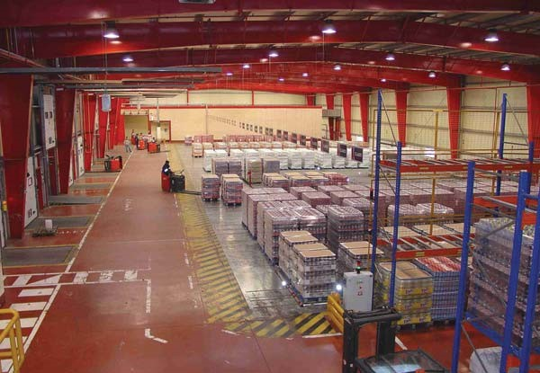 | Registered establishments  Initiation of an in-transit cold treatment occurs at export registered establishments.  The AO attends the registered establishment to supervise the calibration and loading of the in-transit cold treatment.

Inspecting and verifying the container approval for loading
The following table illustrates and describes how an AO inspects the container prior to loading.
What does this look like | Description
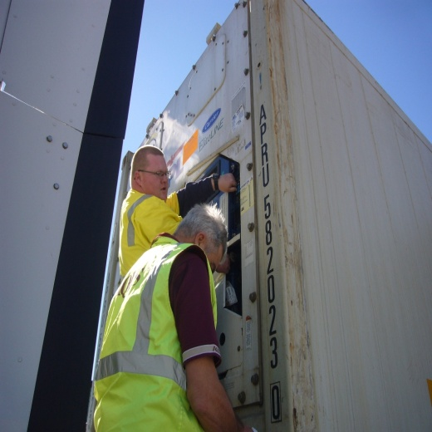 | Verifying container number  The AO checks the container number on the container to confirm it matches the container number listed on the Request for permit (RFP).  The verified container number is recorded on the ITCT-calibration record.
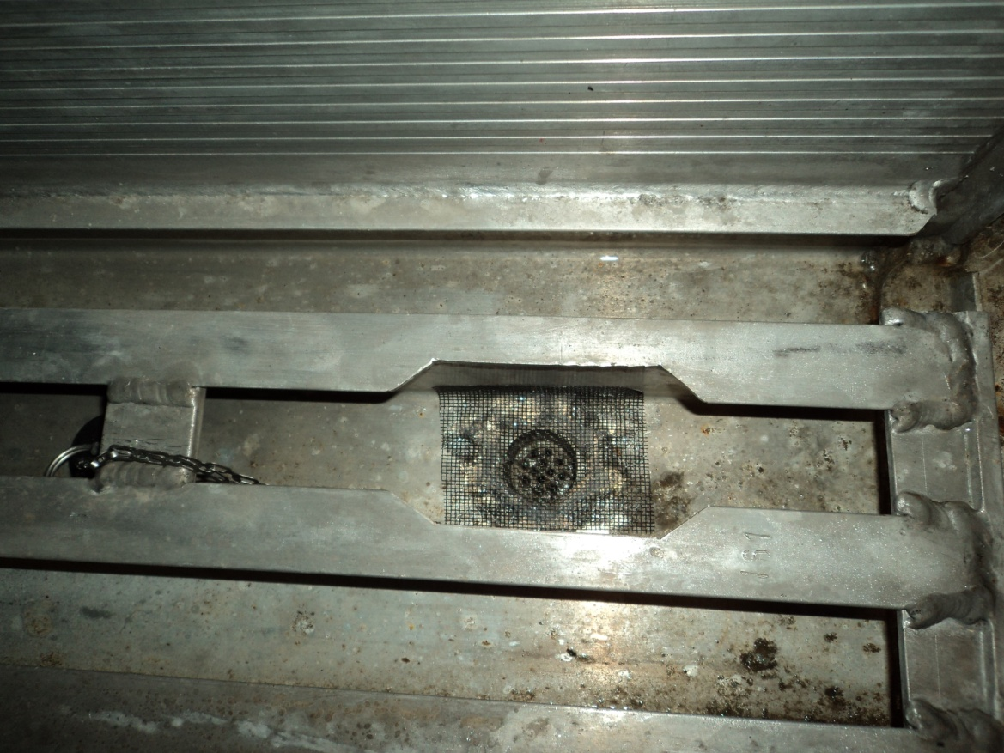 | Inspecting the holes and vents  The AO checks all the holes and vents to ensure they are meshed, so that no gap is bigger than 1.6 mm.  This includes:  - drain holes  - air intakes  - vent holes.
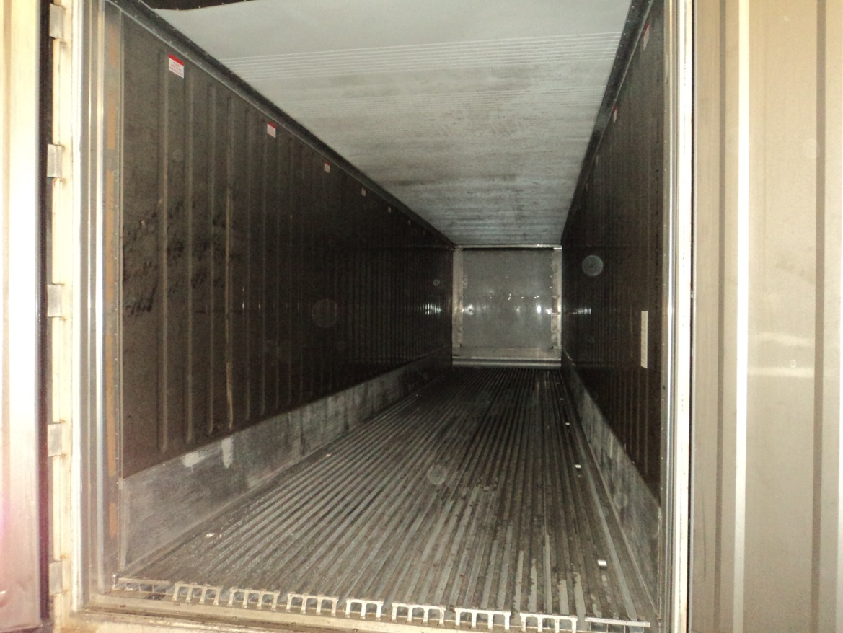 | Inspecting the container for pests and contaminants  The inside of the empty container is inspected to ensure it is free from pests and contaminants including soil.
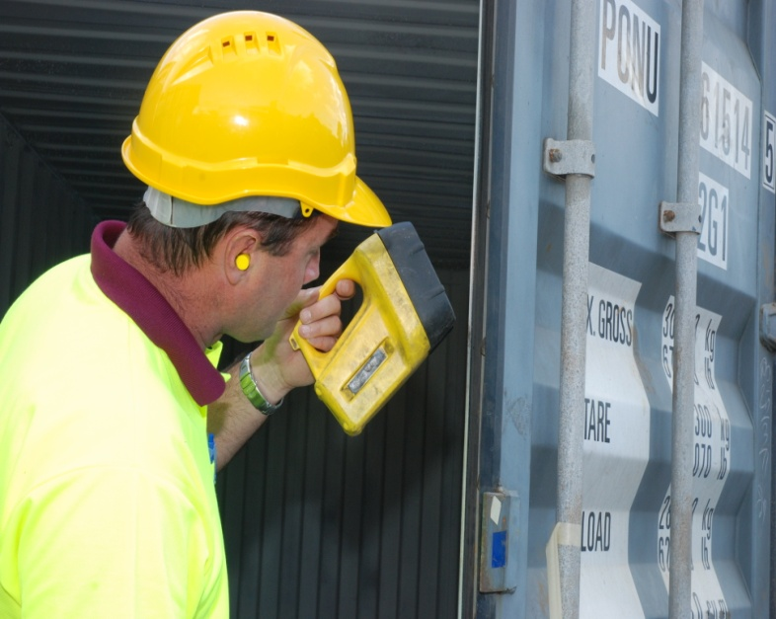 | Inspecting the container for structural damage  The container is inspected for structural damage, and the door seals are checked to ensure they are intact and provide a tight seal.
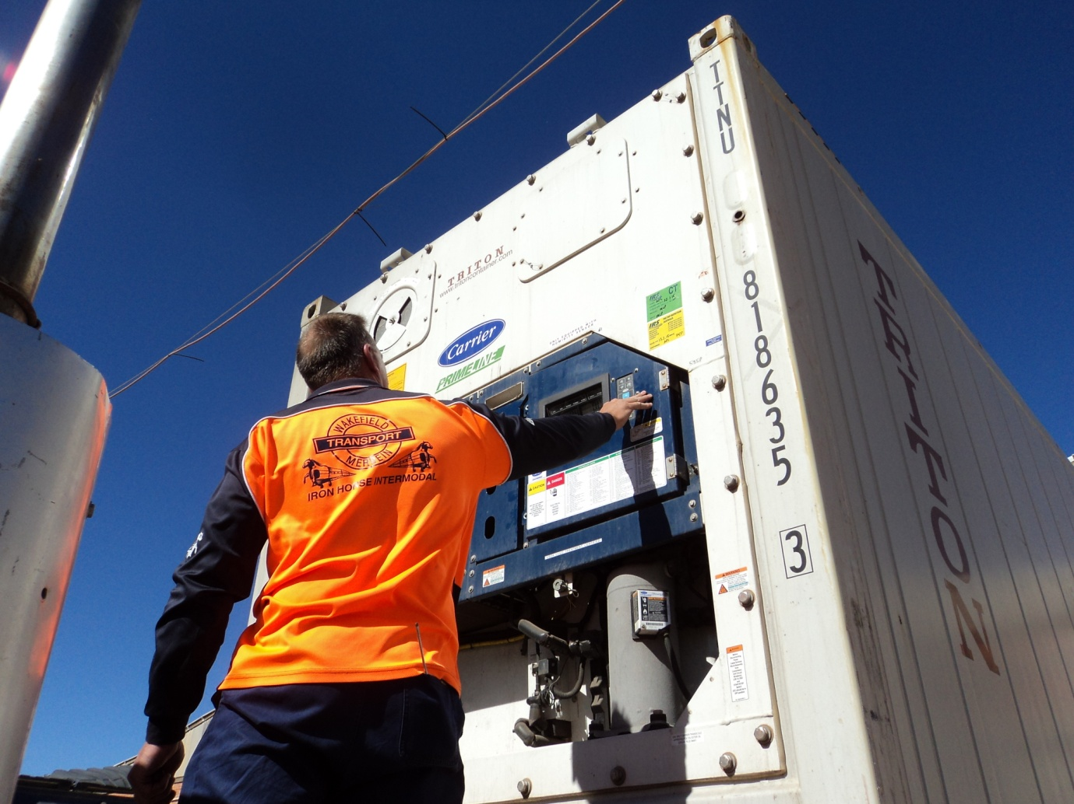 | Recording the temperature data recorder details  The serial number of the temperature data logger is recorded on the ITCT-calibration record.
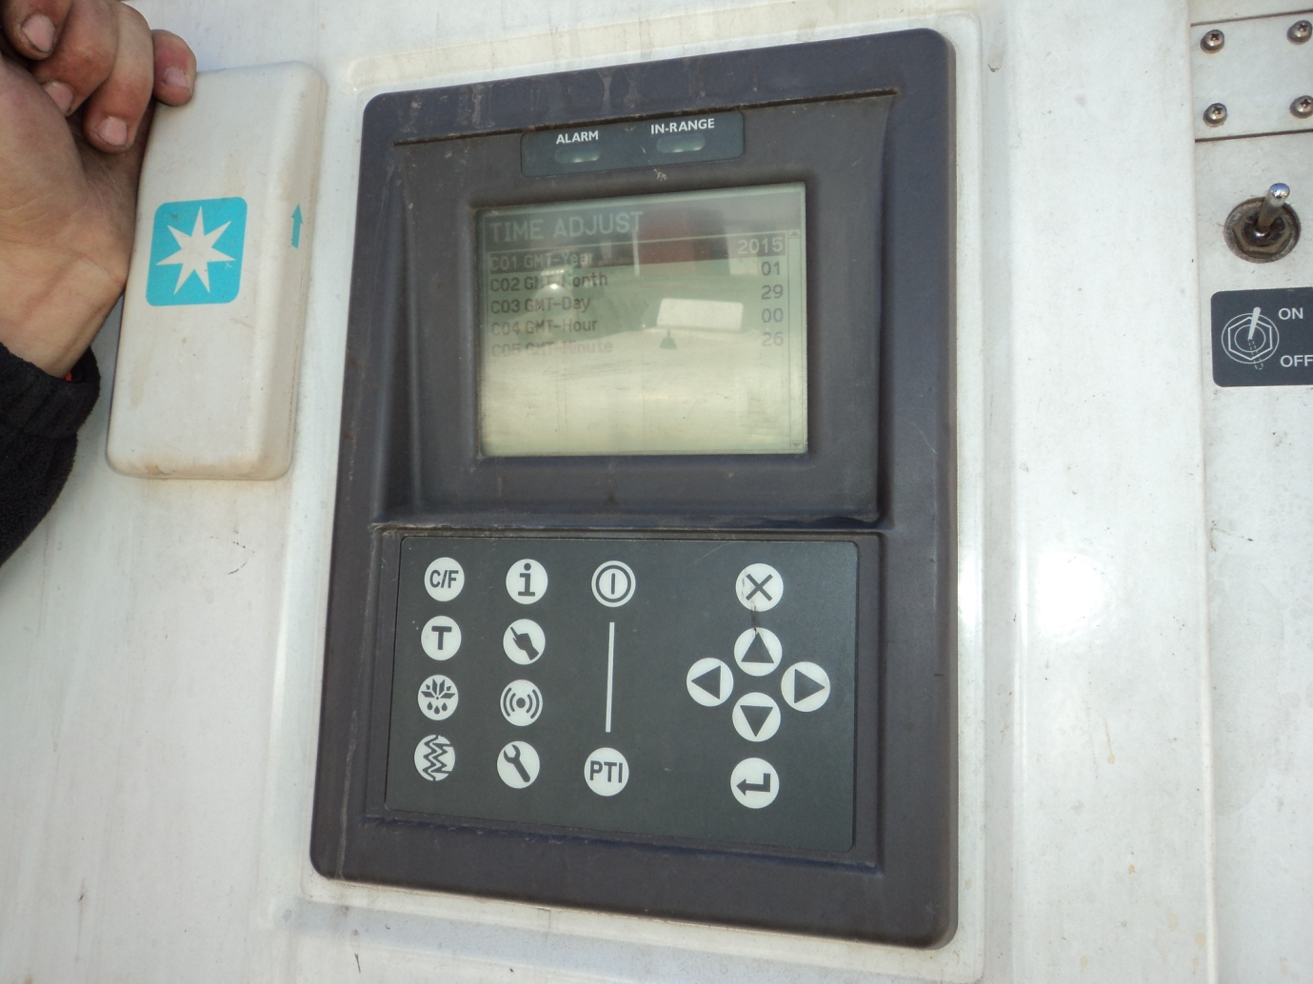 | Verifying the container is set to GMT  The AO asks the container technician to demonstrate that the container is set to within five minutes of Greenwich Mean Time (GMT).  Once verified, this is recorded on the ITCT-calibration record.

Verifying pre-cooling of the product prior to loading
The following table illustrates and describes how an AO verifies that a consignment has been pre-cooled.
What does this look like | Description
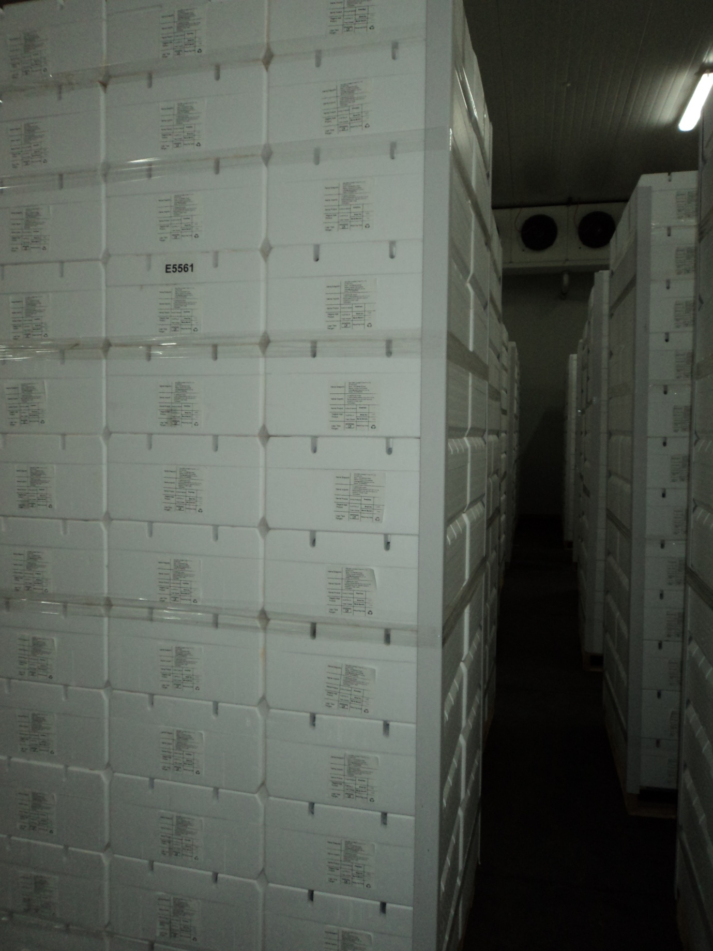  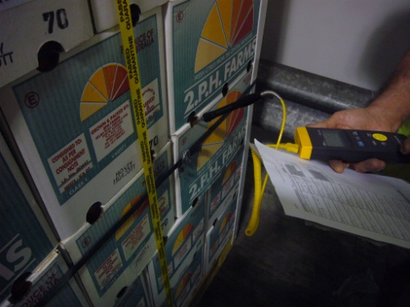 | Verifying pre-cooling and probe placement  The AO selects pallets from the consignment for pre-cooling verification, with a focus on areas that are likely to be warmer, such as boxes that are less insulated on the sides and top of the pallet.  The portable probe thermometer is placed through a packaging vent or box opening and into a piece of fruit, ensuring the tip of the thermometer is covered.  The temperatures are recorded on the ITCT-calibration record.

Supervising calibration of temperature sensors
The following table illustrates and describes how an AO supervises the calibration of temperature sensors.
What does this look like | Description
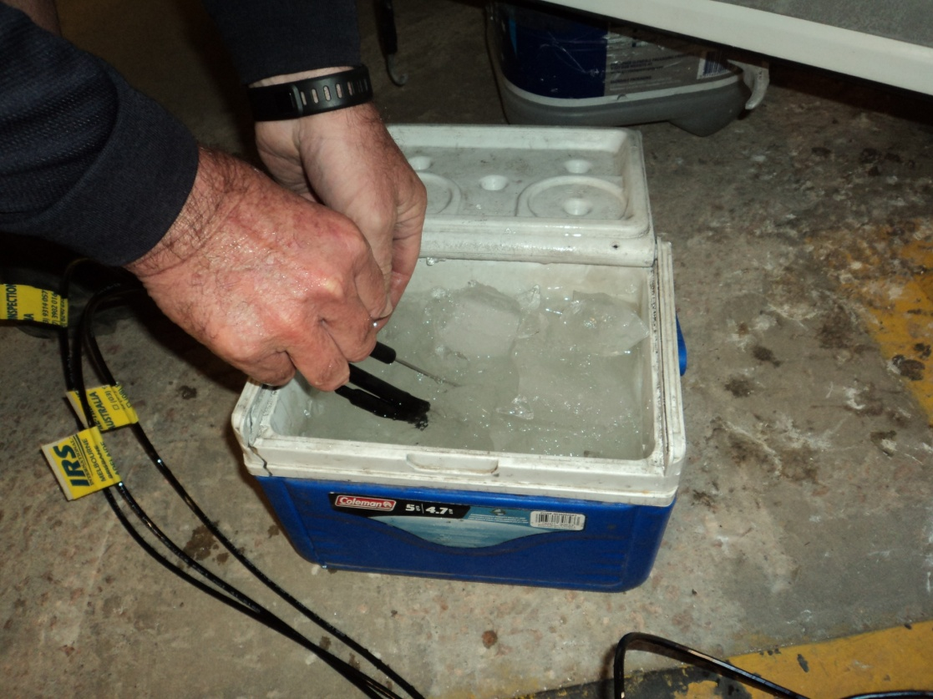 | Ice slurry method  The AO supervises the calibration of the sensors to make sure the client is using the ice slurry method as specified in the Australian phytosanitary treatment application standard for cold disinfestation treatment.
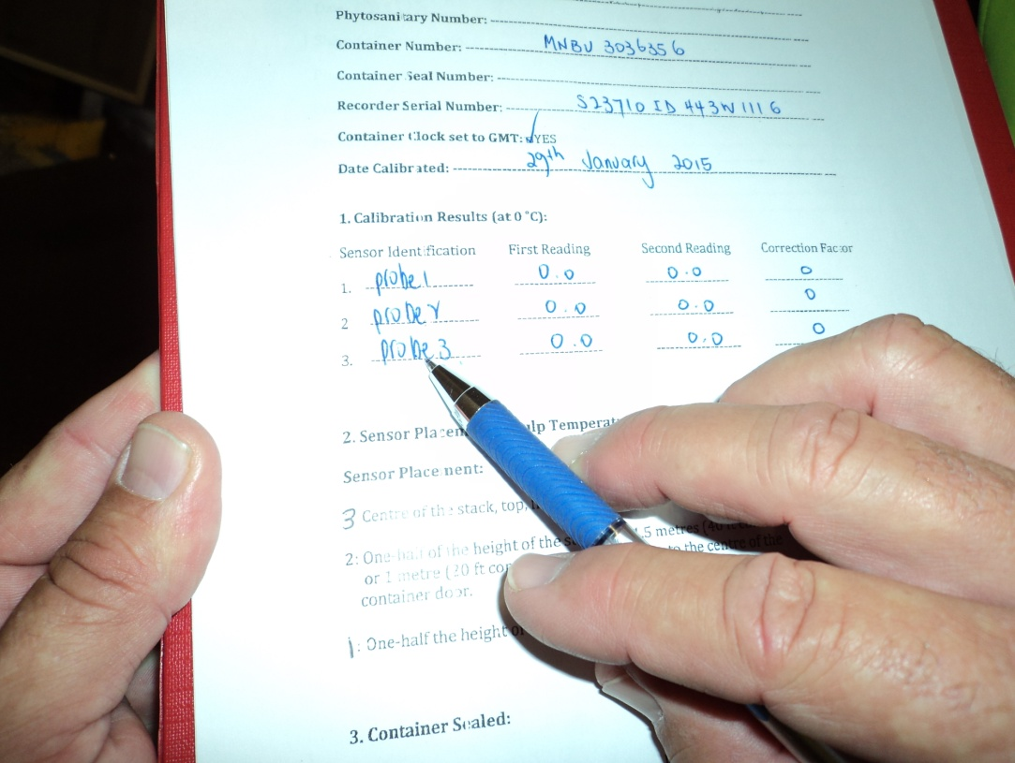 | Recording temperature readings  The temperature of each sensor is observed, and readings for each sensor are taken until the two readings match.  The readings and correction factors for each sensor are recorded on the ITCT-calibration record.

Supervising the loading of the container and sensor placement
The following table illustrates and describes how an AO supervises the loading of the container and sensor placement.
What does this look like | Description
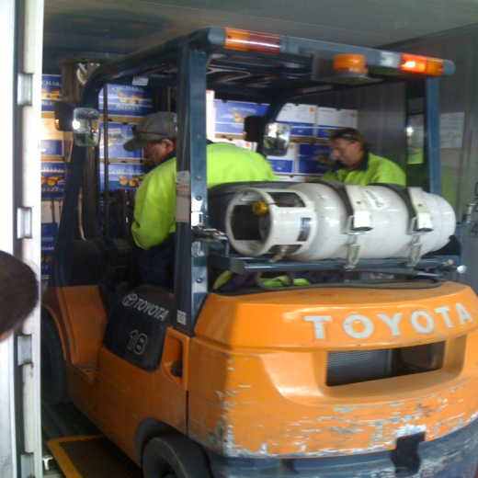 | Loading  The product is moved in such a manner as to prevent cross-infestation and/or cross-contamination.
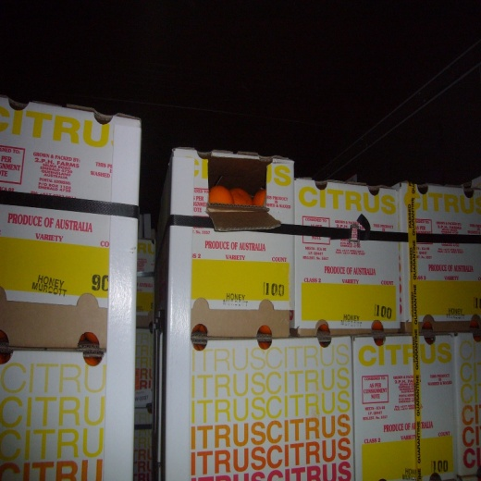 | Supervising sensor placement  The AO supervises the client placing each sensor, and ensures the sensors are placed in the locations specified in the Micor Plants case, protocol or work plan.  The placement details are confirmed on the ITCT-calibration record.
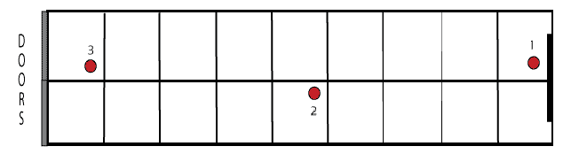 | Correct placement of sensor in a container  Here is an example of sensor placement in a 40 feet refrigerated container with 18 pallets of fruit (not drawn to scale).
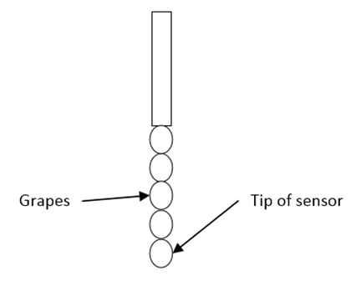  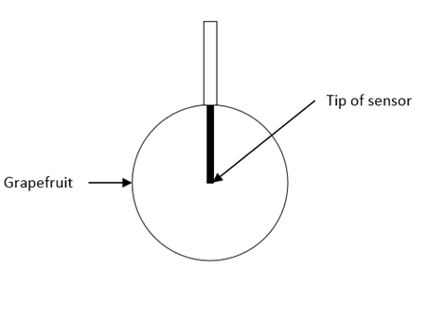 | Inserting sensor into the fruit  The AO supervises the client placing the fruit on the sensor ensuring that the product covers the sensor as much as possible and the sensor tip does not extend beyond the product.  For small fruit like grapes and cherries, multiple pieces of fruit can be placed on the sensor to ensure it is covered.
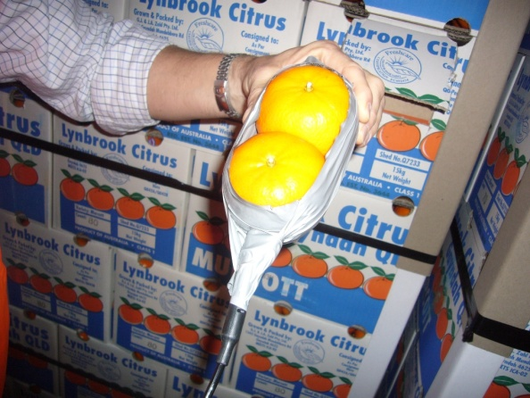 | Placing the fruit with inserted sensor into the carton  Once the fruit has been inserted onto the sensor the client carefully places it back into the carton.  The pulp temperature from each sensor is recorded on the ITCT-calibration record after it is placed back into the carton and stabilised.
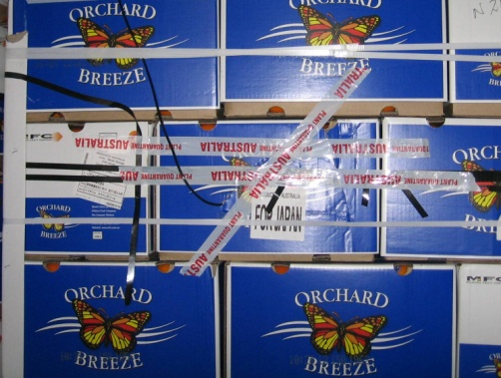  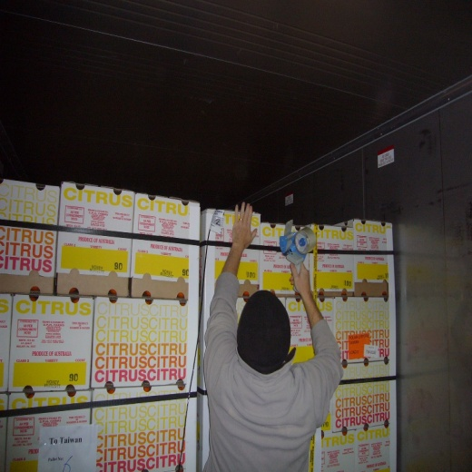 | Securing the sensor placement onto the cartons  The AO verifies the client has taped a spool of cable to the outside of the carton to prevent sensor dislodgement during treatment and verifies the running end of the cable is taped to the carton to prevent the sensor being pulled out of the fruit.
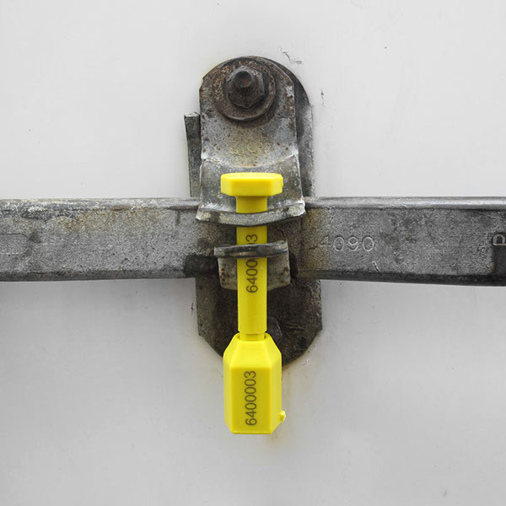 | Sealing the container  The AO observes the client sealing the container with a bolt seal.  The seal number is recorded on the ITCT-calibration record.

Related material
- Export Control Act 2020
- Export Control (Plants and Plant Products) Rules 2021
- Manual of Importing Country Requirements (Micor - Plants)
- Plant exports operations manual (PEOM)
- Work Instruction: Initiating an in-transit cold treatment for plant exports
- Reference: Certificate of loading and calibration record for an in-transit cold treatment
- Reference: Plant exports guide—equipment
- Australian phytosanitary treatment application standard for cold disinfestation treatment.

Contact information
- Authorised Officer Program: PlantExportTraining@aff.gov.au
- Horticulture Exports Program: HorticultureExports@aff.gov.au.

Document information
The following table contains administrative metadata.
Instructional Material Library document ID | Instructional material owner
IMLS-9-7411 | Director, Horticulture Exports Program, Plant Export Operations Branch

Version history
The following table details the published date and amendment details for this document.
Version | Date | Amendment details
1 | 28/06/2021 | First publication of this reference.
2 | 28/07/2023 | Updated department branding and the description of inserting sensor into the fruit.

