Sampling of dissolved gases in groundwater at in-situ pressure: a new methodology

* 1. Introduction

Dissolved gas concentrations in groundwater are useful environmental tracers that can be used for determining groundwater residence times, understanding geochemical processes, monitoring of contamination plumes as well as identification of mineral, oil and gas reserves (Aeschbach-Hertig et al., 1999; Amos et al., 2005; Kendall and McDonnell, 2012; Manning et al., 2003; Thakur and Rajput, 2010). Groundwater typically has a total dissolved gas pressure (TDGP) of approximately 1 atmosphere (atm) (Figure A-1). At this pressure, the gases stay dissolved while being sampled from the well and the sample can be isolated from atmospheric exchange using standard sampling techniques (e.g. using sealed copper tubes connected to the pump outlet) (International Atomic Energy Agency (IAEA), 2013; Weiss, 1968). However, in certain environmental settings, such as when sampling water directly from coal seams, dissolved gas concentrations (typically CH4 and CO2) may be much greater than 1 atm. Within these environments, gases remain dissolved, until there is a reduction in hydrostatic pressure. In the context of groundwater sampling, a decrease of hydrostatic pressure could be caused by a drop in the water level (degassing occurs within the well bore), or by pumping water to the surface (degassing occurs within the pump head or the sampling hose). The latter, particularly with the use of low-flow sampling techniques, can go unnoticed with gas loss in the sampling pump outlet hose. The separation between the water and gas phase complicates sample collection as the water is stripped of much of its gas content and therefore it is difficult to determine the volume of water that yielded the measured gas concentration. This leads to a non-representative sample and inaccurate reporting of both gas concentration and isotopic ratio data in the groundwater sample, which can be critical in areas which are being developed for shale and other unconventional gas resources (Jackson et al., 2013; Osborn et al., 2011; Roy and Ryan, 2013).

Collecting dissolved gas samples in groundwater in the field is often challenging due to, among other factors, well construction limitations, low yielding aquifer formations, high concentration of dissolved gas, and the need to avoid exposure of samples to the atmosphere. To obtain a ‘representative sample’ from the aquifer, an investigator relies on knowing well construction details, physical characteristics of the aquifer and geology, and then, based on this information, choosing and using the most appropriate sampling techniques and devices. In the oil and gas industry, a number of different sampling techniques are used for the collection and measurement of dissolved gases in groundwater. These include simple techniques such as the “inverted bottle” technique where the sample is collected at the surface from the pump outlet (Committee, 1957; Hirsche and Mayer, 2009); to slightly more sophisticated methods like the use of a passive diffusion samplers (Gardner and Solomon, 2009) and snap samplers (ProHydro, Inc.), both deployed at the depth of the well screens; to even more complex methods that involve in-situ samplers (ProOceanus Mini-Pro CH4 and Leutert Positive Displacement Sampler –PDS Sampler or One Phase Sampler). Some of these methods are designed for extreme conditions and ensure the sample remains as a single phase, while others have limited application when TDGP is above 1 atm.

The growth in exploration for unconventional gas resources such as coal seam gas (CSG) has led to increased baseline environmental monitoring of groundwater and other water resources in proximity to these developments. One of the key variables that is used to assess the potential impacts of these developments on nearby water resources is methane concentration and the stable isotope ratios of carbon (13C) and hydrogen (2H) in methane (Hirsche and Mayer, 2009). Baseline data of methane in these environments can be under-reported because the chosen sampling technique and sampling methodology allows dissolved gas to escape before the sample is collected (Molofsky et al., 2016). For example, sampling dissolved gases at the well head from low yielding wells can lead to in-well degassing due to the loss of hydrostatic pressure during pumping (Roy and Ryan, 2010).

Figure A-1 (a) Relationship between total dissolved gas pressure and depth below the water table, (b). Solubility of methane versus depth as a function of temperature.

Portable gas analysers are now being used routinely to perform baseline studies of methane (and other gas) levels around new gas fields, but have mostly been applied to studies investigating fugitive gas emissions (gaseous methane) in the near surface around wells and wellfields (Albertson et al., 2015; Marchese et al., 2015; Mitchell et al., 2015; Pétron et al., 2012a; Pétron et al., 2012b). The measurement of methane in water (dissolved methane) is more limited using these devices because the dissolved gas needs to be extracted from the water before it can be analysed (See e.g. Atkins et al., 2015; Charlotte P. Iverach et al., 2015).

The objective of this study was to develop a sampling methodology to collect dissolved gases from a representative groundwater sample, preventing sample gas loss (effervescence) by maintaining sample pressurisation. The design of the sample device required that it could be deployed easily in the field and that the collected sample could be transferred to a suitable sample container, appropriate for analysis by a portable gas analyser (in this study a Picarro 2201-i Cavity Ring-Down Spectrometer) to determine the dissolved methane concentration in water.

* 1. Methods

The dissolved gas downhole sampler is designed to fit inside a 50 mm diameter PVC well casing, a common casing size for groundwater monitoring wells. It is made up of two inlet and outlet tubes (connected to the surface with ¼” nylon hose to control the pressure at the sampler), a sampling chamber, with a check valve at the top (closing the outlet tube, when actuated) and a bottom check valve (Figure A-2 shows the device schematically). The sampler is designed to be purged with groundwater at depth and then pressurized, using compressed air and check valves, before retrieval and sample collection at the surface. Control is provided using the valves located on the operator assembly (surface control unit) from the surface. In this study both a portable air compressor and cylinder gas (e.g. ultrapure nitrogen) was used to pressurise the assembly at depth. The internal pressure of the system was monitored continuously at the surface using an Omega pressure gauge (rated to 250 psi) logged directly to a laptop.

The operating principles of the sampler are described in the following section, while the main components are illustrated in Figure A-2.

1. The sampler is lowered to the screened interval of the well and the increase in external (hydrostatic) pressure causes the check valves to open, allowing water to fill the sampler and ¼” nylon tubing to the standing water level in the well.
2. Pressurisation of the *inlet* tube forces water down through the sampler, closes off the bottom check valve and then discharges groundwater to the surface via the *outlet* tube.
3. Releasing the pressure at the operator assembly allows water to refill and flush the *inlet* tube and the sampler. The *outlet* tube stays filled because the top check valve prevents backflow.
4. This pressurisation and release pumping process is repeated to ensure fresh formation water is adequately flushed through the sampler. Flushing cycles, leak detection and sample pressure are continuously monitored using a pressure transducer at the surface station.
5. To collect a sample, the operator assembly is switched and the entire assembly including the *inlet* and *outlet* tubing are pressurised to 6.9-8.9 atm (71-91 metres of water column equivalent - mH2O).
6. As the sampler is removed from the well, the water in the sampler remains pressurized at 6.9-8.9 atm hydrostatic pressure, preventing sample effervescence and loss of gas.

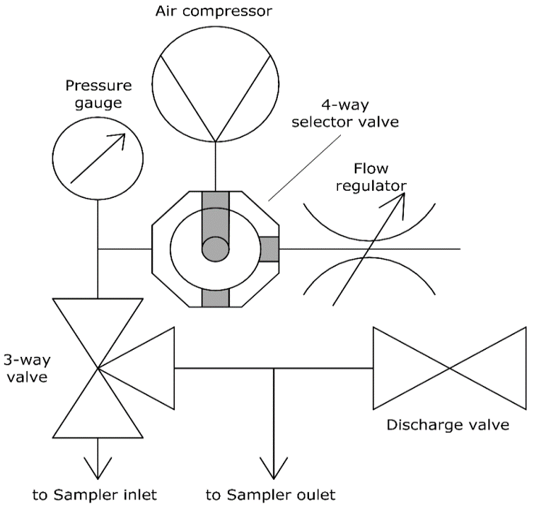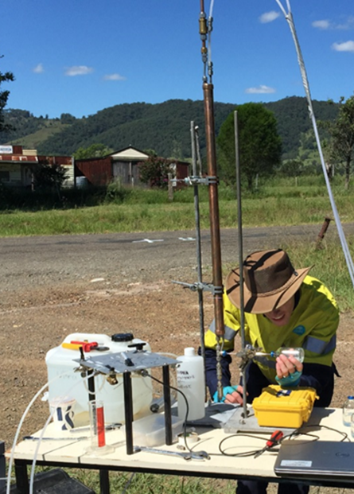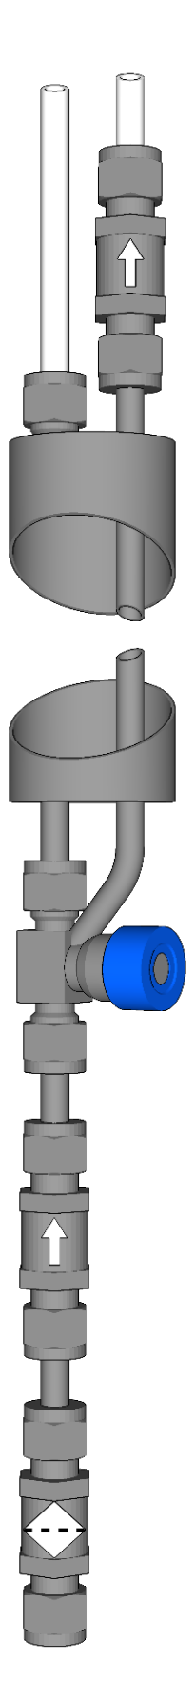

Figure A-2 (a) design of the downhole sampler: [1] nylon inlet tube, [2] nylon outlet tube, [3] sampler, [4] top check valve, [5] bottom check valve, [6] 140 micron filter screen [7] butyl-rubber septa sample port, (b) schematic of surface control unit and (c) downhole sampler in use with operator assembly in foreground.

1. At the well head, the sampler is placed in a support stand and a sample is collected by piercing the butyl-rubber septum on the sampling port with a double-ended needle-valve assembly (Figure A-3). For methane and methane stable isotope samples, the free end of the needle is immediately inserted into the septa of a crimp-sealed, pre-evacuated 100 mL serum bottle and filled halfway with the sample water (~ 50 mL), leaving a head space in the bottle that is at a partial vacuum. Gases that were dissolved because of the sustained sample pressure rapidly degas from the water as it is released into the serum bottle. The design of the sampler means that the separation between the gas and water phase occurs in a closed system and no gas is lost. After measuring the molar fraction as gas in the headspace, the concentration of the dissolved gas can be determined using the known headspace – water volume ratio and the solubility of methane, calculated based on the sample temperature and salinity.

Other samples for hydrochemical analyses can be collected from the discharge outlet using standard methodologies. These include stable isotopes of water, major and trace metals, and radioactive tracers like 14C. In our study, dissolved noble gases (Ar, Ne and He) were also collected in copper tubes and kept at sample pressure using a similar methodology to the downhole sampler described here.

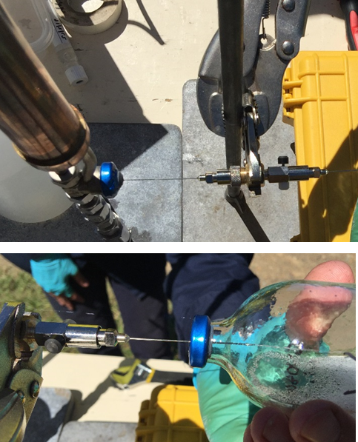

Figure A-3 Sample collection in the field using a double ended syringe from the butyl-rubber septa sample port of the downhole sampler.

* + 1. Sample preparation for methane and methane isotope analysis

Pre-evacuated (<0.001 atm) serum bottles (100 mL clear glass Wheaton bottle) with 20 mm aluminium crimp caps and grey butyl-rubber stoppers were used to collect groundwater samples from the downhole sampler in triplicate. A saturated solution of mercuric chloride (HgCl2) was used as a sample preservative to prevent bio-degradation and injected into the serum bottle (0.2 mL) following pre-evacuation. Once the sample had been collected with approximately 50 mL of sample, the serum bottle was injected with air containing zero methane (zero air) to re-equilibrate the bottle to atmospheric pressure.

A double syringe sampling technique was used to transfer a known volume of sample gas from the equilibrated head space of the serum bottle to a 1 L foil gas sampling bag (Supelco Supel Inert Foil Gas Sampling Bag) which could be directly connected to the inlet of a gas analyser. The suitability of both the serum bottle with butyl septa and the foil bags are recognised as the preferred sample container to minimise isotopic fractionation when storing environmental gas samples (*Eby et al.*, 2015).

In our study, 40 mL of sample gas was added to the bag containing 200 mL of zero air (a total sample volume of 240 mL provided approximately eight minutes of continuous gas analysis through the Picarro Analyzer; N≤120). Groundwater samples with high concentrations (estimated by monitoring total dissolved gas pressure during purging) were further diluted so that the sample was within the detection limits of the Picarro (typically, 2 to 5 mL of the original sample was injected into another foil bag containing 200 mL of zero air).

* + 1. Field Testing site

Samples were collected from 26 groundwater and coal seam gas monitoring wells near Gloucester, New South Wales, Australia. Well depths ranged from 6.5 to 230 meters below ground surface and were typically completed with short screen intervals (<12 m)and casing diameter between 50 and 100 mm. Wells were selected for sampling based on proximity to proposed coal seam gas development, although some were chosen based on results reported in previous gas sampling investigations (Parsons Brinckerhoff, 2012).

The intended sampling procedure was to purge three well volumes from each well so as to ensure that the sampled water represented formation water from the screened interval, etc. Unfortunately, the majority of the wells completed in the interburden and coal seam were very low yielding and it was impossible to purge three well volumes due to the large drawdown and unpractical, long recovery times. For these low yielding wells, at least three screen interval volumes were purged as a minimum and to prevent any de-gassing as a result of purging, the purging rate was set so that the water level in the well was high enough to maintain sufficient hydrostatic. Other standard field parameters (i.e. pH, specific electrical conductivity, dissolved oxygen and total dissolved gas pressure) were also monitored during the purging period.

* 1. Results and discussion
     1. Field testing: downhole sampler

An example of the flushing cycles and sample pressurization routine of a well with high gas concentrations is shown in Figure A-4. Well S4MB02 is completed to 95 m below ground level with a 6 metre screen and the standing water level was 5.53 m below top of casing (TOC) prior to purging. The well was pumped to remove the stagnant water within the well and purging ceased after 20 minutes when the water level dropped to 46.27 m (due to the low yield of the formation) to ensure in-well degassing did not occur. A water level logger re-deployed down the well after the sampling showed that the well took a full day to recover to the standing water level measured prior to sampling. Figure A-4 shows modelled hydrostatic sample pressures based on the system pressures logged at the surface.

Chart of field sampling output

Figure A-4 Example from monitoring well S4MB02 showing the purging and recovery of the bore followed by the deployment, flushing and recovery of the downhole sampler; (a) depth of the sampler and water levels (WL) in the bore and inlet and outlet tubes; (b) pneumatic, hydrostatic and total dissolved gas pressures; sampler pressure is modelled based on water level within the bore, recorded pneumatic pressures at the wellhead and sampler depth; TDG pressure was estimated from the combined CH4 and CO2 concentrations.

True water level and sampler depth pressure may be slightly different than what is indicated because the water level in the inlet line does not recover instantaneously when the line pressure is decreased. To limit large pressure drops in the sampler (i.e. to prevent degassing of the sample during purging) the inlet line was vented slowly, allowing the inlet water level to rise as the pressure dropped.

* + 1. In-field laboratory analysis

A Picarro 2201-i cavity ring down spectrometer (CRDS) (Crosson, 2008) was used as a portable laboratory during the study to provide ‘real time’ measurements of the samples collected each day of the field campaign. The benefit of using the portable laboratory was that it provided the opportunity to use the field-lab results to refine the sampling campaign and target other groundwater wells of interest that were not initially considered during the desktop survey. Average reported values were calculated from an approximately eight minute measurement period (N≤120). Note that gas concentrations as reported by the Picarro Analyzer have been converted to head gas concentration using Henry’s Law. Standard deviations for individual samples are calculated for the concentrations as measured by the measuring instrument. All samples were calibrated both for concentration and isotopic ratio using a number of gases of known concentration and isotopic ratio (Table A-1). To ensure data accuracy of the laboratory analysis, duplicate samples from selected sites were also sent to the UC Davis Stable Isotope Laboratory at the University of California and the GNS Stable Isotope Facility in New Zealand.

The 26 groundwater samples that were collected from the field site near Gloucester, NSW and analysed for CH4 concentration and δ13C of CH4 are shown in Table A-2. Repeat measurements from the same sample bottle and sample site were also undertaken. In most instances, only two samples were analysed as there was good agreement between the measured values (refer to Table A-2 for reported standard deviation). Some samples were only analysed once. The broad range of concentration values and isotopic ratios reflects the range of sample depths (i.e. methane solubilities) and the microbiological and hydrogeological environments (aquifer type, presence of coal seam, etc.) that samples were collected from. To illustrate the need to use the correct sampling methodology, methane concentrations are shown against depth together with two curves that show the solubility of methane at 10 and 20 °C (Figure A-5). Any samples that plot to the right of the solubility curves are likely to have excess gases in solution and must be sampled using appropriate sampling techniques to avoid degassing. It is apparent from this figure that the majority of the groundwater samples collected from the field site in Gloucester could experience gas loss and isotopic fractionation without the use of appropriate sampling techniques.

Table A-3 shows a comparison of data collected from the same groundwater wells during this study using the new downhole sampler with data collected using low flow sampling techniques from a previous study (Parsons Brinckerhoff, 2012). The specific details of the sampling methodology (i.e. deployment depth of pump, type of pump, sample preservation) of the previous study is unknown, however, for all the wells that had methane concentrations above 10,000 ug L-1 there is a considerable discrepancy between reported measurements from the two studies from the same monitoring wells. Much of this discrepancy, especially at higher concentrations suggests the loss of sample due to effervescence of samples as they are sampled. The discrepancy in concentration and the isotopic values may also be caused by poor sample preservation such that the sample becomes oxidised and the methane concentrations will be lower and isotopic ratios of methane more enriched. In the sample comparison where the methane concentrations are less than approximately 10,000 ug L-1, the results are consistent between studies and supports the hypothesis that there is little or no tendency for the fluid sample to lose gas under typical surface atmospheric pressures and temperatures. Any variations that we see at these lower concentrations are likely to reflect differences in how the samples are handled and analysed than in the collection method.

Table A-1 Reported values for the measured calibration gases

|  |  |  |
| --- | --- | --- |
| Calibration gas | Mean | Standard deviation (±) |
| Methane 1.8 ppm | 1.81 | 0.01 |
| Methane 11.4 ppm | 11.28 | 0.08 |
| Methane 746 ppm | 736.77 | 2.92 |
| Isotopes -23.9 @ 2 ppm | -26 | 0.73 |
| Isotopes -66.5 @ 2 ppm | -67.22 | 2.34 |
| Isotopes -23.9 @ 11 ppm | -24.03 | 0.47 |
| Isotopes -66.5 @ 11 ppm | -63.5 | 4.21 |
| Isotopes -23.9 @ 500 ppm | -22.7 | 0.58 |
| Isotopes -66.5 @ 500 ppm | -63.53 | 2.96 |

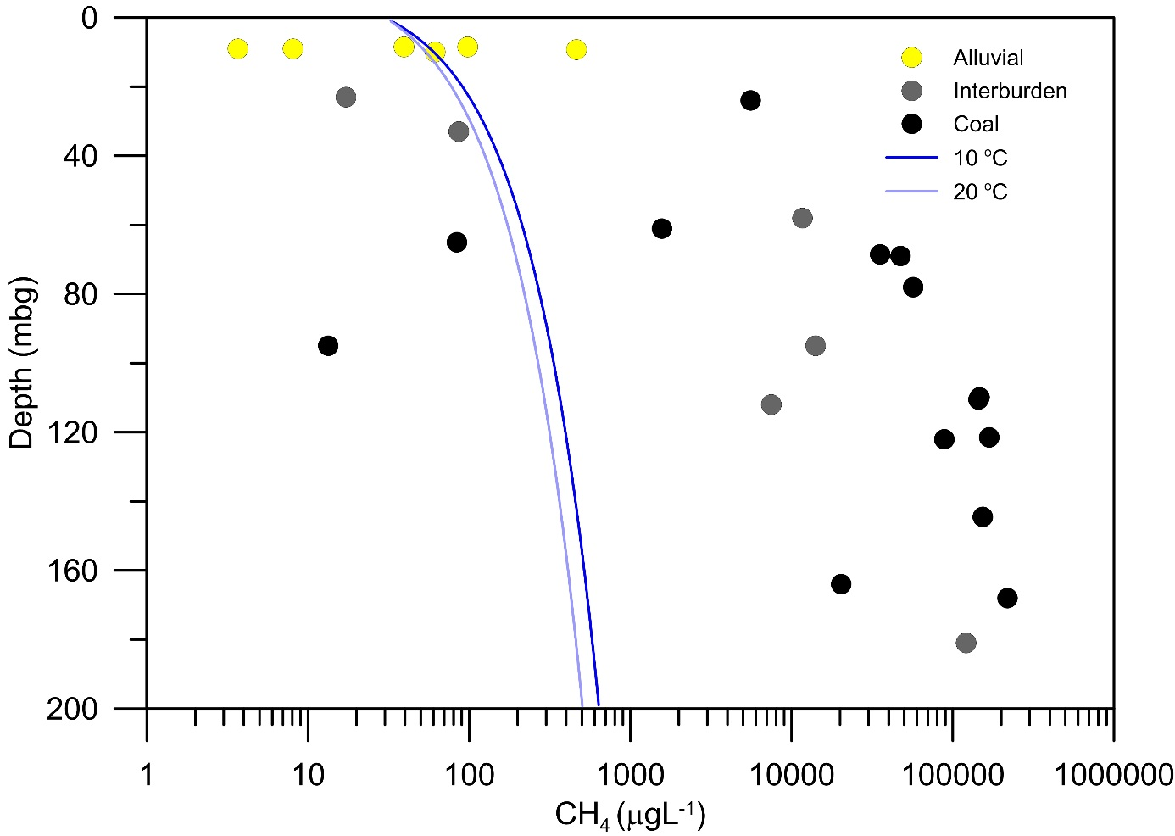

Figure A-5 Methane concentration of the groundwater samples versus depth. Methane solubility curves (at 10 and 20 degrees C) are also shown. Sampled collected under conditions to the right of the blue curves will effervesce as the sample is brought to the surface unless sample pressure is maintained.

Table A-2 Measured CH4 concentrations and isotopic ratios of the 26 groundwater samples (average values presented). Average values and standard deviations are based on the gas concentrations measured on the Picarro Analyzer. n/a indicates where a duplicate sample could not be analysed.

|  |  |  |  |  |  |  |  |  |  |  |
| --- | --- | --- | --- | --- | --- | --- | --- | --- | --- | --- |
| Well ID | Lithology | Completion depth | Mid screen | 1/2 screen length | SWL | Date/Time sampled | CH4 | std.CH4 | d13C-CH4 | std.d13C-CH4 |
|  |  | mbgl | mAHD | m | mbTOC |  | microgL-1 | microgL-1 | per mil | per mil |
| GR-P1 | Alluvial | 8.5 | 98.06 | 1.5 | 3.84 | 1/03/2016 15:00 | 35 | 7 | -43.7 | 0.6 |
| GR-P10 | Alluvial | 8.5 | 103.43 | 1.5 | 4.81 | 24/02/2016 16:38 | 84 | 20 | -40.3 | 1.8 |
| GR-P11 | Alluvial | 9.3 | 102.74 | 1.5 | 4.72 | 1/03/2016 14:40 | 463 | n/a | -62.4 | n/a |
| GR-P2 | Alluvial | 9.0 | 96.13 | 2.5 | 2.11 | 2/03/2016 13:00 | 4 | n/a | -29.2 | n/a |
| GR-P3 | Alluvial | 9.0 | 93.27 | 2.0 | 2.49 | 2/01/2016 12:46 | 8 | 0.1 | -51.9 | 0.2 |
| GR-P6 | Interburden | 23.0 | 126.00 | 3.0 | 4.17 | 22/02/2016 14:40 | 16 | 2 | -65.5 | 1.2 |
| GR-P6A | Coal | 95.0 | 54.00 | 3.0 | 12.24 | 22/02/2016 12:00 | 13 | n/a | -60.4 | n/a |
| GR-P9 | Interburden | 33.0 | 89.37 | 4.5 | 10.31 | 2/01/2016 11:00 | 86 | n/a | -58.6 | n/a |
| GR-P9A | Coal | 65.0 | 55.67 | 3.0 | 8.82 | 2/01/2016 10:10 | 84 | n/a | -46.8 | n/a |
| GW080838-1 | Coal | 78.0 | 39.84 | 6.0 | 3.41 | 28/02/2016 10:50 | 56735 | n/a | -55.9 | n/a |
| GW080838-2 | Coal | 109.9 | 4.48 | 2.5 | 3.48 | 28/02/2016 9:10 | 142184 | 5973 | -50.3 | 0.3 |
| GW080839-1 | Coal | 61.0 | 53.56 | 6.0 | 3.62 | 27/02/2016 16:00 | 1571 | n/a | -60.7 | n/a |
| GW080839-2 | Coal | 110.5 | 2.52 | 4.5 | 2.04 | 27/02/2016 10:15 | 136874 | 12481 | -63.5 | 1.9 |
| GW080840-1 | Coal | 69.0 | 54.30 | 6.0 | 11.47 | 23/02/2016 16:00 | 47442 | n/a | -54.9 | n/a |
| GW080840-2 | Coal | 121.5 | 0.33 | 4.5 | 11.66 | 23/02/2016 15:00 | 153539 | 20642 | -55.5 | 1.2 |
| GW080841-1 | Coal | 24.0 | 83.03 | 3.0 | 2.91 | 24/02/2016 11:39 | 3133 | 807 | -61.0 | 1.0 |
| GW080841-2 | Coal | 144.5 | -36.10 | 4.5 | 1.67 | 24/02/2016 10:09 | 145800 | 12221 | -48.4 | 0.0 |
| GW080843-1 | Coal | 68.5 | 36.71 | 4.5 | 5.77 | 1/03/2016 11:45 | 34064 | 2051 | -76.8 | 0.0 |
| GW080843-2 | Coal | 122.0 | -16.74 | 4.5 | 3.19 | 1/03/2016 9:30 | 87205 | 1823 | -53.7 | 1.1 |
| S4MB02 | Interburden | 95.0 | 27.09 | 3.0 | 5.53 | 26/02/2016 11:10 | 12545 | 2217 | -81.6 | 0.4 |
| S4MB03 | Coal | 168.0 | -46.00 | 3.0 | 4.66 | 26/02/2016 10:31 | 215274 | 4641 | -59.9 | 0.1 |
| S5MB01 | Interburden | 58.0 | 75.50 | 3.0 | 14.14 | 25/02/2016 13:00 | 11481 | 269 | -69.4 | 0.0 |
| S5MB02 | Interburden | 112.0 | 24.40 | 6.0 | 15.93 | 25/02/2016 10:00 | 6693 | 1123 | -66.9 | 0.3 |
| S5MB03 | Coal | 164.0 | -30.68 | 3.0 | 17.41 | 25/02/2016 10:40 | 20327 | n/a | -47.8 | n/a |
| TCMB02 | Interburden | 181.0 | -54.15 | 3.0 | 10.10 | 29/02/2016 14:05 | 116423 | 6660 | -55.8 | 0.8 |
| TMB01 | Alluvial | 10.0 | 99.10 | 1.5 | 4.63 | 29/02/2016 16:00 | 61 | n/a | -58.2 | n/a |

Table A-3 Comparison between data collected from the same wells using the downhole sampler (this study) and samples collected in a previous study (Parsons Brinckerhoff, 2012).

|  |  |  |  |  |
| --- | --- | --- | --- | --- |
| Sample ID | This study | | Previous study (Parsons Brinckerhoff, 2012) | |
| CH4 | 13C-CH4 | CH4 | 13C-CH4 |
| gL-1 | per mil | gL-1 | per mil |
| GR-P3 | 8 | -51.9 | 12 | -38.9 |
| S4MB02 | 12545 | -81.6 | 6960 | -36.8 |
| S4MB03 | 215274 | -59.9 | 39600 | -44.5 |
| S5MB01 | 11481 | -69.4 | 4440 | -39.6 |
| S5MB03 | 20327 | -47.8 | 12100 | -36.6 |
| TCMB02 | 116423 | -55.8 | 10800 | -50.3 |

As an example of the differences between our results and previous results, the methane concentration for sample S4MB02 (shown in Figure A-4) is 12,545 g L-1 in this study, and data collected from a previous study reported a measured methane concentration of 6,960 gL-1. If we consider the methane solubility in groundwater with depth (Figure A-1) and assume that the sample was not collected at sample pressure (i.e. low flow sampling or sample collection at the well head was used), degassing of this sample would start to occur at approximately 20 m below the surface and depending on the time to retrieve, collect and seal the sample, a considerable amount of gas would be lost.

Measurement data reproducibility of water samples collected in environments such as coal seam gas can be challenging, particularly when limited information is known on the sampling procedure or choice of technique that was used to collect the sample. The approach that we have used here attempts to reduce some of the uncertainty by collecting a representative sample from the hydrogeological formation at sample pressure from a well screen that has been adequately flushed. During field testing, the five wells that were sampled previously all reported higher methane concentrations when samples were collected using our new methodology, with some samples an order of magnitude higher. Not knowing the specific details of the previous sampling makes it difficult to rule out other sources of error, however, our results indicate that the approach used in this study is more suited to low yielding wells with high concentrations of dissolved gas concentrations.

* 1. Summary and Conclusions

The choice of sampling technique and method is fundamental to obtaining a representative dissolved gas sample from an aquifer from where the groundwater well screen is completed and the environmental conditions that influence it. This study has demonstrated the benefits of using a simple downhole sampler to sample dissolved gases, particularly in narrow, low yielding wells. The design of the sampler captures a representative dissolved gas sample from the aquifer at in-situ pressure without gas loss and minimal disturbance to the well – problems that can be encountered with other sampling methods.

The use of this new sampler together with a portable gas analyser provides a rapid sampling methodology for the analysis of dissolved gas samples in a field setting. This approach can be very useful in the monitoring and evaluation of unconventional gas resource projects and the collection of baseline data where historical data is scarce. In-situ field-based measurements of dissolved gases can reduce overall project costs and provide an effective sampling strategy to target specific areas of interest.

* 1. References

Aeschbach-Hertig W, Peeters F, Beyerle U, and Kipfer R (1999). Interpretation of dissolved atmospheric noble gases in natural waters. Water Resources Research 35(9): 2779-2792.

Albertson JD, Ferrari S, Harvey T, Amin MS, Foderaro G, Modrak M, Zhu P, Brantley H, Zhou X, and Thoma ED (2015). A mobile sensing approach for regional surveillance of fugitive methane emissions in oil and gas production. Environmental Science and Technology 49: 2487-2497.

Amos RT, Mayer KU, Bekins BA, Delin GN, and Williams RL (2005). Use of dissolved and vapor-phase gases to investigate methanogenic degradation of petroleum hydrocarbon contamination in the subsurface. Water Resources Research 41(2): W02001, doi:10.1029/2004WR003433.

Atkins ML, Santos IR, and Maher DT (2015). Groundwater methane in a potential coal seam gas extraction region. Journal of Hydrology: Regional Studies 4 Part B: 452-471.

Committee R (1957). Proposed Standard Methods for Methane Determination. Journal (American Water Works Association) 49(8): 1077-1084.

Crosson ER (2008). A cavity ring-down analyzer for measuring atmospheric levels of methane, carbon dioxide and water vapor. Applied Physics B: Lasers and Optics 92: 403-408.

Eby P, Gibson JJ, and Yi Y (2015). Suitability of selected free-gas and dissolved-gas sampling containers for carbon isotopic analysis. Rapid Communications in Mass Spectrometry 29(13): 1215-1226.

Gardner P and Solomon DK (2009). An advanced passive diffusion sampler for the determination of dissolved gas concentrations. Water Resources Research 45(6): doi:10.1029/2008WR007399.

Hirsche T and Mayer B (2009), A comprehensive literature review on the applicability of free and dissolved gas sampling for baseline water well testing Rep., 56 pp, Alberta Environment, Edmonton, Alberta.

International Atomic Energy Agency (IAEA) (2013). Isotope methods for dating old groundwater, IAEA, Vienna, Austria.

Iverach CP, Cendón DI, Hankin SI, Lowry D, Fisher RE, France JL, Nisbet EG, Baker A, and Kelly BFJ (2015). Assessing connectivity between an overlying aquifer and a coal seam gas resource using methane isotopes, dissolved organic carbon and tritium. Scientific Reports 5(15996), 11.

Jackson RE, Gorody AW, Mayer B, Roy JW, Ryan MC, and Van Stempvoort DR (2013). Groundwater Protection and Unconventional Gas Extraction: The Critical Need for Field-Based Hydrogeological Research. Groundwater 51(4): 488-510.

Kendall C and McDonnell JJ (2012). Isotope Tracers in Catchment Hydrology, Elsevier Science.

Manning AH, Solomon DK and Sheldon AL (2003). Applications of a Total Dissolved Gas Pressure Probe in Ground Water Studies. Ground Water 41(4): 440-448.

Marchese AJ et al. (2015). Methane emissions from United States natural gas gathering and processing. Environmental Science and Technology 49(17): 10718-10727.

Mitchell AL et al. (2015). Measurement of methane emissions from natural gas gathering facilities and processing plants: Measurement results. Environmental Science and Technology 49: 3219-3227.

Molofsky LJ, Richardson SD, Gorody AW, Baldassare F, Black JA, McHugh TE, and Connor JA (2016). Effect of Different Sampling Methodologies on Measured Methane Concentrations in Groundwater Samples. Groundwater 54(5): 669-680.

Osborn SG, Vengosh A, Warner NR, and Jackson RB (2011). Methane contamination of drinking water accompanying gas-well drilling and hydraulic fracturing. Proceedings of the National Academy of Sciences of the United States of America 108(20): 8172-8176.

Parsons Brinckerhoff (2012). Phase 2 Groundwater Investigations- Stage 1 Gas field Development Area Gloucester Gas Project. January 2012 Rep., AGL Upstream Investments Pty Ltd.

Pétron G et al. (2012a). Hydrocarbon emissions characterization in the Colorado Front Range: A pilot study. Journal of Geophysical Research 117 D04304: 04301-04319.

Pétron G et al. (2012b). Hydrocarbon emissions characterization in the Colorado Front Range: A pilot study. Journal of Geophysical Research-Atmospheres, 117.

D04304. Roy JW and Ryan MC (2010). In-Well Degassing Issues for Measurements of Dissolved Gases in Groundwater. Ground Water 48(6): 869-877.

Roy JW and Ryan MC (2013). Effects of Unconventional Gas Development on Groundwater: A Call for Total Dissolved Gas Pressure Field Measurements. Groundwater 51(4): 480-482.

Thakur NK and Rajput S (2010). Exploration of Gas Hydrates: Geophysical Techniques, Springer Berlin Heidelberg.

Weiss RF (1968). Piggyback sampler for dissolved gas studies on sealed water samples. Deep Sea Research and Oceanographic Abstracts 15(6): 695-699.

Continuous air sampling: CO2, methane and its stable isotopes

Mobile real-time air sampling surveys provide the potential ability to locate, isolate and identify individual methane sources within regions of elevated baseline conditions. Figure A-6 shows the CH4 concentration data in air samples collected on 3 March 2016 starting at approximately 5:00am and finishing by 7:17am, covering a total distance of just over 68 km. Temperature and wind values were typical of conditions for the area and time of day and time of year, i.e. the morning was cool (21-22 oC) with very little wind. The lowest CH4 concentration observed was 1.78 ppm, while the highest was 2.31 ppm. Carbon dioxide concentration data (Figure A-7) were also collected, as were CH4 isotope ratio data and these are presented in Figure A-8. The atmospheric background methane concentration is just under 1.8 ppm (concentration data collected at Cape Grim by CSIRO are very close to this at this time <http://www.csiro.au/greenhouse-gases/>). For comparison it is worth noting that the lower explosive limit for CH4 is 50,000 ppm (5%) (Pennsylvania State University, 2012).

It is very likely that greenhouse gas (GHG) concentrations are slightly “exaggerated” as temperature inversions often form overnight, trapping gases and causing the (trapped) gas concentrations to increase. Nevertheless it was surprising that CH4 concentrations over the majority of the survey are above background (>1.8 ppm) suggesting that there is consistent enrichment of the local atmosphere from local sources. The highest values observed here, although they are not as high as in other potential CSG source areas that have been surveyed, tend to correspond to the measured local hotspot values associated with the river or near some of the water and gas production wells (which have the potential to be emitters). While elevated CH4 concentrations are associated with some stretches of the Waukivory River and one monitoring well, most of the high values were found in the middle of paddocks away from the river and the other wells. It is possible that the high concentrations are associated with cattle in the area, but examination of isotopic signature data does not support a dominant biogenic signature. The δ13C isotope values along the survey route were relatively noisy at low CH4 concentrations, and therefore the data have been further processed using a 30 second moving average filter. It is possible to run longer filters through the data, but, as the anomalous zones are not large, this would most likely over-smooth the data, and some information would be lost; hence, some data noise is still apparent in the data. Figure A-8a shows the entire isotope data set collected over the survey run, whilst Figure A-8b shows only the data associated with CH4 concentration data that was >2 ppm to help visualise the correlation between zones of higher concentration with their isotope values.

Efforts were made to survey a complete loop around Yancoal’s Stratford Duralie coal mine, located in the southern part of the survey to see if the mining operations contributed to the local methane budget. While we were only able to drive around the northern side of the mine, and wind direction (observed to be relatively still), concentration data collected near the mine suggest that there was little input from the mine at that time. The conclusion after examination of the continuous methane, CO2 and stable isotopes of methane survey data is that nearly all of the CH4 data have mixed source signatures, tending toward thermogenic.

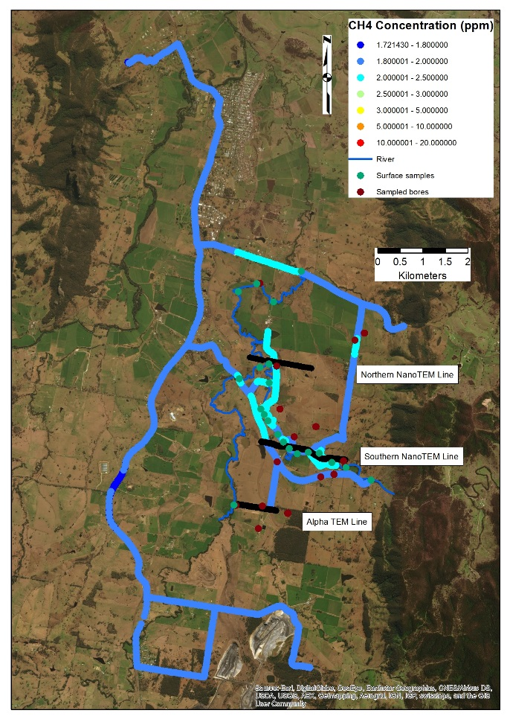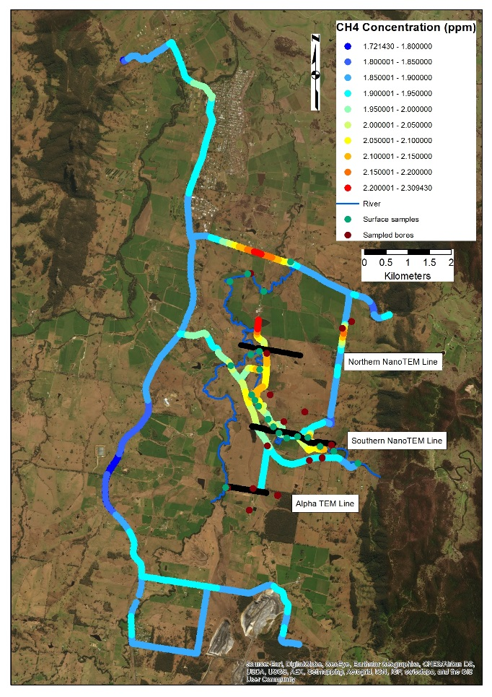

Figure A-6 CH4 gas concentration data measured over Gloucester, NSW. All data collected between approximately 5:00 and 7:00 on the morning of 3 March 2016. Data for (a) are shown using a broad colour bar chosen to highlight the range of data. Data for (b) are shown using a more focused colour bar.

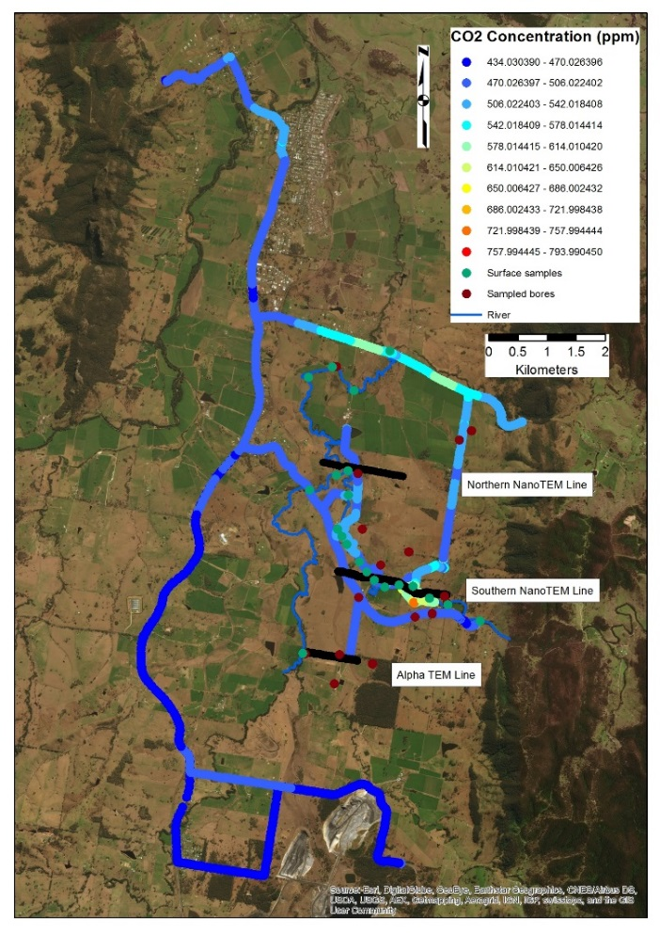

Figure A-7 CO2 concentration (ppm) data measured over Gloucester, NSW. All data collected between approximately 5:00 and 7:00 on the morning of 3 March 2016.

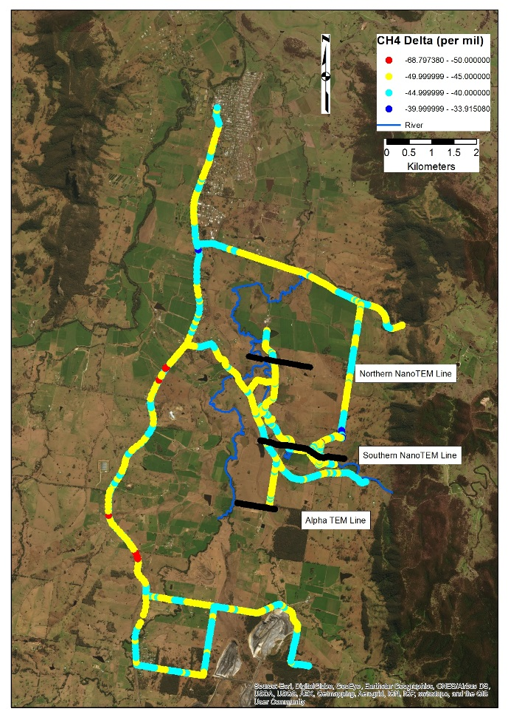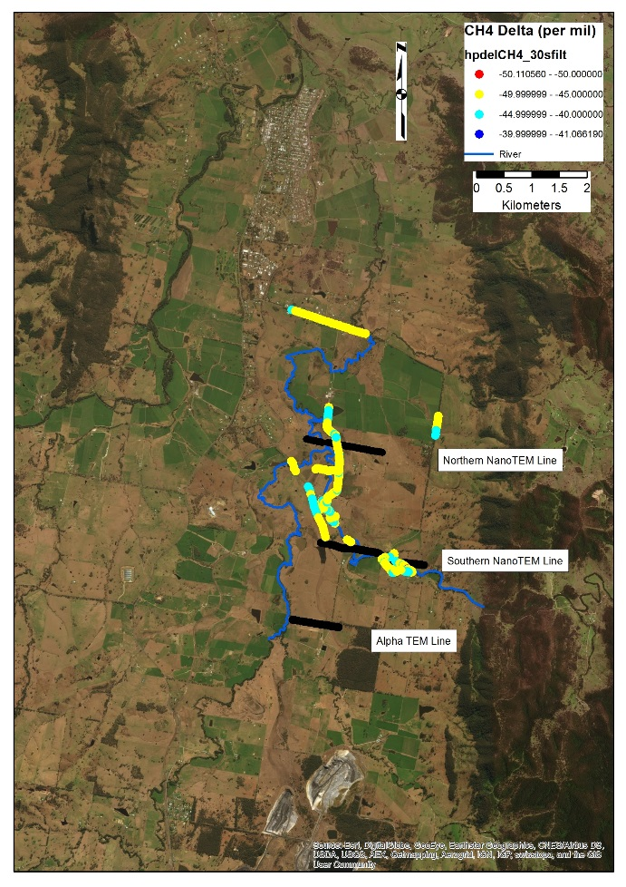

Figure A-8 Methane isotopic signature data (13C-CH4) measured over Gloucester, NSW. All data collected between approximately 5:00 and 7:00 on the morning of 3 March 2016. Data for (a) show all of the isotopic data collected over the area. Data for (b) show only data where CH4 concentration is >2 ppm.

Sampling locations for surface water and groundwater

Table A-4 Measured field parameters and major ion analyses of the collected 22 surface water samples 22nd February to 2nd March 2016.

| Site ID | River | Eastings | Northings | Distance upstream jacks road (m) | Date/Time |
| --- | --- | --- | --- | --- | --- |
| A0 | Avon | 403457 | 6454621 | 0 | 22/02/2016 10:50 |
| A1 | Avon | 402839 | 6453939 | 1450 | 22/02/2016 15:00 |
| A2 | Avon | 402469 | 6454345 | 2120 | 23/02/2016 10:00 |
| A3 | Avon | 402052 | 6454169 | 2810 | 23/02/2016 12:30 |
| A4 | Avon | 402486 | 6453084 | 4695 | 24/02/2016 14:30 |
| A5 | Avon | 402732 | 6452562 | 6020 | 27/02/2016 14:30 |
| At-6 | Avon | 402532 | 6452485 | 6222 | 24/02/2016 11:22 |
| At-7 | Avon | 402074 | 6452233 | 7098 | 24/02/2016 16:40 |
| At-8 | Avon | 401961 | 6449424 | 11330 | 29/02/2016 16:50 |
| W0 | Waukivory | 402743 | 6452146 | 6835 | 24/02/2016 9:10 |
| W1 | Waukivory | 402554 | 6451561 | 7638 | 27/02/2016 16:00 |
| W2 | Waukivory | 402630 | 6451437 | 7915 | 24/02/2016 13:00 |
| W3 | Waukivory | 402716 | 6451297 | 8143 | 27/02/2016 11:45 |
| W4 | Waukivory | 402933 | 6451000 | 8564 | 25/02/2016 12:10 |
| W5 | Waukivory | 403059 | 6450826 | 8820 | 28/02/2016 9:30 |
| W6 | Waukivory | 403189 | 6450682 | 9353 | 27/02/2016 9:00 |
| W7 | Waukivory | 403365 | 6450568 | 9995 | 28/02/2016 11:55 |
| W8 | Waukivory | 403615 | 6450601 | 10258 | 25/02/2016 14:10 |
| W9 | Waukivory | 403849 | 6450581 | 10534 | 26/02/2016 17:20 |
| W10 | Waukivory | 404136 | 6450376 | 10912 | 26/02/2016 15:30 |
| W11 | Waukivory | 404450 | 6450261 | 11277 | 25/02/2016 8:20 |
| W12 | Waukivory | 405004 | 6449982 | 12140 | 25/02/2016 9:50 |

Table A- 5 Measured field parameters and major ion analyses of the collected 26 groundwater samples 22nd February to 2nd March 2016.

|  |  |  |
| --- | --- | --- |
| Well ID | Lithology | Date/Time |
|  |  |  |
| GW201186 | Alluvial | 1/03/2016 15:00 |
| GR-P10 | Alluvial | 24/02/2016 16:38 |
| GR-P11 | Alluvial | 1/03/2016 14:40 |
| GW201185 | Alluvial | 2/03/2016 13:00 |
| GW201184 | Alluvial | 2/01/2016 12:46 |
| GR-P6 | Interburden | 22/02/2016 14:40 |
| GR-P6A | Coal | 22/02/2016 12:00 |
| GR-P9 | Interburden | 2/03/2016 11:00 |
| GR-P9A | Coal | 2/03/2016 10:10 |
| GW080838-1 | Coal | 28/02/2016 10:50 |
| GW080838-2 | Coal | 28/02/2016 9:10 |
| GW080839-1 | Coal | 27/02/2016 16:00 |
| GW080839-2 | Coal | 27/02/2016 10:15 |
| GW080840-1 | Coal | 23/02/2016 16:00 |
| GW080840-2 | Coal | 23/02/2016 15:00 |
| GW080841-1 | Coal | 24/02/2016 11:39 |
| GW080841-2 | Coal | 24/02/2016 10:09 |
| GW080843-1 | Coal | 1/03/2016 11:45 |
| GW080843-2 | Coal | 1/03/2016 9:30 |
| S4MB02 | Interburden | 26/02/2016 11:10 |
| S4MB03 | Coal | 26/02/2016 10:31 |
| S5MB01 | Interburden | 25/02/2016 13:00 |
| S5MB02 | Interburden | 25/02/2016 10:00 |
| S5MB03 | Coal | 25/02/2016 10:40 |
| TCMB02 | Interburden | 29/02/2016 14:05 |
| TMB01 | Alluvial | 29/02/2016 16:00 |

Additional Fault Features: Chimneys

A simple steady-state analytical mass balance approach was used to estimate the flux through the TDS anomaly in Figure A-9 to better constrain fault hydraulic conductivity. The TDS contours were used to determine the plume concentration through space, and provide additional information which will help constrain discharge through the fault. The TDS plume is located within the surficial alluvial aquifer, this sits within a high conductivity weathered zone. Streams to the north and south of the plume provided constant head boundary conditions, and the fault to the west and catchment boundary to the east provided no flow boundaries (Figure A-9).

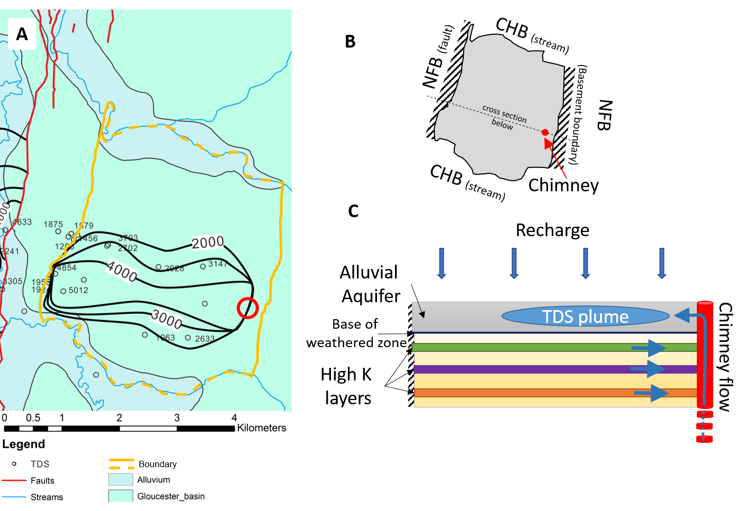

Figure A-9 (A) TDS anomaly and the head boundaries used for the plume analysis, chimney location indicated by the red circle. Solid yellow lines represent the no-flow boundaries, and the dashed lines represent the constant head boundaries, and open black circles represent well locations. (B) Schematic diagram of the aquifer area used in the mass balance analysis showing the boundary conditions (NFB: no flow boundary and CHB: constant head boundary) and chimney location (red circle). (C) schematic cross section throw (B) showing the chimney connectivity between high hydraulic conductivity layers at depth and the overlying alluvial aquifer/weathered zone.

To determine the flow through the chimney a number of simplifying assumptions are required:

1. The alluvial aquifer is isolated from the underlying aquifers (i.e., no diffuse groundwater movement up or downward);
2. Uniform aquifer properties i.e. thickness and porosity (ø);
3. The system is in steady-state (no change in aquifer storage or groundwater level);
4. The concentration of total dissolved solids between contours is constant (the contour represents the average concentration);
5. Flow and concentration of the water through the chimney are constant in time;
6. Groundwater recharge is spatially uniform;
7. Groundwater discharge only occurs along the stream boundaries; and
8. Evapotranspiration is negligible and therefore assumed to be zero.

This approach assumes that the flow into the area defined in Figure A-9 (recharge and flow associated with the TDS plume) is equal to discharge (stream discharge). We also assume that there are no additional losses to other chimneys. Due to the uncertainty in both recharge and discharge in the area, the TDS data provides an additional constraint on the ratio of flux to recharge.

Groundwater data suggests that the geological layers in which the TDS plume occurs are isolated from the underlying layers, i.e., minimal exchange occurs with deeper aquifers. The only connectivity with underlying geological layers is through the chimney conduit which results in the formation of the TDS plume. GIS analysis of the plume contours allowed estimation of the plume extent. It should be noted that this approach provides a very rough estimate based on the available data; for a more accurate assessment further geological and hydrological data are required (both temporal and spatial).

The volume of the TDS plume is estimated by calculating the ratio of the plume concentration (with the groundwater concentration as a reference) within the study area to the source concentration of the plume (with the groundwater concentration as a reference) and the aquifer properties (thickness *b,* and porosity ø):

$V_{p}=\int_{0}^{y}{\int_{0}^{x}{\left(\frac{C_{i}-C_{gw}}{C_{ch}-C_{gw}}\right)bϕdxdy}}$ (A-1)

where Equation A-1 is used to estimate the total volume of water in the TDS plume ($V_{p}$), based on the concentrations within the plume ($C_{i}$), the conduit or chimney location ($C_{ch}$), and the ambient groundwater concentration ($C_{gw}$).Table A-6 provides a description of the variables required for the mass balance approach. The contrasting TDS concentration of the aquifer and conduit provide clear end members for the analysis.

Table A-6 Parameter description for the mass balance analysis

|  |  |  |
| --- | --- | --- |
| Symbol | Parameter | Units |
|  | Spatial coordinates | m |
|  | Volume of the plume from the chimney | m3 |
|  | TDS concentration of TDS contour *i* | mg/L |
|  | TDS concentration at the conduit or chimney, and ambient groundwater | mg/L |
|  | Total volume of the aquifer | m3 |
|  | Aquifer thickness | m |
|  | Porosity | - |
|  | Flow through the conduit or chimney | m3/year |
| *QD* | Flow out of the aquifer to the streams (discharge) | m3/year |
|  | Recharge | m3/year |
|  | TDS concentration of TDS contour *i* | mg/L |

The total volume of water within the aquifer, which includes the plume, is estimated from the study site area, defined in Figure A-9, the aquifer thickness (*b*) and porosity (ø):

$V_{T}=\int_{0}^{y}{\int_{0}^{x}{bϕdxdy}}$ (A-2)

By applying Equations A-1 and A-2 to the study area, the ratio of the plume volume to the total aquifer volume (*V*P/*V*T) was estimated at 0.103. Note that both aquifer thickness *b* and porosity ø can be disregarded in Equations A-1 and A-2 given that they will cancel. By assuming steady-state conditions within the study area, the flow through the chimney is a proportion of the discharge from the area. This proportion is equal to the ratio of the plume volume to the total aquifer volume:

$Q_{ch}=\frac{V_{p}}{V_{T}}Q_{D}$ (A-3)

The flow through the chimney can then be determined as being the total groundwater discharge from the study area excluding recharge (Equation A-4):

$Q_{ch}=Q_{D}-R$ (A-4)

No data regarding the groundwater discharge in the area are available therefore Equation A-4 is rearranged to solve for $Q_{D}$ and substituting this into Equation A-3. This can then be solved for the flow through the chimney ($Q_{ch}$) (Equation A-5):

$Q_{ch}=\frac{V_{p}}{V_{T}}\left(R+Q_{ch}\right)$ (A-5)

or

$Q_{ch}=\frac{R}{\left(\frac{V_{T}}{V_{p}}-1\right)}$ (A-6)

Estimates of recharge for the Gloucester basin are provided by Parsons and Brinckerhoff (2013), ranging between 0 – 115 mm/year for the area. Based on an estimated recharge *R* of 5 mm/year (Parsons Brinckhoff, 2013) and a recharge area of 5,850,000 m2, (total TDS plume area, see Table A-7) the chimney flux *Q*ch was estimated to be about 3,360 m3/year, based on Equation (A-6). The effective hydraulic conductivity of the chimney can be approximated as that of a cylinder (assuming steady-state flow and a vertical gradient of 1 within the chimney):

 (A-7)

where *Keff* is the effective hydraulic conductivity of the cylinder (m/year), and *r* is the radius of the cylinder (m). Based on a chimney radius of 10 m, *K*eff was calculated to be ~10 m/year (approximately 0.01 m/day).

Table A-7 TDS values and areas used in the steady-state mass balance analysis. Contours estimated using a geographical information system approach.

|  |  |  |  |
| --- | --- | --- | --- |
| Location/Contour | TDS mg/L | | Area (m2) |
| Groundwater | | 1,800 | - |
| Chimney | | 5,000 | - |
| Contour: 2000 | | 2,000 | 1,000,000 |
| Contour: 3000 | | 3,000 | 960,970 |
| Contour: 4000 | | 4,000 | 262,030 |
| Total | |  | 5,850,000 |

References

|  |  |  |
| --- | --- | --- |
|  | | |
| CONTACT US  t 1300 363 400  +61 3 9545 2176  e csiroenquiries@csiro.au  w www.csiro.au  At CSIRO, we do the  extraordinary every day  We innovate for tomorrow and help improve today – for our customers, all Australians and the world.  Our innovations contribute billions of dollars to the Australian economy  every year. As the largest patent holder  in the nation, our vast wealth of intellectual property has led to more  than 150 spin-off companies.  With more than 5,000 experts and a burning desire to get things done, we are Australia’s catalyst for innovation.  CSIRO. WE IMAGINE. WE COLLABORATE.  WE INNOVATE. |  | For further information  Land and Water  Dirk Mallants t +61 8 8303 8595  e dirk.mallants@csiro.au  w www.csiro.au/landandwater |