*http://au2011studyabroad.files.wordpress.com/2011/03/aims_logo.jpghttp://au2011studyabroad.files.wordpress.com/2011/03/aims_logo.jpg*

**Australian Institute of Marine Science**

**Integrated monitoring, modelling and management of the GREAT BARRIER REEF WORLD HERITAGE AREA – demonstration case for THE MACKAY REGION**

*Terry Walshe, Aaron MacNeil, Ainsley Archer, Hugh Sweatman, Eric Lawrey, Line Bay, Prue Addison and Ken Anthony.*

*Final Report to the Department of the Environment*

*December 2014*

# Executive Summary

This report has been developed as a partnership between the Great Barrier Reef Taskforce (Commonwealth Department of the Environment) and AIMS. The purpose of the report is to progress plans for an integrated monitoring program (IMP) for the GBRWHA, specifically demonstrating use of integrated monitoring principles and how different operational elements of monitoring, modelling and adaptive management are linked. The motivation for the report comes partly from Regional Sustainability Projects (RSP5 and RSP6) supporting GBRMPA’s strategic assessment for the GBRWHA, and more recently from the Long-Term Sustainability Plan for the Great Barrier Reef (LTSP2050).

The LTSP2050 asserts the Commonwealth and Queensland government’s commitment to the GBR’s Outstanding Universal Value (OUV) and continuous improvement. The validity of this assertion rests on demonstrated performance against specified targets for ecosystem health. This report provides guidance on how data gathered in monitoring can be analysed and communicated in a way that is accessible to managers and stakeholders. Its central objective is to facilitate informed allocation of management and monitoring resources associated with evidence-based tracking of progress made against LTSP2050 targets.

This report focuses on a subsection of the GBRWHA - the Mackay/Whitsunday Region - to illustrate key elements of integrated monitoring. This region encompasses issues encountered more broadly throughout the GBR, including exposure to risks posed by agriculture and ports and shipping, as well as social tension between those that seek a stronger and more diversified economic base for the region and those looking to protect conservation and lifestyle values, and tourism.

The report is structured around the building blocks of an IMP:

* Analysis and integration of datasets (section3)
* Integrating models with data (section 4)
* Integrating social and economic elements (section 5)
* Integrating data capture and reporting (section 6)

We show how advances in statistical modelling can make better use of currently available data and disparate datasets. Specifically, we demonstrate gains in precision in spatially explicit estimates of water quality variables through integration of multiple data sources via Gaussian Process models. Similarly, we illustrate use of Bayesian Hierarchical Process models for spatially discrete habitats, including coral reefs. While these gains are non-trivial, considerable uncertainty remains in the characterisation of water quality and coral cover under current monitoring programs.

A core theme of this report is the trade-offs between the costs of false alarmism (i.e. incorrectly asserting failure in achieving targets), false sense of security (i.e. incorrectly asserting success) and the costs of monitoring. These costs and trade-offs are difficult to characterise. In the past, and in other settings, managers and scientists have often been overconfident in the capacity of skeletal monitoring programs to meaningfully inform management. Many attempts at adaptive management have failed, in part because of this overconfidence. This report takes the view that design specifications are difficult to articulate from the outset. Instead, we outline an approach that uses structured decision-making to estimate the merit of monitoring alternatives. We show how this approach can be used to (a) adaptively manage, and (b) adaptively monitor.

We recommend coherent integration of models and monitoring data to inform adaptive management of the GBR in the context of the LTSP2050. A key role of monitoring against targets is to test the validity of assertions regarding management effectiveness that are implicitly embedded in policies and procedures. Conceptually, the requirement to undertake rigorous and intensive monitoring is proportional to the extent to which OUV and other values are exposed to risk. A risk-averse or precautionary approach to management and approvals implies low likelihood of a negative impact, and investment in monitoring may be a lesser imperative. Where risks are high, greater insurance against harm can be ‘purchased’ through greater investment in monitoring.

Monitoring programs in complex and variable natural systems that clearly differentiate circumstances in which management complies or doesn’t comply with specified goals or targets typically demand intensive sampling (Mapstone 1995). Lower intensities imply higher rates of inferential error. We may infer failure when we are in fact succeeding in our management objectives, or we may infer success when we are in fact failing. Our guess is that with typical budgets dedicated to monitoring, there will be many instances where uncertainty implies intolerable rates of false failure and false success. That is, the inadequacy of resources dedicated to monitoring will be apparent to managers and stakeholders. Credibility of the notions of evidence-based continuous improvement and decision-making would be substantially improved if a consequence of candid description of uncertainty and error in status and trend reporting was a greater allocation of resources to monitoring.

However, our expectation is that it will be cost-prohibitive for managers to allocate sufficient resources to monitoring *all* targets in a way that satisfies near-zero tolerance to the risks associated with false failure and a false success. We suggest an iterative approach to demonstrating progress against targets, whereby targets considered most important by managers and stakeholders are assigned more monitoring resources than targets of lesser importance.

The informed treatment of risk requires,

* probabilistic predictions of performance against LTSP2050 targets obtained through modelling,
* estimation of the precision of a sampling regime,
* characterisation of the consequences of false success, true success, false failure and true failure, and
* estimates of the financial costs of data acquisition.

When considered alongside options for management intervention, these four elements provide the basis for adaptive management and adaptive monitoring. We recommend those responsible for implementation of integrated monitoring under the LTSP2050 embrace urgent development of these four elements as cornerstones of a committed approach to continuous improvement.

Contents

Executive Summary 1

1.0 Introduction 4

1.1 Overview of General Approach 5

1.2 Context 7

2.0 Case study - Mackay-Whitsunday Region 8

2.1 Study Area 8

2.2 Data 14

3.0 Analysis and integration of monitoring data 16

3.1 Analysis of monitoring data 16

3.2 Integrating datasets 28

4.0 Integration of models and monitoring data 37

4.1 Models 37

4.2 Combining models and monitoring data in risk-based adaptive management and adaptive monitoring 44

4.3 Structured decision-making 50

5.0 Integrating social and economic elements 57

6.0 Integration with reporting 61

7.0 Conclusion and recommendations 64

Acknowledgements 65

References 66

Appendix – Monitoring programs in the Mackay-Whitsunday case study area 73

# 1.0 Introduction

This report describes progress in operationalising integrated monitoring in the Great Barrier Reef World Heritage Area (GBRWHA). Using the Mackay region as a case study, it illustrates how targeted and adaptive monitoring can be integrated with modelling and structured decision-making to best inform adaptive management.

The GBRWHA is home to some of the richest and diverse marine ecosystems on Earth. It faces a suite of environmental and human-caused pressures, ranging from global environmental change to regional and local-scale impacts such as land-use run-off and dredging from ports and other coastal developments (GBRMPA 2013, GBRMPA 2014).

Key challenges for GBRWHA managers and decision-makers are to (1) understand the chronic and cumulative impact of multiple stressors, (2) monitor drivers, activities, pressures and their impacts on ecosystem values and their goods and services (and the linked social and economic systems) effectively and optimally in order to (3) support the most well-informed management decisions. When integrated and targeted, monitoring can enable evaluation of system performance (indicated by condition and trend), effectiveness of management actions, and inform allocation of resources to monitoring and specific management action (Field et al. 2005; Nichols and Williams 2006; Sanchirico et al. 2013). Ecological and environmental monitoring in the GBRWHA is substantial but not integrated, targeted or optimal for management (Hedge et al. 2013). Such a lack of monitoring integration into management is a common feature seen in many marine protected areas in Australia (Addison et al. 2015), and indeed around the globe (Addison 2011).

To sustain the GBRWHA now and into the future will require management strategies and policies informed by a deeper understanding of how ecological and social systems interact, and will be interacting under scenarios of environmental change. A path to such understanding is the integration of (1) multidisciplinary and multi-scale monitoring programs with (2) science-based models of ecosystem and socio-ecological behaviour and (3) a framework for transparent environmental decision-making.

This demonstration case incorporates elements and principles of integrated monitoring and links these functionally to the modelling of the environment and its impacts on key ecosystems as a primary objective, and social and economic aspects as secondary objectives. The specific focus ecosystems are seagrass meadows, coral reefs and, by implication, their key dependent species. The report demonstrates how existing monitoring programs provide a stepping stone for fuller integration, and how improved design, coordination and integration with analysis and modelling can improve and support management decisions.

Dredging associated with expansion of port capacity and nutrient and sediment run-off via major rivers are used as key drivers of environmental scenarios in the demonstration case. As part of this demonstration, we show how required monitoring effort is sensitive to the probability of environmental harm (or unacceptable progress towards defined management targets), as informed by modelling.

Although the report uses the waters off Mackay and its surrounds as a specific demonstration case, it is made scalable (expandable) by using a systems approach that allows the incorporation of additional drivers, pressures, indicators and values, and their interaction. Apart from using region-specific monitoring data, such scaling is possible by adjusting the structure and number of layers in the operational models of environment, ecosystem, and social system to represent the local or regional setting.

By using a scalable approach that incorporates elements of integrated monitoring, risk modelling, structured decision-making and adaptive management, the recommendations included in this report are made relevant to the 2050 Long-Term Sustainability Plan for the GBR (Australian and Queensland governments 2014). While environmental and ecosystem values take centre stage in this case study, the approach can also formally accommodate social, economic and cultural objectives, thus supporting broad outcomes for the GBRWHA now and in the future.

### 1.1 Overview of General Approach

Monitoring is a critical component of target-based adaptive management (Keith et al. 2011, Nichols and Williams 2006, Sergeant et al. 2012). Monitoring also helps provide insight into causal linkages in the system, and thereby leads to management gains through improved system understanding. To formalise the role of monitoring in the context of adaptive management and causal linkages (Figure 1), this report builds on two linked frameworks: *Adaptive* *Management* (Holling 1978; Schreiber *et al.* 2004; Argent 2009; Rist et al. 2013)and the *Drivers, Pressures, Impacts (on values) and Responses* hierarchy (Jago-on et al. 2009; Borja et al. 2012; GBRMPA 2013). Integration, coordination and management of monitoring data and models lead to improved understanding of ecosystem status and trend, and attribution of drivers and pressures, in turn leading to more informed management decisions now and into the future.

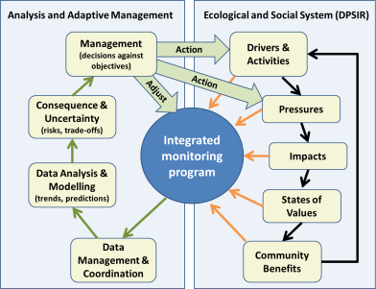

**Figure 1.** The two coupled frameworks used as a basis for this report: *Adaptive Management* and a modified *Drivers, Pressures, Impacts, Status & Response* (DPSIR)framework. The DPSIR framework is largely similar to that used by GBRMPA (2013).

The DPSIR framework has been used extensively in marine and terrestrial environments to discern linkages of cause and effect in ecological and social systems. It is the key structure used in the GBRMPA’s and the Queensland Government’s Strategic Assessment of the GBRWHA (GBRMPA 2013).

Adaptive management is a decision-making process that promotes learning from management outcomes. Key elements of adaptive management include defining management objectives, implementing management action(s), and conducting monitoring and evaluation to assist with clarifying uncertainty and learning about the effectiveness of management intervention (Figure 1; Walters and Hilborn 1978; Williams 2011). In this report, integrated monitoring is a crucial aspect of adaptive management. Integrated monitoring will not only inform when and where management interventions should be made, but will also inform adaptive monitoring, where monitoring is adjusted to meet the needs of increased system representation, reduced uncertainty, and increased cost-effectiveness of both management and monitoring (Field et al. 2005; Lindenmayer and Likens 2009).

Decisions around the approvals and management intervention are based on risk-based judgments (Burgman 2005). In Figure 2, an adaptive cycle is drawn around the modelling, encompassing the DPSIR framework and calibrated against monitoring data. Here, models use representation (high representation means low spatial or temporal bias) and imprecision (variation around means) to propagate uncertainty through the system to calculate uncertainty associated with risk analyses. This builds on the method developed in Anthony et al. 2013, but in this report operationalised further for quantitative rather than qualitative/conceptual models. Similar to the first loop for monitoring, integrated monitoring program (IMP) designs are manipulated through simulation to help identify a more optimal design and distribution of monitoring effort.

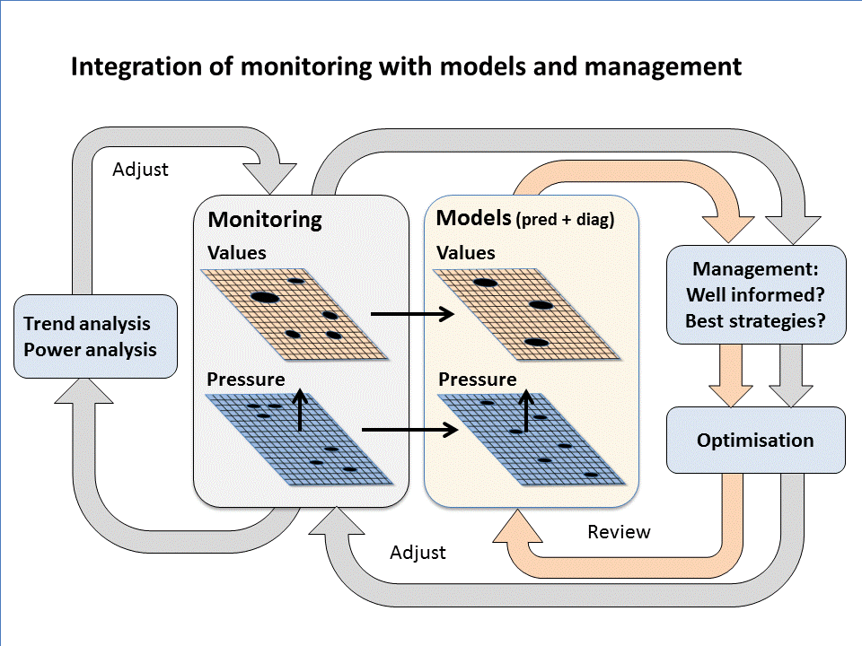

**Figure 2.** Overview of the Integrated Monitoring Program, Analysis and Control Tool (*IMPACT*). This conceptual tool underpins the approach to integrated monitoring adopted in this report. It formally links and interrogates monitoring, modelling and information informing management decisions through two major loops: one pertaining to the statistical analysis of monitoring information and use in the adjustment of monitoring programs, and the other to informing predictive and diagnostic models for the purpose of guiding adaptive management. Arrows from monitoring to modelling represent model calibration and validation.

### 1.2 Context

#### ***Long Term Sustainability Plan 2050***

The Reef 2050 Long-Term Sustainability Plan (LTSP2050; Australian and Queensland governments, 2014) uses an outcomes-based approach to align its vision, long-term objectives, short term targets and actions under seven themes, including water quality, biodiversity, ecosystem health, heritage, community benefits, economic benefits and governance. The overarching vision is that:

*“By 2050 the Great Barrier Reef continues to demonstrate the Outstanding Universal Value for which it was listed as a World Heritage Area and supports a wide range of sustainable economic, social, cultural and traditional activities”.*

Targets are specified for 2020 and represent stepping stones to the achievement of 2050 outcomes. The implicit claim of the LTSP2050 is that success in implementing identified actions will lead to success in the achievement of associated targets.

The specification of targets in the LTSP2050 elevates the importance of monitoring. These targets represent a key element in the quality assurance provided by the Queensland and Commonwealth governments to stakeholders. The extent to which management arrangements are regarded as adequate rests substantially on the extent to which targets are, or can be, achieved. The evidence for success (or failure) will be derived largely from the signal provided by monitoring.

#### Integrated Monitoring Framework

This report builds on the prerequisites and essential monitoring functions that form the guidance for establishing an integrated monitoring program (Table 1, Hedge et al. 2013). The provision of targets in the LTSP2050 provides considerable clarity in progressing these pre-requisites and functions. The content of this report uses the fundamental foundation of targets to progress these monitoring functions further.

We propose that the overarching objectives (function #1) of an integrated monitoring program (IMP) for the GBR are to:

1. Demonstrate performance against targets specified in the LTSP2050.
2. Provide insight on appropriate action to managers.

The clarity with which performance is demonstrated and insight is provided rests fundamentally on the precision and accuracy of monitoring data. In Sections 3 and 4 of this report we outline an approach to assessing the reliability of current monitoring efforts in the Mackay region as a case study. In doing so, we compile and analyse relevant information on existing monitoring programs (function #2), and develop and extend conceptual models to represent synoptic models (function #3). Sections 4 and 5 describe a structured decision-making approach to informing iterative improvement in sampling design (function #4). In Section 6, we provide commentary on data integration and management (functions 6 – 8).

Table 1 Prerequisites and essential monitoring functions that form the guidance for establishing an integrated monitoring framework. Source: Hedge et al. 2013

|  |
| --- |
| **Prerequisites** |
| * Management objectives—to provide clarity about management needs and priorities and inform the identification of monitoring priorities and objectives * Governance—to provide a foundation for performance of the program and conformance to law, regulations, standards and community expectations of probity, accountability and openness * Principles of integrated monitoring—to guide the many discussions and decisions that need to be made to establish an integrated monitoring program |
| **Essential monitoring functions** |
| 1. Clearly defining the purpose of the integrated monitoring program and the monitoring objectives 2. Compiling and analysing relevant information on existing monitoring programs 3. Developing conceptual models 4. Developing overall sampling design for integrated monitoring    1. Selecting indicators and state variables    2. Selecting monitoring programs    3. Developing sampling design 5. Developing monitoring protocols 6. Managing data 7. Analysing data 8. Reporting and communicating 9. Reviewing and auditing |

The focus of the main body of this report is the monitoring of ecological and biophysical elements of the GBRWHA. In Section 5, we discuss one approach that could be used to integrate social and economic objectives in an IMP through considered treatment of trade-offs in the specification of regional targets and thresholds.

# 2.0 Case study - Mackay-Whitsunday Region

### 2.1 Study Area

The Mackay-Whitsunday region stretches from Clairview in the south to Home Hill in the north, comprising approximately 250 kilometres of coastline. The Mackay/Whitsunday catchments cover an area of approximately 9,000 square kilometres and include the Pioneer, O’Connell, Don and Proserpine River systems.

The region has 74 inshore islands surrounded by fringing coral reefs, creating distinct complexity in ecological connectivity and water flow. Larger swaths of reefs stretch from 50 to 150 km offshore. Parts of the coastal marine environments in the region are important seagrass habitat and dugong protection areas, specifically Edgecumbe Bay, Repulse Bay, Newry Region, Sandy Bay, Llewellyn Bay, Ince Bay and Clairview. The Whitsunday Islands are some of the most important domestic and international tourism destinations on the Great Barrier Reef. The region has around 4.6 million domestic and 1.6 million international visitor nights per year (Deloitte Access Economics, 2013). The direct economic contribution of the Mackay–Whitsunday Region via tourism, recreational activity and commercial fishing is around $1.1B. The reef supports around 7,400 jobs in the region.

The rationale for selecting the Mackay-Whitsunday Region for this study is two-fold. Firstly, many of the environmental challenges on the Great Barrier Reef, their influence by regional drivers, and their impact on ecological, social and economic values are broadly represented in the region. Specifically, two major coal port expansions are underway (Abbott Point and Hay Point) servicing multiple coal mining operations; the region supports significant sugar and cattle farming industries in adjacent catchments; and the Whitsunday Islands are one of the most valuable tourism destinations on the Queensland coast and an important tourism gateway to the central Great Barrier Reef.

Secondly, a new report card is being developed for the region supported by the Queensland Government, building on and aligned with the report card for Gladstone Healthy Harbour. The learnings from the Mackay-Whitsunday report card will be applied to the development of other regional integrated monitoring report card programs into the future (e.g. Townsville and Cairns). The intent is to build on the current reef wide approach to reporting, with nested regional models that provide finer scale information and promote community awareness and custodianship.

As the purpose of this report is to demonstrate how an integrated monitoring program can best support adaptive management in the region with consideration of key drivers, activities and pressures on values, we focus on a subsection of the Mackay-Whitsunday Region centred around the Port of Hay Point and downstream influences of the O’Connell, Pioneer and Plane catchments. The specific focus subsection stretches from Gloucester Island in the north to West Hill Island in the south (Figure 3).

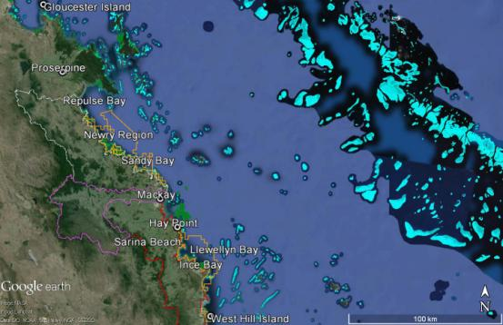

**Figure 3.** Study focus area within the Mackay-Whitsundays region. White, purple and red boundaries on land outline the O’Connell, Pioneer and Plane catchments, respectively. Yellow boundaries in the coastal marine environment are dugong protection zones (GBRMPA). Seagrass habitats are green areas (source: TropWater), and coral reefs are light blue areas (GBRMPA).

#### Key drivers, activities and pressures in the Mackay-Whitsunday Region

The Port of Hay Point, situated 40 km south of Mackay, is one of the largest coal export ports in the world. It consists of two coal export terminals: the Dalrymple Bay and the Hay Point terminals (Figure 4). The two coal terminals service the mines in the Bowen Basin in central Queensland which link to the port through an integrated rail-port network ([www.nqbp.com.au/hay-point/](http://www.nqbp.com.au/hay-point/)). The Hay Point and Dalrymple Bay terminals handled around 40 million and 67 million tonnes of coal in 2013/2014. Around 3-4 cargo ships and 5-10 tugs arrive and depart from Hay Point Port per day ([www.marinetraffic.com](http://www.marinetraffic.com)).

A three-year maintenance dredging program for Hay Point Port is scheduled to start in November 2014. The program will involve dredging a total of 378,000 m3, with a limit of 208,000 m3 in any one year, from five different locations within the harbour and the departure channel ([www.NQBP.com.au](http://www.NQBP.com.au)).

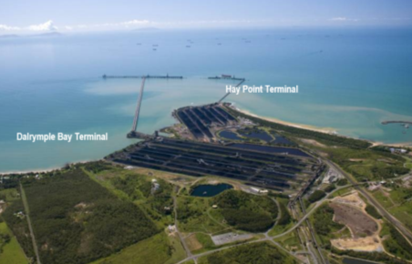

**Figure 4.** Port of Hay Point coal loading terminals. Source: NQBP (2013).

More than 40% of the catchment area of the region is used to support cattle grazing, principally in the headwaters. A total of 416 graziers manage approximately 3,900 square kilometres of land. Nearly 70% of the graziers have adopted significantly improved management practices under Reef Rescue facilitated by Mackay Whitsunday Isaac Reef Catchments NRM. The dominant level of grazing practice has shifted from C to a high B across the region (Figure 5).

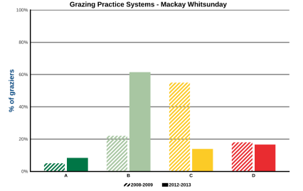

**Figure 5.** Shift in the distribution of grazing management practices between 2008-09 and 2012-2013. Source: GBR Report Card 2012 and 2013 (Anon, 2014).

Another 20% of the catchment area is used for cropping, mainly sugarcane, principally located in the lower catchment, and therefore more proximal influencers of water quality. Agricultural land-use practices in the region are rated as moderate, with C and B practices dominating. However, approximately 50% of sugar cane farmers in the region have adopted some level of improved management practice as part of the Reef Protection Plan (Figure 6).

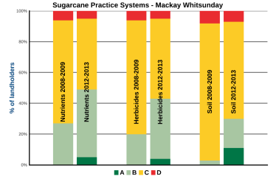

**Figure 6.**  Land-use practices for sugar cane growers in the Mackay-Whitsunday Region. Approximately 50% of the 1,380 growers in the region have adopted improved management practices. Source: GBR Report Card 2012 and 2013 (Anon, 2014).

The Pioneer River is the dominant source of freshwater export to the marine environment in the Mackay-Whitsundays region (Table 2). But to place it in context, the median discharge of the Pioneer River is only around a tenth of the Burdekin and Fitzroy rivers. In recent wet years, floods associated with Tropical Cyclones Oswald (Jan 2013) and Yasi (Feb 2011) led to 2-10 fold increases in river discharges in the Mackay-Whitsunday Region.

The Whitsunday Islands is a busy area for recreational boating, fishing and sailing on the GBR (Deloitte Access Economics, 2013). Boating here is associated with the transport of visitors between the mainland and resort islands, bareboat charters and traffic between mainland and island boat ramps and fishing spots or snorkelling/diving spots. The risk from boat traffic to marine life – particularly boat strikes on dugongs, turtles and cetaceans - in the region is from a diversity of boat users ranging from ferries to tinnies. Gill netting represents a significant risk to both dugongs and turtles. High marine visitation increases the risk of marine debris, which is particularly a threat to turtles (Dobbs and Pierce 2005).

**Table 2.** Riverine discharge volumes to the Great Barrier Reef. * Long - term (LT) median discharges were estimated from available long-term time series.

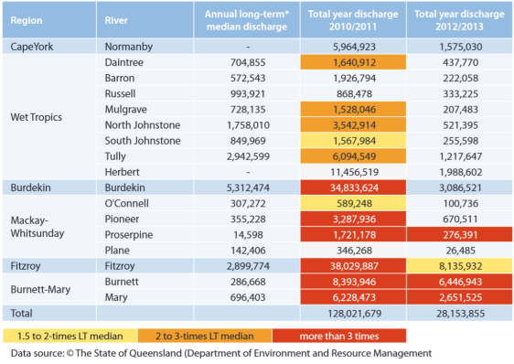

#### Ecological values

In recent years, the condition (distribution and abundance) of ***seagrass*** meadows has declined to poor and very poor in the central and southern GBRWHA, in particular in the Mackay-Whitsunday Region (Figure 7; Anon 2014). This recent decline is partly explained by a series of severe cyclones and associated floods and partly by land run-off of sediment, nutrients and herbicides (GBRMPA 2014). Some of the highest levels of herbicides known to affect seagrass productivity (e.g. diuron) have been found in the Mackay-Whitsunday region (Gallen et al. 2013, Anon 2014).

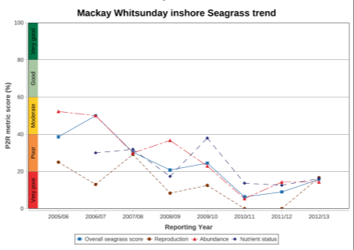

**Figure 7.** Seagrass status and trend in the Mackay-Whitsunday region Source: Anon (2014).

***Dugong*** populations in the central and southern inshore areas of the GBRWHA have continued to decline (GBRMPA 2014). One of the key pressures on dugongs in the Mackay-Whitsunday Region is deterioration of their primary food source, seagrass meadows (Marsh et al. 2005). Other significant local pressures on dugongs are vessel strikes, gill netting, and pesticides. Populations of green ***turtles*** are improving on the Great Barrier Reef and are categorised as healthy (GBRMPA 2014). However, turtle mortality (recorded as strandings) remains higher than historical rates prior to Tropical Cyclone Yasi in 2011 (GBR Report Card, 2013).

***Coral reefs*** are one of the main tourist attractions in the Mackay-Whitsunday region. Many of the coastal islands are surrounded by fringing coral reefs and are important inshore fish habitats. In the most recent decade, the condition of the region’s coral reefs has fallen to moderate (Thompson et al. 2013; Thompson et al. 2014; GBRMPA 2014). The average coral cover is at a historical low, partly explained by poor water quality, cyclones, crown-of-thorns starfish (CoTS) predation and bleaching events (De’ath et al. 2012; Thompson et al. 2014). Sediment resuspension and flood plumes associated with Tropical Cyclone Oswald in early 2013 also led to high turbidity and nutrient loads in the region (Devlin unpublished). While coral reefs in the region are recovering from past CoTS infestations, a new CoTS outbreak is currently underway around Cairns. As CoTS outbreaks have historically propagated south to Whitsundays and beyond (Fabricius et al 2010), the region’s coral reefs, in particular in mid-shelf areas, will be at risk of significant CoTS predation in coming years.

### 2.2 Data

As is the case throughout much of the GBRWHA, there are a number of monitoring programs that collect biophysical data relevant to matters of national environmental significance (MNES) and OUV in the Mackay region. These programs have been established for different reasons and with little coordination regarding coverage or inter-comparability of sampling methods and resulting data.

The AIMS Long-term Monitoring Program is a surveillance monitoring program (sensu Nichols and Williams 2006) that grew out of broadscale surveys of crown-of-thorns starfish beginning in the 1980s. In 1992 the program was modified to monitor reef fishes and benthic organisms at sites in a standard habitat on about 50 reefs between 14.5° S and 23° S. Survey reefs were selected based on accessibility and prior data but are stratified by latitude (six bands) and position on the continental shelf between the coast and the Coral Sea.

The Reef Rescue Marine Monitoring Program (MMP) is a multi-agency program that monitors management performance: it is designed to track improvements in inshore water quality that follow from changes in land use in the GBR catchments as a result of the Reef Water Quality Protection Plan. To this end, intertidal seagrasses are monitored (JCU-TropWater) at three sites in the study area. As well as extent of seagrass beds and species composition, reproduction, tissue chemistry, in situ light and herbicide content in the sediment are recorded. Coral communities are monitored at seven sites (AIMS) including cover of major benthos including corals, colony size structure and estimates of recruitment. Ambient pesticide levels are monitored (Entox UQ) at five sites using passive sampling techniques. A standard range of variables representing ambient water quality are sampled at three sites, both manually and using loggers (AIMS). In addition, flood waters are sampled opportunistically (JCU-TropWater) and water clarity (Kd), chlorophyll, suspended solids and coloured dissolved organic matter are estimated from MODIS images (CSIRO) as part of a GBR-wide program.

Two other programs that monitor management performance have survey sites in the study area. The program ‘effects of management zoning on inshore reefs of the GBRMP’of James Cook University that monitors reef fishes and benthic organisms at 12 sites inside and 12 sites outside areas that are closed to fishing on inshore reefs in the Whitsundays area. A complementary AIMS program monitors the effects of rezoning the GBRMP in 2004 on reef fishes and benthic organisms on six mid-shelf and offshore reefs in the study area.

The GBRMPA Eye on the Reef (EotR) program is active in the study area. This overarching program covers a hierarchy of five sub-programs with multiple functions, including visitor engagement, early warnings of changes, compliance with park regulations and rapid assessments of reef condition. The simplest is the Sightings network in which participants submit records and photos of interesting organisms, providing records of distributions to the Authority and promoting visitors’ interest in the reef environment. The EotR ‘Rapid Surveys’ require minimal training and allow school groups and more engaged reef visitors to collect useful information by having different groups survey in the same site to produce a time series. This also promotes community interest in the GBR and its condition. The ‘Tourism Weekly Monitoring Survey’ program involves trained staff of tourism operations in surveying nearby locations repeatedly to record changes. The Reef Health and Impact Survey program requires more training and is used principally by GBRMPA-QPWS Field Management staff to assess the condition of sites, particularly after events such as cyclones and floods. The final component is the ‘Eyes and Ears’ incident reporting program to record infringements of GBRMP regulations (though the results are confidential).

Extensive physical and biological data have been gathered by North Queensland Bulk Ports (NQBP) Corporation in compliance with environmental legislation associated with maintenance dredging at the Ports of Abbott Point, Hay Point and Mackay, including extensive water quality measurements and assessment of fringing reef communities and benthic infauna and seagrass. NQBP has initiated an ambient water quality monitoring program for the region of these three ports to provide a longer term context for monitoring associated with short term dredging campaigns, based on continuous loggers and quarterly manual sampling.

Beside some of the Eye on the Reef subprograms, two other citizen science programs collect data in the study area. The Seagrasswatch program has long-term intertidal sites at St Helen’s Beach, Seaforth and Sarina Inlet. Reefcheck Australia organises for volunteer divers to gather information on reef condition using standard protocols, and depend on tourism operations to get to their survey sites. Six reef sites at four locations in the Whitsundays were surveyed in 2011-13. These programs have dual functions of gathering data and promoting environmental stewardship through involving members of the local community.

Other broadscale programs that gather biological data in the study region include regular 5-yearly aerial surveys of dugong along the GBR (JCU),monitoring of turtle populations in Edgecumbe Bay (QDEHP), monitoring of seabirds (GBRMPA-QPWS) and the Queensland Shark Control Program (QDAFF) has drum-lines near Mackay. The statewide Strandings Network records large animals that wash up on beaches (relevant for turtle and dugong when broad areas of seagrass beds are destroyed by cyclones).

As well as the monitoring of water quality that forms part of the Reef Rescue MMP, TropWater has monitored floods in the region opportunistically for more than a decade. The region is covered by several broadscale programs that monitor physical conditions that may influence the structure and condition of ecological communities. These include NOAA’s coral reef watch program (SST by remote sensing), and the finer-scale ReefTemp program (GBRMPA, CSIRO & BoM) that aim to predict coral bleaching. The AIMS- GBRMPA sea temperature monitoring program has loggers at 19 sites in the study area and AIMS has an automatic weather station at Hardy Reef. Queensland Government programs monitor wave height at Mackay and Hay Point and heights of storm tides at Laguna Quays, Shute Harbour, Mackay, and Dalrymple Bay.

The totality of monitoring effort in the Mackay-Whitsunday Region is summarised in the accompanying Appendix. The extent to which these data are useful in an IMP depends on targets specified under the LTSP2050 and the models used to capture cause-and-effect understanding linking actions and target outcomes.

# 3.0 Analysis and integration of monitoring data

### 3.1 Analysis of monitoring data

The technical task of gathering and interpreting monitoring data within the LTSP2050’s underpinning philosophy of continuous improvement takes place against a complex social and political background. Conflicting values and multiple narratives regarding the magnitude and seriousness of various impacts are pervasive elements of this complexity. Managers and industry may be over-confident in the effectiveness of their actions (Ludwig et al. 1993, Morgan and Henrion 1990) and tend to regard the claims of environmentalists and others as alarmist. The attitude of community stakeholders toward managers and industry is often characterized by skepticism rather than trust (Bocking 2004). They may be inclined to view the claims of managers and industry as imbuing a false sense of security.

Hard data and scientific rigor are often invoked as the ultimate arbiters of contested claims. However, there is a distinct tendency for people to draw firm conclusions from meager data that are inconsistent with what they themselves might regard as a reasonable burden of proof (Tversky and Kahneman 1971). People are predisposed to this psychological frailty irrespective of their stake in the outcomes of decision-making, and training in science offers only limited immunity.

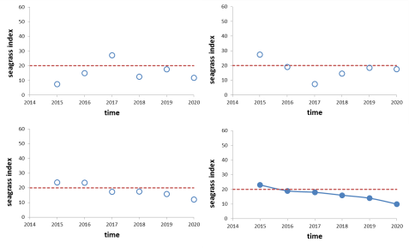

**Figure 8.** Three hypothetical trajectories of status and trend (open circles) sampled from a true trend (closed circles) using sample size *n* = 5. Variability of the system is equivalent to a coefficient of variation (CV) of 50%.

For example, Figure 8 shows three hypothetical trajectories of status and trend monitoring for an arbitrary index of seagrass cover and condition, involving only a modest sample size. By chance alone, one of the trajectories is very close to the true underlying trend. Again by chance alone, the other two trajectories invite different inferences, some of them erroneous, particularly for the period 2015 – 2017. We can insure against erroneous inference and interpretation by increasing the sampling effort (Figure 9). But data do not come for free. We need to balance the costs of alarmism and false security against the costs of data acquisition. A coarse approximation of these trade-offs can be approached by considering the gains in precision that come with increased monitoring effort (i.e. increased costs of data acquisition); see Box 1. These trade-offs have immediate implications for the practicalities of ‘nested’ regional monitoring within ‘whole-of-reef’ monitoring.

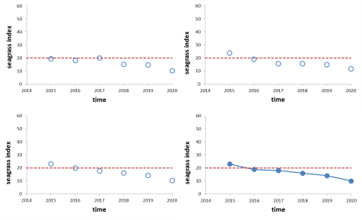

**Figure 9.** Three hypothetical trajectories of status and trend (open circles) sampled from a true trend (closed circles) using sample size *n* = 100. Variability of the system is equivalent to a coefficient of variation (CV) of 50%.

***Box 1. Can we ‘nest’ regional monitoring within whole-of-reef monitoring?***

Water quality action #15 of the LTSP2050 is to *‘expand nested integrated water quality monitoring and report card programs at major ports and activity centres (e.g. Gladstone), in priority catchments (e.g. Mackay Whitsundays) and Reef-wide (i.e. Reef Report Card), to guide local adaptive management frameworks and actions.’*

If regional monitoring is to guide local action it needs to be reasonably precise. Insufficient monitoring may mislead, encouraging misplaced community concern (or community apathy). To make informed decisions about the merit of concentrated or ‘nested’ monitoring in any one region, an appreciation of the trade-off between cost and precision is required.

If the variability of a quantity of interest can be estimated, and we can specify the precision and significance level required, then the number of samples required, *n*, can be calculated using the formula

, where

*CV* is the estimated coefficient of variation (equal to 100 *s*/).

 is from a 2-tailed *t*-table with *v* degrees of freedom corresponding to a Type I error rate = α.

*E* is the level of precision required expressed as a percentage of the mean.

For example, let’s say an estimate of *CV* = 25% for seagrass cover in some section of the GBRWHA is obtained from past sampling. If we wish to be 95% sure a sample mean is within 5% of the true cover, then



It can be seen that the formula is a rearrangement of the terms used in calculating confidence intervals for means. Although the formula has been commonly applied in sampling design for forest inventory (Philip 1994), its use can be extended to any aspect of environmental management where data are normally distributed.

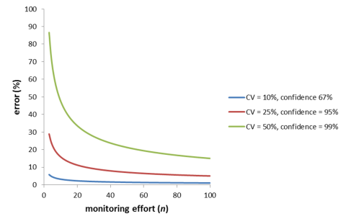

There are no serious technical barriers to nesting regional near-shore monitoring within whole-of reef monitoring. But such an approach may unwittingly encourage over-allocation of scarce resources to data acquisition in near-shore environments. Ultimately, managers need to trade-off investment in management and monitoring resources in inner, mid-shelf and outer reef ecosystems. Section 4 of this report describes an approach to informed resource allocation.

The standard scientific approach to the evidence provided by data is poorly placed to deal with typical environmental management issues (Burgman 2005). Science has an asymmetric view of evidence as a consequence of its focus on the accumulation of knowledge. It is strongly averse to the possibility of concluding from a study that an effect exists when in fact it does not. The philosophical underpinnings and mathematical machinery of null hypothesis testing and statistical inference are designed to limit incidents where researchers claim effects when none exist. Science is less concerned with the possibility of concluding no effect when one in fact exists. In contrast, reef managers and stakeholders need to be alive to the possibility of both kinds of errors.

More specifically, inferences drawn from monitoring data can make two kinds of mistakes in the context of targets identified in LTSP2050 (Table 3) - inferring failure when in fact management is on-target (Type I error) or inferring success when in fact management is falling short of its target (Type II error). Where the issue involves impacts on the environment or social dimensions of sustainability, a Type I error translates to false alarmism and a Type II error promotes a false sense of security. The costs of Type I errors may be borne largely by industry through (unreasonable) loss of community and/or commercial reputation. They may also involve the mobilisation of public resources for ‘problems’ that are in fact more or less absent. The costs of Type II errors are borne by the broader community through (unacknowledged) attrition of public good values or resources.

Standard statistical conventions used in scientific research specify tolerable Type I error rates (commonly 0.05) but are blind to Type II errors (Gerber et al. 2005; Mapstone 1995; Fairweather 1991). Explicit consideration of statistical power is required when decisions are sensitive to Type II errors as well as Type I errors. Generally, to reduce the incidence of both kinds of mistakes better evidence is needed through greater expenditure on monitoring.

**Table 3.** Correct and incorrect inferences from monitoring. The likelihood of Type I and Type II errors (denoted *α* and*β*, respectively) in any study or monitoring program will decrease as the reliability of evidence improves with more data.

|  |  |  |  |
| --- | --- | --- | --- |
|  |  | **Inference from monitoring** | |
|  |  | Target not on-track | Target on-track |
| **Truth** | Target not on-track | Correct | False Success  (Type II error, *β*) |
| Target on-track | False Failure  (Type I error, *α*) | Correct |

#### The statistical power of a hypothetical monitoring program for dredging

Uncertainty is inevitable where sampling is undertaken in environments and contexts characterized by high variability. Through use of a hypothetical example, here we explore the central importance of uncertainty and statistical power in monitoring.

Let’s say a port is required to demonstrate the environmental performance of its maintenance dredging operations, which are of a higher intensity than those of the past. Past turbidity measurements within the zone of influence of the dredging varied around 9.2 turbidity units over a specified temporal and spatial scale. Let’s say the port makes 25 observations of stream turbidity within the zone of influence in any one year, and the mean of these observations was found to be 10.4, with a standard deviation of 7.8. That is, the observed mean was greater than past measurements. What inference might be drawn from these results? Stakeholders concerned about environmental outcomes may see the result as a vindication of their view that dredging poses a serious threat to reef biota.

Anyone trained in basic statistics would be uncomfortable with this inference. The mean obtained from the sampling data may not be consistent with actual turbidity. Intuitively, the likelihood that the sample means are consistent with reality is related to sampling intensity and the magnitude of variation in turbidity. A standard approach to including consideration of sample sizes and variability in assessing data is to use a statistical test involving null (*H*0) and alternative (*H*1) hypotheses.

*H*0: The sample mean was drawn from a population with mean = 9.2 turbidity units (i.e. the new dredging operations have no adverse effect relative to that of the past).

*H*1: The sample mean was drawn from a population with mean > 9.2 turbidity units. (i.e. the new dredging regime causes increased turbidity).

Using a *t*-test, the test statistic is calculated using (Sokal and Rohlf 1995),

 ,

where is the sample mean, *T* is the ‘threshold’ reference against which the mean is compared, *s* is the sample standard deviation and *n* is the sample size.

The *t*-test asks, what is the probability (*p*-value) of obtaining a value as large as the test statistic assuming the sample mean was drawn from a population having a mean of *T* (i.e. assuming the null hypothesis is correct). The convention employed in scientific inference is to reject the null hypothesis in favor of the alternative if the *p*-value is less than 0.05 (i.e. 5%). The null is retained if the *p*-value is greater than 0.05. The value of 0.05 is more or less arbitrary in the context of environmental management. It represents a burden of proof with which science is generally comfortable.

For our turbidity example the test result is,

, *p* = 0.225.

This result might please the port’s corporate stakeholders. The result suggests a non-significant increase in turbidity.

Although common, the use of null hypothesis testing in this way is naïve and can lead to serious managerial mistakes. There are two key shortcomings. Firstly, the *p*-value in standard null hypothesis testingrefers only to the probability of a Type I error (inferring an effect when in fact none exists). The result includes no indication of the probability of a Type II error (inferring no effect when in fact one exists). Secondly, the hypotheses are framed in a way that assumes any effect is important, no matter how small.

The danger of ignoring these shortcomings can be illustrated by changing the sampling intensity in our example. Let’s say that instead of 25 observations the port made 120 observations of turbidity. Let’s also say the sample means and standard deviations remain unchanged. In this circumstance, the inferences that arise from the *t*-test are reversed. The *t*-test reports a *p*-value of 0.047 and the null hypothesis is rejected, supporting the alternative that the new dredging regime causes increased turbidity.

The proposition that management decisions might rest on something as seemingly arbitrary as sampling intensity is disconcerting. But without careful consideration of effect size and Type I and Type II errors, naïve use of null hypothesis testing will tend to mislead. In our hypothetical example, it may be reasonable to assume that mechanical disturbance via dredging will inevitably lead to some increase in turbidity, however small. Where statistical tests are conducted for *any* effect (no matter how miniscule) the tendency will be for larger sample sizes to report statistically significant results relative to smaller samples. In this sense, the use of the term ‘significant’ in statistical inference is unfortunate. Statistical significance is not equivalent to ecological, social or economic significance.

Acknowledgement of the shortcomings of standard statistical analyses encourages managers, stakeholders and auditors to think more critically about the use and misuse of data gathered in monitoring. In an environmental and social context, community stakeholders will be especially interested in minimizing the likelihood of inferring compliance or success when in fact the system is non-compliant or failing (false sense of security). Public relations managers will be concerned about the likelihood of false alarmism (inferring non-compliance or failure when we are in fact compliant or succeeding in meeting targets). To formally and directly address these questions, power calculations are required.

Statistical power is a measure of the confidence with which we would have detected a particular effect, if one existed. It is defined as 1 - *β* (i.e. the complement of the Type II error rate). What was the power of the two sampling strategies explored above for turbidity? Specifically,

Case 1: *n* = 25, and

Case 2: *n* = 120.

First we need to revisit the way we frame our hypotheses to take into account what might represent an *important* effect (as opposed to *any* affect). Let’s say that, after considering dose-response relationships for turbidity, scientists identify 12.0 units as a threshold at which biota within the zone of influence of dredging operations are adversely affected. The null and alternative hypotheses are now:

*H*0: The sample mean was drawn from a population with mean = 9.2 turbidity units (i.e. the new dredging operations have no adverse effect relative to that of the past).

*H*1: The sample mean was drawn from a population with mean = 12.0 turbidity units (i.e. the new dredging operations cause a large enough increase in turbidity to be harmful to inshore biota).

If we defer to scientific convention and accept a Type I error rate *α* = 0.05, we can identify the value of the sample mean beyond which the null hypothesis will be rejected. Expressed algebraically,

,

where *μ* is the population mean associated with the null hypothesis, and *z* comes from the standard normal distribution. For the one-tailed tests in our scenario *z* = 1.645 at α = 0.05.

For the case where turbidity is estimated from *n* = 25, and an estimate of 7.8 for the population standard deviation is used,



That is, 11.77 turbidity units is the critical value beyond which the null hypothesis is rejected. If *H*0 is true, for a sample size of 25, the chance that the sample mean will exceed 11.77 is 5%.

A Type II error arises when the actual turbidity is 12.0 (or greater), but the sample mean is less than 11.77. For the case where *n* = 25,





= 0.44

That is, for a true mean of 12.0 NTU, there is a 44% chance that the mean of a sample of 25 observations will be less than 11.77, leading to the (incorrect) inference that the dredging is benign. The power of the test is 1 - *β* = 0.56.

If we increase the sample size to *n* = 120, the power of the monitoring increases to 1 - *β* = 1 – 0.01 = 0.99. Figure 10 shows these outcomes graphically.

#### What is acceptable power?

Community stakeholders would much prefer turbidity monitoring to have 99% power than 56% power. That is, they may regard a 44% chance of inferring the new dredging regime is no threat to inshore biota when in fact it is as intolerable. A 1% chance of such an outcome would be far more palatable.

The power of any monitoring program is proportional to the effect size to be detected (*ES*), the Type I error rate (*α*), the square root of the sample size (*n*), and the magnitude of variability of the population from which samples are taken () (Fairweather 1991). That is,

.

In most circumstances, the most effective options available for increasing power are to increase sample size or accept a higher Type I error rate. Improved measurement practices or selection of more informative indicators (see Box 2) may also contribute through reducing variability associated with random error. As with the specification of an effect size, the question of what is an acceptable error rate for Type I and Type II errors is not a decision that should be left to a statistician or technician. It involves judgments from managers and stakeholders on the extent to which they can tolerate false success, false failure, false alarmism or a false sense of security.

(a) Case 1: Turbidity, *n* = 25

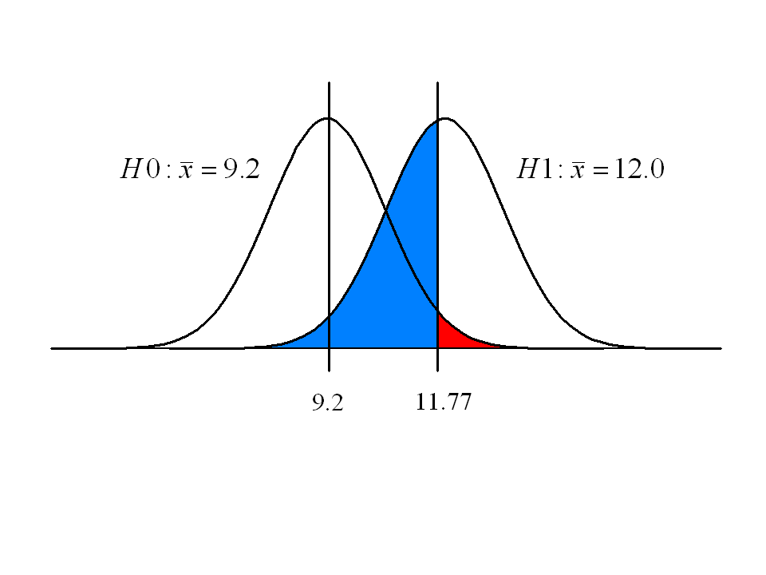

(b) Case 2: Turbidity, n = 120

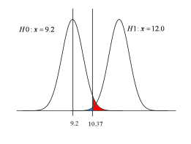

**Figure 10**. Results of power analysis for two sampling intensities measuring turbidity. A Type I error rate of *α* = 0.05 has been specified (shown in red) in each case. Blue areas correspond to the probability of a Type II error, conditional on the alternative hypothesis being true. Curves show distributions of means for turbidity drawn from populations with a standard deviation of 7.8. Smaller sample sizes are characterized by flatter curves, leading to relatively higher chances of committing Type II errors.

***Box 2. Innovation in indicators and early warning***

There are many potential indicators of resilience and vulnerability within a Driver/Activity, Pressure, State, Impact & Response (DPSIR) framework. An issue with all environmental monitoring programs is that whilst the temporal dynamics of an indicator can be revealed, monitoring data will never provide a complete story of cause-and-effect in relation to processes that drive system dynamics (Nichols and Williams 2006; Magurran et al. 2010; Sergeant et al. 2012). Ideally, the selection of indicators would consider the need for early warning, including diagnostics and attribution of the causes of ecological change – specifically land use, coastal developments, dredging, spoil dumping and climate change (including cyclones). From a regulator’s viewpoint, early warning systems are highly desirable. But unless the system is without error, early warning implies elevated risks of false alarms and their attendant costs. These issues are prominent in assessment of new diagnostic tools in human health (Banoo et al. 2008) and environmental monitoring might usefully apply similar protocols for assessing the merit of innovation.

Substantial additional management benefits can be gained from ecological and environmental monitoring if ecosystem health and resilience can be described from the collected data. The distribution and abundance of indicator species or the expression of biomarkers of health (measured in tissue samples collected) have considerable potential to deliver this outcome. When integrated with ecological and environmental variables, these data could quantify ecosystem health and the spatial, temporal and management drivers of resilience (e.g., variation in tolerance, recovery, connectivity) (McClanahan et al. 2012). Indicators and biomarkers can be used in integrated monitoring to quantify health and stress from specific and compound pressures/activities, to causally link indicators and biomarkers to ecosystem health and resilience, and to understand stress thresholds and develop early warning signals of poor health.

Below we outline various classes of indicators. All appear worthy of further exploration. But before they are routinely used, analysts will need to characterise their precision and accuracy and managers need to consider the costs involved in acquiring data from novel lines of evidence.

***Indicator species and their appearance***

The abundance and macroscopic health status of certain species have been linked with ecological processes and ecosystem values that underpin resilience (Maynard et al. 2010) and a number of indicator species are currently monitored. These include amongst others dugong, seagrass, benthic cover and community structure of coral reefs (Anthony et al 2013). Coral cover is the most widely quoted reef health indicator (De’ath et al. 2012), but the cover of benthic macroalgae and crustose coralline algae are also important for corals in terms of competition for space and coral recruitment (e.g. Harrington et al. 2004; Cooper et al. 2008). The abundance of herbivorous fishes is also essential to maintain benthic diversity and avoid algal shifts (e.g., Hughes et al 2007).

Coral health indicators can also be the visual appearance of indicator species and include bleaching (Marshall and Schuttenberg 2006), disease prevalence (McClanahan et al. 2012) and partial mortality (Hughes 1984; Cooper et al. 2008). These measures all indicate poor health and have been linked with reduced fecundity and whole colony mortality (Baird and Marshall 2002; Cooper et al. 2009). More recently, colour and colony brightness have been used as visual proxies for the abundance of photosymbionts and fluorescent proteins in corals tissues. These biomarkers have been linked to coral growth and bleaching tolerance (Cooper et al. 2008) but have not yet been widely applied to ecological monitoring.

***Biomarkers***

Biomarkers refer to physiological, biochemical and molecular states of organisms that are diagnostic of exposure to single or compound stressors, susceptibility and resilience (e.g., resistance to stress, recovery from disturbance). The development of biomarkers must involve not only an attribution of response to specific and compound stressors but also a demonstration of the linkages between physiological states and health and resilience traits.

A wealth of knowledge of the physiology and stress tolerance of target species (e.g., coral and sea grasses) provides a strong foundation for biomarker research (Brown and Cossins 2011). Cooper et al (2008) reviewed indicators of reef health and biomarkers for coral health in the context of water quality and recommended markers associated with energetics (lipids and tissue biomass) and photosymbiont physiology for monitoring. The knowledge of these biomarker behaviours is broad and the strength of attribution to organismal or ecosystem health is based on both empirical and modelling data (e.g. Cooper et al. 2008; Anthony et al. 2009).

The past five years have seen an explosion in next generation sequencing (NGS) and data analysis technology to allow routine broad spectrum scans of 1,000 – 10,000 molecular markers per sample to be obtained within days of collection at relatively low cost (Evans and Hofmann 2012). With further research and development, NGS data may be used in multiple applications that are relevant for natural resource management including (1) scans of microbial and coral photosymbiont communities, (2) screens of target species’ physiology and exposure to stress through gene expression, and, (3) population genomic analyses to examine connectivity, genetic diversity and natural selection.

***Microbial communities as indicators of ecosystem health***

Scans of the microbial communities on target species or from environmental samples may provide substantial information about ecosystem health and can potentially act as early warning signals. For example, pioneering research shows bacterial diversity and abundance reflect the level of human impacts on reefs in the Central Pacific and Caribbean (McDole et al 2012). Bacterial and viral loads in reefal waters increased 10-fold when human disturbance was high and fish biomass was low in the Line Islands (Sandin et al 2008; Dinsdale et al 2008). Further, a large proportion of the microbial taxa on the most disturbed reefs were most closely related to known pathogens (Dinsdale et al 2008). Other studies have detected elevated pathogenic coral associated microbe loads before visual signs of bleaching and disease were observed highlighting the potential for early warning presented by microbial monitoring. Future research is needed to operationalise routine use of microbial communities as indicators.

Mapstone (1995) recommends using a ratio of *α* to *β* that reflects the relative costs of the two kinds of errors, and designing the monitoring program accordingly. Levels of tolerance will vary among interested parties according to the values they seek to promote in GBR management and according to the extent to which they incur the financial costs of collecting data. Power calculations can be conducted before (a-priori) a study or monitoring program is undertaken or after (post-priori). A-priori analyses commonly seek to estimate the sampling intensity required where the effect size to be detected has been identified, tolerable thresholds for Type I and Type II errors have been specified, and an estimate of the population’s variance is available. Post-priori analyses usually estimate the Type II error for whatever sample size has been employed.

Formulae for power calculations vary according to the particular statistical test being used. In the example of a proposed change to dredging explored in this section, we used a simple *t*-test to demonstrate the concepts. Zar (2010) offers a general statistics text book with numerous examples of power calculations. Many statistical software packages include power, but vary in the types of data and problems they can handle. GPOWER is free software dedicated to power calculations that scores reasonably well in terms of ease of use and learning (Thomas and Krebs 1997). Manly (1997) details methods involving computer simulation for complex problems. Chapter 6 of the Australian Guidelines for Water Quality Monitoring and Reporting provides an outline of a variety of statistical tools that are of general interest in monitoring for natural resource management (ANZECC/ARCMANZ, 2000), including control charts that will be of particular use for integrating monitoring into management and a tool for decision-makers to conduct adaptive management of the GBRWHA; see Box 3.

|  |
| --- |
| ***Box 3. Control charts as a tool for adaptive management of the GBRWHA***  Control charts were originally developed for statistical process control in industrial applications, and have been used routinely for over 50 years as rigorous and standardised decision-making tools to achieve quality control of manufacturing processes (Montgomery 2009). More recently, they have been advocated as tools to improve the use of long-term monitoring data in adaptive environmental management (ANZECC/ARCMANZ, 2000; Morrison 2008).  Control charts use statistically derived management thresholds, referred to as control limits, to assess long-term monitoring data and determine whether management intervention is required. Typically a sample statistic (e.g. a mean) of a monitored variable is plotted through time alongside control limits, which represent the bounds of variability of the monitored variable (e.g., 3σ (sigma) control limits; see figure below). Control charts may contain both warning and action control limits. Warning control limits can represent a small process shift and, if breached, can trigger increased monitoring or further investigation. Action control limits represent a large process shift and if breached can trigger remedial action.    There are a variety of control charts available for different applications, for example, mean ($\overline{x}$), range (*R*) and standard deviation (*s*) charts use basic summary statistics and are designed to detect large shifts in a process. Cumulative sum (CUSUM) and exponentially weighted moving average (EWMA) charts are better suited to detecting smaller shifts in a process.  The benefits of control charts to adaptive management include:   * They are simple visual management tools that can assist decision-makers, who may have limited statistical expertise, with interpreting long-term monitoring data (Morrison 2008, ANZECC/ARCMANZ 2000); * they can deal with inherently noisy environmental monitoring data and provide an early warning of a shift outside of the bounds of natural variability (Morrison 2008, ANZECC/ARCMANZ 2000); * they encourage decision-makers to carefully consider Type I and II error rates associated with management thresholds (Burgman 2005; Morrison 2008,) which are commonly overlooked when parametric statistical tests are used to interpret environmental monitoring data (Mapstone 1995); and * they promote a robust connection between monitoring and adaptive management (Burgman 2005, ANZECC/ARCMANZ 2000).   Control charts can be readily applied to water quality data. They are already invoked implicitly in the water quality index of the MMP (Thompson et al. 2013) and in development of the Gladstone Healthy Harbour Partnership report card (Fox 2013). An explicit application of control charts to marine protected area monitoring and management can be found in Addison (2014). |

In consultation with stakeholders, a monitoring program could consider acceptable thresholds for committing Type I and Type II errors, and the program designed accordingly (Field et al. 2004, Mapstone 1995). Not only will stakeholders vary in their aversion to Type I and II errors, but perceptions within any one stakeholder group may vary from region to region. For example, the consequences of failure to meet targets associated with retaining coral cover in the northern section of the GBR may be very different to consequences of failing to meet restoration targets in central or southern sections. Risk-based adaptive sampling needs to recognise such considerations, and adjust critical thresholds accordingly. But what is the relative and absolute importance of the many targets specified in the LTSP2050? What is a reasonable burden of proof in demonstrating compliance (or non-compliance)? To what extent should the burden of proof be conditioned by the cost of collecting data? If answers to these questions can be given, it is a non-trivial, but nevertheless tractable technical exercise for a statistician to calculate the sampling effort required (and the monitoring budget required) to make an assessment of whether or not a system is being managed in a way that is consistent with specified targets.

Strict approaches to the use of statistical power in designing monitoring programs assume that clear answers to these questions are available. But in practice, such clarity rarely exists. Notions of burden of proof and what might be regarded a tolerable impact are not solely technical questions. They involve resolution of the individual and collective judgments of industry, managers and stakeholders. This report avoids pre-empting or second guessing these judgments. Reef managers and stakeholders will not immediately resolve the issues and values associated with alternative perspectives on the importance of various targets or what burden of proof should apply. The approach described in section 4.2 involves use of models and power calculations in development of a framework that encourages progressive exploration of these themes without being prescriptive or draconian in their application. Blanket prescriptions for demonstrating compliance (or non-compliance) with targets are unlikely to be efficient or operationally feasible. This report urges managers and stakeholders to differentiate targets within LTSP2050 that are of greater importance from those of lesser importance, recognising the management context of individual circumstance, and to allocate their monitoring resources accordingly.

### 3.2 Integrating datasets

The intuitive motivation for combining the information embedded in multiple monitoring programs is greater clarity of ecosystem status and trend. In concept, increasing the effective sample size of a monitoring program through integration of multiple datasets should lead to greater precision. (We note that this need not always be the case, especially where instrument error and operator error is substantial). With precision comes clarity in decision-making. Where monitoring indicates targets are unlikely to be met there is an imperative to consider changes in management. Where monitoring indicates success, it may be worth broadening or intensifying the investment in underpinning management interventions.

We want more precision, preferably for little or no additional cost. Before considering major changes to current monitoring of the GBRWHA it’s reasonable to ask, *what can be achieved through better integration of current monitoring programs?*  Wherever possible, an IMP should combine information on specific environmental variables so as to maximise the state of knowledge relating to reef health. In addition, it is desirable this information be presented spatially, with uncertainties clearly represented, so that gaps or overlaps in monitoring can be identified.

Maximizing the information gained from disparate sampling programs across the GBR requires a set of coherent statistical approaches that are (a) appropriate for the kinds of data collected and that can (b) readily integrate information about a given variable collected in different ways. The first consideration is that data currently collected on the GBR can generally be thought of as being either continuous processes in space and time (e.g. water quality variables), or hierarchical*,* meaning that measured variables occur at discrete places in time and are nested within a hierarchical set of spatial scales (e.g. coral reefs). Each of these data types lead to different assumptions about their structure, leading to different approaches for statistical analysis and inference.

The second consideration in developing analytical guidelines is in how to appropriately combine information about a specific variable measured by different data providers. In this regard the solution for both spatial and hierarchal data is similar in that Bayesian methods allow information to be combined in a straightforward and coherent way, with minimum information loss. Bayesian analysis has achieved a high level of traction in recent years due to its exceptional flexibility and coherence for propagating knowledge forward through subsequent analyses. As such it will form the basis of analysis for both spatial and hierarchical IMP data in this report, collected by various data providers.

#### Bayesian Gaussian Process models for IMP geospatial analysis and data integration

Water quality is among the most important measurements made on the GBR and it includes numerous spatially-continuous variables, such as nutrients and turbidity, that are only patchily sampled in space and time. The intrinsic patchiness of sampling such a large water body presents a substantial challenge to GBR managers who must base their advice and decisions on this set of sparse, uncertain data. For these spatially-continuous environmental variables some method of interpolation in space and time is required to estimate the value of each variable at a given point in time. Traditional methods for interpolation include various geospatial and non-geospatial methods (reviewed and compared in Li and Australia (2008)) and among marine environmental scientists, geospatial methods related to kriging are most commonly used to interpolate values between observations in space. A Bayesian analogue for kriging are Gaussian Process (GP) models which use the prior/posterior structure of Bayesian data analysis to provide probabilistic maps for measured variables that include appropriate estimates of uncertainty (Patil et al. 2011; Brando et al. 2014). As a key goal of the IMP is to provide the best possible information for use in management of the GBR, an estimation method that includes probabilistic evaluations of uncertainty and can readily integrate disparate datasets makes GP-based models highly desirable.

Building a GP-based map of GBR environmental variables begins with a prior surface (a map) that includes no data and represents current knowledge about what values a given variable might have at various points in space at a given time. These prior beliefs could be flat, reflecting total ignorance about potential values for the variable being measured (which is unlikely), or can be informative, meaning some knowledge is available about the variable but its values are uncertain. In either case the GP modelling process updates the map of prior beliefs with data where it is observed, as well as at points nearby using a specified covariance function, to generate a new set of posterior maps for a given variable.

A GP model without any covariates is principally defined by its covariance, for which the IMP will use the flexible Matérn function which characterizes the covariance between any two points on the map by their Euclidian distance, given by the latitude/longitude coordinates of each observation. The Matérn covariance function has three parameters: amplitude, governing the relief of the response surface; scale, governing the relatedness of adjacent data points; and difference degree, governing the level of smoothing over the GP map surface. These parameters are estimated from the data and, in the absence of other information, define the way values are interpolated over the entire map surface.

#### Example: nutrient measurements

As a specific case to help illustrate the GP spatial modelling framework let’s consider the measurement of total nitrogen (TN) in the water column, measured by hand at specific points in time by both the Centre for Tropical Water & Aquatic Ecosystem Research at James Cook University (TropWater) and by AIMS, both part of the Marine Monitoring Program (MMP). These consist of site-aggregated water samples taken in small niskin-style bottles at specific points in time, often after a flood in the wet season (Thompson et al. 2013). Data are sparse however; water quality is typically reported from one of four water quality seasons (Q1:Oct-Dec; Q2:Jan-Mar; Q3:Apr-Jun; Q4:Jul-Sep) and samples for the Mackay-Whitsunday Region are mostly from 2008 (Table 4).

**Table 4.** Data providers and number of total nitrogen (TN) samples per year during the wet season (Q2: Jan-Mar).

| **Year** | **TropWater** | **AIMS** |
| --- | --- | --- |
| 2006 | 0 | 3 |
| 2007 | 0 | 3 |
| 2008 | 69 | 3 |
| 2009 | 0 | 3 |
| 2010 | 0 | 3 |
| 2011 | 0 | 3 |
| 2012 | 0 | 3 |
| 2013 | 0 | 3 |
| 2014 | 0 | 3 |

Looking at the wet seasons (Q2) when most observations were taken and starting with the first year observed in the data (2006) there were 3 observations made by AIMS. The basic GP model we will use supposes an initially consistent (constant) surface over which the Bayesian geospatial map for TN will be constructed, equivalent to saying we know nothing about the distribution or concentration of TN at any point in the Mackay-Whitsunday Region. This uninformed prior surface includes an average TN value of zero and a broad (flat) Matérn covariance function.

By passing the wet season data for 2006 to the model a small quantity of information is conveyed, with an estimated 1.5 log-μm of TN over the entire region, given only three data points (Figure 11, first panel). This may seem unrealistic (it is) however it is still better than assuming that TN in the water was zero in the 2006 wet season. Reassuringly, the uncertainty in these estimates is high, with a standard deviation of approximately 1.8 where the data were observed (meaning values between 0 and 5.4 μm are plausible) and a SD of 2 or more further afield (Figure 12, first panel).

Using the 2006 posterior information as a prior for 2007, again with three observations, the updated GP surface map for TN changes slightly, with somewhat higher estimated TN values between 1.8 and 2.1 log-μm TN that vary somewhat from north to south (Figure 11, 2007). Again it may seem impossible to estimate higher values far to the south of the observed data, however the three observations made in each year have added information to both average TN estimates as well as the Matérn covariance function, with a small north-south gradient present among those few observations that is assumed to extend throughout the region. Correspondingly, the uncertainty (standard deviation) surface has been reduced, reflecting the additional information from 2007, particularly in the Whitsundays where the observations were made (Figure 12, 2007).

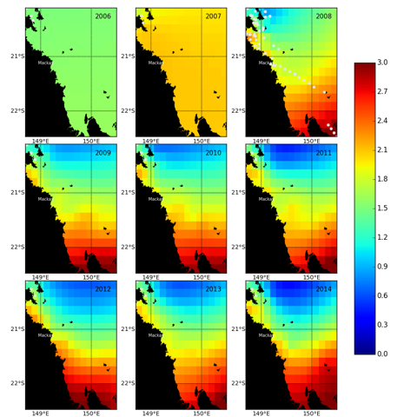

**Figure 11.** Gaussian Process (GP) highest posterior density surface map of log-total nitrogen (TN) concentrations (log-μm) in subsequent wet seasons (Q2:Jan-Mar) in the Mackay-Whitsunday Region, 2006-2014. Posterior densities were built up from summaries of 1000 potential TN maps. Grey dots are observed data locations in each year.

In 2008, dedicated sampling by TropWater in the Mackay-Whitsunday Region resulted in 69 observations along the coast during the wet season. Using the 2007 posterior information and adding these 2008 data to the model has a dramatic effect on the estimated distribution of TN in the region, with a clear gradient increasing from north to south and decreasing from inshore to offshore in the Whitsundays (Figure 11, 2008). Most dramatically, the uncertainty in estimated TN drops substantially, directly in line with where the 2008 observations were made (Figure 11, 2008). It is worth noting here that the integration of TN data from each data source happens directly within the GP scheme; as there are no a priori reasons to favour one sampling method over another the data integrate naturally and their information is combined according to Bayesian probability. Should inter-method differences be identified or known, where one or another method is biased in some way, then method-specific effects can be added to the model. However here we have no information that bias in TN measurements is present in the methods.

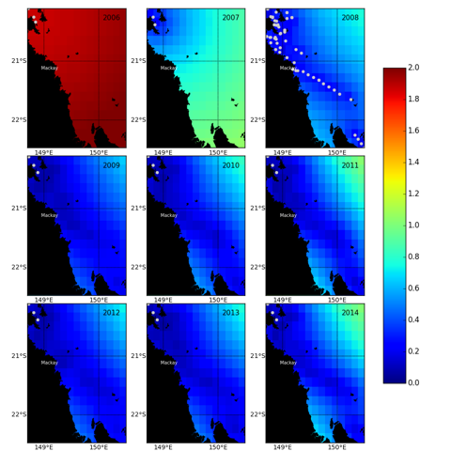

**Figure 12.** Gaussian Process (GP) posterior standard deviation surface map of log-total nitrogen (TN) concentrations (log-μm) in subsequent wet seasons (Q2:Jan-Mar) in the Mackay-Whitsunday Region, 2006-2014. Posterior densities were built up from summaries of 1000 potential TN maps. Grey dots are observed data locations in each year.

Carrying the GP model further in time, three AIMS observations were made in 2009 that, when modelled, lead to nearly the same inferences as in 2008 (Figures 11 and 12, 2009). At first this result may seem implausible, however what it means is that the model posteriors from 2008 used as priors for 2009 continue to represent the best estimate for TN concentrations in the absence of additional information. In this way, the three observations that provided limited information to overall estimates in 2006 and 2007 also had little effect on TN estimates in 2009. In other words, the data are so sparse in 2009 that the posteriors barely differ from the priors, given the three data points observed, which is suboptimal for in situ data. From 2010 to 2014 very little additional information is added from the AIMS observations, demonstrating that what we know about TN concentrations in the Mackay-Whitsundays are almost entirely based on TropWater sampling from 2008.

#### Bayesian Hierarchical Process models for IMP coral-cover analysis and data integration

Although a healthy, functioning GBR consists of a wide diversity of habitat components, hard coral cover is the most prominent, forming the base upon which coral reef ecosystems are formed. Unlike a continuous spatial surface for measurements in seawater, hard coral exists patchily, among the almost 3000 individual reefs that make up the GBR ecosystem. Within the GBR, individual reefs are frequently categorised as being inshore, mid-shelf, or offshore, within shelf positions that form distinct layers of ecological function along its reach. This natural hierarchical structure is ecologically important and, as such, should be recognised by models attempting to describe annual changes and longer-term temporal trends in hard coral cover.

Bayesian Hierarchical linear models (HLMs; Gelman et al., 2004) are a flexible and robust way of estimating averages and trends among coral reefs. Because Bayesian models include priors, which may be flat (uninformative) or informative, estimates of given variables for individual reefs and sectors can be estimated each year, even if no observations were made. The HLM model structure ’borrows’ information from adjacent reefs and combines this information with a prior to come up with a best estimate in light of the model and the observed data. As with the GP models described above, Bayesian HLMs also have the appealing property that they readily integrate various data sources and thereby reduce the uncertainty in larger scale estimates.

Building a hierarchical model begins with specifying priors for each level (spatial scale) of observation. In the case of something like percent hard coral cover, a binomial model provides a convenient distribution for describing the number of hard coral ’successes’ (i.e. percent cover) out of 100 on a given transect. With this, the parameters in a binomial HLM are most frequently given uninformative flat normal priors on a logit scale which, when passed through the appropriate link function, are bounded between zero and one. Including the hierarchical spatial scales relevant for the GBR, an overall (global) estimate is specified as the mean of shelf-level estimates that are themselves the mean of the reef-level estimates within them. This hierarchal structure permits valid inferences to be made for each spatial scale, which conforms to our intuition about the nested structure of the GBR.

#### Example: hard coral measurements

As a specific case to help illustrate how HLMs can be used to estimate hard coral coverage let’s look at hard coral measurements made within the Mackay-Whitsunday Region by the long-term monitoring program (LTMP), MMP, and researchers at James Cook University (JCU). The data consist of hard coral cover measurements made on fixed transects, primarily among inshore reefs; only the LTMP surveyed coral cover on mid and outer shelf positions. The number of observations per year shows that, in most years, only LTMP data were collected (Table 5). However there are a few years - notably 2007, 2009, and 2012 - when all three data-sources surveyed the area.

While hard coral cover observations could be quantified sequentially, as they were for the GP surfaces, we generally know more about hard coral cover on individual reefs than water quality, making it more sensible to estimate annual changes based primarily on the year of observation. There is sufficient information available each year to estimate year-specific random effects that characterise region-wide changes in hard coral cover year on year, as might occur with a large-scale disturbance. We can also get overall, shelf-specific, and reef-specific estimates of total coral cover within the Mackay-Whitsunday region from 1999 to 2014, as well as estimates of inter-annual variability that may be of interest.

**Table 5.** Data sources and number of hard coral (HC) samples per year. * Analyses assume zero counts, however data are not yet available.

| **Year** | **LTMP** | **MMP** | **JCU** |
| --- | --- | --- | --- |
| 1999 | 9 | 0 | 0 |
| 2000 | 9 | 0 | 0 |
| 2001 | 9 | 0 | 0 |
| 2002 | 9 | 0 | 0 |
| 2003 | 9 | 0 | 145 |
| 2004 | 9 | 0 | 60 |
| 2005 | 9 | 0 | 0 |
| 2006 | 10 | 0 | 0 |
| 2007 | 9 | 9 | 205 |
| 2008 | 10 | 10 | 0 |
| 2009 | 9 | 9 | 205 |
| 2010 | 10 | 9 | 0 |
| 2011 | 11 | 10 | 0 |
| 2012 | 8 | 8 | 205 |
| 2013 | 0 | 10 | 0 |
| 2014 | 0* | 0* | 205 |

Average hard coral cover across the entire Mackay-Whitsunday Region was 31%, albeit with uncertainty intervals that spanned the entire 0 to 100 % hard coral cover range, due to the small number of shelf positions (three) contributing to its estimation. Despite the uncertainty in this overall estimate, average cover within individual shelf positions was well estimated, varying from a high of 45% within the inner shelf areas to a low of 22% in the outer shelf areas (Figure 13). Inter-reef variation in hard coral cover was high, ranging from a low of 15% on Hyde Reef, on the outer shelf, to a high of 60% on inshore Hayman Island (Figure 14).

While these within and among-reef, and among-sector differences provide a relatively robust inference about the state of inner, mid, and outer hard coral cover in the Mackay-Whitsunday Region, they include considerably more data for the inshore than the other two shelf positions, which are surveyed only by the LTMP. The greater level of information about the inshore reefs becomes clear when looking at estimated shelf-scale averages through time (Figure 15). Here, the much higher data density is apparent among inshore reefs, with markedly narrower confidence bounds in most years.

Knowing this, what then is the benefit from having integrated the LTMP, MMP, and JCU datasets in quantifying average hard coral cover for the inshore? The answer is the advantages of distinctly stronger inference. In isolation, the LTMP and MMP datasets provide similar inferences concerning inshore hard coral cover being around 40% in the Mackay-Whitsunday Region, with the JCU data estimating 20% more coral being present, at around 60% (Figure 16). Individually, the datasets have relatively broad uncertainty, spanning more than 60 points on the 100 point cover scale. By integrating them however, the inference for average hard coral cover among inshore reefs becomes much less uncertain, centred at just over 40%, between the LTMP and MMP estimates. The JCU data set contributes less than the other data sets because of its greater associated uncertainty.

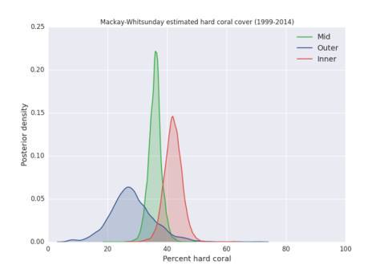

**Figure 13.** Bayesian hierarchical linear model (HLM) posterior densities of shelf-scale percent hard coral cover (HC) in the Mackay-Whitsunday Region, 1999-2014.

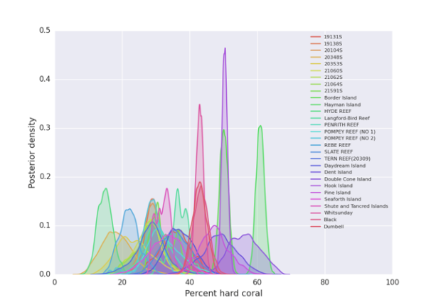**Figure 14.** Bayesian hierarchical linear model (HLM) posterior densities of reef-scale percent hard coral cover (HC) in the Mackay-Whitsunday Region, 1999-2014.

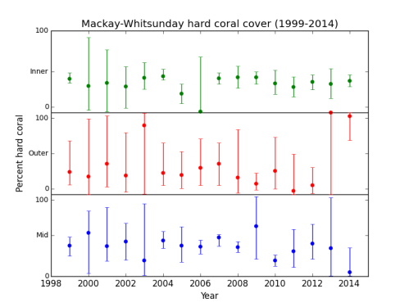

**Figure 15.** Bayesian hierarchical linear model (HLM) posterior densities of inshore, mid, and outer shelf percent hard coral cover (HC) in the Mackay-Whitsunday Region annually (1999-2014).

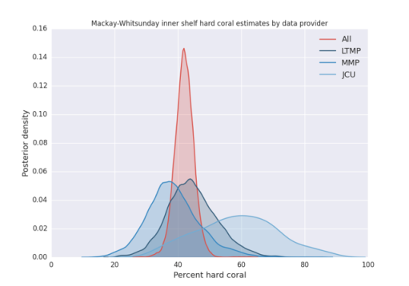

**Figure 16.** Bayesian hierarchical linear model (HLM) posterior densities of inshore percent hard coral cover (HC) in the Mackay-Whitsunday Region (1999-2014) as estimated using data from the Long-Term Monitoring Program (LTMP), Marine Monitoring Program (MMP), researchers at James Cook University (JCU), and all data providers combined.

On the basis of our analyses, our view is that Gaussian predictive process models offer a promising method for statistically valid integration of water quality observations across two or more datasets. However, the prospects for improved clarity through integration of data as it is currently captured under various monitoring programs should not be overstated. Ambient water quality variables are of secondary relevance to LTSP2050 because, at the time of writing, water quality targets are articulated primarily as end of catchment loads. In any case, there are few instances where multiple datasets capture observations for the same variable. The example of Total Nitrogen used here is one of only a handful of variables that are common to two or more datasets. Opportunities for insight via integration across datasets may be more substantial for seagrass and coral.

The gains in precision available through integration of multiple datasets should not be ignored. Gaussian predictive process models and Bayesian hierarchical models provide the analytical rigor for securing these gains. We note that gains may be magnified via re-allocation of current monitoring effort. But these analyses do not in and of themselves tell us how much monitoring effort is adequate. We revisit this question in section 4.2, after considering models and their relevance in section 4.1.

# 4.0 Integration of models and monitoring data

### 4.1 Models

Monitoring provides a rear view of status and trends. While monitoring helps build system understanding, monitoring data per se have no capacity to produce forecasts. To develop an understanding of risks associated with different scenarios requires coupling of targeted monitoring with modelling across the environmental, ecological, social and economic space. Specifically, simulations driven by scenario testing can be used to enable managers to better understand alternative management strategies: both by identifying the different consequences of known strategies but also exploring innovative or untried ones. Ongoing interaction between monitoring and modelling is essential to inform long-term adaptive management strategies, planning, target-setting, and decision-making. Also, modelling provides high-order reporting on system function of activities of interest in the GBRWHA

In essence, while monitoring provides a rear view, modelling adds a windscreen and GPS, i.e. the capacity to work proactively towards achieving targets given a suite of management alternatives and scenarios. The interaction between monitoring, modelling and management can be illustrated as an adaptive loop within the broader framework of Figure 1.

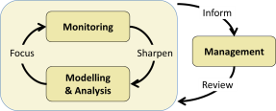

A large number of biophysical models have been developed for different subcomponents of the larger GBR system and adjacent catchments, and the Coral Sea. For example, modelling associated with the Paddock to Reef Program under Reef Plan/Reef Rescue represents a major investment by the Commonwealth and Queensland governments, and now has significant capacity to link land-use practices to nutrient, sediment and pesticide exports via rivers to the GBR lagoon (e.g. Thorburn et al. 2013). Also, eReefs and associated projects (CSIRO, BOM, AIMS, TropWater, UQ) provide new capacity to model the behaviour of receiving waters, and thereby link land influences to ecological risks in marine habitats from the Queensland coastline to the outer Great Barrier Reef. Numerous ecological response models exist for seagrass meadows (e.g. Collier et al. 2012), and for coral reefs (Mumby et al. 2007; Anthony et al. 2011) and population models for dependent species such as dugongs and turtles and a suite of threatened species (Grech et al 2007, Chaloupka et al. 2008), initiatives that are all relevant in an integrated monitoring framework.

To facilitate competent synthesis of existing, and often disparate, modelling initiatives under an integrated monitoring program for the GBRWHA, this report proposes a synoptic Bayesian network approach that captures the results of all underlying models. Specifically, Bayesian networks will be used as a dashboard environment for the purpose of bringing together and interrogating synoptic information from models and data across all drivers, pressures, activities and impacts on the state of values for two key ecosystem types: seagrass meadows and coral reefs, and their key dependent species. Importantly, the Bayesian network approach (1) enables formal inclusion of probabilistic uncertainty in quantitative models, (2) has fidelity to conceptual models of processes in complex ecosystems, (3) accounts for cumulative impacts, (4) enables inclusion of social and economic drivers and benefits, (5) allows for interrogation of the interdependency of targets, and (6) can be represented spatially.

#### Focus ecosystems and key dependent species

The report focuses on seagrass meadows and coral reefs as key habitats, and on a select set of key dependent species. Seagrass meadows in the GBRWHA provide critical resources for species of high conservation value, in particular dugongs and green turtles. Coral reefs on the GBR are some of the richest and most diverse in world. Together, coral reefs and seagrass ecosystems underpin key MNES and contribute to the OUV of the GBRWHA.

The key linkages between environmental exposure and values underpinning ecosystem values have been coarsely assessed through a series of expert workshops, and incorporated into the component qualitative models. Several scenarios are presented based upon provisional management objectives to explore the sensitivities of ecosystem values to key impacts, activities and drivers.

Coral reefs and seagrass meadows are two of the most critical ecosystems underpinning MNES, including the OUV of the GBRWHA. By taking an ecosystem-level, rather than a species-by-species approach the framework accounts for ecosystem processes and thereby provides a practical context for management.

#### Coral reefs

On coral reefs, branching and plating corals, in particular those of the genus *Acropora*, provide key habitats and resources for fish and invertebrates (Jones et al. 2004, Pratchett et al. 2004, Cole et al. 2008), not unlike trees providing habitats for species in the rainforest. Structural corals are therefore used as a principal ecosystem value underpinning MNES in the GBRWHA, and provide an understanding of how other ecosystem components and processes promote or hamper the growth and survival of structural corals and the species they support, including fish and invertebrates.

Figure 17 is a conceptual/qualitative representation of a coral reef model system including causal relationships between drivers, activities, and pressures influencing impacts on the state of key values in the system. The conceptual model is kept parsimonious for the purpose of maintaining clear links between measurable system attributes, management levers and key values.

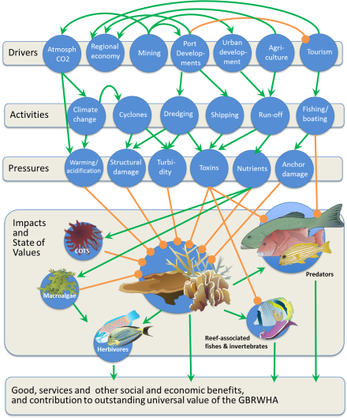

**Figure 17.** Conceptual representations of coral reef and seagrass-based ecosystems and their dependent species. Green arrows are positive and orange arrows are negative linkages. Here, only a subset of pressure nodes is represented without showing their multiple, possible linkages to drivers and activities. Complex food web linkages between all functional fish groups are not shown in the model. Sources: Anthony et al. 2013, IAN Image Library.

#### Seagrass ecosystems

Seagrass meadows provide critical habitat for a range of marine species and serve an array of functional roles in the GBRWHA. Seagrass meadows support dugong and green turtle populations as their primary food source, are important nursery grounds for fish and prawns, and transient homes to a diverse set of species that use seagrass meadows as stepping-stones between coastal ecosystems and coral reefs (Meynecke et al. 2007, Hori et al. 2009).

Dugongs, a listed migratory and marine species protected under the *Environment Protection and Biodiversity Conservation Act 1999* (EPBC Act), feed primarily on seagrasses (Aragones and Marsh 2000) and are therefore highly sensitive to seagrass loss (Lawler et al. 2007). Although dugongs move between foraging grounds, large-scale losses of seagrasses can contribute to population decline (Preen and Marsh 1995, Sheppard et al. 2006, Sheppard et al. 2007). While the Mackay-Whitsunday Region is a relatively minor foraging ground for the larger dugong population in the GBRWHA, any losses of seagrass habitat in the region represents a loss of foraging opportunity for dugongs migrating between key northern (Edgecombe Bay) and southern areas (e.g. Shoalwater Bay).

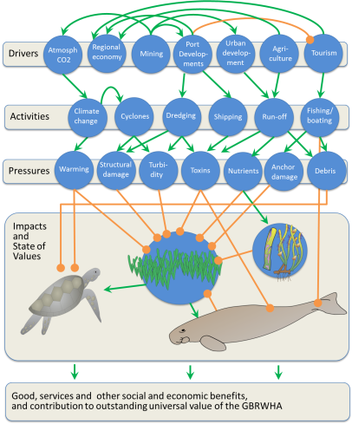

**Figure 18.** Simplified conceptual model of seagrass-based ecosystems and their dependent species. Green arrows are positive and orange arrows are negative linkages. The function of seagrass meadows as nurseries for fish and crustaceans is omitted for clarity. Sources: Anthony et al. 2013, IAN Image Library.

Green turtles *Chelonia mydas*, a vulnerable species under the EPBC Act, are also reliant on seagrass and are sensitive to losses of seagrass meadows, as they are relatively stationary in their foraging grounds (André et al. 2005). The dependence of dugong and green turtle population on seagrass distribution and abundance was evidenced by increased dugong and green turtle deaths in 2011 following several tropical cyclones, which devastated seagrass habitats in the GBRWHA over most of the Wet Tropics and Central region (GBRMPA 2011) and major river floods which devastated seagrass meadows in the southern GBR (Devlin et al. 2012).

#### Quantitative models

This report uses Bayesian networks to facilitate a quantitative synthesis of the multiple models linking drivers, activities and to ecosystem values for seagrass and coral reef ecosystems. The networks build on the qualitative understanding of system dynamics portrayed in Figures 17 and 18 to provide quantitative estimates of outcomes under ‘what-if’ scenarios. Here, for simplicity, Bayes nets are constructed using preliminary sets of conditional probabilities pertaining to two or three possible ranges of states for each node. Importantly, the distribution of conditional probabilities within each node captures the predicted response and associated uncertainty for that node, which can be derived from underlying quantitative models, data and/or expert opinion. Figure 19 below presents preliminary Bayes nets for coral reefs and seagrass systems elicited from a combination of literature review and expert opinion.

Both Bayes nets are constructed consistently with the DPSIR framework – i.e. with drivers and activities (boating, dredging, storms, land-use, ocean warming) influencing pressures (e.g. structural damage, turbidity, nutrients), which in turn lead to impacts on values (e.g. coral growth and survival, fish survival, dugong and turtle survival). Note that drivers, activities and pressures are largely similar for the two ecosystems, which enables analyses of their responses to shared environmental scenarios. Both Bayes nets are shown in a baseline condition – i.e. illustrating the results of a benign scenario. Results of other scenarios can be analysed by directly manipulating the drivers and activities nodes. It is important to stress here that these Bayes net models do not represent separate modelling initiatives for the ecosystems and linked social-economic systems, but are simply a means to integrate the synoptic results of existing modelling efforts across a broad disciplinary spectrum.

**A**

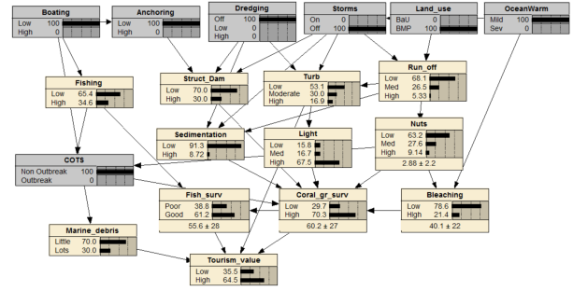

**B**

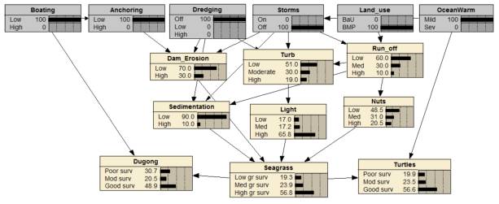

**Figure 19.** Example Bayes net for (A) coral reefs and (B) seagrass ecosystems. Here, drivers and activities are set to a baseline scenario. BMP and BaU represent Best Management Practices, and Business as Usual, respectively. The distribution of probabilities within each node is indicative of uncertainties in responses and the strength of the causal relationships.

***Box 4. Agent-based modelling***

Alongside Bayes nets, an Agent-based modelling (ABM) prototype has been developed in this project to illustrate how complex systems methods can assist adaptive modelling and management. ABM compliments existing tools and augments decision-makers’ capacity to make better decisions. It is not prescriptive, but exploratory. Through its use managers improve their system understanding and can discover novel pathways to preferred outcomes. ABM is a modelling approach that captures cause and effect relationships at a micro scale in systems expressing cumulative impacts at a micro, intermediary and macro-scale (Epstein, 1999). In this model, spatial and temporal representation of seagrass communities and coral reefs are created as agents that interact with environmental variables such as water quality. The LMTP, MMP and other monitoring data provide insight into the scale and nature of interactions. Managers pull ‘management levers’ to explore how they might adapt management practices under varying conditions.

ABMs are commonly used to dynamically interact with system changes through time and space. For the IMP the investigation of cumulative effects of key system drivers, impacts, and pressures (e.g. nutrient loading) aligned with LTSP 2050 targets are especially relevant. ABMs also allow sensitivity analysis of LTSP2050 targets and thresholds to dynamic drivers and pressures, and exploration of alternative management options, including the identification of novel management solutions.

The prototype focuses on water quality with each monitoring source represented through an individual spatial layer. Multiple water quality data sources (TropWater, LTMP and MMP) are included. Data describing seagrass and coral initial states are loaded. Seagrass and coral growth models were adapted from Beth Fulton’s work associated with the Gladstone Healthy Harbour Partnership (originally from Engelen et al., 1997). When fully developed, managers can interrogate the ABM to better understand consequences of specific scenarios.

This report uses Bayes nets as summary models, synthesising the insights of existing theory, observation and modelling. In future, we intend to refine these summary models through further development of ABMs, with emphases on (a) temporal dynamics and (b) feedback loops, both of which are difficult to capture in Bayes nets.

### 4.2 Combining models and monitoring data in risk-based adaptive management and adaptive monitoring

Ideally, integrated monitoring encompasses three separate but related components in an adaptive cycle: adaptive design, adaptive monitoring and adaptive learning. Adaptive design makes use of currently available data, ideally across multiple sources and sensor types, in order to make an informed decision about the selection of the next set of design points. While many different sets of observations could be selected at each design point, there are very few sets near the optimum. The observation of the next set of design points constitutes adaptive monitoring and comparisons between current and past observations support adaptive learning. By incorporating predictive modelling into an integrated monitoring program, adaptive learning can be accelerated, decision support enhanced and information gaps prioritized in future designs.

When designing a monitoring program (or assessing the adequacy of current arrangements) a regulator’s foremost concern is false success or a false sense of security. That is, the risk monitoring will report benign outcomes when in fact harm has occurred. To illustrate, consider this scenario (adapted from Eddy 1982):

*Imagine a project that government approves conditional on implementation of an acceptable monitoring regime. The regulator is uneasy about the project, but not so concerned that it can justify non-approval. Using a model, it estimates that the chance, P, of harm to dugongs is 15%. The proponent’s monitoring program is refreshingly clear about its accuracy and precision. The sampling strategy detailed in the program is capable of detecting harm in 80% of cases, but will fail to detect 20% of the time* (*β* = 0.20*). Likewise it will correctly identify benign impacts 80% of the time, and incorrectly report harm 20% of the time* (*α* = 0.20*). The project goes ahead and the monitoring plan implemented. No harm is detected.*

*What is the chance harm in fact occurred?*

Most people’s (mistaken) guess is 20% or something very close to it. It’s a difficult problem, but a common one. The same problem is faced by doctors when required to make judgments on whether or not a patient has cancer after receiving the results of an imperfect diagnostic test. The same problem is faced by quarantine officers in their decision to allow or disallow a shipment of goods that may contain an exotic pest. Overwhelmingly, people fail to coherently combine information on the reliability of the monitoring (or diagnostic test) with the initial estimate of the chance of an undesirable outcome – harm to a threatened species, cancer, or a pest incursion (Bar-Hillel 1980).

The problem is captured in the logic tree below.

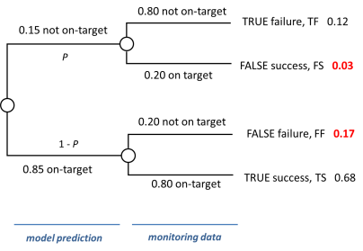

The chance of harm despite monitoring reporting benign impacts = $\frac{false success (FS)}{false success(FS)+true success(TS)}=\frac{0.15 ×0.20}{0.15×0.20+0.85×0.80}=\frac{0.03}{0.03+0.68}$, or about 4.2%. Note that in general, regulators and environmental managers are concerned with the probability of false success, highlighted red. Also highlighted is the focus of industry or proponent concerns, the probability of false failure.

Doctors can’t do much about imperfect diagnostic tests. They’re at the mercy of the available technology. The best they can do is coherently combine the imperfect diagnosis with estimates of disease prevalence to provide patients with sober advice. It’s a different story for environmental monitoring. The reliability of the information gathered in a monitoring plan can be controlled directly through sampling design. In quarantine, analysts consider a tolerable leakage (i.e. false success) rate, calculate the level of α and β needed to satisfy that rate for any estimate of *P*, and then estimate the sampling effort required to achieve α and β. The same logic can be used to estimate the monitoring effort needed to characterise performance against targets in the LTSP2050.

Intuitively, the incidence of false success and false failure is highly sensitive to management decisions. If we allow development such that our model now reports a 50/50 proposition for target success/failure (i.e. *P* = 0.50), we increase the rate of false success to 0.10, and the rate of false failure drops to 0.10. The imperative for greater monitoring effort is felt more acutely by environmental managers than by industry.

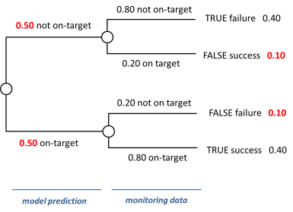

If we invest in additional monitoring effort such that α = β = 0.05, the incidence of false successes and false failures are both reduced, and in our example, equalised to 0.02.

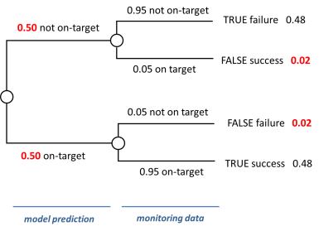

A dearth of information can make it difficult to estimate *P*. In public health, the prevalence of rare and novel diseases is largely unknown. In quarantine, the ‘approach rate’ of many pests is profoundly uncertain. Nevertheless professionals in these domains will hazard a guess, because they want their probabilistic judgments to be coherent. Estimates of the Type I and Type II error rates are conditional probabilities. That is, a Type I error refers to the probability of inferring harm (or failing to meet a target) *conditional* on the opposite being true. Type II errors are *conditional* on circumstances where the truth is harm or failure. To assess the adequacy of a monitoring program we need to ask ourselves what are the chances of harm (or failure) before we consider the evidence from data. Models provide transparent and internally consistent judgments, which can be improved over time through vigorous cross-examination and calibration with data (Burgman 2005).

A common circumstance in environmental management is that no-one has modelled an estimate of *P*, the probability of harm or failure in the absence of monitoring. And no-one has wrestled with what might be considered an acceptable leakage rate. Without these elements, assessment of the adequacy of a monitoring plan can be more or less resolved with a coin toss. More despairing are the costs of inadequate monitoring programs – to MNES, OUV and to industry. To understand these costs, we need to consider the risks faced by regulators and proponents. Who are regulators and proponents in the context of the GBRWHA? Perhaps most familiarly, ports may be considered proponents and their activities regulated by government. But loosely speaking, the Queensland government may be considered a proponent and the Commonwealth government the regulator in the specific context of MNES and strategic assessments. Likewise, the Commonwealth government could be characterised as a proponent and the World Heritage Committee the regulator in the context of OUV.

The leakage rate is the *regulator’s risk*, *Rr*, equating to Pr{failure|monitoring indicates success} = $\frac{FS}{FS+TS}$. The regulator needs to consider what might be a tolerable risk, which may vary according to recent understanding of status and trend, together with a raft of organisational, social and political factors.

The proponent has its own risks to consider. We assume that where monitoring indicates harm or target failure, the proponent will be required to implement a remedy (e.g. adoption of best practice or offsets). The probability monitoring will indicate failure is the sum of the true failure rate (TH) and the false failure rate (FH). The risk and ensuing costs of true failure are made apparent through explicit modelling of *P*. If a proponent wishes to try their luck when *P* is high they can hardly complain when monitoring correctly detects failure. The less palatable risk is that of false failure.

Let’s call the false failure rate the proponent’s risk *Rp* defined as Pr{success|monitoring indicates failure} = $\frac{FF}{FF+TF}$. The key consideration for proponents is the trade-off between the chance they will be required to remedy an impact that in fact hasn’t occurred (*Rp*) and the costs of monitoring. If the regulator is prepared to specify a tolerable level for the *regulator’s risk*, *Rr*, the proponent can make an informed decision about whether it should proceed with its project with or without investment or co-investment in additional monitoring (Box 5).

***Box 5. Informing the proponent’s investment in monitoring within a specified constraint imposed by the regulator.***

One interpretation of harm or failure is decline of a specified magnitude in population size of a threatened species. In this case, the regulator could give the proponent the modelled estimate of *P*, and the non-negotiable threshold for the regulator’s risk, *Rr* and from this information the proponent can calculate the minimum sample size (in any one year) required to detect harm in a way that satisfies the *prescribed* regulator’s risk and any *nominal* proponent’s risk.

For example, let’s say ‘harm’ is defined as a 25% decline in population size. (We note that thresholds for harm can vary according to conservation status, or other considerations). A simple formula for estimating sample size *n* is (Zar 2010)

$n= ρ{\left(z_{α}+z_{β}\right)}^{2}$,

where

*ρ* is the ratio of the population’s coefficient of variation (%) and the effect size defining harm (%),

*zα* is the z-score associated with α, the probability that monitoring incorrectly indicates harmful impacts

*zβ* is the z-score associated with β, the probability that monitoring incorrectly indicates benign impacts.

To find the appropriate level of α and β, we need to solve for these two terms in

$\frac{Pβ}{Pβ+(1 – P)(1 – α)}≤R_{r}$ and

$\frac{\left(1-P\right)α}{\left(1-P\right)α+P\left(1 – β\right)}≤R_{p}.$

where $R_{r}$ is the prescribed regulator’s risk and $R_{p}$ is the nominated proponent’s risk.

Let’s say that for a given sampling design and species of interest the coefficient of variation is estimated to be 50%. If the regulator’s model estimates that a project poses a *P* = 0.10 risk of a 25% decline in a local population of an endangered species, and if $R_{r}$ is set at 0.05 and $R_{p}$ is assigned a nominal value of 0.01, then the required sample size in any one year is 44 (with α = 0.001 and β = 0.473). The proponent may be disinclined to incur the costs of monitoring associated with annual sampling of 44 units. Increasing $R_{p}$ to 0.05 the proponent’s required sample size is now 32 (with α = 0.003 and β = 0.472).

A series of analyses can be run to inform the proponent’s decision on what sampling effort may be appropriate for it to fund. It *must* satisfy the prescribed regulator’s risk. In doing so, it may tolerate a high false harm rate for lower monitoring costs, or vice-versa.

(a)



(b)



(c)



The trade-off between proponent’s risk (*Rp*) and sampling effort for a prescribed regulator’s risk *Rr* = 0.05, a threshold for harm of 25% population decline, and a coefficient of variation (CV) of (a) CV = 25%, (b) CV = 50%, and (c) CV = 100%. The graphs also show the total probability monitoring will indicate harm (true harm + false harm). Results indicate the required sampling effort required is highly sensitive to *P*, *Rp* and *CV*.

### 4.3 Structured decision-making

Informed negotiation of acceptable risk for proponents and regulators will not materialise immediately. Parties need to better comprehend the implications of the outcomes of monitoring, the marginal gains (and losses) in clarity that can be made through changes to monitoring effort, and the distribution of costs and benefits. In short, negotiation of a robust, effective and enduring monitoring program that enjoys the support of all key stakeholders is not an automated exercise that can be achieved by technical analysts in isolation from end-users.

Field et al. (2004) describe the optimal solution to the problem of how much monitoring effort is enough. These authors capture the problem using the same logic we have used in this report. In their logic tree, the costs of true failure and false failure are assumed to lead to remedial action, *R*, of specified magnitude and monetary cost. Likewise, the costs of environmental harm associated with false success are estimated in monetary terms (Figure 20). With this formulation the overarching objective of management is to minimise expected costs, E(C). That is, design the monitoring program such that the Type I (α) and Type II (β) error rates minimise expected cost in the equation,

$$E\left(C\right)=\left(1-P\right)αR+P\left[\left(1-β\right)R+βV\right]+M$$

where *M* is the monetary cost of data acquisition and analysis in the monitoring program.

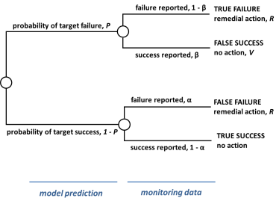

**Figure 20.** Formulation of the problem of allocation of resources to monitoring and management. Adapted from Field et al. (2004).

In concept, this formulation can be extended to multiple values (MNES and OUV) and infinite or near-infinite alternatives for remedial action and spatial and temporal configurations of monitoring effort. But aside from the challenges of valuation of environmental harm in monetary terms, the greatest challenge of immediate application is appreciation of each element of the decision problem and its implications among the multiple managers and stakeholders that might reasonably be expected to contribute to integrated monitoring on the GBR.

Our view is that ultimately managers of the GBR will be well served by the formulation of Field et al. (2004). But as a stepping stone to optimisation, managers and stakeholders are likely to establish a better mutual understanding of imperatives, constraints and trade-offs through a structured decision-making approach involving several discrete alternatives for management and monitoring. As appreciation of the implications of alternatives grows, so too can complexity be accommodated, and progress made toward optimal, or near-optimal solutions.

Structured decision-making is an approach to multi-objective problems that insulates against common traps in decision-making (Hammond et al. 2006). Through considered evaluation of a handful of discrete alternatives it seeks to provide good solutions rather than optimal solutions. In recommending structured decision-making, we recognise that the rules and constraints for searching for optimal solutions among a vast set of alternatives using programming approaches (Chankong and Haimes 2008) will themselves be a source of disquiet among stakeholders and co-managers.

Structured decision-making involves five iterative steps (adapted from Gregory et al. 2012):

* Step 1 Define the decision frame
* Step 2 Define objectives
* Step 3 Develop alternatives
* Step 4 Estimate expected consequences, including plausible bounds
* Step 5 Evaluate trade-offs and select an alternative

Here we outline these steps using a hypothetical sketch that is placed in the context of adaptive management and the LTSP2050.

***Step 1 Define the decision frame***

There are many decisions and many decision frames at play in the GBR. Here we choose just one – the achievement of LTSP2050 targets associated with water quality and their implications for seagrass meadows.

***Step 2 Define objectives***

Among the fundamental objectives of the defined decision frame are the LTSP2050 targets of immediate relevance, including:

* Agricultural best practice (more is better)
* Ports and shipping best practice (more is better)
* End of catchment contaminant loads (less is better)
* Seagrass condition and extent (more is better).

These objectives need to be traded off against the objective of monetary cost (less is better). Monetary costs may be incurred through direct management intervention or through the costs involved in administering a specified monitoring program. There are also embedded objectives involving the costs of false success and false harm (less is better).

***Step 3 Develop alternatives***

Alternatives comprise a small discrete subset of the many options available for management intervention and monitoring effort. The idea in developing mutual understanding in a multi-party decision problem is to have enough alternatives to expose key consequences and trade-offs, but not so many that managers and stakeholders become overwhelmed with complexity. In our hypothetical sketch, we include examples of management interventions documented in LTSP2050:

* Greater investment in best practice for ports and shipping
* Greater investment in best practice for agriculture
* Greater investment in best practice for both ports and agriculture.

As a basis for comparison, structured decision-making also routinely includes status quo management arrangements and the ‘do nothing’ option.

For monitoring effort, we include the following alternatives:

* Status quo
* Double the sampling effort
* Triple the sampling effort

***Step 4 Estimate expected consequences of each alternative against each objective***

This step is the domain of predictive science (and for monetary costs, the domain of accounting). Again, credible models should be made available for interrogation and cross-examination. For the purposes of illustration and communication, the key insights of multiple models and lines of evidence could be synthesised in a summary Bayes net, such as the one depicted in Figure 21.

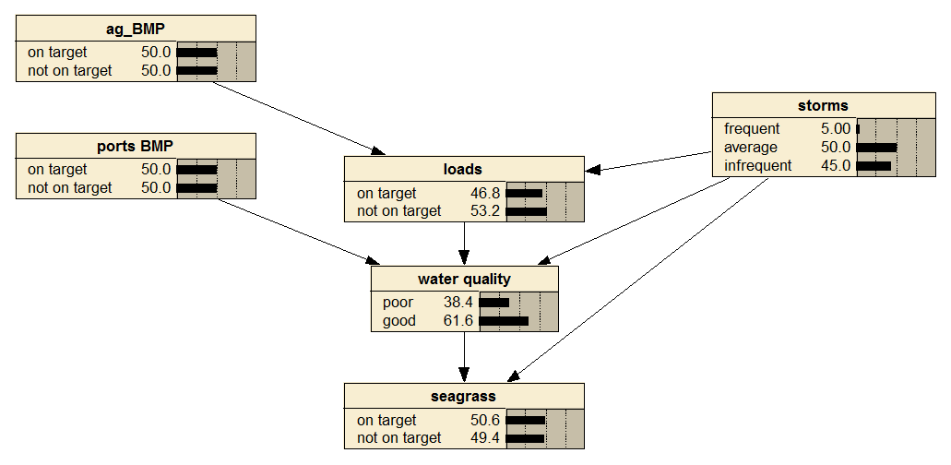

**Figure 21.** Hypothetical summary Bayes net for the decision frame. Summary models may be more effective in communicating consequences of various alternatives than the high-fidelity, high-complexity models from which their inferences are drawn.

After estimating the performance of alternatives against objectives, outcomes can be compactly described in a consequence table (Table 6) and in graphical form (Figure 22).

**Table 6.** Consequence table for the hypothetical decision frame. Note that this consequence table is restricted to alternatives involving management intervention. Alternatives pertaining to monitoring effort are dealt with subsequently.

|  |  |  |  |  |  |
| --- | --- | --- | --- | --- | --- |
|  | **Chance of being on-target (%)** | | | | **cost ($M)** |
| **ALTERNATIVES** | **seagrass** | **loads** | **ag BMP** | **ports BMP** |
| do nothing | 33.7 | 23.3 | 0 | 0 | $0 |
| status quo | 40.5 | 42 | 49 | 50 | $5 |
| more BMP for agriculture | 47.4 | 62 | 100 | 50 | $8 |
| more BMP for ports | 41.2 | 42 | 49 | 100 | $6 |
| more BMP for both | 48.2 | 62 | 100 | 100 | $14 |

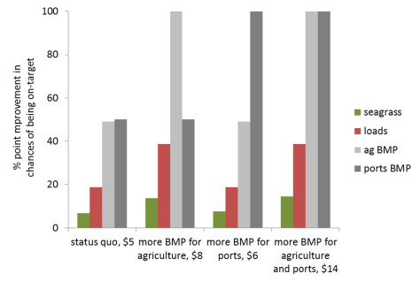

**Figure 22.** Summary of expected performance of each management intervention alternative for each of four relevant LTSP2050 targets relative to the ‘do nothing’ alternative.

***Step 5 Evaluate trade-offs and select an alternative***

The outcomes shown in Figure 22 can mislead. Most managers will be more concerned being on-target for seagrass than for implementation of best management practices as outcomes of substance in and of themselves. Managers and key stakeholders need to weigh the relative importance of each target. Hypothetical judgments are shown in Table 7 and the outcomes shown in Figure 23. Weights are derived using the swing weighting method of von Winterfeldt and Edwards (1986), which involves assigning utilities on an interval scale based on a specified range of consequences, ‘swinging’ from worst to best. We emphasise that the judgments highlighted in Table 7 are not scientific judgments. They are value judgments that organisations implicitly make routinely on behalf of the broader community. In making these judgments explicit, co-managers and stakeholders develop mutual appreciation for the necessity of coherent integration of value judgments and scientific judgments.

**Table 7.** Hypothetical value judgments for target objectives.

|  |  |  |  |  |  |
| --- | --- | --- | --- | --- | --- |
|  | Chance of being on-target (%) | |  |  |  |
|  | worst | best | rank | utility | weight |
| seagrass | 0 | 100 | 1 | 100 | 0.74 |
| loads | 0 | 100 | 2 | 25 | 0.19 |
| ag BMP | 0 | 100 | 3 | 5 | 0.04 |
| ports BMP | 0 | 100 | 3 | 5 | 0.04 |
|  |  |  |  |  | 1.00 |

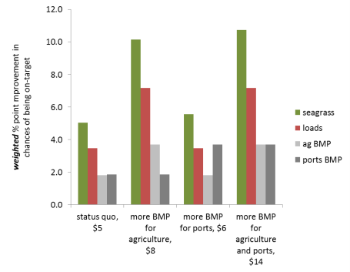

**Figure 23.** Summary of weighted expected performance of each management intervention alternative for each of four relevant LTSP2050 targets relative to the ‘do nothing’ alternative. Note that in contrast to Figure 22, seagrass outcomes dominate aggregated performance.

The task remains to trade-off cost against performance of each LTSP2050 target. Our view is that trade-offs with monetary cost are often the most difficult. Managers and stakeholders have difficulty finding a ‘fair price’ for losses and gains that involve environmental values or risks to organisational reputations. Tetlock (2000) characterises trade-offs involving protected or sacred values (e.g. environmental values of the GBR) and secular values (e.g. money) as ‘taboo’ trade-offs. Decision-makers tend to eschew the cognitive and emotional demands of taboo trade-offs and instead assign infinite (or near infinite) value to the protected, non-market objectives. Wherever possible, taboo trade-offs should be avoided. Instead of asking managers and stakeholders to articulate a monetary willingness to accept or willingness to pay, the approach we advocate is presentation of outcomes according to multi-objective cost-efficiency (Figure 24).

To aggregate over multiple objectives, multi-attribute value theory commonly uses a simple additive model (Keeney and Raiffa 1976). The multi-objective value *V* of a single alternative *j* over *n* preferentially independent objectives is

|  |  |
| --- | --- |
| $$V_{j}=\sum_{i=1}^{n}{w_{i}}v_{i}{(x}_{ij})$$ |  |

where *xij* is the performance of alternative *j* on objective *i*, *vi* is the single-objective value function, and *wi* is the weight of objective *i* (von Winterfeldt & Edwards, 1986). A common simplification is to normalise *vi*(*xij*) using linear value functions, with the poorest performance on any single objective *i* assigned a value of 0 and the best performance assigned a value of 1 across all *j* alternatives. The assumption of linearity avoids the tedious demands of formal elicitation and is reasonable over the local range of consequences associated with most problems (Durbach and Stewart 2009).

We modified this measure to address multi-objective cost-efficiency, such that

|  |  |
| --- | --- |
| $$R_{j0}=\frac{V_{j}-V_{0}}{C_{j}-C_{0}}$$ | (3) |

where *Rjo* is the cost-effectiveness of alternative *j* relative to the ‘do nothing’ alternative (*0*), *Vj* is the multi-objective value of alternative *j*, and *V0* is the multi-objective value for the ‘do nothing’ alternative.

The multi-objective cost-efficiencies shown in Figure 24 report a greater return per unit investment in additional funding for agricultural best management practice than for the status quo. Additional investment in BMPs for ports is no more efficient than the status quo, and investment in both is relatively inefficient. On the basis of these (hypothetical) outcomes there is a sound argument for additional funding for agricultural best practice. Of course, the funding required to implement this alternative needs to be found (an additional $3 million on top of the $5 million allocated under the status quo; Table 6).

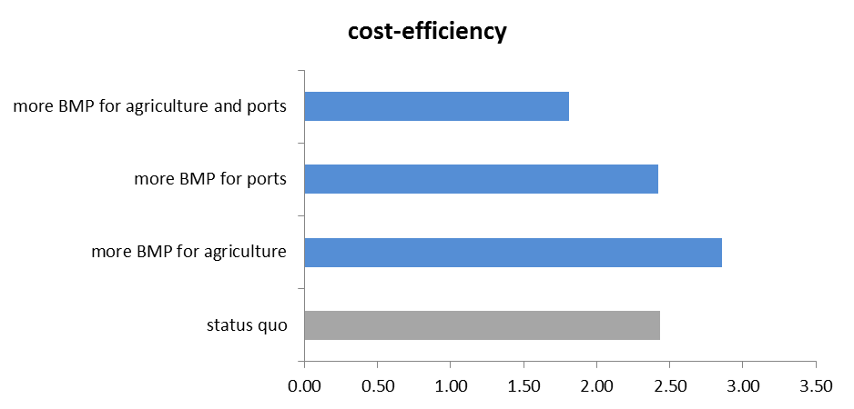

**Figure 24.** Multi-objective cost efficiency of four hypothetical alternatives for management intervention.

Is there an argument to change monitoring effort alongside the argument for change to management intervention? In order to assess the merit of doubling or tripling sampling effort, we need to assess the value of additional information (von Winterfeldt et al 2012, Maxwell et al. 2014). Steps in this assessment include power analyses for each alternative (section 3.1), estimation of the rate of false success, true success, false failure and true failure (section 4.2), and weighting their consequences alongside the value judgments articulated for targets.

The multi-objective cost efficiency of alternative management interventions and alternative sampling intensities can now be considered collectively. In Figure 25, the current sampling effort is the most cost-efficient of the three alternatives considered. So while a substantial argument for a change in on-ground management (more funding for agriculture BMP) is evident, no such argument exists for a change in monitoring effort, at least for the handful of alternatives explored. Whilst we illustrate a simple example where current monitoring effort is compared to doubling or tripling of effort, more monitoring alternatives could also be explored in the future. These could include elements of spatial intensity, temporal intensity, and the effectiveness of monitoring different indicators or using different methods and techniques.

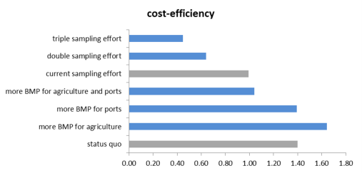

**Figure 25.** Multi-objective cost efficiency of four hypothetical alternatives for management intervention and three hypothetical alternatives for monitoring effort.

# 5.0 Integrating social and economic elements

A core element of integrated monitoring envisaged for the LTSP2050 is monitoring of social and economic considerations alongside the traditional environmental concerns of reef managers. Target #1 under the community benefits theme of LTSP2050 calls for *a long-term social and economic monitoring program guiding management decisions.* Action 1 of the economic benefits theme is to *identify, test and use economic indicators as a component of the Integrated Monitoring Reporting Program* (Australian and Queensland governments, undated).

Environmental planning involves conflicts between stakeholders with different socio-political, environmental, and economic priorities. Public decisions made without public participation and social acceptance are fragile, reducing the viability and longevity of proposed solutions (Gregory and Keeney, 1994). The capture of social impacts in environmental problems is one of the biggest challenges for policy-makers today (Failing et al. 2007). Sound decisions require methodologies that evaluate multiple objectives, integrating economic, biophysical and social information towards broadly acceptable solutions, rather than optimal solutions founded on the values and preferences of a small subset of interests (Dietz 1987, Estevez et al. 2013).

There are many motivations and many decision frames that compel consideration or monitoring of social and economic elements. Among them are the motivations,

* to better characterise the risks to reef values posed by human pressures and behaviours,
* to understand community values and preferences,
* to inform communication strategies, and
* to gauge the degree to which social and economic aspirations are consistent with reef values.

Here we present how the steps of structured decision-making can be used to address the last of these dot points, again as a hypothetical exercise. There is an inevitable tension between the social and economic aspirations of regional governments and the international obligations of the Commonwealth with respect to the GBRWHA. The LTSP2050 notes that *delivering The Queensland Plan objectives for population and economic growth, whilst maintaining the Outstanding Universal Value of the Reef is a key challenge. Reef dependent industries and Reef associated industries support diverse and sustainable communities. These industries and related communities need to be able to continue to prosper, while ensuring protection of the Outstanding Universal Value of the Reef* (page 36, Australian and Queensland governments, undated)

Clearly, the extent to which social and economic objectives can be realised within the constraints of a world heritage listed entity is of interest. Progressing clarity in this matter, and subsequent monitoring of social and economic outcomes will assist ongoing negotiations between the Queensland and Commonwealth governments and their dialogue with the World Heritage Committee.

***Step 1 Define the decision frame***

The decision frame for this problem is identification of the extent to which social and economic aspirations can be accommodated within the constraints implied by world heritage status of the GBR. The context of the decision is the need to develop regional targets and thresholds that acknowledge geographic and demographic variation in opportunities and values. The aggregation of regional targets and thresholds need to be consistent with whole-of-reef targets articulated in the LTSP2050.

***Steps 2 and 3 Define objectives and develop alternatives***

The conceptual model that encompasses social economic elements (Figure 26b) is considerably more elaborate than that for environmental objectives alone (Figure 26a). Together with core objectives associated with ecological targets under LTSP2050, social and economic objectives include economic output (more is better) and quality of life (more is better). Sub-objectives pertaining to quality of life includes, among other things,

* household wealth (more is better),
* amenity (more is better), and
* recreation (more is better).

From a planning perspective, economic output and these sub-elements of quality of life are compensatory. Planners may forgo direct economic benefits for quality of life outcomes, and *vice-versa.* We may place greater emphasis on some elements over others in different regions, according to our understanding of the values and aspirations of local communities, and of opportunities for economic development visible over the planning horizon.

There is less scope to compromise on ecological outcomes. The first target of the LTSP2050’s ecosystem health theme is *that condition and resilience indicators for coral reefs, seagrass, islands, estuaries, shoals and inter-reefal shelf habitats are on a trajectory towards achieving at least good condition* ***at regional and Reef-wide scales*** (emphasis added). Development scenarios that do not satisfy this constraint can be omitted. We note that it may be possible to accommodate substantial industrial development if a co-investment in risk mitigation (e.g. fishing regulation, enhanced paddock to Reef program etc.) is made (Figure 26b). But at some point, such co-investment will become cost-prohibitive. After identifying objectives, a number of scenarios for regional development need to be developed and documented. In Table 8, we illustrate three alternative development scenarios alongside the status quo for two hypothetical regions.

**Table 8.** Strategy table describing qualitative changes to different industries under three alternative futures for a hypothetical ‘north’ and ‘south’ region, relative to the status quo. The table also indicates investment in risk mitigation for each alternative.

|  |  |  |  |  |  |  |
| --- | --- | --- | --- | --- | --- | --- |
|  | Agriculture | Mining | Ports and shipping | Tourism | Fishing | Risk mitigation |
| Status quo |  |  |  |  |  |  |
| North | ○ | ○ | ○ | ● | ● | ○ |
| South | ●● | ● | ● | ● | ● | ○ |
| Alternative A |  |  |  |  |  |  |
| North | ●● | ●● | ●● | ●● | ●● | ●●● |
| South | ●● | ●● | ●● | ●● | ●● | ●●● |
| Alternative B |  |  |  |  |  |  |
| North | ○ | ○ | ○ | ● | ● | ○ |
| South | ●● | ●● | ●● | ●● | ●● | ●●● |
| Alternative C |  |  |  |  |  |  |
| North | ●● | ●● | ●● | ●● | ●● | ● |
| South | ●● | ●● | ●● | ●● | ●● | ● |

(a)

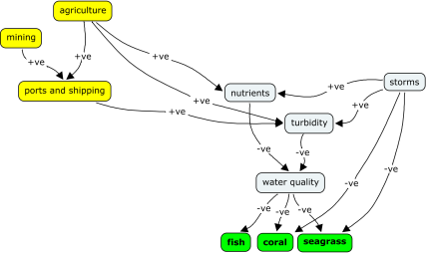

(b)

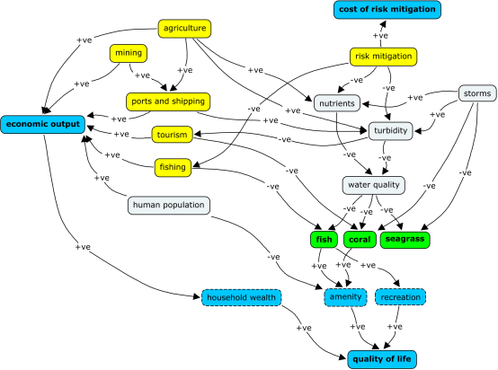

**Figure 26.**  Simplified conceptual models of (a) the ecological system, and (b) the socio-ecological system. Yellow nodes represent elements that can be influenced by planning and management decisions. Green nodes are core ecological objectives and blue nodes social and economic objectives. Positive links indicate the child node moves in the same direction as the parent (e.g. economic output increases as ports and shipping increases). Negative links indicate an inverse relationship between parent and child nodes (e.g. turbidity and nutrients decrease as risk mitigation increases).

***Steps 4 and 5 Estimate expected consequences, evaluate trade-offs and select an alternative***

After estimating the performance of each alternative against each ecological, social and economic objective (for each region), the first task is to filter out any alternatives that do not satisfy constraints on environmental outcomes. For our hypothetical exercise, let’s say the modest investment in risk mitigation under Alternative C was insufficient to offset anticipated adverse impacts associated with the proposed scale of industry development (Table 8). If Alternatives A and B do satisfy environmental constraints, environmental objectives become redundant. The task now is to identify the best alternative among the status quo and Alternatives A and B (Table 9). To do so, requires articulation of trade-offs and assignment of weights, as illustrated in Section 4.3.

**Table 9.** Hypothetical consequence table for two alternative development scenarios, alongside the status quo. Alternative C has been omitted because it failed to satisfy minimum requirements for environmental performance.

|  |  |  |  |
| --- | --- | --- | --- |
| **Social and economic objectives** | **status quo** | **alternative A** | **alternative B** |
| north - economic output ($B per year) | 0.5 | 4 | 0.5 |
| south - economic output ($B per year) | 2 | 4 | 4 |
| north - QoL - household wealth ($k per household) | 200 | 600 | 200 |
| south - QoL - household wealth ($k per household) | 400 | 600 | 600 |
| north - QoL - amenity (constructed scale) | 5 | 1 | 5 |
| south - QoL - amenity (constructed scale) | 3 | 1 | 1 |
| north - QoL - recreation (quality-adjusted recreation days) | 30 | 5 | 30 |
| south - QoL - recreation (quality-adjusted recreation days) | 15 | 5 | 5 |
| north - cost of risk mitigation ($M) | 1 | 500 | 1 |
| south - cost of risk mitigation ($M) | 5 | 500 | 500 |

The results of the trade-off exercise may lead to the outcomes shown in Figure 27. The social and economic multi-objective value of Alternative B is marginally better than the status quo and distinctly better than Alternative A. Alternative B emphasises quality of life in the (hypothetical) north region, and provides substantial economic output with reasonable risk mitigation costs.

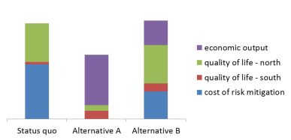

**Figure 27**. Outcomes of a structured decision-making exercise identifying a preferred development scenario (Alternative B) that balances economic output and quality of life across two hypothetical regions, within environmental constraints.

If Alternative B is adopted as the broad development strategy for our two hypothetical regions, the Queensland and Commonwealth governments have clear social and economic targets (i.e. the consequences listed under Alternative B in Table 9) against which monitoring can be undertaken, alongside corresponding targets associated with environmental outcomes. As events unfold, managers can adjust adaptively to social and economic surprises in the same way we have described adaptive management for environmental outcomes.

# 6.0 Integration with reporting

Environmental managers draw on an array of information sources, however these are often from one-off research projects, or from monitoring programs where results are opaque or inaccessible. There is currently intense interest in developing new methods that support integrated monitoring and that better utilise and combine existing information from multiple sources and sensors. The key to achieving an integrated monitoring program, at least from a data and visualisation perspective, is that the whole of the data, to analysis, to modelling, to reporting needs to be made routine.

Report cards are now a common tool used to assist with integrating monitoring results into natural resource management in Australia (e.g., Ecosystem Health Monitoring Program 2012; GBRMPA 2014) and around the globe (e.g., Gittings et al. 2013; Healthy Reefs Initiative 2012). Report cards rely on a strong process/framework to integrate multiple sources of information, assist with the evaluation of ecosystem condition and trend, and effectively synthesize results for communication to the general public (Carruthers et al. 2013; Carter et al. 2007; Lookingbill et al. 2014).

The target audience for report cards includes key stakeholders and the broader public. The motivation for report cards is often as much about mobilising public sentiment as informing management. The preceding sections of this report have been primarily concerned with development of an informed basis for the allocation of scarce monitoring and management resources. The statistical detail and decision science underpinning resource allocation is too detailed for routine reporting to audiences beyond senior managers and decision-makers.

Substantial progress has been made in developing metrics and indices that more effectively communicate status and trend to a broad cross-section of stakeholders. While these initiatives often entail some loss of resolution, the gains in collective understanding of key ecosystem stressors and responses can readily justify their deployment. For example, the ordinal descriptors of condition and trend used in the Outlook report (GBRMPA 2014) are firmly entrenched and broadly accepted as credible. The MMP assigns equal weight to abundance, reproductive effort and nutrient status in its aggregated index of seagrass status (McKenzie et al. 2014). Its summary water quality index (Thompson et al. 2013) aggregates scores for concentrations of particulate phosphorus, particulate nitrogen and chlorophyll and a combined water clarity indicator (suspended solids, turbidity and Secchi depth), relative to guideline values (GBRMPA 2010). And its coral health index aggregates coral cover, cover of macroalgae, density of juvenile corals and the rate of coral cover increase. Challenges remain in the independent validation of these metrics and indices, and in the characterisation of their statistical precision (Borja et al. 2009, Fox 2013). Efforts to address these challenges represent a key priority for applied research informing ongoing refinement of the IMP.

Irrespective of format or granularity, here we propose a process of data collection and dissemination through to management as a supply chain (Figure 28). Monitoring data can be collected manually or automated in the field and captured as raw data. A crucial aspect of any program designed to integrate multiple sources of information is that the data must meet a specified level of quality. A substantial amount of work has been undertaken in Europe regarding the quality assurance of marine biological monitoring data used in environmental decision-making (Addison 2010). Quality Assurance in marine biology should be considered the systematic examination and evaluation of all aspects of a monitoring program (from survey design, field methods, laboratory methods, data analysis and storage) to ensure that standards of data quality and comparability between organisations are being met. Such quality assurance will provide confidence in the evidence-base used to inform adaptive management.



Figure 28. Monitoring, modelling and management supply chain from raw data to outcome reporting. Requirements for consistent meaningful reporting include known data requirements, adhered to standards, scripts to perform required analyses for modelling and reports to expected outputs for management needs.

For integration to be achieved the IMP needs to have a set of designated providers that deliver their data in a rigorous manner on a regular schedule. If the data to be delivered is contracted it can be designed in an integrated manner so that the information streams complement each other and facilitate maximum compatibility for performance integrated analysis. While some of the data streams will be able to be automated as data services, many will still remain manual due to the nature of the field work being undertaken and the level of IT support associated with each data provider. This does not prevent the automation of the rest of the knowledge supply chain as data would be checked upon upload into the system, allowing subsequent processes to automatically process the data.

A range of current and future information products, for example coral reef cover sourced from the LTMP for the Outlook Report (GBRMPA 2014), are generated from manual analysis methods. In the proposed integrated monitoring system, data providers would regularly submit monitoring data to enable routine and automated data analysis . The output of this process would produce value added products that can directly contribute to 1) report cards, and 2) be used by decision-makers to inform adaptive management of the GBRWHA. Over time, data will progressively underpin ecosystem models of the GBRWHA, replacing expert judgment and its attendant frailties, and providing a greater level of sophistication to the understanding of the current and future state of the reef (something that many Australia MPA management agencies are working towards; Addison et al. 2015).

Products from the system, along with their associated analysis scripts would need to be identified and developed. Figure 29 illustrates the Data Integration Management System’s (DIMS) capacity to handle dynamic reporting under uncertain data conditions.

Irrespective of where data originates or is housed, information shall flow on-demand or be triggered by up-dating events from origin to consumers. It is important that the DIMS enables the IMP to generate its report cards even when a number of datasets are not available. In some cases the data might not be available due to delays in sampling. In others, the nature of the data being collected or the data format might change over time making it no longer compatible with the existing indicator analysis scripts. In either case the system will allow the generation of a report card, with appropriate adjustment qualifying commentary describing accuracy and precision.

(a)

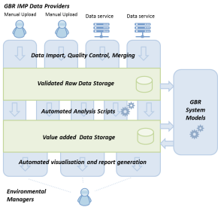

(b)

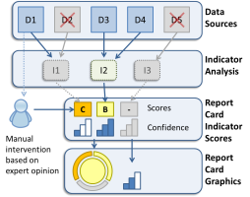

**Figure 29.**  **(a)** Layout of how monitoring data are handled through the Data Integration Management System. **(b)** Layout of how datasets can be handled for the purpose of reporting.

# 7.0 Conclusion and recommendations

The introduction to this report emphasised the facilitation of evidence-based continuous improvement as a central objective. We’ve recommended coherent integration of models and monitoring data to inform adaptive management of the GBR in the context of the LTSP2050. The essential role of monitoring in the context of targets is to test the validity of assertions regarding management effectiveness that are implicitly embedded in policies and procedures. Conceptually, the requirement to undertake rigorous and intensive monitoring is proportional to the extent to which OUV and other values are exposed to risk. A risk-averse or precautionary approach implies low likelihood of a negative impact, and investment in monitoring may be a lesser imperative. Where risks are high, greater insurance against harm can be ‘purchased’ through greater investment in monitoring.

Monitoring programs that clearly differentiate circumstances in which management complies or doesn’t comply with specified goals or targets typically demand intensive sampling (Mapstone 1995). Our guess is that with typical budgets dedicated to monitoring, there will be many instances where uncertainty implies intolerable rates of false failure and false success. This is not a weakness of the approach we advocate. Rather, the inadequacy of resources dedicated to monitoring is made plain to managers and stakeholders. Credibility of the notions of evidence-based continuous improvement and decision-making would be substantially improved if a consequence of candid description of uncertainty in status and trend reporting was a greater allocation of resources to monitoring.

However, our expectation is that it will be cost-prohibitive for managers to allocate sufficient resources to monitoring *all* targets in a way that satisfies demanding Type I and Type II error rates. We suggest an iterative approach to demonstrating progress against targets, whereby targets considered most important by managers and stakeholders are assigned more monitoring resources than targets of lesser importance.

The informed treatment of risk requires,

* probabilistic predictions of performance against LTSP2050 targets obtained through modelling,
* estimation of the precision of a sampling regime,
* characterisation of the consequences of false success, true success, false failure and true failure, and
* estimates of the financial costs of data acquisition.

When considered alongside options for management intervention, these four elements provide the basis for adaptive management and adaptive monitoring. We recommend those responsible for implementation of integrated monitoring under the LTSP2050 embrace urgent development of these four elements as cornerstones of a committed approach to continuous improvement.

# Acknowledgements

We thank Carolyn Cameron and Caroline Brusse from the Great Barrier Reef Taskforce for guidance throughout the project. We also acknowledge the guidance and insight provided by Roger Beeden, Fergus Molly, Margret Gooch, Julia Chandler, Katherine Martin, and Hugh Yorkston at the Great Barrier Reef Marine Park Authority. Thanks to David Williamson for his generosity in sharing data, and to organisations that did likewise, including TropWater at James Cook University and GBRMPA. Development of the content of this report benefited from a one-day meeting of stakeholders, held 19 September in Brisbane. We are grateful to all participants: Nyssa Henry, Claire Andersen, Fergus Molloy , Margaret Gooch, Roger Beeden, David Wachenfeld, Carolyn Cameron, Caroline Brusse , Giles West, Kevin Kane, Paul Doyle, Eva Abal, Nadine Marshall , Michelle Devlin , Len McKenzie and Di Tarte. This report was improved after feedback and contributions from Jamie Oliver, John Gunn, Britta Schaffelke and Julian Caley.

# References

Addison, P. (2010). Quality assurance in marine biological monitoring. A report prepared for the Healthy and Biologically Diverse Seas Evidence Group and the National Marine Biological Analytical Quality Control scheme. Environment Agency and the Joint Nature Conservation Committee.

Addison, P. F. E. (2011). A global review of long-term marine protected area monitoring programmes: The application of a good framework to marine biological monitoring. A report prepared for the Joint Nature Conservation Committee. JNCC Report Number 455. School of Botany, University of Melbourne, Australia.

Addison, P. (2014). Targeting the science–management interface: Improving the use of long-term monitoring in conservation management. PhD dissertation. School of Botany, University of Melbourne, Melbourne, Australia.

Addison, P., Flander, L.B. and Cook, C.N. (2015). Are we missing the boat? Current uses of long-term biological monitoring data in the evaluation and management of marine protected areas. *Journal of Environmental Management,* 149: 148 – 156.

André, J., Gyuris, E. and Lawler, I. R.. (2005). Comparison of the diets of sympatric dugongs and green turtles on the Orman Reefs, Torres Strait, Australia. *Wildlife Research*, 32: 53–62.

Anon (2014). Great Barrier Reef Report Card 2012 and 2013. Reef Water Quality Protection Plan. Australian Government and Queensland Government.

Anthony, K.R.N., Dambacher, J., Walshe, T. and Beeden, R. (2013). A framework for understanding cumulative impacts, supporting environmental decisions and informing resilience-based management of the Great Barrier Reef Heritage Area. Final report for the Great Barrier Reef Marine Park Authority and the Department of the Environment. ISBN: 978-1-022126-06-1

Anthony, K.R.N., Hoogenboom, M.O., Maynard, J.A., Grottoli, A.G. and Middlebrook, R. (2009). Energetics approach to predicting mortality risk from environmental stress: a case study of coral bleaching. *Functional Ecology*, 23: 539-550.

Anthony, K. R. N., Maynard, J. A., Diaz-Pulido, G., Mumby, P. J., Cao, L., Marshall, P. A. and Hoegh-Guldberg, O. (2011). Ocean acidification and warming will lower coral reef resilience. *Global Change Biology*, 17: 1798-1808.

ANZECC/ARCMANZ (2000). *Australian Guidelines for Water Quality Monitoring and Reporting.* Australian and New Zealand Environment and Conservation Council / Agriculture and Resource Management Council of Australia and New Zealand. Canberra: Australian Government Publishing Service.

Aragones, L. and Marsh, H.. (2000). Impact of dugong grazing and turtle cropping on tropical seagrass communities. *Pacific Conservation Biology*, 5: 277–288.

Australian and Queensland governments, undated. Reef 2050 Long-Term Sustainability Plan. For comment. <http://www.environment.gov.au/marine/gbr/reef2050> Accessed 15/09/2014.

Baird, A. H. and Marshall, P.A. (2002). Mortality, growth and reproduction in scleractinian corals following bleaching on the Great Barrier Reef. *Marine Ecology-Progress Series*, 237: 133-141.

Banoo, S., Bell, D., Bossuyt, P., Herring, A., Mabey, D., Poole, F., Smith, P.G., Sriram, N., Wongsrichanalai, C., Linke, R., O'Brien, R., Perkins, M., Cunningham, J., Matsoso, P., Nathanson, C.M., Olliaro, P., Peeling, R.W. and Ramsay, A. (2008). Evaluation of diagnostic tests for infectious diseases: general principles. Nature Reviews Microbiology, 6: S16–S28.

Bar-Hillel, M. (1980). The base-rate fallacy in probability judgments. *Acta Psychologica*, 44: 211 – 233.

Bocking, S. (2004). *Nature’s Experts. Science, Politics and the Environment.* Rutgers University Press, New Brunswick.

Borja, A., Dauer, D.M., Grémare, A. (2012) The importance of setting targets and reference conditions in assessing marine ecosystem quality. *Ecological Indicators,* 12: 1–7.

Borja, A., Ranasinghe, A., Weisberg, S.B. (2009). Assessing ecological integrity in marine waters, using multiple indices and ecosystem components: challenges for the future*. Marine Pollution Bulletin,* 59: 1 - 4.

Brando, V.E., Devlin, M., Dobbie, M., McNeil, A., Schaffelke, B. and and Schroeder, T. (2014). Developing integrated assessment metrics for reporting of water quality in the Great Barrier Reef lagoon. Project RRRD016. CSIRO. Available at http://www.reefrescueresearch.com.au/component/content/article/23-final-reports/188-rrrd016-final-report.html

Brown B.E. and Cossins, A.R. (2011). The potential for temperature acclimatisation of reef corals in the face of climate change. In: Z. Dubinsky and N. Stambler (eds). *Coral reefs: an ecosytem in transition.* Dordrecht Heidelberg London New York: Springer. pp. 421–433.

Carruthers, T. J., Beckert, K., Schupp, C.A., Saxby, T., KumerJ.P., Thomas, J., Sturgis, B., Dennison, W.C., Williams, M. and T. Fisher. T. (2013). Improving management of a mid-Atlantic coastal barrier island through assessment of habitat condition. *Estuarine, Coastal and Shelf Science*, 116: 74-86.

Carter, S. L., Mora-Bourgeois, G., Lookingbill, T.R., Carruthers, T.J. and Dennison, W.C. (2007). The challenge of communicating monitoring results to effect change. The George Wright Forum, pp. 48-58.

Chaloupka, M., Bjorndal, K.A., Balazs, G.H., Bolten, A.B., Ehrhart, L.M., Limpus, C.J.,Suganuma, H., Troeeng, S. and Yamaguchi, M. (2008) Encouraging outlook for recovery of a once severely exploited marine megaherbivore. *Global Ecology and Biogeography*, 17: 297-304.

Chankong, V. and Haimes, Y.Y. (2008). *Multiobjective decision making. Theory and methodology.* Dover, New York.

Cole, A. J., Pratchett, M. S. and Jones, G. P. (2008). Diversity and functional importance of coral-feeding fishes on tropical coral reefs. *Fish and Fisheries*, 9: 1–22.

Collier, C.J., Waycott, M., Ospina A.G. (2012) Responses of four Indo-West Pacific seagrass species to shading. *Marine Pollution Bulletin*, 65: 342–354.

Cooper T.F., Ridd, P., Ulstrup, K.E., Humphrey, C.A., Slivkoff, M.M. and Fabricius, K.E. (2008). Temporal dynamics in coral bioindicators for water quality on coastal coral reefs of the Great Barrier Reef. *Marine and Freshwater Research* 59: 703-716.

De'ath, G. and Fabricius, K.E. (2008). Water quality of the Great Barrier Reef: distributions, effects on reef biota and trigger values for the protection of ecosystem health, Great Barrier Reef Marine Park Authority, Townsville.

Deloitte Access Economics (2013). Economic contribution of the Great Barrier Reef. Great Barrier Reef Marine Park Authority, Townsville.

Devlin, M. J., McKinna, L. W., Alvarez-Romero, J. G., Petus, C., Abott, B., Harkness, P. and Brodie, J. (2012). Mapping the pollutants in surface riverine flood plume waters in the Great Barrier Reef, Australia. *Marine Pollution Bulletin*, 65: 224-235.

Dietz, T. (1987). Theory and method in Social Impact Assessment. *Sociological Inquiry,* 57: 54 - 69.

Dinsdale, E., Pantos, O., Smriga, S., Edwards, R.A., Angly, F., Wegley, L., Hatay, M., Hall, D., Brown, E., Haynes, M., Krause, L., Sala, E., Sandin, S.A., Thurber, R.V., Willis, B.L., Azam, F., Knowlton, N. and Rohwer, F. (2008). Microbial ecology of four coral atolls in the Northern Line Islands. *PLoS ONE* 3: e1584.

Durbach, I.N. and Stewart, T.J. (2009). Using expected values to simplify decision making under uncertainty. *Omega*, 37: 312 – 330.

Ecosystem Health Monitoring Program. (2012). Report card 2012 for the waterways and catchments of south-east Queensland. South East Queensland Healthy Waterways Partnership, Brisbane, Queensland.

Eddy, D.M. (1982). Probabilistic reasoning in clinical medicine: Problems and opportunities. In D. Kahneman, P. Slovic and A. Tversky (Eds.) *Judgment under uncertainty: Heuristics and biases* (pp. 249–267). New York: Cambridge University Press.

Engelen, G., Uljee, I. and White, R. (1997). Vulnerability assessment of low-lying coastal areas and small islands to climate change and sea level rise; Phase 2: Case study St. Lucia. Report & SIMLUCIA User Manual. Report to UNEP CAR/RCU, United Nations Environment Programme, Caribbean Regional Coordinating Unit, Kingston, Jamaica. Research Institute for Knowledge Systems: Masstricht. 90pp.

Epstein, J.M. (1999). Agent-based computational models and generative social science. *Complexity,* 4: 41-57.

Estevez, R.A., Walshe, T. and Burgman, M.A. (2013). Capturing social impacts for decision-making: a Multicriteria Decision Analysis perspective. *Diversity and Distributions*, 19: 608 – 616.

Evans, T. G. and Hofmann, G. E. (2012). Defining the limits of physiological plasticity: how gene expression can assess and predict the consequences of ocean change. *Philosophical Transactions of the Royal Society B-Biological Sciences* 367: 1733–1745.

Fabricius, K.E., Okaji, K. and G. De’ath, G. (2010). Three lines of evidence to link outbreaks of the crown-of-thorns seastar *Acanthaster planci* to the release of larval food limitation. *Coral Reefs*, 29: 593–605.

Failing, L., Gregory, R. and Harstone, M. (2007). Integrating science and local knowledge in environmental risk management: a decision-focused approach. *Ecological Economics,* 64: 47 - 60.

Fairweather, P.G. (1991). Statistical power and design requirements for environmental monitoring. *Australian Journal of Marine Freshwater Research*, 42: 555-567.

Field, S.A., Tyre, A.J., Jonzén, N., Rhodes, J.R., and Possingham, H.P. (2004). Minimizing the costs of environmental management decisions by optimizing statistical thresholds. *Ecology Letters*, 7: 669-675.

Field, S.A., Tyre, A.J. and Possingham, H.P. (2005). Optimizing allocation of monitoring effort under economic and observational constraints. *Journal of Wildlife Management*, 69: 473–482.

Fox, D.R. (2013). Statistical issues associated with development of an ecosystem report card. Environmetrics Australia. Available at http://www.healthyharbour.org.au.preview.cp-server.com/wp-content/uploads/2014/03/Statistical-Considerations-associated-with-the-development-of-an-ecosystem-report-card.pdf

Gallen, C., Devlin, M., Paxman, C., Banks, A. and Mueller, J. (2013). Pesticide monitoring in inshore waters of the Great Barrier Reef using both time-integrated and event monitoring techniques (2012-2013) . University of Queensland. Available at http://elibrary.gbrmpa.gov.au/jspui/handle/11017/2878

GBRMPA. (2010). Water Quality Guidelines for the Great Barrier Reef Marine Park. Revised Edition 2010. Great Barrier Reef Marine Park Authority, Townsville. 100 pp.

GBRMPA. (2011). Extreme weather on the Great Barrier Reef. Great Barrier Reef Marine Park Authority, Townsville.

GBRMPA. (2013). Great Barrier Reef Region Strategic Assessment: Strategic Assessment Report: Draft for public comment. ISBN: 978-922126-24-5. Great Barrier Reef Marine Park Authority, Townsville.

GBRMPA. (2014). Great Barrier Reef Outlook Report 2014. Great Barrier Reef Marine Park Authority, Townsville.

Gelman, A., Carlin, J., Stern, H., and Rubin, D. (2004). *Bayesian data analysis.* Chapman and Hall, New York, 2nd edition.

Gerber, L.R., Beger, M., McCarthy M.A. and Possingham, H.P. (2005). A theory for optimal monitoring of marine reserves. *Ecology Letters*, 8: 829–837

Gittings, S. R., Tartt, M. and Broughton. K. (2013). National Marine Sanctuary system condition report 2013. U.S. Department of Commerce, National Oceanic and Atmospheric Administration, Office of National Marine Sanctuaries, Silver Spring, MD.

Grech, A., and Marsh, H. (2007) Prioritising areas for dugong conservation in a marine protected area using a spatially explicit population model. *Applied GIS*, 3: 1-14.

Gregory, R., Failing, L., Harstone, M., Long, G., McDaniels, T. and Ohlson, D. (2012). *Structured decision making. A practical guide to environmental management choices.* Wiley-Blackwell, Chichester.

Gregory, R. and Keeney, R.L. (1994). Creating policy alternatives using stakeholder values. *Management Science*, 40: 1035-1048.

Hammond, J. S.Keeney, R.L. and Raiffa, H. (2006). The hidden traps in decision-making. *Harvard Business Review,* 118: 120-126.

Harrington, L., K. E. Fabricius, De'ath, G. and Negr, A. (2004). Recognition and selection of settlement substrata determine post-settlement survival in corals. *Ecology,* 85: 3428–3437.

Healthy Reefs Initiative. (2012). Report card for the Mesoamerican reef. An evaluation of ecosystem health 2012. Healthy Reefs for Healthy People.

Hedge, P., Molloy, F., Sweatman, H., Hayes, K., Dambacher, J. Chandler, J., Gooch, M., Chinn, A., Bax, N. and Walshe, T.. (2013) An integrated monitoring framework for the Great Barrier Reef World Heritage Area. Report prepared for the Department of the Environment, Commonwealth Government of Australia.

Hori, M., Suzuki, T., Monthum, Y., Srisombat, T., Tanaka, Y., Nakaoka, M. and Mukai, H. (2009). High seagrass diversity and canopy-height increase associated fish diversity and abundance. *Marine Biology*, 156: 1447-1458.

Hughes, T. P. (1984). Population-dynamics based on individual size rather than age - a general-model with a reef coral example. *American Naturalist,* 123: 778-795.

Hughes, T. P., Rodrigues, M.J., Bellwood, D.R., Ceccarelli, D., Hoegh-Guldberg, O., McCook, L., Moltschaniwskyj, N., Pratchett, M.S., Steneck, R.S. and Willis, B. (2007). Phase shifts, herbivory, and the resilience of coral reefs to climate change. *Current Biology,* **17**: 360-365.

Jago-on, K.A.B., Kaneko, S., Fujikura, R., Fujiwara, A., Imai, T., Matsumoto, T., Zhang, J., Tanikawa, H., Tanaka, K., Lee, B. and Taniguchi, M.(2009). Urbanization and subsurface environmental issues: An attempt at DPSIR model application in Asian cities. *Science of the Total Environment*, 407: 3089-3104.

Jones, G. P., McCormick, M. I., Srinivasan, M. and Eagle, J. V. (2004). Coral decline threatens fish biodiversity in marine reserves. *PNAS,* 101: 8251-8253.

Keeney, R. L. and Raiffa, H. (1976). *Decisions with multiple objectives: Preferences and value tradeoffs.* New York: Wiley.

Keith, D.A., Martin T.G., McDonald-Madden, E., Walters, C. (2011). Uncertainty and adaptive management for biodiversity conservation. *Biological Conservation,* 144: 1175–1178.

Lawler, I. R., Parra, G. and Noad, M. (2007). Vulnerability of marine mammals in the Great Barrier Reef to climate change (Chapter 16, Part II: Species and species groups). In J. Johnson and P. Marshall, (eds). *Climate Change and the Great Barrier Reef: A Vulnerability Assessment.* GBRMPA, Townsville.

Li, J. and Australia, G. (2008). A review of spatial interpolation methods for environmental scientists, Volume 137. Geoscience Australia Canberra.

Lindenmayer, D. B., and Likens, G.E. (2009). Adaptive monitoring: A new paradigm for long-term research and monitoring. *Trends in Ecology and Evolution,* 24: 482–486.

Lookingbill, T. R., Schmit, J.P. Tessel, S. M., Suarez-Rubio, M. and Hilderbrand, R.H. (2014). Assessing national park resource condition along an urban–rural gradient in and around Washington, DC, USA. *Ecological Indicators,* 42: 147-159.

Ludwig, D., Hilborn, R., and Walters, C. (1993). Uncertainty, resource exploitation, and conservation: Lessons from history. *Science*, 260:17-36.

Magurran, A. E., Baillie, S. R., Buckland, S. T., Dick, J. M. , Elston, D. A., Scott, E. M., Smith, R. I., Somerfield, P. J. and Watt, A. D. (2010). Long-term datasets in biodiversity research and monitoring: Assessing change in ecological communities through time. *Trends in Ecology and Evolution,* 25: 574–582.

Manly, B.F.J. (1997). *Randomization, Bootstrap and Monte Carlo Methods in Biology*. 2nd Ed. Chapman and Hall, London.

Mapstone, B.D. (1995). Scaleable decision rules for environmental impact studies: Effect size, Type I and Type II errors. *Ecological Applications*, 5: 401-410.

Marsh, H., De’Ath, G., Gribble, N. and Lane, B. (2005). Historical marine population estimates: triggers or targets for conservation? The dugong case study. *Ecological Applications*, 15: 481 – 492.

Marshall, P. and Schuttenberg, H. (2006). A reef manager's guide to coral bleaching. Townsville, Great Barrier Reef Marine Park Authority.

Maxwell, S.L., Rhodes, J.R., Runge, M.C., Possingham, H.P., Fei Ng, C. and McDonald-Madden, E. (2014). How much is new information worth? Evaluating the financial benefit of resolving management uncertainty. *Journal of Applied Ecology*, DOI: 10.1111/1365-2664.12373.

Maynard, J. A., Anthony, K. R. N., Afatta, S. and Hoegh-Guldberg, O. (2010). Making a model meaningful to coral reef managers in a developing nation: a case study of overfishing and rock anchoring in Indonesia. *Conservation Biology,* 24: 1316-1326.

McClanahan, T.R., Donner, S.D., Maynard, J.A., Macneil, M.A., Graham, N.A., Maina, J., Baker, A.C., Alemu, J.B.I., Beger, M., Campbell, S.J., Darling, E.S., Eakin, C.M., Heron, S.F., Jupiter, S.D., Lundquist, C.J., McLeod, E., Mumby, P.J., Paddack, M.J., Selig, E.R. and van Woesik, R. (2012). Prioritizing key resilience indicators to support coral reef management in a changing climate. *PLoS ONE,* 7: doi:10.1371/journal.pone.0042884.

McDole T., Nulton J., Barott K.L., Felts B., Hand C., Hatay, M., Lee, H., Nadon, M.O., Nosrat, B., Salamon, P., Bailey, B., Sandin, S.A., Vargas-Angel, B., Youle, M., Zgliczynski, B.J., Brainard, R.E. and Rohwer, F. (2012). Assessing coral reefs on a pacific-wide scale using the microbialization score. *PLoS ONE* 7(9): e43233. doi:10.1371/journal.pone.0043233

McKenzie, L.J., Collier, C. and Waycott, M. (2014). Reef Rescue Marine Monitoring Program - Inshore Seagrass, Annual Report for the sampling period 1st July 2011 – 31st May 2012. TropWATER, James Cook University, Cairns. 176pp.

Meynecke, J., Lee, S., Duke, N. and Warnken, J.. (2007). Relationships between estuarine habitats and coastal fisheries in Queensland, Australia. *Bulletin of Marine Science*, 80: 773-793.

Montgomery, D. C. (2009). *Introduction to statistical quality control.* John Wiley & Sons, New York.

Morgan, M.G. and Henrion, M. (1990). *Uncertainty. A Guide to Dealing with Uncertainty in Quantitative Risk and Policy Analysis.* Cambridge University Press, Cambridge.

Morrison, L. (2008). The use of control charts to interpret environmental monitoring data. *Natural Areas Journal*, 28: 66–73.

Mumby, P.J., Hastings, A. and Edwards, H.J. (2007) Thresholds and the resilience of Caribbean coral reefs. *Nature*, 450: 98-101.

Nichols, J.D. and Williams B.K. (2006). Monitoring for conservation. *Trends in Ecology and Evolution,* 21: 668-673.

NQBP (2013). Port of Hay Point fact Sheet. <http://www.nqbp.com.au/port-of-hay-point-fact-sheet/> North Queensland Bulk Ports Corporation.

Parent, E. and Rivot, E. (2013). Introduction to Hierarchical Bayesian Modeling for Ecological Data. CRC Press, Boca Raton.

Patil, A. P., Gething, P. W., Piel, F. B., and Hay, S. I. (2011). Bayesian geostatistics in health cartography: the perspective of malaria. *Trends in Parasitology*, 27: 246–253.

Philip, M.S. (1994). *Measuring Trees and Forests*. 2nd Ed. CABI Publishing, Wallingford.

Pratchett, M. S., Wilson, S. K., Berumen, M. L. and McCormick, M. I. (2004). Sublethal effects of coral bleaching on an obligate coral feeding butterflyfish. *Coral Reefs*, 23: 352-356.

Preen, A. R. and Marsh, H. (1995). Response of dugongs to large-scale loss of seagrass from Hervey Bay, Queensland, Australia. *Wildlife Research*, 22: 507-519.

Rasmussen, C.E. and Williams, C.K.I. (2005). *Gaussian Processes for Machine Learning.* Adaptive Computation and Machine Learning series. The MIT Press.

Sanchirico, J. N., Springborn, M. R., Schwartz, M. W. and Doerr, A. N. (2013). Investment and the policy process in conservation monitoring. *Conservation Biology***,** 28:361–371.

Sandin, S.A., Smith, J.E., DeMartini, E.E., Dinsdale, E.A., Donner, S.D., Friedlander, A.M., Konotchick, T., Malay, M., Maragos, J.E., Obura, D., Pantos, O., Paulay, G., Richie, M., Rohwer, F., Schroeder, R.E., Walsh, S., Jackson, J.B.C., Knowlton, N. and Sala, E. (2008). Baselines and degradation of coral reefs in the Northern Line Islands. *PLoS ONE* 3: e1548.

Sergeant, C. J., Moynahan, B. J. and Johnson, W. F. (2012). Practical advice for implementing long-term ecosystem monitoring. *Journal of Applied Ecology*, 49: 969–973.

Sheppard, J. K., Lawler, I. R. and Marsh, H. (2007). Seagrass as pasture for seacows: Landscape-level dugong habitat evaluation*. Estuarine, Coastal and Shelf Science*, 71: 117-132.

Sheppard, J. K., Preen, A. R., Marsh, H., Lawler, I. R., Whiting, S. D. and Jones, R. E. (2006). Movement heterogeneity of dugongs, *Dugong dugon* (Muller), over large spatial scales. *Journal of Experimental Marine Biology and Ecology*, 334: 64-83.

Sokal, R.R. and Rohlf, F.J. (1995). *Biometry*. 3rd Ed. Freeman, San Francisco.

Tetlock, P.E. (2000). Coping with trade-offs: Psychological constraints and political implications. In A. Lupia, M.D. McCubbins, and S.L. Popkin (eds.), *Elements of reason. Cognition, choice and the bounds of rationality.* Cambridge: Cambridge University Press.

Thomas, L. and Krebs, C.J. (1997). A review of statistical power analysis software. *Bulletin of the Ecological Society of America,* 78:126-139.

Thompson, A., Schaffelke, B., Logan, M., Costello, P., Davidson, J., Doyle, J., Furnas, M., Gunn, K., Liddy, M., Skuza, M., Uthicke, S., Wright, M. and Zagorskis, I. (2013) Reef Rescue Marine Monitoring Program. Annual Report of AIMS Activities 2012 to 2013– Inshore water quality and coral reef monitoring. Report for the Great Barrier Reef Marine Park Authority. Australian Institute of Marine Science, Townsville. 182 pp. Available at http://elibrary.gbrmpa.gov.au/jspui/handle/11017/2877

Thompson, A., Schroeder, T., Brando. V. and Schaffelke, B. (2014). Coral community responses to declining water quality: Whitsunday Islands, Great Barrier Reef, Australia. *Coral Reefs*, 33: 923-938.

Thorburn P.J., Wilkinson, S.N. and Silburn D.M. (2013). Water quality in agricultural lands draining to the Great Barrier Reef: A review of causes, management and priorities. *Agriculture, Ecosystems and Environment*, 180: 4-20.

Tversky, A. and Kahneman, D. (1971). Belief in the law of small numbers. *Psychological Bulletin* 76: 105-110.

von Winterfeldt, D. and Edwards, W. (1986). *Decision analysis and behavioural research.* Cambridge University Press, Cambridge.

von Winterfeldt, D., Kavet, R., Peck, S., Mohan, M. and Hazen, G. (2012). The value of environmental information without control of subsequent decisions. *Risk Analysis,* 12: 2113 – 2132.

Walters, C. J., and Hilborn, R. (1978). Ecological optimization and adaptive management. *Annual Review of Ecology and Systematics*, 9: 157–188.

Williams, B. K. (2011). Passive and active adaptive management: Approaches and an example. *Journal of Environmental Management,* 92: 1371–1378.

Zar, J.H. (2010). *Biostatistical analysis.* Pearson Prentice Hall, Upper Saddle River, New Jersey.

# Appendix – Monitoring programs in the Mackay-Whitsunday case study area

| Program | Responsible organization | Objective | Variables measured | Sites in study area | Information |
| --- | --- | --- | --- | --- | --- |
| AIMS LTMP | AIMS | Monitor the status and trends in condition of coral reefs of the GBR | 1. Manta tow surveys for crown-of-thorns starfish (COTS), reef-wide coral cover, number of coral trout, number of sharks (broadscale surveys)  2. (In standard habitat) surveys of sessile benthic organisms (~70 categories) using still images; visual counts of reef fishes (7 families) & length estimates of all serranids, lutjanids and lethrinids.  3. Counts of juvenile corals  4. Agents of coral mortality (disease, *Drupella*, CoTS) | 9 reefs | http://www.aims.gov.au/docs/research/monitoring/reef/reef-monitoring.html |
| RRMMP - Seagrass | JCU-Tropwater | To detect change in inshore seagrass meadows in response to improvements in water quality associated with improving land use practices in coastal catchments and with disturbance events. | • seagrass % cover & species composition  • seed banks  • epiphytes & macro-algae  • meadow edge mapping (late dry Season, late monsoon Season)  • reproductive health  • seagrass tissue elements (C:N:P) (late dry Season)  • rhizosphere sediment herbicide concentration  • in-situ within canopy temperature  • in-situ canopy light | Pioneer Bay, Hamilton Is, Sarina Inlet | http://www.gbrmpa.gov.au/managing-the-reef/how-the-reefs-managed/reef-2050-marine-monitoring-program/seagrass-monitoring |
| RRMMP – Coral reefs | AIMS | To detect change in inshore coral reef communities in response to improvements in water quality  associated with improving land use practices in coastal catchments and with disturbance events | benthic cover (algae, hard and soft corals),  • taxonomic composition (mainly to species)  • coral demographics (the size classes of corals),  • coral settlement rates on terracotta tiles  Note reefs surveys match spatially with other aspects of the RRMMP notably water quality sampling | Sites at Daydream Is, Double Cone Is and Pine Is | <http://www.gbrmpa.gov.au/managing-the-reef/how-the-reefs-managed/reef-2050-marine-monitoring-program/inshore-coral-reef-monitoring> |
| RRMMP – inshore water quality – Ambient Pesticide Sampling | Entox, UQ | To determine time integrated baseline concentrations of specific organic chemicals in water, with the aim to evaluate long term trends in pesticide concentrations in response to improvements in water quality associated with improving land use practices in coastal catchments. | An index of overall PSII inhibition & spectrum of herbicides based on samples from:  • Empore Disk (ED) samplers deployed at all 15 sample sites during the wet and the dry seasons.  • Polydimethylsiloxane (PDMS) samplers deployed at 9 sites in the wet season & at 3 of those  sites in dry season.  • Semi-permeable membrane devices (SPMD) deployed at 3 of the sites (wet & dry season). | Hamilton Is, Daydream Is, Pioneer Bay, Pioneer River, Sarina Inlet | http://e-atlas.org.au/rrmmp/gbr-entox-uq-inshore-pesticide-monitoring |
| RRMMP – inshore water quality – Ambient water quality Sampling | AIMS | To determine the status of marine water quality in coastal and inshore regions of the GBR lagoon and assess long-term trends in water quality on the Great Barrier Reef. | • ammonium= NH4  • nitrite= NO2  • nitrate= NO3  • phosphate /filterable reactive phosphorus=PO4  • silicate/filterable reactive silicon= Si(OH)4  • dissolved organic nitrogen=DON  • dissolved organic phosphorus= DOP  • dissolved organic carbon= DOC  • particulate organic nitrogen= PN  • particulate phosphorus = PP  • particulate organic carbon= PO  • suspended solids (SS)  • chlorophyll a  In situ loggers record chlorophyll fluorescence, turbidity and temperature. | Sites at Daydream Is, Double Cone Is and Pine Is | <http://www.gbrmpa.gov.au/managing-the-reef/how-the-reefs-managed/reef-2050-marine-monitoring-program/water-quality-monitoring> |
| RRMMP – Inshore  Water Quality Monitoring – Flood Sampling | JCU-Tropwater | To better understand how extreme weather events affect water quality conditions in the GBR. | Opportunistic | Opportunistic | http://e-atlas.org.au/rrmmp/gbr-actrf-jcu-terrestrial-run-off |
| RRMMP –using  Remote Sensing for GBR wide water quality | CSIRO L&W | To develop and apply techniques for large-scale monitoring of coastal water quality; to estimate the  extent of flood plumes | MODIS Aqua ocean colour imagery used to derive spatial and temporal information on near-surface concentrations of suspended solids (as non-algal particulate matter), turbidity (as vertical attenuation of light coefficients Kd), chlorophyll a, and coloured dissolved organic matter (CDOM) | Continuous GBR-wide | http://e-atlas.org.au/rrmmp/gbr-csiro-remote-sensing-wq |
| Flood-plume monitoring | JCU-Tropwater |  |  |  |  |
| Integrated Eye on the Reef (iEotR) –Sightings network | GBRMPA | To build knowledge about species diversity, abundance, habitat and range. | Reef visitors are encouraged to record sightings and submit photos of interesting animals (whales,  COTS, etc.) | Many opportunistic | <http://www.gbrmpa.gov.au/managing-the-reef/how-the-reefs-managed/eye-on-the-reef/report-sightings> |
| iEotR – Rapid surveys | GBRMPA | To allow collection of information on protected and iconic species distribution, after Reef health incidents, or to give early warning of Reef health impacts under GBRMPA's Reef Health Incident Response System.  To promote stewardship: using simple science to introduce reef users to the main threats that are affecting the Great Barrier Reef. | Records the presence or absence of:  • Macroalgae (5 growth forms)  • Corals (7 growth forms + soft coral)  • Coral bleaching (coral type affected)  • Occurrence of coral disease (3 + other); coral predation (COTS*, Drupella* by coral type); recent coral damage  • Garbage | Several opportunistic | <http://www.gbrmpa.gov.au/managing-the-reef/how-the-reefs-managed/eye-on-the-reef/the-rapid-monitoring-survey> |
| iEotR – Tourism weekly monitoring surveys |  | To provide status information and early warning on water quality, the presence of protected  and iconic species, and the health of the Reef.  • To provide vital reef health trend information to inform the Early Warning System and Incident  Response components of GBRMPA's Reef Health Incident Response System, as well as triggers  for management actions. | Water temp; Secchi depth; macroalgae (5 types); herbivorous fishes ( Scarids / Acanthurids; number & average size); corals (soft + 7 life forms); coral bleaching; bleached clams; COTS; *Drupella*; coral disease (3 types); coral spawning; fish spawning; turtles (3 spp); sea-snakes; iconic bony fishes (12 categories); sharks & rays (5 categories); invertebrates(cuttlefish, sea cucumbers, triton shell); jellyfish (irukanji, boxjelly, *Physalia*); *Trichodesmuim*; based on 30 min swim | Several tourism sites in the Whitsundays | <http://www.gbrmpa.gov.au/managing-the-reef/how-the-reefs-managed/eye-on-the-reef/tourism-weekly-monitoring-surveys> |
| iEotR - Reef Health & Impact Survey | GBRMPA - QPWS | Reef Health and Impact Survey (RHIS) is a quick and efficient way to provide a snapshot of reef  health at any time on any reef | * Macroalgal cover (5 growth forms)   • Coral cover (7 growth forms + soft coral)  • Coral bleaching (coral type affected)  • Incidence of coral disease (3 + other); coral predation (COTS*, Drupella* by coral type); recent coral damage.  • Presence of garbage | Many sites visited opportunistically | <http://www.gbrmpa.gov.au/managing-the-reef/how-the-reefs-managed/eye-on-the-reef/reef-health-and-impact-survey> |
| iEotR – “Eyes & ears” incident reporting |  |  |  |  |  |
| Effects of rezoning on offshore coral reef systems | AIMS | To track management effectiveness in the development of effects of rezoning the GBRMP in 2004 on offshore reefs | As AIMS LTMP above | 6 reefs (out of 56 GBR-wide) in study area | <http://www.nerptropical.edu.au/sites/default/files/publications/files/8.1%20NERP%20Factsheet.pdf> |
| Assessing the effects of management zoning on inshore reefs of the Great Barrier Reef Marine Park | JCU | To track management effectiveness in the development of effects of rezoning the GBRMP in 2004 on inshore reefs | Underwater visual census - Although 150 species of reef fish are surveyed, the analysis has focused on coral trout (*Plectropomus* spp.), fishes that are coral trout prey, and fishes of particular interest such as stripey sea perch (*Lutjanus carponotatus*). The biological characteristics of the coral reef communities and incidence of coral disease are also recorded. | 12 sites in No-take areas and 12 sites open to fishing in the Whitsundays (Hook Whitsunday & Border Islands) | http://www.nerptropical.edu.au/sites/default/files/publications/files/8.2%20NERP%20Factsheet_0.pdf |
| Compliance – Port of Mackay | NQBP | To assess the overall state of the port environment or to detect any changes occurring | Coral [near dredge spoil disposal]  Benthic macro-invertebrates  Algae  Turtles  Marine mammals  Fisheries  Marine water quality  Marine sediment quality  Noise & vibration | Sites around the Port |  |
| Compliance – Port of Abbott Point | NQBP | To assess the overall state of the port environment or to  detect any changes occurring | Seagrass communities  Coral communities  Benthic macro-invertebrates  Algae  Turtles  Marine mammals  Fisheries  Marine water quality  Marine sediment quality  Noise & vibration  Migratory birds & waterbirds | Sites around the Port | <http://www.nqbp.com.au/abbot-point/> (with links to Abbott Point cumulative impact assessment reports) |
| Compliance – Port of Hay Point | NQBP | To assess the overall state of the port environment or to  detect any changes occurring | Seagrass communities  Coral communities  Benthic macro-invertebrates  Algae  Turtles  Marine mammals  Fisheries  Marine water quality  Marine sediment quality  Noise & vibration | Sites around the Port |  |
| Port of Mackay & Hay Point Ambient Marine Water Quality Monitoring Program | NQBP | Monitor ambient marine water quality in regional area surrounding port. Offer reference to impact monitoring programs and provide environmental indicator for ongoing port operations | pH, DO, Salinity, Turbidity, Temperature, ORP, PAR, Dissolved Metals, TSS, Nutrients, Chlorophyll-a, Pesticides (select locations) and sedimentation (selected locations) + MODIS satellite imagery and Terravision surface turbidity modelling (periodically) | Freshwater Point to the south of Hay Point to Slade Point to the North of Mackay extending seaward approximately 3 nautical miles  11 monitoring locations  11 WQ loggers  1 current meter |  |
| Port of Abbot Point Ambient Marine Water Quality Monitoring Program | NQBP | Monitor ambient marine water quality in regional area surrounding port. Offer reference to impact monitoring programs and provide environmental indicator for ongoing port operations | pH, DO, Salinity, Turbidity, Temperature, ORP, PAR, Dissolved Metals, TSS, Nutrients, Chlorophyll-a, Pesticides (select locations) | 12 monitoring locations  5 WQ loggers  + current meters |  |
| Seagrasswatch | JCU - TropWater | To educate the wider community on the importance of seagrass resources.  - To raise awareness of coastal management issues.  - To build the capacity of local stakeholders in the use of standardised scientific methodologies.  - To conduct long-term monitoring of seagrass & coastal habitat condition.  - To provide an early warning system of coastal environment changes for management.  - To support conservation measures which ensure the long-term resilience of seagrass  ecosystems | Extent of coverage, species composition, estimates of abundance, presence of epiphytes and macroalgae,  presence of dugong feeding trails. | St Helen’s Beach, Seaforth, Sarina Inlet | http://seagrasswatch.org/home.html |
| Coral reef health monitoring | Reefcheck Australia | To protect and help to rehabilitate Australia's valuable coral reefs through:  1) community education, to raise awareness of the key issues  2) scientific research, to collect data that contributes to solutions. | Coral cover, algae, target organisms | Hardy Reef, Daydream Is, Hook Is, Knuckle Reef | [http://www.reefcheckaustralia.org/#](http://www.reefcheckaustralia.org/) |
| Dugong population surveys | JCU | Spatial distribution (relative abundance), status & trends in dugong populations on East Coast of Qld | Dugong abundance (and turtles) by stratified aerial surveys | General aerial surveys (Torres Strait to NSW border) |  |
| Qld shark control program | QDAFF | To reduce populations of large sharks to minimise the threat of shark attack on humans in particular  locations | Records of sharks caught (and bycatch) | In Mackay region, at Blacks Beach, Bucasia Beach, Eimeo Beach, Harbour Beach, Lamberts Beach | <https://www.daff.qld.gov.au/fisheries/services/shark-control-program> |
| Qld strandings network | QEHP | record information on where sick, injured, dying and dead marine animals have been found in Queensland and assess causes of injury and death where possible. | Animals that are stranded on Qld shores are recorded and examined and sometimes autopsied | Ad hoc state-wide | <http://www.ehp.qld.gov.au/wildlife/caring-for-wildlife/strandnet-reports.html#dugong> |
| Coral Reef Watch | NOAA (USA) | To identify onset of conditions for coral bleaching | Sea surface temperature from remote sensing | General (Remote sensing) | http://coralreefwatch.noaa.gov/satellite/product_overview.html |
| ReefTemp | GBRMPA, CSIRO-CMAR, BoM | Map bleaching risk on the GBR using AVHRR | Sea surface temperature from remote sensing | General (Remote sensing) | <http://www.cmar.csiro.au/remotesensing/reeftemp/web/ReefTemp.htm> |
| Sea temperature monitoring | AIMS / GBRMPA | Continuous measurement of sea temperature over a wide area of the GBR as a physical covariate for biological changes, and ground truth for remote sensing | Data loggers instantaneously record sea temperatures every 30 minutes and are exchanged and downloaded approximately every 12 months | 18 reefs in the study area | http://www.aims.gov.au/docs/research/climate-change/climate-monitoring/sst.html |
| AIMS weather stations | AIMS | To provide near real time weather data for sites across the GBR  Ground truth for remotely sensed sea temperatures, and other variables | Air pressure, air temperature, humidity, light, wind direction, wind speed, rain, sea temperature at one or more depths, updates every 10-30 min. | Hardy Reef | http://data.aims.gov.au/aimsrtds/latestreadings.xhtml |
| Wave height monitoring | QDEHP | Wave information is used in the design and construction of coastal structures and in investigations of natural coastal processes including accretion and erosion. | Wave height, wave direction and sea surface temperature | Abbot Pt, Hay Pt, Mackay | <http://www.ehp.qld.gov.au/coastal/monitoring/waves/index.php> |
| Storm-tide monitoring | QDEHP | To monitor coastal flooding from the sea, usually because of storm surge during tropical cyclones | Tide height | Bowen, Shute Harbour, Laguna Quays, Mackay, Dalrymple Bay | <http://www.qld.gov.au/environment/coasts-waterways/beach/storm/> |
| Qld Turtle Conservation Project | QDEHP | Monitor populations of turtles on East Coast of Queensland:  a) assess breeding on nesting beaches,  b) survey feeding areas (and assess condition of individuals) | Recording, measuring and tagging nesting populations of marine turtles at index beaches within each genetic stock for each species in Queensland  Recording population size, condition, reproductive condition and breeding history of individuals at marine turtle feeding grounds along the Queensland coast | Long-term study sites in Edgecumbe Bay |  |
| Seabird monitoring | GBRMPA / QPWS FMT | To track population sizes of shorebird and seabird species  based on breeding effort & breeding success | Seabird and shore bird abundance and breeding |  | http://www.gbrmpa.gov.au/__data/assets/pdf_file/0003/4818/gbrmpa_coastalbirdmonitoringstrat  egy.pdf |