How do I archive my import inspection requests and bookings?

This task card demonstrates how to archive and restore import inspection request and bookings in the Biosecurity Portal using your Digital ID via the myID pathway, and also via the Other User email and password pathway.

*NOTE: Refer to “How do I login to the Biosecurity Portal?” on how to register and login to the Portal.*

*NOTE: The Portal works best with the latest version of Google Chrome, Safari and Microsoft Edge. Internet Explorer and Mozilla Firefox are not supported.*

*You must allow pop-ups on your browser before proceeding.*

Archiving import inspection requests and bookings

Archive an Entry ID

**Browse** to the Biosecurity Portal landing page – https://biosecurity.awe.gov.au/

**Login** using your Digital ID or email and password. If you have not registered, refer to “How do I register to use the Biosecurity Portal?” task card.

You can archive an inspection request or booking to remove them from your transactional views. To archive a record:

* **Browse** to the Inspections page
* **Find** your Entry ID in the corresponding view ie: Inspection requests, Upcoming bookings or Historical bookings

TIP: In the Inspection Requests, Upcoming Bookings and Historical Bookings views you can:

* *Filter by any column (in-column filtering function)*
* *Sort by any column*
* *Search by Entry ID on the Inspection requests view and*
* *Search by Entry ID or Booking ID in the Upcoming bookings view and Historical bookings view.*
* **Select** the arrow down button to the right of the list under ‘Actions’ and **click** Archive.
* The selected record will be moved to the Archived View: Archives inspection requests or bookings.

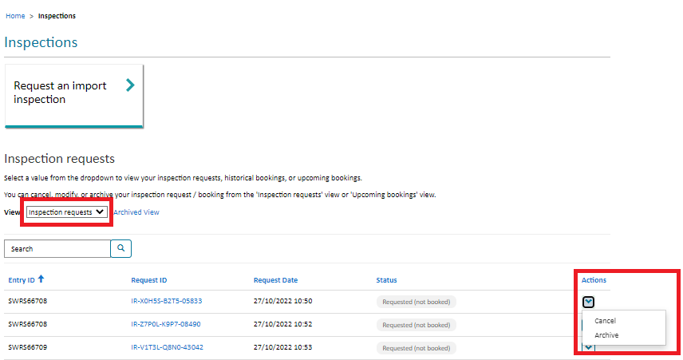

Figure 1: Entry ID selection for archiving

Reinstate an Archived Record

* **Browse** to the Inspections page
* **Select** the Archived View
* **Find** your record in the corresponding view ie: Archived inspection requests or Archived bookings.
* **Select** the down arrow to the right of the list under “Actions” and **click** Restore
* The selected record will be moved back to the corresponding active view based on the status of the item when re-instated.

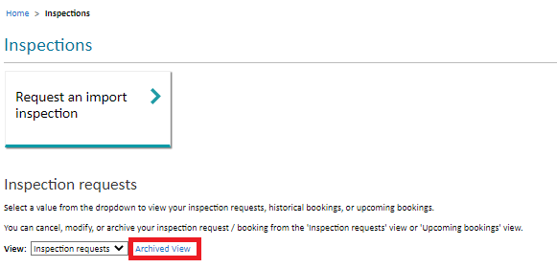

Figure 2: Archived View

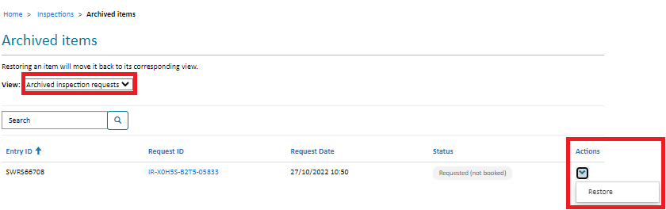

Figure 3: Restore an Archived Item