How do I lodge an import inspection request via the email and password method?

This task card demonstrates how to lodge an inspection request using the Biosecurity Portal Other User.

*NOTE: Refer to “How do I login to the Biosecurity Portal?” on how to register and login to the Portal.*

*NOTE: The Portal works best with the latest version of Google Chrome, Safari and Microsoft Edge. Internet Explorer and Mozilla Firefox are not supported.*

*Ensure pop-ups and cookies are enabled before proceeding.*

Lodging an inspection request

Selecting your Entry ID and Direction

**Browse** to [biosecurity.awe.gov.au](https://biosecurity.awe.gov.au/)

**Login** to the Portal and **select** “Inspection requests” and then “Request an import inspection”.

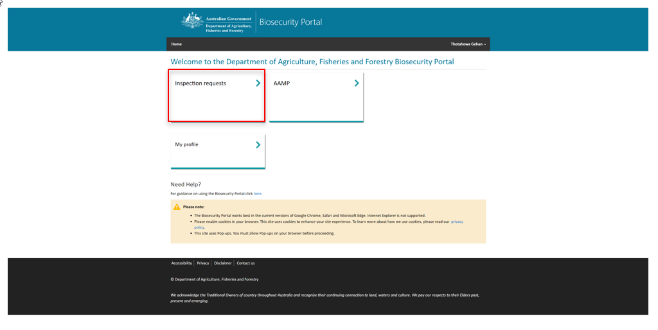

Figure 1: Link to Inspection services

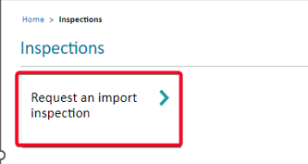

Figure 2: Link to request an import inspection

**Enter** a valid AIMS Entry ID and select **Next**. The system will check to determine if the Entry ID is valid. If not, an error message will be displayed asking you to check the Entry ID and re-enter.

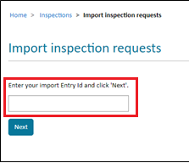

*Tip: Entry IDs is an alpha-numeric, nine-character reference which can be found on the Direction issued by the department.*

*Note: You will be unable to lodge a request for inspection for any direction against an Entry ID if there are other in-progress directions which need to be completed first. For example, if there is any document assessment or ICS amendment required direction/s against that Entry ID, the following message will be displayed:*

“You cannot lodge an inspection request for this entry whilst there are other actions pending. Please contact the broker or provide the information as requested by the department.”

*Once these in-progress directions have been completed, try lodging a request for inspection against the Entry ID and/or Direction again.*

*.*

Figure 3: Enter a valid Entry ID to begin your request for inspection

**Enter** a valid Direction and select **Next**

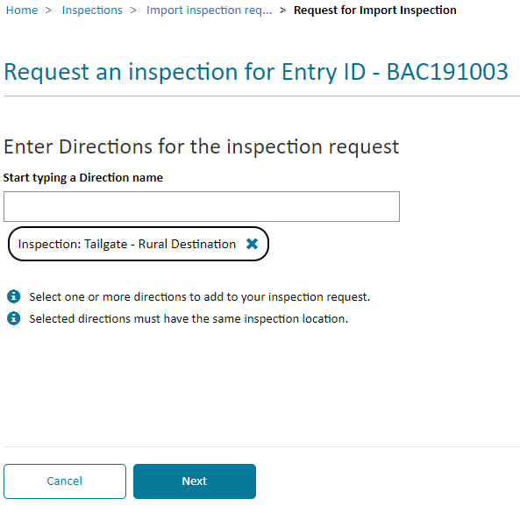

Note: For Biosecurity Directions – enter the Biosecurity direction name to determine its validity to an Entry ID. Not all Biosecurity Directions can have an inspection booking requested.

Note: For Food Directions – there a two generic directions “Imported Food: inspection” and “Imported Food: Failed food inspections”. You do not need to enter the exact Direction name for these Directions. If your Direction pertains to Imported Food Inspection, choose the former, and if it pertains to a failed food inspection, choose the latter, and the system will match the request to the correct Direction in AIMS.

*Tip:* Multiple directions can be included in the one Inspection request, but only if the Inspection location is the same.

Figure 4: Enter a valid Direction

*Note: You will be unable to lodge a request for inspection against a specific direction if there are any open directions which need to be completed first. For example, fumigation or pending test results directions.*

*Once these open directions have been completed, try lodging a request for inspection against the Direction again.*

*Note: A directions order as detailed in comments will not be known or managed by the system. If an inspection direction and fumigation direction are issued, with the inspection direction stating ‘1 of 2’ and the fumigation direction stating ‘2 of 2’, the inspection direction will not be able to be booked unless the fumigation direction is closed.*

*In these instances, you must contact the department to have the blocking direction temporarily closed whilst a request is lodged for the inspection. The blocking direction will be opened immediately following inspection request lodgement.*

Completing the inspection request

Complete all questions on the “Inspection Location”, “Location Contact”, “Consignment information” and “Appointment details” tab to complete your request for inspection.

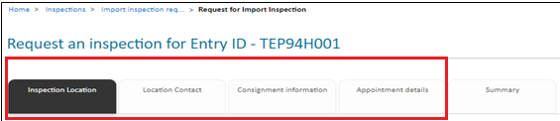

Figure 5: Details about your inspection request

*Note: Mandatory questions are shown by an Asterix (*). You cannot progress your inspection request until all mandatory questions are answered.*

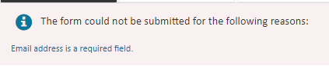

Figure 6: Mandatory question error message

Inspection Location

**Confirm** the location of your inspection. If the Inspection location is the same as stated on the Direction or Food Control Certificate, select **Yes** to proceed to the next screen. **See below if requesting for Imported Food or Cargo Compliance Verification inspections (CCV).**

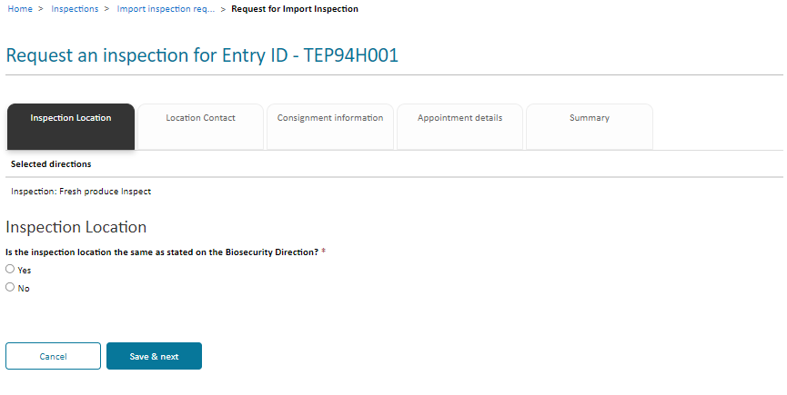

*Note: Please note that this ‘add location’ function will not update the location on the Direction itself so that other parties can book through the Portal.*

*To update the location on the Direction, if you are the broker, the location can be updated through COLS.*

*If you are the AA or the Importer, please contact your broker to update the location.*

Figure 7: Enter a valid Direction

*For* ***Imported Food*** *or* ***CCV*** *inspections: Do not answer YES based on the address listed on the FCC or on the address listed in the CCV directions comments. You must answer ‘No’ for these consignments when answering the '****Is inspection location as advised in Directions?'*** *question. When* ***'No'*** *is selected, a pop-up box will display. It is required that the* ***inspection location address*** *is entered based on the address listed on the FCC or on the address listed in the CCV directions comments.*

Simply **start typing** the inspection location address and **select** from the options presented. If the inspection location address does not appear, **select** Enter the address manually and **type** the address in the fields.

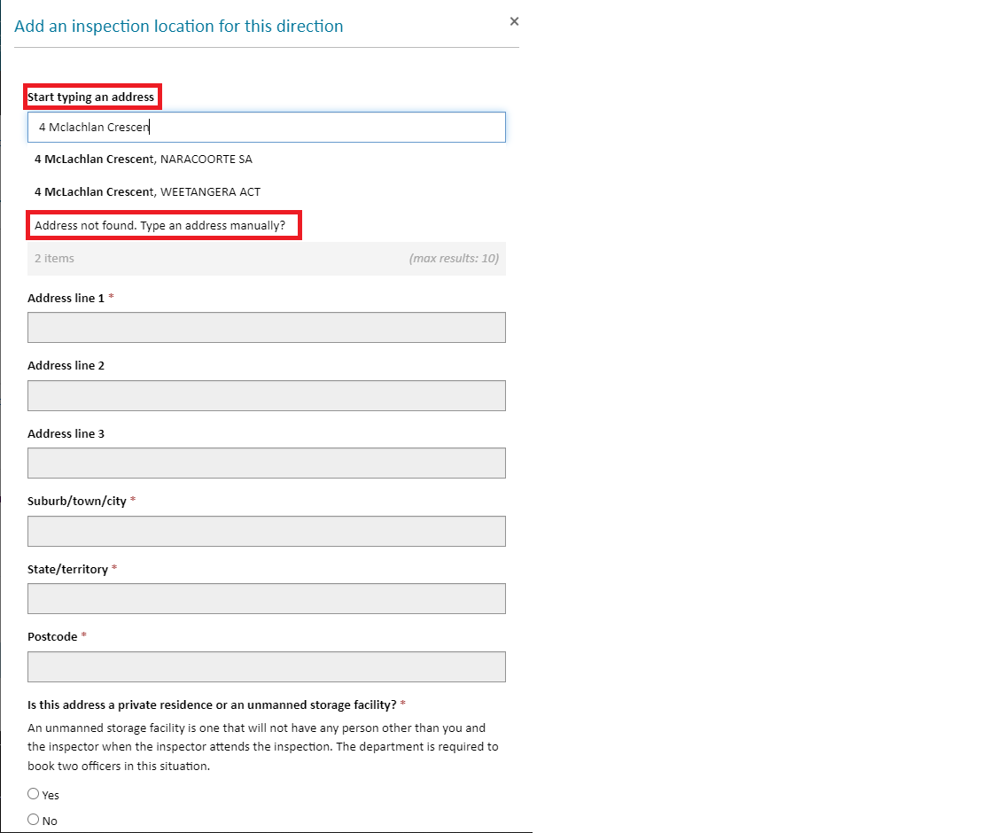

*Note: The option to enter the address manually will only appear once you start typing the Street Number and Name.*

Figure 8 Adding an inspection location and address validation

Consignment Information

**Complete** responses to all applicable questions. **Select** Save & next button to proceed to the next tab.

***Note: Inspection types*** *may be automatically added by the Portal based on selected direction(s) and (or) included tariff code(s). Automatically added inspection types cannot be removed. You can also manually add inspection types based on the consignment.  Refer to the department’s direction and/or packing slips and for imported food the Food control certificates (FCC) for this information. It is important you review the inspection request to ensure that all required inspection types have been included before submission.*

*You can add multiple inspection/consignment types on the consignment information tab by typing each inspection type in the search bar and adding to the inspection request. You will not be able to add duplicate types of inspections. Please refer to the “How do I select the correct inspection type” Task Card.*

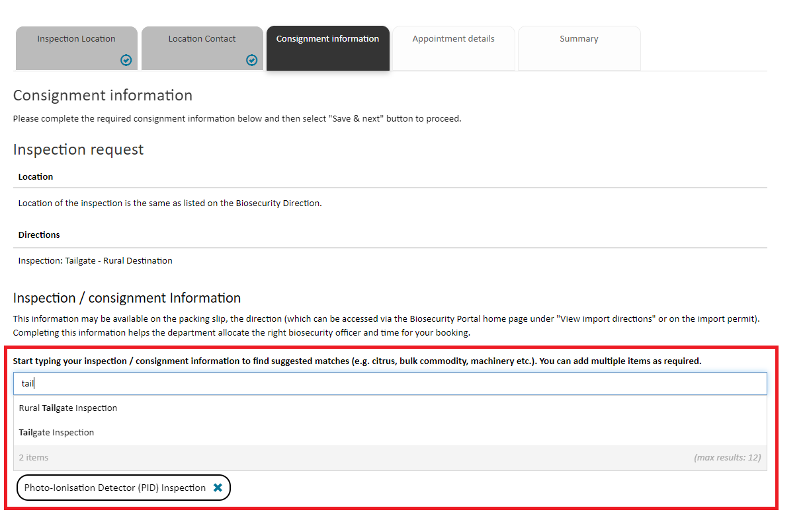

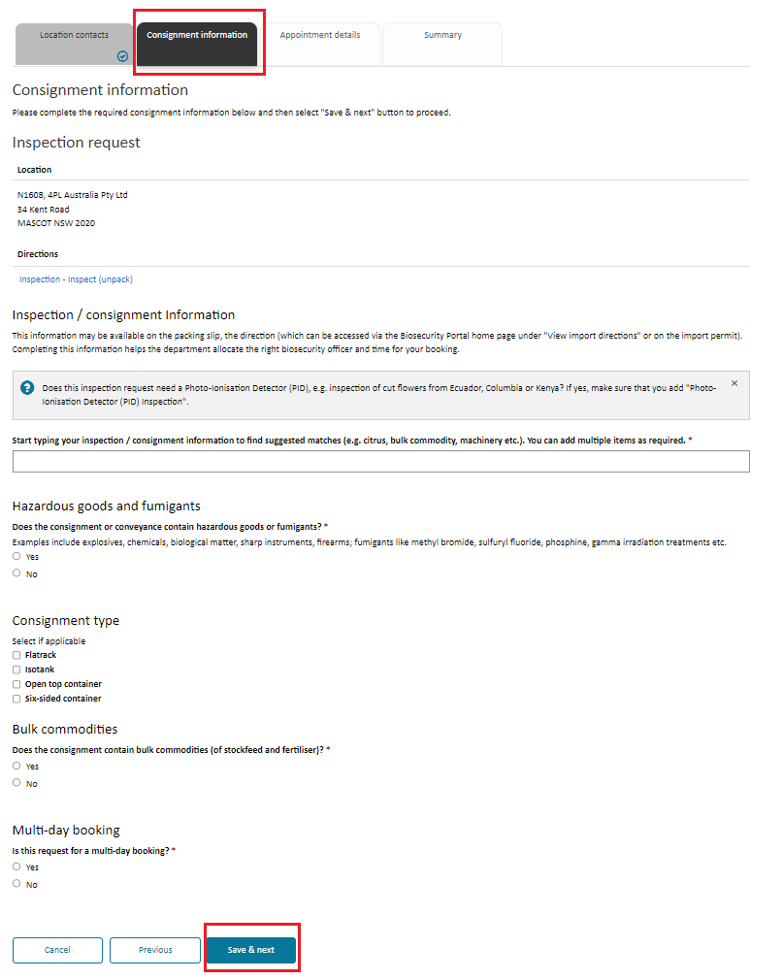

Figure 9: Consignment information

Figure 10: Enter all relevant inspection types for this request contact information

*Tip*: *Questions on the consignment tab are dynamic. Depending on your responses, additional questions will be displayed*.

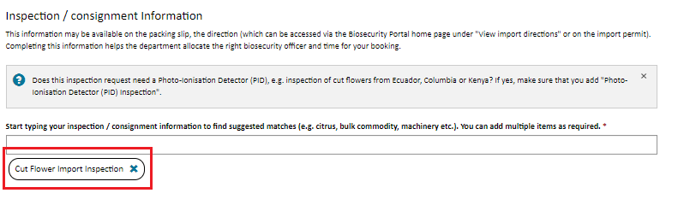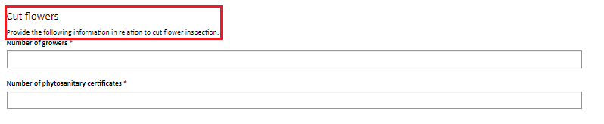

Figure 11: Dynamic questions based on inspection types entered

Appointment Details

**Complete** responses to all applicable questions. **Select** Save & next button to proceed to the next tab.

*.* 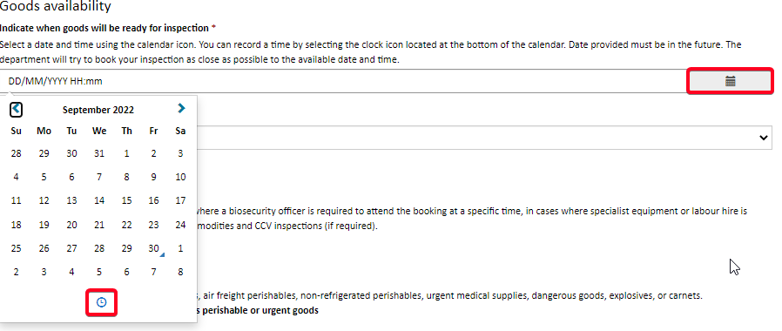

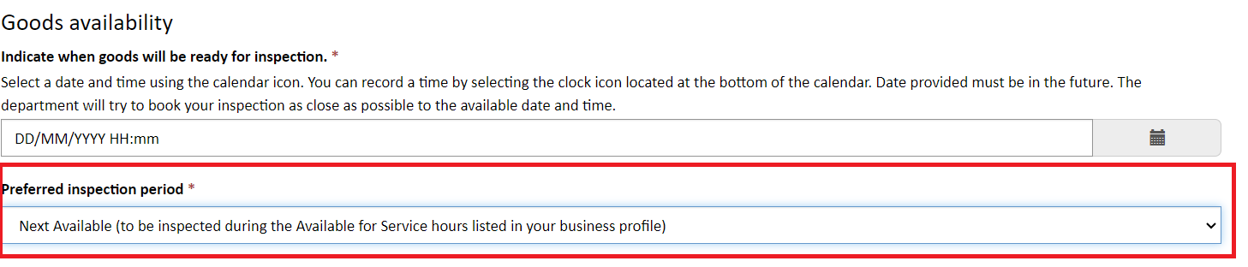

Indicate a date and time when your goods will be ready for inspection – this date and time must be in the future and select a preferred inspection period from the list.

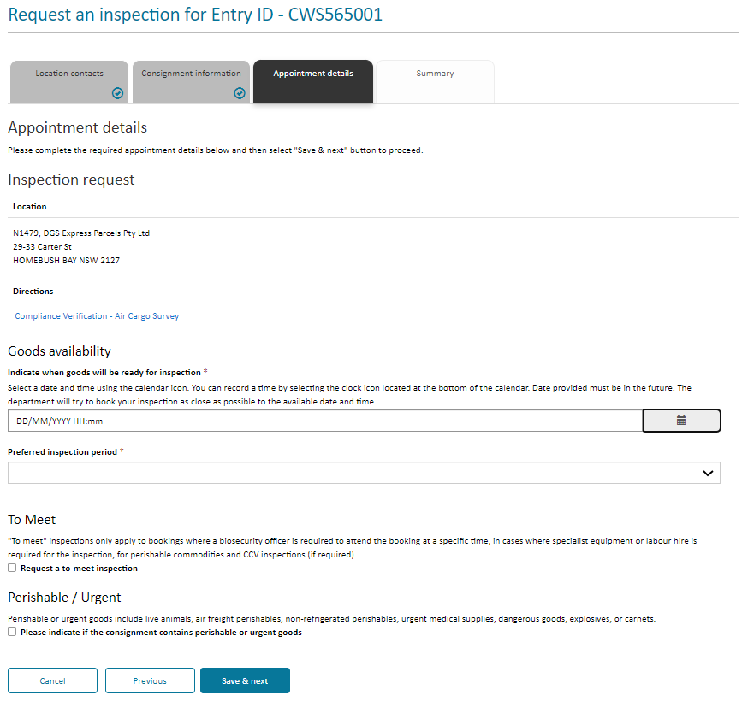

Figure 13: Goods availability date and time

Figure 12: Appointment Information

When you require an inspection outside of departmental core business hours i.e. outside 6:30am to 6:30pm Monday to Friday, you can select the overtime option under the Preferred inspection period. You will receive an email with the day/time once the booking has been confirmed.

*NOTE: If you select AM or PM, you are restricting officer availability to the AM or PM slot only, the department may have earlier availability but is unable to allocate due to the selection. To maximise inspection availability, it is recommended to select NEXT AVAILABLE in the preferred inspection period field.*

*NOTE: Overtime inspections are subject to availability and not guaranteed.*

You can select a ‘To Meet’ booking in certain circumstances for example if specialist equipment or labour hir tis required. The department will review your request and if appropriate your confirmed booking will include the day and time for the inspection.

Please indicate if your inspection contains perishable and/or urgent goods.

Summary

This screen provides a summary of inspection information entered for your inspection request. Once reviewed, if any changes to this information are required, use the **Previous** button to navigate to the relevant tab.

***Note:*** *Ensure that all the entered information is accurate before submitting the form.*

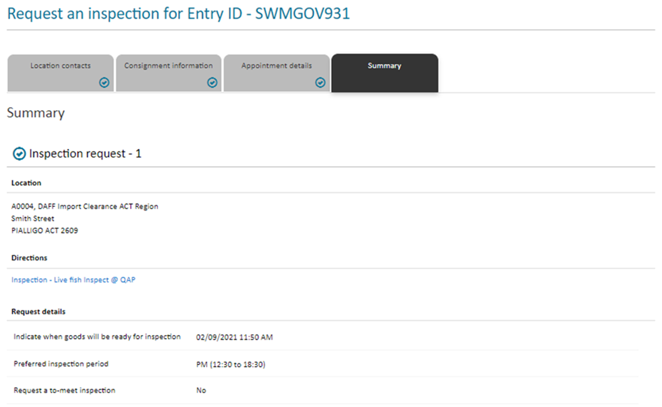

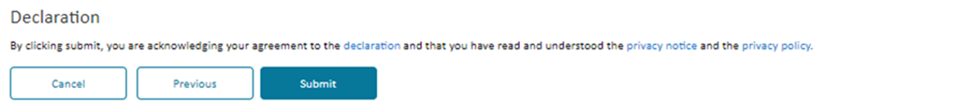

Figure 14: Review the request for inspection details prior to submitting

Note: Please read the declaration notice, privacy notice and privacy policy prior to submitting your inspection request form.

**Submit** the form by selecting the Submit button.

Each request for inspection will have a unique transaction number used to manage your lodgement. An email will also be sent to your registered email address.

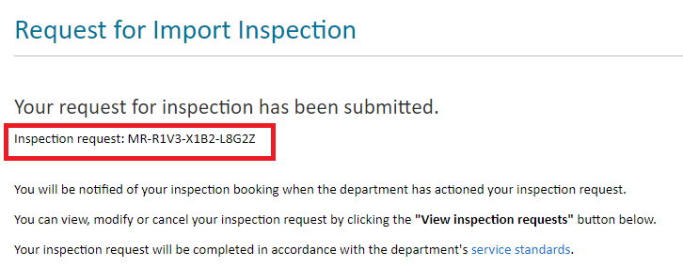

Figure 15: Unique transaction number