How do I view and print AIMS Directions via myID?
This task card demonstrates how to view and print AIMS Directions in the Portal logging in via myID .

NOTE: Refer to “How do I login to the Biosecurity Portal?” on how to register and login to the Portal.
NOTE: The Portal works best with the latest version of Google Chrome, Safari and Microsoft Edge. Internet Explorer and Mozilla Firefox are not supported.
You must allow pop-ups on your browser before proceeding.

AIMS Directions
Viewing AIMS Directions
Browse to biosecurity.awe.gov.au
Login using with your Digital ID via the myID pathway. If you have not registered, refer to “How do I register to use the Biosecurity Portal?”

An authenticated user (logged in using their myID) can view and print all Directions issued against an AIMS Entry ID.

NOTE: Food Control Certificates cannot be viewed via the Portal at this point.

You will be able to view Directions against an AIMS Entry ID when:
- Approved Arrangement – if the AA number is listed against an active Direction.
- Brokerage – the ABN of the brokerage is listed against the import declaration in the Integrated Cargo System (ICS).
- Importer – the ABN of the importer is listed against the import declaration in the Integrated Cargo System (ICS).

Select “View import directions” from the Portal Home page, enter a valid Entry ID and click Submit.

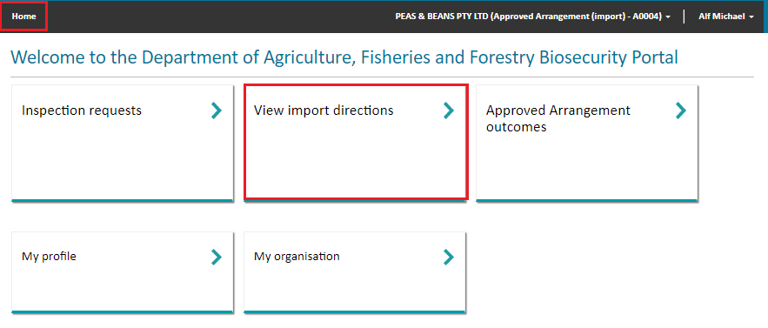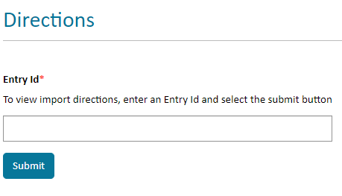
Figure 1: Enter an Entry ID to view Directions

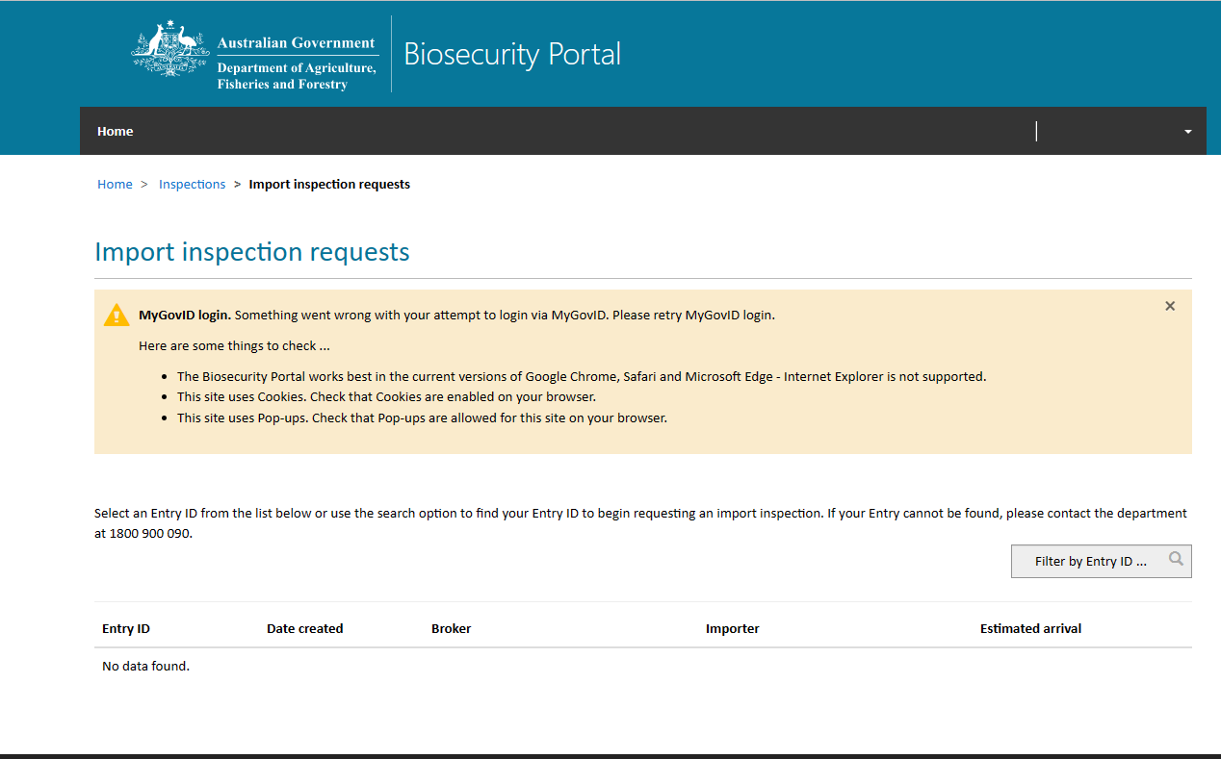
NOTE: If no Entry ID is returned, please ensure you review and check the common reasons this may have occurred and try again.

Figure 2: No Entry IDs displayed for selection – trouble shooting representing to lodge an inspection request

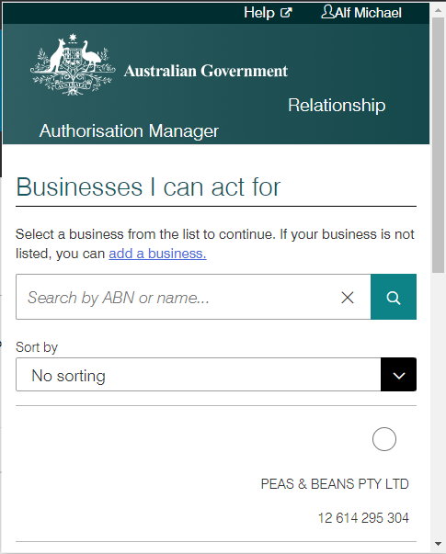
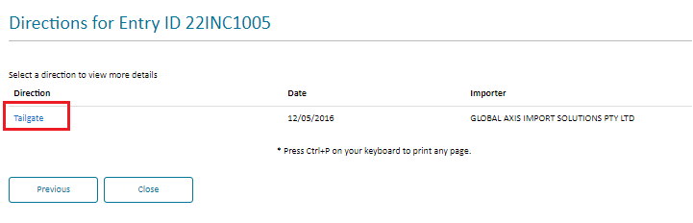
Figure 4: Select the Direction you wish to view
Figure 3: Select the business you are representing to lodge an inspection request
Select the Direction you wish to view. Press Ctrl+P to print the Direction. Select Close to return to the previous screen.
A pop-up window will appear
NOTE: If you are a representative of multiple ABNs, please select the organisation you are representing. This pop up validates the business you are representing prior to integrating with departmental import systems.

    - 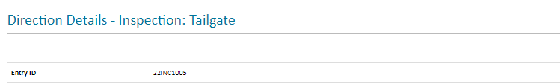
    - 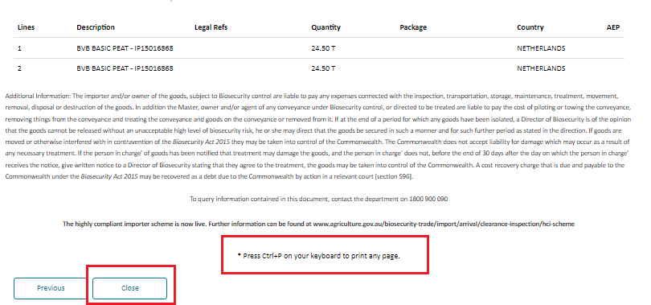
Figure 5: AIMS Direction

