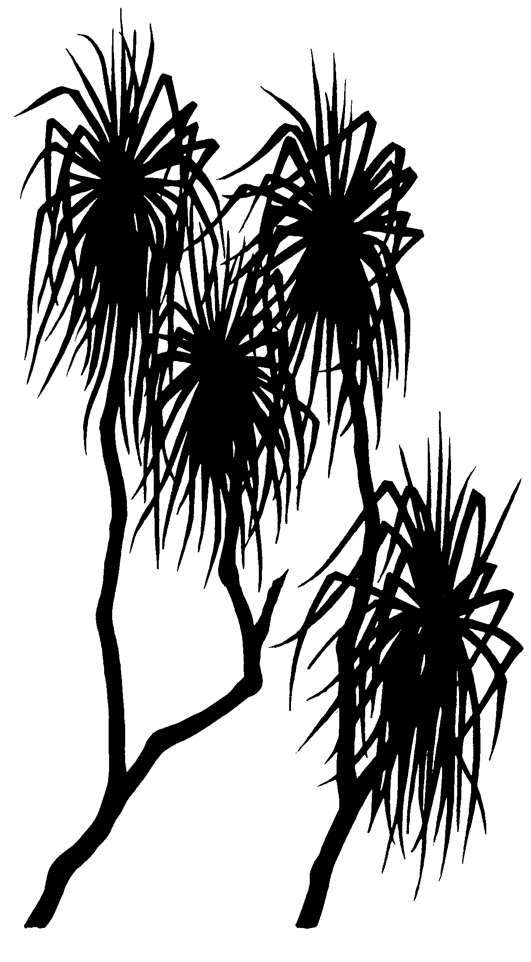

579
internal report
Pilot study on the separation and physical characterisation of lateritic material from the Ranger project area
MJ Saynor & A Harford

October 2010

(Release status – unrestricted)
This page has been left blank intentionally.

Pilot study on the separation and physical characterisation of lateritic material from the Ranger project area

MJ Saynor & A Harford

Supervising Scientist Division
GPO Box 461, Darwin NT 0801

October 2010

Registry File SSD2010/0011

(Release status – unrestricted)


How to cite this report:
Saynor MJ & Harford A 2010. Pilot study on the separation and physical characterisation of lateritic material from the Ranger project area. Internal Report 579, October, Supervising Scientist, Darwin.

Location of final PDF file in SSDX Sharepoint:
Supervising Scientist Division > PublicationWork > Publications and Productions > Internal Reports (IRs) > Nos 500 to 599 > IR579_Lateritic material for ecotox tests

Location of all key data files for this report in SSDX Sharepoint:
Supervising Scientist Division > SSDX > Ecotoxicology of the Alligator Rivers Region > Suspended sediment ecotox > Data

Authors of this report:
Mike Saynor – Hydrological & Geomorphic Processes Program, Environmental Research Institute of the Supervising Scientist, GPO Box 461, Darwin NT 0801, Australia
Andrew Harford – Ecotoxicology Program, Environmental Research Institute of the Supervising Scientist, GPO Box 461, Darwin NT 0801, Australia

The Supervising Scientist is part of the Australian Government Department of Sustainability, Environment, Water, Population and Communities.
© Commonwealth of Australia 2010
Supervising Scientist
Department of Sustainability, Environment, Water, Population and Communities
GPO Box 461, Darwin NT 0801 Australia
This work is copyright. Apart from any use as permitted under the Copyright Act 1968, no part may be reproduced by any process without prior written permission from the Supervising Scientist. Requests and inquiries concerning reproduction and rights should be addressed to Publications Inquiries, Supervising Scientist, GPO Box 461, Darwin NT 0801.
e-mail: publications_ssd@environment.gov.au
Internet: www.environment.gov.au/ssd (www.environment.gov.au/ssd/publications)
The views and opinions expressed in this report do not necessarily reflect those of the Commonwealth of Australia. While reasonable efforts have been made to ensure that the contents of this report are factually correct, some essential data rely on references cited and/or the data and/or information of other parties, and the Supervising Scientist and the Commonwealth of Australia do not accept responsibility for the accuracy, currency or completeness of the contents of this report, and shall not be liable for any loss or damage that may be occasioned directly or indirectly through the use of, or reliance on, the report. Readers should exercise their own skill and judgment with respect to their use of the material contained in this report.

Printed and bound in Darwin NT by Supervising Scientist Division

Contents
Executive summary iv
Acknowledgments iv
1 Introduction 1
2 Background information – laterite 3
2.1 Surficial soil descriptions 3
2.2 Surficial soil particle size descriptions 4
2.3 Lateritic material description 5
3 Collection of lateritic material 6
4 Methods 9
4.1 Lateritic material – particle size analysis (PSA) 9
4.2 Separation of the fine fraction (<63 μm) 9
4.2.1 Dry sieving 9
4.2.2 Wet sieving 10
4.2.3 Drying of the fine fraction after wet sieving 12
4.3 Characterisation of the isolated fine fraction 12
4.3.1 Microscopy 12
4.3.2 Coulter counter 12
5 Results 13
5.1 Lateritic material characterisation 13
5.2 Determination of the fine fraction by dry sieving 14
5.3 Determination of the fine fraction by wet sieving 15
5.4 Microscopy 15
5.5 Coulter counter 17
6 Discussion and recommendations 17
6.1 Detailed particle size characterisation of the lateritic material 18
6.2 Development of <63 μm sediment separation method 18
6.3 Recommendations 19
7 References 19
Appendix 1 Particle size distributions 21
Appendix 2 Separation of the lateritic material – operational protocol 23

Executive summary
The trial landform is a major project being undertaken by Energy Resources of Australia (ERA) to test the effectiveness of the company’s proposed design and revegetation strategies for the final mine landform . This initiative provides an opportunity to measure erosion rates, to determine the composition of sediment being eroded from test areas constructed with different substrates, and to test the capacity of computer landform evolution models to predict rates of erosion through time. The final landform could potentially be a significant source of fine particulates to Magela Creek. Consequently, there is a need to characterise the nature of the particulate matter that could be eroded from the landform, and to investigate its possible impact on aquatic biota downstream of the rehabilitated site, in the context of developing closure criteria and an appropriate performance monitoring framework.
The Pit 3 ‘lateritic’ materials used in this study were nominated by ERA as being representative of the material that was to be used in the construction of the trial landform. In this context ‘laterite’ is the generic term used on site to describe material excavated from the upper weathered horizon of the pit. The depth of weathering can extend to 50m in some places. ‘Laterite’ is a very friable material containing substantial fine-grained minerals produced by the weathering process. This is distinct from the correct geomorphic use of the term ‘laterite’ to describe the upper cemented (ferricrete) horizon of the soil profile
This report describes the development of the most suitable method for separating the finer particulate material, in this case the <63 μm (0.063 mm) fraction from bulk lateritic material collected from Pit 3 at the Ranger mine. This is the fraction of most interest for assessing the effects of fine suspended sediment on aquatic biota. The separation method will subsequently be used to produce a stock of the fines fraction for use in the project ‘The direct effects of suspended sediment on tropical freshwater biota’; SG2008/0179). The process of wet sieving was determined to be the best method, and full details of the procedure/protocol are given in Appendix 2.

Acknowledgments
Thanks to Amber Hooke (Earth Water Life Sciences – EWLS) for arranging the required permits and permissions for accessing Pit 3 at Ranger mine to collect the lateritic material.
Dr Rick Van Dam, Professor Wayne Erskine and Dr David Jones commented on the document
Thank you to SSD Publications Manager Ann Webb for assistance with editing and formatting of the word document.

Pilot study on the separation and physical characterisation of lateritic material from the Ranger project area
MJ Saynor & A Harford

1 Introduction
Anthropogenic elevation of suspended sediments above natural baseline levels has long been recognised as a significant global environmental stressor and many field studies have reported ecological degradation following extended periods of exposure (Stowar 1997, Bilotta & Brazier 2008). However, the setting of Water Quality Guidelines (WQGs) for suspended particulate matter (SPM) based on ecotoxicological testing has proven problematic due to challenges with maintaining and measuring the concentration of particles in a liquid medium and the potential for multiple (ie indirect physical and direct physical and toxicological) modes of action. Quantifying the impacts of SPM on freshwater biota is important for the Ranger mine in the context of establishing suspended sediment water quality guidelines for both the mine’s current operations and future closure and rehabilitation.
Once operations at the Ranger mine are completed a rehabilitated landform will be constructed to encapsulate waste material and tailings for at least 10 000 years. Erosion from this final landform and possible off site impacts are an important issue and have been the basis for many research projects at eriss. One area of research importance is the impact that suspended sediment from the final landform might have on aquatic biota downstream of the rehabilitated site.
To test landform design and revegetation strategies to be used once mining and milling have finished at the Ranger mine, a trial landform has been constructed by Energy Resources of Australia Ltd (ERA). The trial landform is a rectangular shape of approximately 200 m x 400 m (8 ha) in footprint area, adjacent to the north-western wall of the tailings storage facility (TSF) at Ranger mine (Figure 1). The landform was designed to test two types of potential final cover layers:
- Waste rock alone
- Waste rock blended with approximately 30% v/v fine-grained weathered horizon material (laterite)
Once the surface of the trial landform had been constructed the surface was ripped across the contour using a tyne attached to a large bulldozer. To measure erosion rates and determine chemical loads/concentrations, four erosion plots measuring 30 m x 30 m (Figure 2) have been constructed on the trial landform. Research into revegetation strategies is also being undertaken. However, it is the erosion potential from the surface that is the focus of the work described here.
With lateritic material being combined with the waste rock as a growth medium, it is important to determine how much of this material potentially could be eroded from the landform and determine any possible impact on the aquatic biota downstream. This report aims to:
- determine the most suitable method for separating the finer particulate material, in this case the <63 μm (0.063 mm) fraction. This is the fraction of interest for assessing the effects of suspended sediment on aquatic biota, and the separation method that is developed will be used to obtain a stock of such sediment for this purpose (ie to be used for the project ‘The direct effects of suspended sediment on tropical freshwater biota’; SG2008/0179);
- use physical characteristics to determine the nature of the material and if it fits the definition of laterite.

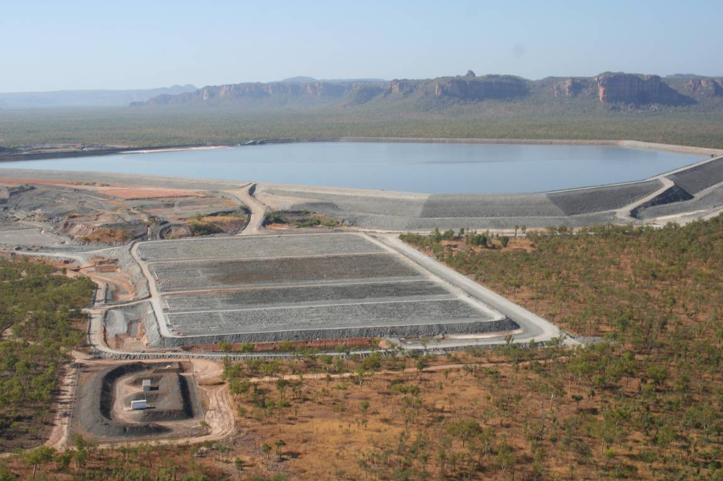
Figure 1 Aerial view of the completed trial landform located north-west of the Ranger mine Tailings storage facility (taken 28 August 2009 by M Saynor)
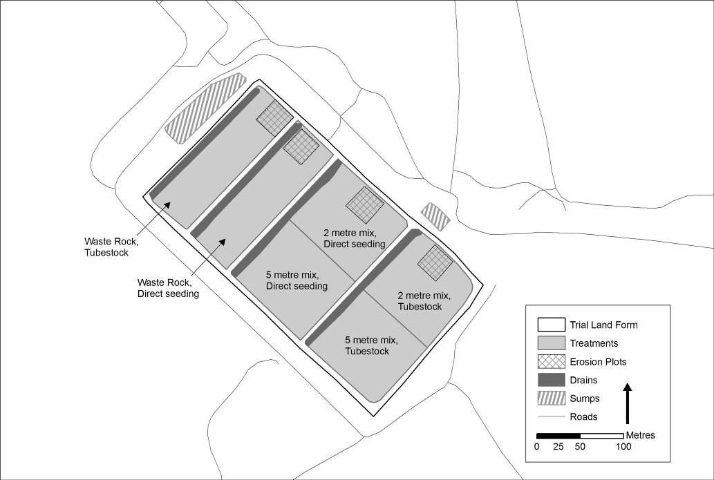
Figure 2 Line diagram of the layout of the erosion plots on the trial landform

2 Background information – laterite
Laterite refers to iron rich soils that have a hard ferruginous surface expression, with some degree of chemical and mineralogical differentiation below (Eggleton 2001). The term ‘lateritic profile’ is used to describe profiles with a sequence of iron-enriched zone, a mottled zone and a pallid zone (Hubble et al 1983). Laterite is the product of weathering, with many examples being described in Australia including Hays (1967), Hunt et al (1977) and Pickett (2003).

2.1 Surficial soil descriptions
The Ranger mine is located on the Koolpinyah surface near the sand bedded Magela Creek. The Northern Lateritic Plains of Christian and Stewart (1953) or the lateritised Koolpinyah Surface of Hays (1967) is an old surface generally characterised by sandy soils. Storey et al (1969) mapped the geomorphology around the Ranger mine site as dissected Koolpinyah surface and weathered zone which comprised of broad valleys, low hills and undulating lowlands. The soils of the Koolpinyah surface were mapped by Storey et al (1969) as gradational and uniform red and yellow-red soils on laterite remnants and minor skeletal and gradational yellow earths on slopes. The general geology of the area is shown as having a surficial cover of Cainozoic soil, unconsolidated sands, ferruginous material over Lower Proterozoic schists of the Cahill Formation. The Koolpinyah surface is generally sandy with not much clay material present because it has been transported away and deposited downstream in swamp (Melaleuca) areas and floodplains.
Surface soils surrounding Ranger mine (25 km2) are described by Wigston (1991). The soils in the upland areas are predominantly shallow to moderately deep, brown to yellowish brown, massive earthy sands. Those in the lower areas are sandy earths with duplex soils being found in some isolated areas. Within the drainage courses, soils are predominantly siliceous sands. The soils are dominated by kaolinitic minerals and are non-saline and non sodic. There is low organic matter in these soils except for some isolated sites south of the pit.
Willet et al (1992) described the soils immediately adjacent to the Ranger mine site for the area between Ranger mine and Magela Creek. This area was known as the Land Application Area (LAA) with the majority of the site on the creek side of the current access road. The surficial soils were predominantly yellow earths, red earths and siliceous sands. All the soils had high (20–50%) gravel contents consisting of ferruginous materials. The soils were generally low in clay (<20%), organic matter (<1%) and were acidic. The clay minerals were of the low activity types, predominantly kaolinite.
Surface soils were described by Chartres et al (1991) as part of a study to characterise soils and hydrology for a LAA between RP2 and Magela Creek. They were part of their land unit II described as:
Brownish, gravely massive loamy sand A1 horizons, yellow brown, massive, cobbly sandy loam A2/A3 horizons. Gravelly, massive to weakly pedal, mottled yellowish red to red B horizons by 20 to 70 cm or weathered schistose substrates by 50 cm. Moderately well to imperfectly drained.
Soil profile descriptions near to the Pit 3 at Ranger mine were described by Chartres et al (1992) (see Tables 1, 2 & 3).
Table 1 Soil profile descriptions for auger hole J49 (Chartres et al 1992). Laterite sample 1 (Figure 3) was collected approximately 42 m north east of this location.
Depth (m) | Soil characteristics
0–0.3 | A1 + A2: 10YR* brown.
0.3–0.6 | Cobbly horizon.
0.6–0.85+ | Red ferruginous rock very hard to drill
 | Profile moist throughout
* Munsell Soil Colour of moist sample
Table 2 Soil profile descriptions for auger hole J10 (Chartres et al 1992). Laterite sample 1 (Figure 3) was collected approximately 50 m north west of this location.
Depth (m) | Soil characteristics
0–0.07 | Dark greyish brown (10YR 4/2*) gravelly coarse sandy loam, massive, moist, very weak, 2 to 10% ferruginous nodules and quartz to 5 mm, gradual boundary.
0.07–0.55 | Dark yellowish brown (10YR 4/4*) gravelly coarse sandy loam, massive, moist, very weak: 10 to 20% ferruginous nodules and quartz to 2 cm, gradual boundary.
0.55–0.7 | Red (10R 4/6*) gravel with clay with strong brown (7.5YR 5/6) and light brownish grey (2.5Y 6/2) mottles, 10 to 20% weathered schist fragments and ferruginous nodules to 2 cm.
* Munsell Soil Colour of moist sample
Table 3 Soil profile descriptions for auger hole J48 (Chartres et al 1992). Laterite sample 2 (Figure 3) was collected approximately 56 m north west of this location.
Depth (m) | Soil characteristics
0–0.3 | A1 + A2: 10YR* brown.
0.3–0.45 | Cobbly horizon.
0.45–1.0+ | Red ferruginous rock: very hard to drill
 | Profile dry to 70 m
* Munsell Soil Colour of moist sample
The surficial soils described by Wigston (1991), Willet et al (1992) and Chartres et al (1992) are brown to yellow sandy soils (siliceous sands) with ferruginous material present. These descriptions indicate that laterite soils and/or profiles are present on the Koolpinyah surface around the Ranger mine site.

2.2 Surficial soil particle size descriptions
Soils in the Gulungul Creek catchment immediately to the west of Ranger mine were sampled in 2006 as part of a large project looking at the impacts of Cyclone Monica, which passed through the area in April 2006 (Saynor et al 2009). Detailed particle size analyses were undertaken on samples collected from the catchment. The results from samples collected from Woodland and Open woodland vegetation communities that are indicative of the vegetation on the Koolpinyah surface are shown in Table 4.
The surficial soils around the Ranger mine are generally high in sand content ranging in Gulungul Creek from 40.3% to 88.7%, with clay percentages less than 14.4 %. The silt + clay (fine fraction) ranged between 10.5 to 27.3%.

Table 4 Particle size results for Gulungul Creek soils
Site number |  | Gravel (%) | Sand  (%) | Silt  (%) | Clay  (%) | Silt + Clay (%)
Upper boundary | Vegetation type |  | < 2.0 mm | < 0.063 mm | < 0.0039 mm | < 0.063 mm
Lower boundary | Vegetation type | > 2.0 mm | > 0.063 mm | > 0.0039 mm
Site 2 | Woodland | 10.7 | 68.9 | 8.6 | 11.8 | 20.4
Site 4 | Woodland | 45.6 | 40.3 | 11.6 | 2.4 | 14.1
Site 18 | Open Woodland | 21.0 | 58.1 | 14.1 | 6.9 | 21.0
Site 19 | Open Woodland | 18.4 | 65.1 | 11.7 | 4.8 | 16.5
Site 20 | Open Woodland | 2.3 | 84.0 | 10.7 | 3.0 | 13.7
Site 21 | Open Woodland | 19.3 | 67.0 | 8.5 | 5.1 | 13.6
Site 22 | Open Woodland | 17.1 | 70.4 | 10.0 | 2.5 | 12.6
Site 23 | Open Woodland | 0.0 | 86.9 | 5.1 | 8.0 | 13.1
Site 30 | Woodland | 0.4 | 87.7 | 5.7 | 6.1 | 11.9
Site 31 | Woodland | 0.2 | 87.5 | 7.1 | 5.1 | 12.3
Site 32 | Woodland | 0.8 | 88.7 | 7.0 | 3.5 | 10.5
Site 33 | Woodland | 1.2 | 71.4 | 13.0 | 14.4 | 27.3

2.3 Lateritic material description
The term ‘lateritic material’ is used at Ranger mine to describe material excavated from the upper horizon of the pit and varies from highly weathered surface material (closest to the definition of laterite) down through a transitional zone (less iron rich) to just above the surface of the competent rock. The Pit 3 ‘lateritic’ materials used in this study were nominated by ERA as being representative of the material that was to be used in the construction of the trial landform. Within Pit 3 at Ranger mine, lateritic material is present down to depths of 40–60 m below the ground surface. The lateritic material is added to the waste rock stockpiles or used for various applications including a pad for the western stockpile and the lift of the tailings dam facility.
The rehabilitation of the footprint disturbed by mining will be carried out utilising in excess of 20 Mm3 material excavated from the pits, including lateritic material, transitional material and competent shot waste rock (Poole 2008). The lateritic material is proposed to be used to provide additional fine particles to the growth medium which may assist the establishment of vegetation in the final landform. For this reason it has also been incorporated into one of the surface treatments used for the trial landform.
Some particle size descriptions of the lateritic material obtained from overburden material excavated from Ranger mine Pit 3 are contained in Hollingsworth (2001). A pad of compacted lateritic material was constructed near Pit 3 to restrict infiltration of leachate from the Western stockplie into the underlying regolith and to direct seepage towards Pit 3. The total area of the stockpile as originally constructed was 42 000 m2, with base lateritic material covering 32 300 m2. Sites were sampled by Earth Water Life Sciences (EWLS) in July 2001 to undertake physical characterisation including particle size analyses (Table 5).
Table 5 Particle size results from lateritic material (Hollingsworth 2001)
Sample name | Gravel (%)  > 2 mm | Sand (%)  < 2 mm  > 75 μm | Fines (%)  < 75 μm
C1 | 27 | 54 | 19
C5 | 15 | 62 | 23
C8 | 17 | 69 | 14
C12 | 23 | 54 | 23

The laboratory Particle Size Analysis (PSA) summarised in Table 5 was undertaken by URS Australia Pty Ltd. It was reported by URS that the results indicate that the pad material is relatively consistent, being a silty sand, with fines of low plasticity. The ‘fines’ content (ie Particles less than 0.075 mm size) was between 14 and 23%. The relatively high Liquid Limit and low Plasticity Index values indicated that the material had a higher proportion of ‘silt’ fines than ‘clay’ fines (Hollingsworth 2001).
A report by Poole (2008) detailed observations from a trial to assess methods of mixing of ‘laterite’ with primary waste rock material. The laterite used for this trial was observed to consist of highly weathered clayey fines, and the waste rock material also appeared to be relatively fine grained.

3 Collection of lateritic material
Lateritic material, which at the time of collection was nominated as being representative of the material that was to be used for the construction of the trial landform, was collected from the Ranger mine site on 3 September 2008. Samples were collected from two locations on the then current edge of Pit 3 (near the base of bench 2 approximately 2–3 m below the land surface) at the Ranger mine site (Figure 3).

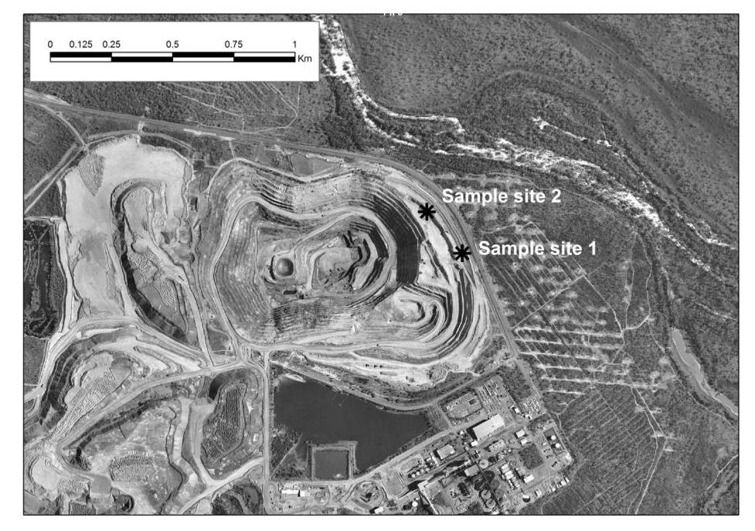
Figure 3 Location of the sampled sites
These sites were on the north-eastern side of the pit near the main access road to Ranger mine. The samples were collected from near the edges of where Djalkmara Billabong used to be located as shown in Figure 4.
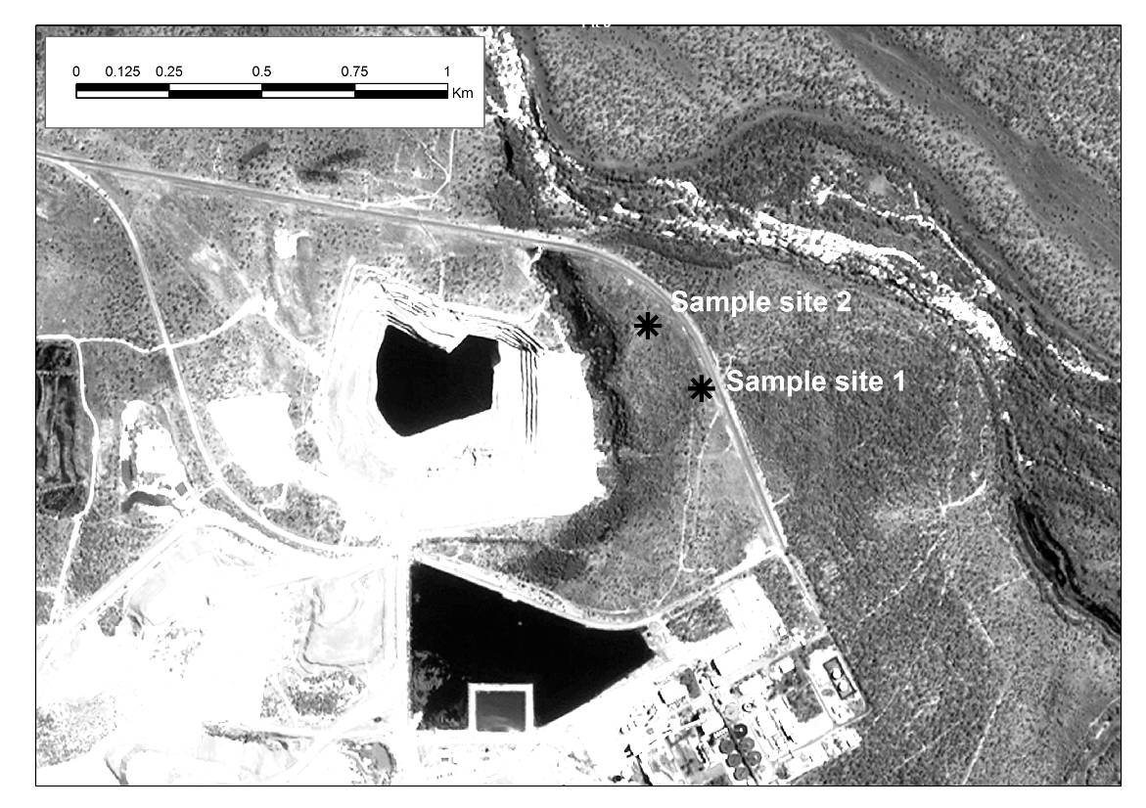
Figure 4 Location of lateritic sample sites in relation to Djalkmara Billabong. This image is an Ikonos image taken in 2001. The sites where the samples were collected are currently just inside the pit. Site 2 is closer to Magela Creek which is also to the north.
GPS coordinates of the sample site locations were:
- Sample site 1 – 12.67506 S, 132.92320 E, (WGS84), (Figure 5)
- Sample site 2 – 12.67351 S, 132.92188 E, (WGS84), (Figure 6)
Samples of the lateritic sediment were collected in acid-washed 20 litre plastic drums. Three plastic drums were collected from both sites with a long handled shovel (Figures 5 & 6). Once the containers were full, the lids were sealed and transported to the main office block at Ranger mine where their radiation levels were measured and found to be at background levels and given a clearance certificate. The plastic drums were transported back to the eriss laboratory in Darwin and stored in a fridge to keep the samples representative of how they were collected in the field and also to reduce microbial growth.
On initial inspection, the samples collected from site 2 appeared to contain a higher sand content that the samples collected from site 1, which may be due to the closer proximity of site 2 to the location of Djalkmara Billabong. Vehicle access to the second site was prevented due to the presence of a large amount of surface water on the bench (shown in Figure 6), which was clearly natural seepage accumulating rather than the result of water being used for dust suppression. Both the collected samples were quite high in water content with water condensing on the inside of the lids during transport to Darwin. Initial field observations of the samples collected were that the material from site 1 was waxy (to touch) in texture whilst the material from site 2 appeared to contain more sand.
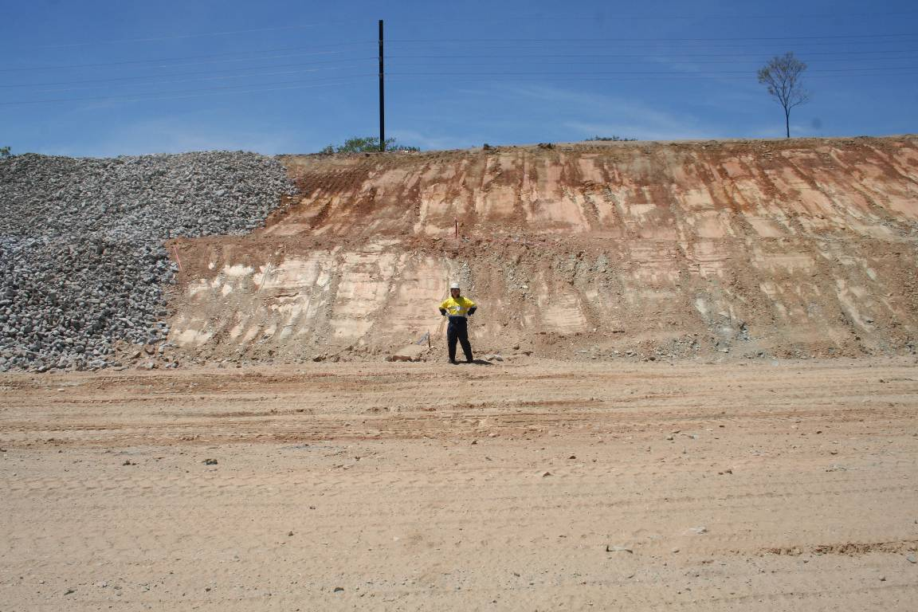
Figure 5 Sample Site 1 collected at GPS location – 12.67506S, 132.92320E near the base of bench 2. Note the steel telegraph pole in the image which is next to the main access road.
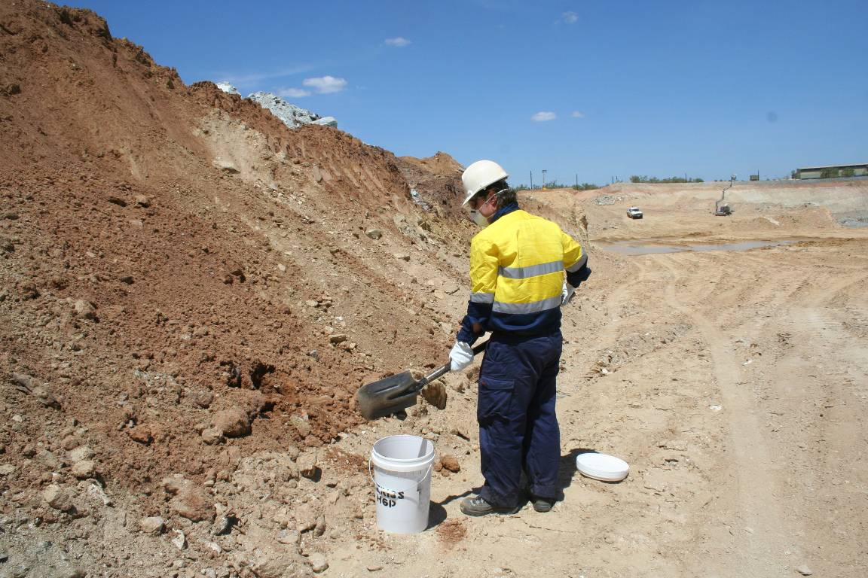
Figure 6 Sample Site 2 collected at GPS location 12.67351S, 132.92188E, near the base of bench 2. Telegraph poles can be seen in the distance, as can parts of the mine workshop building. Note the pooled water in the image.

4 Methods
The samples were dried at 40°C (air dry) in acid-washed plastic food containers for a least 1 week prior to commencement of separation techniques. A low drying temperature of 40°C was used to prevent the samples drying into a solid block that would require additional physical separation. Experience demonstrated that ½ filling the containers resulted in quicker drying time. The samples were left in the containers in the oven until required for separation.

4.1 Lateritic material – particle size analysis (PSA)
Four sub-samples (two from each sample site) were characterised for particle size according to the sieve and hydrometer method of Gee and Bauder (1986). The samples were dried at 105°C for 24 hours and then sieved through a 2 mm sieve to split the sample into the gravel fraction (> 2mm) and the sand, silt and clay fraction (< 2mm). The gravel fraction of the samples was manually sieved in its entirety.
For the < 2 mm fraction, a sub-sample (between 60 and 70 g) was obtained using the cone and quartering method. The samples were chemically dispersed with 25 mL of sodium hexametaphosphate before being mechanically dispersed on a shaking wheel or a shaking platform for at least 12 hours. The sample was then wet sieved through a 63 μm or 4 φ (phi) stainless steel sieve with the material (mud fraction) collected in a 1000 mL cylinder. The sand fraction retained on the 63 µm or 4 φ stainless steel sieve was oven dried at (105°C), weighed and dry sieved through a nest of sieves at φ/2 intervals, using a 15 minute shake time.
The mud suspension retained in the 1000 mL cylinder was made up to volume and left in a constant temperature (24°C) room for at least 24 hours to allow temperature equilibration. Hydrometer readings were taken at 5 min, 10 min, 90 min, 270 min, 480 min and 1440 min and were used to determine the amount of silt and clay in the sample. The fraction coarser than 20 μm or 5.65 φ was also determined by decantation using a sedimentation time based on Stokes equation for the water temperature at the time. Just prior to the decantation a sub-sample of 20 mL was collected using a pipette for analysis on the coulter counter. The grain size data are included in Appendix 1.

4.2 Separation of the fine fraction (<63 μm)
During discussions prior to sampling of the lateritic material, it was agreed that the fine fraction (< 63 μm) was the size fraction that was important for the project to investigate the direct effects of suspended sediment on tropical freshwater biota. Sufficient amounts of the fine fraction needed to be isolated so that there was enough material to run multiple tests. Two methods of separation were assessed for their effectiveness in separating the fine fraction from the rest of the sample. These were dry sieving and wet sieving.

4.2.1 Dry sieving
Once dried at 40°C for at least a week any larger rocks present were hand removed from the samples. Approximately 100 g of sub-sample was obtained using the cone and quarter method on plastic plates. The sub-sample was accurately weighed to allow calculation of the percentage of fine material following the size separation. The sub-sample was then poured into a nested set of stainless steel sieves (stainless steel was used to reduce the risk of toxic metal contamination) at 1/2 φ intervals so that the sieves did not become overloaded. Sieves sizes used are shown in Table 6. Sediment < 63 μm was collected in a receiver at the base of the nest of sieves. The nested set of sieves was placed on an automatic sieve shaker for 15 minutes. After 15 min, the material retained on each of the sieves > 63 μm was carefully removed and placed in a container for storage and ultimately disposal. The sediment fraction that passed through the 63 μm sieve was weighed and transferred into an acid-washed plastic container and stored in a refrigerated area.
The time to weigh the dry sieved sample, including cleaning of the sieves, was approximately half an hour.
Table 6 Sieve sizes used for wet and dry sieving
Dry sieves |  | Wet sieves
φ (phi) | mm | φ (phi) | mm
-1 | 2 | 0 | 1
-0.5 | 1.4 | 1 | 0.5
0 | 1 | 2 | 0.25
0.5 | 0.71 | 3 | 0.125
1 | 0.5 | 4 | 0.063
1.5 | 0.355
2 | 0.25
2.5 | 0.18
3 | 0.125
3.5 | 0.09
4 | 0.063

4.2.2 Wet sieving
Once dried at 40°C for at least a week the larger rocks were removed from the samples. Approximately 100 g of the sample was obtained using the cone and quarter method on plastic plates. The sample was weighed, placed in 600 mL glass beaker and diluted to approximately 500 mL with deionised water. This solution was then mixed thoroughly for at least 5 minutes using a glass stirring rod (Figure 7). No chemical dispersant was used in the separation process.  It is important to note with the wet sieving process that due to the number off transfers between containers there is a greater potential for contamination and/or spillage of the sample. Care must be exercised when transfers are taking place to avoid any contamination or loss of the material. | 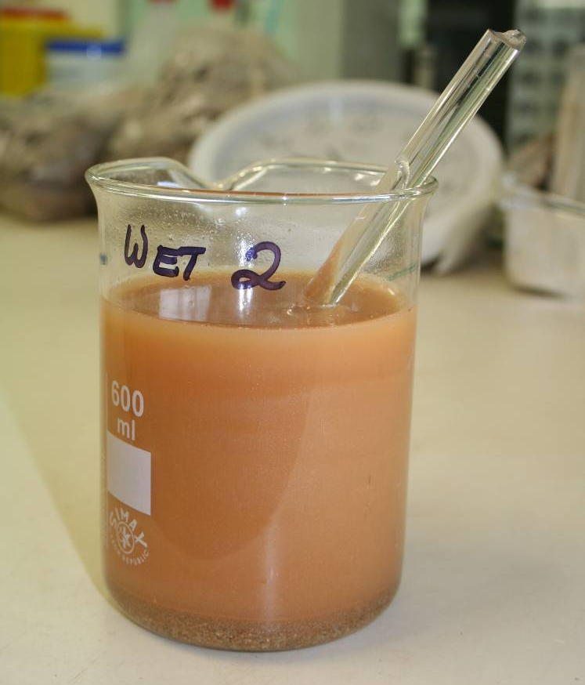  Figure 7 Sample after stirring with  glass rod
The sample solution was then poured into a set of stainless steel sieves nested at 1 φ intervals (Table 6) so that the sieves did not become overloaded. 1 φ intervals were used to reduce the number of sieves that had to be washed and cleaned, which was more difficult and time consuming with the introduction of water. The sieves were placed in a large plastic funnel that drained into a 2 L conical flask. The top sieve (1 mm) was gently rinsed with deionised water to wash the finer material through the nested set of sieves. The sieve was then removed and the material retained on the sieve was washed into a container. The next sieve down was then gently rinsed with water and the process repeated until all the sieves had been cleared (Figure 8). The smaller sieves sizes were prone to clogging with sediment and required gently tipping of the sieves whilst being washed to allow the wetted sediment to pass through (Figure 8).

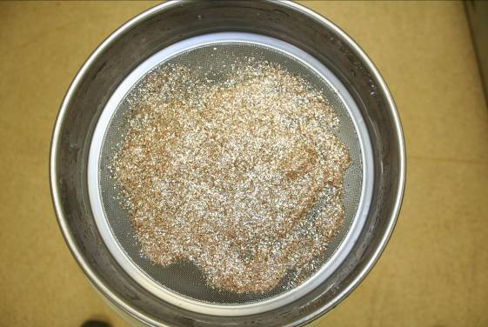 | 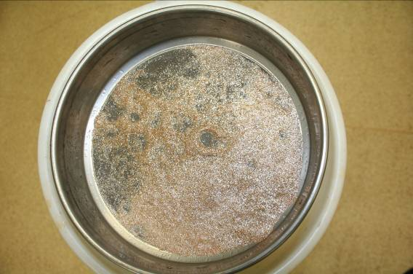
Figure 8a Material retained on 1 mm (0 φ) sieve | Figure 8b Material retained on 0.5 mm (1 φ) sieve
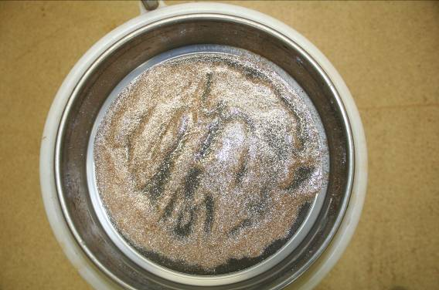 | 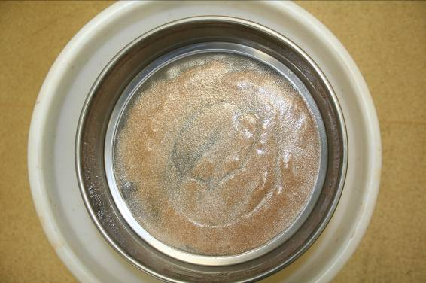
Figure 8c Material retained on 0.25 mm (2 φ) sieve | Figure 8d Material retained on 0.125 mm (3 φ) sieve
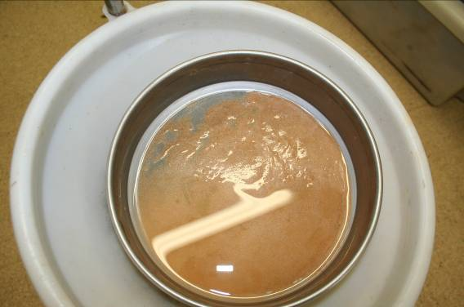 | 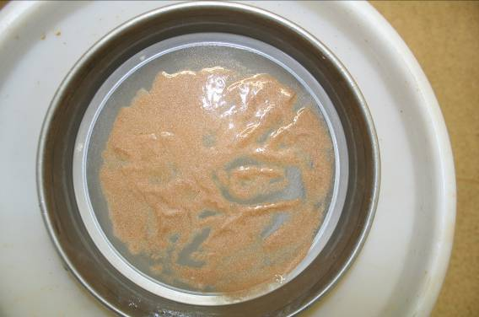
Figure 8e Clogged 0.063 mm (4 φ) sieve. Reflection of the water can clearly be seen. | Figure 8f Material retained on 0.063 mm (4 φ) sieve after carefully tipping to clear
The time to weigh each wet sieved sample through the sieves, including cleaning the sieves was approximately half an hour.
Samples were washed into aluminium containers, oven dried at 105°C and weighed to determine the percentage of material that was recovered using the wet sieving method. Each sample required at least 3 aluminium containers due to the large volumes of water (approximately 3 litres) required to wash and process the sediment. This method was used to determine only the amount of < 63 μm material that could be recovered and assess which method, wet or dry sieving, was most suitable for the separation processes. However, it is important to note that the material would need to be stored as a dry powder to prevent microbial growth and maintain the physico-chemical properties of the material. Drying of the wet sieved sediment in an oven, (at 40°C) would have resulted in it becoming a solid block, which would need to be physically and mechanically broken up. Centrifugation followed by freeze drying was found to be the most effective method of removing water from the sediment and allowing it to remain dry (discussed below).

4.2.3 Drying of the fine fraction (<63 μm) after wet sieving
The water and sediment contained in the conical flask after wet sieving was carefully transferred into 250 mL plastic bottles for centrifugation. Initially, the samples were centrifuged for 10 min at 15 000 g (ie 10 000 rpm on a Multifuge 3S+ located in the Environmental Radioactivity laboratory). The centrifugation time was subsequently extended to 15 min to increase the clarity of the supernatant. Following centrifugation, the majority of supernatant was decanted into another beaker and the remaining sediment (sludge) placed in a small glass beaker, which was then frozen to -20°C overnight (to aid the freeze drying process). The frozen sample was placed in a freeze drier (Alpha1-4LDplus, Martin Christ, Osterode am Harz, Germany) and dried for at least 4-5 days. The freeze dried sediment was carefully transferred to an acid-washed plastic container with the lid secured tightly the container was stored at 4°C. This process was repeated to increase the mass of material <63 μm. Although the process took approximately 1 to 1.5 hours per sample of working time, it required days of use for the freeze drier.

4.3 Characterisation of the isolated fine fraction (<63 μm)
In order to determine the most appropriate method for isolation of the <63 μm fraction, it was important to establish if there were differences between the wet-sieved sediment and the dry-sieved sediment. Microscope observations and electrozoning particle counting methods (ie Beckman, Coulter counter MS3) were used to investigate differences between the samples.

4.3.1 Microscopy
Approximately 0.15 mg of isolated fine fraction material was placed on a slide (several slides for each separation method) and a drop of deionised water was then overlayed on the sample. The slides were then visually inspected under a compound microscope (Leica, Laborlux S) and photographic images of each sample were taken using a 7.1 megapixel digital camera (Powershot S70, Cannon)

4.3.2 Coulter counter
Approximately 0.1 to 0.2 g of isolated fine fraction material was diluted in 1 L of Magela Creek water and subsequently diluted in Isoton II (Coulter counting electrolyte) to a concentration giving a 5-10% coincidence coefficient, as indicated by the Coulter counter. A 2 mL subsample was analysed using a 200 µm aperture tube.

5 Results

5.1 Lateritic material characterisation
The samples collected were the product of mining operations and lacked soil structure. Soil characterisation methods such as colour were made on the sampled material. The material collected from Site 1 had a Munsell Soil Colour (moist sample) dominated by 10 Y/R 6/8 (brownish yellow) with some aggregates predominantly 5 Y/R 8/1 (white). The sample was dominated by mica particles with gravels to 30 mm (b-axis diameter). The material collected from Site 2 had a Munsell Soil Colour (moist sample) of 10 Y/R 5/6 (yellowish brown). The material from Site 2 was much sandier than at site 1, with gravels up to 35 mm (b-axis diameter) and mica was still present.
The cumulative frequency grain size distributions and Folk (1954, 1974) texture group for each sediment sample that had detailed particle size undertaken are shown in Appendix A. There are different boundaries between the different size classes depending on the classification system used. The Wentworth grain size scale for sediments has been used for various reports written by and for the Supervising Scientist Division (Saynor et al 2006), but the International Soil Science Society (ISSS) scheme is also often used to describe Australian soils. The difference is between the sand and silt boundaries and the silt and clay boundaries (Table 7).
Table 7 Particle size boundaries and size percentages
Wentworth Scale (Folk 1974, 1980) |  |  |  |  | Fine Fraction
 | Gravel | Sand | Silt | Clay | Silt + Clay
Upper boundary |  | < 2.0 mm | < 0.063 mm | < 0.0039 mm | < 0.063 mm
Lower boundary | > 2.0 mm | > 0.063 mm | > 0.0039 mm
Site 1-1 | 13.7 | 60.9 | 12.4 | 13.0 | 25.4
Site 1-2 | 18.2 | 65.0 | 9.9 | 6.9 | 16.8
Site 2-1 | 16.9 | 68.7 | 4.1 | 10.4 | 14.5
Site 2-2 | 12.1 | 72.7 | 4.4 | 10.9 | 15.3
International Soil Science Society
 | Gravel | Sand | Silt | Clay | Fine Fraction
Upper boundary |  | < 2.0 mm | < 0.02 mm | < 0.0020 mm | < 0.02
Lower boundary | > 2.0 mm | > 0.02 mm | > 0.002 mm
Site 1-1 | 13.7 | 66.8 | 10.5 | 9.0 | 19.5
Site 1-2 | 18.2 | 70.1 | 6.7 | 5.0 | 11.7
Site 2-1 | 16.9 | 72.2 | 1.1 | 9.9 | 11.0
Site 2-2 | 12.1 | 76.6 | 1.0 | 10.3 | 11.3

Graphic grain size statistics have been calculated for the samples and are shown in Table 8. The meaning of the graphic grain size statistics and the verbal scales of Folk (1974, 1980) to describe these statistics are briefly outlined in Saynor et al (2006). The lateritic samples were either medium or fine sand as indicated by the graphic mean size, which is a reliable estimate of the mean size (Table 7). Inclusive graphic standard deviation is a measure of sorting and is outlined in Saynor et al (2006). The four samples all fall into the category of very poorly sorted and hence have a wide range of grain sizes. Skewness measures the degree of asymmetry of a grain size distribution and a positive skewness indicates an excess of fine sediment and vice versa. The two laterite samples from site 1 have a positive fine skew and the samples from site 2-1 and 2-2 are near symmetrical and negative coarse skewed, respectively. Graphic kurtosis measures the ratio between the sorting in the tails of the grain size distribution and the sorting in the central portion. If the central portion is better sorted than the tails, the curve is leptokurtic; if the tails are better sorted than the central portion, the curve is platykurtic. The samples from site 1 are leptokurtic and the samples from site 2 are extremely leptokurtic. Transformed kurtosis is used to normalise the kurtosis distribution. A normal curve has a value of 0.50 and most sediments range between 0.40 and 0.65.
Table 8 Graphic grain size statistics for laterite samples collected at Ranger mine 3 September 2008
Date Collected | Sample | Graphic mean (φ) | Inclusive graphic SD (φ) | Inclusive graphic skewness | Graphic kurtosis | Transformed kurtosis
03-Sep-08 | Site 1-1 | 2.05 | 3.35 | 0.33 | 1.29 | 0.56
03-Sep-08 | Site 1-2 | 1.31 | 2.94 | 0.32 | 1.34 | 0.57
03-Sep-08 | Site 2-1 | 1.36 | 3.73 | -0.06 | 3.09 | 0.76
03-Sep-08 | Site 2-2 | 2.07 | 3.27 | -0.11 | 3.44 | 0.77

A general observation about the lateritic material was that there appeared to be a lot of mica present and it was slippery and waxy to touch. An important assumption with particle size analysis is that the particles are spherical in shape. Differences in shape affect the settling velocities of the particles in liquid, which is important in the function of the hydrometer in the particle size analysis. Microscopy showed that some particles (mostly mica) were not spherical but rather flat and platy, which will affect the particle size characterisation (see discussion).

5.2 Determination of the fine fraction (<63 μm) by dry sieving
The average percentage values of fine fraction were 1.5% for site 1 and 0.76% for site 2 (Table 9). For both sites the percentage fine material was very low. The sample from site 2 was much sandier than site 1, which is probably due to its proximity to the Djalkmara Billabong, which has since been mined. It was the authors’ opinion that the sandier material collected at site 2 was less likely to be used in the final rehabilitation of the Ranger mine site because there is not sufficient amounts of this material on the mine site. Site 1 was more representative of the material that is likely to be used in the final rehabilitation and, consequently, only this material was used in determination of the fine fraction by wet sieving.
Table 9 Sample masses that were yielded by dry sieving
Sample Name | Sample mass sieved (g) | Mass (g) < 63 μm | % mass  < 63 μm
Site 1-1 | 267.13 | 3.86 | 1.44
Site 1-2 | 181.51 | 2.76 | 1.52
Site 1-3 | 267.31 | 4.37 | 1.63
Site 1-4 | 226.13 | 3.36 | 1.49
Site 1-5 | 240.91 | 3.36 | 1.39
Site 1-6 | 264.66 | 4.35 | 1.64
Site 1-7 | 264.13 | 3.36 | 1.27
Site 1-8 | 241.77 | 4.44 | 1.84
Site 1-9 | 309.11 | 3.71 | 1.20
Site 1-10 | 355.27 | 5.99 | 1.69
 | 2617.93 | 39.56
 |  | Average | 1.51
Sample Name | Sample mass sieved (g) | Mass (g) < 63 μm | % mass  < 63 μm
Site 2-1 | 318.84 | 3.13 | 0.98
Site 2-2 | 317.01 | 2.65 | 0.84
Site 2-3 | 255.82 | 1.59 | 0.62
Site 2-4 | 296.46 | 1.81 | 0.61
Site 2-5 | 221.05 | 2.29 | 1.04
Site 2-6 | 307.41 | 1.51 | 0.49
 | 1716.59 | 12.98
 |  | Average | 0.76

5.3 Determination of the fine fraction (<63 μm) by wet sieving
The average mass obtained by the wet sieving process was approximately 10% of the sample, which was an order of magnitude greater than for the dry sieving process (Table 10). It appeared that the introduction of water to the process allowed the fines to be washed from the large particles and in some cases will have contributed to the dis-aggregation of aggregated fine particles. The dry sieving process was less effective at removing/washing the fine particles. One of the practical issues with obtaining a better return of the finer fraction was the large volume of water that is required for processing. This water needs to be removed without significantly modifying the physico-chemical properties of the sediment. Centrifugation followed by freeze drying was necessary but resulted in the process being resource demanding, both in time and staff.
Table 10 Sample masses that were yielded by wet sieving
 | Total sample mass (g) | Total water used (ml) | Sample  < 63 μm | Sample  % < 63 μm
Sample number
Site 1-1 | 126.2 | 2690 | 12.6 | 9.98
Site 1-2 | 78.11 | 2432.33 | 8.78 | 11.24
Site 1-3 | 104.2 | 2366.83 | 10.29 | 9.88
Site 1-4 | 93.17 | 2316.7 | 8.27 | 8.88
Site 1-5 | 95.95 | 2340.99 | 10.34 | 10.78
Total | 497.63 | 12146.85 | 50.28
 |  |  | Average | 10.10

5.4 Microscopy
Material produced by each separation techniques was placed on a microscope slide and viewed under a compound microscope (x100). Figure 9 shows four different views of dry sieved material and Figure 10 shows four different views of wet sieved material. All samples used had the same mass per volume concentration.
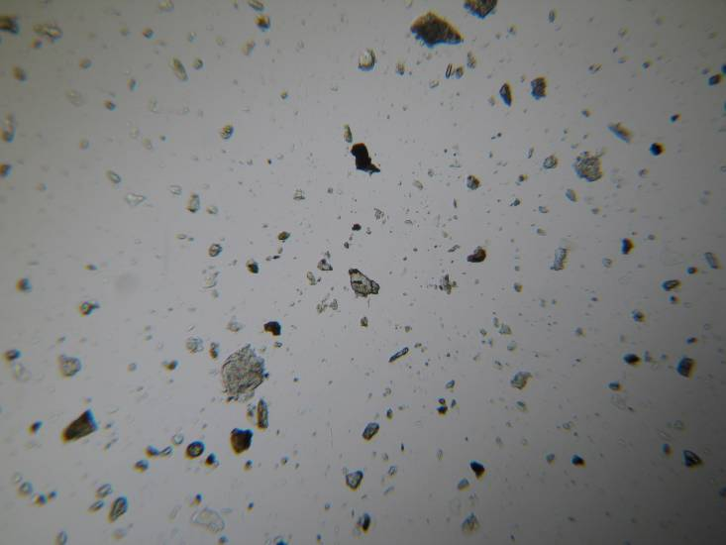  A | 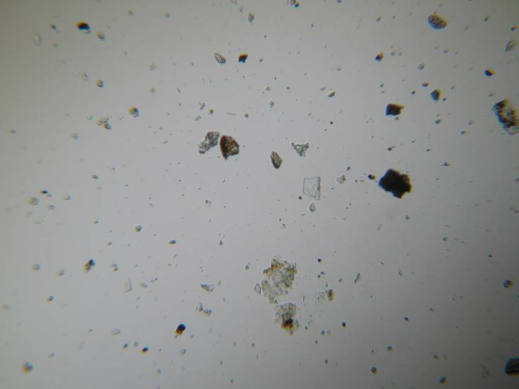  B
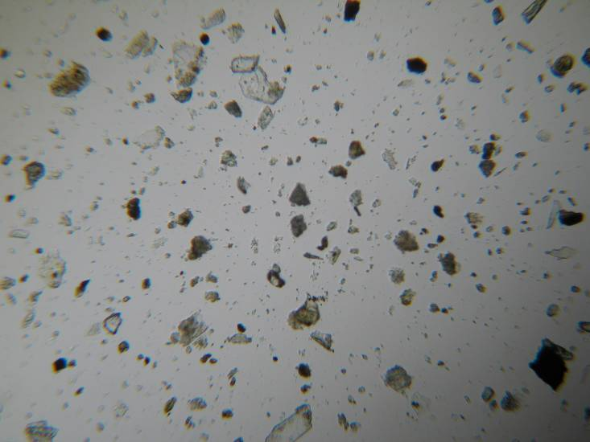  C | 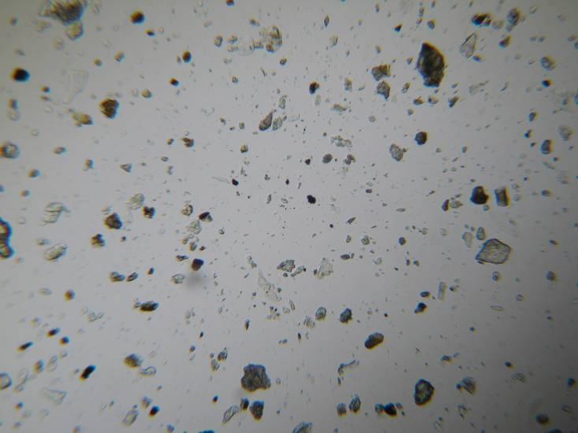  D
Figure 9 Dry sieved lateritic material < 63 μm on a slide. Four different views.
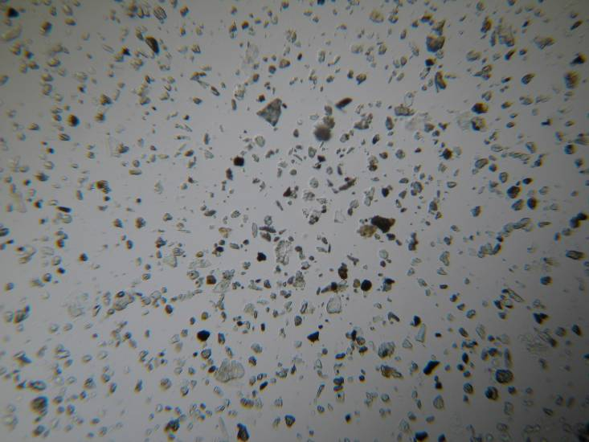  A | 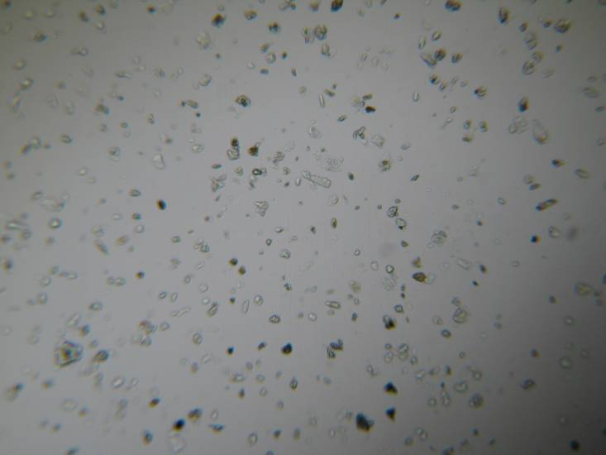  B
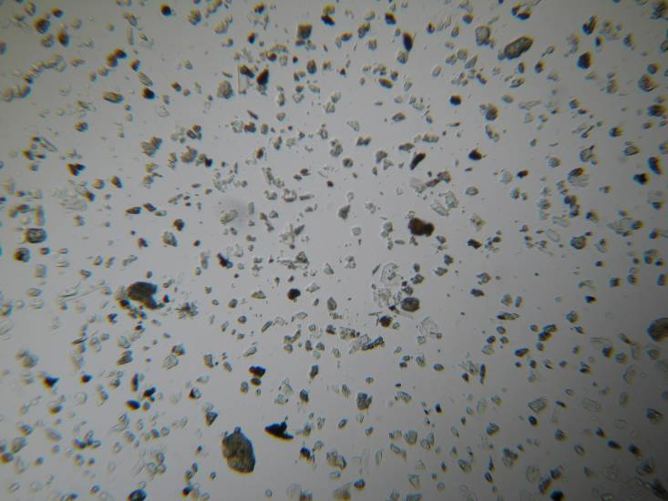  C | 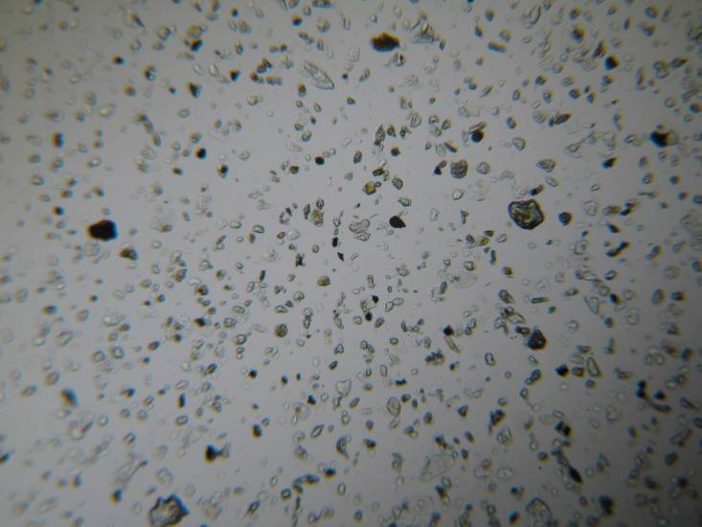  D
Figure 10 Wet sieved lateritic material < 63 μm on a slide. Four different views.
These images demonstrate that a larger amount of fine particles are present in the wet-sieved samples (Figure 10), than for the dry sieved samples (Figure 9). This observation indicates that the wet-sieving process was more successful in obtaining a higher proportion of the finer particles than the dry sieving process, although no quantative analysis from the slides could be undertaken. This is important considering that the finer particles are the focus of this work because they will remain in suspension for longer periods and are suspected to have greater biological activity compared to larger particles. The microscopy results are qualitative only as no quantification was undertaken. Image analysis (using ImageJ software) was attempted but the software was not able to clearly distinguish between the background and the transparent mica particles. Johannson et al (2008) have presented a method of estimating mica counts by a point-count method using micro photos of grain mounts, which could be followed to determine the mica content if required.

5.5 Coulter counter
Coulter counter analysis for the wet-sieved samples was also undertaken to see if this technique could be used to measure the particle size distribution. The Y axis of Figure 11 shows that the majority of particles were < 2 µm (spherical volume) with most of the measured particles present at the very small size fractions. The large number of particles at the lower end of the measurement scale meant that the coulter counter was not a reliable measurement tool. Alternative methods (eg laser diffraction, sedigraph and others) and commercial suppliers offering particle size analysis services are being investigated to further characterise the lateritic material.

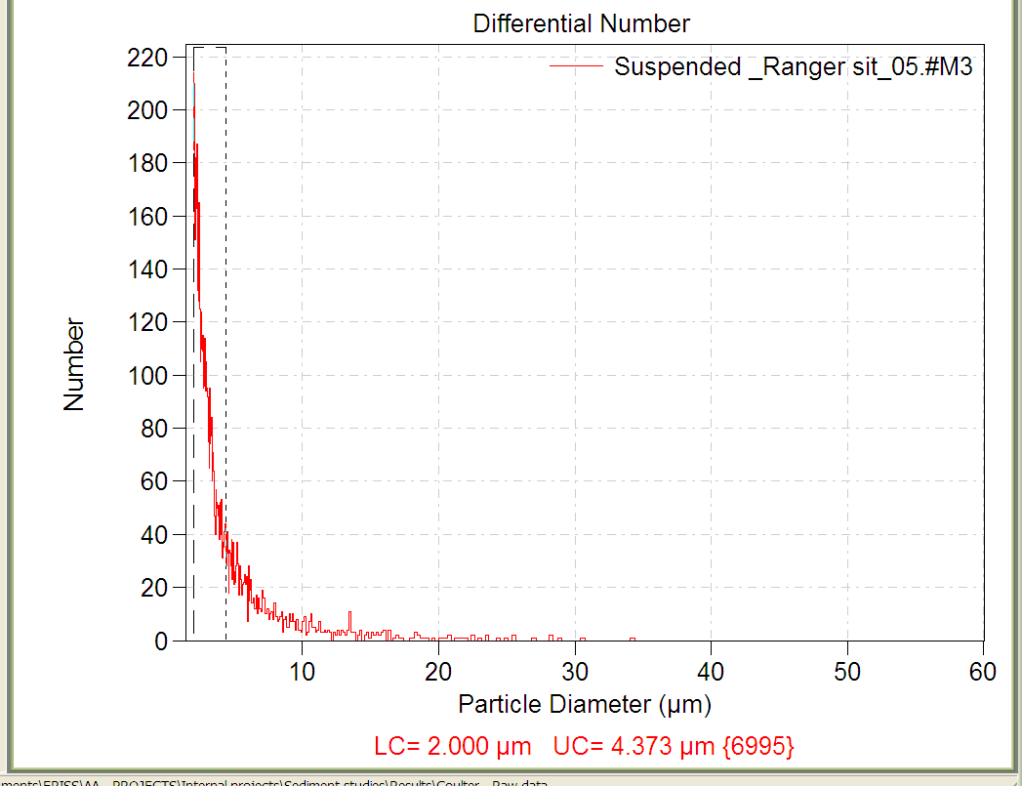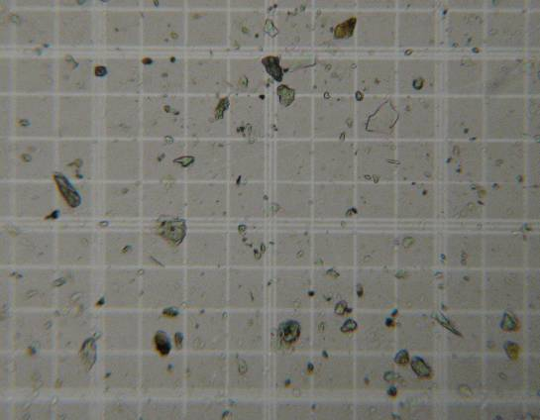
~200 μm
Figure 11 Laterite sample from Ranger mine Pit 3. Wet-sieved and diluted 1:1200 (unknown concentration). (Left) Particle size analysis from the Coulter counter showing the majority of particles < 2 µm; (Right) an image of the same sample from a compound microscope.

6 Discussion and recommendations
The trial landform is a major project to test the effectiveness of the final landform designs and revegetation strategies. The construction of the trial landform provides an opportunity to predict the erosion rates and the composition of suspended sediment being released from the landforms constructed with different substrates. The final landform is likely to be a significant point source of fine particulates to Magela Creek. Consequently, there is a need to characterise these particulates and to determine their possible impacts on aquatic biota downstream of the rehabilitated site.
The Pit 3 lateritic materials used in this study were nominated by ERA and EWLS staff as being representative of the material that was to be used in the construction of the trial landform. Observations (colour and field texture) of the sub surface samples obtained from 2 locations within Pit 3 at Ranger mine showed that they did not fit within the definition of laterite (see below). However, the material collected was the most representative (that was available at the time of sampling) of the type of material that was ultimately used to construct the trial landform and is likely to be used in the final landform.

6.1 Detailed particle size characterisation of the lateritic material
The lateritic material was separated both chemically and physically to obtain percentages of the ultimate particle size. This analysis also indicated the percentage of <63 μm material present in the sample and thus the maximum amount of sediment that could be obtained if a physical and chemical separation was used. The detailed particle size analysis (using both physical and chemical separation) of the material collected at sites 1 and 2 indicated that the material collected from site 2 contained slightly more sand than that collected from site 1 using both the Wentworth scale and the International Soil Science Society (Table 7). When using the Wentworth scale classification scheme these detailed PSA results (Table 7) are similar to those reported in Hollingsworth (2001) (Table 5) even taking into account the slight difference in the fine fraction boundary (Hollingsworth 2001 used 75 μm). All lateritic material samples in Tables 5 and 7 were sub-surface samples obtained from within Pit 3 at Ranger mine.
The detailed PSA characterisation of the four lateritic material sub-samples conducted for this report showed that the fine fraction (<63 μm) ranged between 14.5% and 25.4 % (Table 7). From the 12 surficial sediment analyses (Table 4) undertaken in the Gulungul Creek catchment the range for the fine fraction (<63 μm) was between 10.5% and 27.3%. The <63 μm fraction of the four lateritic samples is similar in range to the sediments sampled from the Gulungul Creek. However the material collected in Gulungul Creek was dominated mainly by quartz sandy material, while the lateritic material collected in Pit 3 at Ranger mine was dominated by mica.

6.2 Development of <63 μm sediment separation method
The average mass <63 μm obtained from the wet sieving process (Table 10) was approximately 10% of the initial mass, which was an order of magnitude greater than for the dry sieving process (Table 9). Only physical separation and the action of water was used to disaggregate and wash the fine particles off the larger ones. Chemical separation was not used in the process as any residual surfactants in <63 μm material to be ultimately used for ecotoxicological tests would potentially compromise the responses of the organisms. Significantly more material would be required to obtain the same sample mass when using the dry sieving method. However, the advantage of the dry sieving method was that the sediment required no drying after separation. There was also an additional advantage that the sample was not transferred between multiple containers, which reduced the risk of contamination or loss.
The main advantage of the wet sieving process was that there was a 10 fold increase in the sediment that was recovered using the process. Furthermore, fluvial erosion of fine particles would be the primary process in which suspended sediment would enter the receiving environment. Thus, the use of wet-sieving is likely to be the most operationally appropriate method. The disadvantage of this process was that large volumes of water were required for the separation process, which needed to be removed. Once the water had been removed the remaining sediment was freeze dried to prevent the sample solidifying into a block. The wet sieving process required considerably longer effort and was resource and staff intensive.
Microscopy demonstrated that a larger amount of fine particles (<63 μm) were present in the wet-sieved samples (Figure 10) compared with the dry sieved samples (Figure 9). Mineralogical analysis was not undertaken from either of the separation methods but this probably would have shown that some minerals types were preferentially retained in the larger size fraction due to electrostatic attraction to the larger particles. Thus, wet-sieving was deemed a superior method to dry sieving, especially considering that the fine particles are of greater interest because they will remain in suspension for longer durations and are likely to be more biologically active than larger particles.

6.3 Recommendations
It is recommended that a wet sieving process be used to process the bulk sampled material and build up a sufficient volume of <63 μm fraction for future test work. The process is more resource dependant (equipment, time & staff) than dry sieving but provides a better representation of the <63 μm fraction because fluvial erosion of the fine particles from the landform is the process in which suspended sediments will be transported to the receiving environment. Hence wet sieving is more likely the most operationally appropriate isolation process. The wet sieving protocol is outlined in Appendix 2.
It is recommended that at least 1 kg of <63 μm particles should be obtained by wet sieving of material collected from the construction of the trial landfrom and stored as a ‘reference material’. This sample should be characterised in detail to provide the context for the subsequent ecotoxicology tests. Specifically, the physico-chemical analysis should include; detailed metal and major ion analyses (ICP-MS/OES) following acid digestion (1M HCl for 1h follwed by aqua-regia), mineralogy (X-ray diffraction), surface area (BET gas absorption), morphology (microscopy) and Particle Size Analysis (PSA). Samples should be further size fractionated to 2.5 µm and 20 µm (which will reduce the obstruction of larger particles in the measurements) and PSA conducted by various methods (eg sedigraphy, laser diffraction and dynamic light scattering). Due to assumptions and limitations of PSA methods, a comparison of results provided by the different instruments will help their interpretation and determine the most appropriate methods for PSA of eriss samples.

7 References
Bilotta GS & Brazier RE 2008. Understanding the influence of suspended solids on water quality and aquatic biota. Water Research 42, 2849–2861.
Chartres CJ, Walker PH, Willett IR, East TJ, Cull RF, Talsma T & Bond WJ 1991. Soils and hydrology of Ranger Uranium Mine sites in relation to application of retention pond water. Technical memorandum 34, Supervising Scientist for the Alligator Rivers Region, AGPS, Canberra.
Christian CS & Stewart GA 1953. General report on survey of Katherine-Darwin region. CSIRO (Australia) Land Research Series No 1, Melbourne.
Eggleton RA 2001. The regolith glossary: Surficial geology, soils and landscapes. Cooperative Research Centre for Landscape Evolution and Mineral Exploration, Canberra.
Gee GW & Bauder JW 1986. Particle size analysis. In Methods of soil analysis Vol. 1, Physical and mineralogical methods, ed A Klute, American Society of Soil Agronomy and Soil Science Society of America, Madison, 825–844.
Hays J 1967. Land surfaces and laterite in the north of the Northern Territory. In Landform Studies from Australia and New Guinea. eds Jennings JN & Mabbutt JA, Australian University Press, Canberra, 182–210.
Hollingsworth ID 2001 Western Stockpile Pad Area Saturated Hydraulic Conductivity & Drainage Flux Draft Report, EWL Sciences Pty Ltd.
Hubble GD, Isbell RF & Northcote KH 1983 Features of Australian soils. In Soils: An Australian viewpoint. Division of Soils, CSIRO, Melbourne & Academic Press, London.
Hunt PA, Mitchell PB & Paton 1977. ‘Laterite profiles’ and ‘lateritic ironstones’ on the Hawkesbury Sandstone, Australia. Geoderma 19, 105–121.
Johansson E, Miskovsky K, Loorents K & Lofgren O 2008. A method for estimation of free mica particles in aggregate fine fraction image analysis of grain mounts. Journal of Materials Engineering and Performance 17(2), 250–253.
Pickett JW 2003. Stratigraphic relationships of laterite at Little Bay, near Maroubra, New South Wales. Australian Journal of Earth Sciences 50, 63–68.
Pool P 2008. Ranger Closure. 1p’s – Laterite Mix Proportion Initial Trials. Short Report EWL Sciences Pty Ltd.
Saynor MJ, Erskine WD & Evans KG 2006. Bed-material grain size changes in the Ngarradj Creek catchment between 1998 and 2003. Supervising Scientist Report 188, Supervising Scientist, Darwin NT.
Saynor MJ, Houghton R, Hancock G, Staben G, Smith B & Lee N 2009. Soil sample descriptions – Gulungul Creek, Ranger mine site and Nabarlek: Cyclone Monica fieldwork. Internal Report 558, Supervising Scientist, Darwin. Unpublished paper.
Story R, Williams MAJ, Hooper ADL, O’Ferral RE & McAlpine JR 1969. Lands of the Adelaide-Alligator area, Northern Territory. Land Research Series No 25, CSIRO (Aust.).
Stowar M 1997. Effects of suspended solids on benthic macroinvertebrate fauna downstream of a road crossing, Jim Jim Creek, Kakadu National Park. Internal report 256, Supervising Scientist, Canberra. Unpublished paper.
Wigston SR 1992. General monitoring of soils at Nabarlek and Ranger Uranium Mines In Proceedings of the Workshop on Land Application of Effluent Water from Uranium Mines in the Alligator Rivers Region. ed Akber RA, Australian Government Publishing Service, Canberra, 43–53.
Willett IR, Chartres CJ & Bond WJ 1992. Soils and hydrology of the Ranger Uranium Mine land application site. In Proceedings of the Workshop on Land Application of Effluent Water from Uranium Mines in the Alligator Rivers Region. ed Akber RA, Australian Government Publishing Service, Canberra, 25–42.

References read but not relevant to laterite characterisation
Campbell S 1994. A study of the rapid disintegration of waste rock dumps at Ranger Uranium mine, Northern Territory. Special topics, Final Report.
Russel H & McGill J 1999. Laterite Processing Trial October. November 1999. Energy Resources of Australia Ltd – Ranger Mine.

Appendix 1 Particle size distributions
Particle size analysis results for the lateritic material collected from Ranger mine on 3 September 2008

Ranger Mine Laterite Site 1
Cumulative frequency data for Ranger mine laterite Site 1
Sample 1 |  |  | Sample 2
Phi (Φ) | Size (mm) | Cumulative Percentage | Phi (Φ) | Size (mm) | Cumulative Percentage
-4 | 16 | 0.00 | -4 | 16 | 0.00
-3.25 | 9.5 | 1.09 | -3.25 | 9.5 | 2.54
-2 | 4 | 7.73 | -2 | 4 | 10.18
-1.5 | 2.8 | 10.46 | -1.5 | 2.8 | 13.77
-1 | 2 | 13.72 | -1 | 2 | 18.24
-0.5 | 1.4 | 18.06 | -0.5 | 1.4 | 24.76
0 | 1 | 23.73 | 0 | 1 | 33.66
0.5 | 0.71 | 30.09 | 0.5 | 0.71 | 40.59
1 | 0.5 | 38.02 | 1 | 0.5 | 49.01
1.5 | 0.355 | 45.20 | 1.5 | 0.355 | 56.43
2 | 0.25 | 54.59 | 2 | 0.25 | 65.24
2.5 | 0.18 | 62.17 | 2.5 | 0.18 | 72.23
3 | 0.125 | 68.04 | 3 | 0.125 | 77.89
3.5 | 0.09 | 71.49 | 3.5 | 0.09 | 80.85
4 | 0.063 | 74.63 | 4 | 0.063 | 83.23
4.64 | 0.04 | 79.93 | 4.64 | 0.04 | 87.99
5.80 | 0.0179 | 80.65 | 5.76 | 0.0185 | 88.34
6.30 | 0.0127 | 82.80 | 6.25 | 0.0131 | 89.40
7.08 | 0.0074 | 85.31 | 7.04 | 0.0076 | 90.81
7.85 | 0.0043 | 86.74 | 7.82 | 0.0044 | 92.93
8.64 | 0.0025 | 88.17 | 8.61 | 0.0026 | 93.64
9.05 | 0.0019 | 91.40 | 9.02 | 0.0019 | 95.05
14.00 | 0.0011 | 100.00 | 14.00 | 0.0011 | 100.00
Graphic grain size statistics of Folk and Ward (1957) and Folk (1954, 1974, 1980)
Site 1 | Graphic Mean (φ) | Inclusive Graphic Standard Deviation (φ) | Inclusive Graphic Skewness | Graphic Kurtosis | Transformed Kurtosis
Site 1-1 | 2.05 | 3.35 | 0.33 | 1.29 | 0.56
Site 1-2 | 1.31 | 2.94 | 0.32 | 1.34 | 0.57
Soil textural classification for soil samples Folk (1954, 1974, 1980)
Site 1 | Method | Textural class
Site 1-1 | Detailed Particle Size Analysis | Pebbly muddy medium sand
Site 1-2 | Detailed Particle Size Analysis | Pebbly muddy medium sand

Ranger Mine Laterite Site 2
Cumulative frequency data for Ranger mine laterite Site 2
Sample 1 |  |  | Sample 2
Phi (Φ) | Size (mm) | Cumulative Percentage | Phi (Φ) | Size (mm) | Cumulative Percentage
-5.00 | 32 | 0.00 | -5.00 | 32 | 0.00
-4 | 16 | 11.01 | -4 | 16 | 5.34
-3.25 | 9.5 | 12.74 | -3.25 | 9.5 | 6.17
-2 | 4 | 15.24 | -2 | 4 | 9.62
-1.5 | 2.8 | 16.00 | -1.5 | 2.8 | 10.90
-1 | 2 | 16.90 | -1 | 2 | 12.08
-0.5 | 1.4 | 17.37 | -0.5 | 1.4 | 12.95
0 | 1 | 18.51 | 0 | 1 | 14.29
0.5 | 0.71 | 21.73 | 0.5 | 0.71 | 17.36
1 | 0.5 | 29.12 | 1 | 0.5 | 24.06
1.5 | 0.355 | 38.79 | 1.5 | 0.355 | 32.46
2 | 0.25 | 53.01 | 2 | 0.25 | 47.63
2.5 | 0.18 | 68.17 | 2.5 | 0.18 | 64.76
3 | 0.125 | 78.07 | 3 | 0.125 | 76.98
3.5 | 0.09 | 83.00 | 3.5 | 0.09 | 82.10
4 | 0.063 | 85.56 | 4 | 0.063 | 84.75
4.64 | 0.04 | 89.07 | 4.64 | 0.04 | 88.43
5.76 | 0.0184 | 89.07 | 5.76 | 0.0185 | 88.75
6.26 | 0.0130 | 89.07 | 6.26 | 0.0131 | 88.75
7.06 | 0.0075 | 89.07 | 7.05 | 0.0075 | 88.75
7.85 | 0.0043 | 89.65 | 7.84 | 0.0044 | 89.07
8.64 | 0.0025 | 89.65 | 8.63 | 0.0025 | 89.39
9.05 | 0.0019 | 90.22 | 9.05 | 0.0019 | 89.71
14.00 | 0.0011 | 100.00 | 14.00 | 0.0011 | 100.00
Graphic grain size statistics of Folk and Ward (1957) and Folk (1954, 1974, 1980)
Site 2 | Graphic Mean (φ) | Inclusive Graphic Standard Deviation (φ) | Inclusive Graphic Skewness | Graphic Kurtosis | Transformed Kurtosis
Site 2-1 | 1.36 | 3.73 | -0.06 | 3.09 | 0.76
Site 2-2 | 2.07 | 3.27 | 0.11 | 3.44 | 0.77
Soil textural classification for soil samples Folk (1954, 1974, 1980)
Site 2 | Method | Textural class
Site 2-1 | Detailed Particle Size Analysis | Pebbly muddy medium sand
Site 2-2 | Detailed Particle Size Analysis | Pebbly muddy fine sand

Appendix 2 Separation of the lateritic material – operational protocol

Introduction
During discussions prior to sampling of the lateritic material, it was agreed that the fine fraction (< 63 µm) was the size fraction that was important for the project to investigate the direct effects of suspended sediment on tropical freshwater biota. This protocol describes the separation method of the lateritic material to obtain the < 63 µm using a wet sieving technique.

Wet laboratory procedure wet sieving
- Sample should be taken directly from the 20 L container and placed on a 2 mm sieve (300 mm diameter) with receiver, so that the mesh is approximately covered.
- Gently shake the sieve set from side to side and roll around the larger rocks.
- Remove the larger rocks by hand as the sample is being gently shaken and set aside in a container.
- Shake the sample for approximately 2–3 mins
- Remove the material on the sieve to container with the larger rocks and store all in a labelled plastic bag.
- Clean the sieve
- Weigh out approximately 100g of the material in the receiver and place in a 600 mL glass beaker
- Add deionised water make up approximately 500 mL of solution and stir thoroughly for at least 5 mins using a glass stirring rod (Figure 1, Appendix).
- Set up set of sieves (1.0 mm, 0.5 mm, 0.25mm, 0.125mm & 0.063mm) in the plastic funnel (see image), place the 3 litre conical flask underneath the funnel outlet (Figure 2, Appendix).
- Fill squirting water bottles with deionised water.
- Stir the sample in the beaker and then gently pour onto the top sieve (1.0 mm).
- Wash all of the sample out of the beaker with the water bottle
- Gently squirt/flush water through the sample on the sieve to move the smaller particles down onto the other sieves.
- Remove the top sieve from the stack and wash (clean) the remaining sediment into another container for storage.
- Repeat the process on each of the sieves down through the set of sieves.
- The lower sieves (finer mesh sizes) are prone to clogging with the material and will require gentle tipping of the sieves whilst being squirted to allow the water laden sediment to pass through.
- Once the bottom sieve has been flushed through and removed carefully squirt around the funnel to wash/flush sediment into the receiving flash.
Note: An initial sediment mass of 100g will take approximately 3 L of deionised water to flush the <63 µm fraction through the set of sieves.

Drying of the sample
The water and sediment contained in the conical flask after wet sieving needs to be dried by centrifugation followed by freeze drying. The centrifuge is located in the Environmental Radioactivity laboratory and the laboratory manager should be notified when it is to be used.
- Carefully mix swirl the sediment solution in the conical flask and carefully pour/transfer similar amounts in to specially-made polycarbonate high-speed centrifuge bottles.
- The beakers need to be weighed so that they are of equal weight to ensure that the centrifuge does not become unbalanced during operation.
- Centrifuge for 15 mins at ~15 000 g (ie 10 000 revolutions/min).
- Carefully decant the supernatant into another beaker.
- Once the supernatant has been decanted, place the remaining sediment (sludge) in a plastic beaker using a minimum amount of water to wash out the centrifuge bottle.
- Place the plastic beaker containing the sediment in a freezer to freeze overnight (to facilitate the freeze drying process).
- Place the plastic beaker container with the frozen sample in the freeze drier and allow drying for at least 4–5 days.
- Once dry transfer into an air-tight, acid-washed plastic container and secure the lid.
- Store the container in a desiccator at room temperature.
- Continue to add sample to this container as it is prepared.

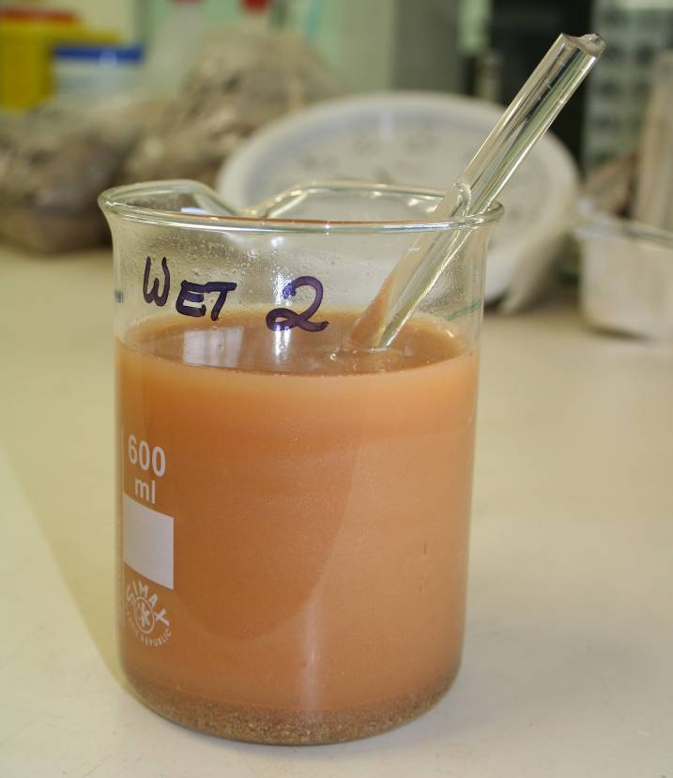  Figure 1 Sample after stirring with glass rod | 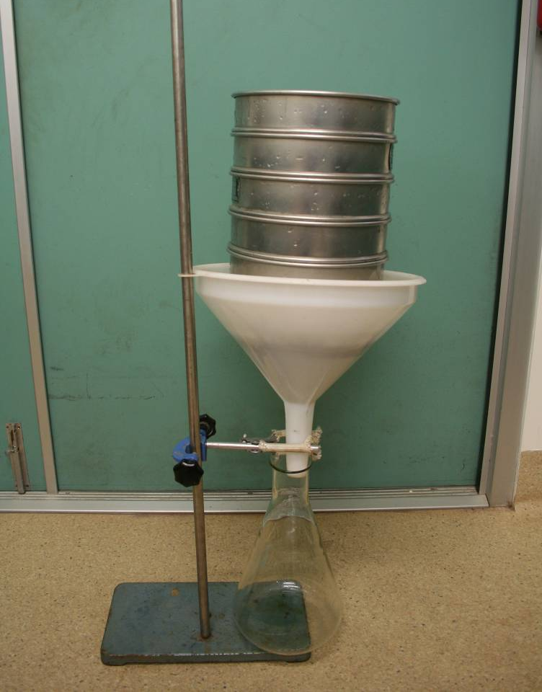  Figure 2 Wet sieve set up

The phi (φ) notation system is often used to describe the grain size of clastic sediment by sedimentologists (Folk 1974, 1980). It is a logarithmic scale in which each grade limit is twice as large as the next smaller grade limit (Folk 1974, 1980) and is denoted by: φ = -log₂ d where d is the grain diameter in mm.

