Wave-short

609

*internal report*





**Surface water chemistry monitoring protocol to assess impacts from the Ranger Mine**

Supervising Scientist Division

December 2012

Release status – Unrestricted

Project number – MON-2001-003

*This page has been left blank intentionally.*

# Surface water chemistry monitoring protocol to assess impacts from the Ranger Mine

Supervising Scientist Division

Supervising Scientist Division

GPO Box 461, Darwin NT 0801

December 2012

Project number **MON-2001-003**

Registry File SSD2011/0159

(Release status – Unrestricted)



*How to cite this report:*

Supervising Scientist Division 2012. Surface water chemistry monitoring protocol to assess impacts from the Ranger Mine. Internal Report 609, December, Supervising Scientist, Darwin.

*Project number – MON-2001-003*

*Location of final PDF file in SSDX SharePoint:*

[*Supervising Scientist Division > PublicationWork > Publications and Productions > Internal Reports (IRs) > Nos 600 to 699 > IR609_Surface water chemistry monitoring protocol (Frostick)*](http://publications.nt.environment.gov.au/PublicationWork/Forms/AllItems.aspx?RootFolder=/PublicationWork/Publications%20and%20Productions/Internal%20Reports%20(IRs)/Nos%20600%20to%20699/IR609_Surface%20water%20chemistry%20monitoring%20protocol%20(Frostick%20and%20Turner)&FolderCTID=&View=%7bB33DDE98-325C-4F81-A334-628A1B8982DA%7d)

*Location of all key data files for this report in SSDX SharePoint:*

Supervising Scientist Division > SSD > RANGER > Water Quality > Stream Based Water Chemistry (Continuous Monitoring) > Protocol

*Authors of this report:*

Supervising Scientist – Supervising Scientist Division, GPO Box 461, Darwin NT 0801, Australia

The Supervising Scientist is part of the Australian Government Department of Sustainability, Environment, Water, Population and Communities.

© Commonwealth of Australia 2012

Supervising Scientist

Department of Sustainability, Environment, Water, Population and Communities

GPO Box 461, Darwin NT 0801 Australia

This work is copyright. Apart from any use as permitted under the Copyright Act 1968, no part may be reproduced by any process without prior written permission from the Supervising Scientist. Requests and enquiries concerning reproduction and rights should be addressed to Publications Enquiries, Supervising Scientist, GPO Box 461, Darwin NT 0801.

e-mail: publications_ssd@environment.gov.au

Internet: www.environment.gov.au/ssd (www.environment.gov.au/ssd/publications)

The views and opinions expressed in this report do not necessarily reflect those of the Commonwealth of Australia. While reasonable efforts have been made to ensure that the contents of this report are factually correct, some essential data rely on references cited and/or the data and/or information of other parties, and the Supervising Scientist and the Commonwealth of Australia do not accept responsibility for the accuracy, currency or completeness of the contents of this report, and shall not be liable for any loss or damage that may be occasioned directly or indirectly through the use of, or reliance on, the report. Readers should exercise their own skill and judgment with respect to their use of the material contained in this report.

Printed and bound in Darwin NT by Supervising Scientist Division

# 

# Contents

Executive summary iv

Preamble v

Acknowledgments v

1 Introduction 1

1.1 Objective 1

1.2 Background 1

1.3 Principle of the monitoring technique 3

1.4 Method development 3

2 Experimental design 6

2.1 Grab sample data for performance assessment 6

2.2 Continuous data for performance assessment 8

3 Overview of monitoring procedures 9

3.1 Occupational health and safety 9

3.2 Monitoring sites 9

3.3 Sample collection and analysis 10

3.4 Quality control procedures 13

4 Data storage, entry and quality control 15

4.1 Data storage 15

4.2 Data entry quality control 16

5 Data analysis 16

6 Reporting 16

6.1 Traditional Owners and Aboriginal residents 18

6.2 Supervising Scientist annual report 18

6.3 Internet 18

6.4 Alligator Rivers Region Technical Committee and Annual Research Summary (Supervising Scientist Report) 18

6.5 Summary report for stakeholders 18

7 Glossary of terms and abbreviations 19

References and additional reading 21

## Executive summary

The Supervising Scientist Division (SSD) operates an integrated chemical (including radiological), physical and biological monitoring program to ensure protection of the aquatic ecosystems of the Alligator Rivers Region (ARR) from the impact of uranium mines in the region. The Ranger Mine, operated by Energy Resources of Australia Ltd, is the only operating mine in the region, with the nearby Jabiluka site having been largely rehabilitated and in long-term care and maintenance. Consequently, the Ranger Mine is the current focus of SSD’s monitoring effort. The monitoring conducted by SSD is an independent assurance program, which complements the compliance water chemistry monitoring program carried out by the mining company (Energy Resources of Australia Ltd) and the check monitoring carried out by the NT government regulator (Department of Mines and Energy).

The techniques and ‘indicators’ used in the monitoring program satisfy two important needs of environmental protection:

1) the early detection of significant changes in measured indicators to avoid short- or longer- term ecologically important impacts; and

2) assessing ecological or ecosystem-level effects by using surrogate indicators of biodiversity. The surface water chemistry monitoring program falls under the early detection category.

For each monitoring component, two levels of documents have been prepared- high-level protocols and detailed operational manuals. This document is the high-level protocol that describes the science underpinning the surface water chemistry monitoring program. It provides an overview of the monitoring principles and objectives, experimental and statistical design, sample collection and chemical analysis methods, data analysis and impact assessment procedures and reporting requirements.

## Preamble

This document details the science underpinning the experimental design and data interpretation methods used for the monitoring of surface water quality in natural streams in the vicinity of the Ranger Mine. The monitoring of water quality in these environments is a component of the multiple lines of evidence monitoring program implemented by the Supervising Scientist Division (van Dam et al 2002, Jones et al 2008).

Full details and descriptions of the methods and procedures required to implement the surface water chemistry monitoring program are contained in the following documents:

1. Surface water chemistry monitoring program — operational manual

The operational manual contains detailed instructions for site and instrument maintenance and calibrations, in-situ quality control checks, sample collection and laboratory processing, response to site alarms, data management and data cleaning and validation.

The operational manual is a controlled document and is in a loose-leaf, ring-bound form allowing for revision and update. It defines the operational details for each the specific methods used for each surface water chemistry monitoring program procedure.

1. Surface water chemistry monitoring program — reporting manual

The reporting Manual describes the procedures used to validate, interpret and report the surface water quality monitoring results. The reporting manual contains detailed instructions for quality control requirements, follow-up actions where trigger values are exceeded and preparation of website charts and explanatory notes.

Proposed revisions to the operational and reporting manuals must be approved by the SSD Monitoring Support Group before these controlled documents can be updated.

## Acknowledgments

The following SSD personnel have been involved in the Surface Water Chemistry Monitoring Program and have provided valuable input into the evolutionary development of this protocol: Alison Frostick, Kate Turner, Lisa Chandler, David Jones, Duncan Buckle, Jenny Brazier, Claudia Sauerland, Michelle Isles, Don Elphick and Christopher Humphrey.

**Contact officers:**

|  |  |
| --- | --- |
| Alison Frostick  Office of the Supervising Scientist,  PO Box 461, Darwin NT  08 8920 1140 Alison.Frostick@environment.gov.au | Kate Turner Environmental Research Institute of the Supervising Scientist, PO Box 461, Darwin NT  08 8920 1391 Kate.Turner@environment.gov.au |

*This page has been left blank intentionally.*

# Surface water chemistry monitoring protocol to assess potential impacts from the Ranger mine site

Supervising Scientist Division

## 1 Introduction

### 1.1 Objective

Detection of changes in water chemistry in water courses downstream of uranium (U) mines and assessment of these changes against a prescribed management framework that determines the most appropriate and relevant course of action according to the magnitude and duration of the change.

### 1.2 Background

The role of the Supervising Scientist Division (SSD) is to ensure the protection of the environment and the people of the Alligator Rivers Region (ARR) from the potential impacts of uranium mining in the ARR, of which the World Heritage listed Kakadu National Park (KNP) comprises the major part. These potential impacts are detected by SSD’s integrated monitoring program. This document describes the scope of, and the science underpinning, the surface water chemistry component of the integrated monitoring program.

There are three mineral leases within the ARR which pre-date the proclamation of KNP. These are Ranger, Jabiluka and Nabarlek (Figure 1). There are also a number of former small uranium mines in the South Alligator Valley (SAV) of the ARR, which were mined between 1954 and 1964.

Jabiluka has been in a long-term care and maintenance phase since late 2003 and in its current state poses a very low potential risk to the environment. The surface water chemistry monitoring data set acquired between 2001 and 2008 indicated that the environment remained protected and as a result the SSD monitoring program at Jabiluka, with the agreement of all relevant stakeholders, has been systematically scaled back. Since the 2009–10 wet season SSD has been collecting continuous monitoring data, including electrical conductivity (EC) and water level, from the downstream statutory compliance site (Supervising Scientist 2010).

A watching brief is maintained for the decommissioned and rehabilitated Nabarlek site in Arnhem Land, and the rehabilitated legacy sites in the SAV. Rehabilitation works in the SAV were completed in late 2009. The results from a risk assessment conducted by SSD concluded that residual water quality impacts did not pose a significant risk to the South Alligator River (Bollhöfer et al 2010, Turner et al 2009). SSD does not undertake any monitoring at Koongarra since the lease has never been subjected to uranium mining activity and is currently in the process of being reincorporated back into Kakadu National Park.

The current primary focus of the surface water chemistry monitoring (SWCM) program conducted by SSD is therefore to ensure that the aquatic environment downstream of the operating Ranger Mine remains protected from the potential impacts of uranium mining.

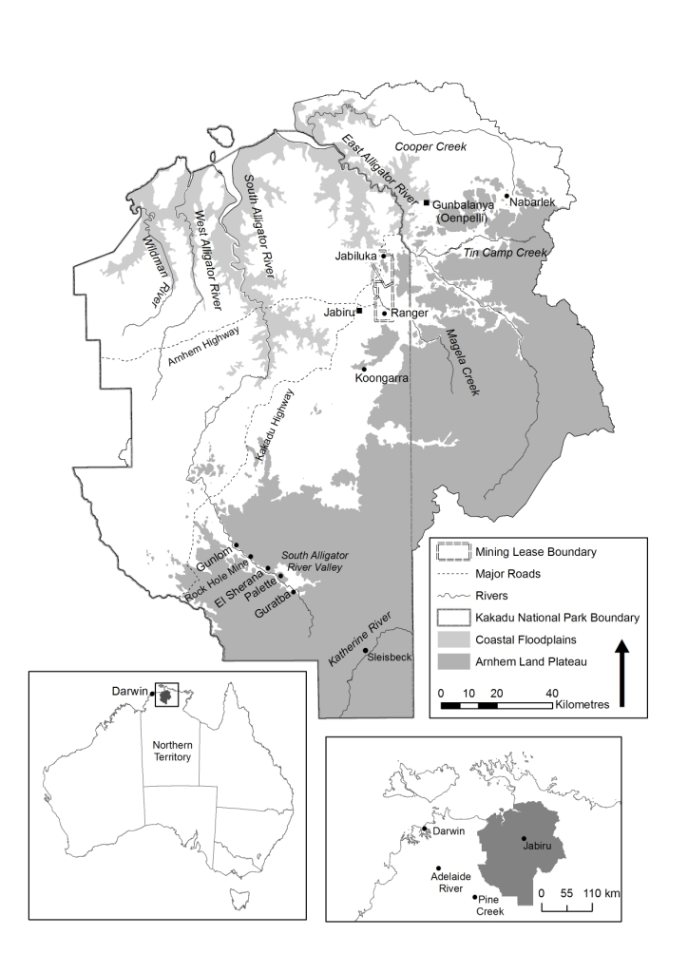

**Figure 1** Map of the Alligator Rivers Region showing the Ranger, Jabiluka, Nabarlek and South Alligator Valley mine sites

Since 2001 SSD has undertaken a formal environmental monitoring program encompassing biological, physical, chemical and radiological components that are used to monitor and assess potential impacts upon ecosystems and humans arising from mining activities at Ranger. The implementation of this program was in response to the Supervising Scientist’s recommendations in the report, *Investigation of tailings water leak at the Ranger uranium mine* (Supervising Scientist 2000).

The aims of the SWCM program are to:

* provide early warning of potentially detrimental changes in water quality;
* provide confidence that the environment downstream of the operational Ranger Mine remains protected from the potential adverse effects of uranium mining;
* determine if values of key water quality variables at the compliance point on the Ranger Project Area exceed the site-specific water quality trigger values adopted for those variables;
* provide confidence that the environment downstream of other potentially mining-impacted catchments within Alligator Rivers Region remains protected;
* identify long- and short-term trends in water quality; and
* assist in the interpretation of biological monitoring data.

### 1.3 Principle of the monitoring technique

Environment protection is ensured by comparing water quality data from sites located downstream of the Ranger Project Area with i) data from control sites located upstream of the Ranger Project Area and/or ii) against a set of trigger values developed in accordance with the Australian and New Zealand Environment Conservation Council and Agriculture and Resource Management Council of Australia and New Zealand Water Quality Guidelines (Iles 2004, ANZECC & ARMCANZ 2000).

### 1.4 Method development

Historically, the SWCM program comprised weekly in situ measurement of physico-chemical parameters and collection of grab samples for analysis of filterable concentrations of mine-related solutes. In 2010 the weekly grab sampling regime was replaced, following five years of rigorous evaluation of methodology, by continuous monitoring of physico-chemical parameters coupled with automatic event-based (triggered by in situ EC and turbidity values) collection of water samples for analysis of total metal concentrations (Supervising Scientist 2010). Progressive enhancements were made during the evaluation period, including the validation of sample filtration and preservation methods used for event-based sampling, and development of EC triggers from the results of ecotoxicological testing.

Continuous monitoring provides the capacity to detect and track, in real time, the dynamic changes in the water quality of the creek system that would otherwise pass undetected by the much less frequent weekly grab sample program. This is illustrated in Figure 2 which compares the continuous EC data with those obtained from weekly grab samples during the 2008–09 wet season, noting the EC guideline value of 43 µs/cm for Magela Creek.

The behaviour of EC downstream of the mine is controlled by the interaction between water level in Magela Creek and inputs of higher EC mine runoff waters via two tributary lines that emanate from the Range lease area. At rising or high flows in Magela Creek, mine-derived waters become backed-up in the tributaries and are only discharged to Magela Creek when the flow recedes, resulting in pulses of increased EC at the downstream site during periods of falling or low flows in Magela Creek.

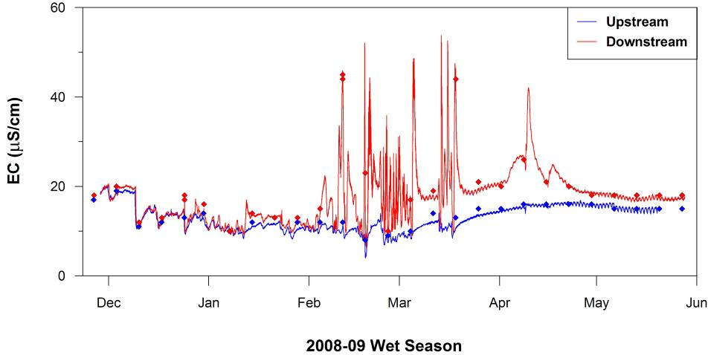

**Figure 2** Upstream (blue) and downstream (red) electrical conductivity (EC) data obtained over the 2008-09 wet season in Magela Creek. The points represent the weekly grab sample data and the lines represent the continuous monitoring data.

In addition, because peak flows in Magela Creek usually occur in the early to mid evening (due to the occurrence of intense tropical storms in the mid to late afternoon) the EC in Magela Creek downstream of the mine follows a diurnal cycle through which there is an inverse relationship between flow and net EC in Magela Creek (Figure 3).



**Figure 3** Mean (between 2005 and 2008) hourly net electrical conductivity (mean downstream EC minus mean upstream EC) in Magela Creek (grey bars). The mean hourly Magela Creek discharge over this period of record (1971 to 2008) is overlain for comparison (black line). The typical time window for collection of grab samples is marked for reference.

The dynamic nature of the above processes explains why so few of the EC pulses occurring during the 2008-09 wet season were captured by the weekly grab sampling program and highlights the benefits of continuous monitoring.

The continuous monitoring methodology was developed further (between 2007 and 2010) to include automated collection of water samples based on in situ values of EC and turbidity. These parameters typically behave differently responding to rainfall events and creek flow. Increased rainfall typically results in a decrease in EC via dilution of solutes with low salinity rainfall. Conversely turbidity will typically spike on the leading edge of the hydrograph of rainfall events as surface water flows mobilise sediment into the creeks.

A sample is collected when a specified threshold value is reached. Subsequent samples are collected for each increase of either a prescribed increment value (for turbidity) or a rate of rise over a prescribed time (for EC), ensuring that good coverage of samples for subsequent chemical analysis is obtained over an event (Table 1).

**Table 1** Values of electrical conductivity (EC) and turbidity used for triggering the automatic collection of event-based water samples

|  |  |  |  |  |
| --- | --- | --- | --- | --- |
|  | **EC (µS/cm)** | | **Turbidity (NTU)** | |
| **Base Trigger** | **Rate of rise** | **Base Trigger** | **Increment Trigger** |
| Magela Creek upstream | 14 | 5 µS/cm in 5 minutes | 10 | 15 |
| Magela Creek downstream | 35 | 10 µS/cm in 5 minutes | 10 | 15 |
| Gulungul Creek upstream | 20 | 10 µS/cm in 5 minutes | 20 | 30 |
| Gulungul Creek downstream | 30 | 10 µS/cm in 5 minutes | 20 | 30 |

One of the critical issues that needed to be addressed as part of the development of the event-based sampling regime was the effect of sample holding time on solute speciation. In particular, the changes through time in dissolved uranium concentration as a result of adsorption on particulate matter. This was not an issue for the original grab sampling program since the collected samples were immediately filtered in the field. In the case of the event-triggered samples, in excess of 24h could pass between collection of the sample and retrieval for processing. To address this issue event-based water samples (94 in total) collected from the Magela Creek downstream site over the 2009–2010 wet season and over a range of EC and turbidity levels were analysed for both the pseudo-total (dissolved metals plus those extracted from suspended particulate material by 2% nitric acid over 24 hours) and filterable (<0.45 µm dissolved metals only) metal concentrations. A pseudo-total analysis results in a partial extraction of metals from the suspended particulate material and provides an estimate of the most readily available metal in the solid phase. This pseudo-total is not a true total of all metal present as would be provided by a complete breakdown of the silicate matrix by digestion using a combination of strong acids (eg nitric, hydrofluoric and boric acids). For the remainder of this document reference to total analysis will mean pseudo-total analysis as described above.

The summary findings from this work are reported in Table 2.

**Table 2** Mean (n=94) distribution of key analytes (as defined in Frostick et al 2012) associated with the dissolved and particulate fraction of water samples collected in Magela Creek at the downstream site. The standard deviation of the mean is in brackets.

|  |  |  |  |  |
| --- | --- | --- | --- | --- |
|  | **Magnesium** | **Manganese** | **Sulfate** | **Uranium** |
| Dissolved (%) | 95 (± 11) | 42 (± 30) | 95 (± 11) | 67 (± 14) |
| Particulate (%) | 5 (± 11) | 58 (± 30) | 5 (± 11) | 33 (± 14) |

The total values for the ‘conservative solutes’ magnesium (Mg) sulfate (SO4) are seen be very close to the true total whilst for , use of a total value will overestimate by about 50% the dissolved concentration. The use of total concentration thus provides for a conservative estimate of the concentrations of the solutes that are present. The relative proportions (dissolved or particulate) of the total concentration present in a given event-based sample can be estimated using the data in Table 2 as a guide, noting that the guideline values used for compliance assessment apply to the dissolved concentrations.

Continuous in situ measurement of key water quality variables (EC and turbidity) and event-based water sampling together ensure the SWCM program is capable of detecting and quantifying any exceedances of water quality trigger values set for key water quality variables.

## 2 Experimental design

The SWCM program is designed to detect and interpret changes in water chemistry (physical and chemical parameters). The hypothesis being tested by the monitoring program is, *that the value of a key parameter measured at a downstream compliance monitoring point* ***does not*** *exceed the trigger guideline or limit set for that parameter at that location.*

Key physico-chemical parameters of importance include (i) indicators of a mining signal, (EC and turbidity) (ii) potential toxicants/stressors (turbidity) or (iii) parameters able to influence toxicity of potential contaminants (pH) (Klessa 2001 a, b, Supervising Scientist 2002).

Key chemical parameters (solutes) of importance are (i) indicators of a mining signal (Mg, SO4 and U), (ii) indicators of process additives (manganese, ammonia and SO4), (iii) potential toxicants/stressors (U and Mg), (iv) solutes able to modify toxicity of potential contaminants (calcium), (v) potentially detrimental to human health (radium-226) or (vi) indicative of contamination introduced into water samples during collection and preparation (aluminium, copper, iron, lead and zinc) (Klessa 2001 a, b, Supervising Scientist 2002).

Continuous in situ measurements and the results of chemical analyses acquired as part of the SWCM program are compared with trigger values set for key parameters for downstream compliance points for Magela and Ngarradj creeks. These trigger values were derived in accordance with the framework specified by the ANZECC & ARMCANZ Water Quality Guidelines (2000). The magnitude and significance of any changes in downstream water quality throughout the wet season is assessed taking into account the current mine site discharges and local hydrological conditions.

### 2.1 Grab sample data for performance assessment

Receiving water standards, in the form of a hierarchy of trigger values, were originally derived for key variables in Magela Creek using a methodology consistent with the ANZECC and ARMCANZ (2000) guidelines (Klessa 2000 & 2001 a, b, Iles 2003). These standards were derived from the grab sampling data record collected between 1997 and 2003 (Iles 2003, 2004). Jones et al (2008) noted that the recommendations in the guidelines were adapted to establish a conservative process for setting water quality guidelines for Magela Creek, using the following hierarchical approach:

1. maximum allowable (regulatory) limits are derived using ecotoxicological data for local aquatic species and human dietary modelling (for radium-226);
2. management triggers (focus, action and guideline values) are derived from either:
   1. statistical distributions of water quality data at an appropriate (upstream) reference site; or
   2. findings from chemical and biological monitoring programs that indicate that a higher than upstream baseline value can occur without significant detriment to ecosystem values.

The current trigger values for key parameters at the Magela Creek downstream compliance point are shown in Table 3.

**Table 3** Current trigger values for key parameters at the Magela Creek downstream compliance point (Iles 2004)

|  |  |  |  |  |
| --- | --- | --- | --- | --- |
| **Key parameter** | **Trigger values** | | | |
| **Focus** | **Action** | **Guideline** | **Limit** |
| pH | 5.9 – 6.5 | 5.6 – 6.7 | 5.0 – 6.9 | N/A |
| Turbidity | 5 NTU | 10 NTU | 26 NTU | N/A |
| Electrical Conductivity | 21 μS/cm | 30 μS/cm | 43 μS/cm | N/A |
| Magnesium, Sulfate | Use EC as proxy | Use EC as proxy | Use EC as proxy | N/A |
| Manganese | 7 μg/L | 11 μg/L | 26 μg/L | N/A |
| Uranium | 0.3 μg/L | 0.9 μg/L | N/A | 6 μg/L |
| Radium-226 | N/A | N/A | N/A | 10 mBq/L wet season median difference |

The derived hierarchy of values (‘focus’, ‘action’ and ‘guideline’ or ‘limit’) trigger increasingly stringent management responses on the mine site (Iles 2004). The limit value is prescribed to ecotoxicologically derived compliance values only. Guideline values are advisory maximum levels that are the equivalent of the 99.7th percentile of the primary dataset, action and focus values correspond to the 95th and 80th percentiles, respectively.

Radium-226 is analysed for human radiological protection purposes. The limit value for radium-226 was derived using the following assumptions:

* a dose constraint of 0.3 mSv per year above natural background from the ingestion of radium-226 in freshwater mussels;
* a 10 year old child consuming 2 kg of mussels annually; and
* a concentration factor for mussels of 19 000 for radium-226.

### 2.2 Continuous data for performance assessment

There is a statistically very strong correlation between the EC and Mg measured at the Magela Creek downstream compliance point (Figure 4). Hence the instantaneous concentration of Mg (the toxicant) at any time can be inferred from the simultaneously measured EC value.

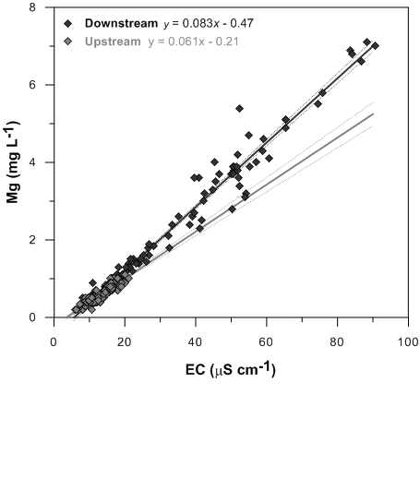

**Figure 4** Best fit relationships between EC and Mg concentrations for the upstream (R2 = 0.84, P<0.0001) and downstream (R2 = 0.96, P<0.0001) monitoring sites in Magela Creek, with the upper and lower 95% confidence limits shown

Limit values for EC and Mg have been developed via ecotoxicological research for both chronic (extended: 72 hours+) and pulse (short duration) exposure regimes (Table 4 and Figure 5), for use in interpreting continuous EC data and for assisting with the interpretation of chemical analysis data from EC event-triggered samples (Hogan et al 2012,).

**Table 4** Ecotoxicologically derived EC and Mg trigger values (99% ecosystem protection level) for short duration pulse exposure

|  |  |  |  |  |  |
| --- | --- | --- | --- | --- | --- |
| **Pulse duration** | **Trigger value** | | **Pulse duration** | **Trigger value** | |
| **(h)** | **EC (µS/cm)** | **Mg (mg/L)** | **(h)** | **EC (µS/cm)** | **Mg (mg/L)** |
| 1 | 11778 | 977 | 18 | 114 | 9.0 |
| 2 | 5268 | 437 | 20 | 110 | 8.6 |
| 3 | 2401 | 199 | 22 | 106 | 8.3 |
| 4 | 1138 | 94 | 24 | 102 | 8.0 |
| 6 | 334 | 27 | 30 | 91 | 7.1 |
| 8 | 174 | 14 | 36 | 82 | 6.3 |
| 10 | 139 | 11 | 48 | 65 | 5.0 |
| 12 | 129 | 10 | 60 | 52 | 3.9 |
| 14 | 123 | 10 | 72 | 42 | 3.0 |
| 16 | 118 | 9.4 |  |  |  |

The highlighted values in Table 4 are values measured by ecotoxicological testing and all other values are interpolated using the functions fitted to the curve in Figure 5.



**Figure 5** Exposure duration curve fitted to the measured data points (trigger value to protect 99% of species) shown as dots

It is anticipated that the trigger value exposure duration curve in Figure 5 will be adopted as the tool for assessing regulatory compliance using continuously monitored EC data.

## 3 Overview of monitoring procedures

### 3.1 Occupational health and safety

SSD has established project and field safety approval processes, guidelines and procedures that must be followed prior to and during all field work. This includes completion of a risk-based, field safety analysis of the required works. All participants are made aware of potential dangers and the procedures implemented to minimise risks by communicating and understanding the field safety analysis before field work commences.

The main health and safety risks in this project are heat stress, dehydration, mosquito borne disease and crocodile attack. Due to the potential risk of crocodile attack, all monitoring and observations are conducted from within boats. Details on how to mitigate the identified health and safety risks for this project are discussed in the operational manual for this protocol.

### 3.2 Monitoring sites

The SWCM program is conducted at designated monitoring sites in Magela and Gulungul creeks, upstream and downstream of point and diffuse inputs of contaminants from the Ranger Mine site. In Figure 6 the sites on Magela Creek are referred to as Magela Upstream and Magela Downstream and the sites on Gulungul Creek are referred to as Gulungul Upstream, Gulungul Midstream and Gulungul Downstream.

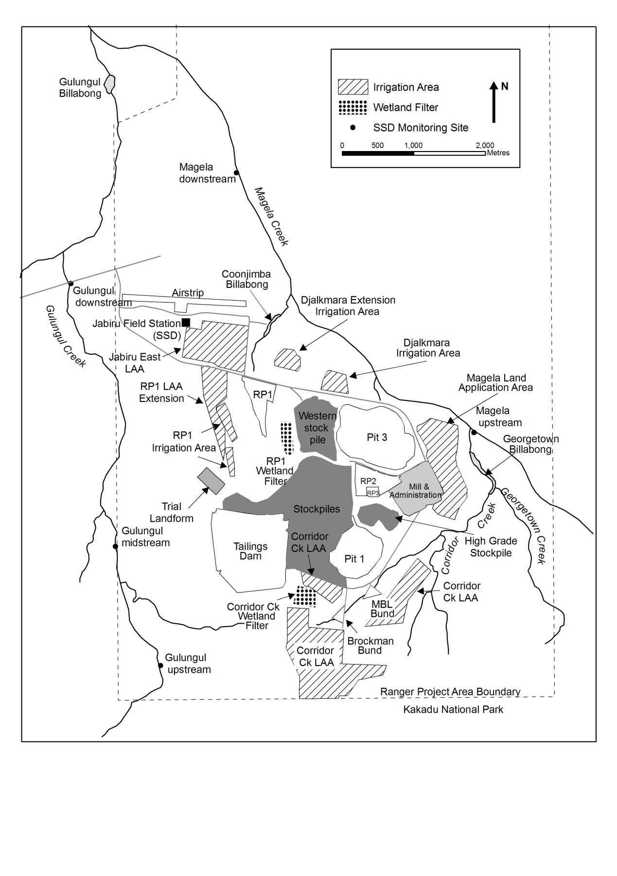

**Figure 6** Location of sampling sites on Magela and Gulungul creeks and key Ranger mine water bodies and landmarks

Routine monitoring is also carried out in Ngarradj Creek downstream of the inactive Jabiluka mine, referred to as ‘SC’ in Figure 7.

### 3.3 Sample collection and analysis

#### 3.3.1 Sample collection

##### Automated event-based sample collection

Automated sample collection is triggered by increases in the EC or turbidity level in the creeks. The samples collected during an ‘EC event’ are retrieved from the field and dispatched for analysis as soon as practical after collection. Retrieval of samples may be delayed on occasion; for example this could be due to access difficulties from flood events. The samples collected during a ‘turbidity event’ are retrieved from the field and processed during the next scheduled site visit.

|  |
| --- |
| Figure1 |
| **Figure 7** The Ngarradj catchment showing the location of the Jabiluka mine and the SSD monitoring sites. The current monitoring station is circled and is referred to as SC (Swift Creek). The ET, UM, TW, TS, TC and TN stations are no longer operational. |

##### Investigative sample collection

SSD may initiate investigative sampling of surface waters from any location on or off the mine site. These samples are collected using the grab sampling method and will often be analysed for both the total and dissolved concentrations of key analytes. Physico-chemical parameters will also be measured during an investigative site visit.

This type of investigative sampling may be conducted in response to:

* an exceedance of a trigger value at one of the downstream sites, particularly the action and guideline/limit values;
* an observation in the field of any unusual condition that may lead to poor quality surface water or runoff entering the creeks; and
* an incident or emergency on site.

#### 3.3.2 Sample analysis

The key parameters that are measured as part of the SWCM program are divided into six suites based on collection method and physical and chemical attributes (Table 5).

**Table 5** Water quality analysis suites

|  |  |  |  |
| --- | --- | --- | --- |
| **Suite** | **Analytes** | **Collection method** | **Analytical laboratory** |
| Physico-chemical suite | pH, EC, turbidity, temperature and water level at specific sites | In situ multiprobe datasondes | N/A |
| Chemical analysis suite | Aluminium, calcium, copper, iron, magnesium, manganese, lead, sulfate, uranium and zinc | Grab samples or event-based samples triggered on EC | Commercial NATA Accredited Lab |
| Radiochemical suite | Total radium-226 activity | Grab samples | EnRad Lab |
| Suspended sediment analysis suite | Suspended sediment concentration and sediment bound aluminium, calcium, copper, iron, magnesium, manganese, lead, sulfate, uranium and zinc | Event-based samples triggered on turbidity | PCP Lab and Commercial NATA Accredited Lab |
| Organic carbon suite | Dissolved organic carbon | Grab samples | EcoTox Lab |
| Nutrient suite | Ammonia, nitrate, total nitrogen, total phosphorus and free reactive phosphorus | Grab samples | Commercial NATA Accredited Lab |

##### Physico-chemical suite

This suite of parameters are measured continuously (up to every 5 minutes) by in situ multi-probe datasondes and comprises pH, EC, turbidity and water temperature.

##### Chemical analysis suite

Water samples for chemical analysis are collected from Magela and Gulungul Creeks either using the automated EC event sampling regime or, for routine radium and QA/QC sampling, using the grab sampling method. Grab sampling is used at any other sampling locations. All water samples are sent to an external service provider (National Association of Testing Authorities (NATA) accredited commercial analytical laboratory) for chemical analysis using inductively coupled plasma mass spectrometry (ICP-MS) or inductively coupled plasma optical emission spectrometry (ICP-OES) techniques.

Comparison of the composition of mine site water (from various on-site water bodies) with Magela Creek water (upstream and downstream of the mine) has been used to establish that U, Mg, aluminium (Al), calcium (Ca), copper (Cu), iron (Fe), manganese (Mn), lead (Pb), sulfate ion (SO42+) and zinc (Zn) are the elements that are of most potential concern to the receiving environment (Supervising Scientist 2009). This list of elements was identified based on i) concentrations present in mine water bodies relative to background concentrations; ii) attenuation by natural processes in catchment drainage lines; and iii) likely or inferred potential for biological impact. The attenuation and dilution of Al, Cu, Fe, Pb and Zn within the tributaries and sentinel waterbodies on site means the concentrations of these metals are not of environmental concern for Magela Creek. These elements, however, provide an excellent indicator of sample contamination that may inadvertently occur as a result of lapse in sample collection practice or contamination in the receiving laboratory.

The automated event-based samples are analysed for total (dissolved plus particulate) concentrations only (see discussion in section 1.4) while grab samples can be analysed for total or dissolved concentrations if they are filtered in the field at the time of collection.

##### Radiochemical suite

Water samples for analysis of radium-226 are collected fortnightly (using the grab sampling method) from Magela and Gulungul creeks. The two samples collected per month from each site are combined to form a composite sample that is analysed for total radium-226 by high resolution alpha spectrometry (Martin et al 2004 & Medley et al 2005).

##### Suspended sediment analysis suite

The concentration of suspended sediment is measured in water samples that are collected by the automated turbidity event sampling regime, and in specified grab samples. An aliquot of suspended sediment (collected by filtering a known volume of sample through a 0.45µm filter paper) may also be sent to an external service provider (NATA accredited commercial analytical laboratory) where it is digested using the reverse aqua regia method (a 3:1 mixture of nitric and hydrochloric acid) and analysed for the same chemical suite as the water samples.

##### Organic carbon suite

When required, water samples are collected (using the grab sampling method) and analysed at the SSD laboratories for concentrations of dissolved organic carbon (DOC). Ecotoxicological testing has shown that DOC has the potential to ameliorate the toxicity of U to organisms (Hogan et al 2005 & Houston et al 2008), and hence is an important parameter to measure, especially for backflow billabongs wherein the DOC concentration can be much higher than in the flowing waters of the stream channels.

##### Nutrient suite

When required, water samples are collected (using the grab sampling method) and sent to an external service provider (NATA accredited commercial analytical laboratory) for analysis of ammonia, nitrate, total nitrogen, total phosphorus and free reactive phosphorus.

### 3.4 Quality control procedures

#### 3.4.1 Continuous monitoring system

To ensure the validity of the continuous monitoring data, a comprehensive quality control (QC) program of infrastructure and equipment management, maintenance and calibration verification is required along with in-built redundancy to ensure that the system remains functional at all times.

At the commencement of flow in the creeks, two multiprobe datasondes and an auto sampler are deployed at each site. The datasondes and auto samplers are connected to data loggers that store the measured data as well as control the functioning the instruments by way of a detailed and comprehensive logging program. This program controls the sampling triggers as well as a number of alarms and backup processes that ensure the immediate rectification of any instrument or sensor issues that may occur.

Each datasonde is calibrated prior to installation and routine in-situ checks are carried out using calibrated hand-held instruments to detect any calibration drift or other instrument issues that may arise throughout the wet season. Full details of these processes are detailed in the Operational manual.

#### 3.4.2 Water sample analysis

A QC program is in place to ensure and demonstrate the quality of chemical analysis of collected water samples. This includes analysis of appropriate blanks, spiked samples, duplicates and inclusion of standard reference materials (SRM). Each month the performance of the water sampling system and techniques are evaluated by assessing the results from the QA/QC samples. Any significant QC issues that arise are reported to the Water Chemistry Monitoring Manager so that the issues can be identified and resolved.

Blank samples are used to determine the existence and magnitude of contamination occurring during field collection or laboratory processing of samples. Analysis of duplicate samples indicates the precision for both field sampling and laboratory analysis methods. Analysis of field duplicates provides an indication of the temporal and spatial variability of water quality at the sampling site. Analysis of laboratory duplicates (obtained by splitting a single sample prior to analysis) provides an indication of the extent of variation attributable to the procedures used in the laboratory.

Analysis of spiked samples and SRM indicates the precision and accuracy of the laboratory results. Laboratory fortified blanks are analysed to determine the bias in the sample spikes. The external analytical laboratory prepares QC samples (SRM, spiked samples, fortified blanks and duplicate samples) and analyses them in the same analysis run as each batch of SSD surface water samples.

For the analysis of trace constituents SSD applies acceptance criteria of ± 20% Relative Percent Difference (RPD) between duplicates. This tolerance limit is based on the Horwitz curve (Horwitz et al 1980), which is a simple exponential relationship between the relative standard deviation of laboratory results to concentration (Figure 8).



**Figure 8** The Horwitz curve which shows increasing relative standard deviation of  
inter-laboratory analytical results with decreasing concentration

As concentrations decrease to the part per billion level, which corresponds to the minimum quantitation limit of many analytical methods, the relative standard deviation can increase sharply. According to the Horwitz curve, the relative standard deviation at the parts per billion concentration range is 40%. Half of this predicted value (20% relative standard deviation) will provide the most conservative measure of tolerable variability. Although U is the only analyte in SSD’s standard analysis suite with a quantitation limit at the parts per billion level, all of the analytes use the 20% RPD limit as the ultimate determinant of the expected degree of measurement variability between duplicates.

For spiked samples a recovery between 80–120% of the spike concentration must be achieved.

Results from the QC samples submitted with each batch of water chemistry monitoring samples provide a proficiency assessment of the analytical service provider. Contaminated blank samples or discrepancies in results between blind duplicate samples (ie unidentifiable by the analytical service provider) will identify problems with the handling procedures of the analytical service provider. Reanalysis of samples can be requested if problems with analytical cleanliness or precision are suspected in the contract laboratory.

#### 3.4.3 Inter-stakeholder comparisons

The available inter-company continuous and grab sample surface water quality data, including data collected by SSD, ERA and the Department of Resources, are compared on a regular basis to check the conformance of the datasets and identify inaccuracies that may highlight problems with measurement methods or techniques. These data comparisons are presented at each Alligator Rivers Region Advisory Committee (ARRAC) meeting where any discrepancies are discussed and investigations initiated if required.

#### 3.4.4 Inter-laboratory comparisons

Once a year a number of duplicate samples (including SRMs) are sent to the primary service provider as well as an alternative service provider for analysis of all analytes in the SSD SWCM suites. This provides a comprehensive assessment of the precision and accuracy of the results provided by the primary external analytical service provider.

#### 3.4.5 Analyte suite assessment

Water samples are collected every two years from point sources on the mine site and in Magela and Gulungul creeks (upstream and downstream sites) for full quantitative analysis by ICP-MS/ICP-OES (66 metals and 7 anions/cations) by an external NATA accredited analytical laboratory. This annual screening permits a comprehensive annual assessment to be made of the composition of on-site water bodies and catchment drainage lines and provides a QC check to ensure that all relevant mine-related metals that might (now or in the future) pose a risk to the receiving waterways are included in the routine chemical monitoring suite (Supervising Scientist 2009).

## 4 Data storage, entry and quality control

### 4.1 Data storage

All data and supporting metadata relevant to the SWCM program is contained in SSD’s document and data management system (SharePoint). The data and metadata are also entered into the Envirosys® database which is SSD’s primary repository for all point source environmental data. The continuous monitoring data are stored in the Hydstra® database, which is an industry benchmark for the storage and management of time-series data. Further information about the use of these databases is detailed in the Operational manual.

### 4.2 Data entry quality control

The SWCM data are manually entered into spreadsheets for the purposes of QC checking, importing to databases, interpretation or reporting. Each time the raw data are copied or manually entered into spreadsheet or database the entered data must be viewed and validated by a second person.

## 5 Data analysis

At each reporting period, which is generally every seven days, the monitoring data are compared to the Magela Creek trigger values (Table 3) as well as to trends occurring in previous reporting periods for the wet season and trends occurring in previous wet season. The physico-chemical and chemistry data are combined in a number of different graphs that display the upstream and the downstream data for each monitoring site over the wet season period (see examples in Figure 9):

* EC and water level;
* turbidity and water level;
* EC and U concentration;
* EC and manganese concentration;
* EC and Mg concentration; and
* EC and SO4 concentration.

Technical and explanatory notes are written to address any specific issues relating to interpretation of the data and their conformance with guideline or trigger values.

The annual compliance assessment for radium-226 is made by comparing the wet season median difference (downstream minus upstream) with the limit value (10 mBq/L). Since the 2010–11 wet season radium-226 samples have been collected from Gulungul Creek to start producing a yearly baseline in anticipation that a similar assessment regime to that in Magela Creek may in future be applied to Gulungul Creek.

## 6 Reporting

Results from the SWCM program are reported to different stakeholder groups using various reporting mechanisms and forums. These include:

* ad hoc reporting to Traditional Owners via SSD’s community liaison officer at Jabiru;
* Supervising Scientist Annual Report;
* internet;
* Alligator Rivers Region Advisory Committee (ARRAC);
* Alligator Rivers Region Technical Committee (ARRTC) and Annual Research Summary;
* the Minesite Technical Committee (MTC); and
* ad hoc summary reports for stakeholders.

|  |
| --- |
| A |
| B |
| C |

**Figure 9** Magela Creek upstream (MCUGT) and downstream (MCDW) data for A) continuous EC and flow in Magela Creek; B) continuous Turbidity and flow in Magela Creek; and C) continuous EC and U concentration in Magela Creek

### 6.1 Traditional Owners and Aboriginal residents

There are two components to communicating the monitoring program and results to Indigenous people:

1. informing people of what tasks are to be undertaken, when, by whom and why; and
2. providing feedback to people on the results of the work and providing assurance that the environment and their lifestyle have been protected.

The monitoring results are also reported in regular updates and reports presented by the Aboriginal Liaison Officer at meetings or open days. Monitoring staff (and more senior Darwin-based staff) are available to answer questions (particularly from Traditional Owners and Aboriginal residents) or provide additional information as requested. In some cases the data may be included in illustrated reports published especially for Traditional Owners and Aboriginal residents.

### 6.2 Supervising Scientist annual report

This SSD Annual Report is tabled in Parliament in the latter part (usually October) of each year. This report contains a summary of the SWCM data including figures and interpretation of the data. The report also includes details of any research and development carried out to improve the monitoring program and to enhance interpretation of the data. The report is available for download from SSD’s website with hardcopy being available on request.

### 6.3 Internet

The SWCM data are reported on the SSD website at:

http://www.environment.gov.au/ssd/monitoring/index.htmlAs data are acquired during the wet season, plots of the accruing results (per Figure 9) are posted to the SSD website along with a short explanatory note commenting the data interpretation, including any trends or unexpected results.

The other reports listed above are also posted to the SSD Website as they become available.

### 6.4 Alligator Rivers Region Technical Committee and Annual Research Summary (Supervising Scientist Report)

Each year a summary of the SWCM results are presented to the ARRTC at the annual wet season meeting. A full report is then presented to ARRTC at the annual dry season meeting. This latter report is used as the basis for the SSD Annual Research Summary, compiled late in the calendar year, together with results from other stream monitoring programs.

The Annual Research Summary is circulated to a wide audience, including the key stakeholders, ERA, the Northern Lands Council and the NT Department of Regional Development, Primary Industry, Fisheries and Resources. The report is available for download from SSD’s website with hardcopy being available on request.

### 6.5 Summary report for stakeholders

Consistent with the reporting to ARRTC and with similar timing, a report and a presentation are provided at each of the two meetings of the ARRAC, representing a wide range of stakeholders for the ARR. The reports contain a summary of major results and conclusions.

## 7 Glossary of terms and abbreviations

**Accuracy** A measure of the closeness of an individual measurement or the average of a number of measurements to the true value.

**Batch** Environmental samples that are prepared and/or analysed together with the same process and personnel, using the same lot(s) of reagents, within a specified time period.

**Field blank** Monitors contamination resulting from field activities and/or ambient levels of analytes present at time of sampling.

**Field duplicate** Two independent samples taken at the same location and the same time to determine the homogeneity of the samples collected.

**Guideline** Guidelines are set to assist in the interpretation and management of water quality. Guidelines are based on the range of values that occur naturally at the upstream reference site and so are expected to be exceeded occasionally at the downstream site. Guidelines are updated occasionally by the Supervising Scientist to reflect changes in the range of values measured at the upstream reference site.

**Laboratory blank** A sample of reagent water or other blank matrices that are treated exactly the same as a sample to determine if method analytes or other interferences are present.

**Laboratory duplicate** Two sub-sample aliquots of the same sample taken in the analytical laboratory and analysed separately with identical procedures. Analysis of the sample and duplicate give a measure of the precision associated with laboratory procedures, but not with sample collection or storage/transport procedures.

**Limit** A ‘limit’ is the value that an indicator must not exceed as a result of mining operations. Limits apply to U and radium-226. Exceedence of a limit, due to mining related activities, would normally be regarded as a breach of statutory regulations.

The limit for uranium (currently 6 µg/L) is based on toxicity to local species in accordance with the ANZECC/ARMCANZ Water Quality Guidelines to protect 99% of the species present. The uranium limit was last updated to its current value in 2004.

For radium-226, the limit is set in accordance with International Commission on Radiological Protection recommendations.

**Precision** The measure of mutual agreement between individual measurements obtained under similar conditions. Precision is usually expressed at % RPD (relative percentage difference).

**QC Quality Control**. The overall system of technical activities whose purpose is to measure and control the quality of a product or service so that it meets the needs of users.

**Spiked sample** A sample to which known quantities analytes are added in the laboratory to determine whether the sample matrix contributes bias to the analytical results.

**SRM Standard Reference Material** is a material containing known concentrations of analytes that is used to assess performance (accuracy and precision) of a chemical analysis method.

**Trigger value** A value of a parameter that when reached or exceeded sets a course of management action in motion.

## References and additional reading

ANZECC & ARMCANZ 2000. *Australian guidelines for water quality monitoring and reporting.* National Water Quality Management Strategy Paper No 7, Australian and New Zealand Environment Conservation Council & Agriculture and Resource Management Council of Australia and New Zealand, Canberra.

Bollhöfer A, Ryan B, Fawcett M, Turner K & Jones D 2010. Remediation of the remnants of past uranium mining activities in the South Alligator River Valley. In ***eriss*** *research summary 2008–2009*. eds Jones DR & Webb A, Supervising Scientist Report 201, Supervising Scientist, Darwin NT, 194–200.

Frostick A; Jones D & Turner K 2012. Review of solute selection for water quality and bioaccumulation monitoring at a northern Australian uranium mine. In *International Mine Water Association Annual Conference,* Bunbury, Australia, 30 September to 4 October 2012, eds McCullough CD, Lund MA & Wyse L,

Hogan AC, van Dam RA, Markich SJ & Camilleri C 2005. Chronic toxicity of uranium to a tropical green alga (*Chlorella* sp) in natural waters and the influence of dissolved organic carbon. *Aquatic Toxicology* 75, 343–353.

Hogan AC, van Dam RA, Trenfield MA & Harford AJ 2012. Toxicity of single magnesium pulse exposures to tropical freshwater species. Internal Report 608, September, Supervising Scientist, Darwin.

Horwitz W, Kamps LR & Boyer KW 1980. Quality assurance in the analysis of foods and trace constituents*.* *Journal of the Association of Official Analytical Chemists* 63 (6), 1344–1354.

Houston M, Ng J, Noller B, Markich SJ & van Dam R. 2008. The influence of dissolved organic carbon (DOC) on the speciation and toxicity of uranium to Australian tropical freshwater species. Paper presented at 5th Society for Environmental Toxicology and Chemistry World Congress. Sydney, 3–7 August 2008.

Iles M 2004. Water quality objectives for Magela Creek – revised November 2004. Internal Report 489, December, Supervising Scientist, Darwin. Unpublished paper.

Jones D, Humphrey C, Iles M & van Dam R 2008. Deriving surface water quality closure criteria – An Australian uranium mine case study. Minewater and the Environment, 10th International Mine Water Association Congress, June 2–5, Karlovy Vary, Czech Republic.

Klessa DA 2000. *The chemistry of Magela Creek: A baseline for assessing change downstream of Ranger*. Supervising Scientist Report 151, Supervising Scientist, Darwin.

Klessa D 2001a. Water quality in Magela Creek upstream and downstream of Ranger: A summary of findings for the 1999–2000 Wet season. Internal Report 360, Supervising Scientist, Darwin. Unpublished paper.

Klessa D 2001b. Water quality in Magela Creek upstream and downstream of Ranger: A summary of performance for 2000–2001 and derived triggers and limits for 2001–2002. Internal Report 380, Supervising Scientist, Darwin. Unpublished paper.

Martin P & Hancock GJ 2004. *Routine analysis of naturally occurring radionuclides in environmental samples by alpha-particle spectrometry*. Supervising Scientist Report 180, Supervising Scientist, Darwin NT.

Medley P, Bollhöfer A, Iles M, Ryan B & Martin P 2005. Barium sulphate method for radium-226 analysis by alpha spectrometry. Internal Report 501, June, Supervising Scientist, Darwin. Unpublished paper.

Supervising Scientist 2000. *Investigation of tailings water leak at the Ranger uranium mine*. Supervising Scientist Report 153, Supervising Scientist, Darwin.

Supervising Scientist 2002. Supervising Scientist Monitoring Program, Instigating an environmental monitoring program to protect aquatic ecosystems and humans from possible mining impacts in the Alligator Rivers Region <http://www.environment.gov.au/ssd/monitoring/pubs/env-mon-prog-background.pdf>   
(25 November 2003)

Supervising Scientist 2009. Annual Report 2008–2009. Supervising Scientist, Darwin.

Supervising Scientist 2010. Annual Report 2009–2010. Supervising Scientist, Darwin.

Supervising Scientist 2011. Annual Report 2010–2011. Supervising Scientist, Darwin.

Tayler K & Frostick A 2013. Establishment of an ecotoxicologically derived magnesium pulse exposure limit for Magela and Gulungul Creek waters. Internal Report (in prep).

Turner K, Jones D & Humphrey C 2009. Changes in water quality of Rockhole Mine Creek associated with historic mining activities. Internal Report 560, June, Supervising Scientist, Darwin. Unpublished paper.

van Dam RA, Humphrey CL & Martin P 2002. Mining in the Alligator Rivers Region, northern Australia: Assessing potential and actual effects on ecosystem and human health. *Toxicology* 181–182, 505–515.