Graphic1.jpgWave-short

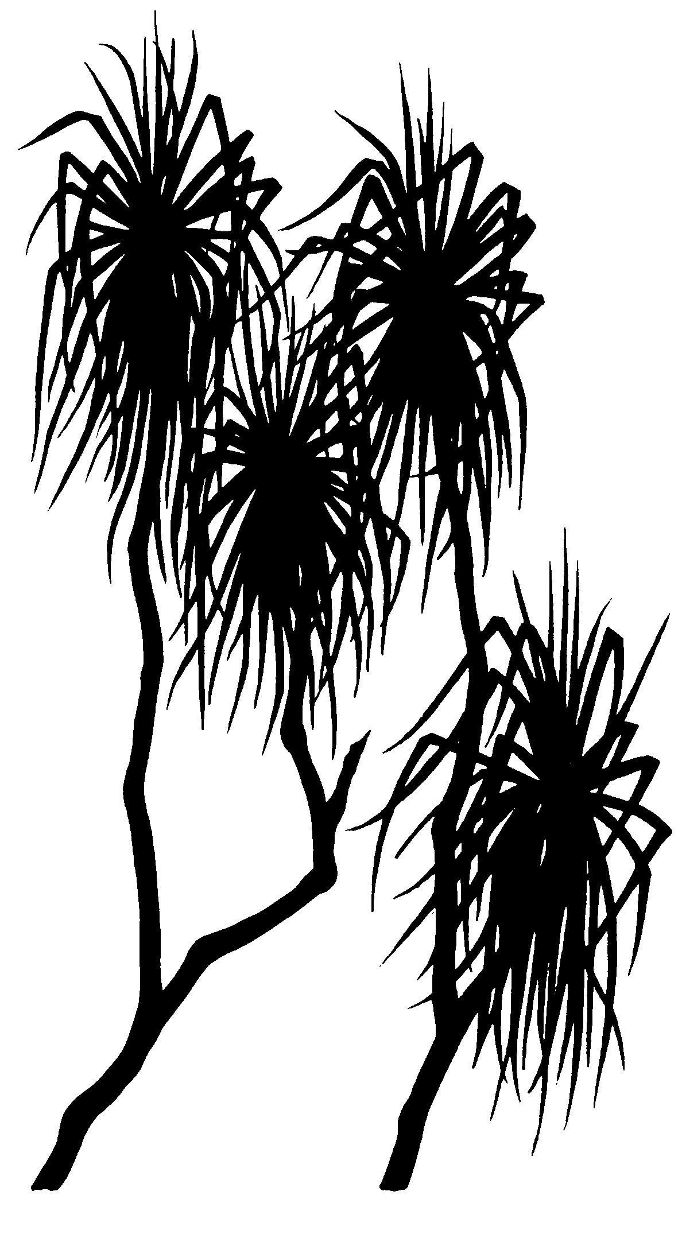

Andreas Bollhöfer, Che Doering, Peter Medley, Linda da Costa

July 2013

Release status – unrestricted

Project number –MON-2013-006

618

*internal report*

Assessment of expected maximum doses from the El Sherana airstrip containment, South Alligator River valley, Australia

*This page has been left blank intentionally.*

# Assessment of expected maximum doses from the El Sherana airstrip containment, South Alligator River valley, Australia

Andreas Bollhöfer, Che Doering, Peter Medley, Linda da Costa

Supervising Scientist Division

GPO Box 461, Darwin NT 0801

July 2013

Project number MON-2013-006

Registry File SG2005/0127

(Release status – unrestricted)

logo4.jpg

*How to cite this report:*

Bollhöfer A, Doering C, Medley P & da Costa L 2013. Assessment of expected maximum doses from the El Sherana airstrip containment, South Alligator River valley, Australia. Internal Report 618, July, Supervising Scientist, Darwin.

*Project number – MON-2013-006*

*Location of final PDF file in SSDX Sharepoint/SPIRE:*

[Supervising Scientist Division>PublicationWork>Publications and Productions>InternalReports (IRs)>Nos 600 to 699>IR618 Dose Constrain El Sherana (Bollhöfer et al)](http://publications.nt.environment.gov.au/PublicationWork/Forms/AllItems.aspx?RootFolder=%2FPublicationWork%2FPublications%20and%20Productions%2FInternal%20Reports%20%28IRs%29%2FNos%20600%20to%20699%2FIR618%5FDose%20constraint%20El%20Sherana%20containment%20%28AB%29%2FSubmitted&InitialTabId=Ribbon%2EDocument&VisibilityContext=WSSTabPersistence)

*Authors of this report:*

Andreas Bollhöfer – Environmental Research Institute of the Supervising Scientist, GPO Box 461, Darwin NT 0801, Australia

Che Doering – Environmental Research Institute of the Supervising Scientist, GPO Box 461, Darwin NT 0801, Australia

Peter Medley – Environmental Research Institute of the Supervising Scientist, GPO Box 461, Darwin NT 0801, Australia

Linda da Costa – Environmental Research Institute of the Supervising Scientist, GPO Box 461, Darwin NT 0801, Australia

The Supervising Scientist is part of the Australian Government Department of Sustainability, Environment, Water, Population and Communities.

© Commonwealth of Australia 2013

Supervising Scientist

Department of Sustainability, Environment, Water, Population and Communities

GPO Box 461, Darwin NT 0801 Australia

This work is copyright. Apart from any use as permitted under the Copyright Act 1968, no part may be reproduced by any process without prior written permission from the Supervising Scientist. Requests and enquiries concerning reproduction and rights should be addressed to Publications Enquiries, Supervising Scientist, GPO Box 461, Darwin NT 0801.

e-mail: enquiries_ssd@environment.gov.au

Internet: www.environment.gov.au/ssd (www.environment.gov.au/ssd/publications)

The views and opinions expressed in this report do not necessarily reflect those of the Commonwealth of Australia. While reasonable efforts have been made to ensure that the contents of this report are factually correct, some essential data rely on references cited and/or the data and/or information of other parties, and the Supervising Scientist and the Commonwealth of Australia do not accept responsibility for the accuracy, currency or completeness of the contents of this report, and shall not be liable for any loss or damage that may be occasioned directly or indirectly through the use of, or reliance on, the report. Readers should exercise their own skill and judgment with respect to their use of the material contained in this report.

Printed and bound in Darwin NT by Supervising Scientist Division

# Contents

Executive summary vii

1 Background 1

2 Methods 2

2.1 External gamma radiation measurements 2

2.2 222Rn activity flux density measurements 2

2.3 Measurement of the 226Ra soil activity concentration 2

3 Results and Discussion 4

3.1 External gamma radiation 4

3.2 222Rn activity flux densities 5

3.3 226Ra soil activity concentrations 7

4 Dose assessment 11

4.1 Scenario 1: Park Rangers working on site 11

4.1.1 External gamma dose rate 11

4.1.2 Radon decay product inhalation modelling 11

4.1.3 Dust inhalation 13

4.1.4 Ingestion 13

4.2 Scenario 2: Tourists visiting the area 13

4.2.1 External Gamma dose rate 13

4.2.2 Radon decay product inhalation modelling 13

4.2.3 Dust inhalation 16

4.2.4 Ingestion 16

4.3 Scenario 3: Traditional Owners 16

Summary and Conclusions 18

References 19

Appendix 1 Details of gamma survey instruments 21

Appendix 2 Gamma dose rate measurement results 23

Appendix 3 222Rn activity flux density measurement results 30

Appendix 4 Soil activity concentration measurement results 32

Appendix 5 Results from ResRad-Offsite modelling 33

Appendix 6 Report provided to Parks Australia, May 2013 35

## List of Figures

Figure 1: 2007 (baseline) and 2012 external gamma dose rates [µGy∙hr-1] measured at the El Sherana containment. 4

Figure 2 Frequency distribution of above baseline gamma dose rates [μGy∙hr-1] measured at the El Sherana containment in September 2012. 5

Figure 3: 222Rn activity flux densities [mBq∙m2∙s-1] measured at the El Sherana airstrip containment in September 2010 (left) and September 2012 (right). 5

Figure 4: Histograms of the 2009 baseline, the 2010 and 2012 222Rn activity flux density measurements from within the fenced area. 6

Figure 5: Frequency distribution of 222Rn activity flux densities measured in September 2010 and 2012 at the El Sherana containment. 6

Figure 6: Probability plot of above baseline 222Rn activity flux densities measured in 2012 for the total population (red), population 1 (<40 mBq∙m-2∙s-1, black squares) and population 2 (>200 mBq∙m-2∙s-1, grey diamonds). 7

Figure 7 Soil 226Ra activity concentrations [Bq∙kg-1] (left) and RE-R [mBq∙m-2∙s-1/Bq∙kg-1] (right) measured at the El Sherana airstrip containment in 2012. 7

Figure 8 Measured versus calculated gamma dose rates [µGy∙hr-1] at the 17 soil sampling sites. 8

Figure 9 Annual on-site dose from the inhalation of 222Rn decay products assuming access for 8760 hours per year. 12

Figure 10 Site layout chosen for modelling the atmospheric pathway using ResRad-Offsite (version 2.6). 14

Figure 11 Maximum annual off-site dose (SW corner of containment) from the inhalation of 222Rn decay products assuming access for 8760 hours per year. 14

Figure 12 Waste origin 222Rn concentration in air with distance from the fenceline. 15

Figure 13 Waste origin 222Rn decay product inhalation doses (assuming full year occupancy) plotted against distance from the fenceline. 16

Figure A1 Calibration Certificate for GM tube 2 from 1 December 2012. 21

Figure A5.1 Maximum annual doses [mSv∙yr-1] received from the inhalation of radon decay products from 0-40 years, 30 m downwind of the El Sherana containment. 33

Figure A5.2 Maximum annual doses [mSv∙yr-1] received from the inhalation of radon decay products from 0-40 years, 75 m downwind of the El Sherana containment. 33

Figure A5.3 Maximum annual doses [mSv∙yr-1] received from the inhalation of radon decay products from 0-40 years, 140 m downwind of the El Sherana containment. 34

Figure A5.4 Maximum annual doses [mSv∙yr-1] received from the inhalation of radon decay products from 0-40 years, 240 m downwind of the El Sherana containment. 34

## List of Tables

Table 1 Engineering details of the El Sherana airstrip containment.1 1

Table 2 Parameter values used for ResRad-Offsite modelling. 12

Table 3 Chi/Q and calculated 222Rn activity and 222Rn decay product (RDP) potential alpha energy concentrations. 15

Table 4 Maximum above background annual effective doses from the various pathways for 3 different scenarios. 18

Table A1 Details of instruments used to conduct the gamma dose rate measurements at the containment. 22

Table A2 Date, location, eastings and northings, counts per seconds and calculated absorbed gamma dose rates *He*, uncertainty in calculated dose rates and comments recorded on the fieldsheets. 23

Table A3 Canister number, eastings and northings, 222Rn activity flux density and comments recorded on fieldsheets. 30

Table A4 Results of soil radionuclide activity concentration measurements for 17 radon exhalation measurement sites (canister numbers), radon flux densities and RE-R (mBq∙m-2∙s-1 per Bq∙kg-1). 32

# Executive summary

The El Sherana airstrip containment is a near-surface disposal facility located in the South Alligator Valley area in the south of Kakadu National Park. The containment was constructed, filled and covered in the 2009 dry season. It is currently in the institutional control period. This is the period following closure of the facility during which public access to, or alternative use of, the site must be restricted (NHMRC 1993). The containment is managed by Parks Australia with regulatory oversight by the Australian Radiation Protection and Nuclear Safety Agency (ARPANSA). An inspection of Parks Australia by ARPANSA on 27–28 September 2011 highlighted that dose constraints for the containment had not been established. Parks Australia subsequently requested that SSD conduct an assessment of potential doses to workers and the public from the containment that could be used to guide decision making on dose constraints.

Two scenarios were considered. The occupational scenario assumed that a Park Ranger spends 80 hours per year working onsite at the containment for routine maintenance. The member of the public scenario assumed that a tourist camped for four nights (40 hours in total) next to the boundary fence of the containment.

The dose from external gamma radiation was calculated by multiplying the 99th percentile of the above background dose rate with the time spent on site. The dose from radon progeny inhalation was calculated using the RESRAD-Offsite computer model, with the 99th percentile of the above background radon exhalation flux density used to determine the radon progeny concentration in air on and downwind of the containment for highly stable atmospheric conditions. The ingestion and dust inhalation pathways have not been considered. The expected maximum doses to a worker and a member of the public from the containment for the assumed exposure scenarios is less than 10 µSv per year for the current radiological characteristics of the containment.

# 1 Background

The El Sherana airstrip containment is a near-surface disposal facility located in the South Alligator River valley in the south of Kakadu National Park. It was constructed in the 2009 dry season and contains approximately 22,000 m3 of naturally occurring radioactive material (NORM) contaminated waste from the remediation of legacy uranium mining and processing sites in the area (see Waggitt 2004) for details of the uranium mining history of the South Alligator River valley). Table 1 gives the engineering details of the containment.

The 2009 remediation of legacy uranium mining and processing sites and construction of the containment occurred as part of the 1996 lease agreement between the Gunlom Aboriginal Land Trust and the Director of National Parks and Wildlife (now the Director of National Parks) for traditional Aboriginal lands in the upper South Alligator River valley to be managed as part of Kakadu National Park. In particular, the lease agreement required the lessee to develop and fully implement a remediation plan which, in essence, would return the area to near to natural environmental status by the end of 2015. Parks Australia was the Australian Government agency responsible for development and implementation of the plan and was allocated $7.3 million over four years in the 2006–07 Federal Budget specifically for the programme (Director of National Parks 2006). The 2009 remediation works and construction of the containment represent major milestones in the lease agreement.

The ***eriss*** Environmental Radioactivity program has measured gamma dose rates and 222Rn activity flux densities at the containment site prior to construction and again in 2010 one year after closure (Doering et al 2011). Gamma dose rates and 222Rn activity flux densities were also measured in September 2012 as part of an ongoing (biannual) monitoring program. The purpose of this program is to assess whether the radiological conditions at the containment are stable, and to assess the performance of the containment through time. The 2012 measurements are presented in this report and are used to make an assessment of expected maximum annual doses for occupational and public exposure scenarios.

Table 1 Engineering details of the El Sherana airstrip containment.1

|  |  |
| --- | --- |
| Parameter | Description |
| Surface footprint | 8750 m2 (175 m × 50 m) |
| Maximum capacity | 25,000 m3 |
| Maximum excavation depth below natural ground level | 5 m |
| Side slopes | 3:1 (horizontal:vertical) |
| Maximum thickness of waste material | 4.5 m |
| Base layer | 0.5 m compacted clay |
| Capping layer | 0.5 m compacted clay |
| Cover (growth medium) | 1.8–2.4 m uncompacted natural soil |

1Information from O’Kane Consultants (2012)

# 2 Methods

## 2.1 External gamma radiation measurements

A gamma survey was conducted at the containment on 3–4 September 2012 using three identical monitors with compensated Geiger Müller (GM) tubes. Measurements were made of the total counts per 100 s in air at a height of 1 m above the ground surface. A total of 274 measurements were made: 202 within the fenced area of the containment; 33 south of the fenced area; and 39 north of the fenced area.

One of the monitors was calibrated in December 2012. The calibration certificate for this monitor is shown in Figure A1 in Appendix 1. An intercomparison of the three monitors was conducted in the field to cross-calibrate them. Details of the monitors including the results of the cross-calibrations are shown in Table A1 in Appendix 1.

## 2.2 222Rn activity flux density measurements

222Rn activity flux density measurements at the containment were made over the period 3–5 September 2012. The prevailing meteorological conditions over the measurement period were typical of the tropical Northern Territory dry season, with maximum daytime temperatures above 30°C and zero rainfall.

Brass canisters containing activated charcoal to entrap radon emanating from the ground surface were used for the field sampling of 222Rn. Fourty three canisters were deployed on and around the containment. The canisters were embedded in the ground surface to a depth of approximately 1 cm in order to ensure a good seal and prevent leakage of radon from the canister to the atmosphere. Three additional canisters were carried into the field but remained sealed at all times. These canisters were ‘controls’ and used to determine the background activity of 222Rn collected on the charcoal.

The 222Rn activity flux density was calculated from the measured 222Rn progeny activity in the canisters according to the method described in Doering et al (2011) and Spehr & Johnston (1983). The 222Rn progeny activity in each canister was counted for ten minutes using a sodium iodide detector and the resulting energy spectrum displayed on a multi-channel analyser. Regions of interest were established around the characteristic photopeaks of 214Pb -214 (242 keV, 295 keV and 352 keV) and 214Bi (609 keV) from which the net count rate was determined by adding the total counts under each peak for the individual field samples and then subtracting the mean sum of the counts under the corresponding regions of interest in the control canisters’ spectra. The efficiency of the detector for 222Rn progeny counting via this method is approximately 10.8%.

## 2.3 Measurement of the 226Ra soil activity concentration

Soil samples from the top 5 cm were collected from directly underneath the planted radon cups at 17 locations on the containment (ie above the buried waste) after retrieval of the radon cups. This was principally done to determine the 226Ra activity concentration in those soils and the relationship with 222Rn activity flux density.

Soil radionuclide activity concentrations were measured using the high purity germanium gamma detectors of the ***eriss*** Environmental Radioactivity program. Approximately 15 g of sample were pressed into a standard geometry and then measured on the detectors to give 238U, 226Ra, 228Ra, 228Th, 210Pb and 40K activities in the samples. In-house procedures for sample collection, preparation and measurement via gamma spectrometry are described in Marten (1992) and Pfitzner (2010). An in-house program was used for analysis of sample radionuclide activity concentrations (Esparon & Pfitzner 2010).

The stability and background of the detectors are checked weekly with a multi-isotope standard containing radionuclides of the uranium and thorium decay chains and a blank matrix (empty container), respectively. Detection limits for soil samples using gamma spectrometry are dependent on sample size, detector efficiency and background count rates of the given nuclide, but are typically ~3 Bq∙kg-1 for 226Ra for a one day count in the present study.

# 3 Results and Discussion

## 3.1 External gamma radiation

External gamma dose rates were measured two years before construction of the containment in June 2007 (baseline), one year after construction in September 2010 and three years after construction in September 2012. The results of the 2012 measurements are given in Table A2 in Appendix 2. The results of the baseline and 2010 measurements are given in Doering et al (2011).

Figure 1 shows the location and magnitude of the baseline (left) and 2012 (right) gamma dose rate measurements at the containment site overlaid on an aerial photograph of the area from March 2007. The outer white rectangle indicates the approximate location of the boundary fence around the containment. The inner rectangle shows the approximate location of the containment and buried waste.

|  |  |
| --- | --- |
|  |  |

Figure 1: 2007 (baseline) and 2012 external gamma dose rates [µGy∙hr-1] measured at the El Sherana containment.

It has been shown that the baseline gamma dose rate measurements were normally distributed, with an average value inside the fenced area of 0.13±0.01 µGy∙hr-1 (Bollhöfer et al 2009). This is the same as the average value inside the fenced area from the 2012 measurements, meaning that the mean (50th percentile) above baseline gamma dose rate three years after construction is zero (Figure 2). The frequency distribution plot can also be used to determine the 99th percentile, which is 0.03 µGy∙hr-1. This means that less than 1% of the measured values is more than 0.03 µGy∙hr-1 above the baseline value.



Figure 2 Frequency distribution of above baseline gamma dose rates [μGy∙hr-1] measured at the El Sherana containment in September 2012. N: number of measurements; AD: Anderson-Darling statistic.

## 3.2 222Rn activity flux densities

222Rn activity flux densities were measured before construction of the containment in July 2009 (baseline), one year after construction in September 2010 and three years after construction in September 2012. The results of the 2012 measurements are given in Table A3 in Appendix 3. The results of the baseline and 2010 measurements are given in Doering et al (2011).

The average baseline 222Rn activity flux density measured in July 2009 was 14 mBq∙m2∙s-1. Figure 3 shows the location and magnitude of post-construction 222Rn activity flux density measurements conducted in 2010 (left) (Doering et al 2011) and in 2012 (right) at the containment overlaid on an aerial photograph of the area from March 2007. The outer white rectangle indicates the approximate location of the boundary fence around the containment. The inner rectangle shows the approximate location of the containment and buried waste.

|  |  |
| --- | --- |
|  |  |

Figure 3: 222Rn activity flux densities [mBq∙m-2∙s-1] measured at the El Sherana airstrip containment in September 2010 (left) and September 2012 (right).

222Rn activity flux densities measured on the containment in 2012 were higher than those measured in 2010, but there has been little change in 222Rn activity flux densities outside the fenced area at the control sites. The typical value measured in 2010 outside the fenced area was 16 mBq∙m2∙s-1 (similar to the baseline value of 14 mBq∙m2∙s-1measured in 2009) with values ranging from 10–36 mBq∙m2∙s-1. In 2012, the typical value outside the fenced area was 21 mBq∙m2∙s-1, with a range of 9–30 mBq∙m2∙s-1. The average of the baseline and background measurements combined from the three years is 17 mBq∙m2∙s-1.

It has been shown that exhalation of radon in the natural environment follows a log-normal distribution (e.g. Bollhöfer et al 2005; Lawrence et al 2009), in accordance with the Theory of Successive Random Dilutions, which is in particular appropriate for inert substances (such as radon) released at relatively high concentrations into carrier media (Ott, 1995). Figure 4 shows histograms of the 2009 baseline 222Rn activity flux density measurements and of the 2010 and 2012 222Rn activity flux density measurements from within the fenced area only. In 2009, the measurements followed a log-normal distribution. Although the histograms suggest that the measurements in 2010 and 2012 are also log-normally distributed, probability plots shown in Figure 5 show that this is not the case (p-value < 0.005). In particular, the 2012 measurements show a distinct bimodal distribution, with three quarters of values below 60 mBq∙m2∙s-1 and one quarter above 200 mBq∙m2∙s-1. Hence, the 99th percentile has not been determined using the log-normal distribution fitted to the entire 2012 data in Figure 5.

|  |  |  |
| --- | --- | --- |
|  |  |  |

Figure 4: Histograms of the 2009 baseline, the 2010 and 2012 222Rn activity flux density measurements from within the fenced area.

|  |  |
| --- | --- |
|  |  |

Figure 5: Frequency distribution of 222Rn activity flux densities measured in September 2010 and 2012 at the El Sherana containment. P-values for the log-normal distribution are < 0.005, suggesting that the data are not from log-normally distributed populations. This is in particular obvious for the 2012 data.

Above baseline 222Rn activity flux densities have been calculated by subtracting the average of the baseline and background 222Rn activity flux density measurements (17 mBq∙m-2∙s-1) from the measurements conducted within the fenced area in 2012. Figure 6 shows the frequency distribution plot of the above baseline 222Rn activity flux densities measured in 2012 with a log-normal distribution fitted to the total data population and individual log-normal distributions fitted to above baseline 222Rn flux densities less than 40 mBq∙m-2∙s-1 (population 1) and greater than 200 mBq∙m-2∙s-1 (population 2), respectively. Sampling points of population 2 were all located centrally on top of the buried waste. Sampling points of population 1 were located at the edges or off the buried waste (Figure 3). Individual populations follow a log-normal distribution. Mean (50th percentile) above background 222Rn activity flux densities are 10 mBq∙m-2∙s-1 and 380 mBq∙m-2∙s-1 for populations 1 and 2, respectively.



Figure 6: Probability plot of above baseline 222Rn activity flux densities measured in 2012 for the total population (red), population 1 (<40 mBq∙m-2∙s-1, black squares) and population 2 (>200 mBq∙m-2∙s-1, grey diamonds). P-values for the log-normal distributions fitted to populations 1 and 2 are larger than 0.05 and AD statistics are low, suggesting that data are log-normally distributed around two modes. Loc and Scale are the location and scale parameters of the log-normal distribution.

## 3.3 226Ra soil activity concentrations

Figure 7 (left) shows the location of the soil samples taken and the magnitude of measured 226Ra soil activity concentrations at the containment overlaid on an aerial photograph of the area from March 2007. The outer white rectangle indicates the approximate location of the boundary fence around the containment. The inner rectangle shows the approximate location of the containment and buried waste.

|  |  |
| --- | --- |
|  |  |

Figure 7 Soil 226Ra activity concentrations [Bq∙kg-1] (left) and RE-R [mBq∙m-2∙s-1/Bq∙kg-1] (right) measured at the El Sherana airstrip containment in 2012.

The variability of the 226Ra soil activity concentration is low. The minimum 226Ra soil activity concentration is 11 Bq∙kg-1 and the maximum is 34 Bq∙kg-1. Arithmetic and geometric means are 23 and 22 Bq∙kg-1, respectively, with a standard deviation of 6 Bq∙kg-1. Results are shown in Table A4 in Appendix 4.

Saito & Jacob (1995) have used Monte Carlo methods to model the absorbed gamma dose rates 1 m above ground from measured 238U, 232Th and 40K soil activity concentrations, assuming secular equilibrium in the 238U and 232Th decay chains and homogeneity of the radionuclide acitivity concentrations throughout the soil profile. The conversion equation is shown below (equation 1). Figure 8 shows a plot of the measured versus the calculated gamma dose rates for the 17 soil sampling sites.

*He = a1∙238U + a2∙232Th + a3∙40K* (1)

With:

*He*: absorbed gamma dose rate 1m above ground (nGy∙hr-1),

*a1*: 0.462 (nGy∙hr-1)/(Bq∙kg-1),

*a2*: 0.604 (nGy∙hr-1)/(Bq.kg-1) ,

*a3*: 0.0417 (nGy∙hr-1)/(Bq∙kg-1),

*238U, 232Th,∙40K*: soil activity concentrations (Bq∙kg-1).



Figure 8 Measured versus calculated gamma dose rates [µGy∙hr-1] at the 17 soil sampling sites.

Figure 8 shows that the measured gamma dose rates are generally about two times higher than the calculated gamma dose rates, assuming that the measured soil radionuclide activity concentrations in the top 5 cm of the soils are representative for the entire soil profile. The gamma signal measured in air originates from radionuclides located in the top 0.5 m of the soil, while deeper lying radionuclides only contribute a few percent or less (depending on photon energy) to the signal (ICRU 1994; Saito & Jacob 1995). It is thus unlikely that the higher than expected gamma signal originates from the buried waste, as it is covered by more than two metres of ‘clean’ material. More likely, radionuclide acitivity concentrations of the containment cover below 5 cm are somewhat higher than radionuclide acitivity concentrations measured in the top 5 cm of the soil profile.

Porstendörfer (1994) discusses the theory of radon exhalation and provides a method to estimate the 222Rn activity flux density *E*. *E* can be determined from the emanation power *ɛ* of radon from soil grains (which gives a value for the fraction of radon escaping from a soil grain after decay of 226Ra within the grain, and is between 0 and 1), the measured soil 226Ra activity concentration *R* [Bq∙kg-1], the soil density *ρ* [kg∙m-3], the 222Rn decay constant *λ* [s-1] and the 222Rn diffusion length *L* [m-1] as:

*E = ɛ∙R∙ρ∙λ∙L (2)*

The underlying assumptions are that flow of radon in the soil is by molecular diffusion alone, that the soil 226Ra activity concentration is homogenous across the soil profile and that radon gas activity concentration at the surface of the soil can be neglected.

The typical diffusion length of 222Rn in natural soils is 1.5 m (Porstendörfer 1994), the emanation power for sandy and silty loams is approximately 0.2–0.25 (Sisigina 1974), the average soil 226Ra activity concentration of soils around the containment is 23 Bq∙kg-1 (determined from soil samples taken above the containment), soil density at the containment is 1500–1600 kg∙m-3 (O’Kane 2012) and the 222Rn decay constant λ is 2.1×10-6 s-1. With these parameters, it can be estimated that the natural background 222Rn activity flux density in the area should be 20–30 mBq∙m-2∙s-1, which is in agreement with our measurements. 222Rn activity flux densities measured above the containment however are much higher.

The ratio (*RE-R*) has been determined of the 222Rn activity flux density (mBq∙m-2∙s-1) to the measured soil 226Ra activity concentration (Bq∙kg-1) (Figure 7 (right) and Table A4). It has previously been shown that sites with similar geomorphologic structure and vegetation in the Alligator Rivers Region have comparable *RE-R* values and the values reported are between 0.61 (mBq∙m-2∙s-1)/(Bq∙kg-1) for vegetated woodland and rehabilitated areas up to 2.7 (mBq∙m-2∙s-1)/(Bq∙kg-1) for non-compacted fine grains (Lawrence et al 2009). Using equation (1) above gives typical values for natural soils of ~ 1 (mBq∙m-2∙s-1)/(Bq∙kg-1).

Figure 7 (right) shows that most of the *RE-R* values determined for the containment are above 9 with a maximum of 41 (mBq∙m-2∙s-1)/(Bq∙kg-1). This means that 222Rn exhalation is elevated in places despite low surface soil 226Ra activity concentration and similar geomorphic structure across the containment. This suggests that the elevated 222Rn activity flux densities measured on top of the containment are associated with 222Rn emanating from deeper sections with higher 226Ra activity concentrations, diffusing through the containment cover and exhaling at the containment surface. While some of the elevated 222Rn activity flux density may be due to higher 226Ra activity concentrations in the cover itself, it is unlikely that this will lead to an increase of the 222Rn exhalation by a factor of 40, given that measured gamma dose rates 1 m above ground are only about 2 times higher than the gamma dose rates expected from the surface soil activity concentrations.

The diffusion length *L* can be used to estimate the effectiveness of the cover in retaining 222Rn from the buried material above which the compacted clay layer and growth medium have been placed as capping. Assuming the 222Rn activity flux density from the buried material is *E0* and a layer thickness *t* is placed over the waste, then the 222Rn activity flux density above that layer originating from the buried waste can be approximated as:

*E = E0∙e –t/L (3)*

and the fraction reaching the surface is:

*E/E0∙= e –t/L (4)*

Assuming an average diffusion length of 1.5 m (Porstendörfer 1994) and using a maximum thickness of the cover of 2.9 m (including the compacted clay layer) (O’Kane Consultants 2012) this fraction is about 15 % for the containment. In other words, about 15% of the 222Rn emanating from the buried waste may still be exhaling at the containment surface.

Figures 3, 4 and 5 show that 222Rn exhalation at the containment surface has increased between 2010 and 2012. It is important to note that the diffusion length of a material can change with factors such as soil porosity and moisture content. The effect of water content can be quite significant, particularly in the wet and dry tropics (Lawrence et al 2009), where the ground wetness can change substantially with time.

The compacted clay layer was kept moist when it was placed over the buried waste in 2009 and was then subsequently covered with topsoil. Drying and cracking of this clay layer may have occurred over the subsequent two dry seasons, and 222Rn exhalation over the buried waste increased as an effect of the cracking. In addition, the establishment of vegetation on the containment and roots penetrating into the topsoil may have led to preferential pathways for 222Rn to escape from deeper sections of the containment.

Equations 2 and 4 can be used to provide an estimate of the 226Ra activity concentration of the buried waste. Assuming that 15% of the 222Rn exhaled from the waste reaches the surface of the containment leads to 222Rn activity flux densities from the waste between 70 mBq∙m-2∙s-1 (population 1 in Figure 6) and 2500 mBq∙m-2∙s-1 (for population 2 in Figure 6), respectively. Assuming a 222Rn emanation coefficient between 0.07 (dry uranium ore) and 0.3 (moist uranium tailings) (Strong & Levins 1981) and using equation 2 above leads to 226Ra activity concentrations of the buried waste between 50 and 7500 Bq∙kg-1.

# 4 Dose assessment

## 4.1 Scenario 1: Park Rangers working on site

Parks Australia staff and Rangers have been consulted regarding person working hours on and around the El Sherana containment. The result of the consultation is that Park Rangers would spend a total of 80 person hours on site per year. Works conducted on site include general maintenance, weed and fire management and monitoring, including downloading of in-situ monitoring equipment. In our assessment it is assumed that one Ranger conducts all the work activities over one year and that the site is accessed during normal working hours.

### 4.1.1 External gamma dose rate

A normal probability frequency distribution plot of the above baseline gamma dose rates within the fenced area of the containment is shown in Figure 2. This plot shows that in 2012 95% of the gamma dose rates measured at the containment were less than 0.021 µGy∙hr-1 (lower bound: 0.019 µGy∙hr-1, upper bound: 0.024 µGy∙hr-1) and 99% were less than 0.03 µGy∙hr-1 (lower bound: 0.026 µGy∙hr-1; upper bound 0.033 µGy∙hr-1) above the 2007 baseline.

The 99th percentile (0.03 µGy∙hr-1) has been chosen as the assessment input for above baseline external gamma dose rates at the containment. Only one percent of the area on top of the containment will exhibit gamma dose rates greater than 0.03 µGy∙hr-1 above the baseline. A Ranger accessing the fenced site for routine work activites for 80 hours in a year would thus receive an above background annual external gamma dose below 3 µSv per year from external gamma radiation.

### 4.1.2 Radon decay product inhalation modelling

The radon inhalation pathway has been modelled using the computer code RESRAD-Offsite (version 2.6), developed by the Argonne National Laboratory (ANL) (Yu et al, 2009). RESRAD is a computer model designed to estimate radiation doses and risks from RESidual RADioactive materials.

RESRAD-Offsite models atmospheric transport and calculates annual doses received from the inhalation of radon decay products in air on and off-site, emitted from buried radioactive waste that is capped with a ‘clean’ cover. RESRAD-Offsite also calculates the ratio of the average airborne 222Rn activity concentrations on top of the containment or downwind of the buried waste to the 222Rn activity flux (Bq∙s-1) exhaling from the surface of a containment, the so-called Chi over Q value (Bq m-3/Bq s-1). As the 222Rn activity flux density from the containment has been determined experimentally and the containment dimensions are known (~4800 m2), average downwind 222Rn concentrations can be modelled. The 99th percentile of the 222Rn activity flux density of population 2 (Figure 6) of 900 mBq∙m-2∙s-1 has been chosen for the whole containment to determine maximum 222Rn activity concentrations in air, both on and off-site.

RESRAD-Offsite models annual doses from the inhalation of radon decay products from the assumed activity concentration of the buried waste, the physical properties of the waste and the cover material and meteorological parameters for the site. Default or site-specific values can be input into the program.

The parameter values chosen for the containment are shown in Table 2. It was assumed that meteorological conditions are generally stable (Pasquill stability class F; Pasquill (1974)) with the wind blowing steadily at 0.89 m s-1 from the NE-NNE to the SW-SSW towards the southwestern corner of the containment. These weather conditions are unrealistic to prevail all year around and will lead to higher average 222Rn activity concentrations and thus higher annual inhalation doses both on top and at the SW corner of the containment. Higher wind speeds are generally encountered and the atmospheric stability is much smaller especially during the day when the ground is heated and atmospheric convection is much larger. These daytime conditions lead to lower 222Rn activity concentrations, which will generally be indistinguishable from the general background 222Rn activity concentration (see for example Bollhöfer et al 2012). The parameter values in Table 2 have been chosen to determine the maximum waste origin radon decay product inhalation doses that could potentially be received on top of the containment, and results from the modelling are shown in Figure 9.

Table 2 Parameter values used for ResRad-Offsite modelling.

|  |  |  |
| --- | --- | --- |
| **Parameter** | **Value** | **Comment** |
| 226Ra (and 238U + progeny) | 18 Bq∙g-1 | Calculated using 99th percentile Rn activity flux density and equations 2 and 4 |
| Thickness of contaminated material | 4.5 m | O’Kane (2012) |
| 222Rn diffusion coefficient of contaminated material | 5∙10-6 m2∙s-1 | Porstendörfer (1993) |
| Thickness of clean cover | 1.8 m | O’Kane (2012), worst case |
| 222Rn diffusion coefficient of cover | 5∙10-6 m2∙s-1 (1.7-15)∙10-6 m2∙s-1 | Porstendörfer (1993) |
| 222Rn emanation power | 0.15 | Strong & Levins (1981) |
| volumetric water content | 0.01 |  |
| Wind speed | 0.89 m∙s-1 | assuming stable conditions |
| Wind direction | NNE-SSW (50%) and NE-SW (50%) |  |
| Occupancy | 100% outdoors |  |

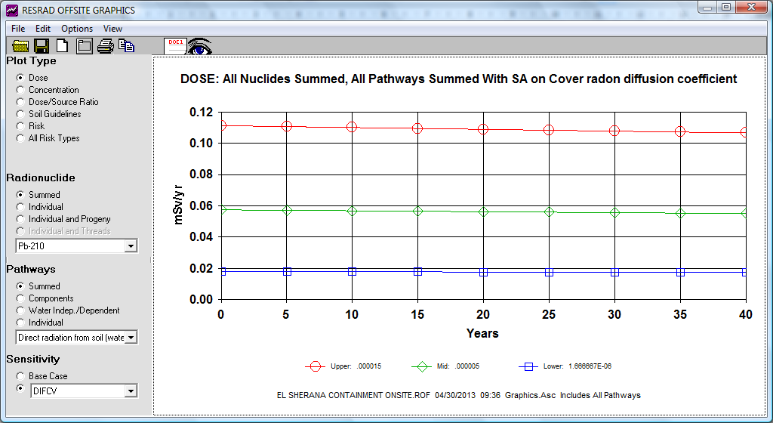

Figure 9 Annual on-site dose from the inhalation of 222Rn decay products assuming access for 8760 hours per year. A sensitivity analysis of the cover 222Rn diffusion coefficient has been conducted and values varied over one order of magnitude from 1.7×10-6 m2∙s-1 (blue symbols) to 15×10-6 m2∙s-1 (red symbols).

A sensitivity analysis has been also run on the cover 222Rn diffusion coefficient, which was varied from 1.7×10-6 m2∙s-1 to 15×10-6 m2∙s-1. The maximum dose from the inhalation of waste origin radon decay products on top of the containment as modelled from RESRAD-Offsite is about 0.11 mSv for 8760 hours access, or about 1 µSv if the site was accessed for 80 hours per year for general maintenance activities.

### 4.1.3 Dust inhalation

This pathway has not been considered as the waste is contained and covered by a cover with activity concentrations of 226Ra and other radionuclides typical for background soil activity concentrations in the region. No scenario was included that assumed that the containment cover was breached (accidentally or intentionally) and the buried waste exposed during maintenance activities such as patching up of erosion channels.

### 4.1.4 Ingestion

The ingestion pathway has not been considered, as no bushfood items or water is consumed by Rangers in the area.

## 4.2 Scenario 2: Tourists visiting the area

It was assumed that tourists visit the South Alligator River valley twice in a year to access a popular camping area at Koolpin Gorge, are caught out by darkness and camp illegally at the southwest corner of the fenced area of the containment. Although there are ‘better’ illegal camping spots in the area, this spot is easily accessible and out of view from the gravel road to Guratba. It is also assumed that access to this area is for 10 hours during night and the early morning hours only, and that the area is accessed for camping twice, on the way in and out of the Koolpin (or other) areas. This results in 40 hours occupancy per year. The area that was assumed to be accessed for camping is shown in Figure 10, and is bordering the south western fence line.

### 4.2.1 External Gamma dose rate

Tourists camping outside the fence would not receive an above baseline gamma dose rate, due to their distance to the buried waste and the miniscule above background gamma dose rates at the containment.

### 4.2.2 Radon decay product inhalation modelling

The inputs chosen to model off-site 222Rn inhalation doses are identical to the on-site scenario and are shown in Table 2.

Figure 10 shows the site set-up chosen for the overnight camping scenario. It was assumed that people camp immediately next to the fenceline. RESRAD-Offsite uses a Gaussian dispersion model to model off-site atmospheric transport and calculates annual doses received from the inhalation of radon decay products in air, emitted from buried radioactive waste that is covered with a ‘clean’ cover. The radon decay product inhalation doses next to the fence calculated by RESRAD-Offsite (in mSv per year) are shown in Figure 11.



Figure 10 Site layout chosen for modelling the atmospheric pathway using ResRad-Offsite (version 2.6).

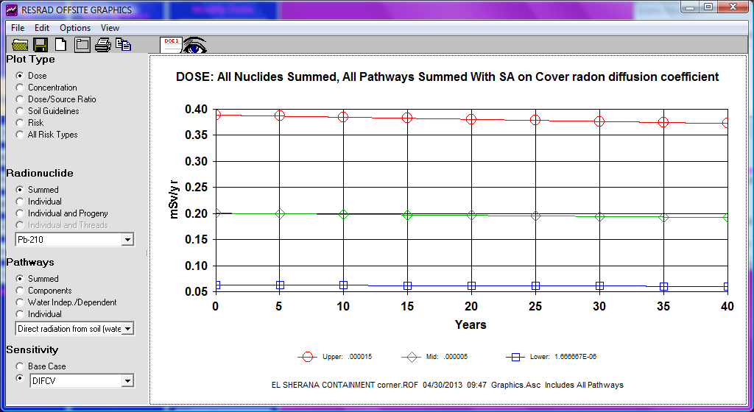

Figure 11 Maximum annual off-site dose (SW corner of containment) from the inhalation of 222Rn decay products assuming access for 8760 hours per year. A sensitivity analysis of the cover 222Rn diffusion coefficient has been conducted, values varied from 1.7×10-6 m2∙s-1 (blue symbols) to 15×10-6 m2∙s-1 (red symbols).

The Chi over Q value (Bq m-3/Bq s-1) can be used to calculate the waste origin airborne 222Rn activity concentrations downwind of the containment. A maximum average 222Rn activity flux density of 900 mBq∙m-2∙s-1 (99th percentile of population 2 in Figure 6) has been chosen to determine a maximum 222Rn flux from the buried waste at the containment to 4320 Bq s-1. This value and the modelled Chi over Q values have been used to determine 222Rn activity concentrations in air both on and off-site from the containment (Table 3).

222Rn activity concentrations in air have also been calculated for various other locations downwind of the containment, and these locations are indicated in Figure 10 as well. The distances from the containment fence were 0, 30, 75, 140 and 240 m, respectively. Figure 12 shows the 222Rn activity concentration in air with distance from the location of the fence. Appendix 5 shows the RESRAD-Offsite plots (in mSv per year) for those additional offsite locations.

Table 3 Chi/Q and calculated 222Rn activity and 222Rn decay product (RDP) potential alpha energy concentrations.

|  |  |  |  |
| --- | --- | --- | --- |
| **Location of ‘dwelling’** | **Chi/Q**  **[s∙m-3]** | **Rn**  **[Bq∙m-3]** | **RDP**  **[µJ∙m-3]** |
| On Site | 1.87E-03 | 8.1 | 0.0045 |
| SW fence corner | 1.30E-02 | 56 | 0.126 |
| 30 m SW of corner | 2.62E-03 | 11 | 0.025 |
| 75 m SW of corner | 4.90E-04 | 2.1 | 0.005 |
| 140 m SW of corner | 8.31E-05 | 0.36 | 0.0008 |
| 240 m SW of corner | 0.00E+00 | 0 | 0 |



Figure 12 Waste origin 222Rn concentration in air with distance from the fenceline.

The 222Rn activity concentrations shown in Figure 12 have been used to determine 222Rn decay product (RDP) inhalation doses for comparison with the results obtained directly from the RESRAD-Offsite modelling (Appendix 5). For this, an equilibrium factor of 0.1 (on-site) and 0.4 (off-site) has been used. These are similar to equilibrium factors determined elsewhere in the Alligator Rivers Region and the wet-dry tropics of northern Australia (Akber & Pfitzner 1994; Bollhöfer et al 2012). A conversion factor of 0.0056 µJ∙Bq-1 has been used to determine the potential alpha energy concentration of radon in equilibrium with its progeny and calculated radon decay product potential alpha energy concentration values are given in Table 3. The current ICRP recommended dose conversion coefficient for 222Rn progeny for the public of 1.1 µSv per µJ∙h∙m-3 (ICRP 1993) has been used to calculate inhalation doses shown in Figure 13.



Figure 13 Waste origin 222Rn decay product inhalation doses (assuming full year occupancy) plotted against distance from the fenceline. Calculated using 222Rn concentrations in air from Figure 11 (blue diamonds), and modelled using ResRad-Offsite (open circles) with parameter values given in Table 2. Note the log-scale of the y-axis.

Figure 13 shows that the maximum annual 222Rn decay product inhalation doses modelled from the input parameters in RESRAD-Offsite, and calculated using the Chi over Q values and maximum 222Rn flux densities from the containment agree well, although the inhalation dose is somewhat higher at the fenceline when calculated using the Chi over Q values. Assuming that people camp at this spot for 40 hours total per year, will lead to a waste origin inhalation dose of approximately 6 µSv. The inhalation dose for 40 hours annual habitation is insignificant (< 0.04 µSv) at a distance of 140 m from the fenceline.

### 4.2.3 Dust inhalation

This pathway has not been considered as the waste is contained and covered by soil with activity concentrations of 226Ra and other radionuclides typical for background soil activity concentrations in the region. No scenario was included that assumed that the containment cover was breached (accidentally or by intend) and the buried waste exposed during maintenance activities such as patching up of erosion channels.

### 4.2.4 Ingestion

The ingestion pathway has not been considered, as no bushfood items or water have been assumed to be consumed by Toursits camping in the area.

## 4.3 Scenario 3: Traditional Owners

An Aboriginal occupation scenario in the direct vicinity of the containment was considered unlikely. This is because Aboriginal people prefer other sites in the South Alligator River valley for hunting, fishing and overnight camping. Aboriginal people mainly go fishing around the One Lane Bridge or Callahan’s Hut down stream on the South Alligator River, or at the Flying Fox Crossing and near the down stream end of South Alligator Gorge. These areas are several kilometers away from the containment.

Assuming that Aboriginal people camp along the banks of the South Alligator River will lead to negligible doses from the inhalation of 222Rn decay products (see Figure 13) and doses from the exposure to above background gamma radiation will also be zero. It is unlikely that any terrestrial bushfood flora will be collected on site. Terrestrial animals (wallaby, buffalo or pig) which are consumed are unlikely able to access the containment and take up contaminants from the buried waste due to continuing maintenance of the fence around the containment. The groundwater levels are deeper than the buried waste (about 10–12 m below surface) and transport of groundwater from the containment to the South Alligator River is slow at about 4 mm per day (Puhalovich et al 2006). Consequently, the ingestion pathway for aquatic foods can be disregarded. Consequently, the Aboriginal occupation scenario has not been considered further in the assessment.

# Summary and Conclusions

In the dry season 2009 a near-surface disposal facility was purpose-built at the disused El Sherana airstrip in the South Alligator River valley to hold NORM waste from legacy uranium mining and processing sites in the area.

Whereas the external gamma dose rates measured 1 m above ground in 2010 and 2012 are not substantially different from external gamma dose rates measured before containment construction, the geometric mean 222Rn activity flux density has increased threefold from 18 mBq∙m2∙s-1 in 2010 to 56 mBq∙m2∙s-1 in 2012. It is possible that drying and subsequent cracking of the 0.5 m thick compacted clay layer, and the establishment of roots and thus preferential pathways for radon transport through the containment cover have contributed to the increase in 222Rn activity flux density from the containment. It is important to continue 222Rn exhalation measurements for the foreseeable future to assess whether 222Rn activity flux densities increase further or stabilise to an average value similar to that measured in 2012.

In order to estimate expected maximum annual doses from the containment, two scenarios were considered. Scenario 1 was for Park Rangers that access the containment routinely as part of their general work duties for 80 hours in a year. Scenario 2 was for tourists visiting the area and using the area next to the south western fenceline at the containment as an overnight camping spot for four nights (40 hours) in a year. The 99th percentiles of the above background gamma radiation dose rate was used to determine doses from direct gamma radiation. The 99th percentile of the 222Rn activity flux density measured in 2012 and the RESRAD-Offsite modelling program was used to determine doses from the inhalation of 222Rn decay products on and off-site. Table 4 summarises the expected maximum annual doses for these scenarios.

Table 4 Maximum above background annual effective doses from the various pathways for 3 different scenarios.

|  |  |  |  |  |  |
| --- | --- | --- | --- | --- | --- |
|  | **Direct γ** | **Inhalation** | | **Ingestion** | **Total** |
|  |  | 222Rn decay products | Dust |  |  |
| **Park Rangers** | 3 μSv | 1 μSv | 0 μSv | 0 μSv | 4 μSv |
| **Tourists** | 0 μSv | 6 μSv | 0 μSv | 0 μSv | 6 μSv |
| **Aboriginal people** | 0 μSv | 0 μSv | 0 μSv | 0 μSv | 0 μSv |

# References

Akber RA & Pfizner JL 1994. Atmospheric concentrations of radon and radon daughters in jabiru East. Technical memorandum 45. Supervising Scientist for the Alligator Rivers Region. Australian Goverment Publishing Services, Canberra.

Bollhöfer A, Storm J, Martin P & Tims S 2005. Geographic variability in radon exhalation at a rehabilitated uranium mine in the Northern Territory, Australia. Environmental Monitoring and Assessment 114. 313-330.

Bollhöfer A, Dunn L, Pfitzner K, Ryan B, Fawcett M & Jones DR 2009. Remediation of the remnants of past uranium mining activities in the South Alligator River Valley. In eriss research summary 2007–2008. eds Jones DR & Webb A, Supervising Scientist Report 200, Supervising Scientist, Darwin NT, 206-211.

Bollhöfer A, Doering C, Fox G, Pfitzner J & Medley P 2012. Assessment of the radiological exposure pathways at Rum Jungle Creek South (Rum Jungle Lake Reserve) – Batchelor. Report prepared by the Environmental Research Institute of the Supervising Scientist for: Northern Territory Government Department of Resources. May 2012.

Director of National Parks 2006. *Annual Report 2005–06*. Director of National Parks, Canberra.

Doering C, Bollhöfer A, Ryan B, Sellwood J, Fox T & Pfitzner J 2011. Baseline and post-construction radiological conditions at El Sherana airstrip containment, South Alligator River valley, Australia. Internal Report 592, June, Supervising Scientist, Darwin.

Esparon A & Pfitzner J 2010. Visual gamma: ***eriss*** gamma analysis technical manual. Internal Report 539, December, Supervising Scientist, Darwin.

International Commission on Radiation Units and Measurements (ICRU) 1994. Gamma-ray spectrometry in the environment. ICRU Report 53.

International Commission on Radiological Protection (ICRP) 1993. Protection against radon-222 at home and at work. ICRP Publication 65, Annals of the ICRP 23(2).

Lawrence CE, Akber RA, Bollhöfer A & Martin P 2009. Radon-222 exhalation from open ground on and around a uranium mine in the wet-dry tropics. Journal of Environmental Radioactivity 100, 1–8.

Marten R 1992. Procedures for routine analysis of naturally occurring radionuclides in environmental samples by gamma-ray spectrometry with HPGe detectors. Internal report 76, Supervising Scientist for the Alligator Rivers Region, Canberra. Unpublished paper.

National Health and Medical Research Council (NHMRC) 1993. Code of practice for the near-surface disposal of radioactive waste in Australia (1992). Radiation Health Series No. 35.

O’Kane Consultants 2012. Gunlom Land Trust Area, Kakadu National Park Containment Facility for Radiologically Contaminated Materials – Record of Construction and Quality Control and Assurance Report. OKC Report No. 765/10-01 prepared for Parks Australia.

Ott WR 1995. Environmental Statistics and Data Analysis. Lewis Publishers.

Pasquill F, 1974. Atmospheric diffusion: the dispersion of windborne material from industrial and other sources. Chichester New York, E. Horwood; Halsted Press. 429 pp.

Pfitzner J 2010. ***eriss*** HPGe detector calibration. Internal Report 576, October, Supervising Scientist, Darwin. Unpublished paper.

Porstendörfer J 1994. Properties and behaviour of radon and thoron and their decay products in the air. Journal of Aerosol Science 25(2), 219–263.

Puhalovich A, Pillai M, McGovern E & Jacobsen N 2006. Groundwater Level Monitoring & Permeability Testing – Candidate Containment Sites (Gulom Radiological Materials). Draft Report for Parks Australia North prepared by EWL Sciences Pty Ltd. August 2006.

Saito K & Jacob P 1995. Gamma ray fields in the air due to sources in the ground. Radiat. Prot. Dosim. 58(1), 29-45.

Sisigina TI 1974. Assessment of Radon Emanation from the Surface of Extensive Territories. Nuclear Meteorology, Israeli Program of Scientific Translations, Jerusalem, p. 239.

Spehr W & Johnston A 1983. The measurement of radon emanation rates using activated charcoal. *Radiation Protection in Australia* 1(3), 113–116.

Strong KP & Levins DM 1982. Effect of Moisture Content on Radon Emanation from Uranium Ore and Tailings. Health Physics 42, 27-32.

Waggit P 2004. Uranium mine rehabilitation: The story of the South Alligator Valley intervention. *Journal of Environmental Radioactivity* 76, 51–66.

Yu C, Gnanapragasam E, Biwer B, Cheng JJ, Kamboj S, Klett T, Zielen A, Williams WA, Domotor S & Wallo A 2009. RESRAD-OFFSITE – A new member of the RESRAD family of codes. Radioprotection 44, 5. 659–664.

# Appendix 1 Details of gamma survey instruments

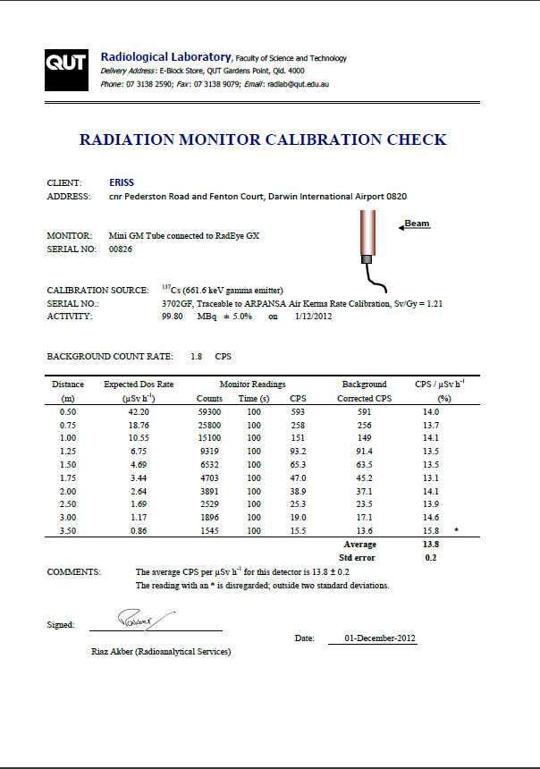

Figure A1 Calibration Certificate for GM tube 2 from 1 December 2012.

Table A1 Details of instruments used to conduct the gamma dose rate measurements at the containment.

|  |  |  |  |
| --- | --- | --- | --- |
|  | GM1 | GM2 | GM3 |
| Description | Geiger Müller tube | Geiger Müller tube | Geiger Müller tube |
| Manufacturer | Mini-instruments | Mini-instruments | Mini-instruments |
| Serial number | 00827 | 00828 | 00362 |
| Meter | RadEye GX | RadEye GX | RadEye GX |
| Serial number | 00711 | 0314 | 00630 |
| Correction factora | 0.90 | 1 | 0.86 |

a The correction factor gives the the ratio of the counts measured by the respective GM tube to the counts measured by GM tube 2 during the intercomparison in the field. Measured counts per second have been divided by this factor to correct for inter-instrument differences.

# Appendix 2 Gamma dose rate measurement results

Table A2 Date, location, eastings and northings, counts per seconds and calculated absorbed gamma dose rates *He*, uncertainty in calculated dose rates and comments recorded on the fieldsheets.

|  |  |  |  |  |  |  |  |  |
| --- | --- | --- | --- | --- | --- | --- | --- | --- |
| **Date** | **Location** | **Easting** | **Northing** | **Counts**  **s-1** | **+-** | **He**  **µGy h-1** | **+-** | **Comments** |
| **Within fenced area** | | | | | | | | |
| 3/09/2012 | 24E | 228937 | 8506248 | 2.27 | 0.15 | 0.14 | 0.01 | Off containment. |
| 3/09/2012 | 25E | 228931 | 8506232 | 1.98 | 0.14 | 0.12 | 0.01 | in erosion gully (30cm deep). |
| 3/09/2012 | 2E | 228920 | 8506216 | 2.19 | 0.15 | 0.13 | 0.01 | Off containment. |
| 3/09/2012 | 98E | 228915 | 8506196 | 2.20 | 0.15 | 0.13 | 0.01 | Off containment. |
| 3/09/2012 | 64 | 228904 | 8506167 | 2.12 | 0.15 | 0.13 | 0.01 | Off containment. |
| 3/09/2012 | 94 | 228891 | 8506147 | 2.04 | 0.14 | 0.12 | 0.01 | Off containment. |
| 3/09/2012 | 72 | 228865 | 8506161 | 2.21 | 0.15 | 0.13 | 0.01 | Off containment. |
| 3/09/2012 | 62E | 228876 | 8506181 | 2.01 | 0.14 | 0.12 | 0.01 |  |
| 3/09/2012 | 7E | 228886 | 8506198 | 2.32 | 0.15 | 0.14 | 0.01 | Next to erosion gully (~ 1m deep) |
| 3/09/2012 | 70 | 228899 | 8506220 | 2.16 | 0.15 | 0.13 | 0.01 |  |
| 3/09/2012 | 63 | 228905 | 8506241 | 2.09 | 0.14 | 0.13 | 0.01 |  |
| 3/09/2012 | 16E | 228910 | 8506258 | 2.21 | 0.15 | 0.13 | 0.01 | Off containment. |
| 3/09/2012 | 75 | 228876 | 8506265 | 1.93 | 0.14 | 0.12 | 0.01 | Off containment. |
| 3/09/2012 | 81 | 228863 | 8506249 | 1.91 | 0.14 | 0.11 | 0.01 |  |
| 3/09/2012 | 79 | 228848 | 8506223 | 1.80 | 0.13 | 0.11 | 0.01 |  |
| 3/09/2012 | 30E | 228838 | 8506230 | 2.67 | 0.16 | 0.16 | 0.01 | Weather station. |
| 3/09/2012 | 83 | 228844 | 8506195 | 2.20 | 0.15 | 0.13 | 0.01 |  |
| 3/09/2012 | 78 | 228833 | 8506170 | 2.13 | 0.15 | 0.13 | 0.01 |  |
| 3/09/2012 | 31E | 228794 | 8506187 | 2.25 | 0.15 | 0.13 | 0.01 |  |
| 3/09/2012 | 10E | 228803 | 8506213 | 2.56 | 0.16 | 0.15 | 0.01 |  |
| 3/09/2012 | 4E | 228811 | 8506241 | 1.98 | 0.14 | 0.12 | 0.01 |  |
| 3/09/2012 | 90 | 228820 | 8506265 | 1.91 | 0.14 | 0.11 | 0.01 |  |
| 3/09/2012 | 96 | 228824 | 8506289 | 2.49 | 0.16 | 0.15 | 0.01 |  |
| 3/09/2012 | 77 | 228790 | 8506299 | 1.95 | 0.14 | 0.12 | 0.01 | Off containment. |
| 3/09/2012 | 35E | 228778 | 8506267 | 2.52 | 0.16 | 0.15 | 0.01 | Waypoint not saved. |
| 3/09/2012 | 1E | 228770 | 8506241 | 1.99 | 0.14 | 0.12 | 0.01 |  |
| 3/09/2012 | 97 | 228764 | 8506223 | 2.06 | 0.14 | 0.12 | 0.01 |  |
| 3/09/2012 | 13E | 228752 | 8506204 | 2.09 | 0.14 | 0.13 | 0.01 | Off containment. |
| 3/09/2012 | 29E | 228726 | 8506219 | 1.96 | 0.14 | 0.12 | 0.01 | Off containment. |
| 3/09/2012 | 20E | 228733 | 8506250 | 2.10 | 0.14 | 0.13 | 0.01 |  |
| 3/09/2012 | 3E | 228744 | 8506268 | 2.21 | 0.15 | 0.13 | 0.01 |  |
| 3/09/2012 | 17E | 228752 | 8506269 | 2.35 | 0.15 | 0.14 | 0.01 |  |
| 3/09/2012 | 19E | 228765 | 8506312 | 2.27 | 0.15 | 0.14 | 0.01 | Off containment. |
| 3/09/2012 | 71 | 228722 | 8506323 | 2.13 | 0.15 | 0.13 | 0.01 | Off containment. |
| 3/09/2012 | 69 | 228716 | 8506299 | 2.28 | 0.15 | 0.14 | 0.01 | Off containment. |
| 3/09/2012 | 87 | 228709 | 8506272 | 1.95 | 0.14 | 0.12 | 0.01 | Off containment. |
| 3/09/2012 | 36E | 228693 | 8506238 | 2.22 | 0.15 | 0.13 | 0.01 | Off containment. |
| 3/09/2012 | 14E | 228687 | 8506218 | 2.32 | 0.15 | 0.14 | 0.01 | Off containment. |
| **Date** | **Location** | **Easting** | **Northing** | **Counts**  **s-1** | **+-** | **E**  **µGy h-1** | **+-** | **Comments** |
| 4/09/2012 |  | 228668 | 8506333 | 2.39 | 0.15 | 0.14 | 0.01 |  |
| 4/09/2012 |  | 228683 | 8506327 | 2.02 | 0.14 | 0.12 | 0.01 |  |
| 4/09/2012 |  | 228702 | 8506321 | 2.05 | 0.14 | 0.12 | 0.01 |  |
| 4/09/2012 |  | 228722 | 8506314 | 1.89 | 0.14 | 0.11 | 0.01 |  |
| 4/09/2012 |  | 228738 | 8506306 | 2.04 | 0.14 | 0.12 | 0.01 |  |
| 4/09/2012 |  | 228759 | 8506300 | 2.33 | 0.15 | 0.14 | 0.01 |  |
| 4/09/2012 |  | 228774 | 8506294 | 2.30 | 0.15 | 0.14 | 0.01 |  |
| 4/09/2012 |  | 228789 | 8506286 | 2.14 | 0.15 | 0.13 | 0.01 |  |
| 4/09/2012 |  | 228805 | 8506282 | 2.14 | 0.15 | 0.13 | 0.01 |  |
| 4/09/2012 |  | 228826 | 8506278 | 2.55 | 0.16 | 0.15 | 0.01 |  |
| 4/09/2012 |  | 228844 | 8506270 | 1.92 | 0.14 | 0.11 | 0.01 |  |
| 4/09/2012 |  | 228861 | 8506264 | 1.87 | 0.14 | 0.11 | 0.01 |  |
| 4/09/2012 |  | 228878 | 8506258 | 2.38 | 0.15 | 0.14 | 0.01 |  |
| 4/09/2012 |  | 228893 | 8506247 | 2.42 | 0.16 | 0.14 | 0.01 |  |
| 4/09/2012 |  | 228910 | 8506241 | 2.02 | 0.14 | 0.12 | 0.01 |  |
| 4/09/2012 |  | 228922 | 8506236 | 2.44 | 0.16 | 0.15 | 0.01 |  |
| 4/09/2012 |  | 228942 | 8506232 | 2.38 | 0.15 | 0.14 | 0.01 |  |
| 4/09/2012 |  | 228957 | 8506222 | 2.48 | 0.16 | 0.15 | 0.01 |  |
| 4/09/2012 |  | 228936 | 8506171 | 1.97 | 0.14 | 0.12 | 0.01 |  |
| 4/09/2012 |  | 228920 | 8506180 | 2.40 | 0.15 | 0.14 | 0.01 |  |
| 4/09/2012 |  | 228905 | 8506185 | 2.17 | 0.15 | 0.13 | 0.01 |  |
| 4/09/2012 |  | 228887 | 8506193 | 1.85 | 0.14 | 0.11 | 0.01 |  |
| 4/09/2012 |  | 228883 | 8506193 | 2.21 | 0.15 | 0.13 | 0.01 | On side of erosion gully. |
| 4/09/2012 |  | 228877 | 8506188 | 2.14 | 0.15 | 0.13 | 0.01 | Inside erosion gully. |
| 4/09/2012 |  | 228869 | 8506203 | 2.06 | 0.14 | 0.12 | 0.01 |  |
| 4/09/2012 |  | 228861 | 8506203 | 1.89 | 0.14 | 0.11 | 0.01 | On side of erosion gully. |
| 4/09/2012 |  | 228858 | 8506196 | 2.11 | 0.15 | 0.13 | 0.01 | Inside erosion gully. |
| 4/09/2012 |  | 228849 | 8506202 | 2.43 | 0.16 | 0.15 | 0.01 |  |
| 4/09/2012 |  | 228835 | 8506209 | 2.34 | 0.15 | 0.14 | 0.01 |  |
| 4/09/2012 |  | 228816 | 8506218 | 1.93 | 0.14 | 0.12 | 0.01 |  |
| 4/09/2012 |  | 228800 | 8506224 | 2.27 | 0.15 | 0.14 | 0.01 | Inside earthworks - rise on edges. |
| 4/09/2012 |  | 228785 | 8506232 | 2.69 | 0.16 | 0.16 | 0.01 | Next to sediment trap. |
| 4/09/2012 |  | 228765 | 8506242 | 2.34 | 0.15 | 0.14 | 0.01 |  |
| 4/09/2012 |  | 228749 | 8506247 | 2.39 | 0.15 | 0.14 | 0.01 |  |
| 4/09/2012 |  | 228734 | 8506252 | 2.25 | 0.15 | 0.13 | 0.01 |  |
| 4/09/2012 |  | 228716 | 8506258 | 1.86 | 0.14 | 0.11 | 0.01 |  |
| 4/09/2012 |  | 228697 | 8506265 | 2.17 | 0.15 | 0.13 | 0.01 |  |
| 4/09/2012 |  | 228682 | 8506273 | 2.16 | 0.15 | 0.13 | 0.01 |  |
| 4/09/2012 |  | 228661 | 8506281 | 2.37 | 0.15 | 0.14 | 0.01 |  |
| 4/09/2012 |  | 228650 | 8506244 | 2.23 | 0.15 | 0.13 | 0.01 |  |
| 4/09/2012 |  | 228666 | 8506237 | 2.00 | 0.14 | 0.12 | 0.01 |  |
| 4/09/2012 |  | 228683 | 8506233 | 1.80 | 0.13 | 0.11 | 0.01 |  |
| 4/09/2012 |  | 228703 | 8506228 | 1.74 | 0.13 | 0.10 | 0.01 |  |
| **Date** | **Location** | **Easting** | **Northing** | **Counts**  **s-1** | **+-** | **E**  **µGy h-1** | **+-** | **Comments** |
| 4/09/2012 |  | 228715 | 8506220 | 2.18 | 0.15 | 0.13 | 0.01 |  |
| 4/09/2012 |  | 228730 | 8506215 | 2.25 | 0.15 | 0.13 | 0.01 |  |
| 4/09/2012 |  | 228739 | 8506209 | 2.16 | 0.15 | 0.13 | 0.01 |  |
| 4/09/2012 |  | 228761 | 8506200 | 2.54 | 0.16 | 0.15 | 0.01 |  |
| 4/09/2012 |  | 228772 | 8506197 | 2.59 | 0.16 | 0.16 | 0.01 |  |
| 4/09/2012 |  | 228790 | 8506188 | 2.22 | 0.15 | 0.13 | 0.01 |  |
| 4/09/2012 |  | 228807 | 8506183 | 2.10 | 0.14 | 0.13 | 0.01 |  |
| 4/09/2012 |  | 228819 | 8506178 | 2.08 | 0.14 | 0.12 | 0.01 |  |
| 4/09/2012 |  | 228842 | 8506170 | 2.55 | 0.16 | 0.15 | 0.01 | Washout, bottom of erosion gully |
| 4/09/2012 |  | 228859 | 8506159 | 2.18 | 0.15 | 0.13 | 0.01 |  |
| 4/09/2012 |  | 228873 | 8506152 | 2.02 | 0.14 | 0.12 | 0.01 |  |
| 4/09/2012 |  | 228897 | 8506148 | 1.98 | 0.14 | 0.12 | 0.01 |  |
| 4/09/2012 |  | 228913 | 8506140 | 2.32 | 0.15 | 0.14 | 0.01 |  |
| 4/09/2012 |  | 228665 | 8506320 | 2.57 | 0.21 | 0.15 | 0.01 | West gate. |
| 4/09/2012 |  | 228680 | 8506318 | 2.33 | 0.20 | 0.14 | 0.01 |  |
| 4/09/2012 |  | 228698 | 8506310 | 2.33 | 0.20 | 0.14 | 0.01 |  |
| 4/09/2012 |  | 228715 | 8506297 | 2.27 | 0.19 | 0.14 | 0.01 | Next to radon cup. |
| 4/09/2012 |  | 228732 | 8506293 | 2.30 | 0.19 | 0.14 | 0.01 | At bottom of containment; west. |
| 4/09/2012 |  | 228752 | 8506284 | 2.24 | 0.19 | 0.13 | 0.01 | Top of containment. |
| 4/09/2012 |  | 228768 | 8506284 | 2.28 | 0.19 | 0.14 | 0.01 | Top of containment. |
| 4/09/2012 |  | 228783 | 8506273 | 2.35 | 0.20 | 0.14 | 0.01 | Top containment, close to Rn cup |
| 4/09/2012 |  | 228798 | 8506266 | 2.45 | 0.20 | 0.15 | 0.01 |  |
| 4/09/2012 |  | 228816 | 8506261 | 2.17 | 0.19 | 0.13 | 0.01 | Weather station. |
| 4/09/2012 |  | 228832 | 8506255 | 2.26 | 0.19 | 0.14 | 0.01 |  |
| 4/09/2012 |  | 228851 | 8506250 | 2.17 | 0.19 | 0.13 | 0.01 |  |
| 4/09/2012 |  | 228866 | 8506244 | 2.05 | 0.18 | 0.12 | 0.01 |  |
| 4/09/2012 |  | 228887 | 8506238 | 2.05 | 0.18 | 0.12 | 0.01 |  |
| 4/09/2012 |  | 228908 | 8506233 | 2.42 | 0.20 | 0.15 | 0.01 | Gully start. Next to east marker |
| 4/09/2012 |  | 228924 | 8506221 | 2.18 | 0.19 | 0.13 | 0.01 | Bottom of containment; east. |
| 4/09/2012 |  | 228937 | 8506217 | 2.16 | 0.19 | 0.13 | 0.01 |  |
| 4/09/2012 |  | 228948 | 8506206 | 1.94 | 0.18 | 0.12 | 0.01 | On access track. |
| 4/09/2012 |  | 228944 | 8506189 | 2.57 | 0.21 | 0.15 | 0.01 |  |
| 4/09/2012 |  | 228929 | 8506197 | 2.38 | 0.20 | 0.14 | 0.01 |  |
| 4/09/2012 |  | 228909 | 8506203 | 2.11 | 0.19 | 0.13 | 0.01 | Bottom of containment; east. |
| 4/09/2012 |  | 228894 | 8506209 | 2.37 | 0.20 | 0.14 | 0.01 | Top of containment. |
| 4/09/2012 |  | 228889 | 8506211 | 2.48 | 0.20 | 0.15 | 0.01 | Start of erosion gully. |
| 4/09/2012 |  | 228878 | 8506216 | 2.19 | 0.19 | 0.13 | 0.01 |  |
| 4/09/2012 |  | 228857 | 8506218 | 1.98 | 0.18 | 0.12 | 0.01 |  |
| 4/09/2012 |  | 228837 | 8506224 | 2.59 | 0.21 | 0.15 | 0.01 | top of containment |
| 4/09/2012 |  | 228833 | 8506235 | 2.12 | 0.19 | 0.13 | 0.01 |  |
| 4/09/2012 |  | 228805 | 8506240 | 1.94 | 0.18 | 0.12 | 0.01 | weather station. |
| 4/09/2012 |  | 228788 | 8506246 | 2.55 | 0.21 | 0.15 | 0.01 |  |
| 4/09/2012 |  | 228770 | 8506254 | 2.34 | 0.20 | 0.14 | 0.01 |  |
| **Date** | **Location** | **Easting** | **Northing** | **Counts**  **s-1** | **+-** | **E**  **µGy h-1** | **+-** | **Comments** |
| 4/09/2012 |  | 228761 | 8506265 | 2.40 | 0.20 | 0.14 | 0.01 |  |
| 4/09/2012 |  | 228738 | 8506271 | 2.32 | 0.20 | 0.14 | 0.01 |  |
| 4/09/2012 |  | 228722 | 8506277 | 2.91 | 0.22 | 0.17 | 0.01 | Bottom of containment; west. |
| 4/09/2012 |  | 228707 | 8506280 | 2.13 | 0.19 | 0.13 | 0.01 |  |
| 4/09/2012 |  | 228694 | 8506288 | 1.98 | 0.18 | 0.12 | 0.01 |  |
| 4/09/2012 |  | 228676 | 8506295 | 2.13 | 0.19 | 0.13 | 0.01 |  |
| 4/09/2012 |  | 228661 | 8506300 | 2.32 | 0.20 | 0.14 | 0.01 | Fence. |
| 4/09/2012 |  | 228643 | 8506207 | 1.95 | 0.18 | 0.12 | 0.01 |  |
| 4/09/2012 |  | 228650 | 8506198 | 2.33 | 0.20 | 0.14 | 0.01 |  |
| 4/09/2012 |  | 228664 | 8506190 | 2.15 | 0.19 | 0.13 | 0.01 |  |
| 4/09/2012 |  | 228688 | 8506184 | 2.39 | 0.20 | 0.14 | 0.01 |  |
| 4/09/2012 |  | 228698 | 8506177 | 2.30 | 0.19 | 0.14 | 0.01 |  |
| 4/09/2012 |  | 228713 | 8506171 | 1.62 | 0.16 | 0.10 | 0.01 |  |
| 4/09/2012 |  | 228731 | 8506165 | 2.12 | 0.19 | 0.13 | 0.01 |  |
| 4/09/2012 |  | 228744 | 8506155 | 2.05 | 0.18 | 0.12 | 0.01 |  |
| 4/09/2012 |  | 228760 | 8506153 | 2.05 | 0.18 | 0.12 | 0.01 |  |
| 4/09/2012 |  | 228778 | 8506147 | 2.09 | 0.18 | 0.13 | 0.01 |  |
| 4/09/2012 |  | 228798 | 8506139 | 1.94 | 0.18 | 0.12 | 0.01 |  |
| 4/09/2012 |  | 228808 | 8506132 | 2.25 | 0.19 | 0.13 | 0.01 |  |
| 4/09/2012 |  | 228824 | 8506122 | 2.04 | 0.18 | 0.12 | 0.01 |  |
| 4/09/2012 |  | 228842 | 8506120 | 2.09 | 0.18 | 0.13 | 0.01 |  |
| 4/09/2012 |  | 228864 | 8506113 | 1.79 | 0.17 | 0.11 | 0.01 |  |
| 4/09/2012 |  | 228885 | 8506105 | 2.09 | 0.18 | 0.13 | 0.01 |  |
| 4/09/2012 |  | 228900 | 8506098 | 2.13 | 0.19 | 0.13 | 0.01 |  |
| 4/09/2012 |  | 228674 | 8506350 | 2.12 | 0.18 | 0.13 | 0.01 |  |
| 4/09/2012 |  | 228690 | 8506344 | 2.45 | 0.19 | 0.15 | 0.01 |  |
| 4/09/2012 |  | 228707 | 8506338 | 2.22 | 0.18 | 0.13 | 0.01 |  |
| 4/09/2012 |  | 228726 | 8506331 | 2.54 | 0.20 | 0.15 | 0.01 |  |
| 4/09/2012 |  | 228747 | 8506326 | 2.12 | 0.18 | 0.13 | 0.01 |  |
| 4/09/2012 |  | 228766 | 8506318 | 2.23 | 0.18 | 0.13 | 0.01 |  |
| 4/09/2012 |  | 228782 | 8506311 | 2.16 | 0.18 | 0.13 | 0.01 |  |
| 4/09/2012 |  | 228797 | 8506307 | 2.35 | 0.19 | 0.14 | 0.01 |  |
| 4/09/2012 |  | 228814 | 8506300 | 2.28 | 0.19 | 0.14 | 0.01 |  |
| 4/09/2012 |  | 228834 | 8506295 | 2.18 | 0.18 | 0.13 | 0.01 |  |
| 4/09/2012 |  | 228851 | 8506288 | 1.98 | 0.17 | 0.12 | 0.01 |  |
| 4/09/2012 |  | 228869 | 8506280 | 2.42 | 0.19 | 0.14 | 0.01 |  |
| 4/09/2012 |  | 228885 | 8506274 | 2.23 | 0.18 | 0.13 | 0.01 |  |
| 4/09/2012 |  | 228901 | 8506267 | 2.32 | 0.19 | 0.14 | 0.01 |  |
| 4/09/2012 |  | 228916 | 8506262 | 2.47 | 0.20 | 0.15 | 0.01 |  |
| 4/09/2012 |  | 228935 | 8506258 | 2.45 | 0.19 | 0.15 | 0.01 |  |
| 4/09/2012 |  | 228949 | 8506248 | 2.43 | 0.19 | 0.15 | 0.01 |  |
| 4/09/2012 |  | 228965 | 8506243 | 1.86 | 0.17 | 0.11 | 0.01 |  |
| 4/09/2012 |  | 228929 | 8506153 | 2.13 | 0.18 | 0.13 | 0.01 |  |
| **Date** | **Location** | **Easting** | **Northing** | **Counts**  **s-1** | **+-** | **E**  **µGy h-1** | **+-** | **Comments** |
| 4/09/2012 |  | 228916 | 8506164 | 1.98 | 0.17 | 0.12 | 0.01 |  |
| 4/09/2012 |  | 228899 | 8506167 | 2.06 | 0.18 | 0.12 | 0.01 |  |
| 4/09/2012 |  | 228880 | 8506169 | 2.01 | 0.17 | 0.12 | 0.01 |  |
| 4/09/2012 |  | 228873 | 8506178 | 2.39 | 0.19 | 0.14 | 0.01 | On edge of erosion gully. |
| 4/09/2012 |  | 228858 | 8506180 | 2.25 | 0.19 | 0.13 | 0.01 | On edge of erosion gully. |
| 4/09/2012 |  | 228849 | 8506184 | 2.05 | 0.18 | 0.12 | 0.01 | On bottom of erosion gully. |
| 4/09/2012 |  | 228841 | 8506187 | 2.36 | 0.19 | 0.14 | 0.01 | On edge of erosion gully. |
| 4/09/2012 |  | 228830 | 8506193 | 2.41 | 0.19 | 0.14 | 0.01 |  |
| 4/09/2012 |  | 228807 | 8506198 | 2.18 | 0.18 | 0.13 | 0.01 | On edge of erosion gully. |
| 4/09/2012 |  | 228792 | 8506207 | 2.37 | 0.19 | 0.14 | 0.01 |  |
| 4/09/2012 |  | 228778 | 8506217 | 1.85 | 0.17 | 0.11 | 0.01 | In between two erosion gullys. |
| 4/09/2012 |  | 228757 | 8506226 | 2.33 | 0.19 | 0.14 | 0.01 |  |
| 4/09/2012 |  | 228742 | 8506230 | 2.32 | 0.19 | 0.14 | 0.01 |  |
| 4/09/2012 |  | 228726 | 8506231 | 2.16 | 0.18 | 0.13 | 0.01 |  |
| 4/09/2012 |  | 228708 | 8506242 | 2.01 | 0.17 | 0.12 | 0.01 |  |
| 4/09/2012 |  | 228688 | 8506248 | 2.06 | 0.18 | 0.12 | 0.01 |  |
| 4/09/2012 |  | 228669 | 8506253 | 2.22 | 0.18 | 0.13 | 0.01 |  |
| 4/09/2012 |  | 228653 | 8506258 | 2.31 | 0.19 | 0.14 | 0.01 |  |
| 4/09/2012 |  | 228649 | 8506224 | 2.25 | 0.19 | 0.13 | 0.01 |  |
| 4/09/2012 |  | 228659 | 8506215 | 2.16 | 0.18 | 0.13 | 0.01 |  |
| 4/09/2012 |  | 228674 | 8506209 | 2.03 | 0.17 | 0.12 | 0.01 |  |
| 4/09/2012 |  | 228692 | 8506202 | 2.03 | 0.17 | 0.12 | 0.01 |  |
| 4/09/2012 |  | 228708 | 8506198 | 2.33 | 0.19 | 0.14 | 0.01 |  |
| 4/09/2012 |  | 228720 | 8506191 | 2.17 | 0.18 | 0.13 | 0.01 |  |
| 4/09/2012 |  | 228736 | 8506184 | 2.19 | 0.18 | 0.13 | 0.01 |  |
| 4/09/2012 |  | 228751 | 8506178 | 2.14 | 0.18 | 0.13 | 0.01 |  |
| 4/09/2012 |  | 228766 | 8506169 | 1.85 | 0.17 | 0.11 | 0.01 |  |
| 4/09/2012 |  | 228784 | 8506164 | 1.91 | 0.17 | 0.11 | 0.01 |  |
| 4/09/2012 |  | 228800 | 8506155 | 2.25 | 0.19 | 0.13 | 0.01 |  |
| 4/09/2012 |  | 228820 | 8506152 | 2.02 | 0.17 | 0.12 | 0.01 |  |
| 4/09/2012 |  | 228837 | 8506143 | 2.22 | 0.18 | 0.13 | 0.01 |  |
| 4/09/2012 |  | 228855 | 8506137 | 2.06 | 0.18 | 0.12 | 0.01 |  |
| 4/09/2012 |  | 228873 | 8506131 | 2.17 | 0.18 | 0.13 | 0.01 |  |
| 4/09/2012 |  | 228892 | 8506126 | 2.18 | 0.18 | 0.13 | 0.01 |  |
| 4/09/2012 |  | 228910 | 8506118 | 2.05 | 0.18 | 0.12 | 0.01 |  |
| **North of fenced area** | | | | | | | | |
| 4/09/2012 |  | 228975 | 8506270 | 2.29 | 0.15 | 0.14 | 0.01 |  |
| 4/09/2012 |  | 228948 | 8506280 | 2.71 | 0.16 | 0.16 | 0.01 |  |
| 4/09/2012 |  | 228919 | 8506286 | 2.45 | 0.16 | 0.15 | 0.01 |  |
| 4/09/2012 |  | 228892 | 8506293 | 2.52 | 0.16 | 0.15 | 0.01 |  |
| 4/09/2012 |  | 228870 | 8506305 | 2.28 | 0.15 | 0.14 | 0.01 |  |
| 4/09/2012 |  | 228845 | 8506315 | 2.27 | 0.15 | 0.14 | 0.01 |  |
| 4/09/2012 |  | 228821 | 8506324 | 2.32 | 0.15 | 0.14 | 0.01 |  |
| **Date** | **Location** | **Easting** | **Northing** | **Counts**  **s-1** | **+-** | **E**  **µGy h-1** | **+-** | **Comments** |
| 4/09/2012 |  | 228788 | 8506336 | 1.93 | 0.14 | 0.12 | 0.01 |  |
| 4/09/2012 |  | 228764 | 8506345 | 2.00 | 0.14 | 0.12 | 0.01 |  |
| 4/09/2012 |  | 228747 | 8506351 | 2.24 | 0.15 | 0.13 | 0.01 | Edge of gravel pit |
| 4/09/2012 |  | 228719 | 8506342 | 2.17 | 0.15 | 0.13 | 0.01 | road outside containment fence. |
| 4/09/2012 |  | 228698 | 8506350 | 2.21 | 0.15 | 0.13 | 0.01 |  |
| 4/09/2012 |  | 228670 | 8506359 | 2.45 | 0.16 | 0.15 | 0.01 |  |
| 4/09/2012 |  | 228994 | 8506315 | 2.30 | 0.19 | 0.14 | 0.01 |  |
| 4/09/2012 |  | 228964 | 8506316 | 2.64 | 0.21 | 0.16 | 0.01 |  |
| 4/09/2012 |  | 228926 | 8506334 | 2.82 | 0.22 | 0.17 | 0.01 |  |
| 4/09/2012 |  | 228903 | 8506343 | 2.97 | 0.23 | 0.18 | 0.01 |  |
| 4/09/2012 |  | 228881 | 8506350 | 2.45 | 0.20 | 0.15 | 0.01 |  |
| 4/09/2012 |  | 228857 | 8506358 | 2.69 | 0.21 | 0.16 | 0.01 |  |
| 4/09/2012 |  | 228831 | 8506368 | 2.80 | 0.22 | 0.17 | 0.01 |  |
| 4/09/2012 |  | 228807 | 8506378 | 2.47 | 0.20 | 0.15 | 0.01 |  |
| 4/09/2012 |  | 228779 | 8506389 | 2.17 | 0.19 | 0.13 | 0.01 |  |
| 4/09/2012 |  | 228755 | 8506392 | 2.49 | 0.20 | 0.15 | 0.01 |  |
| 4/09/2012 |  | 228728 | 8506403 | 2.24 | 0.19 | 0.13 | 0.01 |  |
| 4/09/2012 |  | 228705 | 8506409 | 2.49 | 0.20 | 0.15 | 0.01 |  |
| 4/09/2012 |  | 228684 | 8506427 | 1.99 | 0.18 | 0.12 | 0.01 |  |
| 4/09/2012 |  | 228987 | 8506291 | 2.23 | 0.18 | 0.13 | 0.01 |  |
| 4/09/2012 |  | 228950 | 8506300 | 2.80 | 0.21 | 0.17 | 0.01 |  |
| 4/09/2012 |  | 228922 | 8506310 | 2.63 | 0.20 | 0.16 | 0.01 |  |
| 4/09/2012 |  | 228896 | 8506318 | 2.52 | 0.20 | 0.15 | 0.01 |  |
| 4/09/2012 |  | 228881 | 8506326 | 2.60 | 0.20 | 0.16 | 0.01 |  |
| 4/09/2012 |  | 228847 | 8506337 | 2.75 | 0.21 | 0.16 | 0.01 |  |
| 4/09/2012 |  | 228824 | 8506347 | 2.54 | 0.20 | 0.15 | 0.01 |  |
| 4/09/2012 |  | 228794 | 8506353 | 2.24 | 0.18 | 0.13 | 0.01 |  |
| 4/09/2012 |  | 228772 | 8506364 | 2.24 | 0.18 | 0.13 | 0.01 |  |
| 4/09/2012 |  | 228752 | 8506373 | 2.23 | 0.18 | 0.13 | 0.01 |  |
| 4/09/2012 |  | 228730 | 8506388 | 2.36 | 0.19 | 0.14 | 0.01 |  |
| 4/09/2012 |  | 228699 | 8506397 | 2.25 | 0.19 | 0.13 | 0.01 |  |
| 4/09/2012 |  | 228681 | 8506403 | 2.29 | 0.19 | 0.14 | 0.01 |  |
| **North of fenced area** | | | | | | | | |
| 3/09/2012 | 68 | 228676 | 8506197 | 2.22 | 0.15 | 0.13 | 0.01 | Outside fence. |
| 3/09/2012 | 95 | 228729 | 8506175 | 1.93 | 0.14 | 0.12 | 0.01 | Outside fence. |
| 3/09/2012 | 8E | 228769 | 8506147 | 2.19 | 0.15 | 0.13 | 0.01 | Outside fence. |
| 3/09/2012 | 18E | 228823 | 8506110 | 1.94 | 0.14 | 0.12 | 0.01 | Outside fence. |
| 3/09/2012 | 40 | 228877 | 8506087 | 1.74 | 0.13 | 0.10 | 0.01 | Outside fence. |
| 4/09/2012 |  | 228856 | 8506086 | 1.98 | 0.18 | 0.12 | 0.01 |  |
| 4/09/2012 |  | 228838 | 8506097 | 1.96 | 0.18 | 0.12 | 0.01 |  |
| 4/09/2012 |  | 228790 | 8506112 | 1.97 | 0.18 | 0.12 | 0.01 |  |
| 4/09/2012 |  | 228756 | 8506123 | 1.95 | 0.18 | 0.12 | 0.01 |  |
| 4/09/2012 |  | 228731 | 8506124 | 1.96 | 0.18 | 0.12 | 0.01 |  |
| **Date** | **Location** | **Easting** | **Northing** | **Counts**  **s-1** | **+-** | **E**  **µGy h-1** | **+-** | **Comments** |
| 4/09/2012 |  | 228704 | 8506130 | 2.22 | 0.19 | 0.13 | 0.01 |  |
| 4/09/2012 |  | 228672 | 8506136 | 1.99 | 0.18 | 0.12 | 0.01 |  |
| 4/09/2012 |  | 228644 | 8506144 | 2.11 | 0.19 | 0.13 | 0.01 |  |
| 4/09/2012 |  | 228627 | 8506148 | 2.47 | 0.20 | 0.15 | 0.01 |  |
| 4/09/2012 |  | 228659 | 8506133 | 2.05 | 0.18 | 0.12 | 0.01 |  |
| 4/09/2012 |  | 228688 | 8506124 | 2.08 | 0.18 | 0.12 | 0.01 |  |
| 4/09/2012 |  | 228716 | 8506118 | 2.12 | 0.19 | 0.13 | 0.01 |  |
| 4/09/2012 |  | 228749 | 8506108 | 1.93 | 0.18 | 0.12 | 0.01 |  |
| 4/09/2012 |  | 228780 | 8506098 | 1.75 | 0.17 | 0.10 | 0.01 |  |
| 4/09/2012 |  | 228809 | 8506081 | 2.17 | 0.19 | 0.13 | 0.01 |  |
| 4/09/2012 |  | 228840 | 8506071 | 1.98 | 0.18 | 0.12 | 0.01 |  |
| 4/09/2012 |  | 228868 | 8506052 | 2.01 | 0.18 | 0.12 | 0.01 |  |
| 4/09/2012 |  | 228895 | 8506038 | 2.03 | 0.18 | 0.12 | 0.01 |  |
| 4/09/2012 |  | 228620 | 8506125 | 2.01 | 0.17 | 0.12 | 0.01 |  |
| 4/09/2012 |  | 228653 | 8506114 | 1.73 | 0.16 | 0.10 | 0.01 |  |
| 4/09/2012 |  | 228684 | 8506103 | 2.19 | 0.18 | 0.13 | 0.01 |  |
| 4/09/2012 |  | 228715 | 8506092 | 2.12 | 0.18 | 0.13 | 0.01 |  |
| 4/09/2012 |  | 228749 | 8506083 | 2.19 | 0.18 | 0.13 | 0.01 |  |
| 4/09/2012 |  | 228773 | 8506071 | 1.92 | 0.17 | 0.11 | 0.01 |  |
| 4/09/2012 |  | 228804 | 8506054 | 2.10 | 0.18 | 0.13 | 0.01 |  |
| 4/09/2012 |  | 228834 | 8506042 | 2.34 | 0.19 | 0.14 | 0.01 |  |
| 4/09/2012 |  | 228862 | 8506031 | 1.92 | 0.17 | 0.11 | 0.01 |  |
| 4/09/2012 |  | 228893 | 8506019 | 2.13 | 0.18 | 0.13 | 0.01 |  |

# Appendix 3 222Rn activity flux density measurement results

Table A3 Canister number, eastings and northings, 222Rn activity flux density and comments recorded on fieldsheets.

|  |  |  |  |  |
| --- | --- | --- | --- | --- |
| **Canister** | **Easting** | **Northing** | **Rn**  **[mBq m-2 s-1]** | **Comments** |
| 1E | 228770 | 8506241 | 326±7 |  |
| 24E | 228937 | 8506248 | 24±2 | Off containment. |
| 25E | 228931 | 8506232 | 21±2 | Off containment; in an erosion gully (30cm deep). |
| 30E | 228838 | 8506230 | 419±8 | Weather station. |
| 31E | 228794 | 8506187 | 33±2 | off containment |
| 36E | 228693 | 8506238 | 41±2 | Off containment. |
| 3E | 228744 | 8506268 | 241±5 |  |
| 40 | 228877 | 8506087 | 28±2 | Outside containment fence. |
| 4E | 228811 | 8506241 | 415±8 |  |
| 62E | 228876 | 8506181 | 24±2 |  |
| 63 | 228905 | 8506241 | 34±2 |  |
| 64 | 228904 | 8506167 | 30±2 | Off containment. |
| 70 | 228899 | 8506220 | 443±8 |  |
| 71 | 228722 | 8506323 | 54±3 | Off containment. |
| 77 | 228790 | 8506299 | 33±2 | Off containment. |
| 78 | 228833 | 8506170 | 24±2 | off containment |
| 79 | 228848 | 8506223 | 745±12 |  |
| 20E | 228733 | 8506250 | 30±2 |  |
| 69 | 228716 | 8506299 | 47±2 | Off containment. |
| 35E | 228778 | 8506267 | 570±9 | Waypoint not saved. |
| 10E | 228803 | 8506213 | 20±2 |  |
| 14E | 228687 | 8506218 | 43±2 | Off containment. |
| 16E | 228910 | 8506258 | 20±2 | Off containment. |
| 17E | 228752 | 8506269 | 42±2 |  |
| 8E | 228823 | 8506110 | 9±2 | Outside containment fence. |
| 19E | 228765 | 8506312 | 37±2 | Off containment. |
| 29E | 228726 | 8506219 | 32±2 | Off containment. |
| 2E | 228920 | 8506216 | 31±2 | Off containment. |
| 68 | 228676 | 8506197 | 25±2 | Outside containment fence. |
| 72 | 228865 | 8506161 | 22±2 | Off containment. |
| 75 | 228876 | 8506265 | 24±2 | Off containment. |
| 7E | 228886 | 8506198 | 342±7 | Next to a deep erosion gully (Approx. 1m deep) |
| 81 | 228863 | 8506249 | 263±6 |  |
| 83 | 228844 | 8506195 | 27±2 |  |
| 87 | 228709 | 8506272 | 31±2 | Off containment. |
| 8E | 228769 | 8506147 | 30±2 | Outside containment fence. |
| 90 | 228820 | 8506265 | 111±4 |  |
| 13E | 228752 | 8506204 | 27±2 | Off containment. |
| **Canister** | **Easting** | **Northing** | **Rn**  **[mBq m-2 s-1]** | **Comments** |
| 94 | 228891 | 8506147 | 28±2 | Off containment. |
| 95 | 228729 | 8506175 | 22±2 | Outside containment fence. |
| 96 | 228824 | 8506289 | 19±2 | Off containment. |
| 97 | 228764 | 8506223 | 18±2 |  |
| 98E | 228915 | 8506196 | 26±2 | Off containment. |

# Appendix 4 Soil activity concentration measurement results

Table A4 Results of soil radionuclide activity concentration measurements for 17 radon exhalation measurement sites (canister numbers), radon flux densities and RE-R (mBq∙m-2∙s-1 per Bq∙kg-1).

|  |  |  |  |  |  |  |  |  |
| --- | --- | --- | --- | --- | --- | --- | --- | --- |
| **SampleCode** | **Can** | **238U**  **[Bq∙kg-1]** | **226Ra**  **[Bq∙kg-1]** | **228Ra-**  **[Bq∙kg-1]** | **228Th**  **[Bq∙kg-1]** | **40K**  **[Bq∙kg-1]** | **222Rn**  **[mBq∙m-2∙s-1]** | **RE-R** |
| XX12057 | 1E | 14±3 | 22.5±0.3 | 17.1±0.5 | 17.0±0.5 | 138±4 | 326±7 | 14.5±0.4 |
| XX12058 | 3E | 18±4 | 19.2±0.3 | 16.1±0.5 | 18.0±0.5 | 158±4 | 241±5 | 12.6±0.4 |
| XX12059 | 4E | 14±3 | 17.9±0.3 | 12.1±0.4 | 13.2±0.4 | 93±3 | 415±8 | 23.3±0.6 |
| XX12062 | 7E | 20±4 | 25.0±0.4 | 20.4±0.6 | 23.3±0.6 | 209±5 | 342±7 | 13.7±0.3 |
| XX12063 | 10E | 15±3 | 21.4±0.3 | 18.1±0.5 | 19.4±0.5 | 172±4 | 20±2 | 0.9±0.1 |
| XX12064 | 17E | 23±4 | 33.0±0.4 | 18.5±0.6 | 19.9±0.5 | 209±5 | 42±2 | 1.3±0.1 |
| XX12066 | 20E | 33±4 | 26.5±0.4 | 18.1±0.5 | 20.7±0.5 | 184±4 | 30±2 | 1.1±0.1 |
| XX12067 | 30E | 24±3 | 34.0±0.4 | 18.9±0.5 | 20.5±0.5 | 222±5 | 419±8 | 12.3±0.3 |
| XX12068 | 35E | 25±4 | 25.5±0.4 | 17.1±±0.5 | 18.7±0.5 | 149±4 | 570±9 | 22.4±0.5 |
| XX12072 | 62E | 26±3 | 20.6±0.3 | 16.6±0.5 | 16.9±0.5 | 119±3 | 24±2 | 1.2±0.1 |
| XX12060 | 63 | 34±4 | 24.9±0.4 | 18.6±0.6 | 19.1±0.5 | 181±4 | 34±2 | 1.4±0.1 |
| XX12061 | 70 | 8±3 | 30.5±0.4 | 19.3±0.5 | 20.3±0.5 | 191±4 | 443±8 | 14.5±0.3 |
| XX12065 | 79 | 29±4 | 18.4±0.3 | 17.4±0.5 | 18.8±0.5 | 160±4 | 745±12 | 40.5±0.9 |
| XX12069 | 81 | 15±3 | 11.0±0.2 | 11.3±0.4 | 12.5±0.4 | 80±3 | 263±6 | 23.9±0.7 |
| XX12070 | 83 | 14±3 | 18.3±0.3 | 12.3±0.4 | 13.4±0.4 | 83±3 | 27±2 | 1.5±0.1 |
| XX12071 | 90 | 14±3 | 19.5±0.3 | 15.3±0.5 | 15.1±0.4 | 150±4 | 111±4 | 5.7±0.2 |
| XX12073 | 97 | 32±4 | 20.3±0.3 | 19.0±0.6 | 21.7±0.6 | 228±5 | 18±2 | 0.9±0.1 |

# Appendix 5 Results from ResRad-Offsite modelling

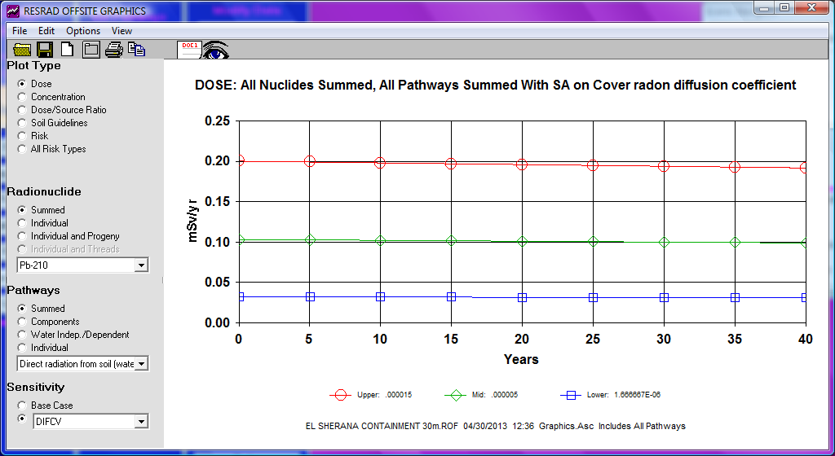

Figure A5.1 Maximum annual doses [mSv∙yr-1] received from the inhalation of radon decay products from 0-40 years, 30 m downwind of the El Sherana containment.

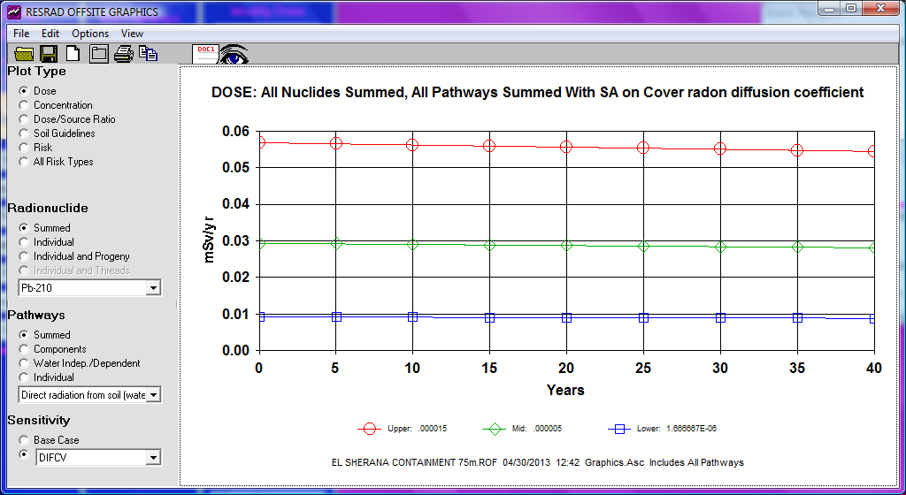

Figure A5.2 Maximum annual doses [mSv∙yr-1] received from the inhalation of radon decay products from 0-40 years, 75 m downwind of the El Sherana containment.

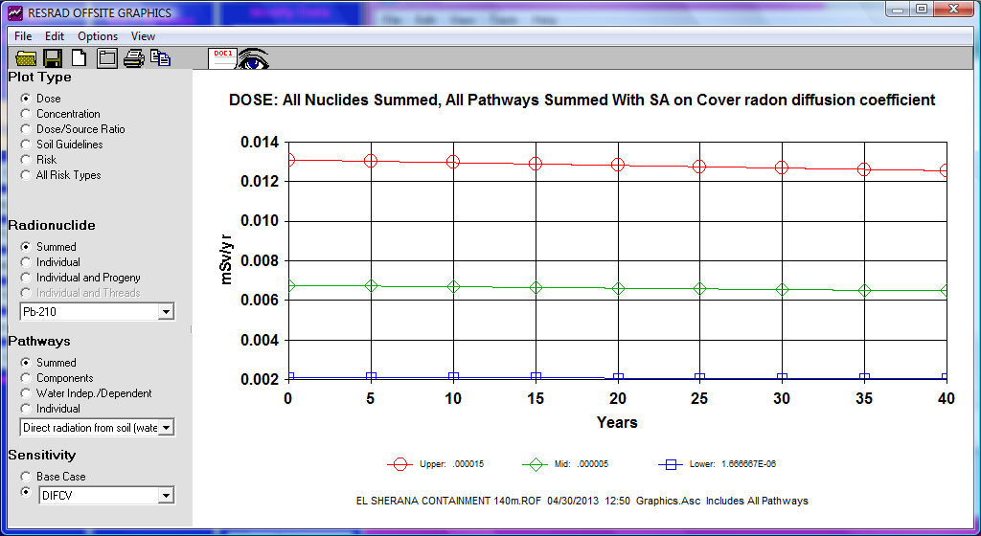

Figure A5.3 Maximum annual doses [mSv∙yr-1] received from the inhalation of radon decay products from 0-40 years, 140 m downwind of the El Sherana containment.

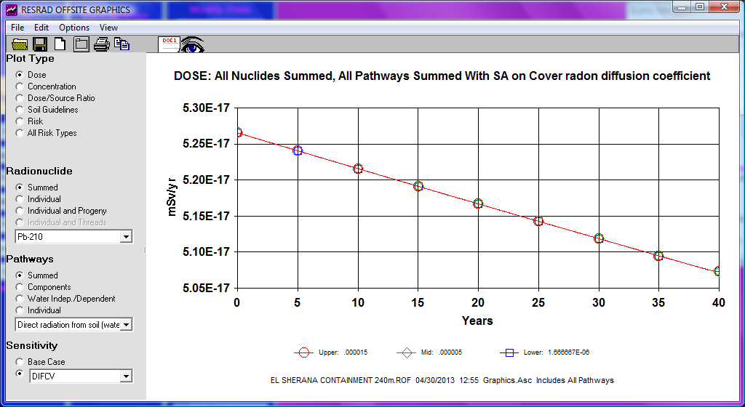

Figure A5.4 Maximum annual doses [mSv∙yr-1] received from the inhalation of radon decay products from 0-40 years, 240 m downwind of the El Sherana containment.

# Appendix 6 Report provided to Parks Australia, May 2013

# Expected maximum doses to the public from the El Sherana airstrip containment

Andreas Bollhöfer & Che Doering

Environmental Research Institute of the Supervising Scientist, Darwin. May 2013

# 1 Introduction

## 1.1 Background

The El Sherana airstrip containment is a near-surface disposal facility located in the South Alligator Valley area in the south of Kakadu National Park. It contains approximately 22,000 m3 of contaminated waste from historic uranium mining activities conducted in the area between 1955 and 1964. It was built as part of a lease agreement between the Gunlom Aboriginal Land Trust and the Director of National Parks for traditional Aboriginal lands in the upper South Alligator Valley to be managed as part of Kakadu National Park.

The containment was constructed, filled and covered in the 2009 dry season. It is currently in the institutional control period. This is the period following closure of the facility during which public access to, or alternative use of, the site must be restricted (NHMRC 1993). A boundary fence and warning signs are in place at the containment to restrict access and deter against alternative uses of the site, including camping.

The containment is currently managed by Parks Australia with regulatory oversight by the Australian Radiation Protection and Nuclear Safety Agency (ARPANSA). An inspection of Parks Australia by ARPANSA on 27–28 September 2011 highlighted that dose constraints for the containment had not been established. The inspection report (ARPANSA 2011) recommended that:

*“Parks Australia should undertake an updated assessment of the impact of the containment taking account of recently acquired monitoring data. Once levels are proposed, ARPANSA will agree on dose constraint levels with Parks Australia.”*

Parks Australia subsequently requested the assistance of the Supervising Scientist Division (SSD) to help address this recommendation. In particular, it was requested that SSD conduct an assessment of potential doses to workers and the public from the containment that could be used to guide decision making on dose constraints.

## 1.2 Objective

The objective of this report is to summarise the results of an assessment of expected maximum doses to workers and the public from the El Sherana airstrip containment (Bollhöfer et al 2013) that can be used by Parks Australia to propose dose constraints to ARPANSA for the containment.

## 1.3 Scope

The assessment applies to the current radiological conditions of the containment and for its normal (passive) operation. No breach of the surface cover of the containment, either intentionally or by natural processes, was assumed in the assessment.

# 2 Method

## 2.1 Exposure scenarios

### 2.1.1 Occupational

It was assumed that a Park Ranger spends 80 hours per year working onsite at the containment. Work conducted at the site was assumed to include general site maintenance, weed and fire management and downloading in-situ monitoring equipment. Digging into the buried waste or repair of the capping layer or surface cover was not considered in the assessment, as this was not considered to be part of the normal (passive) operation of the containment.

### 2.1.2 Public (tourist camping)

It was assumed that a tourist camped for four nights (40 hours in total) next to the boundary fence of the containment. The camping location was assumed to be immediately downwind of the containment to give the highest possible exposure scenario. No inadvertent or intentional intrusion of the fence was assumed.

### 2.1.3 Public (Aboriginal person)

An exposure scenario for Aboriginal people was not assessed, as anecdotal evidence suggested that they do not spend time in the immediate vicinity of the containment, but rather prefer other sites in the South Alligator Valley for hunting, fishing and camping. The likelihood of exposure of an Aboriginal person was considered negligible.

## 2.2 Exposure pathways

Table 1 gives the exposure pathways included in the assessment for each exposure scenario. For the occupational scenario, the pathways included were radon progeny inhalation and external gamma radiation. For the public (tourist camping) scenario, the only pathway included was radon progeny inhalation. The dust inhalation pathway was not included in either scenario as the contaminated waste was assumed to be permanently buried under a clay capping layer and clean soil cover, with no breach of the capping layer. Any radionuclides in dust from the soil cover were considered to be part of the natural background.

The ingestion pathway was not included as bushfoods and locally sourced water were not considered to be consumed in either the occupational or public exposure scenario. Additionally, it is unlikely that any terrestrial plant-based bushfood would be collected onsite by the public, nor is it likely that terrestrial animals (such as wallaby, pig or buffalo) that are sometimes consumed by Aboriginal people would be able to access the site and take up radionuclides from the buried waste due to the presence of the boundary fence during the institutional control period. Groundwater levels are deeper than the buried waste (10-12 m below surface) and transport of groundwater from the containment to the South Alligator River is slow (~ 4 mm/day) (Puhalovich et al 2006) and consequently the ingestion pathway for aquatic bushfoods and water is negligible, at least for the institutional control period.

Table 1. Exposure pathways considered in the assessment of each exposure scenario1.

|  |  |  |  |  |
| --- | --- | --- | --- | --- |
|  | External gamma | Radon progeny | Dust | Ingestion |
| Occupational | 🗸 | 🗸 | n.a. | n.a. |
| Public | n.a. | 🗸 | n.a. | n.a. |

1n.a. = not applicable.

## 2.3 Radiological characteristics

SSD has made measurements of external gamma dose rates and radon exhalation flux densities at the containment at the following points in time:

* 2007 and 2009: pre-construction (baseline) (Bollhöfer et al, 2009; Doering et al 2011);
* 2010: one year after closure (Doering et al 2011); and
* 2012: three years after closure (Bollhöfer et al 2013).

The external gamma dose rate and radon exhalation flux density used in the assessment were the 99th percentile of the above background values calculated from the difference of the 2012 and baseline measurements. These values were 0.03 µGy h-1 for external gamma dose rate and 900 mBq m-2 s-1 for radon exhalation flux density.

Comparison of the 2010 and 2012 measurements indicated that there was no significant difference in external gamma dose rates. However, there was an approximately 3 fold increase in radon exhalation flux densities from 2010 to 2012. This increase may be indicative of deterioration in site radiological characteristics. Potentially, the 0.5 m compacted clay capping that was placed immediately on top of the buried waste has dried and cracked in places, or roots from plants establishing on site have created preferential pathways, allowing more radon from the buried waste to diffuse through and exhale from the soil cover.

## 2.4 Assessment method

The dose from external gamma radiation was calculated by multiplying the 99th percentile of the above background dose rate with the time spent onsite. The dose from radon progeny inhalation was calculated using the RESRAD-Offsite computer model, with the 99th percentile of the above background radon exhalation flux density used to determine the radon progeny concentration in air on and downwind of the containment for highly stable atmospheric conditions. Full details of the assessment are given in Bollhöfer et al (2013).

# 3 Results

Table 2 gives the expected maximum doses to a worker and a member of the public from the containment for the assumed exposure scenarios. The results indicate that in both cases the expected maximum dose from all pathways is less than 10 µSv per year for the current radiological characteristics of the containment. The tourist camping received the higher dose due to radon progeny as it was assumed the worker was in the centre of the containment and thereby only exposed to radon expressed from the upwind section, whereas the camper is downwind of the entire containment footprint.

Table 2. Expected maximum above background annual effective doses (µSv) to a worker and the public from the El Sherana airstrip containment.

|  |  |  |  |  |  |
| --- | --- | --- | --- | --- | --- |
|  | External gamma | Inhalation | | Ingestion | Total |
|  |  | Radon progeny | Dust |  |  |
| Occupational (Park Ranger) | 3 | 1 | 0 | 0 | 4 |
| Public (tourist camping) | 0 | 6 | 0 | 0 | 6 |

# 4 Discussion

A dose constraint is *“a prospective and source-related restriction on the individual dose from a source in planned exposure situations ... which serves as an upper bound on the predicted dose in the optimisation of protection for that source”* (ICRP 2007). In the context of proposing or establishing a dose constraint for a source, the implication is that it should be commensurate with the expected maximum dose to an individual from the source based on an assessment that takes into account the characteristics of the source and the scenarios for exposure. However, other factors may also influence the selection of dose constraint, including:

* the possibility of deterioration in site characteristics and capacity for repair;
* the views of interested parties (stakeholders);
* the capability to measure and demonstrate doses below the dose constraint; and
* national and international guidance and good practice elsewhere.

Based on the assessment results of Bollhöfer et al (2013) alone, and assuming stable site characteristics into the future, a dose constraint of around 10 µSv per year would be appropriate for the containment for both workers and the public for the institutional control period. However, there is some evidence to suggest that radiological site characteristics have deteriorated between 2010 and 2012, allowing more radon to diffuse through and exhale from the soil cover. Further increases in radon exhalation from the site would imply higher maximum expected doses than those given in Table 2. A dose constraint greater than 10 µSv per year may therefore be appropriate to compensate for this and still achieve doses that provide an optimised level of protection for workers and the public.

# References

ARPANSA 2011. Inspection report. Report number R11/12857. Available from: <http://arpansa.gov.au/pubs/regulatory/inspections/R11-12857.pdf>

Bollhöfer A, Dunn L, Pfitzner K, Ryan B, Fawcett M & Jones DR 2009. Remediation of the remnants of past uranium mining activities in the South Alligator River Valley. In eriss research summary 2007–2008. eds Jones DR & Webb A, Supervising Scientist Report 200, Supervising Scientist, Darwin NT, 206-211.

Bollhöfer A, Doering C, Medley P & Da Costa L 2013. Assessment of expected maximum doses from the El Sherana airstrip containment, South Alligator River valley, Australia. Internal Report 618, May 2013, Supervising Scientist, Darwin.

Doering C, Bollhöfer A, Ryan B, Sellwood J, Fox T & Pfitzner J 2011. Baseline and post-construction radiological conditions at El Sherana airstrip containment, South Alligator River valley, Australia. Internal Report 592, June, Supervising Scientist, Darwin.

International Commission on Radiological Protection (ICRP) 2007. The 2007 recommendations of the International Commission on Radiological Protection. ICRP Publication 103, Annals of the ICRP 37(2–4).

National Health and Medical Research Council (NHMRC) 1993. Code of practice for the near-surface disposal of radioactive waste in Australia (1992). Radiation Health Series No. 35.

Puhalovich A, Pillai M, McGovern E & Jacobsen N 2006. Groundwater Level Monitoring & Permeability Testing – Candidate Containment Sites (Gunlom Radiological Materials). Draft Report for Parks Australia North prepared by EWL Sciences Pty Ltd. August 2006.