Wave-short

630

*internal report*

Ecotoxicological assessment of manganese

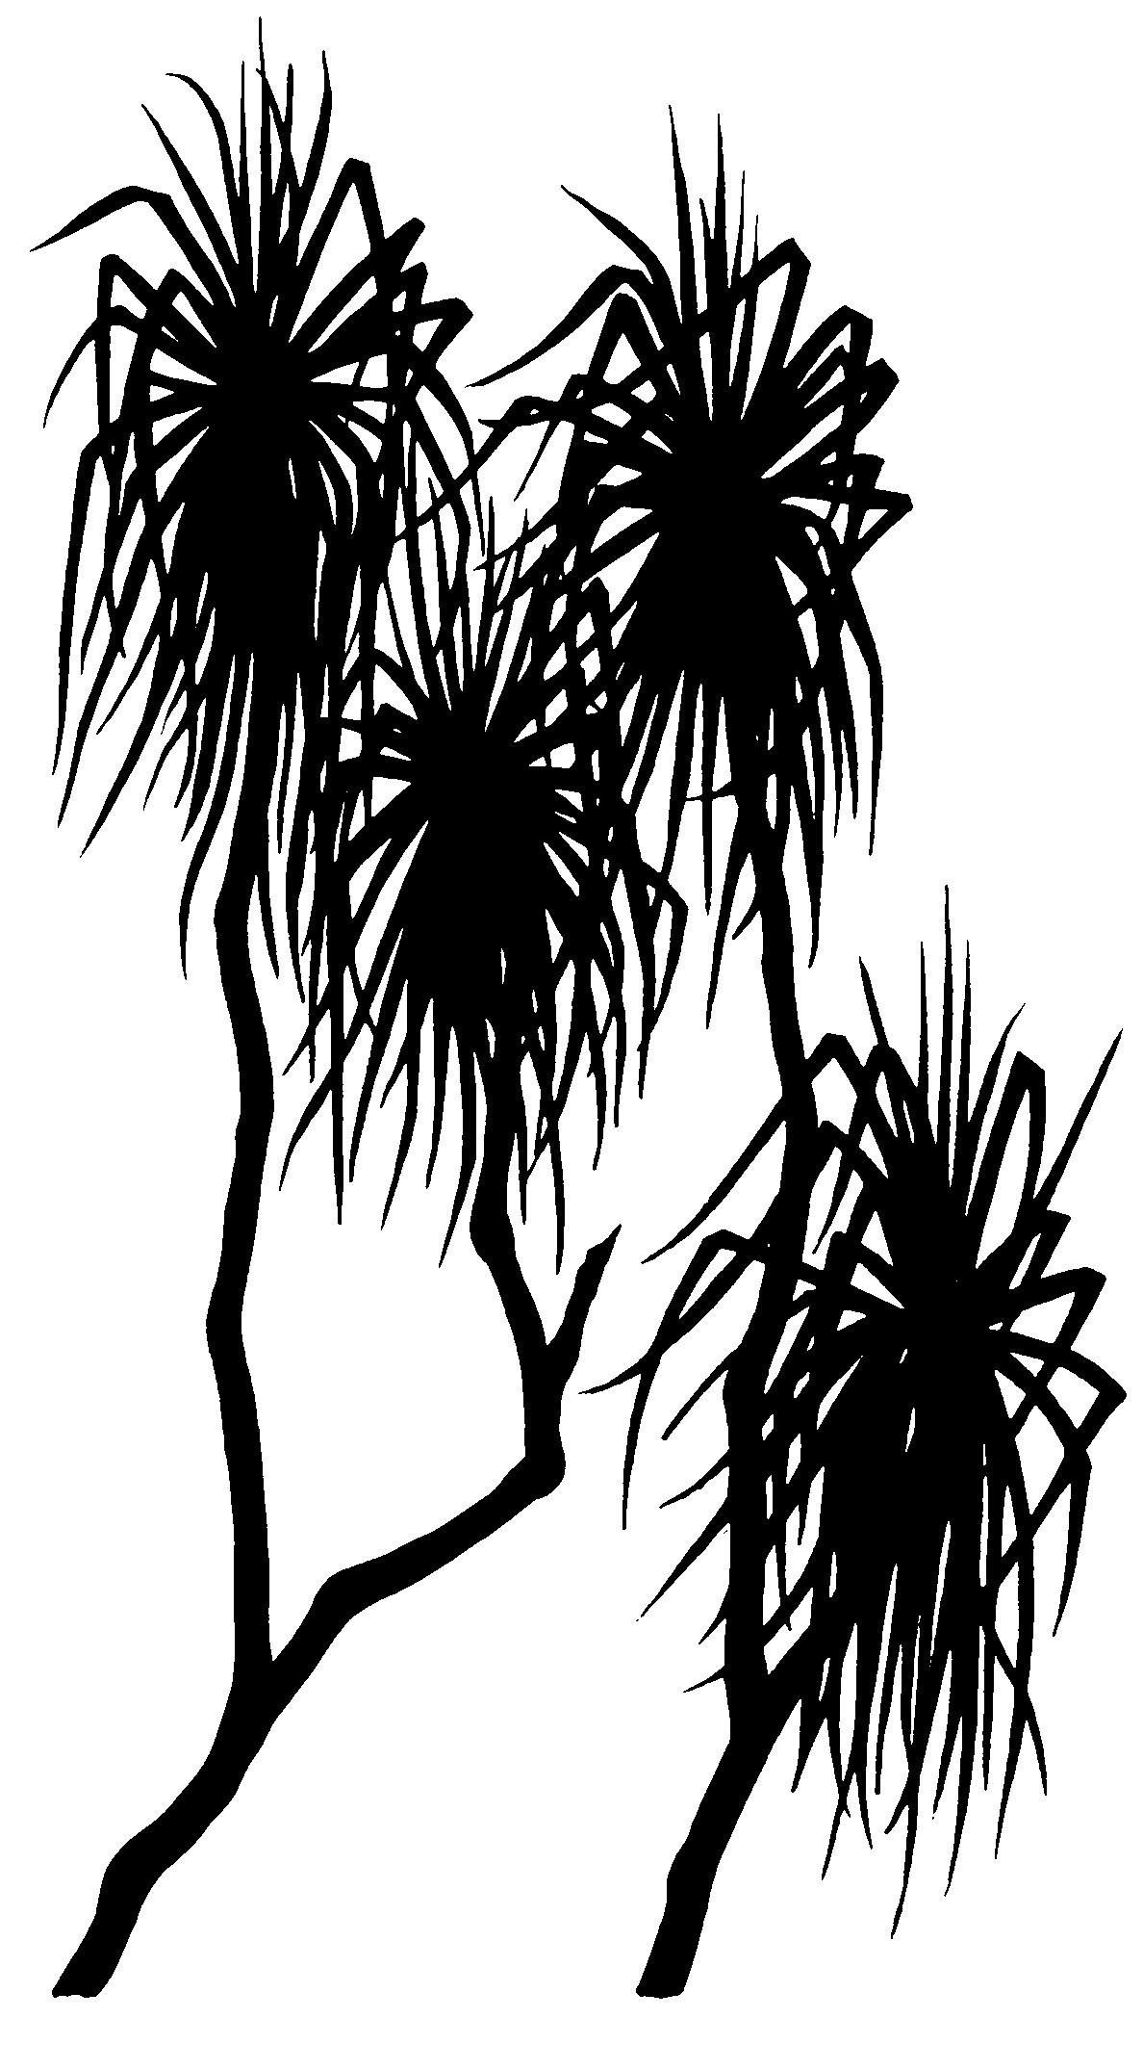



AJ Harford, MA Trenfield,   
KL Cheng, & RA van Dam

April 2014

Release status – unrestricted

Project number – RES-2012-001

*This page has been left blank intentionally.*

**Ecotoxicological assessment of manganese**

**AJ Harford, MA Trenfield, KL Cheng & RA van Dam**

Supervising Scientist Division

GPO Box 461, Darwin NT 0801

April 2014

Project number RES-2012-001

Registry File SG2008/0102

(Release status – unrestricted)



*How to cite this report:*

Harford AJ, Trenfield MA, Cheng KL & van Dam RA 2014. Ecotoxicological assessment of manganese. Internal Report 630, April, Supervising Scientist, Darwin.

*Project number –* RES-2012-001

*Authors of this report:*

Andrew Harford – Environmental Research Institute of the Supervising Scientist, GPO Box 461, Darwin NT 0801, Australia

Melanie Trenfield – Environmental Research Institute of the Supervising Scientist, GPO Box 461, Darwin NT 0801, Australia

Kim Cheng – Environmental Research Institute of the Supervising Scientist, GPO Box 461, Darwin NT 0801, Australia

Rick van Dam – Environmental Research Institute of the Supervising Scientist, GPO Box 461, Darwin NT 0801, Australia

The Supervising Scientist is a division of the Australian Government Department of the Environment.

Supervising Scientist  
Department of the Environment   
GPO Box 461, Darwin NT 0801 Australia

© Copyright Commonwealth of Australia, 2014.

Copyright Image.tif

IR630 is licensed by the Commonwealth of Australia for use under a Creative Commons By Attribution 3.0 Australia licence with the exception of the Coat of Arms of the Commonwealth of Australia, the logo of the agency responsible for publishing the report, content supplied by third parties, and any images depicting people. For licence conditions see: http://creativecommons.org/licenses/by/3.0/au/

Internet: **environment**.gov.au/ssd/publications

The views and opinions expressed in this publication are those of the authors and do not necessarily reflect those of the Australian Government or the Minister for the Environment.

While reasonable efforts have been made to ensure that the contents of this publication are factually correct, the Commonwealth does not accept responsibility for the accuracy or completeness of the contents, and shall not be liable for any loss or damage that may be occasioned directly or indirectly through the use of, or reliance on, the contents of this publication.

Printed and bound in Darwin NT by Supervising Scientist Division

# 

# Contents

Contents iii

Executive summary v

1 Introduction 1

2 Methods 4

2.1 General laboratory procedures 4

2.2 Test diluents 4

2.3 Toxicity Tests 5

2.3.1 Ngarradj Creek Water Study 5

2.3.2 Magela Creek Water Study 5

2.3.3 Fate of manganese in the *H. viridissima* test 7

2.4 Quality Control 8

2.4.1 Manganese chemistry 8

2.4.2 Quality Control Chemistry 8

2.4.3 General water quality 8

2.6.3 Control responses 8

2.5 Toxicity estimate calculations 9

2.6 Trigger Value Derivation 9

3 Results 11

3.1 Ngarradj Creek Water Study 11

3.1.1 Chemistry 11

3.1.2 Toxicity 11

3.2 Magela Creek Water 13

3.2.1 Chemistry 13

3.2.2 Toxicity 13

3.2.3 Fate of manganese in the *H. viridissima* toxicity test 16

3.2.4 *H. viridissima* toxicity tests conducted in pH 5.2 Magela Creek Water 18

3.3 Derivation of a Trigger Value for Magela Creek 19

4 Discussion 21

5 Recommendations 25

6 Conclusions 26

7 Acknowledgements 26

8 References 27

Appendix A Water quality measurements for toxicity tests 29

Ngarradj Creek Water 29

Magela Creek Water 32

Appendix B Chemical analyses 50

Appendix C Statistical Summaries 59

Ngarradj Creek Water 59

Magela Creek Water 65

# Executive summary

Manganese (Mn) is a ubiquitous element in the earth’s mantle and a key contaminant of Ranger mine process water. Manganese toxicity is dependent on pH and water hardness, which is consistent with what is known for other metals. However, Mn aquatic chemistry is also a complex function of the pH and redox micro-environment with Mn primarily existing as soluble Mn(II) and insoluble Mn(IV) oxidation states. The risks of Mn toxicity to aquatic biota of Magela Creek have been considered low to date. However, groundwater modeling of Pit 1 and Pit 3 closures has found that elevated concentrations of Mn may reach Magela Creek and indicated that Mn will be a key contaminant of concern. Additionally, the likelihood of higher Mn concentrations being released to Magela Creek may increase following the commissioning of the brine concentrator plant. Insufficient Mn toxicity data existed for local species in local natural waters to be able to (i) conclude with high confidence that no adverse effects would be expected given the current water quality and (ii) predict at what Mn concentrations adverse effects would be expected to occur. A site-specific assessment of Mn is of particular pertinence given the low water hardness and relatively low pH of natural waters of the Alligator Rivers Region, which could potentially result in higher than expected (i.e. from existing literature) Mn toxicity. The aims of this study were to:

1. Assess the toxicity of manganese (Mn) in Magela Creek water (pH ~6–6.5) to six tropical freshwater species.
2. Derive a site-specific Trigger Value (TV) for Mn in Magela Creek.
3. Recommend Limit, Focus and Action Trigger Values, which can be incorporated into the Water Quality Objective (WQO) for Magela Creek.

The TVs derived in this project were incorporated into the water quality trigger framework for Magela Creek that has been described by Iles (2004). The framework consists of a hierarchy of TVs (Focus, Action and Limits) and exceedance of these TVs initiate increasingly strict reporting and investigation actions by the mine’s operator.

The six local freshwater species tested in this study had a broad range of sensitivities to Mn in the soft surface waters of Ngarradj and Magela Creeks. For three of the species, Mn toxicity was higher than many of the species reported in the literature, which was probably due to the low concentration of Ca2+ in the natural waters. The low pH may have decreased to the toxicity of Mn to *Chlorella* sp., but increased the potential for Mn2+ to remain dissolved and, hence bioavailable. A loss of Mn was observed on the final day of a number of the *H. viridissima* toxicity tests but the Mn could not be recovered from the test system. This observation may be a result of the previously reported complex speciation of Mn. We accounted for such issues through extensive analysis of Mn (0.1 µm filtered and total) at the start and end of the tests. Toxicity estimates were adjusted using the measured Mn concentrations. The Species Sensitivity Distribution (SSD), which used the three international toxicity estimates derived under relevant physico-chemical conditions, produced a 99% TV that can be implemented in Magela Creek

It is recommended that a 99% protection TV of 75 µg L-1 Mn be applied at MG009. The Focus and Action TVs should be 35 and 45 µg L-1, respectively. These TVs are rounded out from the calculated 99% TV of 73 µg L-1 and the 95th and 80th confidence intervals of 33 and 46 µg L-1, respectively.

# 1 Introduction

Manganese (Mn) is a ubiquitous element in the earth’s mantle and is present in most rocks and soil types (Homoncik et al. 2010). Trace amounts are an essential element for organisms and human-health because it is a constituent in a number of important enzymes and co-factors. It is considered less of an environmental hazard than many other metals and evidence from the literature suggests that the acute and chronic toxicity of Mn to many freshwater biota was low (i.e. in the mg L-1 range). This was reflected in the relatively high 95% protection trigger value (TV) reported by ANZECC and ARMCANZ (2000) of 1900 µg L-1. However, recent studies have reported particularly sensitive species, e.g. *Hyalella azteca* with an IC10 of 96 µg L-1 Mn (IMnI 2009, cited Peters 2010). A review of Mn toxicity in freshwaters by the Environment Agency (UK) recommended a Predicted No Effect Concentration (PNEC) of 62 - 123 µg L-1 (Peters et al. 2010), which was based on a Species Sensitivity Distribution (SSD) of 12 toxicity estimates. The calculated Hazardous Concentration predicted to effect 5% of species (HC5; equivalent to a 95% TV) was 246 µg L-1. The aforementioned PNECs were derived by applying 2–4 Application Factors (AF; aka Safety Factor) to the HC5. The use of an AF is mandatory for the derivation of an Environmental Quality Standard (EQS) under Annex VIII of the Water Framework Directive of the European Commission (EC) but this led to an EQS that was too stringent for many waterways, although it was considered relevant to conditions of high bioavailability, i.e. low pH, hardness, alkalinity and Dissolved Organic Carbon (DOC). This issue was addressed by the EC through the development of a Biotic Ligand Model (BLM) for Mn, which allowed for the adjustment of the EQS under different physico-chemical conditions (Peters et al. 2011).

The Mn BLM reported by Peters et al. 2011 describes its toxicity as a function of water quality. They found that increasing H+ ions, or low pH, ameliorates the toxicity of Mn to algae. Additionally, Ca2+ cations ameliorate the toxicity of Mn to fish and invertebrates while Mg2+ cations ameliorate the toxicity to only invertebrates but not to the extent of Ca2+. This is because these ions compete with Mn for binding sites on/in organisms, noting that the nature of these binding sites is likely to differ across taxa. The dependence of Mn toxicity on pH and water hardness is also consistent with what is known for other metals (Peters et al. 2011). However, Mn aquatic chemistry is also a complex function of the pH and redox micro-environment with Mn primarily existing as soluble Mn(II) and insoluble Mn(IV) oxidation states. Increasing pH and redox of a solution generally results in particulate formation due to the oxidation of Mn(II) to form Mn(III)/Mn(IV) oxyhydroxide precipitates. These reactions are slow in the absence of a catalyst (Chiswell & Mokhtar 1986) but many aquatic bacteria use Mn(II) as a terminal electron acceptor during respiration, which results in the production of insoluble Mn(IV) oxides in the environment (Horsburgh et al. 2002). Richardson et al. (1988) also showed that microalgae can form micro-environments of high pH and high O2, which promotes the formation of insoluble MnO2 colloids. Hence, compared to other metals Mn can be a problematic metal in toxicity tests and detailed chemical analyses are essential to determine accurate exposure measurements.

Due to observations at Ranger in the early 2000s of increasing concentrations of (Mn) in a shallow groundwater bore adjacent to Magela Creek greater attention was paid to (Mn) as a contaminant of potential ecotoxicological concern, (MC20; up to 50 000 μg L-1; ERA 2002). Additionally, concentration ‘spikes’ have been observed in early wet season surface water in lower Corridor Creek (GC2; 700–800 μg L-1) and Coonjimba Billabong (1300 μg L-1 in December 2002/January 2003) (van Dam 2004). Since then, Mn concentrations in bore MC20, which is in a local depression and acts as a collection point for surface drainage, have consistently been measured at 40 000–50 000 μg L-1 during the dry season (ERA 2008), with much lower values (100-1000 g L-1; based on limited data) in the wet season following flushing of the shallow groundwater system. This appeared to be a localised effect, with dry season Mn concentrations in nearby shallow groundwater bores over the same time period being at least two orders of magnitude lower than in bore MC20. Four more occurrences of Mn above 800 μg L-1 (with a maximum of 1690 μg L-1 in November 2004) have been measured at GC2, while Coonjimba Billabong has experienced one additional spike above 800 μg/L, in December 2007 (ERA 2008). Two of the measured spikes exceeded the ANZECC/ARMCANZ (2000) 99% species protection trigger of 1200 μg L-1, and were above concentrations reported in the literature to cause chronic toxicity to some species. The current site-specific guideline for Mn in Magela Creek downstream of Ranger is 26 μg L-1 (based on upstream reference site data; Iles 2004). This value was derived from statistical analysis of water quality data from the upstream reference site data, and applicable only when flow in Magela Creek is greater than 5 cumecs. It is approximately two orders of magnitude more conservative than the ANZECC/ARMCANZ (2000) trigger value.

Notwithstanding these high concentrations, Mn concentrations in Magela Creek downstream of the mine have remained between 3 and 15 µg L-1 (5th and 95th percentile, n = 557). Even during periods of low flow in the creek the maximum concentration measured was 50 µg L-1. The current site-specific guideline for Mn in Magela Creek of 26 μg L-1 has been exceeded in less than 2% of the Magela Creek water samples collected since 1980 (Harford et al. 2009). The majority of exceedances have occurred during early wet season flows or end of wet season recessional flows, often when flow is less than 5 cumecs. These periods are considered to be atypical of the season as a whole given the increased contributions from shallow groundwater at these times. Consequently, the risks of Mn toxicity to aquatic biota have been considered low to date. However, groundwater modeling of Pit 1 and 3 closures has found that elevated concentrations of Mn may reach Magela Creek and indicated that Mn will be a key contaminant of concern (reported at ARRTC 31). Additionally, the likelihood of higher Mn concentrations being released to Magela Creek may increase following the commissioning of the brine concentrator plant. The pilot-scale brine concentrator plant tested in 2011 produced two distillate waters containing Mn at concentrations of 130 and 240 µg L-1 (Harford et al. 2013), which is residual from the 1400 mg L-1 Mn in the untreated process water. The full-scale brine concentrator has produced typically cleaner distillates due to additional vapor scrubbing facilities. The median Mn concentration was 1.0 µg L-1 (n=61, ARRTC31) but a maximum concentration of 110 µg L-1 was reported. Such Mn concentrations are higher than those currently measured in mine waters discharged from Ranger (RP1 had 0.2 to 63 µg L-1 during 2011–2012), and the addition of distillate to such waters may eventually result in higher Mn concentrations in Magela Creek than have previously been measured.

Insufficient Mn toxicity data existed for local species in local natural waters to be able to (i) conclude with high confidence that no adverse effects would be expected given the current water quality and (ii) predict at what Mn concentrations adverse effects would be expected to occur. A site-specific assessment of Mn is of particular pertinence given the low water hardness and relatively low pH of natural waters of the Alligator Rivers Region, which could potentially result in higher than expected (i.e. from existing literature) Mn toxicity. The aims of this study were to:

1. Assess the toxicity of manganese (Mn) in Magela Creek water (pH ~6–6.5) to six tropical freshwater species.
2. Derive a site-specific Trigger Value (TV) for Mn in Magela Creek.
3. Recommend Limit, Focus and Action Trigger Values, which can be incorporated into the Water Quality Objective (WQO) for Magela Creek.

The TVs derived in this project were incorporated into the water quality trigger framework for Magela Creek that has been described by Iles (2004). The framework consists of a hierarchy of TVs (Focus, Action and Limits) and exceedance of these TVs initiate increasingly strict reporting and investigation actions by the mine’s operator.

# 2 Methods

## 2.1 General laboratory procedures

All equipment which test organisms or media came in contact with, or were exposed to, was made of chemically inert materials (e.g. Teflon, glass or polyethylene). All plastics and glassware were washed by soaking in 5% (v/v) HNO3 for 24 h before being washed with a non-phosphate detergent (Dr. Weigert, neodisher® LaboClean FLA, Hamburg, Germany) in a laboratory dishwasher operated with reverse osmosis/deionised water (Elix, Millipore, Molshiem, France). All reagents used were analytical grade and stock solutions were made up in high purity water (18 MΩ, Milli-Q Element, Millipore, Molshiem, France).

Glassware used in the toxicity tests was silanised with 2% dimethyldichlorosilane in 1,1,1-trichloroethane (Coatasil, AJAX, Seven Hills, Australia) to reduce Mn adsorption to the glass. All reagents used were analytical grade and stock solutions were made up in Milli-Q water.

## 2.2 Test diluents

A low pH diluent water (Ngarradj Creek Water, NCW) was chosen for preliminary toxicity tests because the bioavailability of Mn was likely to be higher at a lower pH. NCW was collected from near the Ngarradj Creek Upstream gauging station (NCUS: 0275473; 8616847; WGS84, Zone 53).

Natural Magela Creek water (MCW) was used as the control treatment and for dissolution media in all other tests, and was obtained from Bowerbird Billabong (latitude 12° 46’ 15’’, longitude 133° 02’ 20’’). This natural water has been extensively characterised and has been used as a diluent in toxicity testing for over 20 years in the ***eriss*** ecotoxicology laboratory.

The natural waters were collected in 20 L acid-washed plastic containers and transported 2.5 h to the laboratory at ambient temperature. At the laboratory, they were filtered within 3 days of collection (2.5 µm, Filter paper no 42, Whatman or 3.0 µm, Sartopure PP2 depth filter MidiCaps, Sartorius). The waters were stored at 4 ± 1°C prior to filtration and up to 1 month following collection. For the *A. cumingi* tests, the NMCW diluent water was as per that described above, with the exception that given the high volumes of water required for a single toxicity test, it was not pre-filtered. This had the potential to introduce coarse particulates and wild zooplankton into the test. However, both the diluent and test solutions were visibly free of coarse particulates, whereas wild zooplankton were not observed in the test (possibly because the waters were stored at 4°C after collection). Even if they were present in low numbers, they were considered unlikely to adversely affect the snails’ reproduction or affect the toxicity of Mn.

Diluent waters were sub-sampled for physico-chemical analyses. Specifically pH, DO, EC and DOC were measured in-house. Additional sub-samples were sent to an environmental chemistry laboratory (Envirolab, Chatswood, NSW) for measurement of alkalinity (APHA2320B), and a limited metal and major ion suite (totals only; Al, Cd, Co, C, Cu, Fe, Mn, Ni, Pb, Se, U, Zn, Ca, Mg, Na, SO4 (analysed as S and converted)) by ICP-MS and ICP-AES.

## 2.3 Toxicity Tests

The toxicity of Mn was assessed using six Australian tropical freshwater species: the unicellular green alga (*Chlorella* sp.); the duckweed (*Lemna aequinoctialis*); the green hydra (*Hydra viridissima*);the cladoceran (*Moinodaphnia macleayi*); the aquatic snail (*Amerianna cumingi*) and the Northern trout gudgeon (*Mogurnda mogurnda*). All the organisms were isolated from soft surface waters in Kakadu National Park and have been cultured continuously at the Environmental Research Institute of the Supervising Scientist over many years (10–25 years depending on the species). The test methods are described in detail by Riethmuller et al. (2003) and, for *A. cumingi* only, Houston et al. (2007). Key details of each test are provided in Table 1. For the *L. aequinoctialis* and *Chlorella* sp. tests, nutrients (nitrate and phosphate) were added at the minimum concentrations that would sustain acceptable growth (see Table 1). The MCW used in the *Chlorella* sp. tests also had 1 mM HEPES buffer added to maintain a stable pH.

The natural water diluents were spiked with Mn using a stock solution of 52.5 mg L-1 manganese sulfate (MnSO4.H2O, Sigma-Aldrich). Concentrations of dissolved Mn (0.1 µm filtered) were measured before and after the test exposure through ICP-MS analysis (see QC section below).

### 2.3.1 Ngarradj Creek Water Study

Preliminary experiments were undertaken using Ngarrdj Creek Water (NCW) and *Chlorella* sp. and *H. viridissima*. For *M. macleayi* a modified chronic toxicity tests and an acute test were conducted (Table 2), in order to determine the influence of the algal food source on Mn toxicity. A Magela Creek Water (MCW) quality control group was included for each test conducted in NCW (i.e. organisms were maintained in the standard natural MCW; pH – 6.8, EC – 16 μS/cm, DO – 97.5% saturation).

With the exception of one of the *M. macleayi* tests (see below), all experiments were conducted in accordance with the standardised ***eriss*** ecotoxicological protocols described in Riethmuller et al. (2003). Two of the *M. macleayi* chronic toxicity tests were conducted simultaneously with one of the tests excluding the algal component of the cladocerans’ food (Table 1). This was done to determine if the presence of actively photosynthesising algae would result in oxidation of the manganese and production of insoluble manganese oxyhydroxides (MnO, Richardson et al. 1988), thereby reducing the bioavailability and toxicity of Mn.

### 2.3.2 Magela Creek Water Study

At least two valid toxicity tests were completed for each species and for most of the toxicity tests a modified design was used (Table 2). Specifically, the concentration range was increased by reducing treatment replication from 3 replicates to 2 replicates. The design has the advantage of being able to better characterise the concentration-response relationships and derive toxicity estimates with increased accuracy. Due to logistical reasons, the modified design was not used for the snail toxicity tests.

**Table 1** Details of toxicity tests for the six Australian tropical freshwater species used to assess the toxicity of manganese. Full details of the methods are provided in Riethmuller et al. (2003) and Houston et al. (2007).

|  |  |  |  |  |  |  |  |
| --- | --- | --- | --- | --- | --- | --- | --- |
| **Species  (common name)** | **Test duration and endpoint** | **Control response acceptability criterion** | **Temperature, light intensity, photoperiod** | **Feeding/ nutrition** | **No. replicates (Individuals per replicate)a** | **Test volume (mL)** | **Static/daily renewals** |
| *Chlorella* sp. (unicellular green alga) | 72-h population growth rate | 1.4 ± 0.3 doublings day-1;  % CVa <20% | 29 ± 1°C  100-150 μmol m-2 sec-1 12:12h | 14.5 mg L-1 NO3  0.14 mg L-1 PO4 | 3  (3×104 cells ml-1) | 50 | Static |
| *Lemna aequinoctialis* (tropical duckweed) | 96-h growth rate | Mean surface area growth rate (k, mm2 day -1) ≥0.40;  % CV <20% | 29 ± 1°C  100-150 μmol m-2 sec-1 12:12h | 3 mg L-1 NO3  0.3 mg L-1 PO4 | 3 (4 with 3 fronds) | 100 | Static |
| *Hydra viridissima*  (green hydra) | 72-h population growth rate | Mean population growth rate (k, day -1) ≥0.27; % CV <20% | 27 ± 1°C  30-100 μmol m-2 sec-1 12:12h | 3-4 *Artemia* nauplii day-1 | 3 (10) | 30 | Daily renewals |
| *Moinodaphnia macleayi* (cladoceran) | 3-brood  (120-144 h) reproduction | Mean adult survival ≥80%; mean neonates per adult ≥30; % CV <20% | 27 ± 1°C  30-100 μmol m-2 sec-1 12:12h | 30 μl FFVb and  6 × 106 cells of Chlorella sp. d-1 | 10 (1) | 30 | Daily renewals |
| *Amerianna cumingi* | 96-h reproduction | Mean eggs per snail pair  ≥100; %CV<30% | 30°C; 30 - 100 mmol m-2 sec-1;  12:12h | 2 cm2 lettuce disc per snail per day | 3 (12) | 1750 | Daily renewals |
| *Mogurnda mogurnda* (Northern trout gudgeon) | 96-h survival | Mean larval survival ≥80%;  % CV <20% | 27 ± 1°C  30-100 μmol m-2 sec-1 12:12h | Nil | 3 (10) | 30 | Daily renewals |

a Replication was reduced for modified tests in order to increase the number of treatments. See Table 2  
b CV: Percent co-efficient of variation  
c FFV: fermented food with vitamins. Represents an organic and bacterial suspension prepared by method described in Riethmuller *et al* (2003)

**Table 2** Details of the manganese concentration-response tests conducted

|  |  |  |  |  |  |
| --- | --- | --- | --- | --- | --- |
| **Test ID** | **Date** | **Species name** | **Endpoint** | **Mn concentration range tested (µg L-1)** a | **Comments** |
| **Ngarradj Creek Water** | | | | | |
| 933D | 31/05/08 | *M. macleayi* | Reproduction | 4.2 - 1870 | Modified design – no algae, 30 µL FFV only |
| 934D  937D | 31/05/08 20/06/08 | *M. macleayi* | Reproduction | 4.2 – 1840  4.6 – 15300 | As per protocol |
| 938I | 20/06/08 | *M. macleayi* | Survival | 4.6 – 15100 | No food |
| 936B | 16/06/08 | *H. viridissima* | Population growth | 5.2 – 19150 | As per protocol |
| 939G | 24/06/08 | *Chlorella* sp. | Population growth | 4.5 – 59 300 | As per protocol |
| **Magela Creek Water** | | | | | |
| 1278G  1294G | 30/04/12  28/08/12 | *Chlorella sp.* | Population growth | 4.0 – 480000  3.0– 135000 | Modified designb |
| 1276L  1279L  1297L | 30/04/12  23/04/12  10/09/12 | *L. aequinoctialis* | Surface area growth rate | 3.0 – 44000  2.0 – 19000  0.3 – 39000 | Modified designb |
| 1290B  1277B  1310B  1318B  1379B  1381B | 30/07/12  30/05/12  19/11/12  11/02/2013  21/01/14  28/01/14 | *H. viridissima* | Population growth | 0.6 – 755  0.3 – 840  1.8 – 1950  5.0 - 1750  3.0 – 2300  3.0 – 2300 | Modified designb  1290B and 1277B not used in toxicity estimate due to Mn loss  1379B and 1381 tests conducted with pH 5.2 MCW |
| 1299D  1345D | 14/09/12  1/08/13 | *M. macleayi* | Reproduction | 3.0 – 1150  2.0 – 4700 | Modified design for first test onlyb |
| 1275S  1307S  1335S | 23/04/12  29/10/12  29/04/13 | *A. cumingi* | Reproduction | 1.8 – 33500  2.0 – 10500  2.0 – 29500 | As per protocol |
| 1284E  1293E  1300E | 14/06/12  23/08/12  20/09/12 | *M. mogurnda* | Survival | 2.0 – 46500  4.0 – 295000  4.0 - 360000 | Modified designb |

a Concentration range is based on the mean of start and end Mn values

b A modified design of less replicates and more treatments was used were indicated

### 2.3.3 Fate of manganese in the *H. viridissima* test

Due to observed losses of Mn in the *H. viridissima* toxicity tests, an experiment was conducted to assess the fate of Mn in the hydra test system. Three Mn concentrations in MCW (background, 250 and 600 µg L-1) were assessed. An additional treatment was included for each Mn concentration, whereby the test petri dishes were pre-inoculated with a solution of 250 µg Mn L-1 for 24 h prior to the test commencement, i.e. ‘primed’. This treatment was incorporated to see if Mn binding sites on the petri dishes could be saturated prior to the experiment, thereby reducing this source of Mn loss during the test. Measurements of Mn were made on the following components of the test system:

1. Test solutions from the test petri dishes at test commencement and every 24 h just prior to test solution renewal, until the end of the test (96 h) (total and 0.1 µm filtered Mn)
2. Test solutions from the 5 L test solution storage bottles at the commencement and end of the test (total and 0.1 µm filtered Mn)
3. Hydra tissue at the end of the test (total Mn in all hydra)
4. The surface of the test petri dishes, following rinsing with 5% HNO3 (total Mn).

## 2.4 Quality Control

### 2.4.1 Manganese chemistry

Water samples (total and 0.1 m filtered) for chemical analyses were collected and analysed both before and after exposure to track the status of the added Mn. Filtration through 0.1 m membranes, rather than the conventional 0.45 m filtration, was used specifically for this work to provide increased ability to identify Mn oxides in colloidal form.

### 2.4.2 Quality Control Chemistry

For each test, blanks and procedural blanks (i.e. ultra-pure water that has been exposed to all components of the test system) were also analysed for a limited metal and major ion suite (Al, Cd, Co, C, Cu, Fe, Mn, Ni, Pb, Se, U, Zn, Ca, Mg, Na, SO4 - analysed as S and converted). Chemistry data for the blanks and procedural blanks were initially assessed by searching for analyte concentrations higher than detection limits. Where these concentrations were greater than 1 g L-1 and above background levels of MCW, duplicate procedural blank samples were re-analysed and/or the control water concentrations were compared to those in tests without blank contamination, to determine if the contamination was limited to the one sample bottle or experienced throughout the test. The likelihood that contamination may have confounded the toxicity test results was investigated and discussed on a case-by-case basis.

### 2.4.3 General water quality

For each test, data were considered acceptable if: the recorded temperature of the incubator remained within the prescribed limits (see test descriptions, above); the recorded pH was within ± 1 unit of values at test commencement (i.e. Day 0); the EC for each test solution was within 10% (or 5 µS cm-1 for samples with low conductivity) of the values at test commencement; and the DO concentration was greater than 70% throughout the test (see Appendix A for data). The occurrence of any significant water quality changes were investigated and discussed on a case-by-case basis.

### 2.6.3 Control responses

Tests were considered valid if the organisms in the QC treatment (i.e. those in the MCW or SSW control) met the following criteria:

##### Chlorella sp. cell division rate test

* The algal growth rate is within the range 1.4 ± 0.3 doublings day-1; and
* There is <20% variability (i.e. co-efficient of variation, CV <20%) in growth rate.

##### L. aequinoctialis plant growth test

* The average increase in frond number in any flask at test conclusion is at least four times that at test start (i.e. a total of 60 fronds/flask or specific growth rate (k) > 0.4 day-1); and
* There is <20% variability (CV < 20%) in growth rate.

##### M. macleayi 3-brood reproduction test

* 80% or more of the cladocera are alive and female, and have produced three broods at the end of the test period;
* Reproduction in the control averages 30 or more live neonates per female over the test period; and

##### H. viridissima population growth test

* More than 30 healthy hydroids (i.e. specific growth rate specific growth rate (k) > 0.27 day-1) remain in each dish at the end of the test period; and
* There is <20% variability (CV <20%) in growth rate.

##### A. cumingi reproduction test

* More than 100 eggs per snail pair
* There is <30% variability (CV<30%) in mean egg production

##### M. mogurnda larval fish survival test

* The mean mortality or presence of fungus on the fish does not exceed 20%; and
* There is <20% variability (CV <20%) in survival.

## 2.5 Toxicity estimate calculations

For the NCW toxicity tests, linear interpolation analyses were used to determine point estimates of Inhibitory Concentrations (ICs) that reduced endpoint responses by 10% and 50% (i.e. IC10 and IC50) relative to the control responses (ToxCalc version 5.0.23F, Tidepool Scientific Software; Appendix C). Non-linear regression could not be used due to an insufficient number of data points for the NCW tests. For the MCW toxicity tests, the individual tests were pooled and the raw data analysed. Two valid hydra tests, where significant loss of Mn was measured, were not used in the calculation of the toxicity estimate because a reliable exposure concentration could not be estimated (Table 2). Non-linear regression (3-parameter log-logistic) analyses were used to determine point estimates of Inhibitory Concentrations (ICs) that reduced endpoint responses by 10% and 50% (i.e. IC10 and IC50) relative to the control responses (CETIS version 1.8.7.4, Tidepool Scientific Software; Appendix C). Because the *M. mogurnda* test represents an acute exposure and measures lethality, a more conservative 5% effect/lethal concentration was estimated instead of a 10% effect/lethal concentration.

## 2.6 Trigger Value Derivation

A site-specific 99% protection Trigger Value (TV) was derived using the Species Sensitivity Distribution (SSD) method (BurrilOz 2.0, CSIRO). In order to improve the fit of the distribution three extra toxicity estimates from international studies in physico-chemical conditions closely related to Magela Creek were added to the local species dataset. Specifically, toxicity estimates from the temperate, northern hemisphere species, *Pseudokirchneriella subcapitata* (alga)*, Ceriodaphnia dubia* (cladoceran) and *Pimephales promelas* (fish) were added to the SSD. These toxicity tests were conducted at 25°C in a natural soft water (Hardness = 12 mg L-1 CaCO3, Ca = 4 mg L-1) with a pH of 6.7. The Dissolved Organic Carbon (DOC) was 12 mg/L, which is four times higher than MCW (typically <3 mg L-1). However, DOC has been reported to have less of an influence on Mn toxicity compared to other physico-chemical parameters (Peters et al. 2011). Focus and Action TVs were calculated using the lower 95 and 80% confidence intervals of the site-specific 99% protection TV.

# 3 Results

## 3.1 Ngarradj Creek Water Study

### 3.1.1 Chemistry

Prior to filtering, the NCW had a pH of 5.3, an electrical conductivity (EC) of 13 S cm-1 and a dissolved oxygen (DO) content of 86%. Following filtration, the water had a pH of 5.6, an EC of 12 S cm-1 and a DO content of 75%. For the testing, the pH was higher again, but remained 6.0–7.0 for all tests. Metal analysis of filtered NCW indicated that it contained some aluminium (3.0 g L-1), zinc (2.0 g L-1), nickel (1.6 g L-1) and manganese (3.8 g L-1). All other metals analysed were at concentrations <1 g L-1.

The results of Mn analyses for the toxicity tests are reported in Appendix B (Table B1). The total concentration of Mn did not change during the course of the experiments, indicating that there was no loss to the test system (e.g. walls of the test vials). At the commencement of the tests, ~92% of the total Mn was present in the <0.1 m fraction (i.e. dissolved or very fine colloidal fraction), compared to approximately 86-92% by the end of the tests. Furthermore, tests that did not receive daily water renewal and were conducted over longer time periods (i.e. 72-h algae test and 48-h acute flea tests) did not show markedly larger losses of Mn. To account for the change in soluble (i.e. bioavailable) Mn, the calculation of toxicity estimates used an average of the start and end of test filtered concentrations. Analysis of the test solutions from the initial two cladoceran tests (i.e. 933D and 943D) indicated that significant concentrations of oxidised Mn forms (i.e. insoluble forms) were not being formed in the presence of photosynthetic organisms (i.e. the algal food source).

### 3.1.2 Toxicity

The initial chronic toxicity experiment with *M. macleayi* demonstrated that excluding the algal food from the test significantly reduced their reproductive health (Figure 1a). Exposure of *M. macleayi* to Mn with and without the algal food in the test system resulted in a similar concentration-response. Excluding the algal food resulted in a significant reduction in neonate numbers of ~40% at 1840 µg L-1 Mn and while there was a similar reduction in the test with algae, the larger variation in the control response resulted in no statistically significant effects (Figure 1a). In order to further understand the affect of algae, a 6-d chronic test with algal food and a 48-h acute test without food were conducted at higher concentrations. Both these studies resulted in 100% lethality to *M. macleayi* within 48 h at concentrations ≥1845 g L-1 Mn (Figure 1a and b). A Mn concentration of 870 g L-1 Mn resulted in a statistically significant reduction in the number of neonates (i.e. 13%) in the chronic test, while in the acute test no significant effects were observed at 770 g L-1 Mn (Figure 1). The results of the tests indicate a dramatic threshold response for *M. macleayi* survival at between 1000–2000 μg L-1 Mn and showed that the presence of algae did not markedly alter the toxicity.

Of the three species tested, *H. viridissima* was the most sensitive to Mn exposure but the lowest concentration of Mn tested resulted in a significant reduction of population growth rate. An IC10 of 60 (30 – 330) g L-1 and an IC50 of 770 (590 – 940) g L-1 were determined but it should be noted that only a limited number of concentrations were tested and these tests were not repeated. Manganese only inhibited the growth rate of *Chlorella* sp by 13.5% over the concentration range that was tested (Figure 1, Table 3). An IC10 of 5100 g L-1 was calculated, while the IC50 could not be determined but was >59 300 g L-1. However, due to low intra-treatment variability in the control and treatment groups in a statistically significant inhibition of growth rate was detected in the intermediate treatments of 1860 g L-1 and 5960 g L-1 Mn. The results demonstrate that *Chlorella* sp. is tolerant to Mn exposure, especially in comparison to *H. viridissima*

|  |  |
| --- | --- |
| **a)** | **b)** |
|  |  |
| **c)** | **d)** |
|  |  |

**Figure 1**  Effect of Manganese on a) the reproduction of *M. macleayi* over six days b) the survival and reproduction of *M. macleayi* over 48 h c) the population growth rate of *H. viridissima* over 96 h and d) the growth rate of *Chlorella* sp. over 72 h. * and † denote significantly different from the NCW control (*p*<0.05)

**Table 3** Summary of the Mn toxicity estimates to three local freshwater species in Ngarradj Creek Water

|  |  |  |  |  |  |  |  |
| --- | --- | --- | --- | --- | --- | --- | --- |
| **Test ID and Date** | **Species name** | **Endpoint** | **Control performance** | | | **Toxicity (g L-1)** | |
| **Creek water** | **mean** | **%CV2** | **IC103** | **IC504** |
| 933D 31/05/08 | *M. macleayi* | # neonates | Magela | 35.4 | 6.2 | 1750 (nc)5 | >1870 (nc) |
| Ngarradj | 32.2 | 36.4 |
| 934D 31/05/08 | *M. macleayi* | # neonates | Magela | 13.6 | 8.6 | 410 (nc) | >1840 (nc) |
| Ngarradj | 16.1 | 4.6 |
| 936B 16/06/08 | *H. viridissima* | Population growth rate | Magela | 0.3 | 5.8 | 60  (30-330) | 770  (590-940) |
| Ngarradj | 0.3 | 10.6 |
| 937D 20/06/08 | *M. macleayi* | # neonates | Magela | 27 | 43 | 650  (360-920) | 1290  (1200-1340) |
| Ngarradj | 35.1 | 5.3 |
| 938I 20/06/08 | *M. macleayi* | Survival | Magela | 100 | 0 | 880  (730-880) | 1310  (1230-1310) |
| Ngarradj | 100 | 0 |
| 939G 24/06/08 | *Chlorella* sp. | Growth rate | Magela | 1.8 | 3.3 | 5100 (nc) | <59300 (nc) |
| Ngarradj | 1.7 | 3.3 |

1 Control growth rate in doublings day-1

2 %CV: percent co-efficient of variation

3 IC10: the concentration that results in a 10% reduction in growth rate relative to the controls

4 IC50: the concentration that results in a 50% reduction in growth rate relative to the controls

5 nc = not calculable

## 3.2 Magela Creek Water

### 3.2.1 Chemistry

Physicochemical parameters of the control MCW were maintained within the following ranges across all tests: pH 5.7-7.1, DO 80–119%, and EC (of controls only) 15-47 µs cm-1 (higher EC occurs in the algae test due to the addition of nutrients; see Appendix A).

With the exception of three tests there was little difference between the 0.1 µm filtered Mn concentrations measured before and after the tests, indicating negligible loss (including precipitation) of Mn from the test systems. An unexpected observation during the study was the loss of a significant proportion of Mn from the test solutions during some of the hydra tests and a snail test, especially at Mn concentrations below 230 µg L-1. This loss of Mn from the test waters was not observed for any of the other toxicity tests and also did not occur in the NCW toxicity tests. Potential sources of Mn loss included adsorption to the test solution bottles and/or the test containers, precipitation and/or adsorption/absorption by the test animals. Experiments aimed to determine the fate of Mn in the test system were unable to definitively identify the cause of the loss (see section 3.2.3). The toxicity estimates reported in Table 4 were based on Mn concentrations calculated by averaging the before and after test 0.1 µm filtered Mn concentrations in the test solutions.

### 3.2.2 Toxicity

Manganese toxicity varied markedly between the six local tropical freshwater species assessed (Figure 2 and Table 4). Concentration-response relationships were established for all species (Figure 2). Toxicity to the fish, *Mogurnda mogurnda*, duckweed, *Lemna aequinoctialis*, and green alga, *Chlorella* sp., was low, with IC10 values all above 2000 µg L-1 (Table 4). The aquatic snail, *Amerianna cumingi*, the cladoceran, *Moinodaphnia macleayi*, and the hydra, *H. viridissima* were markedly more sensitive, with IC10 values lower than 610 µg L-1 for these three species. The hydra was the most sensitive species that was tested with an IC10 of 140 µg L-1 (Table 4).

A noteworthy loss of Mn was observed in two out of four *H. viridissima* toxicity tests. Due to the chemistry sampling design, the loss Mn of ~250 µg L-1 was measured in only half of the treatments in the first *H. viridissima* toxicity test (1277B). Hence, because Mn was not measured in all treatments this test was omitted from the derivation of the toxicity estimate. A similar Mn loss was seen in one other *H. viridissima* toxicity test (1290B). For this test, the concentration of Mn was measured in all treatments at the end of the test and therefore an average Mn concentration could be used for the toxicity estimate. Interestingly, a loss of Mn was not observed in the following two *H. viridissima* toxicity tests and the concentrations of Mn at the end of the test were within 10% of the starting concentrations. The fate and rate of the Mn loss in the test system was specifically examined (see section 3.2.3). The toxicity estimates reported in Table 2 for *H. viridissima* were based on Mn concentrations calculated by averaging the before and after test 0.1 µm filtered Mn concentrations in the test solutions. The IC10 for *H. viridissima* was 2 times higher in MCW compare to NCW at 140 (100 – 180) µg L-1 compared to 60 (30 – 330) µg L-1.

Typically, Mn no/low effect toxicity estimates (e.g. EC/IC10s, no-observed-effect**-**concentrations) for freshwater species are > 1000 µg L-1. It is noteworthy that three of the species tested in the present study had IC10s < 1000 µg L-1. The order of sensitivity of the six species to Mn was:

H. viridissima > A. cumingi >M. macleayi >> L. aequinoctialis > Chlorella sp. >> M. mogurnda

|  |  |
| --- | --- |
| **a) Chlorella sp.** | **b) L. aequinoctialis** |
|  |  |
| **c) H. viridissima** | **d) M. macleayi** |
|  |  |
| **e) A. cumingi** | **f) M. mogurnda** |
|  |  |

**Figure 2** Manganese concentration-response relationships for the six tested species. Data points represent the mean ± standard error of 2-3 replicates, except for *M. macleayi* (*n* = 5-10 replicates). 3-parameter logistic models were used to determine toxicity estimates for all species.

**Table 4** Summary of the Mn toxicity estimates to three local freshwater species in Magela Creek Watera

|  |  |  |
| --- | --- | --- |
| **Species** | **IC10 (µg L-1)b** | **IC50 (µg L-1)c** |
| *Chlorella* sp. | 12 × 103 (10 – 14 × 103) | 60 × 103 (55 – 70 × 103) |
| *L. aequinoctialis* | 2200  (910 - 3400) | 11 × 103 (9 – 13 × 103) |
| *H. viridissima* | 140 (100 - 180) | 1380 (1200 - 1560) |
| *M. macleayi* | 610 (500 - 690) | 1100 (1030 - 1170) |
| *A. cumingi* | 340 (830 - 920) | 5660 (2830 - 12660) |
| *M. mogurnda d* | 80 × 103 (40 – 110 × 103) | 240 × 103 (200 – 320 × 103) |

a Statistical analyses are in appendix C; nc = not calculable  
b IC10: the concentration that results in a 10% reduction in growth rate relative to the controls  
c IC50: the concentration that results in a 50% reduction in growth rate relative to the controls  
d Toxicity estimates for *M. mogurnda* are LC05 and LC50, that is the concentration that results in 10 and 50% reduction in the survival of the fish

### 3.2.3 Fate of manganese in the *H. viridissima* toxicity test

An unexpected observation was the loss of a significant proportion of Mn from the test solutions during the *H. viridissima* tests, especially below 230 µg L-1 (Figure 3). Total Mn loss (from beginning of test to end of test) in the Mn fate tests was similar in magnitude compared to that observed in the toxicity tests (Figure 3). The measured concentration of dissolved Mn at the start of the test (Day 0) was 60 and 40% lower than expected in the 250 and 600 µg L-1 treatments, respectively. This appeared to be erroneous because water samples taken from the same bottle on following days were all within 10% of the nominal concentrations, which indicates that the correct concentration of Mn was added. It may have been due to the Mn not being fully dissolved but there were no signs of precipitates and this did not occur in any of the other toxicity test.

Observed Mn loss, when measured on a day by day basis, was greatest on day 4. This is counter to the hypothesis that Mn is adsorbing to the test dishes where a decrease in daily loss over the test period is normally observed, e.g. (Hogan et al. 2010). Additionally, the similarity in Mn concentrations from solutions taken from primed and unprimed plates also provides evidence that the adsorption of Mn to plates is not the primary issue. The higher loss of Mn on day 4 coincided with the appearance of a floating precipitate on the last day of the test (presumably a form of Mn-oxyhydroxide, although this was not characterised), particularly in the 600 µg L-1 treatment. Despite extensive sampling of the test solutions, petri dishes and hydra tissues, a large proportion of the Mn was unrecovered in the treatments ≤250 µg L-1 (Figure 4).

|  |  |
| --- | --- |
| **a) Unprimed 250 µg L-1** | **b) Primed 250 µg L-1** |
|  |  |
| **c) Unprimed 600 µg L-1** | **d) Primed 650 µg L-1** |
|  |  |
| **e) Unprimed 250 µg L-1** | **f) Primed 250 µg L-1** |
|  |  |
| **g) Unprimed 600 µg L-1** | **h) Primed 650 µg L-1** |
|  |  |

**Figure 3** Loss of dissolved (0.1 µm) (a-d) and total manganese (e-g) from the test solutions during the 96-h exposure.



**Figure 4** Percentage recovery of Mn from test solutions, petri dishes and hydra at the end of a *Hydra viridissima* Mn toxicity test. Samples from each replicate were pooled for chemical analysis.

### 3.2.4 *H. viridissima* toxicity tests conducted in pH 5.2 Magela Creek Water

In January 2014, the pH of MCW was pH 5.1. Consequently, in order to estimate the effect of pH on the toxicity of Mn to *H. viridissima* two additional toxicity tests were conducted. The results showed similar IC10s, with overlapping confidence intervals, of 140 (100 – 180) µg L-1 and 200 (80 – 270) µg L-1 for the MCW at a starting pH 5.9 compared to that with a pH 5.1 (Figure 5). However, there were different IC50s of 1380 (1200 – 1570) and 800 (610 – 1040) µg L-1 Mn for the MCW with a pH of 5.9 and 5.1, respectively. The confidence intervals of the IC50 toxicity estimates did not overlap, which indicates that the concentration-response relationship may have been significantly different at the lower pH. However, it should be noted that these tests did not meet the minimum QC criterion for growth.



**Figure 5** Comparison of Mn toxicity to hydra at two different pH concentrations. The

## 3.3 Derivation of a Trigger Value for Magela Creek

The toxicity estimates from the Magela Creek Water study (Table 2) were used to construct a SSD and derive a 99% Protection TV (Figure 5). The 99% TV derived from the SSD was 4.1 (0.7 – 182) µg L-1 Mn, which is below the 50th percentile of the concentrations measured at the Magela Creek Upstream Monitoring site (MCUS; Figure 6). International data from toxicity tests conducted in a natural water (Pinelands, New Jersey, USA) with a similar physico-chemistry to MCW (i.e. temperature = 24–25°C, pH = 6.7, alkalinity = 8 mg L-1, hardness = 12 mg L-1 and DOC = 12 mg L-1) were combined with the site-specific data in order to improve the SSD. This approach produced a 99% TV of 73 (33 -466) µg L-1 Mn (Figure 7). The 95th and 80th confidence limits of this TV were 33 and 46 µg L-1, respectively.

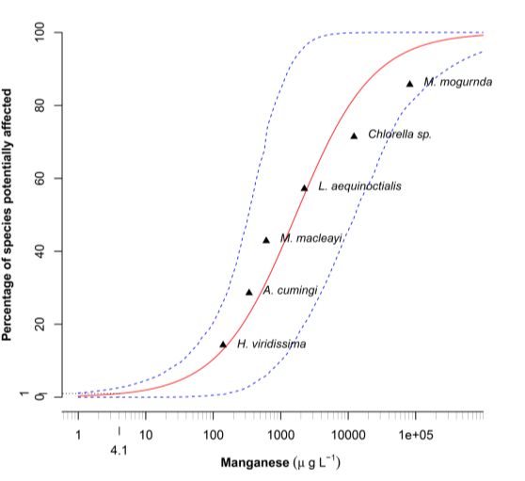

**Figure 6** Species Sensitivity Distribution of manganese toxicity estimates for the six local species.

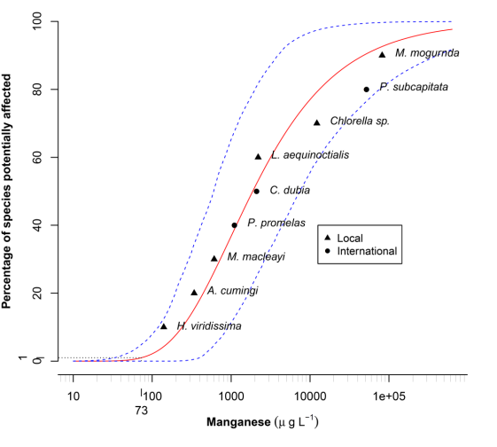

**Figure 7** Species Sensitivity Distribution of manganese toxicity estimates for the six local species and including 3 toxicity estimates from international datasets (*P. subcapitata*, *C. dubia* and *P. promelas*).

# 4 Discussion

The results from the pilot study using Ngarradj Creek Water found that Mn toxicity was relatively high to *H. viridissima* and *M. macleayi* compared to values reported in the literature and those toxicity estimates used in the ANZEEC and ARMCANZ (2000) default TV. Conversely, the green alga, *Chlorella* sp. was extremely tolerant to Mn and was only effected by 10–15% by concentrations up to 50 000 μg L-1. The Mn appeared acutely toxic to *M. macleayi* as there were similar concentration-response relationships for the chronic and acute endpoints*.* Removal of the algal food from the *M. macleayi* test system aimed to determine if the algae were creating microenvironments that produced Mn oxides, which would reduce the bioavailable Mn2+ (Richardson et al. 1988). This test did produce a slightly more sensitive response compared to the test with algal food but organism in this test did not reproduce optimally due to their need for an algal food source. Hence, it was impossible to determine if the higher sensitivity was due to Mn bioavailability or because the organisms were stressed. The hydra, *H. viridissima*, was clearly the most sensitive species with a significant reduction in population growth rate at the lowest concentration tested (106 μg L-1), with a resultant IC10 value of 60 μg L-1. This result warranted further investigation because the concentration-response was not comprehensively characterised during the preliminary studies but it was the one of the most sensitive toxicity estimates reported in the literature at that time. Additionally, further characterisation of *M. macleayi’s* strong threshold response was needed strengthen confidence in the toxicity estimates obtained by this study.

The results of the comprehensive study using MCW as the diluent found that three of the tropical species were more sensitive to Mn than most of species in the international literature (Figure 7). Namely, *M. macleayi*, *A. cumingi* and *H. viridissima* showed a relatively high sensitivity to Mn and only one other international species, the amphipod, *Hyalella azteca,* was more sensitive to Mn exposure (Peters et al. 2010). However, the toxicity estimates for *H. azteca* varied markedly when different container materials were used. Toxicity tests performed in glass resulted in high sensitivity to Mn (i.e. EC25 = ~100 µg L-1) (Norwood et al. 2007, Peters et al. 2010), while toxicity tests performed in high density polyethylene resulted in a markedly different EC25 of 7000 µg L-1. This difference was not explained but concurring toxicity estimates in glass were consistently were derived by two different research groups. Hence, the values were considered reliable by Peters et al. (2010) and used for the European EQS. One other study has reported a more sensitive Mn toxicity estimate than *H. azteca*. Fargašová (1997) reported 43% mortality of the midge larva, *Chironomus plumosus*, at 55 g L-1 Mn. However, this was the only concentration tested and many details of the test method (e.g. physico-chemistry of diluent water, chemical analysis of the test chemical) were not described, making it difficult to establish the quality of the data. Hence, this result was not used by ANZECC and ARMCANZ (2000) in the derivation of the default TV or the more recent European EQS (Peters et al. 2010).

Strong concentration-response relationships with r2 values >0.9 were established for all species except *M. mogurnda*. The concentration-response relationship for *M. mogurnda* may have been better characterised with further toxicity testing but the fit of the logistic model was reasonable (r2 = 0.78) and there was clearly no effect at concentrations up to ~100 000 µg L-1. The IC10 of 80 000 µg L-1 appeared accurate and further testing was unlikely to produce a toxicity estimate that would affect the TV because the IC10 was 100 times higher than the most sensitive species. Overall, despite the extremely broad range of toxicity estimates, the values obtained in these tests were what would be expected in the local soft waters.

The higher toxicity found in three species of this study is possibly due to the low hardness and ionic strength of the soft waters of Magela and Ngarradj Creeks. Research involving the development of a Biotic Ligand Model (BLM) for Mn has reported that there is competition between Mn and cations in solution, primarily H+ and Ca2+ (Peters et al. 2011). Other studies have also specifically demonstrated the amelioration of Mn toxicity by increasing water hardness (Lasier et al. 2000). The present study assessed Mn under conditions of extremely low water hardness (i.e. ~5 mg L-1 as CaCO3) and, thus, Mn was expected to be of higher toxicity. However, it should be noted that Mn discharged from the mine could be associated with Mg2+ and Ca2+ concentrations that are higher than typical Magela Creek concentrations. Higher Mg2+ and Ca2+ ameliorates Mn toxicity in exotic species but the ability of these major ions to ameliorate toxicity in local species was not studied. Conversely, Mg has a higher toxicity in the soft waters of Magela Creek compared to its toxicity in harder waters and the combined toxic effects of Mn and Mg in extremely soft waters of Magela creek is also unknown.

The low pH (i.e. pH <6.5) of MCW might be expected to reduce the toxicity if competition between H+ and Mn2+ ions was significant. We found that *Chlorella* sp. had a similar insensitive response to Mn in both NCW and MCW (Figure 9). There might have been a difference in response at a concentration of 60 000 µg L-1 Mn, which resulted in a 50% effect in MCW but only a 10% effect in NCW. However, the start-of-test pH for NCW and MCW were similar at 5.9 and 6.2, respectively while the end-of test pH was 6.4 for both waters. Algae have been found to be particularly tolerant to Mn exposure in studies at low pH conducted by other researchers (Peters et al. 2010; Peters et al. 2011). Hence, the lower pH of NCW and MCW may have reduced the alga’s sensitivity to Mn compared to other studies. Past studies have also reported that *Chlorella* sp. uptake and sensitivity to U is reduced at lower pH, with the hypothesis being that U also competes with H+ ions (Franklin et al. 2000). Nevertheless, these observations do not further inform the role that pH play in determining Mn toxicity. Further studies would need to be initiated if the influence of toxicity modifying factors, such as pH and hardness, needs to be understood in the context of Magela Creek.



**Figure 9** Comparison of the Mn toxicity to algae in Ngarradj Creek Water and Magela Creek Water.

*Hydra viridissima* was less sensitive in MCW compared with the preliminary Mn toxicity testing undertaken using NCW, which might be due to reduced bioavailability for the metal (Harford et al. 2009). Two hydra toxicity tests conducted at a low pH of 5.1 (Figure 8) indicated that decreasing pH may increase the toxicity of Mn to *H. viridissima*. However, the hydra in these tests did not meet the minimum acceptable growth rates, which indicates that the organisms may have been stressed at pH 5.1. The loss of Mn from the first two of the MCW hydra tests had not occurred in the hydra toxicity test conducted in NCW and was an unexpected occurrence. Manganese loss was also observed in one of the *A. cumingi* toxicity tests but this is a complex test system containing both glass and plastic. Hence, the potential for losing metals in this system was greater compared to the *H. viridissima* toxicity test, which is conducted in only plastic dishes.

The potential sources of Mn loss included adsorption to the test solution bottles and/or the test containers, precipitation and/or adsorption/absorption by the test animals. However, attempts to recover the Mn from the *H. viridissima* test were unproductive. The unrecoverable Mn may have been bound to the petri dishes and the 5% HNO3 acid-extraction may have been insufficient extract the bound Mn. However, pre-inoculating the test dishes with Mn, with the aim of reducing Mn binding to the dishes, only slightly reduced Mn loss. Compared with no Mn pre-inoculation, the Mn loss in the 600 µg L-1 treatment was reduced by ~20% but no reductions were noted in the 250 µg L-1 treatment. Measured Mn in the hydra tissues at the end of the tests showed a good relationship between nominal Mn concentration and hydra tissue concentrations (Figure 10) but the amount recovered did not account for the missing proportion of Mn. This suggests that the Mn was not bound to the dishes or absorbed/adsorbed by the hydra and hence, the fate of some of the Mn is unknown. Although there was some difference in the pH of the test diluents between the NCW and MCW studies (pH 6.2 for NCW compared to pH 6.5 for the MCW) and even though Mn speciation is pH-dependent, the kinetics of Mn speciation are extremely slow and such pH differences are considered unlikely to result in significant speciation changes over the 96-h time course of a hydra experiment (Barry Chiswell, University of Queensland, pers. Comm.). Furthermore, extensive chemical analysis of the ‘old’ waters (i.e. those used to expose the hydra for 24 h) showed that the loss was only measurable between 72 –96 h, or the last day of the test. This time also coincided with the appearance of a white floating precipitate, which was suspected to be an oxy-hydroxide of Mn. A speciation change due to an increase in pH was not responsible for the precipitation as the pH of test solution on day 4 was not higher than on the previous 3 days. The sudden loss of the Mn on the final day suggests that the reaction may be biologically catalysed. Indeed, *H. viridissima* contain a symbiotic *Chlorella* sp. that may be producing Mn oxidising microenvironments described by Richardson et al. (1988). Additionally, Mn-oxidising bacteria are well-known, reported to be ubiquitous in freshwater environments and are also credited for the majority of Mn oxidation (Tebo et al. 2005, Anderson et al. 2009). The intermittent appearance of Mn-oxidising bacteria would also explain why the loss of Mn was not experienced in the final two hydra toxicity tests. Manganese oxidising microorganism would need time to grow and might preferably proliferate in a Mn rich culture medium. However, this does not explain why the loss occurred only in the hydra test when tests on other species used the same water, which indicates that the hydra played a role. Further, experiments would be needed to determine if the loss was due to Mn oxidising bacteria and if hydra also participated in removing Mn from the system. Ultimately, the Mn losses were accounted for by averaging the start and end of test Mn concentrations in order to derive the toxicity estimates.

**Figure 10** Amount of manganese measured in hydra tissues

The Species Sensitivity Distribution (SSD) using the six local species produced a 99% Trigger value of 4.1 (0.7 – 182) µg/L, which has been exceeded at least 50% of the time at the downstream monitoring site. Hence, it was a TV that could not be implemented. It is noteworthy that implementation of the European EQS for Mn was also problematic due to the same reason, i.e. it was too often exceeded. The European’s solution to this issue was to recommend that the EQS was useful only in situations where Mn was of highest bioavailability and then developed a BLM to predict Mn toxicity for waters with other physico-chemical conditions (Peters et al. 2010; Peters et al. 2011). The low site-specific TV produced by this study was a result of the wide range of toxicity estimates used in the SSD. Ironically, it is the high toxicity estimates in the SSD that push the lower-end of the log-logistic model to lower concentrations. Including the extra international data to site-specific is a method recommended by ANZECC and ARMCANZ (2000) provided that the toxicity tests were conducted under relevant physico-chemical conditions. Additionally, researchers have recommended the inclusion of extra samples to SSDs in order to increase the reliability of the TV (Newman et al. 2000) and the European Commission and Australia are now recommending that a minimum of 8 toxicity estimates are needed for an “high reliability” TV (European Commission 2011; Batley et al. 2013). In this case, three toxicity estimates were identified as being conducted in natural water with sufficiently low hardness (12 mg L-1 CaCO3, Ca = 4 mg L-1) and a temperature similar to that used for the site specific species, i.e. 25°C compared to 27–29°C. The inclusion of these additional toxicity estimates produced a TV of 73 (33 – 466) µg L-1, which has not been exceeded in the creek and can be implemented as a guideline value for the Ranger mine. The 95th and 80th confidence intervals of the statistical distribution were 33 and 46 µg L, which form the basis of the Focus and Action TVs.



**Figure 6** Comparison of environmental Mn chemistry (0.45 µm filtered) with the calculated 99% Trigger Values.

# 5 Recommendations

It is recommended that a 99% protection TV of 75 µg L-1 Mn be applied at MG009. The Focus and Action TVs should be 35 and 45 µg L-1, respectively. These TVs are rounded out from the calculated 99% TV of 73 µg L-1 and the 95th and 80th confidence intervals of 33 and 46 µg L-1, respectively.

# 6 Conclusions

The six local freshwater species tested in this study had a broad range of sensitivities to Mn in the soft surface waters of Ngarradj and Magela Creeks. For three of the species, Mn toxicity was higher than many of the species reported in the literature, which was probably due to the low concentration of Ca2+ in the natural waters. The low pH may have decreased to the toxicity of Mn to *Chlorella* sp. but increased the potential for Mn2+ to remain dissolved and, hence bioavailable. A loss of Mn was observed on the final day of a number of the *H. viridissima* toxicity tests but the Mn could not be recovered from the test system. This observation may be a result of the previously reported complex speciation of Mn. We accounted for such issues through extensive analysis of Mn (0.1 µm filtered and total) at the start and end of the tests. Toxicity estimates were adjusted using the average of measured Mn concentrations taken at the start and end of the toxicity tests. The Species Sensitivity Distribution, which used the three international toxicity estimates derived under relevant physico-chemical conditions, produced a 99% TV that can be implemented in Magela Creek

# 7 Acknowledgements

Approval for the ethical use of *M. mogurnda* was granted through the Charles Darwin University’s Animal Ethics Committee. The authors would like to thank Alicia Hogan and Tom Mooney for their critical review of the report and Claire Costello and Ceiwen Pease for their technical expertise in conducting the toxicity tests.

# 8 References

Anderson CR, Johnson HA, Caputo N, Davis RE, Torpey JW & Tebo BM 2009. Mn(II) Oxidation Is Catalyzed by Heme Peroxidases in *Aurantimonas manganoxydans* Strain SI85-9A1 and Erythrobacter sp Strain SD-21. *Applied and Environmental Microbiology* 75 (12), 4130–4138.

Batley GE, Chapman JC, Fox DR, Hickey CW, Stauber JL, van Dam RA & Warne M.St.J. (2013) Revision of the method for deriving water quality guideline trigger values for toxicants. Prepared for the Council of Australian Governments Standing Council on Environment and Water (SCEW), Canberra.

Chiswell B & Mokhtar MB 1986. The speciation of manganese in freshwaters. *Talanta* 33 (8), 669–677.

ERA 2002. Ranger Mine Annual Environmental Management Report, Energy Resources of Australia, Darwin, Northern Territory.

ERA 2008. Draft ERA Ranger Mine Wet Season Report. Energy Resources of Australia Ltd, Darwin, NT.

European Comission 2011. Technical guidance for deriving environmental quality standards. Guidance Document No 27, Common Implementation Strategy for the Water Framework Directive, European Commission, Brussels.

Fargašová A 1997. Sensitivity of Chironomus plumosus Larvae to V5+, Mo6+, Mn2+, Ni2+, Cu2+, and Cu+ Metal Ions and Their Combinations. *Bulletin of Environmental Contamination and Toxicology* 59 (6), 956–962.

Franklin NM, Stauber JL, Markich SJ & Lim RP 2000. pH dependent toxicity of copper and uranium to a tropical freshwater alga (*Chlorella* sp.). *Aquatic Toxicology* 48, 275–289.

Harford AJ, Hogan AC, Cheng K, Costello C, Houston M & van Dam RA 2009. Preliminary assessment of the toxicity of manganese to three tropical freshwater species. In eriss research summary 2007–2008, eds Jones DR & Webb, Supervising Scientist Report 200, Supervising Scientist Division, Darwin, Northern Territory 12–19.

Harford AJ, Jones DR & van Dam RA 2013. Highly treated mine waters may require major ion addition before environmental release. *Science of the Total Environment* 443 (0), 143–151.

Hogan A, van Dam R, Houston M, Harford A & Nou S 2010. Uranium Exposure to the Tropical Duckweed Lemna aequinoctialis and Pulmonate Snail Amerianna cumingi: Fate and Toxicity. *Archives of Environmental Contamination and Toxicology* 59 (2), 204–215.

Homoncik SC, Macdonald AM, Heal KV, Dochartaigh BE & Ngwenya BT 2010. Manganese concentrations in Scottish groundwater. *Science of the Total Environment* 408 (12), 2467–2473.

Horsburgh MJ, Wharton SJ, Karavolos M & Foster SJ 2002. Manganese: elemental defence for a life with oxygen. *Trends in Microbiology* 10 (11), 496–501.

Houston M, Hogan A, van Dam R & Nou S 2007. Procedure for the 96 hour gastropod reproduction toxicity test using *Amerianna cumingi*. Internal Report 525, June, Supervising Scientist, Darwin, Northern Territory, Australia.

Iles M 2004. Water quality objectives for Magela Creek. Internal Report 489, Department of the Environment and Heritage, Canberra, Australia.

Lasier P, Winger P & Bogenrieder K 2000. Toxicity of manganese to *Ceriodaphnia dubia* and *Hyalella azteca*. *Archives of Environmental Contamination and Toxicology* 38 (3), 298–304.

Newman MC, Ownby DR, Mézin LCA, Powell DC, Christensen TRL, Lerberg SB & Anderson BA 2000. Applying species senstivity distributions in ecological risk assessment: Assumptions of distribution type and sufficient number of species. *Environmental Toxicology and Chemistry* 19 (2), 508–515.

Norwood WP, Borgmann U & Dixon DG 2007. Chronic toxicity of arsenic, cobalt, chromium and manganese to *Hyalella azteca* in relation to exposure and bioaccumulation. *Environmental Pollution* 147(1), 262–272.

Peters A, Crane M, Maycock D, Merrington G, Simpson P, Sorokin N & Atkinson C 2010. Proposed EQS for Water Framework Directive Annex VIII substances: manganese (total dissolved). Bristol, United Kingdom: Environment Agency.

Peters A, Lofts S, Merrington G, Brown B, Stubblefield W & Harlow K 2011. Development of biotic ligand models for chronic manganese toxicity to fish, invertebrates, and algae. *Environmental Toxicology and Chemistry* 30 (11), 2407–2415.

Richardson LL, Aguilar C & Nealson KI 1988. Manganese oxidation in pH and microenvironments produced by phytoplankton. Limnol. *Oceanogr* 33 (3), 352–363.

Riethmuller N, Camilleri C, Franklin N, Hogan AC, King A, Koch A, Markich SJ, Turley C & van Dam RA 2003. Ecotoxicological testing protocols for Australian tropical freshwater ecosystems. Supervising Scientist Report 173, Supervising Scientist, Darwin, Northern Territory, Australia.

Tebo BM, Johnson HA, McCarthy JK & Templeton AS 2005. Geomicrobiology of manganese(II) oxidation. *Trends in Microbiology* 13 (9), 421–428.

van Dam RA 2004. A review of the eriss Ecotoxicology Program. Supervising Scientist Report 182, Supervising Scientist, Darwin, Northern Territory, Australia.

# Appendix A Water quality measurements for toxicity tests

### Ngarradj Creek Water

**Table A1 936B *H. viridissima***

|  |  |  |  |  |  |  |  |  |  |  |  |  |  |  |  |
| --- | --- | --- | --- | --- | --- | --- | --- | --- | --- | --- | --- | --- | --- | --- | --- |
| **Treatment (µg L-1 Mn)** | | **MCW** | | **NCW (0)** | | **200** | | **660** | | **2000** | | **6600** | | **20000** | |
| **Parameter** | | **0 h** | **24 h** | **0 h** | **24 h** | **0 h** | **24 h** | **0 h** | **24 h** | **0 h** | **24 h** | **0 h** | **24 h** | **0 h** | **24 h** |
| Day 0 | pH | 6.6 | 7.0 | 6.2 | 6.4 | 6.1 | 6.4 | 6.1 | 6.4 | 6.1 | 6.3 | 6.2 | 6.3 | 5.8 | 6.2 |
|  | EC (µS cm-1) | 17 | 17 | 12 | 13 | 13 | 14 | 16 | 17 | 21 | 22 | 42 | 41 | 97 | 92 |
|  | DO (%) | 101 | 94 | 100 | 95 | 97 | 98 | 100 | 95 | 95 | 93 | 101 | 95 | 102 | 93 |
| Day 1 | pH | 6.7 | 6.9 | 6.1 | 6.4 | 6.0 | 6.4 | 6.0 | 6.4 | 6.0 | 6.3 | 6.0 | 6.2 | NM | NM |
|  | EC (µS cm-1) | 16 | 17 | 12 | 14 | 13 | 14 | 16 | 17 | 22 | 22 | 42 | 43 | NM | NM |
|  | DO (%) | 109 | 95 | 105 | 97 | 107 | 98 | 106 | 93 | 102 | 93 | 108 | 96 | NM | NM |
| Day 2 | pH | 6.7 | 6.9 | 6.2 | 6.6 | 6.1 | 6.4 | 6.1 | 6.3 | 6.1 | 6.3 | NM | NM | NM | NM |
|  | EC (µS cm-1) | 16 | 18 | 12 | 14 | 13 | 14 | 16 | 17 | 22 | 22 | NM | NM | NM | NM |
|  | DO (%) | 116 | 95 | 114 | 93 | 114 | 94 | 113 | 96 | 113 | 97 | NM | NM | NM | NM |
| Day 3 | pH | 6.5 | 6.9 | 6.3 | 6.4 | 6.0 | 6.4 | 6.0 | 6.3 | 6.0 | 6.3 | NM | NM | NM | NM |
|  | EC (µS cm-1) | 16 | 17 | 13 | 13 | 13 | 14 | 16 | 16 | 21 | 22 | NM | NM | NM | NM |
|  | DO (%) | 118 | 95 | 115 | 95 | 119 | 96 | 117 | 96 | 113 | 95 | NM | NM | NM | NM |

a NM = Not measured due to complete mortality in the treatment

**Table A2 937D *M. macleayi***

|  |  |  |  |  |  |  |  |  |  |  |  |  |  |  |  |
| --- | --- | --- | --- | --- | --- | --- | --- | --- | --- | --- | --- | --- | --- | --- | --- |
| **Treatment (µg L-1 Mn)** | | **MCW** | | **NCW (0)** | | **1000** | | **2000** | | **4000** | | **8000** | | **16000** | |
| **Parameter** | | **0 h** | **24 h** | **0 h** | **24 h** | **0 h** | **24 h** | **0 h** | **24 h** | **0 h** | **24 h** | **0 h** | **24 h** | **0 h** | **24 h** |
| Day 0 | pH | 6.8 | 7.0 | 6.2 | 6.4 | 6.2 | 6.5 | 6.1 | 6.2 | 6.1 | 6.4 | 6.2 | 6.3 | 6.1 | 6.3 |
|  | EC (µS cm-1) | 21 | 26 | 17 | 16 | 20 | 19 | 24 | 23 | 32 | 31 | 49 | 48 | 32 | 81 |
|  | DO (%) | 100 | 94 | 106 | 91 | 103 | 93 | 102 | 89 | 104.9 | 95.5 | 102.3 | 93.5 | 99.0 | 93.6 |
| Day 1 | pH | 6.8 | 7.4 | 6.4 | 7.0 | 6.4 | 6.8 | 6.4 | 6.6 | NM a | NM | NM | NM | NM | NM |
|  | EC (µS cm-1) | 44 | 27 | 18 | 13 | 25 | 18 | 27 | 22 | NM | NM | NM | NM | NM | NM |
|  | DO (%) | 103 | 100 | 102 | 97 | 94 | 96 | 106 | 99 | NM | NM | NM | NM | NM | NM |
| Day 2 | pH | 6.7 | 7.3 | 6.1 | 6.5 | 6.2 | 6.7 | 6.1 | NM | NM | NM | NM | NM | NM | NM |
|  | EC (µS cm-1) | 21 | 26 | 14 | 13 | 18 | 27 | 23 | NM | NM | NM | NM | NM | NM | NM |
|  | DO (%) | 106 | 24 | 108 | 25 | 103 | 24 | 103 | NM | NM | NM | NM | NM | NM | NM |
| Day 3 | pH | 6.8 | 7.2 | 6.1 | 6.5 | 6.3 | 6.3 | NM | NM | NM | NM | NM | NM | NM | NM |
|  | EC (µS cm-1) | 17 | 16 | 14 | 13 | 21 | 18 | NM | NM | NM | NM | NM | NM | NM | NM |
|  | DO (%) | 109 | 102 | 111 | 98 | 109 | 99 | NM | NM | NM | NM | NM | NM | NM | NM |
| Day 4 | pH | 6.7 | 7.6 | 6.3 | 6.4 | 6.3 | 6.3 | NM | NM | NM | NM | NM | NM | NM | NM |
|  | EC (µS cm-1) | 17 | 16 | 14 | 14 | 18 | 18 | NM | NM | NM | NM | NM | NM | NM | NM |
|  | DO (%) | 106 | 99 | 110 | 92 | 113 | 95 | NM | NM | NM | NM | NM | NM | NM | NM |
| Day 5 | pH | 6.7 | 6.8 | 6.4 | 6.4 | 6.3 | 6.5 | NM | NM | NM | NM | NM | NM | NM | NM |
|  | EC (µS cm-1) | 17 | 18 | 14 | 16 | 19 | 18 | NM | NM | NM | NM | NM | NM | NM | NM |
|  | DO (%) | 107 | 96 | 105 | 90 | 109 | 97 | NM | NM | NM | NM | NM | NM | NM | NM |

a NM = Not measured due to complete mortality in the treatment

**Table A3 938I *M. macleayi* (acute)**

|  |  |  |  |  |  |  |  |  |  |  |  |  |  |  |
| --- | --- | --- | --- | --- | --- | --- | --- | --- | --- | --- | --- | --- | --- | --- |
| **Treatment (µg L-1 Mn)** | **MCW** | | **0 (NCW)** | | **1000** | | **2000** | | **4000** | | **8000** | | **16000** | |
| **Parameter** | **0h** | **72h** | **0h** | **72h** | **0h** | **72h** | **0h** | **72h** | **0h** | **72h** | **0h** | **72h** | **0h** | **72h** |
| pH | 6.6 | 6.9 | 5.6 | 6.2 | 5.8 | 6.0 | 5.7 | 6.0 | 5.7 | 5.9 | 5.7 | 5.9 | 5.6 | 5.9 |
| EC (µS cm-1) | 14 | 14 | 12 | 12 | 14 | 18 | 20 | 19 | 28 | 29 | 46 | 46 | 78 | 79 |
| DO (%) | 97 | 94 | 96 | 93 | 108 | 93 | 104 | 92 | 99.6 | 94.7 | 96.7 | 94.2 | 100.9 | 91.6 |

**Table A4** 939G *Chlorella* sp.

|  |  |  |  |  |  |  |  |  |  |  |  |  |  |  |  |  |
| --- | --- | --- | --- | --- | --- | --- | --- | --- | --- | --- | --- | --- | --- | --- | --- | --- |
| **Treatment (µg L-1 Mn)** | **MCW** | | **(NCW) 0** | | **200** | | **660** | | **2000** | | **6660** | | **20000** | | **66000** | |
| **Parameter** | **0 h** | **72 h** | **0 h** | **72 h** | **0 h** | **72 h** | **0 h** | **72 h** | **0h** | **72 h** | **0h** | **72 h** | **0 h** | **72 h** | **0 h** | **72 h** |
| pH | 6.3 | 6.7 | 5.9 | 6.5 | 5.9 | 6.3 | 5.9 | 6.5 | 6.0 | 6.5 | 5.93 | 6.42 | 5.9 | 6.4 | NM | 6.4 |
| EC (µS cm-1) | 44 | 42 | 43 | 41 | 44 | 42 | 46 | 44 | 52 | 50 | 72 | 71 | 126 | 126 | NM | 287 |
| DO (%) | 109 | 97 | 112 | 93 | 110 | 93 | 109 | 94 | 109 | 96.5 | 112 | 93 | 112 | 92 | NM | 89 |

a NM = Not measured due to complete mortality in the treatment

### Magela Creek Water

**Table A5 1275S *A. cumingi***

|  |  |  |  |  |  |  |  |  |  |  |  |  |
| --- | --- | --- | --- | --- | --- | --- | --- | --- | --- | --- | --- | --- |
| **Treatment (µg L-1 Mn)** | **0** | | **8x103** | | **4x104** | | **2x105** | | **1x106** | | **5x106** | |
| **Parameter** | **0 h** | **24 h** | **0 h** | **24 h** | **0 h** | **24 h** | **0 h** | **24 h** | **0 h** | **24 h** | **0h** | **24 h** |
| pH | 6.5 | 6.9 | 6.4 | 6.9 | 6.4 | 7.1 | 5.8 | 7.0 | 3.7 | 4.9 | 3.1 | 3.5 |
| EC (µS cm-1) | 16 | 37 | 44 | 66 | 149 | 176 | 560 | 582 | 2150 | 1950 | 7630 | 6900 |
| DO (%) | 100 | 83 | 106 | 80 | 106 | 83 | 108 | 83 | 108 | 87 | 103 | 89 |
| pH | 6.5 | 7.1 | 6.5 | 7.0 | 6.5 | 7.0 | 5.8 | 7.1 | NM | NM | NM | NM |
| EC (µS cm-1) | 17 | 36 | 47 | 69 | 151 | 177 | 562 | 602 | NM | NM | NM | NM |
| DO (%) | 96 | 85 | 106 | 84 | 102.5 | 82 | 104 | 80 | NM | NM | NM | NM |
| pH | 6.5 | 6.9 | 6.6 | 6.9 | 6.5 | 7.0 | 5.9 | 6.8 | NM | NM | NM | NM |
| EC (µS cm-1) | 16 | 35 | 45 | 60 | 150 | 168 | 566 | 580 | NM | NM | NM | NM |
| DO (%) | 92 | 85 | 94 | 86 | 95 | 83 | 93 | 89 | NM | NM | NM | NM |
| pH | 6.3 | 7.0 | 6.3 | 7.1 | 6.4 | 7.0 | NM | NM | NM | NM | NM | NM |
| EC (µS cm-1) | 17 | 36 | 46 | 60 | 150 | 170 | NM | NM | NM | NM | NM | NM |
| DO (%) | 99 | 87 | 105 | 83 | 102 | 84 | NM | NM | NM | NM | NM | NM |

a NM = Not measured due to complete mortality in the treatment

**Table A6** 1276L *L. aequinoctialis*

|  |  |  |  |  |  |  |  |  |  |  |  |  |
| --- | --- | --- | --- | --- | --- | --- | --- | --- | --- | --- | --- | --- |
| **Treatment (µg L-1 Mn)** | **0** | | **80** | | **400** | | **2000** | | **10 000** | | **50 000** | |
| **Parameter** | **0h** | **72h** | **0h** | **72h** | **0h** | **72h** | **0h** | **72h** | **0h** | **72h** | **0h** | **72h** |
| pH | 6.2 | 6.5 | 6.1 | 6.6 | 6.1 | 6.4 | 6.1 | 6.4 | 6.1 | 6.5 | 6.0 | 6.1 |
| EC (µS cm-1) | 19 | 17 | 20 | 15 | 22 | 16 | 27 | 23 | 58 | 56 | 192 | 195 |
| DO (%) | 107 | 95 | 106 | 81 | 108 | 90 | 108 | 97 | 107 | 89 | 109 | 87 |

**Table A7 1277B *H. viridissima***

|  |  |  |  |  |  |  |  |  |  |  |  |  |  |  |  |
| --- | --- | --- | --- | --- | --- | --- | --- | --- | --- | --- | --- | --- | --- | --- | --- |
| **Treatment (µg L-1 Mn)** | | **0** | | **31** | | **63** | | **125** | | **250** | | **500** | | **1000** | |
| **Parameter** | | **0h** | **24h** | **0h** | **24h** | **0h** | **24h** | **0h** | **24h** | **0h** | **24h** | **0h** | **24h** | **0h** | **24h** |
| Day 0 | pH | 6.5 | 6.7 | 6.5 | 6.7 | 6.4 | 6.7 | 6.5 | 6.6 | 6.5 | 6.6 | 6.5 | 6.7 | 6.5 | 6.7 |
|  | EC (µS cm-1) | 18 | 18 | 17 | 18 | 17 | 18 | 17 | 18 | 17 | 18 | 19 | 20 | 21 | 21 |
|  | DO (%) | 104 | 88 | 106 | 91 | 112 | 88 | 114 | 91 | 107 | 86 | 103 | 90 | 104 | 86 |
| Day 1 | pH | 6.7 | 6.7 | 6.6 | 6.7 | 6.5 | 6.8 | 6.4 | 6.7 | 6.5 | 6.8 | 6.5 | 6.7 | 6.6 | 6.6 |
|  | EC (µS cm-1) | 17 | 20 | 17 | 18 | 17 | 18 | 17 | 18 | 17 | 18 | 19 | 20 | 20 | 22 |
|  | DO (%) | 103 | 90 | 108 | 91 | 113 | 93 | 105 | 93 | 110 | 89 | 101 | 91 | 106 | 91 |
| Day 2 | pH | 6.5 | 6.7 | 6.5 | 6.8 | 6.5 | 6.8 | 6.4 | 6.8 | 6.4 | 6.7 | 6.5 | 6.7 | 6.4 | 6.6 |
|  | EC (µS cm-1) | 16 | 18 | 17 | 18 | 17 | 18 | 17 | 18 | 17 | 18 | 18 | 19 | 20 | 21 |
|  | DO (%) | 106 | 94 | 105 | 94 | 109 | 95 | 109 | 94 | 109 | 94 | 109 | 94 | 108 | 92 |
| Day 3 | pH | 6.6 | 6.9 | 6.5 | 6.8 | 6.5 | 6.8 | 6.5 | 6.9 | 6.5 | 6.8 | 6.5 | 6.8 | 6.5 | 6.6 |
|  | EC (µS cm-1) | 17 | 17 | 17 | 17 | 17 | 17 | 17 | 17 | 17 | 17 | 19 | 17 | 20 | 20 |
|  | DO (%) | 104 | 96 | 108 | 92 | 114 | 93 | 114 | 93 | 113 | 89 | 111 | 91 | 110 | 92 |

**Table A8 1278G *Chlorella* sp.**

|  |  |  |  |  |  |  |  |  |  |  |  |  |
| --- | --- | --- | --- | --- | --- | --- | --- | --- | --- | --- | --- | --- |
| **Treatment (µg L-1 Mn)** | **0** | | **31250** | | **62500** | | **125000** | | **250000** | | **500000** | |
| **Parameter** | **0h** | **72h** | **0h** | **72h** | **0h** | **72h** | **0h** | **72h** | **0h** | **72h** | **0h** | **72h** |
| pH | 6.4 | 6.6 | 6.2 | 6.5 | 6.3 | 6.5 | 6.2 | 6.4 | 6.3 | 6.5 | 6.3 | 6.6 |
| EC (µS cm-1) | 47 | 45 | 236 | 236 | 273 | 275 | 461 | 466 | 793 | 795 | 1330 | 1344 |
| DO (%) | 116 | 97 | 113 | 92 | 106 | 93 | 110 | 89 | 104 | 91.4 | 103.8 | 90 |

**Table A9 1292G *Chlorella* sp.**

|  |  |  |  |  |  |  |  |  |  |  |  |  |  |  |  |  |
| --- | --- | --- | --- | --- | --- | --- | --- | --- | --- | --- | --- | --- | --- | --- | --- | --- |
| **Treatment (µg L-1 Mn)** | **0** | | **2500** | | **5000** | | **10000** | | **20000** | | **40000** | | **80000** | | **160000** | |
| **Parameter** | **0h** | **72h** | **0h** | **72h** | **0h** | **72h** | **0h** | **72h** | **0h** | **72h** | **0h** | **72h** | **0h** | **72h** | **0h** | **72h** |
| pH | 6.1 | 6.5 | 6.2 | 6.5 | 6.2 | 6.5 | 6.2 | 6.5 | 6.2 | 6.5 | 6.2 | 6.4 | 6.2 | 6.3 | 6.0 | 6.1 |
| EC (µS cm-1) | 46.0 | 43.0 | 57.0 | 54.0 | 67.0 | 64.0 | 87.0 | 85.0 | 122 | 121 | 186 | 187 | 326 | 328 | 558 | 564 |
| DO (%) | 108.4 | 90.2 | 109.1 | 93.1 | 104.4 | 92.5 | 105.1 | 90.0 | 106 | 95.1 | 100.6 | 94 | 101.9 | 95.3 | 103.9 | 94 |

**Table 10 1294G *Chlorella* sp.**

|  |  |  |  |  |  |  |  |  |  |  |  |  |  |  |  |  |  |  |
| --- | --- | --- | --- | --- | --- | --- | --- | --- | --- | --- | --- | --- | --- | --- | --- | --- | --- | --- |
| **Treatment (µg L-1 Mn)** | **0** | | **10000** | | **20000** | | **40000** | | **60000** | | **80000** | | **100000** | | **120000** | | **140000** | |
| **Parameter** | **0h** | **72h** | **0h** | **72h** | **0h** | **72h** | **0h** | **72h** | **0h** | **72h** | **0h** | **72h** | **0h** | **72h** | **0h** | **72h** | **0h** | **72h** |
| pH | 6.2 | 6.6 | 6.2 | 6.6 | 6.3 | 6.5 | 6.2 | 6.4 | 6.2 | 6.4 | 6.2 | 6.4 | 6.2 | 6.4 | 6.2 | 6.4 | 6.2 | 6.4 |
| EC (µS cm-1) | 47.0 | 43.0 | 90.0 | 85.0 | 127.0 | 123.0 | 198.0 | 198.0 | 271 | 268 | 330 | 332 | 387 | 396 | 449 | 454 | 509 | 514 |
| DO (%) | 104.2 | 97.4 | 108.9 | 93.8 | 106.6 | 93.0 | 108.9 | 94.6 | 101.9 | 90.4 | 99.8 | 91.6 | 102.2 | 91.7 | 98.5 | 91.4 | 97.7 | 92 |

**Table A11 1276L *L. aequinoctialis***

|  |  |  |  |  |  |  |  |  |  |  |  |  |
| --- | --- | --- | --- | --- | --- | --- | --- | --- | --- | --- | --- | --- |
| **Treatment (µg L-1 Mn)** | **0** | | **80** | | **400** | | **2000** | | **10000** | | **50000** | |
| **Parameter** | **0h** | **72h** | **0h** | **72h** | **0h** | **72h** | **0h** | **72h** | **0h** | **72h** | **0h** | **72h** |
| pH | 6.2 | 6.5 | 6.1 | 6.6 | 6.1 | 6.4 | 6.1 | 6.4 | 6.1 | 6.5 | 6.0 | 6.1 |
| EC (µS cm-1) | 19 | 17 | 20 | 15 | 22 | 16 | 27 | 23 | 58 | 56 | 192 | 195 |
| DO (%) | 107 | 95 | 106 | 81 | 108 | 90 | 108 | 97 | 107 | 89 | 109 | 87 |

**Table A12 1279L *L. aequinoctialis***

|  |  |  |  |  |  |  |  |  |  |  |  |  |
| --- | --- | --- | --- | --- | --- | --- | --- | --- | --- | --- | --- | --- |
| **Treatment (µg L-1 Mn)** | **0** | | **1000** | | **4000** | | **6000** | | **8000** | | **20000** | |
| **Parameter** | **0h** | **72h** | **0h** | **72h** | **0h** | **72h** | **0h** | **72h** | **0h** | **72h** | **0h** | **72h** |
| pH | 6.5 | 7.1 | 6.4 | 6.9 | 6.3 | 6.5 | 6.3 | 6.7 | 6.1 | 6.5 | 6.0 | 6.2 |
| EC (µS cm-1) | 24 | 23 | 29 | 25 | 42 | 40 | 50 | 49 | 59 | 60 | 106 | 106 |
| DO (%) | 102 | 92 | 99 | 93 | 104 | 93 | 103 | 94 | 103 | 90 | 96 | 0 |

**Table A13 1297L *L. aequinoctialis***

|  |  |  |  |  |  |  |  |  |  |  |  |  |  |  |  |  |  |  |
| --- | --- | --- | --- | --- | --- | --- | --- | --- | --- | --- | --- | --- | --- | --- | --- | --- | --- | --- |
| **Treatment (µg L-1 Mn)** | **0** | | **2500** | | **5000** | | **10000** | | **15000** | | **20000** | | **25000** | | **30000** | | **40000** | |
| **Parameter** | **0h** | **72h** | **0h** | **72h** | **0h** | **72h** | **0h** | **72h** | **0h** | **72h** | **0h** | **72h** | **0h** | **72h** | **0h** | **72h** | **0h** | **72h** |
| pH | 6.5 | 7.0 | 6.3 | 6.8 | 6.5 | 6.5 | 6.4 | 6.7 | 6.4 | 6.7 | 6.4 | 6.8 | 6.61 | 6.81 | 6.5 | 6.9 | 6.5 | 6.9 |
| EC (µS cm-1) | 23.0 | 19.0 | 33.0 | 28.0 | 44.0 | 41.0 | 65.0 | 64.0 | 84.0 | 82.0 | 104.0 | 104.0 | 123 | 123 | 141.0 | 140.0 | 174 | 177 |
| DO (%) | 96.1 | 88.6 | 92.2 | 88.8 | 88.1 | 89.0 | 97.9 | 87.2 | 97.2 | 89.0 | 97.2 | 90.0 | 99.9 | 89.8 | 95.5 | 85.1 | 95.5 | 87.2 |

**Table A14 1277B *H. viridissima***

|  |  |  |  |  |  |  |  |  |  |  |  |  |  |  |  |
| --- | --- | --- | --- | --- | --- | --- | --- | --- | --- | --- | --- | --- | --- | --- | --- |
| **Treatment (µg L-1 Mn)** | | **0** | | **31** | | **63** | | **125** | | **250** | | **500** | | **1000** | |
| **Parameter** | | **0h** | **24h** | **0h** | **24h** | **0h** | **24h** | **0h** | **24h** | **0h** | **24h** | **0h** | **24h** | **0h** | **24h** |
| Day 0 | pH | 6.5 | 6.7 | 6.5 | 6.7 | 6.4 | 6.7 | 6.5 | 6.6 | 6.5 | 6.6 | 6.5 | 6.7 | 6.5 | 6.7 |
|  | EC (µS cm-1) | 18 | 18 | 17 | 18 | 17 | 18 | 17 | 18 | 17 | 18 | 19 | 20 | 21 | 21 |
|  | DO (%) | 104 | 88 | 106 | 91 | 112 | 88 | 114 | 91 | 107 | 86 | 103 | 90 | 104 | 86 |
| Day 1 | pH | 6.7 | 6.7 | 6.6 | 6.7 | 6.5 | 6.8 | 6.4 | 6.7 | 6.5 | 6.8 | 6.5 | 6.7 | 6.6 | 6.6 |
|  | EC (µS cm-1) | 17 | 20 | 17 | 18 | 17 | 18 | 17 | 18 | 17 | 18 | 19 | 20 | 20 | 22 |
|  | DO (%) | 103 | 90 | 108 | 91 | 113 | 93 | 105 | 93 | 110 | 89 | 101 | 91 | 106 | 91 |
| Day 2 | pH | 6.5 | 6.7 | 6.5 | 6.8 | 6.5 | 6.8 | 6.4 | 6.8 | 6.4 | 6.7 | 6.5 | 6.7 | 6.4 | 6.6 |
|  | EC (µS cm-1) | 16 | 18 | 17 | 18 | 17 | 18 | 17 | 18 | 17 | 18 | 18 | 19 | 20 | 21 |
|  | DO (%) | 106 | 94 | 105 | 94 | 109 | 95 | 109 | 94 | 109 | 94 | 109 | 94 | 108 | 92 |
| Day 3 | pH | 6.6 | 6.9 | 6.5 | 6.8 | 6.5 | 6.8 | 6.5 | 6.9 | 6.5 | 6.8 | 6.5 | 6.8 | 6.5 | 6.6 |
|  | EC (µS cm-1) | 17 | 17 | 17 | 17 | 17 | 17 | 17 | 17 | 17 | 17 | 19 | 17 | 20 | 20 |
|  | DO (%) | 104 | 96 | 108 | 92 | 114 | 93 | 114 | 93 | 113 | 89 | 111 | 91 | 110 | 92 |

**Table A15 1290B *H. viridissima***

|  |  |  |  |  |  |  |  |  |  |  |  |  |  |  |  |
| --- | --- | --- | --- | --- | --- | --- | --- | --- | --- | --- | --- | --- | --- | --- | --- |
| **Treatment (µg L-1 Mn)** | | **0** | | **31.25** | | **62.5** | | **125** | | **250** | | **500** | | **1000** | |
| **Parameter** | | **0 h** | **24 h** | **0 h** | **24 h** | **0 h** | **24 h** | **0 h** | **24 h** | **0 h** | **24 h** | **0 h** | **24 h** | **0 h** | **24 h** |
| Day 0 | pH | 6.6 | 6.5 | 6.5 | 6.6 | 6.4 | 6.7 | 6.4 | 6.6 | 6.3 | 6.6 | 6.4 | 6.6 | 6.4 | 6.6 |
|  | EC (µS cm-1) | 15.0 | 16.0 | 14.0 | 15 | 14.0 | 15.0 | 15.0 | 16.0 | 16.0 | 16.0 | 16.0 | 17.0 | 18.0 | 19.0 |
|  | DO (%) | 109.3 | 92.8 | 111.5 | 95 | 118.9 | 94.9 | 113.1 | 96.3 | 117.3 | 94.1 | 109.2 | 96.0 | 109.4 | 94.6 |
| Day 1 | pH | 6.4 | 6.4 | 6.4 | 6.6 | 6.4 | 6.6 | 6.4 | 6.6 | 6.3 | 6.6 | 6.3 | 6.6 | 6.3 | 6.5 |
|  | EC (µS cm-1) | 14.0 | 16.0 | 14.0 | 15 | 14.0 | 15.0 | 14.0 | 15.0 | 15.0 | 15.0 | 15.0 | 16.0 | 17.0 | 18.0 |
|  | DO (%) | 107.4 | 94.3 | 113.8 | 98 | 108.1 | 95.6 | 117.9 | 96.5 | 119.3 | 96.7 | 112.0 | 92.8 | 108.9 | 92.7 |
| Day 2 | pH | 6.4 | 6.5 | 6.5 | 6.7 | 6.3 | 6.6 | 6.4 | 6.6 | 6.4 | 6.6 | 6.4 | 6.6 | 6.4 | 6.5 |
|  | EC (µS cm-1) | 14.0 | 15.0 | 14.0 | 15 | 14.0 | 15.0 | 14.0 | 15.0 | 15.0 | 15.0 | 16.0 | 16.0 | 17.0 | 18.0 |
|  | DO (%) | 108.9 | 93.9 | 114.6 | 94 | 115.5 | 93.4 | 117.8 | 93.1 | 115.8 | 96.0 | 110.9 | 94.9 | 114.1 | 94.9 |
| Day 3 | pH | 6.3 | 6.4 | 6.4 | 6.5 | 6.5 | 6.5 | 6.7 | 6.5 | 6.6 | 6.5 | 6.5 | 6.5 | 6.4 | 6.5 |
|  | EC (µS cm-1) | 14.0 | 15.0 | 14.0 | 15 | 14.0 | 15.0 | 14.0 | 15.0 | 15.0 | 15.0 | 16.0 | 16.0 | 17.0 | 18.0 |
|  | DO (%) | 103.9 | 92.8 | 107.3 | 95 | 105.0 | 93.7 | 110.1 | 93.9 | 108.6 | 92.5 | 105.1 | 92.9 | 106.5 | 91.8 |

**Table A16 1310B *H. viridissima***

|  |  |  |  |  |  |  |  |  |  |  |  |  |  |  |  |  |  |
| --- | --- | --- | --- | --- | --- | --- | --- | --- | --- | --- | --- | --- | --- | --- | --- | --- | --- |
| **Treatment (µg L-1 Mn)** | | **0** | | **250** | | **500** | | **750** | | **1000** | | **1250** | | **1750** | | **2000** | |
| **Parameter** | | **0 h** | **24 h** | **0 h** | **24 h** | **0 h** | **24 h** | **0 h** | **24 h** | **0 h** | **24 h** | **0h** | **24 h** | **0h** | **24 h** | **0h** | **24 h** |
| Day 0 | pH | 6.6 | 6.9 | 6.4 | 6.8 | 6.4 | 6.8 | 6.5 | 6.8 | 6.4 | 6.8 | 6.5 | 6.8 | 6.4 | 6.7 | 6.4 | 6.7 |
|  | EC (µS cm-1) | 19 | 19 | 20 | 20 | 20 | 20 | 21 | 21 | 22 | 23 | 24 | 22 | 25 | 25 | 28 | 26 |
|  | DO (%) | 100.5 | 89.4 | 103.9 | 91.1 | 103.7 | 92.9 | 100.4 | 93.4 | 101.1 | 88.7 | 99.1 | 92.9 | 103.4 | 92.3 | 102.3 | 90.8 |
| Day 1 | pH | 6.4 | 6.7 | 6.4 | 6.8 | 6.3 | 6.7 | 6.4 | 6.7 | 6.4 | 6.6 | 6.3 | 6.7 | 6.4 | 6.7 | 6.4 | 6.7 |
|  | EC (µS cm-1) | 17 | 19 | 18 | 19 | 20 | 20 | 20 | 21 | 21 | 23 | 22 | 22 | 24 | 25 | 26 | 26 |
|  | DO (%) | 110.9 | 88.2 | 110.3 | 90.4 | 107.8 | 92.5 | 112.9 | 90.5 | 114.1 | 93.6 | 114.2 | 90.6 | 112.5 | 89.9 | 112 | 98.8 |
| Day 2 | pH | 6.4 | 6.7 | 6.5 | 6.7 | 6.4 | 6.8 | 6.4 | 6.7 | 6.4 | 6.7 | 6.4 | 6.7 | 6.4 | 6.7 | 6.4 | 6.6 |
|  | EC (µS cm-1) | 17 | 19 | 18 | 20 | 20 | 20 | 20 | 21 | 22 | 23 | 23 | 22 | 24 | 25 | 26 | 27 |
|  | DO (%) | 104.2 | 90.8 | 112.4 | 91.4 | 108 | 91 | 112.5 | 86.7 | 112 | 92 | 111.1 | 93.8 | 106.1 | 92.6 | 99.7 | 89.5 |
| Day 3 | pH | 6.4 | 7.0 | 6.4 | 6.9 | 6.5 | 7.0 | 6.5 | 6.9 | 6.5 | 6.8 | 6.5 | 6.9 | 6.5 | 6.8 | 6.6 | 6.8 |
|  | EC (µS cm-1) | 18 | 18 | 19 | 18 | 19 | 20 | 21 | 20 | 22 | 23 | 22 | 21 | 24 | 23 | 26 | 26 |
|  | DO (%) | 113.1 | 84.2 | 118.5 | 89.5 | 118.6 | 87.3 | 112.8 | 89.4 | 101.2 | 91 | 114.5 | 88 | 112.3 | 91 | 108.5 | 90.7 |

**Table A17 1318B *H. viridissima***

|  |  |  |  |  |  |  |  |  |  |  |  |  |  |  |  |  |  |  |  |
| --- | --- | --- | --- | --- | --- | --- | --- | --- | --- | --- | --- | --- | --- | --- | --- | --- | --- | --- | --- |
| **Treatment (µg L-1 Mn)** | | **0** | | **50** | | **100** | | **200** | | **400** | | **600** | | **800** | | **1400** | | **2000** | |
| **Parameter** | | **0 h** | **24 h** | **0 h** | **24 h** | **0 h** | **24 h** | **0 h** | **24 h** | **0 h** | **24 h** | **0h** | **24 h** | **0h** | **24 h** | **0h** | **24 h** | **0h** | **24 h** |
| Day 0 | pH | 6.1 | 6.4 | 6.0 | 6.4 | 6.0 | 6.4 | 6.0 | 6.4 | 6.0 | 6.4 | 6.0 | 6.5 | 5.9 | 6.4 | 6.0 | 6.4 | 5.9 | 6.4 |
|  | EC (µS cm-1) | 15 | 16 | 15 | 16 | 15 | 16 | 16 | 16 | 17 | 17 | 17 | 18 | 18 | 20 | 21 | 22 | 24 | 24 |
|  | DO (%) | 107.3 | 93.7 | 109.1 | 93.3 | 108.8 | 93.7 | 109 | 92.3 | 107.3 | 93.6 | 103.4 | 92.6 | 107.8 | 92.2 | 109 | 93 | 105 | 91.2 |
| Day 1 | pH | 6.1 | 6.4 | 6.1 | 6.5 | 6.1 | 6.4 | 6.1 | 6.4 | 6.1 | 6.4 | 6.1 | 6.4 | 6.0 | 6.4 | 6.1 | 6.4 | 6.1 | 6.4 |
|  | EC (µS cm-1) | 16 | 16 | 15 | 16 | 15 | 16 | 16 | 16 | 17 | 18 | 17 | 18 | 18 | 19 | 21 | 22 | 23 | 24 |
|  | DO (%) | 111.4 | 89 | 114.3 | 92 | 111.7 | 94.3 | 114.4 | 92.9 | 110.8 | 90.6 | 110.4 | 93.1 | 112.2 | 94.3 | 110.5 | 93.3 | 110.8 | 93.8 |
| Day 2 | pH | 6.2 | 6.4 | 6.2 | 6.4 | 6.1 | 6.4 | 6.1 | 6.4 | 6.2 | 6.4 | 6.1 | 6.4 | 6.1 | 6.4 | 6.1 | 6.4 | 6.2 | 6.4 |
|  | EC (µS cm-1) | 15 | 17 | 15 | 16 | 15 | 16 | 15 | 16 | 16 | 17 | 17 | 18 | 18 | 19 | 21 | 22 | 23 | 24 |
|  | DO (%) | 109 | 93.4 | 113.8 | 94.7 | 110.6 | 93.1 | 103 | 92.7 | 110.1 | 89.9 | 108.1 | 92.7 | 112.9 | 93.1 | 112.2 | 92.7 | 113.6 | 92.8 |
| Day 3 | pH | 6.2 | 6.6 | 6.2 | 6.6 | 6.2 | 6.5 | 6.2 | 6.5 | 6.2 | 6.5 | 6.1 | 6.5 | 6.1 | 6.5 | 6.1 | 6.5 | 6.2 | 6.5 |
|  | EC (µS cm-1) | 16 | 15 | 15 | 15 | 15 | 15 | 16 | 16 | 16 | 16 | 17 | 17 | 18 | 18 | 21 | 21 | 23 | 24 |
|  | DO (%) | 106.6 | 89.9 | 115 | 92.7 | 112.7 | 93 | 115 | 92.3 | 116.2 | 92.1 | 116.7 | 92.7 | 118.8 | 93.8 | 115.1 | 91.8 | 114.6 | 92.2 |

**Table A18 1299D *M. macleayi***

|  |  |  |  |  |  |  |  |  |  |  |  |  |  |  |  |  |  |  |  |
| --- | --- | --- | --- | --- | --- | --- | --- | --- | --- | --- | --- | --- | --- | --- | --- | --- | --- | --- | --- |
| **Treatment (µg L-1 Mn)** | | **0** | | **50** | | **100** | | **200** | | **400** | | **600** | | **800** | | **1000** | | **1200** | |
| **Parameter** | | **0 h** | **24 h** | **0 h** | **24 h** | **0 h** | **24 h** | **0 h** | **24 h** | **0 h** | **24 h** | **0 h** | **24 h** | **0 h** | **24 h** | **0 h** | **24 h** | **0 h** | **24 h** |
| Day 0 | pH | 6.3 | 6.6 | 6.4 | 6.6 | 6.5 | 6.6 | 6.4 | 6.7 | 6.4 | 6.6 | 6.4 | 6.6 | 6.4 | 6.6 | 6.4 | 6.67 | 6.4 | 6.6 |
|  | EC (µS cm-1) | 17.0 | 19.0 | 19.0 | 18.0 | 18.0 | 19.0 | 18.0 | 18.0 | 18.0 | 20.0 | 20.0 | 21.0 | 20.0 | 21.0 | 22 | 22 | 23.0 | 23.0 |
|  | DO (%) | 95.5 | 88.1 | 99.5 | 90.0 | 98.1 | 91.3 | 100.3 | 91.9 | 97.5 | 90.2 | 94.8 | 91.8 | 96.8 | 89.6 | 96.1 | 89.7 | 98.1 | 87.6 |
| Day 1 | pH | 6.5 | 6.5 | 6.5 | 6.6 | 6.5 | 6.6 | 6.5 | 6.7 | 6.5 | 6.7 | 6.5 | 6.7 | 6.5 | 6.6 | 6.4 | 6.7 | 6.4 | 6.6 |
|  | EC (µS cm-1) | 17.0 | 18.0 | 19.0 | 19.0 | 19.0 | 18.0 | 19.0 | 19.0 | 20.0 | 20.0 | 21.0 | 21.0 | 22.0 | 22.0 | 22 | 22 | 23.0 | 23.0 |
|  | DO (%) | 102.8 | 90.9 | 99.8 | 92.1 | 100.7 | 89.7 | 101.6 | 89.8 | 105.6 | 90.2 | 99.9 | 89.4 | 102.6 | 90.7 | 98.3 | 90.2 | 100.3 | 90.0 |
| Day 2 | pH | 6.6 | 6.5 | 6.5 | 6.6 | 6.5 | 6.6 | 6.5 | 6.6 | 6.6 | 6.6 | 6.6 | 6.6 | 6.6 | 6.6 | 6.5 | 6.5 | 6.5 | 6.5 |
|  | EC (µS cm-1) | 19.0 | 19.0 | 18.0 | 19.0 | 19.0 | 19.0 | 19.0 | 19.0 | 20.0 | 20.0 | 21.0 | 21.0 | 22.0 | 22.0 | 22 | 23 | 23.0 | 23.0 |
|  | DO (%) | 104.5 | 91.6 | 102.9 | 92.1 | 106.3 | 88.1 | 101.7 | 90.9 | 101.3 | 94.6 | 102.0 | 93.9 | 99.9 | 94.9 | 103.9 | 94.1 | 102.6 | 97.0 |
| Day 3 | pH | 6.5 | 6.6 | 6.5 | 6.6 | 6.5 | 6.8 | 6.5 | 6.6 | 6.5 | 6.6 | 6.5 | 6.7 | 6.5 | 6.6 | 6.5 | 6.6 | 6.5 | 6.6 |
|  | EC (µS cm-1) | 18.0 | 19.0 | 19.0 | 19.0 | 19.0 | 18.0 | 19.0 | 19.0 | 20.0 | 20.0 | 21.0 | 21.0 | 22.0 | 21.0 | 22 | 22 | 23.0 | 23.0 |
|  | DO (%) | 98.9 | 89.0 | 100.5 | 90.2 | 97.4 | 90.2 | 100.2 | 89.8 | 101.4 | 91.0 | 100.5 | 89.8 | 98.5 | 90.4 | 102.1 | 91.2 | 99.6 | 88.7 |
| Day 4 | pH | 6.5 | 6.7 | 6.4 | 6.7 | 6.5 | 6.7 | 6.5 | 6.7 | 6.4 | 6.7 | 6.4 | 6.7 | 6.5 | 6.6 | 6.4 | 6.6 | 6.4 | 6.6 |
|  | EC (µS cm-1) | 18.0 | 18.0 | 19.0 | 19.0 | 19.0 | 19.0 | 19.0 | 19.0 | 20.0 | 19.0 | 21.0 | 20.0 | 22.0 | 22.0 | 22 | 22 | 23.0 | 23.0 |
|  | DO (%) | 101.8 | 93.3 | 106.0 | 92.5 | 103.9 | 93.7 | 105.8 | 93.8 | 104.9 | 94.2 | 104.3 | 97.8 | 106.4 | 96.8 | 106.2 | 94.9 | 104.5 | 94.4 |
| Day 5 | pH | 6.3 | 6.6 | 6.5 | 6.6 | 6.4 | 6.7 | 6.4 | 6.6 | 6.5 | 6.6 | 6.4 | 6.6 | 6.4 | 6.6 | 6.5 | 6.7 | 6.4 | 6.7 |
|  | EC (µS cm-1) | 18.0 | 18.0 | 19.0 | 18.0 | 19.0 | 18.0 | 19.0 | 19.0 | 20.0 | 20.0 | 21.0 | 21.0 | 21.0 | 22.0 | 21 | 22 | 23.0 | 22.0 |
|  | DO (%) | 107.5 | 90.9 | 109.3 | 88.4 | 106.3 | 91.0 | 115.9 | 87.7 | 104.8 | 88.9 | 108.6 | 90.1 | 111.5 | 84.1 | 113.1 | 86.9 | 101.6 | 86.7 |

**Table A19 1345D *M. macleayi***

|  |  |  |  |  |  |  |  |  |  |  |  |  |  |  |  |  |  |  |  |
| --- | --- | --- | --- | --- | --- | --- | --- | --- | --- | --- | --- | --- | --- | --- | --- | --- | --- | --- | --- |
| **Treatment (µg L-1 Mn)** | | **0** | | **125** | | **250** | | **500** | | **750** | | **1000** | | **1500** | | **2000** | | **3000** | |
| **Parameter** | | **0 h** | **24 h** | **0 h** | **24 h** | **0 h** | **24 h** | **0 h** | **24 h** | **0 h** | **24 h** | **0 h** | **24 h** | **0 h** | **24 h** | **0 h** | **24 h** | **0 h** | **24 h** |
| Day 0 | pH | 6.5 | 6.9 | 6.6 | 6.9 | 6.6 | 6.9 | 6.6 | 6.9 | 6.5 | 6.9 | 6.5 | 6.9 | 6.5 | 6.8 | 6.5 | 6.9 | 6.5 | 6.8 |
|  | EC (µS cm-1) | 18.0 | 18.0 | 18.0 | 20.0 | 18.0 | 20.0 | 20.0 | 21.0 | 21.0 | 22.0 | 22.0 | 23.0 | 24.0 | 25.0 | 26 | 27 | 38.0 | 39.0 |
|  | DO (%) | 100.8 | 91.1 | 110.2 | 92.4 | 108.0 | 92.3 | 105.8 | 92.3 | 106.6 | 91.1 | 107.9 | 93.3 | 102.0 | 89.9 | 101.3 | 90.3 | 104.9 | 90.1 |
| Day 1 | pH | 6.7 | 7.0 | 6.7 | 6.9 | 6.7 | 6.9 | 6.6 | 6.9 | 6.6 | 6.9 | 6.6 | 6.8 | 6.7 | 6.8 | 6.7 | 6.9 | 6.6 | NM |
|  | EC (µS cm-1) | 18.0 | 18.0 | 18.0 | 18.0 | 19.0 | 19.0 | 20.0 | 21.0 | 21.0 | 21.0 | 22.0 | 22.0 | 25.0 | 25.0 | 25 | 27 | 39.0 | NM |
|  | DO (%) | 106.1 | 91.2 | 107.1 | 90.6 | 103.4 | 94.1 | 98.1 | 92.2 | 103.2 | 91.1 | 100.0 | 92.4 | 100.3 | 90.6 | 98.8 | 91.3 | 99.0 | NM |
| Day 2 | pH | 6.8 | 7.0 | 6.6 | 6.9 | 6.6 | 6.9 | 6.6 | 6.9 | 6.6 | 6.9 | 6.6 | 6.9 | 6.6 | 6.9 | 6.6 | 6.9 | NM a | NM |
|  | EC (µS cm-1) | 18.0 | 19.0 | 19.0 | 19.0 | 19.0 | 20.0 | 20.0 | 21.0 | 21.0 | 22.0 | 22.0 | 23.0 | 24.0 | 27.0 | 27 | 28 | NM | NM |
|  | DO (%) | 110.4 | 93.3 | 109.2 | 92.4 | 108.0 | 92.0 | 107.7 | 91.8 | 106.2 | 91.6 | 109.6 | 90.5 | 107.8 | 90.6 | 104.6 | 90.6 | NM | NM |
| Day 3 | pH | 6.7 | 6.8 | 6.7 | 6.9 | 6.7 | 6.8 | 6.6 | 6.8 | 6.6 | 6.8 | 6.7 | 6.8 | 6.6 | 6.8 | 6.7 | NM | NM | NM |
|  | EC (µS cm-1) | 18.0 | 19.0 | 18.0 | 19.0 | 19.0 | 20.0 | 20.0 | 21.0 | 21.0 | 22.0 | 22.0 | 23.0 | 25.0 | 26.0 | 27 | NM | NM | NM |
|  | DO (%) | 109.6 | 88.3 | 109.9 | 84.3 | 111.5 | 89.3 | 108.2 | 87.8 | 104.3 | 87.7 | 104.3 | 90.0 | 106.7 | 91.3 | 103.2 | NM | NM | NM |
| Day 4 | pH | 6.6 | 6.9 | 6.6 | 6.8 | 6.7 | 6.8 | 6.6 | 6.8 | 6.7 | 6.8 | 6.7 | 6.9 | 6.7 | 6.9 | NM | NM | NM | NM |
|  | EC (µS cm-1) | 18.0 | 18.0 | 19.0 | 19.0 | 19.0 | 20.0 | 20.0 | 20.0 | 21.0 | 22.0 | 23.0 | 24.0 | 25.0 | 25.0 | NM | NM | NM | NM |
|  | DO (%) | 103.5 | 91.1 | 106.4 | 90.5 | 110.2 | 91.3 | 107.6 | 90.2 | 103.2 | 89.4 | 105.4 | 89.3 | 103.5 | 89.4 | NM | NM | NM | NM |
| Day 5 | pH | 6.6 | 6.9 | 6.7 | 6.9 | 6.7 | 6.8 | 6.6 | 6.8 | 6.8 | 6.8 | 6.7 | 6.8 | 6.7 | 6.8 | NM | NM | NM | NM |
|  | EC (µS cm-1) | 19.0 | 19.0 | 20.0 | 19.0 | 20.0 | 20.0 | 21.0 | 21.0 | 23.0 | 22.0 | 23.0 | 23.0 | 25.0 | 25.0 | NM | NM | NM | NM |
|  | DO (%) | 105.7 | 86.6 | 98.8 | 85.7 | 102.7 | 89.5 | 100.2 | 90.2 | 99.7 | 87.3 | 101.0 | 89.3 | 99.8 | 88.1 | NM | NM | NM | NM |

a NM = Not measured due to complete mortality in the treatment

**Table A20 1275S *A. cumingi***

|  |  |  |  |  |  |  |  |  |  |  |  |  |  |
| --- | --- | --- | --- | --- | --- | --- | --- | --- | --- | --- | --- | --- | --- |
| **Treatment (µg L-1 Mn)** | | **0** | | **8000** | | **40000** | | **200000** | | **1000000** | | **5000000** | |
| **Parameter** | | **0 h** | **24 h** | **0 h** | **24 h** | **0 h** | **24 h** | **0 h** | **24 h** | **0 h** | **24 h** | **0h** | **24 h** |
| Day 0 | pH | 6.5 | 6.9 | 6.4 | 6.9 | 6.4 | 7.1 | 5.8 | 7.0 | 3.7 | 4.9 | 3.1 | 3.5 |
|  | EC (µS cm-1) | 16 | 37 | 44 | 66 | 149 | 176 | 560 | 582 | 2150 | 1950 | 7630 | 6900 |
|  | DO (%) | 100 | 83 | 106 | 80 | 106 | 83 | 108 | 83 | 108 | 87 | 103 | 89 |
| Day 1 | pH | 6.5 | 7.1 | 6.5 | 7.0 | 6.5 | 7.0 | 5.8 | 7.1 | NM a | NM | NM | NM |
|  | EC (µS cm-1) | 17 | 36 | 47 | 69 | 151 | 177 | 562 | 602 | NM | NM | NM | NM |
|  | DO (%) | 96 | 85 | 106 | 84 | 103 | 82 | 104 | 80 | NM | NM | NM | NM |
| Day 2 | pH | 6.5 | 6.9 | 6.6 | 6.9 | 6.5 | 7.0 | 5.9 | 6.8 | NM | NM | NM | NM |
|  | EC (µS cm-1) | 16 | 35 | 45 | 60 | 150 | 168 | 566 | 580 | NM | NM | NM | NM |
|  | DO (%) | 91.8 | 85 | 94.2 | 85.5 | 95.4 | 83 | 92.6 | 89 | NM | NM | NM | NM |
| Day 3 | pH | 6.3 | 7.0 | 6.3 | 7.1 | 6.4 | 7.1 | NM | NM | NM | NM | NM | NM |
|  | EC (µS cm-1) | 17 | 36 | 46 | 60 | 150 | 170 | NM | NM | NM | NM | NM | NM |
|  | DO (%) | 99 | 87 | 105 | 83 | 102 | 84 | NM | NM | NM | NM | NM | NM |

a NM = Not measured due to complete mortality in the treatment

**Table A21 1307S *A. cumingi***

|  |  |  |  |  |  |  |  |  |  |  |  |  |  |
| --- | --- | --- | --- | --- | --- | --- | --- | --- | --- | --- | --- | --- | --- |
| **Treatment (µg L-1 Mn)** | | **0** |  | **625** | | **1250** | | **2500** | | **5000** | | **10000** | |
| **Parameter** | | **0 h** | **24 h** | **0 h** | **24 h** | **0 h** | **24 h** | **0 h** | **24 h** | **0 h** | **24 h** | **0h** | **24 h** |
| Day 0 | pH | 6.7 | 6.9 | 6.7 | 6.9 | 6.6 | 6.8 | 6.5 | 6.9 | 6.6 | 6.9 | 6.5 | 7.0 |
|  | EC (µS cm-1) | 16 | 28 | 22 | 33 | 24 | 36 | 29 | 38 | 39 | 48 | 58 | 75 |
|  | DO (%) | 91.3 | 85.3 | 92.9 | 84.6 | 97 | 80 | 94.9 | 85 | 92.8 | 87.4 | 92.6 | 83.4 |
| Day 1 | pH | 6.6 | 7.1 | 6.6 | 7.0 | 6.5 | 7.0 | 6.5 | 7.0 | 6.5 | 7.0 | 6.4 | 6.9 |
|  | EC (µS cm-1) | 17 | 27 | 20 | 34 | 23 | 37 | 25 | 40 | 38 | 48 | 58 | 73 |
|  | DO (%) | 93.1 | 90 | 91.9 | 83.7 | 93.1 | 84.5 | 92.1 | 83.3 | 93.6 | 84.7 | 91.7 | 78 |
| Day 2 | pH | 6.5 | 7.0 | 6.5 | 7.0 | 6.5 | 7.0 | 6.4 | 6.9 | 6.4 | 6.9 | 6.4 | 6.9 |
|  | EC (µS cm-1) | 17 | 26 | 20 | 29 | 23 | 31 | 29 | 36 | 39 | 48 | 58 | 70 |
|  | DO (%) | 99 | 86.9 | 96.5 | 89.2 | 100.2 | 88.1 | 99.3 | 89 | 97.6 | 85.8 | 96.4 | 90.2 |
| Day 3 | pH | 6.5 | 7.0 | 6.6 | 7.0 | 6.5 | 7.1 | 6.4 | 7.0 | 6.6 | 7.0 | 5.7 | 7.0 |
|  | EC (µS cm-1) | 17 | 28 | 22 | 29 | 23 | 32 | 29 | 37 | 38 | 49 | 58 | 68 |
|  | DO (%) | 105.7 | 87.4 | 96.3 | 88.6 | 105.2 | 90.4 | 110.5 | 91.6 | 92.3 | 93.4 | 64.2 | 85.6 |

**Table A22 1284E *M. mogurnda***

|  |  |  |  |  |  |  |  |  |  |  |  |  |  |
| --- | --- | --- | --- | --- | --- | --- | --- | --- | --- | --- | --- | --- | --- |
| **Treatment (µg L-1 Mn)** | | 0 | | 80 | | 400 | | 2000 | | 10000 | | 50000 | |
| Parameter | | 0 h | 24 h | 0 h | 24 h | 0 h | 24 h | 0 h | 24 h | 0 h | 24 h | 0h | 24 h |
| Day 0 | pH | 6.5 | 6.8 | 6.5 | 6.7 | 6.5 | 6.7 | 6.5 | 6.6 | 6.6 | 6.6 | 6.4 | 6.5 |
|  | EC (µS cm-1) | 18.0 | 21.0 | 18.0 | 21.0 | 20.0 | 22.0 | 27.0 | 29.0 | 60.0 | 62.0 | 205.0 | 205.0 |
|  | DO (%) | 100.1 | 88.3 | 104.4 | 89.9 | 101.3 | 88.8 | 101.0 | 93.4 | 101.9 | 91.7 | 102.4 | 90.5 |
| Day 1 | pH | 6.8 | 7.2 | 6.8 | 7.2 | 6.7 | 7.1 | 6.6 | 7.0 | 6.5 | 6.8 | 6.5 | 6.8 |
|  | EC (µS cm-1) | 18.0 | 20.0 | 18.0 | 92.9 | 19.0 | 22.0 | 26.0 | 29.0 | 58.0 | 62.0 | 205.0 | 211.0 |
|  | DO (%) | 98.0 | 91.2 | 99.8 | 24.5 | 98.1 | 92.3 | 98.7 | 92.2 | 100.3 | 91.2 | 97.4 | 90.7 |
| Day 2 | pH | 7.0 | 7.1 | 7.0 | 7.1 | 7.0 | 7.1 | 6.9 | 6.9 | 6.9 | 6.8 | 6.8 | 6.9 |
|  | EC (µS cm-1) | 18.0 | 22.0 | 18.0 | 20.0 | 19.0 | 22.0 | 26.0 | 29.0 | 59.0 | 63.0 | 204.0 | 211.0 |
|  | DO (%) | 106.1 | 90.1 | 107.8 | 94.0 | 111.2 | 93.3 | 110.9 | 92.9 | 108.9 | 91.0 | 100.2 | 89.6 |
| Day 3 | pH | 6.8 | 7.1 | 6.8 | 7.1 | 6.9 | 7.0 | 6.9 | 7.0 | 6.8 | 6.8 | 6.7 | 6.8 |
|  | EC (µS cm-1) | 18.0 | 20.0 | 18.0 | 21.0 | 19.0 | 22.0 | 26.0 | 29.0 | 59.0 | 64.0 | 201.0 | 214.0 |
|  | DO (%) | 105.9 | 23.1 | 109.0 | 89.5 | 112.8 | 84.5 | 111.1 | 91.3 | 112.6 | 92.0 | 111.2 | 87.6 |

**Table A23 1293E *M. mogurnda***

|  |  |  |  |  |  |  |  |  |  |  |  |  |  |  |  |  |  |  |  |
| --- | --- | --- | --- | --- | --- | --- | --- | --- | --- | --- | --- | --- | --- | --- | --- | --- | --- | --- | --- |
| **Treatment (µg L-1 Mn)** | | 0 | | 12500 | | 25000 | | 50000 | | 100000 | | 150000 | | 200000 | | 250000 | | 300000 | |
| Parameter | | 0 h | 24 h | 0 h | 24 h | 0 h | 24 h | 0 h | 24 h | 0 h | 24 h | 0h | 24 h | 0h | 24 h | 0h | 24 h | 0h | 24 h |
| Day 0 | pH | 6.4 | 6.5 | 6.3 | 6.6 | 6.3 | 6.7 | 6.3 | 6.7 | 6.3 | 6.6 | 6.3 | 6.6 | 6.3 | 6.7 | 6.3 | 6.7 | 6.4 | 6.7 |
|  | EC (µS cm-1) | 15 | 17 | 65 | 67 | 113 | 116 | 202 | 206 | 360 | 363 | 501 | 507 | 636 | 643 | 751 | 764 | 888 | 893 |
|  | DO (%) | 100.2 | 94.6 | 103.1 | 98.3 | 102 | 93.8 | 98 | 97.9 | 102.1 | 92.5 | 97.5 | 93.9 | 94.3 | 93.3 | 95.4 | 90.1 | 97.7 | 88.8 |
| Day 1 | pH | 6.4 | 6.5 | 6.3 | 6.7 | 6.6 | 6.6 | 6.6 | 6.6 | 6.7 | 6.5 | 6.5 | 6.7 | 6.6 | 6.6 | 6.5 | 6.6 | 6.65 | 6.7 |
|  | EC (µS cm-1) | 15 | 17 | 64 | 68 | 112 | 118 | 201 | 209 | 360 | 374 | 500 | 516 | 635 | 654 | 760 | 784 | 884 | 908 |
|  | DO (%) | 102.9 | 102.2 | 107.3 | 98.8 | 110.9 | 98.5 | 108.6 | 98.5 | 107.3 | 95.3 | 104 | 96.8 | 103.5 | 96 | 108.6 | 95.1 | 105.8 | 92.5 |
| Day 2 | pH | 6.2 | 6.7 | 6.2 | 6.7 | 6.6 | 6.8 | 6.6 | 6.7 | 6.6 | 6.7 | 6.5 | 6.7 | 6.7 | 6.7 | 6.6 | 6.7 | 6.6 | 6.8 |
|  | EC (µS cm-1) | 15 | 17 | 64 | 68 | 112 | 117 | 203 | 211 | 360 | 372 | 500 | 516 | 632 | 652 | 761 | 782 | 886 | 906 |
|  | DO (%) | 118.1 | 95.9 | 117.3 | 97.2 | 122 | 97 | 119.2 | 99.7 | 116.9 | 98.7 | 116.7 | 97.7 | 114 | 96.2 | 116.3 | 96.2 | 116.4 | 95.3 |
| Day 3 | pH | 6.3 | 6.7 | 6.3 | 6.7 | 6.4 | 6.7 | 6.3 | 6.8 | 6.4 | 6.8 | 6.4 | 6.8 | 6.4 | 6.8 | 6.4 | 6.8 | 6.5 | 6.8 |
|  | EC (µS cm-1) | 15 | 18 | 64 | 69 | 112 | 118 | 203 | 211 | 360 | 367 | 501 | 513 | 633 | 655 | 762 | 788 | 884 | 910 |
|  | DO (%) | 124.1 | 89.7 | 120.8 | 91.6 | 123.8 | 92.6 | 126.5 | 90.6 | 124 | 92 | 123.8 | 92.6 | 121.6 | 92.5 | 125.7 | 93.9 | 127.2 | 91.8 |

**Table A24 1300E *M. mogurnda***

|  |  |  |  |  |  |  |  |  |  |  |  |  |  |  |  |  |  |
| --- | --- | --- | --- | --- | --- | --- | --- | --- | --- | --- | --- | --- | --- | --- | --- | --- | --- |
| **Treatment (µg L-1 Mn)** | | 0 | | 37500 | | 75000 | | 125000 | | 175000 | | 275000 | | 350000 | | 400000 | |
| Parameter | | 0 h | 24 h | 0 h | 24 h | 0 h | 24 h | 0 h | 24 h | 0 h | 24 h | 0h | 24 h | 0h | 24 h | 0h | 24 h |
| Day 0 | pH | 6.5 | 6.9 | 6.4 | 6.6 | 6.4 | 6.6 | 6.3 | 6.6 | 6.3 | 6.7 | 6.3 | 6.7 | 6.3 | 6.7 | 6.3 | 6.8 |
|  | EC (µS cm-1) | 15 | 18 | 162 | 167 | 280 | 287 | 433 | 441 | 585 | 593 | 819 | 827 | 990 | 1004 | 1107 | 1125 |
|  | DO (%) | 98.9 | 87.3 | 105.7 | 93.4 | 105.2 | 90.1 | 103.9 | 91.3 | 101.7 | 90.9 | 100.4 | 90.5 | 101.8 | 92.8 | 98.6 | 87.1 |
| Day 1 | pH | 6.3 | 7.0 | 6.4 | 6.7 | 6.6 | 6.7 | 6.4 | 6.8 | 6.4 | 6.8 | 6.4 | 6.8 | 6.5 | 6.8 | 6.4 | 7.0 |
|  | EC (µS cm-1) | 15 | 18 | 161 | 165 | 280 | 288 | 432 | 444 | 581 | 599 | 814 | 830 | 980 | 1014 | 1100 | 1122 |
|  | DO (%) | 102 | 93.5 | 105.2 | 93 | 99.8 | 93.4 | 106.6 | 91.8 | 107.5 | 95.2 | 104.3 | 95.1 | 103.2 | 93.9 | 103 | 91.4 |
| Day 2 | pH | 6.4 | 7.1 | 6.4 | 6.8 | 6.4 | 6.8 | 6.5 | 6.9 | 6.4 | 6.9 | 6.5 | 7.0 | 6.5 | 7.0 | 6.6 | 7.0 |
|  | EC (µS cm-1) | 15 | 18 | 160 | 166 | 280 | 289 | 432 | 444 | 583 | 599 | 813 | 838 | 986 | 1012 | 1103 | 1129 |
|  | DO (%) | 100.1 | 94.5 | 113.5 | 95.8 | 111.2 | 91.9 | 109.9 | 96.8 | 111 | 95.7 | 106 | 93.3 | 110 | 92.4 | 110.4 | 91.2 |
| Day 3 | pH | 6.5 | 6.9 | 6.4 | 6.6 | 6.5 | 6.7 | 6.5 | 6.9 | 6.6 | 6.9 | 6.5 | 6.9 | 6.6 | 6.9 | NM | NM |
|  | EC (µS cm-1) | 15 | 19 | 160 | 166 | 280 | 293 | 433 | 456 | 582 | 603 | 808 | 835 | 985 | 1023 | NM | NM |
|  | DO (%) | 101.2 | 89.2 | 113.6 | 90.7 | 109.6 | 92.7 | 114.4 | 90.3 | 114.7 | 89.3 | 113.8 | 93.4 | 114.8 | 92.2 | NM | NM |

**Table A25 1379B *H. viridissima***

|  |  |  |  |  |  |  |  |  |  |  |  |  |  |  |  |  |  |  |  |
| --- | --- | --- | --- | --- | --- | --- | --- | --- | --- | --- | --- | --- | --- | --- | --- | --- | --- | --- | --- |
| Treatment (µg L-1) | | 0 | | 20 | | 40 | | 80 | | 160 | | 320 | | 640 | | 1200 | | 2560 | |
| Parameter | | 0 h | 24 h | 0 h | 24 h | 0 h | 24 h | 0 h | 24 h | 0 h | 24 h | 0h | 24 h | 0h | 24 h | 0h | 24 h | 0h | 24 h |
| Day 0 | pH | 5.1 | 5.7 | 5.2 | 5.6 | 5.2 | 5..5 | 5.2 | 5.6 | 5.1 | 5.6 | 5.2 | 5.6 | 5.2 | 5.7 | 5.3 | 5.6 | 5.0 | 5.6 |
|  | EC (µS cm-1) | 10 | 11 | 11 | 11 | 10 | 10 | 10 | 11 | 11 | 11 | 11 | 12 | 13 | 14 | 16 | 16 | 21 | 22 |
|  | DO (%) | 105 | 88 | 107 | 91 | 106 | 91 | 106 | 92 | 106 | 92 | 104 | 92 | 104 | 90 | 103 | 92 | 101 | 92 |
| Day 1 | pH | 5.2 | 5.5 | 5.1 | 5.5 | 5.1 | 5.5 | 5.1 | 5.4 | 5.1 | 5.4 | 5.1 | 5.4 | 5.1 | 5.4 | 5.3 | 5.3 | 4.9 | 5.3 |
|  | EC (µS cm-1) | 10 | 11 | 10 | 11 | 10 | 10 | 11 | 11 | 11 | 11 | 12 | 11 | 13 | 13 | 15 | 16 | 27 | 21 |
|  | DO (%) | 103 | 94 | 107 | 92 | 104 | 96 | 105 | 95 | 105 | 93 | 103 | 93 | 103 | 95 | 99 | 92 | 100 | 94 |
| Day 2 | pH | 5.2 | 5.7 | 5.2 | 5.7 | 5.1 | 5.6 | 5.2 | 5.6 | 5.1 | 5.5 | 5.1 | 5.6 | 5.1 | 5.5 | 5.2 | 5.5 | 5.0 | 5.4 |
|  | EC (µS cm-1) | 10 | 11 | 10 | 11 | 10 | 10 | 10 | 11 | 11 | 11 | 11 | 12 | 13 | 13 | 15 | 16 | 22 | 22 |
|  | DO (%) | 110 | 88 | 114 | 91 | 106 | 95 | 101 | 91 | 110 | 93 | 109 | 91 | 104 | 93 | 103 | 90 | 104 | 90 |
| Day 3 | pH | 5.2 | 5.6 | 5.2 | 5.5 | 5.2 | 5.5 | 5.2 | 5.4 | 5.2 | 5.3 | 5.2 | 5.4 | 5.2 | 5.3 | 5.2 | 5.3 | 5.1 | NM |
|  | EC (µS cm-1) | 10 | 10 | 10 | 13 | 10 | 12 | 10 | 11 | 11 | 11 | 11 | 13 | 13 | 11 | 15 | 16 | 21 | NM |
|  | DO (%) | 11 | 92 | 110 | 96 | 111 | 92 | 110 | 93 | 108 | 95 | 116 | 94 | 109 | 95 | 113 | 93 | 110 | NM |

**Table A26 1381B *H. viridissima***

|  |  |  |  |  |  |  |  |  |  |  |  |  |  |  |  |  |  |  |  |
| --- | --- | --- | --- | --- | --- | --- | --- | --- | --- | --- | --- | --- | --- | --- | --- | --- | --- | --- | --- |
| Treatment (µg L-1) | | 0 | | 20 | | 40 | | 80 | | 160 | | 320 | | 640 | | 1200 | | 2560 | |
| Parameter | | 0 h | 24 h | 0 h | 24 h | 0 h | 24 h | 0 h | 24 h | 0 h | 24 h | 0h | 24 h | 0h | 24 h | 0h | 24 h | 0h | 24 h |
| Day 0 | pH | 5.4 | 5.7 | 5.4 | 5.7 | 5.4 | 5.6 | 5.2 | 5.6 | 5.3 | 5.6 | 5.3 | 5.6 | 5.2 | 5.6 | 5.2 | 5.5 | 5.2 | 5.4 |
|  | EC (µS cm-1) | 12 | 11 | 10 | 11 | 11 | 11 | 10 | 11 | 10 | 11 | 12 | 13 | 13 | 14 | 15 | 16 | 21 | 21 |
|  | DO (%) | 106 | 93 | 99 | 93 | 105 | 94 | 106 | 90 | 106 | 90 | 102 | 94 | 102 | 93 | 103 | 92 | 105 | 91 |
| Day 1 | pH | 5.5 | 5.8 | 5.5 | 5.9 | 5.5 | 5.6 | 5.3 | 5.6 | 5.3 | 5.6 | 5.3 | 5.5 | 5.2 | 5.5 | 5.3 | 5.5 | 5.3 | 5.3 |
|  | EC (µS cm-1) | 11 | 11 | 10 | 11 | 10 | 11 | 10 | 11 | 10 | 11 | 11 | 12 | 13 | 13 | 15 | 16 | 21 | 22 |
|  | DO (%) | 106 | 90 | 107 | 88 | 105 | 91 | 101 | 91 | 104 | 93 | 105 | 86 | 106 | 92 | 104 | 82 | 104 | 94 |
| Day 2 | pH | 5.2 | 5.7 | 5.2 | 5.6 | 5.2 | 5.6 | 5.2 | 5.5 | 5.2 | 5.5 | 5.3 | 5.5 | 5.2 | 5.5 | 5.2 | 5.4 | NM | NM |
|  | EC (µS cm-1) | 10 | 11 | 10 | 10 | 10 | 11 | 10 | 11 | 10 | 11 | 11 | 12 | 13 | 13 | 15 | 16 | NM | NM |
|  | DO (%) | 101 | 93 | 105 | 94 | 103 | 93 | 103 | 94 | 104 | 93 | 102 | 92 | 106 | 93 | 100 | 92 | NM | NM |
| Day 3 | pH | 5.3 | 5.4 | 5.3 | 5.4 | 5.3 | 5.4 | 5.1 | 5.3 | 5.1 | 5.3 | 5.2 | 5.3 | 5.2 | 5.3 | 5.1 | 5.3 | NM | NM |
|  | EC (µS cm-1) | 10 | 10 | 10 | 10 | 10 | 10 | 10 | 10 | 10 | 11 | 11 | 12 | 12 | 13 | 15 | 16 | NM | NM |
|  | DO (%) | 106 | 89 | 105 | 95 | 106 | 94 | 104 | 94 | 104 | 94 | 102 | 93 | 99 | 94 | 99 | 95 | NM | NM |

**Table A27 Summary for control water**

|  |  |  |  |  |  |  |  |  |  |
| --- | --- | --- | --- | --- | --- | --- | --- | --- | --- |
| **Species** | **Test** | **pH** | | **EC (µS/cm)** | | **DO (%)** | | **DOC (mg/L)** | **Alkalinity**  **(mg/L CaCO3)** |
|  |  | **new** | **old** | **new** | **old** | **new** | **old** |  |  |
| *Chlorella* sp. | 1278G | 6.4 | 6.6 | 47 | 45 | 116 | 97 | 2.48 | 8 |
|  | 1292G | 6.1 | 6.5 | 46 | 43 | 108.4 | 90.2 | 1.8 | 7 |
|  | 1294G | 6.2 | 6.6 | 47 | 43 | 104.2 | 97.4 | 1.8 | 7 |
| *Lemna aequinoctialis* | 1276L | 6.2 | 6.5 | 19 | 17 | 107 | 95 | 2.48 | 8 |
|  | 1279L | 6.5 | 7.1 | 24 | 23 | 102 | 92 | 2.48 | 8 |
|  | 1297L | 6.5 | 7.0 | 23 | 19 | 96 | 89 | 2.22 | 5 |
| *Hydra viridissima* | 1277B | 6.6 | 6.8 | 17 | 18 | 104 | 92 | 2.6 | 7 |
|  | 1290B | 6.4 | 6.5 | 14 | 16 | 107 | 94 | 1.8 | 7 |
|  | 1310B | 6.4 | 6.8 | 18 | 19 | 107 | 88 | 2.7 | 8 |
|  | 1318B | 6.1 | 6.5 | 16 | 16 | 109 | 92 | 3.97 | 6 |
| *Moinodaphnia macleayi* | 1299D | 6.4 | 6.6 | 18 | 19 | 102 | 90.6 | 2.22 | 5 |
|  | 1345D | 6.7 | 6.9 | 18 | 19 | 106 | 90.3 | 2.3 | NM |
| *Amerianna cumingi* | 1275S | 6.5 | 7.0 | 17 | 36 | 97 | 85 | 2.48 | 8 |
|  | 1307S | 6.6 | 7.0 | 17 | 27 | 97 | 87.4 | 2.68 | 8 |
| *Mogurnda mogurnda* | 1284E | 6.8 | 7.0 | 18 | 21 | 103 | 89.9 | 2.26 | 7 |
|  | 1293E | 6.4 | 6.6 | 15 | 17 | 111 | 95.6 | 1.8 | 7 |
|  | 1300E | 6.4 | 70 | 15 | 18 | 101 | 91 | 2.22 | 5 |
| **Average** |  | **6.4** | **6.8** | **23** | **24** | **105** | **92** | **2.37** | **6.9** |

# Appendix B Chemical analyses

**Table B1** Measured and predicted1 Mn concentrations in the Ngarradj Creek Water tests

|  |  |  |  |  |  |
| --- | --- | --- | --- | --- | --- |
| **Test number/Code** | **Nominal Mn (g L-1)** | **Start of test (g L-1)** | | **End of test (g** **L-1)** | |
| **Total Mn** | **0.1 m filtered Mn** | **Total Mn** | **0.1 m filtered Mn** |
| **Initial chronic cladoceran tests** | | | | | |
| 934D/933D Pro Blank2 | 0 | 0.3 | NA3 | NA | NA |
| 934D/933D A | 0 (NCW) | 5.3 | 3.8 | ***5.3*** | ***4.6*** |
| 934D/933D B | 20 | 7.2 | 6.5 | NA | 4.74/4.35 |
| 934D/933D C | 63 | 70 | 60 | ***70*** | ***60*** |
| 934D/933D D | 200 | 210 | 190 | NA | 150/150 |
| 934D/933D E | 630 | 660 | 600 | ***660*** | ***570*** |
| 934D/933D F | 2000 | 2040 | 1940 | NA | 1740/1800 |
| **Chronic hydra test** | | | | | |
| 936B Pro Blank | 0 | <0.01 | NA | NA | NA |
| 936B B | 0 (NCW) | 6.3 | 5.0 | ***6.3*** | ***5.5*** |
| 936B C | 200 | 200 | 140 | 170 | 70 |
| 936B D | 666 | 670 | 540 | ***670*** | ***580*** |
| 936B E | 2000 | 2070 | 1800 | 2170 | 1650 |
| 936B F | 6660 | 6600 | 6470 | ***6590*** | ***5700*** |
| 936B G | 20,000 | 22,100 | 19200 | 21700 | 19100 |
| **Repeat chronic cladoceran test** | |  |  |  |  |
| 937D Pro Blank | 0 | 0.06 | NA | NA | NA |
| 937D B | 0 (NCW) | 5.1 | 4.9 | ***5.1*** | ***4.4*** |
| 937D C | 1000 | 1030 | 950 | 1010 | 800 |
| 937D D | 2000 | 2080 | 1910 | ***2080*** | ***1800*** |
| 937D E | 4000 | 4160 | 3800 | 4080 | 3700 |
| 937D F | 8000 | 8380 | 7900 | ***8380*** | ***7250*** |
| 937D G | 16000 | 16500 | 15500 | 16300 | 1510 |
| **Acute cladoceran test** | |  |  |  |  |
| 938I Pro Blank | 0 | 0.06 | NA | NA | NA |
| 938I B | 0 (NCW) | 5.1 | 4.9 | ***5.1*** | ***4.4*** |
| 938I C | 1000 | 1030 | 950 | 1010 | 590 |
| 938I D | 2000 | 2080 | 1910 | ***2080*** | ***1800*** |
| 938I E | 4000 | 4160 | 3800 | 4050 | 3570 |
| 938I F | 8000 | 8380 | 7900 | ***8380*** | ***7250*** |
| 938I G | 16000 | 16500 | 15500 | 16400 | 14700 |
| **Chlorella test** | | | | | |
| 939G Pro Blank | 0 | 0.02 | NA | NA | NA |
| 939G B | 0 (NCW) | 5.2 | 4.7 | ***5.2*** | ***4.5*** |
| 939G C | 200 | 220 | 200 | ***220*** | ***190*** |
| 939G D | 1000 | 720 | 660 | 650 | 460 |
| 939G E | 2000 | 2090 | 1910 | ***2090*** | ***1810*** |
| 939G F | 8000 | 7180 | 6320 | 7030 | 5600 |
| 939G G | 20000 | 21400 | 19800 | ***21400*** | ***18520*** |
| 939G H | 66000 | 68300 | ***62500*** | 69000 | 59300 |

1 Predicted concentrations (shown in bold italics) were determine based on regression equations derived from the measured Mn concentrations, ie End of test total Mn = 1 x start of test total Mn (r2 = 0.99); End of test filtered Mn = 0.87 x end of test Total Mn (r2 = 0.99) .

2 Pro Blank=Procedural Blank 3 NA = Not Analysed

4 Measured Mn at the end of test 933D and 5 Measured Mn at the end of test 934D

**Table B2** Measured manganese concentrations in the Magela Creek water tests

|  |  |  |  |  |  |
| --- | --- | --- | --- | --- | --- |
| **Test number/Code** | **Nominal Mn (g/L)** | **Start of Test (g L-1)** | | **End of Test (g L-1)** | |
| **Total Mn** | **0.1 m Filtered Mn** | **Total Mn** | **0.1 m Filtered Mn** |
| 1st Sub-chronic snail test | | | | | |
| 1275S Pro Blank | 0 | 0.055 | 0.1 | NM | NM |
| 1275S Blank | 0 | <0.01 | N.M | 0.3 | 0.5 |
| 1275S A | 0 (MCW) | 3.1 | 2 | 0.38 | 0.5 |
| 1275S B | 8000 | 6500 | 6400 | 5600 | 5500 |
| 1275S C | 40000 | 32000 | 33000 | 29000 | 32000 |
| 2nd Sub-chronic snail test | | | | | |
| 1307S Pro Blank | 0 | NM | 2 | NM | NM |
| 1307S Blank | 0 | NM | NM | NM | <0.01 |
| 1307S A | 0 | NM | 4 | NM | <0.01 |
| 1307S B | 625 | NM | 560 | NM | 350 |
| 1307S C | 1250 | NM | 1200 | NM | 820 |
| 1307S D | 2500 | NM | 2800 | NM | 1900 |
| 1307S E | 5000 | NM | 5500 | NM | 4800 |
| 1307S F | 10000 | NM | 11000 | NM | 10000 |
| 1st Chronic Lemna test | | | | | |
| 1276L Pro Blank | 0 | 0.23 | NM | NM | NM |
| 1276L Blank | 0 | 0.3 | 0.1 | 1.2 | 0.4 |
| 1276L A | 0 | 3.3 | 3 | 1.3 | 0.4 |
| 1276L B | 80 | NM | 65 | NM | NM |
| 1276L C | 400 | 320 | 310 | 140 | 130 |
| 1276L D | 2000 | NM | 1700 | NM | NM |
| 1276L E | 10000 | 8700 | 8700 | 8100 | 8300 |
| 1276L F | 50000 | NM | 44000 | NM | NM |
| 2nd Chronic Lemna test | | | | | |
| 1279L Pro Blank | 0 | 0.31 | 0.05 | NM | NM |
| 1279L Blank | 0 | <0.01 | NM | 0.22 | 0.2 |
| 1279L A | 0 | 1.8 | 2 | 3.4 | 3 |
| 1279L B | 1000 | NM | 980 | 836 | 836 |
| 1279L C | 4000 | 3900 | 3900 | 3400 | 3500 |
| 1279L D | 6000 | NM | 6000 | 5334 | 5334 |
| 1279L E | 8000 | 7700 | 7700 | 7200 | 7300 |
| 1279L F | 20000 | NM | 19000 | 17928 | 17928 |

NM = Not measured

**Table B2** **continued** Measured manganese concentrations in the Magela Creek water tests

|  |  |  |  |  |  |
| --- | --- | --- | --- | --- | --- |
| **Test number/Code** | **Nominal Mn (g/L)** | **Start of test (g L-1)** | | **End of test (g L-1)** | |
| **Total Mn** | **0.1 m filtered Mn** | **Total Mn** | **0.1 m filtered Mn** |
| 3rd chronic Lemna test | | | | | |
| 1297L Pro Blank | 0 | NM | <0.01 | NM | NM |
| 1297L Blank | 0 | NM | NM | NM | <0.01 |
| 1297L A | 0 | NM | 6 | NM | 0.2 |
| 1297L B | 2500 | NM | 2500 | NM | 1900 |
| 1297L C | 5000 | NM | 5000 | NM | 4500 |
| 1297L D | 10000 | NM | 10000 | NM | 9700 |
| 1297L E | 15000 | NM | 15000 | NM | 14000 |
| 1297L F | 20000 | NM | 20000 | NM | 19000 |
| 1297L G | 25000 | NM | 24000 | NM | 24000 |
| 1297L H | 30000 | NM | 29000 | NM | 28000 |
| 1297L I | 40000 | NM | 39000 | NM | 39000 |
| 1st chronic hydra test | | | | | |
| 1277B Pro Blank | 0 | 0.14 | 0.3 | NM | NM |
| 1277B Blank | 0 | 0.27 | NM | 0.042 | 0.06 |
| 1277B A | 0 | 2.4 | 2 | 0.55 | 0.3 |
| 1277B B | 31 | 32 | 31 | NM | NM |
| 1277B C | 63 | 60 | 61 | 2.7 | 0.9 |
| 1277B D | 125 | 120 | 120 | NM | NM |
| 1277B E | 250 | 240 | 240 | 85 | 76 |
| 1277B F | 500 | 476.0742 | 480 | NM | NM |
| 1277B G | 1000 | 950 | 960 | 720 | 690 |
| 2nd chronic hydra test | | | | | |
| 1290B Pro Blank | 0 | NM | <0.01 | NM | NM |
| 1290B Blank | 0 | NM | NM | <0.01 | 0.05 |
| 1290B A | 0 | NM | 1 | 2.4 | 0.2 |
| 1290B B | 31.25 | NM | 30 | NM | 0.5 |
| 1290B C | 62.5 | NM | 59 | NM | 0.6 |
| 1290B D | 125 | NM | 120 | NM | 2 |
| 1290B E | 250 | NM | 230 | 85 | 48 |
| 1290B F | 500 | NM | 440 | NM | 290 |
| 1290B G | 1000 | NM | 850 | 780 | 660 |

NM = Not measured

**Table B2** **continued** Measured manganese concentrations in the Magela Creek water tests

|  |  |  |  |  |  |
| --- | --- | --- | --- | --- | --- |
| **Test number/Code** | **Nominal Mn (g/L)** | **Start of test (g L-1)** | | **End of test (g L-1)** | |
| **Total Mn** | **0.1 m filtered Mn** | **Total Mn** | **0.1 m filtered Mn** |
| 3rd chronic hydra test | | | | | |
| 1310B Pro Blank | 0 | NM | <0.01 | NM | NM |
| 1310B Blank | 0 | NM | NM | 0.02 | NM |
| 1310B A | 0 | NM | 2 | NM | 0.5 |
| 1310B B | 250 | NM | 230 | NM | 130 |
| 1310B C | 500 | NM | 490 | NM | 390 |
| 1310B D | 750 | NM | 710 | NM | 580 |
| 1310B E | 1000 | NM | 890 | 830 | 780 |
| 1310B F | 1250 | NM | 1200 | NM | 1100 |
| 1310B G | 1750 | NM | 1600 | NM | 1500 |
| 1310B H | 2000 | NM | 2000 | NM | 1900 |
| 4th chronic hydra test | |  |  |  |  |
| 1318B Pro Blank | 0 | NM | 0.01 | NM | NM |
| 1318B Blank | 0 | NM | NM | NM | <0.01 |
| 1318B A | 0 | NM | 7 | NM | 5 |
| 1318B B | 50 | NM | 62 | NM | 58 |
| 1318B C | 100 | NM | 98 | NM | 96 |
| 1318B D | 200 | NM | 180 | NM | 180 |
| 1318B E | 400 | NM | 340 | NM | 340 |
| 1318B F | 600 | NM | 540 | NM | 520 |
| 1318B G | 800 | NM | 700 | NM | 710 |
| 1318B H | 1400 | NM | 1200 | NM | 1200 |
| 1318B I | 2000 | NM | 1700 | NM | 1700 |
| 1st Chronic algae test | |  |  |  |  |
| 1278G Pro Blank | 0 | <0.010 | NM | NM | NM |
| 1278G Blank | 0 | <0.010 | <0.01 | <0.01 | 1 |
| 1278G A | 0 | 0.43 | 2 | 3.5 | 6 |
| 128GL B | 31250 | NM | 49000 | NM | NM |
| 1278G C | 62500 | 59000 | 61000 | 60000 | 59000 |
| 1278G D | 125000 | NM | 120000 | NM | NM |
| 1278G E | 250000 | 230000 | 230000 | 230000 | 240000 |
| 1278G F | 500000 | NM | 480000 | NM | NM |

NM = Not measured

**Table B2** **continued** Measured manganese concentrations in the Magela Creek Water tests

|  |  |  |  |  |  |
| --- | --- | --- | --- | --- | --- |
| **Test number/Code** | **Nominal Mn (g/L)** | **Start of test (g L-1)** | | **End of test (g L-1)** | |
| **Total Mn** | **0.1 m filtered Mn** | **Total Mn** | **0.1 m filtered Mn** |
| 2nd chronic algae test | | | | | |
| 1292G Pro Blank | 0 | NM | 0.02 | NM | NM |
| 1292G Blank | 0 | NM | <0.01 | NM | 0.4 |
| 1292G A | 0 | NM | 4 | NM | 5 |
| 1292G B | 2500 | NM | 2500 | NM | 2400 |
| 1292G C | 5000 | NM | 4900 | NM | 4900 |
| 1292G D | 10000 | NM | 11000 | NM | 10000 |
| 1292G E | 20000 | NM | 19000 | NM | 19000 |
| 1292G F | 40000 | NM | 37000 | NM | 38000 |
| 1292G G | 80000 | NM | 82000 | NM | 83000 |
| 1292G H | 160000 | NM | 160000 | NM | 160000 |
| 3rd chronic algae test | | | | | |
| 1294G Pro Blank | 0 | NM | 0.1 | NM | NM |
| 1294G Blank | 0 | NM | <0.01 | NM | 0.01 |
| 1294G A | 0 | NM | 2 | NM | 4 |
| 1294G B | 10000 | NM | 9900 | NM | 8900 |
| 1294G C | 20000 | NM | 17000 | NM | 17000 |
| 1294G D | 40000 | NM | 41000 | NM | 36000 |
| 1294G E | 60000 | NM | 60000 | NM | 54000 |
| 1294G F | 80000 | NM | 78000 | NM | 74000 |
| 1294G G | 100000 | NM | 97000 | NM | 94000 |
| 1294G H | 120000 | NM | 110000 | NM | 120000 |
| 1294G I | 140000 | NM | 130000 | NM | 140000 |
| 1st fish test | | | | | |
| 1284E Pro Blank | 0 | NM | <0.01 | NM | NM |
| 1284E Blank | 0 | 0.89 | NM | NM | NM |
| 1284E A | 0 | NM | 2 | NM | 2 |
| 1284E B | 80 | NM | 99 | NM | 75 |
| 1284E C | 400 | NM | 380 | NM | 390 |
| 1284E D | 2000 | NM | 2000 | NM | 2000 |
| 1284E E | 10000 | NM | 9800 | NM | 9700 |
| 1284E F | 50000 | NM | 45000 | NM | 47000 |

NM = Not measured

**Table B2** **continued** Measured manganese concentrations in the Magela Creek water tests

|  |  |  |  |  |  |
| --- | --- | --- | --- | --- | --- |
| **Test number/Code** | **Nominal Mn (g/L)** | **Start of test (g L-1)** | | **End of test (g L-1)** | |
| **Total Mn** | **0.1 m filtered Mn** | **Total Mn** | **0.1 m filtered Mn** |
| 2nd fish test | | | | | |
| 1293E Pro Blank | 0 | NM | 0.8 | NM | NM |
| 1293E Blank | 0 | NM | <0.01 | NM | <0.01 |
| 1293E A | 0 | NM | 4 | NM | 7 |
| 1293E B | 12500 | NM | 9300 | NM | 13000 |
| 1293E C | 25000 | NM | 23000 | NM | 23000 |
| 1293E D | 50000 | NM | 47000 | NM | 49000 |
| 1293E E | 100000 | NM | 93000 | NM | 97000 |
| 1293E F | 150000 | NM | 140000 | NM | 140000 |
| 1293E G | 200000 | NM | 190000 | NM | 190000 |
| 1293E H | 250000 | NM | 240000 | NM | 250000 |
| 1293E I | 300000 | NM | 290000 | NM | 300000 |
| 3rd fish test | | | | | |
| 1300E Pro Blank | 0 | NM | <0.01 | NM | NM |
| 1300E Blank | 0 | NM | <0.01 | NM | <0.01 |
| 1300E A | 0 | NM | 3 | NM | 5 |
| 1300E B | 37500 | NM | 36000 | NM | 37000 |
| 1300E C | 75000 | NM | 69000 | NM | 73000 |
| 1300E D | 125000 | NM | 120000 | NM | 120000 |
| 1300E E | 175000 | NM | 160000 | NM | 170000 |
| 1300E F | 275000 | NM | 250000 | NM | 250000 |
| 1300E G | 350000 | NM | 310000 | NM | 330000 |
| 1300E H | 400000 | NM | 360000 | NM | 360000 |
| 1st cladoceran test | | | | | |
| 1299D Pro Blank | 0 | NM | <0.01 | NM | NM |
| 1299D Blank | 0 | NM | NM | NM | <0.01 |
| 1299D A | 0 | NM | 3 | NM | 3 |
| 1299D B | 50 | NM | 54 | NM | 51 |
| 1299D C | 100 | NM | 100 | NM | 93 |
| 1299D D | 200 | NM | 210 | NM | 200 |
| 1299D E | 400 | NM | 400 | NM | 390 |
| 1299D F | 600 | NM | 590 | NM | 580 |
| 1299D G | 800 | NM | 790 | NM | 820 |
| 1299D H | 1000 | NM | 1000 | NM | 990 |
| 1299D I | 1200 | NM | 1200 | NM | 1100 |

NM = Not measured

**Table B2** **continued** Measured manganese concentrations in the Magela Creek water tests

|  |  |  |  |  |  |
| --- | --- | --- | --- | --- | --- |
| 2nd cladoceran test | | | | | |
| 1345D Pro Blank | 0 | NM | <0.01 | NM | NM |
| 1345D Blank | 0 | NM | NM | NM | 0.01 |
| 1345D A | 0 | NM | 1 | NM | 3 |
| 1345D B | 125 | NM | 120 | NM | 130 |
| 1345D C | 250 | NM | 240 | NM | 240 |
| 1345D D | 500 | NM | 480 | NM | 460 |
| 1345D E | 750 | NM | 710 | NM | 700 |
| 1345D F | 1000 | NM | 950 | NM | 950 |
| 1345D G | 1500 | NM | 1500 | NM | 1500 |
| 1345D H | 2000 | NM | 2000 | NM | NM |
| 1345D I | 3000 | NM | 4800 | NM | NM |

NM = Not measured

**Table B3** Measured elements in the Blank and Procedural Blank (Pro Blank) samples

|  |  |  |  |  |  |  |  |  |  |  |  |  |  |  |  |  |  |
| --- | --- | --- | --- | --- | --- | --- | --- | --- | --- | --- | --- | --- | --- | --- | --- | --- | --- |
| **Test code/Sample** | **Date Sampled** | **Al** | **Cd** | **Co** | **Cr** | **Cu** | **Fe** | **Mn** | **Ni** | **Pb** | **Se** | **U** | **Zn** | **Ca** | **Mg** | **Na** | **SO4** |
| **µg/L** | **µg/L** | **µg/L** | **µg/L** | **µg/L** | **µg/L** | **µg/L** | **µg/L** | **µg/L** | **µg/L** | **µg/L** | **µg/L** | **mg/L** | **mg/L** | **mg/L** | **mg/L** |
| 1275S Pro Blank | 24/04/2012 | 0.9 | <0.02 | <0.01 | <0.1 | 0.026 | <1 | 0.055 | 0.15 | 0.23 | <0.2 | <0.001 | 3.7 | <0.1 | <0.1 | <0.1 | <0.5 |
| 1275S Blank | 24/04/2012 | 1.4 | <0.02 | <0.01 | <0.1 | <0.01 | <1 | <0.01 | 0.14 | 0.051 | <0.2 | <0.001 | <0.1 | <0.1 | <0.1 | <0.1 | <0.5 |
| 1275S Pro. Blank | 24/04/2012 | 0.2 | <0.02 | <0.01 | <0.1 | 0.02 | <1 | 0.1 | 0.07 | 0.07 | <0.2 | 0.002 | 4 | <0.1 | <0.1 | <0.1 | <0.5 |
| 1276L Pro Blank | 23/04/2012 | 1.1 | <0.02 | <0.01 | <0.1 | 0.036 | <1 | 0.23 | 0.2 | 0.011 | <0.2 | 0.0032 | <0.1 | <0.1 | <0.1 | <0.1 | <0.5 |
| 1276L Blank | 23/04/2012 | 0.12 | <0.02 | <0.01 | <0.1 | 0.013 | <1 | 0.3 | 0.19 | <0.01 | <0.2 | 0.0023 | <0.1 | <0.1 | <0.1 | <0.1 | <0.5 |
| 1276L Blank | 23/04/2012 | 3.0 | <0.02 | <0.01 | <0.1 | 0.03 | <1 | 0.1 | 0.09 | <0.01 | <0.2 | <0.001 | <0.1 | <0.1 | <0.1 | <0.1 | <0.5 |
| 1277B Pro Blank | 1/05/2012 | <0.1 | <0.02 | <0.01 | <0.1 | <0.01 | <1 | 0.14 | 0.15 | 0.043 | <0.2 | 0.006 | 0.58 | <0.1 | <0.1 | <0.1 | <0.5 |
| 1277B Blank | 1/05/2012 | <0.1 | <0.02 | <0.01 | <0.1 | <0.01 | <1 | 0.27 | 0.13 | <0.01 | <0.2 | 0.001 | <0.1 | <0.1 | <0.1 | <0.1 | <0.5 |
| 1277B Pro Blank | 1/05/2012 | 0.9 | <0.02 | <0.01 | <0.1 | <0.01 | <1 | 0.3 | 0.05 | 0.02 | <0.2 | 0.006 | 0.5 | <0.1 | <0.1 | <0.1 | <0.5 |
| 1278G Pro Blank | 30/07/2012 | 2.2 | <0.02 | <0.01 | <0.1 | 0.11 | <1 | <0.000 | 0.26 | 0.068 | 0.36 | 0.0044 | 0.46 | <0.1 | <0.1 | <0.1 | <0.5 |
| 1278G Blank | 30/07/2012 | 1.7 | <0.02 | <0.01 | <0.1 | 0.053 | <1 | <0.000 | 0.21 | <0.01 | <0.2 | <0.001 | 0.18 | <0.1 | <0.1 | <0.1 | <0.5 |
| 1278G Pro Blank | 30/07/2012 | 2.0 | <0.02 | <0.01 | <0.1 | 0.01 | <1 | <0.01 | 0.1 | 0.04 | <0.000 | 0.03 | <0.000 | <0.1 | <0.1 | <0.1 | <0.5 |
| 1279L Pro Blank | 30/04/2012 | <0.1 | 0.082 | <0.01 | <0.1 | 0.053 | <1 | 0.31 | 0.18 | 0.057 | <0.2 | 0.014 | <0.1 | <0.1 | <0.1 | <0.1 | <0.5 |
| 1279L Pro Blank | 30/04/2012 | <0.1 | <0.02 | <0.01 | <0.1 | <0.01 | <1 | 0.05 | 0.06 | <0.01 | 0.3 | 0.02 | <0.1 | <0.1 | <0.1 | <0.1 | <0.5 |
| 1279L Blank | 30/04/2012 | <0.1 | <0.02 | <0.01 | <0.1 | <0.01 | <1 | <0.01 | 0.13 | <0.01 | <0.2 | 0.01 | <0.1 | <0.1 | <0.1 | <0.1 | <0.5 |
| 1283E Pro Blank | 14/06/2012 | 0.14 | <0.02 | <0.01 | <0.1 | <0.01 | <1 | 1.8 | <0.01 | 0.039 | <0.2 | 0.024 | <0.1 | <0.1 | <0.1 | <0.1 | <0.5 |
| 1283E Pro Blank | 14/06/2012 | 0.5 | <0.02 | <0.01 | <0.1 | <0.01 | <1 | <0.01 | <0.01 | 0.1 | <0.2 | 0.01 | 0.4 | <0.1 | <0.1 | <0.1 | <0.5 |
| 1283E Blank | 14/06/2012 | <0.1 | <0.02 | <0.01 | <0.1 | <0.01 | <1 | 1.2 | <0.01 | <0.01 | <0.2 | 0.002 | <0.1 | <0.1 | <0.1 | <0.1 | <0.5 |
| 1290B Pro Blank | 30/07/2012 | 0.3 | <0.02 | <0.01 | <0.1 | 0.06 | <1 | <0.01 | 0.1 | 0.01 | <0.2 | 0.1 | <0.1 | <0.1 | <0.1 | <0.1 | <0.5 |
| 1290B Blank | 30/07/2012 | <0.1 | <0.02 | <0.01 | <0.1 | 0.073 | <1 | <0.01 | 0.12 | <0.01 | <0.2 | <0.001 | <0.1 | <0.1 | <0.1 | <0.1 | <0.5 |
| 1292G Pro Blank | 13/08/2012 | 0.9 | <0.02 | <0.01 | <0.1 | 0.1 | <1 | 0.02 | 0.1 | 0.05 | <0.2 | 0.01 | 0.7 | 0.4 | <0.1 | <0.1 | <0.5 |

**Table B3** **continued** Measured elements in the Blank (Totals) and Procedural Blank (Pro Blank, 0.1 µm filtered) samples

|  |  |  |  |  |  |  |  |  |  |  |  |  |  |  |  |  |  |
| --- | --- | --- | --- | --- | --- | --- | --- | --- | --- | --- | --- | --- | --- | --- | --- | --- | --- |
| **Test code/Sample** | **Date Sampled** | **Al** | **Cd** | **Co** | **Cr** | **Cu** | **Fe** | **Mn** | **Ni** | **Pb** | **Se** | **U** | **Zn** | **Ca** | **Mg** | **Na** | **SO4** |
| **µg/L** | **µg/L** | **µg/L** | **µg/L** | **µg/L** | **µg/L** | **µg/L** | **µg/L** | **µg/L** | **µg/L** | **µg/L** | **µg/L** | **mg/L** | **mg/L** | **mg/L** | **mg/L** |
| 1292G Blank Totals | 13/08/2012 | <0.1 | <0.02 | <0.01 | <0.1 | 0.06 | <1 | <0.01 | 0.23 | <0.01 | <0.2 | <0.001 | <0.1 | <0.1 | <0.1 | <0.1 | <0.5 |
| 1293E Pro Blank | 23/08/2012 | <0.1 | <0.02 | 0.08 | <0.1 | 0.2 | 1 | 0.8 | 0.9 | 0.2 | <0.2 | 0.001 | 3 | <0.1 | <0.1 | <0.1 | <0.5 |
| 1293E Blank | 23/08/2012 | <0.1 | <0.02 | <0.01 | <0.1 | 0.054 | <1 | <0.01 | 0.2 | <0.01 | <0.2 | <0.001 | <0.1 | <0.1 | <0.1 | <0.1 | <0.5 |
| 1294G Pro Blank | 28/08/2012 | 0.7 | <0.02 | <0.01 | <0.1 | 0.09 | <1 | 0.1 | 0.2 | 0.05 | 0.2 | 0.02 | 0.5 | <0.1 | <0.1 | <0.1 | <0.5 |
| 1294G Blank Totals | 28/08/2012 | <0.1 | <0.02 | <0.01 | <0.1 | 0.04 | <1 | <0.01 | 0.22 | 0.012 | <0.2 | 0.002 | <0.1 | <0.1 | <0.1 | <0.1 | <0.5 |
| 1297L Pro Blank | 10/09/2012 | 2 | <0.02 | <0.01 | <0.1 | 0.06 | <1 | <0.01 | 0.1 | 0.08 | <0.2 | 0.007 | <0.1 | <0.1 | <0.1 | <0.1 | <0.5 |
| 1297L Blank | 10/09/2012 | <0.1 | <0.02 | <0.01 | <0.1 | 0.054 | <1 | <0.01 | 0.2 | <0.01 | <0.2 | 0.004 | <0.1 | <0.1 | <0.1 | <0.1 | <0.5 |
| 1299D Pro Blank | 14/09/2012 | 0.6 | <0.02 | <0.01 | <0.1 | 0.1 | <1 | <0.01 | 0.3 | 0.05 | <0.2 | 0.003 | 0.4 | <0.1 | <0.1 | <0.1 | <0.5 |
| 1299D Blank | 14/09/2012 | <0.1 | <0.02 | <0.01 | <0.1 | 0.093 | <1 | 0.51 | 0.18 | <0.01 | <0.2 | <0.001 | <0.1 | <0.1 | <0.1 | <0.1 | <0.5 |
| 1300E Pro Blank | 20/09/2012 | 0.2 | <0.02 | <0.01 | <0.1 | 0.09 | <1 | <0.01 | 0.2 | 0.06 | <0.2 | 0.006 | 0.2 | <0.1 | <0.1 | <0.1 | <0.5 |
| 1300E Blank | 20/09/2012 | 0.15 | <0.02 | <0.01 | <0.1 | 0.073 | <1 | <0.01 | 0.19 | <0.01 | <0.2 | <0.001 | <0.1 | <0.1 | <0.1 | <0.1 | <0.5 |
| 1307S Pro Blank | 29/10/2012 | 0.7 | 0.06 | <0.01 | <0.1 | 0.08 | <1 | 2 | 0.02 | 0.3 | <0.2 | 0.004 | 0.2 | <0.1 | <0.1 | <0.1 | <0.5 |
| 1307S Blank | 29/10/2012 | 0.15 | <0.02 | <0.01 | <0.1 | 0.065 | <1 | 0.04 | 0.083 | 0.018 | <0.2 | 0.005 | <0.1 | <0.1 | <0.1 | <0.1 | <0.5 |
| 1310B Pro Blank | 19/11/2012 | 0.7 | <0.02 | <0.01 | <0.1 | 0.06 | <1 | <0.01 | 0.05 | 0.03 | <0.2 | 0.006 | <0.1 | <0.1 | <0.1 | <0.1 | <0.5 |
| 1310B Blank | 19/11/2012 | 0.6 | <0.02 | <0.01 | <0.1 | 0.057 | <1 | 0.032 | 0.05 | <0.01 | <0.2 | 0.001 | <0.1 | <0.1 | <0.1 | <0.1 | <0.5 |
| 1318B Pro Blank | 11/02/2013 | 0.1 | <0.02 | <0.01 | <0.1 | 0.1 | <1 | <0.01 | 0.04 | 0.04 | <0.2 | 0.002 | 0.2 | <0.1 | 0.2 | 1.2 | <0.5 |
| 1345D Blank | 1/08/2013 | <0.1 | <0.02 | <0.01 | <0.1 | 0.01 | <1 | 0.01 | 0.01 | 0.01 | <0.2 | 0.002 | <0.1 | <0.1 | <0.1 | <0.1 | <0.5 |
| 1345D Pro Blank | 1/08/2013 | 0.1 | <0.02 | <0.01 | <0.1 | 0.02 | <1 | 0.01 | <0.01 | <0.01 | <0.2 | <0.001 | <0.1 | <0.1 | <0.1 | <0.1 | <0.5 |

# Appendix C Statistical Summaries

## Ngarradj Creek Water

#### *Moinodaphnia macleayi* 933D

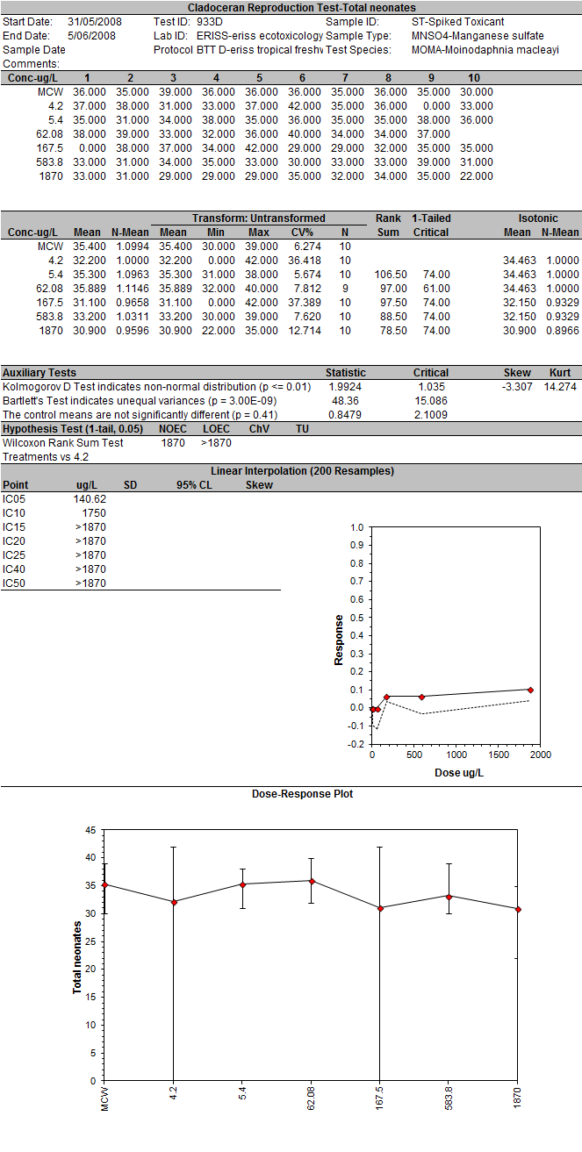

#### *Moinodaphnia macleayi* 934D

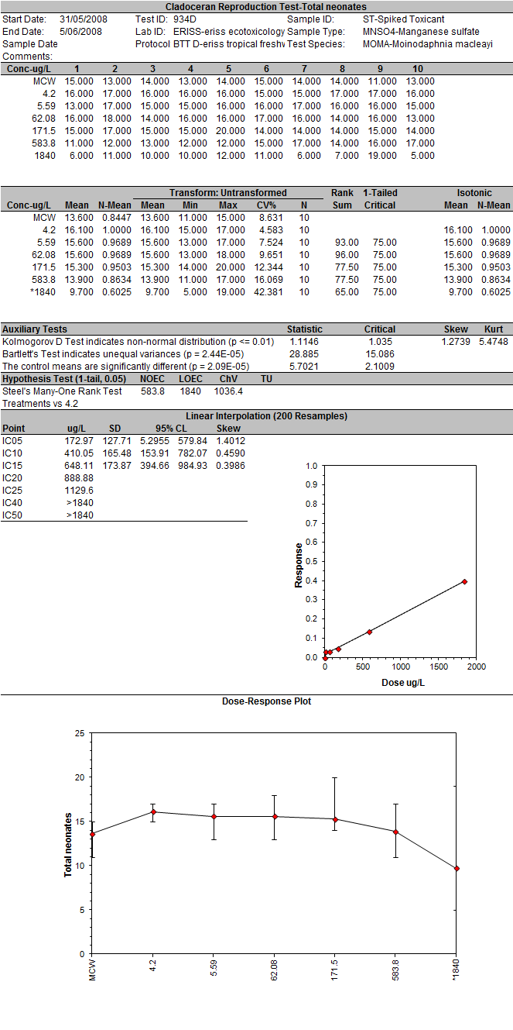

#### *Hydra viridissima* 936B

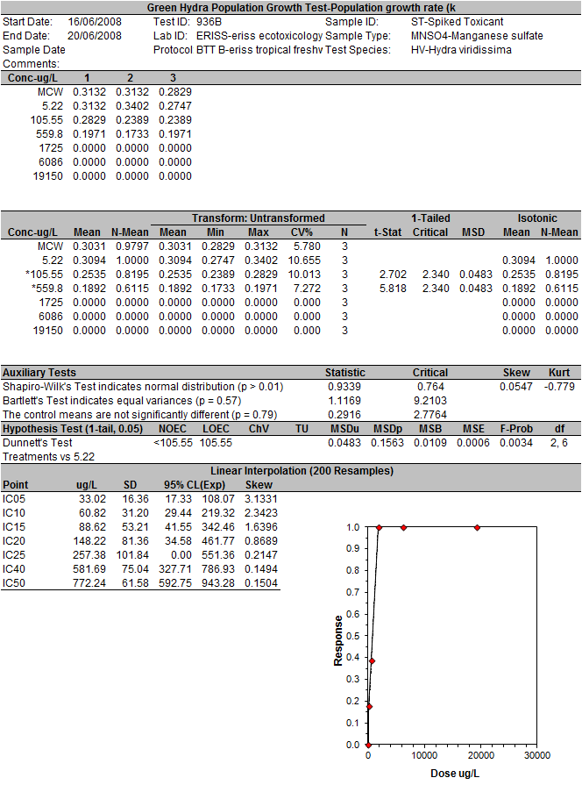

#### *Moinodaphnia macleayi* 937D

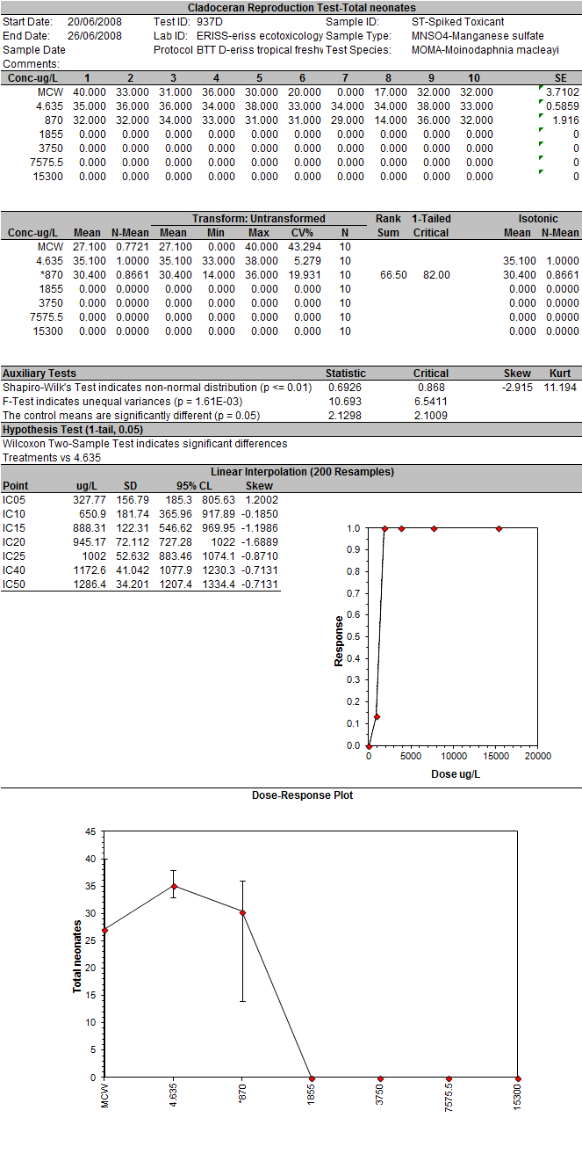

#### *Moinodaphnia macleayi* 938I

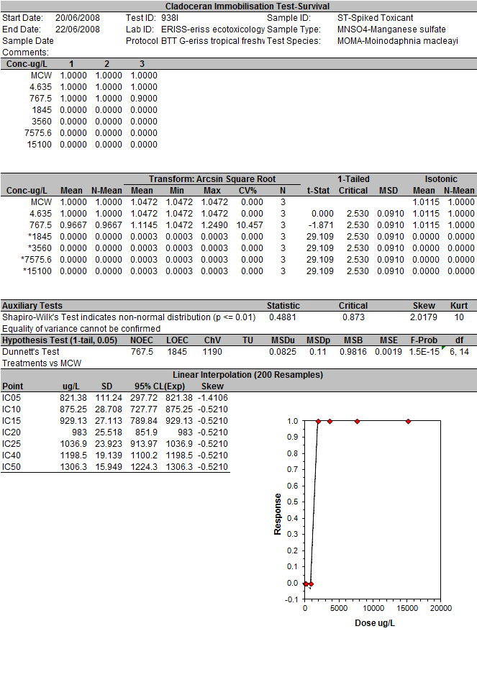

#### *Chlorella* sp. 939G

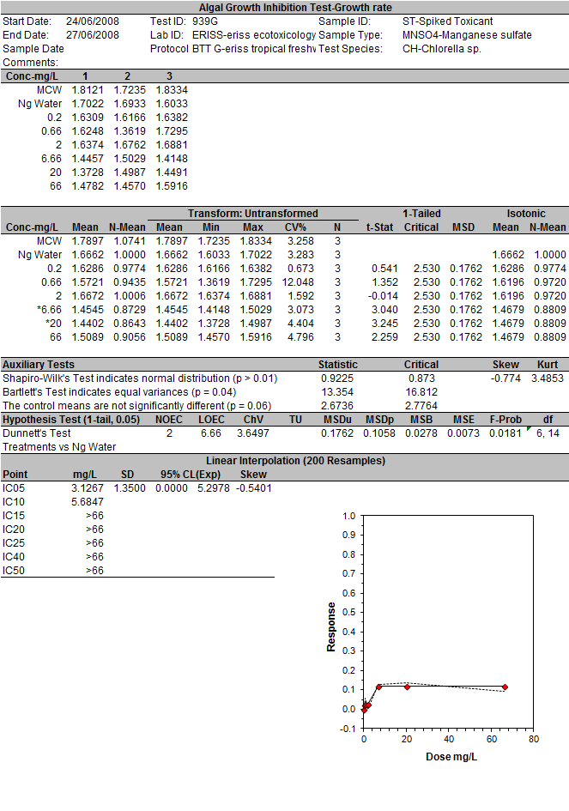

## Magela Creek Water

#### *Chlorella* sp. 1292G, 1294G pooled

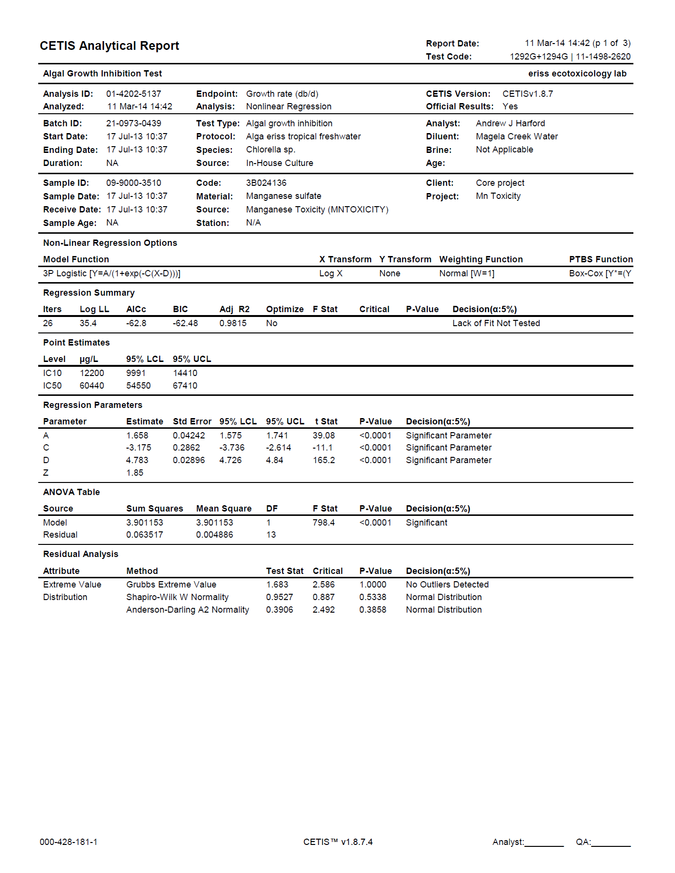

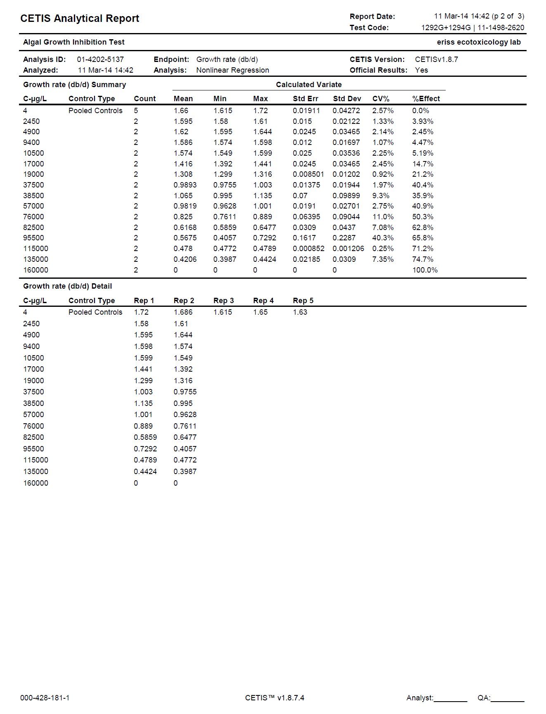

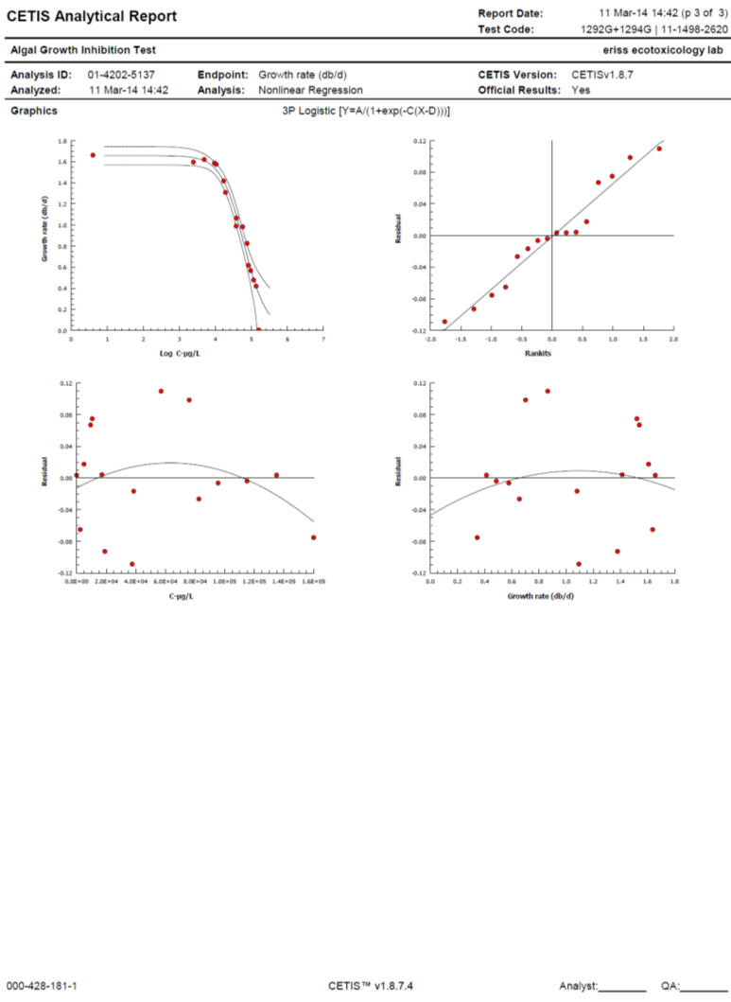

#### *Lemna aequinoctialis* 1276L, 1279L, 1297L pooled

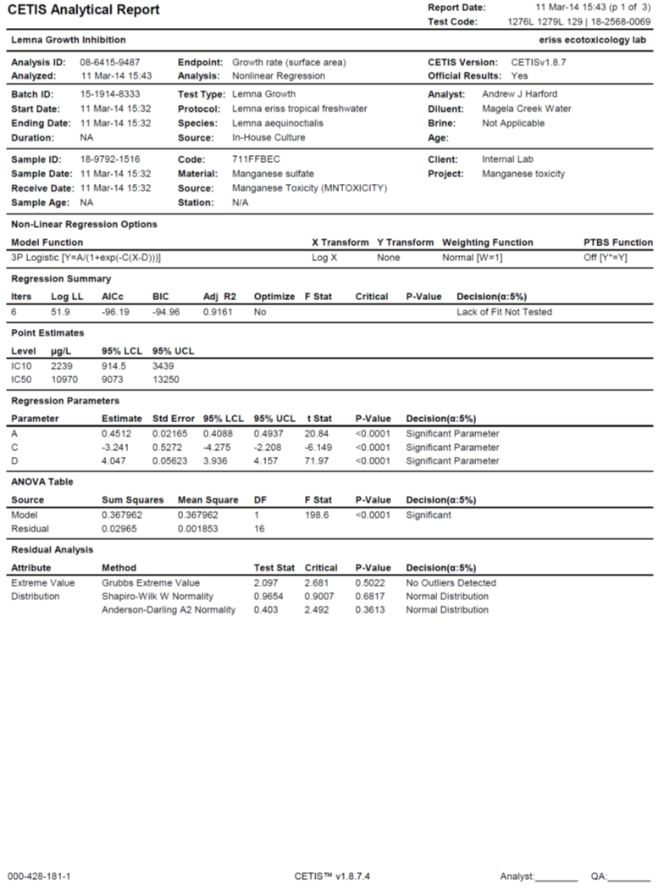

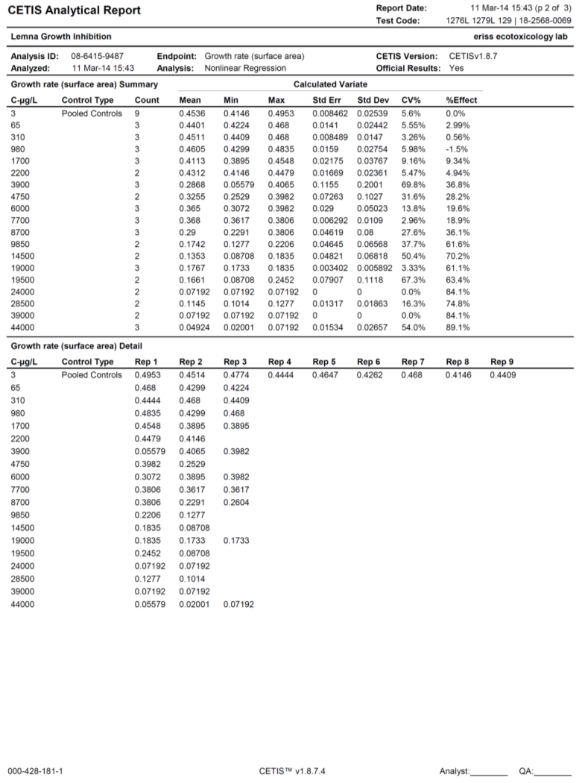

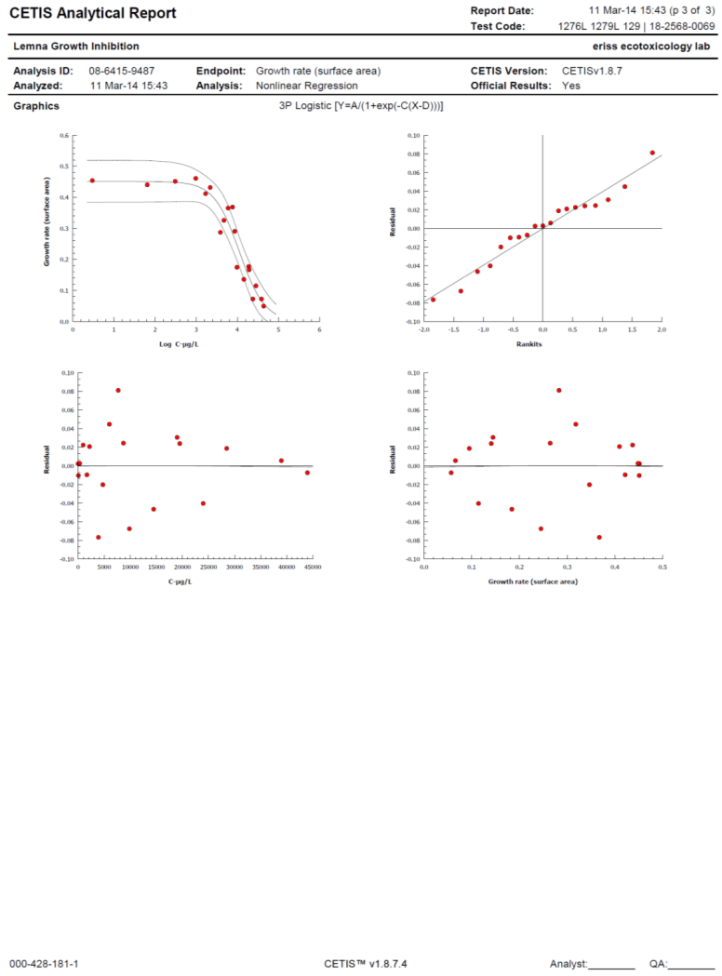

#### *Hydra viridissima* 1310B, 1318B pooled

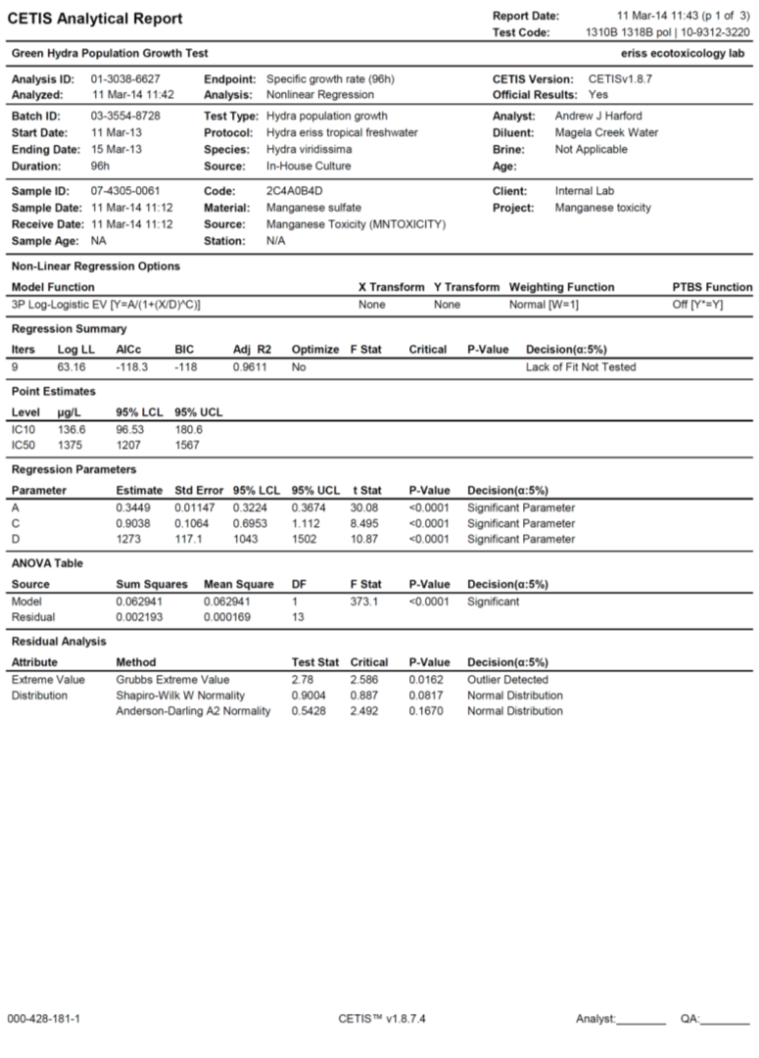

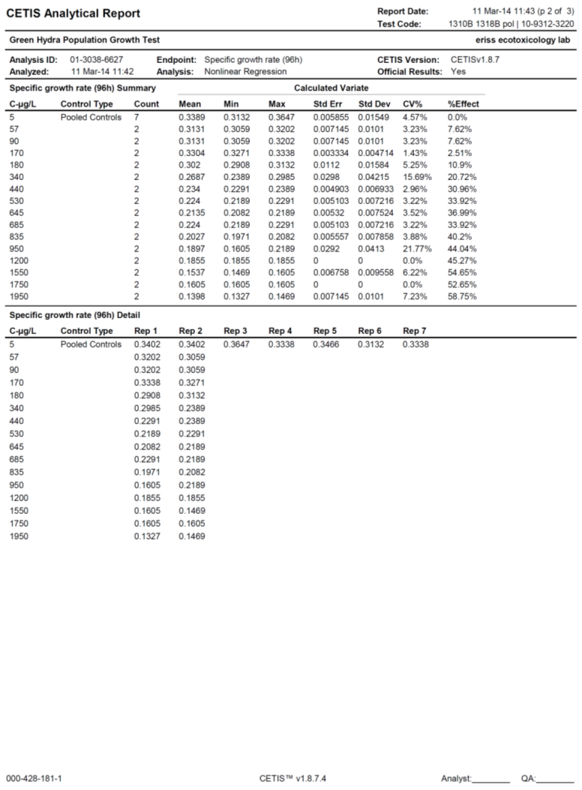

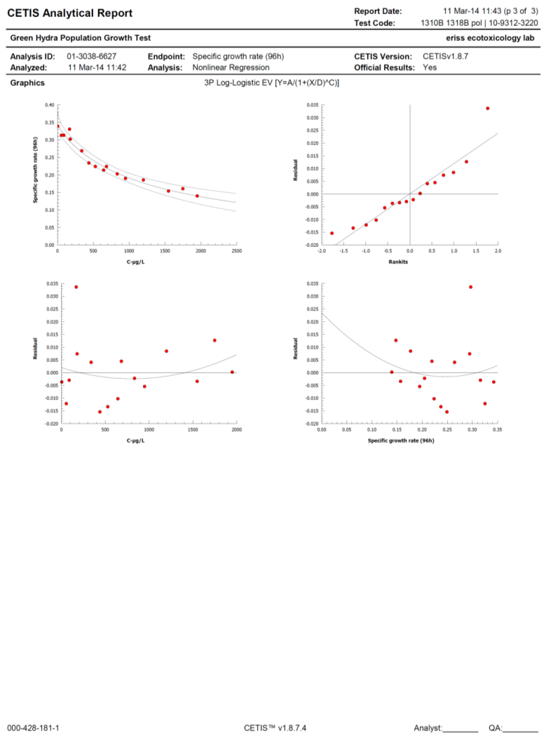

#### *Moinodaphnia macleayi* 1299D, 1345D pooled

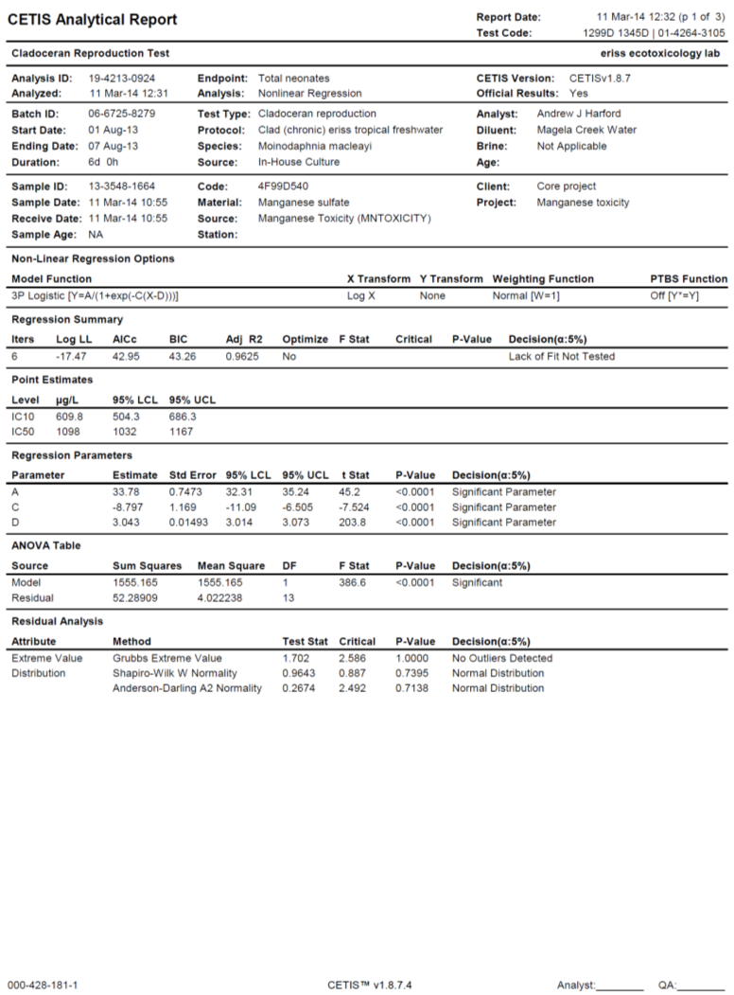

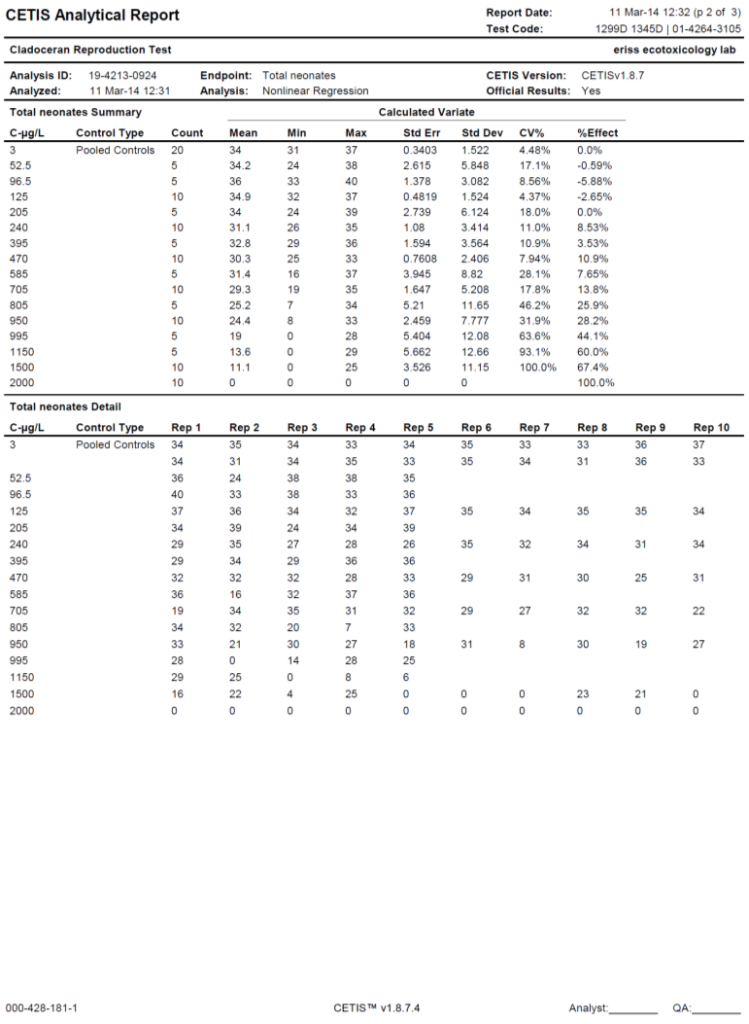

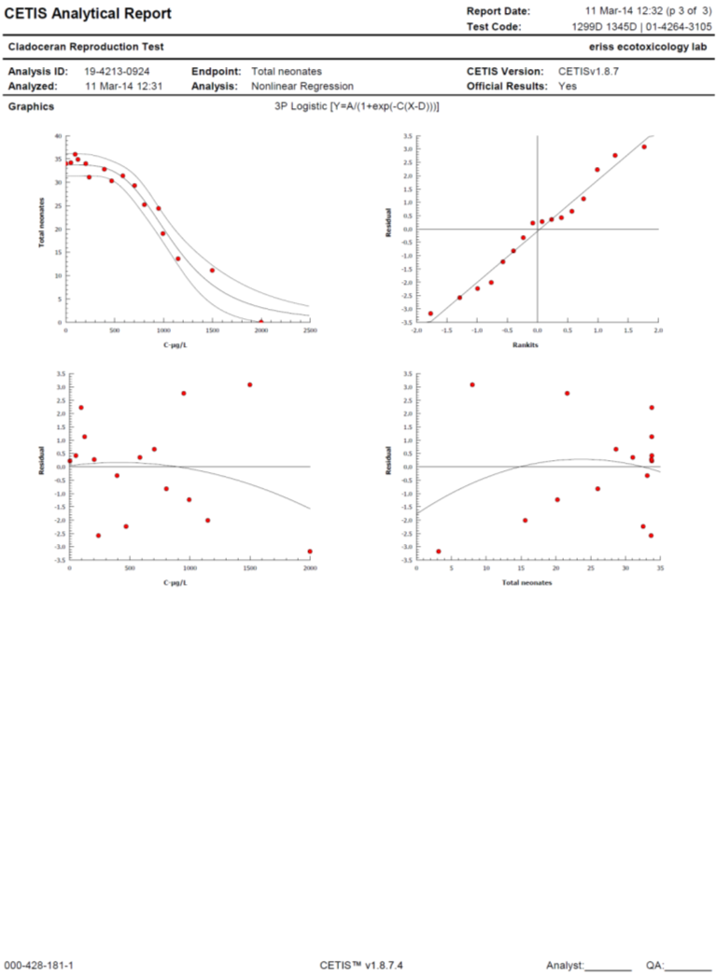

#### *Amerianna cumingi* 1275S 1307S 1335S pooled

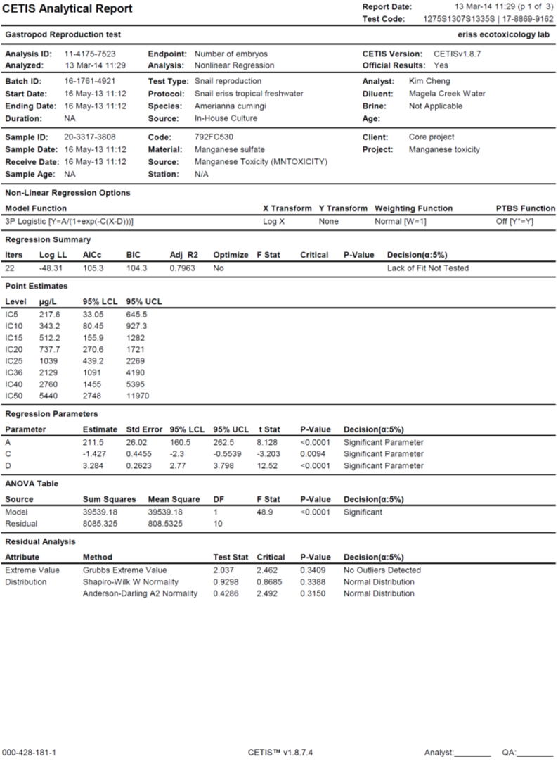

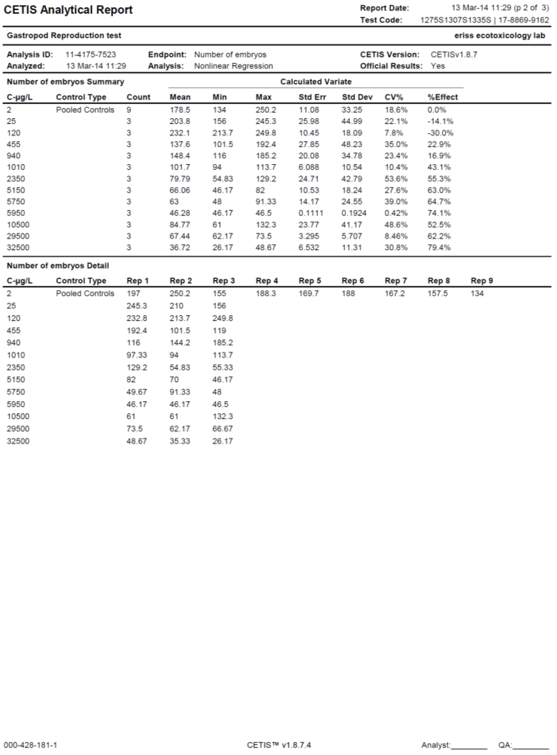

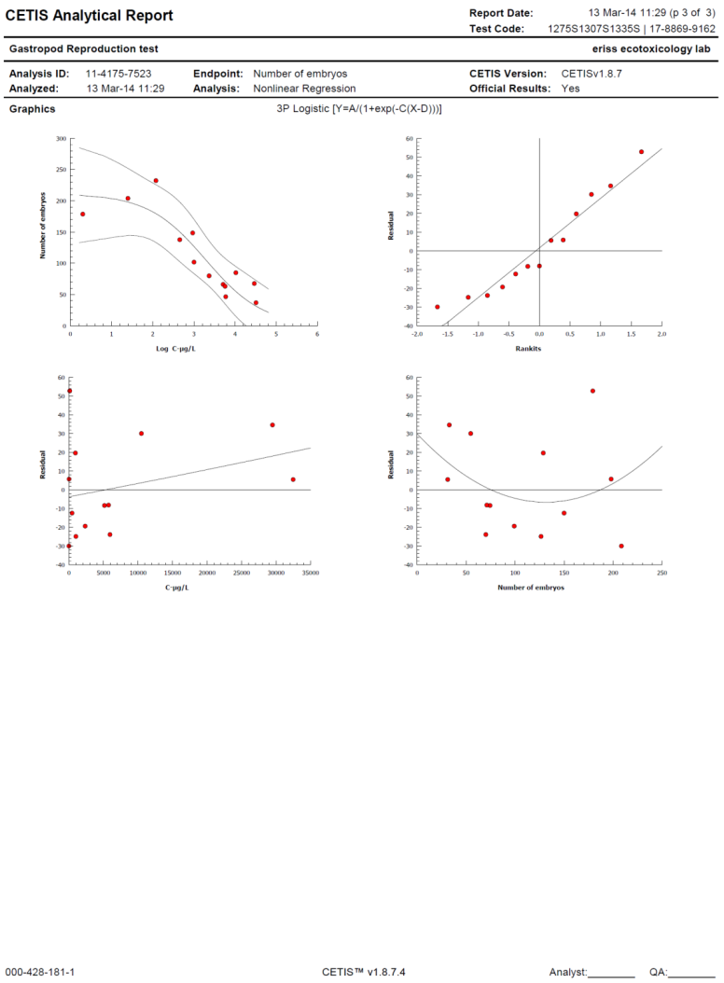

#### *Mogurnda mogurnda* 1293E, 1300E

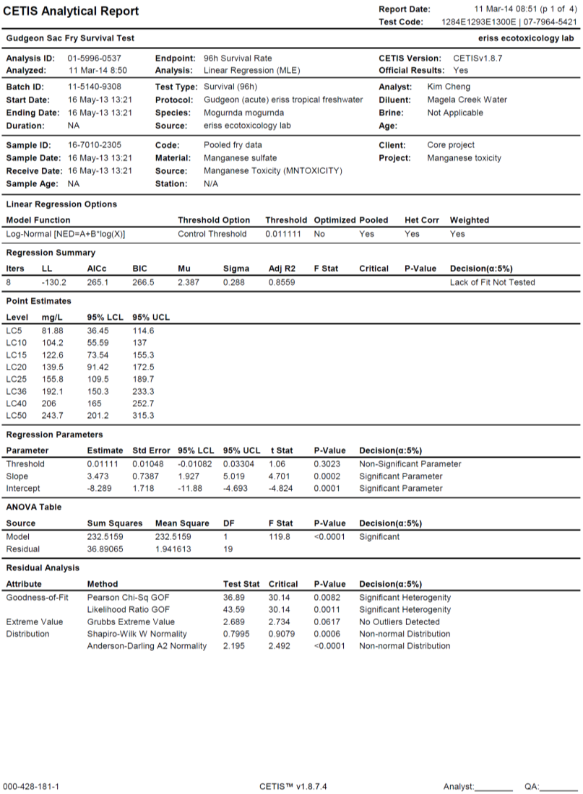

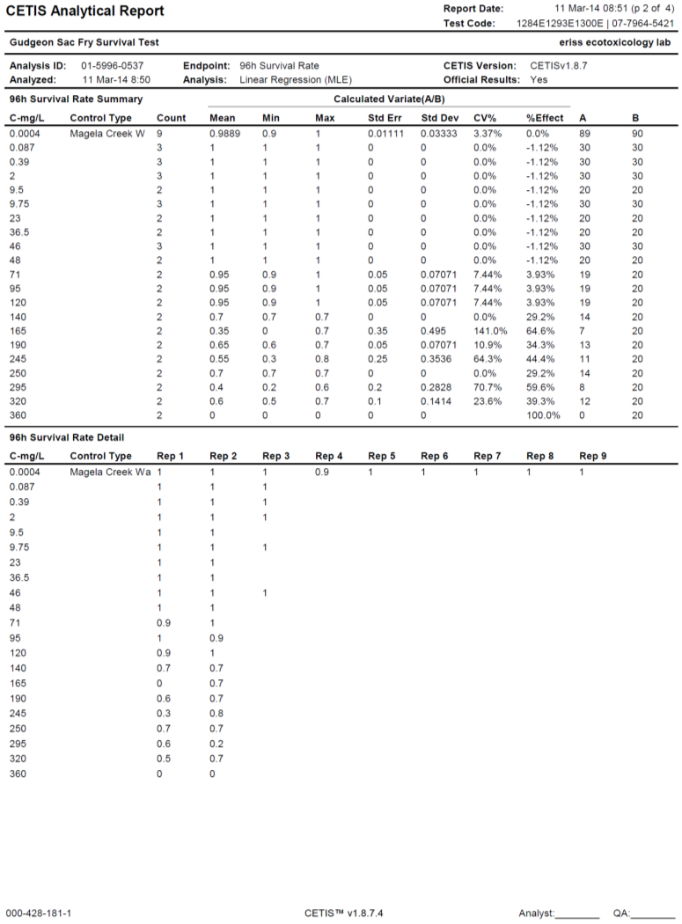

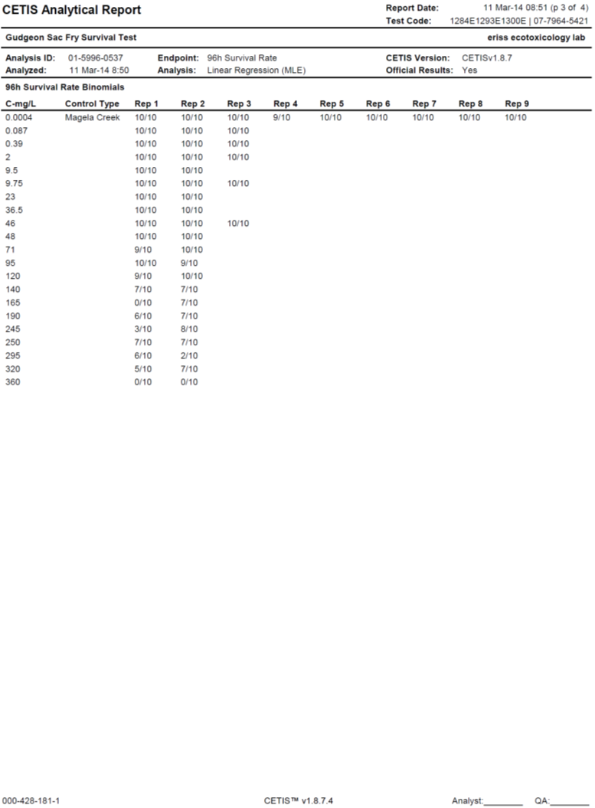

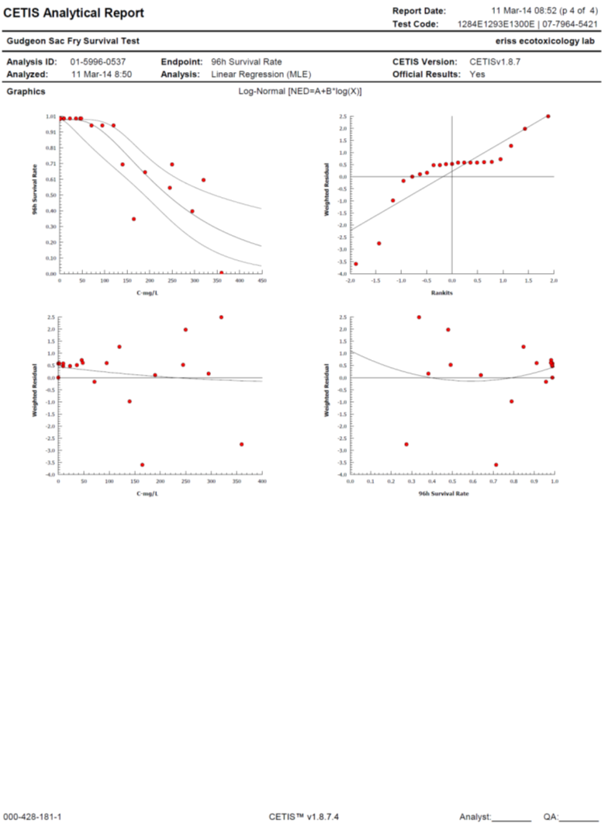

#### *Hydra viridissima* 1379B 1381B (low pH tests)

