Wave-short

632

*internal report*

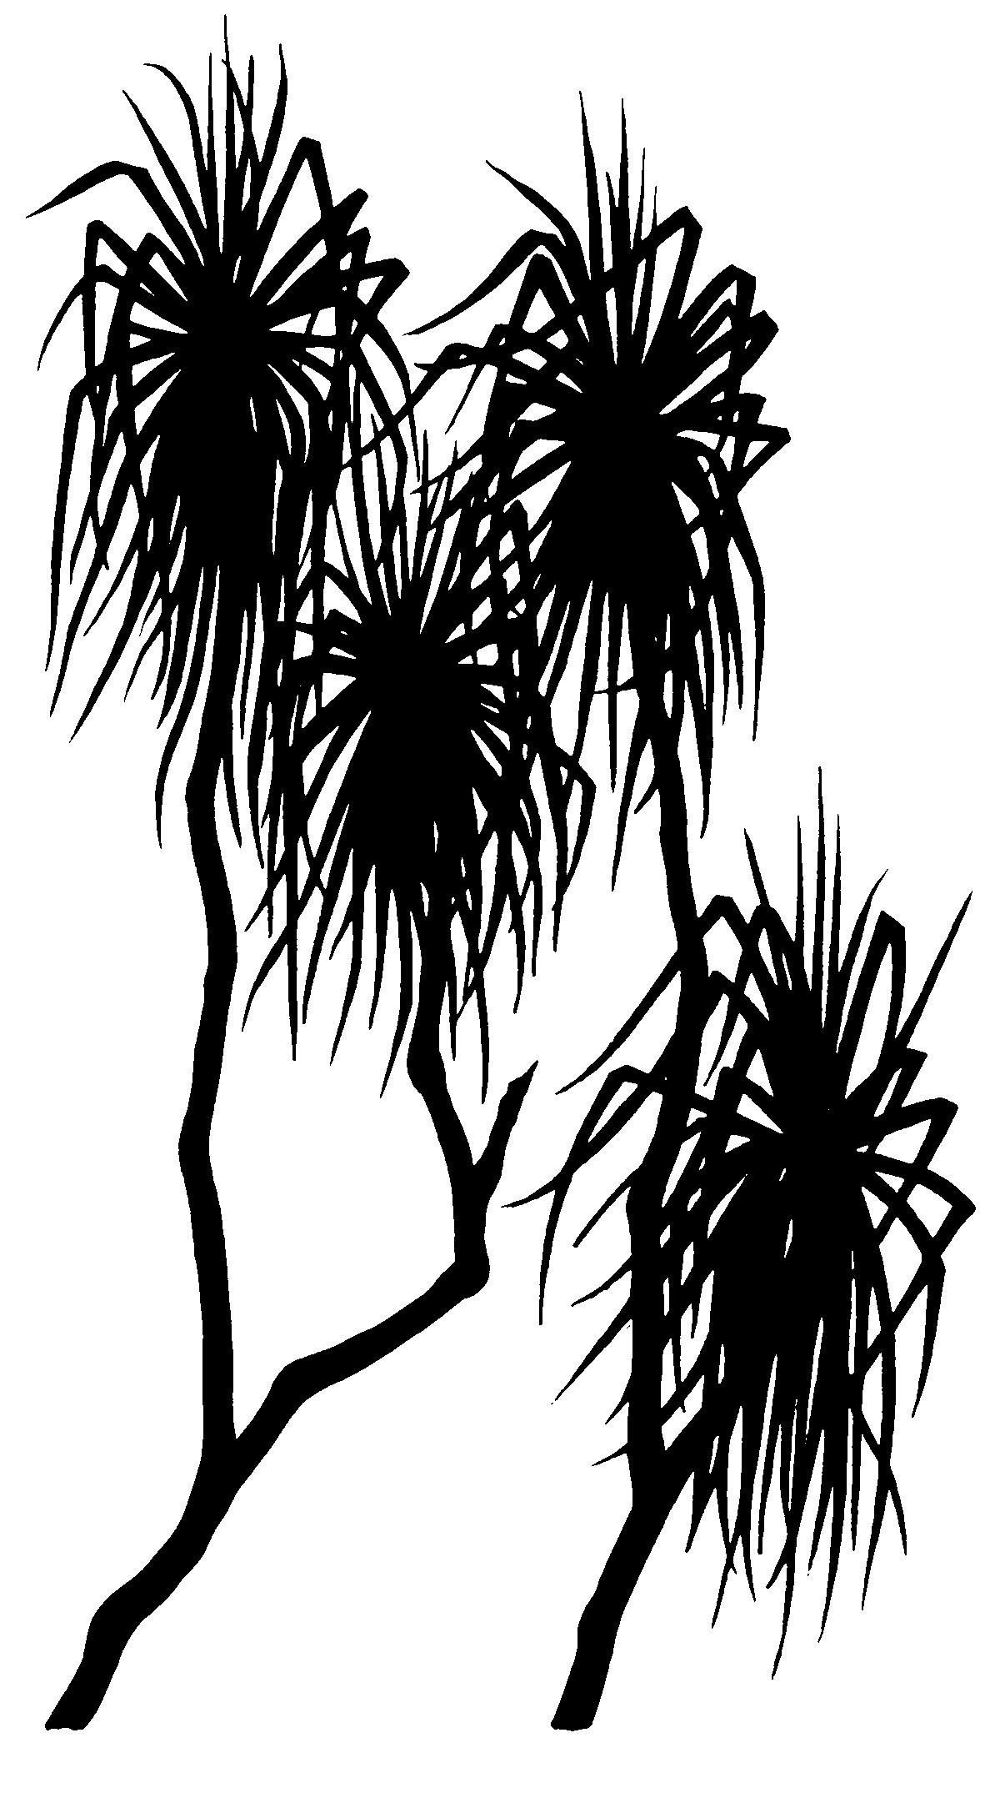



Ranger Trial Landform: Hydrology – Rainfall & runoff data for Erosion Plot 2: 2009 - 2014

M Saynor, J Boyden and   
W Erskine

April 2016

Release status – unrestricted

Project number – RES-2009-011

*The Department acknowledges the traditional owners of country throughout Australia and their continuing connection to land, sea and community. We pay our respects to them and their cultures and to their elders both past and present.*

# Ranger Trial Landform: Hydrology – Rainfall & runoff corrections for erosion Plot 2

Mike Saynor, James Boyden and Wayne Erskine

Supervising Scientist

GPO Box 461, Darwin NT 0801

April 2016

Release status – unrestricted



*How to cite this report:*

Saynor M, Boyden J & Eerskine W 2016. Ranger Trial Landform: Hydrology – Rainfall & runoff corrections for erosion Plot 2. Internal Report 632, April, Supervising Scientist, Darwin.

*Project number: RES-2009-011*

*Authors of this report:*

Mike Saynor –Supervising Scientist, GPO Box 461, Darwin NT 0801, Australia

James Boyden –Supervising Scientist, GPO Box 461, Darwin NT 0801, Australia

Wayne Erskine –Supervising Scientist, GPO Box 461, Darwin NT 0801, Australia

The Supervising Scientist is a branch of the Australian Government Department of the Environment.

Supervising Scientist

Department of the Environment

GPO Box 461, Darwin NT 0801 Australia

**environment**.gov.au/science/supervising-scientist/publications

© Commonwealth of Australia 2016

Copyright Image.tif

IR632 is licensed by the Commonwealth of Australia for use under a Creative Commons By Attribution 3.0 Australia licence with the exception of the Coat of Arms of the Commonwealth of Australia, the logo of the agency responsible for publishing the report, content supplied by third parties, and any images depicting people. For licence conditions see: [http://creativecommons.org/licenses/by/3.0/au/](http://creativecommons.org/licenses/by/3.0/au/%20)

**Disclaimer**

The views and opinions expressed in this publication are those of the authors and do not necessarily reflect those of the Australian Government or the Minister for the Environment.

While reasonable efforts have been made to ensure that the contents of this publication are factually correct, the Commonwealth does not accept responsibility for the accuracy or completeness of the contents, and shall not be liable for any loss or damage that may be occasioned directly or indirectly through the use of, or reliance on, the contents of this publication.

# Contents

Executive summary v

Acknowledgments vi

List of Figures vii

List of Tables x

1 Introduction 1

1.1 Erosion Plot 2 characteristics 2

2 Issues with water runon and runoff on EP2 5

2.1 Water runon 5

2.2 Disrupted water flow through stilling basin at higher flows 6

3 Data correction methods 10

3.1 Rainfall 10

3.2 Correcting the stage trace for offsite runon 12

3.2.1 Event - 10 March 2011 13

3.3 Correcting the shaft encoder stage trace for high runoff events 16

3.3.1 2009–2010 water year 17

3.3.2 2010–2011 water year 17

3.3.3 2011–2012 water year 22

3.3.4 2012–2013 water year 23

3.3.5 2013–2014 water year 24

3.4 General methods for correcting the shaft encoder stage trace 25

3.4.1 Shaft encoder roll over. 26

3.4.2 Recession events. 26

3.4.3 Infilling missing data 27

4 Data correction results 29

4.1 Rainfall 29

4.2 Corrections to the shaft encoder stage trace for off-site runon 32

4.3 Corrections to the stage trace for high-runoff events 33

4.4 General corrections to the shaft encoder stage trace 35

4.4.1 Changed data points 35

4.4.2 Missing data corrections 35

5.0 Discussion and conclusions 36

6.0 References 38

Appendix 1 - Correcting EP2 stage trace for runon 39

Appendix 2 – HYEXTREM output for larger events 48

Appendix 3 – Runoff comparisons for 2009–2010 water year 51

Appendix 4 – Stage traces for each of the 5 water years 2009–2010 to 2013–2014 81

# Executive summary

Seasonal rainfall and associated runoff have been continuously monitored from 2009 at four Erosion Plots (EP1 to EP4) located on the Ranger mine Trial Landform. This report addresses the Erosion Plot 2 (EP2) dataset collected from 01‑09‑2009 to 31‑08‑2014 over five water years. The systematic assessment and corrections applied to these data have resulted in a complete, quality coded hydrology record suitable for further analysis with other parameters such as erosion bedload, also monitored at the plots. This corrected dataset is stored in the TLF2 archive file of Hydstra under variables 10.01 (rainfall) and 100.01 (runoff trace), located at **HYDSTRA$(****\\pvnt01flpr01)(U:)\HYD**(U:)\HYD)**.**

# Acknowledgments

There have been many who have helped with this project over its long period of existence.

Matt Daws, Ping Lu, Amber Hooke from ERA assisted in many aspects of the setup of the erosion pots. ERA constructed the landform on which the erosion plots have been built.

Richard Houghton assisted greatly with the set up of the erosion plots on the trial landform, ably assisted in no particular order by Dene Moliere, Grant Staben and John Lowry.

Austin Brandis (Envirotech Monitoring) assisted greatly with the establishment of the telemetry system and the installation of the sensors into the gauging stations at the outlet of each plot. Kate Turner and Sean Fagan have assisted with many aspects of Hydstra.

Over the years many people have assisted in the field, John Taylor, Michael Fromholtz, Rob Thorn, Graeme Passmore (ERA), Jess Bartlett (ERA) Peter Poole (ERA).

Thanks also to Mitch Rudge who reviewed an earlier version of this report.

## List of Figures

**Figure 1** Alligator Rivers Region showing the location of the Ranger Mine and the trial landform with erosion plots (Plots 1 to 4). 1

**Figure 2** Aerial view of the completed trial landform located next to the Ranger mine Tailings Storage Facility (taken 28 August 2009) 2

**Figure 3** Across EP2, showing the upstream stilling-basin, part of the flume and the shelter for the data logger (2 February 2010). 3

**Figure 4** Flume, upstream stilling-basin and downstream draining-basin and of EP2 (2 February 2010). 3

**Figure 5** Breach or piping failure under the top boundary of EP2 indicated by arrow. 5

**Figure 6** Concrete along the top boundary of EP2 to seal the breach and reinforce the boundary. 6

**Figure 7** Flow through TLF2 flume at 5:50pm, uniform steady flow. 7

**Figure 8** Flow through TLF2 flume at 6:00 pm, flow is being affected by the stainless cage for the EC probe. 7

**Figure 9** Flow through TLF2 flume at 6:10 pm, flow is being affected by the stainless cage. Flow is being affected by the cage for the EC probe and is rising up around the outside of the basin. 8

**Figure 10** Flow through TLF2 flume at 6:20 pm, Getting much darker and the water is flowing more smoothly through the flume. 8

**Figure 11** Example of the difference in water level between the stage trace and pressure transducer (i.e. black vs blue traces) at higher runoff flows Blue is the EP2 pressure transducer and black is the shaft encoder. 9

**Figure 12** Equipment shelter with the location of the raingauge just downslope of the plot (5 May 2012). 10

**Figure 13** Relationship between the TLFERA and Erosion Plot 2 sites for common ½ hourly interval rainfall on the trial landform (collected from 24-11-2009 to 3-01-2010). 11

**Figure 14** Green dotted line is the stage trace for EP2 and the green line above is stage trace for EP1. The black lines are CTF’s for EP1 and EP2. Red line is rainfall for EP2 and blue line is rainfall for EP1. 13

**Figure 15** The blue and red dotted line shows the correction that has been made to the stage trace for EP2. The orange line is the original stage trace. The colours of the other lines are the same as Figure 13. 14

**Figure 16** Runoff from EP1 for the event 10 March 2011. 15

**Figure 17** Runoff from EP2 for the event 10 March 2011. 16

**Figure 19** Event 6 runoff hydrograph on 13 February 2011 the pressure transducer (red) is higher than the shaft-encoder (black). The pressure transducer has been aligned to the same datum as the shaft-encoder by adding 0.789 m. Cumulative rain is shown as the rising red line. 18

**Figure 20** Water through EP2 flume at 5:30 pm on 13 February 2011. 19

**Figure 21** Water through EP2 flume at 5:40 pm on 13 February 2011. Disturbance in the upstream stilling basin can just be seen at the top of the image. 19

**Figure 22** Water through EP2 flume at 5:50 pm on 13 February 2011. 20

**Figure 23** Water through EP2 flume at 5:50 pm on 13 February 2011. 20

**Figure 24** Event 8 hydrograph. The black is the shaft encoder and the red is the pressure transducer. 0.789m has been added to the pressure transducer. The start of the events have been aligned to the same datum 21

**Figure 25** Event 11, the black is the shaft encoder and the blue is the pressure transducer. The pressure transducer trace has been raised by 0.807m to align it to the same datum as measured by the shaft encoder. Cumulative rainfall is indicated in mm by the red line. 22

**Figure 26** Flow through the flume on EP2 at 4:40 pm (time of the highest flow). The upstream basin cannot be seen in the image. 23

**Figure 27** Event 20 hydrograph from 15 December 2012. Tithe black is the shaft encoder and the blue is the pressure transducer that has been aligned to the same datum. Cumulative rainfall is indicated by the red line. 24

**Figure 28** Event 30, the black is the shaft-encoder and the blue is the pressure transducer. 25

**Figure 29** Output from Hydstra HYPLOTXY for common data on EP1 and EP1 during the 2013–2014 water year. TLF is EP1 and TLF2 is EP2. 28

**Figure 30** Cumulative rainfall on EP2 for 2009–2010 water year. The orange part of the line has been infilled from ERATLF. 29

**Figure 31** Cumulative rainfall on EP2 for 2010–2011 water year. 30

**Figure 32** Cumulative rainfall on EP2 for 2011–2012 water year. 30

**Figure 33** Cumulative rainfall on EP2 for 2012–2013 water year. 31

**Figure 34** Cumulative rainfall on EP2 for 2013–2014 water year. The orange section shows where EP2 rainfall data has been infilled with EP3 data. 31

**Figure 35** Part of the stage trace on EP2 for the 2013–2014 water year. The orange section shows where EP2 stage trace data has been infilled with EP1 data using the regression equation. 35

**Figure 36** Event 43 hydrograph from 3 May 2014. Red is the pressure transducer and black is the shaft-encoder. 80

**Figure A1-1** Green dotted line is the stage trace for EP2 and the green line above is stage trace for EP1. The black lines are CTF’s for EP1 and EP2. Red line is rainfall for EP2 and blue line is rainfall for EP1. 40

**Figure A1-2** The blue and red dotted lines show the correction that has been made to the stage trace for EP2. The orange line is the original stage trace. The colours of the other lines are the same as Figure A1-1. 40

**Figure A1-3** Green dotted line is the stage trace for EP2 and the green line above is stage trace for EP1. The black lines are CTF’s for EP1 & EP2. Red line is rainfall for EP2 and blue line is rainfall for EP1. 41

**Figure A1-4** The blue and red dotted line shows the correction that has been made to the stage trace for EP2. The orange line is the original stage trace. The colours of the other lines are the same as Figure A1-3. 41

**Figure A1-5** Green dotted line is the stage trace for EP2 and the green line above is stage trace for EP1. The black lines are CTF’s for EP1 and EP2. Red line is rainfall for EP2 and blue is rainfall for EP1. 42

**Figure A1-6** The blue and red dotted line shows the correction that has been made to the stage trace for EP2. The orange line is the original stage trace. The colours of the other lines are the same as Figure A1-5. 42

**Figure A1-7** Green dotted line is the stage trace for EP2 and the green line above is stage trace for EP1. The black lines are CTF’s for EP1 and EP2. Red line is rainfall for EP2 and blue is rainfall for EP1. 43

**Figure A1-8** The blue and red dotted line shows the correction that has been made to the stage trace for EP2. The orange line is the original stage trace. The colours of the other lines are the same as Figure A1-7. 43

**Figure A1-9** Green dotted line is the stage trace for EP2 and the green line above is stage trace for EP1. The black lines are CTF’s for EP1 and EP2. Red line is rainfall for EP2 and blue is rainfall for EP1. 44

**Figure A1-10** The blue and red dotted line shows the correction that has been made to the stage trace for EP2. The orange line is the original stage trace. The colours of the other lines are the same as Figure A1-9. 44

**Figure A1-11** Blue dotted line is the stage trace for EP2 and the green line above is stage trace for EP1. The black lines are CTF’s for EP1 and EP2. Red line is rainfall for EP2 and blue is rainfall for EP1. 45

**Figure A1-12** The blue and red dotted line shows the correction that has been made to the stage trace for EP2. The orange line is the original stage trace. The colours of the other lines are the same as Figure A1-11. 45

**Figure A1-13** Blue dotted line is the stage trace for EP2 and the green line above is stage trace for EP1. The black lines are CTF’s for EP1 and EP2. Red line is rainfall for EP2 and blue line is rainfall for EP1. 46

**Figure A1-14** The blue and red dotted line shows the correction that has been made to the stage trace for EP2. The orange line is the original stage trace. The colours of the other lines are the same as Figure A1-13. 46

**Figure A1-15** Blue dotted line is the stage trace for EP2 and the green line above is stage trace for EP1. The black lines are CTF’s for EP1 and EP2. Red line is rainfall for EP2 and blue line is rainfall for EP1. 47

**Figure A1-16** The blue and red dotted line shows the correction that has been made to the stage trace for EP2. The orange line is the original stage trace. The colours of the other lines are the same as Figure A1-15 47

## List of Tables

**Table 1** Periods of missing rainfall record for EP2 for the five water years 2009–2010 to 2013–1014. 11

**Table 2** Correlations between rainfall gauge sites on the trial landform taken from ½ hourly interval totals. A zero-intercept was not enforced in the regressions. 12

**Table 3** Difference in stage traces between EP2 and EP1 12

**Table 4** Periods of missing record on EP2 and how it has been infilled. Note PT = pressure transducer data for EP2. 27

**Table 5** Rainfall data for EP2 on the trial landform for the five water years. 32

**Table 6** Difference in stage traces between EP2 and EP1 32

**Table 7** Corrections made to the shaft encoder data for events greater than 1.040 mm. PT is Pressure Transducer 33

**Table A2- 1** Hydstra HYEXTREM outputs for EP2 for water greater than 1.040 mm 49

# 1 Introduction

The Ranger Uranium Mine, surrounded by Kakadu National Park (Figure 1) is located in the Alligator Rivers Region (ARR) in the wet-dry monsoonal tropics, approximately 250 km east of Darwin, Northern Territory. A trial landform, measuring approximately 200 m by 400 m (8 ha) was constructed during late 2008 and early 2009 by Energy Resources of Australia (ERA), adjacent to the north-western wall of the tailings storage facility at the Ranger Mine (Figures 1 & 2). A collaborative research program involving ***eriss*** (***Environmental Research Institute of the Supervising Scientist***) and ERA, has been underway to measure long-term (five to ten year) rainfall, runoff, sediment and solute losses, seepage and vegetation establishment on the trial landform.

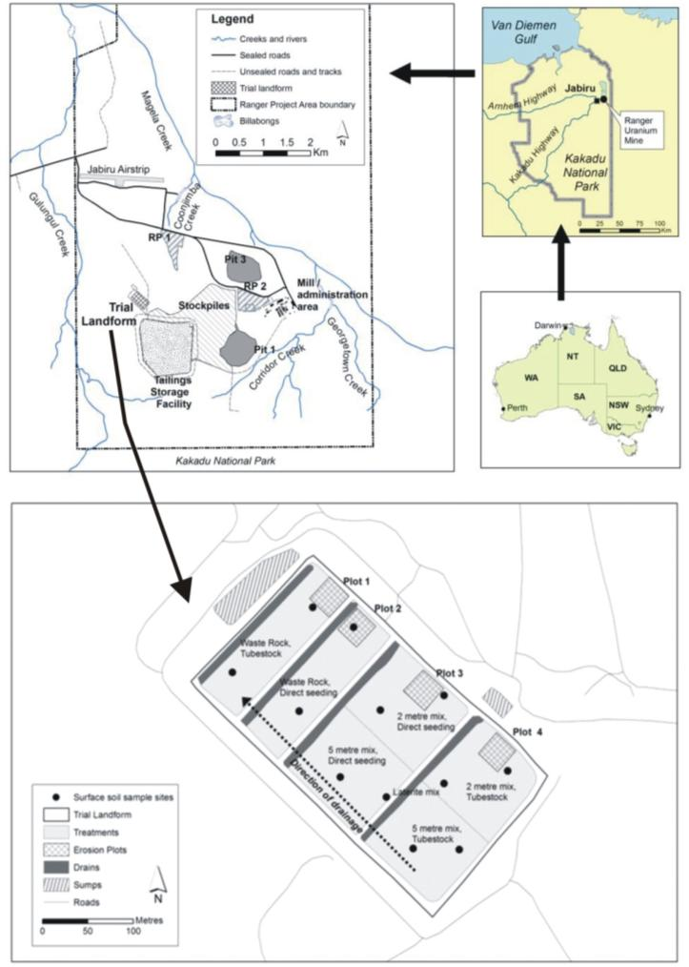

**Figure 1** Kakadu National Park showing the location of the Ranger Mine and the trial landform with erosion plots (Plots 1 to 4).

Rainfall, runoff, sediment (suspended sediment and bedload) and solute parameters have been collected from four erosion plots (EP1 to EP4) constructed on the surface of the trial landform from the 2009–2010 to 2013–2014 water year. A water year is defined as the period 1 September to 31 August the following year. This internal report summarises the quality assessment and corrections of rainfall and runoff data from Erosion Plot 2 (EP2) for the 5 water years,   
2009–2010 to 2013–2014.

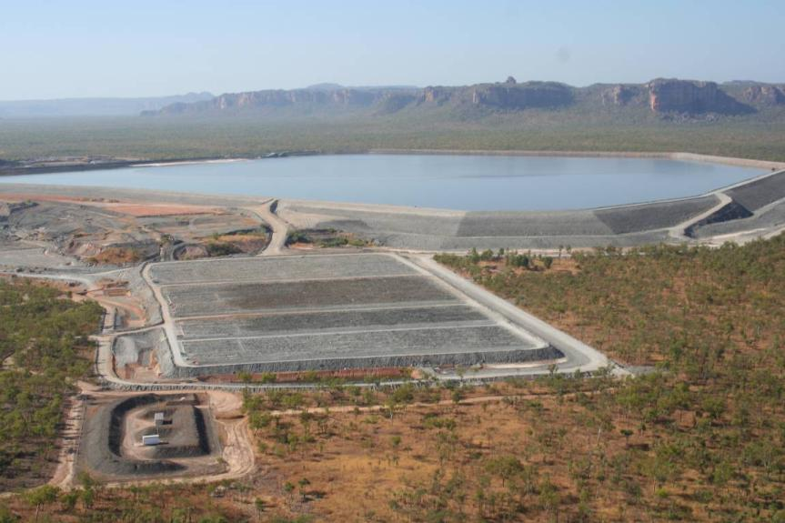

EP2

**Figure 2** Aerial view of the completed trial landform located next to the Ranger mine Tailings Storage Facility (taken 28 August 2009)

## 1.1 Erosion Plot 2 characteristics

Erosion Plot 2 (EP2) was built during 2009 in the area that is waste rock only and was initially vegetated by direct seeding in July 2009 (Figure 3). Its measured dimensions are 29.858 m across by 28.747 m down the plot giving an area of 858.342 m2. The surveyed average slope of the plot was 1.62 % or 0.93 degrees.

Plot boundaries were dampcourse concreted in place with a U-PVC pipe at the downstream end of the plot. The U-PVC pipe is sloped (>0.02 m/m) toward one side of the plot to direct water into a stilling basin upstream of a Rectangular Broad Crest (RBC) flume  (Bos et al 1984, Clemmens et al 2001), Figure 4.

Stage height of water leaving the plot is measured by two sensors, a shaft encoder (primary sensor) in a stilling well with the intake in the stilling basin and a pressure transducer (secondary sensor) with the intake in the upstream section of the flume. The shaft encoder is the primary sensor because they are highly accurate (with a float on the water surface in the stilling well) and have good temperature stability. Stage height data in both height recorders is measured at 10 second intervals with a vertical precision of 1 mm. New data points are recorded only when the change in water level is greater than 1 mm.

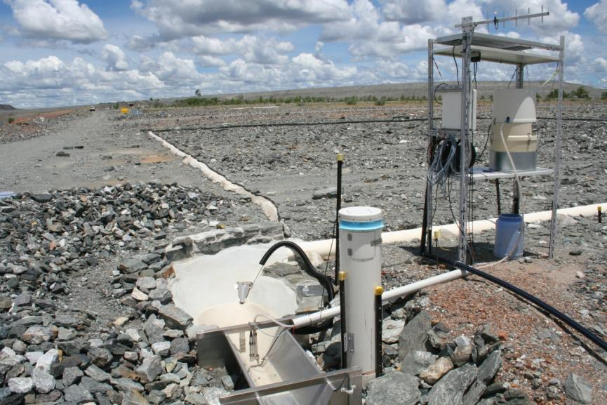

**Figure 3** Across EP2, showing the upstream stilling-basin, part of the flume and the shelter for the data logger (2 February 2010).

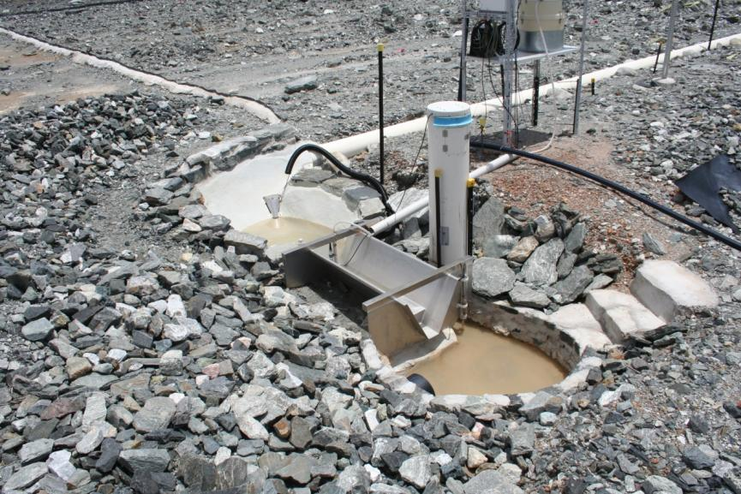

**Figure 4** Flume, upstream stilling-basin and downstream draining-basin of EP2 (2 February 2010).

The upstream stilling-basins of the four plots are of different sizes. The stilling-basin of the flume EP2 has a volume of 135 litres which is the second smallest of the stilling-basins (Saynor et al 2013).

Rainfall is recorded using a 0.2 mm tipping bucket pluviograph (Hydrological Services Pty. Ltd.) at the downslope end of the plot. Rainfall data is recorded to the data logger at 1 minute intervals, (i.e. the number of tips each minute is recorded). Runoff from EP2 is responsive with rainfall of 3-5 mm producing runoff from the plot. Runoff usually continues for 45-60 minutes after the rainfall ceases depending on the amount of rainfall.

# 2 Issues with water runon and runoff on EP2

There are two specific issues that have at times contributed to either an overestimate or underestimate of runoff from EP2. Overestimates of runoff were associated with a breach of the upstream plot boundary in 2010-2011 which allowed additional water to flow on to the plot. Under-estimates of runoff have resulted from uneven flow through the upstream stilling basin and flume. This section describes these issues and how they were corrected.

## 2.1 Water runon

At the end of the 2010-2011 water year a large breach was noticed in the boundary along the upslope edge of EP2 (Figure 5). This breach is believed to have occurred during the very large event on 22 February 2011 (Figure 6). This breach was fixed during the 2011 dry season using a concrete truck and a team of staff. The impact of this breach could be identified in the stage trace by a second peak appearing well after the rainfall had finished. The second peak was not present on stage traces on erosion plot 1 (EP1) for the same event. A comparison of the EP2 and EP1 stage traces should be used to apply corrections to the EP2 stage traces affected by the breach.

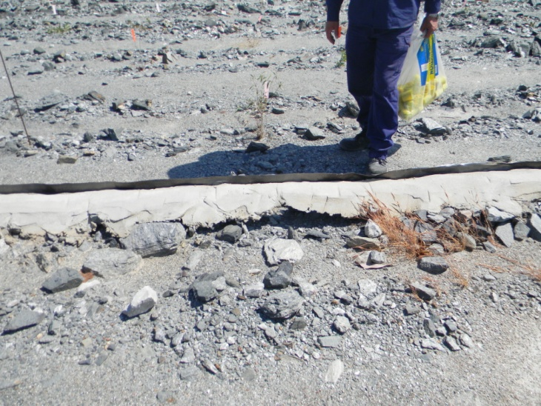

**Figure 5** Piping failure under the top boundary of EP2 indicated by arrow.

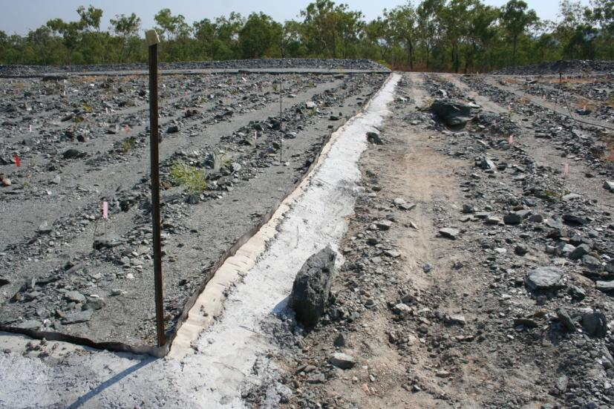

**Figure 6** Concrete along the top boundary of EP2 to seal the breach and reinforce the boundary. The red arrow shows where the breach occurred.

## 2.2 Disrupted water flow through stilling basin at higher flows

The comparison of the shaft encoder data with the pressure transducer suggests that there are differences in stage heights at higher runoff flows. The size and shape of the stilling-basin influences the energy dissipation of inflowing water and thereby impacts on its ability to settle water for smooth flow through and over the crest of the flume. It was determined that the smaller stilling basin size resulted in an uneven and more turbulent flow-level in the stilling basin at higher flow rates.

Inspection of the photos taken during high runoff events at EP2 show that water deflects off the stainless cage housing of the upstream Electrical Conductivity (EC) sensor. It rises up the right bank side of the stilling basin before flowing into the throat of the flume. This results in a difference between the data recorded by the shaft encoder and the pressure transducer due to the intakes being located in different locations. The intake of the shaft encoder is in the middle of the stilling basin and appears to be prone to uneven water levels. By contrast the intake for the pressure transducer is located in the upstream end (throat) of the flume, where water levels appear to be more stable.

Photos taken at 10 minute intervals during an event on 24 November 2012 are shown in Figures 7 to 10. Rainfall started at 5:47 pm and was intense until 6:20 pm, with less intense rain continuing until 7:25 pm with a second period of more intense rain starting at 6:42 pm resulting in a second peak in the hydrograph. The rainfall totalled 54 mm in approximately 1½ hours with the most intense rain falling in a ½ hour period and totalling 34 mm.

Figure 7 taken at 5:50 pm shows steady flow through the flume and also a settled water level in the upstream stilling basin. Figure 8 taken at 6:00 pm shows water deflecting off the stainless steel cage that houses the EC probe. The water can be seen rising up the side of the stilling basin, however, the flow through the flume looks to be uniform. By 6:10 pm (Figure 9) most of the water is being deflected off the side of the stainless steel cage and rising high up the right side of the stilling basin. The water looks to be turbulent as it enters the flume, which is not a uniform height through the flume. At 6:20 pm (Figure 10) less water is deflecting off the stainless cage and the water through the flume has become more uniform.

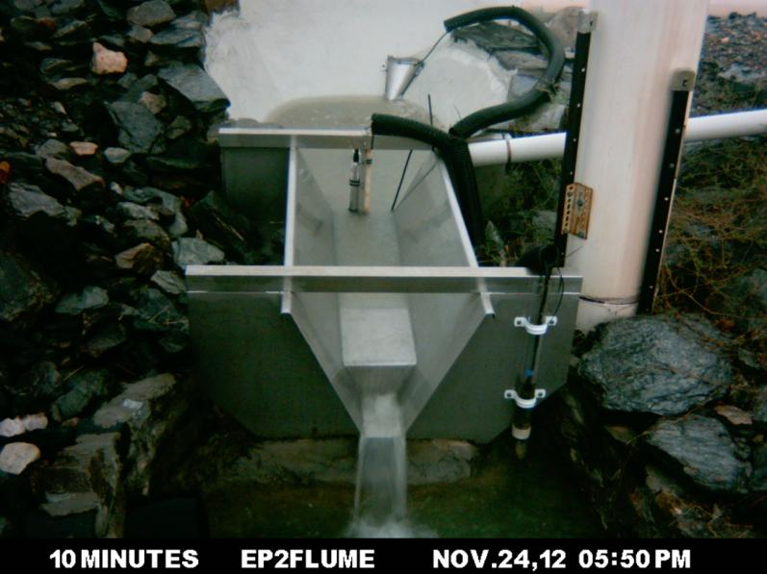

**Figure 7** Flow through TLF2 flume at 5:50pm, uniform steady flow.

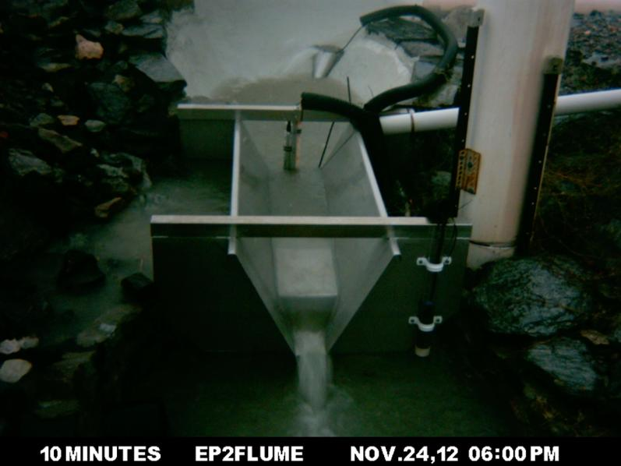

**Figure 8** Flow through TLF2 flume at 6:00 pm, flow is starting to be deflected by the stainless cage, indicated by the yellow arrow.

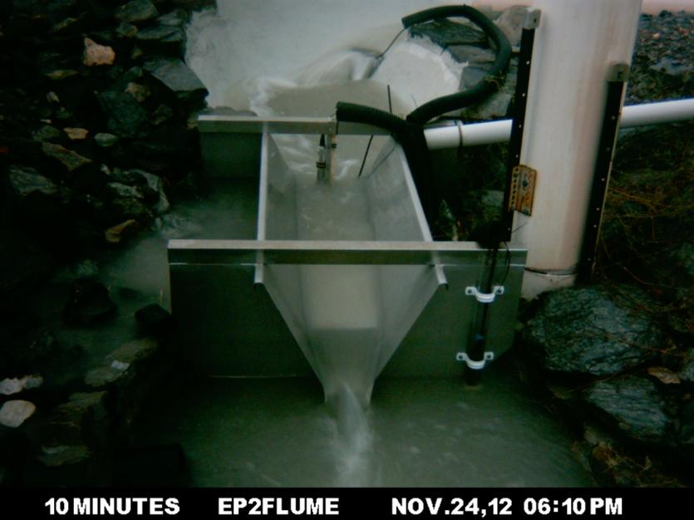

**Figure 9** Flow through TLF2 flume at 6:10 pm, flow is being affected. The flow can be seen deflecting off the cage (yellow arrow) and can be seen rising up around the outside of the basin (red arrow).

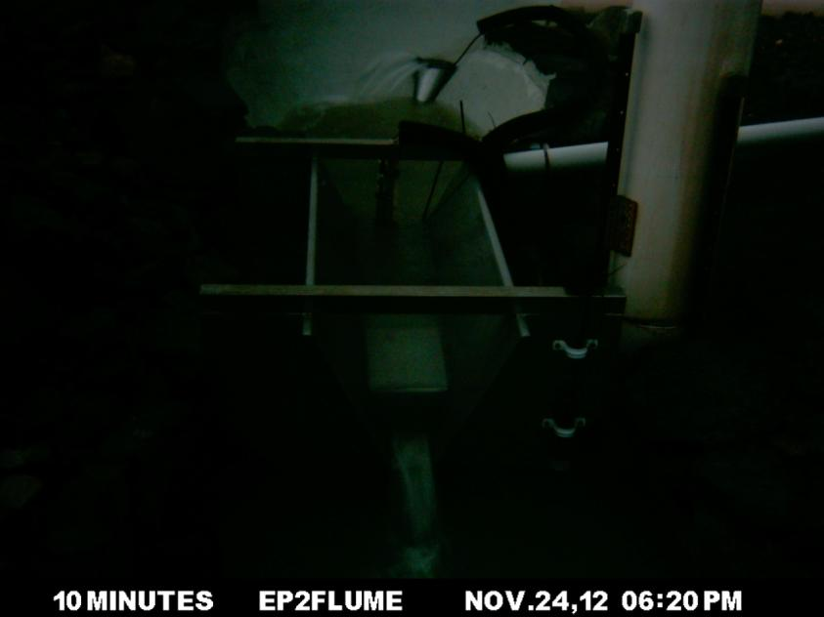

**Figure 10** Flow through TLF2 flume at 6:20 pm, Getting much darker and the water is still deflecting off the cage (yellow arrow) but is not rising up as high on the outside of the basin (red arrow).

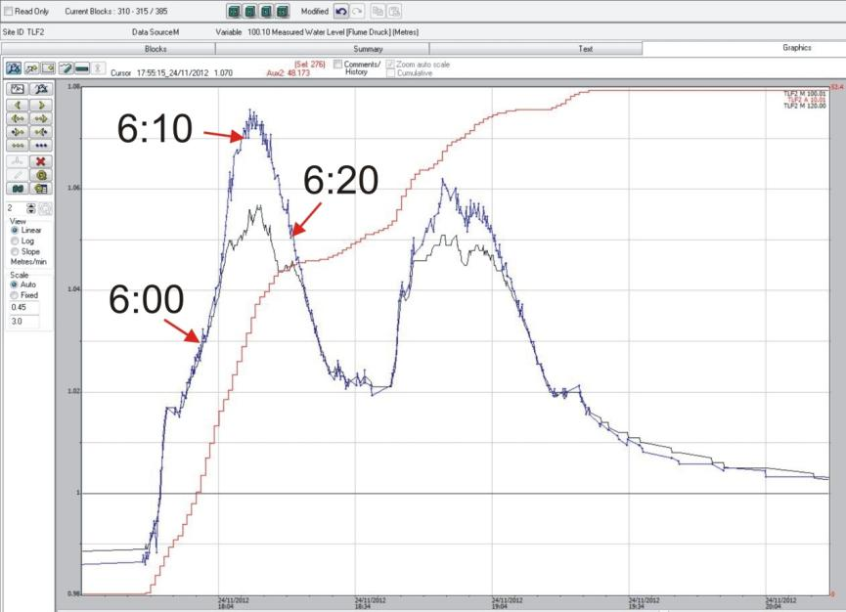

**Figure 11** Example of the difference in water level between the stage trace and pressure transducer at higher runoff flows. The blue line (higher peaks) is the EP2 pressure transducer and black line is the shaft encoder. The red line is the cumulative rainfall for the event.

The EP2 stage traces (on the same datum) from the shaft encoder and the pressure transducer for the event on 24 November 2012 are shown in Figure 11. The times of the photos in Figures 7 to 10 are shown on the stage traces in Figure 11. At 6:10 pm the stage trace for the pressure transducer is clearly above the stage trace of the shaft encoder. At this time Figure 9 also shows the most disturbance in the stilling basin and through the flume. The photos and stage traces show that at higher flows the water flow through the flume is not uniform.

On EP2 water levels through the flume are disrupted at high flows by both the smaller size of the upstream stilling basin and the location of the stainless steel cage. Inspection of many events indicated that this problem appeared to occur only when water depths were greater than 1.045 m as recorded by the shaft encoder).

In Figure 11, at the peak of the event there is a difference of 22 mm between the shaft encoder and the pressure transducer.

# 3 Data correction methods

This Section describes methods applied to attain a complete and corrected data timeseries for the reporting period. Data from the EP2 site are automatically uploaded to a Hydstra database (a file-based time-series data management system used for storing hydrologic information). Occasional maintenance issues with the continuous monitoring system can result in data qualities issues such as gaps in the data record or inconsistencies in stage trace calibration. Also other known data quality issues described in the previous Section can cause either over- or under-estimation of the stage trace values. For these reasons, all data needed to be systematically checked and corrected on an event by event basis.

## 3.1 Rainfall

Rainfall data is collected from all 4 erosion plots by a tipping bucket rain gauge located just down slope of the plot boundary. Each rain gauge is cleaned and calibrated during each dry season. The location of the EP2 rain gauge in relation to the equipment shelter and flume is shown in Figure 12.

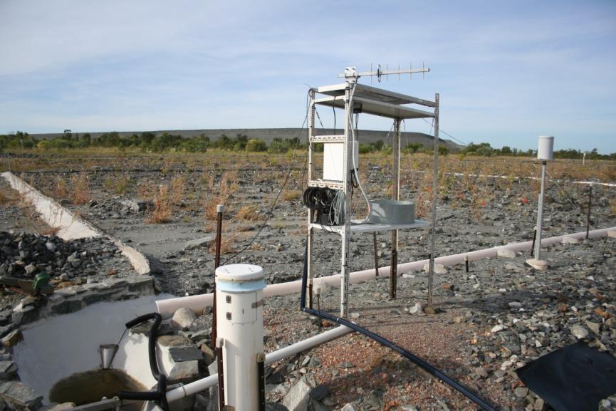

**Figure 12** Equipment shelter with the location of the rain gauge (yellow arrow) just downslope of the plot (5 May 2012).

The occasional gaps in the rainfall data record can result from system issues such as:

* a faulty data logger
* a faulty analogue channel of the logger
* logger memory is full
* the read switch on the rain gauge might have failed.

From 2009 to 2014 there were four periods when rainfall on EP2 was not recorded. These periods and how they were corrected for missing rainfall are summarised in Table 1. Corrections were made by direct infill from records taken from nearby alternative rain gauge sites with highly similar rainfall pattern.

**Table 1** Periods of missing rainfall record for EP2 for the five water years 2009–2010 to 2013–2014.

|  |  |  |  |  |  |  |
| --- | --- | --- | --- | --- | --- | --- |
| **Start Date** | **Start Time** | **Finish Date** | **Finish Time** | **Infill site** | **Infilled Rainfall (mm)** | **Reason for missing data** |
| 01/09/09 | 00:00 | 24/11/09 | 00:00 | ERA-TLF | 65.0 | Not instrumented until 20/9/09 |
| 24/02/10 | 21:55 | 25/2/10 | 16:06 | EP3 | 15.6 | Problem with a new logger code |
| 13/10/10 | 12:00 | 14/10/10 | 10:06 | EP1 | 3.2 | Unknown |
| 01/09/13 | 07:49 | 06/03/2014 | 15:10 | EP3 | 1496.0 | Faulty analogue channel in data logger |

The erosion plots on the trial landform were not instrumented until 19 November 2009, meaning that some early rainfall events were not recorded. However, ½-hourly rainfall was collected for the trial landform from 17 April 2009 by ERA. The ERA rain gauge (named TLFERA in Hydstra) is located closest to the rain gauge at EP2, a distance of approximately 50 m. A regression relationship was derived for the period 24 November 2009 to 3 January 2010 for coincident ½-hourly interval rainfall totals from TLFERA and EP2. This relationship was y = 0.9645x +0.0045 (R2 of 0.9849) (Figure 13). Based on this near 1:1 linear relationship, the 30-minute interval measurements from the TLFERA rain gauge were used as a direct infill for the EP2 missing data period, 1 September 2009 to 24 November 2009. For each water year that had missing rainfall data, regressions relationships were derived with the closest erosion plots that had reliable rainfall data (Table 2). In every case a near 1:1 linear relationship was evident with R2 values always greater than 0.987. This justified the decision to substitute the data gaps by direct infill from the closest rain gauge on the landform with reliable data. The in filled data has been assigned the Hydstra quality code 77, which signifies, Correlation with other station, same variable

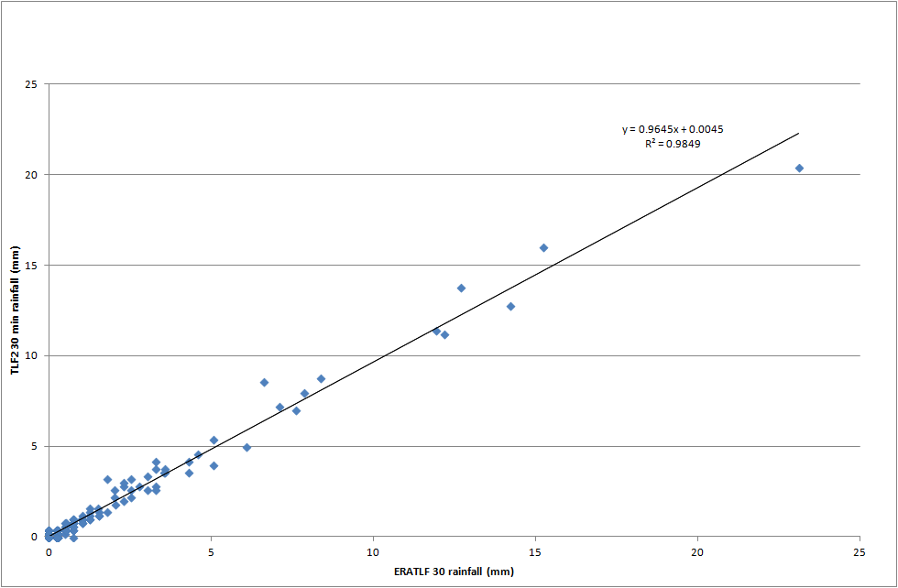

**Figure 13** Relationship between the TLFERA and Erosion Plot 2 for common ½ hourly interval rainfall on the trial landform (collected from 24-11-2009 to 3-01-2010).

**Table 2** Correlations between rainfall data on the trial landform taken from ½ hourly interval totals. A zero-intercept was not enforced in the regressions.

|  |  |  |  |
| --- | --- | --- | --- |
| **Water year** | **Sites** | **Equation** | **R2** |
| 2009-2010 | ERATLF vs. EP2 | Y = 0.9645x+0.0045 | 0.996 |
|  | EP3 vs. EP2 | Y = 1.0328x + 0.0006 | 0.992 |
| 2010-2011 | EP1 vs. EP2 | Y = 0.9982x + 0.0041 | 0.993 |
| 2013-2014 | EP3 vs. EP2 (Y) | Y = 1.0218x + 0.0004 | 0.998 |

## 3.2 Correcting the stage trace for offsite runon

As previously noted, an erosion breach of the EP2 boundary, occurred after a very large rain event on 22 February 2011. This breach caused additional flow (from offsite) onto EP2 during the latter half of this water year (2010-11). Excess runon events were detected and corrected by comparing the EP2 and EP1 stage traces against each other. This was done using Hydstra to overlay the coincident rainfall and runoff events for EP2 and EP1, respectively. From the 21 February 2011, there was a series of EP2 runoff events where a clear second peak occurred. It is established that these second peaks at EP2 were due to offsite runon, because these peaks were not apparent for the same event series for EP1 (which had no plot boundary breach).

Runoff events were compared for all events from 21 February 2011 and where there is a difference they are listed in Table 3. There were 10 events (including the event that was the cause of the breach) where the runon onto EP2 impacted on the discharge hydrographs. There are also some multi-peak events on EP2 that have a substantially higher peak (2nd or subsequent peak) on EP2 compared to EP1, and it is considered that these events are also influenced by offsite runon.

**Table 3** Difference in stage traces between EP2 and EP1

|  |  |  |  |
| --- | --- | --- | --- |
| **Date** | **Start Time** | **Rainfall (mm)** | **Comment** |
| 21 February 2011 | 11:29 pm | 180 | Event that caused the breach, comparison with EP1 impacted by runon to EP1. Extremely large event. |
| 25 February 2011 | 3:20 pm | 36 | EP2 has much higher middle peak with longer duration compared to EP1 |
| 10 March 2011 | 5:30 pm | 12 | Second delayed peak on EP2 not present on EP1. Earlier event at 11:40 of 8.2 mm didn’t show a difference |
| 14 March 2011 | 7:29 pm | 19 | Second peak on EP2 higher than then the 1st peak. EP1 has the 1st peak higher than the second peak. |
| 15 March 2011 | 0:15 pm | 16 | Second peak on EP2 not present on EP1 |
| 15 March 2011 | 3:47 pm | 19 | Second peak much higher on EP2 than on EP1 |
| 27 March 2011 | 7:24 pm | 53 | Much higher middle peak on EP2 than on EP1 |
| 29 March 2011 | 6:00 pm | 39 | 1 continuous event on EP2, 2 events on EP1, Second peak on EP2 higher than the second event on EP1 |
| 2 April 2011 | 11:49 pm | 29 | Much higher peak on EP2 |
| 5 April 2011 | 4:19 pm | 19 | Second peak much higher on EP2 than on EP1 |

The EP2 stage trace was manually adjusted to remove the influence of the offsite runon for each event where offsite runon was detected. This was done using the ‘draw’ mode of the Hydstra Data Managers Workbench, which allows a freehand change to the stage trace. The Cease to Flow (CTF) reference line for the shaft-encoder is 1.027m for EP1 and is 1.000 m for EP2. With these different CTF levels it was possible to display the stage traces on the same Hydstra plot and differentiate between them, with the EP1 stage trace at a higher level than the stage trace for EP2. This provided a method to make a relative comparison of EP1 and EP2 stage traces from which the editor could effectively judge the manual correction of the EP2 stage trace, by eye. A detailed example of the process to detect and correct runon events is provided for the event occurring on 10 March 2010, below. Other corrected events are listed in Appendix 1. The removal of the additional water from the hydrographs due to the breach along the top boundary will give more accurate discharges when the ratings tables are used to convert the stage to a discharge.

Event stage traces continued to be compared for EP1 and EP2 for the early 2011–2012 water year, after repairs to the EP2 boundary had been completed. It was determined that the repair of the top boundary during 2011 had stopped additional (offsite) surface flow onto EP2, as the shapes of the stage traces from both plots were very similar.

### 3.2.1 Event - 10 March 2011

A small rainfall event of 12 mm which produced a second peak on the stage trace on EP2 is shown in Figure 14. The second peak on EP2 stage trace needed to be removed (Figure 15). The rationale for removing the second peak was because it was not represented on the stage trace for EP1 and was not associated with an increase in rainfall over the period.

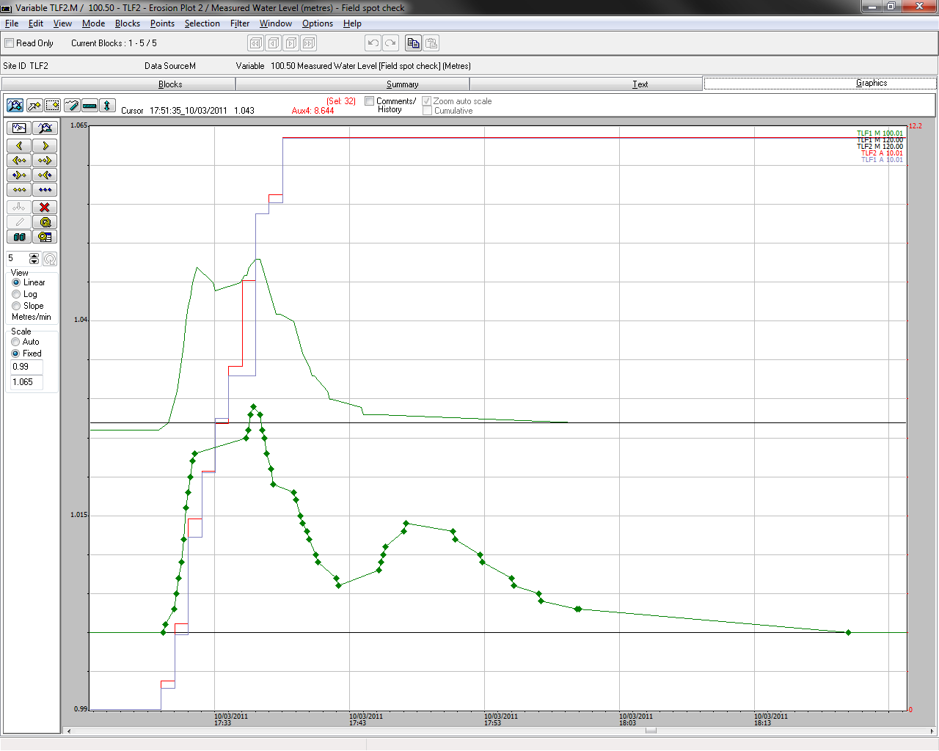

**Figure 14** Green dotted line is the stage trace for EP2 and the green line above is stage trace for EP1. The black horizontal lines are CTF’s for EP1 and EP2. Red vertical line is rainfall for EP2 and blue vertical line is rainfall for EP1.

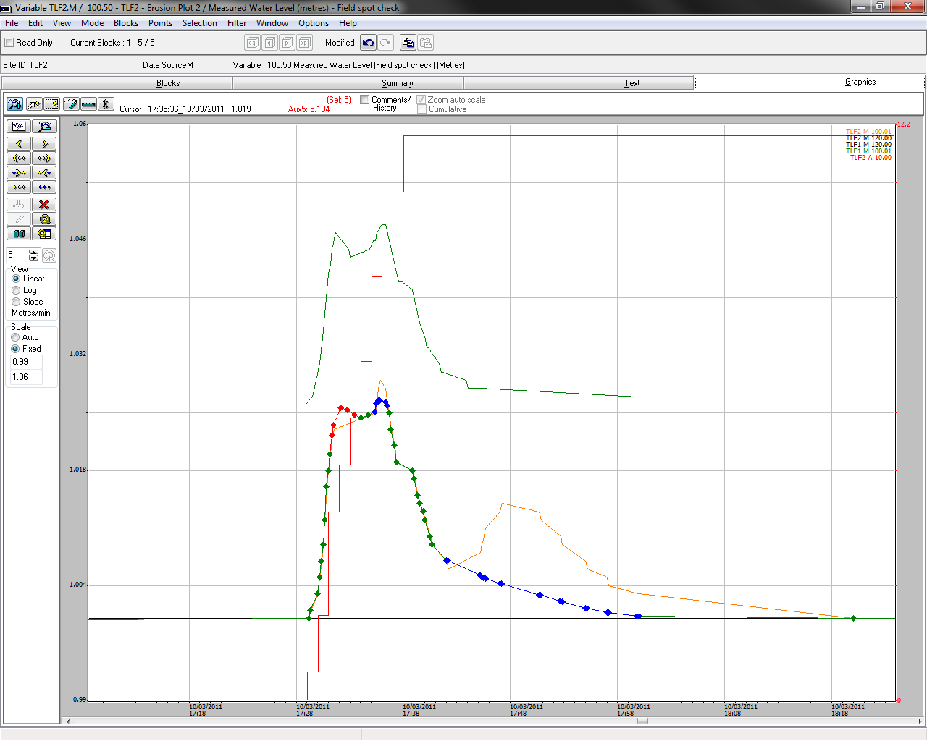

**Figure 15** The blue and red dotted line shows the correction that has been made to the stage trace for EP2. The orange line is the original stage trace. The colours of the other lines are the same as Figure 14.

Photographs of runoff through flumes EP1 and EP2 were taken for the small rainfall event on 10 March 2011. On EP1 four images from 5:30 pm to 6:00 pm on 10 March 2011 capture this runoff event (Figure 16). Runoff flow is clearly shown at 5:30 pm but is reduced to only a trickle by 5:40 pm and then only drips by 5:50 pm. By 6:00 pm there is no apparent flow through the flume. On EP2 there are four images that capture the same event by showing runoff through the flume (Figure 17). Runoff is clearly shown at 5:30 pm and has reduced by 5:40 pm., however flow has increased again on the 5:50 pm and this did not happen on EP1 at the same time (Figure 16). Runoff is shown to have reduced substantially by 6:00 pm on EP2.

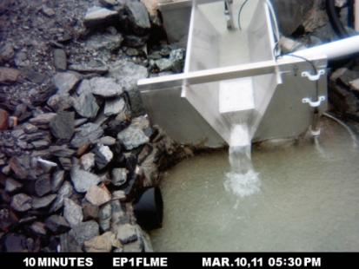 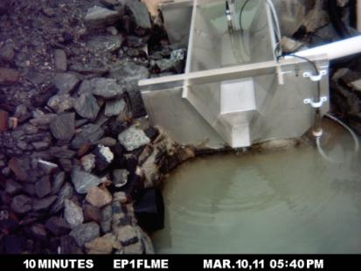

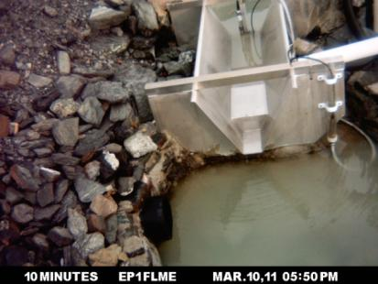 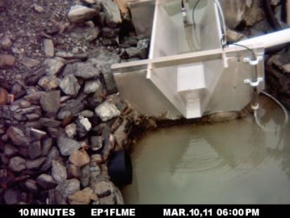

**Figure 16** Runoff from EP1 for the event 10 March 2011.

The increase of water flow through the flume on EP2 at 5:50 pm is evidence of surface water flowing onto the plot through the top boundary. This runon took additional time to flow down across the plot and is seen on the photos as water flowing through the flume, without any accompanying rain (Figure 17).

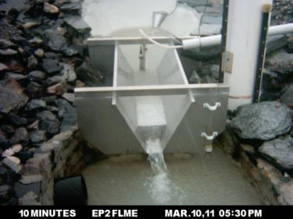 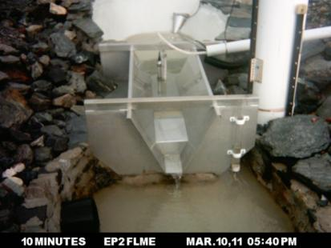

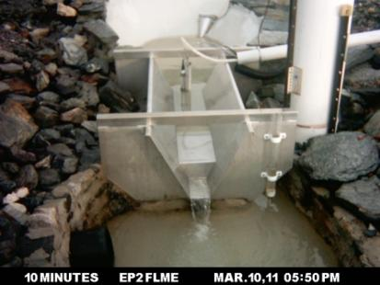 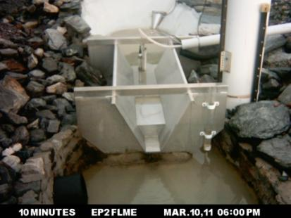

**Figure 17** Runoff from EP2 for the event 10 March 2011.

When investigating the rainfall events after 22 February 2011 on EP2, there appears to be a rain threshold, above which there is runon on to the plots. When the rainfall event was greater than 10 mm in total then runon to the plots occurred. This happened on nine occasions after the initial breach on 21 February 2010.

## 3.3 Correcting the shaft encoder stage trace for high runoff events

Initial comparisons of the EP2 stage trace suggested that most ‘high-flow’ discrepancies in water level occurred at levels above 1.085 m or 85 mm above the crest of the flume. However, it became apparent that the difference between water level sensors could occur when water level was greater than 1.045 m or 45 mm above the crest of the flume. It was therefore deemed that all events greater than 40mm above the crest of the flume be inspected and adjusted, where necessary, for the ‘high-flow’ data quality issue (i.e. all events that are ≥ 1.040 on EP2 shaft-encoder).

The Hydstra HYEXTREM function was used to identify events that had a water level greater or equal to 40 mm above the flume crest. HYEXTREM provides a report of data records which fall within or outside a specified range. In this case it was used to generate a report where the shaft encoder trace exceeded or was equal to 1.040 m. Parameters used to generate the HYEXTREM report are contained in Appendix 2. The HYEXTREM report sometimes generates multiple records for the same continuous runoff event (e.g. when there are multiple flow peaks > 1.04 for the same event). For reporting purposes these instances have been grouped together by each continuous flow event.

There were 43 events that had a shaft-encoder peak greater than 1.040. Comparisons of each event were made using the shaft-encoder and pressure transducer data aligned to the same datum. The events have been numbered in order of occurrences and are grouped by water year. Selected events are reported in the following text and the remainder are compiled in Appendix 3.

### 3.3.1 2009–2010 water year

The 2009-2010 water year was the first water year that the erosion plots on the trial landform were monitored. There were 4 events (1 to 4) with a stage trace greater than 1.040 m. Event 1 occurred on 23 January 2010 and is shown in Figure 18.

##### Event 1 - 23 January 2010

Rain started at 4:19 pm and continued for 51 mins during which 60 mm of rain fell. During this event the largest flow peak is higher on the pressure transducer than the shaft-encoder. For the large peak the stage height of the pressure transducer is on average 14 mm higher than the shaft-encoder. The pressure transducer trace was used to correct the higher part of the shaft-encoder stage trace.

During the 2009-2010 water year no time-lapse cameras were installed to monitor water flow characteristics in the stilling basin.

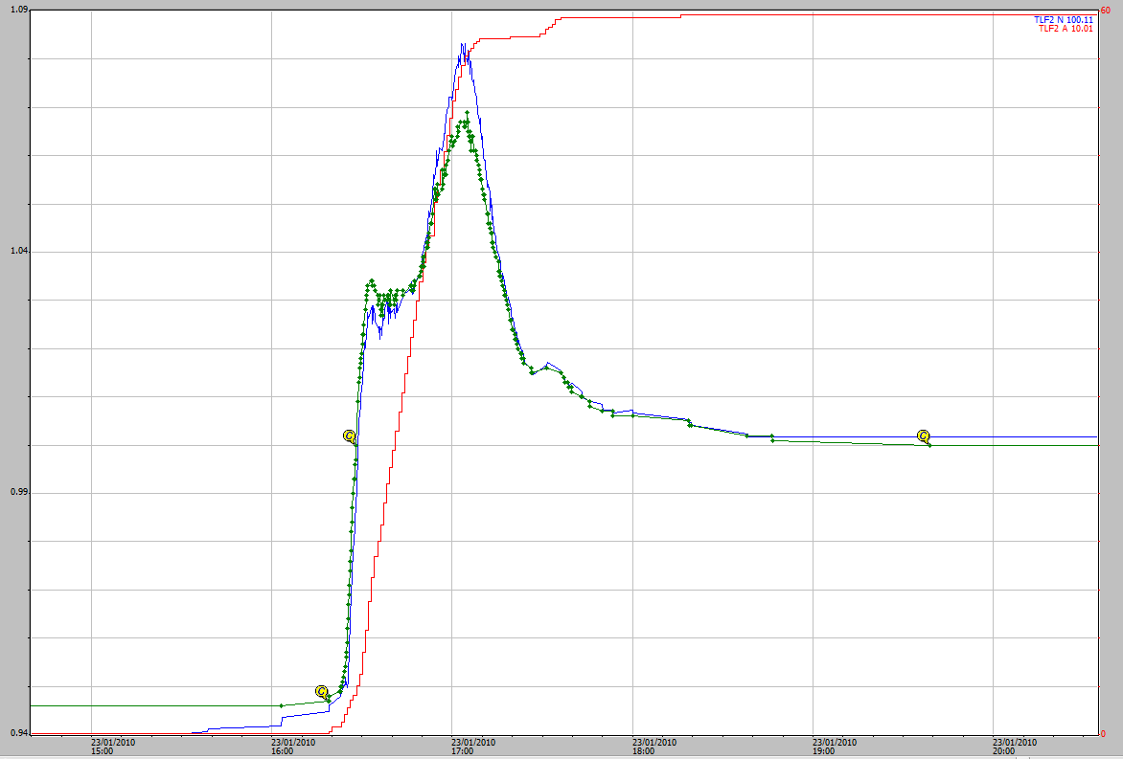

**Figure 18** Event 1 – 23 January 2010, the pressure transducer (blue) aligned with the shaft encoder (green). Cumulative rain is shown in red. Stage height (m) is shown on the left y axis and rainfall (mm) is shown on the right y axis.

### 3.3.2 2010–2011 water year

During the 2010–2011 water year there were 5 runoff events (5 to 9) when the peak shaft encoder height was greater than 1.040 m. Two of these events were captured by time-lapse cameras installed to record runoff over the flume during daylight hours. One of these, Event 6, is illustrated by hydrograph and photos Figures 19 to 23 and runoff flow began at 5:00 pm on February 13 2011. Rain started at 5:21 pm and continued for 51 minutes during which 52 mm of rain fell. The largest runoff event (recorded during the five years of measurements) happened in this water year and is also described as Event 8, below (Figures 23). The other runoff events are shown in Appendix 3.

##### Event 6 – 13 February 2011 at 5:00 pm

Rain started at 5:21 pm until 6:12 (51 mins) during which 52 mm of rain fell.

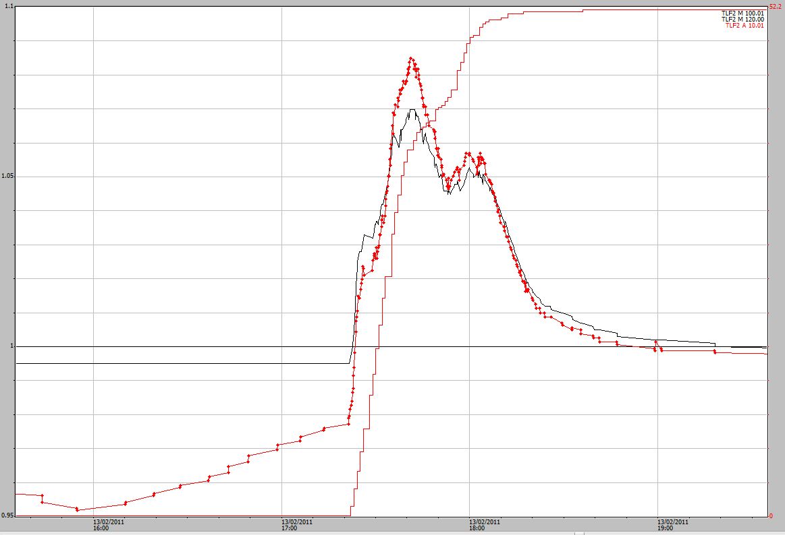

**Figure 19** Event 6 runoff hydrograph on 13 February 2011 the pressure transducer (red line with dots) is higher than the shaft-encoder (black). The pressure transducer has been aligned to the same datum as the shaft-encoder by adding 0.789 m. Cumulative rain is shown as the rising red line. Stage height (m) is shown on the left y-axis and rainfall (mm) is shown on the right y-axis.

Event 6 shows a difference between the shaft encoder and the pressure transducer with the pressure transducer 15mm higher than the shaft encoder. Photos in figures 20 to 23 show flow through the flume at 10 minute intervals. The image at 5:40 pm (Figure 21) shows the initial disturbance in the upstream stilling basin. The pressure transducer trace was used to correct the higher part of the shaft encoder stage trace after aligning it to the same datum as the 1º shaft-encoder.

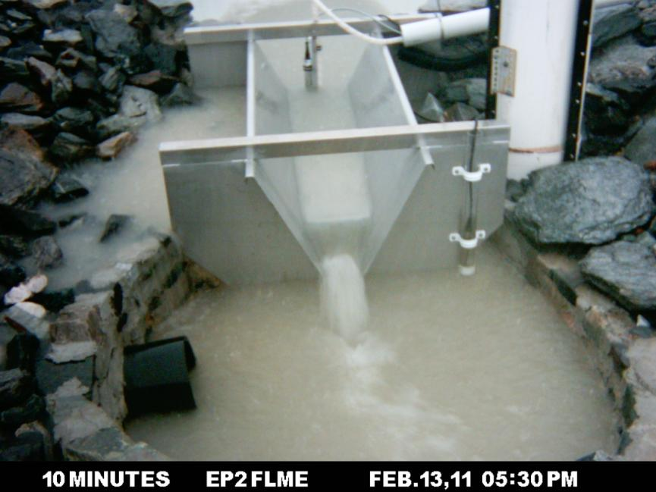

**Figure 20** Water through EP2 flume at 5:30 pm on 13 February 2011.

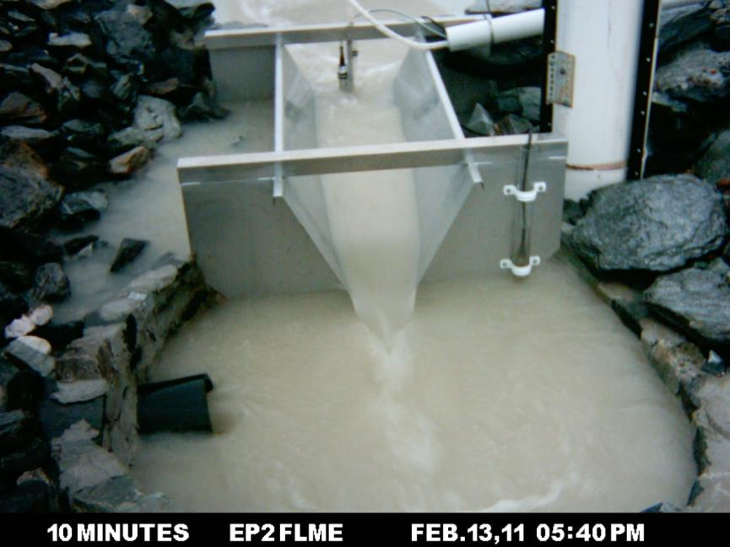

**Figure 21** Water through EP2 flume at 5:40 pm on 13 February 2011. Although a poor field of view the disturbance in the upstream stilling basin can just be seen at the top of the image (red arrow) and the uneven flow through the flume is shown by the yellow arrow.

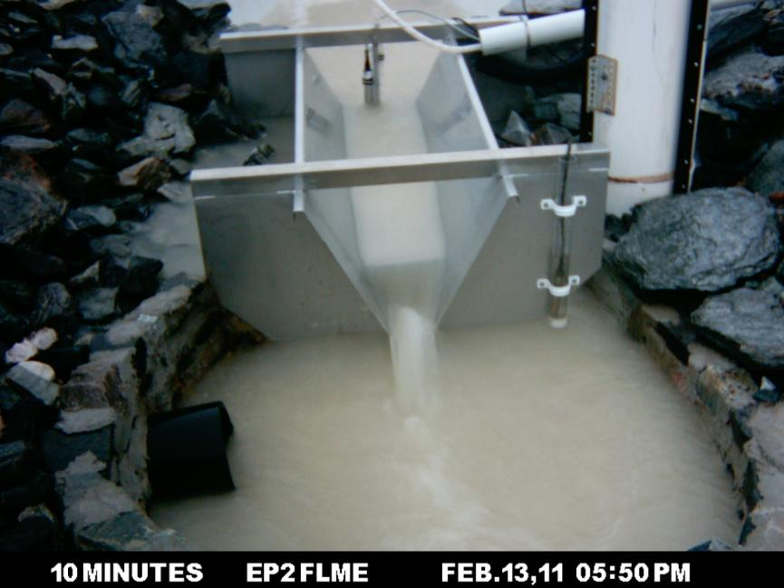

**Figure 22** Water through EP2 flume at 5:50 pm on 13 February 2011.

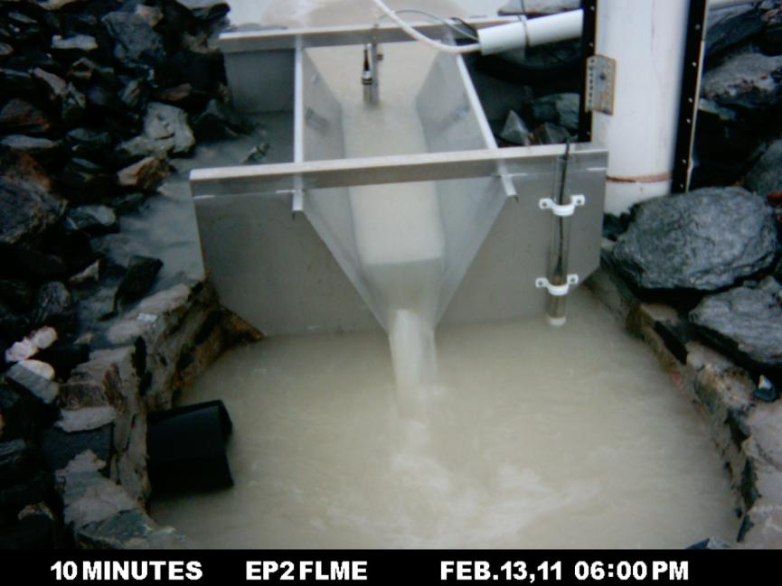

**Figure 23** Water through EP2 flume at 5:50 pm on 13 February 2011.

##### Event 8 – 21 February 2011

The largest runoff episode, Event 8, occurred on 21 February. Rain started at 11:30 pm and continued for 2 hours during which 180 mm of rain fell (Figure 24). The main rainfall was 167mm in about two hours (a rainfall intensity of 80 mm per hour). It is suspected that there was an issue with the accurate measurement of water level over the flume by both the stage trace and pressure transducer, due to the exceptionally high and uneven water flows through the flume. It is also thought that the structural breach in top boundary of the erosion plot happened during this event, further complicating the exact measurement of actual runoff volume from EP2. Therefore, in this case, it is impossible to know the exact stage trace and runoff generated for the EP2 catchment area, given the large volume of water that was generated and the breach of the plots boundary. While the pressure transducer is higher and should be substituted for the shaft-encoder, this measurement will still be an under-estimation given the uneven flow levels through the flume. Although the additional off-site flow onto the plot may have ‘compensated’ for the under-estimated runoff through the flume the actual discharge from rainfall falling on the plot site cannot be determined.

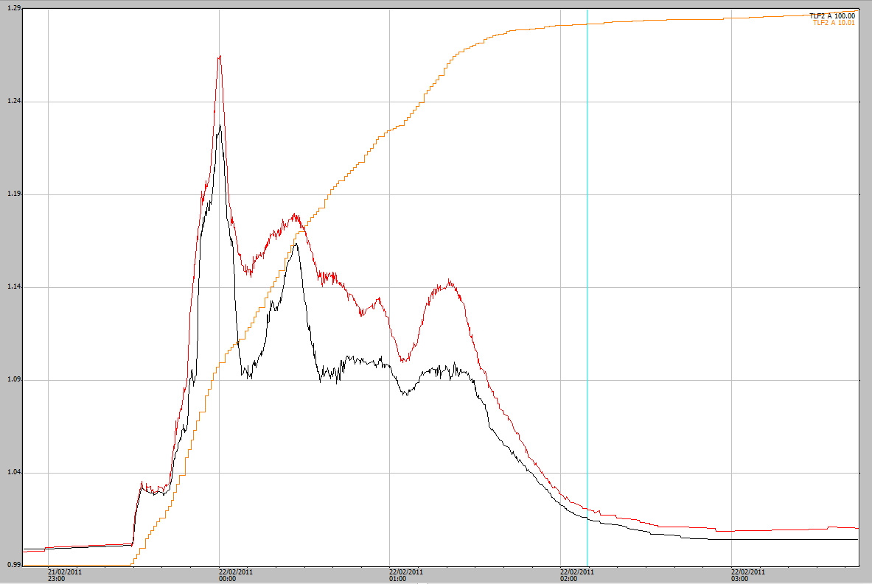**Figure 24** Event 8 hydrograph. The black is the shaft encoder and the red is the pressure transducer. 0.789m has been added to the pressure transducer. The start of the event has been aligned to the same datum. Orange is the cumulative rainfall. Stage height (m) is shown on the left-y axis.

The possibility of the flume crest being ‘drowned out’ during larger events has been discussed by the authors. This might occur when the capacity of the downstream stilling basin and the drain pipe from the basin are exceeded and water cannot get away. This would result in a relatively flat stage trace for a period of time as the water level was constant or slowly rising. The stage trace for the largest event does not appear to have these periods of steady flow. This pattern (prolonged periods of steady flow) were not evident in the stage trace for the largest event so it doesn’t look like the flume was back-water effected even during the largest event of the 5-water year period. It is unlikely that the flume has been drowned out for any of the other events.

### 3.3.3 2011–2012 water year

The 2011–2012 water year had 6 events (10 – 15) when the shaft encoder stage trace was greater than 1.040 m. The largest, Event 11, occurred on 3 December 2011 and is shown in Figure 25. Rain started at 4:18 pm and continued for 50 minutes during which 82 mm of rain fell. Other events are shown in Appendix 3. Note that from the 18th of December 2011 the pressure transducer stopped recording meaningful data and was not replaced until May 2012.

##### Event 11- 3 December 2011

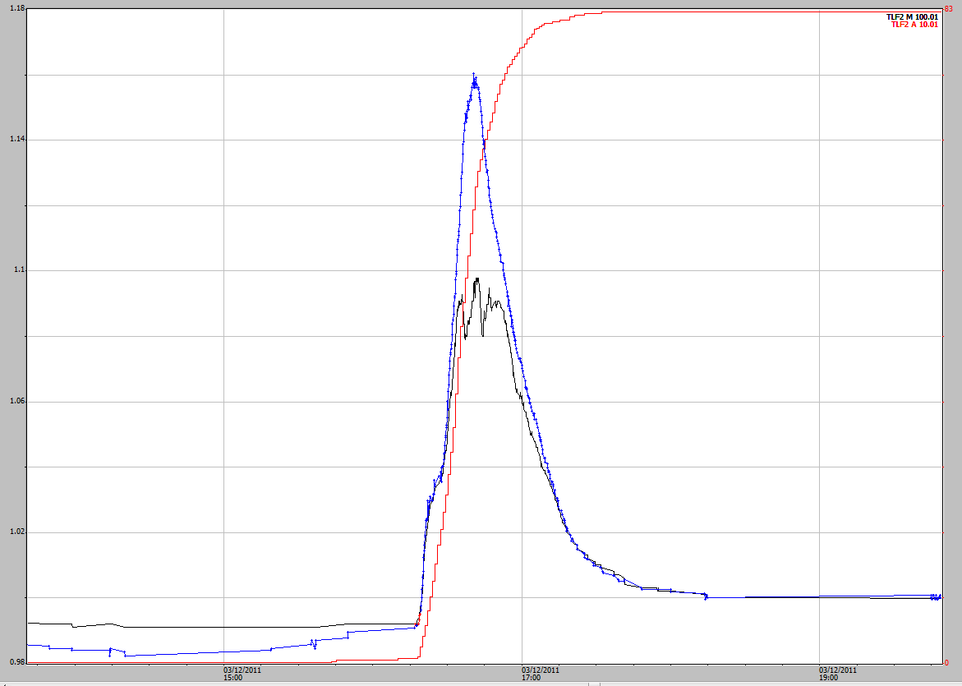

**Figure 25** Event 11, the black is the shaft encoder and the blue is the pressure transducer. The pressure transducer trace has been raised by 0.807m to align it to the same datum as measured by the shaft encoder. Cumulative rainfall is indicated in mm by the red line. Stage height (m) is shown on the left y-axis and rainfall (mm) is shown on the right y-axis.

At the peak of the event the pressure transducer was higher than the shaft encoder for this event with a difference of 22 mm. The image at 4:40 pm of this event (Figure 26) showed flow over the flume and into the lower stilling basin, the upstream stilling basin can not been seen nor the flow through the flume. This was a large event of 82 mm in just under an hour and the pressure transducer should be used to correct the shaft encoder above 1.040m.

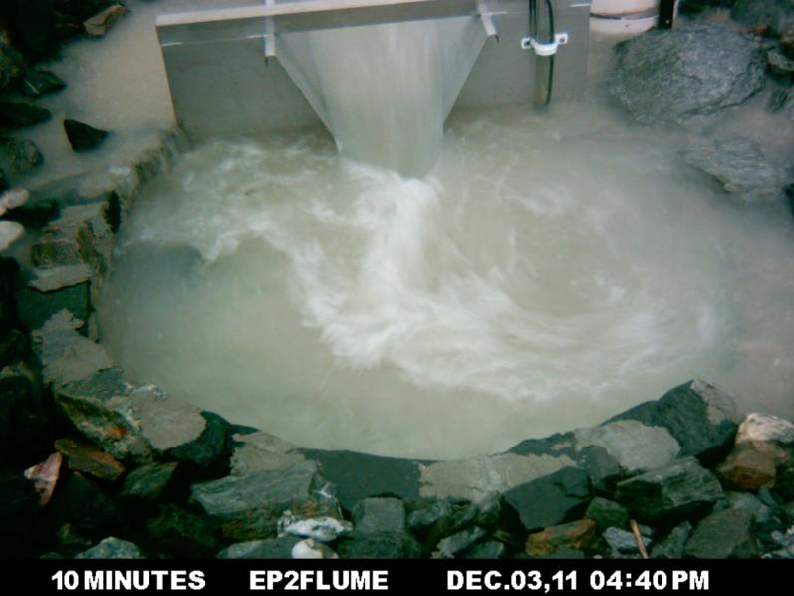

**Figure 26** Flow through the flume on EP2 at 4:40 pm (time of the highest flow). The upstream basin cannot be seen in the image.

### 3.3.4 2012–2013 water year

The 2012–2013 water year had 12 events (events 16 to 27) where the shaft encoder recorded heights over the flume greater than 1.040m. Event 20 on the 15th of December 2012 is shown in Figure 27. Rain started at 4:34 pm and continued for 24 mins during which 29 mm of rain fell. This was a short but intense rainfall event with the pressure transducer data higher than the shaft encoder data. The pressure transducer data should be added to the shaft encoder peak. The other events are shown in Appendix 3.

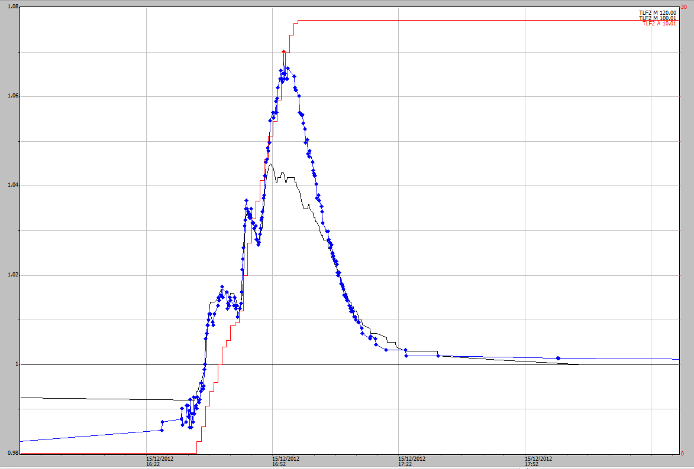

**Figure 27** Event 20 hydrograph from 15 December 2012. The black line is the shaft encoder and the blue line is the pressure transducer that has been aligned to the same datum. Cumulative rainfall is indicated by the red line. Stage height (m) is shown on the left y-axis and rainfall (mm) is shown on the right y-axis.

### 3.3.5 2013–2014 water year

During the 2013–2014 water year there were 16 events (events 28 to 43) that exceeded the 1.040 reading in the shaft encoder. Over this period the pressure transducer did not always produce reliable data. Consequently, there are instances when the stage trace recession period was not recorded by the pressure transducer until well after the shaft encoder had already recorded its recession. In these instances the shape of the shaft encoder was estimated based on information and observations obtained in previous water years.

##### Event 30 – 5 December 2013

Event 30 as shown in Figure 28 occurred on the 5th December 2013 and is one of the events where the pressure transducer measurement was reliable. This was a reasonably large event of 70 mm. Rain started at 4:10 pm and 56 mm of rain fell in just 1 hour 17 minutes. An additional 14 mm of rain fell in the following 90 minutes, mainly as drizzle. At the peak of this event the pressure transducer was higher than the shaft encoder with a difference of 20 mm. The pressure transducer was used to correct the shaft encoder above 1.040m. The other events with peak heights greater than 1.040 are shown in Appendix 3.

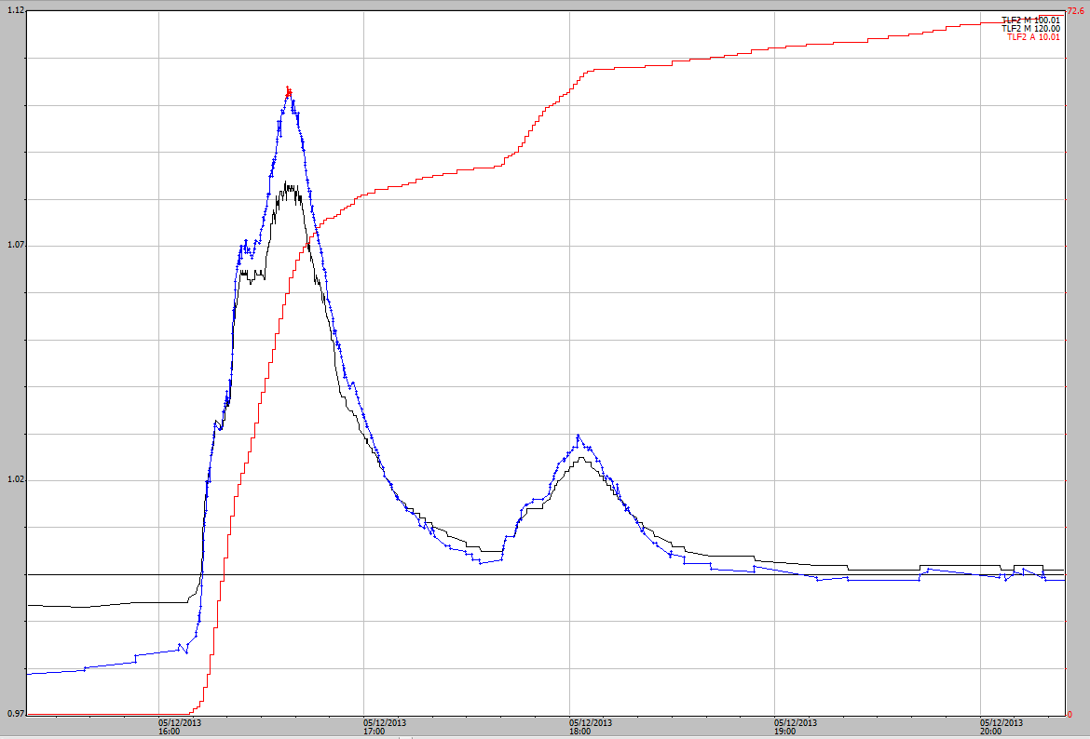

**Figure 28** Event 30, the black is the shaft-encoder and the blue (higher peak) is the pressure transducer. Stage height (m) is shown on the left y-axis and rainfall (mm) is shown on the right y-axis.

## 3.4 General methods for correcting the shaft encoder stage trace

In each water year, a large number of points on the stage trace were added, deleted or had their value changed, including:

* Start of runoff events,
* Finish of runoff events
* Start of upstream basin fill events.

In each case when a change was made a comment describing the change, including who and when the change was made, was registered in the edited version of the data file in Hydstra. This resulted in a series of discrete runoff events for each of the water years (usually > 100 per season).

Initially, each individual (or series of) runoff event(s) were adjusted by-eye to align the beginning and end of each event to the CTF reference line. This was done by simple addition or subtraction of a constant. The applied constant was specific to the event or event series and therefore could vary between events (or series of events). In many cases entire events were raised or lowered by 1 or 2 mm to better represent the actual duration of the events and the beginning and end of the each event in relation to the CTF reference line. It is thought that temperature might impact on the height information. Also water tension in the basin could cause some drift of ± 1 mm from an initial calibrated zero.

Subsequent, fine-scale, changes to values of individual or multiple points were made where necessary. This section describes a number or miscellaneous issues requiring particular adjustments. In each instance where a change is made a comment is tied to the single or first point in the Hydstra data series from which the edit were made. These comments are all stored in Hydstra.

### 3.4.1 Shaft encoder roll over.

In 2009 there were initial problems with ‘rolling back’ of the shaft-encoder data when the values recorded were below zero. For example, when the shaft-encoder recorded below zero it recorded a value of 65.535 instead of recording -0.001. To correctly align the stage trace, 65.535 needed to be subtracted from the affected points in Hydstra. To reduce the occurrences of this problem the CTF reference was adjusted to 1.000 on EP2.

### 3.4.2 Recession events.

Runoff over the flume usually stopped within 45 to 60 mins from the cessation of rain as determined from observation of stage traces for multiple runoff events and including images obtained from the in situ cameras. However, in some instances it took an excessive period for water level to drop down by 1mm during the final recessional period. The occasional delays to register 1 mm drop-downs may be because of water surface tension in the basins. A consequence of drop down recording lags was that the duration of continuous flow and discharge for the event was overestimated. Therefore, in order to correct for the longer recessional periods, a data point was either inserted for an appropriate time on the CTF reference line; or an existing point had its value lowered by 0.001 to identify the end of the runoff.

### 3.4.3 Infilling missing data

During the five water years, 2009–2010 to 2014–2015, there were 8 periods where stage trace data were not recorded by the shaft encoder on EP2. If pressure transducer data of acceptable quality existed a direct infill was performed to correct the gap in the stage trace dataset. These infill’s were done using edit tools of the Hydstra® Data Managers Work bench and usually involved two steps. Firstly, the pressure transducer data for the missing event had to be aligned to the same stage height datum as the shaft encoder. This was done by adding or subtracting a constant from the 2º data event series so that records for the beginning and end of the flow event aligned with the CTF reference line for the shaft encoder. Then the pressure transducer data series for data gap were spliced into the data gap of the shaft encoder. This could be done in a number of ways, usually by using the “copy reference trace” option of the Workbench edit menu. In some instances there was no data recorded by either stage height sensors on EP2. In most of these cases data were infilled from the nearest reliable data once the correlations had been undertaken. The periods of missing shaft-encoder data on EP2 and the method of infill are shown in Table 4. In a small number of instances missing data was not infilled because of the small size of the rainfall or the time in the dry season when there would have been minimal runoff (e.g. September or November).

**Table 4** Periods of missing record on EP2 and how it has been infilled. Note PT = pressure transducer data for EP2.

|  |  |  |  |  |  |  |
| --- | --- | --- | --- | --- | --- | --- |
| **Date and time from** | **Date and time to** | **Duration (decimal days)** | **Total rain in period (mm)** | **No. of events** | **Infill type** | **Comments** |
| 19-11-2009 12:13 | 21-12-2009 17:15 | 32.2 | 426 | 38 | EP2 PT | Infilled by direct substitution using data from same plot. |
| 24-02-2010 23:59 | 25-02-2010 16:05 | 0.7 | 16 | 3 | EP3 shaft encoder | Infilled by direct substitution |
| 13-10-2010 00:00 | 14-10-2010 00:00 | 1.0 | 3 | 1 | None | Not infilled as 1 small events during the late dry season with only 3 mm of rainfall not much runoff |
| 13-10-2011 9:06 | 18-10-2011 8:53 | 5.0 | 4 | 1 | EP2 PT | Infilled by direct substitution using data from same plot. |
| 28-11-12 14:48 | 29-11-12 9:52 | 0.8 | 28 | 1 | EP2 PT | Infilled by direct substitution using data from same plot. |
| 16-04-2013 00:00 | 07-05-2013 01:02 | 21.0 | 3 | 1 | None | N/A – Given the amount of rainfall it was decided not to infill TLF2 stage trace |
| 01-09-2013 00:00 | 02-10-2013 00:00 | 31.0 | 15 | 2 | None | N/A – Given the amount of rainfall it was decided not to infill TLF2 stage trace |
| 13-02-2014 11:10 | 20-02-2014 9:50 | 6.9 | 192 | 11 | TLF 1 Shaft Encoder | Regression equation used.  YTLF2= 1.6*XTLF1 + 0.001. |

During the 2013-2014 water year there was a period of seven days on EP2 during which 192 mm of rainfall fell where neither stage trace or pressure transducer height data were recorded. In this case an infill was applied using a correlation function derived using with data from the neighbouring site, EP1. The regression correlation was completed in Hydstra using a HYPLOTXY which plots one data variable (height from one plot) against another for a given period of time. Common periods of data from the 2013–2014 water year for EP1 and EP2 were compared using HYPLOTXY (Figure 29) This comparison gave a regression equation of YTLF2= 1.6*XTLF1 + 0.001 (where TLF2 =EP2 and TLF1 = EP1) and a correlation coefficient of 0.814. This regression equation was used to infill the missing data for the 7 day period.

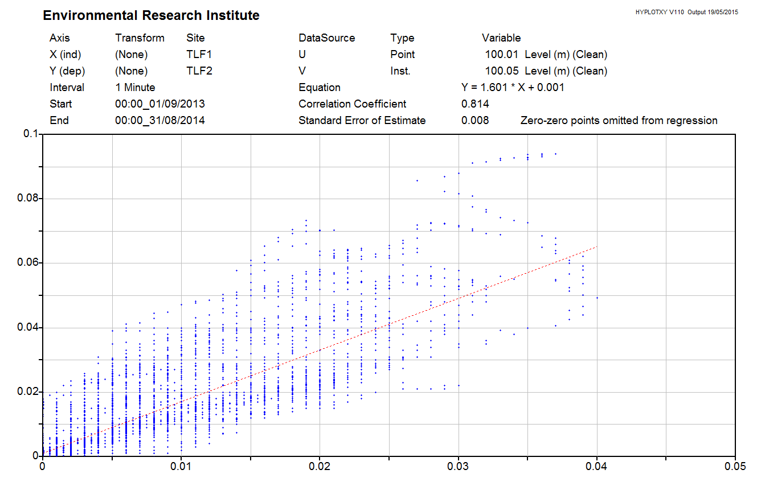

**Figure 29** Output from Hydstra HYPLOTXY for common data on EP1 and EP1 during the 2013–2014 water year. TLF1 is EP1 and TLF2 is EP2.

# 4 Data correction results

## 4.1 Rainfall

On EP2 there were four instances during the five water years where rainfall was not recorded (Table 1, above). These periods of missing data have been infilled and the corrected cumulative rainfall graph for each of the water years is shown in Figures 30 to 34. As stated in Section 1.0, a water year is defined as the period 1 September to 31 August the following year.

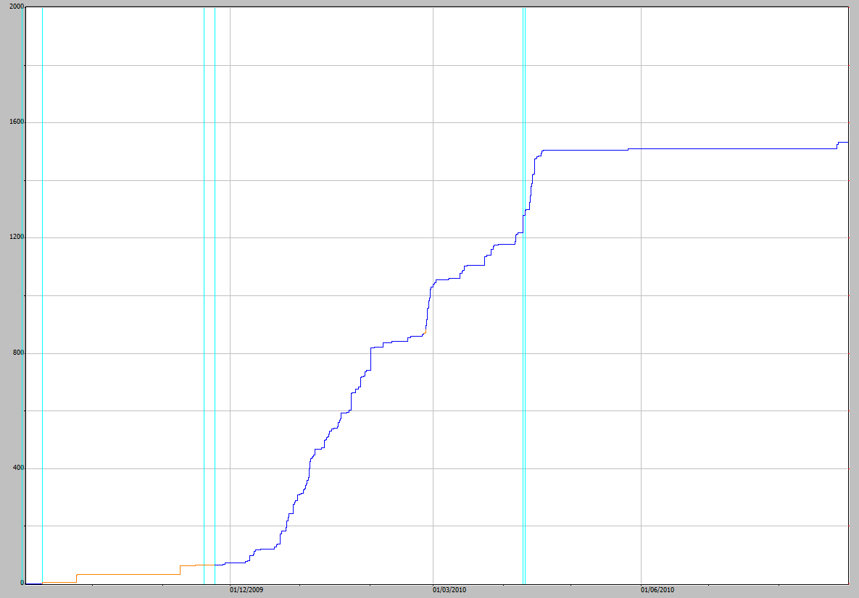

**Figure 30** Cumulative rainfall on EP2 for 2009–2010 water year. The orange part of the line has been infilled from TLFERA. Rainfall (mm) is shown on the y-axis.

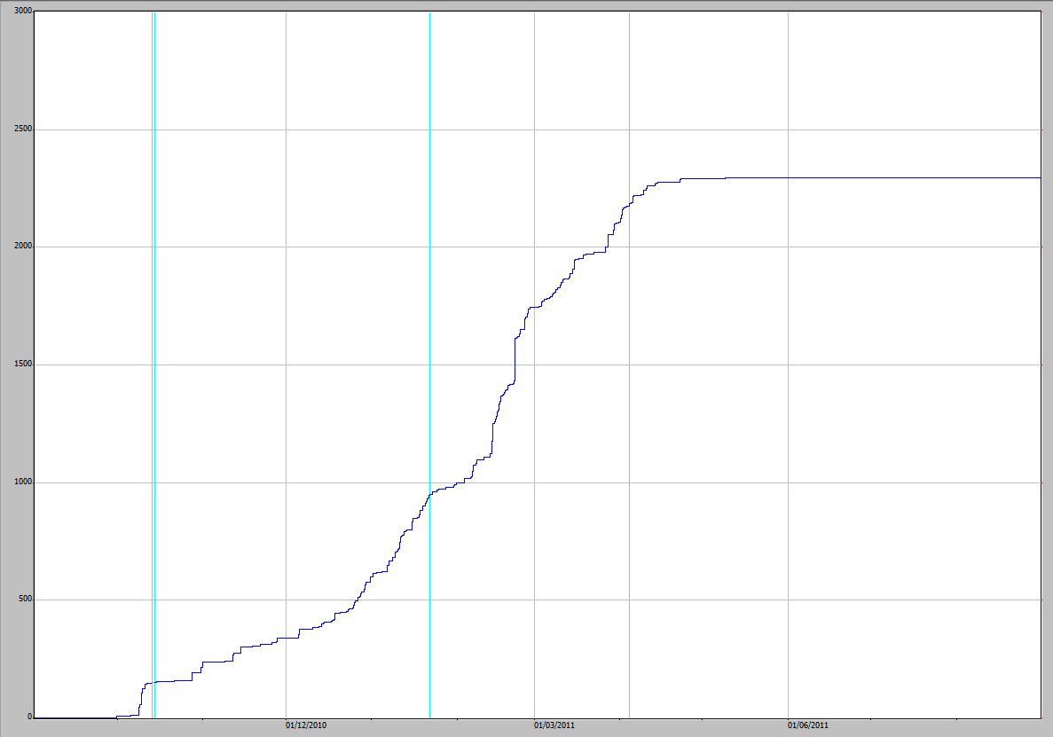

**Figure 31** Cumulative rainfall on EP2 for 2010–2011 water year. Rainfall (mm) is shown on the y-axis.

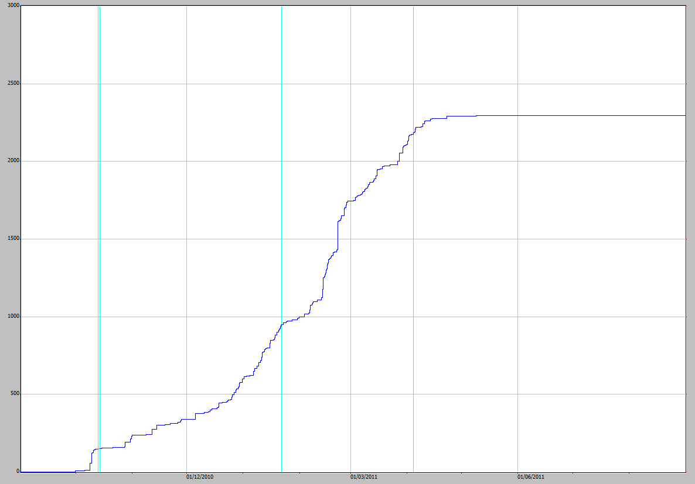

**Figure 32** Cumulative rainfall on EP2 for 2011–2012 water year. Rainfall (mm) is shown on the y-axis.

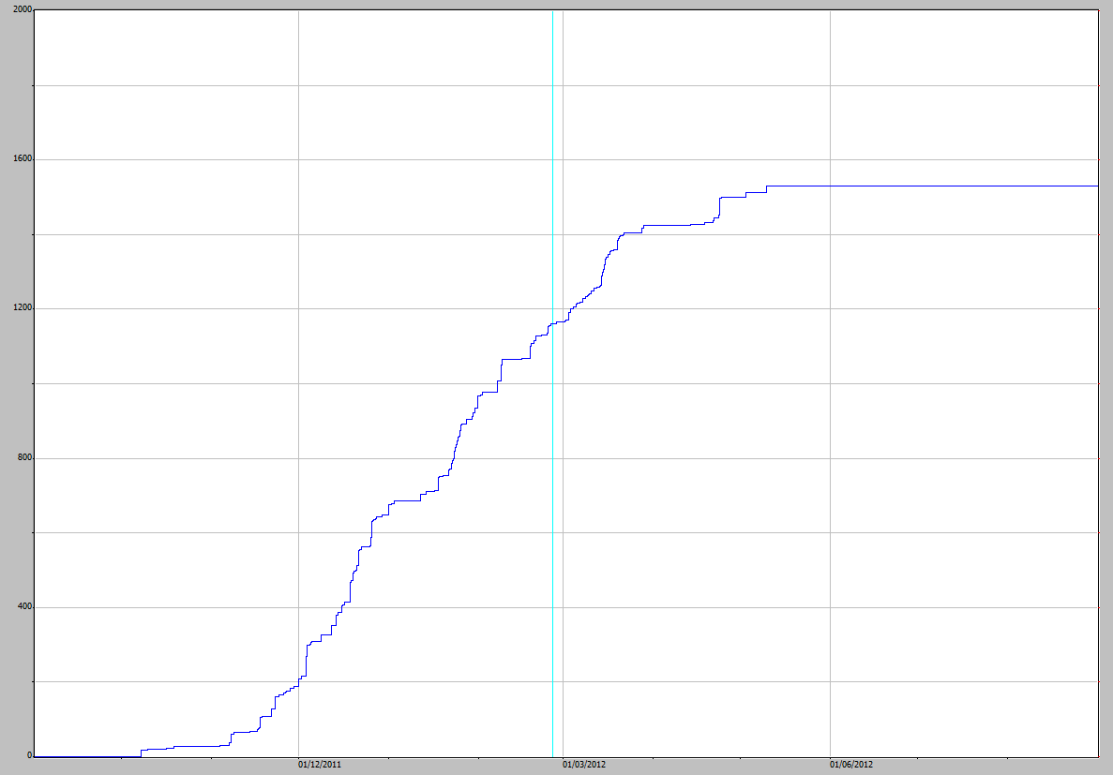

**Figure 33** Cumulative rainfall on EP2 for 2012–2013 water year. Rainfall (mm) is shown on the y-axis.

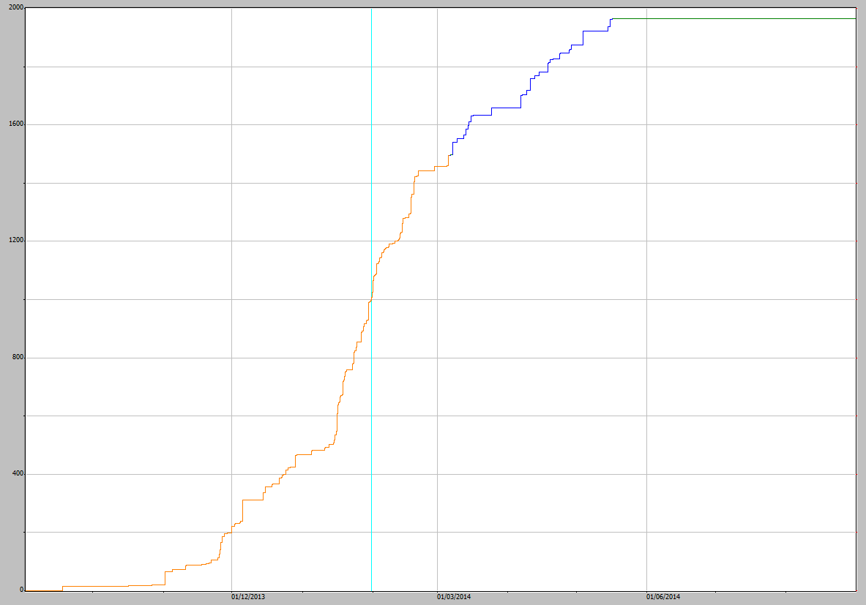

**Figure 34** Cumulative rainfall on EP2 for 2013–2014 water year. The orange section shows where EP2 rainfall data has been infilled with EP3 data. Rainfall (mm) is shown on the y-axis.

Mean annual rainfall at Jabiru Airport (Station No. 014198, located 2.3 km from the trial landform) is 1584 mm (Bureau of Meteorology 2014). The annual rainfall on EP2 is shown in Table 5. The 2010–11 water year was the highest during the five years with 2290 mm and was 44.6% higher than the mean annual rainfall at Jabiru Airport. The 2013–14 water year was above average, having the second highest rainfall for the five years. The annual rainfall for the 2012–13 water year on the trial landform was the lowest for the five years of study with 1274 mm (table 5) and was 19.6% lower than the mean annual rainfall at Jabiru airport.

**Table 5** Rainfall data for EP2 on the trial landform for the five water years.

|  |  |
| --- | --- |
| **Water year** | **Erosion Plot 2 Rainfall (mm)** |
| 2009–10 | 1531 |
| 2010–11 | 2290 |
| 2011–12 | 1531 |
| 2012–13 | 1274 |
| 2013-14 | 1962 |

## 4.2 Corrections to the shaft encoder stage trace for off-site runon

There were 9 events that had runon to the plot as a result of the boundary breach during the very large event on 22 February 2011. These 9 events were corrected as shown in Table 6 and are illustrated in Section 3.2 and Appendix 2.

**Table 6** Difference in stage traces between EP2 and EP1

|  |  |  |
| --- | --- | --- |
| **Date** | **Rainfall (mm)** | **Corrections made** |
| 25 February 2011 | 368 | The higher middle peak was lowered by estimation so that the traces had a similar path to those on EP1 |
| 10 March 2011 | 12 | Second peak removed and the recession of the peak smoothed. |
| 14 March 2011 | 19 | The second peak during this event was lowered by estimation. |
| 15 March 2011 | 16 | The second peak during this event was lowered by estimation. |
| 15 March 2011 | 19 | The second peak during this event was lowered by estimation so that the traces had a similar path to those on EP1 |
| 27 March 2011 | 53 | The much higher peak during this event was lowered by estimation so that the traces had a similar path to those on EP1 |
| 29 March 2011 | 39 | Using EP1 as a guide the single event on plot2 was made into 2 separate events and the second peak lowered by estimation so that the traces had a similar path |
| 2 April 2011 | 29 | The second peak during this event was lowered by estimation so that the traces had a similar path to those on EP1 |
| 5 April 2011 | 19 | The second peak during this event was lowered by estimation so that the traces had a similar path to those on EP1 |

The removal of the additional water from the hydrographs due to the breach along the top boundary will give more accurate discharges when the ratings tables are used to convert the stage to a discharge. These changes were all made using “line draw” in Hydstra to estimate the stage traces.

## 4.3 Corrections to the stage trace for high-runoff events

As described above the larger events caused uneven flow in the upstream basin and flume resulting in underestimated height values for the shaft encoder above heights of 1.040. Where possible the stage trace above 1.040 has been corrected for this error using the data from the pressure transducer. When there were flow events where there was no pressure transducer data available, experience from observations obtained when data was available were used to estimate and smooth the stage traces, by eye. The changes to the shaft encoder stage traces at the higher events and what correction method was used are shown in Table 7.

**Table 7** Corrections made to the shaft encoder data for events greater than 1.040 mm. PT is Pressure Transducer

| **Event No.** | **Start of event** | **SE Extreme** | **PT extreme** | **Difference** | **Correction Required** | **Correction Method** | **Notes** |
| --- | --- | --- | --- | --- | --- | --- | --- |
| 1 | 23/01/2010 | 1.069 | 1.084 | 0.015 | Yes | PT |  |
| 2 | 1/02/2010 | 1.045 | 1.048 | 0.003 | No | No Infill |  |
| 3 | 9/04/2010 | 1.05 | 1.053 | 0.003 | Yes | PT |  |
| 4 | 12/04/2010 | 1.042 | 1.044 | 0.002 | Yes | PT |  |
| 5 | 9/10/2010 | 1.055 |  |  | Yes | Estimated | No PT data |
| 7 | 13/02/2011 | 1.083 | 1.094 | 0.011 | Yes | PT |  |
| 6 | 13/02/2011 | 1.07 | 1.085 | 0.015 | Yes | PT |  |
| 8 | 21/02/2011 | 1.228 | 1.263 | 0.035 | Yes | PT | Largest event |
| 9 | 25/02/2011 | 1.0409 |  |  | No | No Infill | Curve corrected due to runon to the plot |
| 10 | 22/11/2011 | 1.052 | 1.062 | 0.01 | Yes | PT |  |
| 11 | 3/12/2011 | 1.098 | 1.16 | 0.062 | Yes | PT |  |
| 12 | 21/12/2011 | 1.07 |  |  | Yes | Estimated | No PT data |
| 13 | 8/02/2012 | 1.068 |  |  | Yes | Estimated | No PT data |
| 14 | 18/02/2012 | 1.047 |  |  | Yes | Estimated | No PT data |
| 15 | 23/04/2012 | 1.05 |  |  | Yes | Estimated | No PT data |
| 16 | 8/10/2012 | 1.046 |  |  | No | No Infill |  |
| 17 | 12/11/2012 | 1.047 | 1.056 | 0.009 | Yes | PT |  |
| 18 | 24/11/2012 | 1.057 | 1.074 | 0.017 | Yes | PT |  |
| 19 | 28/11/2012 | 1.048 | 1.048 |  | No | No Infill |  |
| 20 | 15/12/2012 | 1.045 | 1.07 | 0.025 | Yes | PT |  |
| 21 | 18/12/2012 | 1.086 | 1.112 | 0.026 | Yes | PT |  |
| 22 | 23/12/2012 | 1.048 | 1.056 | 0.008 | Yes | PT |  |
| 23 | 16/01/2013 | 1.098 | 1.111 | 0.013 | Yes | PT |  |
| 24 | 27/01/2013 | 1.078 | 1.09 | 0.012 | Yes | PT |  |
| 25 | 29/03/2013 | 1.042 |  |  | Yes | Estimated | Poor PT data |
| 26 | 30/03/2013 | 1.065 |  |  | Yes | Estimated | Poor PT data |
| 27 | 31/03/2013 | 1.049 |  |  | No | No Infill |  |
| 28 | 1/11/2013 | 1.057 | 1.057 | 0 | No | No Infill |  |
| 29 | 25/11/2013 | 1.06 | 1.069 | 0.009 | Yes | PT |  |
| 30 | 5/12/2013 | 1.084 | 1.104 | 0.02 | Yes | PT |  |
| 31 | 15/12/2013 | 1.041 | 1.052 | 0.011 | Yes | PT |  |
| 32 | 28/12/2013 | 1.054 |  |  | Yes | PT |  |
| 33 | 15/01/2014 | 1.09 |  |  | Yes | Estimated | Poor PT data |
| 34 | 16/01/2014 | 1.044 | 1.053 |  | Yes | Shaft as a basis | Poor PT data |
| 35 | 23/01/2014 | 1.066 |  |  | Yes | Estimated | Poor PT data |
| 36 | 26/01/2014 | 1.041 |  |  | Yes | Estimated | Poor PT data |
| 37 | 30/01/2014 | 1.041 |  |  | Yes | Estimated | Poor PT data |
| 38 | 31/01/2014 | 1.044 |  |  | No | No Infill |  |
| 39 | 17/02/2014 | 1.047 |  |  | No | No Infill |  |
| 40 | 5/03/2014 | 1.041 |  |  | Yes | PT |  |
| 41 | 7/03/2014 | 1.041 |  |  | Yes | Estimated | Poor PT data |
| 42 | 15/03/2014 | 1.041 |  |  | Yes | Estimated |  |
| 43 | 3/05/2014 | 1.051 | 1.064 |  | Yes | PT |  |

During the 2009–2010 water year there were 4 events (number 1 to 4) where the shaft encoder data values exceeded 1.040. Three of these events had the shaft encoder values adjusted using the pressure transducer data. The other event had a close agreement between the both sensors so the data was not changed.

During the 2010–2011 water year there were 5 events (5 to 9) that exceeded 1.040 mm, including the largest event of the 5 water years with over 160 mm of rain falling in a 2 hour period. Three of the events were adjusted using the pressure transducer data. One event was estimated as the pressure transducer had been removed for calibration. Another event had already been corrected for the run on to the plot (see Appendix 1).

There were 6 events (10 to 15) during the 2011–2012 water year where the shaft-encoder went above 1.040. The first two events of the season were corrected using the pressure transducer as a guide. The other 4 events were estimated as no pressure transducer data were available.

Of the 12 events (16 to 27) that had stage height greater than 1.040 during the 2012–2013 water year, 3 did not require infill as the stage traces looked similar. The pressure transducer was used as a guide for 7 of the events and 2 were estimated.

The 2013–2014 water year had 16 events where the stage trace exceeded 1.040 m. During this season there were problems with the data from the pressure transducer sensor. Consequently 7 of the corrections to the shaft encoder were estimated, (using knowledge and observations from the previous water year corrections). For the events where pressure transducer data were of reasonable quality, 6 events were corrected using the pressure transducer data while 3 events did not require any correction due to the similarity between sensors.

There were 43 events identified with points on the stage trace greater than 1.040 m. Of these events, 21 were corrected by direct infill from the pressure transducer, 14 were estimated and 8 did not require any changes.

## 4.4 General corrections to the shaft encoder stage trace

### 4.4.1 Changed data points

The general changes to data points as described in the methods are too numerous to list here. Detailed annotations of changes are recorded against the edited shaft encoder stage trace file for EP2 (Boyden et al 2015) maintained in the Hydstra database (TLF2 100.01, ‘A’ file). Edited data can also to be readily compared against original data files in Hydstra (TLF2 100.00, ‘B’ file)

### 4.4.2 Missing data corrections

There were 8 occasions when stage trace data for the stage trace was missing, not recorded or lost (Table 4). In each instance data has been infilled using the most appropriate alternative data and method available. This resulted in a continuous and complete stage trace for each water year. The corrected stage trace dataset will be used to calculate discharges from the plots, and if necessary can be filtered by data quality codes to conduct more specific analyses.

A section of the stage trace that has been infilled by the regression equation developed using HYPLOTXY is shown in Figure 35. Stage traces for each of the 5 water years are shown in Appendix 4.

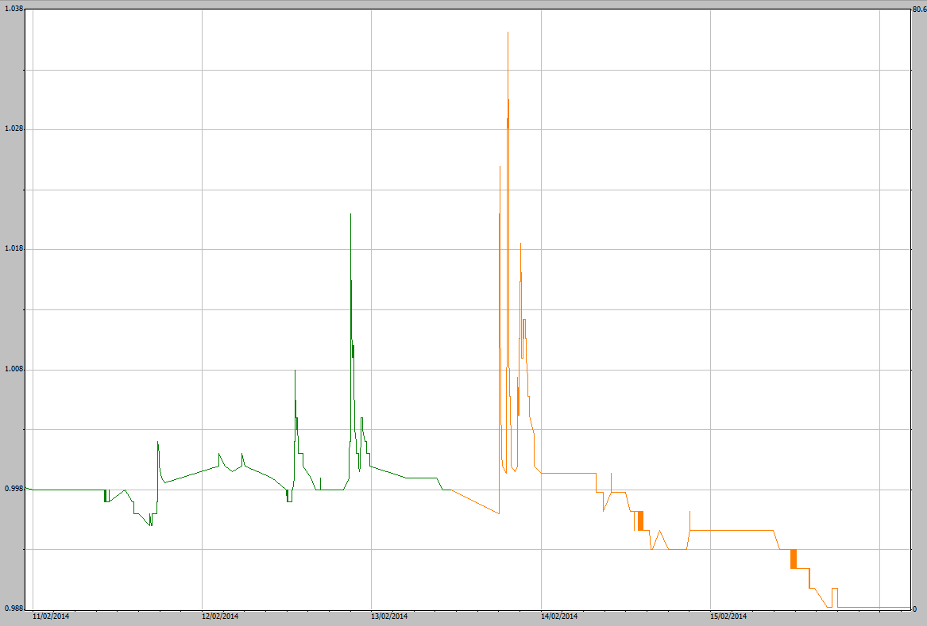

**Figure 35** Part of the stage trace on EP2 for the 2013–2014 water year. The orange section shows where EP2 stage trace data has been infilled with EP1 data using the regression equation. Stage height (m) is shown on the y-axis.

# 5.0 Discussion and conclusions

This internal report describes data quality and corrections made to rainfall and the stage trace for EP2. It has resulted in a clean rainfall and stage trace dataset for the period 01‑09‑2009 to 31‑08‑2014. The methods will be applied to correct similar data from EP2 in the future.

The corrected rainfall and runoff data has been annotated and quality coded in Hydstra. It is now suitable for calculating the most accurate estimates of rainfall and runoff discharge from the EP2 plot area. With a complete and corrected stage trace, it can be used to determine discharge (using a rating table, see Saynor et al 2013) which can then be used to calculate total loads for parameters such as suspended sediment & electrical conductivity.

A near 1:1 relationship was attained between rainfall measured from all 4 plot sites by tipping bucket rain gauges. Therefore, in order to infill missing rainfall at any of the erosion plot rainfall gauges, the closest rainfall gauge with reliable record can be used as a direct infill, noting that some small-scale variation between the four rainfall stations is apparent. The amount of rainfall recorded in the plots may be affected as vegetation communities and plant heights grow and change over time (especially around the rain gauge stand). Therefore, correlations between the rain-gauges should be monitored routinely to see if the 1:1 relationship is still valid.

Most uncertainty exists for runoff measurements during the period when there was a structural breach to the upslope boundary of plots for the events > 10 mm rain. Field inspection of EP2 during the 2011 dry season showed an area where the boundary dampcourse had been undermined and breached, allowing additional water to flow onto the plot. Additional runoff was clearly evident by the existence of a second peak on the event hydrographs, occurring well after rainfall has ceased. There were 9 runoff events affected by the additional runoff through the breach. It was determined that storms of greater than 10 mm could cause the additional runon. The stage traces for these events have been corrected to more accurately reflect runoff from the plot. Since the additional runon from these events is likely to have increased sediment loads, corrections will also have to be applied to these parameters sets (e.g. bedload, suspended load and turbidity). It is suggested that proportion of the original event compared to the corrected event can be used as a guide to correct for these parameters. For example, if the corrected runoff was 15% smaller than then the original runoff calculation then the bedload removed from the plot should also be adjusted by 15%.

It was also determined that larger runoff events (registering ≥ 1.040 mm on the EP2 stage trace) could cause uneven flow levels in the upstream basin and flume. This sometimes resulted in lower stage trace values for the shaft encoder. During the 5 water years there were 43 events that had a peak higher than 1.040 mm. Of these, 35 had the peak adjusted with 8 not requiring any changes. Where possible the pressure transducer stage trace was used to correct the shaft encoder stage traces higher than 1.040. When there were events with no pressure transducer data, information and experience gained from correction of other events was used to estimate the correction of the peak. Initially, it was thought that a regression relationship might be able to be developed to help correct the data. However, this was not possible due to changes in duration of rainfall events and the varying intensities during events.

The ability of the lower basin drain to remove water at a rate fast enough to stop water backing up and drowning out the flume was investigated. If the flume becomes drowned out, the stage trace hydrograph will be affected and result in excessively high and possibly more even (level) peaks on the stage trace. However, no such characteristics in the stage trace were observed from data for the largest event over the 5 water years. That is, the stage trace appeared to respond normally, rising and falling and without prolonged level (horizontal) periods of the stage trace during peak flows. It can therefore be concluded that other *smaller* events were, similarly, not backwater affected for EP2. Hence, the pipe that drains water from the lower basin of EP2 appears to have sufficient capacity to remove the water.

The methods applied for the first 5 years of water year data should be used on subsequent water years according to the following set of rules:

**Rainfall**

* Identify periods of missing or impaired rainfall data.
* Check correlation with closest reliable rainfall data for a common period not including the period of missing data.
* If good correlation, complete a direct infill (with the correct quality coding)

**Runoff**

* Check stage trace for periods of data that are unusually high or low, subtract or add values to align with the CTF to flow of the flume on EP2 (1.000).
* Identify any breaches of the plot boundary and make the necessary corrections to the stage trace.
* Correct for any events with a stage trace height above 1.040 m
* Identify periods of missing or stage data.
  + For stage trace data above CTF, check correlation using HYPLOTXY with the closest reliable data for a common period not including the period of missing data.
  + If good correlation, correct the stage trace using the regression equation generated by HYPLOTXY.
  + For stage trace below CTF, use a direct infill from the closest plot with reliable data.
* All changes made should be recorded in the comment field in Hydstra so that it can be tracked.

Further details on the data cleaning methods are compiled in the standard operating procedures manual for managing Trial Landform hydrology data (Boyden et al in prep). Rainfall intensity and discharge from EP2 will be investigated and reported on in either a Supervising Scientist Report or in a journal paper..

# 6.0 References

Boyden J 216. Standard operating procedures (in prep)

Bureau of Meteorology 2014. www.bom.gov.au/climate/averages/tables/cw_014198.shtml, accessed 26 September 2014.

Bos MG, Replogle JA & Clemmens AJ 1984. *Flow measuring flumes for open channel systems.* Wiley, New York.

Clemmens AJ, Wahl TL, Bos MG & Regplogle JA 2001. *Water Measurement with Flumes and Weirs.* International Institute for Land Reclamation and Improvement, Wageningen, 90-70754-55-x.

Saynor MJ, Erskine, WD, Moliere DR & Evans KG 2013. Determination of filling curves for the stilling basins, the size of the flumes and rating curves for the Rectangular Broad Crested flumes for the erosion plots on the Ranger Trial Landform. Internal Report 614, January, Supervising Scientist, Darwin.

# Appendix 1 - Correcting EP2 stage trace for runon

Runoff breached the top boundary of EP2 in the 2010–2011 water year during the largest event on 22 February 2011. Runoff events for EP1 and EP2 were compared for all events after 22 February 2011 and those events where there is a difference in hydrograph are listed in Table 1. There were 9 events where the runon onto EP2 impacted on the discharge hydrographs. The event on 10 March 2011 is described in the in Section 3.2, above. All the other events are shown in chronological order below.

#### Event - 25 February 2011

The middle peak on EP2 is much higher than on EP1 indicating runon to the plot and 2 events on EP2 have become 1 event on EP2. The rainfall for the event was 36 mm.

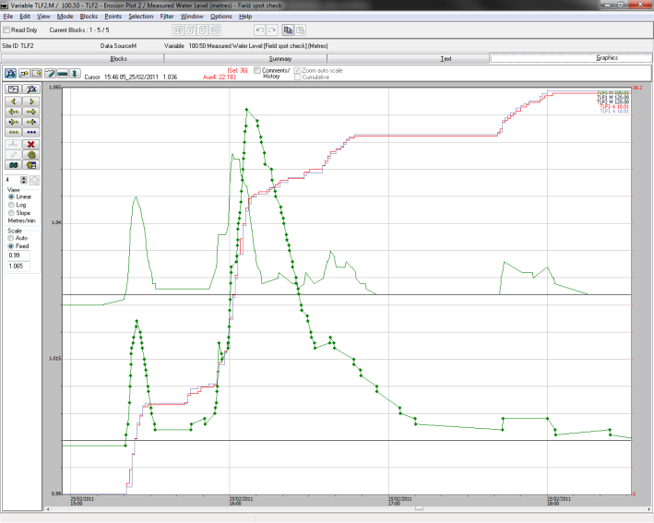

**Figure A1-1** Green dotted line is the stage trace for EP2 and the green line above is stage trace for EP1. The black lines are CTF’s for EP1 and EP2. Red vertical line is rainfall for EP2 and blue vertical line is rainfall for EP1.

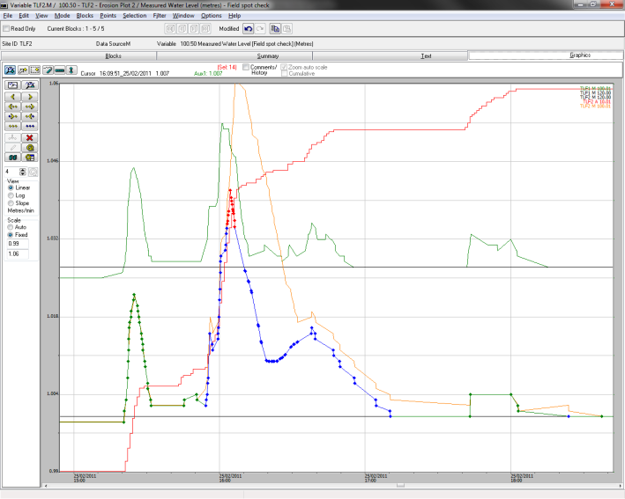

**Figure A1-2** The blue and red dotted lines show the correction that has been made to the stage trace for EP2. The orange line is the original stage trace. The colours of the other lines are the same as Figure A1-1.

#### Event - 14 March 2011

Rainfall event of 18 mm which produced a much higher 2nd peak on the stage trace on EP2. The 2nd peak on EP2 stage trace needs to be corrected by lowering the peak.

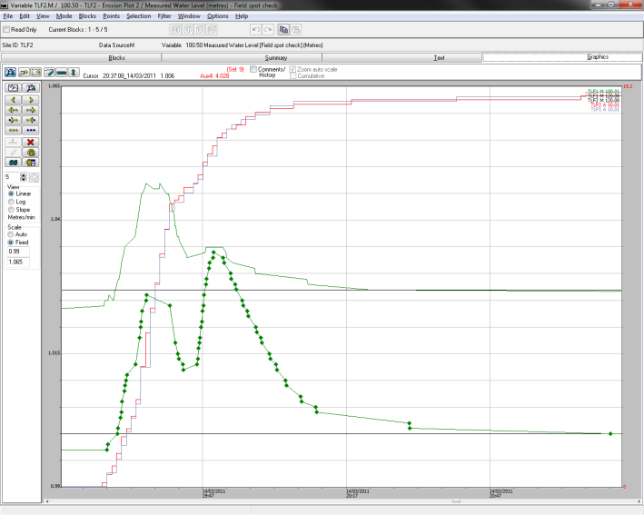

**Figure A1-3** Green dotted line is the stage trace for EP2 and the green line above is stage trace for EP1. The black lines are CTF’s for EP1 & EP2. Red vertical line is rainfall for EP2 and blue vertical line is rainfall for EP1.

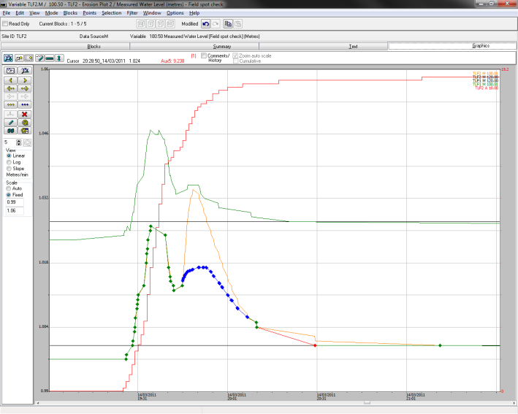

**Figure A1-4** The blue and red dotted line shows the correction that has been made to the stage trace for EP2. The orange line is the original stage trace. The colours of the other lines are the same as Figure A1-3.

#### Event - 15 March 2011 - 12:15 pm

Second peak on EP2 not present on EP1 (17 mm rainfall event). The second peak on the EP2 stage trace needs to be removed. There are photographs of the flumes on EP1 and EP2 that show additional flow, similar to the event on 10 March 2011.

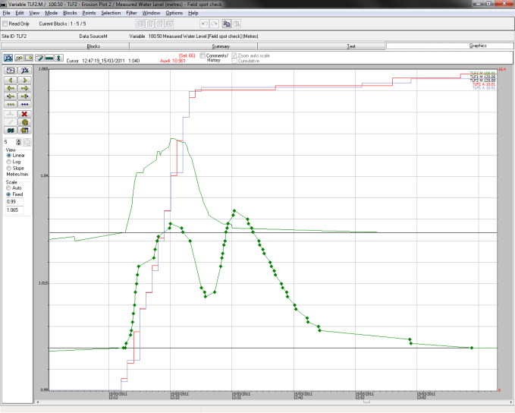

**Figure A1-5** Green dotted line is the stage trace for EP2 and the green line above is stage trace for EP1. The black lines are CTF’s for EP1 and EP2. Red vertical line is rainfall for EP2 and blue vertical line is rainfall for EP1.

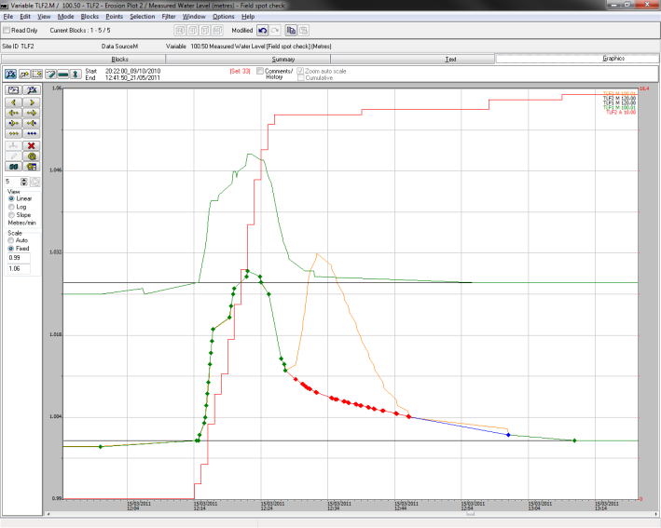

**Figure A1-6** The blue and red dotted line shows the correction that has been made to the stage trace for EP2. The orange line is the original stage trace. The colours of the other lines are the same as Figure A1-5.

#### Event - 15 March 2011 – 3:47 pm

Rainfall event of 19 mm which produced a much higher second peak on the stage trace on EP2. Need to lower the second peak on EP2 stage trace.

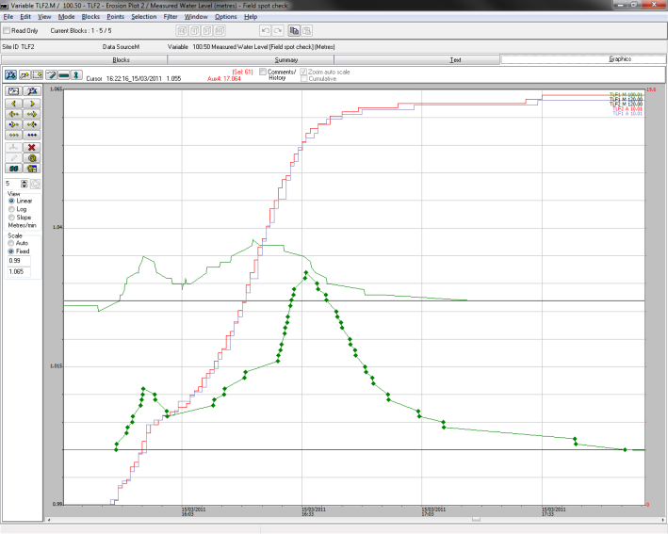

**Figure A1-7** Green dotted line is the stage trace for EP2 and the green line above is stage trace for EP1. The black lines are CTF’s for EP1 and EP2. Red vertical line is rainfall for EP2 and blue vertical line is rainfall for EP1.

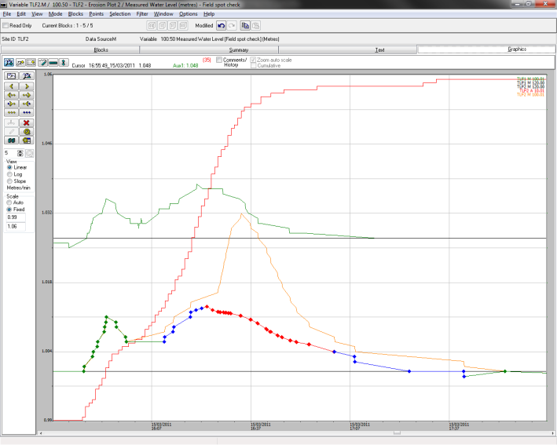

**Figure A1-8** The blue and red dotted line shows the correction that has been made to the stage trace for EP2. The orange line is the original stage trace. The colours of the other lines are the same as Figure A1-7.

#### Event - 27 March 2011

There is a much higher middle peak on the EP2 stage trace than on the EP1 trace. The rainfall for this event was 53 mm. The peak on EP2 needs to be lowered.

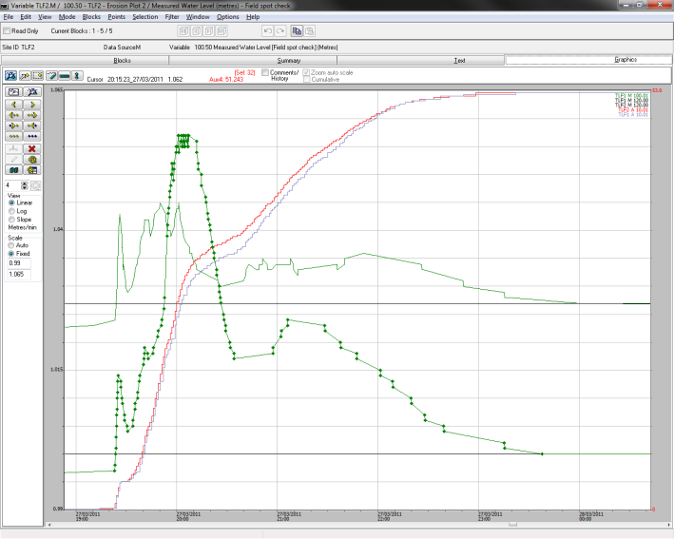

**Figure A1-9** Green dotted line is the stage trace for EP2 and the green line above is stage trace for EP1. The black lines are CTF’s for EP1 and EP2. Red vertical line is rainfall for EP2 and blue vertical is rainfall for EP1.

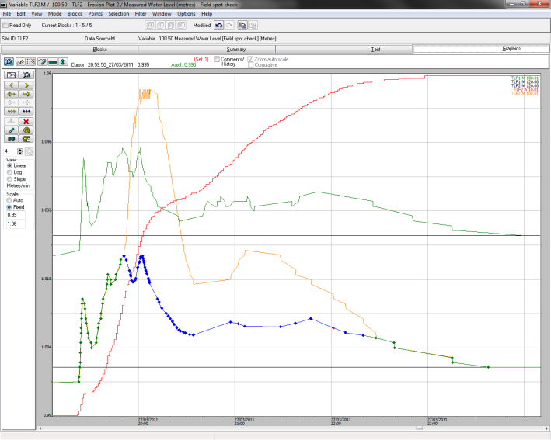

**Figure A1-10** The blue and red dotted line shows the correction that has been made to the stage trace for EP2. The orange line is the original stage trace. The colours of the other lines are the same as Figure A1-9.

#### Event - 29 March 2011

Two events on EP1 stage trace which are shown as one event on EP2 stage trace, with a much higher second peak on EP2. The rainfall for the stage trace was 53 mm.

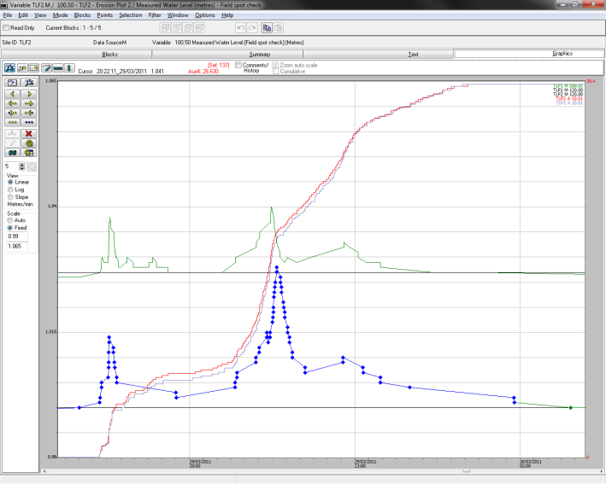

**Figure A1-11** Blue dotted line is the stage trace for EP2 and the green line above is stage trace for EP1. The black lines are CTF’s for EP1 and EP2. Red vertical line is rainfall for EP2 and blue vertical line is rainfall for EP1.

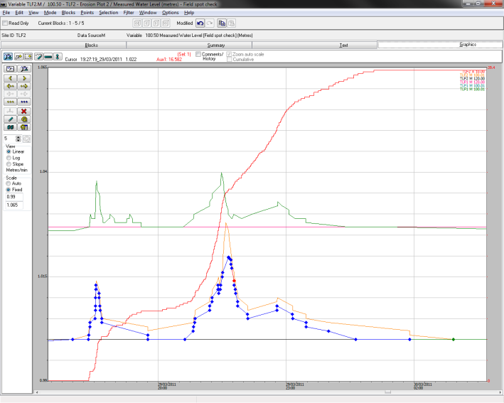

**Figure A1-12** The blue and red dotted line shows the correction that has been made to the stage trace for EP2. The orange line is the original stage trace. The colours of the other lines are the same as Figure A1-11.

#### Event - 2 May 2011

This stage trace was the result of 21 mm of rain with the second peak on EP2 much higher than on EP1 stage trace. Need to lower the stage trace on EP2.

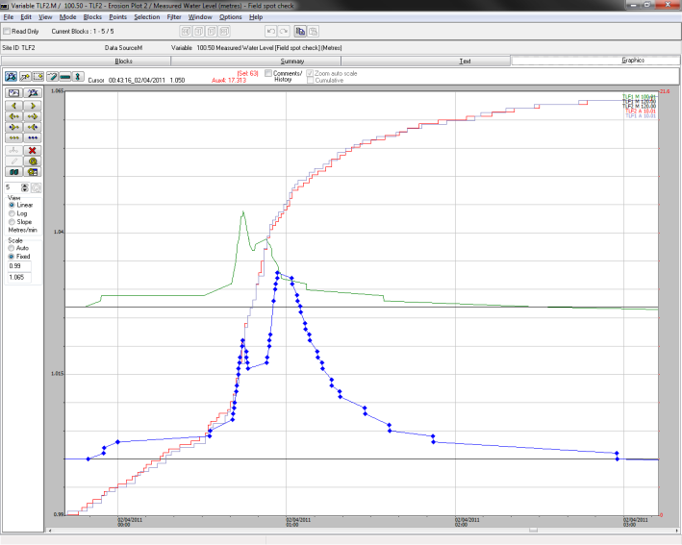

**Figure A1-13** Blue dotted line is the stage trace for EP2 and the green line above is stage trace for EP1. The black lines are CTF’s for EP1 and EP2. Red vertical line is rainfall for EP2 and blue vertical line is rainfall for EP1.

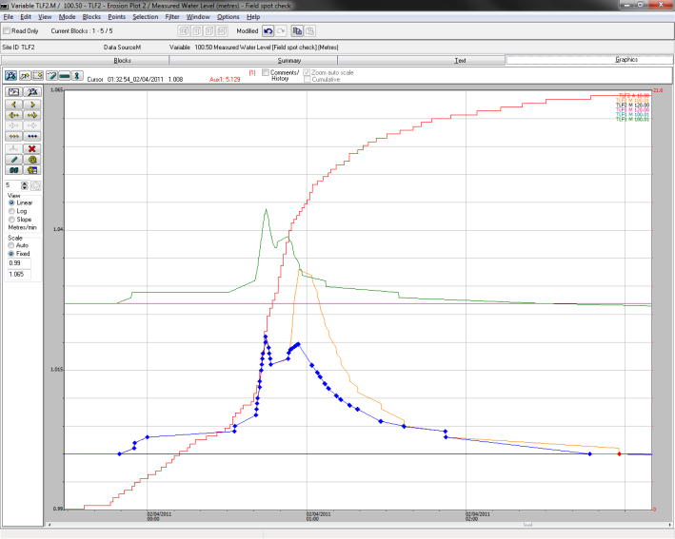

**Figure A1-14** The blue and red dotted line shows the correction that has been made to the stage trace for EP2. The orange line is the original stage trace. The colours of the other lines are the same as Figure A1-13.

#### Event - 5 April 2011

There is a second much higher peak on the EP2 stage trace than on the EP1 stage trace. The event was from 19 mm of rain Need to lower the second peak on the EP2 stage trace.

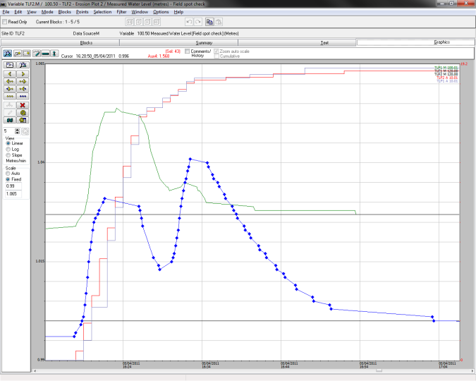

**Figure A1-15** Blue dotted line is the stage trace for EP2 and the green line above is stage trace for EP1. The black lines are CTF’s for EP1 and EP2. Red vertical line is rainfall for EP2 and blue vertical line is rainfall for EP1.

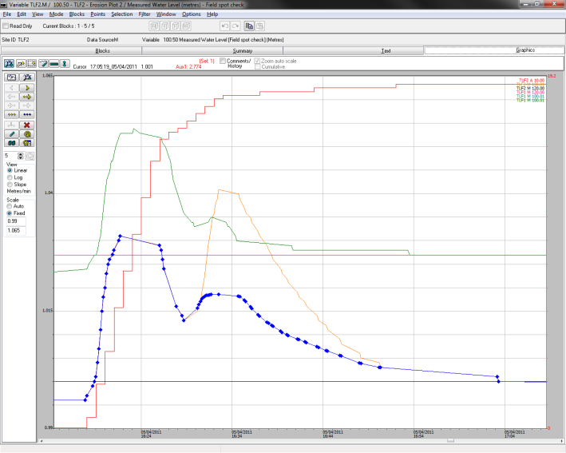

**Figure A1-16** The blue and red dotted line shows the correction that has been made to the stage trace for EP2. The orange line is the original stage trace. The colours of the other lines are the same as Figure A1-15

# Appendix 2 – HYEXTREM output for larger events

The parameters used in HYEXTREM to determine the number of events greater than 1.040 mm (40 mm over the crest of the flume) are shown in Figure A2-1. The output generated with these parameters is contained in Table A2-1.

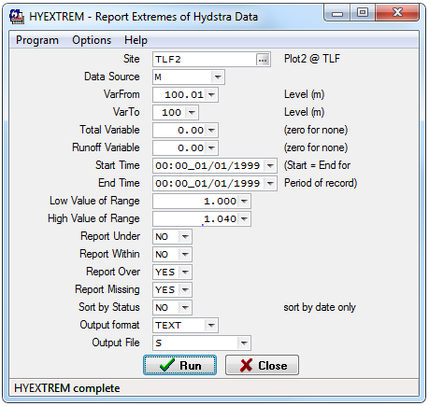

**Figure A2- 1** The values that were input to run HYEXTREM

**Table A2- 1** Hydstra HYEXTREM outputs for EP2 for water greater than 1.040 mm

| HYEXTREM V83 Output 23/03/2015 | | | |  |  |
| --- | --- | --- | --- | --- | --- |
| Data File TLF2.M TLF2 - Erosion Plot 2 | | |  |  |  |
| VarFrom 100.01 Measured Water Level in Metres | | | |  |  |
| VarTo 100.01 Measured Water Level in Metres | | | |  |  |
| Start 12:13_19/11/2009 | |  |  |  |  |
| End 03:10_18/03/2015 | |  |  |  |  |
| Range 1.0000 .. 1.0400 | | |  |  |  |
| **Data** | **Start** | **End** | **Duration** | **Points** | **Extreme** |
| Over | 16:51_23/01/2010 | 17:14_23/01/2010 | 23.3 Minutes | 76 | 1.069 |
| Over | 05:29_01/02/2010 | 05:38_01/02/2010 | 9.1 Minutes | 15 | 1.045 |
| Over | 17:13_09/04/2010 | 17:26_09/04/2010 | 12.5 Minutes | 36 | 1.05 |
| Over | 17:32_09/04/2010 | 17:36_09/04/2010 | 4.0 Minutes | 7 | 1.041 |
| Over | 17:36_09/04/2010 | 17:37_09/04/2010 | 20.0 Second | 2 | 1.04 |
| Over | 19:49_12/04/2010 | 19:54_12/04/2010 | 5.0 Minutes | 10 | 1.042 |
| Over | 19:55_12/04/2010 | 19:55_12/04/2010 | 0.0 Second | 1 | 1.04 |
| Over | 20:06_09/10/2010 | 20:37_09/10/2010 | 31.3 Minutes | 62 | 1.055 |
| Over | 17:32_13/02/2011 | 18:10_13/02/2011 | 38.2 Minutes | 115 | 1.07 |
| Over | 23:08_13/02/2011 | 23:35_13/02/2011 | 26.3 Minutes | 101 | 1.083 |
| Over | 23:43_21/02/2011 | 01:50_22/02/2011 | 2.1 Hours | 473 | 1.228 |
| Over | 16:04_25/02/2011 | 16:05_25/02/2011 | 29.0 Second | 2 | 1.0409 |
| Over | 18:58_22/11/2011 | 19:10_22/11/2011 | 12.0 Minutes | 39 | 1.052 |
| Over | 16:28_03/12/2011 | 17:08_03/12/2011 | 39.5 Minutes | 184 | 1.098 |
| Over | 17:08_03/12/2011 | 17:08_03/12/2011 | 20.0 Second | 1 | 1.041 |
| Over | 17:31_21/12/2011 | 17:52_21/12/2011 | 20.7 Minutes | 84 | 1.07 |
| Over | 17:22_08/02/2012 | 17:47_08/02/2012 | 24.4 Minutes | 108 | 1.068 |
| Over | 19:11_18/02/2012 | 19:19_18/02/2012 | 7.4 Minutes | 20 | 1.047 |
| Over | 18:19_23/04/2012 | 18:26_23/04/2012 | 6.9 Minutes | 26 | 1.05 |
| Over | 17:39_08/10/2012 | 17:45_08/10/2012 | 5.7 Minutes | 20 | 1.046 |
| Over | 21:09_12/11/2012 | 21:16_12/11/2012 | 6.3 Minutes | 17 | 1.047 |
| Over | 18:04_24/11/2012 | 18:23_24/11/2012 | 18.5 Minutes | 81 | 1.057 |
| Over | 18:46_24/11/2012 | 19:08_24/11/2012 | 22.2 Minutes | 58 | 1.051 |
| Over | 15:14_28/11/2012 | 15:21_28/11/2012 | 7.3 Minutes | 19 | 1.0487 |
| Over | 15:22_28/11/2012 | 15:22_28/11/2012 | 2.7 Second | 1 | 1.04 |
| Over | 16:50_15/12/2012 | 16:58_15/12/2012 | 7.4 Minutes | 23 | 1.045 |
| Over | 20:01_18/12/2012 | 20:07_18/12/2012 | 5.8 Minutes | 17 | 1.046 |
| Over | 20:46_18/12/2012 | 20:47_18/12/2012 | 50.0 Second | 3 | 1.042 |
| Over | 20:48_18/12/2012 | 21:11_18/12/2012 | 23.0 Minutes | 119 | 1.086 |
| Over | 00:22_23/12/2012 | 00:52_23/12/2012 | 30.1 Minutes | 92 | 1.048 |
| Over | 23:29_16/01/2013 | 23:50_16/01/2013 | 21.1 Minutes | 96 | 1.098 |
| Over | 19:12_27/01/2013 | 19:45_27/01/2013 | 32.2 Minutes | 120 | 1.078 |
| Over | 14:26_29/03/2013 | 14:32_29/03/2013 | 6.3 Minutes | 6 | 1.042 |
| Over | 17:07_30/03/2013 | 17:30_30/03/2013 | 22.5 Minutes | 97 | 1.071 |
| Over | 17:35_30/03/2013 | 17:56_30/03/2013 | 20.3 Minutes | 75 | 1.065 |
| Over | 02:07_31/03/2013 | 02:07_31/03/2013 | 0.0 Second | 1 | 1.04 |
| Over | 02:07_31/03/2013 | 02:31_31/03/2013 | 24.0 Minutes | 59 | 1.049 |
| Over | 02:31_31/03/2013 | 02:32_31/03/2013 | 10.0 Second | 2 | 1.04 |
| Over | 18:56_01/11/2013 | 18:57_01/11/2013 | 1.0 Minute | 4 | 1.042 |
| Over | 18:57_01/11/2013 | 19:13_01/11/2013 | 15.8 Minutes | 61 | 1.057 |
| Over | 22:44_25/11/2013 | 22:57_25/11/2013 | 13.1 Minutes | 53 | 1.06 |
| Over | 16:21_05/12/2013 | 16:53_05/12/2013 | 31.6 Minutes | 147 | 1.084 |
| Over | 16:16_15/12/2013 | 16:20_15/12/2013 | 4.0 Minutes | 13 | 1.045 |
| Over | 16:20_15/12/2013 | 16:21_15/12/2013 | 40.0 Second | 1 | 1.041 |
| Over | 19:10_28/12/2013 | 19:29_28/12/2013 | 18.9 Minutes | 83 | 1.054 |
| Over | 23:43_15/01/2014 | 23:52_15/01/2014 | 8.8 Minutes | 26 | 1.046 |
| Over | 23:52_15/01/2014 | 00:29_16/01/2014 | 36.5 Minutes | 137 | 1.09 |
| Over | 09:09_16/01/2014 | 09:14_16/01/2014 | 4.2 Minutes | 11 | 1.044 |
| Over | 15:15_23/01/2014 | 15:32_23/01/2014 | 16.7 Minutes | 64 | 1.066 |
| Over | 19:32_26/01/2014 | 19:33_26/01/2014 | 35.0 Second | 2 | 1.041 |
| Over | 23:48_29/01/2014 | 00:23_30/01/2014 | 35.5 Minutes | 124 | 1.059 |
| Over | 00:23_30/01/2014 | 00:24_30/01/2014 | 40.0 Second | 1 | 1.041 |
| Over | 23:13_31/01/2014 | 23:14_31/01/2014 | 25.0 Second | 1 | 1.041 |
| Over | 23:14_31/01/2014 | 23:15_31/01/2014 | 30.0 Second | 2 | 1.042 |
| Over | 23:15_31/01/2014 | 23:19_31/01/2014 | 4.3 Minutes | 14 | 1.044 |
| Over | 13:43_17/02/2014 | 13:46_17/02/2014 | 3.2 Minutes | 12 | 1.047 |
| Over | 20:38_05/03/2014 | 20:49_05/03/2014 | 11.6 Minutes | 51 | 1.055 |
| Over | 20:50_05/03/2014 | 20:50_05/03/2014 | 15.0 Second | 1 | 1.041 |
| Over | 22:54_07/03/2014 | 23:14_07/03/2014 | 19.5 Minutes | 97 | 1.071 |
| Over | 23:14_07/03/2014 | 23:14_07/03/2014 | 20.0 Second | 1 | 1.041 |
| Over | 23:10_15/03/2014 | 23:10_15/03/2014 | 20.0 Second | 1 | 1.041 |
| Over | 20:53_03/05/2014 | 21:12_03/05/2014 | 19.0 Minutes | 66 | 1.051 |
| Over | 21:12_03/05/2014 | 21:12_03/05/2014 | 0.0 Second | 1 | 1.04 |
| Over | 17:27_06/11/2014 | 17:49_06/11/2014 | 22.2 Minutes | 108 | 1.05 |
| Over | 17:50_06/11/2014 | 17:50_06/11/2014 | 0.0 Second | 1 | 1.04 |
| Over | 17:52_06/11/2014 | 17:54_06/11/2014 | 1.4 Minutes | 5 | 1.042 |
| Over | 20:09_30/12/2014 | 20:10_30/12/2014 | 10.0 Second | 1 | 1.041 |
| Over | 16:07_22/01/2015 | 16:07_22/01/2015 | 8.3 Second | 1 | 1.041 |
| Over | 08:23_23/01/2015 | 08:23_23/01/2015 | 0.0 Second | 1 | 1.04 |
| Over | 08:24_23/01/2015 | 08:26_23/01/2015 | 1.3 Minutes | 7 | 1.041 |
| Over | 20:48_24/02/2015 | 21:16_24/02/2015 | 27.8 Minutes | 136 | 1.064 |
| Over | 01:07_15/03/2015 | 01:11_15/03/2015 | 3.8 Minutes | 17 | 1.045 |

When determining the number of instances that the flow is greater than 1.040 mm, HYEXTREM sometimes produces 2 of more points for the same event. When this has occurred the values have been grouped as one event.

# Appendix 3 – Runoff comparisons for 2009–2010 water year

### 2009–2010 water year (events 1–4)

##### Event 1 – 23 January 2010 is shown in section 3.2.1 as Figure 18 on page 27.

##### Event 2 – 1 February 2010

Rain started at 4:15 am until 08:09 am (3 hours, 54 mins) during which 77 mm of rain fell.

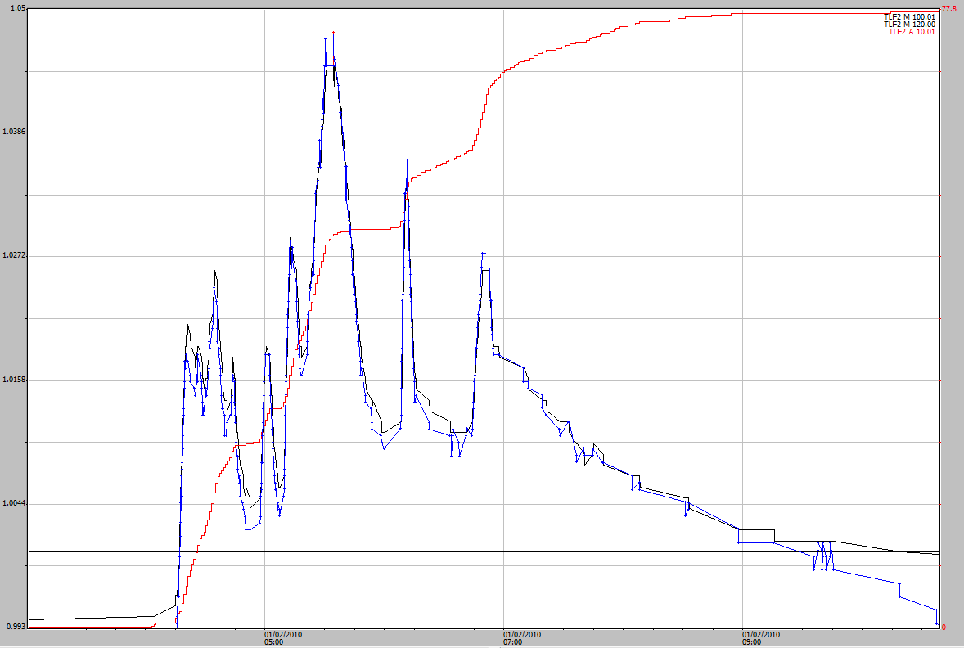

**Figure A3-1** Event 2 hydrograph on 1 February 2010 both the pressure transducer (blue) and the shaft-encoder (black) stage traces are very similar. 0.895m has been added to the pressure transducer.

The traces look to be very similar and there are only a couple of single points on the pressure transducer which are higher than the shaft-encoder (approximately 5:30 am). The rainfall fell over a nearly 4 hour period and the intensity does not seem sufficient to cause flow issues in the flume. The shaft-encoder stage trace should be left as it is.

##### Event 3 – 9 April 2010

Rain started at 4:55 pm until 6:15 am (1 hour, 20 mins) during which 52 mm of rain fell. 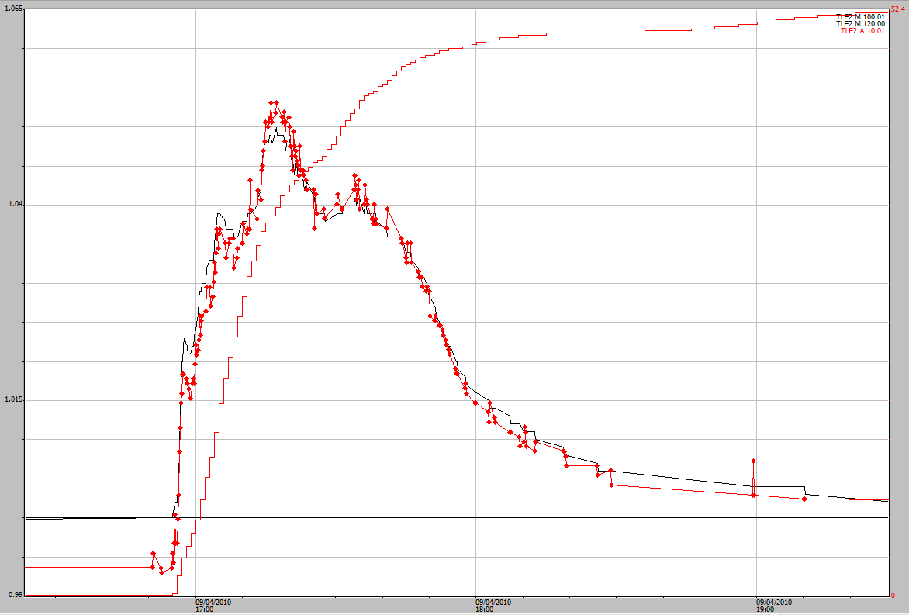

**Figure A3-2** Event 3 hydrograph on 9 April 2010 both the pressure transducer (red) and the shaft-encoder (black) stage traces are very similar. 0.894m has been added to the pressure transducer.

The main peak on the pressure transducer is slightly higher than the shaft encoder. In this case the pressure transducer data should be substituted for to the shaft-encoder data.

##### Event 4 – 12 April 2010

Rain started at 6:26 pm until 7:58 (1 hour, 32 mins) during which 49 mm of rain fell.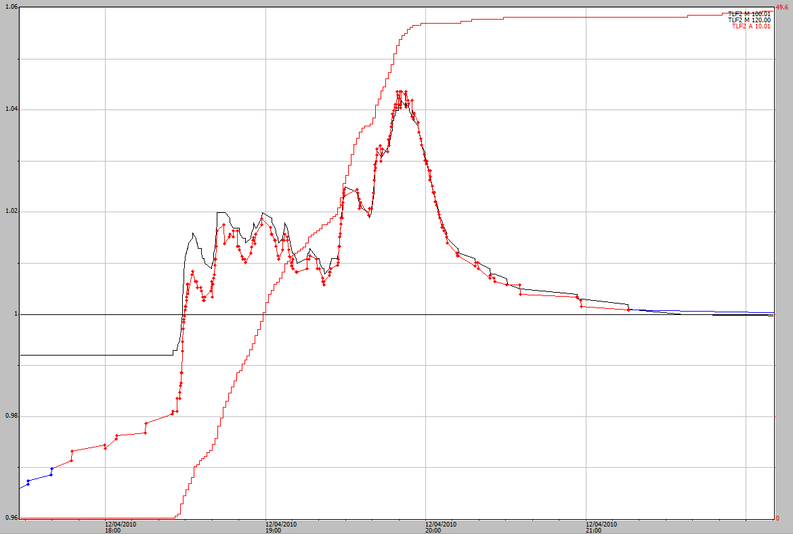

**Figure A3-3** Event 4 hydrograph on 9 April 2010 both the pressure transducer (red) and the shaft-encoder (black) stage traces are very similar. 0.895m has been added to the pressure transducer.

The main peak on the pressure transducer is slightly higher than the shaft encoder. The main peak should have the pressure transducer data smoothed and added to the shaft-encoder data.

### 2010–2011 water year

*Event 5 – 9 October 2010*

Rain started at 7:32 pm until 8:37 pm (1 hour, 5 mins) during which 55 mm of rain fell.

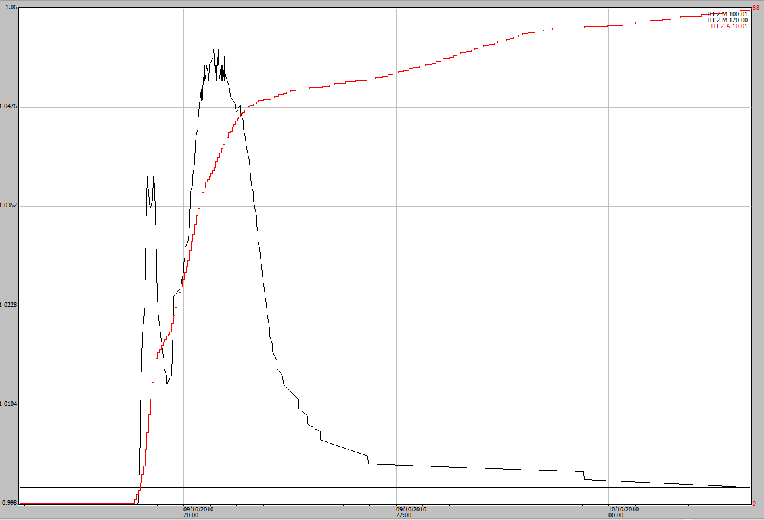

**Figure A3-4** Event 5 hydrograph on 9 October 2010 Black line is the shaft-encoder. No pressure transducer stage trace.

The pressure transducer was not re-installed after calibration checks until 14 October 2010. The second peak is uneven and should be smoothed, either by regression equation or by built up knowledge and observations of how the peaks react during events.

There may be an issue with the data at the higher parts of the stage trace.

*Event 6 – 13 February 2011* at 5:00 pm is shown in section 3.3.2 as Figure 19 on page 28.

*Event 7 – 13 February 2011 at 22:00*

Rain started for the larger middle event at 7:32 pm until 8:37 pm (1 hour, 5 mins) during which 55 mm of rain fell.

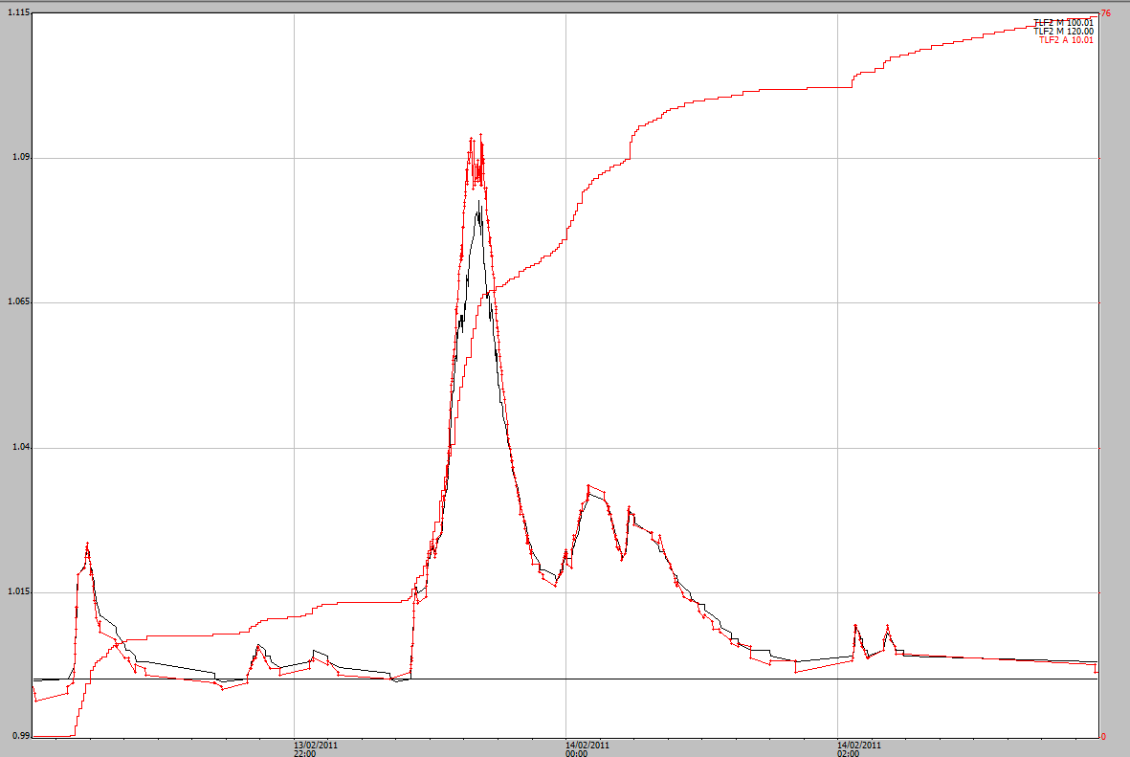

**Figure A3-5** Event 7 hydrograph on 13 February 2011from 22:00. The pressure transducer (red) is higher than the shaft-encoder (black). 0.789m has been added to the pressure transducer.

Pressure transducer is higher than the shaft-encoder by 10 or 11 mm however there also appears to be a problem with the stage trace for the pressure transducer as well (given the jerky uneven nature of the stage trace at peak height). Suggest to add/replace the higher part of the shaft-encoder peak with the pressure transducer and also smooth out the peak perhaps rounding off the peak for the pressure transducer and then adding it to the trace.

**Event 8 – 21 February 2011,** the largest event during the five year study period is shown section 3.3.2 in Figure 24 on page 31.

**Event 9 – 25 February 2011**

Rain started at 7:32 pm until 8:37 pm (1 hour, 5 mins) during which 55 mm of rain fell.

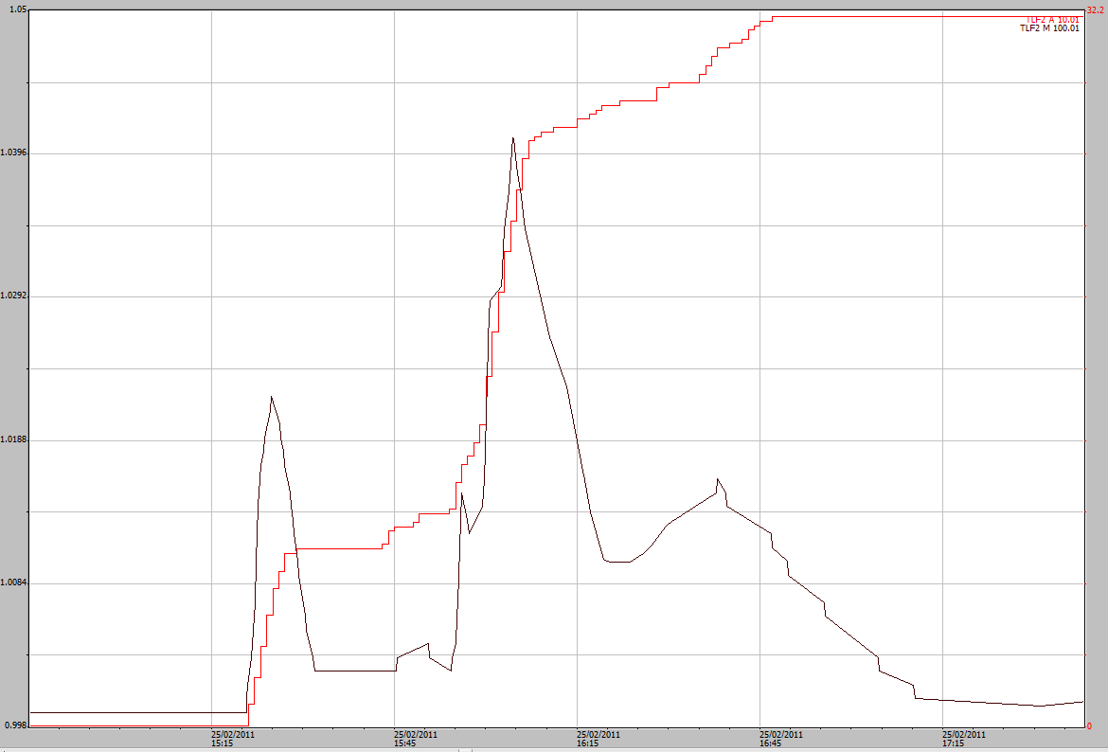

**Figure A3-6** Event 9 hydrograph on 25 February 2011t from 22:00. There is no pressure-transducer data for this period.

From what can be seen in Figure A3-6 the flow through the flume appears to be uniform. This curve has been corrected due to the runon of water through the breach of the top boundary. This was the only event greater than 1.040 following the breach of the top boundary.

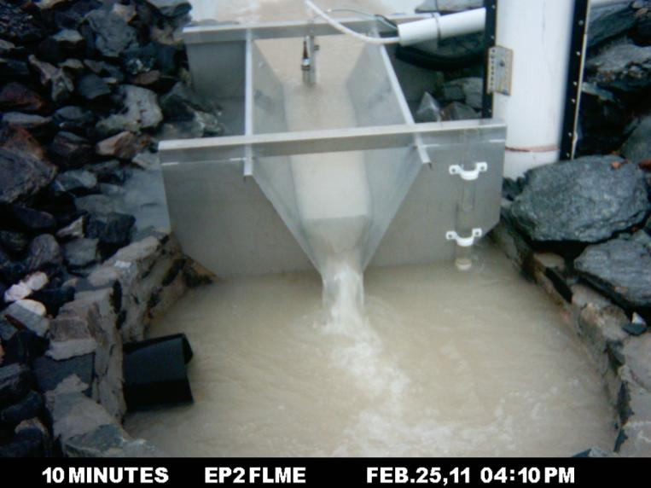

**Figure A3-7** Image of the event 9 on 25 February 2011, however it is difficult to see what is going on in the upstream stilling basin.

### 2011–2012 water year

The 2011–2012 water year was the third season that the trial landform was monitored. During the 2011–2012 water year there were 6 events (10 – 15) with the shaft-encoder stage trace greater than 1.040 m. The largest event during the water year on 3 December 2011 is shown in Section 3.3.4 all of the other events are shown in below on chronological order. The pressure transducer stopped recording meaningful data on 18 December 2011 and was not replaced until May 2012.

##### Event 10- 22 November 2011

Rain started at 6:46 pm until 7:07 pm (21 mins) during which 31 mm of rain fell.

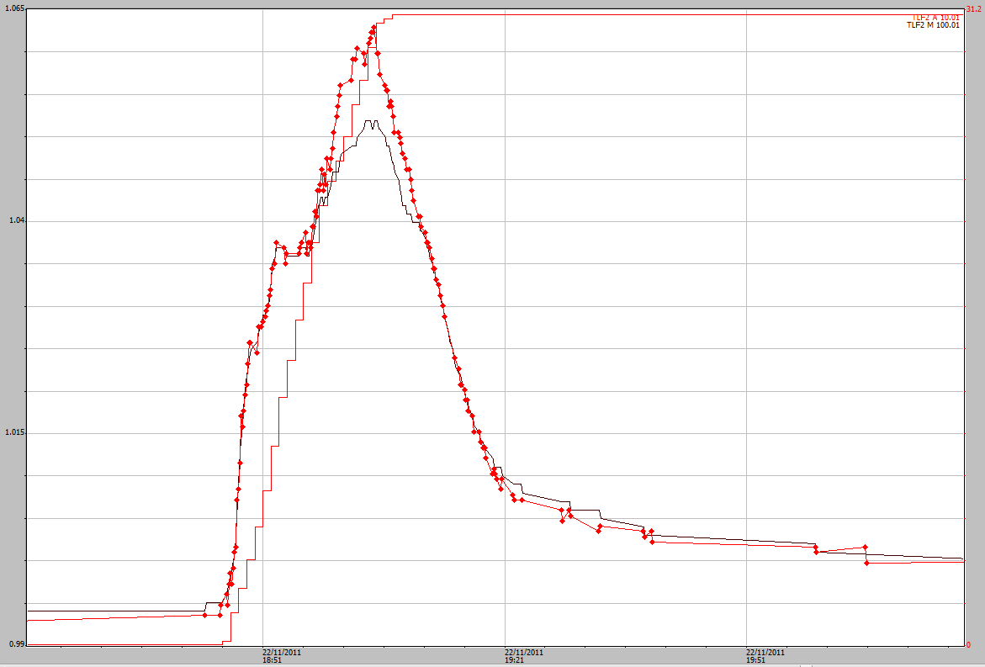

**Figure A3-8** Event 10 hydrograph on 22 November 2011. The pressure-transducer (red) is 11 mm higher than the shaft-encoder (black). 0.806m has been added to the pressure transducer.

This was an intense but quick rainfall event, with the pressure-transducer higher than the shaft-encoder. The shaft-encoder should have the top of the peak substituted with the pressure-transducer.

##### Event 11- 3 December 2011

This is show in section 3.334 in Figure 25 on page 33.

##### Event 12 – 21 December 2011

There was small rainfall event starting at 4:39 pm during which 11 mm of rain fell. A second event started at 5:25 pm until 5:50 pm (35 mins) during which 31 mm of rain fell.

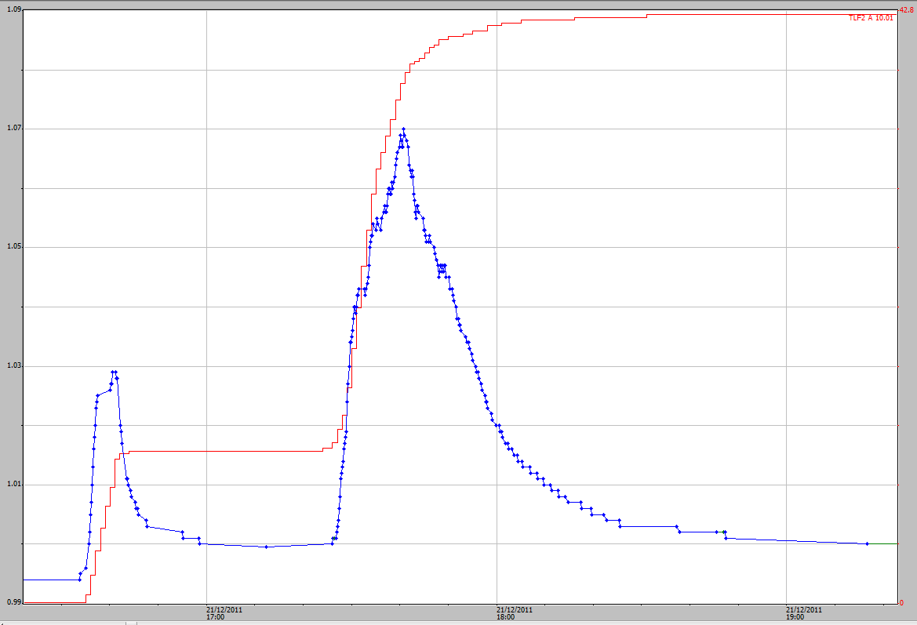

**Figure A3-9** Event 12 hydrograph on 21 December 2011 the shaft-encoder is shown and there was no pressure transducer data.

The second peak looks to be slightly affected by flow through the upstream basin and should have the peak raised and smoothed by eye. This is based on previous comparisons with shaft-encoder and pressure transducer.

##### Event 13 – 8 February 2012

Rain started at 5:12 pm until 5:41 (29 mins) during which 42 mm of rain fell.

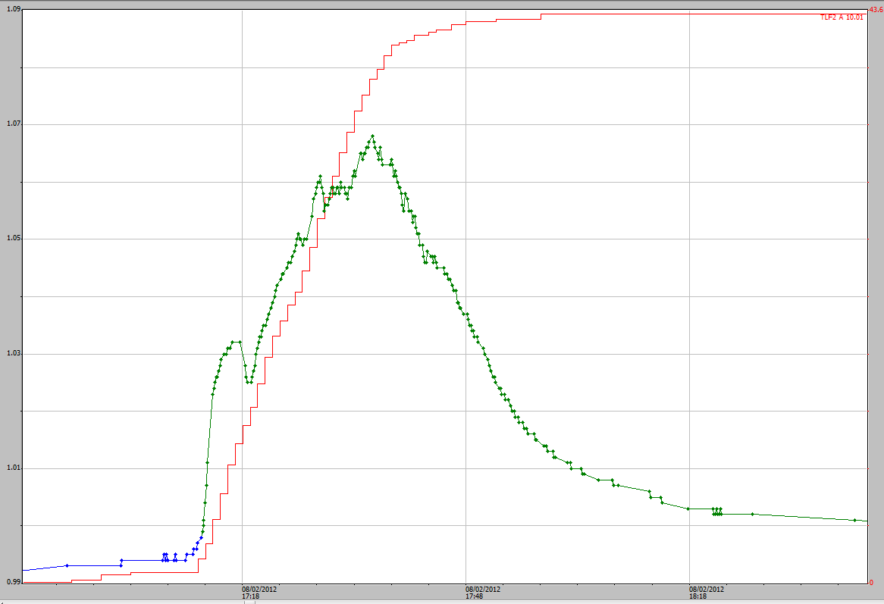

**Figure A3-10** Event 13 hydrograph on 8 February 2012 the shaft-encoder is shown and there was no pressure transducer data.

The stop of the peak looks to be affected by flow through the upstream basin and should have the peak raised and smoothed by eye. This is based on previous comparisons with shaft-encoder and pressure transducer.

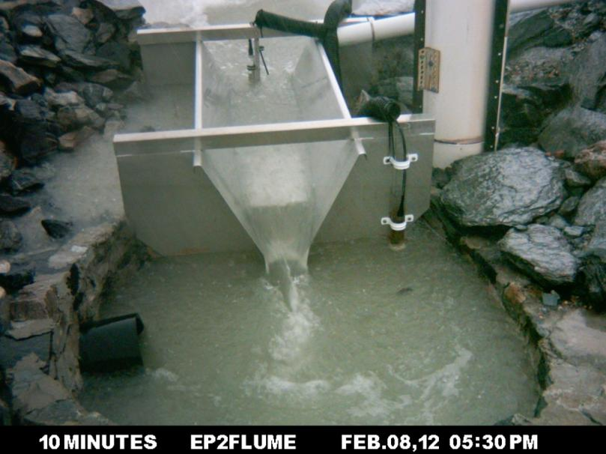

**Figure A3-11** Event 13 on 8 February 2012 at 5:30 pm. Some disturbance can be seen in the upstream stilling basin at this time.

*Event 14 – 18 February 2012*

Rain started at 6:42 pm until 7:20 pm (38 mins) during which 23 mm of rain fell. Rain continued as drizzle for another 2 hours.

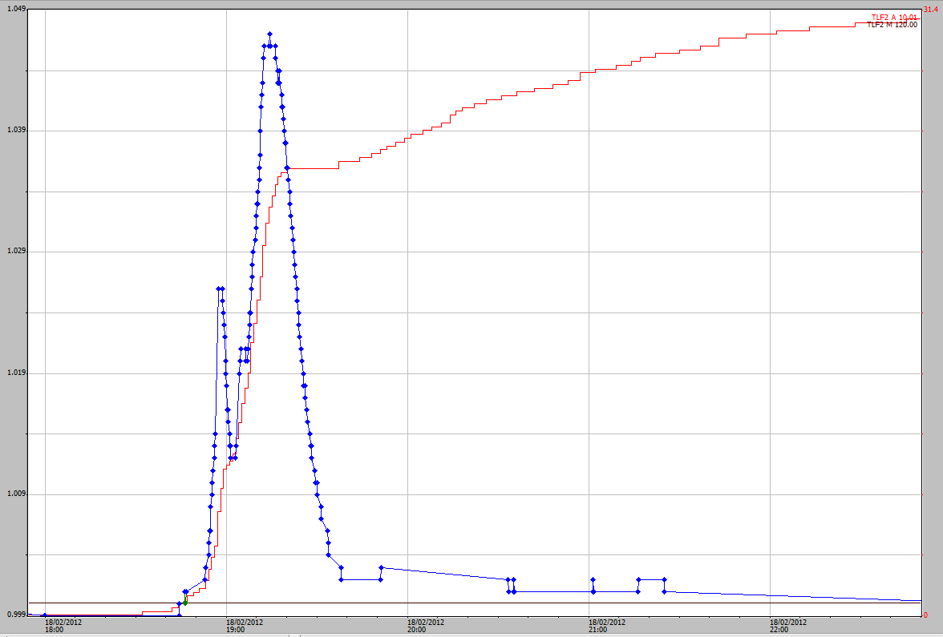

**Figure A3-12** Event 14 hydrograph on 18 February 2012 the shaft-encoder is shown and there was no pressure transducer data.

There is no pressure-transducer data for this event. Any changes are estimations based on experience from previous events where data for both sensors was available. The very top of the peak could be smoothed slightly but this curve doesn’t look too bad.

##### Event 15 – 23 April 2012

Rain started at 6:06 pm until 6:28 pm (22 mins) during which 22 mm of rain fell. There was a small storm at 3:54 pm during which 8 mm of rain fell.

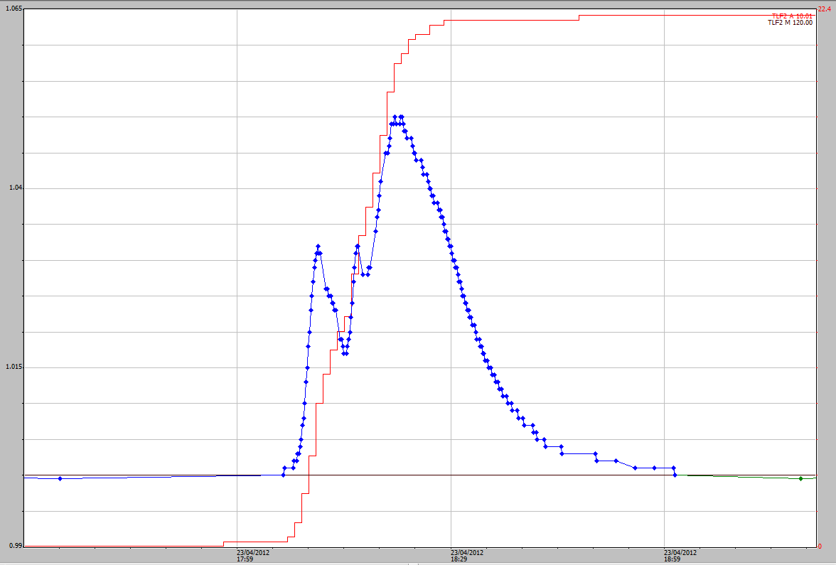

**Figure A3-13** Event 15 hydrograph on 23 April 2012 the shaft-encoder is shown and there was no pressure transducer data.

There is no pressure transducer for this event and any changes are estimations based on information from previous events where there data for both sensors were available. There could be a small problem at the peak of this event. A point should be added that is slightly higher than the two highest values.

### 2012–2013 water year

During the 2012–2013 water year there were 12 events (events 16 to 27) where the shaft-encoder recorded stage heights over the flume greater than 1.040 m.

##### Event 16 – 8 October 2012

Rain started at 5:15 pm until 5:53 pm (38 mins) during which 30 mm of rain fell.

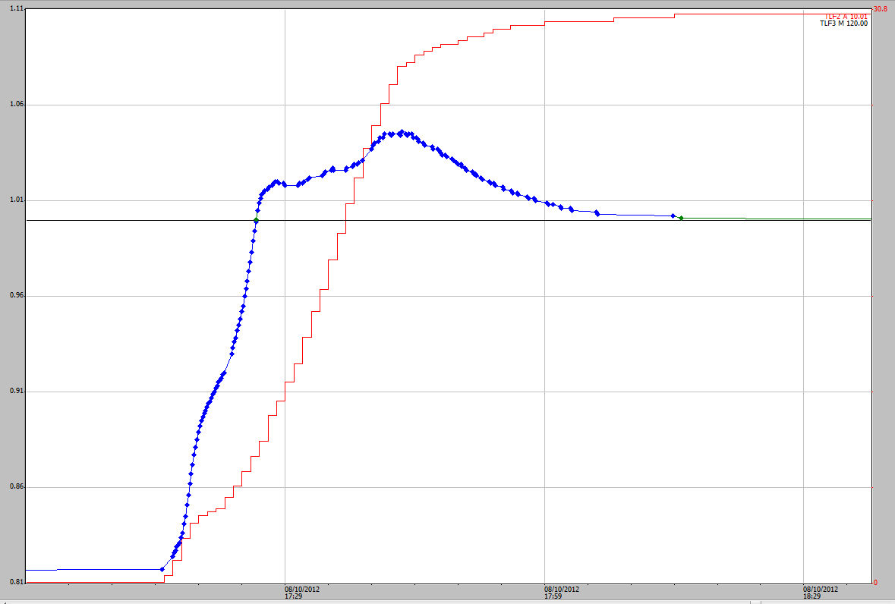

**Figure A3-14** Event 16 hydrograph on 8 October 2012 the shaft-encoder is shown and there was no pressure transducer data as it had been removed for calibration checks.

This was the first event of the water year and the basin had been completely empty. The initial runoff from the plot filled the basin before flowing over the flume. The stage trace of the peak looks reasonable and should be left as is.

*Event 17 – 12 November 2012*

Rain started at 8:52 pm until 9:15 pm (22 mins) during which 23 mm of rain fell.

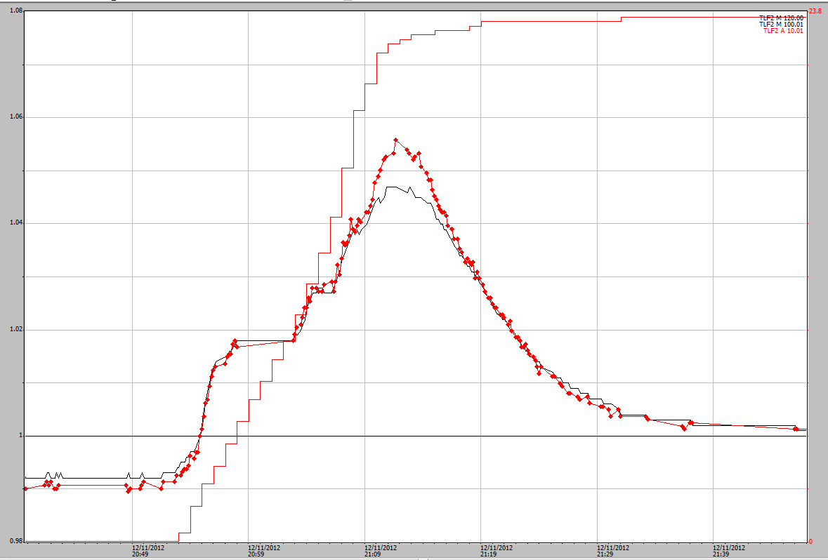

**Figure A3-15** Event 17 hydrograph on 12 November 2012, the start of the events have been aligned, the black is the shaft-encoder and the red is the pressure transducer.

This was a short intense rainfall event during which 23 mm fell in 22 minutes, where the pressure transducer values where higher than the shaft-encoder. The pressure transducer values should be added to the shaft-encoder values.

##### Event 18 – 24 November 2012

Rain started at 5:48 pm until 7:26 pm on 24 November 2011 (1 hour 38 minutes) during which 53 mm of rain fell. 35 mm of rain fell during the first 30 minutes of the event.

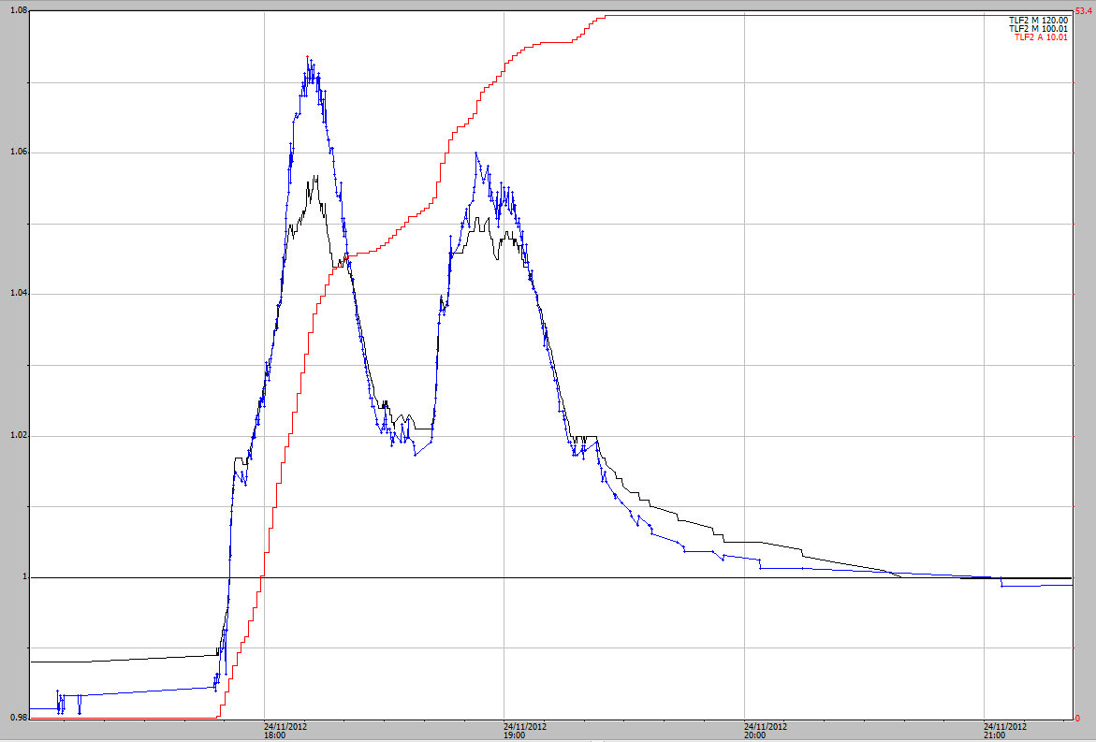

**Figure A3-16** Event 18 hydrograph on 24 November 2012. Black is the shaft-encoder and the blue is the pressure transducer and both have been aligned to the stage trace sensor datum.

Event 18 has two peaks with the pressure transducer higher than the shaft-encoder. The difference on the first peak is 17 mm. The pressure transducer values should be added to the shaft-encoder values for both of the peaks. This event was described with Figures 7 to 11 in Section 2.2 to show the uneven flow problems through the EP2 flume.

##### Event 19 – 28 November 2012

Rain started at 2:58 pm until 3:24 pm (36 mins) during which 27 mm of rain fell.

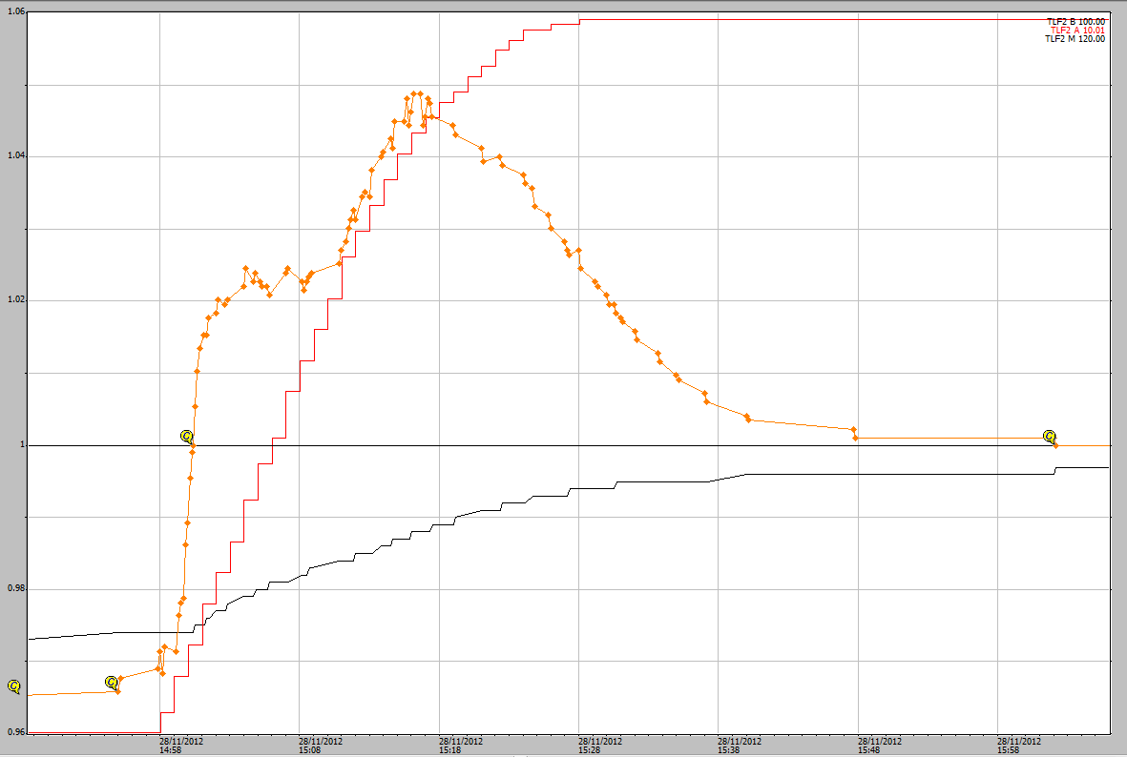

**Figure A3-17** Event 19 hydrograph on 28 November 2012 shows the pressure transducer in orange and the shaft-encoder the black steadily rising line.

The shaft-encoder for this event had an issue and appears to have got caught in the stilling well perhaps as it only recorded a steady rise with no recession. The pressure transducer has been added as the main stage trace data for this event.

##### Event 20 – 15 December 2012

This is shown in Section 3.3.4 as Figure 27 on page 34.

##### Event 21 – 18 December 2012

Rain started at 7:44 pm until 9:04 pm (1 hour 20 mins) during which 52 mm of rain fell in two distinct time periods. The length of time between rainfall events was 20 minutes.

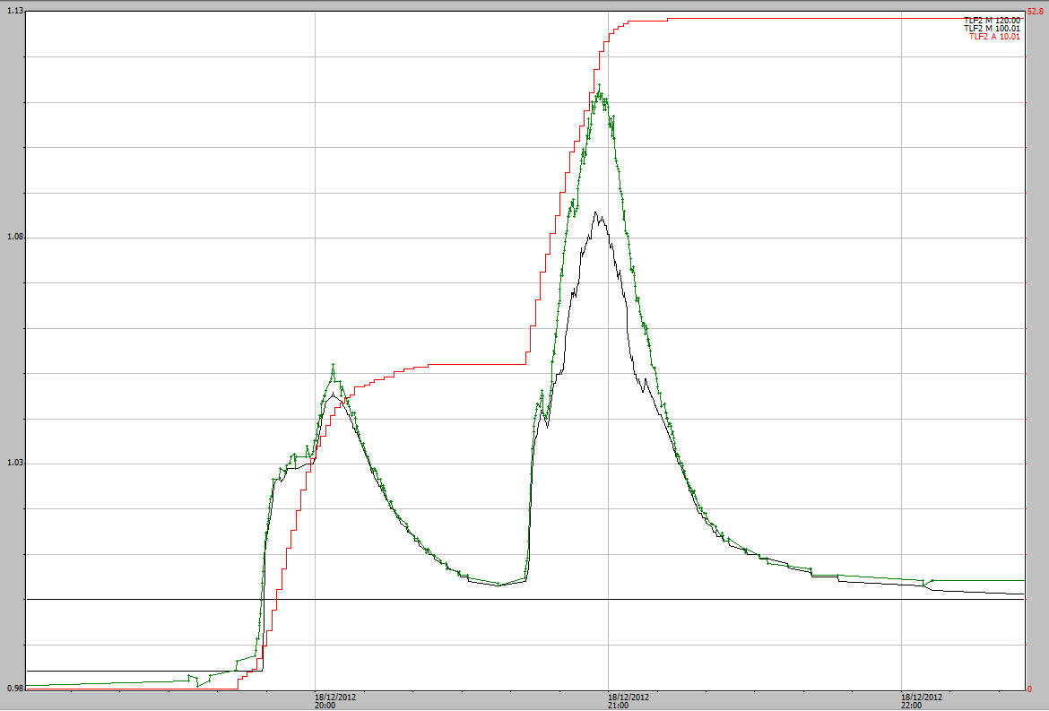

**Figure A3-18** Event 21 hydrograph from 18 December 2012. Green is the pressure transducer and black is the shaft-encoder. 0.839 was added to the pressure transducer data to bring it up to the CTF of 1.00 the same as for the shaft-encoder.

The two runoff peaks are separated because the rain stopped for a period of approximately 20 minutes. The runoff did not stop between the two peaks so it is called the one runoff event. Comparison of the two stage traces suggests that there is interference through the flume. The top parts of both peaks should be adjusted with the pressure transducer traces.

The first rainfall event had 25 mm in about 40 mins then a larger event of about 28 mm in about 20 mins followed about ½ hour later.

##### Event 22 – 23 December 2012

Rain started at 11:50 pm until 1:21 am (1 hour 31 mins) during which 32 mm of rain fell.

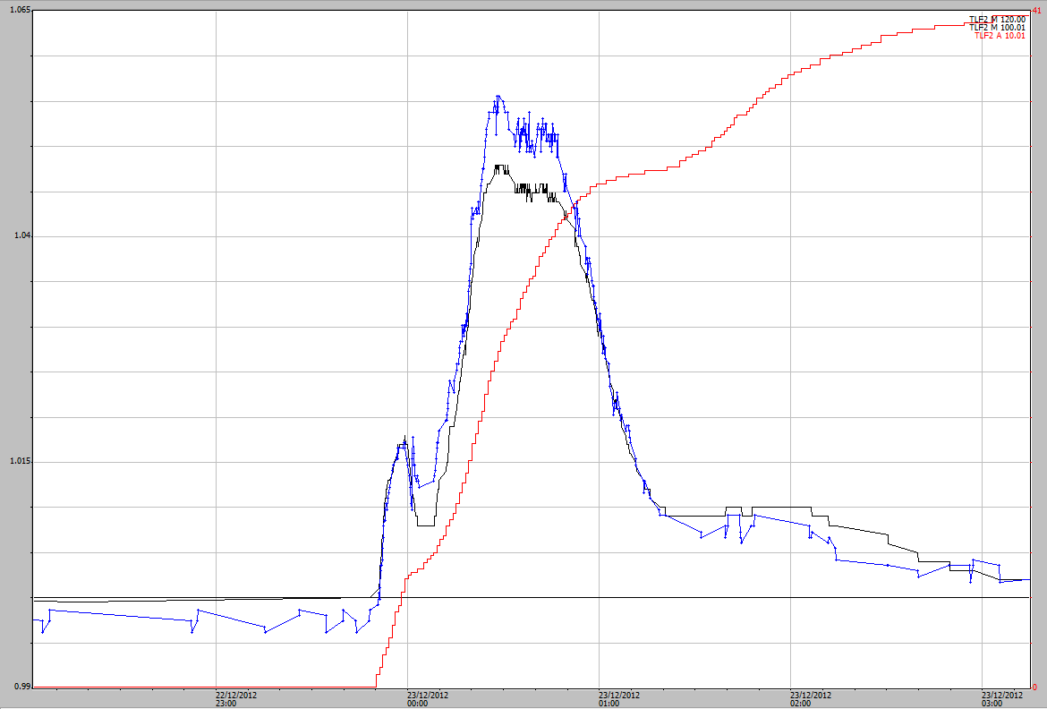

**Figure A3-19** Event 22 hydrograph from 23 December 2012. Blue is the pressure transducer and black is the shaft-encoder. 0.839 was added to the pressure transducer data to bring it up to the CTF of 1.00 the same as for the shaft-encoder.

The one peak has the pressure transducer data higher than the shaft-encoder, the shaft-encoder data should be adjusted by using the pressure transducer data.

##### Event 23 – 16 January 2013

Rain started at 11:10 pm until 0:30 am (38 mins) during which 42 mm of rain fell, of this rainfall 34 mm fell in 30 minutes.

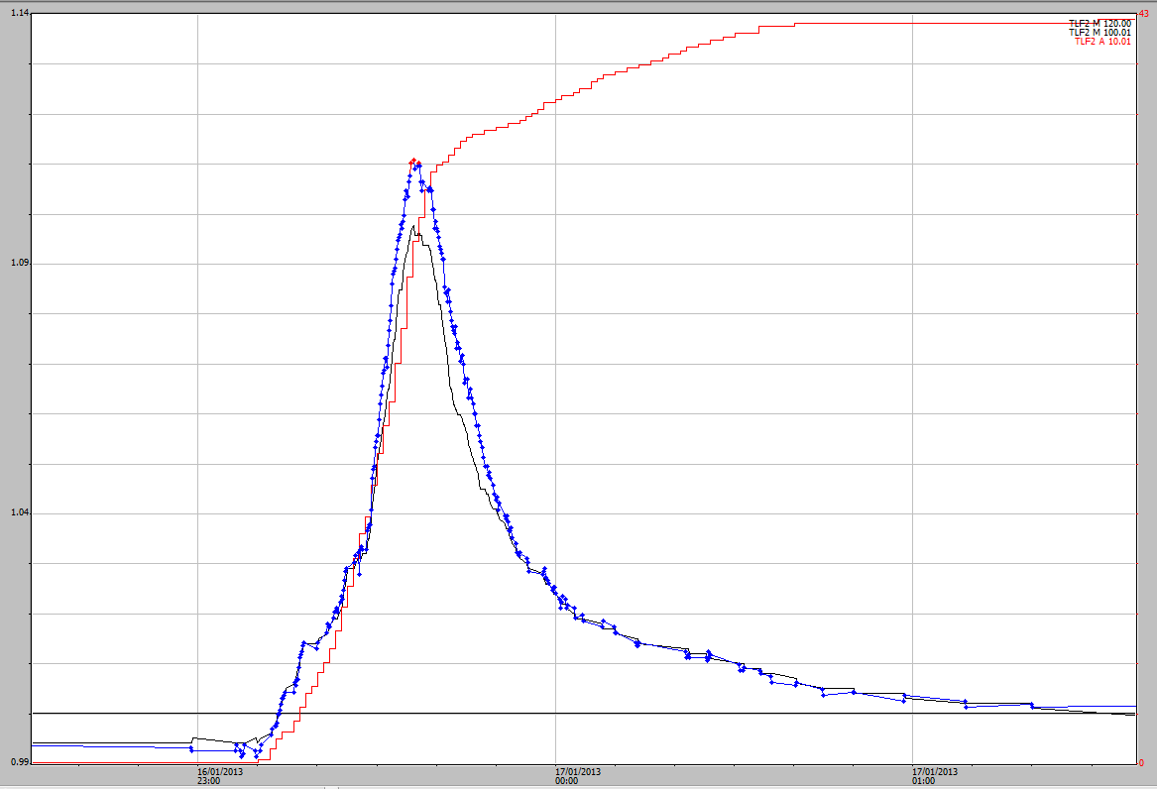

**Figure A3- 20** Event 23 hydrograph from 16 January 2013. Blue is the pressure transducer and black is the shaft-encoder.

This was a short, single-peak, event with 34 mm in 30 minutes. In this case the pressure transducer data should be used to correct the shaft-encoder data.

##### Event 24 – 27 January 2013

Rain started at 5:15 pm until 5:53 pm (38 mins) during which 30 mm of rain fell.

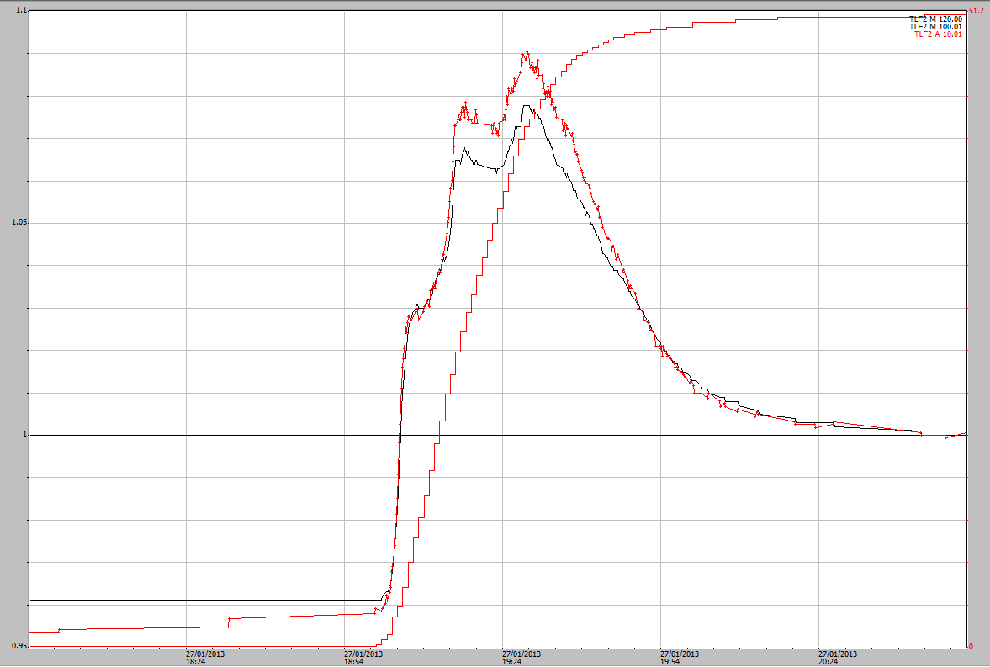

**Figure A3- 21** Event 24 hydrograph from 27 January 2013. Red is the pressure transducer and black is the shaft-encoder.

This event has two peaks with the pressure transducer higher than the shaft-encoder. The shaft-encoder data should be corrected using the pressure transducer data.

Event 25, 26 and 27 all occurred during extended rainfall during the Easter period. The pressure transducer seems to have a scaling issue. Very poor correlation with the druck data. Events 25 and 26 should be corrected but event 27 should be left as it was recorded.

### 2013–2014 water year

During the 2013–2014 water year there were 16 events (events 28 to 43) that exceeded the 1.040 reading in the shaft-encoder. During this water year the pressure transducer did not always produce reliable data. There many instances where the recession of the pressure transducer did not start until after the rain had finished and well after the shaft-encoder had started its recession. In these instances the shape of the shaft-encoder was estimated based on information and observations obtained in previous water years.

Event 30 is shown in section 3.3.6 on page 27 and the other events are shown below in chronological order.

#### Event 28 – 1 November 2013

Rain started at 6:40 pm until 7:16 pm on 1 November 2013 (36 minutes) during which 40 mm of rain fell.

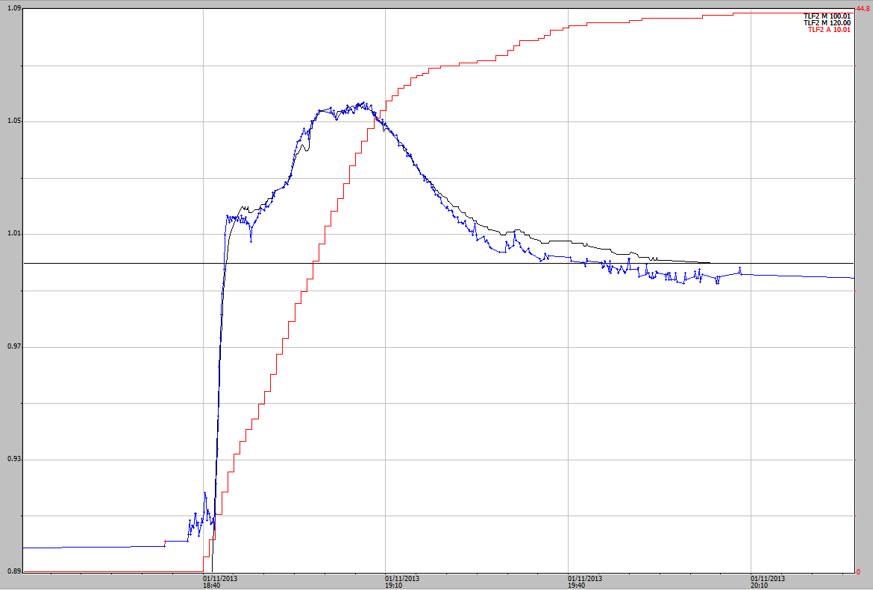

**Figure A3-22** Event 28 hydrograph from 1 November 2013. Blue is the pressure transducer and black is the shaft-encoder.

The traces look a bit jerky, perhaps due to the first event of the season. The main peak should be smoothed so that the stage trace is not as jerky.

#### Event 29 – 25 November 2013

Rain started at 9:55 pm until 11:16 pm on 25 November 2013 (1 hour 21 minutes) during which 36 mm of rain fell.

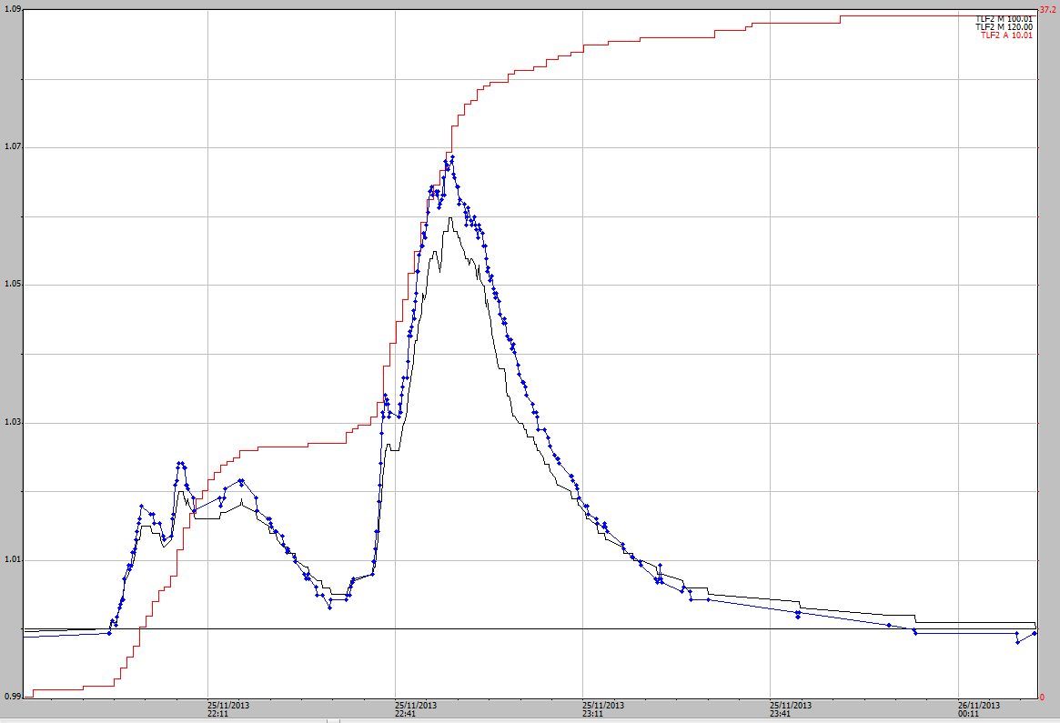

**Figure A3-23** Event 29 hydrograph from 25 November 2013. Blue is the pressure transducer and black is the shaft-encoder.

The shaft encoder should have the higher values from the pressure transducer added

#### Event 30 – 5 December 2013

This is shown in section 3.3.6 as Figure 27 on page 27.

#### Event 31 – 15 December 2013

Rain started at 4:06 pm until 4:30 pm on 15 December (24 minutes) during which 21 mm of rain fell.

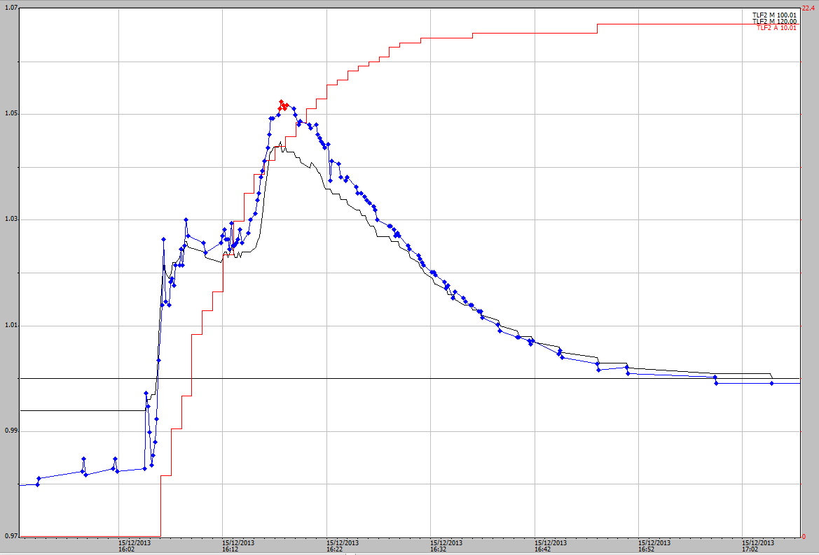

**Figure A3- 24** Event 31 hydrograph from 15 December 2013. Blue is the pressure transducer and black is the shaft-encoder.

The shaft encoder should have the higher values from the pressure transducer added.

#### Event 32 – 28 December 2013

Rain started at 6:53 pm until 7:38 pm on 28 December (45 minutes) during which 37 mm of rain fell.

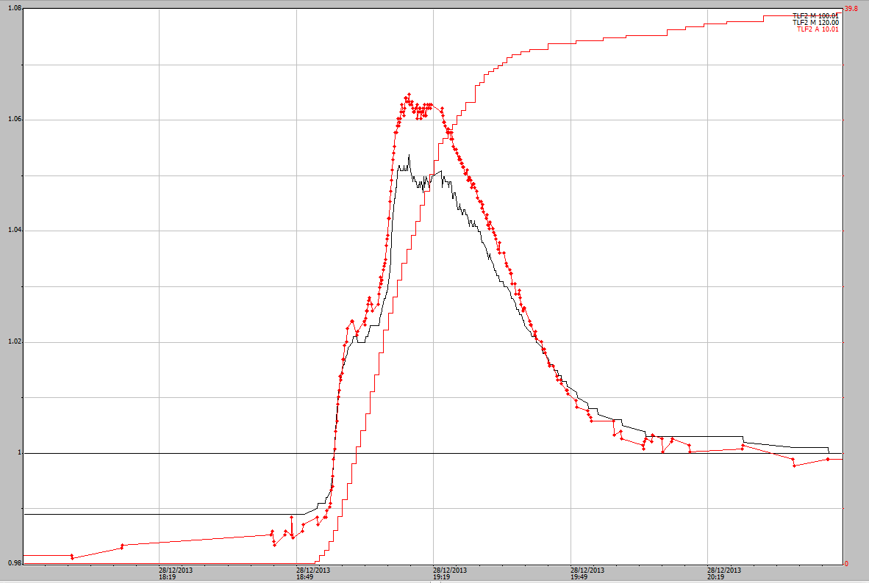

**Figure A3- 25** Event 32 hydrograph from 28 December 2013. Red is the pressure transducer and black is the shaft-encoder.

The shaft encoder should have the higher values from the pressure transducer added.

#### Event 33 – 15 January 2014

Rain started at 10:39 pm until 0:26 am on 15 January (2 hours 5 minutes) during which 63 mm of rain fell. 50 mm of rain fell in an hour period during the main event.

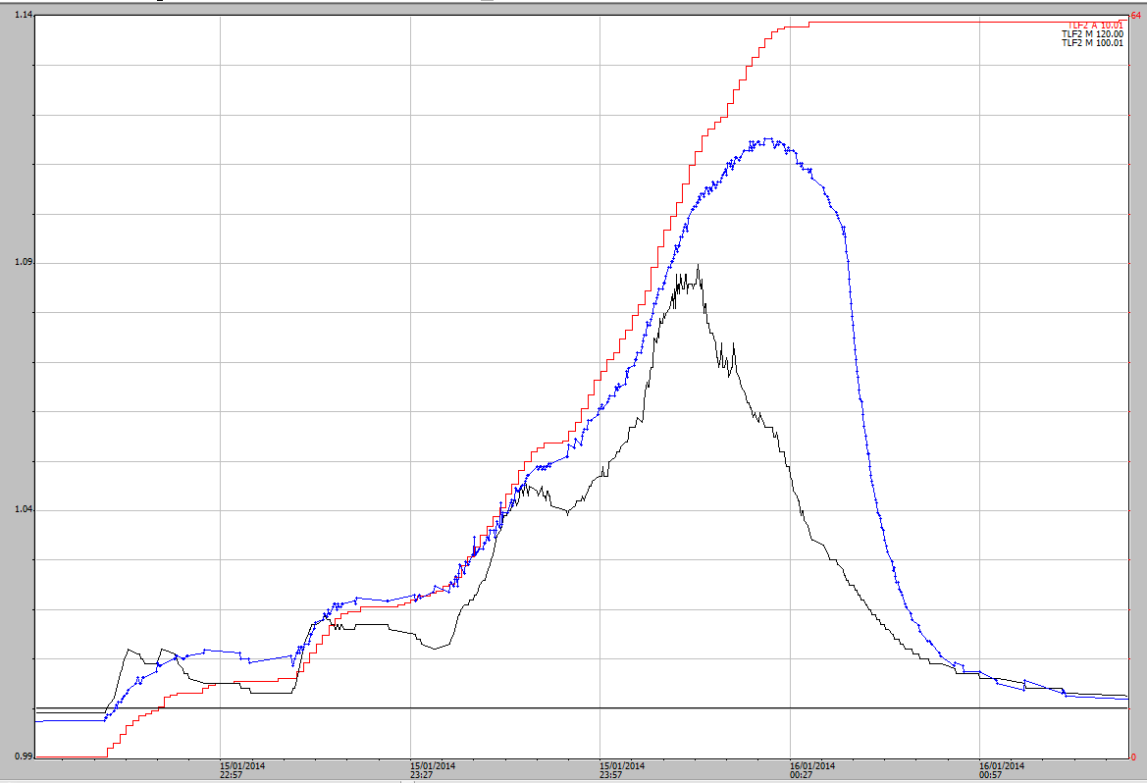

**Figure A3- 26** Event 33 hydrograph from 15 January 2014. Blue is the pressure transducer and black is the shaft-encoder.

Both of the hydrographs look a bit strange. The shaft encoder (black) looks very jagged but appears to tail off when the rain intensity decreases at about 00:14. The pressure transducer appears to rise too long (perhaps) and then drop off very sharply. There is a problem with the recession flow on the pressure transducer. Perhaps the inlet pipes have been blocked. The shaft-encoder should be corrected by best estimate.

#### Event 34 – 16 January 2014

Rain started at 8:51 am until 9:22 am on 16 January 2014 (31 minutes) during which 20 mm of rain fell.

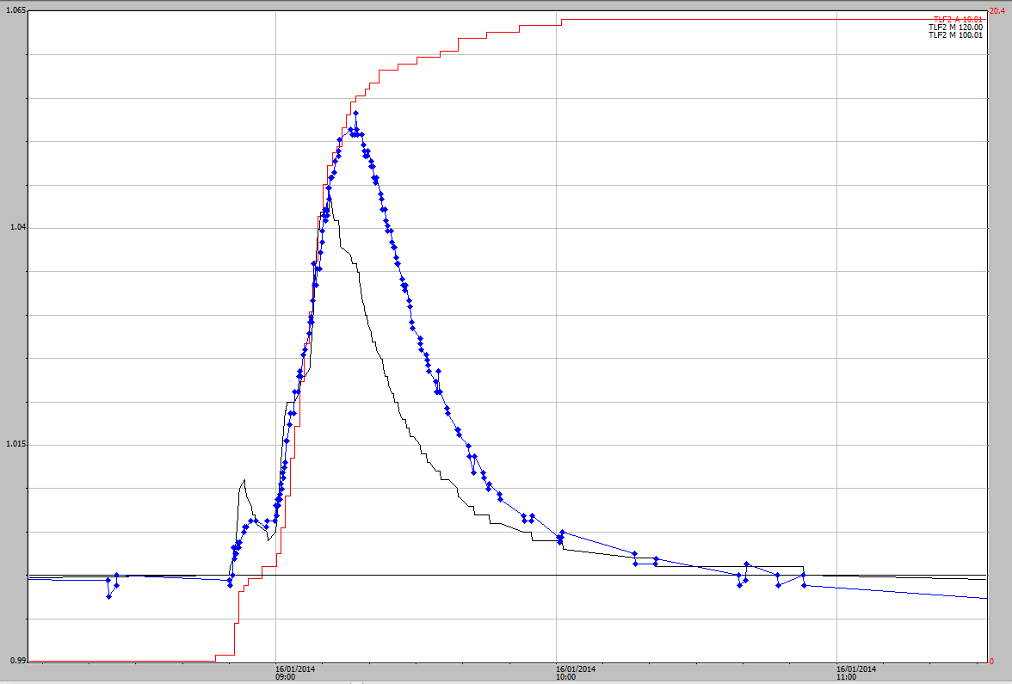

**Figure A3- 27** Event 34 hydrograph from 16 January 2014. Blue is the pressure transducer and black is the shaft-encoder.

Again the pressure transducer lags behind shaft-encoder. Need to have a best estimate to infill the data.

#### Event 35 – 23 January 2014

Rain started at 3:04 pm until 3:43 am on 23 January 2014 (39 minutes) during which 35 mm of rain fell.

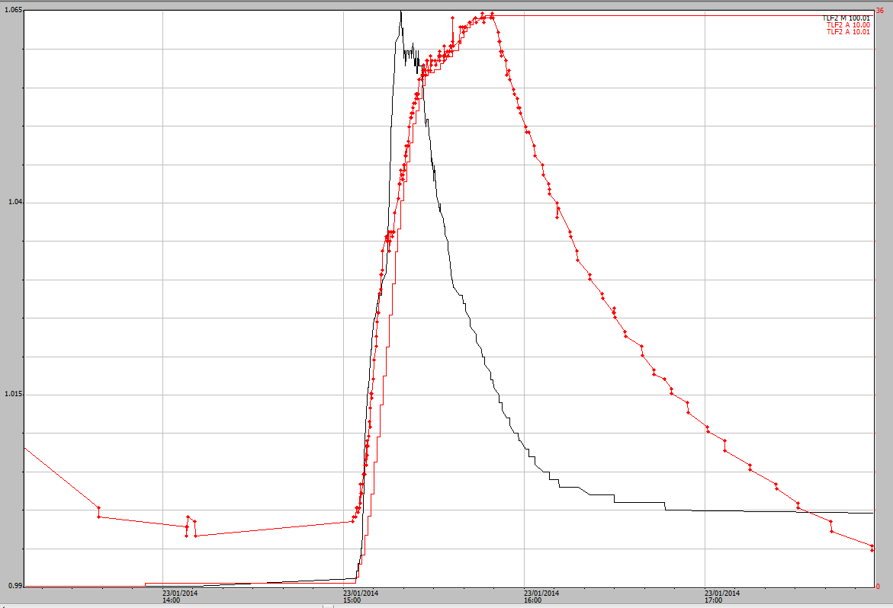

**Figure A3- 28** Event 35 hydrograph from 23 January 2014. Red is the pressure transducer and black is the shaft-encoder.

The pressure transducer trace looks unusual. It is elevated for a longer period than the shaft-encoder indicating a problem. The pressure transducer is not responding as it should with changes in flow. The shaft-encoder vales need to be estimated to match in with the shaft-encoder.

#### Event 36 – 26 January 2014

Rain started at 7:10 pm until 8:20 am on 23 January 2014 (1 hour 10 minutes) during which 30 mm of rain fell.

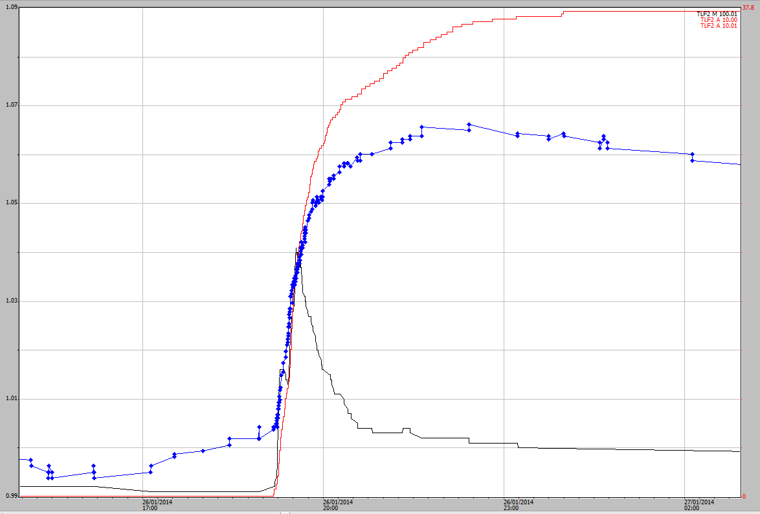

**Figure A3- 29** Event 36 hydrograph from 26 January 2014. Blue is the pressure transducer and black is the shaft-encoder.

There is clearly a problem with the stage trace for the pressure transducer. Given that the peak height of this event was 1.041 it can be left as it is. No correction is required.

#### Event 37 – 30 January 2014

The more intense rain started at 11:14 pm until 00:35 am on 30 January 2014 (1 hour 11 minutes) during which 40 mm of rain fell. There was a total of 60 mm of rain during the event with less intense rain occurring as drizzle before and after the more intense rain.

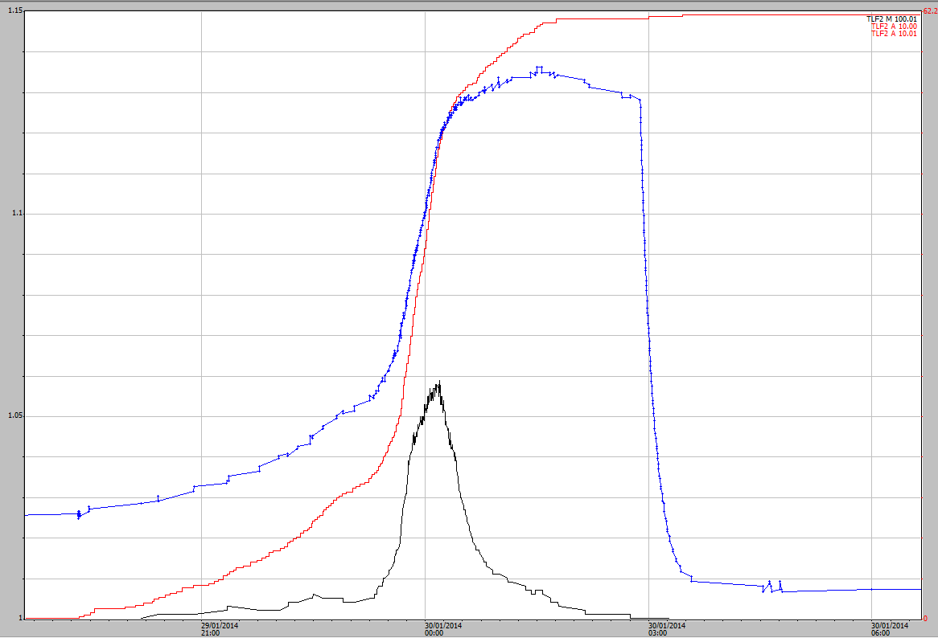

**Figure A3- 30** Event 37 hydrograph from 30 January 2014. Blue is the pressure transducer and black is the shaft-encoder.

There is still clearly a problem with the stage trace for the pressure transducer. The peak of the event for the shaft-encoder should be estimated by eye.

#### Event 38 – 31 January 2014

The rain started at 3:29 pm until 3:42 pm on 31 January 2014 (13 minutes) during which 15 mm of rain fell.

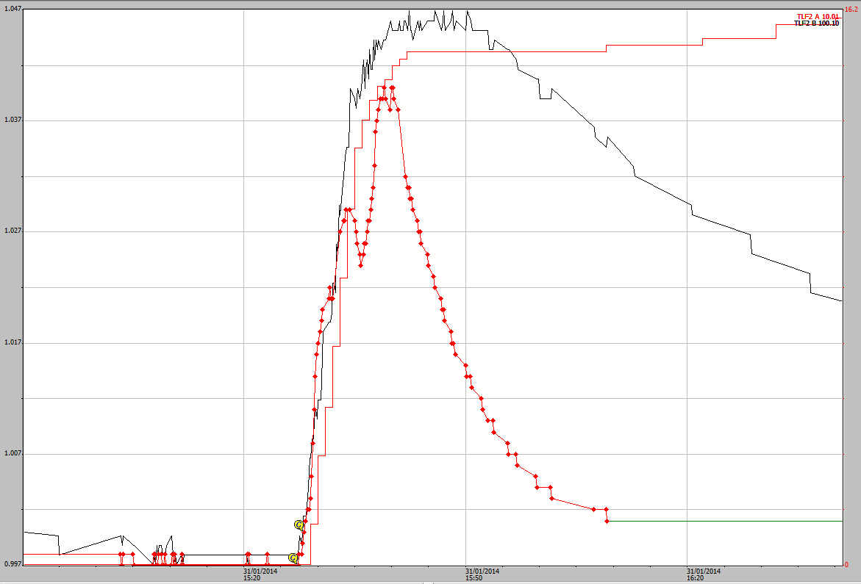

**Figure A3- 31** Event 38 hydrograph from 31 January 2014. Black is the pressure transducer and red is the shaft-encoder.

There is clearly a problem with the stage trace for the pressure transducer. Given that the peak height of this event was 1.040 it can be left as it is. No correction is required.

#### Event 39 – 17 February 2014

The rain started at 1:24 pm until 2:00 pm on 17 February 2014 (36 minutes) during which 28 mm of rain fell.

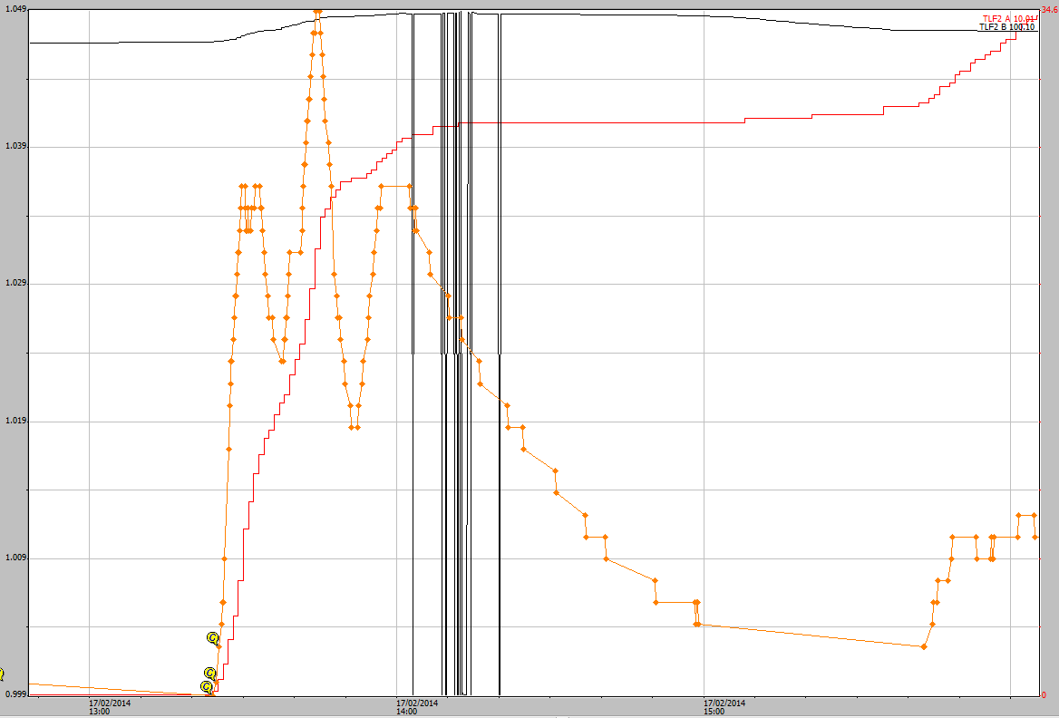

**Figure A3- 32** Event 39 hydrograph from 17 February 2014. Black is the pressure transducer and orange is the shaft-encoder.

The data from the pressure transducer is meaningless (drops down to negative numbers) and cannot be used. The shaft-encoder data looks OK with only a short peak going above 1.040 mm. No corrections are required for this event.

#### Event 40 – 5 March 2014

The more intense rain started at 8:05 pm until 8:53 pm on 5 March 2014 (48 minutes) during which 29 mm of rain fell.

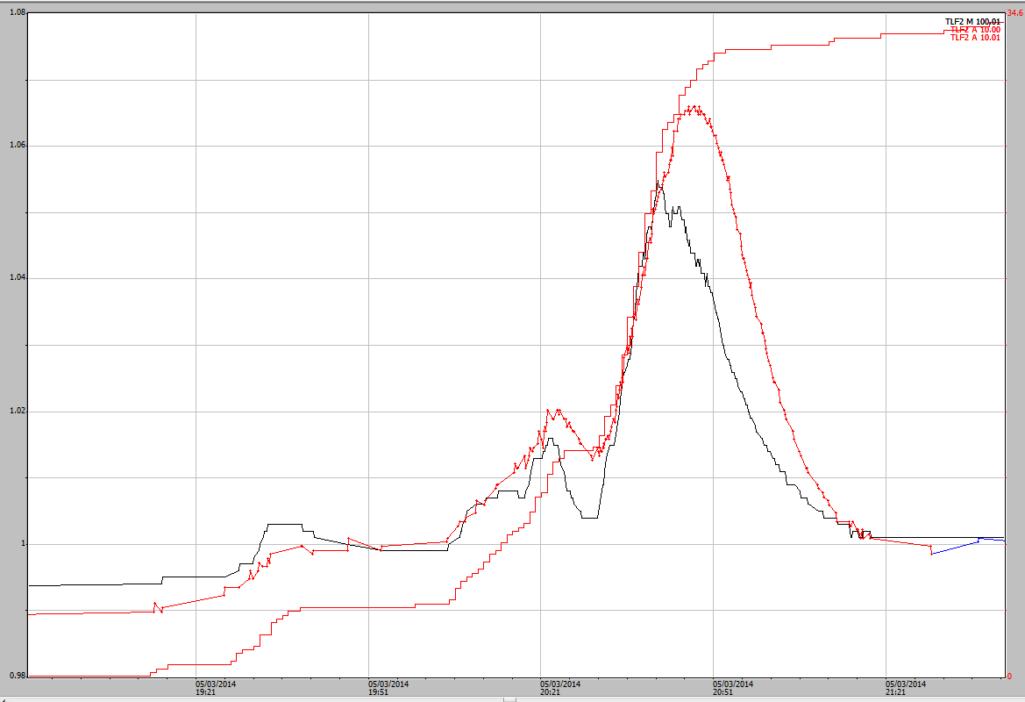

**Figure A3- 33** Event 40 hydrograph from 5 March 2014. Black is the pressure transducer and red is the shaft-encoder.

The shaft-encoder appears to drop off at the maximum intensity of the rainfall this appear rather odd. The height of the pressure transducer should be used to as a guide height for the shaft-encoder, with the line estimated to match in with the shaft-encoder.

#### Event 41 – 7 March 2014

The intense rain started at 10:44 pm until 11:10 pm on 7 March 2014 (26 minutes) during which 40 mm of rain fell.

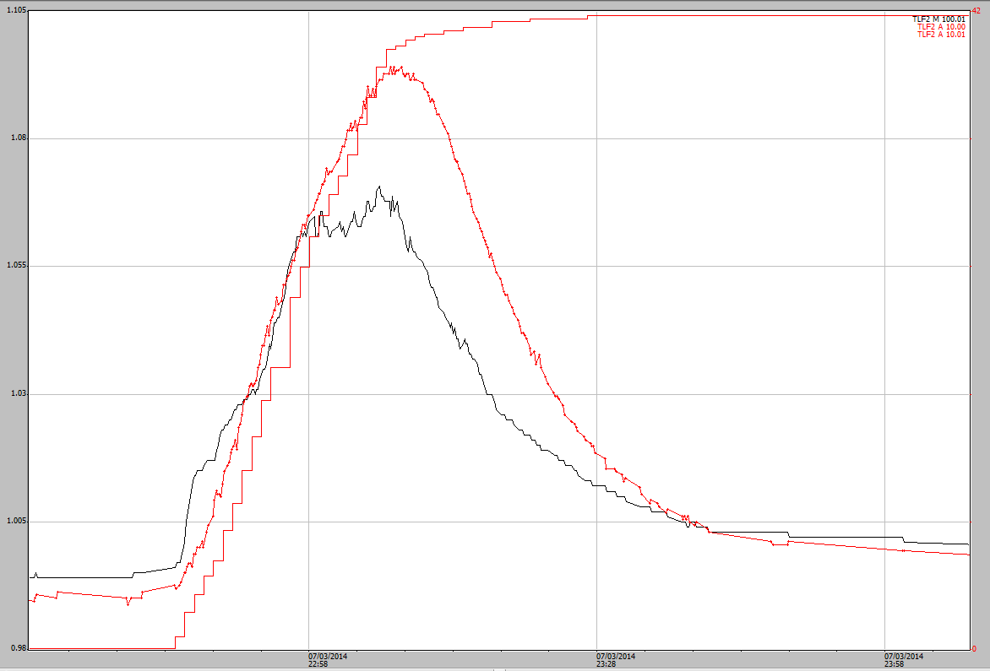

**Figure A3- 34** Event 41 hydrograph from 7 March 2014. Black is the pressure transducer and red is the shaft-encoder.

The pressure transducer should be used as a guide for the shaft-encoder which is very uneven at the top of the peak.

#### Event 42 – 15 March 2014

The rain started at 10:50 pm until 11:15 pm on 16 March 2014 (25 minutes) during which 19 mm of rain fell.

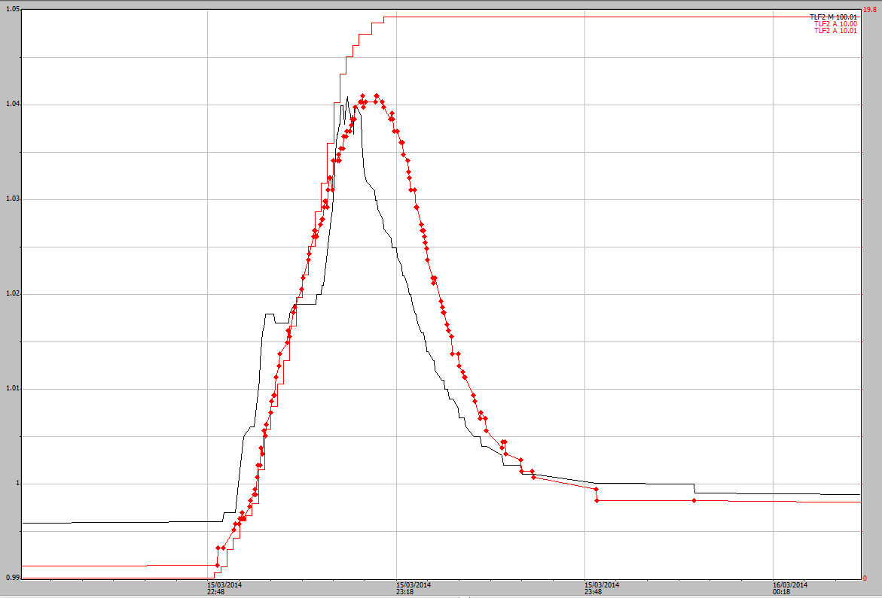

**Figure A3- 35** Event 42 hydrograph from 15 March 2014. Red is the pressure transducer and black is the shaft-encoder.

There is still an issue with the pressure transducer going for a longer time than it should. The top of the shaft-encoder could be smoothed out.

#### Event 43 – 3 May 2014

The more intense rain started at 10:36 pm until 9:46 pm on 16 March 2014 (25 minutes) during which 47 mm of rain fell.

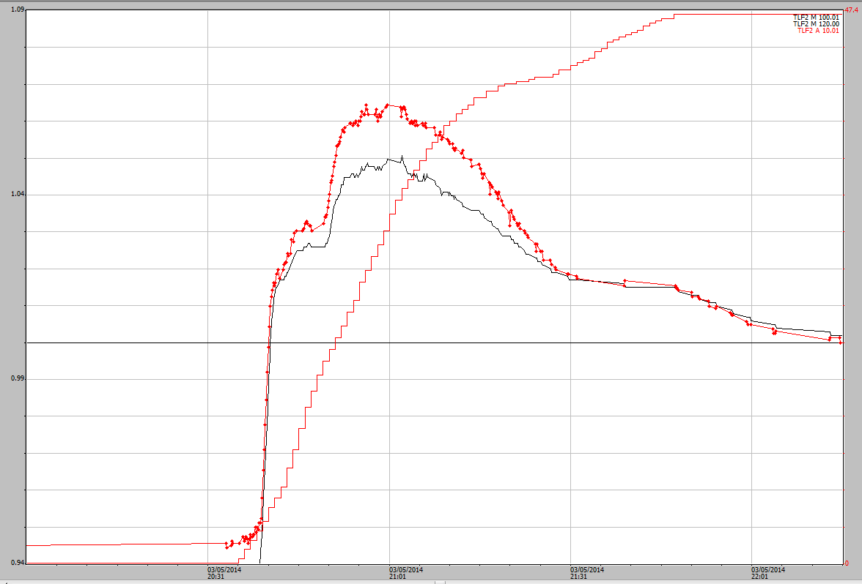

**Figure 36** Event 43 hydrograph from 3 May 2014. Red is the pressure transducer and black is the shaft-encoder.

The pressure transducer should be used as a guide for the shaft-encoder which is very uneven at the top of the peak.

# Appendix 4 – Stage traces for each of the 5 water years 2009–2010 to 2013–2014

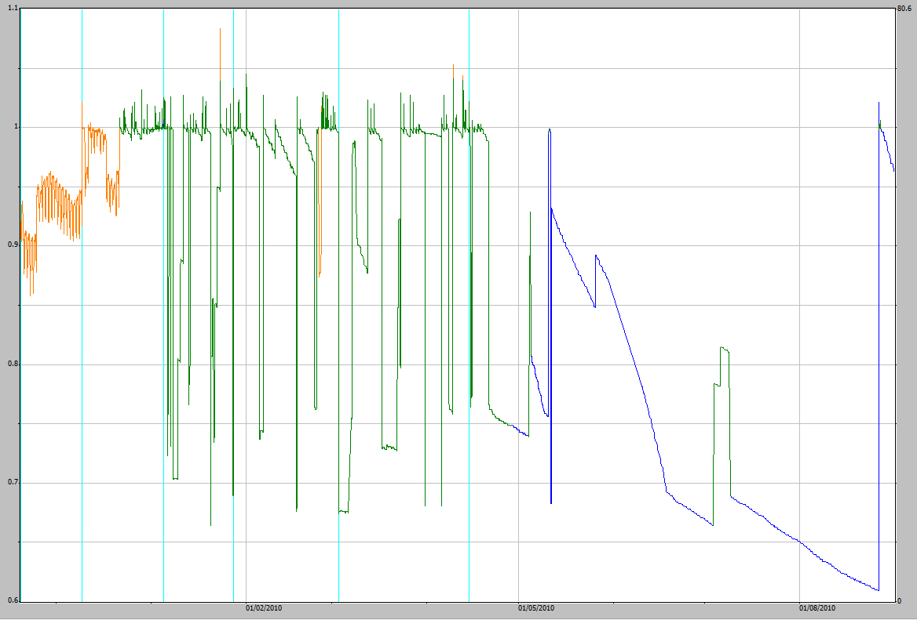

**Figure A4-1** Stage trace for the 2009–2010 water year. The different colours represent different quality codes and the low points are where the basins have been drained to collect the bedload.

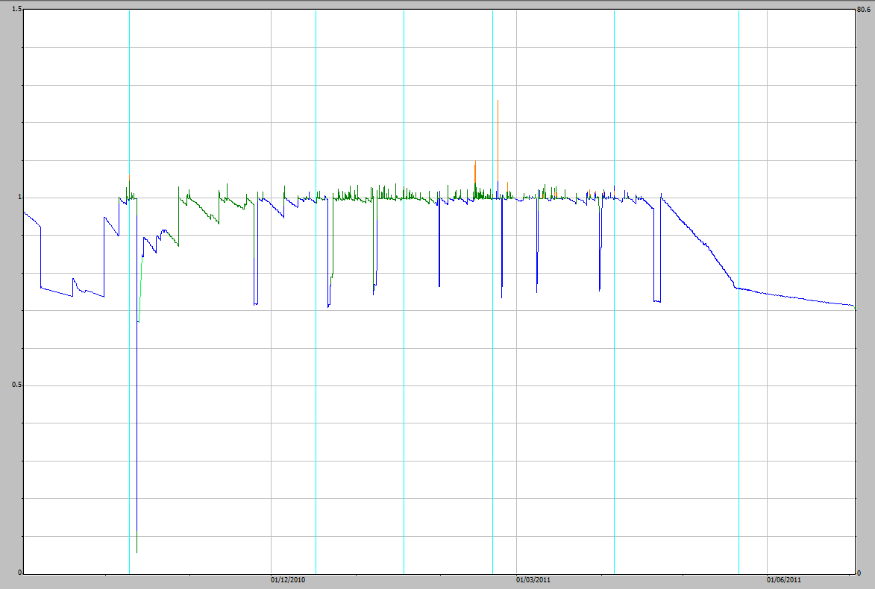

**Figure A4-2** Stage trace for the 2010–2011 water year. The different colours represent different quality codes and the low points are where the basins have been drained to collect the bedload.

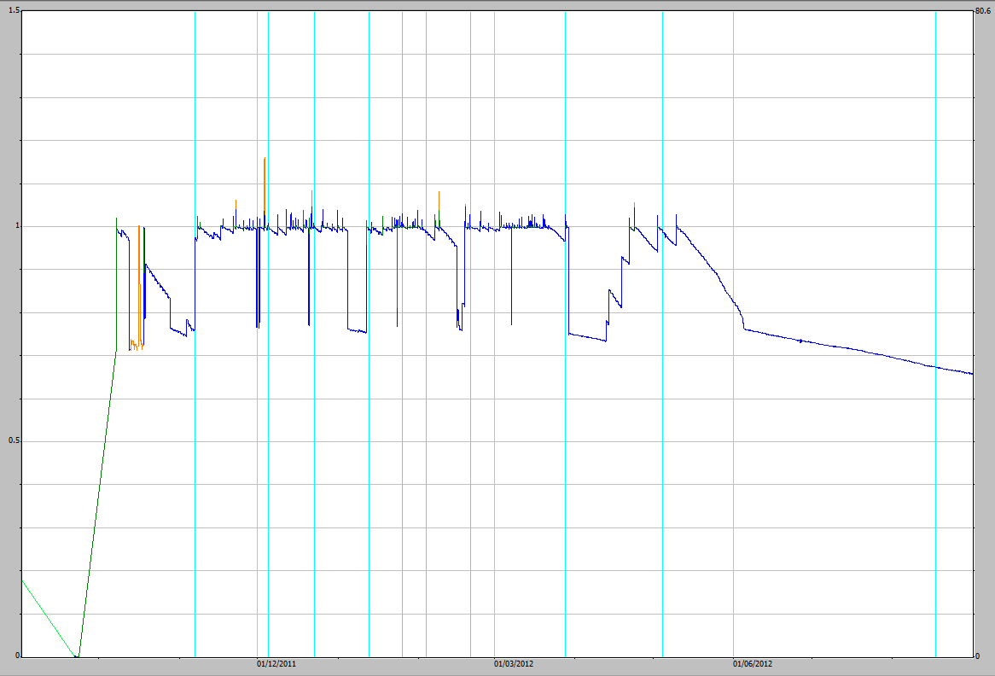

**Figure A4-3** Stage trace for the 2011–2012 water year. The different colours represent different quality codes and the low points are where the basins have been drained to collect the bedload.

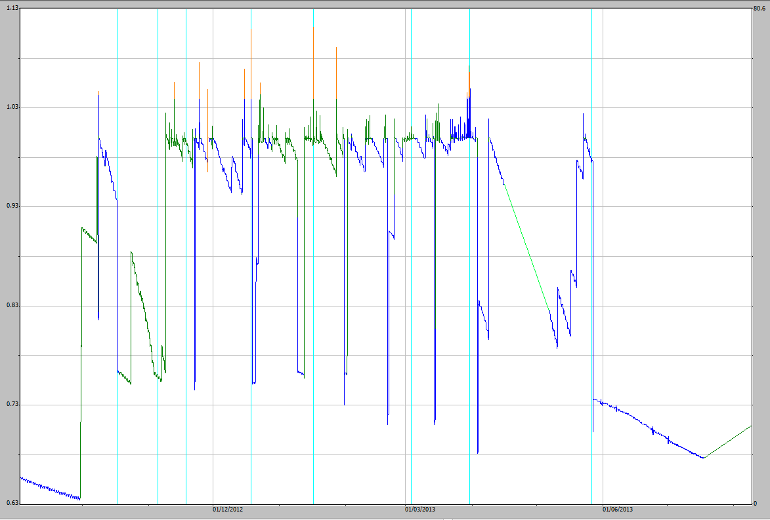

**Figure A4-4** Stage trace for the 2012–2013 water year. The different colours represent different quality codes and the low points are where the basins have been drained to collect the bedload.

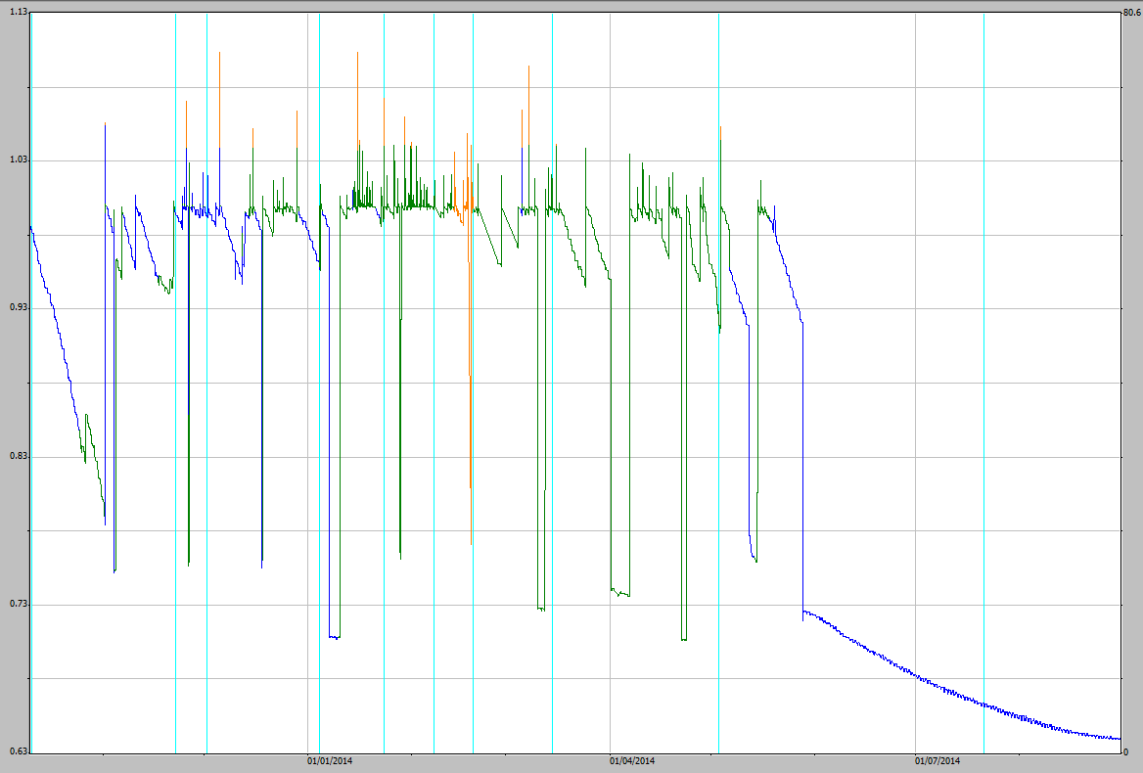

**Figure A4-5** Stage trace for the 2013–2014 water year. The different colours represent different quality codes and the low points are where the basins have been drained to collect the bedload.