Wave-short

633

*internal report*





## A multi–year assessment of landform evolution model predictions for the Ranger trial landform

J Lowry, M Saynor &   
W Erskine

February 2015

Release status – Unrestricted

Project number – RES-2010-007

*This page has been left blank intentionally.*

# A multi–year assessment of landform evolution model predictions for the Ranger trial landform

J Lowry, M Saynor & W Erskine

Supervising Scientist

GPO Box 461, Darwin NT 0801

February 2015

Project number RES-2010-007

(Release status – Unrestricted)



*How to cite this report:*

Lowry J, Saynor M & Erskine W 2015. A multi-year assessment of landform evolution model predictions for the Ranger trial landform. Internal Report 633, February, Supervising Scientist, Darwin.

*Project number: RES-2010-007*

*Authors of this report:*

John Lowry – Environmental Research Institute of the Supervising Scientist, GPO Box 461, Darwin NT 0801, Australia

Dr Mike Saynor – Environmental Research Institute of the Supervising Scientist, GPO Box 461, Darwin NT 0801, Australia

Dr Wayne Erskine – Environmental Research Institute of the Supervising Scientist; GPO Box 461, Darwin NT 0801, Australia

The Supervising Scientist is a branch of the Australian Government Department of the Environment.

Copyright Image.tif

© Commonwealth of Australia 2015

Supervising Scientist

Department of the Environment

GPO Box 461, Darwin NT 0801 Australia

**environment**.gov.au/science/supervising-scientist/publications

IR633 is licensed by the Commonwealth of Australia for use under a Creative Commons By Attribution 3.0 Australia licence with the exception of the Coat of Arms of the Commonwealth of Australia, the logo of the agency responsible for publishing the report, content supplied by third parties, and any images depicting people. For licence conditions see: [http://creativecommons.org/licenses/by/3.0/au/](http://creativecommons.org/licenses/by/3.0/au/%20)

**Disclaimer**

The views and opinions expressed in this publication are those of the authors and do not necessarily reflect those of the Australian Government or the Minister for the Environment.

While reasonable efforts have been made to ensure that the contents of this publication are factually correct, the Commonwealth does not accept responsibility for the accuracy or completeness of the contents, and shall not be liable for any loss or damage that may be occasioned directly or indirectly through the use of, or reliance on, the contents of this publication.

Printed and bound in Darwin NT by Supervising Scientist

# Contents

Acknowledgements iv

Executive summary v

1 Introduction 6

1.1 Background 6

1.1.1 Study site 7

1.1.2 CAESAR–Lisflood model 9

2 Methods 12

2.1 DEM creation 12

2.2 Rainfall and sediment collection 13

2.3 Grain/particle size distribution 14

2.3.1 Weathering 15

2.4 Model scenarios 16

3 Results 17

3.1 Data issues – Plots 3 and 4 17

3.2 Results for Plots 1 and 2 18

4 Discussion 24

References 26

# Acknowledgements

Professor Tom Coulthard (University of Hull, United Kingdom) and Associate Professor Greg Hancock (University of Newcastle, Australia) are both thanked for their continuing and ongoing assistance in the development and application of the CAESAR–Lisflood model for use in assessing the geomorphic stability of a rehabilitated mine landform.

The following current and former staff of Supervising Scientist are thanked for their fieldwork, laboratory analyses, data entry and support: Richard Houghton, Jon Taylor, Kate Turner, Sean Fagan, Michael Fromholtz, Tanya Kerrigan and David Jones.

Energy Resources of Australia Ltd is acknowledged for their assistance in the establishment of the erosion plots, access to the study site and assistance with sample collection.

# Executive summary

This report describes the methodology employed and the results to date of the application of the CAESAR–Lisflood Landform Evolution Model (LEM) to predict soil erosion from four 30 m x 30 m experimental plots constructed on a trial rehabilitated landform at the Ranger Uranium Mine in the Northern Territory, Australia.

The Ranger trial landform plays an important role both in understanding potential erosion rates off a final rehabilitated mine surface and in providing field measurements which can be used to assess the predictions of landform evolution models such as CAESAR-Lisflood. This information in turn fulfils an important part of planning for the rehabilitation of the Ranger mine site through the ability to assess the geomorphic stability of the final landform, over time frames ranging from decades to millennia. While erosion may be monitored and assessed over the short-term (years to decades), the longer term behaviour (centuries to millennia) of such constructed landscapes is not within any meaningful human management timeframe. LEMs can provide information on soil erosion rates at decadal or centennial scales over large spatial scales, and evaluate the sensitivity of these processes to environmental changes. However, an important issue associated with the use of models is the ability to assess the reliability and accuracy of   
the model.

In order to address this, a range of field measurements have been collected and recorded on the trial landform over four wet seasons since 2009. This data is being used to compare and assess model predictions of bedload and suspended sediment loads from the erosion plots for periods of up to 4 years. Once calibrated for the specific site hydrological conditions, the predicted bedload demonstrated an excellent correspondence with the field data.However, longer-term simulations of 10 years identified an exhaustion effect in sediment yield from the landform. These latter results indicate that a weathering function needs to be incorporated into CAESAR–Lisflood to ensure confidence that the CAESAR–Lisflood LEM will be able to correctly predict the long term evolution of a rehabilitated landform once it has been constructed.

A shortened version of this report was included in the peer-reviewed proceedings of the *Life-of-Mine 2014* Conference held in Brisbane. The reference for this publication is:

Lowry J, Saynor M, Erskine W, Coulthard T & Hancock G 2014. A multi-year assessment of landform evolution predictions for a trial rehabilitated landform. In *Life-of-Mine 2014: Delivering sustainable legacies through integrated Life-of-Mine Planning*. Brisbane Australia, 16–18 July 2014, The Australasian Institute of Mining and Metallurgy, Melbourne, Victoria 3053 Australia, pp 67–80.

# 1 Introduction

At the 27th meeting of the Alligator Rivers Region Technical Committee (ARRTC) in December 2011, Energy Resources of Australia (ERA) announced a concerted focus on rehabilitation and closure research needs for the Ranger uranium mine. It was agreed that ERA would identify the key operational and closure-related tasks, and associated knowledge requirements, and prioritise these against the current Key Knowledge Needs (KKNs), specifically KKN 2.2.1 *Landform Design* and KKN 2.2.4 *Geomorphic Behaviour and Evolution of the Final Landform*. It was recognised that the focus on rehabilitation and closure research needs for Ranger would strongly influence, and hence be accounted for in, the future research planning cycles of both ERA and Supervising Scientist (SS).

A key project aims to assess the geomorphic and erosional stability of the Ranger trial landform by integrating digital elevation data and field parameters collected on the trial landform through the application of landform evolution modelling techniques. The landform modelling techniques will focus on the use of the Catchment Automaton Evolutionary Slope And River (CAESAR) model which has been specifically modified to work at the erosion plot scale. Data collected on the trial landform over a period of years will be used to validate the model results by comparing simulated results with observed field measurements of erosion on the trial landform.

The objectives of the project are as follows:

* To assess the geomorphic stability of various surface treatments and vegetation on erosion rates on a trial constructed landform at Ranger mine using landform evolution modelling software.
* Over a period of years, to assess the relative accuracy of simulation outputs by comparing simulated erosion with actual erosion measured on the landform

It is anticipated that the information from this will be used to inform ERA of potential landform design and stability issues for the final landform. Importantly, the methodology and applications developed in this proposal will provide the basis for further assessments of landform stability for a period of 10 000 years.

## 1.1 Background

This project is one of a number of related projects undertaken collaboratively by SSD and ERA that address ARRTC Key Knowledge Need (KKN) 2.2.1 *Landform Design*. Specifically it will provide information on erosion and deposition that has occurred on the trial landform and can be used to determine parameter values for SIBERIA and CAESAR modelling of the final rehabilitated landform. SSD has invested significant resources in assessing, developing, and adapting landform evolution modelling software, such as SIBERIA, and most recently CAESAR, to assess the geomorphic stability of a rehabilitated mine landform, in support of the KKN 2.2.4 *Geomorphic behaviour and evolution of the landform*. Consequently, the construction of the trial landform provides an opportunity to gain an improved understanding not only of the erosive processes likely to be experienced on the final landform, but the responses of the models used to simulate these processes.

Information on the levels of suspended sediment that might be eroded from the final landform will also be useful to assess impacts on aquatic biota downstream.

The mine currently plans to continue production through to 2021 after which the site will be rehabilitated. Given the above-mentioned regional significance, it is important to determine the likely erosional stability of the proposed rehabilitated landform through time, to ensure that post closure environmental protection objectives are met. These state, with respect to mine closure, that:

*“… the operator of the mine shall rehabilitate the Ranger Project Area to establish an environment similar to the adjacent areas of Kakadu National Park such that, in the opinion of the Minister with the advice of the Supervising Scientist, the rehabilitated area could be incorporated into the Kakadu National Park*.” (Supervising Scientist Division, 1999).

The environmental requirements further specify that the final landform should possess “*erosion characteristics which, as far as can reasonably be achieved, do not vary significantly from those of comparable landforms in surrounding undisturbed areas*” (Supervising Scientist Division, 1999).

It is therefore crucial that rehabilitation planning and landform design incorporate landform shape and surface treatments that reduce erosion and minimise the potential release of contaminants. Specifically, erosion should not result in gullying which may expose contained waste material to the environment within a specified time period.

A long-term (5–10 year) collaborative research program involving the Environmental Research Institute of the Supervising Scientist (***eriss***) and ERA, is underway to measure rainfall, runoff, sediment and solute losses, seepage and vegetation establishment from a recently constructed trial rehabilitation landform.

Numerical modelling provides a means for assessing the potential performance of constructed mine landforms. Over the last 40 years a variety of models have been used to evaluate erosion and simulate post mining landscape stability (Evans, 2000; Loch *et al*, 2000). These models include the water erosion prediction programme (WEPP)   
(Laflen *et al*, 1991), universal soil loss equation (USLE), modified universal soil loss equation (MUSLE), revised universal soil loss equation (RUSLE) (Onstad and Foster, 1975; Wischmeier & Smith, 1978; Renard *et al*, 1994), and SIBERIA (Willgoose *et al*, 1989).

The CAESAR–Lisflood model (Coulthard *et al*, 2002, 2013) was originally developed to examine the effects of environmental change on river evolution, and to study the movement of contaminated river sediments. Recently, it has been modified and applied to study the evolution of proposed rehabilitated mine landforms in northern Australia (Hancock *et al*, 2010; Lowry *et al*, 2011, 2013; Saynor *et al*, 2012). In this paper, the CAESAR–Lisflood model has been used to assess potential erosion from purpose-built erosion plots located on a trial rehabilitated landform on the Ranger mine area.

### 1.1.1 Study site

The soil erosion plots providing the input data for this study are located on a much larger trial landform constructed to study rates of soil erosion at the Ranger mine. The trial landform was constructed by ERA between late 2008 and early 2009. It is located to the north-west of the tailings storage facility at Ranger mine (Figure 1).

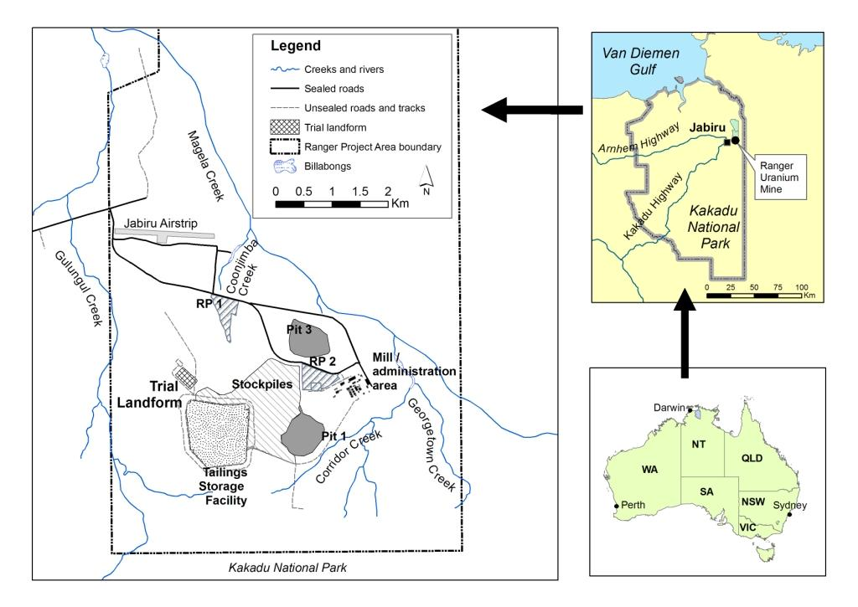

**Figure 1** Location of the Ranger Mine and the Trial Landform

The trial landform covers a total footprint area of 8 hectares. Excluding boundary batter slopes and perimeter access roads the effective top surface area is 6 ha with a mean slope of 4.2%. The landform was designed to test two types of potential final cover material: waste rock alone; and waste rock blended with approximately 30% of fine-grained weathered horizon material (laterite). Following initial construction the surface was ripped along the contour using tynes attached to a large bulldozer. In addition to different types of cover materials, two different planting methods were initially assessed: direct seeding and tubestock. For each cover material, half the area was planted with tubestock with the other half direct seeded. However, because of poor germination, those plots which had been direct seeded were infilled with tubestock in January 2011. ERA intends to use the trial landform to test landform design and revegetation strategies to assist in the development of a robust rehabilitation strategy once mining and milling have finished. In the longer term, the trial landform will be incorporated into the final rehabilitated landform.

During 2009 the Supervising Scientist Division constructed four erosion plots (approximately 30 m x 30 m) on the trial landform surface, with two plots in the area of waste rock, and two in the area of mixed waste rock and laterite (Figure 2). The plots were physically isolated from runoff from the rest of the landform area by constructed borders. The erosion plots were constructed to enable the:

1. Measurement of erosion rates through time to assess effects of different surface treatments and vegetation establishment strategies.
2. Generation of input data for long term predictive geomorphic computer modelling of the proposed landform designs.
3. Determination of loads of sediment and key contaminants present in the dissolved and fine suspended-sediment fractions available for export from the trial landform via the surface water runoff pathway.

The purpose of the trial landform is to test, over the long term, proposed landform design and revegetation strategies for the site, such that the most appropriate ones can be implemented at mine site closure. While ***eriss***is leading the erosion assessment project, and providing most of the staff resources for this aspect of the work, there is also assistance and collaboration being provided by technical staff from ERA. In addition, ***eriss*** is also contributing to the revegetation research component of the trial landform.

As of March 2014, data have now been collected from the trial landform for four complete rainfall years (1 September–31 August) from 2009 (Supervising Scientist, 2013).

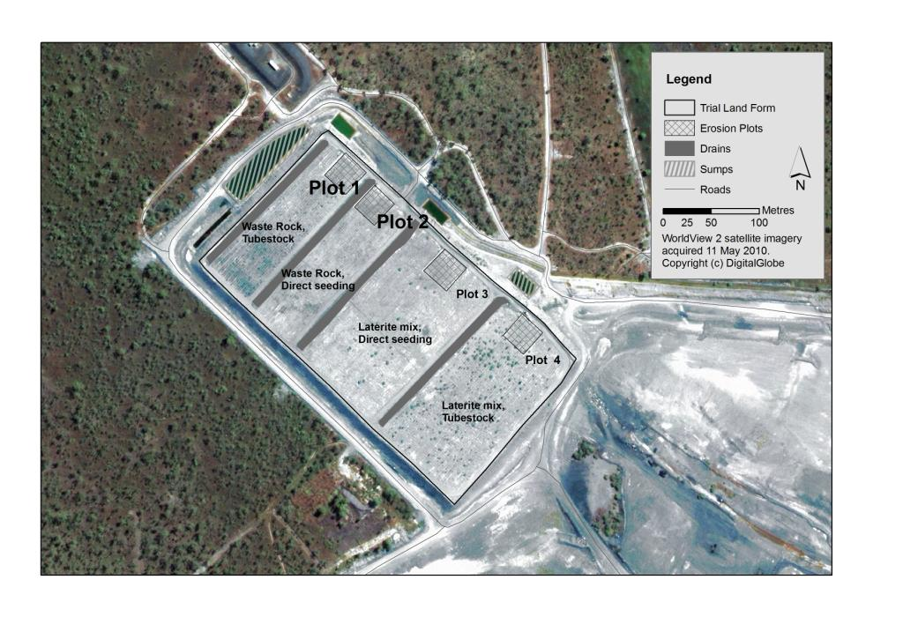

Figure 2 Satellite image and schematic of the trial landform at Ranger mine detailing the size and location of plots 1 and 2.

### 1.1.2 CAESAR–Lisflood model

The CAESAR–Lisflood landscape evolution model (Coulthard *et al*, 2002; 2013, Van de Wiel *et al*, 2007) simulates landscape development by routing water over a regular grid of cells and altering elevations according to erosion and deposition from fluvial and slope processes. CAESAR–Lisflood can be run in two modes: a catchment mode (as used here), with no external in-fluxes other than rainfall; and a reach mode, with one or more points where sediment and water enter the system. For both modes the model requires the specification of several parameters or initial conditions including elevation, grain sizes and rainfall (catchment mode) or a flow input (reach mode). The initial topography of the landscape drives fluvial and hillslope processes that determine the spatial distribution of erosion (loss) and deposition (gain) that occurs during a given time step. This altered topography becomes the starting point for the next time step. Outputs of the model are elevation and sediment distributions through space and time, and discharges and sediment fluxes at the outlet(s) through time. There are four main components to CAESAR–Lisflood: a hydrological model; a flow model; fluvial erosion and deposition; and slope processes.

When running in catchment mode, runoff over the catchment is generated through the input of rainfall data. This is calculated using an adaptation of TOPMODEL (Bevan & Kirkby, 1979) that contains a lumped soil moisture store which when it exceeds a threshold value creates surface runoff. The surface runoff generated by the hydrological model is then routed using a flow model.

For the purposes of this study the CAESAR–Lisflood model was modified to run data recorded at 10 minute intervals, to reflect the much smaller catchment areas modelled, and the corresponding shorter timeframes for system response to rainfall. Rainfall data collected during the 2009–10, 2010–11, 2011–12 and 2012–13 wet seasons from the trial landform surface are used in the simulations reported here.

Flow is the main driver for the geomorphological processes in alluvial environments and CAESAR–Lisflood uses a “flow-sweeping” algorithm, which calculates a steady-state, uniform flow approximation to the flow field. Discharge is distributed to all cells within a 2–5 cell range in front of a cell according to differences in water elevation of the donor cell and bed elevations in the receiving cell. If no eligible receiving cells can be identified in the sweep direction, i.e. if there is a topographic obstruction, then the discharge remains in the donor cells to be distributed in subsequent sweeps (in different directions) during the same scan.

Although flow is the main driver of the model, morphological changes result from entrainment, transport and deposition of sediments. CAESAR–Lisflood can accept up to nine size-based fractions of sediment which are transported either as bed load or as suspended load, depending on the grain sizes. CAESAR–Lisflood provides two different methods of calculating sediment transport, based on the Einstein (1950) and the Wilcock & Crowe (2003) equations. The Einstein (1950) approach was developed based on (predominantly) sand based laboratory channels, whereas the Wilcock and Crowe (2003) formula utilised field and lab data with a coarser bed gravel/sand mix. For this application the Wilcock & Crowe (2003) method was used.

Sediments are transported as either bed load or suspended load. Bedload is distributed proportional to the local bed slope whereas suspended load is routed according to flow velocity. Deposition of sediments also differs between bed load and suspended load. At each time step iteration of the model, all transported bed load material is deposited in the receiving cells where it can be re-entrained in the next iteration. The extent of deposition of suspended sediments at each step is derived from fall velocities and concentrations in suspension for each suspended sediment fraction.

The model allows for sediment heterogeneity and keeps track of nine user-defined grain size fractions. Selective erosion, transport and deposition of these different size fractions will result in spatially variable sediment size distributions. Since this variability is expressed not only horizontally, but also vertically, it requires a method of storing sub-surface sediment data. This is carried out by using a system of layers comprising an active layer representing the stream bed; multiple buried layers (strata); a base layer; and if required an immovable bedrock layer. The layers have a fixed thickness and their position is fixed relative to the bedrock layer. Up to 20 strata can be stored at any cell on the grid. Erosion removes sediment and causes the active layer thickness to decrease. If the thickness becomes less than a threshold value, then the upper stratum is incorporated in the active layer to form a new, thicker active layer. Conversely, deposition adds material to the active layer, causing it to grow. If the active layer becomes greater than a set value a new stratum is created, leaving a thinner active layer.

Limited slope processes are also included, with mass movement when a critical slope threshold is exceeded, together with soil creep, or the movement of rock/soil down a low–grade slope. These allow material from slopes to be fed into the fluvial system as well as the input from landslides (both large scale and small – e.g. bank collapse). After the fluvial erosion/deposition and slope process amounts are calculated, the elevations and grain size properties of the cells are updated simultaneously.

A key attribute of the CAESAR–Lisflood model is the ability to utilise rainfall data recorded at 10 minute intervals from the study area, enabling the modelling of the effects of specific rainfall events. Event modelling is critical, especially for the early stages of landform evolution, since it is recognised that the majority of erosion typically occurs during a limited number of high-intensity events (Moliere *et al*, 2002). As the climatic region in which the Ranger mine occurs is dominated by seasonal, high–intensity rainfall events (McQuade *et al*, 1996), the ability to model specific rainfall events meant that the CAESAR–Lisflood model was the model of choice for this project.

# 2 Methods

The application of the CAESAR–Lisflood model to the trial landform required the collation and integration of data from a range of different sources. The key data inputs used by the model were a digital elevation model (DEM); rainfall data and surface particle size data.

## 2.1 DEM creation

A DEM of the trial landform was produced from data collected by a Terrestrial Laser Scanner in June 2010. The data were captured at two resolutions. Each of the four erosion plots were scanned at a resolution of 2 cm at a distance of 100 metres (Figure 3).

For the purposes of this study, the data for the erosion plots were interpolated to produce a surface grid with a horizontal resolution of 20 cm, to reduce the processing time required by the model. The DEMs were processed using ArcGIS software to ensure that the DEMs were pit-filled and hydrologically corrected. This pit filling was important in order to remove data artefacts in the DEM, which included remnants of vegetation (peaks) as well as artificial depressions, or sinks created through the interpolation of the DEM. Only Plots 1 and 2 were used in this study, as the field-collected hydrological and sediment data for Plots 3 and 4 were not yet available. This meant it was not possible to compare model outputs with field observations for these plots. Plots 1 and 2 have identical dimensions and slopes and are constructed from the same material (i.e. waste rock).

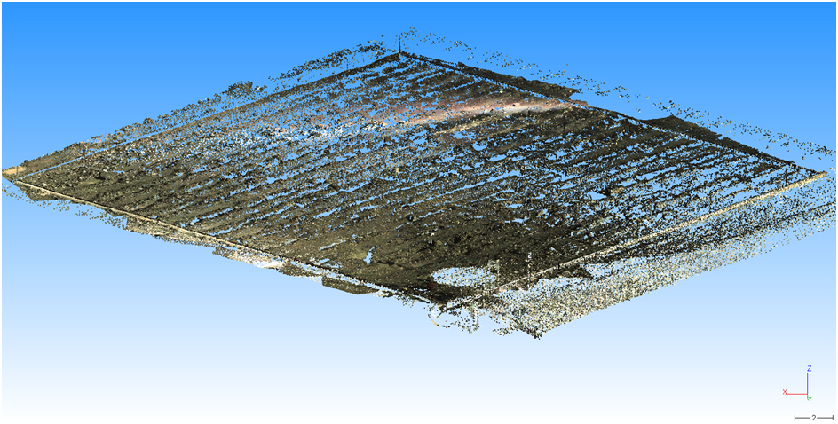

**(a)**

**Figure 3 (a)** Point cloud data gathered for plot 2 and **(b)** the 20 cm DEM generated for erosion plot 2

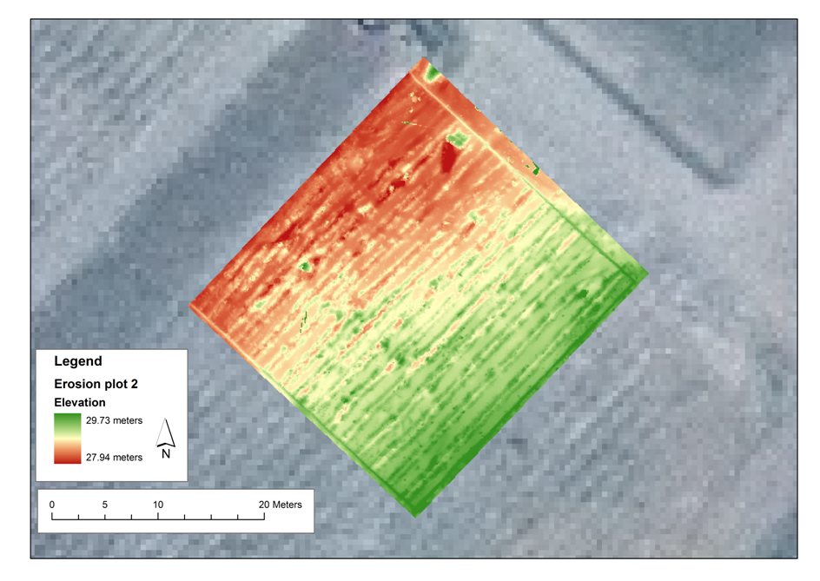

**(b)**

## 2.2 Rainfall and sediment collection

The model outputs were compared with field data collected from the outlet of each erosion plot, which was instrumented with a range of sensors (Figure 4). These included a pressure transducer and shaft encoder to measure stage height; a turbidity probe; electrical conductivity probes located at the inlet to the stilling basin and in the entry to the flume to provide a measure of the concentrations of dissolved salts in the runoff; an automatic water sampler to collect event based samples; and a data logger with mobile phone telemetry connection. Data acquired over the study period from 2009–2013 were stored in the hydrological database, Hydstra.

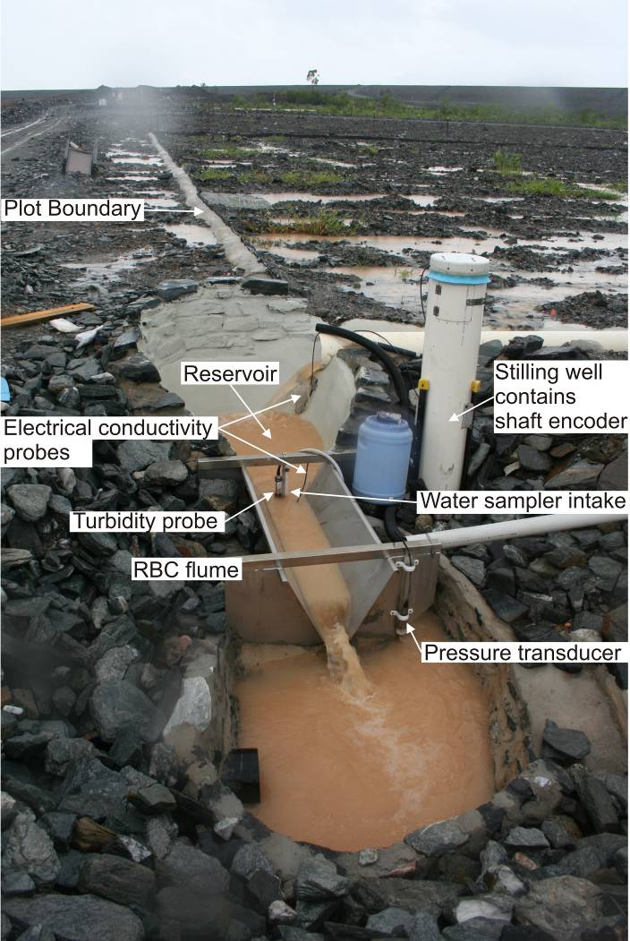

Figure 4 Instrumentation installed on Plot 2

Rainfall measurements were collected by a pluviometer located adjacent to each erosion plot. Rainfall measurements were recorded for each rainfall year between 2009 and 2013, with each rainfall year commencing the 1st of September and running through to the 31st of August of the following year. On the rare occasions when data were not recorded, rainfall measured at the adjacent plot was used to infill the gap. For this study, rainfall for each plot was collated and output at 10 minute intervals.

Bedload data was collected at the end of each fortnight from the collection half pipe that defined the downslope boundary of the plot, and the stilling well upstream of the flume. The collected material was dried, sieved for size classification above 63 µm and weighed. The sub 63 µm fraction is treated as suspended sediment within CAESAR-Lisflood. Turbidity measurements were calibrated to suspended sediment concentrations via collection of water and sediment samples.

## 2.3 Grain/particle size distribution

Using the process described in Saynor & Houghton (2011), the grain size data for CAESAR–Lisflood were obtained from size-fractionated bulk samples of surface material collected at eight points on the waste rock surface of the trial landform. Grain size analysis was completed on these samples and the results averaged into nine grain size classes (Figure 5) which were used for input into CAESAR–Lisflood.

**Figure 5** Grainsize distribution of waste rock used in initial simulations.

The same grain size classes were used for the simulations for Plots 1 and 2.

### 2.3.1 Weathering

The CAESAR–Lisflood model is currently not able to model the weathering of a particular surface cover over time. Rather, if permitted, it will simulate the removal of all the material, until total exhaustion of all sediment occurs.

This was noted to occur after a simulated period of 2 years on both Plot 1 and Plot 2. While field observations show a clear and identifiable decline in sediment yield from the plots in each year, total sediment exhaustion did not occur after 2 years.

To address this limitation, the weathering of the particle sizes modelled was artificially simulated by stopping the simulation at two years. The proportions of the different particles sizes of the waste rock material were then modified, to simulate weathering. This was done by making small reductions in the proportions of the largest particle sizes i.e. reducing the 64mm size class from 30% to 29%, while increasing the proportion of the mid-range particle sizes i.e. increasing the 2 mm and 4mm size classes from 8% to 9% until the modelled values approximated field-based measurements. The revised particle size distribution utilised in the simulation after the second year is shown in Figure 6. The simulation was then restarted, using a simulated two-year old surface and the modified particle size distribution and run for a further 2 years, to match the total period for which field data was available.

**Figure 6** Grainsize distribution of waste rock inserted after 2 simulated years.

## 2.4 Model scenarios

The comparison of CAESAR-Lisflood modelled results and field measurements focussed on Plots 1 and 2 as they had the most complete sets of validated hydrological and measured bedload data, and corrected DEMs at the time of writing.

Five sets of simulations have been conducted for each plot:

1. A four year simulation using rainfall data collected on the landform for the period 2009–13 at intervals of 10 minutes.
2. A 10 year simulation using the 2009–13 rainfall data looped 2.5 times.
3. A 10 year simulation including measured data from an extreme rain event, in which 785 mm fell over 72 h between 17:00 h on 27 February and 17:00 h on 2 March 2007 at Jabiru Airport, inserted in the first year of the simulation.
4. A 10 year simulation in which the 2007 extreme event was inserted in the third year of the simulation.
5. A 10 year simulation in which the 2007 extreme event was inserted in the eighth year of the simulation.

Sediment totals for each of the nine grain size classes and runoff values were recorded from the model at intervals of one day of simulated time. Surface elevations and the distribution of grain sizes for material remaining on the landform were recorded every week of simulated time.

# 3 Results

Annual rainfall and bedload yields for each plot for each water year are contained in Table 1. The 2010–11 water year recorded the highest annual rainfall over the period of study, with up to 944 mm more rainfall falling than in 2012–13, which recorded the lowest annual rainfall. Measured bedload yields were greatest in the 2009–10 year, and declined steadily over the period of study. With exception of Plot 4, the dominant fraction moved in each year on each plot was sand. Over the period 2010–12, the dominant fraction moved in Plot 4 was gravel.

|  |  |  |  |  |  |  |
| --- | --- | --- | --- | --- | --- | --- |
| **Water year** | **Erosion plot** | **Annual rainfall (mm)** | **Annual bedload yield (t/km2.yr)** | **% Gravel  (> 2 mm)** | **% Sand  (< 2 mm &  > 63 µm)** | **% Silt and clay (< 63 µm)** |
| 2009–10 | Plot 1 | 1533 | 106 | 34 | 60 | 6 |
| 2010–11 | Plot 1 | 2227 | 59 | 33 | 64 | 3 |
| 2011-12 | Plot 1 | 1508 | 34 | 44 | 53 | 3 |
| 2012-13 | Plot 1 | 1283 | 28 | 40 | 57 | 3 |
| 2009–10 | Plot 2 | 1531 | 147 | 34 | 55 | 11 |
| 2010–11 | Plot 2 | 2290 | 113 | 40 | 55 | 5 |
| 2011-12 | Plot 2 | 1531 | 48 | 42 | 55 | 3 |
| 2012-13 | Plot 2 | 1274 | 50 | 31 | 65 | 4 |
| 2009–10 | Plot 3 | 1480 | 111 | 37 | 59 | 4 |
| 2010–11 | Plot 3 | 2205 | 54 | 46 | 53 | 1 |
| 2011-12 | Plot 3 | 1456 | 38 | 47 | 52 | 1 |
| 2012-13 | Plot 3 | 1260 | 14 | 45 | 54 | 1 |
| 2009–10 | Plot 4 | 1528 | 143 | 35 | 61 | 4 |
| 2010–11 | Plot 4 | 2296 | 56 | 50 | 49 | 1 |
| 2011-12 | Plot 4 | 1489 | 15 | 50 | 49 | 1 |
| 2012-13 | Plot 4 | 1264 | 14 | 45 | 54 | 1 |

**Table 1** Rainfall, bedload yields and particle size distribution of bedload from the four erosion plots for the 2009–10, 2010–11, 2011–12 and 2012–13 water years (September to August inclusive)

## 3.1 Data issues – Plots 3 and 4

Field discharge data has been collected for Plots 3 and 4. However, while the processing of the data has progressed through 2013–14, the data for these plots have not yet been compiled into a format that would enable the data to be compared with model predictions on discharge for Plots 3 and 4.

Sediment data for Plots 3 and 4 have been collected but have not been processed or analysed. Consequently, it was not possible to compare simulated outputs produced by CAESAR–Lisflood for field observations of these plots.

## 3.2 Results for Plots 1 and 2

The evolution of the landform can be visualised through the generation of elevation surfaces at simulated intervals of 1 week through the period of the CAESAR–Lisflood simulation. The high resolution DEM images in Figures 7 (Plot 1) & 8 (Plot 2) show snapshots of the evolution of the landform surface through the simulated cycle of 4 years. The DEMs show the initial surface; the development of drainage networks after two years; and the final surface after four years in which the tops of the rip lines have been lowered by erosion and the gaps between the rip lines partially infilled.

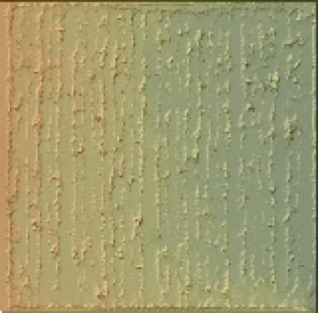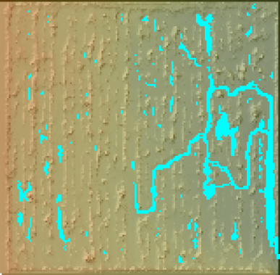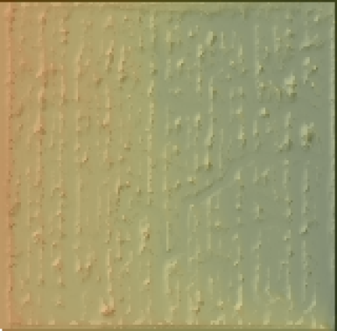

Start 1/9/2009 Plot surface 1/1/2011 Finish 31/8/2013

**Figure 7** Modelled evolution of plot 1 surface over a time period of 4 years.

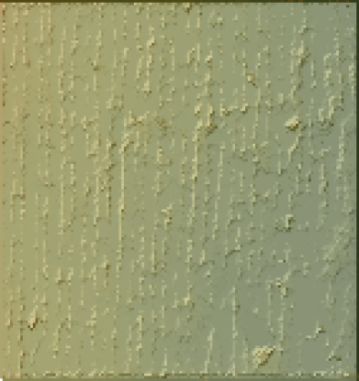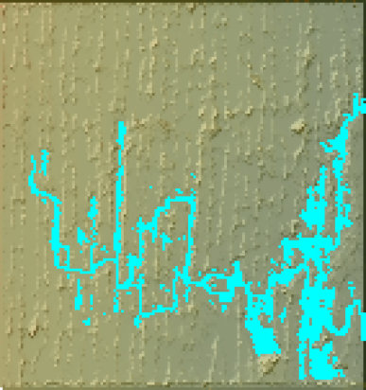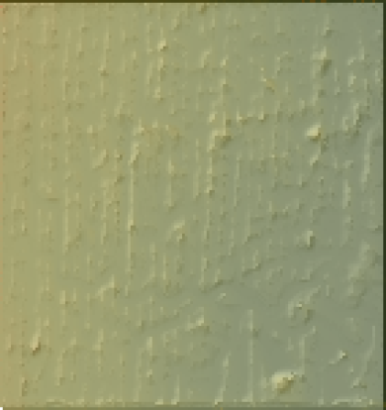

Start 1/9/2009 Plot surface 1/1/2011 Finish 31/8/2013

**Figure 8** Modelled evolution of plot 2 surface over a time period of 4 years.

The four year simulation results for measured and modelled bedload yields are shown in Figures 9 (Plot 1) and 10 (Plot 2). These indicate that after a period of four years, the modelled and measured bedload figures for both plots are within a range of 10% of each other and thus very similar.

**Figure 9** Comparison of modelled cumulative bedload and field-measured cumulative bedload yield for Plot 1.

**Figure 10** Comparison of modelled cumulative bedload and field-measured cumulative bedload yield for Plot 2.

Modelled and measured suspended sediment loads for Plot 1 are shown in Figure 11. Suspended sediment data is not currently available for Plot 2. Over the period of four years, model predictions exceed those of field based measurements. However field data are incomplete, with suspended sediment data unavailable for the 2010–11 year. It is envisaged that once the data becomes available, the final difference between the field and modelled data will be much closer.

**Figure 11** Measured versus modelled prediction of suspended sediment concentrations for   
Plot 1 2009–13.

Comparisons of measured and modelled water discharge from Plot 2 are shown in Figure 12. This shows a high correspondence between the measured and modelled predictions for discharge over the study period. Discharge data for Plot 1 is not yet in a format that would enable comparison with the model output.

**Figure 12** Measured versus modelled prediction of cumulative discharge for Plot 2, 2009–13

Longer term 10 year simulations of Plots 1 and 2 were run utilising the rainfall scenarios described earlier in the methodology section. Both plots returned the same trends in denudation and sediment yield under the different scenarios (Table 2). These show that the addition of an extreme rainfall event after three years produces the greatest increase in sediment yield, whilst the addition of an extreme rainfall event after eight years does not appear to have an impact on the sediment yield or denudation rate.

|  |  |  |  |  |  |
| --- | --- | --- | --- | --- | --- |
|  | | Plot 1 | | Plot 2 | |
|  | Total Load (m3) | | Denudation rate (mm yr-1) | Total Load (m3) | Denudation rate  (mm yr-1) |
| 10 years | 0.38 | | 0.04 | 0.24 | 0.02 |
| 10 years – extreme event in year 1 | 0.44 | | 0.05 | 0.37 | 0.04 |
| 10 years – extreme event in year 3 | 0.54 | | 0.06 | 0.41 | 0.05 |
| 10 years – extreme event in year 8 | 0.38 | | 0.04 | 0.24 | 0.02 |

Table 2 Predicted total loads and denudation rates after 10 years from plots 1 and 2

An exhaustion effect in sediment yield may be seen in each 10-year simulation on both Plots 1 and 2. An example of a 10 year simulation without the inclusion of an extreme rainfall event for Plot 2 is shown in Figure 13. The introduction of an extreme event (utilising the rainfall from February 2007) at the beginning of year 3 and at the end of the simulation period is shown in Figures 14 and 15 respectively. All simulations show a sediment exhaustion effect before the end of the simulation period, regardless of the presence or timing of the extreme event.

**Figure 13** 10 year simulation – Plot 2. No extreme rain event applied.

**Time (Years)**

**Figure 14** 10 year simulation – Plot 2 – extreme rain event after 3 years.

Time (Years)  
  
Figure 15 10 year simulation – Plot 2 – extreme event after 8 years

# 4 Discussion

The predicted bedload yields from CAESAR–Lisflood for the period 2009–2013 correspond well with the field measurements for the same period for both Plots 1 and 2. For the first two years (2009–11), measured cumulative bedload from Plot 1 (Figure 9) was slightly higher than the predicted cumulative bedload. However, at the start of the 2011–12 water year, a spike in predicted bedload yield occurred, which exceeds the measured bedload. This is attributed to a manual (as opposed to automatic) modification in the proportion of the larger particle sizes used in the simulation. The CAESAR–Lisflood model currently does not have a weathering function. Consequently, it was necessary to manually simulate a weathering effect by stopping the simulation after two years, modifying the proportion of the particle size distribution used and restarting the simulation. As described earlier, the revised particle size distribution was derived by altering the proportions of the largest and mid-size classes, until the modelled bedload values approximated those of field measured bedload. After a simulated period of one additional year, a further exhaustion effect appears to reduce further predicted bedload increases, resulting in a final predicted bedload yield which is approximately 3% greater than the final measured bedload yield. The close range of the final bedload yields provides encouragement that the model is able to predict bedload from a rehabilitated surface.

For Plot 2 (Figure 10) the predicted bedload generally compares well with the measured bedload. Compared to Plot 1, the predicted bedload is less than the actual measured throughout the simulated period. However, at the end of the simulation period, the total bedload yield of both the predicted and measured datasets are very close – within 7% of each other.

The denudation rates for Plots 1 and 2 are 0.07 mm/yr and 0.06 mm/yr respectively over a simulated period of four years. These are higher than the published rates   
(0.01–0.04 mm/yr) of natural denudation for the region (Cull et al 1992, Erskine and Saynor 2000). However, it must be noted that the latter were determined from a range of catchments of different size. In this study, each plot represented a closed catchment of approximately 900 m2 with a uniformly very gentle slope and no ability to recharge or replenish the material within the plot.

Comparison of modelled with measured discharge for Plot 2 is shown in Figure 12. Modelled discharge is consistently higher than measured discharge for the 2009–11 period; however this is reversed for the latter two years of the period of simulations. At this stage it is unknown why this is the case and warrants more investigation of all four plots as more validated discharge data becomes available.

Both plots use the same particle size distribution values for model input and the rainfall values are measured but essentially the same because the plots are so close together. However, there is a difference in the DEMs for the two plots. Examination of the DEMs in Figures 7 and 8 shows more, well defined rip lines at the base of Plot 1 than on Plot 2. This observation suggests that differences in the surface topography can substantively influence the predicted results, and may indicate an important sensitivity of the model to this attribute.

The longer (10 year) simulations show a noticeable exhaustion effect in the modelled data (Figure 13), with high sediment outputs in the initial 2 year cycle, and much lower sediment yields in succeeding years. The introduction of the extreme rainfall in year 3 appears to enhance the exhaustion effect (Figure 14), notwithstanding that immediately following this event there is a higher sediment yield. The higher sediment yield in this scenario is attributed to the modification of the particle size distribution after two years, simulating the weathering of the material. Thereafter, the successive rainfall cycles yield little sediment. The introduction of the extreme rainfall event towards the end of the 10 year period (Figure 15) reinforces the predicted sediment exhaustion of the landform after 5 years, with no additional sediment yield ensuing after the extreme event. Indeed, the predicted denudation and sediment yield for this scenario is the same as for the first scenario (no extreme rainfall event at all), indicating that by the time the extreme rainfall event occurs, all available material has been removed from the study plot.

It is important to recognise that several caveats need to be placed on the results produced to date. Foremost amongst them is recognition that the simulations have been done for an ‘idealised’ environment. Specifically, the erosion plots are located on a uniformly gently sloping (4.2%) surface that represents only a component, albeit a substantial fraction, of the total area of the proposed rehabilitated landform. Such a gentle slope is likely to be least susceptible to erosion. The modelled area within each plot boundary assumes no replenishment of material from upslope (or outside the boundaries of the erosion plots), thereby enabling the modelled area to be totally exhausted and as such may not be representative of catchment areas likely to be encountered on a rehabilitated landform.

Finally, this study was conducted at a very high spatial scale (20 cm resolution DEM over a 900 m2 study areas) that will be hard to replicate on a full scale rehabilitated landform. Further work is required to extrapolate the results generated at the plot scale up to the landscape or whole–of–landform scale.

The role of evolving vegetation (both canopy and ground) was not considered in the simulations. However, this is not a particular issue for the initial two years of results presented here as vegetation was not a major feature of the surface landscape. The trial landform at Ranger initially presented a blank canvas with regard to vegetation as just after construction there was no vegetation present. Vegetation was initially established (at lower densities) during the first year and the footprint of canopy cover is increasing each year. This progressive evolution in vegetation cover will need to be incorporated into future runs of the CAESAR–Lisflood model. The field measurements that are being made through time on the erosion plots as the vegetation cover increases will provide an invaluable dataset to improve existing algorithms or develop new ones to better account for the development of vegetation on rehabilitated mine landforms. The sensitivity of erosion rate to slope angle also needs to be implicitly addressed in future modelling runs. Continued monitoring of the trial landform over successive wet seasons will enable the effects of surface weathering, self-armouring, and the development of vegetation cover to be quantified. The collection of field data will enable longer-term comparison of model results and further test the ability of the model to make long term predictions of rates of erosion from rehabilitated mine landforms. These results will also assist with the determination of closure criteria that need to be established for the Ranger site.

Previous studies have focussed on collecting field data to support a specific model application (i.e. SIBERIA). Currently field data is being collected on a stand alone basis and can be used to support a range of model applications. In this case, field measurements closely match predicted outputs of the CAESAR model thereby validating model results over the period of field collection. The development of a weathering module to incorporate into the CAESAR–Lisflood model will provide increased confidence in the ability of CAESAR–Lisflood to predict the long-term stability of a rehabilitated landform.

# References

Bevan K and Kirkby M J, 1979. A physically based contributing area model of basin hydrology. *Hydrological Science Bulletin*, 24:43-69.

Bureau of Meteorology, 2014. Climate statistics for Australian locations – Jabiru Airport. Available at <http://www.bom.gov.au/climate/averages/tables/cw_014198.shtml>

Coulthard T J, Macklin M G, and Kirkby M J, 2002. Simulating upland river catchment and alluvial fan evolution. *Earth Surface Processes and Landforms,* 27, 269-288.

Coulthard T J, Neal J C, Bates P D, Ramirez J, de Almeida G A M and Hancock G R, 2013. Integrating the LISFLOOD-FP 2D hydrodynamic model with the CAESAR model: implications for modelling landscape evolution. *Earth Surface Processes and Landforms*, DOI: 10.1002/esp.3478

Cull R, Hancock G, Johnston A, Martin P, Marten R, Murray A S, Pfitzner J, Warner R F and Wasson R J, 1992. *Past, present and future sedimentation on the Magela plain and its catchment, in Modern Sedimentation and Late Quaternary Evolution of the Magela Plain* (ed: R J Wasson), pp. 226–268, Supervising Scientist for the Alligator Rivers Region Research Report 6, AGPS, Canberra.

Einstein H A 1950. The Bedload Function for Sediment Transport in Open Channel Flow, *Soil Conservation Technical Bulletin* No. 1026, U.S. Department of Agriculture, Washington, DC.

Erskin W D and Saynor M J, 2000. *Assessment of the off-site geomorphic impacts of uranium mining on Magela Creek, Northern Territory, Australia*, Supervising Scientist Report 156, Supervising Scientist, Darwin.

Evans K G, 2000. Methods for assessing mine site rehabilitation design for erosion impact, *Australian Journal of Soil Research*, 38(2), pp. 231–248.

Hancock G R, Lowry J B C, Coulthard T J, Evans K G and Moliere D R 2010. A catchment scale evaluation of the SIBERIA and CAESAR landscape evolution models, *Earth Surface Processes and Landforms*, Vol. 35, pp. 863–875.

Jones D R, Humphrey C, van Dam R, Harford A, Turner K and Bollhoefer A, 2009. Integrated chemical, radiological and biological monitoring for an Australian uranium mine - a best practice case study in *Proceedings International Mine Water Conference*, 19-23 October, Pretoria, South Africa 95-104.

Laflen J M, Elliot W J, Simanton J R, Holzhey C S and Kohl K D 1991. WEPP soil erodibility experiments for rangeland and cropland soils, *Journal of Soil and Water Conservation* 39-34.

Loch R J, Connolly R D and Littleboy M, 2000. Using rainfall simulation to guide planning and management of rehabilitated areas: Part 2, Computer simulations using parameters from rainfall simulation, *Land Degradation and Development*, Vol. 11(3), pp. 241–255.

Lowry J B C, Coulthard T J, Hancock G R, Jones D R 2011. Assessing soil erosion on a rehabilitated landform using the CAESAR landscape evolution model, in *Proceedings of the 6th International Conference on Mine Closure*, (eds: A B Fourie, M Tibbett and A Beersing) 18–21 September 2011, Australian Centre for Geomechanics, Perth, pp. 613–6213–212.

Lowry J B C, Coulthard T J, Hancock G R, 2013. Assessing the long–term geomorphic stability of a rehabilitated landform using the CAESAR–Lisflood landscape evolution model, in *Proceedings of the 8th International Conference on Mine Closure* (eds: M Tibbett, A B Fourie, and C Digby) 18–20 September 2013, Australian Centre for Geomechanics, Perth, pp. 611–624.

McQuade C V, Arthur J T and Butterworth I J, 1996. Climate and hydrology, in *Landscape and Vegetation of the Kakadu Region, Northern Australia*, (eds: C.M. Finlayson and I. von Oertzen), Kluwer Academic Publishers, Dordrecht, pp. 17–35.

Moliere D R, Evans K G, Willgoose G R and Saynor M J, 2002. Temporal trends in erosion and hydrology for a post-mining landform at Ranger Mine. Northern Territory. Supervising Scientist Report 165, Supervising Scientist, Darwin.

Onstad C A. and Foster G R (1975) Erosion modelling on a watershed, *Transactions of the American Society of Agricultural Engineers*, Vol. 26, pp. 1102–1104.

Saynor M J and Houghton R 2011. *Ranger trial landform: particle size of surface material samples in 2009 with additional observations in 2010*. Internal Report 596, August, Supervising Scientist, Darwin.

Saynor M J, Lowry J B C, Erskine W D, Coulthard T, Hancock G, Jones D R and Lu P, 2012. Assessing erosion and run-off performance of a trial rehabilitated mining landform. *Life of Mine Conference*, Brisbane Queensland 10–12 July 2012.

Supervising Scientist Division 1999. *Environmental Requirements for the Ranger Uranium Mine*, Department of Sustainability, Environment, Water, Populations and Communities, viewed 7 February 2014, [http://www.environment.gov.au/  
resource/environmental-requirements-ranger-uranium-mine](http://www.environment.gov.au/resource/environmental-requirements-ranger-uranium-mine)

Supervising Scientist 2013. *Annual Report 2012–13*. Supervising Scientist Division, Darwin.

Renard KG, Laflen J M, Foster G R and McCool D K 1994. The revised universal soil loss equation. In Lal, R. (ed.) *Soil Erosion Research Methods* (ed: R. Lal), Soil and Water Conservation Society, Ankeny, 2nd ed., 105–124.

Van De Wiel M J, Coulthard T J, Macklin M G and Lewin J, 2007. Embedding reach-scale fluvial dynamics within the CAESAR cellular automaton landscape evolution model. *Geomorphology*, Vol. 90 (3–4), pp. 283–301.

Wilcock P R and Crowe J C 2003. Surface-based transport model for mixed-size sediment, *Journal of Hydraulic Engineering*, Vol. 129, pp. 120–128.

Willgoose G R, Bras R L and Rodriguez-Iturbe I, 1989. *A physically based channel network and catchment evolution model*, TR 322, Ralph M. Parsons Laboratory, Department of Civil Engineering, MIT, Boston, USA, 464p.

Wischmeier W H and Smith D D, 1978. *Predicting rainfall erosion losses – a guide to conservation planning, Agriculture* Handbook No. 537.2, US Department of Agriculture, 85p.