Wave-short

635

*internal report*

Gamma dose rates and radon-222 exhalation flux densities at El Sherana containment in 2017

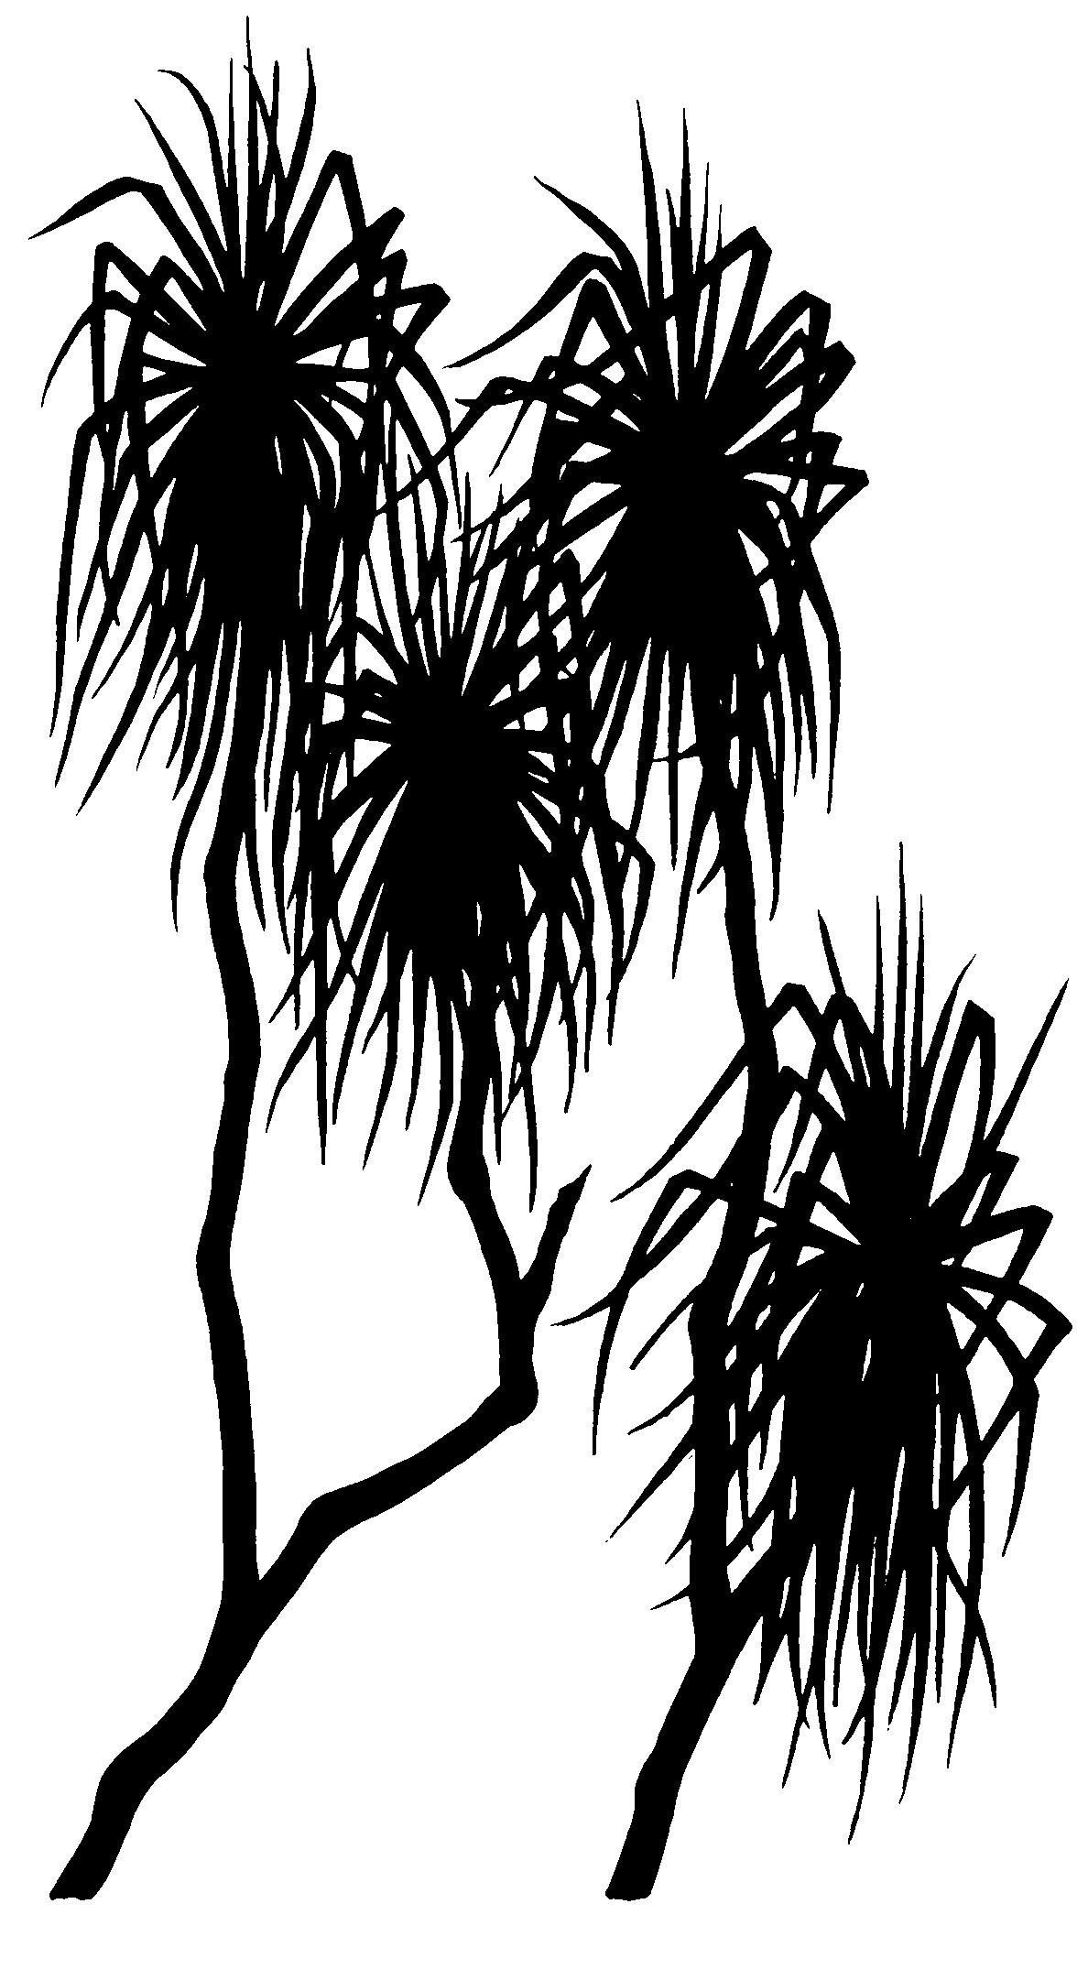



Che Doering, Peter Medley, Jefferson Chen

August 2017

Release status – Unrestricted

Project number – MON-2013-006

*The Department acknowledges the traditional owners of country throughout Australia and their continuing connection to land, sea and community. We pay our respects to them and their cultures and to their elders both past and present.*

# Gamma dose rates and radon-222 exhalation flux densities at El Sherana containment in 2017

Che Doering, Peter Medley, Jefferson Chen

Supervising Scientist

GPO Box 461, Darwin NT 0801

August 2017

(Release status – Unrestricted)



*How to cite this report:*

Doering C, Medley P, & Chen J, 2017. Gamma dose rates and radon-222 exhalation flux densities at El Sherana containment in 2017. Internal Report 635, August, Supervising Scientist, Darwin.

*Project number: (MON-2013-006)*

*Authors of this report:*

Che Doering –Supervising Scientist, GPO Box 461, Darwin NT 0801, Australia

Peter Medley –Supervising Scientist, GPO Box 461, Darwin NT 0801, Australia

Jefferson Chen –Supervising Scientist, GPO Box 461, Darwin NT 0801, Australia

Supervising Scientist is a branch of the Australian Government Department of   
the Environment and Energy.

Supervising Scientist   
Department of the Environment and Energy   
GPO Box 461, Darwin NT 0801 Australia

**environment**.gov.au/science/supervising-scientist/publications

© Commonwealth of Australia 2017

Copyright Image.tif

IR635 is licensed by the Commonwealth of Australia for use under a Creative Commons By Attribution 3.0 Australia licence with the exception of the Coat of Arms of the Commonwealth of Australia, the logo of the agency responsible for publishing the report, content supplied by third parties, and any images depicting people. For licence conditions see: http://creativecommons.org/licenses/by/3.0/au/

**Disclaimer**

The views and opinions expressed in this publication are those of the authors and do not necessarily reflect those of the Australian Government or the Minister for the Environment and Energy.

While reasonable efforts have been made to ensure that the contents of this publication are factually correct, the Commonwealth does not accept responsibility for the accuracy or completeness of the contents, and shall not be liable for any loss or damage that may be occasioned directly or indirectly through the use of, or reliance on, the contents of this publication.

# Contents

Gamma dose rates and radon-222 exhalation flux densities at El Sherana containment in 2017 i

Contents iii

Executive summary iv

1 Introduction 5

2 Methods 5

2.1 Radon-222 exhalation flux densities 5

2.2 Gamma dose rates 6

3 Results and discussion 7

4 Conclusion 9

References 10

Appendix 1 Gamma and radon-222 measurements 11

# Executive summary

Gamma dose rates and radon-222 exhalation fluxes are measured at the El Sherana containment every two years to provide ongoing assurance that radioactive waste material buried at the facility does not present an unacceptable radiation health risk to Parks Australia employees or the public. This report presents the measurements from June 2017, the fifth set of measurements since construction of the containment in 2009. Average gamma dose rates and radon-222 exhalation flux densities in 2017 were no different to baseline values in 2007 before the containment was built. Consequently, the levels measured in 2017 would not result in above-background doses to Parks Australia employees or the public above the dose constraint of 30 µSv per year. The implication of these results is that there is currently no unacceptable radiation health risk associated with buried radioactive waste material at the containment.

# Introduction

The El Sherana containment is a near-surface disposal facility located in the South Alligator River valley in the southern part of Kakadu National Park. It was constructed in the 2009 dry season and contains approximately 22,000 m3 of radioactively contaminated waste from the remediation of legacy uranium mining and processing sites in the area. Engineering details of the containment are summarised in Doering et al (2011) and Bollhöfer et al (2013, 2015). The uranium mining history of the South Alligator River valley is summarised in Waggitt (2004).

The El Sherana containment is currently in the institutional control period, during which time, public access to the site must be restricted and the site must not be used for other purposes (NHMRC 1993). The site is managed by the Director of National Parks, with regulatory oversight by the Australian Radiation Protection and Nuclear Safety Agency (ARPANSA). The Supervising Scientist assists the Director of National Parks with radiological monitoring of the site by conducting biennial measurements of gamma dose rates and radon-222 exhalation flux densities.

A dose constraint of 30 µSv y-1 for both public and occupational exposure has been set for the El Sherana containment based on an assessment of plausible exposure scenarios Bollhöfer et al (2013). The dose constraint represents an upper bound on the expected above-background doses from the containment and a level below which radiation exposures should be optimised (ICRP 2007).

This report presents the results of gamma dose rate and radon exhalation flux density measurements conducted in June 2017 and compares them to previous measurement results, including baseline values measured in 2007. Based on these results, we have determined the potential for above-background radiation doses to workers and the public, and also the acceptability of such exposures in the context of the dose constraint.

# 2 Methods

## 2.1 Radon-222 exhalation flux densities

Radon-222 exhalation flux densities were measured over the period 8–14 June 2017. The prevailing meteorological conditions during the measurement period were typical of the tropical Northern Territory dry season, with maximum daytime temperatures around 30°C and zero rainfall.

Brass canisters containing activated charcoal were used for field sampling of radon-222 exhalation flux densities. The canisters were prepared by heating in an oven at 110°C for 48 hours to drive out residual radon-222 adsorbed on the surface of the charcoal. They were then allowed to cool to room temperature and immediately sealed for transport to the field.

Forty six canisters were deployed on and around the containment and their geospatial coordinates recorded using a global positioning system (GPS). The canisters were embedded in the ground surface to a depth of approximately 1 cm to trap exhaling radon-222. Two additional canisters were carried into the field but remained sealed at all times. These canisters were ‘controls’ and used to determine the background activity of radon-222 on the charcoal.

At the end of the sampling period, the canisters were removed from the ground surface and immediately sealed for transport back to the laboratory. They were then counted for a period of 600 s on a sodium iodide detector and the resulting energy spectrum displayed on a multi-channel analyser. The control canisters were also counted. Regions of interest were established around the characteristic photopeaks of the radon-222 decay products lead-214 (242 keV, 295 keV and 352 keV) and bismuth-214 (609 keV). The net count rate of these decay products in the field samples was determined by summing the total counts under each photopeak and then subtracting the arithmetic mean of the total counts under the corresponding regions of interest for the two control canisters. The counting efficiency of the detector was determined to be 10.3% using a sealed canister containing charcoal spiked with a known activity of radium-226, the parent radionuclide of radon-222.

Radon-222 exhalation flux densities were calculated following the method described in Spehr & Johnston (1983) as:



where *J* (Bq m-2 s-1) is the average radon-222 flux density, *R* (s-1) is the net count rate of radon-222 decay products, *tc* (s) is the counting period, *λ* (s-1) is the radon-222 decay constant, *td* (s) is the delay period from the end of sampling to the beginning of counting, *ε* (s-1 Bq-1) is the counting efficiency of the detector, *a* (m2) is the area of the open face of the canister when embedded in the ground and *ts* (s) is the duration of the sampling period.

## 2.2 Gamma dose rates

Total gamma counts were measured on 8 June 2017 at each location where charcoal canisters were deployed. The count time was 60 s and the height of the measurement was approximately 1 m above the ground surface. Two RadEye GX meters with an attached Mini Instrument MC70 Geiger Müller tube were used to make the measurements. One meter (GM2) was calibrated by an external laboratory (SafeRadiation) against a certified radiation source and the other meter (GM3) was cross-calibrated to the first. The ratio of counts recorded by meter GM3 to meter GM2 during the cross-calibration was 0.934. This ratio was subsequently used to normalise field counts recorded by GM3 to GM2. Gamma counts recorded by both meters during the field survey were then converted to an absorbed dose rate using:

$$D=\frac{C}{T}×\frac{1}{14.0}×\frac{1}{1.21}$$

where:

*D* (µGy h-1) is the absorbed dose rate;

*C* (counts) is the number of counts recorded by the meter normalised to GM2;

*T* (s) is the time over which field counts were recorded;

14.0 (counts s-1 per µSv h-1) is the count rate to effective dose rate conversion factor reported on the calibration certificate of GM2; and

1.21 (Sv Gy-1) is the to effective to absorbed dose conversion factor reported on the calibration certificate of GM2.

# 3 Results and discussion

Figure 1 shows the location and magnitude of the radon-222 exhalation flux density measurements and Figure 2 shows the gamma dose rate measurements. Data underpinning the figures have been provided in Appendix 1.

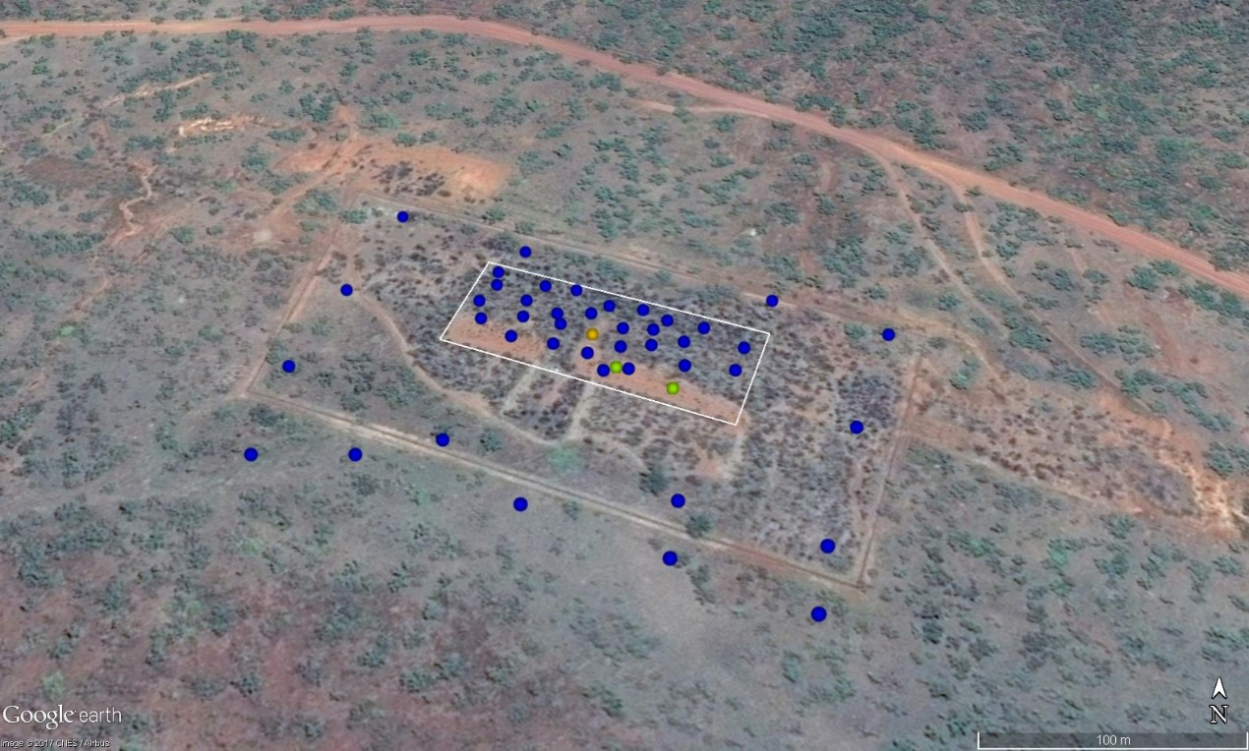

|  |  |
| --- | --- |
| **Radon flux (mBq m-2 s-1)** | |
| ● | <50 |
| ● | 50–100 |
| ● | 100–250 |
| ● | 250–500 |
| ● | >500 |

**Figure 1** Radon-222 exhalation flux densities at El Sherana containment in 2017. The white rectangle shows the approximate outline of the containment. The fence line of the facility is visible in the image.

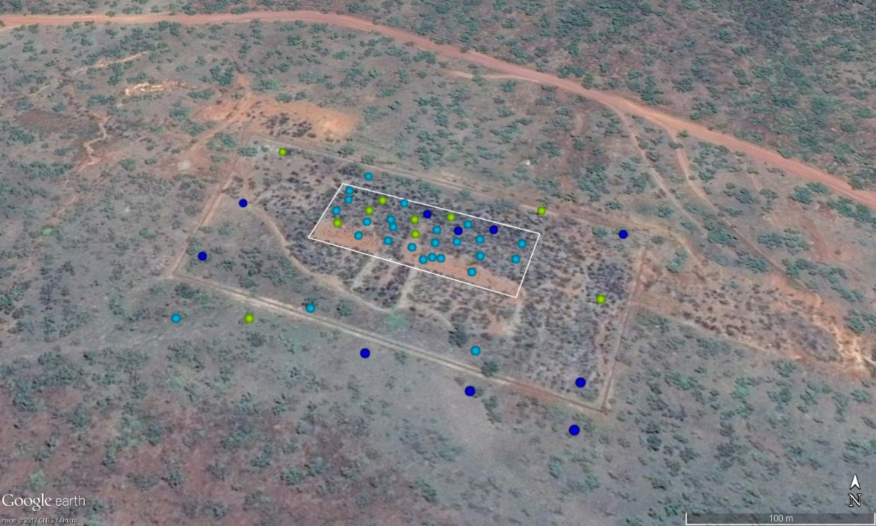

|  |  |
| --- | --- |
| **Gamma dose rate (µGy h-1)** | |
| ● | <0.12 |
| ● | 0.12–0.14 |
| ● | 0.14–0.16 |
| ● | 0.16–0.18 |
| ● | >0.18 |

**Figure 2** Gamma dose rates at El Sherana containment in 2017. The white rectangle shows the approximate outline of the containment. The fence line of the facility is visible in the image.

Radon-222 exhalation flux densities directly above the containment, off the containment but inside the fenced area and outside the fenced area were generally similar except for three elevated measurements directly above the containment (Figure 1). The arithmetic mean and standard deviation radon-222 exhalation flux density directly above the containment was 29 ± 70 mBq m-2 s-1 (*n* = 31), off the containment but inside the fenced area was 12 ± 4 mBq m-2 s-1 (*n* = 10) and outside the fenced area was 5.8 ± 3.8 mBq m-2 s-1 (*n* = 5). The arithmetic mean value directly above the containment has been skewed by the three elevated measurements. The geometric mean value of 7.1 mBq m-2 s-1 is perhaps more representative of the average radon-222 exhalation flux density over the total area directly above the containment, as less weight is placed on outliers.

The three locations where elevated radon-222 exhalation flux densities were measured do not correspond with elevated gamma dose rates (Figure 2), suggesting that the sampled radon-222 at these locations may have originated from deeper in the soil profile, possibly from the buried waste itself through cracks in the clay cap. Radon-222 in dry soil has a diffusion length of about 1.5 m (IAEA 2013, Porstendörfer 1994), making it possible for radon-222 generated by the decay of radium-226 in the buried waste to be exhaled from the surface of the containment. By comparison, the gamma signal in air at 1 m above the ground generally comes from radionuclides located in about the top 0.5 m of the soil, with deeper lying radionuclides tending to contribute only a few percent or less (ICRU 1994).

Gamma dose rates directly above the containment, off the containment but inside the fenced area and outside the fenced area were effectively the same (Figure 2). The arithmetic mean and standard deviation gamma dose rate directly above the containment was 0.13 ± 0.01 µGy h-1 (*n* = 31), off the containment but inside the fenced area was 0.12 ± 0.02 µGy h-1 (*n* = 10) and outside the fenced area was 0.11 ± 0.02 µGy h-1 (*n* = 5).

Table 1 compares the 2017 radon-222 exhalation flux densities directly above the containment to previous measurements, including baseline values from 2007. Radon-222 exhalation flux densities directly above the containment have typically been higher than baseline values and variable between years, though showing a decreasing trend since 2012. The geometric mean of the 2017 measurements was less than the geometric mean baseline value, implying there was no above-background radon-222 exposure pathway to workers or the public at the time of measurements.

**Table 1** Summary of biennial radon exhalation flux densities (mBq m-2 s-1) on the containment

|  |  |  |  |  |  |  |  |
| --- | --- | --- | --- | --- | --- | --- | --- |
| Year | Arithmetic mean | Arithmetic standard deviation | Geometric mean | Geometric standard deviation | Minimum | Maximum | *n* |
| 2007a | 14 | 6 | 13 | 1.5 | 5.0 | 25 | 21 |
| 2010 | 29 | 39 | 19 | 2.8 | 6.2 | 170 | 34 |
| 2012 | 240 | 230 | 120 | 2.2 | 18 | 750 | 17 |
| 2013 | 180 | 150 | 99 | 2.1 | 9.7 | 530 | 30 |
| 2015 | 110 | 90 | 72 | 3.0 | 5.0 | 350 | 30 |
| 2017 | 29 | 70 | 7.1 | 4.0 | 0.19 | 320 | 31 |

aBaseline measurements

Variability in radon-222 exhalation flux densities between years may be due to a number of factors, including changes in containment surface soil and vegetation cover and differences in the timing of biennial measurements. The original ~2.5 m thick surface soil layer (or ‘growth medium’) on the containment was supplemented by an additional 1 m of soil in 2013 and the surface re-contoured following erosion in the previous wet seasons. Vegetation cover on the containment has varied from being bare in 2010 and 2013, to that of dense grass and scrub in 2015. Vegetation cover in 2017 was generally sparse due to a recent fire, though some patches of thick grass were present. Radon-222 measurements in 2015 and 2017 were taken early in the dry season (May and June) and were lower than those in 2010–2013, taken late in the dry season (September and October) (Table 1). Soil moisture content will be higher in the early dry season, immediately following the wet season. Higher soil moisture content is known to result in lower radon-222 exhalation from a substrate (Bollhöfer & Doering 2016), as it impedes the emanation of radon-222 from the soil grain into the soil pore space (IAEA 2013, Porstendörfer 1994).

Table 2 compares the 2017 gamma dose rates directly above the containment to previous measurements, including baseline values from 2007. Gamma dose rates have effectively remained unchanged from baseline values. The implication is that gamma radiation from radionuclides in the buried waste has been effectively attenuated by the clay cap and surface soil layer and that to date there has been no above-background gamma exposure pathway to workers or the public from the containment.

**Table 2** Summary of biennial gamma dose rates (µGy h-1) on the containment

|  |  |  |  |  |  |  |  |
| --- | --- | --- | --- | --- | --- | --- | --- |
| Year | Arithmetic mean | Arithmetic standard deviation | Geometric mean | Geometric standard deviation | Minimum | Maximum | *n* |
| 2007a | 0.12 | 0.01 | 0.12 | 1.1 | 0.09 | 0.14 | 100 |
| 2010 | 0.10 | 0.01 | 0.10 | 1.1 | 0.08 | 0.13 | 230 |
| 2012 | 0.13 | 0.01 | 0.13 | 1.1 | 0.10 | 0.17 | 202 |
| 2013 | 0.13 | 0.01 | 0.13 | 1.1 | 0.11 | 0.15 | 30 |
| 2015 | 0.13 | 0.01 | 0.13 | 1.1 | 0.10 | 0.14 | 30 |
| 2017 | 0.13 | 0.01 | 0.13 | 1.1 | 0.11 | 0.15 | 31 |

aBaseline measurements

No dose modelling using the 2017 measurements was conducted, as the results indicated there was effectively no above-background radon-222 or gamma exposure pathway to workers or the public. Thus, the outcome of dose modelling using the measurement results would be a zero dose.

# 4 Conclusion

Average radon-222 exhalation flux densities and gamma dose rates at the El Sherana containment in 2017 were effectively no different to baseline values from 2007. The conclusion is that there was no above-background radon-222 or gamma exposure pathway to workers or the public at the time of measurements and there would be no exceedance of the occupational or public dose constraint of 30 µSv y-1 for the containment. Measurements of radon-222 exhalation flux densities and gamma dose rates at the containment should continue into the future to provide ongoing assurance of the performance of the facility and to ensure that workers and the public remain protected against radiation exposure from the buried waste.

# References

Bollhöfer A & Doering C 2016. Long-term temporal variability of the radon-222 exhalation flux from a landform covered by low uranium grade waste rock. *Journal of Environmental Radioactivity* 151, 593–600.

Bollhöfer A, Doering C & Fox G 2015. Gamma dose rates and 222Rn activity flux densities at the El Sherana containment. Internal Report 642, Supervising Scientist, Darwin.

Bollhöfer A, Doering C, Medley P & da Costa L 2013. Assessment of expected maximum doses from the El Sherana airstrip containment, South Alligator River valley, Australia. Internal report 618, Supervising Scientist, Darwin.

Doering C, Bollhöfer A, Ryan B, Sellwood J, Fox T & Pfitzner J 2011. Baseline and post-construction radiological conditions at El Sherana airstrip containment, South Alligator River valley, Australia. Internal Report 592, Supervising Scientist, Darwin.

IAEA 2013. Measurement and calculation of radon releases from NORM residues. Technical Report Series No. 474, Iinternational Atomic Energy Agency, Vienna.

ICRP, 2007. The 2007 recommendations of the International Commission on Radiological Protection. ICRP Publication 103, Annals of the ICRP 37(2–4).

ICRU 1994. Gamma-ray spectrometry in the environment. ICRU Report 53, International Commission on Radiation Units and Measurements.

NHMRC 1993. *Code of practice for the near-surface disposal of radioactive waste in Australia (1992)*. Radiation Health Series No. 35, Australian Government Publishing Service, Canberra.

Porstendörfer J 1994. Properties and behaviour of radon and thoron and their decay products in the air. *Journal of Aerosol Science* 25(2), 219–263.

Spehr W & Johnston A 1983. The measurement of radon emanation rates using activated charcoal. *Radiation Protection in Australia* 1(3), 113–116.

Waggitt PW 2004. Uranium mine rehabilitation: the story of the South Alligator Valley intervention. *Journal of Environmental Radioactivity* 76, 51–66.

# Appendix 1 Gamma and radon-222 measurements

**Table A1** Gamma counts (cpm) and dose rates (µGy h-1) and radon-222 exhalation flux densities (mBq m-2 s-1) measured on and around the El Sherana containment in June 2017

|  |  |  |  |  |  |
| --- | --- | --- | --- | --- | --- |
| Easting | Northing | Gamma counts | Gamma meter | Dose rate | Radon-222 |
| **On containment** | | | | | |
| 228802 | 8506249 | 148 | GM2 | 0.15 ± 0.01 | 320 ± 4 |
| 228800 | 8506237 | 136 | GM2 | 0.13 ± 0.01 | 8.0 ± 0.7 |
| 228783 | 8506243 | 124 | GM2 | 0.12 ± 0.01 | 5.1 ± 0.7 |
| 228786 | 8506256 | 128 | GM2 | 0.13 ± 0.01 | 6.9 ± 0.7 |
| 228784 | 8506263 | 120 | GM2 | 0.12 ± 0.01 | 4.4 ± 0.7 |
| 228793 | 8506279 | 125 | GM2 | 0.12 ± 0.01 | 3.8 ± 0.7 |
| 228777 | 8506282 | 151 | GM2 | 0.15 ± 0.01 | 15 ± 1 |
| 228768 | 8506272 | 156 | GM2 | 0.15 ± 0.01 | 8.2 ± 0.7 |
| 228767 | 8506261 | 133 | GM2 | 0.13 ± 0.01 | 9.3 ± 0.9 |
| 228762 | 8506248 | 136 | GM2 | 0.13 ± 0.01 | 44 ± 1 |
| 228746 | 8506260 | 145 | GM2 | 0.14 ± 0.01 | 26 ± 1 |
| 228744 | 8506272 | 132 | GM2 | 0.13 ± 0.01 | 4.8 ± 0.7 |
| 228752 | 8506283 | 137 | GM2 | 0.13 ± 0.01 | 8.5 ± 0.9 |
| 228752 | 8506292 | 122 | GM2 | 0.12 ± 0.01 | 6.3 ± 0.8 |
| 228876 | 8506240 | 129 | GM2 | 0.13 ± 0.01 | 1.7 ± 0.7 |
| 228871 | 8506226 | 118 | GM2 | 0.12 ± 0.01 | 2.7 ± 0.7 |
| 228857 | 8506253 | 110 | GM2 | 0.11 ± 0.01 | 1.2 ± 0.7 |
| 228847 | 8506244 | 122 | GM2 | 0.12 ± 0.01 | 3.5 ± 0.6 |
| 228847 | 8506229 | 132 | GM2 | 0.13 ± 0.01 | 2.0 ± 0.5 |
| 228841 | 8506215 | 122 | GM2 | 0.12 ± 0.01 | 220 ± 3 |
| 228820 | 8506227 | 122 | GM2 | 0.12 ± 0.01 | 14 ± 1 |
| 228831 | 8506242 | 120 | GM2 | 0.12 ± 0.01 | 1.4 ± 0.6 |
| 228832 | 8506252 | 110 | GM2 | 0.11 ± 0.01 | 0.2 ± 0.6 |
| 228839 | 8506258 | 124 | GM2 | 0.12 ± 0.01 | 2.0 ± 0.6 |
| 228827 | 8506265 | 151 | GM2 | 0.15 ± 0.01 | 3.8 ± 0.6 |
| 228817 | 8506253 | 119 | GM2 | 0.12 ± 0.01 | 8.6 ± 0.9 |
| 228816 | 8506241 | 122 | GM2 | 0.12 ± 0.01 | 5.6 ± 0.8 |
| 228814 | 8506228 | 134 | GM2 | 0.13 ± 0.01 | 140 ± 2 |
| 228808 | 8506226 | 135 | GM2 | 0.13 ± 0.01 | 8.8 ± 0.7 |
| 228810 | 8506268 | 116 | GM2 | 0.11 ± 0.01 | 2.6 ± 0.6 |
| 228801 | 8506263 | 147 | GM2 | 0.14 ± 0.01 | 15 ± 1 |

**Table A1** (continued)

|  |  |  |  |  |  |
| --- | --- | --- | --- | --- | --- |
| Easting | Northing | Gamma counts | Gamma meter | Dose rate | Radon-222 |
| **Off containment** | | | | | |
| 228947 | 8506248 | 96 | GM3 | 0.10 ± 0.01 | 9.7 ± 0.9 |
| 228924 | 8506191 | 138 | GM3 | 0.15 ± 0.01 | 8.1 ± 0.9 |
| 228765 | 8506307 | 124 | GM3 | 0.13 ± 0.01 | 11 ± 1 |
| 228696 | 8506335 | 141 | GM3 | 0.15 ± 0.01 | 20 ± 1 |
| 228675 | 8506280 | 97 | GM3 | 0.10 ± 0.01 | 20 ± 1 |
| 228656 | 8506229 | 109 | GM3 | 0.11 ± 0.01 | 12 ± 1 |
| 228736 | 8506184 | 115 | GM3 | 0.12 ± 0.01 | 10 ± 1 |
| 228842 | 8506152 | 110 | GM3 | 0.12 ± 0.01 | 9.4 ± 0.9 |
| 228904 | 8506129 | 97 | GM3 | 0.10 ± 0.01 | 10 ± 1 |
| 228892 | 8506271 | 136 | GM3 | 0.14 ± 0.01 | 10 ± 1 |
| **Outside fence** | | | | | |
| 228651 | 8506175 | 124 | GM3 | 0.13 ± 0.01 | 9.5 ± 0.9 |
| 228698 | 8506175 | 133 | GM3 | 0.14 ± 0.01 | 6.5 ± 0.8 |
| 228774 | 8506149 | 82 | GM3 | 0.09 ± 0.01 | 1.1 ± 0.7 |
| 228838 | 8506123 | 82 | GM3 | 0.09 ± 0.01 | 2.5 ± 0.7 |
| 228897 | 8506098 | 109 | GM3 | 0.11 ± 0.01 | 9.3 ± 0.9 |