Wave-short

642

*internal report*

Gamma dose rates and 222Rn activity flux densities at the El Sherana containment

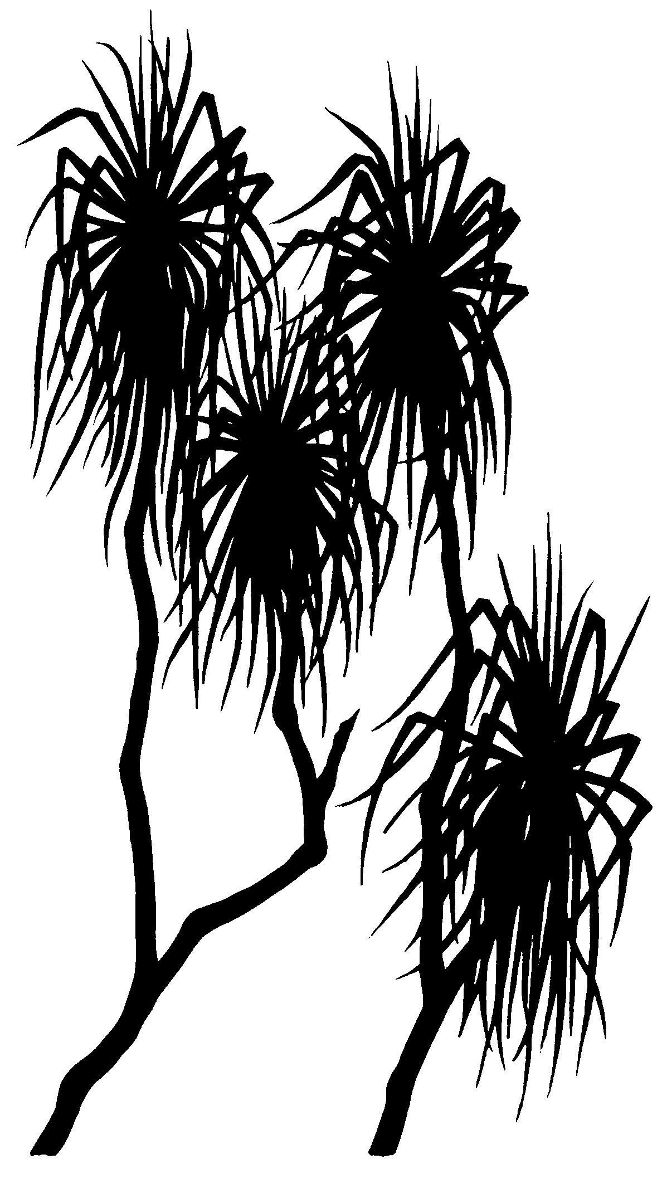



Andreas Bollhöfer, Che Doering, Gary Fox

July 2015

Release status – unrestricted

Project number – MON-2013-006

*This page has been left blank intentionally.*

**Gamma dose rates and 222Rn activity flux densities at the El Sherana containment**

Andreas Bollhöfer, Che Doering, Gary Fox

Supervising Scientist

GPO Box 461, Darwin NT 0801

July 2015

(Release status – unrestricted)



*How to cite this report:*

Bollhöfer A, Doering C & Fox G 2015. Gamma dose rates and 222Rn activity flux densities at the El Sherana containment. Internal Report 642, July, Supervising Scientist, Darwin.

*Project number: MON-2013-006*

*Authors of this report:*

Andreas Bollhöfer – Environmental Research Institute of the Supervising Scientist, GPO Box 461, Darwin NT 0801, Australia

Che Doering – Environmental Research Institute of the Supervising Scientist, GPO Box 461, Darwin NT 0801, Australia

Gary Fox – Environmental Research Institute of the Supervising Scientist, GPO Box 461, Darwin NT 0801, Australia

Supervising Scientist is a branch of the Australian Government Department of   
the Environment.

Copyright Image.tif

© Commonwealth of Australia 2015

Supervising Scientist

Department of the Environment

GPO Box 461, Darwin NT 0801 Australia

**environment**.gov.au/science/supervising-scientist/publications

IR642 is licensed by the Commonwealth of Australia for use under a Creative Commons By Attribution 3.0 Australia licence with the exception of the Coat of Arms of the Commonwealth of Australia, the logo of the agency responsible for publishing the report, content supplied by third parties, and any images depicting people. For licence conditions see: http://creativecommons.org/licenses/by/3.0/au/

**Disclaimer**

The views and opinions expressed in this publication are those of the authors and do not necessarily reflect those of the Australian Government or the Minister for the Environment.

While reasonable efforts have been made to ensure that the contents of this publication are factually correct, the Commonwealth does not accept responsibility for the accuracy or completeness of the contents, and shall not be liable for any loss or damage that may be occasioned directly or indirectly through the use of, or reliance on, the contents of this publication.

Produced in Darwin NT by Supervising Scientist.

# Contents

Executive summary iii

1 Introduction 5

2 Methods 7

2.1 Geospatial coordinates 7

2.2 External gamma radiation measurements 7

2.3 222Rn activity flux density measurements 7

3 Results 7

3.1 External gamma radiation 7

3.2 222Rn activity flux densities 7

4 Discussion and Conclusion 7

References 7

Appendix 7

## List of Figures

Figure 1: 2007 (baseline) and 2015 external gamma dose rates [µGy∙hr-1] measured at the South Alligator Containment Facility. 7

Figure 2 Histogram of gamma dose rates [µGy hr-1] measured within the fenced area of the South Alligator Containment Facility in May 2015. 7

Figure 3: 222Rn activity flux densities [mBq∙m-2∙s-1] measured at the South Alligator Containment Facility in September 2010 (left) and May 2015 (right). 7

Figure 4: Frequency distribution of 222Rn activity flux densities measured in May 2015 at the South Alligator Containment Facility. 7

Figure 5 Box plot of environmental background (open boxes) and containment (grey boxes) 222Rn exhalation flux densities. The marker indicates the median, the width of the box is the interquartile range, whiskers indicate the upper and lower 25% of the distribution. 7

Figure A1: Calibration certificate for gamma probe used for dose rate measurements in May 2015. 7

## List of Tables

Table 1 Engineering details of the El Sherana airstrip containment 5

Table 2 Approved monitoring programme for the South Alligator containment facility 6

Table A1: Eastings, northings and measured γ-dose rates and 222Rn activity flux densities, May 2015. 7

# Executive summary

Gamma dose rates and radon exhalation flux densities are measured at the El Sherana containment every two years as part of the approved environmental monitoring program. This report presents the measurements from 2015, the fourth set of measurements since construction of the containment in 2009. Gamma dose rates on top of the containment in 2015 were no different to those measured prior to its construction and remain at typical environmental background levels. Radon exhalation flux densities on top of the containment in 2015 were higher than those measured prior to its construction, but have not increased since the last set of measurements in 2013. The levels of gamma dose rate and radon exhalation flux density measured at the containment in 2015 would not lead to above background doses of Parks Australia employees or the public in excess of the dose constraint of 30 µSv per year.

# 1 Introduction

The El Sherana airstrip containment (or South Alligator containment facility) is a near-surface disposal facility located in the South Alligator River valley in the south of Kakadu National Park. It was constructed in the 2009 dry season and contains approximately 22,000 m3 of naturally occurring radioactive material (NORM) contaminated waste from the remediation of legacy uranium mining and processing sites in the area (see Waggitt (2004) for details of the uranium mining history of the South Alligator River valley). Following closure of the facility it is currently in the institutional control period, during which public access to, or alternative use of, the site must be restricted. The containment is managed by the Director of National Parks, with regulatory oversight by the Australian Radiation Protection and Nuclear Safety Agency (ARPANSA). The Supervising Scientist currently assists the Director of National Parks by conducting biennial monitoring to assess the radiological conditions on site. Table 1 gives the engineering details of the containment.

Table 1 Engineering details of the El Sherana airstrip containment1

|  |  |
| --- | --- |
| Parameter | Description |
| Surface footprint | 8750 m2 (175 m × 50 m) |
| Maximum capacity | 25,000 m3 |
| Maximum excavation depth below natural ground level | 5 m |
| Side slopes | 3:1 (horizontal:vertical) |
| Maximum thickness of waste material | 4.5 m |
| Base layer | 0.5 m compacted clay |
| Capping layer | 0.5 m compacted clay |
| Cover (growth medium) | 1.8–2.4 m uncompacted natural soil |

1Information from O’Kane Consultants (2012)

As part of their licence conditions for the South Alligator containment facility, the Director of National Parks has to provide to the CEO of ARPANSA within 28 days of the end of each financial year information about compliance with the licence conditions for the previous year. This report should include a status update on the integrity of the surface cover, any changes in environmental circumstances of the facility and a summary of information collected through an approved monitoring programme. This approved monitoring programme includes the measurement of gamma dose rates and radon-222 (222Rn) exhalation flux densities from the containment every two years and is shown in Table 2. The previous set of measurements were conducted in October 2013.

After an inspection of the South Alligator Disposal facility by ARPANSA in 2011 (ARPANSA 2011), ARPANSA requested that Parks Australia undertake a radiological impact assessment of the South Alligator containment facility to establish appropriate dose constraints, in line with the requirements outlined in the Code of Practice for the near surface disposal of radioactive waste (NHMRC 1993). The Environmental Radioactivity group of the Supervising Scientist was approached by the Director of National Parks to undertake this impact assessment, and modelling of doses to Parks employees and the general public using the ResRad Offsite computer code (Yu et al. 2009) has shown that effective radiation doses will be below 10 µSv per year (Bollhöfer et al 2013; Supervising Scientist 2013). A dose constraint of 30 µSv per year was set for the South Alligator Disposal facility and approved by ARPANSA in 2013.

Table 2 Approved monitoring programme for the South Alligator Containment Facility

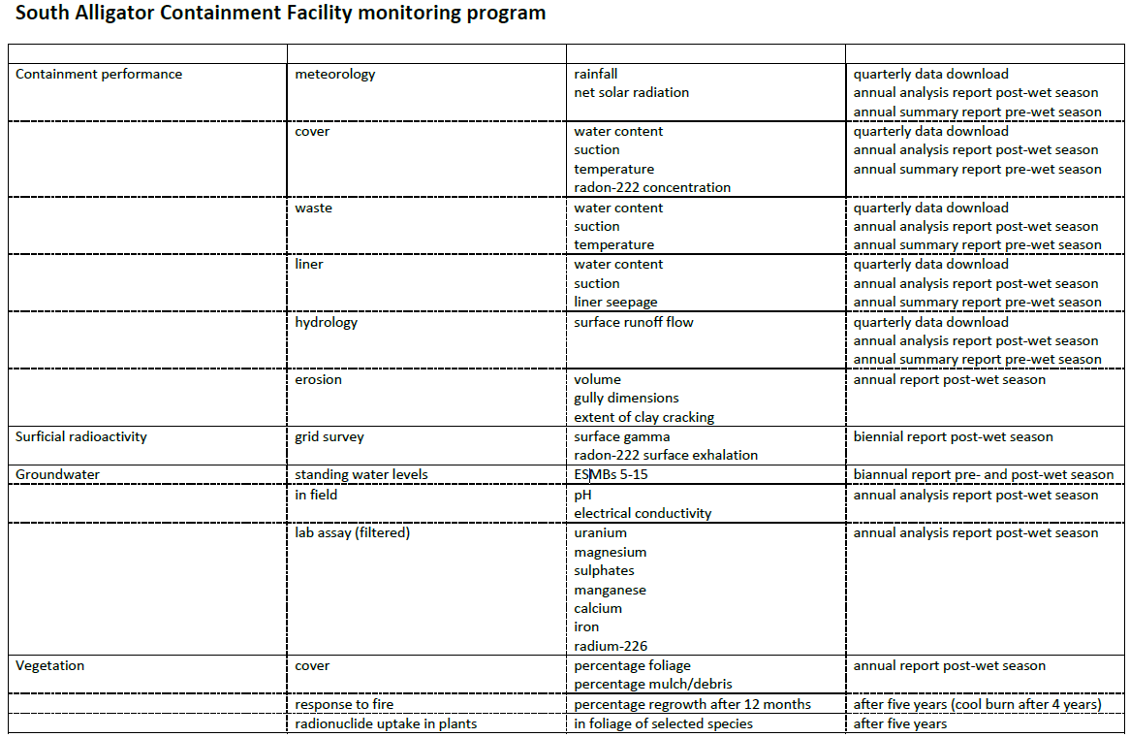

The ***eriss*** Environmental Radioactivity program has measured gamma dose rates and 222Rn activity flux densities at the containment site prior to construction and again in 2010 one year after construction (Doering et al 2011). Gamma dose rates and 222Rn activity flux densities were also measured in September 2012 as part of an ongoing (biannual) monitoring program. These 2012 measurements were used to make an assessment of expected maximum annual doses for occupational and public exposure scenarios (Bollhöfer et al 2013). Because radon exhalation had increased between 2010 and 2012, a further set of measurements of radon exhalation was taken between 7 and 10 October 2013. This was approximately 3 months after vegetation in the middle of the containment was cleared and 1 metre of clean soil placed on top of the existing capping to re-contour the surface and prevent erosion of the capping material at the containment. The survey also coincided with an inspection of the containment by an ARPANSA officer. Results of the 2013 survey were published in Supervising Scientist Report 205 (Supervising Scientist, 2013) and reported in a Minute to the Director of National Parks in May 2014.

The measurements taken in 2013 showed that the average gamma dose rate measured in 2012 and 2013 (0.13±0.01 µGy/hr) was no different to the baseline gamma dose rate measured in 2007. Consequently, the above baseline gamma dose rate three (2012) and four (2013) years after containment construction was zero. However, the radon flux from the containment measured in 2013 was still higher than the pre-construction radon fluxes measured in the area, but has not increased further compared to the measurements taken in 2012.

The report presented here details the results of gamma dose rate and radon flux density measurements conducted in May 2015, within the fenced area of the containment and outside the fence, down gradient of the containment.

# 2 Methods

## 2.1 Geospatial coordinates

Site locations were recorded as projected coordinates (easting and northings) based on the WGS84 standard, using a hand-held global positioning system (GPS) device. The site coordinates project into Universal Transverse Mercator (UTM) zone 53S.

## 2.2 External gamma radiation measurements

A gamma survey was conducted at the containment on 22 May 2015 using a compensated Geiger Müller (GM) tube (Mini Instrument MC70) connected to a Thermo Scientific RadEye GX gauge.

Measurements were made of the total counts per 60 s in air at a height of 1 m above the ground surface. A total of 45 measurements were made: 40 within the fenced area of the containment (of which 30 points were on top of the buried waste) and 5 south of the fenced area outside the containment facility. The gamma dose rate monitor was calibrated in January 2015, the calibration certificate for this monitor is shown in Figure A1 in Appendix 1. Table A1 in the Appendix shows the results of the gamma dose rate measurements.

## 2.3 222Rn activity flux density measurements

222Rn activity flux density measurements at the containment were made over the period 22-26 May 2015. The prevailing meteorological conditions over the measurement period were typical of the tropical Northern Territory dry season, with maximum daytime temperatures around 30°C and zero rainfall.

Brass canisters containing activated charcoal to entrap radon emanating from the ground surface were used for the field sampling of 222Rn. Forty five canisters were deployed on and around the containment. The canisters were embedded in the ground surface to a depth of approximately 1 cm in order to ensure a good seal and prevent leakage of radon from the canister to the atmosphere. Three additional canisters were carried into the field but remained sealed at all times. These canisters were ‘controls’ and used to determine the background activity of 222Rn collected on the charcoal.

The 222Rn activity flux density was calculated from the measured 222Rn progeny activity in the canisters according to the method described in Doering et al (2011) and Spehr & Johnston (1983). The 222Rn progeny activity in each canister was counted for ten minutes using a sodium iodide detector and the resulting energy spectrum displayed on a multi-channel analyser. Regions of interest were established around the characteristic photopeaks of lead-214 (242 keV, 295 keV and 352 keV) and bismuth-214 (609 keV) from which the net count rate was determined by summing the total counts under each peak for the individual field samples and then subtracting the mean sum of the counts under the corresponding regions of interest in the control canisters’ spectra. The efficiency of the detector for 222Rn progeny counting via this method was 9.6%. Table A1 in the Appendix shows the results of the 222Rn activity flux density measurements.

# 3 Results

## 3.1 External gamma radiation

Figure 1 shows the location and magnitude of the baseline (left) and 2015 (right) gamma dose rate measurements at the containment site overlaid on an aerial photograph of the area from March 2007. The outer white rectangle indicates the approximate location of the boundary fence around the containment. The inner rectangle shows the approximate location of the containment and buried waste.

|  |  |
| --- | --- |
|  |  |

Figure 1 2007 (baseline) and 2015 external gamma dose rates [µGy∙hr-1] measured at the South Alligator Containment Facility.

It has been shown that the 2007 baseline gamma dose rate measurements were normally distributed, with an average value inside the fenced area of 0.13 µGy∙hr-1 (Bollhöfer et al 2009). The data measured in 2015 within the fenced area also fit a normal distribution and a histogram of the measured gamma dose rates is shown in Figure 2. Within uncertainties, gamma dose rates measured in 2007 and in 2015 (0.124±0.012 µGy∙hr-1) are the same, and there has been no increase in the measured gamma dose rates within the fenced area of the containment over the years (see also Bollhöfer et al 2013).



Figure 2 Histogram of gamma dose rates [µGy hr-1] measured within the fenced area of the South Alligator Containment Facility in May 2015.

## 3.2 222Rn activity flux densities

Figure 3 shows the location and magnitude of post-construction 222Rn activity flux density measurements conducted in 2010 (left) (Doering et al 2011) and in 2015 (right) at the containment, overlaid on an aerial photograph of the area from March 2007. The outer white rectangle indicates the approximate location of the boundary fence around the containment. The inner rectangle shows the approximate location of the containment and buried waste.

222Rn activity flux densities measured on the containment in 2015 were still higher than those measured in 2010, but there has been little change in 222Rn activity flux densities outside the fenced area at the control sites. The typical value (geometric mean) measured in 2010 outside the fenced area was 16 mBq∙m2∙s-1 (similar to the baseline value of 14 mBq∙m2∙s-1 measured in 2009) with values ranging from 10–36 mBq∙m2∙s-1. In 2015, the typical value outside the fenced area was 10 mBq∙m2∙s-1, with values a little lower, showing a range of 6-17 mBq∙m2∙s-1.

Figure 4 shows that the 222Rn activity flux densities measured in 2015 follow a lognormal distribution (p = 0.1) although there is still some indication, albeit less pronounced than in 2012, of a bimodal distribution that was observed in 2012 (Bollhöfer et al 2012).

|  |  |
| --- | --- |
|  |  |

Figure 3 222Rn activity flux densities [mBq∙m-2∙s-1] measured at the South Alligator Containment Facility in September 2010 (left) and May 2015 (right).



Figure 4 Frequency distribution of 222Rn activity flux densities measured in May 2015 at the South Alligator Containment Facility.

# 4 Discussion and Conclusion

The survey of external gamma dose rates and 222Rn exhalation flux densities across the El Sherana containment in May 2015 was the fourth of its kind since its construction in 2009. External gamma dose rates on top of the containment have not changed and stayed at typical environmental levels without any noticeable increase above typical environmental levels.

Figure 5 shows the results of the 222Rn exhalation flux densities measured from environmental areas nearby and from the top of the containment, in September 2010, September 2012, October 2013 and May 2015. It is obvious that there is a tendency towards higher 222Rn exhalation flux densities from the containment 3, 4 and 5.5 years after construction compared to 1 year after construction in 2010.

The reason for this increase may be associated with changes of the physical properties of the containment cover, as outlined in the 2012-13 Supervising Scientist Annual Report (Supervising Scientist 2013). In June 2013, vegetation in the middle of the containment was cleared and approximately 1 metre of clean soil placed on top of the existing capping to re-contour the surface and prevent erosion of the capping material at the containment. This additional layer does not appear to have lowered overall radon activity fluxes from the containment measured in October 2013.



Figure 5 Box plot of environmental background (open boxes) and containment (grey boxes) 222Rn exhalation flux densities. The marker indicates the median, the length of the box is the interquartile range, whiskers indicate the upper and lower 25% of the distribution.

The apparent decrease of the 222Rn activity flux densities in May 2015 compared to the previous two surveys is most likely associated with the time of year of the measurements: the 2015 survey was conducted in May, at the end of the wet season, when 222Rn exhalation flux densities from soils are typically lower due to the higher soil moisture that limits radon exhalation from a substrate (Bollhöfer & Doering 2015). In contrast, the previous three surveys were conducted during peak dry season conditions at the end of the dry. The higher volumetric water (VWC) content in May 2015 is clearly visible in VWC profiles at the containment shown in O’Kane (2015). 222Rn activity flux densities measured outside the fenced area in 2015 were also slightly lower compared to the previous surveys.

The measurements conducted in May 2015 show that gamma dose rates and 222Rn exhalation flux densities from the containment have not increased between 2012 and 2015. Consequently, the dose constraint of 30 µSv per year (which was determined based on the 2012 monitoring results) is not exceeded. 222Rn exhalation flux densities measured at the El Sherana containment do not lead to unacceptable radiation doses to workers or the public, and continue to be less than 10 µSv per year.

# References

ARPANSA 2011. Inspection report. Report number R11/12857. Available from: <http://arpansa.gov.au/pubs/regulatory/inspections/R11-12857.pdf>

Bollhöfer A, Doering C, Medley P & da Costa L 2013. Assessment of expected maximum doses from the El Sherana airstrip containment, South Alligator River valley, Australia. Internal report 618, Supervising Scientist for the Alligator Rivers Region, Canberra. Unpublished paper.

Bollhöfer A & Doering C 2015. Long-term temporal variability of the radon-222 exhalation flux from a landform covered by low uranium grade waste rock. *Journal of Environmental Radioactivity* 127, 88–94. DOI: 10.1016/j.jenvrad.2015.06.005

Doering C, Bollhöfer A, Ryan B, Sellwood J, Fox T & Pfitzner J 2011. Baseline and post-construction radiological conditions at El Sherana airstrip containment, South Alligator River valley, Australia. Internal Report 592, June, Supervising Scientist, Darwin.

National Health and Medical Research Council (NHMRC) 1993. Code of practice for the near-surface disposal of radioactive waste in Australia (1992). Radiation Health Series No. 35

O’Kane Consultants 2012. Gunlom Land Trust Area, Kakadu National Park Containment Facility for Radiologically Contaminated Materials – Record of Construction and Quality Control and Assurance Report. OKC Report No. 765/10-01 prepared for Parks Australia.

O’Kane Consultants 2015. South Alligator Containment Facility, Gunlom Land Trust Area, Kakadu National Park Monitoring Data Summary Report for the Period October 2013 - September 2014. OKC Report No. 765/14-01 prepared for Australian Government, Director of National Parks.

Spehr W & Johnston A 1983. The measurement of radon emanation rates using activated charcoal. *Radiation Protection in Australia* 1(3), 113–116.

Supervising Scientist Division 2013. eriss research summary 2012–2013. Supervising Scientist Report 205, Supervising Scientist, Darwin NT.

Waggit P 2004. Uranium mine rehabilitation: The story of the South Alligator Valley intervention. *Journal of Environmental Radioactivity* 76, 51–66.

Yu C, Gnanapragasam E, Biwer B, Cheng JJ, Kamboj S, Klett T, Zielen A, Williams WA, Domotor S & Wallo A 2009. RESRAD-OFFSITE – A new member of the RESRAD family of codes. *Radioprotection* 44, (5) 659–664.

# Appendix

Figure A1: Calibration certificate for gamma probe used for dose rate measurements in May 2015.

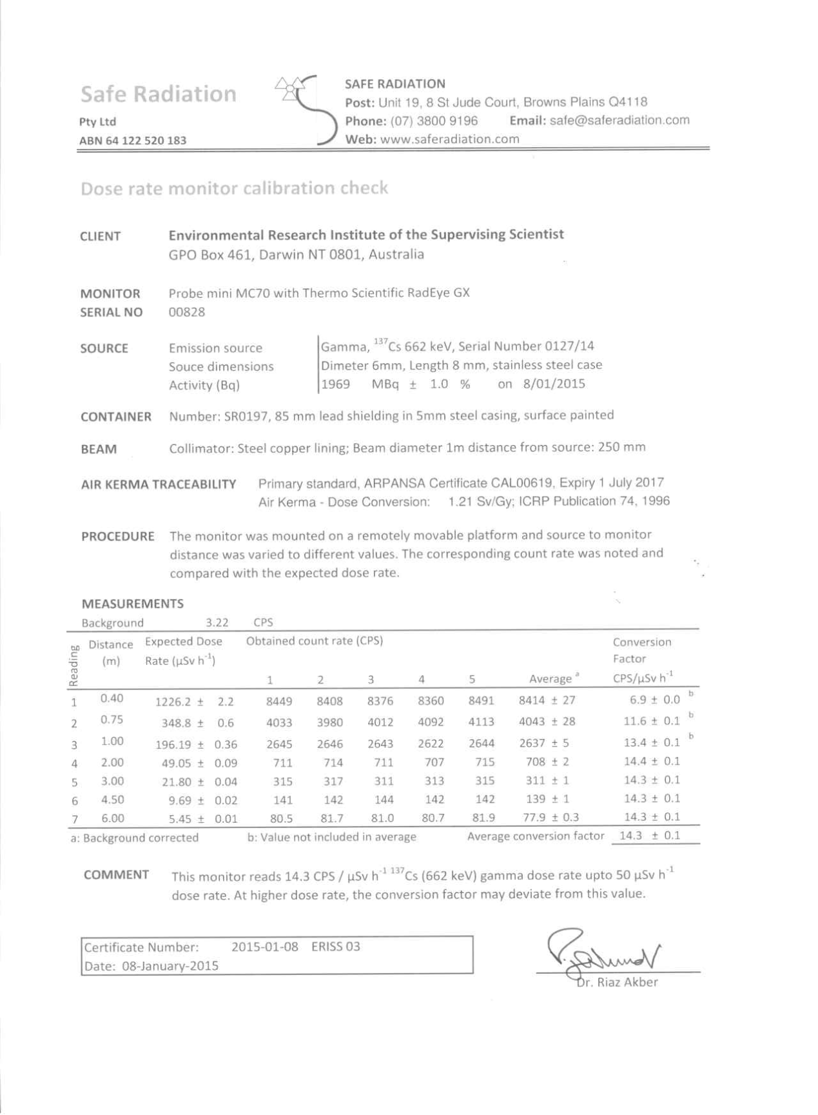

Table A1: Eastings, northings and measured γdose rates and 222Rn activity flux densities, May 2015.

|  |  |  |  |
| --- | --- | --- | --- |
| **Easting** | **Northing** | **Gamma dose rate** | **222Rn activity flux** |
| **On containment** | | [µGy hr-1] | [mBq m-2 s-1] |
| 228811 | 8506246 | 0.11±0.01 | 168±4 |
| 228777 | 8506255 | 0.13±0.01 | 52±2 |
| 228785 | 8506237 | 0.12±0.01 | 113±3 |
| 228796 | 8506263 | 0.13±0.01 | 43±2 |
| 228813 | 8506255 | 0.12±0.01 | 355±6 |
| 228784 | 8506264 | 0.12±0.01 | 138±3 |
| 228838 | 8506222 | 0.13±0.01 | 104±3 |
| 228872 | 8506216 | 0.13±0.01 | 10±1 |
| 228835 | 8506217 | 0.12±0.01 | 146±3 |
| 228749 | 8506246 | 0.13±0.01 | 65±2 |
| 228804 | 8506227 | 0.13±0.01 | 38±2 |
| 228790 | 8506256 | 0.13±0.01 | 64±2 |
| 228847 | 8506238 | 0.10±0.01 | 303±5 |
| 228791 | 8506249 | 0.11±0.01 | 86±2 |
| 228768 | 8506243 | 0.12±0.01 | 116±3 |
| 228805 | 8506234 | 0.14±0.01 | 201±4 |
| 228865 | 8506205 | 0.14±0.01 | 61±2 |
| 228782 | 8506259 | 0.13±0.01 | 22±1 |
| 228755 | 8506266 | 0.13±0.01 | 67±2 |
| 228788 | 8506244 | 0.14±0.01 | 184±4 |
| 228762 | 8506274 | 0.12±0.01 | 74±2 |
| 228868 | 8506209 | 0.14±0.01 | 5±1 |
| 228874 | 8506233 | 0.12±0.01 | 116±3 |
| 228756 | 8506260 | 0.13±0.01 | 32±2 |
| 228874 | 8506225 | 0.13±0.01 | 231±4 |
| 228853 | 8506243 | 0.12±0.01 | 7±1 |
| 228808 | 8506238 | 0.12±0.01 | 3035± |
| 228844 | 8506230 | 0.13±0.01 | 13±1 |
| 228773 | 8506249 | 0.12±0.01 | 170±4 |
| 228752 | 8506254 | 0.14±0.01 | 76±2 |
| **Within fence** | |  |  |
| 228738 | 8506182 | 0.12±0.01 | 6±1 |
| 228909 | 8506127 | 0.13±0.01 | 19±1 |
| 228656 | 8506222 | 0.08±0.01 | 18±1 |
| 228926 | 8506185 | 0.14±0.01 | 13±1 |
| 228768 | 8506309 | 0.10±0.01 | 18±1 |
| 228947 | 8506237 | 0.13±0.01 | 21±1 |
| 228863 | 8506269 | 0.13±0.01 | 7±1 |
| 228675 | 8506280 | 0.10±0.01 | 14±1 |
| 228843 | 8506152 | 0.11±0.01 | 6±1 |
| 228696 | 8506332 | 0.12±0.01 | 11±1 |
| **Outside fence** | |  |  |
| 228701 | 8506173 | 0.12±0.01 | 6±1 |
| 228838 | 8506125 | 0.10±0.01 | 17±1 |
| 228902 | 8506100 | 0.13±0.01 | 12±1 |
| 228654 | 8506180 | 0.11±0.01 | 7±1 |
| 228753 | 8506155 | 0.13±0.01 | 10±1 |