Wave-short

644

*internal report*

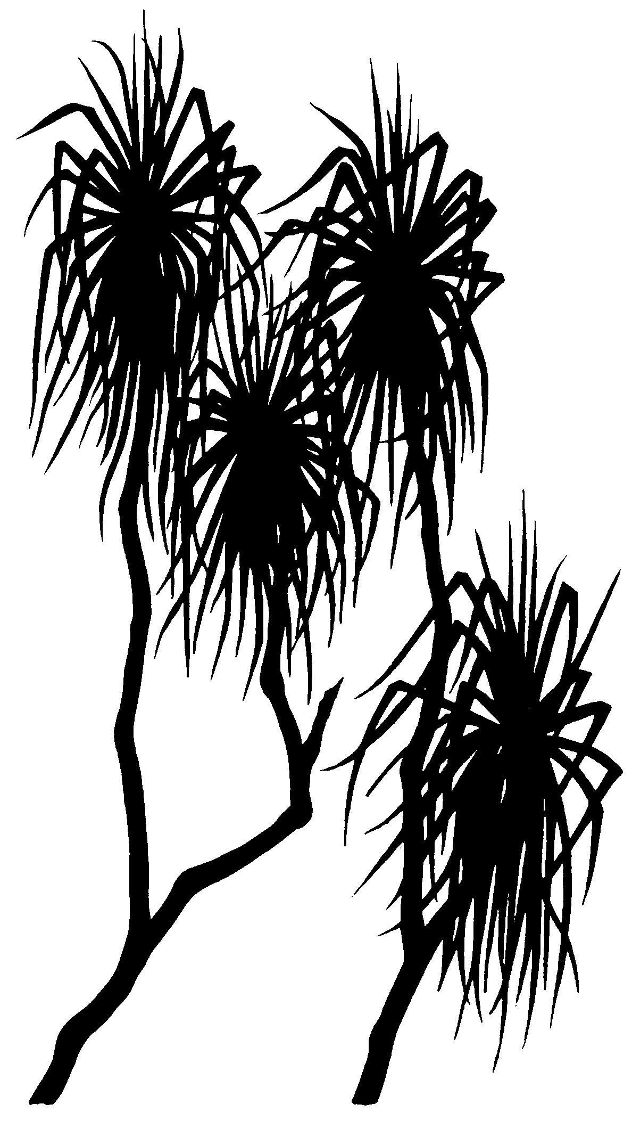



Ceiwen Pease, Melanie Trenfield, Kim Cheng, Andrew Harford, Alicia Hogan, Claire Costello, Thomas Mooney, and Rick van Dam

June 2016

Release status - unrestricted

Project number - COR-2009-010

(Release status –)

# Refinement of the reference toxicity test protocol for the tropical duckweed *Lemna aequinoctialis*

*The Department acknowledges the traditional owners of country throughout Australia and their continuing connection to land, sea and community. We pay our respects to them and their cultures and to their elders both past and present.*

**Refinement of the reference toxicity test protocol for the tropical duckweed   
*Lemna aequinoctialis***

Ceiwen Pease, Melanie Trenfield, Kim Cheng, Andrew Harford,   
Alicia Hogan, Claire Costello, Thomas Mooney and Rick van Dam

Supervising Scientist

GPO Box 461, Darwin NT 0801

June 2016

(Release status – unrestricted)



*How to cite this report:*

Pease C, Trenfield M, Cheng K, Harford A, Hogan A, Costello C, Mooney T & van Dam R 2016. Refinement of the reference toxicity test protocol for the tropical duckweed *Lemna aequinoctialis*. Internal Report 644, June, Supervising Scientist, Darwin.

Project number – COR-2009-010

*Authors of this report:*

Ceiwen Pease – Supervising Scientist, GPO Box 461, Darwin NT 0801, Australia

Kim Cheng – Supervising Scientist, GPO Box 461, Darwin NT 0801, Australia

Andrew Harford – Supervising Scientist, GPO Box 461, Darwin NT 0801, Australia

Alicia Hogan – Supervising Scientist, GPO Box 461, Darwin NT 0801, Australia

Claire Costello – Supervising Scientist, GPO Box 461, Darwin NT 0801, Australia

Thomas Mooney – Supervising Scientist, GPO Box 461, Darwin NT 0801, Australia

Rick van Dam – Supervising Scientist, GPO Box 461, Darwin NT 0801, Australia

Supervising Scientist is a branch of the Australian Government Department of   
the Environment.

Supervising Scientist   
Department of the Environment   
GPO Box 461, Darwin NT 0801 Australia

**environment**.gov.au/science/supervising-scientist/publications

© Commonwealth of Australia 2016

Copyright Image.tif

IR644 is licensed by the Commonwealth of Australia for use under a Creative Commons By Attribution 3.0 Australia licence with the exception of the Coat of Arms of the Commonwealth of Australia, the logo of the agency responsible for publishing the report, content supplied by third parties, and any images depicting people. For licence conditions see: http://creativecommons.org/licenses/by/3.0/au/

**Disclaimer**

The views and opinions expressed in this publication are those of the authors and do not necessarily reflect those of the Australian Government or the Minister for the Environment.

While reasonable efforts have been made to ensure that the contents of this publication are factually correct, the Commonwealth does not accept responsibility for the accuracy or completeness of the contents, and shall not be liable for any loss or damage that may be occasioned directly or indirectly through the use of, or reliance on, the contents of this publication.

# 

# Contents

[Executive summary 1](#_Toc454457290)

[1 Introduction 2](#_Toc454457291)

[2 Methods 3](#_Toc454457292)

[2.1 Test organism and culture condition 3](#_Toc454457293)

[2.2 General laboratory procedures 3](#_Toc454457294)

[2.3 Test details 3](#_Toc454457295)

[2.4 Physico-chemical measurements 4](#_Toc454457296)

[2.5 Test medium trials 5](#_Toc454457297)

[2.5.1 CAAC 5](#_Toc454457298)

[2.5.2 SSW 5](#_Toc454457299)

[2.5.3 Nutrient optimisation 5](#_Toc454457300)

[2.5.4 Reference toxicity testing 5](#_Toc454457301)

[2.6 Surface area measurement using ImageJ analysis 5](#_Toc454457302)

[2.7 Data analysis 6](#_Toc454457303)

[3 Results 7](#_Toc454457304)

[3.1 Growth trials with 0.5% CAAC 7](#_Toc454457305)

[3.2 Toxicity testing using 2.5% CAAC 7](#_Toc454457306)

[3.3 Toxicity testing using 1% CAAC 7](#_Toc454457307)

[3.5 Trialling amended Synthetic Soft Water as a test diluent 9](#_Toc454457308)

[3.6 Confirmation of suitable nutrient levels for toxicity testing 10](#_Toc454457309)

[3.7 Toxicity testing using Synthetic Soft Water 12](#_Toc454457310)

[3.8 Surface area as an endpoint 12](#_Toc454457311)

[3.9 Quality control and metal analyses 13](#_Toc454457312)

[4 Discussion 14](#_Toc454457313)

[4.1 Determining an optimal test medium 14](#_Toc454457314)

[4.2 The use of surface area to determine growth rate 14](#_Toc454457315)

[5 Conclusions and recommendations 16](#_Toc454457316)

[6 References 17](#_Toc454457317)

[Appendix A: Growth inhibition protocol for *Lemna aequinoctialis* using surface area and frond number as endpoints 18](#_Toc454457318)

[1 Objective 18](#_Toc454457319)

[2 Principle of the test 18](#_Toc454457320)

[3 Test organism 18](#_Toc454457321)

[4 Dilution water 18](#_Toc454457322)

[5 Chemical solutions 19](#_Toc454457323)

[6 Test solutions 19](#_Toc454457324)

[7 Physico-chemical samples and water parameters 19](#_Toc454457325)

[8 Apparatus and test equipment 20](#_Toc454457326)

[8.1 Container preparation 20](#_Toc454457327)

[8.2 Temperature and photoperiod control 20](#_Toc454457328)

[8.3 Equipment 20](#_Toc454457329)

[9 Area for test preparation 21](#_Toc454457330)

[10 Recording data 21](#_Toc454457331)

[11 Test procedure 21](#_Toc454457332)

[12 Randomisation 23](#_Toc454457333)

[13 Reference toxicants 23](#_Toc454457334)

[14 Acceptability of test data 23](#_Toc454457335)

[15 Analyses of test data 24](#_Toc454457336)

[Appendix B List of tests 25](#_Toc454457337)

[Appendix C Using Gas-tight chambers for pH control 28](#_Toc454457338)

[1 Determination of CO2 volume 28](#_Toc454457339)

[2 Testing method 28](#_Toc454457340)

[Appendix D Measurement of frond surface area using ImageJ software 30](#_Toc454457341)

[Appendix E CAAC medium preparation 34](#_Toc454457342)

[1 Safety 34](#_Toc454457343)

[2 Preparation of a working solution 34](#_Toc454457344)

[3 Making stocks 34](#_Toc454457345)

[Appendix F Synthetic Soft water preparation 36](#_Toc454457346)

[1 Safety 36](#_Toc454457347)

[2 Preparation of solution 36](#_Toc454457348)

[3 Making stocks 36](#_Toc454457349)

[Appendix G Water Quality measurements for tests used in the control charts 37](#_Toc454457350)

[Appendix H Summary of metal analyses 46](#_Toc454457351)

[Appendix I Analytical reports 51](#_Toc454457352)

# Executive summary

The duckweed *Lemna* *aequinoctialis* is one of the routine test species of the reference toxicity testing program initiated in 2004 which is used by the Supervising Scientist Branch (SSB) ecotoxicology laboratory to assess uranium toxicity. Test protocols for four of the five routine test species (*Mogurnda mogurnda*, *Hydra viridissima*, *Moinodaphnia macleayi* and *Chlorella* sp.) have been used successfully for many years to develop a comprehensive data set. However, the reference toxicity test developed for *L. aequinoctialis*, was not ideal for several reasons. Firstly, the initial test medium was very nutrient rich. While this allowed for healthy plant growth, the excessive nutrients were also reducing the bioavailability of U and interfering with the assessment of U toxicity. Secondly, the test incorporated a single endpoint despite OECD guidelines recommending two endpoints be used. Frond number, which is the primary endpoint used in the initial test design, provided a good indication of cell division inhibition, however, fronds were counted regardless of size or colour (and health). In the search for a second endpoint, measuring plant weight proved to be unreliable. Surface area (SA) was recognised as a reliable endpoint but it has only been possible to measure this accurately with the use of digital imaging software.

The aims of this study were (i) to develop a successful test medium more representative of the natural waters which provides sufficient plant growth but does not interfere with U toxicity, and (ii) develop a reliable second endpoint based on frond surface area to be used in addition to frond number.

# 1 Introduction

In response to recommendations by the Alligator Rivers Region Technical Committee’s (ARRTC) 14th meeting in 2004 and van Dam (2004), the SSB ecotoxicology laboratory has implemented a quality assurance/quality control (QA/QC) program of reference toxicant testing using uranium (U). Reference toxicity testing will allow early detection of changes in sensitivity of laboratory species as well as to measure the reproducibility within a test method by way of control charts. Control charts can be generated with a minimum of five tests with Effect Concentration (EC) data points. Reference toxicity tests should be conducted according to specific laboratory protocols (Environment Canada 1990). Test protocols for four of the five routine test species (i.e. *Mogurnda mogurnda*, *Hydra viridissima*, *Moinodaphnia macleayi* and *Chlorella* sp.) were developed. For the fifth species, *Lemna aequinoctialis*, reference toxicity testing proved to be problematic.

When developing a reference toxicity test it is important to use a suitable test medium for the species in question. The key challenge when selecting a test medium is finding a medium that promotes the growth of healthy individuals without detracting from the sensitivity of the test. For aquatic plants such as *L. aequinoctialis* this can prove difficult seeing as the addition of nutrients such as phosphate, which are required for healthy plant growth, can bind to U to form stable compounds, therefore becoming biologically unavailable and reducing toxicity (Mkandawire et al. 2006, 2007). Previously, synthetic soft water (SSW) was trialled as a potential test medium. However, the growth rates observed did not meet acceptability criteria and the plants appeared unhealthy (Appendix B). This resulted in SSW being discarded as a potential test medium and movement towards other potential media such as modifications of the culture medium (50% modified Hoagland’s E and K medium (CAAC)) as can be seen in this report. We later returned to SSW as a potential test medium after we observed that *L.  aequinoctialis* grew well in distillate from the Ranger brine concentrator (EC = 3 µS cm-1) with only Ca, Na, K added at 0.4, 1 and 0.4 mg L-1 respectively (a much simpler medium than SSW).

Currently, the SSB Ecotoxicology *L. aequinoctialis* test protocol endpoint is growth rate based on frond number. Frond number is a good indicator of cell division inhibition and is used as the primary measured endpoint. However, fronds are counted as a whole frond regardless of size or colour. Consequently, OECD (2006) recommends that at least one other endpoint is used to quantify phytotoxic effects, because some toxicants may reduce growth rates without a measured effect on the frond numbers. Either weight (wet or dry) or surface area (OECD 2006) should be used as a secondary endpoint. Past work has proven the use of weight as an endpoint to be unreliable for *L. aequinoctialis*, as the plants, when stressed, can produce starch granules and increase in weight (Dirilgen & İnel 1994). Surface area (SA) is a reliable endpoint when measured with digital imaging software and has the advantage of easily being captured throughout the toxicity test period (as opposed to an endpoint based on weight). The image can also be archived for future analyses. Moreover, digital image analyses are a powerful tool for detecting differences between healthy and chlorotic or necrotic tissue (Brain & Solomon 2007).

The aim of this report is to describe a series of experiments undertaken firstly to select an appropriate test medium for the *L. aequinoctialis* reference toxicant test protocol and secondly to incorporate the use of SA as an additional endpoint into the protocol.

# 2 Methods

## 2.1 Test organism and culture condition

*Lemna aequinoctialis* was originally collected from surface waters of Kakadu National Park in 1997 (Yellow Water Billabong, 12°53.77 S, 132°31.10 E). An axenic culture was maintained in 50% modified Hoagland’s E and K medium (CAAC) at 29 ± 1°C on a 12:12 h light to dark cycle   
(75 µmol photons PAR m-2s-1) (Riethmuller et al. 2003).

## 2.2 General laboratory procedures

The general toxicity test method was adapted from an existing formal protocol (Riethmuller et al.2003, Hogan et al. 2009). Full details of the final test methods are provided in the following sections, with a summary of the general test procedure provided below. Riethmuller et al. (2003) was based on international standards, specifically: OECD ([2006](#_ENREF_3)) test number 221: *Lemna* sp. Growth Inhibition Test and the ASTM ([1992](#_ENREF_1)) Standard guide for conducting static toxicity tests with *Lemna gibba*.

All equipment that came into contact with test organisms, control water or test solutions were made of chemically inert materials (e.g. teflon, glass or polyethylene). All plastic and glassware were washed by soaking in 5% v/v nitric acid (HNO3, Chem-supply, Gillman, Australia) for 24 h before undergoing a detergent wash (Neodisher Laboclean, phosphate free) and a rinse in a laboratory dishwasher (Miele, Gütersloh, Germany) with deionised reverse osmosis water (Elix, Millipore, Massachusetts, USA). All reagents used were analytical grade and stock solutions were made up in high purity water (18 MΩ, Milli-Q, Millipore, Massachusetts, USA). Glassware used in toxicity tests was silanised with 2% dimethyldichlorosilane in 1,1,1-trichloroethane (Coatasil, Thermofisher Scientific, Massachusetts, USA) to decrease U adsorption to the glass.

## 2.3 Test details

Diluent waters were prepared by diluting CAAC medium (CAAC composition in Appendix E) with high purity water or adding different salts to high purity water in the case of the SSW amended trials. Uranium test solutions were prepared using 5 g L-1 or a 50 mg L-1 stock solution (as uranyl sulfate, UO2SO4.3H2O Ajax Chemicals, Sydney Australia). Following addition of U stock solution, test solutions were pH adjusted to match that of the control (within ± 0.5 units, ideally ± 0.2 units). Adjustments were made with 0.1 g L-1 potassium hydroxide and allowed at least 1 h to equilibrate before final checks and adjustments were made.

Vegetatively reproducing *L. aequinoctialis* plants were carefully removed from stock cultures using sterile, plastic inoculating loops, briefly placed in high purity water to rinse off any remaining CAAC medium, and then randomly placed into 250 ml borosilicate glass Erlenmeyer flasks containing 100 ml of test solution. A total of 4 plants, each with 3-fronds (i.e. 12 fronds in total) were added to each flask (Figure 1). Tests were conducted using three replicate flasks for each treatment and the flasks were incubated for 96 h at 29 ± 1°C on a 12:12 h light to dark cycle at 100–150 µmol photons PAR m-2 s-1. At the completion of the test, the numbers of fronds in each replicate were counted and the average specific growth rate (k, in terms of number of fronds or SA per day) was calculated using the following formula:



where n4 = number of fronds (or SA) at the end of the four-day test period

n0 = number of fronds (n0 = 12) or SA at the start of the test period

T = length of test period in days (T=4)

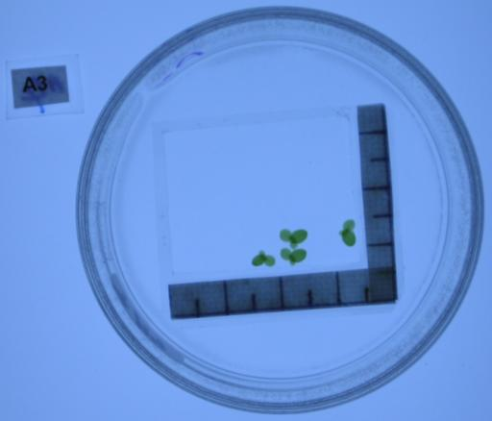

Figure 1 Example of the correct *L. aequinoctialis* stage for test start.

## 2.4 Physico-chemical measurements

For each toxicity test, sub-samples (at least 14 ml) of each treatment were collected in plastic sample bottles and acidified with 1% HNO3. Samples were analysed at Northern Territory Environmental Laboratory (NTEL, Northern Territory, Australia), and later Envirolab (New South Wales, Australia) for Al, Ca, Cd, Co, Cr, Cu, Fe, Mg, Mn, Na, Ni, Pb, Se, SO4, U and Zn using ICP-MS or ICP-OES. Physico-chemical water quality parameters - electrical conductivity (EC), pH (WTW Multiline P4 Meter, Weilheim, Germany) and dissolved oxygen (DO, WTW inoLab Multiline Level 1, Weilheim, Germany) - are measured at the start and conclusion of the test on pooled samples of each treatment. Several different instruments were used to monitor incubator temperature across the course of these tests. For the earlier tests (1026-1141L), temperature was read from a digital max-min thermometer stored in the plant growth cabinet. This was followed by the use of a Tinytag data logger (Hastings Data Loggers, NSW, Australia, tests 1167-1248L), with the most recent tests (1287–1475L) being monitored using the Testo Saveris™ (Lenzkirch, Germany) remote logging system with the temperature sensor placed in a 50 ml falcon tube filled with 30 ml of ultra-pure water to represent the temperature in test solutions.

Water quality data were considered acceptable if: (1) the recorded temperature of the incubator remained within ±1°C; (2) the recorded pH of the control group was within ± 1 unit of Day 1 values; (3) the EC for the control solution was within 10% of the values obtained on Day 1; and (4) the DO concentration was greater than 70% saturation throughout the test.

## 2.5 Test medium trials

### 2.5.1 CAAC

Due to its success as a growth medium, three dilutions of CAAC were trialled as test media. Six tests were conducted using 0.5% CAAC, a single test was conducted using 2.5% CAAC, and twelve tests were conducted using 1% CAAC (Appendix B). While the growth and overall health improved using CAAC, it ameliorated the toxicity of U to an unacceptable extent.

### 2.5.2 SSW

The use of SSW as a growth medium was revisited with four tests trialling different variants of our SSW (different combinations of ultra-pure water amended with trace metals and essential salts. Refer to Appendix B for SSW amended compositions).

### 2.5.3 Nutrient optimisation

Once an acceptable synthetic water was established, three nutrient optimisation tests were conducted, trialling a range of nitrate and phosphate concentrations to determine the minimum concentration of nutrients that could be added without affecting growth rates. Further growth optimisation and pH control was sought by conducting two tests in a CO2 enriched environment (as per Appendix C).

### 2.5.4 Reference toxicity testing

An acceptability criterion of 0.4 doublings d-1 was used as an approximate guide initially during reference toxicity testing however based on the tests performed in this study a acceptability criterion of 0.35 ± 0.1 cm2 d-1 was decided on. The final test medium was decided upon (SSW as the test media and nutrient concentrations of 1 mg L-1 NO3- and 0.1 mg L-1 PO4-) and three reference toxicity tests were performed.

## 2.6 Surface area measurement using ImageJ analysis

At commencement of the test, three surrogate replicates of starting plants were placed in 50 ml crystallising dishes containing 50 ml of high pure water and a floating framed border with an in-built scale. The volume of water had enough depth to allow the plant stems to hang freely in order for the fronds to sit upright and flat at the surface. The floating frame was large enough to fit all plants on completion of the test without any overlapping (approx 35 x 25 mm). The dish containing the plants were placed on top of a light box (Snapper Displays, Western Australia) and photos were taken using a digital camera (Canon PowerShot S70, Tokyo, Japan and later a Sony DSC-TX30, Tokyo, Japan) secured to a tripod (Figure 2). To enable easy cropping of the photo prior to SA analysis, the floating frame was positioned square with the frame of the photo.

When photos were taken it was important to ensure that the fronds themselves were in focus and no other part of the image. This increases the quality of the fond images which improves SA analysis accuracy. A new camera was purchased to further improve the quality of our photos. The DSC-TX30 allows for focus point selection using the touch screen. By selecting a focus point on the Lemna fronds within the crystallising dish the camera will focus on the fronds in the photo, ensuring that the correct part of the image is in focus.

At the conclusion of the test, the process above is repeated for all treatments. The SA of the fronds was calculated using image analysis software (ImageJ, V1.44p, National Institute of Health, Bethesda, Maryland, USA and the threshold colour plug-in tool (V1.12, [www.dentistry.bham.ac.uk/landinig/software/](http://rsbweb.nih.gov/ij/index.html)software.html). Further details of the image analysis method are in Appendix D.

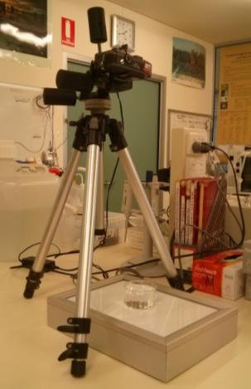

**Figure 2** Set up of camera, tripod and light box for capturing surface area images

## 2.7 Data analysis

Linear interpolation is used to determine toxicity estimates of effective concentrations (ECs) that reduced the frond growth rate or SA by 10 and 50% relative to the controls. Measured total concentrations were used in the derivation of EC10s and EC50s. Toxicant concentration is log transformed in all analyses.

# 3 Results

The raw data for the following series of tests are located in Appendix I.

## 3.1 Growth trials with 0.5% CAAC

Six tests were conducted using 0.5% CAAC (Table 1). Specific frond growth rates ranged from 0.31-0.49 fronds d-1. Two of the six tests reached the minimum acceptable control growth rate of 0.4 fronds d-1 (i.e. a four-fold increase in frond numbers after 96 h). Additionally, plants were generally pale with signs of necrosis, indicating a lack of nutrients being available for growth.

**Table 1** Summary of growth tests using 0.5% CAAC

|  |  |  |
| --- | --- | --- |
| **Test Code** | **0.5% CAAC growth rate k, fronds d-1 (% CV)** | **Criterion met? Yes/No** |
| 802L | 0.38 (3.5) | N |
| 820L | 0.49 (3.7) | Y |
| 825L | 0.37 (9.0) | N |
| 831L | 0.36 (6.5) | N |
| 943L | 0.31 (13) | N |
| 1167L | 0.45 (6.7) | Y |

## 3.2 Toxicity testing using 2.5% CAAC

A single test was conducted using 2.5% CAAC, which resulted in no effect to plants exposed up to 19 600 µg L-1 U. Growth in all treatments was similar to that of the control (growth rate = 0.48 fronds d-1). The control growth rate and variation met the minimum criteria of 0.4 fronds d-1 and <20% CV in controls.

## 3.3 Toxicity testing using 1% CAAC

Twelve tests were conducted using 1% CAAC. All control growth rates (based on frond number) exceeded the protocol’s minimum acceptable growth rate of 0.4 fronds d-1 with less than 20% CV (Table 2, Figure 3). No effects were observed up to ~ 5600 µg L-1 U in most tests with the EC50s ranging from 8.2–22.0 mg L-1 (Table 2). Plants showed a higher level of sensitivity in test 1049L with exposure to 5000 µg L-1 U resulting in a 30% reduction in growth compared to the control. The mean EC50 shown in Figure 3 (11140 µg L-1 U, 33% CV), was 43% lower than that observed in 2.5% CAAC.

**Table 2** Summary of uranium reference toxicity tests during 2009-2013 using 1% CAAC as growth medium

|  |  |  |  |  |  |  |  |
| --- | --- | --- | --- | --- | --- | --- | --- |
|  |  | **Growth Rate (Frond number)** | | | **Growth Rate (SA)** | | |
| **Test #** | **Test Code** | **Control Growth Rate (CV%)** | **EC10 mg L-1 (95%CL)** | **EC50 mg L-1 (95%CL)** | **Control Growth Rate (CV%)** | **EC10 mg L-1 (95%CL)** | **EC50 mg L-1 (95%CL)** |
| 1 | 1049L | 0.5 (3.8) | 1.3 (NCa, 3) | 10 (8, 12) | NMb | NMb | NMb |
| 2 | 1065L | 0.48 (1.4) | 3.8 (3, 4) | 22 (20, 23) | NMb | NMb | NMb |
| 3 | 1089L | 0.46 (3) | 1.9 (NCa, 7) | 9 (7, 11) | NMb | NMb | NMb |
| 4 | 1093L | 0.52 (1.3) | 6.4 (6, 7) | 10 (9.5, 11) | 0.38 (7.2) | 6.3 (6, 6.3) | 8.4 (8, 8.4) |
| 5 | 1141L | 0.54 (4.1) | 6.8 (6, 7) | 13 (12, 16) | NMb | NMb | NMb |
| 6 | 1167L | 0.47 (3.1) | 7 (NCa, 7.4) | 10.5 (10, 11) | 0.38 (5.3) | 13 (12, 13) | 17 (15, 18) |
| 7 | 1183L | 0.51 (4.3) | 4.8 (3, 5) | 9.3 (7.6, 11.7) | 0.43 (3.7) | 3.8 (0.4, 6) | 7.9 (7, 9) |
| 8 | 1248L | 0.48 (1.6) | 4.8 (NCa, 5) | 8.4 (6, 15) | 0.41 (5.8) | 1.8 (1, 3) | 7 (6, 9) |
| 9 | 1287L | 0.48 (3.3) | 5.8 (NCa, 6) | 9.8 (9, 11) | 0.46 (4.2) | 5.9 (NCa, 7) | 8.7 (7.7, 11) |
| 10 | 1301L | 0.52 (3.1) | 6 (5.5, 7) | 11.8 (10, 14) | 0.46 (0.4) | 5.8 (4, 6) | 10.4 (9, 11) |
| 11 | 1315L | 0.48 (4.2) | 5 (NCa, 6) | 8.2 (7, 9) | 0.44 (0.7) | 5.4 ( 5, 6) | 7.4 (7, 8) |
| 12 | 1330L | 0.43 (0.9) | 6.9 (6, 7) | 11 (9, 15) | 0.44 (0.7) | 6.1 (6, 6.3) | 9 (8,10) |

a – NC = Not calculated  
b – NM = Not measured

**Figure 3** Reference toxicant control chart for *L. aequinoctialis* using growth rate based on frond number as an endpoint in 1% CAAC medium. Data points represent EC50 µg L-1 U toxicity estimates and their 95% confidence limits (CLs). Reference lines represent the following: dashed lines – upper and lower 99% CLs (± 3 standard deviations) of the whole data set; dotted lines – upper and lower warning limits (± 2 standard deviations); solid line – running mean

## 3.5 Trialling amended Synthetic Soft Water as a test diluent

Four tests were conducted using different modifications of our standard SSW. Very little difference was observed between the different SSW variants trialled (average growth rate based on frond number = 0.41 ± 0.005, S.A. = 0.38 ± 0.004). As such it was decided to use unmodified SSW for ease and consistency with all other reference toxicity tests (Figure 4). 1% CAAC outperformed all other treatments (average growth rate based on frond number = 0.46 ± 0.007, SA = 0.44 ± 0.01). However in these four tests the pH in the 1% CAAC control increased by more than one pH unit and this diluent was therefore unacceptable.



Figure 4 Growth rates of *L. aequinoctialis* on different modifications of SSW. ‘SSW amended’ is composed of ultra-pure water with the addition of 50 µg L-1 of various salts   
(NaHCO3, CaCl.2H2O, KCl, Al(SO4)3.18H2O, MgSO4.7H2O, FeCl3.6H2O)

## 3.6 Confirmation of suitable nutrient levels for toxicity testing

Three trials were performed with amended SSW with different concentrations of nitrate and phosphate added. Two of the trials included the use of gastight compartments enriched with carbon dioxide (CO2, see Appendix C for use). For all of the SSW amended treatments there was no added benefit of placing the Lemna into the gastight chambers (frond number: F1,4 = 3.14, *p* = 0.15, S.A. = F1,4 = 2.11, *p* = 0.220 (Sigmaplot)). However we saw a significant increase in growth rate in the 1% CAAC treatment for both the SA and frond number endpoint. A concentration of 1 mg L-1 of NO3- and 0.1 mg L-1 PO4- was selected as this was the lowest concentration of nutrients where we saw acceptable population growth rates in both end points (Figure 5 & 6). This is significantly lower than the concentrations added previously (3 mg L-1 of NO3- and 0.3 mg L-1 PO4-).



Figure 5 Surface area population growth rate of *L. aequinoctialis* at different concentrations of nutrients (N = NO3-, P = PO4-)



Figure 6 Frond number population growth rate for *L. aequinoctialis* at different concentrations of nutrients (N = NO3-, P = PO4-)

## 3.7 Toxicity testing using Synthetic Soft Water

A vast difference in sensitivity was observed between the two different endpoints. SA was a more sensitive endpoint in comparison to frond number. An EC50 obtained for one of the tests based on the frond number endpoint was more than 4 times greater than the average EC50 based on SA (852.6 µg L-1 compared to 204.4 µg L-1 U, Table 3).

Table 3 Summary of uranium reference toxicity tests during 2015 using SSW plus nutrients as a test medium

|  |  |  |  |  |  |  |
| --- | --- | --- | --- | --- | --- | --- |
|  | **Growth Rate (Frond number)** | | | **Growth Rate (Surface area)** | | |
| **Test Code** | **Control Growth Rate (CV%)** | **EC10 µg L-1 (95%CL)** | **EC50 µg L-1 (95%CL)** | **Control Growth Rate (CV%)** | **EC10 µg L-1 (95%CL)** | **EC50 µg L-1 (95%CL)** |
| 1465L | 0.40 (7.8) | 12.8 (NCa,130) | >1350 (NCa, NCa) | 0.35 (4.8) | 33.1 (NCa,61) | 89.6 (64, 120) |
| 1473L | 0.39 (3.0) | 108.6 (2, 188) | 852.6 (NCa, NCa) | 0.33 (5.7) | 33.9 (NCa, 58) | 222.7 (148, 322) |
| 1475L | 0.38 (3.1) | 127.6 (38, 316) | >880 (NCa, NCa) | 0.35 (3.7) | 80.4 (7, 156) | 300.9 (269, 337) |

a NC = Not calculated

## 3.8 Surface area as an endpoint

Eight of the twelve tests conducted using 1% CAAC and 4 tests using amended SSW, measured SA as an endpoint. When comparing the growth rate based on frond number and SA, SA appeared to be consistently more sensitive than using frond number. The mean EC50 determined in 1% CAAC medium shown in Figure 7 (8962 µg L-1 U, 21% CV), was 24% lower than the EC50 based on frond number. These initial results suggested that SA growth rate correlates strongly with frond number growth rate and represents a measurable valuable endpoint (Figure 8).

**Figure 7** Reference toxicant control chart for *L. aequinoctialis* using surface area growth rate as an endpoint. Data points represent EC50 µg L-1 U toxicity estimates and their 95% confidence limits (CLs). Reference lines represent the following: dashed lines – upper and lower 99% CLs (± 3 standard deviations) of the whole data set; dotted lines – upper and lower warning limits (± 2 standard deviations); solid line – running mean

**Figure 8** Correlation of EC50s based on frond number and total SA for 9 valid tests (R2 = 0.7168).

## 3.9 Quality control and metal analyses

Sixteen of the 30 tests performed had a pH change of >1 pH unit during the 96 h test period. This was predominantly in the 1% CAAC controls and reference toxicity tests that were performed using 1% CAAC as the test media (Appendix B). All other water quality was considered acceptable (Appendix G). All test temperatures were kept within the acceptable range of 29°C ± 1°C apart from 1330L, 1375L, 1372L and 1377L which were slightly under (average temp = 27.6°C). Metal analyses of the blanks, procedural blanks and control treatments showed no signs of metal contamination in the majority of the samples (See Appendix H for exceptions) however the responses observed in contaminated tests were as expected and as such the data were still used. Uranium loss in test solutions varied greatly between tests, however, the majority of loss was within 20% of nominal concentrations. Loss of U is common during reference toxicity testing due to the high binding affinity of U to glass and other materials. To compensate for this loss measured totals were used in analysis.

# 4 Discussion

## 4.1 Determining an optimal test medium

The results of this study indicate that the most suitable test medium for *L. aequinoctialis* reference toxicity testing is SSW with the addition of 1 mg L-1 of NO3- and 0.1 mg L-1 PO4-. The selection of SSW as the test medium was driven by the fact that much lower concentrations of U were required to observe a phytotoxic response (mean EC10 based on frond number = 82.99 µg L-1, and based on SA = 49.13 µg L-1). Also much smaller deviations in pH were observed in tests using SSW compared to the 0.5, 1 and 2.5% CAAC media.

While growth rates were acceptable in 2.5% CAAC medium, plants showed no signs of toxicity when exposed to up to 19 600 µg L-1 U. The CAAC at 0.5% strength was not a suitable medium as it resulted in unacceptably low and variable growth rates over 96 h. Uranium exposures in 1% CAAC medium consistently resulted in acceptable control growth rates and produced phytotoxic responses at concentrations above 6 mg L-1 U. An important thing to note here is that only 6 out of the 20 CAAC tests performed met the acceptability criteria of less than 1 pH unit variation within the 96 h test period. Toxicity of uranium is highly dependent on pH and as such it is important to have as much control over pH as possible. Thus, CAAC should be discounted as a suitable test medium.

The increased sensitivity of *L. aequinoctialis* to U when using SSW may be explained by the reduction of the concentration of potential metal ligands in the test system. Uranium in solution undergoes speciation changes when in the presence of ligands such as carbonates, phosphates, hydroxides, and organic matter (Markich 2002). This complexation is known to reduce U toxicity to freshwater organisms (Markich 2000, Trenfield 2011) and has been shown specifically for *Lemna gibba* by Mkandawire et al. (2006, 2007). Ethylenediaminetetraacetic acid (EDTA), a component of CAAC, is also a chelator that is essential for optimal growth of *Lemna* (Huebert and Shay 1992) but which may influence metal toxicity by reducing free ion activity. By using SSW and reducing the concentration of nutrients that are being added into the test medium the ionic interactions that will occur with U have been minimised.

During optimisation of the test media for *L. aequinoctialis*, a small amount of transparency was observed in control test fronds for both types of media, which was not seen in the culture plants (see Figure 9a for an example). This was initially a concern as it was thought that plants with transparent patches may be less healthy or stressed. However given that transparency was observed throughout the controls in both the CAAC and SSW tests, and growth rates were acceptable it was determined that this was just an artefact of being transferred from the nutrient rich 50% CAAC culture medium to a simpler test medium. Future work could explore whether acclimation of *L. aequinoctialis* to a less nutrient rich medium would reduce this effect on the plants.

## 4.2 The use of surface area to determine growth rate

When under stress, *Lemna* plants can exhibit chlorosis, necrosis, colony break-up and root destruction (Figure 9b). It has long been established that frond numbers are irrelevant to frond size or biomass and that it does not necessarily provide an indication of live or dead plants (Wang 1990). ImageJ (when used with standardised Hue, Saturation and Brightness (HSB) parameters) can select the green area of a partially chlorotic frond. This allows endpoints to be based on chlorosis, and not just size alone. The HSB parameters were determined using acceptable healthy control plants. ImageJ will omit necrotic plants from the SA calculation, thereby eliminating human bias that can be introduced through deciding which fronds should be included in counts.

|  |  |
| --- | --- |
| **a)** | **b)** |
| DSC00008.JPG | 1355L Lem_RBCP_02 020.JPG |

**Figure 9** Examples of a) healthy fronds from a SSW control water treatment and b) fronds displaying chlorosis following exposure to a treated-mine water.

Growth rates calculated for healthy plants (i.e. unaffected) using SA were around 20% lower than those based on frond number. This is likely to be due to the increased accuracy of the SA measurement as it takes into account the size of the smaller, less developed fronds. This difference in growth rate between SA and front number increased markedly when comparing affected plants (i.e. chlorotic or necrotic, Figure 9). Growth rates based on SA were 80% lower than those based on frond number, due to the exclusion of chlorotic plants in the SA measurements. These lower growth rates translated to lower EC50 values (Table 2, Figure 9).

# 5 Conclusions and recommendations

Growth trials have found that SSW with added nutrients was a suitable test medium. Movement away from CAAC as a test medium will allow for much lower concentrations of U to be used during testing due to an increased sensitivity of *L. aequinoctialis* to U. It also creates consistency with the same diluent then being used for reference toxicity tests with all species in the SSBecotoxicology laboratory.

Using SA as an endpoint further increased this sensitivity, resulting in a mean EC50 that was 15% lower than that based on frond number.

It is recommended that;

* A reference toxicity testing program be established using a medium composed of SSW with added nitrate and phosphate.
* Surface area should be used as an additional endpoint for all *L. aequinoctialis* toxicity tests.
* The acceptability criterion for SA growth rate should be greater than 0.35 ± 0.05 cm2 d-1 (based on the range of control growth rates to date).

# 6 References

ASTM 1992. American Society for Testing and Materials. Standard guide for conducting static toxicity tests with *Lemna gibba*. E1415-91. Philadelphia, USA.

Brain R & Solomon K 2007. A protocol for conduction 7-day daily renewal tests with *Lemna Gibba*. *Nature Protocols* 2, 979-987.

Cleland C F & Briggs W R 1969. Gibberellin and CCC effects on flowering and growth in the long-day plant *Lemna gibba* G3. *Plant Physiology* 44, 503-507.

Dirilgen N & İnel Y 1994. Effects of zinc and copper on growth and metal accumulation in duckweed, Lemna minor. *Bulletin of Environmental Contamination and Toxicology* 53, 442-449.

Environment Canada 1990. Guidance document on control of toxicity test precision using reference toxicants. *Environmental Protection Series*. Minister of Supply and Services, Canada.

Hogan AC, van Dam RA, Houston MA, Harford AJ & Nou S 2009. Uranium exposure to the tropical duckweed, *Lemna aequinoctialis*, and pulmonate snail, *Amerianna cumingi*: fate and toxicity. *Archives of Environmental Contamination and Toxicology* 59, 204-215

Huebert D & Shay J 1992. The effect of EDTA on cadmium and zinc uptake and toxicity in *Lemna triscula L*. *Archives of Environmental Contamination and Toxicology*. 22, 313-318

Markich SJ 2002. Uranium speciation and bioavailability in aquatic systems: An overview. *Scientific World Journal* 2, 707-729.

Mkandawire M, Taubert B and Dudel EG 2006. Limitations of growth-parameters in *Lemna gibba* bioassays for arsenic and uranium under variable phosphate availability. *Ecotoxicology and Environmental Safety* 65, 118-128.

Mkandawire M, Vogel K, Taubert B & Dudel EG 2007. Phosphate regulates uranium (VI) toxicity to *Lemna gibba* L. *Environmental Toxicology* 22, 9-16.

OECD 2006. Test No. 221: *Lemna sp* growth inhibition test. OECD guidelines for testing of chemicals # 221. Organisation for Economic Co-operation and Development, Paris.

Riethmuller N, Camilleri C, Franklin N, Hogan AC, King A, Koch A, Markich SJ, Turley C & van Dam R 2003. *Ecotoxicological testing protocols for Australian tropical freshwater ecosystems.* Supervising Scientist Report 173, Supervising Scientist, Darwin NT.

Trenfield MA, Ng JC, Noller BN, Markich SJ, van Dam RA. 2011. Dissolved organic carbon reduces uranium bioavailability and toxicity.2. Uranium [VI] speciation and toxicity to three tropical freshwater organisms. *Environmental Science and Technology* 45, 3082-3089.

van Dam R 2004. *A review of the eriss Ecotoxicology Program.* Supervising Scientist Report 182, Supervising Scientist, Darwin NT.

# Appendix A: Growth inhibition protocol for *Lemna aequinoctialis* using surface area and frond number as endpoints

## 1 Objective

The objective of a test series (i.e. 3-4 definitive tests) is to determine the concentrations of a specified chemical or whole effluent that shows the effect concentration (e.g. EC50). This is the concentration of a chemical in solution that is estimated to cause a 50% effect concentration of a sublethal response of test organisms. This is measured as the 50% effect plant growth/frond numbers of test *Lemna aequinoctialis* over 96 h (ASTM 1992).

## 2 Principle of the test

A standard number of vegetatively reproducing lemna plants are exposed to a range of concentrations of a toxicant for 96h under controlled conditions. The number of fronds are counted at the end of the test and from this the increase in biomass is calculated. Surface area is also used as an endpoint. Photos are taken at the start and end of the test and using image analysis software the increase in surface area calculated. A test substance is considered toxic when a statistically significant concentration-dependent inhibition of lemna growth occurs.

This protocol has been modified from the protocol found in Riethmuller *et al.* (2003) with the addition of a secondary endpoint (surface area) and a reduction in the concentration of nutrients added to the test diluent (reduced from 3.0 mg L-1 NO3- and 0.3 mg L-1 PO43- to 1.0 mg L-1 NO3- and 0.1 mg L-1 PO43-). Riethmuller et al. (2003) was based on international standards, specifically: OECD ([2006](#_ENREF_3)) test number 221: *Lemna* sp. Growth Inhibition Test and the ASTM ([1992](#_ENREF_1)) Standard guide for conducting static toxicity tests with *Lemna gibba*.

## 3 Test organism

*Lemna aequinoctialis* Welwitsch (Lemnaceae, Spathiflorae) was originally collected from surface waters of Kakadu National Park in 1997 (Yellow Water Billabong, 12°53.77 S, 132°31.10 E) by   
C. Camilleri. An axenic culture is maintained in 50% modified Hoagland’s E and K medium (CAAC) at 29 ± 1°C on a 12:12 h light to dark cycle (75 µmol photons PAR m-2s-1, Riethmuller et al. 2003).

## 4 Dilution water

Depending on the aim of the test, either synthetic soft water (SSW) or uncontaminated natural water (often Magela Creek (MCW) for Ranger related toxicity tests) is used as the test diluent.

Magela Creek water is collected from one of two locations in the creek. When there is flow in the creek during the wet season water is collected by boat near Georgetown Billabong (Map Grid of Australia (MGA) Zone 53, 275320.954 East, 8597972.198 North). Throughout the rest of the year water is collected from Bowerbird Billabong closer to the source of the creek (MGA Zone 53, 287190 East, 8587265 North) where there is a persistent water body during the drier months.

SSW was created to emulate the inorganic composition of Magela Creek water during the wet season. Magela Creek water is very soft and slightly acidic with a low buffering and chemical binding capacity. These qualities make synthetic soft water useful as a worst case scenario for assessing toxicity. SSW is made using the method in Appendix F. SSW is prepared as close to the start of an experiment as possible and can be stored in sealed polyethylene containers and refrigerated for up to a month.

Alternatively the diluent water may be water provided from a specific location where testing is required.

## 5 Chemical solutions

All reagents used are analytical grade and stock solutions are made up in ultra-pure water (18 MΩ, Milli-Q, Millipore). The date of stock preparation, source and the person who made the solution are all marked on the bottle. A label displaying the chemical name, formula and any required hazard symbols and first aid information must also be included on the bottle. These labels must adhere to the Supervising Scientist Branch (SSB) chemical labelling protocol (See SSB document WHS-029).

## 6 Test solutions

Test diluent waters are enriched with nutrients in order to promote healthy Lemna growth. Nutrient enriched water should be made in batches to ensure nutrient homogeneity between treatments; 5 L of diluent requires 1130 µL KNO3 and 540 µL of KH2PO4 to make a solution of 1.0 mg L-1 NO3- and 0.1 mg L-1 PO43-. 1 L of test solution is made per treatment with a 100 ml aliquot dispensed into three 250 ml Erlenmeyer flasks. The remaining test solution is used for the validation of toxicant and nutrient concentrations, and water quality measurements.

## 7 Physico-chemical samples and water parameters

At the start of each toxicity test, sub-samples (40 ml) of the control, a procedural blank and an ultra-pure water blank are collected in plastic sample bottles and acidified with 1% HNO3. Samples were analysed at Envirolab Services (New South Wales, Australia) for Al, Ca, Cd, Co, Cr, Cu, Fe, Mg, Mn, Na, Ni, Pb, Se, SO4, U and Zn using ICP-MS or ICP-OES. Samples are also taken from all other treatments and analysed for elements relevant to the test in question. Verification of nutrient concentrations (nitrate and phosphate) are performed by taking a 50 ml subsample from the control treatment and an ultra-pure water blank. Chemical analyses are considered acceptable if the control, procedural blank and ultra-pure water blank are free of contamination and the measured U concentrations are within 20% of nominal concentrations.

Physico-chemical water quality parameters - electrical conductivity (EC), pH (WTW Multiline P4 Meter, Weilheim, Germany) and dissolved oxygen (DO, WTW inoLab Multiline Level 1, Weilheim, Germany) - are measured at the start and conclusion of the test on pooled samples of each treatment. Temperature was monitored using the Testo Saveris™ (Lenzkirch, Germany) remote logging system with the temperature sensor placed in a 50 ml falcon tube filled with 30 ml of ultra-pure water to represent the temperature in test solutions. Water quality data were considered acceptable if; the recorded temperature of the incubator remained at 29 ±1°C; the recorded pH of the control group was within ± 1 unit of Day 1 values; the EC for the control solution was within 10% of the values obtained on Day 1; and the DO concentration was greater than 70% saturation throughout the test.

## 8 Apparatus and test equipment

### 8.1 Container preparation

All equipment that comes into contact with test organisms, control water or test solutions should made of chemically inert materials (e.g. teflon, glass or polyethylene). All plastic and glassware should be washed by soaking in 5 % v/v nitric acid (HNO3, Chem-supply, Gillman, SA) for 24 h before undergoing a detergent wash (Neodisher Laboclean, phosphate free, Hamburg, Germany) and two rinses in a laboratory dishwasher (Miele, Gütersloh, Germany) with deionised reverse osmosis water (Elix, Millipore, Massachusetts, USA). Glassware used in toxicity tests must be silanised with 2% dimethyldichlorosilane in 1,1,1-trichloroethane (Coatasil, Themofisher Scientific, Massachusetts, USA) to decrease U adsorption to the glass.

### 8.2 Temperature and photoperiod control

Tests are conducted at 29 ± 1ºC using a constant temperature growth cabinet. The temperature of the test environment is monitored by the laboratory temperature monitoring system (Testo Saveris Professional™, Lenzkirch, Germany). During the testing period test containers are removed from the temperature controlled chamber for the minimum amount of time to maintain as constant temperature as possible throughout the test. Tests are conducted with a 12 h light: 12 h dark photoperiod. Light intensity ranges between 100-150 µmol m-2 s-1 and is checked quarterly using a light meter.

### 8.3 Equipment

* Light-tight constant temperature incubator (set at 29 ºC)
* Merck ultra-pure water purification system or similar
* Refrigerator (set at 4 ºC)
* pH, electrical conductivity and dissolved oxygen meters
* A-grade volumetric flasks (1 L and 5 L)
* Chemicals and reagents
* Analytical balance and weigh boats
* Borosilicate glass 200 ml Erlenmeyer flasks with aluminium caps
* Automatic adjustable pipettes (100µL, 1 ml and 5 ml)
* Disposable microlitre pipette tips
* Light meter
* Magnetic stirrer and stirrer bars
* Polyethylene storage containers (1 L)
* 120 ml polystyrene water parameter vials
* Testo Saveris™ temperature monitoring system
* Random number sheet
* Light box
* Disposable sterilised inoculating loops
* Three 50 ml crystalysing dishes
* Magnifying lamp
* Needle-nosed forceps
* Sony Cybershot DSC-TX30 camera
* Camera Tripod
* Laminated scale grid
* Counter
* Image J Image analysis software

### 9 Area for test preparation

The preparation of test solutions should be carried out in an area with ample room and free of contamination from harmful vapours, dust or disturbance. Throughout the test workers should take care not to introduce any contaminants during daily observations and water exchanges by washing hands and arms and wearing disposable gloves.

### 10 Recording data

The number of Lemna plants and fronds in each test flask is counted 96 h after test commencement. Three surrogate control replicates are photographed at the start of the test to provide a starting test surface area and then all replicates are photographed at 96 h. Image analysis software is used to determine the surface area increase over the 96 h period. Both of these data are then used to calculate growth rate. The pH, dissolved oxygen and electrical conductivity are measured on a subsample of test waters at the start and end of the test. Continuous temperature data is collected throughout the test by the Testo Saveris™ temperature probe inside the incubator.

### 11 Test procedure

**Day 0**

1. Prepare test solutions, check pH and leave for at least one hour to equilibrate.
2. Dispense 100 ml aliquot of test solution into three erlemeyer flasks per treatment and 50 ml into a water parameter vial, place in incubator to warm to test temperature.
3. Once at testing temperature, a sterile plastic inoculation loop is used to place four Lemna plants with two full sized fronds and one new frond into each flask (Figure A1).
4. Place a piece of aluminium foil on the top of each flask and remove excess foil so that the shadow in the flask is minimised.
5. Check that each flask contains 4 x 3- fronded plants.
6. Use the random number sheet to place the flasks into the incubator.
7. Perform water quality checks and collect samples for chemical and nutrient analysis.



Figure A1 Example of the correct *L. aequinoctialis* stage for test start.

**Days 1-3**

1. At the appropriate time, i.e. at 24 h intervals, remove all test flasks from the incubator
2. Record the number of plants in each flask, whether there is any fungal or bacterial growth and any other observations on the test sheet.
3. Re-randomise flask positions within the incubator

**Day 4**

1. Remove flasks from the incubator and arrange them in order of ascending toxicity
2. Set up a magnification lamp, the camera and tripod (Figure A2)

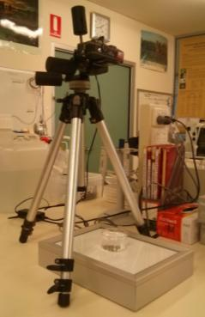

Figure A2 Set up of camera, tripod and light box for capturing surface area images

1. Make general observations of plant health e.g. size and colour of fronds.

*Surface area*

1. Transfer all fronds within each flask into a 50 ml crystallising dish containing 50 ml of ultra-pure water making sure that all plants are placed within the laminated scale grid with no overlapping plants (as in Figure A1).
2. The crystallising dish should then be placed on the lightbox directly under the camera with the treatment and replicate number placed next to it.
3. The camera should be zoomed to 4.8x zoom and the centre of the lemna fronds selected on the camera touch screen so that this will be the point of focus of the photo.

NOTE: Selecting the centre of the lemna fronds is very important otherwise another point on the image may become the focus point and will decrease the resolution of the lemna fronds for analysis.

1. Half press the shutter button on the camera so that the box highlighting the centre of the lemna turns green. Then fully depress the shutter button to capture the image.
2. Repeat for each flask going up in ascending toxicity
3. Copy images off the camera and load them on to a computer with the appropriate image analysis software installed.
4. Following Appendix C calculate the surface area of each image.

*Frond count*

1. Once an image has been captured the crystallising dish is removed from the light box and placed under the magnification lamp.
2. Count the number of plants within the dish and record it on the test sheet
3. Using needle-nosed forceps gently remove each plant from the dish and count the fronds under magnification. A frond is counted, however small, when it is visible beyond the margin of the mother frond ([Cleland and Briggs 1969](#_ENREF_2)). Place the frond on a tissue or white sheet of paper, discarding when count is complete.
4. Record the number of fronds on the test sheet.
5. Pour a sub-sample from each flask in each treatment into a water parameter vial and measure the water quality parameters.

## 12 Randomisation

Each day a new set of random numbers must be used to assign the position of each flask within the incubator. Each flask has a number written on the top of the tin foil lid and is placed into the incubator according to the order of the numbers on the random number sheet. The flasks need to be positioned on the edges of each shelf as close to the light source as possible to ensure that light exposure is maximised. Randomisation is an important part of the experimental design. Random numbers are obtained from a random number table or generator for each day of the test. A set of random numbers is unique for each test and is not to be reused.

## 13 Reference toxicants

The use of reference toxicants enables the response of the test organism to be assessed over time to ensure the response is reproducible. This process also checks the proficiency of operators and laboratory standards. Uranium (U, added as uranyl sulphate) is used in a concentration range from 50-1000 µg L-1. Synthetic soft water is used as the diluent. The EC50 value, calculated from the concentration-response curve, should fall within 3 standard deviations (SDs) of the mean on the quality control chart for the test species. If the value falls outside 2 SDs of the mean, it is a warning that there may be something wrong with the test. It is important to note that a control chart cannot be produced or considered reliable with less than 5 values.

## 14 Acceptability of test data

The test data is considered acceptable if:

1. The recorded temperature of the incubator remains within the prescribed limits (29 ± 1ºC)
2. The growth rate of the control treatment is within the range 0.35 ± 0.1 cm2 d-1 for the SA end point and 0.4 ± 0.1 fronds d-1 for the frond count end point
3. There is < 20% variability in the control growth rate
4. The recorded pH is within the prescribed limits
5. The results of reference toxicity testing are within the set limits.

## 15 Analyses of test data

Growth rate for both surface area and frond count is calculated using the below formula:

$$K= \frac{\ln{N_{t}-\ln{N_{0}}}}{t}$$

Where *Nt* = number of fronds (or SA) at the end of the four-day test period

*N0*= number of fronds (n0 = 12) or SA at the start of the test period

*t* = length of test period in days (T=4)

The growth rates of each treatment are presented as a function of the control response and these are plotted against measured toxicant concentrations. Linear interpolation is used to calculate EC values when performing reference toxicity tests using uranium (U) however in all other toxicant tests three parameter logistic regression is used. Toxicant concentration is log transformed in all analyses.

# Appendix B List of tests

| **Test**  **Code** | **Date** | **Diluent** | **Treatments** | **Valid?**  **Yes/No** | **Failure reason** |
| --- | --- | --- | --- | --- | --- |
| 716L | 10/10/05 | SSW | SSW, SSW + 15, 30, 60, 120, 240, 480, 960 µg L-1 U | Y |  | |
| 732L | 23/01/06 | SSW | SSW, SSW + 250, 500, 1000, 1500, 2000 µg L-1 U | N | Poor control growth | |
| 739L | 22/02/06 | SSW | SSW, SSW + 250, 500, 1000, 1500, 2000 µg L-1 U | Y |  | |
| 775L | 20/11/06 | SSW | MCW control + 0.3 mg L-1 PO4- and 3 mg L-1 NO3-, SSW + 1 mg L-1 NO3- and 0.1 mg L-1 PO4-, SSW + 0.3 mg L-1 PO4- and 3 mg L-1 NO3-, SSW + 1 mg L-1 PO4- and 10 mg L-1 NO3-, SSW + 3 mg L-1 PO4- and 30 mg L-1 NO3-, SSW + 10 mg L-1 PO4- and 100 mg L-1 NO3- | N | Poor control growth | |
| 779L | 20/11/06 | SSW | MCW, SSW, SSW + 250, 500, 1000, 1500, 2000 µg L-1 all treatments included 0.3 mg L-1 PO4- and 3 mg L-1 NO3- | N | Poor control growth | |
| 786L | 6/12/06 | SSW | MCW, SSW (pH 6), SSW (pH7), SSW + CoCl2 (3.54 µg L-1, pH 6), SSW + CoCl2 (3.54 µg L-1, pH 7), SSW + 1 mg L-1 NO3- and 0.1 mg L-1 PO4-, SSW + 1 mg L-1 PO4- and 10 mg L-1 NO3-, SSW + 3 mg L-1 PO4- and 30 mg L-1 NO3-, SSW + 10 mg L-1 PO4- and 100 mg L-1 NO3- | N | Poor control growth | |
| 802L | 22/02/07 | 0.5% CAAC | MCW, 0.5% CAAC, 1% CAAC, 1.5% CAAC, 2% CAAC, 2.5% CAAC | Y |  | |
| 820L | 23/04/07 | 0.5% CAAC | MCW + 0.3 mg L-1 PO4- and 3 mg L-1 NO3-, Milli-Q + 0.3 mg L-1 PO4- and 3 mg L-1 NO3-, 0.5% CAAC, 1% CAAC, 1.5% CAAC, 2% CAAC, 2.5% CAAC | N | >1 pH unit increase | |
| 825L | 28/05/07 | 0.5% CAAC | MCW + 0.3 mg L-1 PO4- and 3 mg L-1 NO3-, 0.5% CAAC, 250, 500, 1000, 1500, 2000 µg L-1 U | N | >1 pH unit increase | |
| 831L | 14/8/07 | 0.5% CAAC | MCW + 0.3 mg L-1 PO4- and 3 mg L-1 NO3-, 0.5% CAAC, 500, 1000, 2000, 4000 µg L-1, 0.25% CAAC, 0.25% CAAC + 2000 µg L-1 | Y |  | |
| 943L | 02/09/08 | 0.5% CAAC | MCW + 0.3 mg L-1 PO4- and 3 mg L-1 NO3-, 0.25% CAAC, 0.5% CAAC | N | >1 pH unit increase | |
| 1167L | 28/03/11 | 0.5% CAAC | 0.5% CAAC, 1% CAAC, 0.5% CAAC + 1.56, 3.13, 6.25, 12.5, 25 mg L-1 U | N | >1 pH unit increase | |
| 1026L | 12/10/09 | 2.5% CAAC | 2.5% CAAC, 2.5% CAAC + 0.625, 1.25, 2.5, 5, 10, 20 mg L-1 U | N | >1 pH unit increase | |
| 1049L | 20/11/09 | 1.0% CAAC | 2.5% CAAC,1% CAAC, 1% CAAC + 0.625, 1.25, 2.5, 5, 10, 20 mg L-1 U | Y |  | |
| 1065L | 22/02/10 | 1.0% CAAC | 2.5% CAAC, 1% CAAC, 1% CAAC + 1.25, 2.5, 5, 10, 20, 40 mg L-1 U | N | >1 pH unit increase | |
| 1089L | 12/04/10 | 1.0% CAAC | 2.5% CAAC,1% CAAC, 1% CAAC + 0.625, 1.25, 2.5, 5, 10, 20 mg L-1 U | Y |  | |
| 1093L | 24/05/10 | 1.0% CAAC | 1% CAAC, 1% CAAC + 0.78, 1.56, 3.13, 6.25, 12.5, 25 mg L-1 U | N | >1 pH unit increase | |
| 1141L | 22/11/10 | 1.0% CAAC | 1% CAAC, 1% CAAC + 0.78, 1.56, 3.13, 6.25, 12.5, 25 mg L-1 U | N | >1 pH unit increase | |
| 1167L | 28/3/11 | 1.0% CAAC | 0.5% CAAC, 1% CAAC, 1% CAAC + 1.56, 3.13, 6.25, 12.5, 25 mg L-1 U | Y |  | |
| 1183L | 04/07/11 | 1.0% CAAC | 1% CAAC, 1% CAAC + 1.56, 3.13, 6.25, 12.5, 25 mg L-1 U | N | >1 pH unit increase | |
| 1248L | 21/11/11 | 1.0% CAAC | 1% CAAC, 1% CAAC + 1.56, 3.13, 6.25, 12.5, 25 mg L-1 U | N | >1 pH unit increase | |
| 1287L | 30/04/12 | 1.0% CAAC | 1% CAAC, 1% CAAC + 1.56, 3.13, 6.25, 12.5, 25 mg L-1 U | N | >1 pH unit increase | |
| 1301L | 24/09/12 | 1.0% CAAC | 1% CAAC, 1% CAAC + 1.56, 3.13, 6.25, 12.5, 25 mg L-1 U | N | >1 pH unit increase | |
| 1315L | 14/01/13 | 1.0% CAAC | 1% CAAC, 1% CAAC + 1.56, 3.13, 6.25, 12.5, 25 mg L-1 U | N | >1 pH unit increase | |
| 1330L | 19/08/13 | 1.0% CAAC | 1% CAAC, 1% CAAC + 1.56, 3.13, 6.25, 12.5, 25 mg L-1 U | Y |  | |
| 1372L | 18/11/15 | 1.0% CAAC | 1% CAAC, 1% CAAC + 1.56, 3.13, 6.25, 12.5, 25 mg L-1 U, Milli-Q + 50 µL L-1 of NaHCO3, CaCl.2H2O3 KCl and MgSO4.7H2O | N | >1 pH unit increase | |
| 1375L | 02/12/13 | SSW amendeda | 1% CAAC, SSW amended + No FeCl3.6H2O, SSW amended | N | Wrong volume of CAAC added | |
| 1377L | 14/12/13 | SSW amendeda | 1% CAAC, SSW amended, SSW amended 1.5x volume of salts, SSW amended 2x volume of salts, SSW amended + 0.3 mg L-1 PO4- and 3mg L-1 NO3- | N | Wrong volume of CAAC added | |
| 1419L | 18/08/14 | SSW amendeda | 1% CAAC, SSW amended, SSW amended 1.5x volume of salts, SSW amended 2x volume of salts, MCW control. All treatments (apart from 1% CAAC) have 0.3 mg L-1 PO4- and 3 mg L-1 NO3- included | Y |  | |
| 1420L | 25/08/14 | SSW amendeda | 1% CAAC, SSW amended, SSW amended + trace Mn, MilliQ amended + trace Mn, Cu, Zn, Pb, MCW control. All treatments (apart from 1% CAAC) have 0.3 mg L-1 PO4- and 3 mg L-1 NO3- included | Y |  | |
| 1428L | 17/11/14 | SSW amendeda | 1% CAAC, SSW amended + 0.5 mg L-1 NO3- and 0.05 mg L-1 PO4-, SSW amended + 1 mg L-1 NO3- and 0.1 mg L-1 PO4-, SSW amended + 0.3 mg L-1 PO4- and 3 mg L-1 NO3-, SSW amended + 0.6 mg L-1 PO4- and 6 mg L-1 NO3- | N | >1 pH unit increase | |
| 1454L | 16/03/15 | SSW amendeda | 1% CAAC, 1% CAAC (chamber), SSW amended + no nutrients, SSW amended + no nutrients (chamber), SSW amended + 0.025 mg L-1 PO4- and 0.25 mg L-1 NO3-, SSW amended + 0.05 mg L-1 PO4- and 0.5 mg L-1 NO3-, SSW amended + 0.05 mg L-1 PO4- and 0.5 mg L-1 NO3- (chamber), SSW amended + 0.075 mg L-1 PO4- and 0.75 mg L-1 NO3-, SSW amended + 0.1 mg L-1 PO4- and 1 mg L-1 NO3- | N | >1 pH unit increase | |

|  |  |  |  |  |  |
| --- | --- | --- | --- | --- | --- |
| 1457L | 06/04/15 | SSW amendeda | 1% CAAC, 1% CAAC (chamber), SSW amended + 0.1 mg L-1 PO4- and 1 mg L-1 NO3-, SSW amended + 0.1 mg L-1 PO4- and 1 mg L-1 NO3- (chamber), SSW amended + 0.3 mg L-1 PO4- and 3 mg L-1 NO3- (chamber), SSW amended + 0.6 mg L-1 PO4- and 6 mg L-1 NO3-, SSW amended + 0.6 mg L-1 PO4- and 6 mg L-1 NO3- (chamber) | Y |  |
| 1465L | 01/06/15 | SSW | SSW, SSW + 100, 250, 500, 750, 1000, 1250, 1500 µg L-1 U + 0.1 mg L-1 PO4- and 1 mg L-1 NO3- in each treatment | Y |  |
| 1473L | 27/07/15 | SSW | SSW, SSW + 25, 50, 100, 200, 350, 500, 1000, 1500, 2000 µg L-1 U + 0.1 mg L-1 PO4- and 1 mg L-1 NO3- in each treatment | Y |  |
| 1475L | 10/8/15 | SSW | SSW, SSW + 50, 100, 250, 500, 750, 1000 µg L-1 U + 0.1 mg L-1 PO4- and 1 mg L-1 NO3- in each treatment | Y |  |

a – SSW amended is made up of the following constituents - 50 µL L-1 of NaHCO3, CaCl.2H2O3 KCl, Al(SO4)3.18H2O, MgSO4.7H2O and FeCl3.6H2O

# Appendix C Using Gas-tight chambers for pH control

## 1 Determination of CO2 volume

* The amount of CO2 enriched gas required for a chamber will differ depending on the initial pH of the MCW, the toxicant being tested and test organism.
* When testing with a new batch of MCW it is essential that a 24 h trial is conducted to determine the volume of CO2-enriched gas required to achieve the desired pH of the testing waters.
* When MCW has a natural pH of 6.2–6.3, 80 ml of CO2 enriched gas should be sufficient to maintain testing at pH ~ 6.
* Fill the chamber (Figure C1) with the number of vials/petri dishes which will be used during testing with the new MCW. Prime the chamber with CO2 and leave in the test incubator overnight.

**NOTE:** Results from these trials should only be used as a guide and more or less CO2 may be required depending on test organism and toxicant.

* During the wet season MCW has a natural pH of <6, therefore using this system may not be appropriate.

## 2 Testing method

* Dispense test solution into vials or petri dishes.
* Ensure magnetic mixing flea is in the centre of the bottom of each chamber.
* Add vials or petri dishes to chambers, 30 flea testing vials or 12 petri dishes (stacked) will fit per chamber.
* If multiple chambers are required ensure the same number of testing vials or petri dishes are in all chambers. This will help prevent differences in CO2 concentrations among chambers.
* Seal the chamber.
* Fill the gas-tight syringe with CO2 enriched air to the desired volume and inject it into the chamber using the left inlet hose. While the syringe is still attached to the inlet hose draw the syringe in and out 3 to 4 times to help mix the gases.

**NOTE:** Only draw the syringe out a maximum of 50 ml to prevent possible damage to the chamber.

* Put the chamber on a magnetic stirring plate, ensuring the flea is freely spinning at the bottom of the chamber. Leave for a minimum of 2 min to allow the gases in the chamber to mix thoroughly.
* Attach the syringe to the outlet hose (right hose) and repeat the process of drawing air in and out of the chamber 3 to 4 times to make sure the air is thoroughly mixed. Withdraw the volume of gas that was injected initially into the chamber and seal off the syringe and the chamber before detaching the syringe from the hose.
* Use the environmental gas monitor to measure the concentration of CO2 in the chamber from the sample of gas that was just extracted (see environmental gas monitor method).

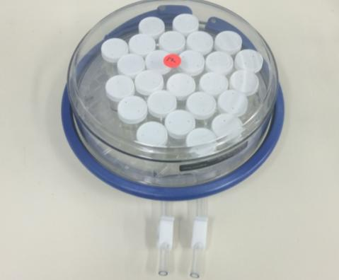

Outlet hose

Inlet hose

**Figure C1** Gas-tight chamber.

* It is important to ensure that test waters have been primed in CO2-enriched test chambers before the test organism is introduced. This is achieved by pre-priming the test waters in the chambers for a minimum of:
* 2 h for petri dishes
* 4 h for flea vials

# Appendix D Measurement of frond surface area using ImageJ software

The ImageJ software can be downloaded from [http://rsbweb.nih.gov/ij/index.html](http://www.dentistry.bham.ac.uk/landinig/software/).

1) Open the picture in ImageJ

1. File → Open → Select photo. (Note it is easy to preview files and open them using the Windows photo browser and the “open with” function in the right click menu)

2) Set the scale using the line tool (Figure D1)

1. Select the line tool (i.e. 5th box from the left under the menu bar). Draw a line on the scale of the floating frame (zoom in (i.e. ctrl and +) for more accuracy).
2. Analyze → Set scale. Add the length of your line enter in the scale (e.g. cm).
3. Check the global box so that all subsequent images will using this scale

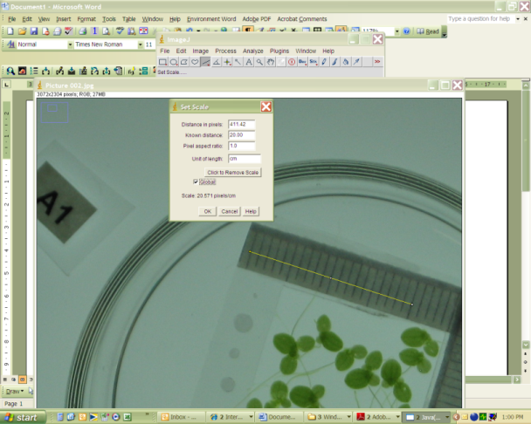

Figure D1 Setting the scale

3) Choose SA as a measurement

1. Analyze → Set measurements. Select parameter(s) required (i.e. area). Check “Limit to threshold” box.

3) Rotate and Crop

1. If needed, rotate the image (Image → Transform → Rotate; Figure D2) so that the plastic frame is squared and aligned.
2. Crop the photo using the box tool (Image → Crop; Figure D3). It is important to remove the scale and as much background as possible leaving only Lemna fronds.

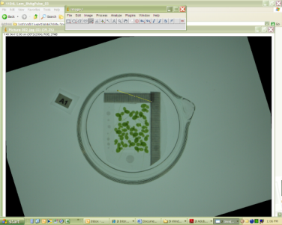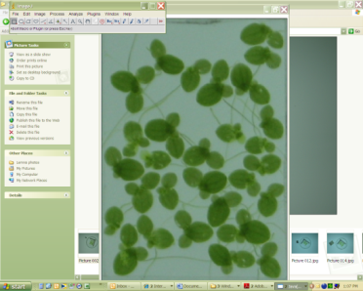

Figure D2 Rotated image Figure D3 Cropped image

4) Open the Threshold Colour tool

1. Open the dialogue box (Plugins →Analyze→ Threshold Colour; Figure D4).

The Threshold Colour plugin tool methods that could be used: i) HSB (Hue, Saturation and Brightness) ii) RGB (Red, Green, Blue) and iii) YUV (colour encoding system used for analogue television).

HSB system discriminates the Lemna leaves from the roots and was most useful for this method. Three histograms are shown and represent the HSB parameters, Hue (pure colour), Saturation (intensity of colour) and Brightness (relative to true colour).

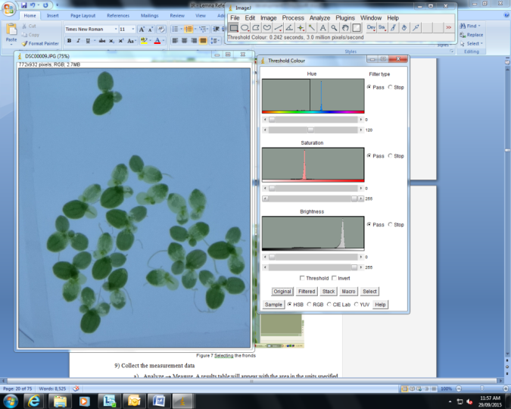

Figure D4 Threshold Colour

5) Set threshold for green pixels

1. Lemna fronds have a green hue (hue = “pure” colour) – Set bottom sliding bar on the Hue histogram to one 120 (Figure D5). By moving the sliding bar to 120 the roots and background within the image should have been removed.

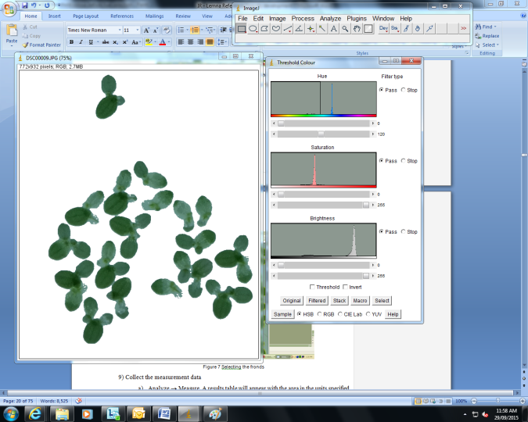

**Figure D5** Setting HSB threshold

6) Click ‘Select’ and a yellow border will appear around the fronds (Figure D6).

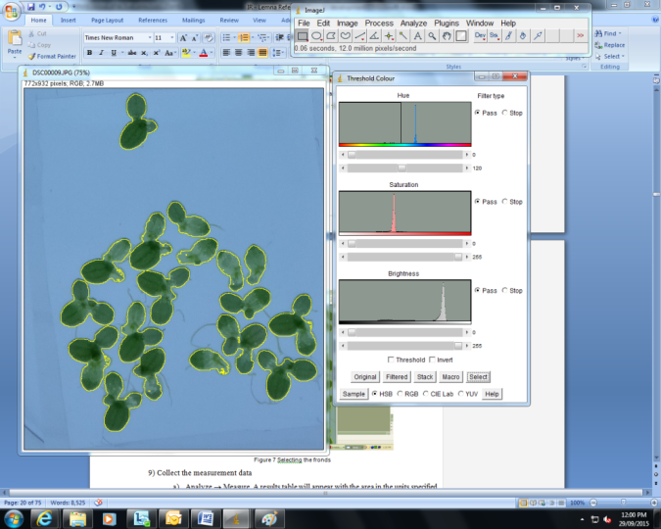

**Figure D6** Selecting the fronds

9) Collect the measurement data

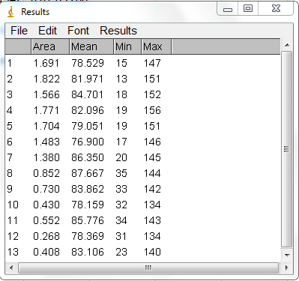

Figure D7 Example of a results table created in ImageJ

1. Analyze → Measure (Ctrl+M). A results table will appear with the area in the units specified in step 2 (e.g. cm2, Figure D7). This can be saved or cut and pasted into an Excel spreadsheet for analysis.

# Appendix E CAAC medium preparation

## 1 Safety

Check the SDSs for any chemicals you are about to use prior to starting to make any solutions to ensure you are aware of any WH&S issues and the appropriate PPE. There are no risks associated with CAAC due to the low concentrations of all chemicals added. Gloves, eye protection and a lab coat must be worn while preparing CAAC.

## 2 Preparation of a working solution

1. Weigh out 2.05 g sucrose into a plastic weigh boat and add to a partially filled 1 L flask of Milli-Q. Shake the flask to dissolve the sucrose.

**Note:** Sucrose is not kept as a stock solution as this can promote bacterial contamination.

1. Add the appropriate amount of the 7 solutions (see Table E1) to the flask. Make flask up to 1 L.

**Note:** These ingredients are stored at 4°C, and will require replacing at 18–24 month intervals.

1. Adjust medium to pH 6.0 (+/- 0.15) using 0.178 M KOH (1g KOH in 100 ml   
   Milli-Q) or 10% HCl (usually around 60-70 drops of KOH are required per 1 L of medium)
2. Pour CAAC medium into 10 x 250 ml flasks, such that there is 100 ml per flask.
3. Use a bung to plug the top of each flask (refer to Laboratory manual method 6ECOTX09 for a description on bung construction). Cover the bung and mouth of flask with alfoil. Record the date the medium is autoclaved and medium type on a strip of autoclave tape and place on alfoil.
4. Autoclave at 121°C for 20 min.
5. Allow the medium to cool to room temperature before inoculating.
6. Medium may be stored at room temperature while not in use.

## 3 Making stocks

Stocks are made up every 18–24 months.

* Add the appropriate amount of chemical in column 2 of Table E1.
* Make up 1L stocks.

Table E1 Stock solutions used to prepare CAAC medium.

|  |  |  |  |
| --- | --- | --- | --- |
|  | Ingredient | Stock Solution (g L-1) | Volume of stock solution added to Milli-Q |
| 1 | KH2PO4 | 50.32 | 5 ml L-1 |
| 2 | KNO3 | 88.9 | 5 ml L-1 |
| 3 | Ca(NO3)2.4H2O | 94.4 | 5 ml L-1 |
| 4 | MgSO4.7H2O | 50 | 5 ml L-1 |
| 5 | EDTA | 9 | 500 μL L-1 |
| 6 | Tartaric acid | 3 | 500 μL L-1 |
| 7 | Micronutrients  H3BO3  ZnSO4.7H2O  Na2MoO4.2H2O  CuSO4.5H2O  MnCl2.4H2O  FeCl3.6H2O | In 1 L add:  2.86  0.22  0.12  0.08  3.62  5.4 | 500 μL L-1 |

# Appendix F Synthetic Soft water preparation

## 1 Safety

Check the SDSs for any chemicals you are about to use prior to making up solutions to ensure you are aware of any WH&S issues and the appropriate PPE. There are no risks associated with SSW due to the low concentrations of all chemicals added. Gloves, eye protection and a lab coat must be work while preparing Synthetic Soft Water.

## 2 Preparation of solution

1. Fill a 5 L volumetric flask with Milli-Q water and pour this into a clean 25 L plastic barrel designated for synthetic water preparation.
2. Partially refill the 5L flask with Milli-Q and add the appropriate amount of the 7 stock solutions (see Table F1) to the flask. Make the flask up to volume with Milli-Q and pour into the barrel.
3. Fill the 5 L flask twice more to make the volume in the barrel equal 20 L.
4. Aerate overnight to allow mixing and gaseous exchange.
5. Check pH after a minimum of 12 hours aeration and adjust to 6.0 ± 0.15 using 0.05 M H2SO4 or 0.05 M NaOH.
6. The water can be stored at 4°C for up to two weeks if necessary. The pH needs to be checked before use to ensure it remains within range.

## 3 Making stocks

Stocks are made up every 18–24 months.

* Add the appropriate amount of chemical in column 2 of Table C1.
* Make up 1 L of stocks at a time.

**Table F1** Stock solutions used to prepare synthetic soft water.

|  |  |  |  |  |
| --- | --- | --- | --- | --- |
|  | **Ingredient** | **Stock Solution (g L-1)** | **Volume of stock per 20 L** | **Nominal concs. of element in SSW** |
| 1 | NaHCO3 | 72.34 | 1 ml | 0.99 mg L-1 |
| 2 | Al2(SO4)3.18H2O\* | 17.26 | 1 ml | 0.075 mg L-1 |
| 3 | MgSO4.7H2O | 121.52 | 1 ml | 0.599 mg L-1 |
| 4 | CaCl2.2H2O | 32.96 | 1 ml | 0.449 mg L-1 |
| 5 | KCl | 14.09 | 1 ml | 0.3107 mg L-1 |
| 6 | FeCl3.6H2O | 10 | 1 ml | 0.1285 mg L-1 |
| 7 | Trace Element Solution  CuSO4.5H2O  ZnSO4.7H2O  Pb(NO3)2 (from EnRad )  MnSO4.H2O  UO2SO4.3H2O (use 5gL-1 U stock in fridge 2) | In 1 L add:  0.11  0.123  0.008  1.188  0.007 | 0.5 ml | 0.975 µg L-1  0.699 µg L-1  0.125 µg L-1  9.654 µg L-1  0.1125 µg L-1 |

\*Requires heating to dissolve

# Appendix G Water Quality measurements for tests used in the control charts

1049L Lem\_reftox\_09

|  |  |  |  |  |  |  |  |  |  |  |  |  |  |  |
| --- | --- | --- | --- | --- | --- | --- | --- | --- | --- | --- | --- | --- | --- | --- |
| Treatment | 1% CAAC | | 594 µg L-1 U | | 990 µg L-1 U | | 1600 µg L-1 U | | 4830 µg L-1 U | | 9320 µg L-1 U | | 16800 µg L-1 U | |
| Parameter | 0h | 72h | 0h | 72h | 0h | 72h | 0h | 72h | 0h | 72h | 0h | 72h | 0h | 72h |
| pH | 6.0 | 6.5 | 6.1 | 6.5 | 5.9 | 6.4 | 6.0 | 6.5 | 5.8 | 5.2 | 5.9 | 4.8 | 6.0 | 5.2 |
| EC (µS cm-1) | 20 | 13 | 22 | 16 | 19 | 14 | 20 | 15 | 25 | 15 | 29 | 31 | 43 | 45 |
| DO (%) | 97.5 | 83.9 | 94.5 | 85.1 | 91.7 | 92.0 | 88.5 | 86.8 | 91.1 | 93.0 | 93.9 | 93.2 | 93.2 | 88.8 |
| Temp(Ave) (°C) | 28.0-30.2 (29.6) | | | | | | | | | | | | | |

**1065L** Lem\_reftox\_10

|  |  |  |  |  |  |  |  |  |  |  |  |  |  |  |
| --- | --- | --- | --- | --- | --- | --- | --- | --- | --- | --- | --- | --- | --- | --- |
| Treatment | 1% CAAC | | 1050 µg L-1 U | | 1700 µg L-1 U | | 2950 µg L-1 U | | 10100 µg L-1 U | | 22000 µg L-1 U | | 39900 µg L-1 U | |
| Parameter | 0h | 72h | 0h | 72h | 0h | 72h | 0h | 72h | 0h | 72h | 0h | 72h | 0h | 72h |
| pH | 6.0 | 6.8 | 6.0 | 6.8 | 5.9 | 6.8 | 5.9 | 6.7 | 5.9 | 4.9 | 5.7 | 4.5 | 6.0 | 5.3 |
| EC (µS cm-1) | 36 | 26 | 37 | 29 | 39 | 31 | 41 | 32 | 44 | 45 | 56 | 65 | 57 | 82 |
| DO (%) | 101.4 | 87.6 | 102.5 | 88.3 | 99.0 | 88.8 | 99.8 | 86.7 | 100.1 | 90.1 | 99.1 | 89.1 | 96.9 | 86.1 |
| Temp (Ave) (°C) | 28.0-31.9 (30.0) | | | | | | | | | | | | | |

**1089L** Lem\_reftox\_11

|  |  |  |  |  |  |  |  |  |  |  |  |  |  |  |
| --- | --- | --- | --- | --- | --- | --- | --- | --- | --- | --- | --- | --- | --- | --- |
| Treatment | 1% CAAC | | 552 µg L-1 U | | 1100 µg L-1 U | | 2450 µg L-1 U | | 5000 µg L-1 U | | 9550 µg L-1 U | | 18700 µg L-1 U | |
| Parameter | 0h | 72h | 0h | 72h | 0h | 72h | 0h | 72h | 0h | 72h | 0h | 72h | 0h | 72h |
| pH | 5.9 | 6.5 | 5.9 | 6.4 | 5.9 | 6.2 | 6.0 | 6.3 | 6.0 | 6.4 | 5.9 | 5.0 | 5.9 | 4.9 |
| EC (µS cm-1) | 32 | 26 | 44 | 56 | 34 | 27 | 34 | 29 | 37 | 32 | 41 | 42 | 42 | 42 |
| DO (%) | 106.4 | 107.8 | 103.6 | 109.4 | 104.6 | 100.5 | 107.3 | 109.0 | 106.4 | 108.0 | 102.6 | 108.9 | 106.6 | 107.7 |
| Temp (Ave) (°C) | 27-28.9 (28.0) | | | | | | | | | | | | | |

**1093L** Lem\_reftox\_12

|  |  |  |  |  |  |  |  |  |  |  |  |  |  |  |
| --- | --- | --- | --- | --- | --- | --- | --- | --- | --- | --- | --- | --- | --- | --- |
| Treatment | 1% CAAC | | 690 µg L-1 U | | 1540 µg L-1 U | | 3070 µg L-1 U | | 5860 µg L-1 U | | 11800 µg L-1 U | | 22800 µg L-1 U | |
| Parameter | 0h | 72h | 0h | 72h | 0h | 72h | 0h | 72h | 0h | 72h | 0h | 72h | 0h | 72h |
| pH | 5.2 | 6.8 | 5.3 | 6.4 | 5.1 | 6.4 | 5.1 | 6.2 | 5.1 | 6.3 | 5.0 | 4.8 | 5.2 | 4.7 |
| EC (µS cm-1) | 36 | 22 | 36 | 22 | 37 | 23 | 38 | 26 | 41 | 25 | 48 | 50 | 61 | 64 |
| DO (%) | 89.4 | 91.2 | 94.1 | 86.1 | 95.7 | 85.5 | 92.9 | 84.0 | 95.8 | 87.5 | 97.3 | 91.9 | 96.6 | 88.5 |
| Temp (Ave) (°C) | 26.5-29.3 (27.9) | | | | | | | | | | | | | |

**1141L** Lem\_reftox\_13

|  |  |  |  |  |  |  |  |  |  |  |  |  |  |  |
| --- | --- | --- | --- | --- | --- | --- | --- | --- | --- | --- | --- | --- | --- | --- |
| Treatment | 1% CAAC | | 725 µg L-1 U | | 1560 µg L-1 U | | 3040 µg L-1 U | | 5880 µg L-1 U | | 13700 µg L-1 U | | 25400 µg L-1 U | |
| Parameter | 0h | 72h | 0h | 72h | 0h | 72h | 0h | 72h | 0h | 72h | 0h | 72h | 0h | 72h |
| pH | 5.7 | 6.8 | 5.7 | 6.5 | 5.7 | 6.7 | 5.7 | 6.5 | 5.7 | 6.5 | 5.7 | 5.1 | 5.7 | 4.9 |
| EC (µS cm-1) | 33 | 24 | 34 | 34 | 49 | 25 | 39 | 29 | 49 | 33 | 45 | 47 | 59 | 62 |
| DO (%) | 92.7 | 83.3 | 91.2 | 91.2 | 91.8 | 87.1 | 90.8 | 90.2 | NA | 87.9 | 90.2 | 92.6 | 92.9 | 93.3 |
| Temp (Ave) (°C) | 28.0-30.1 (29.1) | | | | | | | | | | | | | |

**1167L** Lem\_reftox\_14

|  |  |  |  |  |  |  |  |  |  |  |  |  |
| --- | --- | --- | --- | --- | --- | --- | --- | --- | --- | --- | --- | --- |
| Treatment | 1% CAAC | | 1600 µg L-1 U | | 3300 µg L-1 U | | 6550 µg L-1 U | | 12500 µg L-1 U | | 18900 µg L-1 U | |
| Parameter | 0h | 72h | 0h | 72h | 0h | 72h | 0h | 72h | 0h | 72h | 0h | 72h |
| pH | 5.5 | 6.8 | 5.5 | 6.6 | 5.5 | 6.7 | 5.6 | 6.8 | 5.5 | 5.2 | 5.5 | 5.0 |
| EC (µS cm-1) | 34 | 25 | 35 | 27 | 37 | 30 | 47 | 39 | 45 | 46 | 59 | 62 |
| DO (%) | 91.9 | 88.0 | 89.9 | 90.5 | 92.1 | 89.9 | 90.5 | 92.2 | 91.9 | 91.9 | 91.6 | 90.0 |
| Temp (Ave) (°C) | 26.4-29.1 (28) | | | | | | | | | | | |

**1183L** Lem\_reftox\_15

|  |  |  |  |  |  |  |  |  |  |  |  |  |
| --- | --- | --- | --- | --- | --- | --- | --- | --- | --- | --- | --- | --- |
| Treatment | 1% CAAC | | 1190 µg L-1 U | | 2810 µg L-1 U | | 4840 µg L-1 U | | 13100 µg L-1 U | | 25800 µg L-1 U | |
| Parameter | 0h | 72h | 0h | 72h | 0h | 72h | 0h | 72h | 0h | 72h | 0h | 72h |
| pH | 5.7 | 6.7 | 5.3 | 6.7 | 5.2 | 6.8 | 5.0 | 6.7 | 5.2 | 5.0 | 5.4 | 4.9 |
| EC (µS cm-1) | 40 | 22 | 36 | 24 | 38 | 25 | 41 | 30 | 46 | 48 | 60 | 64 |
| DO (%) | 93.6 | 87.4 | 96.8 | 88.1 | 98.3 | 85.0 | 93.5 | 87.6 | 89.1 | 89.3 | 95.1 | 90.4 |
| Temp (Ave) (°C) | 27.1-29.2 (28.3) | | | | | | | | | | | |

**1248L** Lem\_reftox\_16

|  |  |  |  |  |  |  |  |  |  |  |  |  |
| --- | --- | --- | --- | --- | --- | --- | --- | --- | --- | --- | --- | --- |
| Treatment | 1% CAAC | | 1200 µg L-1 U | | 2300 µg L-1 U | | 4700 µg L-1 U | | 9700 µg L-1 U | | 23000 µg L-1 U | |
| Parameter | 0h | 72h | 0h | 72h | 0h | 72h | 0h | 72h | 0h | 72h | 0h | 72h |
| pH | 5.6 | 6.8 | 5.6 | 6.9 | 5.9 | 6.2 | 5.5 | 6.2 | 5.6 | 4.7 | 5.7 | 4.9 |
| EC (µS cm-1) | 66 | 29 | 69 | 31 | 64 | 44 | 54 | 37 | 65 | 57 | 82 | 70 |
| DO (%) | 96.0 | 88.3 | 99.9 | 91.1 | 98.1 | 87.4 | 95.0 | 87.5 | 96.7 | 94.0 | 96.8 | 92.6 |
| Temp (Ave) (°C) | 26.7-29.1 (28.1) | | | | | | | | | | | |

**1287L** Lem\_reftox\_17

|  |  |  |  |  |  |  |  |  |  |  |  |  |
| --- | --- | --- | --- | --- | --- | --- | --- | --- | --- | --- | --- | --- |
| Treatment | 1% CAAC | | 1500 µg L-1 U | | 3100 µg L-1 U | | 5700 µg L-1 U | | 12000 µg L-1 U | | 25000 µg L-1 U | |
| Parameter | 0h | 72h | 0h | 72h | 0h | 72h | 0h | 72h | 0h | 72h | 0h | 72h |
| pH | 5.4 | 6.9 | 5.4 | 6.4 | 5.4 | 6.5 | 5.5 | 6.6 | 5.3 | 5.0 | 5.5 | 4.9 |
| EC (µS cm-1) | 37 | 28 | 37 | 33 | 37 | 33 | 39 | 31 | 46 | 48 | 62 | 65 |
| DO (%) | 95.5 | 88.0 | 97.8 | 89.5 | 98.7 | 84.6 | 94.9 | 88.1 | 98.7 | 88.7 | 94 | 87.7 |
| Temp (Ave) (°C) | 28.7-28.8 (28.8) | | | | | | | | | | | |

**1301L** Lem\_reftox\_18

|  |  |  |  |  |  |  |  |  |  |  |  |  |
| --- | --- | --- | --- | --- | --- | --- | --- | --- | --- | --- | --- | --- |
| Treatment | 1% CAAC | | 1500 µg L-1 U | | 3000 µg L-1 U | | 5600 µg L-1 U | | 13000 µg L-1 U | | 24000 µg L-1 U | |
| Parameter | 0h | 72h | 0h | 72h | 0h | 72h | 0h | 72h | 0h | 72h | 0h | 72h |
| pH | 5.5 | 6.8 | 5.6 | 6.7 | 5.6 | 6.7 | 5.6 | 6.6 | 5.7 | 5.4 | 5.7 | 5.3 |
| EC (µS cm-1) | 35 | 22 | 37 | 25 | 37 | 26 | 40 | 33 | 46 | 49 | 61 | 66 |
| DO (%) | 90.2 | 83.0 | 90.5 | 81.5 | 88.3 | 81.7 | 89.6 | 81 | 90.7 | 81.7 | 89.8 | 89.2 |
| Temp (Ave) (°C) | 29.0-29.1 (29.1) | | | | | | | | | | | |

**1315L** Lem\_reftox\_19

|  |  |  |  |  |  |  |  |  |  |  |  |  |
| --- | --- | --- | --- | --- | --- | --- | --- | --- | --- | --- | --- | --- |
| Treatment | 1% CAAC | | 1300 µg L-1 U | | 2600 µg L-1 U | | 5300 µg L-1 U | | 10000 µg L-1 U | | 23000 µg L-1 U | |
| Parameter | 0h | 72h | 0h | 72h | 0h | 72h | 0h | 72h | 0h | 72h | 0h | 72h |
| pH | 5.8 | 7.3 | 5.8 | 6.7 | 5.7 | 6.7 | 5.7 | 6.7 | 5.7 | 5.5 | 5.7 | 5.4 |
| EC (µS cm-1) | 36 | 24 | 37 | 30 | 38 | 32 | 40 | 36 | 47 | 53 | 62 | 68 |
| DO (%) | 86.7 | 87.0 | 91.1 | 87.9 | 90.3 | 81.7 | 89.4 | 87.5 | 88.8 | 87.8 | 89.6 | 86.9 |
| Temp (Ave) (°C) | 29.3-29.7 (29.5) | | | | | | | | | | | |

**1330L** Lem\_reftox\_20

|  |  |  |  |  |  |  |  |  |  |  |  |  |
| --- | --- | --- | --- | --- | --- | --- | --- | --- | --- | --- | --- | --- |
| Treatment | 1% CAAC | | 1500 µg L-1 U | | 3000 µg L-1 U | | 6000 µg L-1 U | | 13000 µg L-1 U | | 22000 µg L-1 U | |
| Parameter | 0h | 72h | 0h | 72h | 0h | 72h | 0h | 72h | 0h | 72h | 0h | 72h |
| pH | 5.8 | 6.3 | 5.9 | 6.6 | 5.7 | 6.6 | 5.9 | 6.5 | 5.9 | 5.3 | 5.8 | 5.0 |
| EC (µS cm-1) | 45 | 41 | 49 | 46 | 50 | 43 | 51 | 48 | 59 | 62 | 79 | 78 |
| DO (%) | 98.1 | 84.2 | 89.9 | 87.9 | 91.6 | 86.7 | 89.8 | 86.4 | 90.1 | 86.2 | 90.7 | 84.3 |
| Temp (Ave) (°C) | 27.3-27.6 (27.6) | | | | | | | | | | | |

**1372L** Lem\_reftox\_21

|  |  |  |  |  |  |  |  |  |  |  |  |  |  |  |
| --- | --- | --- | --- | --- | --- | --- | --- | --- | --- | --- | --- | --- | --- | --- |
| Treatment | 1% CAAC | | 1200 µg L-1 U | | 2200 µg L-1 U | | 4800 µg L-1 U | | 89000 µg L-1 U | | 20000 µg L-1 U | | MQ +Na K Ca and Mg | |
| Parameter | 0h | 72h | 0h | 72h | 0h | 72h | 0h | 72h | 0h | 72h | 0h | 72h | 0h | 72h |
| pH | 5.5 | 7.3 | 5.7 | 7.2 | 5.6 | 6.9 | 5.6 | 6.9 | 5.8 | 5.3 | 5.9 | 5.3 | 6.7 | 6.5 |
| EC (µS cm-1) | 49 | 37 | 50 | 41 | 50 | 44 | 53 | 47 | 60 | 60 | 74 | 76 | 16 | 13 |
| DO (%) | 94.1 | 81.7 | 94.6 | 87.8 | 93.1 | 90.5 | 93.1 | 91.5 | 90.7 | 89.6 | 90.9 | 86.4 | 91.8 | 92 |
| Temp(Ave) (°C) | 26.3-29.1 (27.6) | | | | | | | | | | | | | |

**1375L** Lem\_methoddev\_01

|  |  |  |  |  |  |  |
| --- | --- | --- | --- | --- | --- | --- |
| Treatment | 1% CAAC | | MQ amended | | MQ amended + Fe | |
| Parameter | 0h | 72h | 0h | 72h | 0h | 72h |
| pH | 5.5 | 5.7 | 5.7 | 5.6 | 6.2 | 6.2 |
| EC (µS cm-1) | 4 | 3 | 18 | 16 | 26 | 23 |
| DO (%) | 96.5 | 88.5 | 89.8 | 89.2 | 93.2 | 89.0 |
| Temp (Ave) (°C) | 26.9-28.1 (27.6) | | | | | |

**1377L** Lem\_methoddev\_02

|  |  |  |  |  |  |  |  |  |  |  |
| --- | --- | --- | --- | --- | --- | --- | --- | --- | --- | --- |
| Treatment | 1% CAAC | | MQ amended | | MQ amended x1.5 | | MQ amended x2 | | MQ amended + N and P | |
| Parameter | 0h | 72h | 0h | 72h | 0h | 72h | 0h | 72h | 0h | 72h |
| pH | 6.1 | 6.1 | 5.9 | 5.9 | 6.2 | 6.2 | 6.2 | 6.1 | 6.2 | 6.5 |
| EC (µS cm-1) | 3 | 3 | 18 | 16 | 30 | 28 | 33 | 31 | 26 | 21 |
| DO (%) | 95.1 | 86.7 | 97 | 86.5 | 96.8 | 88.2 | 97.5 | 88.2 | 96.8 | 87.3 |
| Temp (Ave) (°C) | 27.0-28.2 (27.7) | | | | | | | | | |

**1419L** Lem\_methoddev\_04

|  |  |  |  |  |  |  |  |  |  |  |
| --- | --- | --- | --- | --- | --- | --- | --- | --- | --- | --- |
| Treatment | 1% CAAC | | MQ amended + N and P | | MQ amended x1.5 + N and P | | MQ amended x2 + N and P | | MCW + N and P | |
| Parameter | 0h | 72h | 0h | 72h | 0h | 72h | 0h | 72h | 0h | 72h |
| pH | 6.0 | 6.6 | 6.1 | 6.8 | 6.1 | 7.0 | 6.1 | 6.9 | 6.4 | 7.1 |
| EC (µS cm-1) | 47 | 38 | 24 | 20 | 31 | 27 | 39 | 35 | 23 | 18 |
| DO (%) | 97.3 | 89.4 | 96.4 | 91.9 | 100.1 | 95.3 | 91 | 95 | 104.8 | 96.2 |
| Temp (Ave) (°C) | 28.6-30.0 (29.0) | | | | | | | | | |

**1420L** Lem\_methoddev\_05

|  |  |  |  |  |  |  |  |  |  |  |
| --- | --- | --- | --- | --- | --- | --- | --- | --- | --- | --- |
| Treatment | 1% CAAC | | MQ amended + N and P | | MQ amended + trace Mn + N and P | | MQ amended + trace Mn, Cu, Zn, Pb + N and P | | MCW + N and P | |
| Parameter | 0h | 72h | 0h | 72h | 0h | 72h | 0h | 72h | 0h | 72h |
| pH | 5.8 | 6.7 | 6.1 | 6.8 | 6.1 | 6.8 | 6.1 | 6.8 | 6.3 | 6.7 |
| EC (µS cm-1) | 48 | 38 | 25 | 19 | 25 | 20 | 23 | 18 | 22 | 17 |
| DO (%) | 94.5 | 86.1 | 97.4 | 92.6 | 101.8 | 93 | 101.8 | 92.4 | 111.6 | 94.3 |
| Temp (Ave) (°C) | 28.7-29.6 (29.0) | | | | | | | | | |

**1428L** Lem\_methoddev\_06

|  |  |  |  |  |  |  |  |  |  |  |  |  |
| --- | --- | --- | --- | --- | --- | --- | --- | --- | --- | --- | --- | --- |
| Treatment | 1% CAAC | | MQ amended + no nutrients | | MQ amended + 0.5 mg/L NO3- and 0.05 mg/L PO4- | | MQ amended + 1.0 mg/L NO3- and 0.1 mg/L PO4- | | MQ amended + 3 mg/L NO3- and 0.3 mg/L PO4- | | MQ amended + 6 mg/L NO3- and 0.6 mg/L PO4- | |
| Parameter | 0h | 72h | 0h | 72h | 0h | 72h | 0h | 72h | 0h | 72h | 0h | 72h |
| pH | 5.8 | 6.9 | 5.5 | 6.3 | 5.8 | 6.4 | 5.6 | 6.4 | 5.8 | 6.5 | 5.8 | 6.5 |
| EC (µS cm-1) | 49 | 40 | 19 | 14 | 19 | 14 | 20 | 14 | 24 | 18 | 31 | 25 |
| DO (%) | 90.1 | 83.6 | 97.2 | 88.2 | 95.3 | 87.0 | 103.8 | 86.9 | 103.5 | 86.3 | 97 | 89.0 |
| Temp (Ave) (°C) | 28.0-29.1 (28.7) | | | | | | | | | | | |

**1454L** Lem\_methoddev\_07

|  |  |  |  |  |  |  |  |  |  |  |  |  |  |  |  |  |  |  |
| --- | --- | --- | --- | --- | --- | --- | --- | --- | --- | --- | --- | --- | --- | --- | --- | --- | --- | --- |
| Treatment | 1% CAAC | | 1% CAAC (chamber) | | MQ amended (no nutrients) | | MQ amended (no nutrients + chamber) | | MQ amended + 0.25 mg/L NO3- and 0.025 mg/L PO4- | | MQ amended + 0.5 mg/L NO3- and 0.05 mg/L PO4- | | MQ amended + 0.5 mg/L NO3- and 0.05 mg/L PO4- (chamber) | | MQ amended + 0.75 mg/L NO3- and 0.075 mg/L PO4- | | MQ amended + 1.0 mg/L NO3- and 0.1 mg/L PO4- | |
| Parameter | 0h | 72h | 0h | 72h | 0h | 72h | 0h | 72h | 0h | 72h | 0h | 72h | 0h | 72h | 0h | 72h | 0h | 72h |
| pH | 5.6 | 7.2 | 5.4 | 6.5 | 5.9 | 6.4 | 5.9 | 5.7 | 6.0 | 6.3 | 6.1 | 6.3 | 5.8 | 5.6 | 6.1 | 6.5 | 6.2 | 6.6 |
| EC (µS cm-1) | 48 | 37 | 49 | 32 | 16 | 13 | 16 | 14 | 16 | 13 | 18 | 14 | 17 | 13 | 17 | 13 | 18 | 14 |
| DO (%) | 97.5 | 93.6 | 95.5 | 102.3 | 100.8 | 94.3 | 98.7 | 98.3 | 99.6 | 99.0 | 99.7 | 98.0 | 96.1 | 98.8 | 98.1 | 97.4 | 99.1 | 98 |
| Temp (Ave) (°C) | 28.3-29.3 (28.8) | | | | | | | | | | | | | | | | | |

**1457L** Lem\_methoddev\_08

|  |  |  |  |  |  |  |  |  |  |  |  |  |  |  |
| --- | --- | --- | --- | --- | --- | --- | --- | --- | --- | --- | --- | --- | --- | --- |
| Treatment | 1% CAAC | | 1% CAAC (chamber) | | MQ amended + 1.0 mg/L NO3- and 0.1 mg/L PO4- | | MQ amended + 1.0 mg/L NO3- and 0.1 mg/L PO4- (chamber) | | MQ amended + 3.0 mg/L NO3- and 0.3 mg/L PO4- (chamber) | | MQ amended + 6.0 mg/L NO3- and 0.6 mg/L PO4- | | MQ amended + 6.0 mg/L NO3- and 0.6 mg/L PO4- (chamber) | |
| Parameter | 0h | 72h | 0h | 72h | 0h | 72h | 0h | 72h | 0h | 72h | 0h | 72h | 0h | 72h |
| pH | 5.7 | 6.5 | 5.8 | 6.6 | 6.1 | 6.4 | 5.9 | 5.6 | 5.8 | 5.9 | 6.0 | 6.5 | 5.9 | 6.2 |
| EC (µS cm-1) | 47 | 41 | 49 | 31 | 18 | 14 | 18 | 13 | 22 | 15 | 29 | 24 | 29 | 20 |
| DO (%) | 97.5 | 91 | 100.8 | 93 | 96.2 | 89.5 | 97.1 | 92 | 97.2 | 90.0 | 95.3 | 90.1 | 100.7 | 89.8 |
| Temp (Ave) (°C) | 28.6-29.9 (29.2) | | | | | | | | | | | | | |

**1465L** Lem\_methoddev\_09

|  |  |  |  |  |  |  |  |  |  |  |  |  |  |  |  |  |
| --- | --- | --- | --- | --- | --- | --- | --- | --- | --- | --- | --- | --- | --- | --- | --- | --- |
| Treatment | Bgd | | 100 µg L-1 U | | 250 µg L-1 U | | 500 µg L-1 U | | 750 µg L-1 U | | 1000 µg L-1 U | | 1250 µg L-1 U | | 1500 µg L-1 U | |
| Parameter | 0h | 72h | 0h | 72h | 0h | 72h | 0h | 72h | 0h | 72h | 0h | 72h | 0h | 72h | 0h | 72h |
| pH | 6.1 | 6.2 | 6.0 | 6.2 | 6.0 | 6.0 | 6.0 | 5.9 | 5.9 | 5.8 | 5.9 | 5.9 | 5.9 | 5.9 | 6.0 | 5.9 |
| EC (µS cm-1) | 18 | 13 | 18 | 14 | 18 | 17 | 18 | 18 | 19 | 18 | 19 | 19 | 19 | 20 | 20 | 20 |
| DO (%) | 98.9 | 90.7 | 102.1 | 92.9 | 104.0 | 93.2 | 104.1 | 93.3 | 99.9 | 92.8 | 101.6 | 90.1 | 102.2 | 91.4 | 103.0 | 92.1 |
| Temp (Ave) (°C) | 28.7-29.2 (28.9) | | | | | | | | | | | | | | | |

**1473L** Lem\_reftoxnew\_01

|  |  |  |  |  |  |  |  |  |  |  |  |  |  |  |  |  |  |  |  |  |
| --- | --- | --- | --- | --- | --- | --- | --- | --- | --- | --- | --- | --- | --- | --- | --- | --- | --- | --- | --- | --- |
| Treatment | Bgd | | 25 µg L-1 U | | 50 µg L-1 U | | 100 µg L-1 U | | 200 µg L-1 U | | 350 µg L-1 U | | 500 µg L-1 U | | 1000 µg L-1 U | | 1500 µg L-1 U | | 2000 µg L-1 U | |
| Parameter | 0h | 72h | 0h | 72h | 0h | 72h | 0h | 72h | 0h | 72h | 0h | 72h | 0h | 72h | 0h | 72h | 0h | 72h | 0h | 72h |
| pH | 6.3 | 6.6 | 6.2 | 6.6 | 6.2 | 6.6 | 6.1 | 6.5 | 6.1 | 6.4 | 6.1 | 6.3 | 6.0 | 6.2 | 6.0 | 6.0 | 6.1 | 6.2 | 6.1 | 6.2 |
| EC (µS cm-1) | 17 | 13 | 17 | 13 | 17 | 14 | 17 | 14 | 17 | 15 | 18 | 18 | 18 | 18 | 19 | 19 | 20 | 20 | 20 | 21 |
| DO (%) | 103.8 | 90.0 | 103.2 | 92.3 | 106.0 | 93.1 | 106.7 | 93.8 | 107.4 | 93.0 | 105.6 | 94.3 | 104.7 | 91.2 | 106.0 | 93.4 | 102.9 | 94.3 | 103.4 | 94.8 |
| Temp (Ave) (°C) | 28.2-29.3 (28.8) | | | | | | | | | | | | | | | | | | | |

**1475L** Lem\_reftoxnew\_02

|  |  |  |  |  |  |  |  |  |  |  |  |  |  |  |
| --- | --- | --- | --- | --- | --- | --- | --- | --- | --- | --- | --- | --- | --- | --- |
| Treatment | Bgd | | 50 µg L-1 U | | 100 µg L-1 U | | 250 µg L-1 U | | 500 µg L-1 U | | 750 µg L-1 U | | 1000 µg L-1 U | |
| Parameter | 0h | 72h | 0h | 72h | 0h | 72h | 0h | 72h | 0h | 72h | 0h | 72h | 0h | 72h |
| pH | 6.0 | 6.7 | 6.1 | 6.7 | 6.1 | 6.7 | 6.0 | 6.3 | 6.0 | 6.1 | 5.9 | 6.1 | 5.9 | 6.0 |
| EC (µS cm-1) | 20 | 14 | 21 | 15 | 19 | 16 | 19 | 17 | 19 | 18 | 21 | 19 | 21 | 20 |
| DO (%) | 99.8 | 89.5 | 103.5 | 90.0 | 103.5 | 90.6 | 106.9 | 90.0 | 105.0 | 90.0 | 102.4 | 92.2 | 99.6 | 93.4 |
| Temp (Ave) (°C) | 28.2-29.2 (28.7) | | | | | | | | | | | | | |

# Appendix H Summary of metal analyses

Table H1 Metal and major ion analyses of QC waters for reference toxicity tests.

|  |  |  |  |  |  |  |  |  |  |  |  |  |  |  |  |  |
| --- | --- | --- | --- | --- | --- | --- | --- | --- | --- | --- | --- | --- | --- | --- | --- | --- |
| **Analyte** | **Al** | **Cd** | **Co** | **Cr** | **Cu** | **Fe** | **Mn** | **Ni** | **Pb** | **Se** | **U** | **Zn** | **SO4** | **Ca** | **Na** | **Mg** |
| **Units** | **µg L-1** | **µg L-1** | **µg L-1** | **µg L-1** | **µg L-1** | **µg L-1** | **µg L-1** | **µg L-1** | **µg L-1** | **µg L-1** | **µg L-1** | **µg L-1** | **mg L-1** | **mg L-1** | **mg L-1** | **mg L-1** |
| **PQL** | **0.1** | **0.02** | **0.01** | **0.1** | **0.01** | **1** | **0.01** | **0.01** | **0.01** | **0.2** | **0.001** | **0.1** | **0.5** | **0.1** | **0.1** | **0.1** |
| 1026L Blk | <0.1 | <0.1 | <0.02 | <0.01 | <0.01 | 0.02 | <20 | <0.1 | <0.01 | NMa | 0.07 | 0.03 | <0.01 | <0.02 | <0.001 | <0.01 |
| 1065L Blk | <0.1 | <0.1 | <0.02 | <0.01 | <0.1 | 0.03 | <20 | <0.1 | <0.01 | <0.1 | 0.05 | 0.02 | <0.1 | <0.2 | 0.001 | 0.2 |
| 1089L Blk | <0.1 | <01 | <0.02 | <0.01 | <0.1 | 0.1 | <20 | <0.1 | <0.01 | 0.1 | 0.04 | 0.02 | <0.1 | <0.2 | 0.006 | <0.1 |
| 1093L Blk | <0.1 | <0.1 | <0.02 | <0.01 | <0.1 | 0.05 | <20 | <0.1 | <0.01 | <0.1 | 0.04 | 0.01 | <0.1 | <0.2 | <0.001 | <0.1 |
| 1141L Blk | <0.1 | <0.1 | <0.02 | <0.01 | <0.1 | 0.01 | <20 | <0.1 | <0.01 | <0.1 | 0.02 | 0.01 | <0.1 | <0.2 | 0.002 | <0.1 |
| 1167L Blk | <0.1 | <0.1 | <0.02 | <0.01 | <0.1 | <0.01 | <20 | <0.1 | <0.01 | <0.1 | 0.05 | <0.01 | 0.2 | <0.2 | <0.001 | 0.3 |
| 1183L Blk | <0.1 | <0.1 | <0.02 | <0.01 | <0.1 | <0.01 | <20 | <0.1 | <0.01 | <0.1 | 0.04 | <0.01 | <0.1 | <0.2 | <0.001 | <0.1 |
| 1248L Blk | 32 | 0.1 | <0.02 | 0.011 | <0.10 | 0.10 | 1.6 | 0.3 | 0.063 | <0.1 | 0.70 | 0.10 | <0.5 | <0.20 | 0.011 | 0.50 |
| 1287L Blk | <0.1 | NMa | <0.02 | <0.01 | <0.1 | 0.073 | <1.0 | NMa | <0.01 | NMa | 0.12 | <0.01 | NMa | <0.2 | <0.001 | <0.1 |
| 1301L Blk | <0.1 | <0.1 | <0.02 | <0.01 | <0.1 | 0.069 | <1.0 | <0.1 | <0.01 | <0.1 | 0.12 | <0.01 | <0.5 | <0.2 | 0.012 | <0.1 |
| 1315L Blk | <0.1 | <0.1 | <0.02 | <0.01 | <0.1 | <0.01 | <1.0 | <0.1 | <0.01 | <0.1 | 0.029 | <0.01 | <0.5 | <0.2 | <0.001 | <0.1 |
| 1330L Blk | <0.1 | <0.1 | <0.02 | <0.01 | <0.1 | <0.01 | <1 | <0.1 | <0.01 | <0.1 | <0.01 | <0.01 | <0.5 | <0.2 | <0.001 | <0.1 |
| 1372L Blk | <0.1 | <0.1 | <0.02 | <0.01 | <0.1 | 0.01 | <1 | <0.1 | <0.01 | <0.1 | <0.01 | <0.01 | <0.5 | <0.2 | <0.001 | <0.1 |
| 1375L Blk | 5 | <0.1 | <0.02 | <0.01 | <0.1 | 2 | <1 | <0.1 | 0.05 | 0.1 | 0.08 | 0.07 | <0.5 | <0.2 | 0.02 | 0.9 |
| 1419L Blk | 0.5 | <0.1 | <0.02 | <0.01 | <0.1 | 0.03 | <1 | <0.1 | <0.01 | <0.1 | <0.01 | <0.01 | <0.1 | <0.2 | <0.001 | <0.1 |
| 1420L Blk | 0.3 | <0.1 | <0.02 | <0.01 | <0.1 | 0.03 | <1 | <0.1 | <0.01 | <0.1 | 0.01 | <0.01 | <1 | <0.2 | <0.001 | <0.1 |
| 1454L Blk | 0.2 | <0.1 | <0.02 | <0.01 | <0.1 | 0.06 | <1 | <0.1 | <0.01 | <0.1 | <0.01 | <0.01 | <0.5 | <0.2 | <0.001 | <0.1 |
| 1457L Blk | NMa | NMa | NMa | NMa | NMa | NMa | NMa | NMa | NMa | NMa | NMa | NMa | NMa | NMa | NMa | NMa |
| **Analyte** | **Al** | **Cd** | **Co** | **Cr** | **Cu** | **Fe** | **Mn** | **Ni** | **Pb** | **Se** | **U** | **Zn** | **SO4** | **Ca** | **Na** | **Mg** |
| **Units** | **µg L-1** | **µg L-1** | **µg L-1** | **µg L-1** | **µg L-1** | **µg L-1** | **µg L-1** | **µg L-1** | **µg L-1** | **µg L-1** | **µg L-1** | **µg L-1** | **mg L-1** | **mg L-1** | **mg L-1** | **mg L-1** |
| **PQL** | **0.1** | **0.02** | **0.01** | **0.1** | **0.01** | **1** | **0.01** | **0.01** | **0.01** | **0.2** | **0.001** | **0.1** | **0.5** | **0.1** | **0.1** | **0.1** |
| 1465L Blk | <0.1 | <0.1 | <0.02 | <0.01 | <0.1 | 0.04 | <1 | <0.1 | <0.01 | <0.1 | 0.01 | <0.01 | <0.5 | <0.2 | <0.001 | <0.1 |
| 1473L Blk | 0.3 | <0.1 | <0.02 | <0.01 | <0.1 | 0.06 | <1 | <0.1 | <0.01 | <0.1 | <0.01 | <0.01 | <0.5 | <0.2 | <0.001 | <0.1 |
| 1475L Blk | 0.03 | <0.1 | <0.02 | <0.01 | <0.1 | 0.07 | 14 | <0.1 | 0.1 | <0.1 | 0.02 | <0.01 | NMa | <0.2 | <0.001 | <0.1 |
| 1026L Pro Blk | 0.2 | <0.1 | <0.02 | <0.01 | <0.01 | 0.04 | <20 | <0.1 | 0.01 | N.A | 0.08 | 0.04 | <0.01 | <0.02 | <0.001 | <0.01 |
| 1049L Pro Blk | <0.01 | <0.01 | <0.02 | <0.01 | <0.1 | 0.02 | <20 | <0.1 | <0.01 | <0.1 | 0.04 | 0.02 | <0.1 | <0.2 | 0.005 | <0.1 |
| 1065L Pro Blk | 0.3 | <0.1 | <0.02 | <0.01 | <0.1 | 2.88 | <20 | <0.1 | 0.08 | <0.1 | 0.38 | 0.08 | <0.1 | <0.2 | 0.019 | 3.2 |
| 1089L Pro Blk | 0.2 | <0.1 | <0.02 | <0.01 | <0.1 | 0.21 | <20 | <0.1 | <0.01 | 0.3 | 0.05 | 0.03 | <0.1 | <0.2 | <0.001 | <0.1 |
| 1093L Pro Blk | 1 | <0.1 | <0.02 | <0.01 | <0.1 | 0.62 | <20 | <0.1 | 0.02 | <0.1 | 0.07 | 0.02 | <0.1 | <0.2 | 0.006 | 0.7 |
| 1141L Pro Blk | 3.3 | <0.1 | <0.02 | <0.01 | <0.1 | 0.56 | <20 | <0.1 | 0.07 | <0.1 | 14.5 | 0.05 | <0.1 | <0.2 | 0.018 | 0.6 |
| 1167L Pro Blk | <0.1 | <0.1 | <0.02 | <0.01 | <0.1 | 0.05 | <20 | <0.1 | 0.02 | <0.1 | 0.04 | 0.02 | 0.1 | <0.2 | <0.001 | 0.6 |
| 1183L Pro Blk | <0.1 | <0.1 | <0.02 | <0.01 | <0.1 | 0.03 | <20 | <0.1 | <0.01 | <0.1 | 0.05 | 0.03 | <0.1 | <0.2 | 0.003 | <0.1 |
| 1248L Pro Blk | 0.44 | <0.1 | <0.02 | <0.01 | <0.10 | 0.091 | <1.0 | <0.1 | 0.011 | <0.1 | 0.12 | 0.011 | <0.5 | <0.20 | 0.004 | 6.3 |
| 1287L Pro Blk | 0.71 | NMa | 0.024 | <0.01 | <0.1 | 0.083 | <1.0 | NMa | <0.01 | NMa | 0.13 | 0.095 | NMa | <0.2 | 0.023 | <0.1 |
| 1301L Pro Blk | 2.6 | <0.1 | 0.039 | <0.01 | <0.1 | 0.073 | <1.0 | <0.1 | <0.01 | <0.1 | 0.13 | 0.1 | <0.5 | <0.2 | 0.002 | 0.23 |
| 1315L Pro Blk | 0.35 | <0.1 | <0.02 | <0.01 | <0.1 | <0.01 | <1.0 | <0.1 | 0.011 | <0.1 | 0.031 | 0.071 | <0.5 | 0.31 | 0.03 | <0.1 |
| 1330L Pro Blk | <0.1 | <0.1 | <0.02 | <0.01 | <0.1 | 0.5 | <1 | <0.1 | <0.01 | <0.1 | 0.05 | <0.01 | <0.5 | <0.2 | 0.01 | <0.1 |
| 1372L Pro Blk | 0.7 | <0.1 | <0.02 | <0.01 | <0.1 | 0.3 | <1 | <0.1 | <0.01 | <0.1 | <0.01 | 0.03 | <0.5 | <0.2 | 0.03 | <0.1 |
| 1375L Pro Blk | 6 | <0.1 | <0.02 | <0.01 | <0.1 | 4 | <1 | <0.1 | 0.07 | 0.1 | 0.1 | 0.09 | <0.5 | <0.2 | 0.03 | 1 |
| 1419L Pro Blk | 0.3 | <0.1 | <0.02 | <0.01 | <0.1 | 0.03 | <1 | <0.1 | 0.03 | <0.1 | <0.01 | <0.01 | <0.1 | <0.2 | <0.001 | <0.1 |
| 1420L Pro Blk | 0.4 | <0.1 | <0.02 | <0.01 | <0.1 | 0.03 | <1 | <0.1 | 0.01 | <0.1 | 0.01 | <0.01 | <1 | <0.2 | <0.001 | <0.1 |
| **Analyte** | **Al** | **Cd** | **Co** | **Cr** | **Cu** | **Fe** | **Mn** | **Ni** | **Pb** | **Se** | **U** | **Zn** | **SO4** | **Ca** | **Na** | **Mg** |
| **Units** | **µg L-1** | **µg L-1** | **µg L-1** | **µg L-1** | **µg L-1** | **µg L-1** | **µg L-1** | **µg L-1** | **µg L-1** | **µg L-1** | **µg L-1** | **µg L-1** | **mg L-1** | **mg L-1** | **mg L-1** | **mg L-1** |
| **PQL** | **0.1** | **0.02** | **0.01** | **0.1** | **0.01** | **1** | **0.01** | **0.01** | **0.01** | **0.2** | **0.001** | **0.1** | **0.5** | **0.1** | **0.1** | **0.1** |
| 1454L Pro Blk | 2 | <0.1 | <0.02 | <0.01 | <0.1 | 0.1 | <1 | <0.1 | <0.01 | <0.1 | 0.02 | <0.01 | <0.5 | <0.2 | 0.01 | <0.1 |
| 1457L Pro Blk | 3 | <0.1 | <0.02 | <0.01 | <0.1 | 0.09 | <1 | <0.1 | 0.05 | <0.1 | 0.5 | <0.01 | <0.5 | <0.2 | 0.001 | <0.1 |
| 1465L Pro Blk | 0.3 | <0.1 | <0.02 | <0.01 | <0.1 | 0.05 | <1 | <0.1 | <0.01 | <0.1 | 0.01 | <0.01 | <0.5 | <0.2 | 0.004 | <0.1 |
| 1473L Pro Blk | 0.9 | <0.1 | <0.02 | 0.02 | <0.1 | 0.1 | <1 | <0.1 | <0.01 | <0.1 | <0.01 | 0.03 | <0.5 | <0.2 | 0.007 | 0.1 |
| 1475L Pro Blk | 1 | <0.1 | <0.02 | <0.01 | <0.1 | 0.06 | <1 | <0.1 | <0.01 | <0.1 | 0.01 | 0.03 | NMa | <0.2 | 0.7 | <0.1 |
| 1026L Control (2.5% CAAC) | 1 | 4.1 | <0.02 | <0.01 | <0.01 | 0.6 | 20 | 1.2 | 26.1 | N.A | 0.11 | 0.05 | 4.9 | <0.02 | 0.127 | 2.4 |
| 1049L Control (1% CAAC) | 0.2 | 0.8 | <0.02 | <0.01 | <0.1 | 0.16 | <20 | 0.3 | 5.01 | 0.3 | 0.12 | 0.04 | 1 | <0.2 | 0.47 | 1 |
| 1065L Control (1% CAAC) | 0.5 | 1.8 | <0.02 | <0.01 | <0.1 | 2.09 | <20 | 0.6 | 9.06 | 0.4 | 0.22 | 0.04 | 2.2 | <0.2 | 0.006 | 1 |
| 1089L Control (1% CAAC) | 0.2 | 1.5 | <0.02 | <0.01 | <0.1 | 0.3 | <20 | 0.5 | 8.7 | 0.3 | 0.1 | 0.04 | 2 | <0.2 | 0.037 | 1.6 |
| 1093L Control (1% CAAC) | 0.9 | 1.7 | 0.04 | <0.01 | <0.1 | 0.45 | <20 | 0.7 | 15.6 | <0.1 | 0.81 | 0.07 | 2.9 | <0.2 | 0.023 | 1.9 |
| 1141L Control (1% CAAC) | <0.1 | 1.6 | <0.02 | <0.01 | <0.1 | 0.39 | <20 | 0.5 | 9.79 | <0.1 | 0.25 | 0.04 | 2 | <0.2 | 0.733 | 1 |
| 1167L Control (1% CAAC) | 1.3 | 1.7 | <0.02 | <0.01 | <0.1 | 0.25 | <20 | 0.5 | 11.1 | 0.2 | 0.11 | 0.01 | 2 | <0.2 | 0.098 | 1 |
| 1183L Control (1% CAAC) | 0.5 | 1.7 | <0.02 | <0.01 | <0.1 | 0.23 | <20 | 0.5 | 9.41 | <0.1 | 0.05 | 0.04 | 2.2 | <0.2 | 1.06 | 1 |
| 1248L Control (1% CAAC) | 0.67 | 1.4 | <0.02 | 0.039 | <0.10 | 0.27 | 9.1 | 0.5 | 8.8 | <0.1 | 0.18 | 0.076 | 2.0 | <0.20 | 0.94 | 0.69 |
| 1287L Control (1% CAAC) | 0.72 | NMa | 0.022 | 0.012 | <0.1 | 0.33 | 11.0 | NMa | 9.7 | NMa | 0.17 | 0.16 | NMa | 0.3 | 1.1 | 2.3 |
| 1301L Control (1% CAAC) | NMa | NMa | NMa | NMa | NMa | NMa | NMa | NMa | NMa | NMa | NMa | NMa | NMa | NMa | NMa | NMa |
| 1315L Control (1% CAAC) | 0.77 | 1.5 | <0.02 | <0.01 | <0.1 | 0.19 | 9.3 | 0.5 | 8.8 | <0.1 | 0.094 | 0.068 | 2 | <0.2 | 0.5 | 0.71 |
| 1330L Control (1% CAAC) | 0.5 | 1.9 | <0.02 | <0.01 | <0.1 | 0.08 | 21 | 1.6 | 11 | <0.1 | 0.04 | 0.02 | 3 | <0.2 | 0.2 | 0.6 |
| 1372L Control (1% CAAC) | 0.8 | 1.9 | <0.02 | <0.01 | <0.1 | 0.2 | 19 | 1.6 | 11 | <0.1 | <0.01 | 0.05 | 2 | <0.2 | 0.07 | 0.4 |
| 1375L Control (1% CAAC) | 0.5 | <0.1 | <0.02 | <0.01 | <0.1 | 0.03 | <1 | <0.1 | 0.1 | <0.1 | <0.01 | <0.01 | <0.5 | <0.2 | 0.3 | <0.2 |
| **Analyte** | **Al** | **Cd** | **Co** | **Cr** | **Cu** | **Fe** | **Mn** | **Ni** | **Pb** | **Se** | **U** | **Zn** | **SO4** | **Ca** | **Na** | **Mg** |
| **Units** | **µg L-1** | **µg L-1** | **µg L-1** | **µg L-1** | **µg L-1** | **µg L-1** | **µg L-1** | **µg L-1** | **µg L-1** | **µg L-1** | **µg L-1** | **µg L-1** | **mg L-1** | **mg L-1** | **mg L-1** | **mg L-1** |
| **PQL** | **0.1** | **0.02** | **0.01** | **0.1** | **0.01** | **1** | **0.01** | **0.01** | **0.01** | **0.2** | **0.001** | **0.1** | **0.5** | **0.1** | **0.1** | **0.1** |
| 1419L Control (1% CAAC) | 4 | 1.8 | <0.02 | <0.01 | <0.1 | 0.7 | 23 | 1.5 | 11 | <0.1 | 0.08 | 0.07 | 2 | <0.2 | 0.009 | 2 |
| 1420L Control (1% CAAC) | 1 | 1.9 | 0.04 | 0.01 | <0.1 | 0.3 | 24 | 1.6 | 13 | <0.1 | 0.2 | 0.06 | 2 | <0.2 | 0.01 | 1 |
| 1454L Control (1% CAAC) | 1 | 1.9 | <0.02 | <0.01 | <0.1 | 0.3 | 11 | 1.6 | 12 | <0.1 | 0.04 | 0.06 | 2 | <0.2 | 0.1 | 0.7 |
| 1457L Control (1% CAAC) | 2 | 2 | <0.02 | <0.01 | <0.1 | 0.3 | 10 | 1.7 | 12 | <0.1 | 0.1 | 0.04 | 2 | <0.2 | 0.04 | 2 |
| 1465L Control (SSW) | 8 | 4 | <0.02 | <0.01 | <0.1 | 0.3 | 56.5 | 0.6 | 8 | 1 | 0.2 | 0.09 | 3 | <0.2 | 0.03 | 0.8 |
| 1473L Control (SSW) | 9 | 0.4 | <0.02 | <0.01 | <0.1 | 0.5 | 56 | 0.6 | 9 | 1.1 | 0.05 | 0.09 | 2 | <0.2 | 0.05 | 0.9 |
| 1475L Control (SSW) | 18 | 0.4 | <0.02 | <0.01 | <0.1 | 0.4 | 71 | 0.6 | 10 | 1.1 | 0.05 | 0.07 | NMa | <0.2 | 0.06 | 0.7 |

a Not measured

Highlighted entries are higher than what would usually be expected in controls

Table H2 Measured uranium concentrations in reference toxicity tests.

|  |  |  |
| --- | --- | --- |
| **Test & treatment code** | **Nominal U concentration**  **(µg L-1)** | **Measured U concentration**  **(µg L-1)** |
| 1465L PRO BLK | - | 0.004 |
| 1465L A | Bgd\* | 0.03 |
| 1465L B | 100 | 35 |
| 1465L C | 250 | 120 |
| 1465L D | 500 | 310 |
| 1465L E | 750 | 560 |
| 1465L F | 1000 | 790 |
| 1465L G | 1250 | 960 |
| 1465L H | 1500 | 1300 |
| 1473L PRO BLK | - | 0.007 |
| 1473L A | Bgd | 0.05 |
| 1473L B | 25 | 20 |
| 1473L C | 50 | 42 |
| 1473L D | 100 | 83 |
| 1473L E | 200 | 170 |
| 1473L F | 350 | 310 |
| 1473L G | 500 | 460 |
| 1473L H | 1000 | 900 |
| 1473L I | 1500 | 1400 |
| 1473L J | 2000 | 1800 |
| 1475L PRO BLK | - | 0.7 |
| 1475L A | Bgd | 0.06 |
| 1475L B | 50 | 39.5 |
| 1475L C | 100 | 77 |
| 1475L D | 250 | 210 |
| 1475L E | 500 | 420 |
| 1475L F | 750 | 660 |
| 1475L G | 1000 | 880 |

**Table H3** Measured nitrate and phosphate concentrations in quality check waters in reference toxicity tests.

|  |  |  |
| --- | --- | --- |
| **Test code and treatment** | **Measured nutrient concentrations** | |
| **Nitrate as N (mg L-1)** | **Phosphate as P (mg L-1)** |
| 1465L BLK | <0.005 | <0.005 |
| 1465L A | 0.094 | 0.011 |
| 1473L BLK | <0.005 | <0.005 |
| 1473L A | 0.18 | 0.055 |
| 1475L BLK | <0.005 | <0.005 |
| 1475L A | 0.17 | 0.012 |

# Appendix I Analytical reports

Analytical reports for tests measuring the sensitivity of *Lemna aequinoctialis* to uranium in different test media.

**Figure I1** Test raw data and analysis report for test 1049L (frond count)

H:\My Documents\Ecotox Lab\Reftox\Lem_RefTox\Lemna stats for report\1049L p1.TIF

**Figure I1** Continued

H:\My Documents\Ecotox Lab\Reftox\Lem_RefTox\Lemna stats for report\1049L p2.TIF

**Figure I2** Test raw data and analysis report for test 1065L (frond count)

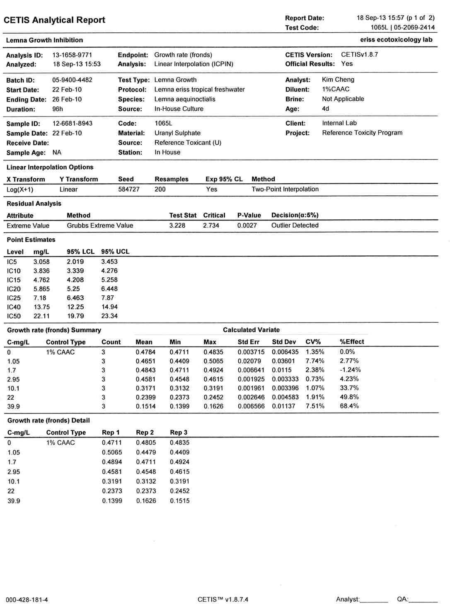

**Figure I2** Continued

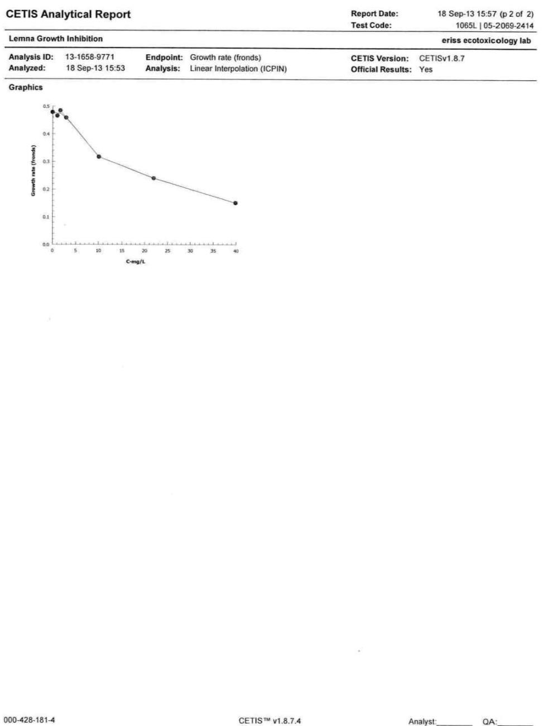

**Figure I3** Test raw data and analysis report for test 1089L (frond count)

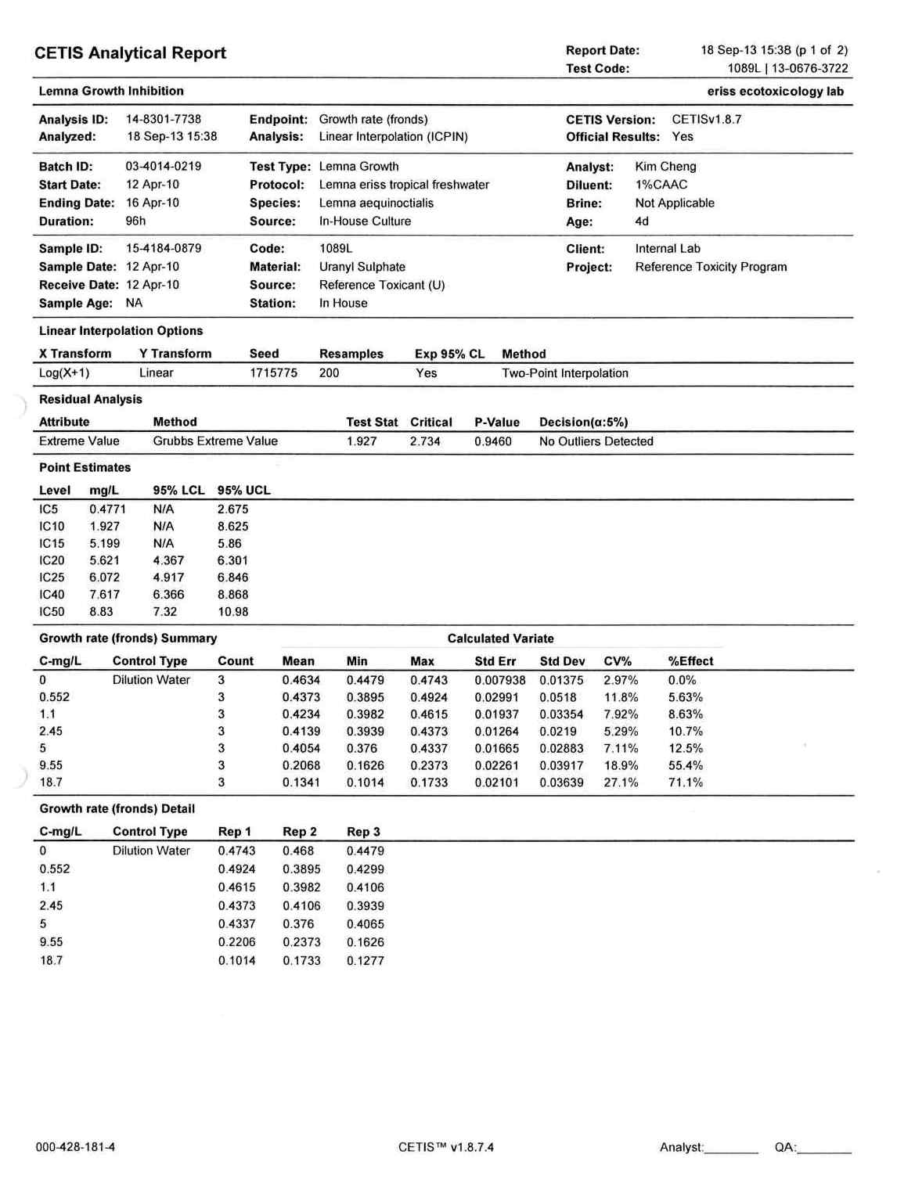

**Figure I3** Continued

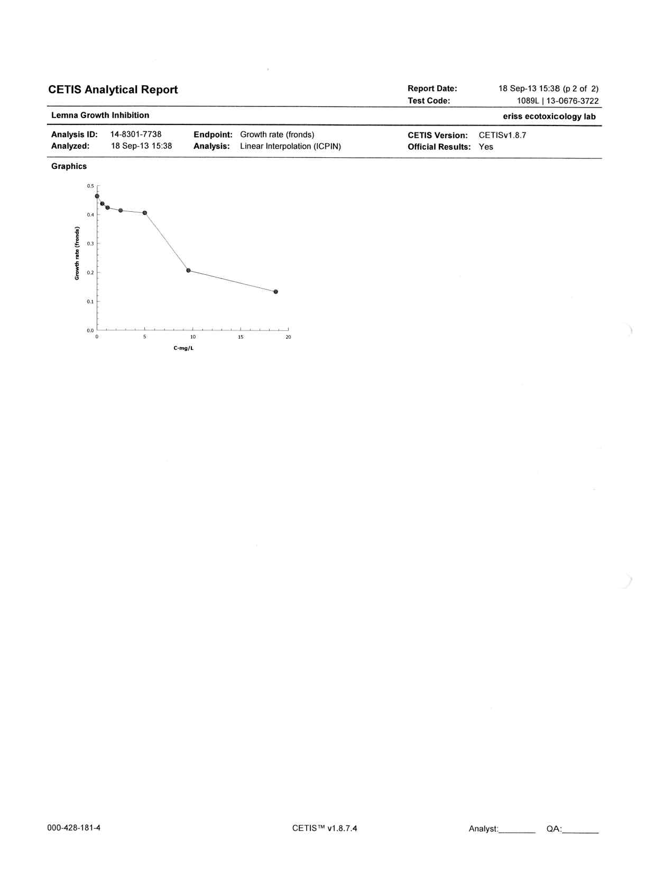

**Figure I4** Test raw data and analysis report for test 1093L (frond count)

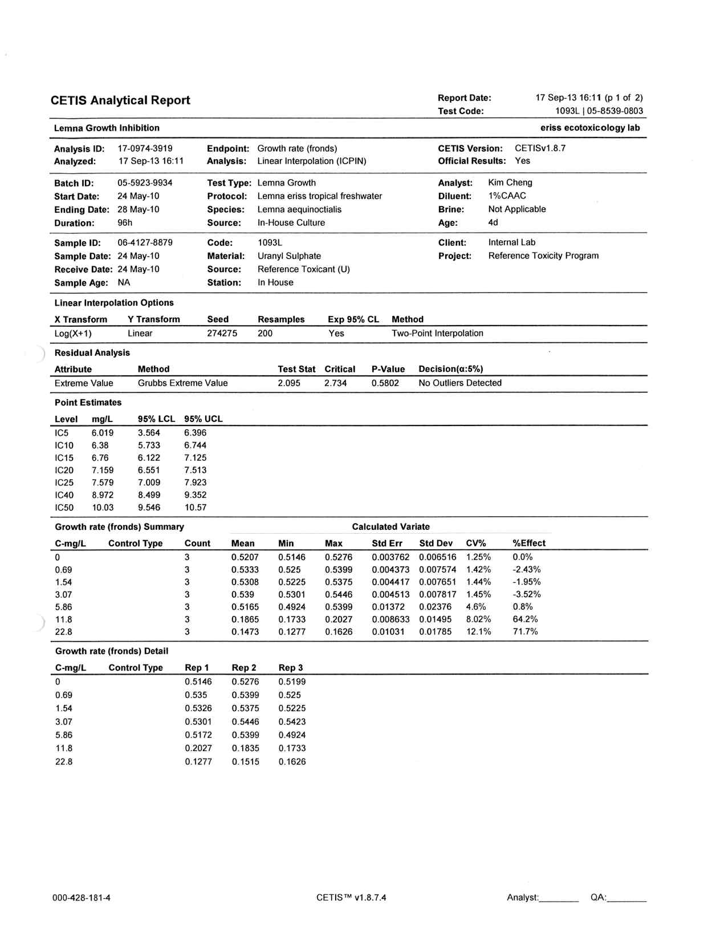

**Figure I4** Continued

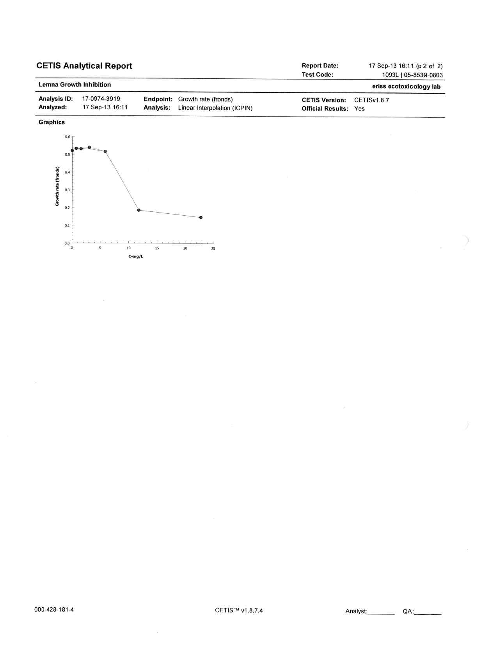

**Figure I5** Test raw data and analysis report for test 1093L (surface area)

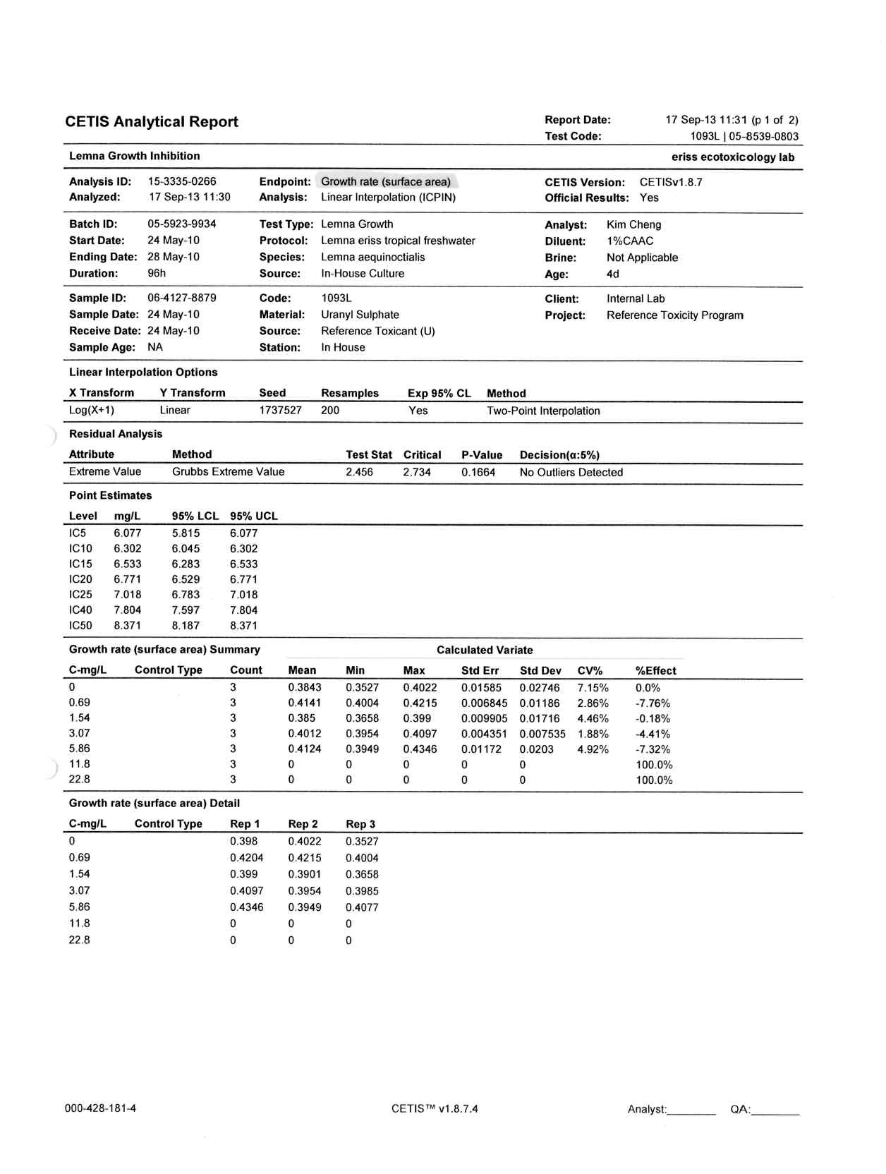

**Figure I5** Continued

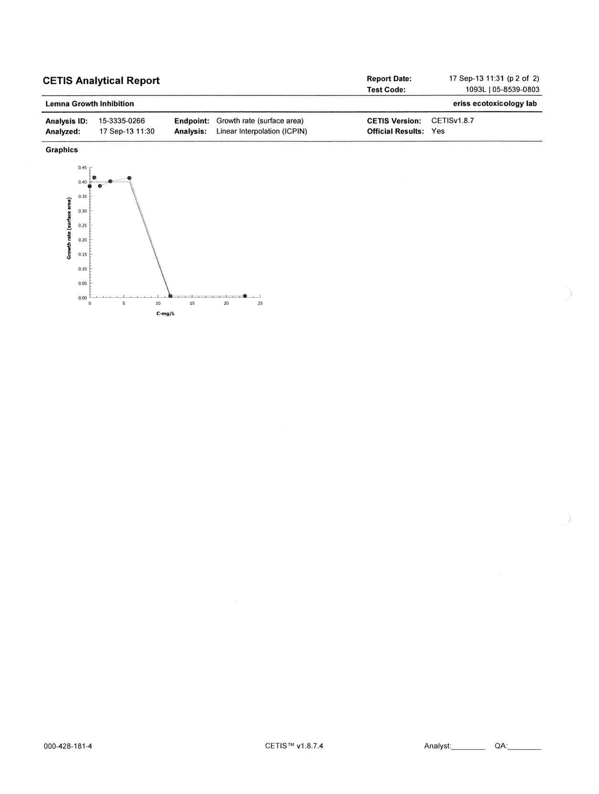

**Figure I6** Test raw data and analysis report for test 1141L (frond count)

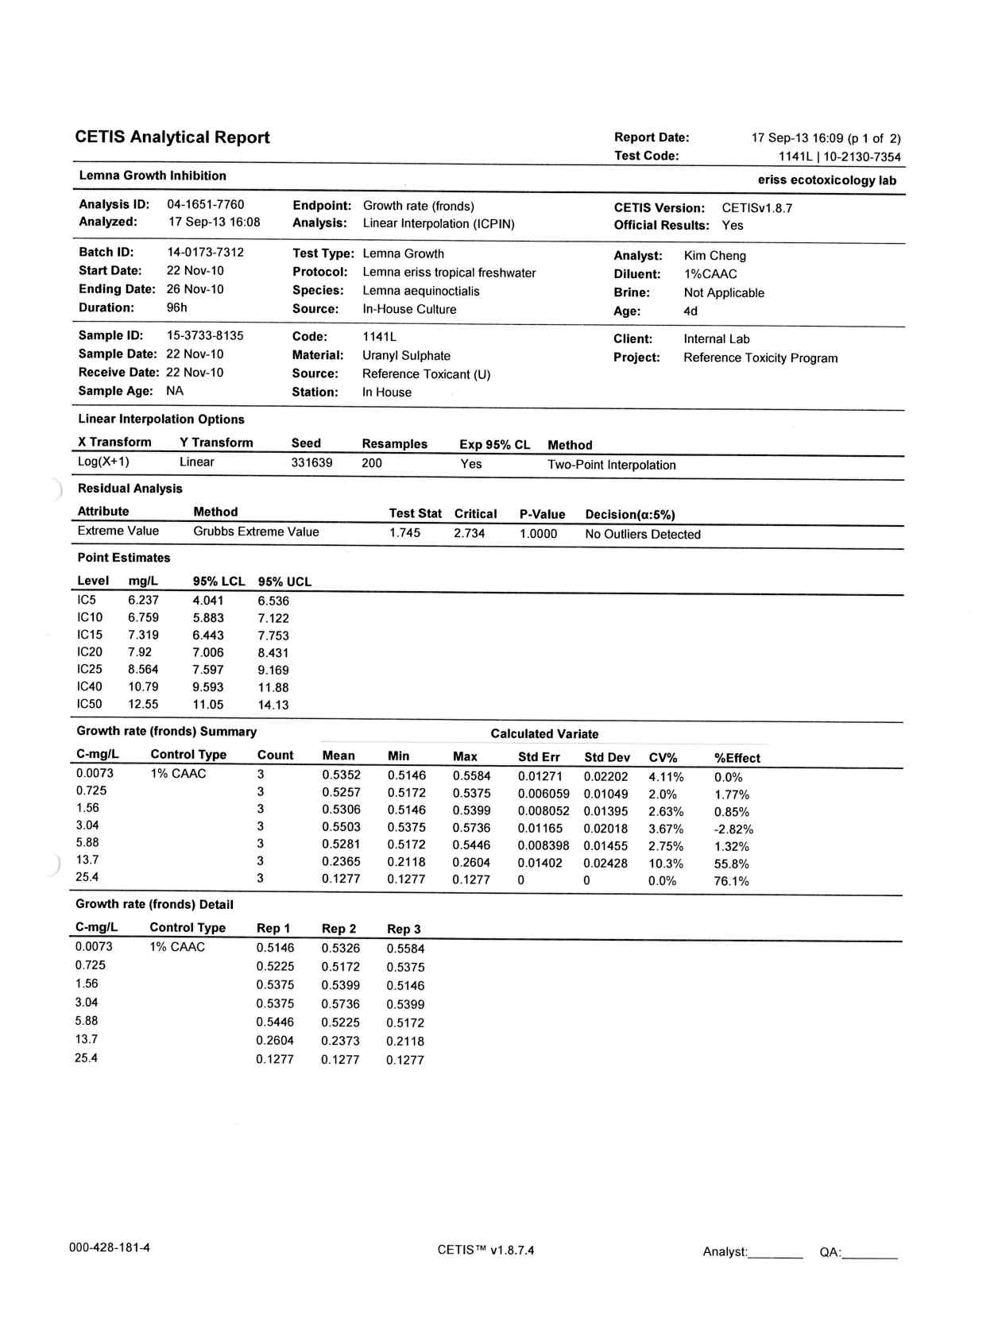

**Figure I6** Continued

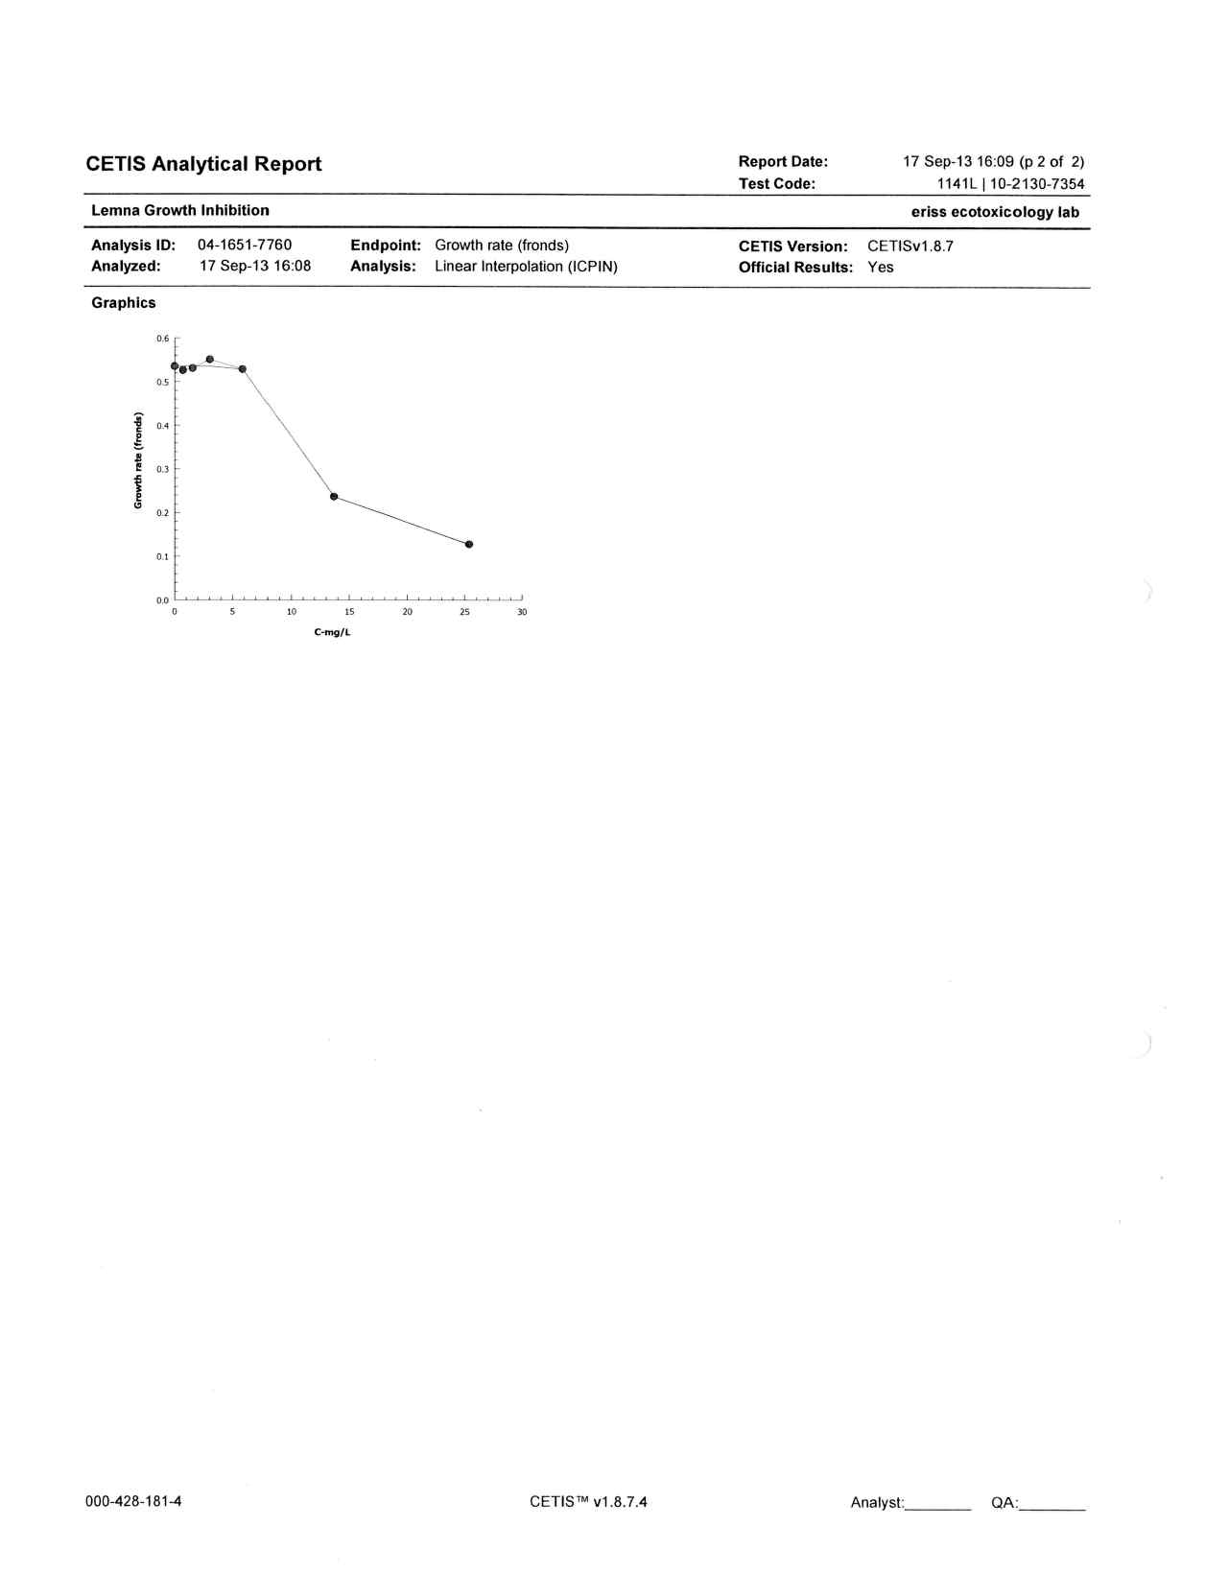

**Figure I7** Test raw data and analysis report for test 1167L (found count)

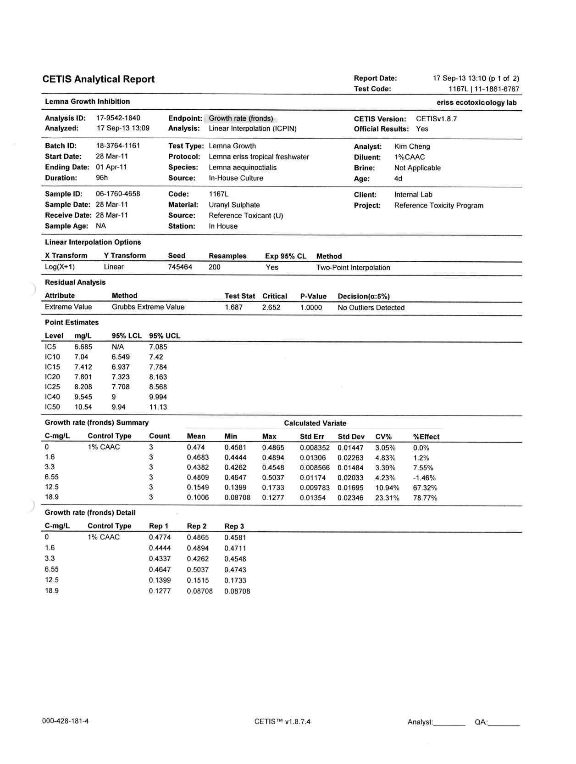

**Figure I7** continued

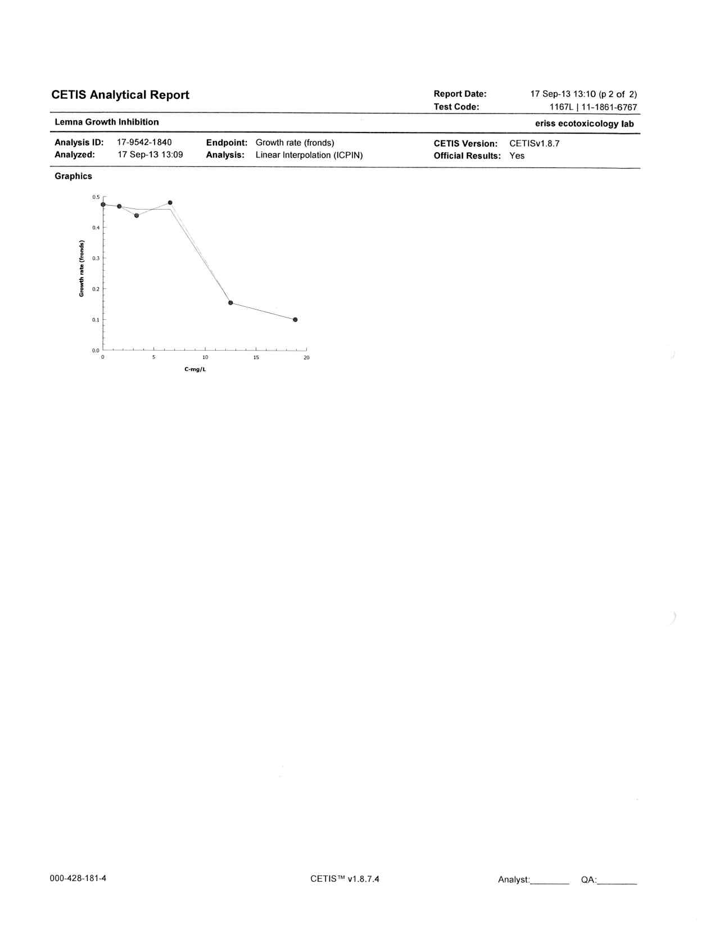

**Figure I8** Test raw data and analysis report for test 1183L

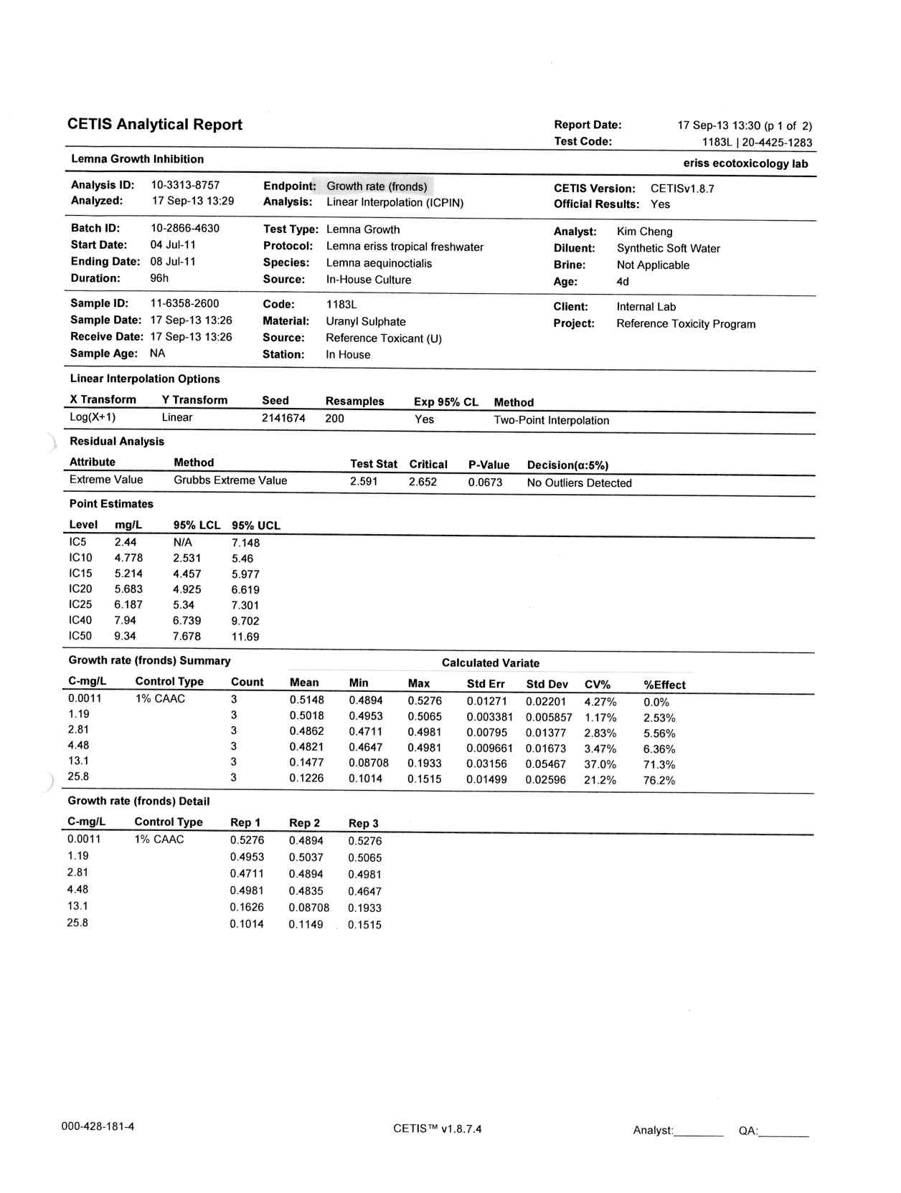

**Figure I8** Continued

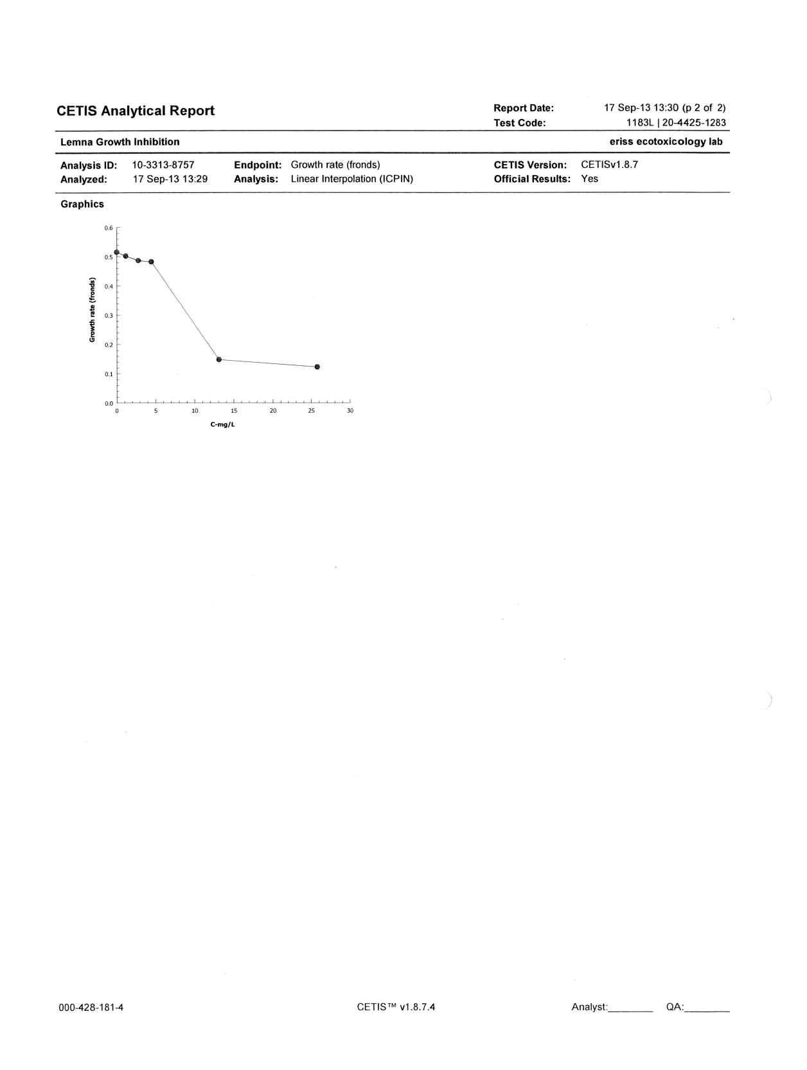

**Figure I9** Test raw data and analysis report for test 1183L (surface area)

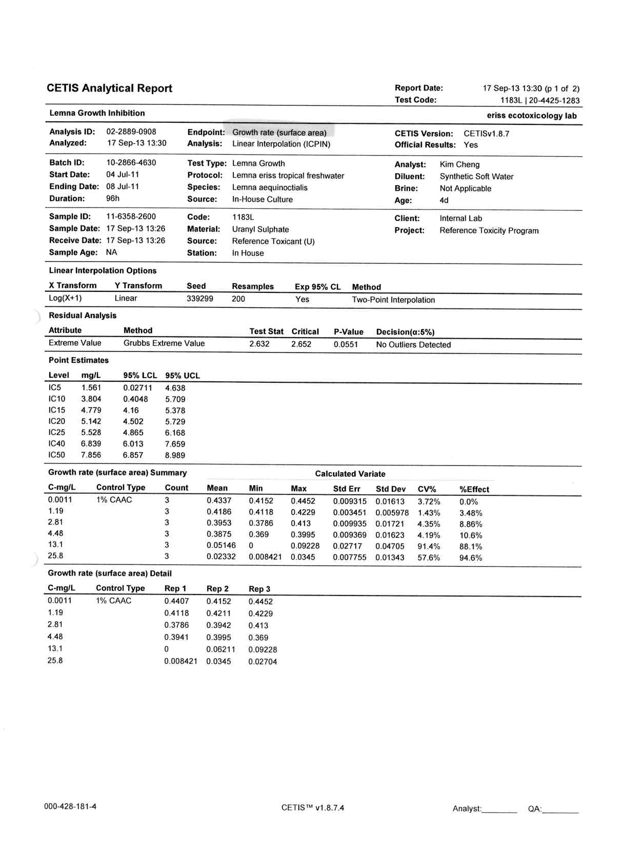

**Figure I9** Continued

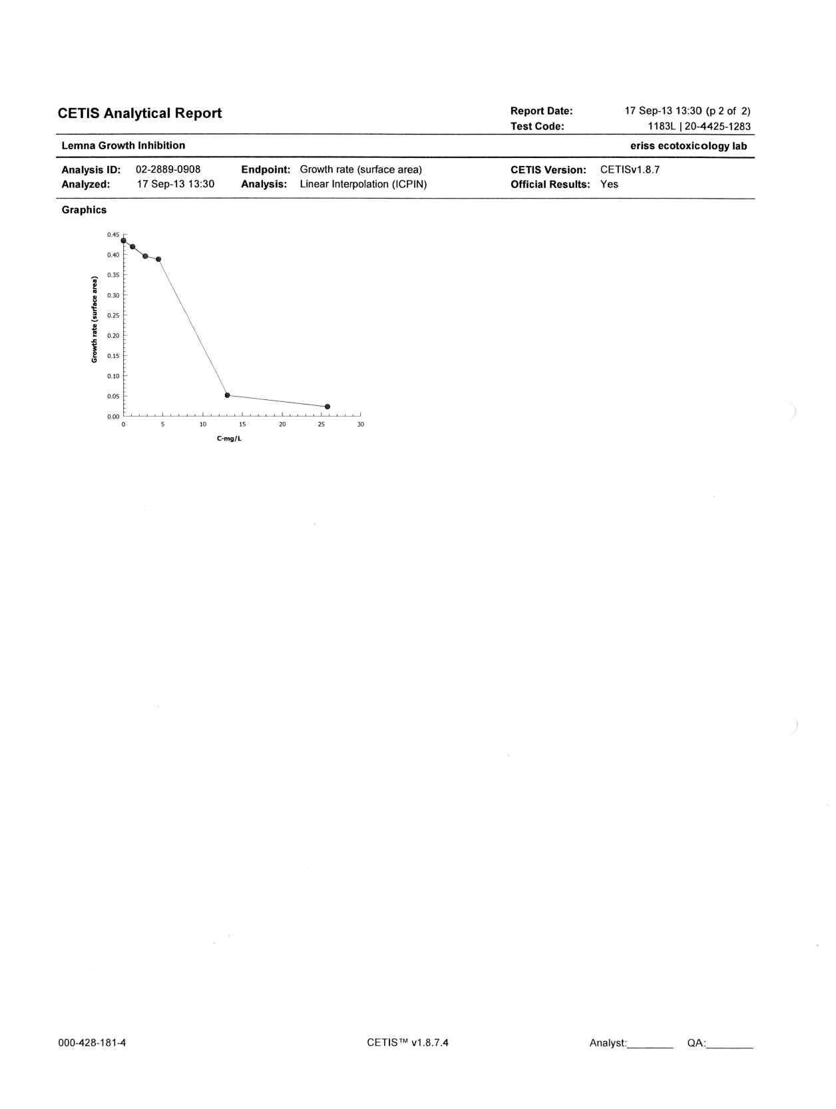

**Figure I10** Test raw data and analysis report for test 1248G (found count)

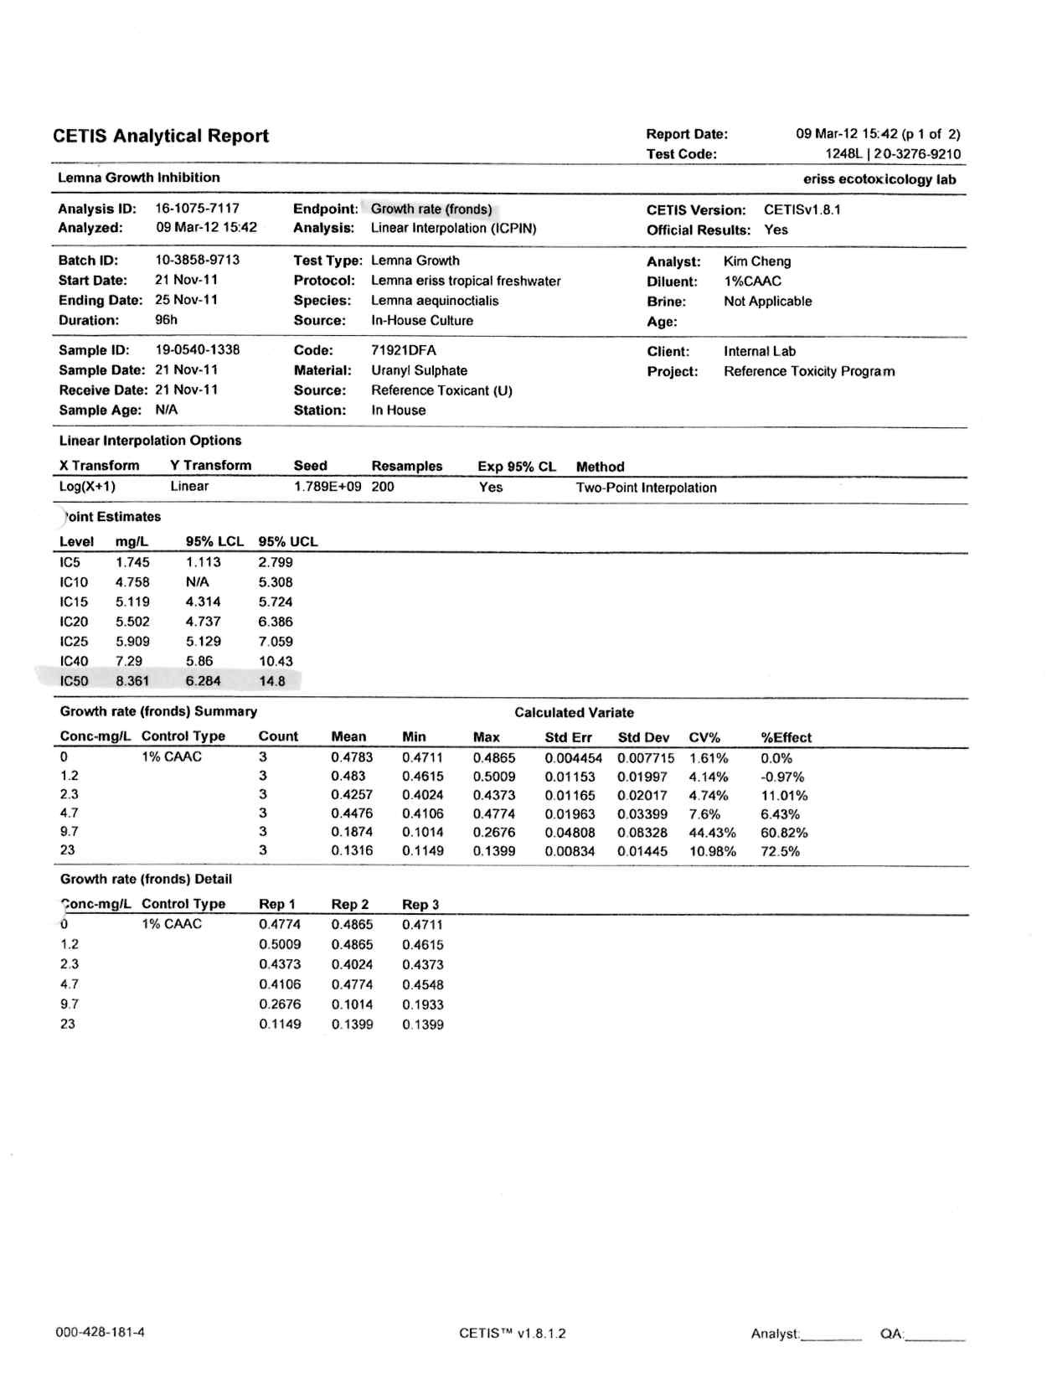

**Figure I10** Continued

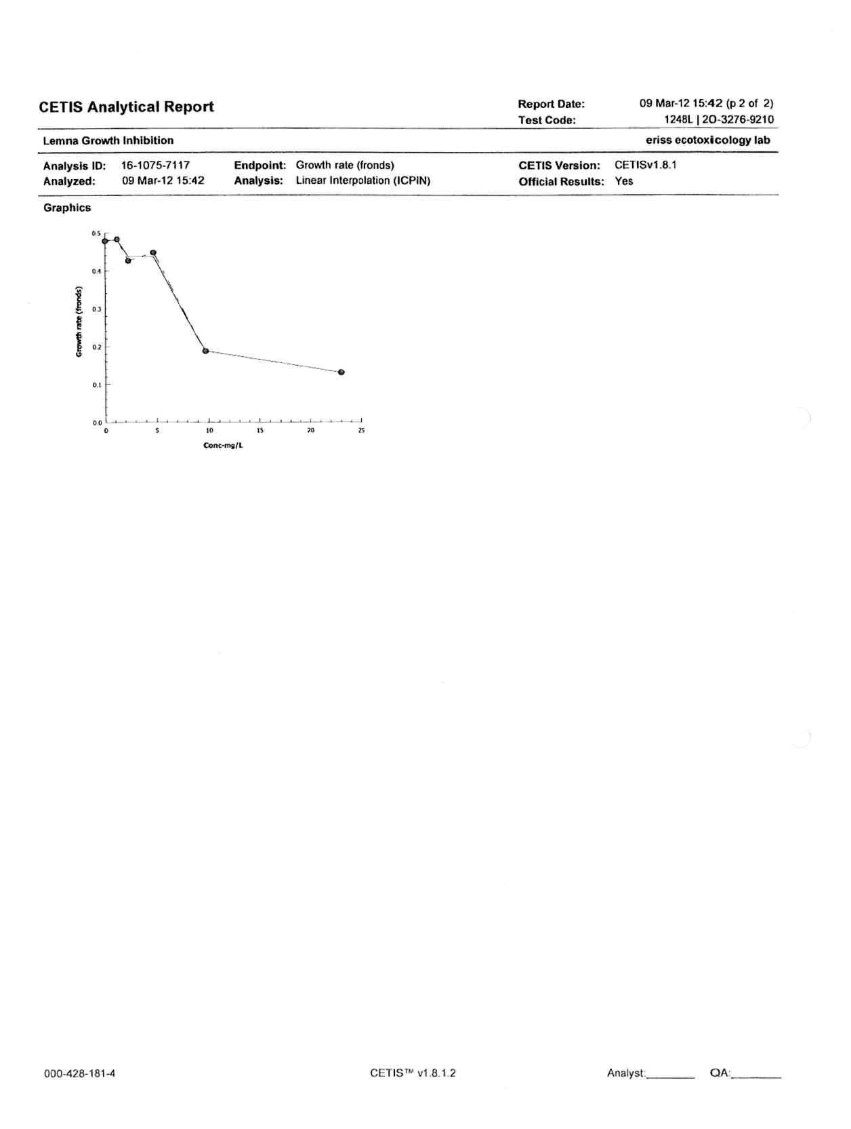

**Figure I11** Test raw data and analysis report for test 1248L (surface area)

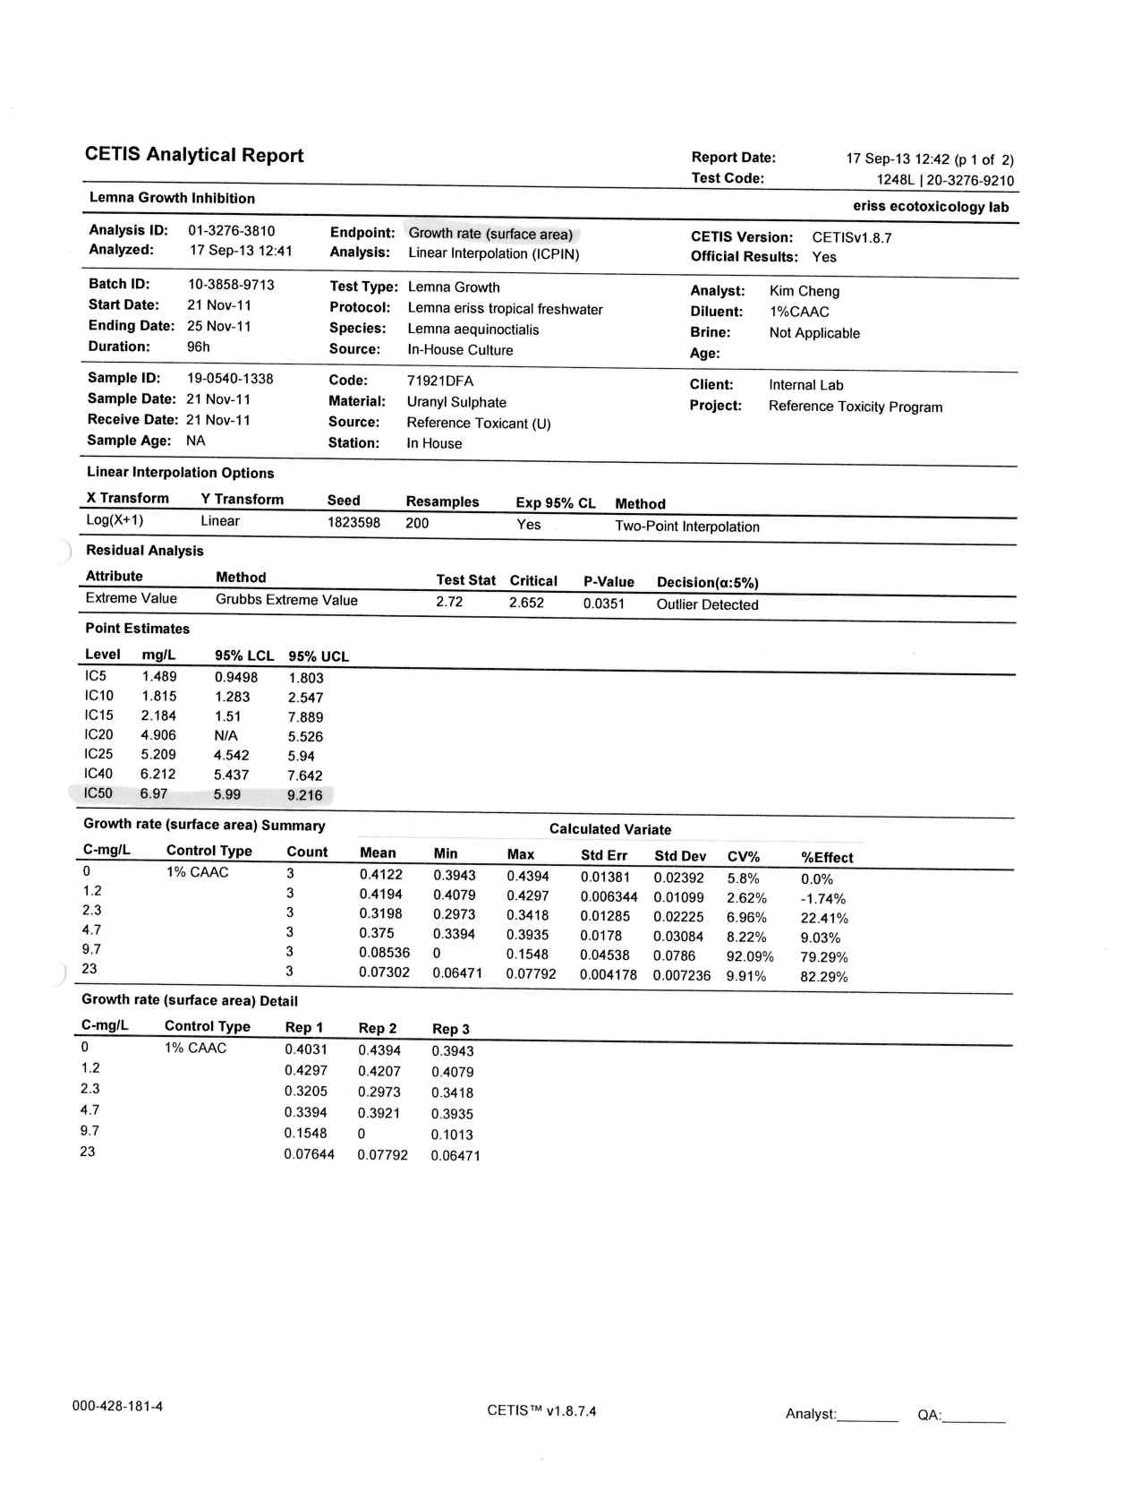

**Figure I11** Continued

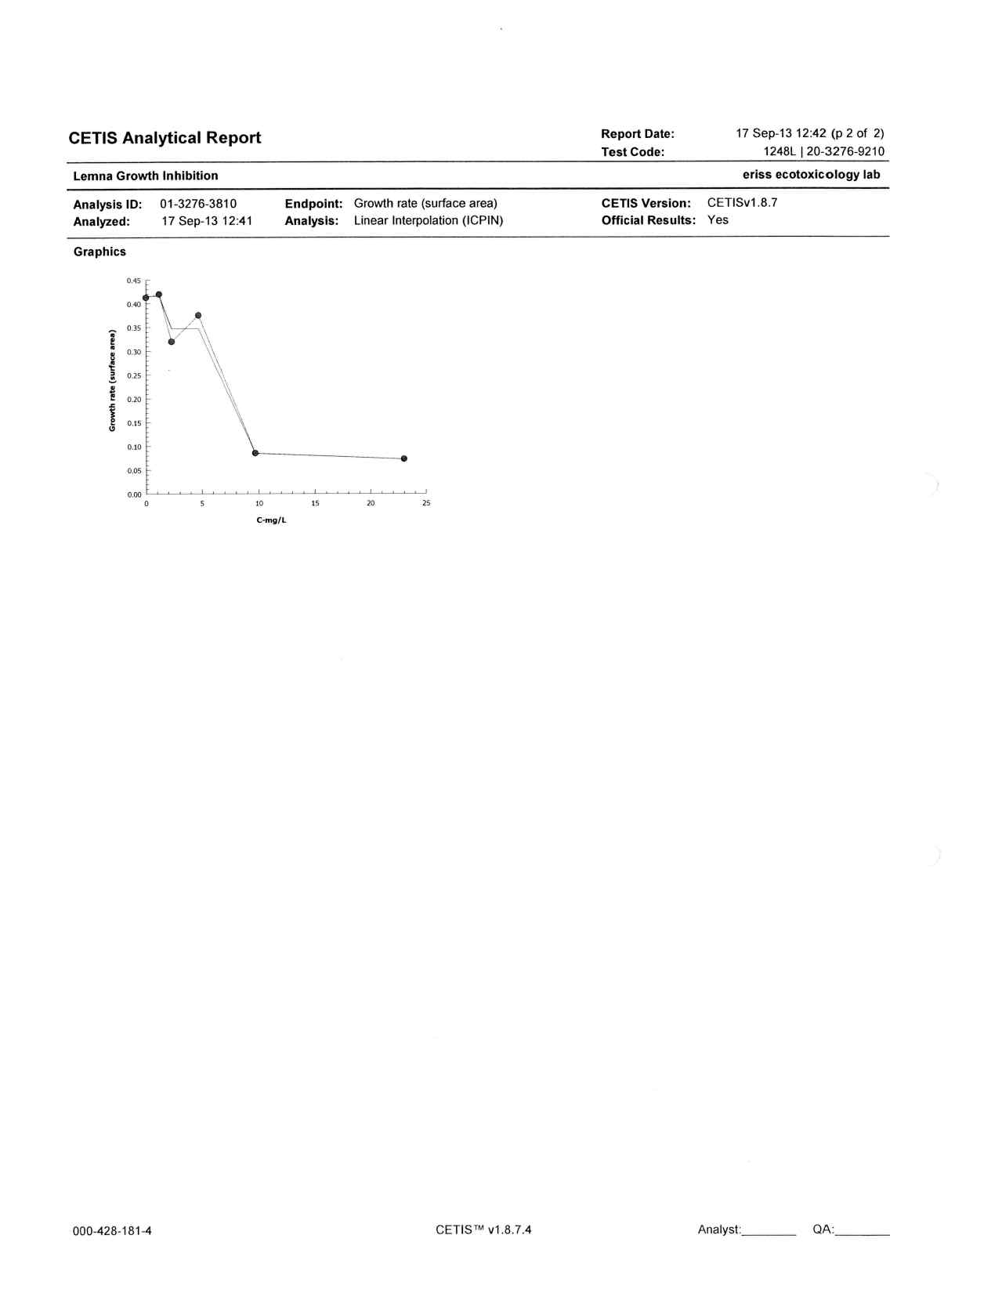

**Figure I12** Test raw data and analysis report for test 1287L (frond count)

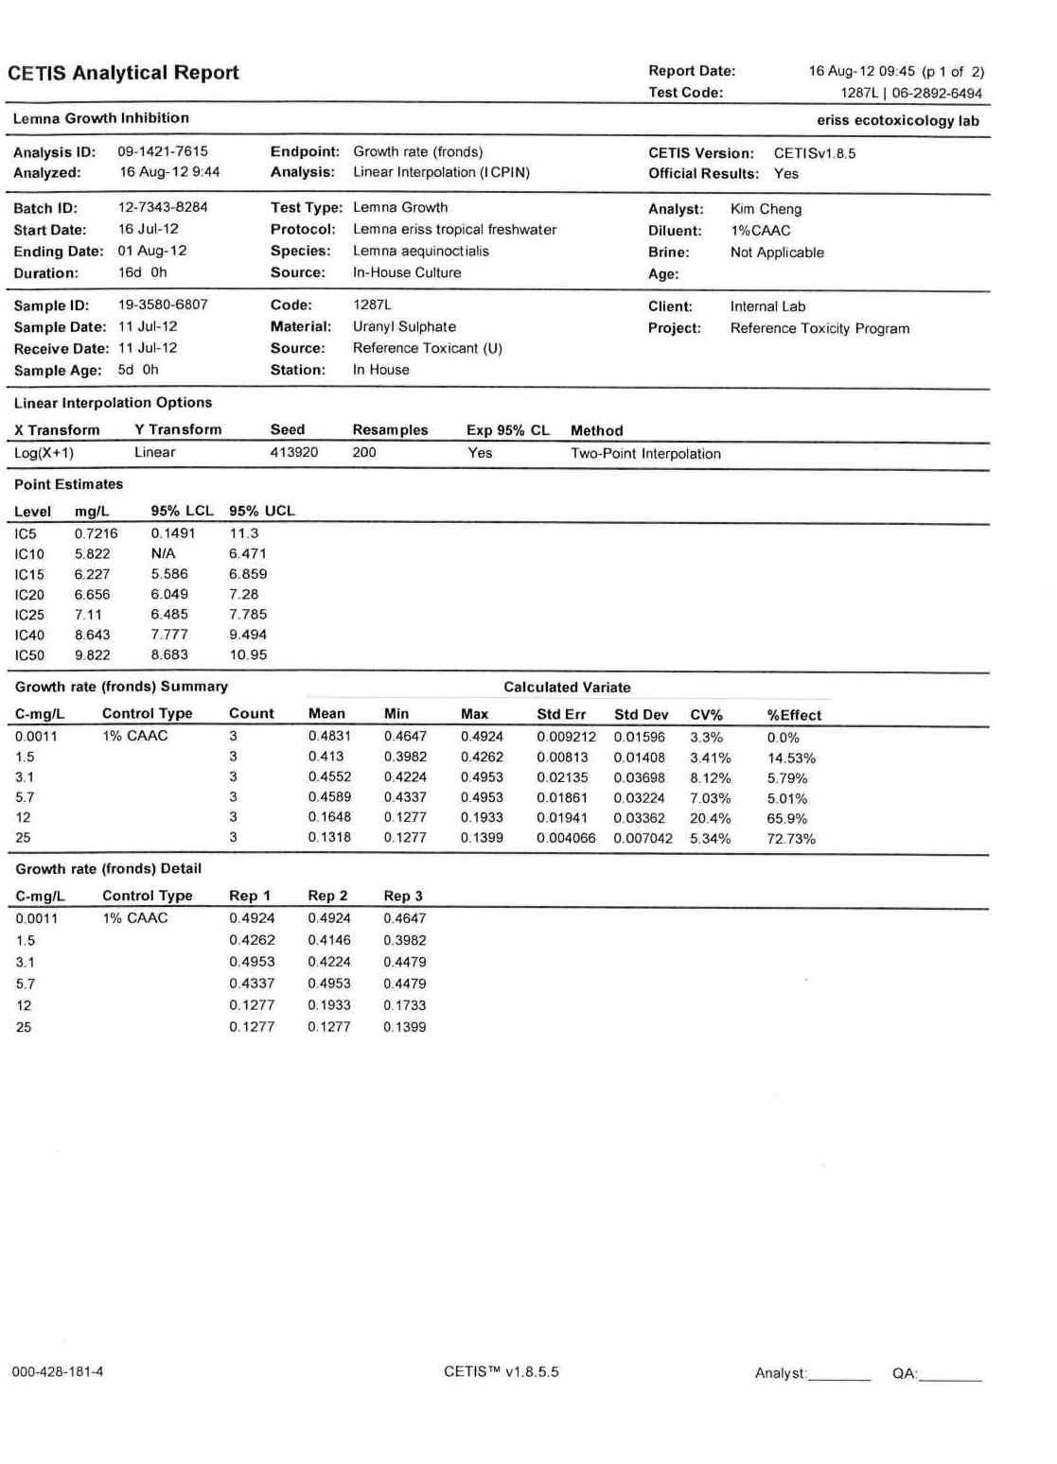

**Figure I12** Continued

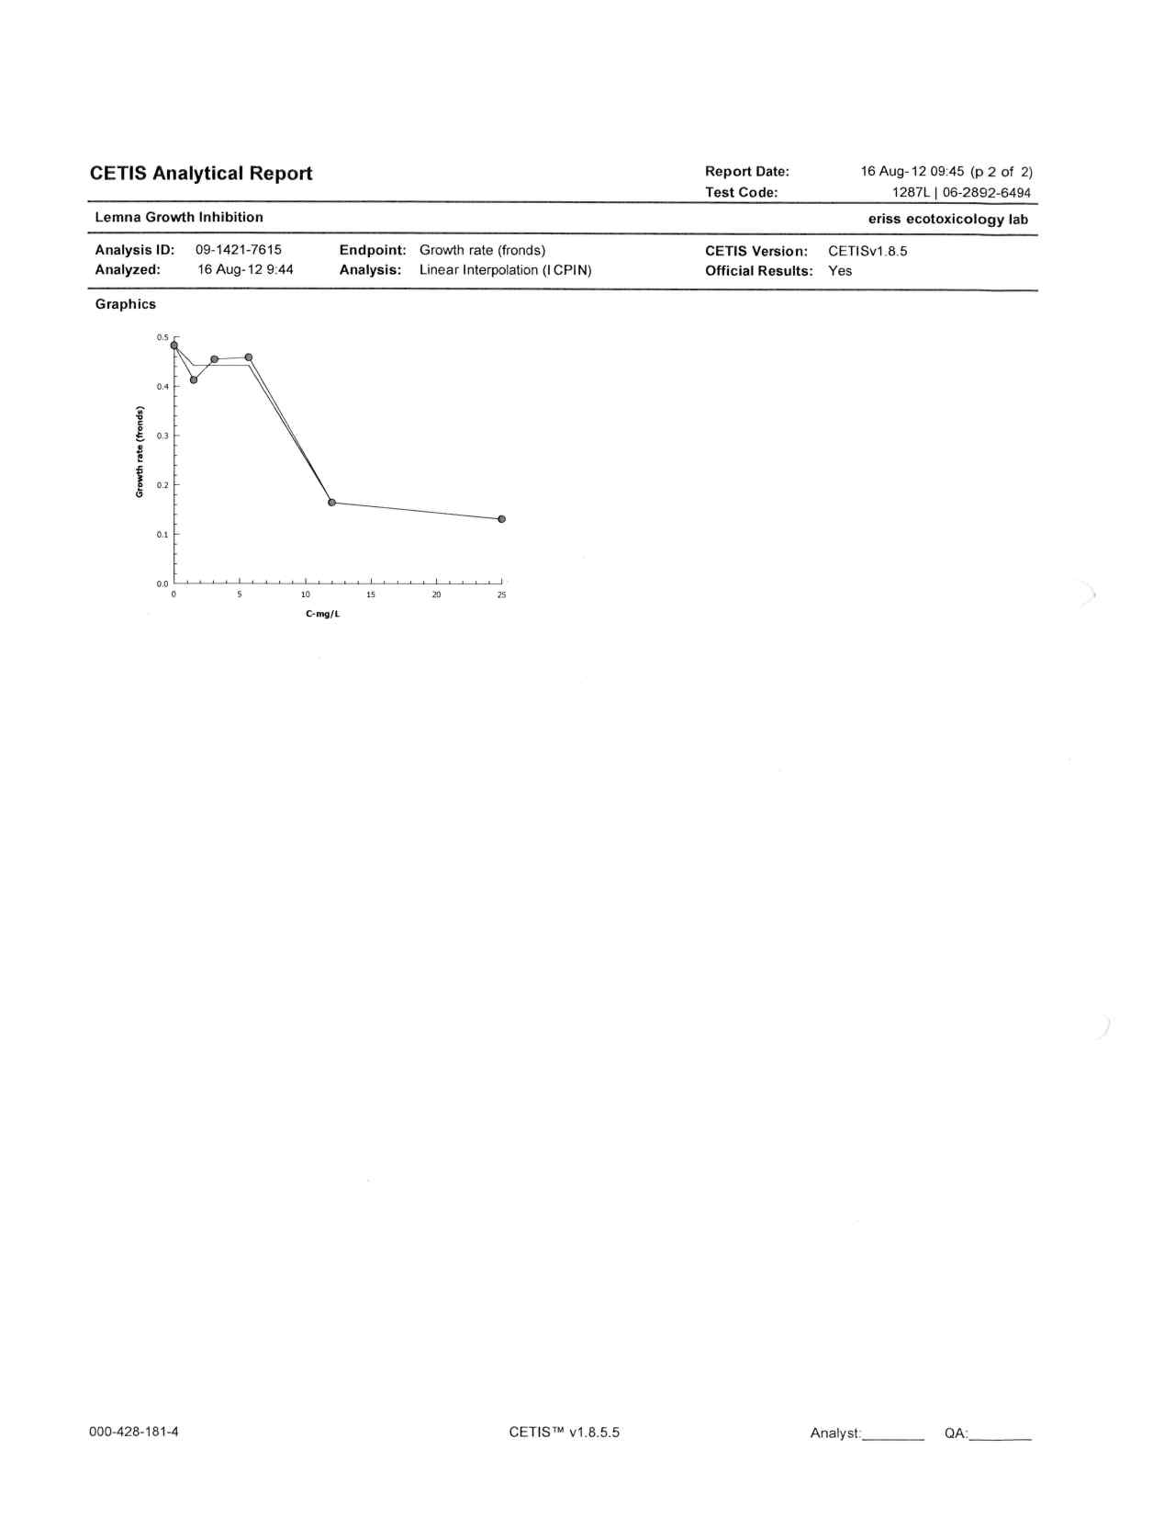

**Figure I13** Test raw data and analysis report for test 1287L (surface area)

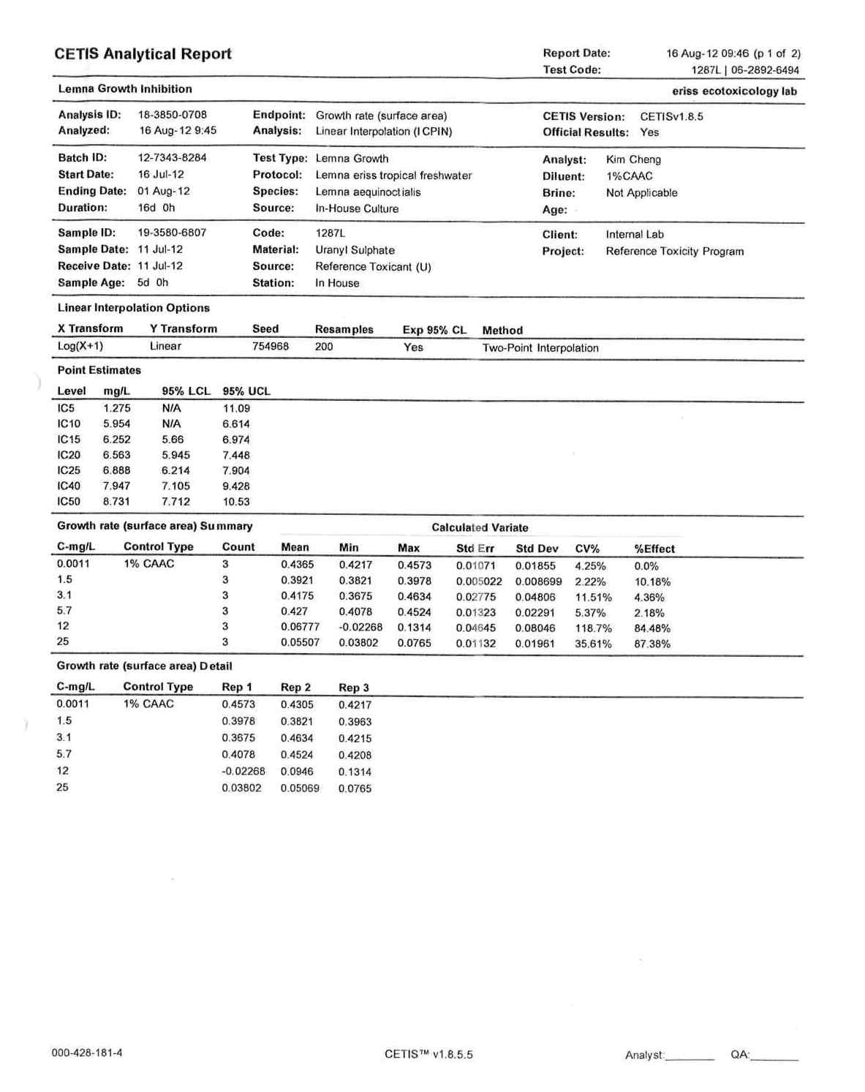

**Figure I13** Continued

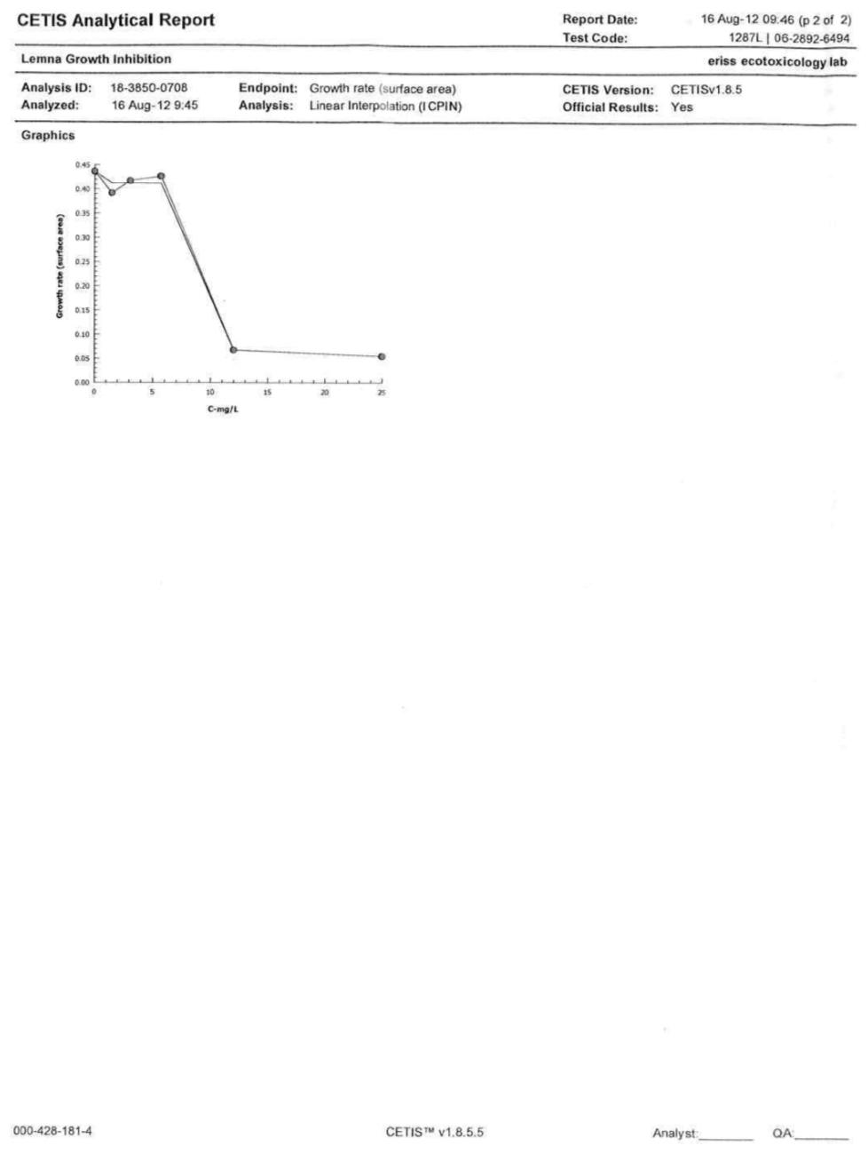

**Figure I14** Test raw data and analysis report for test 1301L (frond count)

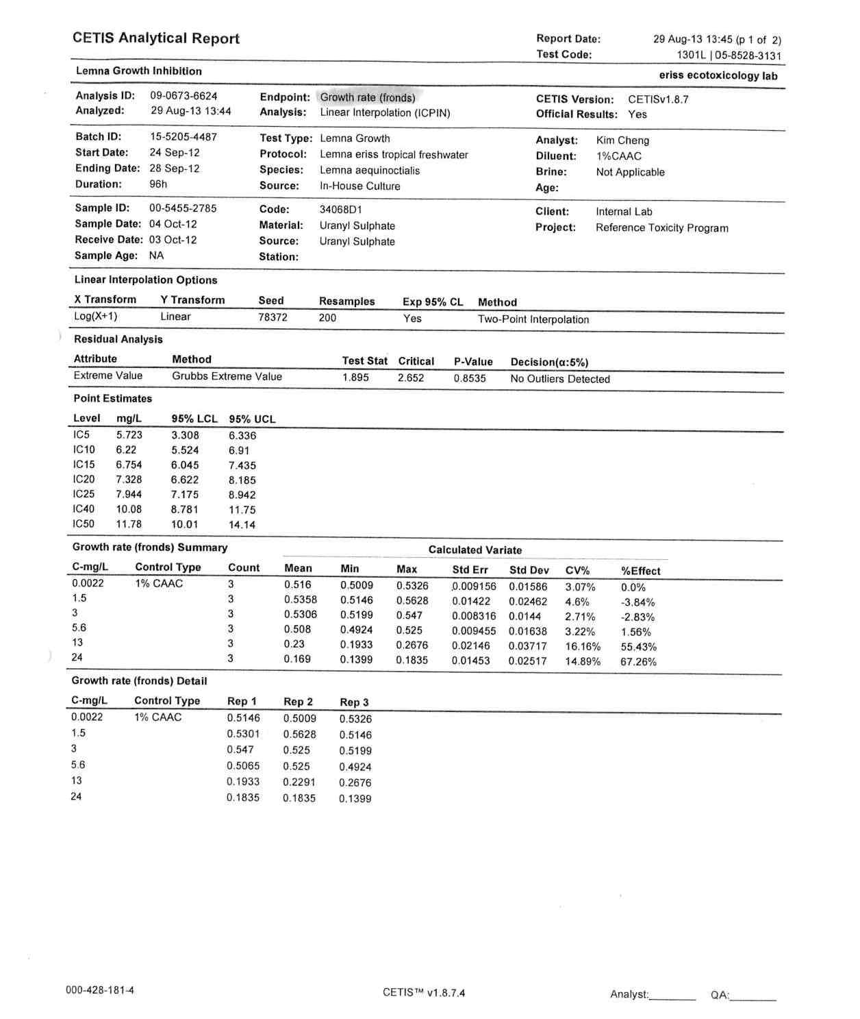

**Figure I14** Continued

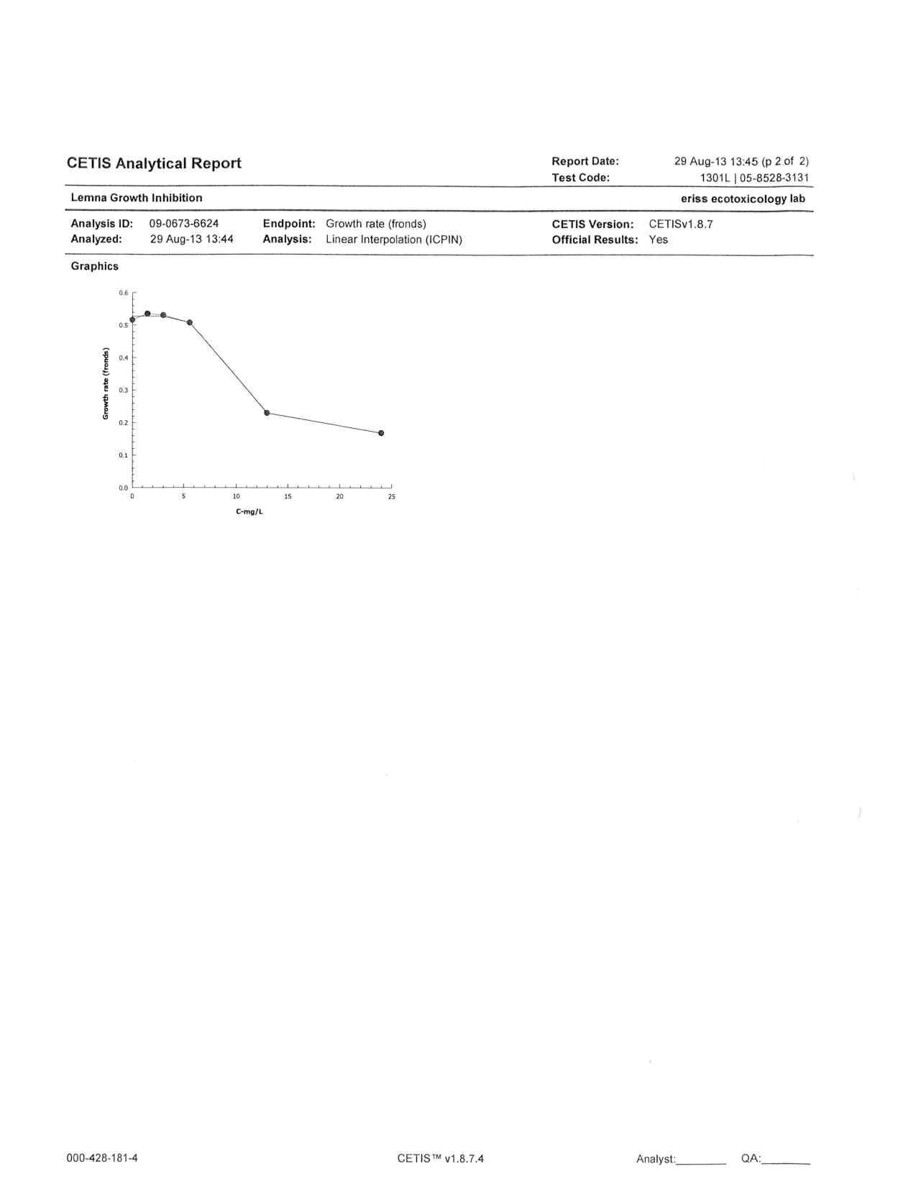

**Figure I15** Test raw data and analysis report for test 1301L (surface area)

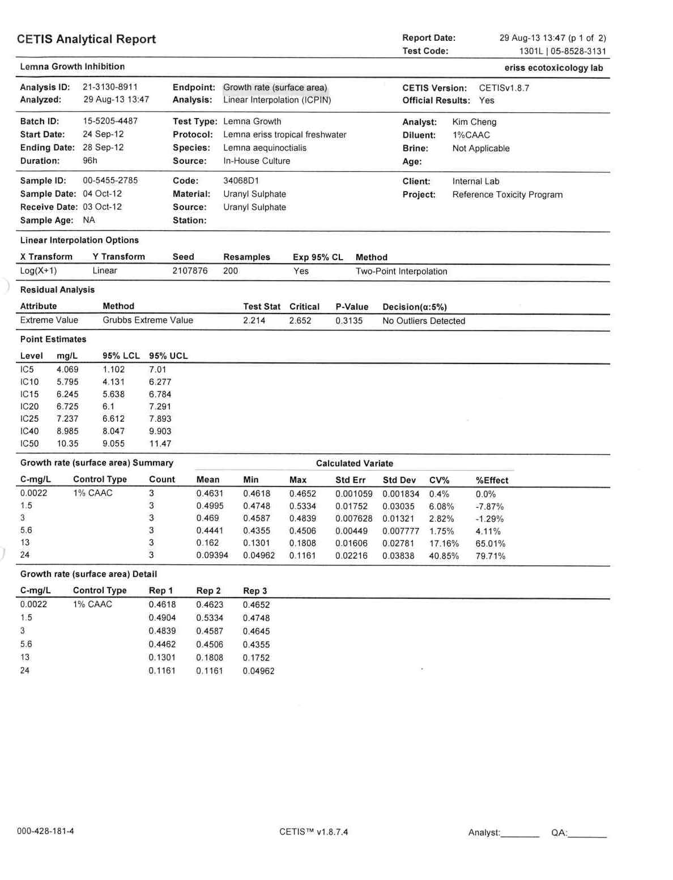

**Figure I15** Continued

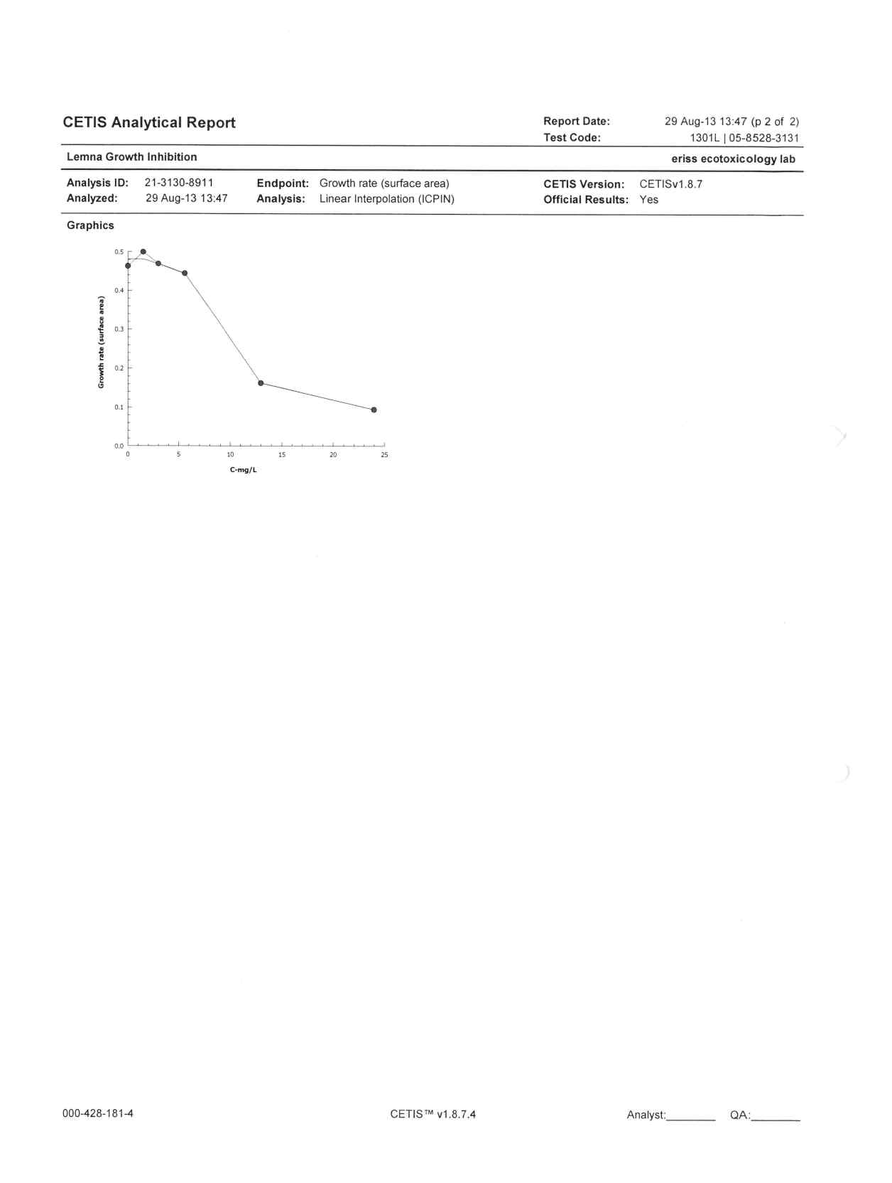

**Figure I16** Test raw data and analysis report for test 1315L (frond count)

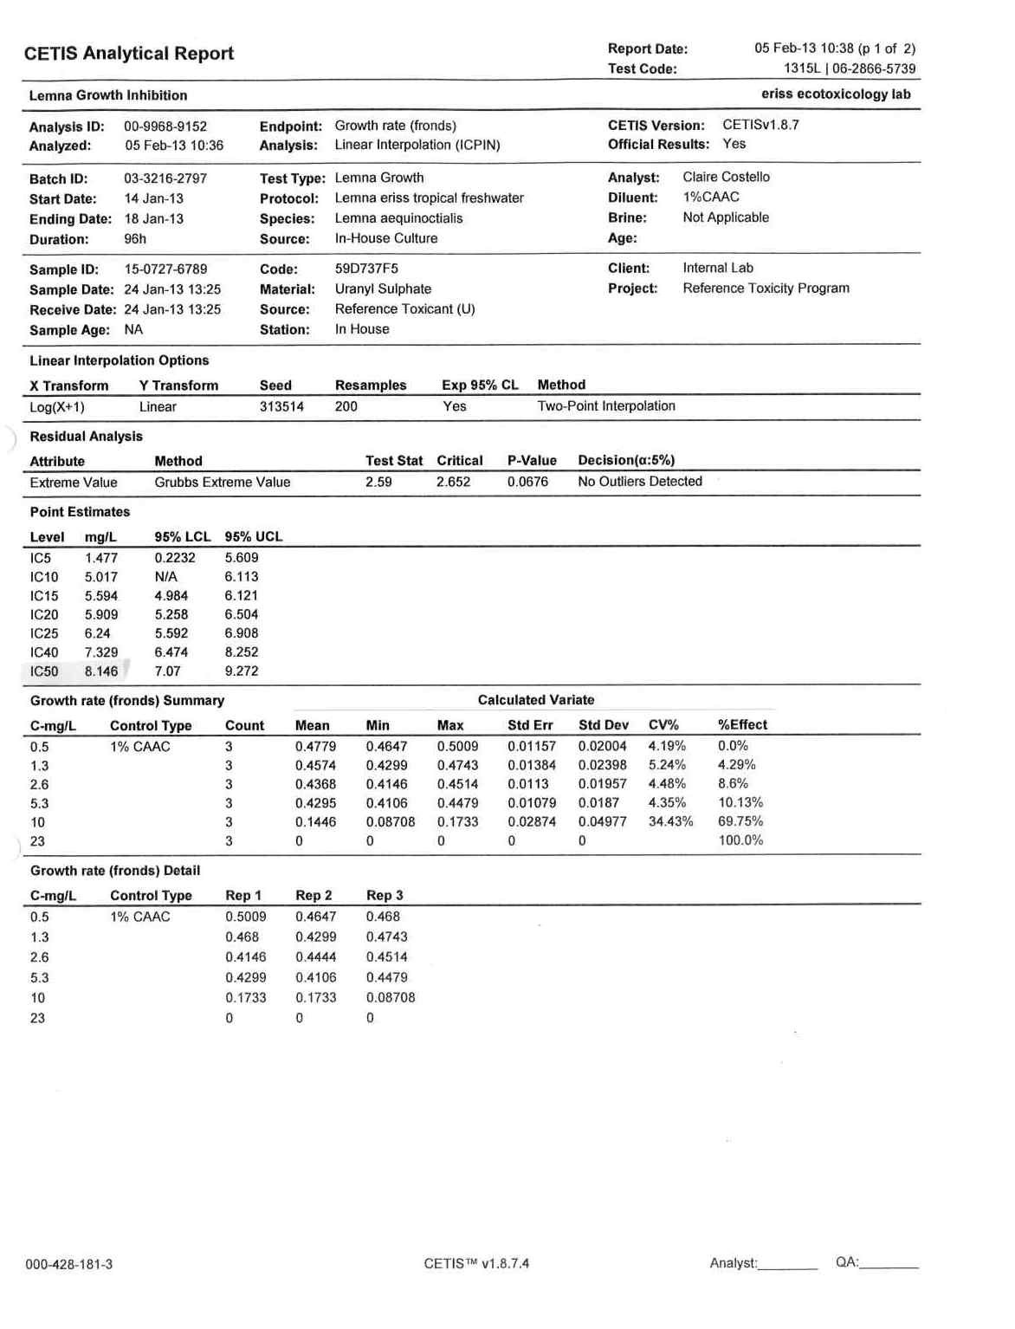

**Figure I16** Continued

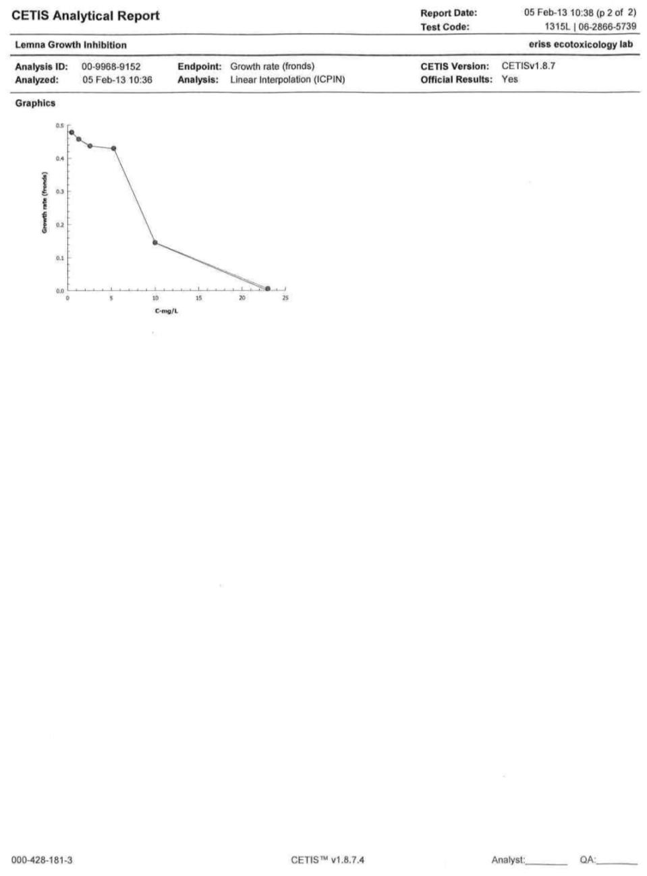

**Figure I17** Test raw data and analysis report for test 1315L (surface area)

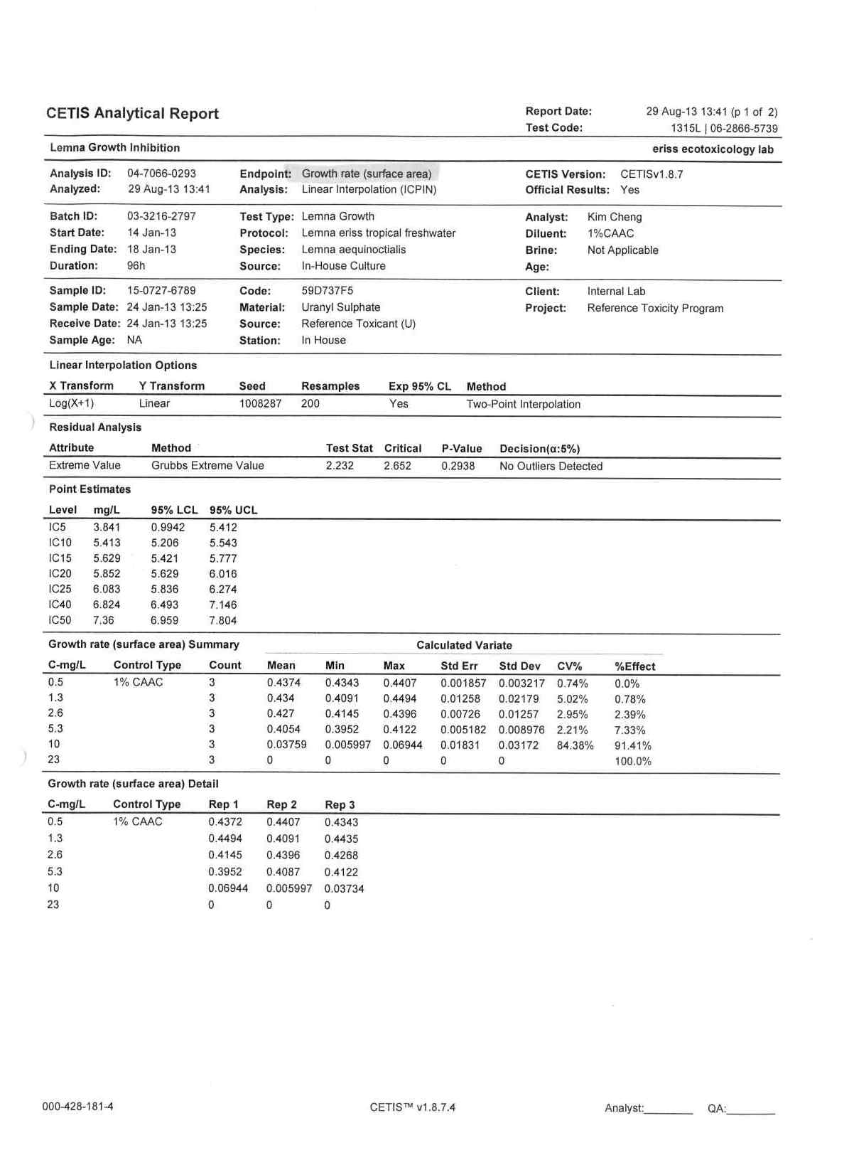

**Figure I17** Continued

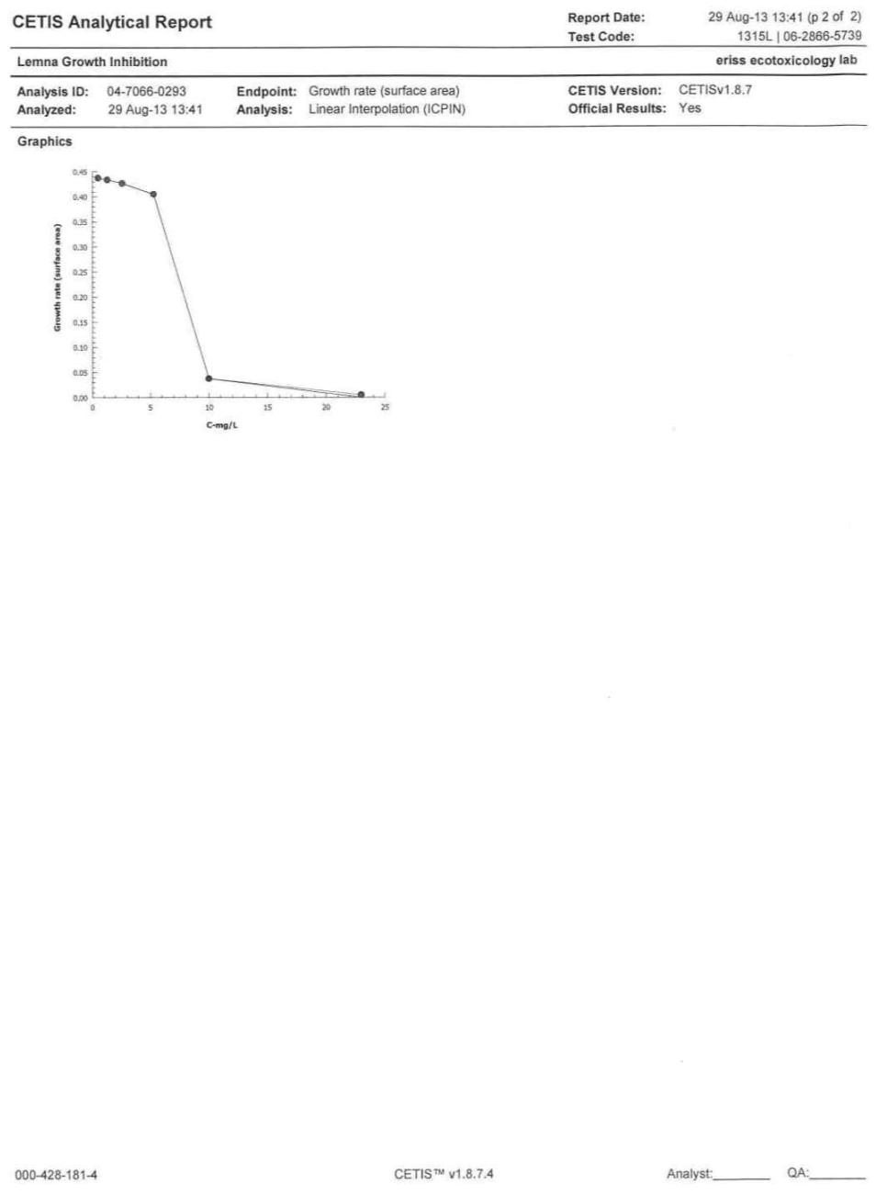

**Figure I18** Test raw data and analysis report for test 1330L (frond count)

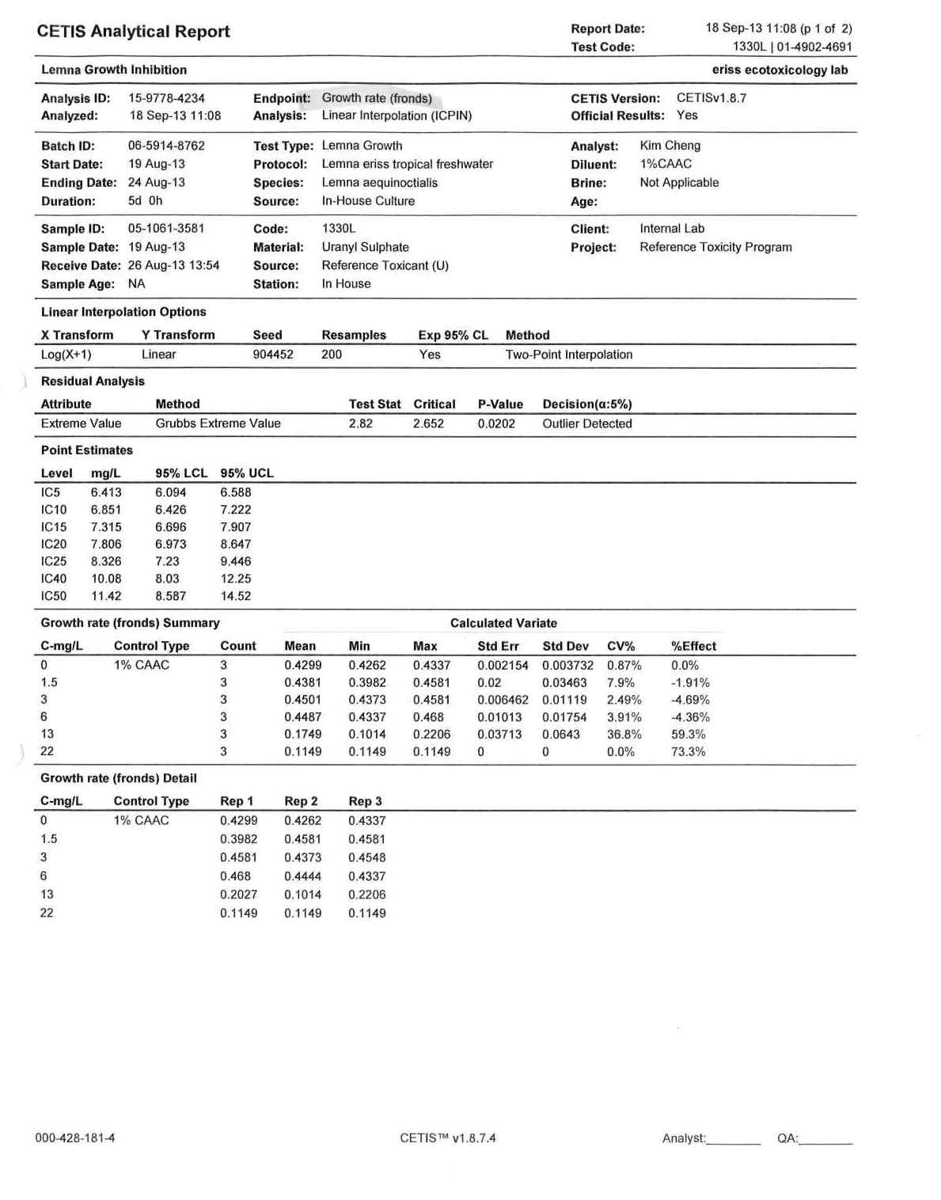

**Figure I18** Continued

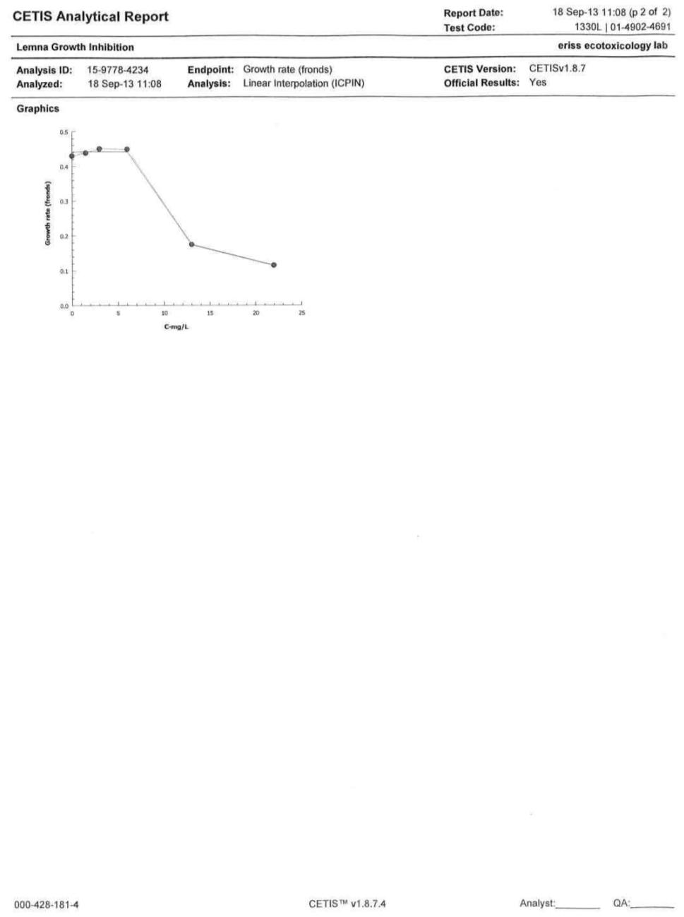

**Figure I19** Test raw data and analysis report for test 1330L (surface area)

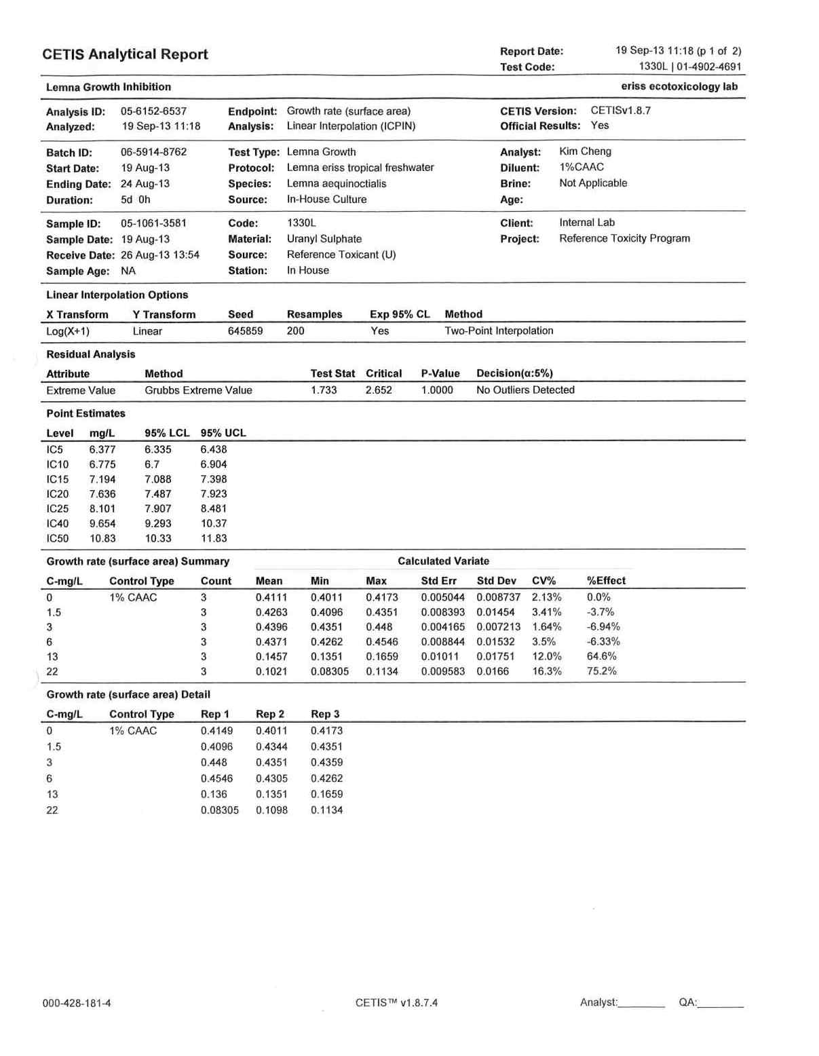

**Figure I19** Continued

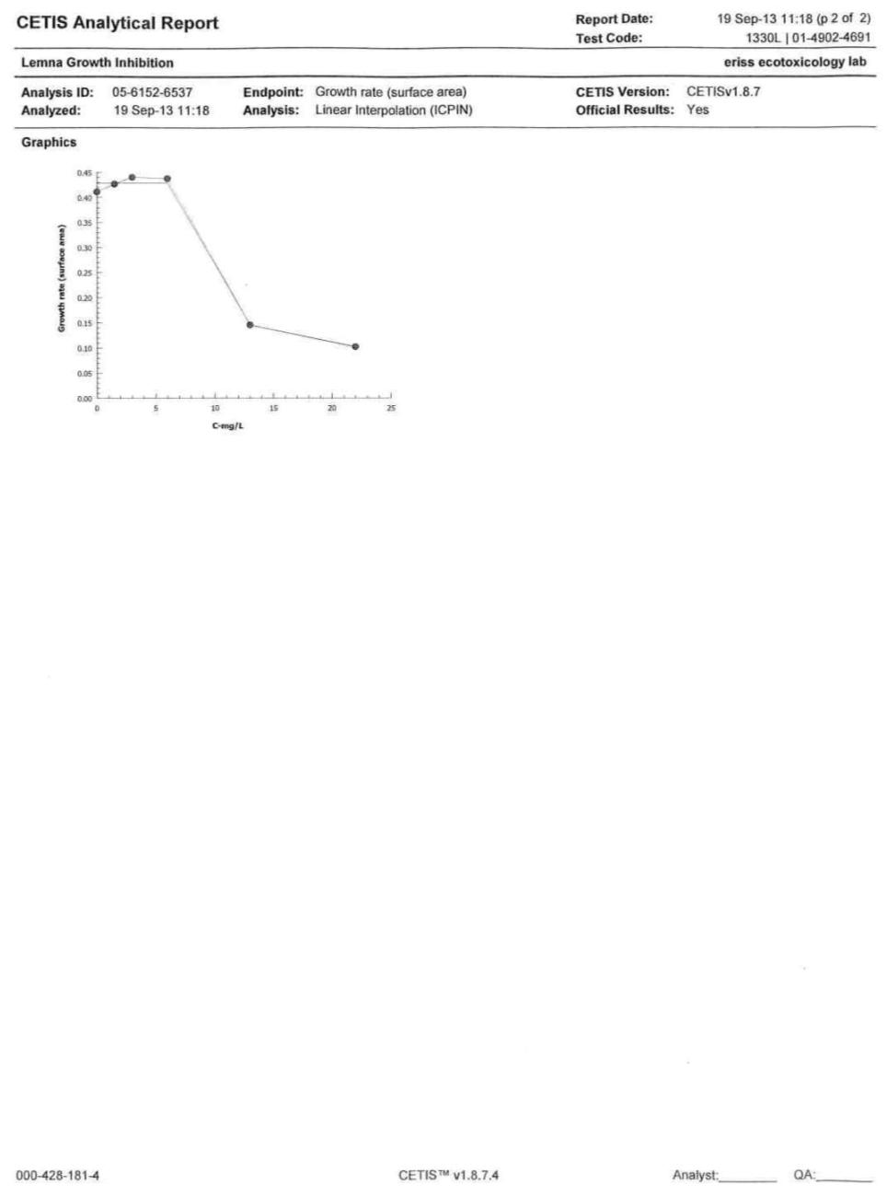

**Figure I20** Test raw data and analysis report for test 1465L (frond count)

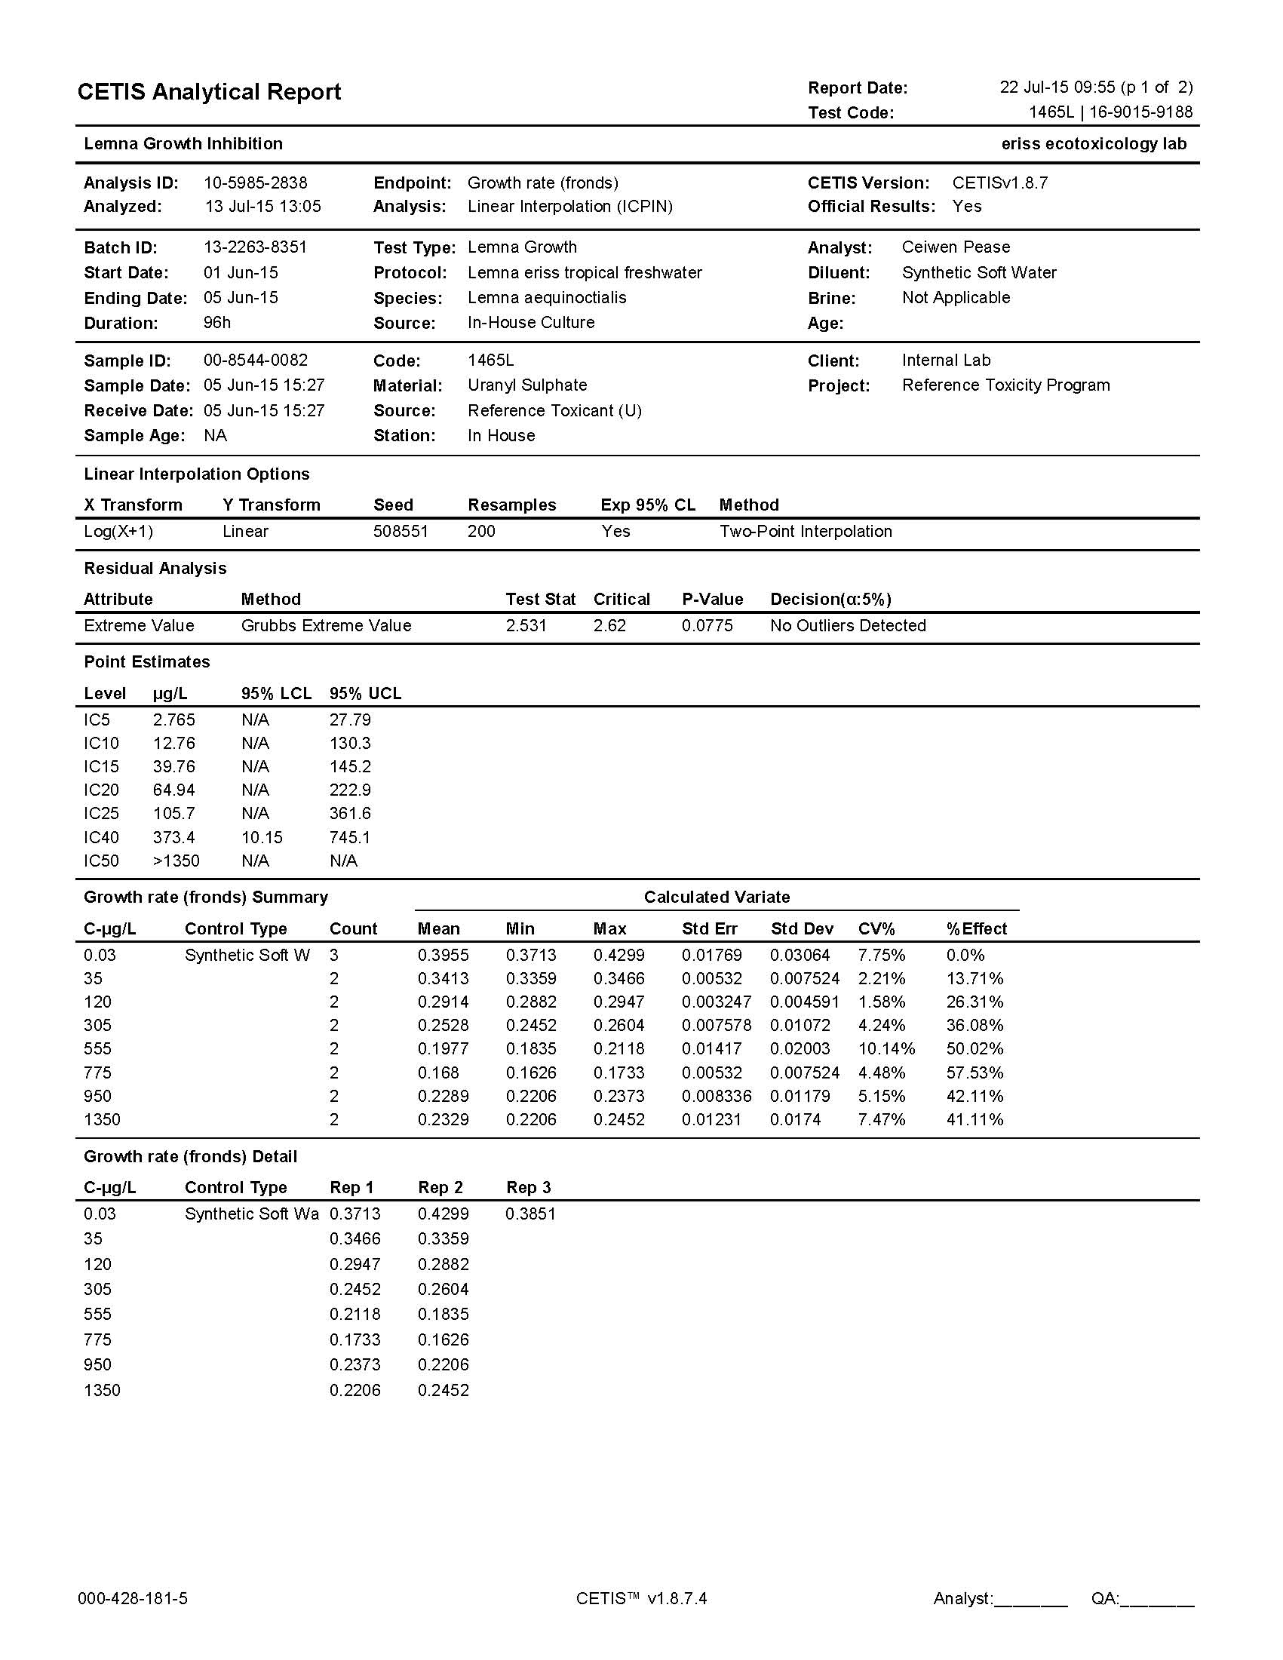

**Figure I20** Continued

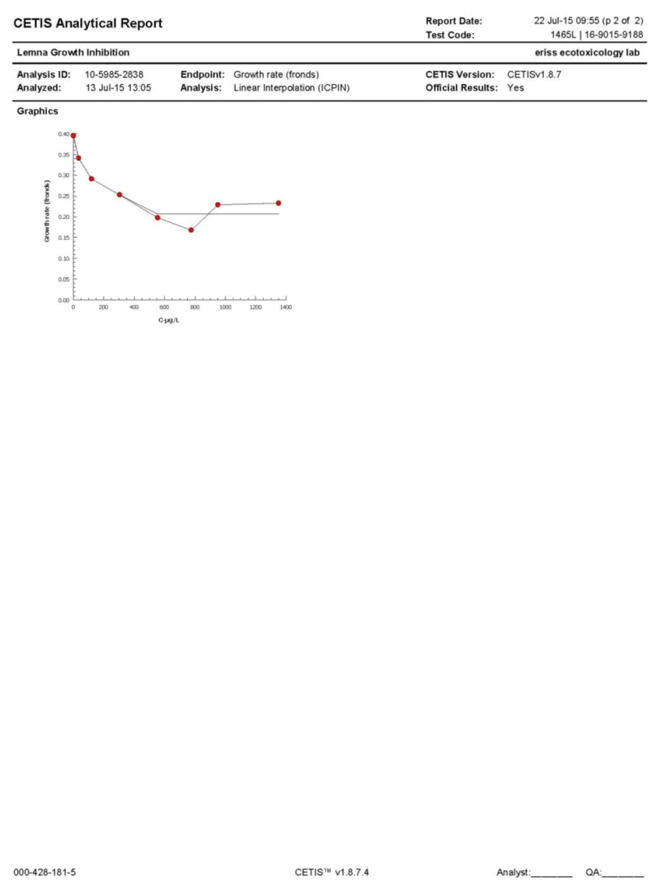

**Figure I21** Test raw data and analysis report for test 1465L (surface area)

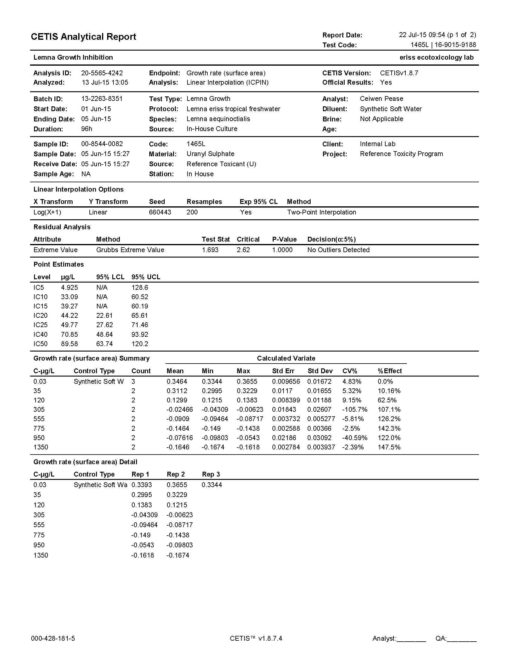

**Figure I21** Continued

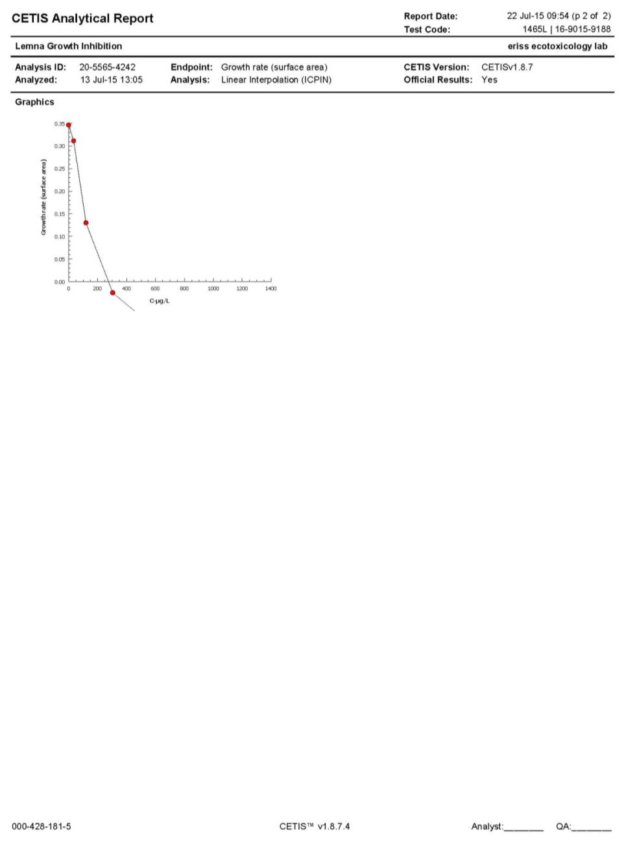

**Figure I22** Test raw data and analysis report for test 1473L (frond count)

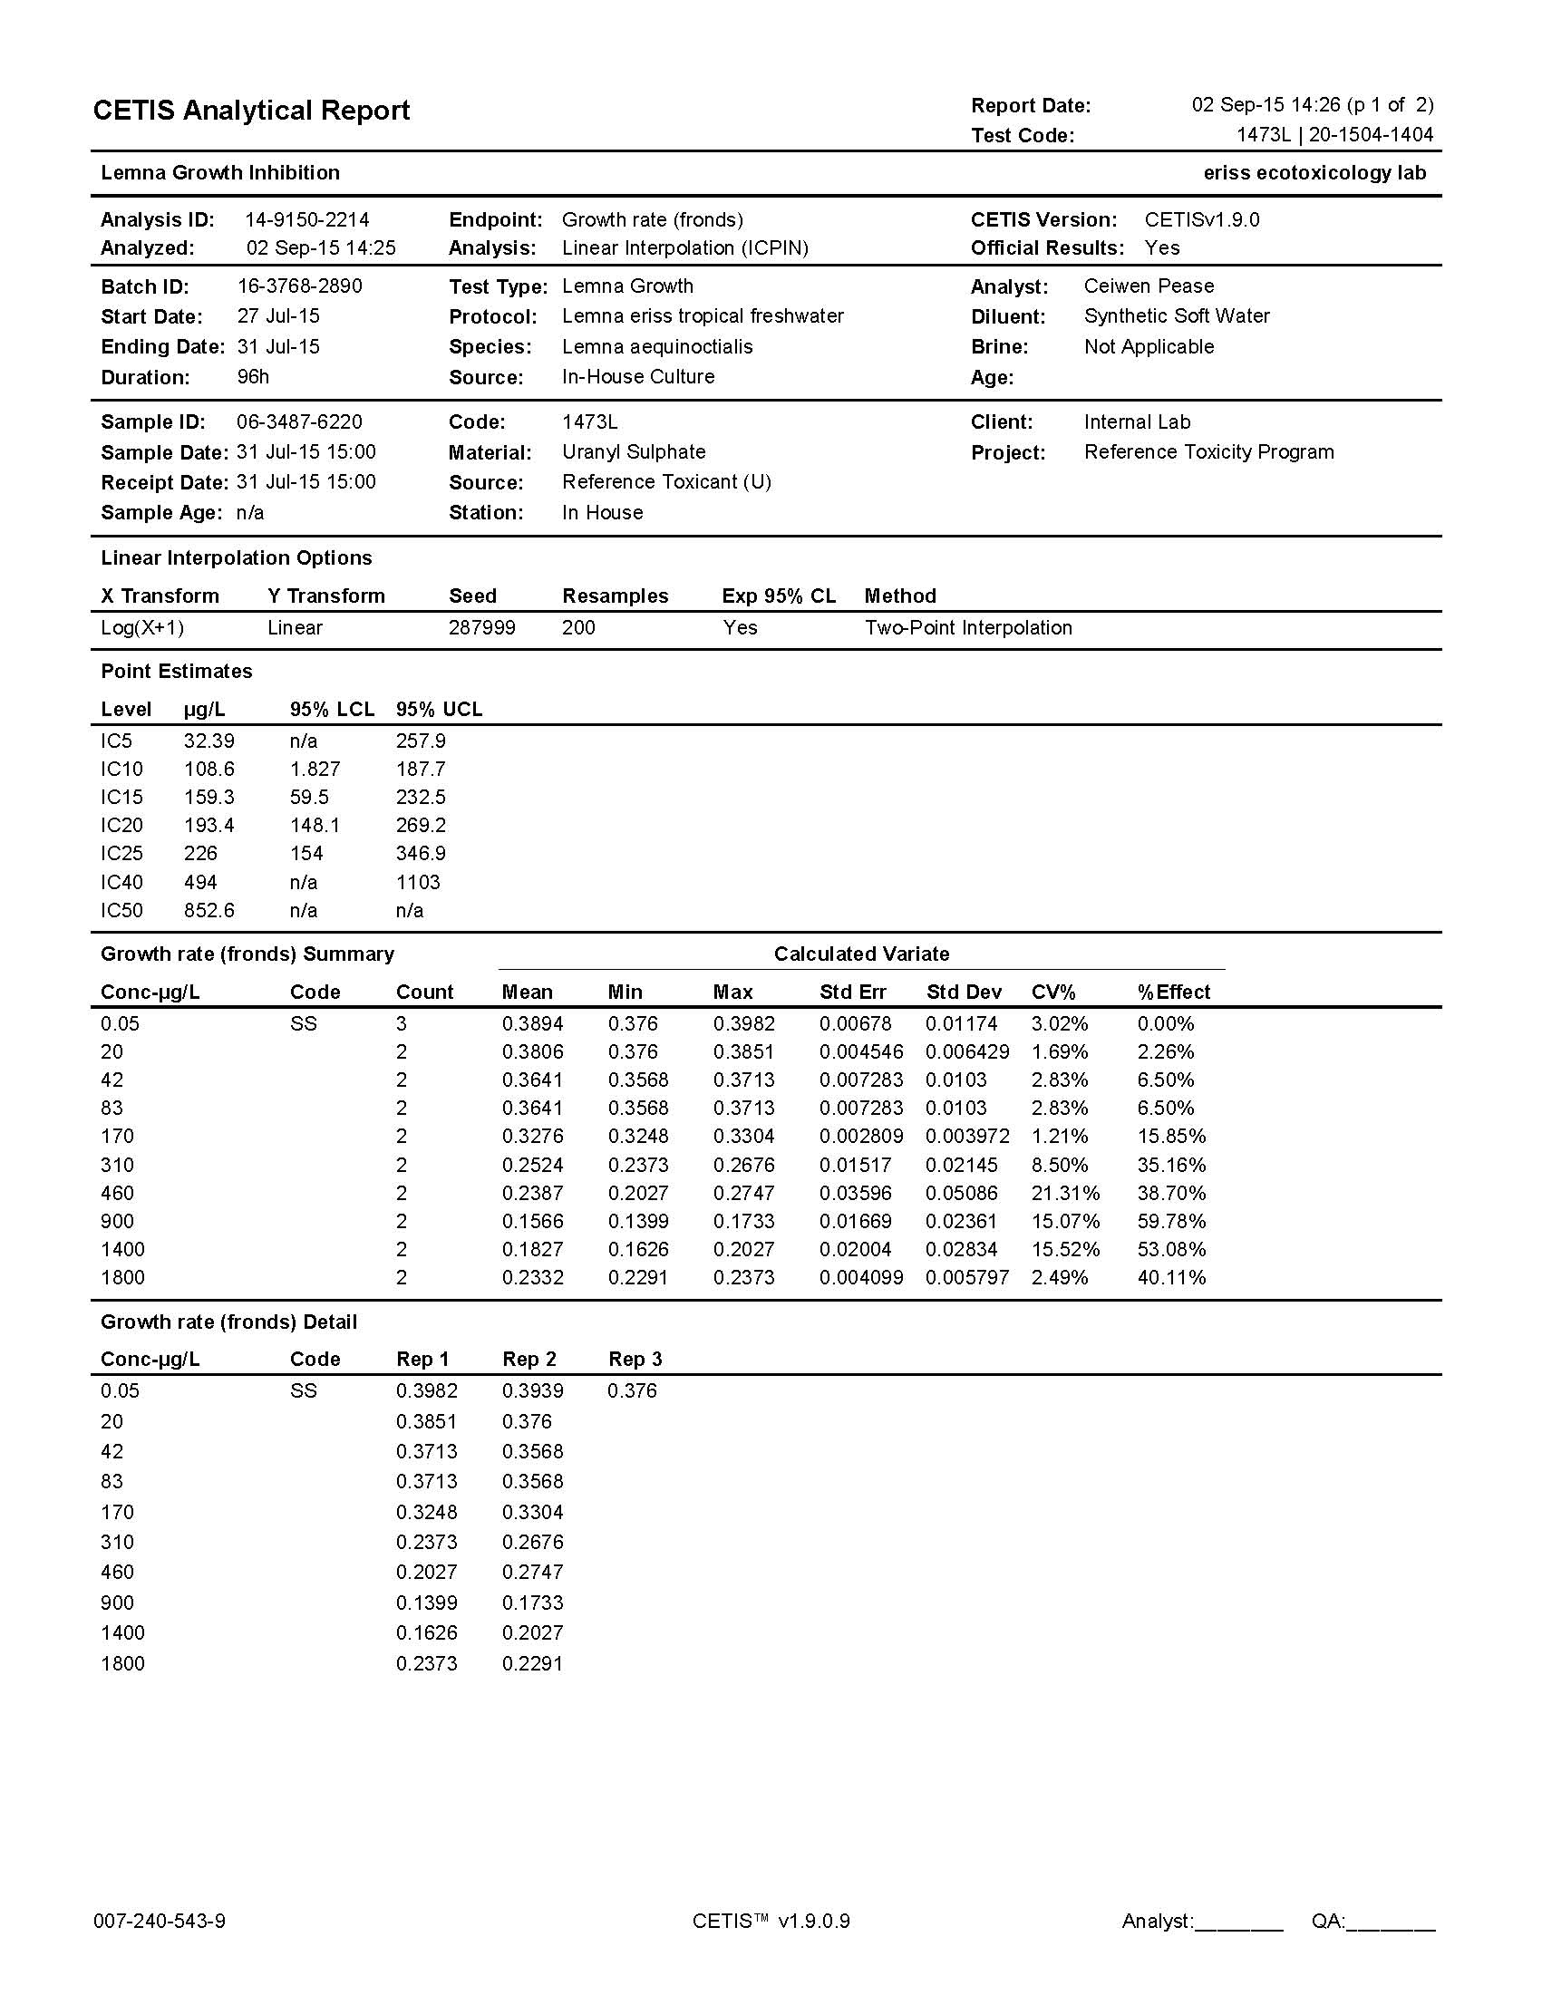

**Figure I22** Continued

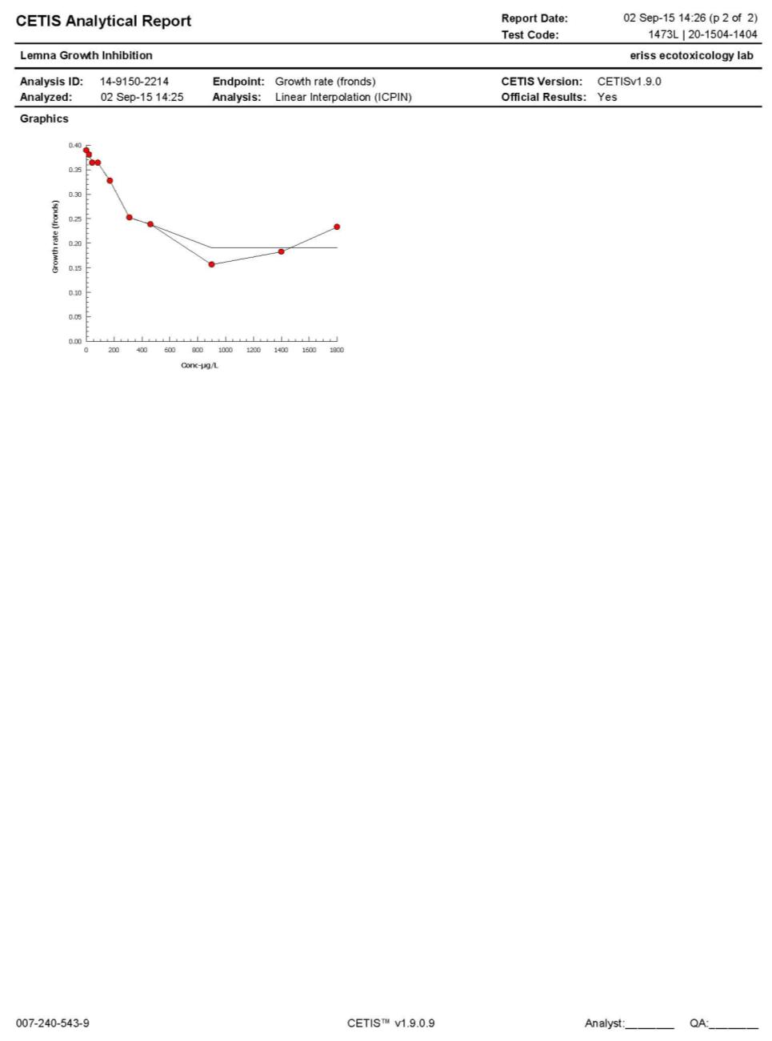

**Figure I23** Test raw data and analysis report for test 1473L (surface area)

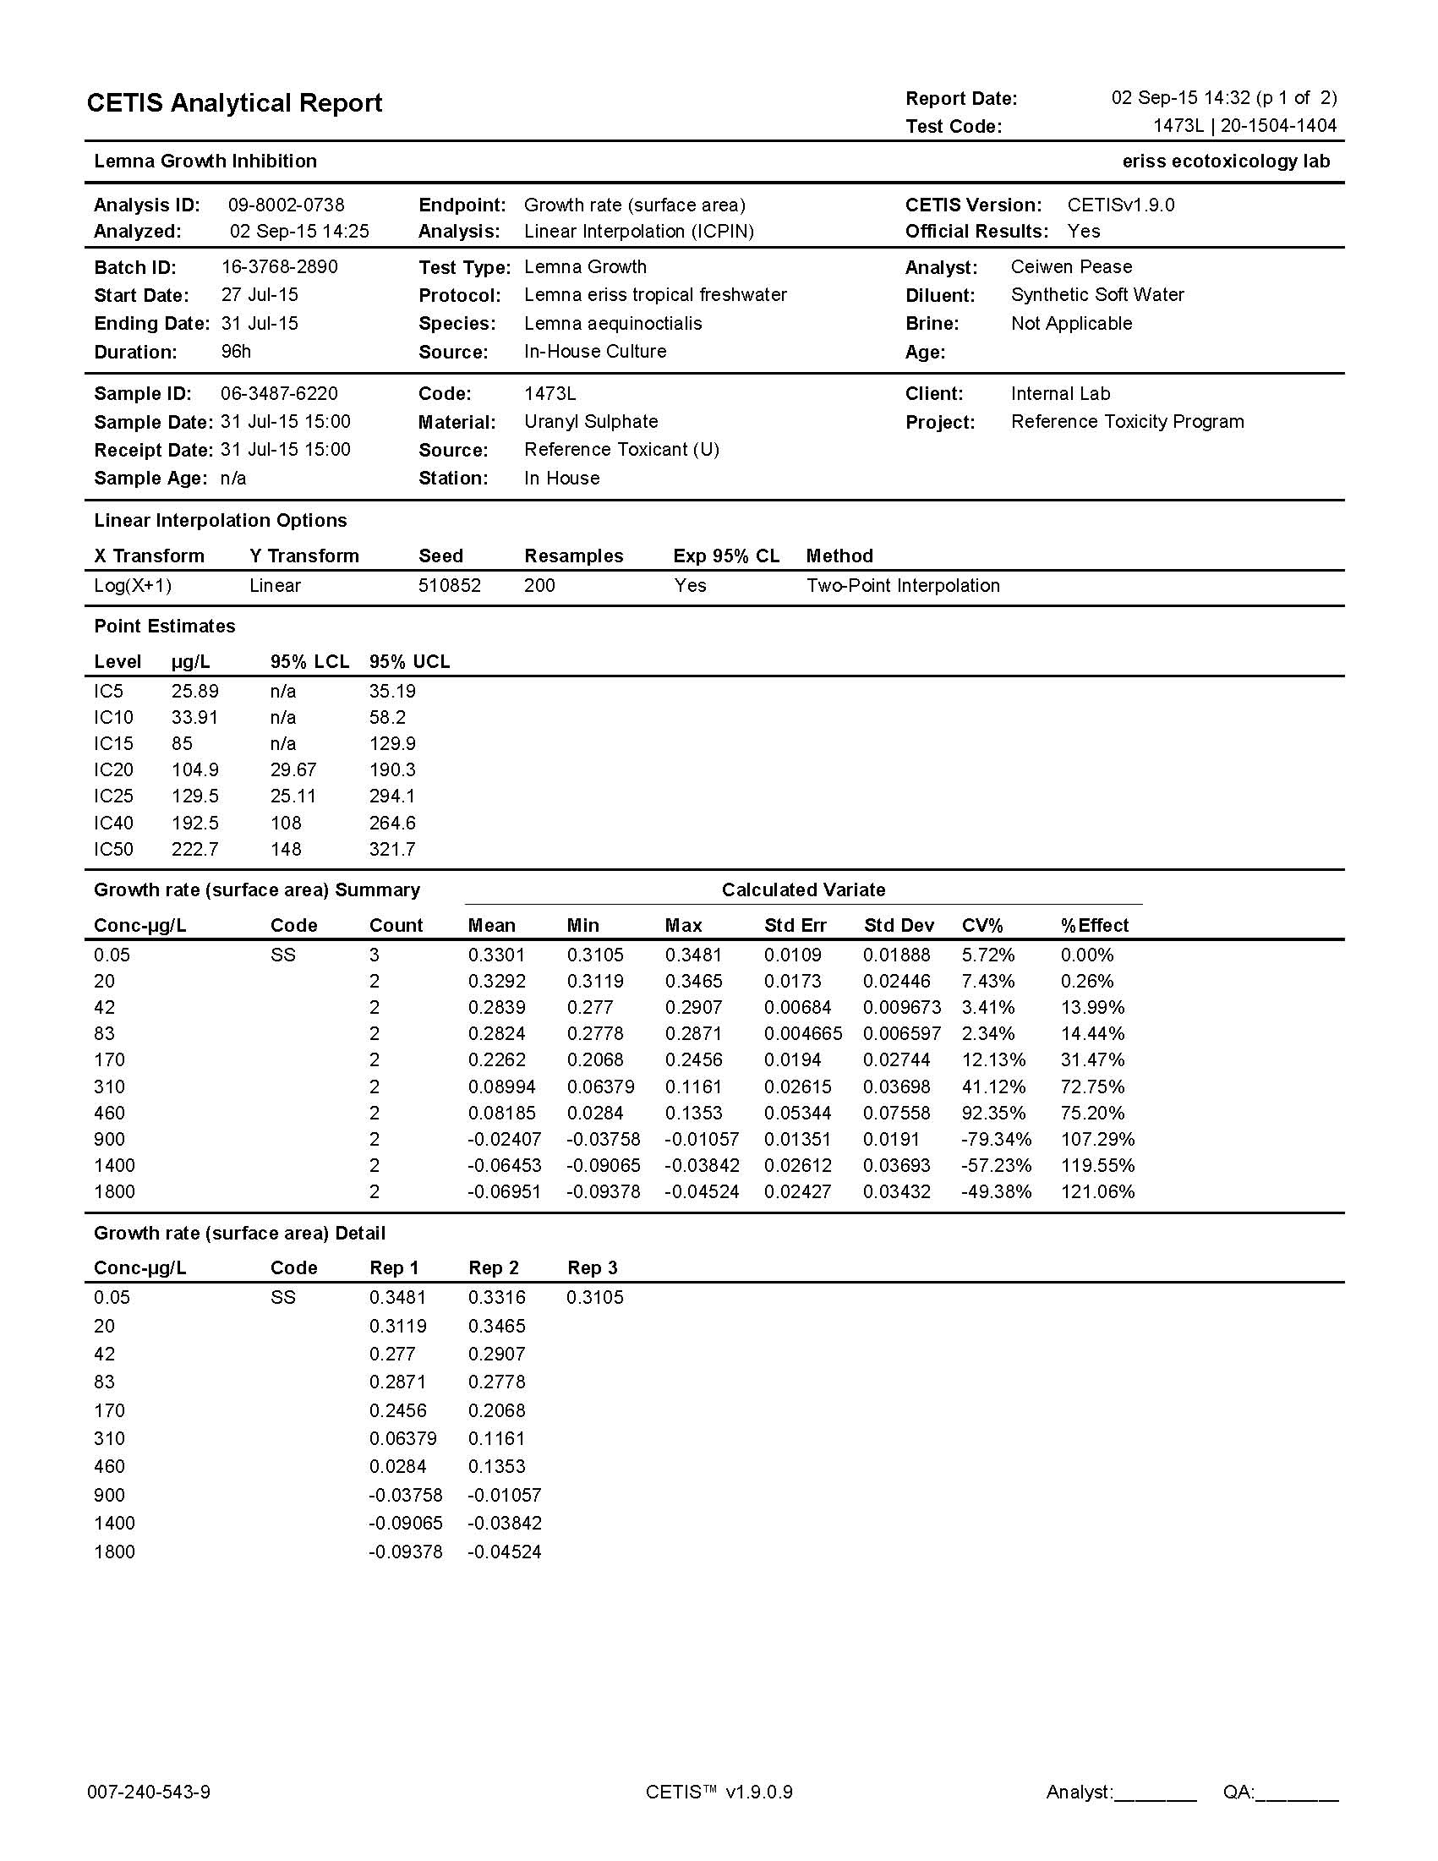

**Figure I23** Continued

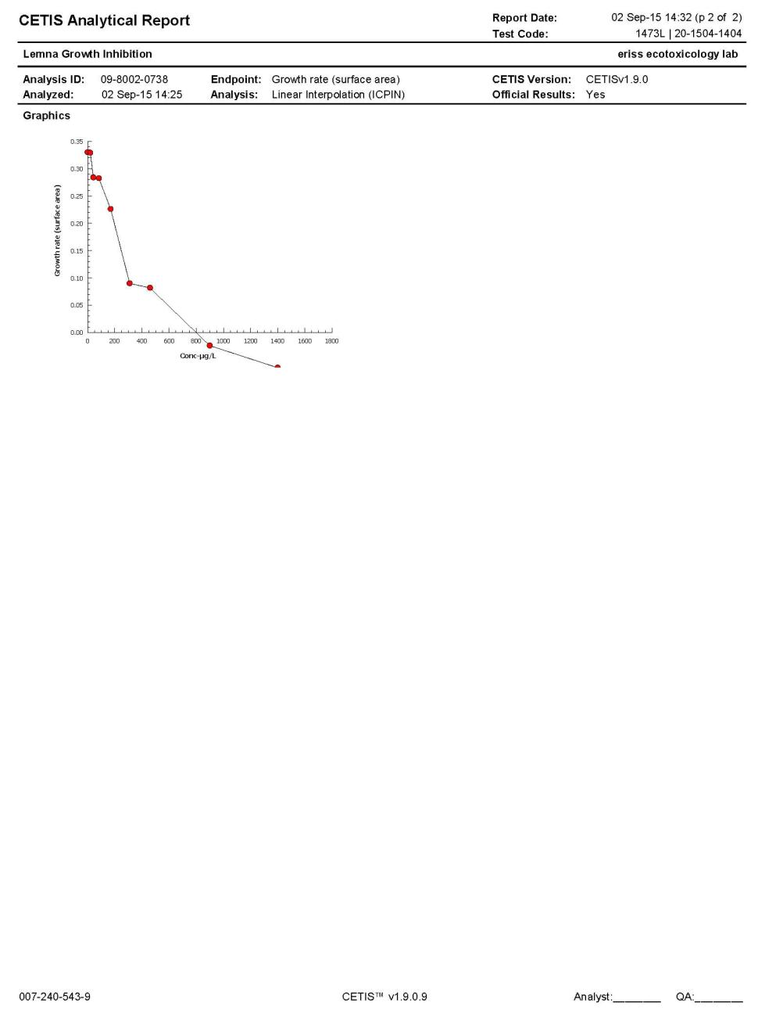

**Figure I24** Test raw data and analysis report for test 1475L (frond count)

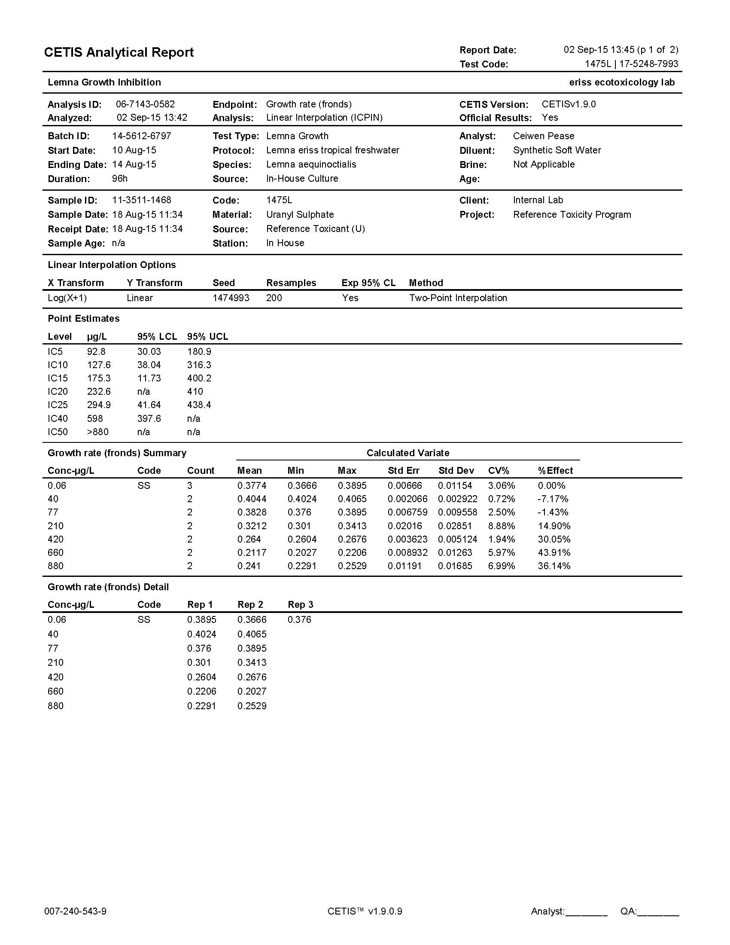

**Figure I24** Continued

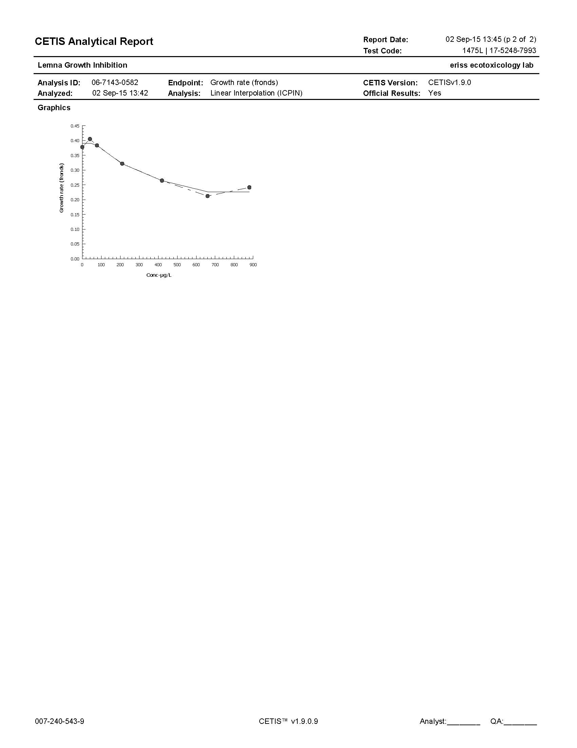

**Figure I25** Test raw data and analysis report for test 1475L (surface area)

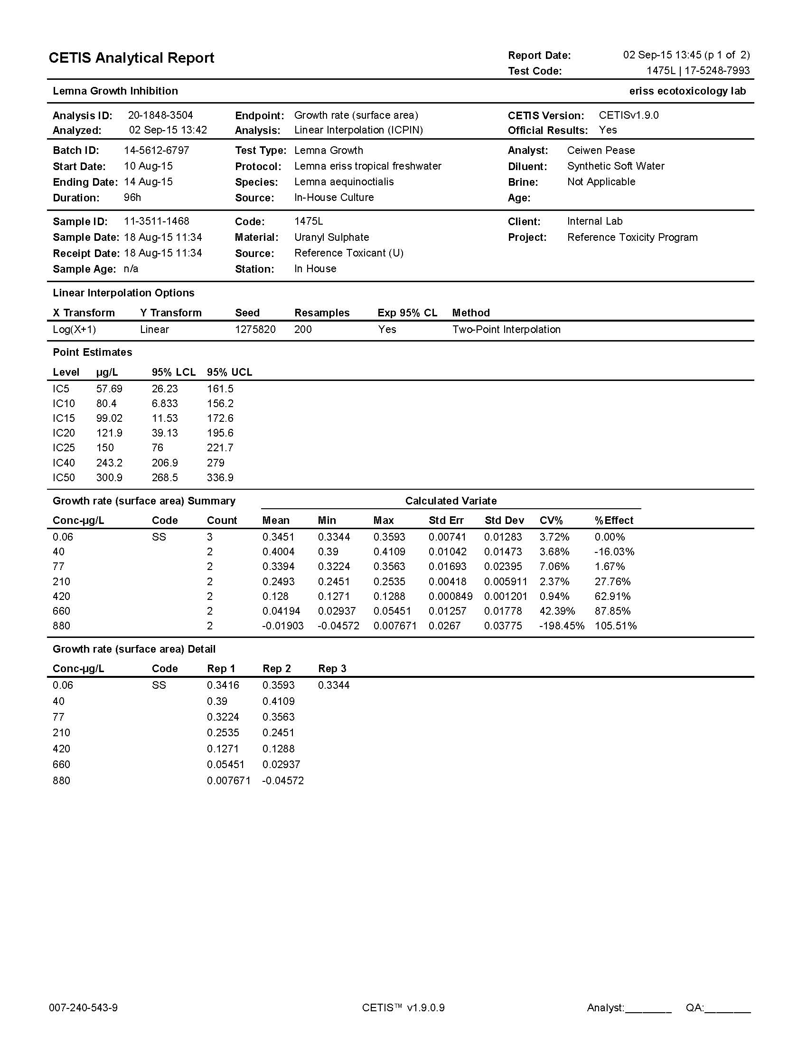

**Figure I25** Continued

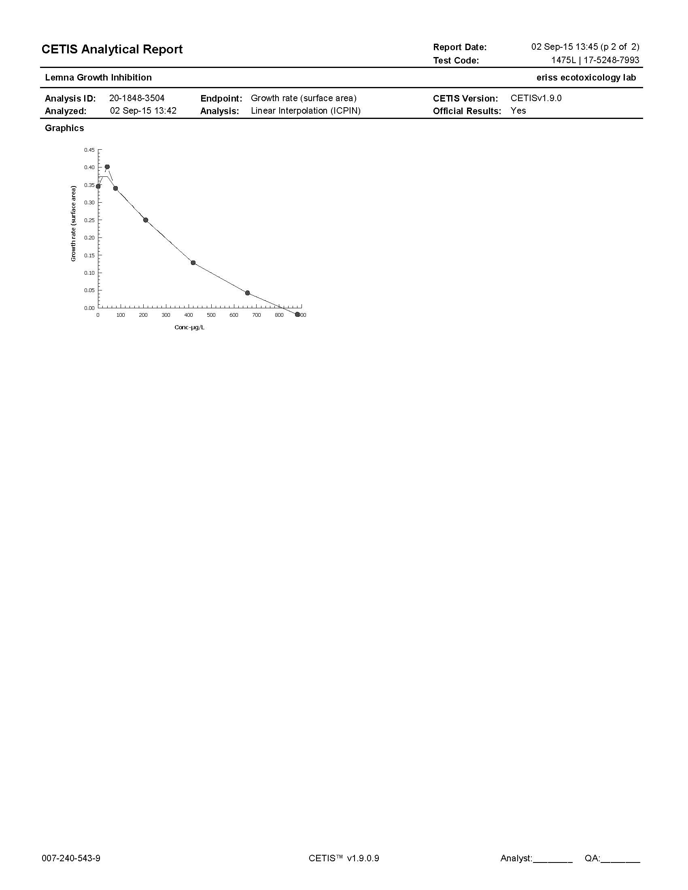

ASTM, 1992.. Standard guide for conducting static toxicity tests with Lemna gibba. *American Society for Testing and Materials.* E1415-91. Philadelphia, USA.