Wave-short



646

*internal report*

Ranger Trial Landform: Hydrology – Rainfall & runoff data for Erosion Plot 1: 2009-2015



J Boyden, M Saynor and   
W Erskine

August 2016

Release status – unrestricted

Project number – RES-2009-011

*The Department acknowledges the traditional owners of country throughout Australia and their continuing connection to land, sea and community. We pay our respects to them and their cultures and to their elders both past and present.*

# Ranger Trial Landform: Hydrology – Rainfall & runoff data for Erosion Plot 1: 2009-2015

James Boyden, Mike Saynor and Wayne Erskine

Supervising Scientist

GPO Box 461, Darwin NT 0801

August 2016

Release status – unrestricted



*How to cite this report:*

Boyden J, Saynor M & Erskine W 2016. Ranger Trial Landform: Hydrology – Rainfall & runoff data for Erosion Plot 1: 2009-2015. Internal Report 646, August, Supervising Scientist, Darwin.

*Project number: RES-2009-011*

*Authors of this report:*

James Boyden –Supervising Scientist, GPO Box 461, Darwin NT 0801, Australia

Mike Saynor –Supervising Scientist, GPO Box 461, Darwin NT 0801, Australia

Wayne Erskine –Supervising Scientist, GPO Box 461, Darwin NT 0801, Australia

The Supervising Scientist is a branch of the Australian Government Department of the Environment and Energy.

Supervising Scientist

Department of the Environment and Energy

GPO Box 461, Darwin NT 0801 Australia

**environment**.gov.au/science/supervising-scientist/publications

© Commonwealth of Australia 2016

Copyright Image.tif

IR646 is licensed by the Commonwealth of Australia for use under a Creative Commons By Attribution 3.0 Australia licence with the exception of the Coat of Arms of the Commonwealth of Australia, the logo of the agency responsible for publishing the report, content supplied by third parties, and any images depicting people. For licence conditions see: [http://creativecommons.org/licenses/by/3.0/au/](http://creativecommons.org/licenses/by/3.0/au/%20)

**Disclaimer**

The views and opinions expressed in this publication are those of the authors and do not necessarily reflect those of the Australian Government or the Minister for the Environment and Energy.

While reasonable efforts have been made to ensure that the contents of this publication are factually correct, the Commonwealth does not accept responsibility for the accuracy or completeness of the contents, and shall not be liable for any loss or damage that may be occasioned directly or indirectly through the use of, or reliance on, the contents of this publication.

# Contents

[Executive summary iii](#_Toc455042490)

[Acknowledgements iv](#_Toc455042491)

[List of Figures v](#_Toc455042492)

[List of Tables vii](#_Toc455042493)

[List of Figures (Appendices) viii](#_Toc455042494)

[1 Introduction 1](#_Toc455042495)

[1.1 Erosion Plot 1 characteristics 3](#_Toc455042496)

[2 Methods: Data correction and quality assessment 5](#_Toc455042497)

[2.1 Rainfall corrections 5](#_Toc455042498)

[2.2 Stage trace corrections 6](#_Toc455042499)

[2.2.1 General adjustments to the Cease-to-flow (CTF) datum 6](#_Toc455042500)

[2.2.2 Missing data in-fills 7](#_Toc455042501)

[2.2.3 Evaluation of shaft encoder accuracy at high flows 7](#_Toc455042502)

[2.2.4 Correction for boundary overflow onto the plot 8](#_Toc455042503)

[2.3 Analysis of boundary overflow 10](#_Toc455042504)

[2.3.1 Time-lapse photography 10](#_Toc455042505)

[2.3.2 Rainfall characteristics associated with overflow 11](#_Toc455042506)

[2.3.3 Contribution of overflow to total EP1 discharge 11](#_Toc455042507)

[3 Results and discussion 12](#_Toc455042508)

[3.1 Rainfall corrections 12](#_Toc455042509)

[3.2 Stage trace corrections 20](#_Toc455042510)

[3.2.1 Missing data corrections 20](#_Toc455042511)

[3.2.2 Evaluation of shaft encoder accuracy at high flows 21](#_Toc455042512)

[3.2.3 Correction for boundary overflow onto the plot 22](#_Toc455042513)

[3.3 Analysis of boundary overflow 23](#_Toc455042514)

[3.3.1 Time-lapse photography 23](#_Toc455042515)

[3.3.2 Rainfall characteristics associated with overflow 25](#_Toc455042516)

[3.3.3 Contribution of overflow to total EP1 discharge 28](#_Toc455042517)

[4 Conclusions 29](#_Toc455042518)

[5 References 31](#_Toc455042519)

[Appendix 1 EP1 vs. EP2 stage trace comparisons 32](#_Toc455042520)

[Appendix 1.1 EP1 runoff events where boundary overflow was indicated and corrected 32](#_Toc455042521)

[Appendix 1.2 EP1 events where no boundary overflow was indicated 43](#_Toc455042522)

[Appendix 2 Photos of road drain runoff peaks and associated EP1 stage trace 60](#_Toc455042523)

[Appendix 3 Rainfall statistics associated with ‘overflow’ and ‘no overflow’ runoff events with ≥ 30 mm rain 63](#_Toc455042524)

# Executive summary

A trial rehabilitation landform was constructed at Ranger uranium mine in early 2009 for the purpose of charactering vegetation establishment, rates of erosion and contaminant transport under different surface treatments and vegetation establishment strategies. To support this research, four erosion plots were designed and constructed by ***eriss*** (project RES-2009-011) to continuously monitor, across the different regimes: rainfall; associated surface water runoff; solute; and sediment transport (suspended sediment and bedload). In this regard, the time-series data for rainfall and runoff are to be used in conjunction with other measured variables to: a) determine physical erosion rates in relation to rainfall and surface water discharge; b) provide calibration input data for predictive geomorphic computer modelling of proposed landform designs ([Lowry et al 2015](#_ENREF_3)); and c) determine contaminant loads, pathways, and sedimentation sinks.

To meet these requirements, it was necessary that the hydrology dataset undergo rigorous screening to provide assurance that data were suitable for intended purposes. To address issues in data quality, a separate report has been written for each plot and selected periods (as required) with two reports, for Erosion Plots 1 and 2, reported so far. In this regard this report assesses quality of the Erosion Plot 1 (EP1) hydrology dataset from 01‑09‑2009 to 31‑08‑2015, covering a period of 6 water-years, and describes the methods used to check and correct these data. Other physico-chemical variables were also monitored at EP1 from 2009 to 2014 but are not the subject of this report.

This assessment found a site-specific problem with excess runoff, believed to occur from off-site surface water flowing across the plot containment (i.e. boundary overflow) during periods of high rainfall. The methods developed to identify and correct for these and other issues, have minimised errors in the dataset. It is considered that the applied corrections have resulted in a complete, quality coded hydrology record suitable for further analysis. An important conclusion is that in future years of data acquisition, any event with rainfall greater than 30 mm should be checked for overflow error at this monitoring site.

# Acknowledgements

There have been many who have help with the project over its long period of existence.

Ranger Mine operator, Energy Resources of Australia Ltd (ERA) constructed the landform on which the erosion plots have been built.

Richard Houghton assisted greatly with the set up of the erosion plots on the trial landform, ably assisted in no particular order by Dene Moliere, Grant Staben and John Lowry.

Austin Brandis (Envirotech Monitoring) assisted greatly with the establishment of the telemetry system and installation of sensors into the gauging stations at the outlet of each plot. Kate Turner and Sean Fagan have also assisted with many aspects of Hydstra data management.

Over the years many people have assisted in the field, John Taylor, Michael Fromholtz, Rob Thorn, Graeme Passmore (ERA), Jess Bartlett (ERA) and Peter Poole (ERA).

Thanks also to John Lowry and Mitch Rudge who provided constructive reviews report drafts.

# List of figures

[**Figure 1.** The location of Ranger Uranium Mine within Kakadu National Park and the Trial Landform. 1](#_Toc451787028)

[**Figure 2.** Aerial view of the completed Trial Landform located next to the Ranger mine Tailings Storage Facility. Erosion Plot 1 (EP1) is indicated by red arrow and black dotted outline. 2](#_Toc451787029)

[**Figure 3.** Erosion Plot 1 showing the boundary pipe, stilling basin, flume and downstream basin drain. 3](#_Toc451787030)

[**Figure 4.** The location of the EP1 raingauge just right of the downstream plot boundary and in relation to other EP1 monitoring equipment: Data-logger and shelter; runoff stilling-basin; and stilling-well housing for the shaft encoder.. 4](#_Toc451787031)

[**Figure 5.** Example of water-level disturbance in the upstream stilling basin at EP2 during the peak of a high-flow event.. 8](#_Toc451787032)

[**Figure 6.** Evidence and correction of roadside drain overflow event where: **a)** overflow is indicated by a 2nd peak in the EP1 trace after a brief yet intense 31 mm rain event on the 21st December 2011; and **b)** correction applied to abnormal records by manual editing (orange line). 9](#_Toc451787033)

[**Figure 7.** Evidence and correction of roadside drain overflow event where: **a)** overflow was indicated by the exceedance of the EP1 stage trace in relation to EP2; and **b)** correction applied to abnormal records by manual editing (orange line). 10](#_Toc451787034)

[**Figure 8.** Linear relationship between TLFERA and EP1 for common ½ hourly interval rainfall totals on the TLF (collected from 31-08-2009 to 11-06-2010). 12](#_Toc451787035)

[**Figure 9.** EP1 cumulative rainfall graph for the 2009–10 water-year (1533 mm total). Rainfall (mm) is on the y-axis. 14](#_Toc451787036)

[**Figure 10.** EP1 cumulative rainfall graph for the 2010–11 water-year (2227 mm total). Rainfall (mm) is on the y-axis. 15](#_Toc451787037)

[**Figure 11.** EP1 cumulative rainfall graph for the 2011–12 water-year (1509 mm total). Rainfall (mm) is on the y-axis. 16](#_Toc451787038)

[**Figure 12.** EP1 cumulative rainfall graph for the 2012–13 water-year (1283 mm total). Rainfall (mm) is on the y-axis. 17](#_Toc451787039)

[**Figure 13.** EP1 cumulative rainfall graph for the 2013–14 water-year (1961 mm total). Rainfall (mm) is on the y-axis. 18](#_Toc451787040)

[**Figure 14.** EP1 cumulative rainfall graph for the 2014–15 water-year (1053 mm total). Rainfall (mm) is on the y-axis 19](#_Toc451787041)

[**Figure 15.** EP1 (Blue) and EP2 (red) stage traces and corresponding time-lapse photos at peak of runoff event during some 54 mm of rainfall over 1 ½ hours on 24/11/2012. 22](#_Toc451787042)

[**Figure 16.** Five-minute interval photo sequence (1 to 12) showing flow along the roadside drain (to left of EP1) during a 22 mm rain event on 1-03-2015.. 23](#_Toc451787043)

[**Figure 17.** Shaft-encoder stage trace for EP1 during the 22 mm rain event over which roadside drain runoff was also captured on camera (i.e. Figure 16 above). 24](#_Toc451787044)

[**Figure 18.** Comparison of the rainfall characteristics (magnitude and duration) during, 24, 48 and 96 hrs before runoff for the runoff events where no overflow was indicated and where overflow was suspected. 25](#_Toc451787045)

[**Figure 19.** Stage traces for an EP1 and EP2 runoff event 14-02-2011 where minor boundary overflow correction to the EP1 stage trace was necessary.. 27](#_Toc451787046)

[**Figure 20.** Bar graph showing: **a)** corrected EP1 runoff totals for each water-year; and **b)** the amount of boundary overflow. Numbers of discreet runoff events for each group are shown in brackets. 28](#_Toc451787047)0

# List of tables

[**Table 1.** Periods of missing rainfall record for EP1 over the six water-years, 2009-10 to 2014-15. 12](#_Toc458521662)

[**Table 2.** Correlations between rainfall gauge sites on the TLF. A zero-intercept was not enforced in the regressions. Note that 10-minute interval totals data were used to derive these regressions with the exception of the TLFERA site, where ½ hourly totals were used. 13](#_Toc458521663)

[**Table 3**  Water-year corrected rainfall totals for EP1 including the largest continuous rainfall event in that year, concurrent with a period of continuous flow over the flume. 20](#_Toc458521664)

[**Table 4.** Periods of missing EP1 stage trace data and how it was infilled. Notes: site name aliases in Hydstra TLF1 = EP1, TLF2 = EP2 and TLF3 = EP3; ShEn = Shaft encoder; PT = pressure transducer). 21](#_Toc458521665)

[**Table 5.** Results from Kruskal-Wallis One Way Analysis of Variance on Ranks (for non-normal distributions) for the comparison of median rainfall for overflow and non-overflow events with ≥ 30 mm of rainfall (also illustrated in Figure 18) 26](#_Toc458521666)

[**Table 6.** Tabulation of total runoff and overflow correction estimates calculated for all runoff events (Flow over flume + Basin Fill Only events) 28](#_Toc458521667)

# List of figures (appendices)

[**Figure A1-1.** Stage traces for an EP1 and EP2 runoff event on 01-02-2010 where some 76 mm of rainfall occurred during the runoff period this being the total amount occurring in a 24-hr period from the end of rainfall. 32](#_Toc451787054)

[**Figure A1-2.** Stage traces for an EP1 and EP2 runoff event on 13-02-2011 where some 48 mm of rainfall occurred during the runoff period with 64 mm occurring in a 24-hr period from the end of rainfall. 33](#_Toc451787055)

[**Figure A1-3.** Stage traces for an EP1 and EP2 runoff event on 14-02-2011. Only 13 mm of rainfall occurred during the runoff period but 76 mm occurred in a 24-hour period prior to the end of rainfall. 33](#_Toc451787056)

[**Figure A1-4.** Stage traces for an EP1 and EP2 runoff event on 14-02-2011. Some 63 mm of rainfall occurred during the runoff period and a total of 127 mm occurred in a 24-hour period from the end of rainfall. 34](#_Toc451787057)

[**Figure A1-5.** Stage traces for an EP1 and EP2 runoff event on 22-02-2011. Some 180 mm of rainfall occurred during the runoff period and a total of 195 mm occurred in a 24-hour period from the end of rainfall. 34](#_Toc451787058)

[**Figure A1-6.** Stage traces for an EP1 and EP2 runoff event on 03-12-2011. Some 84 mm of rainfall occurred during the runoff period this also being the total rain that occurred in the 24-hour period the end of rainfall. 35](#_Toc451787059)

[**Figure A1-7.** Stage traces for an EP1 and EP2 runoff event on 21-12-2011. Some 30 mm of rainfall occurred during the runoff period and a total of 57 mm of rain occurred in the 24-hour period before the end of rainfall. 35](#_Toc451787060)

[**Figure A1-8.** Stage traces for an EP1 and EP2 runoff event on 26-12-2011. Some 58 mm of rainfall occurred during the runoff period and a total of 68 mm of rain occurred in the 24-hour period before the end of rainfall. 36](#_Toc451787061)

[**Figure A1-9.** Stage traces for an EP1 and EP2 runoff event on 08-02-2012. Some 40 mm of rainfall occurred during the runoff period and a total of 41 mm of rain occurred in the 24-hour period before the end of rainfall. 36](#_Toc451787062)

[**Figure A1-10.** Stage traces for an EP1 and EP2 runoff event on 18-12-2012. Some 31 mm of rainfall occurred during the runoff period and a total of 56 mm of rain occurred in the 24-hour period before the end of rainfall. 37](#_Toc451787063)

[**Figure A1-11.** Stage traces for an EP1 and EP2 runoff event on 23-12-2012. Some 48 mm of rainfall occurred during the runoff period and a total of 77 mm of rain occurred in the 24-hour period before the end of rainfall. 37](#_Toc451787064)

[**Figure A1-12.** Stage traces for an EP1 and EP2 runoff event on 16-01-2013. Some 48 mm of rainfall occurred during the runoff period and this was also the total rain that had occurred in the 24-hour period before the end of rainfall. 38](#_Toc451787065)

[**Figure A1-13.** Stage traces for an EP1 and EP2 runoff event on 27-01-2013. Some 53 mm of rainfall occurred during the runoff period and this was also the total rain that had occurred in the 24-hour period before the end of rainfall. 38](#_Toc451787066)

[**Figure A1-14.** Stage traces for EP1 and EP2 runoff events from 30-03-2013. Some 170 mm of rainfall occurred during the runoff periods and a total of 187 mm rain occurred in the 24-hour period before the end of rainfall. 39](#_Toc451787067)

[**Figure A1-15.** Stage traces for EP1 and EP2 runoff events from 05-12-2013. Some 72 mm of rainfall occurred during the runoff periods and a total of 77 mm rain occurred in the 24-hour period before the end of rainfall. 39](#_Toc451787068)

[**Figure A1-16.** Stage traces for EP1 and EP2 runoff events from 16-01-2014. Some 66 mm of rainfall occurred during the runoff periods and a total of 82 mm rain occurred in the 24-hour period before the end of rainfall. 40](#_Toc451787069)

[**Figure A1-17.** Stage traces for EP1 and EP2 runoff events from 18-01-2014. Some 30 mm of rainfall occurred during the runoff periods and a total of 58 mm rain occurred in the 24-hour period before the end of rainfall. 40](#_Toc451787070)

[**Figure A1-18.** Stage traces for EP1 and EP2 runoff events from 23-01-2014. Some 37 mm of rainfall occurred during the runoff periods and a total of 60 mm rain occurred in the 24-hour period before the end of rainfall. 41](#_Toc451787071)

[**Figure A1-19.** Stage traces for EP1 and EP2 runoff events from 29-01-2014. Some 63 mm of rainfall occurred during the runoff periods and a total of 75 mm rain occurred in the 24-hour period before the end of rainfall. 41](#_Toc451787072)

[**Figure A1-20.** Stage traces for EP1 and EP2 runoff events from 31-01-2014. Some 33 mm of rainfall occurred during the runoff periods and a total of 83 mm rain occurred in the 24-hour period before the end of rainfall. 42](#_Toc451787073)

[**Figure A1-21.** Stage traces for EP1 and EP2 runoff events from 07-03-2014. Some 33 mm of rainfall occurred during the runoff periods and a total of 83 mm rain occurred in the 24-hour period before the end of rainfall. 42](#_Toc451787074)

[**Figure A1-22.** 23/12/2009, 46 mm rain event in about 2 ½ hours (black trace) EP1 shaft encoder (green trace) EP2 shaft encoder (red trace). No overflow problem indicated. 43](#_Toc451787075)

[**Figure A1-23.** 05/01/2010, 37 mm rain event (black trace) EP1 shaft encoder (green trace) EP2 shaft encoder (red trace). No overflow problem indicated. 43](#_Toc451787076)

[**Figure A1-24.** 23/01/2010, 58 mm rain event (black trace) EP1 shaft encoder (green trace) EP2 shaft encoder (red trace). No overflow problem indicated. 44](#_Toc451787077)

[**Figure A1-25.** 27/01/2010, 30 mm rain event (black trace) EP1 shaft encoder (green trace) EP2 shaft encoder (red trace). No overflow problem indicated. 44](#_Toc451787078)

[**Figure A1-26.** 09/04/2010, 53 mm rain event (black trace) EP1 shaft encoder (green trace) EP2 shaft encoder (red trace). No overflow problem indicated. 45](#_Toc451787079)

[**Figure A1-27.** 12/04/2010, 51 mm rain event (black trace) EP1 shaft encoder (green trace) EP2 shaft encoder (red trace). No overflow problem indicated. 45](#_Toc451787080)

[**Figure A1-28.** 13/04/2010, 32 mm rain event (black trace) EP1 shaft encoder (green trace) EP2 shaft encoder (red trace). No overflow problem indicated. 46](#_Toc451787081)

[**Figure A1-29.** 08/10/2010, 45 mm rain event (black traces for plots 1 to 4) EP1 shaft encoder (green trace) EP2 shaft encoder (red trace). No overflow problem indicated. 46](#_Toc451787082)

[**Figure A1-30.** 09/10/2010, 69 mm rain (black traces for plots 1 to 4). EP1 shaft encoder (green trace) EP2 shaft encoder (red trace). Marginal overflow detected at end of recession period. Perhaps could be corrected but has been left at this stage. The multimodal peaks on the EP1 stage trace correspond to changes in rain intensity. 47](#_Toc451787083)

[**Figure A1-31.** 27/03/2011, 53 mm rain event (black) EP1 shaft encoder (green trace) EP2 shaft encoder (red trace). Marginal overflow problem indicated on recession but no correction applied. 47](#_Toc451787084)

[**Figure A1-32.** 22/11/2011, 30 mm rain event (black traces for plots 1 to 4). EP1 shaft encoder (green trace) EP2 shaft encoder (red trace). No overflow problem indicated. 48](#_Toc451787085)

[**Figure A1-33.** 18/12/2011: 45 mm rain event over two events (rising black traces, plots 1 to 4) EP1 shaft encoder (green trace) EP2 shaft encoder (red trace). No overflow problem indicated. 48](#_Toc451787086)

[**Figure A1-34.** 18/12/2011: 30 mm rain event (rising black traces, plots 1 to 4) EP1 shaft encoder (green trace) EP2 shaft encoder (red trace). No overflow problem indicated. 49](#_Toc451787087)

[**Figure A1-35.** 18/02/2012, 32 mm rain event (rising black traces, plots 1 to 4) EP1 shaft encoder (green trace) EP2 shaft encoder (red trace). No overflow problem indicated. 49](#_Toc451787088)

[**Figure A1-36.** 23/11/2012, 55 mm rain event (black) EP1 shaft encoder (green trace) EP2 shaft encoder (red trace). No overflow problem indicated. 50](#_Toc451787089)

[**Figure A1-37.** 18/12/2012, 56 mm rain (black) over two runoff events. EP1 shaft encoder (green trace) EP2 shaft encoder (red trace). No overflow problem indicated. 50](#_Toc451787090)

[**Figure A1-38.** 23/12/2012, 48 mm rain event (black) EP1 shaft encoder (green trace) EP2 shaft encoder (red trace). No overflow problem indicated. 51](#_Toc451787091)

[**Figure A1-39.** 29/03/2013, 33 mm rain event (black) EP1 shaft encoder (green trace) EP2 shaft encoder (red trace). No overflow problem indicated. 51](#_Toc451787092)

[**Figure A1-40.** 01/11/2013 (Plot1/2): 43 mm rain event (black) EP1 shaft encoder (green trace) EP2 shaft encoder (red trace). No overflow problem indicated. 52](#_Toc451787093)

[**Figure A1-41.** 25/11/2013, 36 mm rain event (black) EP1 shaft encoder (green trace) EP2 shaft encoder (red trace). No overflow problem indicated. 52](#_Toc451787094)

[**Figure A1-42.** 28/12/2013, 39 mm rain event (black) EP1 shaft encoder (green trace) EP2 shaft encoder (red trace). No overflow problem indicated. 53](#_Toc451787095)

[**Figure A1-43.** 26/01/2014, 39 mm rain event (black) EP1 shaft encoder (green trace) EP2 shaft encoder (red trace). No overflow problem indicated. 53](#_Toc451787096)

[**Figure A1-44.** 13/02/2014 (Plot1/2): 48 mm rain (black) over three runoff events. EP1 shaft encoder (green trace) EP2 shaft encoder (red trace). No overflow problem indicated. 54](#_Toc451787097)

[**Figure A1-45.** 17/02/2014 (Plot1/2): 53 mm rain event (black) EP1 shaft encoder (green trace) EP2 shaft encoder (red trace). No overflow problem indicated. 54](#_Toc451787098)

[**Figure A1-46.** 18/02/2014 (Plot1/2): 37 mm rain event (black) EP1 shaft encoder (green trace) EP2 shaft encoder (red trace). No boundary overflow problem indicated. 55](#_Toc451787099)

[**Figure A1-47.** 05/03/2014 (Plot1/2): 33 mm rain event (black) EP1 shaft encoder (green trace) EP2 shaft encoder (red trace). No boundary overflow problem indicated. 55](#_Toc451787100)

[**Figure A1-48.** 06/04/2014, 41 mm rain event (black) EP1 shaft encoder (green trace) EP2 shaft encoder (red trace). No boundary overflow problem indicated. 56](#_Toc451787101)

[**Figure A1-49.** 10/04/2014, 38 mm rain (black) over 2 runoff events. EP1 shaft encoder (green trace) EP2 shaft encoder (red trace). No boundary overflow problem indicated. 56](#_Toc451787102)

[**Figure A1-50.** 03/05/2014, 46 mm rain event (black) EP1 shaft encoder (green trace) EP2 shaft encoder (red trace). No boundary overflow problem indicated. 57](#_Toc451787103)

[**Figure A1-51.** 04/11/2014, 33 mm rain event (black) EP1 shaft encoder (green trace) EP2 shaft encoder (red trace). No boundary overflow problem indicated. 57](#_Toc451787104)

[**Figure A1-52.** 06/11/2014, 63 mm rain event (black) EP1 shaft encoder (green trace) EP2 shaft encoder (red trace). No boundary overflow problem indicated. 58](#_Toc451787105)

[**Figure A1-53.** 30/12/2014, 50 mm rain event (black) EP1 shaft encoder (green trace) EP2 shaft encoder (red trace). No boundary overflow problem indicated. 58](#_Toc451787106)

[**Figure A1-54.** 01/01/2015, 50 mm rain event (black) EP1 shaft encoder (green trace) EP2 shaft encoder (red trace). No boundary overflow problem indicated. 59](#_Toc451787107)

[**Figure A1-55.** 24/02/2015, 56 mm rain event (black) EP1 shaft encoder (green trace) EP2 shaft encoder (red trace). Marginal boundary overflow indicated on recession but no correction applied. 59](#_Toc451787108)

[**Figure A2-1.** EP1 stage trace for a 5.6mm rain event from 4:06 to 4:07 pm on the 25-02-2015 and photo of the adjacent roadside drain showing peak runoff at 4:09 pm with no plot boundary overflow. 60](#_Toc451787109)

[**Figure A2-2.** EP1 stage trace for a 5.9 mm rain event from 4:40 to 4:56 pm on the 27-02-2015 and photo of the adjacent roadside drain showing peak runoff at 4:54 pm with no plot boundary overflow. 60](#_Toc451787110)

[**Figure A2-3.** EP1 stage trace for a 2.6 mm rain event from 6:13 to 6:46 pm on the 28-02-2015 and photo of the adjacent roadside drain showing peak runoff at 6:44 pm with no plot boundary overflow. 61](#_Toc451787111)

[**Figure A2-4.** EP1 stage trace for a 22 mm rain event from 4:51 to 5:25 pm on the 01-03-2015 and photo of the adjacent roadside drain showing peak runoff at 5:15 pm with no plot boundary overflow. These events are also illustrated in Figures 16 and 17 of the results as the largest rainfall runoff event captured by camera. 61](#_Toc451787112)

[**Figure A2-5.** EP1 stage trace for a 2.6 mm rain event from 6:20 to 9:51 am on the 02-03-2015 and photo of the adjacent roadside drain showing peak runoff at 8:18 am with no plot boundary overflow. 61](#_Toc451787113)

[**Figure A2-6.** EP1 stage trace for a 1.6 mm rain event from 5:22 to 5:26 PM on the 02-03-2015 and photo of the adjacent roadside drain showing peak runoff at 5:26 PM with no plot boundary overflow. 62](#_Toc451787114)

[**Figure A2-7.** EP1 stage trace for a 1.6 mm rain event from 5:22 to 5:26 PM on the 14-03-2015 and photo of the adjacent roadside drain showing peak runoff at 5:26 PM with no plot boundary overflow. 62](#_Toc451787115)

# 1 Introduction

The Ranger Uranium Mine (Ranger), surrounded by Kakadu National Park (Figure 1) and within the wet-dry monsoonal tropics of the Alligator Rivers Region, is approximately 250 km east of Darwin, Northern Territory, Australia. Located adjacent to the north-western wall of the tailings storage facility at Ranger (Figures 1 & 2), a Trial Landform (TLF) of approximately 200 m by 400 m (8 ha) was constructed by Energy Resources of Australia (ERA) during late 2008 and early 2009 for the purpose of monitoring vegetation establishment, erosion rates and contaminant transport under different surface treatments and vegetation establishment strategies. In this regard, collaborative research involving the Supervising Scientist Branch and ERA has been underway to measure long-term (five to ten year) geomorphic stability and vegetation establishment on the TLF.

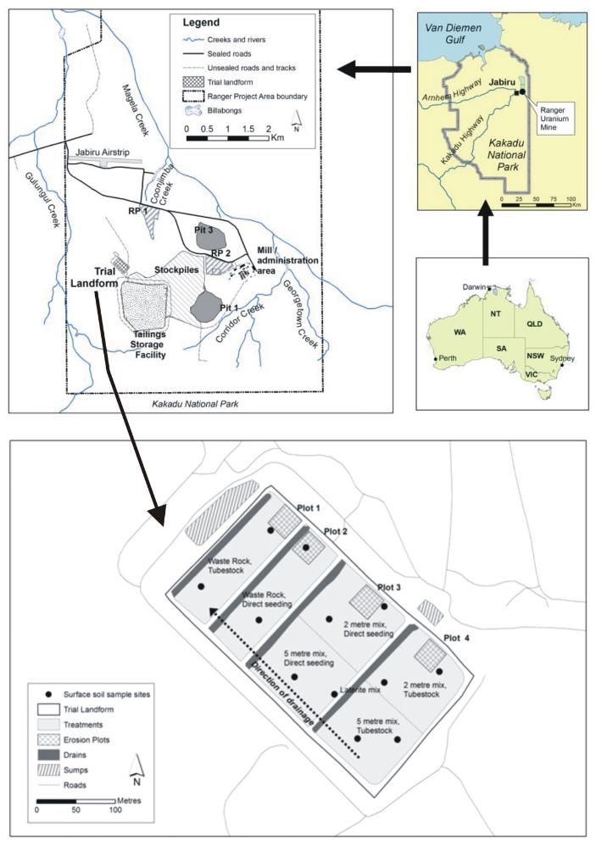

**Figure 1**  The location of Ranger Uranium Mine within Kakadu National Park and the Trial Landform.

To support this research, four erosion plots (EP1 to EP4) were constructed by ***eriss*** with identical instrumentation to measure, across the different treatments, rainfall, associated runoff, solute and sediment (suspended sediment and bedload). Specifically, rainfall and runoff data gathered from plots are to be used in conjunction with other measured variables to: a) determine physical rates of erosion; b) provide calibration input data for predictive geomorphic modelling of proposed landform designs; and to c) determine contaminant loads and pathways (i.e. see ***eriss*** project RES-2009-011).

Located between 20 and 220 m of each other, each plot had approximately similar characteristics in area and slope. However, plots differed in microtopography and the relative mix waste rock and lateritic material used in construction. The applied revegetation treatments and associated vegetation change trajectories also differed among plots.

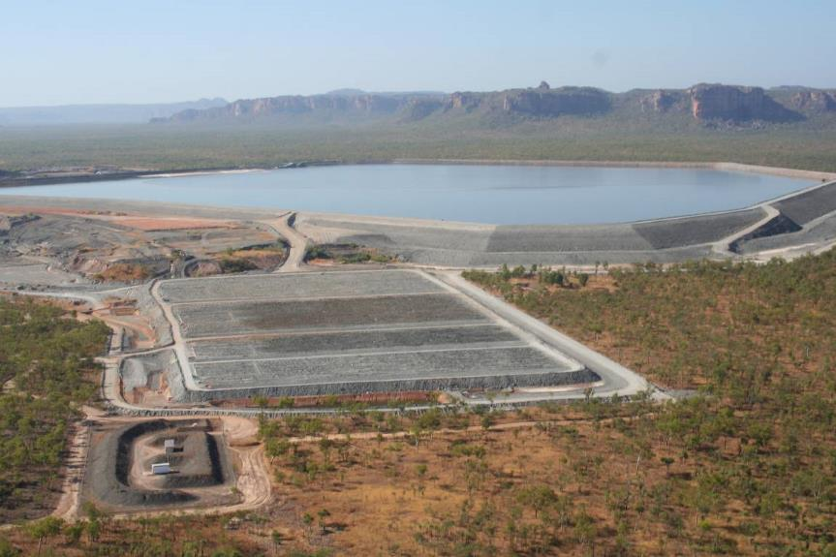

**EP1**

**Figure 2.** Aerial view of the completed Trial Landform located next to the Ranger mine Tailings Storage Facility. Erosion Plot 1 (EP1) is indicated by red arrow and black dotted outline.

This report describes hydrology data gathered from Erosion Plot1 (EP1) from 01-09-2009 to 31-08-2015 and the methods used to assess its quality and make necessary corrections. Data were evaluated and reported separately by each water-year. Importantly, a water-year is defined as the period between 1 September and 31 August the following year. The objective of this exercise was to attain a complete and accurate rain and runoff long-term record for EP1, necessary for calibration of predictive geomorphic models. This was achieved by:

1. Checking the EP1 rainfall and runoff data for consistency and completeness;
2. Applying data corrections; and
3. If a gap in the continuous record existed, apply data substitution from suitable alternative data sources collected from other monitoring sites of the TLF.

Methods used to achieve these objectives are further detailed in the Standard Operating Procedures (SOP) for management of hydrological data from the TLF (Boyden and Saynor, in prep).

## 1.1 Erosion Plot 1 characteristics

The EP1 was built during 2009 within the area that is waste rock only and was vegetated by planting tube stock in March 2009 (Figure 3). Its measured dimensions were 30.198 m across and 30.010 m down giving an area of 906.242 m2. The surveyed average slope of the plot was 2.1 % or 1.2 degrees. Plot boundaries were dampcourse concreted in place with a u-PVC at the downstream end of the plot. The u-PVC pipe is sloped (by >0.02 m/m) toward one side of the plot to direct water into a stilling basin upstream of a RBC flume ([Bos et al 1984](#_ENREF_1), [Clemmens et al 2001](#_ENREF_2)). Stage height of surface water leaving the plot was measured by two sensors: a Unidata optical shaft encoder, model 6541C‑11C (the primary sensor) in a stilling well with the intake in the stilling basin; and a GE Druck PTX 1830 pressure transducer (the secondary sensor) with the intake in the upstream section of the flume and range of 0.79 to 1.5m H2O gauge. The stilling basin upstream of the EP1 flume has a volume of 163 litres.

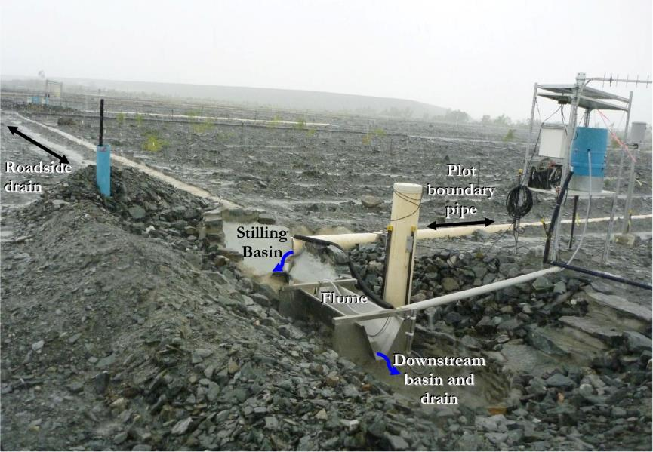

**Figure 3.** Erosion Plot 1 showing the boundary pipe, stilling basin, flume and downstream basin drain. The adjacent roadside drain (top left) is also shown. Photo taken 09-Dec-2009

Rainfall was measured at each plot with a 0.2 mm tipping bucket raingauge (TB3 model by Hydrological Services Pty. Ltd.). The raingauges were cleaned and calibrated towards the end of each dry season. They were located just down-slope of each plot as shown for EP1 in Figure 4. Data for rainfall and runoff were recorded by a data logger (CR1000, Campbell Scientific) at 1-min and 10-s intervals, respectively. These data were uploaded on a daily basis via a telemetry link to a time-series database used for storing hydrologic information (Hydstra version 10.2.2, http://kisters.com.au/).

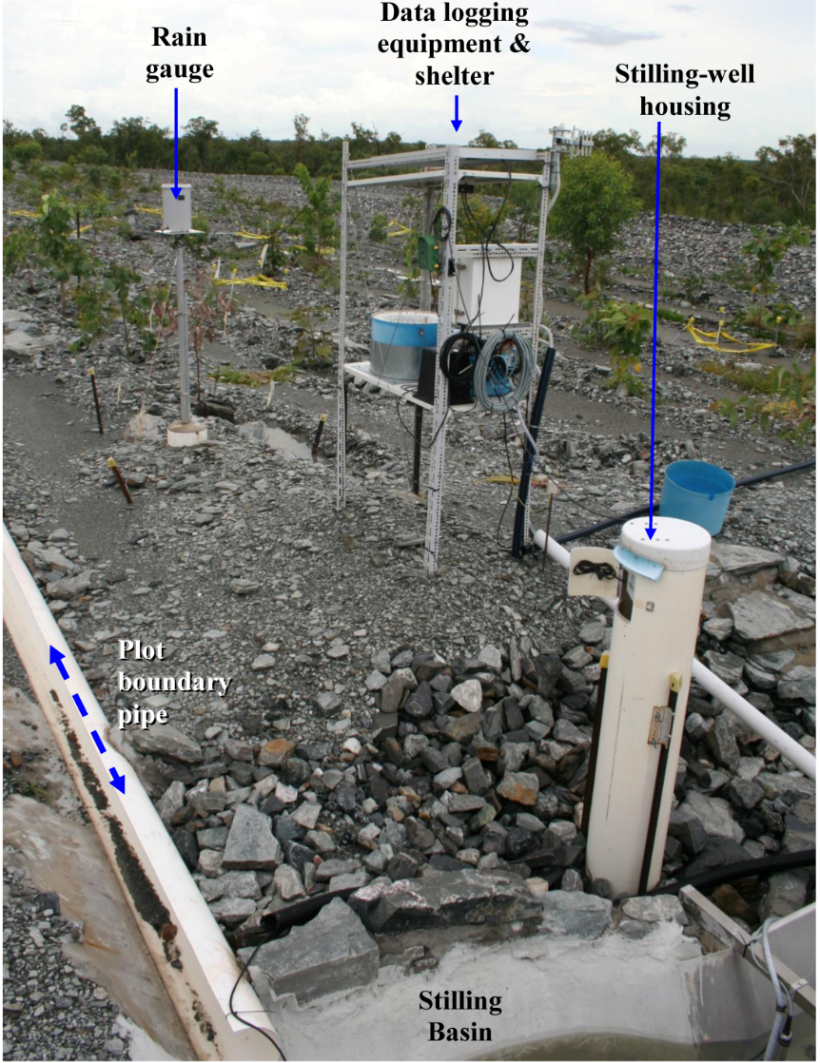

**Figure 4.** The location of the EP1 raingauge just right of the downstream plot boundary and in relation to other EP1 monitoring equipment: Data-logger and shelter; runoff stilling-basin; and stilling-well housing for the shaft encoder. Photo taken 19-01-2011.

Runoff from EP1 is responsive with about 3-5 mm rainfall producing runoff from the plot. Runoff duration after rain ceases is dependent on the amount and intensity of the rainfall event as well as how water-logged the ground is at the time of the event. For these reasons the duration of runoff can vary considerably. On average, runoff continues for 20 ± 15 min (SD, n = 94) after rain ceases.

## 2 Methods: Data correction and quality assessment

The EP1 data were checked and edited for consistency and completeness using the Hydstra Data Managers Workbench (DMWB). This graphic interface allows coincident data records for the multiple variables (i.e. rain, shaft encoder and pressure transducer) and monitoring sites to be checked in parallel, on the same timeline. Specifically, this process involved comparison of:

* The cumulative rainfall data traces for all plots, EP1 to EP4 and a TLF raingauge kept by ERA;
* EP1 runoff data (i.e. stilling basin water level) from either the shaft encoder or the pressure transducer against associated rainfall data;
* EP1 runoff data (i.e. stilling basin water level) from either the shaft encoder or the pressure transducer against corrected runoff data for EP2, nearby; and
* EP1 shaft encoder or the pressure transducer stage traces against each other.

The systematic detection of inconsistencies among and between the variables (including those from the nearby sites with similar local response) was the basis to correcting the EP1 dataset. For example, a mismatch in the data trace pattern, between sites, can indicate missing data or instrumentation malfunction. Higher than expected runoff, relative to one of the other nearby sites, might also indicate a problem with overflow onto the erosion plot containment. The primary assumption in these methods was that the rain and runoff responses, compared between plots, tracked each other closely because of the close proximity of the four monitoring plots. In addition, due to inherent differences between the different plot areas, surfaces and vegetation development trajectories, over time, each plot also had a site-specific runoff ‘signature’. The methods that were developed were quantitative in that observations between sites were undertaken on the same measurement scales in Hydstra, but were qualitative in that a trained technician was required to make judgement as to when errors, requiring correction, were apparent. Baseline data gathered from each plot while the sensors and systems were operating properly provided the basis for making these judgements. To minimise user bias, completed corrections were also validated independently by another trained technician at least once.

Due to the large amount of data collected it was necessary to process it in sections by each water-year period. Processing was iterative and tracked in a spreadsheet for purposes of monitoring progress and quality control. The methods summarised here also complement the Standard Operations Procedures manual (Boyden and Saynor, in prep).

Note that in Hydstra, EP1 data were filed under the alias TLF1. The rainfall, shaft encoder and pressure transducer variables are identified by the codes 10.00, 100.00 and 100.10 respectively. The original, unedited, dataset resides in the TLF1-B file, while corrected data for rainfall and stage trace (shaft encoder) reside in the TLF1-A (archive) under variables 10.01 and 100.01. Editing of data was conducted on a copy (the TLF1-M file) before moving complete and verified data to the archive.

## 2.1 Rainfall corrections

Occasional gaps or errors in the rainfall data record occurred as the result of issues such as:

* A faulty data logger system;
* The logger memory is full; and
* A faulty analogue channel of the logger.
* The read switch on the raingauge might have failed.

Corrections were made by a direct infill with rainfall records taken from an alternative TLF site first determined to be similar to the EP1 rainfall by linear regression. In this context, deemed bounds in regression were an R2 of ≥ 0.99 and equation slope approaching 1 ± 0.05. These infilled records were then assigned a data quality code of 77 in Hydstra (i.e. 77 = correlation with other station, same variable). Potential alternative data sources included rainfall collected from nearby raingauges on the TLF: EP2, 3, 4 and the ERA-TLF raingauge.

The regression-validation analyses were undertaken in Hydstra using “HYPLOTXY”, which plots one variable against another for a specified period and using data points calculated at a specified temporal resolution. Further details of this procedure are provided in the SOP (Boyden and Saynor, in prep). Separate regression relationships were derived for each water-year period for potential alternative sites using the data recording periods common from both sites (within any one water-year). To calculate data points used in each regression, a temporal resolution of either 10 minutes (for alternative EP sites) or ½-hour was used (only in the case of the ERATLF raingauge, mentioned above).

## 2.2 Stage trace corrections

The shaft encoder stage trace needed to be checked and corrected for the following issues:

* General adjustment of flow events on the stage trace to the Cease-to-flow (CTF) water-level datum (Section 2.2.1);
* Identification of missing or erratic sensor data and its correction (Section 2.2.2); and
* Identification and correction for offsite-water flowing onto the EP1 plot containment, a problem specific to EP1 and detected by abnormally high stage trace water-levels during some events (Section 2.2.3).

Each change was flagged with a concise comment against relevant point records in Hydstra. When a change was made to a continuous series of points then the first and last point in the series have been flagged only. Further information on interpreting annotation codes is provided in the SOP for management of TLF hydrology data (Boyden and Saynor in prep).

### 2.2.1 General adjustments to the Cease-to-flow (CTF) datum

The CTF datum is the water level (nominated on the stage trace) below which no flow over the flume occurred. The CTF value assigned to EP1 is 1.027 m (Saynor et al. 2013). Discreet ‘flow over flume’ events on the stage trace must each be adjusted to CTF in order to attain accurate estimates of discharge from reported conversion equations (Saynor et al. 2013). Time-points for the start and stop of flow must accurately intersect the CTF line. The CTF intersect points on the trace line are determined by the traces shape in relation to rainfall over time.

Adjustment of event(s) to CTF was made by adding or subtracting a constant to a selected series of data points representing one or more *complete* flow events. The value of the chosen constant could vary depending upon its location on time series trace. This manual adjustment procedure was a based on observing the runoff pulses (on stage trace) against a known scale (water height in the flume stilling basin). This assessment was a technical skill developed through experience; reinforced by scrutinising the trace for many discreet flow events, in relation to the CTF line and the cumulative rainfall trace. The precision of the stage trace height adjustment to CTF is estimated to be ± 1 mm. Further detail on the procedure is provided in the SOP (Boyden and Saynor in prep).

Once initial adjustments to events were made, fine-tuning (to the start and end time of each event) were sometimes necessary so to realistically represent event duration. For example, this may involve inserting or deleting a single point on the CTF line or similarly changing the level value for a single point by ± 1 mm (0.001) near the CTF. Final adjustments were then validated by time-lapse photography (which was available for some flow events) and by independent review by a trained editor (not involved with the initial editing pass).

### 2.2.2 Missing data in-fills

Two methods could be applied to correct for data gaps:

* A direct infill from the EP1 pressure transducer; and
* Infill with data from another erosion plot.

A direct infill with EP1 pressure transducer record was the preferred option when these data existed and were of acceptable quality. Pressure transducer data were deemed to be of acceptable quality when its trace closely tracked the response of the shaft encoders. This was determined by checking common shaft encoder and pressure transducer records against each other, immediately to either side of the missing-data period.

The data in-fills were made using edit tools of the Hydstra DMWB and involved two steps with similar objectives to steps described in Section 2.2.1. First, the pressure transducer data for the missing event had to be aligned to the same CTF datum as the shaft encoder stage height. This involved adding or subtracting a time-specific constant (i.e. as similarly described in Section 2.2.1) from the pressure transducer data series such that the points at the beginning and end of the flow event aligned with the CTF datum for the shaft encoder. Then this data series was spliced into the data gap of the shaft encoder stage trace (100.01 M file). This was done using the “copy reference trace” option of the DMWB edit menu.

Second, with no pressure transducer data available, gaps were directly in-filled using the data from the nearest EP site with good quality data.

### 2.2.3 Evaluation of shaft encoder accuracy at high flows

Water-level measurements in stilling basins of some plots (e.g. EP2) have been found to be disrupted during high-flow events (Figure 5). This potential issue, which has required some manual correction at EP2 to stage trace flow peaks, was investigated for EP1. This was done by comparing the consistency of the EP1 shaft encoder and pressure transducer stage traces for the larger runoff events. The same higher flow events that were known to cause a problem at EP2 (Saynor et al. 2015) were also investigated at EP1.

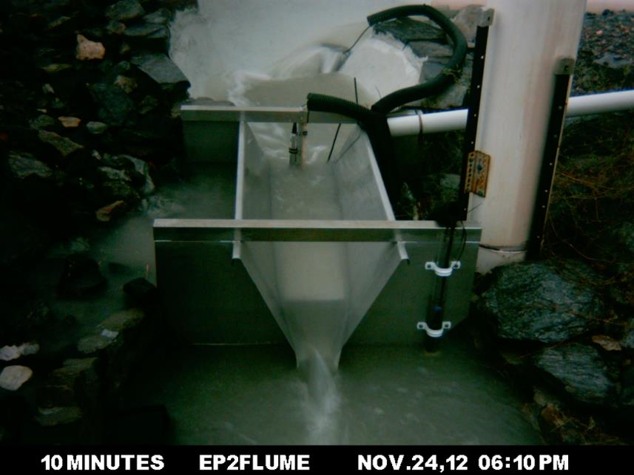

**Figure 5**  Example of water-level disturbance in the upstream stilling basin at EP2 during the peak of a high-flow event. The flow can be seen deflecting off the cage (yellow arrow) and can be seen rising up around the outside of the basin (red arrow).

### 2.2.4 Correction for boundary overflow onto the plot

Runoff over the erosion plot boundary from an offsite source (referred to here as an overflow event) caused runoff from the area of the plot containment to be overestimated by the stage trace. At EP1 this problem was found to be apparent during higher rainfall periods and/or intensities. Field observations suggest that the source of overflow was from the roadside drain adjacent to EP1 (see Figure 3, above). The overflow events were identified by comparing the stage trace of EP1 with EP2. Overflow was indicated by excessive stage trace heights or prolonged flows over the flume, relative to EP2. Specifically these events were also recognised by:

* A delayed additional peak in the EP1 trace after rain had stopped (e.g. Figure 6a). This pattern was typical after brief but intense rainfall events; or
* A larger recessional flow (e.g. Figure 7a) compared to EP2. This overflow pattern was typical when a large amount of rain had already fallen prior to the rain associated with the actual runoff event. In the example shown in Figure 7 some 253 mm rain fell in the 48 hours prior to the end of this event.

Overflow events were corrected by manual editing (Figure 6b and 7b) of the stage trace using the ‘draw’ mode of the Hydstra DMWB. Overlaying the original (uncorrected) stage trace for both EP1 and EP2 onto the same hydrograph datum (where zero indicated the start and cease to flow points of each event) provided a visual cue for making the corrections. The trace for cumulative rainfall was also overlaid so the pattern of the EP1 runoff could be judged against rainfall pattern on the graph timeline. Edits were applied to a separate file copy of the EP1 stage trace, also overlayed on the graph. Different colour codes were applied on the graph to each stage trace/file source, allowing the edited and original versions to be easily compared. Corrected runoff events were annotated at the beginning and end of each period and all changed data points were quality coded using Hydstra code 79, signifying records partly estimated.

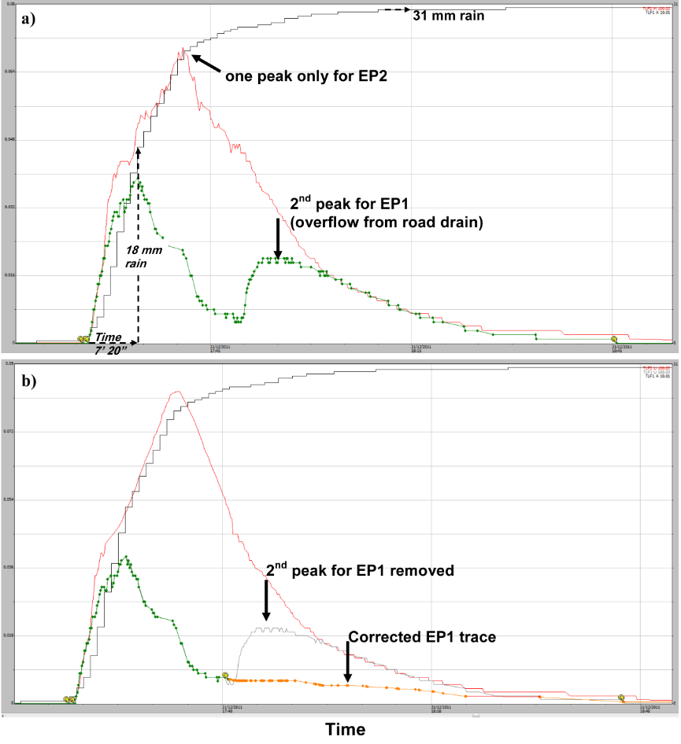

**Figure 6**  Evidence and correction of roadside drain overflow event where: **a)** overflow is indicated by a 2nd peak in the EP1 trace after a brief yet intense 31 mm rain event on the 21st December 2011; and **b)** correction applied to abnormal records by manual editing (orange line).

*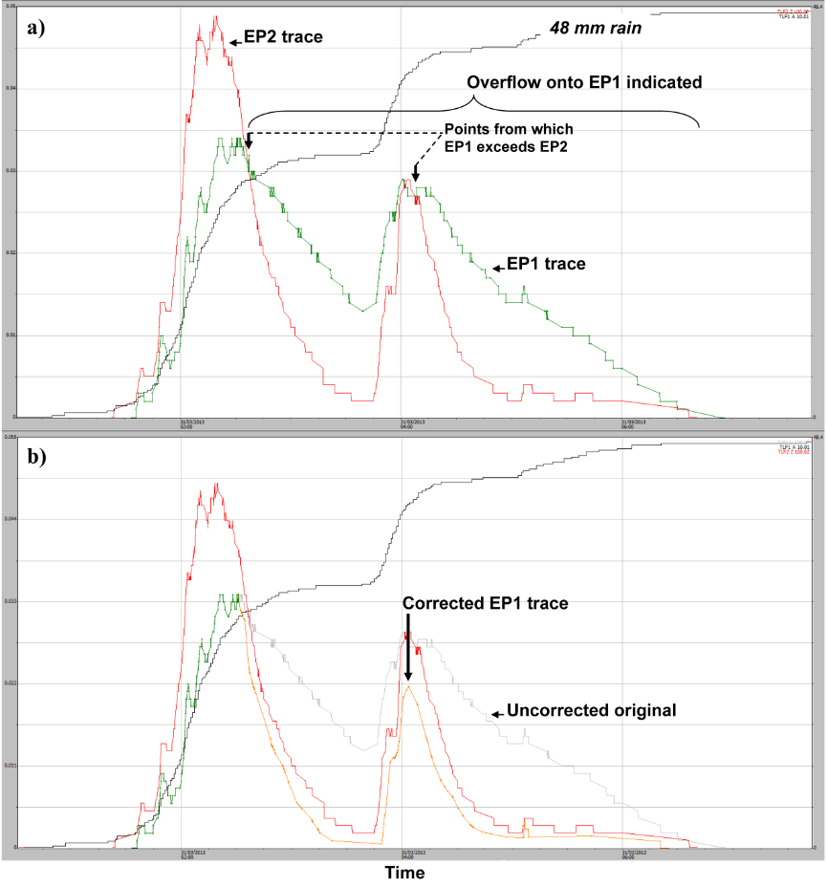*

**Figure 7**  Evidence and correction of roadside drain overflow event where: **a)** overflow was indicated by the exceedance of the EP1 stage trace in relation to EP2; and **b)** correction applied to abnormal records by manual editing (orange line).

## 2.3 Analysis of boundary overflow

The following analyses were undertaken to:

1. Validate the location of the of boundary overflow problem (Section 2.3.1);
2. Characterise the rainfall conditions at which the overflow occurred (Section 2.3.2); and
3. Assess contribution of boundary overflow to total discharge measured from EP1   
   (Section 2.3.3).

### 2.3.1 Time-lapse photography

A time-lapse camera (Wingscapes, Manufacturer etc?) was set up on 19 September 2014 to monitor flow events and possible overflow from the adjacent roadside drain onto EP1. While it was limited to daylight runoff events at 5-minute intervals, photographic records now exist of runoff events for the 2014-15 and 2015-2016 water-years. Linked with rainfall records, the photos assisted with characterising possible rainfall thresholds (i.e. magnitude, duration and intensities) at which road overflow onto EP1 is initiated.

### 2.3.2 Rainfall characteristics associated with overflow

Characteristics of discreet runoff events, associated with at least 30 mm of continuous rainfall, were described in relation to whether boundary overflow or no overflow was indicated. The upper threshold of 30 mm of rain was chosen as this value was associated with the smallest discreet runoff event where overflow had been implicated. Each runoff event (of ≥ 30 mm of rain) was then labelled according to whether it was considered to be an ‘overflow’ or ‘normal’ event (unaffected by offsite water). The following variables were described for each event as measured from the rainfall/runoff traces in Hydstra DMWB:

* Runoff event time and date;
* Rain total during the runoff event period;
* Start and finish times of continuous rain for the runoff event;
* Total duration of the event (hr:mm);
* Event intensity (mm/hr);
* Rain totals occurring during and in the last 24, 48 and 96 hrs of each runoff event.

The above variables for overflow and normal categories (as tabulated in Appendix 3) were then compared using graphics and statistical software(Sigmaplot, developer etc) to test the following hypotheses:

* Overflow is triggered after a certain magnitude of rainfall (occurring during or in the last 24, 48 and 96 hours of the event)?
* High rainfall intensity during the runoff event contributes to boundary overflow?

If true, the hypotheses will indicate a statistical thresholds for rainfall amount and duration above which runoff events should be checked for boundary overflow.

A Kruskal-Wallis One Way Analysis of Variance on Ranks was performed for the comparison of rainfall characteristics between the overflow and ‘normal’ plot runoff (no-overflow) event groups. These results were tabulated and illustrated graphically in Section 3.3.2.

### 2.3.3 Contribution of overflow to total EP1 discharge

The contribution of ‘overflow’ to discharge measured from EP1 was estimated in litres. This was done by comparing EP1 discharge measurements before and after the corrections for overflow had been applied. Discharge in litres was calculated from individual events in each water-year as described in the SOP (Boyden and Saynor, in prep). The results are represented graphically by water-year in Section 3.3.3.

# 3 Results and discussion

## 3.1 Rainfall corrections

There were six periods when rainfall on EP1 was not recorded or was erratic. These periods were infilled with reliable data, summarised in Table 1.

**Table 1**  Periods of missing rainfall record for EP1 over the six water-years, 2009-10 to 2014-15.

|  |  |  |  |  |  |  |
| --- | --- | --- | --- | --- | --- | --- |
| **Start Date** | **Start Time** | **Finish Date** | **Finish Time** | **Infill site Source** | **Infilled Rainfall (mm)** | **Reason for missing / erratic data** |
| 08-09-09 | 00:00 | 24-11-09 | 00:00 | TLFERA | 65.0 | Site not instrumented until 19-09-09 |
| 25-02-10 | 05:31 | 25-2-10 | 15:49 | EP3 | 5.0 | New logger code problem – not logged |
| 16-03-11 | 13:38 | 18-03-11 | 00:29 | EP2 | 3.0 | Measurements not logged. |
| 05-12-13 | 17:20 | 14-12-13 | 09:58 | EP3 | 17.0 | Measurements not logged |
| 04-11-14 | 00:00 | 23-11-14 | 12:00 | EP2 | 113.8 | Faulty logger caused erratic data |
| 22-01-15 | 14:35 | 22-01-15 | 15:53 | EP2 | 8.2 | Measurements not logged |

Some early rainfall was also not recorded at any EP raingauges as these were not installed until 19 November 2009. In this initial period, ½ hourly rainfall recorded at the TLF by ERA were used as a direct infill for the missing data period, 1 September 2009 to 24 November 2009. The ERA raingauge (site named TLFERA in Hydstra) is located a distance of about 140 m from the EP1 raingauge. The regression relationship between EP1 and TLFERA was y = 0.9832x + 0.0042; R2 of 0.99 (Figure 8) using ½-hourly interval rainfall totals from 31 August 2009 to 11 June 2010. Based on this near 1:1 linear relationship, the ½-hourly interval data were considered the most suitable alternative data source for direct infill in this case. However, it is noted that this temporal resolution (½-hourly) was courser than that measured by other Erosion Plot loggers (at 1-minute). For all other corrections suitable 1-minute records were available.

|  |  |
| --- | --- |
| **TLFERAvTLF1.PNG** | **Figure 8** Linear relationship between TLFERA and EP1 for common ½ hourly interval rainfall totals on the TLF (collected from 31-08-2009 to 11-06-2010). |

Regression results for the infill validations are summarised in Table 2. A near 1:1 linear relationship was evident in every case and R2 values were all equal to 0.99 (after rounding). It is therefore concluded that, within the water-years analysed, the other Erosion Plot raingauges provided similar data that could be used when necessary as a direct infill for EP1. Note that this relationship could however change in the future as vegetation growing near the raingauge stations could potentially alter measurements.

**Table 2**  Correlations between rainfall gauge sites on the TLF. A zero-intercept was not enforced in the regressions. Note that 10-minute interval totals data were used to derive these regressions with the exception of the TLFERA site, where ½ hourly totals were used.

|  |  |  |  |
| --- | --- | --- | --- |
| **Water-year** | **Sites** | **Equation** | **R2** |
| 2009-10 | TLFERA vs. EP1 | Y = 0.9832 + 0.0042 | 0.99 |
| EP3 vs. EP1 | Y = 1.0445x + 0.0003 | 0.99 |
| 2010-11 | EP2 vs. EP1 | Y= 0.969\*X | 0.99 |
| 2013-14 | EP2 vs. EP1 | Y= 0.981\*X | 0.99 |
| 2013-14 | EP3 vs. EP1 | Y= 1.0016x + 0.0004 | 0.99 |
| 2014-15 | EP2 vs. EP1 | Y=0.928\*X | 0.99 |

Figures 9 to 14 are the corrected cumulative rainfall graph for each water-year. As previously stated, a water-year is defined as the period 1 September to 31 August the following year. Note the dark-blue trace lines represent original EP1 data (i.e. named TLF1 in Hydstra database) while orange lines are data infilled from alternative sites where good quality data was available. Disregard the light-blue vertical lines on these screenshots as they relate to data-block divisions in Hydstra, not to the quality of data values.

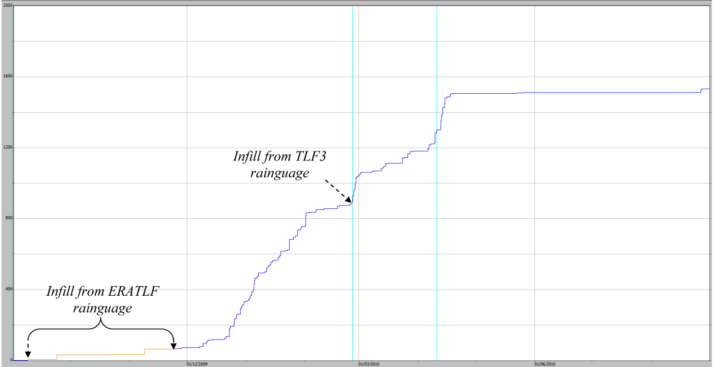

1600

800

0

**Figure 9** EP1 cumulative rainfall graph for the 2009–10 water-year (1533 mm total). Rainfall (mm) is on the y-axis.

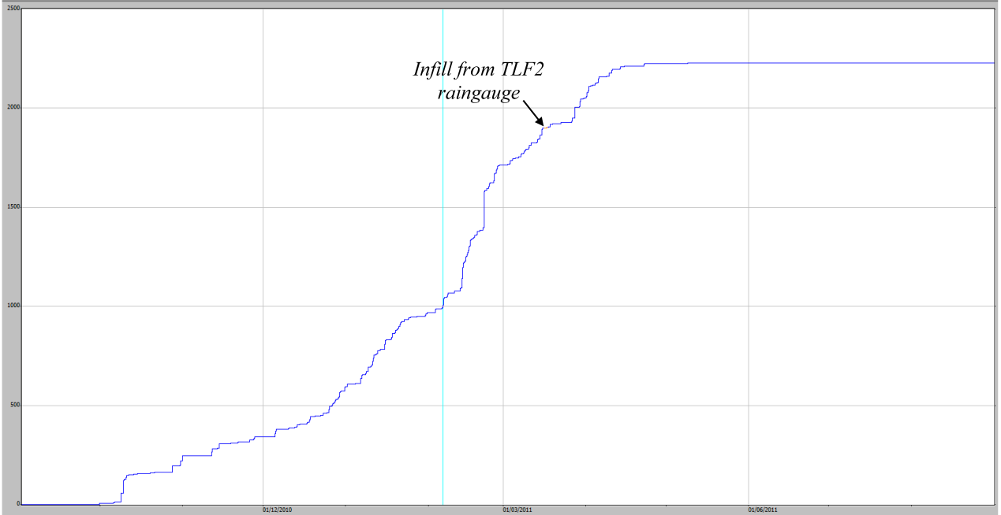

2000

1000

0

**Figure 10**  EP1 cumulative rainfall graph for the 2010–11 water-year (2227 mm total). Rainfall (mm) is on the y-axis.

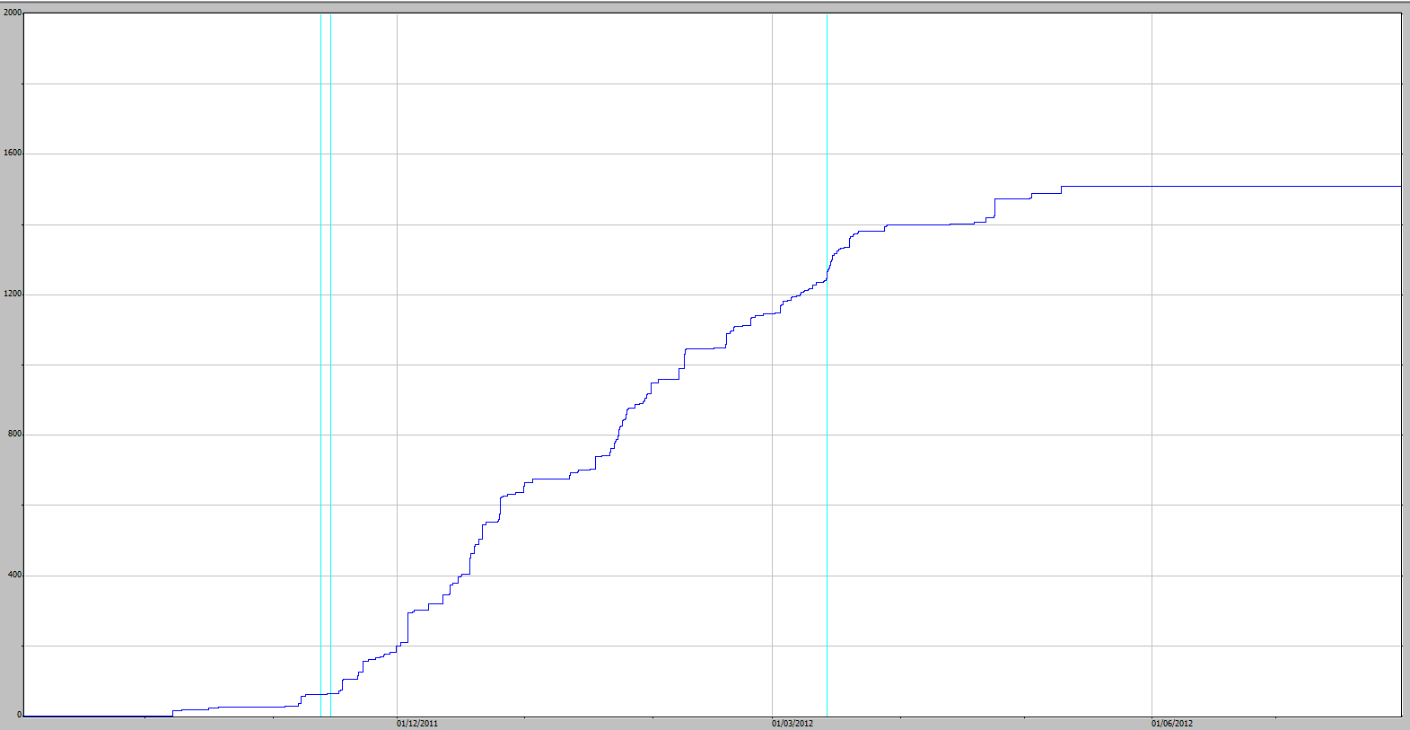

1600

800

0

**Figure 11**  EP1 cumulative rainfall graph for the 2011–12 water-year (1509 mm total). Rainfall (mm) is on the y-axis.

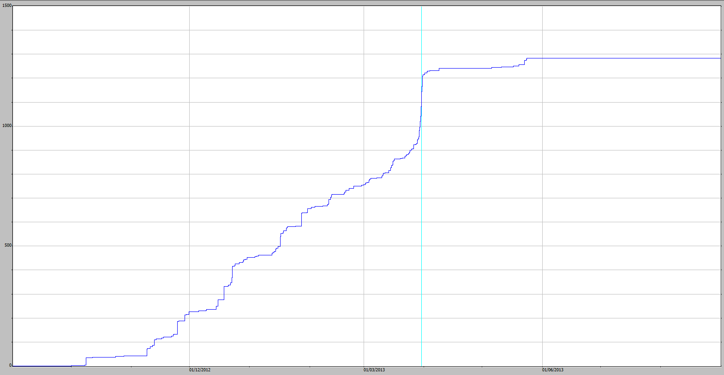

1000

500

0

**Figure 12**  EP1 cumulative rainfall graph for the 2012–13 water-year (1283 mm total). Rainfall (mm) is on the y-axis.

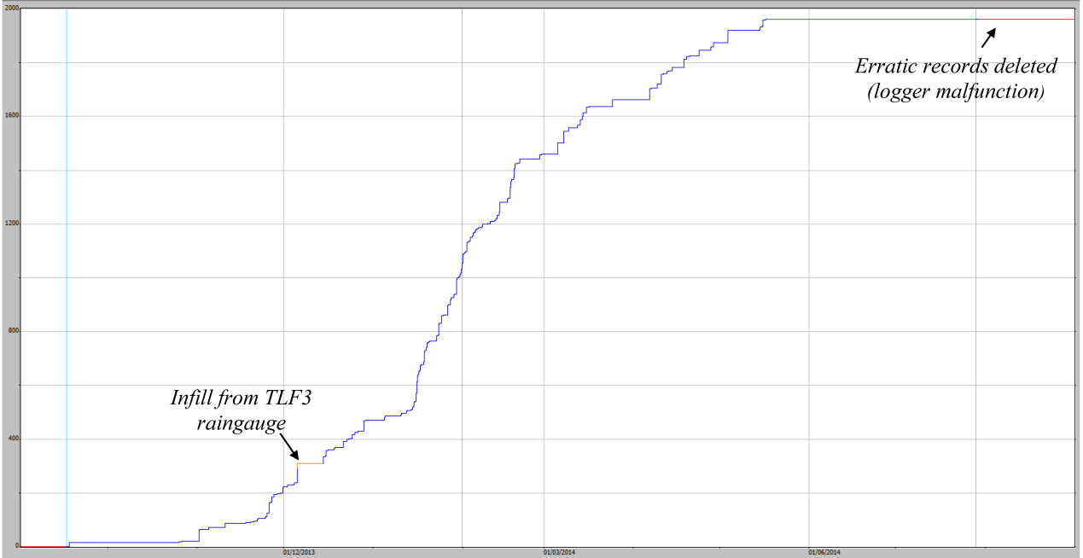

1600

800

0

**Figure 13**  EP1 cumulative rainfall graph for the 2013–14 water-year (1961 mm total). Rainfall (mm) is on the y-axis.

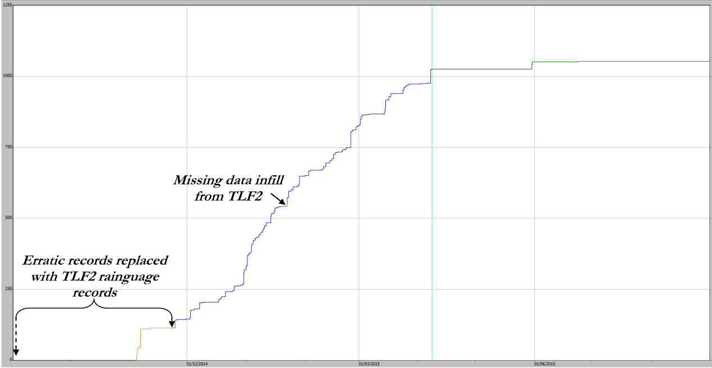

1000

500

0

**Figure 14**  EP1 cumulative rainfall graph for the 2014–15 water-year (1053 mm total). Rainfall (mm) is on the y-axis

.

The annual rainfall recorded on EP1 for each water-year is shown in Table 3. Annual rainfall was highly variable relative to the long-term mean annual rainfall of 1568 mm for Jabiru Airport, Bureau of Meteorology Station No. 014198 located 2.3 km from the TLF (Bureau of Meteorology 2015). The 2010–11 water-year was the highest during the five years (2227 mm) and was 41 % higher than the Jabiru Airport mean. The 2013–14 water-year was also above average, having the second highest rainfall for the five years. The rainfall for the 2014–15 water-year was the lowest at EP1 over the six years with 1053 mm and was 34 % lower than the Jabiru Airport annual mean.

**Table 3**  Water-year corrected rainfall totals for EP1 including the largest continuous rainfall event in that year, concurrent with a period of continuous flow over the flume.

|  |  |  |  |
| --- | --- | --- | --- |
| **Water-year** | **Date of largest rainfall** | **Largest Rainfall event (mm)** | **Erosion Plot 1 Rainfall (mm)** |
| 2009–10 | 01-02-2010 | 76 | 1533 |
| 2010–11 | 21-02-2011 | 189 | 2227 |
| 2011–12 | 03-12-2011 | 85 | 1509 |
| 2012–13 | 30-03-2013 | 73 | 1283 |
| 2013-14 | 05-12-2013 | 73 | 1961 |
| 2014-15 | 06-11-2014 | 63 | 1053 |

## 3.2 Stage trace corrections

A large number of general and specific corrections were made to the stage trace for EP1. Annotated comments for individual corrections, too numerous to list here, may be viewed within the Hydstra DMWB under the TLF1-A file, where a comments report may be generated if required.

### 3.2.1 Missing data corrections

There were five periods during which the EP1 shaft encoder did not recorded data for reasons summarised in Table 4. As described, these missing data have been infilled with either ‘at-site’ pressure transducer data or with shaft encoder data from either EP2 or 3.

**Table 4** Periods of missing EP1 stage trace data and how it was infilled. Notes: site name aliases in Hydstra TLF1 = EP1, TLF2 = EP2 and TLF3 = EP3; ShEn = Shaft encoder; PT = pressure transducer).

|  |  |  |  |  |  |  |
| --- | --- | --- | --- | --- | --- | --- |
| **Date and time from** | **Date and time to** | **Duration (decimal days)** | **Rain in period (mm)** | **No. of events** | **Infill type** | **Comments** |
| 19-11-2009 13:07 | 08-01-2010 08:56 | 49.8 | 426 | 38 | Direct infill from TLF1 PT | Shaft encoder malfunction |
| 25-02-2010 05:30 | 25-02-2010 15:49 | 0.4 | 7 | 2 | Direct infill from TLF3 ShEn | Code issue - Missed the start of the event only |
| 10-05-2010 00:00 | 07-09-2010 10:59 | 113.0 | 24 | 2 | Direct infill from TLF3 ShEn | Unknown reason – As only missed two small events during the dry season used a direct infill from EP3 |
| 16-03-2011 14:58 | 17-03-2011 10:59 | 0.9 | 3 | 1 | Direct infill from TLF3 ShEn | Unknown reason As only missed one small event used a direct infill from EP3 |
| 06-01-2015 13:15 | 13-01-2015 04:18 | 6.6 | 50 | 7 | Direct infill from TLF1 PT | Shaft encoder malfunction |

The direct infills from EP3 account for a small portion of total rainfall/runoff in effected water-years. There was a total 34 mm of rainfall over the infill periods with rain scattered over five discreet rain events ranging from < 3 mm to 24 mm. Linear regression methods for deriving a more accurate infill relationship (i.e. as described in the SOP, Boyden and Saynor, in prep) were deemed not necessary in this case, given the very small contribution to runoff.

### 3.2.2 Evaluation of shaft encoder accuracy at high flows

No corrections were necessary as inspection of all events with rainfall greater than 35 mm showed that the flow level was correctly measured by the EP1 shaft encoder. This is illustrated for a large 54 mm rain event (Figure 15). In this event the shaft encoder data corresponds to the water level measured by the pressure transducer, which was not the case on EP2. Photos (Figure 15) show even water level in the EP1 stilling basin but uneven levels in the EP2 stilling basin. Given that this was a large rain event on EP1 and it did not show any disturbance in the stilling basin, it is assumed that there is no disturbance for any other rain events during the study period.

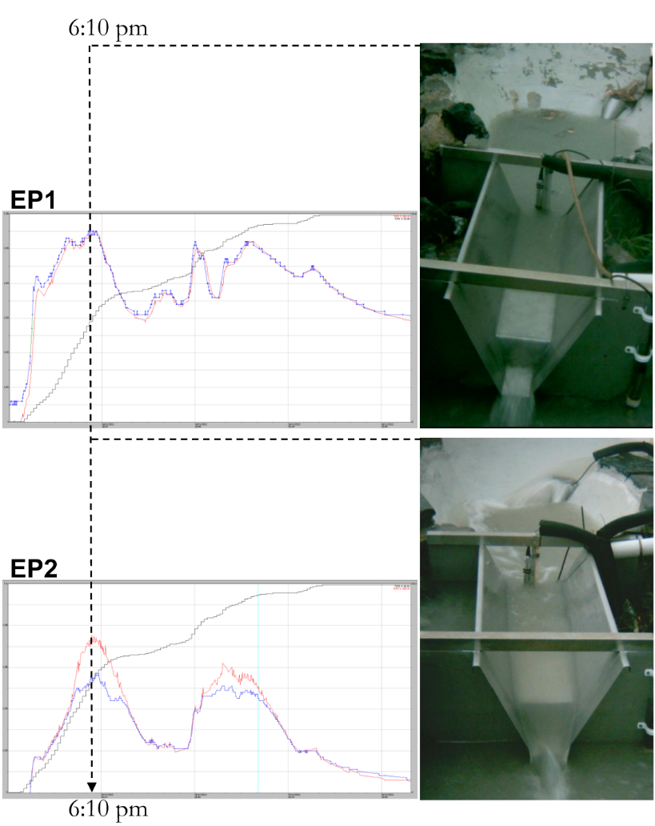

**Figure 15**  EP1 (Blue) and EP2 (red) stage traces and corresponding time-lapse photos at peak of runoff event during some 54 mm of rainfall over 1 ½ hours on 24/11/2012.

### 3.2.3 Correction for boundary overflow onto the plot

No structural breaches of the EP1 boundary were found during the monitoring period so no repairs were necessary. However, observation of the EP1 stage trace strongly suggests that, during higher rainfall events, ‘offsite’ water overflows onto EP1. Boundary overflow was indicated onto EP1 by excessive runoff (relative to the EP2 stage trace) in 22 events. These events were identified by the peaks on EP1 stage trace being larger than the EP2 stage trace and/or when the recession on EP1 stage trace was higher and longer than that for EP2. The smallest rainfall event where overflow was indicated was 31 mm. The largest runoff event was 189 mm. Stage trace illustrations of the corrections made to the 22 events are provided in Appendix 2. These corrections have reduced the discharge from EP1 (Section 3.2.3.2) to be a more accurate representation of flow off EP1 during the 6 water-years.

## 3.3 Analysis of boundary overflow

### 3.3.1 Time-lapse photography

Photos of roadside drainage were captured for six daytime rainfall events from the 25 February to 14 March, 2015. The largest of these events was 22 mm and the photos show flow along the road drain but no boundary overflow at peak flow (Figure 16, photo 5). Similarly, the EP1 runoff stage trace for this event showed no indication of boundary overflow (Figure 17). Events with ≥ 30 mm of rain (and where the stage trace indicated overflow) usually occurred at night and could not be captured by the camera were not represented in the photo data.

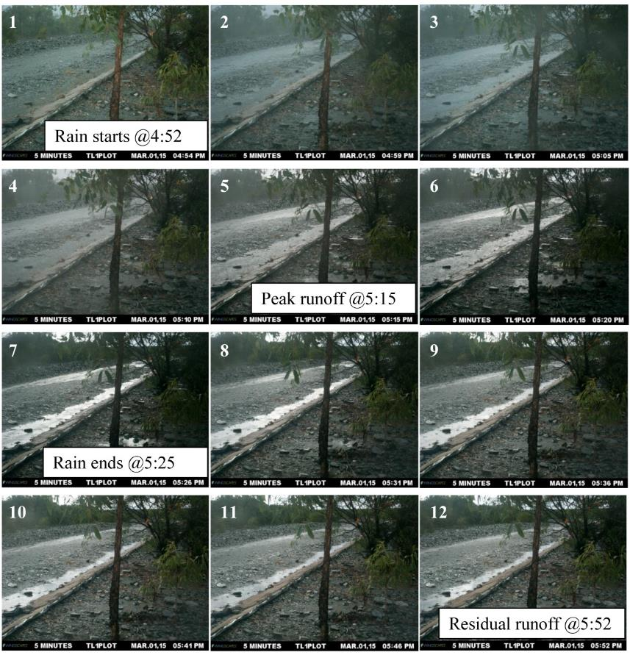

**Figure 16**  Five-minute interval photo sequence (1 to 12) showing flow along the roadside drain (to left of EP1) during a 22 mm rain event on 1-03-2015. Rain start and stop times are taken from the EP1 raingauge record illustrated in Figure 17.

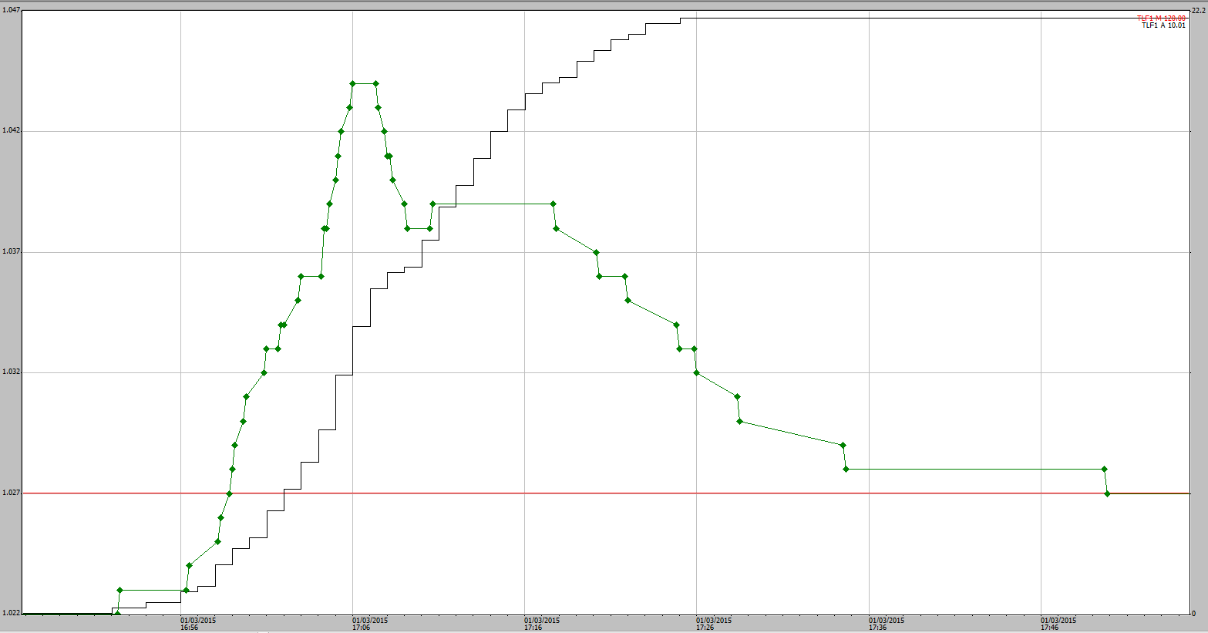

**Figure 17**  Shaft-encoder stage trace for EP1 (green line) during the 22 mm rain event (black line) over which roadside drain runoff was also captured on camera (i.e. Figure 16 above). The CTF line is indicated in red.

Time-stamped photos at the peak of road-drain runoff and the corresponding EP1 stage trace are shown in Appendix 3.

### 3.3.2 Rainfall characteristics associated with overflow

There were 42 runoff events with over 30 mm of continuous rain from commencement of flow over the flume. Just over half of these events (22) were considered to be influenced by boundary overflow. The effected events were associated with larger rainfall and of longer duration, immediately prior to the commencement of flow over the flume (Figure 18). This result is expected, given that boundary overflow from the road is likely triggered once soil-pores become saturated after longer periods of continuous rain.

|  |  |
| --- | --- |
| rain_runoff.PNG | **Figure 18**  Comparison of the rainfall characteristics (magnitude and duration) during, 24, 48 and 96 hrs before runoff for the runoff events where no overflow was indicated (OK) and where overflow was suspected (Overflow). Note all events selected on basis of having ≥ 30 mm of rain during the runoff. Error bars are 95 % CI but distributions are not normal. |

The Kruskal-Wallis one-way ANOVA on Ranks indicated that higher rainfall 24, 48 and 96 hrs immediately prior to actual runoff was a significant factor in triggering overflow (Table 5). Higher rain during the runoff event period was a weak factor separating ‘overflow’ from ‘no overflow’ events (p = 0.054). Rain in the 24 hours prior to the event was the most significant (p < 0.001) and in the 48 and 96 period prior to an event was also significant. Based on these results, overflow is most likely to occur when median rainfall exceeds 75, 72, or 121 mm in respective 24-, 48- or 96‑hour periods prior to the end of a runoff event. Rainfall intensity (Appendix 3) was not a significant factor separating ‘OK’ from overflow events.

**Table 5**  Results from Kruskal-Wallis One Way Analysis of Variance on Ranks (for non-normal distributions) for the comparison of median rainfall for overflow and non-overflow events with ≥ 30 mm of rainfall (also illustrated in Figure 18)

|  |  |  |  |  |  |  |
| --- | --- | --- | --- | --- | --- | --- |
|  | **Median rainfall (mm)** | |  | |  | |
| **Rain period** | **Normal group** | **Overflow group** | | **H** | | **p** |
| **During the runoff period** | 41 | 48 | | 3.7 | | 0.054 |
| **24 hrs** | 47 | 76 | | 11.7 | | < 0.001 |
| **48 hrs** | 57 | 84 | | 10.7 | | 0.001 |
| **96 hrs** | 74 | 121 | | 7.7 | | 0.006 |

Of all the runoff events requiring overflow correction, only one had less than 30 mm of rain   
(13 mm) from the commencement of flow over the flume (Figure 19). In this case the suspected overflow can be explained by the fact that there was also 76 mm of rain in the 24 hour period prior to the end of the runoff.

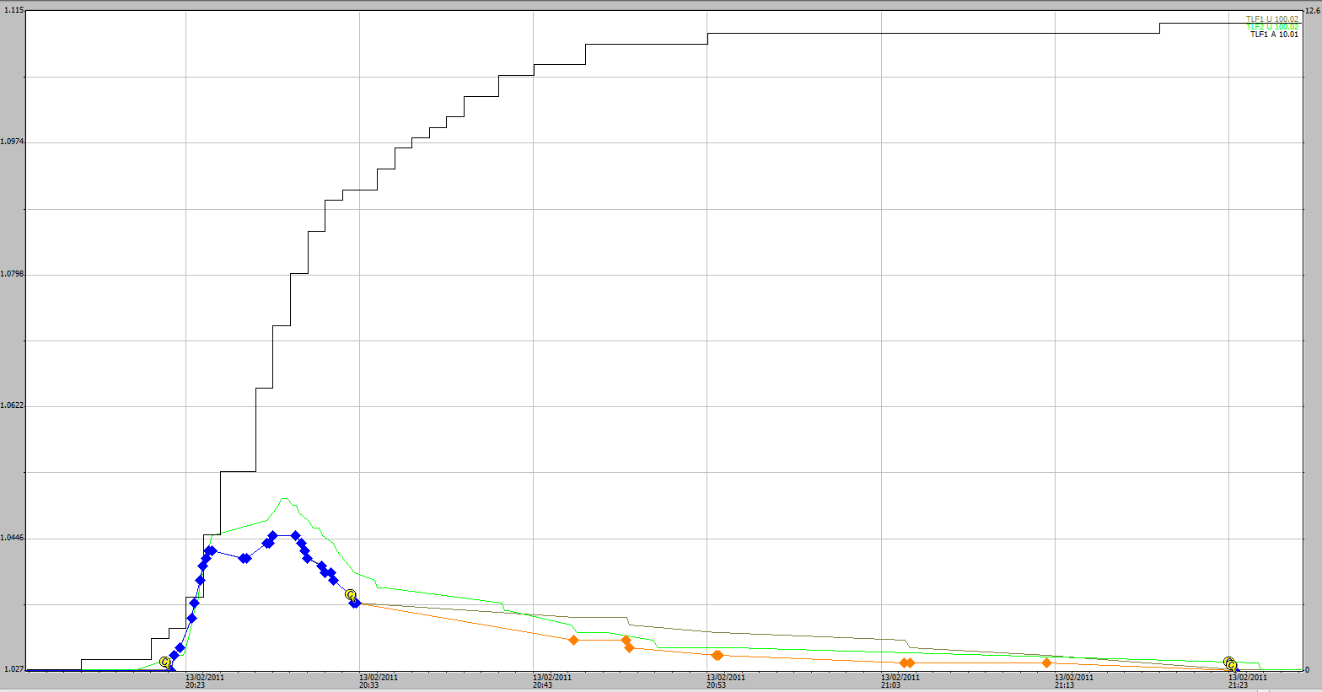

**Figure 19**  Stage traces for an EP1 and EP2 runoff event 14-02-2011 where minor boundary overflow correction to the EP1 stage trace was necessary. While only 13 mm of rainfall occurred during the runoff period (rising black line, right axis), 76 mm occurred in a 24-hour period prior to the end of this runoff event. The EP1 trace is represented by the blue, grey and orange trace lines. Blue is correct and unedited, grey indicates the overflow (above the EP2 trace in green) and the overflow-corrected trace is in orange.

### 3.3.3 Contribution of overflow to total EP1 discharge

Contributions of the 22 boundary overflow events to runoff during each water-year are shown in Figure 20 and Table 6. Within any water-year there were a small number of events (i.e. ranging from 0 to 7) that were overflow-effected. However, these events contributed to a large proportion of the total runoff. Total overflow was estimated at 278,772 litres over the six water-years or over any one season an average of 36 % ± 27 SD. The high variability in overflow between years is a reflection of the high variability in rainfall magnitude and intensities.

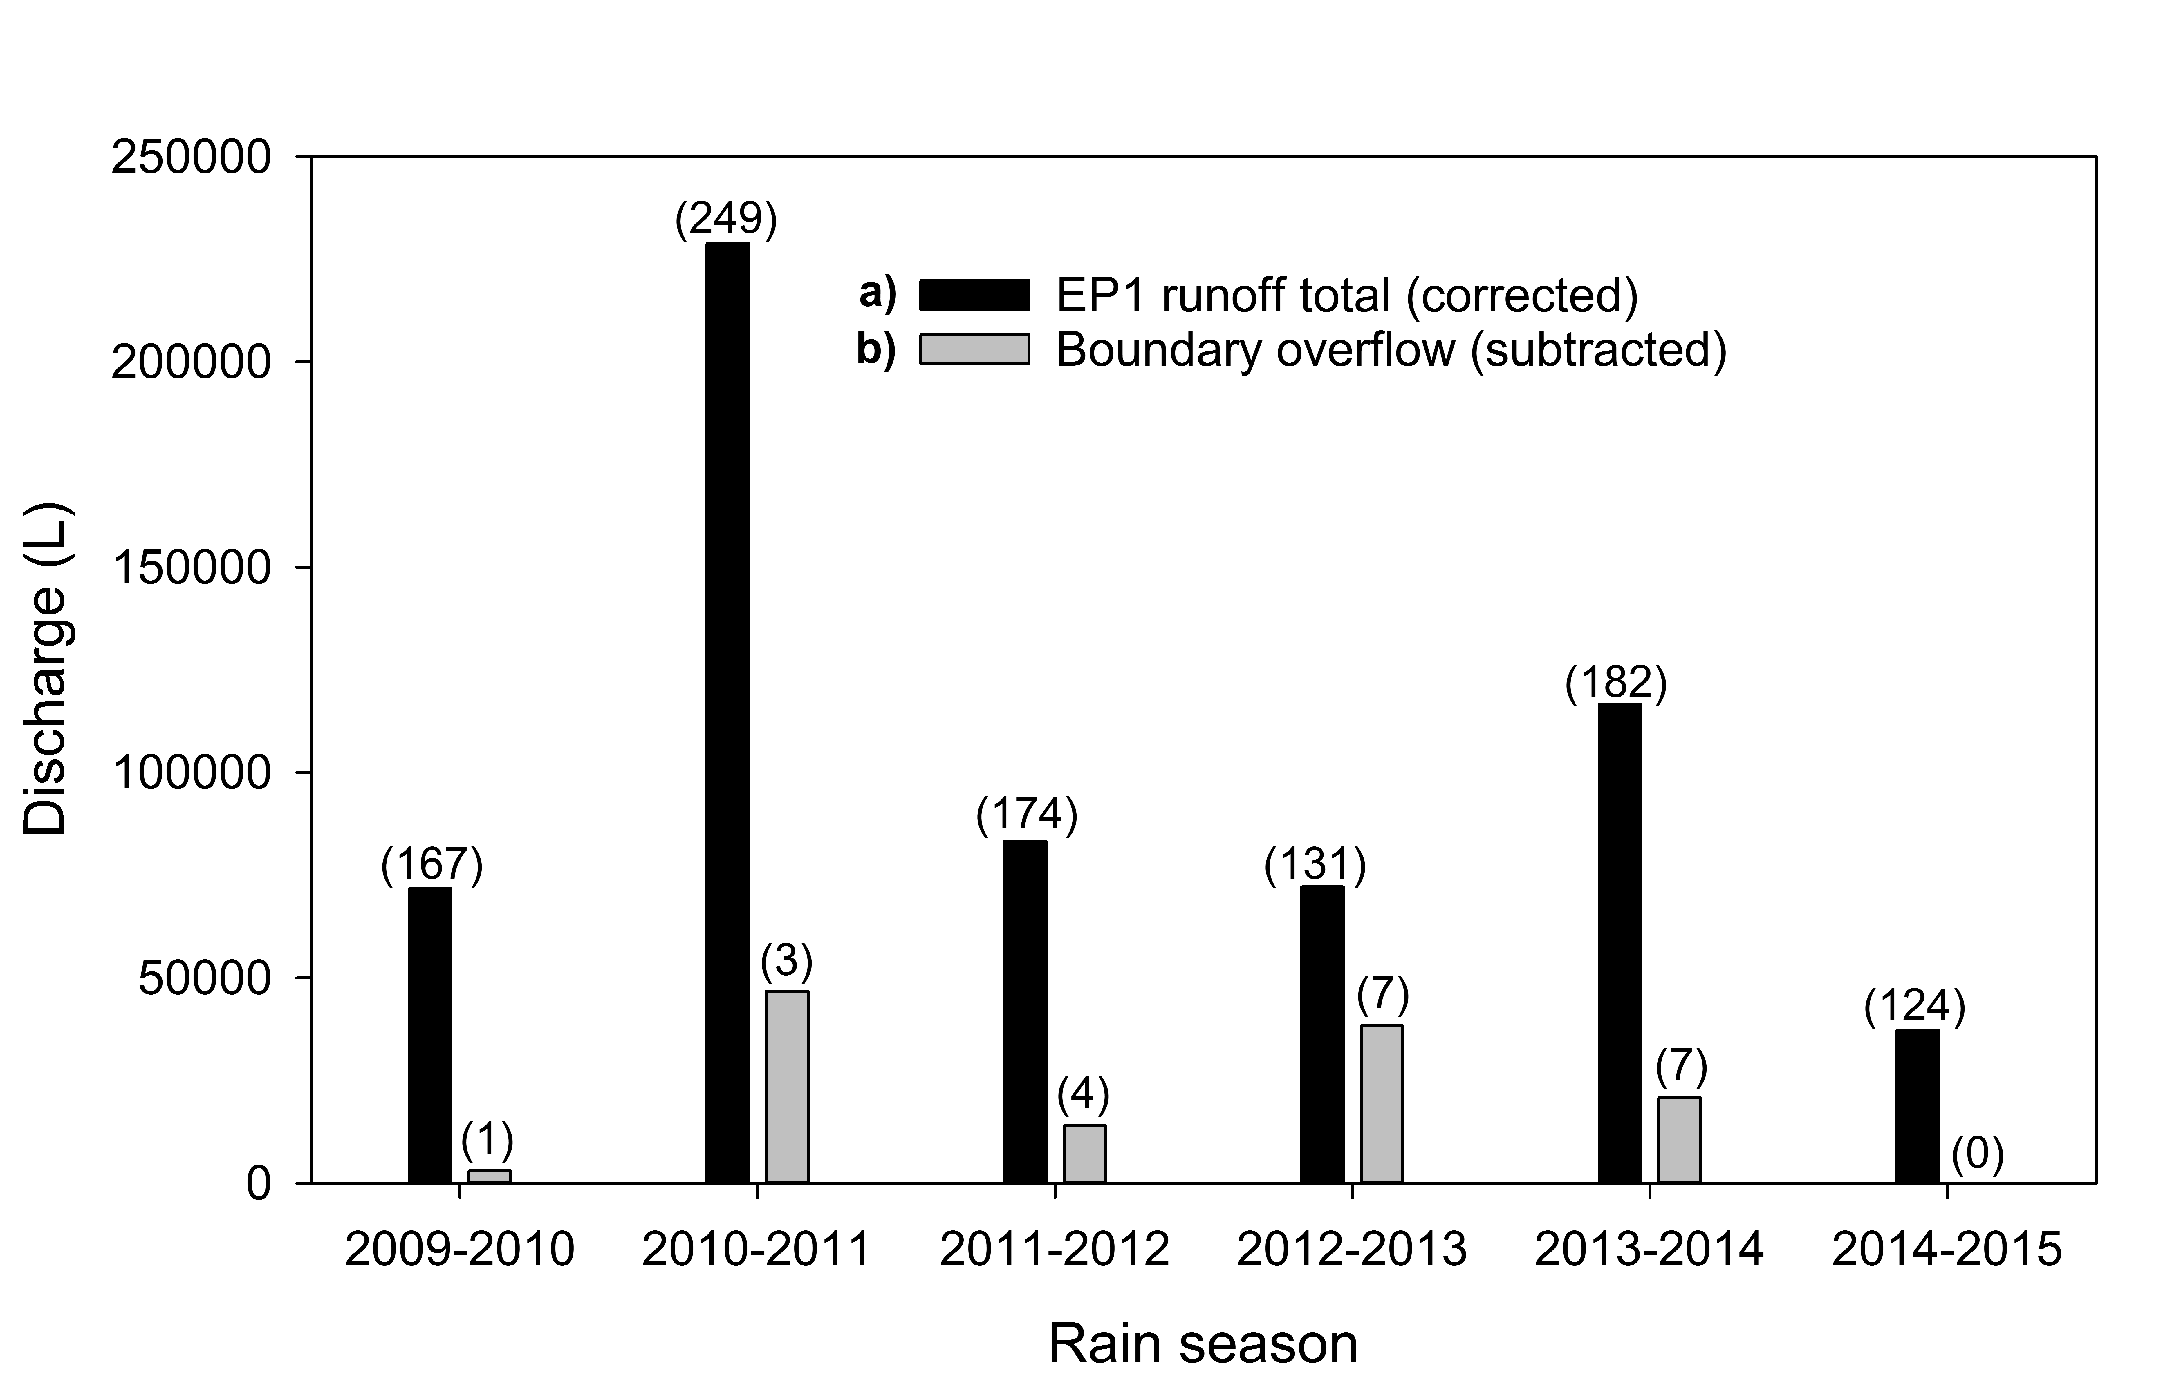

**Figure 20**  Bar graph showing: **a)** corrected EP1 runoff totals for each water-year; and **b)** the amount of boundary overflow. Numbers of discreet runoff events for each group are shown in brackets.

**Table 6**  Tabulation of total runoff and overflow correction estimates calculated for all runoff events (Flow over flume + Basin Fill Only events)

|  |  |  |  |  |  |  |
| --- | --- | --- | --- | --- | --- | --- |
| **Water year** | **Total Rain (mm)** | **Number of runoff events measured at EP1** | | | **Estimated Discharge (L)** | |
| **Total** | **BFO** | **Requiring overflow correction** | **Overflow (subtracted)** | **Corrected EP1 runoff** |
| 2009-2010 | 1533 | 167 | 34 | 1 | 6851 | 71747 |
| 2010-2011 | 2227 | 249 | 36 | 3 | 148169 | 228779 |
| 2011-2012 | 1509 | 174 | 27 | 4 | 32493 | 83309 |
| 2012-2013 | 1283 | 131 | 37 | 7 | 47634 | 72180 |
| 2013-2014 | 1961 | 182 | 26 | 7 | 43625 | 116574 |
| 2014-2015 | 1053 | 124 | 33 | 0 | 0 | 37266 |

# 4 Conclusions

This report describes the methodology used to correct and assess the quality of continuous time-series data for rainfall and runoff collected from EP1 on the Ranger mine TLF for the period 1 September 2009 to 31 August 2015. The resulting cleaned and quality coded datasets are stored in the TLF1 archive file of Hydstra under variables 10.01 (rainfall) and 100.01 (runoff stage trace).

Although some small scale variation between the four rainfall stations was apparent, a near 1:1 relationship in rainfall was measured between all EP sites. Therefore, data collected at raingauges on erosion plots 2, 3 and 4 were sufficiently similar with EP1 to, when necessary, be used for a direct infill of missing rainfall data in the EP1 rainfall record. However, this degree of similarity might change with increases in vegetation height (especially around the raingauge stand). Therefore, correlations between the sites should be checked routinely in future years to see if the 1:1 relationship remains valid.

A large number of general corrections were made to the EP1stage trace and periods of missing data have been infilled from good quality data. Boundary overflow error was found to be a significant problem requiring a rigorous screening and correction procedure. Unlike at other sites, water level measurements were not underestimated by the shaft encoder and so, in this regard, no data corrections were necessary.

With one exception, overflow events were discovered by screening all events which had > 30 mm of rain during the runoff period. Of these 41 events, 20 required overflow correction. Statistically, these events were also clustered with periods of sustained higher rainfall (occurring for 24- 48- and 96-hr periods) prior to the end of runoff. An important conclusion is that in future years of data acquisition, any event with rainfall greater than 30 mm should be checked for overflow error. In addition, all events associated with heavy rainfall in the 24- 48- and 96-hr period prior to runoff should be checked, as even small runoff (and rainfall) events associated with longer periods of higher rain may occasionally be overflow-affected. Continued collection of time-lapse photography may assist in validating and refining future ‘overflow’ correction procedures.

The methods applied to data for the first 6 water-years should also be used on subsequent years according to the following steps.

**Rainfall**

1. Identify periods of missing or impaired rainfall data,
2. Check correlation with closest reliable rainfall data for a common period not including the period of missing data; and
3. If good correlation, complete a direct infill (with the correct quality coding)

**Runoff**

1. Check the stage trace for periods of data that are unusually high or low, subtract or add values to align with the CTF of the flume on EP1,
2. Identify any breaches of the plot boundary or boundary overflow and make the necessary corrections to the stage trace,
3. Check for any breaches of the plot boundary, repair boundary and correct stage trace data as necessary,
4. Check for any events with rainfall greater than 30 mm for overflow error,
5. Identify periods of missing or stage data,
   1. For stage trace data above CTF, check correlation using HYPLOTXY with the closest reliable data for a common period not including the period of missing data,
   2. If good correlation, correct the stage trace using the regression equation generated by HYPLOTXY,
   3. For stage trace below CTF, use a direct infill from the closest plot with reliable data,
6. All changes made should be recorded in the comment field in Hydstra so that it can be tracked.

Further details on the data cleaning methods are compiled in the Standard Operations Procedure manual for managing TLF hydrology data (Boyden and Saynor, in prep).

# 5 References

Bos MG, Replogle JA & Clemmens AJ 1984. *Flow measuring flumes for open channel systems.* Wiley, New York.

Boyden J & Saynor (2016) Standard operating procedures for the management of hydrology data collected from erosion plots on the Ranger Uranium Mine Trial Landform.Clemmens AJ, Wahl TL, Bos MG & Regplogle JA 2001. *Water Measurement with Flumes and Weirs.* International Institute for Land Reclamation and Improvement, Wageningen, 90-70754-55-x.

Bureau of Meteorology 2015. www.bom.gov.au/climate/averages/tables/cw\_014198.shtml, accessed 22 December 2015.

Clemmens AJ, Wahl TL, Bos MG & Replogle JA 2001. Water measurement with flumes and weirs. International Institute for Land Reclamation and Improvement, Wageningen, The Netherlands. ISBN 90-70754-55-x.

Lowry J, Saynor M & Erskine W 2015. A multi-year assessment of landform evolution model predictions for the Ranger trial landform. Internal Report 633, 01/02/2015, Supervising Scientist, Darwin, NT, Unpublished paper.

Saynor MJ, Boyden J & Erskine WD 2016 Ranger Trial Landform Hydrology – Rainfall and runoff corrections for Erosion Plot 2

Saynor MJ, Erskine WD, Moliere DR & Evans KG 2013. Determination of filling curves for the stilling basins, the size of the flumes and rating curves for the Rectangular Broad Crested Flumes for the erosion plots on the Ranger Trial Landform. Internal report 614, January 2013, Supervising Scientist Division, Darwin, Unpublished paper.

# Appendix 1 EP1 vs. EP2 stage trace comparisons

This appendix compiles screenshots of the stage trace for EP1 and EP2 runoff events with at least 30 mm of rainfall. Events where boundary overflow is suspected, where corrections to the EP1 stage trace were applied, are shown in Appendix 1.1. Events where no overflow was indicated, where no such corrections were necessary, are shown in Appendix 1.2.

## Appendix 1.1 EP1 runoff events where boundary overflow was indicated and corrected

The EP1 trace line in the following Figures is represented by either blue, grey or orange. Blue is unedited (correct) data, grey indicates the overflow (above the EP2 trace in green) and the overflow-corrected EP2 trace is in orange. Cumulative rainfall over each timeline is represented by the rising black line.

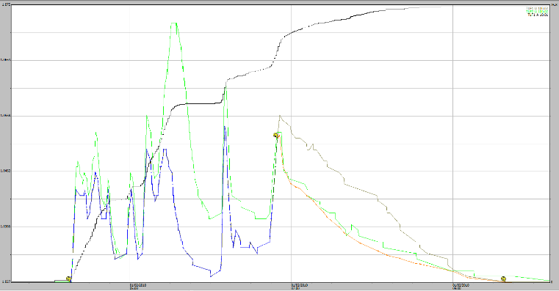

**Figure A1-1** Stage traces for an EP1 and EP2 runoff event on 01-02-2010 where some 76 mm of rainfall occurred during the runoff period this being the total amount occurring in a 24-hr period from the end of rainfall.

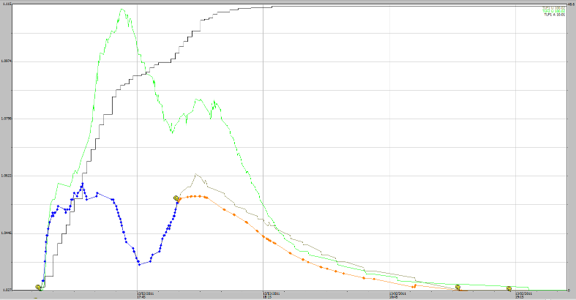

**Figure A1-2** Stage traces for an EP1 and EP2 runoff event on 13-02-2011 where some 48 mm of rainfall occurred during the runoff period with 64 mm occurring in a 24-hr period from the end of rainfall.

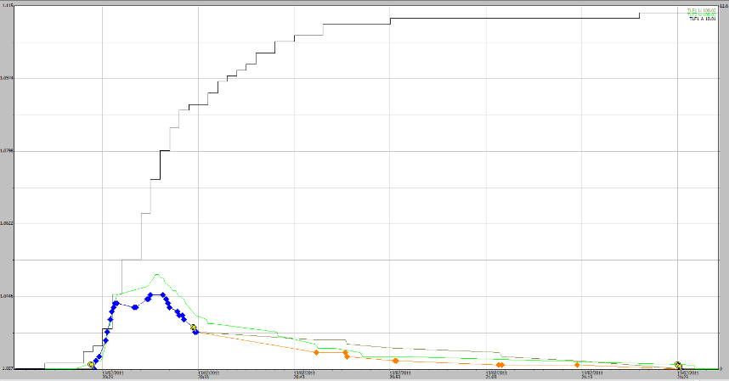

**Figure A1-3** Stage traces for an EP1 and EP2 runoff event on 14-02-2011. Only 13 mm of rainfall occurred during the runoff period but 76 mm occurred in a 24-hour period prior to the end of rainfall.

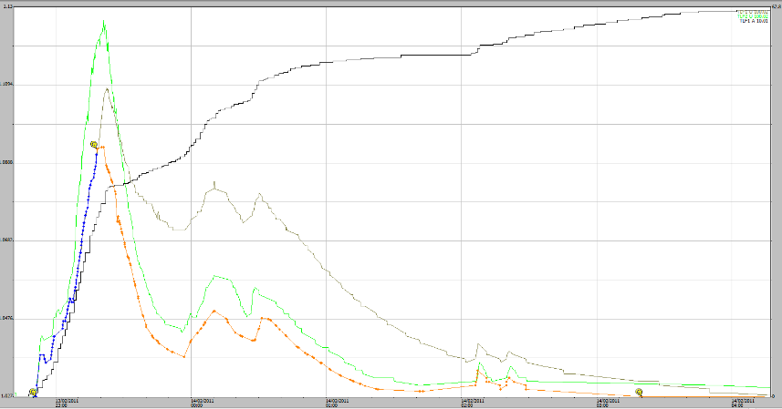

**Figure A1-4** Stage traces for an EP1 and EP2 runoff event on 14-02-2011. Some 63 mm of rainfall occurred during the runoff period and a total of 127 mm occurred in a 24-hour period   
from the end of rainfall.

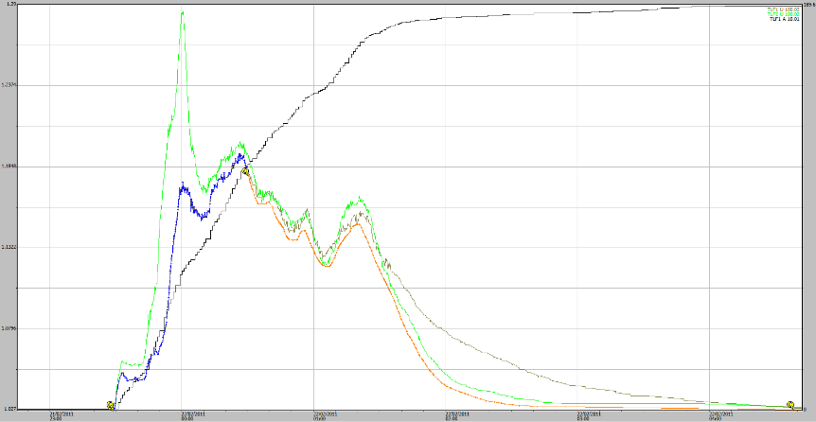

**Figure A1-5** Stage traces for an EP1 and EP2 runoff event on 22-02-2011. Some 180 mm of rainfall occurred during the runoff period and a total of 195 mm occurred in a 24-hour period   
from the end of rainfall.

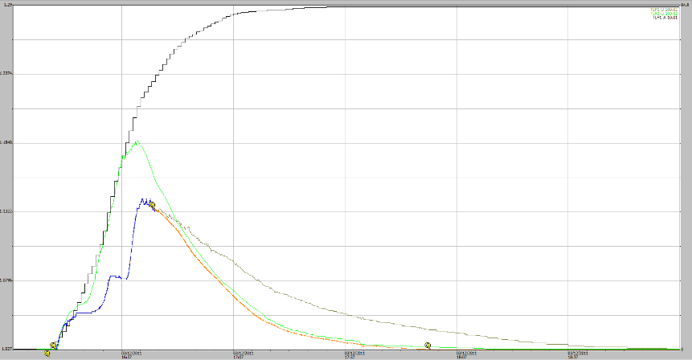

**Figure A1-6** Stage traces for an EP1 and EP2 runoff event on 03-12-2011. Some 84 mm of rainfall occurred during the runoff period this also being the total rain that occurred in the 24-hour period the end of rainfall.

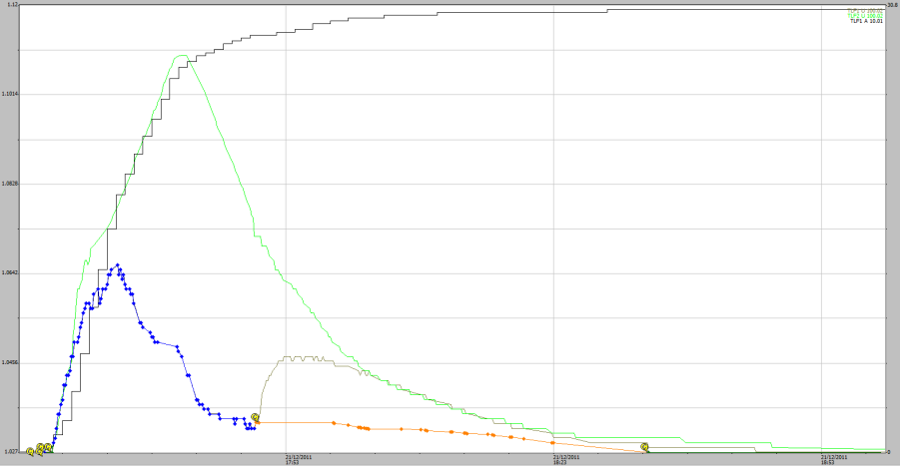

**Figure A1-7** Stage traces for an EP1 and EP2 runoff event on 21-12-2011. Some 30 mm of rainfall occurred during the runoff period and a total of 57 mm of rain occurred in the 24-hour period before the end of rainfall.

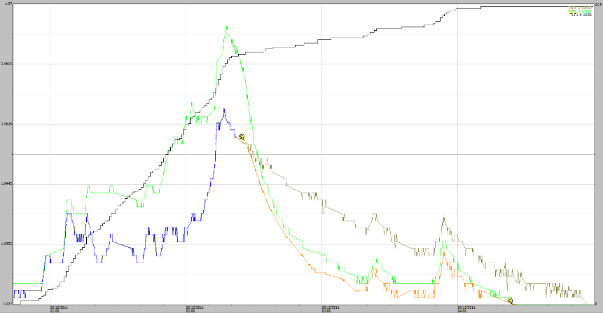

**Figure A1-8** Stage traces for an EP1 and EP2 runoff event on 26-12-2011. Some 58 mm of rainfall occurred during the runoff period and a total of 68 mm of rain occurred in the 24-hour period before the end of rainfall.

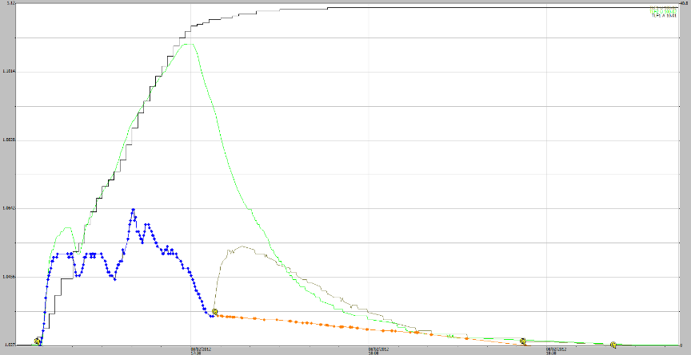

**Figure A1-9** Stage traces for an EP1 and EP2 runoff event on 08-02-2012. Some 40 mm of rainfall occurred during the runoff period and a total of 41 mm of rain occurred in the 24-hour period before the end of rainfall.

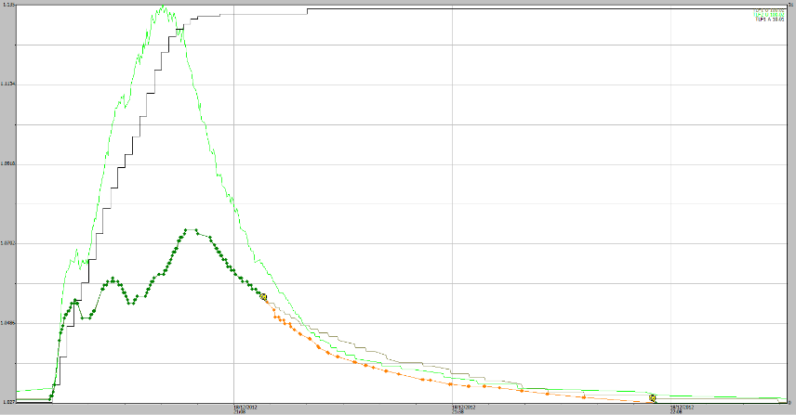

**Figure A1-10** Stage traces for an EP1 and EP2 runoff event on 18-12-2012. Some 31 mm of rainfall occurred during the runoff period and a total of 56 mm of rain occurred in the 24-hour period before the end of rainfall.

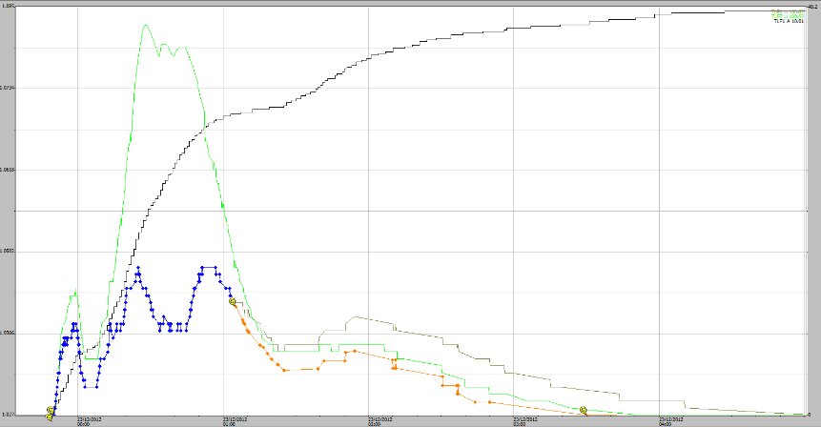

**Figure A1-11** Stage traces for an EP1 and EP2 runoff event on 23-12-2012. Some 48 mm of rainfall occurred during the runoff period and a total of 77 mm of rain occurred in the 24-hour period before the end of rainfall.

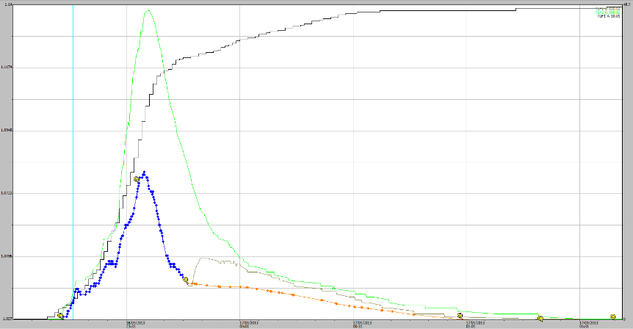

**Figure A1-12** Stage traces for an EP1 and EP2 runoff event on 16-01-2013. Some 48 mm of rainfall occurred during the runoff period and this was also the total rain that had occurred in the 24-hour period before the end of rainfall.

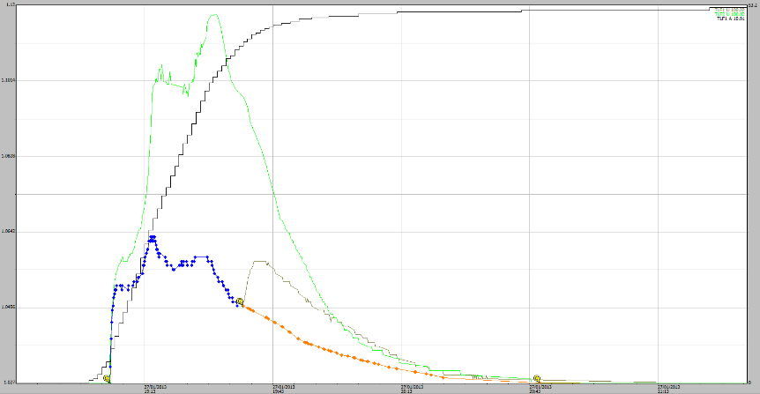

**Figure A1-13** Stage traces for an EP1 and EP2 runoff event on 27-01-2013. Some 53 mm of rainfall occurred during the runoff period and this was also the total rain that had occurred in the 24-hour period before the end of rainfall.

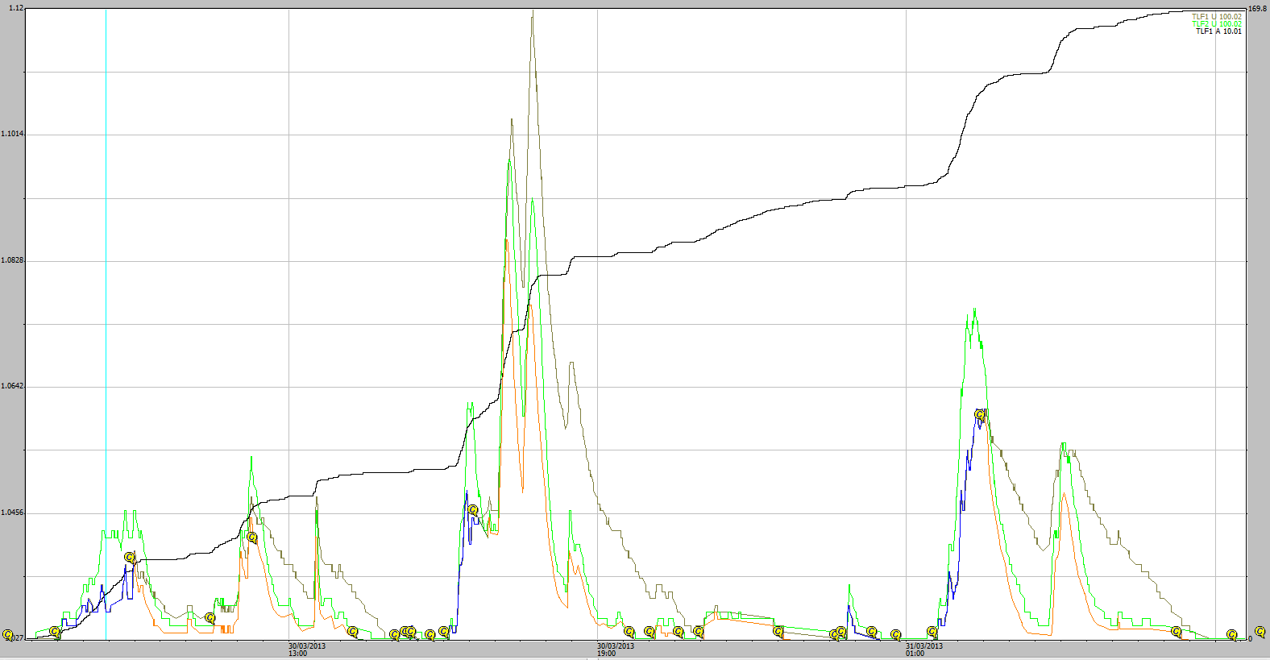

**Figure A1-14** Stage traces for EP1 and EP2 runoff events from 30-03-2013. Some 170 mm of rainfall occurred during the runoff periods and a total of 187 mm rain occurred in the 24-hour period before the end of rainfall.

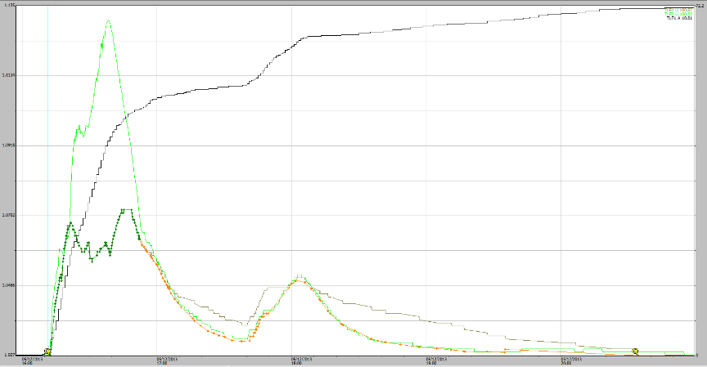

**Figure A1-15** Stage traces for EP1 and EP2 runoff events from 05-12-2013. Some 72 mm of rainfall occurred during the runoff periods and a total of 77 mm rain occurred in the 24-hour period before the end of rainfall.

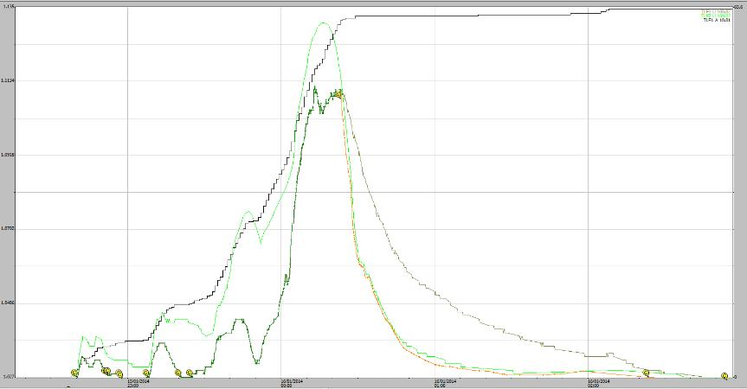

**Figure A1-16** Stage traces for EP1 and EP2 runoff events from 16-01-2014. Some 66 mm of rainfall occurred during the runoff periods and a total of 82 mm rain occurred in the 24-hour period before the end of rainfall.

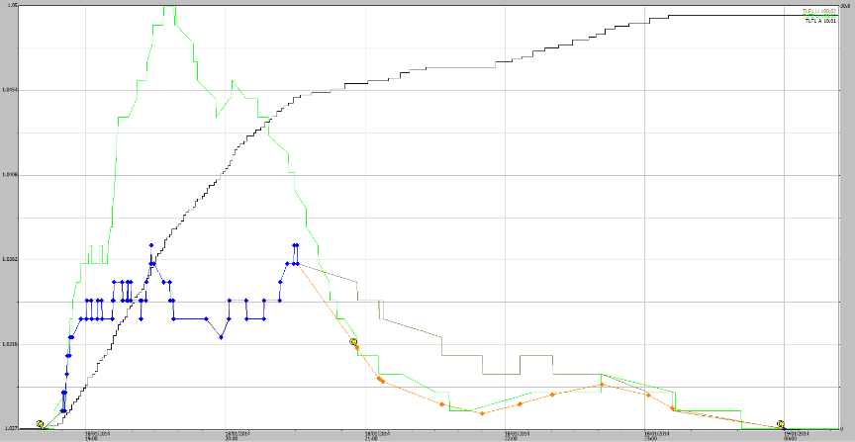

**Figure A1-17** Stage traces for EP1 and EP2 runoff events from 18-01-2014. Some 30 mm of rainfall occurred during the runoff periods and a total of 58 mm rain occurred in the 24-hour period before the end of rainfall.

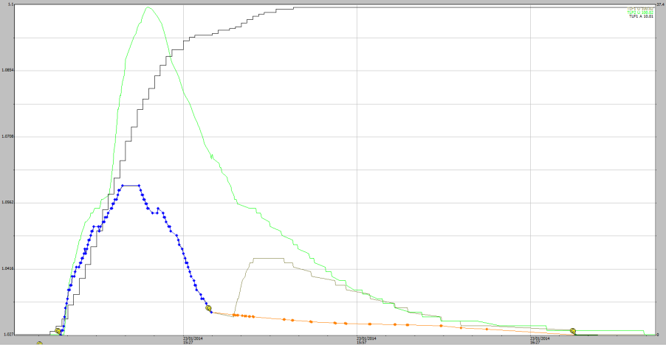

**Figure A1-18** Stage traces for EP1 and EP2 runoff events from 23-01-2014. Some 37 mm of rainfall occurred during the runoff periods and a total of 60 mm rain occurred in the 24-hour period before the end of rainfall.

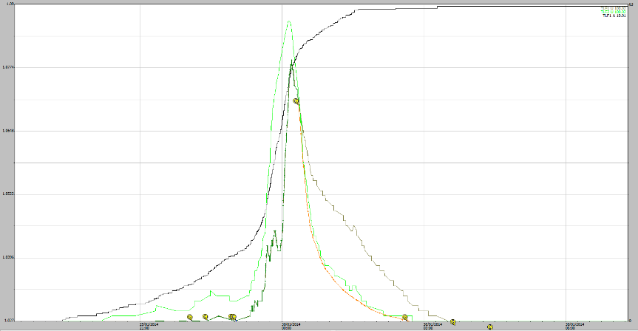

**Figure A1-19** Stage traces for EP1 and EP2 runoff events from 29-01-2014. Some 63 mm of rainfall occurred during the runoff periods and a total of 75 mm rain occurred in the 24-hour period before the end of rainfall.

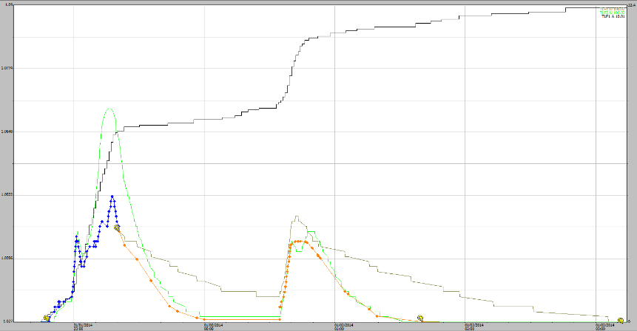

**Figure A1-20** Stage traces for EP1 and EP2 runoff events from 31-01-2014. Some 33 mm of rainfall occurred during the runoff periods and a total of 83 mm rain occurred in the 24-hour period before the end of rainfall.

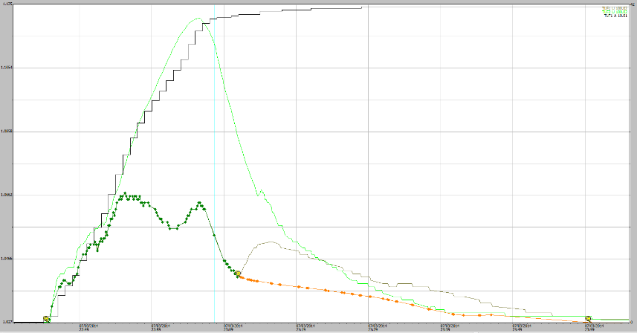

**Figure A1-21** Stage traces for EP1 and EP2 runoff events from 07-03-2014. Some 33 mm of rainfall occurred during the runoff periods and a total of 83 mm rain occurred in the 24-hour period before the end of rainfall.

## Appendix 1.2 EP1 events where no boundary overflow was indicated

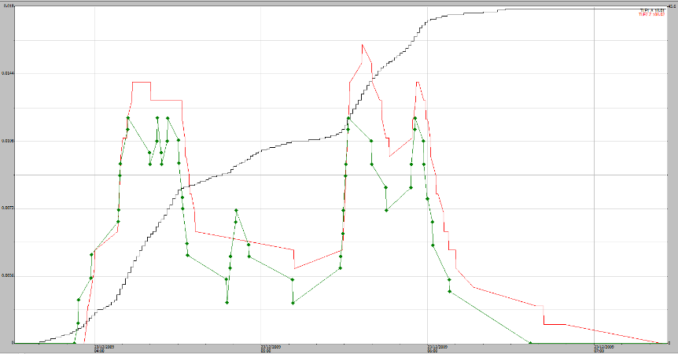

**Figure A1-22** 23/12/2009, 46 mm rain event in about 2 ½ hours (black trace) EP1 shaft encoder (green trace) EP2 shaft encoder (red trace). No overflow problem indicated.

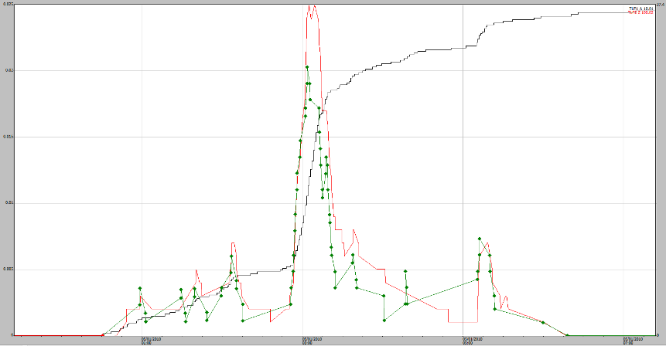

**Figure A1-23** 05/01/2010, 37 mm rain event (black trace) EP1 shaft encoder (green trace) EP2 shaft encoder (red trace). No overflow problem indicated.

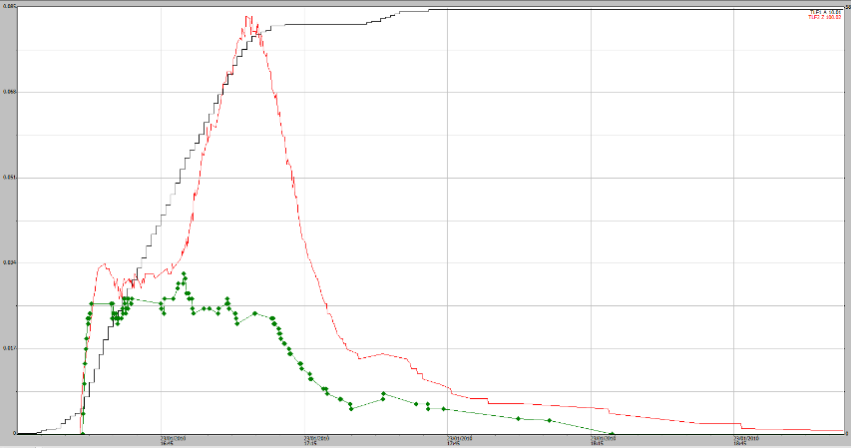

**Figure A1-24** 23/01/2010, 58 mm rain event (black trace) EP1 shaft encoder (green trace) EP2 shaft encoder (red trace). No overflow problem indicated.

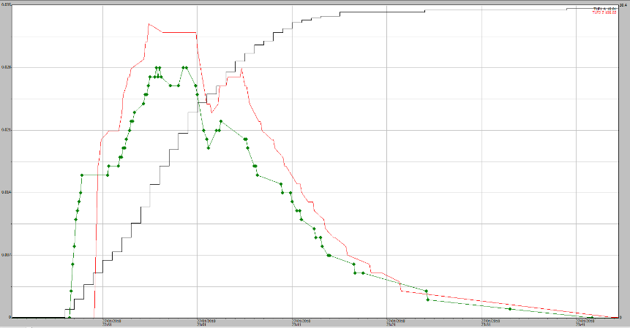

**Figure A1-25** 27/01/2010, 30 mm rain event (black trace) EP1 shaft encoder (green trace) EP2 shaft encoder (red trace). No overflow problem indicated.

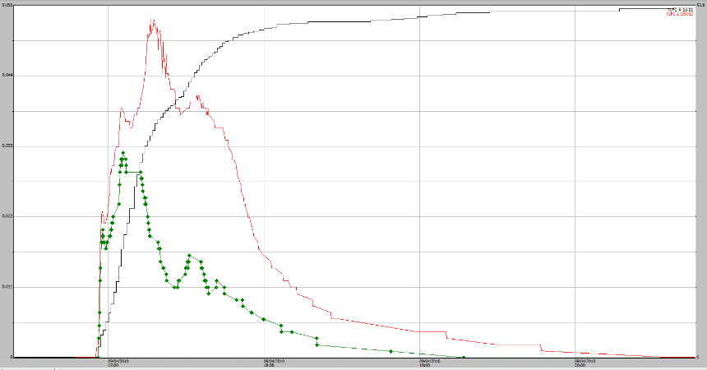

**Figure A1-26** 09/04/2010, 53 mm rain event (black trace) EP1 shaft encoder (green trace) EP2 shaft encoder (red trace). No overflow problem indicated.

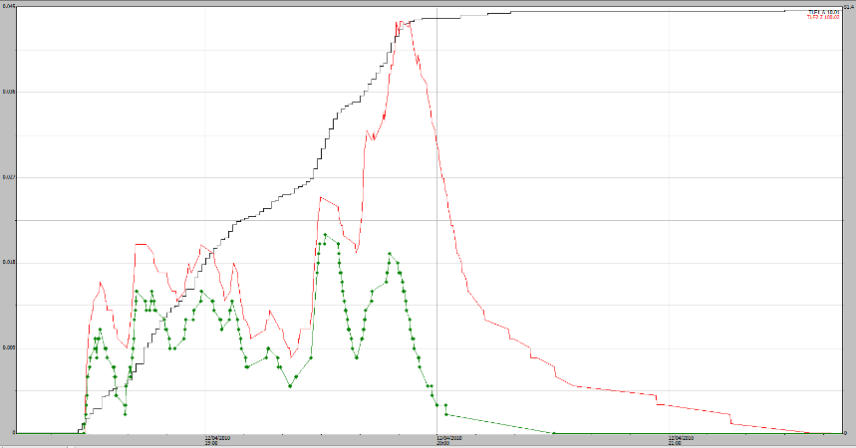

**Figure A1-27** 12/04/2010, 51 mm rain event (black trace) EP1 shaft encoder (green trace) EP2 shaft encoder (red trace). No overflow problem indicated.

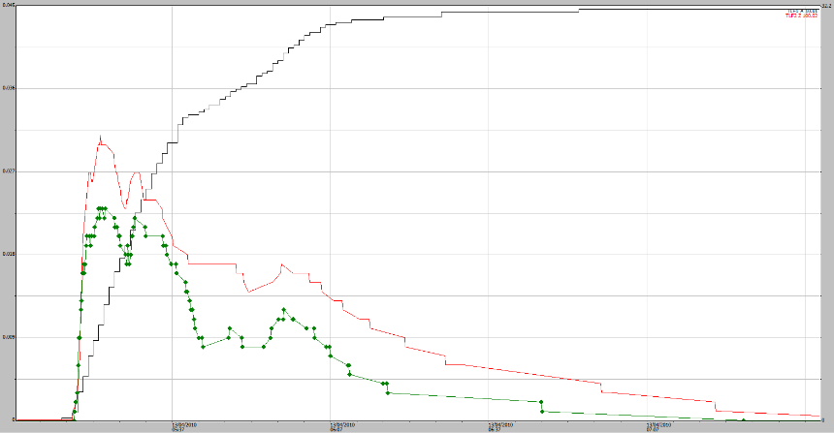

**Figure A1-28** 13/04/2010, 32 mm rain event (black trace) EP1 shaft encoder (green trace) EP2 shaft encoder (red trace). No overflow problem indicated.

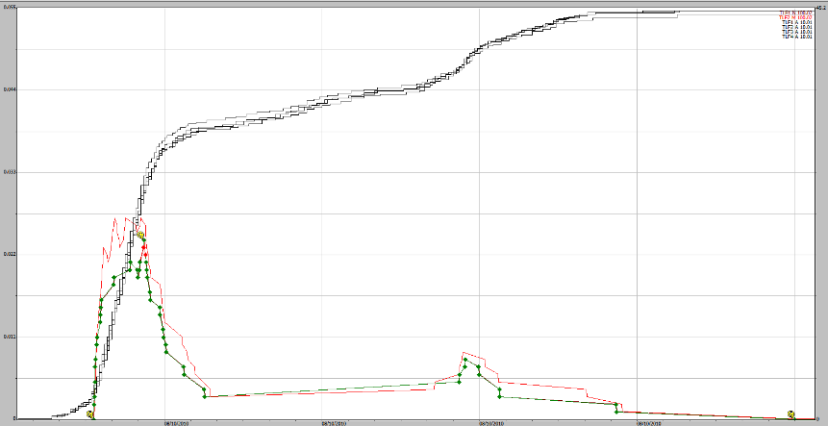

**Figure A1-29** 08/10/2010, 45 mm rain event (black traces for plots 1 to 4) EP1 shaft encoder (green trace) EP2 shaft encoder (red trace). No overflow problem indicated.

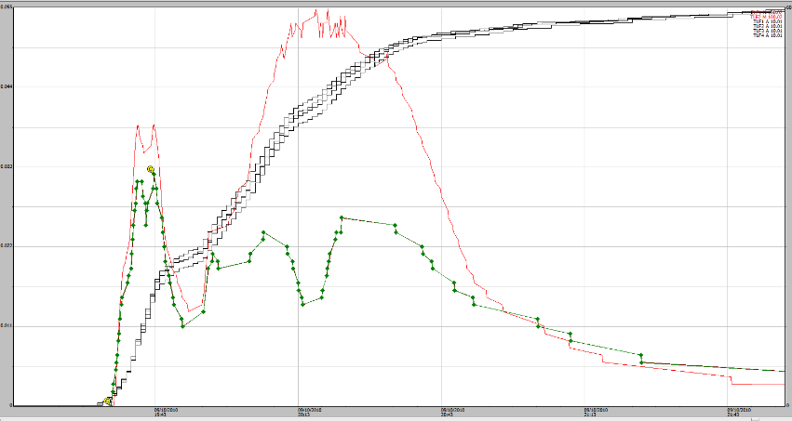

**Figure A1-30** 09/10/2010, 69 mm rain (black traces for plots 1 to 4). EP1 shaft encoder (green trace) EP2 shaft encoder (red trace). Marginal overflow detected at end of recession period. Perhaps could be corrected but has been left at this stage. The multimodal peaks on the EP1 stage trace correspond to changes in rain intensity.

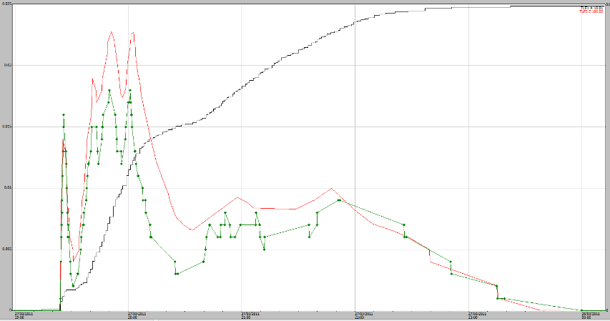

**Figure A1-31** 27/03/2011, 53 mm rain event (black) EP1 shaft encoder (green trace) EP2 shaft encoder (red trace). Marginal overflow problem indicated on recession but no correction applied.

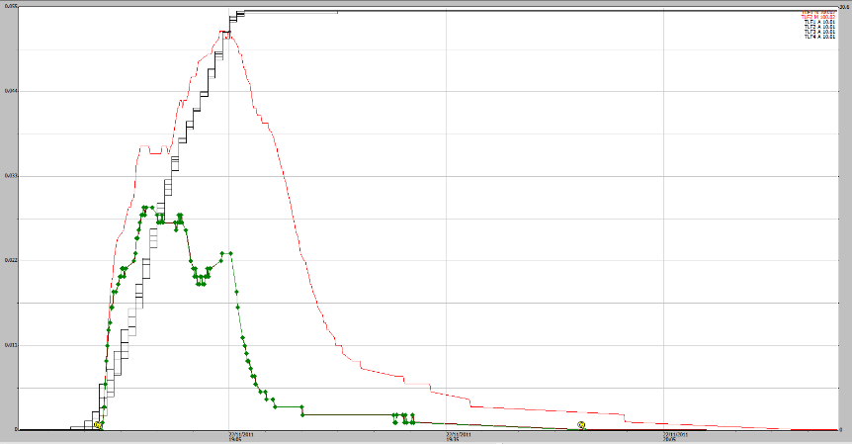

**Figure A1-32** 22/11/2011, 30 mm rain event (black traces for plots 1 to 4). EP1 shaft encoder (green trace) EP2 shaft encoder (red trace). No overflow problem indicated.

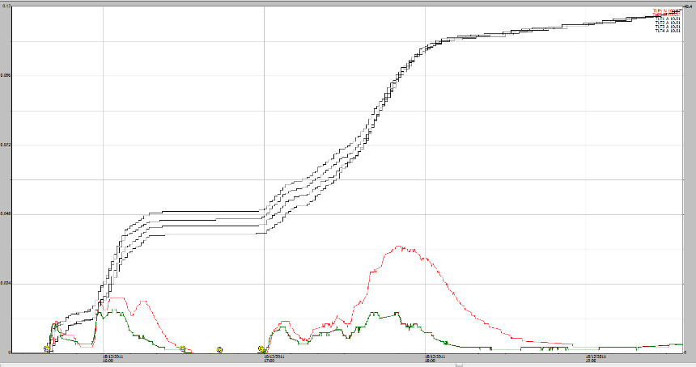

**Figure A1-33** 18/12/2011: 45 mm rain event over two events (rising black traces, plots 1 to 4) EP1 shaft encoder (green trace) EP2 shaft encoder (red trace). No overflow problem indicated.

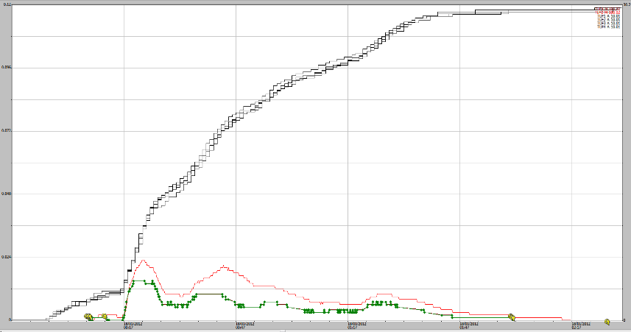

**Figure A1-34** 18/12/2011: 30 mm rain event (rising black traces, plots 1 to 4) EP1 shaft encoder (green trace) EP2 shaft encoder (red trace). No overflow problem indicated.

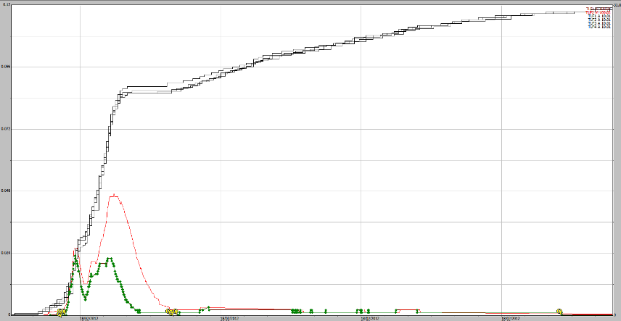

**Figure A1-35** 18/02/2012, 32 mm rain event (rising black traces, plots 1 to 4) EP1 shaft encoder (green trace) EP2 shaft encoder (red trace). No overflow problem indicated.

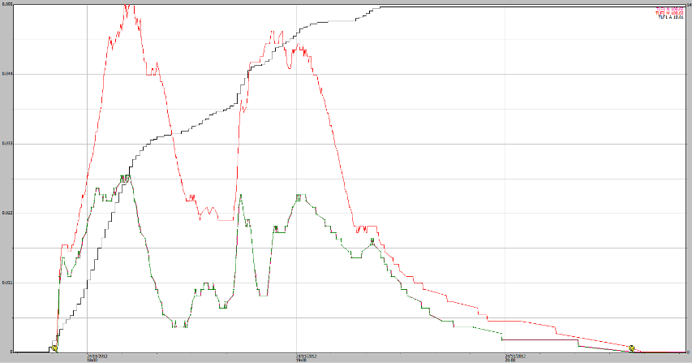

**Figure A1-36** 23/11/2012, 55 mm rain event (black) EP1 shaft encoder (green trace) EP2 shaft encoder (red trace). No overflow problem indicated.

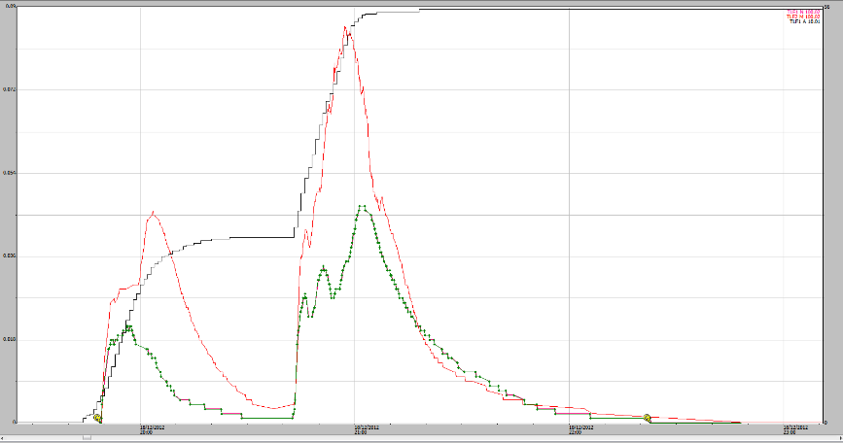

**Figure A1-37** 18/12/2012, 56 mm rain (black) over two runoff events. EP1 shaft encoder (green trace) EP2 shaft encoder (red trace). No overflow problem indicated.

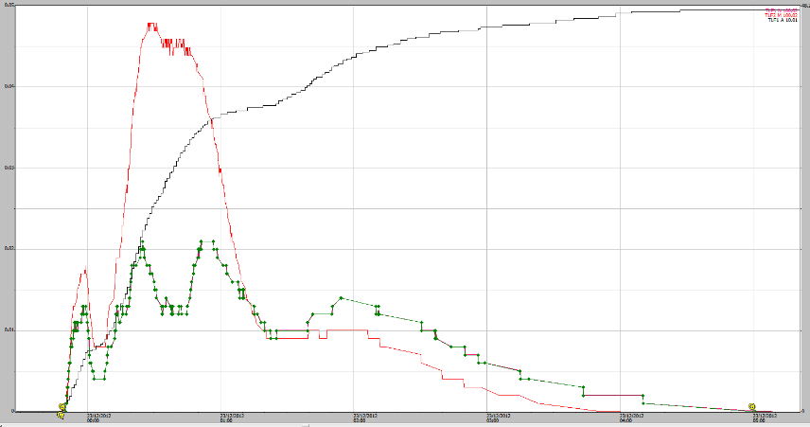

**Figure A1-38** 23/12/2012, 48 mm rain event (black) EP1 shaft encoder (green trace) EP2 shaft encoder (red trace). No overflow problem indicated.

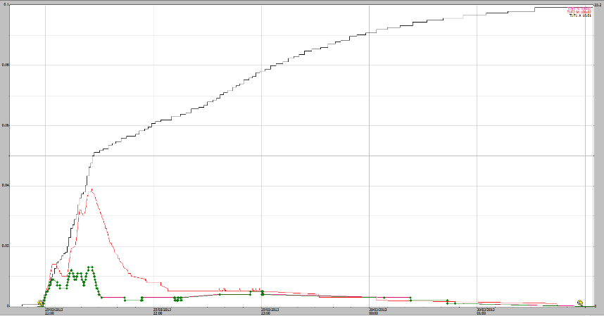

**Figure A1-39** 29/03/2013, 33 mm rain event (black) EP1 shaft encoder (green trace) EP2 shaft encoder (red trace). No overflow problem indicated.

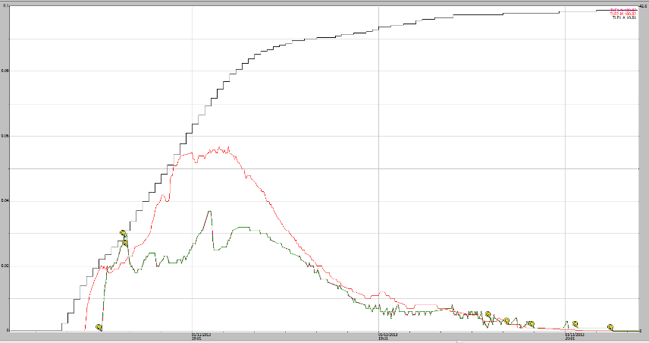

**Figure A1-40** 01/11/2013 (Plot1/2): 43 mm rain event (black) EP1 shaft encoder (green trace) EP2 shaft encoder (red trace). No overflow problem indicated.

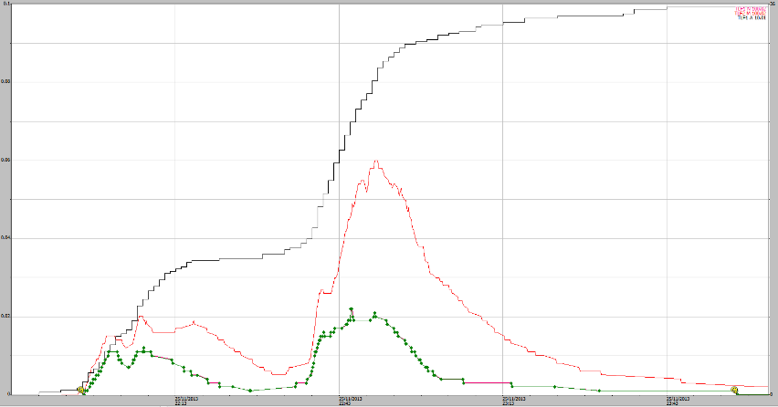

**Figure A1-41** 25/11/2013, 36 mm rain event (black) EP1 shaft encoder (green trace) EP2 shaft encoder (red trace). No overflow problem indicated.

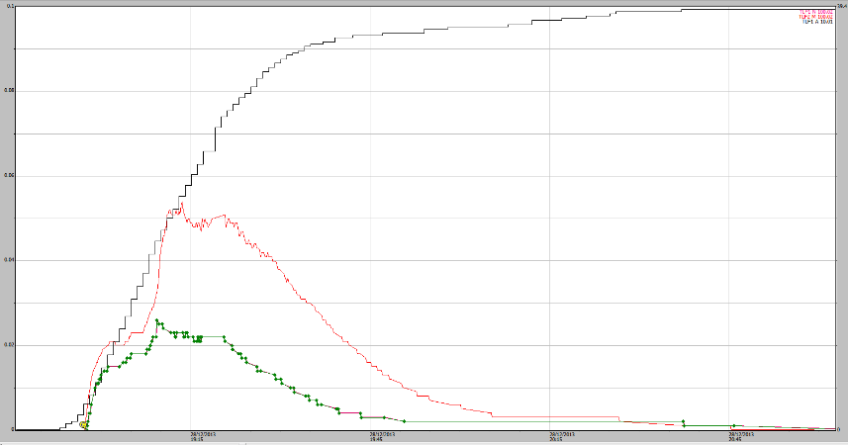

**Figure A1-42** 28/12/2013, 39 mm rain event (black) EP1 shaft encoder (green trace) EP2 shaft encoder (red trace). No overflow problem indicated.

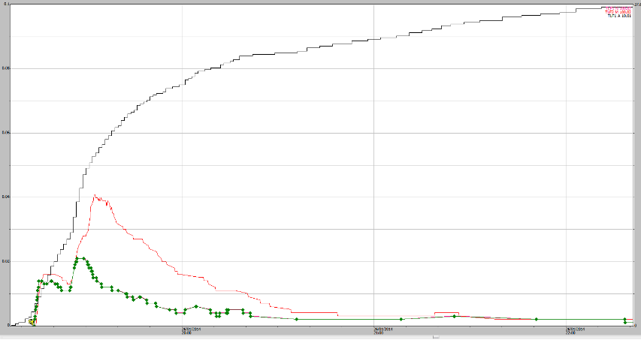

**Figure A1-43** 26/01/2014, 39 mm rain event (black) EP1 shaft encoder (green trace) EP2 shaft encoder (red trace). No overflow problem indicated.

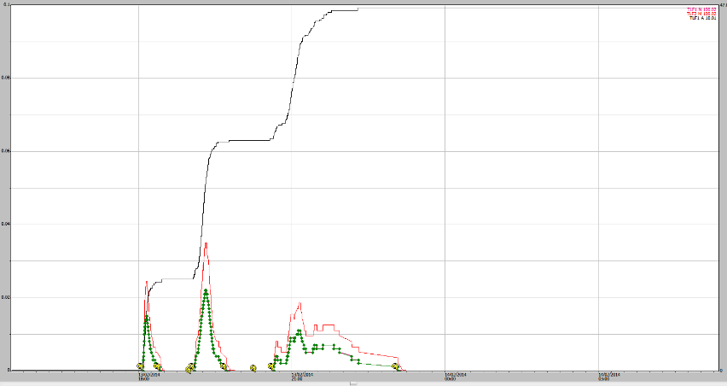

**Figure A1-44** 13/02/2014 (Plot1/2): 48 mm rain (black) over three runoff events. EP1 shaft encoder (green trace) EP2 shaft encoder (red trace). No overflow problem indicated.

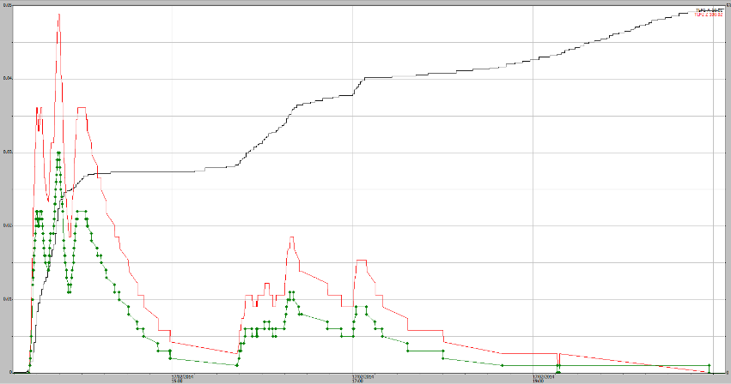

**Figure A1-45** 17/02/2014 (Plot1/2): 53 mm rain event (black) EP1 shaft encoder (green trace) EP2 shaft encoder (red trace). No overflow problem indicated.

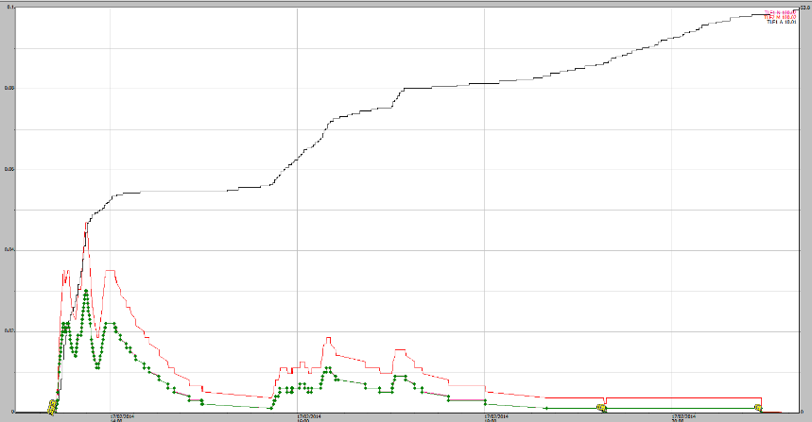

**Figure A1-46** 18/02/2014 (Plot1/2): 37 mm rain event (black) EP1 shaft encoder (green trace) EP2 shaft encoder (red trace). No boundary overflow problem indicated.

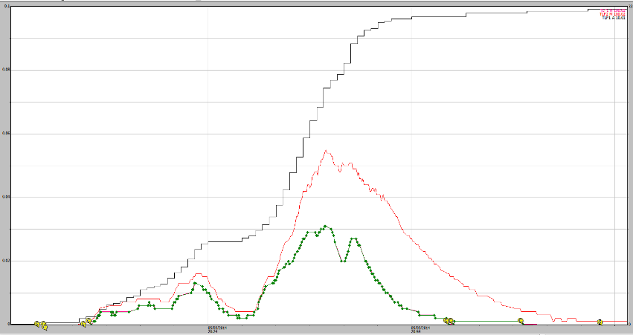

**Figure A1-47** 05/03/2014 (Plot1/2): 33 mm rain event (black) EP1 shaft encoder (green trace) EP2 shaft encoder (red trace). No boundary overflow problem indicated.

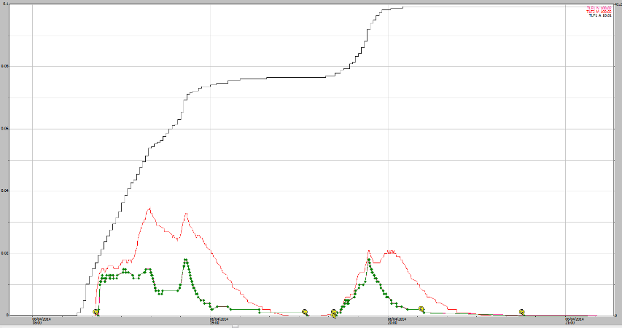

**Figure A1-48** 06/04/2014, 41 mm rain event (black) EP1 shaft encoder (green trace) EP2 shaft encoder (red trace). No boundary overflow problem indicated.

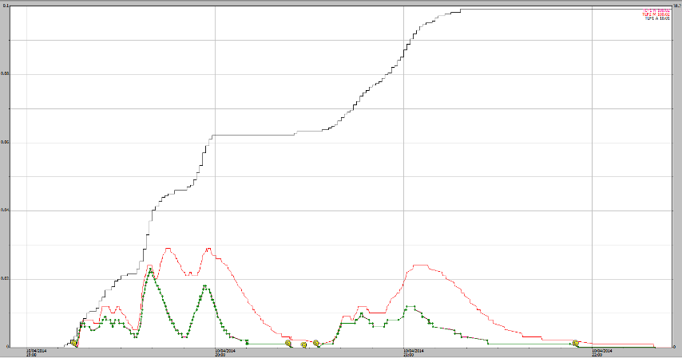

**Figure A1-49** 10/04/2014, 38 mm rain (black) over 2 runoff events. EP1 shaft encoder (green trace) EP2 shaft encoder (red trace). No boundary overflow problem indicated.

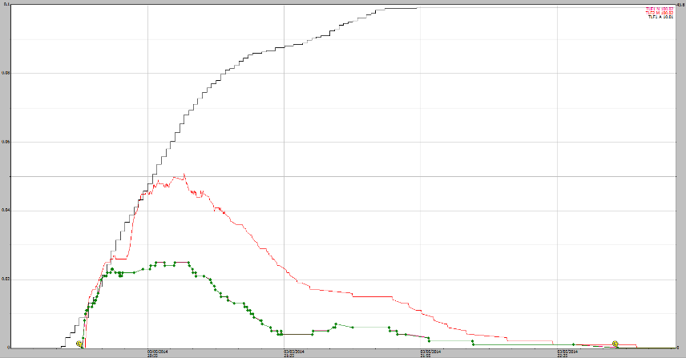

**Figure A1-50** 03/05/2014, 46 mm rain event (black) EP1 shaft encoder (green trace) EP2 shaft encoder (red trace). No boundary overflow problem indicated.

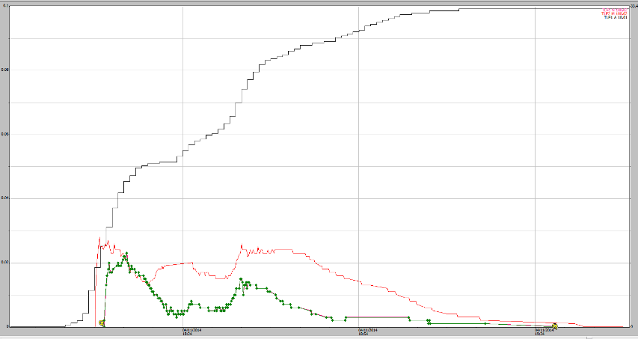

**Figure A1-51** 04/11/2014, 33 mm rain event (black) EP1 shaft encoder (green trace) EP2 shaft encoder (red trace). No boundary overflow problem indicated.

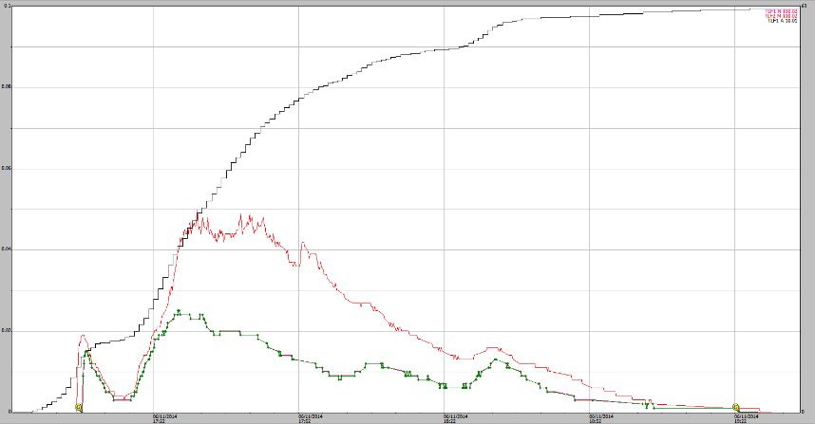

**Figure A1-52** 06/11/2014, 63 mm rain event (black) EP1 shaft encoder (green trace) EP2 shaft encoder (red trace). No boundary overflow problem indicated.

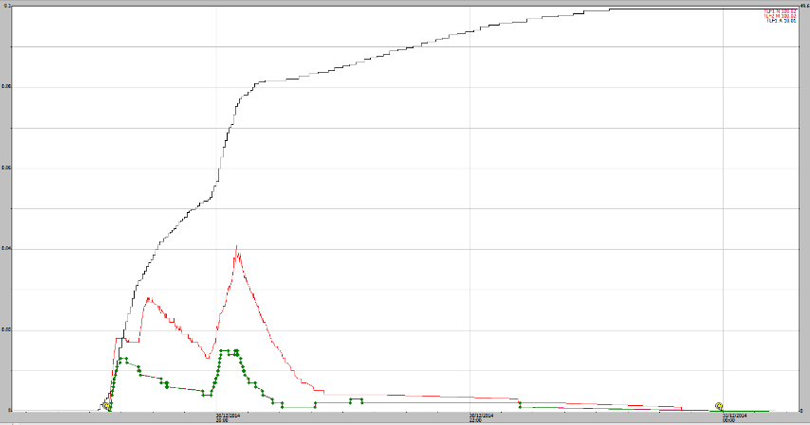

**Figure A1-53.** 30/12/2014, 50 mm rain event (black) EP1 shaft encoder (green trace) EP2 shaft encoder (red trace). No boundary overflow problem indicated.

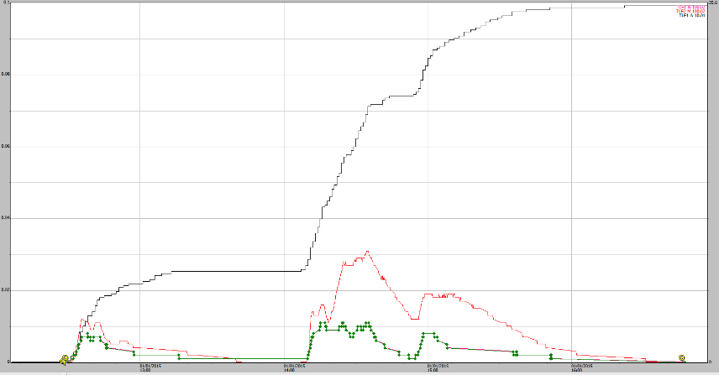

**Figure A1-54** 01/01/2015, 50 mm rain event (black) EP1 shaft encoder (green trace) EP2 shaft encoder (red trace). No boundary overflow problem indicated.

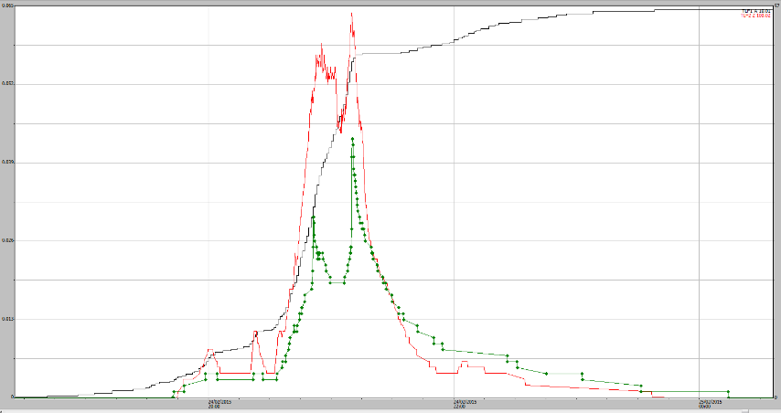

**Figure A1-55** 24/02/2015, 56 mm rain event (black) EP1 shaft encoder (green trace) EP2 shaft encoder (red trace). Marginal boundary overflow indicated on recession but no correction applied.

# Appendix 2 Photos of road drain runoff peaks and associated EP1 stage trace

Each photo represents the peak runoff level on the roadside drain for a discreet runoff event measured by the EP1 stage trace. A screenshot of the Hydstra trace for EP1 runoff and rainfall is provided to the left of each photo. These photos of the roadside drain are the only useful ones captured to date. The future planned deployment of a more reliable uWay camera (capable of also taking night-time photography) will address the gap in characterising larger events.

|  |  |
| --- | --- |
| Capture25-02-2015.PNG | \\pvnt01flpr01\user$\A02268\Documents\WSCT1624.JPG |

**Figure A2-1**  EP1 stage trace for a 5.6mm rain event from 4:06 to 4:07 pm on the 25-02-2015 and photo of the adjacent roadside drain showing peak runoff at 4:09 pm with no plot boundary overflow.

|  |  |
| --- | --- |
| Capture27-02-2015.PNG | \\pvnt01flpr01\user$\A02268\Documents\WSCT1910.JPG |

**Figure A2-2**  EP1 stage trace for a 5.9 mm rain event from 4:40 to 4:56 pm on the 27-02-2015 and photo of the adjacent roadside drain showing peak runoff at 4:54 pm with no plot boundary overflow.

|  |  |
| --- | --- |
| Capture28-02-2015.PNG | \\pvnt01flpr01\user$\A02268\Documents\WSCT2070.JPG |

**Figure A2-3**  EP1 stage trace for a 2.6 mm rain event from 6:13 to 6:46 pm on the 28-02-2015 and photo of the adjacent roadside drain showing peak runoff at 6:44 pm with no plot boundary overflow.

|  |  |
| --- | --- |
| Capture01-03-2015.PNG | \\pvnt01flpr01\user$\A02268\Documents\WSCT2192.JPG |

**Figure A2-4**  EP1 stage trace for a 22 mm rain event from 4:51 to 5:25 pm on the 01-03-2015 and photo of the adjacent roadside drain showing peak runoff at 5:15 pm with no plot boundary overflow. These events are also illustrated in Figures 16 and 17 of the results as the largest rainfall runoff event captured by camera.

|  |  |
| --- | --- |
| Capture02-03-2015.PNG | WSCT2228.JPG |

**Figure A2-5**  EP1 stage trace for a 2.6 mm rain event from 6:20 to 9:51 am on the 02-03-2015 and photo of the adjacent roadside drain showing peak runoff at 8:18 am with no plot boundary overflow.

|  |  |
| --- | --- |
| Capture02-03-2015b.PNG | \\pvnt01flpr01\user$\A02268\Documents\WSCT2333.JPG |

**Figure A2-6**  EP1 stage trace for a 1.6 mm rain event from 5:22 to 5:26 PM on the 02-03-2015 and photo of the adjacent roadside drain showing peak runoff at 5:26 PM with no plot boundary overflow.

|  |  |
| --- | --- |
| Capture14-03-2015.PNG | WSCT3998.JPG |

**Figure A2-7**  EP1 stage trace for a 1.6 mm rain event from 5:22 to 5:26 PM on the 14-03-2015 and photo of the adjacent roadside drain showing peak runoff at 5:26 PM with no plot boundary overflow.

# Appendix 3 Rainfall statistics associated with ‘overflow’ and ‘no overflow’ runoff events with ≥ 30 mm rain

Rainfall statistics associated for runoff events where > 30 mm rain fell and grouped according to whether ‘boundary overflow’ occurred or not (i.e. OK): Characteristics include additional rain in the last 24, 48 and 96 hrs; as well as actual rainfall intensity and duration occurring during the runoff event.

| Group | Event date | Event Total (mm) | Last 24hrs (mm) | Last 48hrs (mm) | Last 96hrs (mm) | Event intensity (mm/ hrs) | Duration (hh:mm) | Start  (dd/mm/yyyy hh:mm) | Finish  (dd/mm/yyyy hh:mm) | Note |
| --- | --- | --- | --- | --- | --- | --- | --- | --- | --- | --- |
| OK | 05/01/2009 | 36 | 49 | 81 | 146 | 7 | 05:27 | 05/01/2009 00:31 | 05/01/2009 05:58 | druck-sensor |
| OK | 23/12/2009 | 45 | 45 | 56 | 75 | 16 | 02:48 | 23/12/2009 03:40 | 23/12/2009 06:28 |  |
| OK | 23/01/2010 | 58 | 58 | 58 | 58 | 45 | 01:17 | 23/01/2010 16:19 | 23/01/2010 17:36 |  |
| OK | 27/01/2010 | 30 | 38 | 38 | 60 | 62 | 00:29 | 27/01/2010 22:47 | 27/01/2010 23:16 |  |
| OK | 09/04/2010 | 53 | 59 | 59 | 66 | 22 | 02:25 | 09/04/2010 16:55 | 09/04/2010 19:20 |  |
| OK | 12/04/2010 | 51 | 51 | 64 | 143 | 33 | 01:32 | 12/04/2010 18:26 | 12/04/2010 19:58 |  |
| OK | 13/04/2010 | 32 | 84 | 84 | 215 | 27 | 01:12 | 13/04/2010 05:16 | 13/04/2010 06:28 |  |
| OK | 08/10/2010 | 45 | 46 | 46 | 53 | 13 | 03:27 | 08/10/2010 19:17 | 08/10/2010 22:44 |  |
| OK | 09/10/2010 | 69 | 114 | 115 | 167 | 12 | 05:32 | 09/10/2010 19:31 | 10/10/2010 01:03 | borderline |
| OK | 27/03/2011 | 53 | 71 | 77 | 101 | 16 | 03:23 | 27/03/2011 19:14 | 27/03/2011 22:37 | borderline |
| OK | 22/11/2012 | 30 | 30 | 50 | 72 | 90 | 00:20 | 22/11/2012 18:47 | 22/11/2012 19:07 |  |
| OK | 01/11/2013 | 42 | 42 | 42 | 42 | 40 | 01:03 | 01/11/2013 18:40 | 01/11/2013 19:43 |  |
| OK | 25/11/2013 | 37 | 51 | 71 | 104 | 19 | 01:55 | 25/11/2013 21:48 | 25/11/2013 23:43 |  |
| OK | 28/12/2013 | 39 | 39 | 40 | 51 | 23 | 01:44 | 28/12/2013 18:53 | 28/12/2013 20:37 |  |
| OK | 26/01/2014 | 39 | 39 | 39 | 136 | 9 | 04:25 | 26/01/2014 19:18 | 26/01/2014 23:43 |  |
| OK | 17/02/2014 | 53 | 69 | 82 | 130 | 7 | 07:55 | 17/02/2014 13:23 | 17/02/2014 21:18 |  |
| OK | 18/02/2014 | 37 | 47 | 107 | 192 | 20 | 01:53 | 18/02/2014 18:22 | 18/02/2014 20:15 |  |
| OK | 05/03/2014 | 32 | 39 | 39 | 46 | 42 | 00:46 | 05/03/2014 20:05 | 05/03/2014 20:51 |  |
| OK | 06/04/2014 | 32 | 32 | 32 | 32 | 35 | 00:55 | 06/04/2014 18:15 | 06/04/2014 19:10 |  |
| OK | 03/05/2014 | 46 | 46 | 46 | 46 | 39 | 01:11 | 03/05/2014 20:36 | 03/05/2014 21:47 |  |
| boundary overflow | 01/02/2010 | 76 | 76 | 80 | 103 | 16 | 04:37 | 01/02/2010 04:14 | 01/02/2010 08:51 |  |
| boundary overflow | 13/02/2011 | 48 | 64 | 64 | 89 | 52 | 00:55 | 13/02/2011 17:22 | 13/02/2011 18:17 |  |
| boundary overflow | 14/02/2011 | 62 | 131 | 131 | 220 | 13 | 04:57 | 13/02/2011 22:48 | 14/02/2011 03:45 |  |
| boundary overflow | 22/02/2011 | 189 | 204 | 209 | 263 | 41 | 04:38 | 21/02/2011 23:29 | 22/02/2011 04:07 |  |
| boundary overflow | 03/12/2011 | 84 | 84 | 94 | 122 | 68 | 01:14 | 03/12/2011 16:18 | 03/12/2011 17:32 |  |
| boundary overflow | 21/12/2011 | 30 | 57 | 78 | 188 | 41 | 00:44 | 21/12/2011 17:25 | 21/12/2011 18:10 | twin peak |
| boundary overflow | 26/12/2011 | 58 | 68 | 85 | 103 | 7 | 07:47 | 25/12/2011 20:22 | 26/12/2011 04:10 |  |
| boundary overflow | 08/02/2012 | 40 | 41 | 74 | 108 | 49 | 00:49 | 08/02/2012 17:11 | 08/02/2012 18:00 | borderline |
| boundary overflow | 18/12/2012 | 31 | 56 | 57 | 85 | 20 | 01:34 | 18/12/2012 19:44 | 18/12/2012 21:18 |  |
| boundary overflow | 23/12/2012 | 48 | 77 | 83 | 118 | 10 | 04:38 | 22/12/2012 23:49 | 23/12/2012 04:27 |  |
| boundary overflow | 16/01/2013 | 48 | 48 | 56 | 84 | 33 | 01:27 | 16/01/2013 23:10 | 17/01/2013 00:38 | twin peak |
| boundary overflow | 27/01/2013 | 53 | 53 | 53 | 54 | 50 | 01:03 | 27/01/2013 19:00 | 27/01/2013 20:03 |  |
| boundary overflow | 30/03/2013 | 45 | 129 | 160 | 292 | 7 | 06:37 | 30/03/2013 07:48 | 30/03/2013 14:26 |  |
| boundary overflow | 30/03/2013 | 73 | 174 | 232 | 410 | 10 | 07:18 | 30/03/2013 16:01 | 30/03/2013 23:20 |  |
| boundary overflow | 31/03/2013 | 47 | 187 | 261 | 499 | 10 | 04:45 | 31/03/2013 01:20 | 31/03/2013 06:05 |  |
| boundary overflow | 05/12/2013 | 72 | 77 | 79 | 95 | 16 | 04:37 | 05/12/2013 16:09 | 05/12/2013 20:46 |  |
| boundary overflow | 16/01/2014 | 66 | 84 | 107 | 158 | 61 | 01:05 | 15/01/2014 23:24 | 16/01/2014 00:29 |  |
| boundary overflow | 18/01/2014 | 30 | 58 | 89 | 272 | 7 | 04:28 | 18/01/2014 18:42 | 18/01/2014 23:10 |  |
| boundary overflow | 23/01/2014 | 37 | 60 | 83 | 120 | 54 | 00:41 | 23/01/2014 15:04 | 23/01/2014 15:46 | twin peak |
| boundary overflow | 29/01/2014 | 63 | 75 | 86 | 177 | 24 | 02:35 | 29/01/2014 23:01 | 30/01/2014 01:37 |  |
| boundary overflow | 31/01/2014 | 33 | 83 | 138 | 268 | 8 | 04:01 | 31/01/2014 22:45 | 01/02/2014 02:46 |  |
| boundary overflow | 07/03/2014 | 42 | 43 | 44 | 88 | 57 | 00:44 | 07/03/2014 22:44 | 07/03/2014 23:28 |  |