
651
internal report
Assessment Report:
Ranger Pit 1 Final Tailings Deposition Level to +7 mRL


K Turner, K Tayler, A Costar,
C Zimmermann, M Bouma
and P Baker
February 2017
Release status – unrestricted

The Department acknowledges the traditional owners of country throughout Australia and their continuing connection to land, sea and community. We pay our respects to them and their cultures and to their elders both past and present.
Assessment Report: Ranger Pit 1 Final Tailings Deposition Level to +7 mRL
Kate Turner, Keith Tayler, Adrian Costar, Carl Zimmermann,
Mitchell Bouma and Peter Baker

Supervising Scientist
GPO Box 461, Darwin NT 0801

February 2017

(Release status – Unrestricted)



How to cite this report:
Turner K, Tayler K, Costar A, Zimmermann C, Bouma M, & Baker P, 2017. Assessment Report: Ranger Pit 1 Final Tailings Deposition Level to +7 mRL. Internal Report 651, February, Supervising Scientist, Darwin.
Authors of this report:
Kate Turner – Supervising Scientist, GPO Box 461, Darwin NT 0801, Australia
Keith Tayler – Supervising Scientist, GPO Box 461, Darwin NT 0801, Australia
Adrian Costar – Supervising Scientist, GPO Box 461, Darwin NT 0801, Australia
Carl Zimmermann – Office of Water Science, GPO Box 787 Canberra ACT 2601, Australia
Mitchell Bouma – Office of Water Science, GPO Box 787 Canberra ACT 2601, Australia
Peter Baker – Supervising Scientist, GPO Box 461, Darwin NT 0801, Australia

Supervising Scientist and Office of Water Science are branches of the Australian Government Department of the Environment and Energy.
Supervising Scientist
Department of the Environment and Energy
GPO Box 461, Darwin NT 0801 Australia
environment.gov.au/science/supervising-scientist/publications

© Commonwealth of Australia 2017
IR651 is licensed by the Commonwealth of Australia for use under a Creative Commons By Attribution 3.0 Australia licence with the exception of the Coat of Arms of the Commonwealth of Australia, the logo of the agency responsible for publishing the report, content supplied by third parties, and any images depicting people. For licence conditions see: http://creativecommons.org/licenses/by/3.0/au/
Disclaimer
The views and opinions expressed in this publication are those of the authors and do not necessarily reflect those of the Australian Government or the Minister for the Environment and Energy.
While reasonable efforts have been made to ensure that the contents of this publication are factually correct, the Commonwealth does not accept responsibility for the accuracy or completeness of the contents, and shall not be liable for any loss or damage that may be occasioned directly or indirectly through the use of, or reliance on, the contents of this publication.

Contents
Executive Summary 1
1 Introduction 3
1.1 Regulatory Arrangements 3
1.2 Pit 1 Overview 4
1.3 Previous Applications 4
2 Assessment Overview 7
2.1 Application Summary 7
2.2 Assessment Process 7
2.3 Key Environmental Risks 8
2.3.1 Groundwater 8
2.3.1.1 Source Term Geochemistry 8
2.3.1.2 Tailings Consolidation Modelling 9
2.3.1.3 Contaminant Transport Modelling 9
2.3.1.4 Groundwater/Surface Water Interactions and Stream Flow 11
2.3.2 Landform 11
2.3.3 Radiation 12
3 Assessment Outcomes 14
3.1 Summary 14
3.2 Recommended Approval Conditions 15
4 References 17
Appendix 1 Advice on Pit 1 Notification: final in-pit tailings level from the Supervising Scientist to the Northern Territory Minister for Primary Industry and Resources 18
Appendix 2 Supervising Scientist Branch review of Pit 1 Notification: final in-pit tailings level 23
Appendix 3 Office of Water Science Branch review of Pit 1 Notification: final in-pit tailings level 32
Appendix 4 Hydrogeologic Pty Ltd – Pit 1 consolidation model review: Ranger Pit 1 Consolidation Modelling Independent Review 42
Appendix 5 South Australian Department of Environment, Water and Natural Resources – Pit 1 groundwater and contaminant transport model review: Review of Contaminant Egress Mitigation Modelling for Ranger Pit 1 Closure 56
Appendix 6 DR Jones Environmental Excellence – Mine site geochemistry review: Review of Geochemistry-Related Aspects of Closure Modelling for Ranger Pit 1 and Pit 3 57
Appendix 7 Summary outcomes of the Groundwater Workshop hosted by the Supervising Scientist Branch, 5-7 September 2016 70

Executive summary
Responsibility for the regulation of uranium mining in the Alligator Rivers Region (ARR) has been delegated by the Commonwealth to the Northern Territory (NT) Minister for Primary Industry and Resources via a series of inter-governmental agreements. The working arrangements between the NT and the Commonwealth require the NT Minister for Primary Industry and Resources to seek the advice of the Supervising Scientist with respect to uranium mining activities in the ARR.
The Environmental Requirements of the Commonwealth of Australia for the Operation of Ranger Uranium Mine stipulate the Commonwealth’s environmental protection conditions for Ranger mine, with which the operator must comply. The mine operator, Energy Resources of Australia Ltd (ERA), is responsible for demonstrating achievement of the Environmental Requirements. The Supervising Scientist plays a key role, along with other stakeholders, in assessing the adequacy and acceptability of the information provided by ERA in doing so.
The Environmental Requirements stipulate that all tailings produced at Ranger mine must be placed in the mine pits for permanent storage, and ERA must demonstrate that for 10,000 years after mine closure tailings will not be exposed; contaminants arising from tailings will not cause environmental impacts in the surrounding Kakadu National Park; and any impacts within the Ranger Project Area are as low as reasonably achievable.
Formal approval for placement of tailings in Pit 1 was initially granted by the NT Government in 1995 and tailings deposition commenced in 1996. In 2005 approval was given to temporarily store tailings to a maximum level of +12 meters Reduced Level (mRL), alleviating the risk (at the time) associated with the high water level in the tailings dam. A condition of the 2005 approval was that further approval would be required, including justification of the final tailings level, prior to the permanent capping and closure of Pit 1. To satisfy this condition, and to demonstrate achievement of the above Environmental Requirements, an application for the approval of the permanent storage of tailings in Pit 1 to a final average tailings level of + 7 mRL, Pit 1 Notification – Final-in-pit tailings level, was submitted to stakeholders on 16 March 2016 by ERA.
The Supervising Scientist undertook a comprehensive review and assessment of the Application, including seeking technical advice from a range of independent experts and hosting a multi-day, widely attended workshop. Subject to the proposed conditions detailed in Section 3.2, the Supervising Scientist supports approval of an average final tailings level of +7 mRL in Pit 1 and the commencement of the bulk backfill activities, which will improve consolidation of tailings and maximise the recovery of tailings pore water during the operational phase whilst it can be actively treated.
While the approach proposed by ERA for the long-term storage of tailings in Pit 1 was considered to be acceptable, looking at Pit 1 in isolation does not enable a thorough assessment of the potential environmental impacts from the rehabilitated Ranger site as a whole. Therefore, the Supervising Scientist’s assessment focused on the risk associated with a maximum average tailings level in Pit 1 of +7 mRL relative to the cumulative risk associated with the whole rehabilitated mine site. The information presented in the Application was sufficient to demonstrate that the risk to Kakadu National Park specifically from tailings stored in Pit 1 is low compared to the cumulative risk associated with the whole rehabilitated mine site and that transfer of tailings to Pit 3 (the only alternative storage location) in order to reduce the final tailings level in Pit 1 would not further reduce this risk.
Cumulative risk needs to be considered with a whole-of-site focus in order to fully understand the potential environmental impacts from the whole rehabilitated mine site. The proposed conditions in Section 3.2 include additional whole-of-site investigations and modelling that will enable a more comprehensive, whole-of-site environmental impact assessment. This assessment will be required for ERA to demonstrate their ability to achieve the Environmental Requirements. The proposed conditions also ensure that ERA implement a comprehensive monitoring program for detecting groundwater seepage around Pit 1, and that clear contingencies are planned and available for implantation if mitigation measures are required in the future.

Introduction

Regulatory Arrangements
The Commonwealth’s environmental protection conditions for Ranger mine, with which the operator must comply, are set out in the Environmental Requirements of the Commonwealth of Australia for the Operation of Ranger Uranium Mine (the Environmental Requirements). The Environmental Requirements are given force through attachment to the Atomic Energy Act 1953 s41 Authority for ERA to mine uranium within the Ranger Project Area and are reflected in the NT Mining Management Act Authorisation under which Ranger operates.
Clause 2 of the Environmental Requirements pertaining to rehabilitation states:
2.1 Subject to subclauses 2.2 and 2.3, the company must rehabilitate the Ranger Project Area to establish an environment similar to the adjacent areas of Kakadu National Park such that, in the opinion of the Minister with the advice of the Supervising Scientist, the rehabilitated area could be incorporated into the Kakadu National Park

2.2 The major objectives of rehabilitation are:

- revegetation of the disturbed sites of the Ranger Project Area using local native plant species similar in density and abundance to those existing in adjacent areas of Kakadu National Park, to form an ecosystem the long term viability of which would not require a maintenance regime significantly different from that appropriate to adjacent areas of the park;
- stable radiological conditions on areas impacted by mining so that, the health risk to members of the public, including traditional owners, is as low as reasonably achievable; members of the public do not receive a radiation dose which exceeds applicable limits recommended by the most recently published and relevant Australian standards, codes of practice, and guidelines; and there is a minimum of restrictions on the use of the area;
- erosion characteristics which, as far as can reasonably be achieved, do not vary significantly from those of comparable landforms in surrounding undisturbed areas.

2.3 Where all the major stakeholders agree, a facility connected with Ranger may remain in the Ranger Project Area following the termination of the Authority, provided that adequate provision is made for eventual rehabilitation of the affected area consistent with principles for rehabilitation set out in subclauses 2.1, 2.2 and 3.1.

Clause 11 of the Environmental Requirements pertaining to tailings disposal states:
11.1 During mining operations and prior to final placement, covering and rehabilitation of the tailings, tailings must be securely contained in a manner approved by the Supervising Authority or the Minister with the advice of the Supervising Scientist which prevents detrimental environmental impact.

11.2 By the end of operations all tailings must be placed in the mined out pits.

11.3 Final disposal of tailings shall be undertaken to the satisfaction of the Minister with the advice of the Supervising Scientist on the basis of best available modelling, in such a way to ensure that:
- the tailings are physically isolated from the environment for at least 10,000 years;
- any contaminants arising from the tailings will not result in any detrimental environmental impact for at least 10,000 years;
- radiation doses to members of the public will comply with relevant Australian law and be less than limits recommended by the most recently published and relevant Australian standards, codes of practice and guidelines effective at the time of the final disposal.
Whilst the Supervising Scientist oversees ERAs compliance with the Environmental Requirements generally, clauses 2.1, 11.1 and 11.3 specifically require the Supervising Scientist to provide advice to the Minister for Resources and Northern Australia in relation to mine rehabilitation and the final disposal of tailings. This report forms the Supervising Scientist’s advice to the Minister for Resources and Northern Australia, and the NT Minister for Primary Industry and Resources, with respect to the final disposal of tailings in Pit 1.

Pit 1 Overview
Ranger Pit 1 is located within the Corridor Creek catchment. Corridor Creek drains surface water and shallow groundwater to Magela Creek, via Georgetown Billabong.
Pit 1 is a conventional open cut pit that was mined between May 1980 and December 1994. The excavated surface area is 42 ha, with a surface diameter of approximately 700 m and a final depth of 170 m below the surrounding land surface. Tailings were deposited into the pit from August 1996 and reached the maximum permitted (average) level of +12 mRL in December 2008.
Modelling has demonstrated that the tailings will consolidate up until the end of 2018 and that the final average tailings level will be +7 mRL (minimum elevation less than +1 mRL in the centre to a maximum elevation of +15 mRL at the pit edges) (ATC Williams, 2012). Final consolidation is dependent on the timing of load placements, including the bulk waste rock backfill that will be placed over the tailings.

Previous Applications
Previous regulatory approvals for the deposition of tailings in Pit 1 are summarised below.
Deposition of Neutralised Tailings in Ranger #1 Pit - 1995
The original application for the use of Pit 1 as a repository for tailings was submitted by ERA on 3 August 1995 and was subsequently approved on 5 September 1995 (ERA, 1995). The Application was titled Deposition of Neutralised Tailings in Ranger #1 Pit and sought approval to deposit and store tailings to a level of 0 mRL with a target density of 1.2 – 1.3 t/m3. The Application indicates that seepage at depth is unlikely due to the low permeabilities of the deeper aquifers. Most seepage outflow from the pit ‘would be concentrated in the Hanging Wall Series rocks at and above bench 0 (0 mRL) in the south-east corner of the pit. Consequently, if tailings are deposited above bench 0 (0 mRL), there would be potential for tailings seepage to reach surface water in a direction generally east of the pit.’ Notably, dry season seepage inflow rates from the Hanging Wall Sequence were estimated, based on dewatering rates from Mine Bore L (MBL) to range between 3.3 L/s to 5.5 L/s.
Interim Deposition of Tailings to RL+12 in Ranger #1 Pit - 2005
An extension of the original 1995 Application was submitted by ERA on 11 May 2005, entitled Interim Deposition of Tailings to RL+12 in Ranger #1 Pit (ERA, 2005). This Application outlined an interim operational tailings management strategy that involved temporary storage of tailings to a level of +12 mRL. This would allow ERA to field-test the security of in-pit tailings storage and to maximise the volume of tailings in Pit 1. At the time of submission of this Application, the final level of tailings in Pit 1 and strategies for pit decommissioning and rehabilitation had yet to be determined. The Application was intended to cover the period of mine operations until Pit 3 had been prepared and approved for tailings deposition, thereby reducing the requirement to recommission the tailings dam which had reached its maximum level. To reduce the risk of seepage into the permeable zone above 0 mRL, a seepage limiting barrier was constructed in the south-eastern part of Pit 1, which extended from 0 mRL to +15 mRL. A comprehensive monitoring system was installed to enable detection of seepage from the pit and a number of contingency measures were developed for implementation should this occur. These contingencies formed part of the conditions of approval, granted on 6 August 2005:
The measures that have been designed to correct any significant excursion of seepage from the pit include:
- treatment and disposal of process water to lower the level of water in the pit;
- creating an hydraulic barrier to seepage by raising groundwater levels behind the pit wall, for example by stopping pumping at the MB-L dewatering bore;
- additional grouting;
- implementing a seepage recovery system;
- modifying the properties of tailings to reduce the permeability of tailings deposited against the barrier and pit walls;
- modifying the existing barrier or installing an additional seepage-limiting barrier (for example, a slurry wall);
- interim deposition of tailings in the tailings dam; and
- transfer of tailings out of the pit to a level where seepage is minimised.
The conditions of approval of the 2005 Application, which remain in force, are as follows:
ERA is authorised to store tailings to an average level of RL+12 and process water to RL+14 in Ranger Pit #1 in accordance with the Application titled Interim Deposition of Tailings to RL +12 in Ranger #1 Pit date 11 May 2005 (the Application) subject to the following conditions:
  - The Supervising Authority may direct ERA to either implement any, or all, of the contingencies detailed under Section 3.8 of the Application or to remove tailings and process water to a scientifically justifiable level.
  - Prior to the permanent storage of tailings in Ranger #1 Pit ERA is required to submit a further Application for the permanent storage of tailings in the Pit #1, including appropriate supporting information, for consideration by the Supervising Authority.
  - ERA will monitor potential groundwater impacts resulting from the storage of tailings in Ranger #1 Pit in accordance with section 3.7 of the Application and make all resulting data available to the Supervising Authority as soon as is practicable after the verified data are available.
  - In the event that an impact from the storage of tailings in Ranger #1 Pit is determined ERA will implement contingency actions in accordance with section 3.8 of the Application.
  - Any alteration to the monitoring program or contingency actions contained in the Application must have the approval of the Supervising Authority.
Section 3.3.2 of the 2005 Application indicated that ‘downstream groundwater interception bores’ were a feasible option for minimising and managing seepage from Pit 1.
These conditions remain in force until the current Application is approved.

Assessment Overview

Application Summary
Condition 1.2 of the 2005 approval for interim storage of tailings in Pit 1 was that ERA would, prior to the permanent storage of tailings in Pit 1, submit a further Application for consideration and approval by the Supervising Authority, including a final maximum tailings level in Pit 1, along with appropriate supporting information to demonstrate this maximum level minimises potential environmental harm. The application Pit 1 Notification – Final-in-pit tailings level, dated 16 March 2016, was submitted to satisfy this condition and is the subject of this assessment report (ERA, 2016).
The 2016 Application for a final tailings level in Pit 1 includes information related to:
- the Pit 1 closure strategy
- a best practicable technology assessment
- an environmental risk assessment
- potential impacts related to identified risks
- future monitoring requirements.
In particular, the Application includes information on a numerical groundwater contaminant transport model that describes transport of contaminants of potential concern (COPCs) in groundwater from the pit to the surrounding environment. The model simulates groundwater flow and non-reactive transport of contaminants to enable estimation of contaminant loads delivered from Pit 1 sources (tailings and waste rock) to Corridor Creek for 10,000 years after closure, in accordance with the Environmental Requirements.
Various other models are also referenced, including a tailings consolidation model, a landform evolution model, a stockpile resource model, the Ranger groundwater conceptual model and the method used to predict concentrations of radon decay products.

Assessment Process
A review and assessment of the Application was conducted by the Supervising Scientist Branch of the Department of the Environment and Energy’s Science Division (Appendix 2). The Office of Water Science Branch of the Department of the Environment and Energy’s Science Division provided advice on the general hydrogeological aspects of the Application (Appendix 3). In addition to this, external expertise was sought to undertake independent technical reviews of the tailings consolidation strategy and modelling, the groundwater and contaminant transport modelling and the source term geochemistry. Hydrogeologic Pty Ltd, the South Australian (SA) Department of Environment, Water and Natural Resources (DEWNR) and DR Jones Environmental Excellence were engaged to undertake these reviews and their reports are presented in Appendices 4, 5 and 6, respectively.
The tailings consolidation review focuses specifically on Pit 1 whereas the groundwater modelling and the source term geochemistry reviews have more of a whole-of-site focus. As a result, a number of issues raised by the reviewers were not considered to be directly relevant to assessing the appropriateness of +7 mRL as a final maximum average tailings level. These concerns have been acknowledged in this report as key knowledge gaps that will need to be investigated further to determine potential whole-of-site impacts on the environment. The review findings are summarised in this report.
A groundwater workshop was held by SSB on 5–7 September 2016 to discuss the Pit 1 groundwater and contaminant transport modelling along with the broader Ranger hydrogeological system, as represented in the Ranger Conceptual Model (INTERA, 2016). Participating stakeholders included ERA, the Gundjeihmi Aboriginal Corporation (the representative body of the Mirrarr Aboriginal people), the Northern Land Council, the Office of Water Science, Geoscience Australia, NT DPIR, SA DEWNR, DR Jones Environmental Excellence and staff from the Supervising Scientist Branch. The outcomes of the workshop are summarised in Appendix 7 and have informed this assessment report.

Key Environmental Risks

Groundwater
A key risk to the environment associated with permanent disposal of tailings in Pit 1 is from contaminants transported via groundwater seepage to surrounding surface water bodies, both on and off the Ranger Project Area. The key components that govern the transport of contaminants from Pit 1 are outlined below, along with the key findings from the reviews as they relate to each component.

Source Term Geochemistry
DR Jones Environmental Excellence conducted an independent review of the source term characterisation for tailings, pit tailings flux, waste rock and groundwater in, and surrounding Pit 1. In the context of this report, a source term is considered to be an estimate of the concentration of a contaminant that is potentially available for transport into the receiving environment from a specific source over a certain period of time. The review covered geochemical processes and associated assumptions made in the contaminant transport modelling undertaken by ERA. While the review extends to broader site-wide issues, a number of recommendations apply to this Application and the assessment of the final tailings level in Pit 1.
Importantly, the review found that the list of COPCs identified was appropriate and that the overall approach of assuming non-reactive transport to estimate loads of contaminants discharged from Pit 1 through time was adequate. However, the reviewer recommended that calcium should be included in the model and that further consideration should be given to the anticipated magnesium/calcium ratio of Pit 1 discharges to ensure a better understanding of potential magnesium toxicity in receiving surface waters.
The review indicated that the modelled annual contaminant loads delivered to Corridor Creek from Pit 1 may be underestimated due to uncertainty in the source term characterisation. In relation to the final tailings level in Pit 1, this is not considered to be of concern as the contaminant loads predicted to be delivered to Corridor Creek from Pit 1 tailings are significantly lower than the loads currently reporting to the creeks during mine operations. Further to this, the data presented in the Ranger Conceptual Model indicates that that most significant source of contaminants on the rehabilitated mine site is waste rock, and that the peak annual magnesium load from Pit 1 tailings is equivalent to approximately 1.5% of the peak annual magnesium load that is expected to be generated from the waste rock landform. While further refinement of the source terms will improve confidence in the overall site-wide contaminant loading estimates, any changes to the current load estimates for Pit 1 would be negligible compared to other contaminant sources.
The Supervising Scientist agrees with the recommendation to include calcium in the contaminant transport modelling and to improve the general characterisation of the key sources terms. Both of these recommendations have been included in the proposed conditions for approval (Section 3.2).

Tailings Consolidation Modelling
The tailings consolidation model estimates the volume of tailings pore water that will be expressed from Pit 1 during the consolidation process, as the tailings settle underneath the load of waste rock above to a final average level of +7 mRL. The pore water expressed from the Pit requires active management and treatment prior to release, which is only possible up to 2025 after which time the water treatment facilities on site will be decommissioned. Any remaining pore will become a long-term source of contaminants (pit tailings flux) and maximising its removal whilst it can be treated is critical to reduce future potential environmental effects.
Modelling indicates that the majority of consolidation, and hence expression of pore water, will occur during the placement of the initial 20 MT of waste rock bulk backfill. The model predicts that if bulk backfill commenced in August 2016, the peak in pore water expression will occur during 2018, at around 300 m3 per day. The model estimates that ‘minimal’ volumes are likely to be expressed beyond 2026. The consolidation model was reviewed by Hydrogeologic Pty Ltd on behalf of SSB. Despite concern about the model uncertainly the review indicated that the model was ‘generally fit for purpose’ for estimating the final level of tailings after consolidation and the associated pore water volumes expressed during consolidation. The model demonstrated adequate performance as predicted settlement values corresponded well with actual settlement values measured between 2013 and 2015. However, the review recommended that ongoing settlement monitoring was necessary to allow further verification and to improve quantification of model uncertainty. The Supervising Scientist agrees with this recommendation and has included it in the proposed approval conditions (Section 3.2).
A further concern raised in the review was that the tailings consolidation model did not include sufficient data to represent the existing water balance for Pit 1. A water balance defines the water flowing in and out of the pit and should include measurements of rainfall, groundwater inflows, evapotranspiration and expressed pore water. The review considered that a water balance is required to improve the accuracy of flow estimates over time and that the lack of an adequate water balance results in significant uncertainty in the current modelled flow predictions. The review recommended that water balance measurements should be collected to improve confidence in the consolidation model capability. The Supervising Scientist agrees with this recommendation and has included it in the proposed approval conditions (Section 3.2).

Contaminant Transport Modelling
The movement of contaminants in groundwater away from Pit 1 was simulated using a groundwater numerical model. This model was reviewed formally by SA DEWNR and was also scrutinised at a groundwater workshop which was attended by various experts as well as ERA and the model developers.
It was generally considered that the model is suitable for the intended purpose of estimating average and peak annual contaminant loads delivered to Corridor Creek over 10,000 years. The predicted contaminant contribution from tailings within Pit 1 is low relative to the contribution currently delivered to Corridor Creek during mine operations, which has not resulted in any observed environmental impacts. A key criticism of the model was the short calibration period (1 year) compared to the extreme length of the predictive period (10,000 years). However, while model calibration to a longer and/or wider dataset may increase the accuracy of the predicted timing of peak contaminant delivery to Corridor Creek, it would be unlikely to increase the magnitude of the peak contaminant load, which is more important for determining environmental impact.
The review found that the overall model uncertainly was high, resulting in low confidence in the modelled results. The low confidence was mainly due to:
- The short calibration period (1 year) compared to the extreme length of the predictive period (10,000 years), as indicated above.
- Uncertainty in the assumed initial conditions for the model, specifically with respect to groundwater levels (which are assumed to return to pre-mining levels by 2025) and groundwater quality (which is assumed to represent background quality).
- Insufficient sensitivity and uncertainty analysis for parameters that may govern the migration of contaminants, including porosity and hydraulic conductivity.
The geochemical review undertaken DR Jones Environmental Excellence also identified the above issues and the associated recommendations have been included in the proposed approval conditions (Section 3.2).
The groundwater modelling will need to integrate with surface water models to allow the estimation of contaminant concentrations in surface water. Historical stream water quality monitoring data have shown that shallow groundwater in the Corridor Creek catchment expresses into the creek channel under low surface flow conditions, particularly towards the end of the wet season. As a result, contaminants transported from Pit 1 in the shallow groundwater are likely to enter the creek channel primarily during periods of recessional flow. To be able to estimate the contaminant concentrations during these low flow periods, the groundwater contaminant transport model would need to produce outputs at a higher temporal resolution. Both reviews agree that further work is required to enable the estimation of loads at a spatial and temporal resolution more appropriate for estimating contaminant concentrations in Corridor Creek over the seasonal flow cycle. Improving the model resolution is necessary to inform the future assessment of whole-of-site surface water impacts.
The need for undertaking higher resolution modelling to assess impacts arising from contaminant toxicity on a whole-of-site basis is included in the proposed approval conditions (3.2).
Further to the findings outlined above, the Pit 1 groundwater and surface water monitoring plan included in the Application was deficient. Given the overall model uncertainty there is a need for ongoing monitoring to enhance the hydrogeological conceptualisation and improve model calibration. The current monitoring proposal does not indicate how these issues will be addressed and may be inadequate for detection of seepage from the pit. Some of the proposed monitoring bores have screen lengths intersecting multiple aquifers which will confound the water level and water quality data. In order to enable implementation of future mitigation measures, if required, an ongoing understanding of groundwater movement and quality is needed. To achieve this, a more substantial groundwater monitoring program is necessary. Associated recommendations have been included in the proposed approval conditions (Section 2.3).

Groundwater/Surface Water Interactions and Stream Flow
Understanding groundwater/surface water interactions is important for the conversion of predicted annual contaminant loads to concentrations that can be used to assess toxicological impacts in surface waters. Further work is required to define these interactions to enable a better understanding of the locations and rates of delivery of contaminants from Pit 1, and more broadly across the mine site, to the surrounding surface waters. In the case of Pit 1, modelling is required to characterise the surface water flow dynamics in Corridor Creek post-rehabilitation, after the removal of several small dams and the cessation of treated mine water inputs.
The Application included an estimate of the stream-flow rate that would be required in Corridor Creek (1 m3 second) to effectively dilute contaminant concentrations to environmentally acceptable levels. This estimate assumes that the groundwater enters the creek at a constant rate throughout each year, which is not the case and oversimplifies the dynamic interactions between groundwater and surface water. This is a critical knowledge gap that reduces the overall confidence in the Ranger mine hydrogeological conceptualisation as well as current and future predictive modelling. Associated recommendations have been included in the proposed approval conditions (Section 3.2).
The contaminants arising from tailings in Pit 1 will report to Corridor Creek, however as discussed above, the possible environmental impacts from tailings in Pit 1 need to be considered in the context of the entire rehabilitated mine site. This includes any existing groundwater contamination, the tailings stored in Pit 3 and the final landform itself. The peak annual contaminant loads estimated to be delivered to Corridor Creek from Pit 1 were small in comparison to the loads estimated for other contaminant sources. This suggests that impacts to the surrounding Kakadu National Park arising specifically from tailings in Pit 1 are highly unlikely, and would not be meaningfully reduced by a reduction in tailings level.

Landform
To demonstrate achievement of a number of the rehabilitation Environmental Requirements, the final landform design must demonstrate that gully formation will not result in the exposure of tailings, and that the landform will support and sustain plant growth. The final landform design is still undergoing assessment and has not yet been approved.
The landform evolution modelling presented in the Application shows the formation of a gully over the southern portion of Pit 1, reducing the depth of the waste rock cap above the tailings from approximately 15 meters to 5 meters. The error associated with this distance is likely to be ± 10 m because the digital elevation model used to represent the landform surface in the landform evolution modelling had a vertical resolution of approximately 10 metres. This suggests that the gully shown in the Application could possibly lead to exposure of tailings in the long term. In relation to Pit 1 (and eventually Pit 3), the final landform design should be revised to minimise gully formation over tailings and will not be endorsed until the Supervising Scientist is satisfied that the risk of tailings exposure within 10,000 years in minimised. Related recommendations have been included in the proposed approval conditions (Section 3.2).
The Application includes a schedule of works for the rehabilitation and closure of Pit 1, indicating that revegetation of the Pit 1 waste rock cap will commence 12 months after the commencement of the bulk backfill process. Prior to completion of the bulk backfill and commencement of vegetation, the final landform design must be approved. Additional information relating to the ability of the waste rock cap on Pit 1 to support and sustain plant growth (such as plant available water) is required before the design can be approved. Related recommendations have been included in the proposed approval conditions (Section 3.2).
The final tailings level in Pit 1, and the placement of the initial layer of bulk backfill, does not impact on the ability to further revise the final landform surface or the design of a plant growth medium. Therefore the need to complete this additional work should not prevent approval of the final tailings level and the commencement of the initial stage of bulk backfill. However, the Application contained very little information on the bulk backfill strategy, such as the methods and timing of rock placement. This should be provided before bulk backfill commences. Associated recommendations have been included in the proposed approval conditions (Section 3.2).

Radiation
Exposure to radiation from the tailings permanently stored in Pit 1 can occur via three pathways: inhalation of radon decay products; ingestion of radionuclides in food, dust and water; and external exposure to gamma radiation. According to Environmental Requirement 11.3 the total radiation dose to members of the public from all pathways must not exceed applicable limits, and land use restrictions required to ensure this must be kept to a minimum. The most current limit applicable to mining in Australia is 1mSv per year, which excludes the dose received from natural and medical sources (ARPANSA, 2005).
The Application addressed each of the three exposure pathways and concluded that, provided tailings are not exposed due to erosional process, radiation exposure from tailings will be negligible. The Supervising Scientist agrees that the majority of the total radiation dose from the rehabilitated mine site will come from the waste rock landform, with a negligible contribution from the buried tailings.

Inhalation pathway
The risk of radiation exposure from the inhalation of radon decay products from tailings is considered to be negligible because the proposed depth of the waste rock cap will significantly reduce the emanation of radon. The Supervising Scientist is satisfied that a reduction in tailings level in Pit 1 will not meaningfully reduce radon emanation rates.
Landform modelling indicates there is a possibility that gullies may form above Pit 1. This would reduce the waste rock depth above the stored tailings and result in an increase in radon emanation rate in the immediate vicinity of the gully. Given the localised nature of the increased risk, it is not considered to significantly increase the overall risk of radiation exposure from radon decay products from the tailings source.

Ingestion pathway
Radiation exposure to people via the ingestion pathway occurs when radionuclides in dust, bushfoods or water are ingested. Ingestion of radionuclides from tailings dust is not possible unless tailings are exposed, so the main risk to people is from ingesting contaminated bushfoods, such as mussels and native fruits and from the contamination of surface water.
In the absence of exposed tailings, the primary mechanism for tailings derived radionuclides to enter the surrounding environment is via groundwater seepage into surrounding surface waters. Key radionuclides, radium and polonium, were included in the groundwater contaminant transport modelling discussed in Section 2.3.1.3. The average annual loads of radium and polonium predicted to seep from tailings in Pit 1 into surrounding surface waters were low compared to the loads currently released during mine operations, and compared to the annual load limits for these radionuclides in surface waters. An extensive monitoring data set has shown that operational radionuclide loads have not been of human health significance. Accordingly, radiation dose to the public from Pit 1 tailings via the ingestion pathway is not of significance.
The Application suggests that the depth of the waste rock cap is sufficient to prevent any interaction between tailings and the roots of plants growing on the surface, however this is not well supported. The Supervising Scientist considers that further work is required to validate this and has included associated recommendations in the proposed conditions for approval (Section 3.2).

External pathway
Radiation exposure via the external gamma pathway can only occur in the immediate vicinity of exposed tailings. Provided they are not exposed, tailings in Pit 1 should not provide any external gamma dose to humans.

Assessment Outcomes

Summary
The Supervising Scientist has undertaken a detailed review and assessment of the 2016 application, Pit 1 Notification – Final-in-pit tailings level, including the tailings consolidation modelling and the numerical groundwater modelling, both used to estimate loads of contaminants reporting to Corridor Creek over time.
Subject to specific proposed approval conditions outlined in Section 3.2, the Supervising Scientist supports approval of a final average tailings level of +7 mRL in Pit 1 and the commencement of the bulk backfill activities, which will improve consolidation of tailings and maximise the recovery of tailings pore water during the operational phase whilst it can be actively treated.
The level of tailings currently contained in Pit 1 could only be reduced by transferring tailings to Pit 3. A reduction in the final tailings level in Pit 1 from the proposed average level of +7 mRL to 0 mRL (an historically acceptable level) would reduce the total tailings volume in the pit by approximately 8%, representing a negligible reduction in the tailings contaminant source. This is unlikely to reduce the risk to the environment. Furthermore, elevating the final tailings level in Pit 3 may increase the risk to the environment by resulting in:
- increased risk of tailings exposure should the Djalkmara watercourse re-form near its original location, which would reduce the cover between the tailings and the surface of the landform
- increased risk of contaminants entering Magela Creek through zones of comparatively high permeability, including the ‘Djalkmara Sands’ zone located to the north-east of Pit 3 and the fault-zone, located to the north of Pit 3
- decreased opportunity for dilution of contaminants prior to surface waters flowing into the surrounding Kakadu National Park, as Pit 3 is located about 100 m from Magela Creek (whereas Pit 1 is located adjacent to Corridor Creek, a minor tributary that flows into Magela Creek via Georgetown Billabong thus offering significant opportunity for dilution).
The Application and the Ranger Conceptual Model (INTERA, 2016) provided sufficient information to conclude that the risk to Kakadu National Park specifically from the tailings in Pit 1 is low compared to the cumulative risk associated with the whole rehabilitated mine site, and unlikely to impact human health or the environment.
Cumulative risk needs to be considered with a whole-of-site focus in order to fully understand the potential environmental impacts from the whole rehabilitated mine site. The proposed conditions in Section 3.2 include additional whole-of-site investigations and modelling that will enable a more comprehensive, whole-of-site environmental impact assessment. This assessment will be required for ERA to demonstrate their ability to achieve the Environmental Requirements. While these proposed approval conditions are specific to Pit 1, ERA should consider the cumulative risk to the environment from the whole mine site in their implementation.

Recommended approval conditions
Based on the best available modelling the Supervising Scientist supports the approval of a final average tailings level of +7 mRL in Pit 1 of the Ranger uranium mine, subject to the following conditions:
- Bulk backfill. Prior to the commencement of any further Pit 1 backfill works ERA must provide a detailed Pit 1 backfill plan for the approval of the Director with the advice of the Supervising Scientist. The plan must demonstrate how the work will reconcile assumptions made in the tailings consolidation model and should include a detailed method and schedule for fill placement, and a comprehensive monitoring program for tailings consolidation, including settlement surveys and water balance measurements.
- Landform design. Prior to commencing the placement of the final six million tons of backfill in Pit 1 ERA must have obtained approval for the final landform design from the Director with the advice of the Supervising Scientist. The design must specifically address issues including plant available water, the potential for plant root interactions with tailings and the formation of gullies over the top of tailings.
- Within eight weeks of the release of this report ERA should propose a schedule for completion of each of the following for the approval of the Director with the advice of the Supervising Scientist:
  - Risk assessment. A revised environmental risk assessment that clearly indicates how each risk was identified, how each risk scenario was evaluated, and how the risk ratings and related management classes were assigned. The assessment must clearly describe each of the existing and proposed controls, including demonstrating how effectiveness and manageability of each control was ranked.
  - Geochemistry. A reactive-transport model for calcium in groundwater and further characterisation of source terms in and around Pit 1, including saturated waste rock, pit tailings flux and groundwater surrounding Pit 1.
  - Tailings consolidation. A plan that outlines an approach to ongoing verification of the tailings consolidation model, which should enable refinement of the pit tailings flux source term for contaminant transport modelling as well as an ongoing understanding of how the groundwater system will respond throughout the bulk backfill process. The plan must include a detailed evaluation of model uncertainty, a monitoring program for settlement plates in Pit 1 and a monitoring program that enables better understanding of the Pit 1 water balance (including measurement of the quantity and conductivity of decant water removed from the pit).
  - Groundwater modelling. Additional groundwater modelling to better estimate the timing and magnitude of contaminant delivery to Corridor Creek throughout the seasonal stream-flow cycle and to better understand the initial period of groundwater stabilisation. Groundwater modelling must be conducted in consideration of groundwater/surface water interactions to allow integration with surface water modelling. Further investigation should be carried out on specific hydrogeological zones that represent potential pathways (e.g. the ‘MBL zone’ and the Lower Mine Sequence carbonate zone between Pit 1 and Pit 3).
  - Surface water modelling. Additional surface water modelling for the Ranger site and surrounds, including the Corridor and Magela Creek systems, to estimate post-closure surface water flows and associated concentrations of contaminants in surface waters at a resolution suitable for aquatic toxicity assessment. Surface water modelling must be conducted in consideration of groundwater/surface water interactions to allow integration with groundwater modelling.
  - Groundwater monitoring. A groundwater monitoring program appropriate for further refinement of the Ranger hydrogeological conceptualisation, ongoing model validation and early detection of seepage from Pit 1. The program must include a schedule for the routine measurement of groundwater levels, quality and gradients at key locations along with trigger values that can be used to identify seepage from the pit and provide the basis on which to consider implementing contingency measures. Where these locations differ to those in the current Pit 1 monitoring program, as approved in 2005, justification must be provided.
  - Contingency planning. A contingency plan that explicitly details all controls that are currently in place to reduce environmental risk, and any planned contingency measures that can be implemented to mitigate impacts in the event that monitoring detects concentrations of contaminants in groundwater that are in excess of those predicted or are likely to be of environmental significance.

References
ARPANSA 2005. Code of Practice on Radiation Protection and Radioactive Waste Management in Mining and Mineral Processing. Australian Radiation Protection and Nuclear Safety Agency.
ATC Williams 2012. Pit #1 Updated Consolidation Analysis. Prepared by ACT Williams on behalf of Energy Resources of Australia Ltd, December.
ERA 2016. Pit 1 Notification: Final in-pit tailings level. Energy Resources of Australia Ltd, March.
ERA 2005. Application to Supervising Authorities: Interim Deposition of Tailings to RL+12 in Ranger #1 Pit. Energy Resources of Australia Ltd, May.
ERA 1995. Application for Approval: Deposition of Neutralised Tailings in Ranger #1 Pit. Energy Resources of Australia Ltd, August.
INTERA 2016. Final Report: Conceptual model for Ranger Mine. Prepared by INTERA on behalf of Energy Resources Australia Ltd, July.

Appendix 1
Advice on Pit 1 Notification: final in-pit tailings level from the Supervising Scientist to the Northern Territory Minister for Primary Industry and Resources

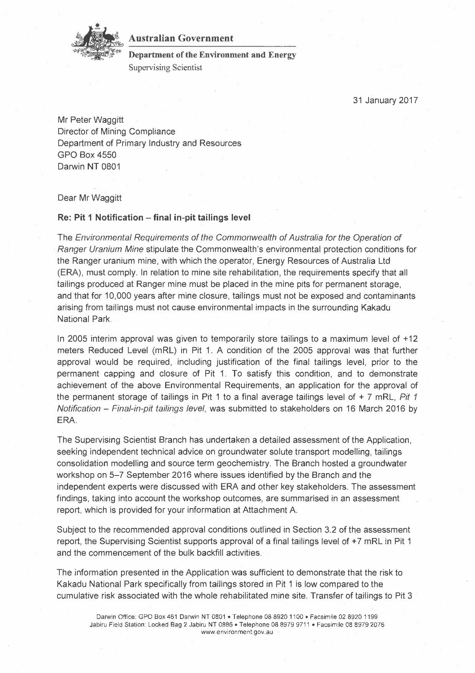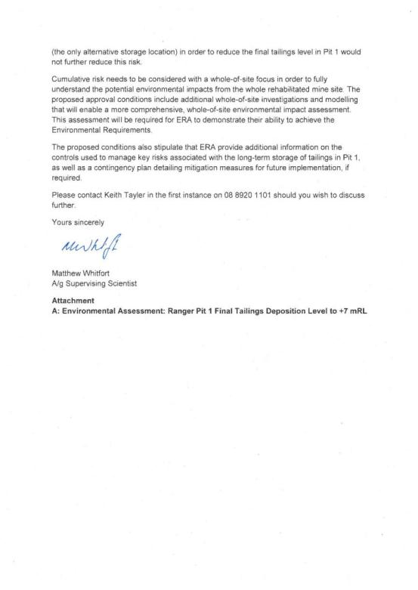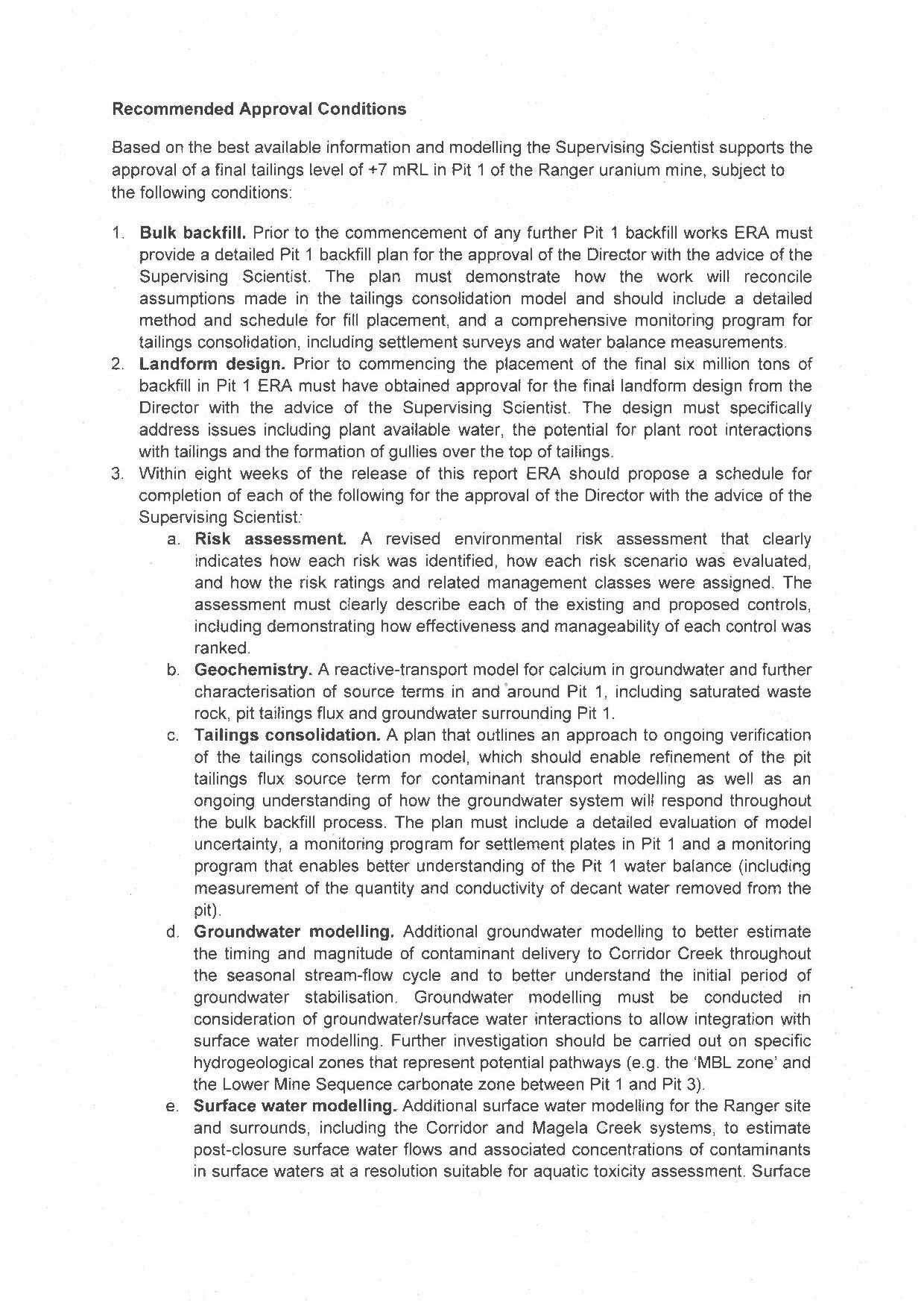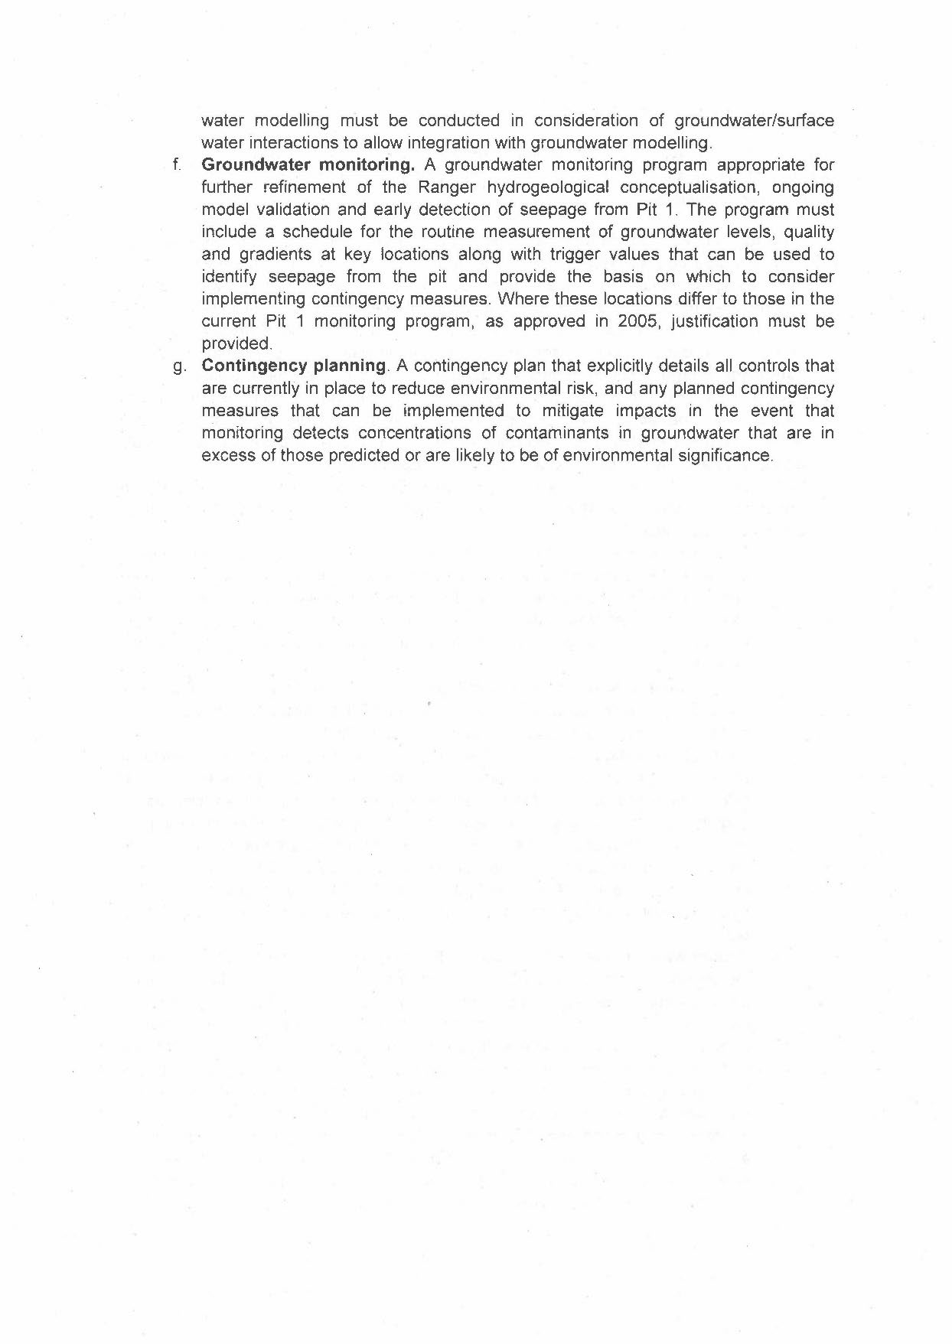

Appendix 2
Supervising Scientist Branch review of Pit 1 Notification: final in-pit tailings level

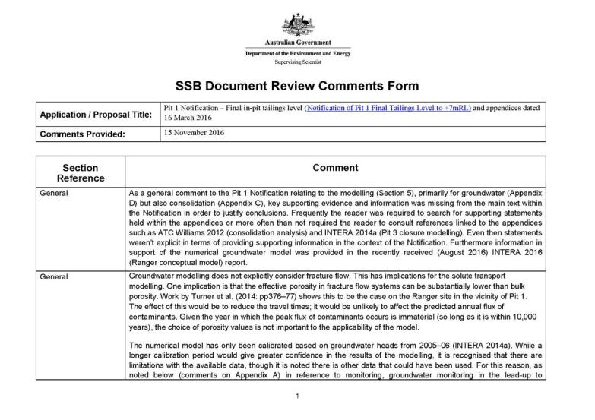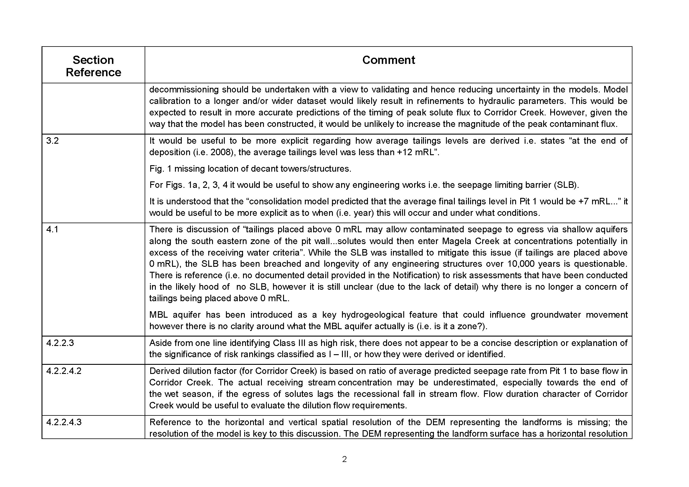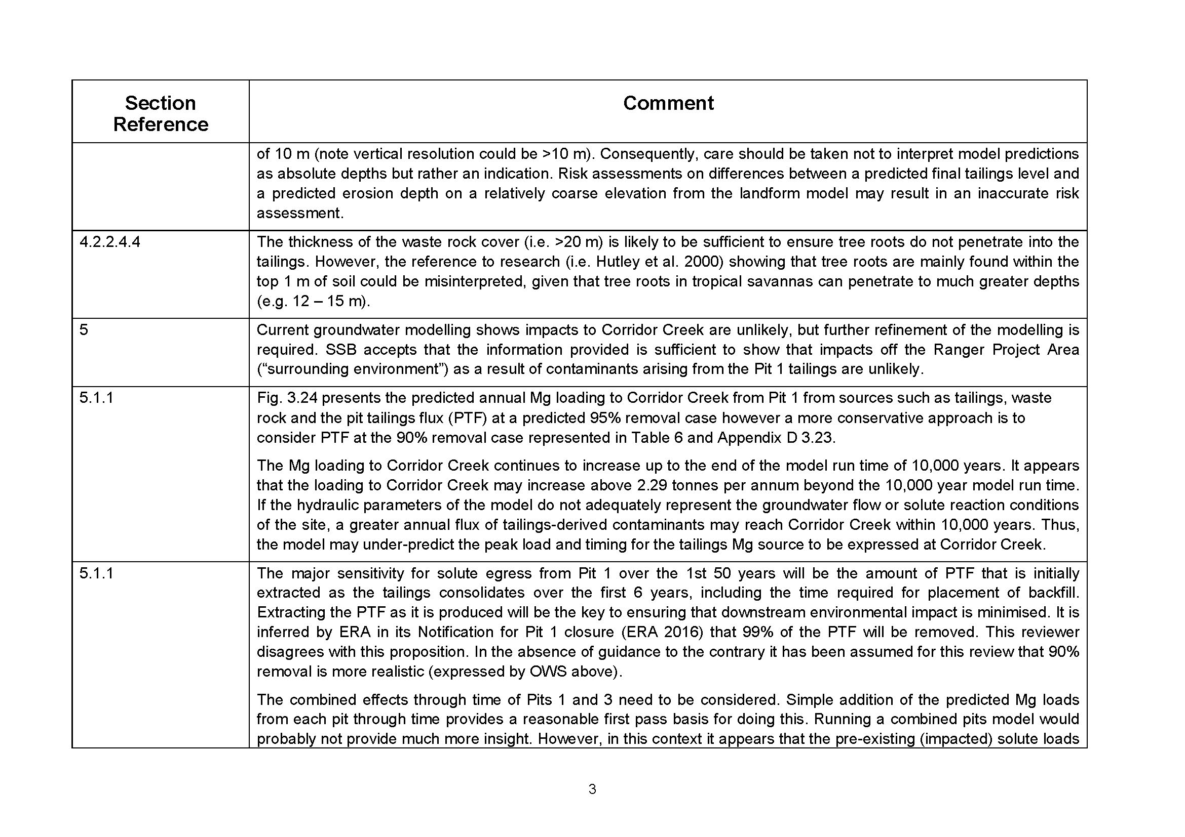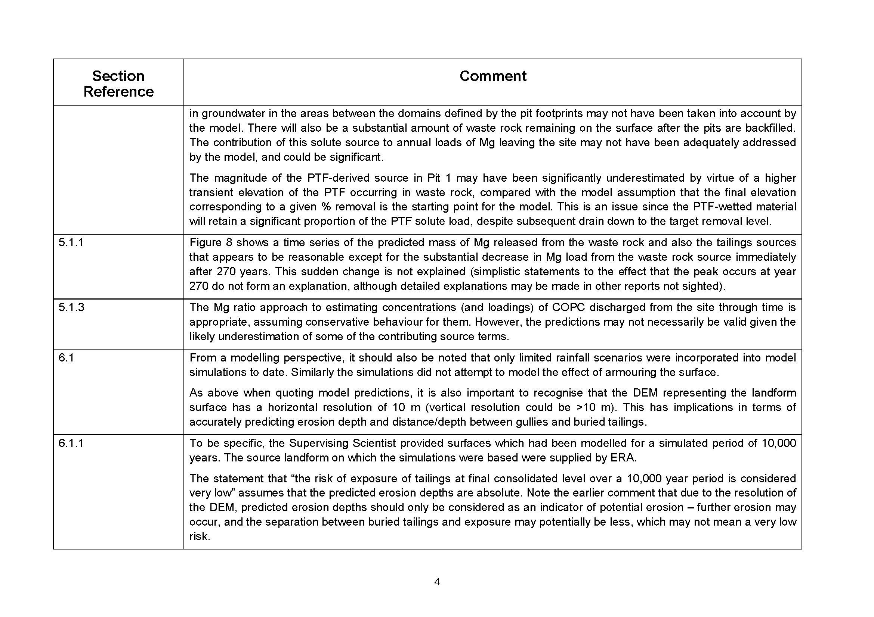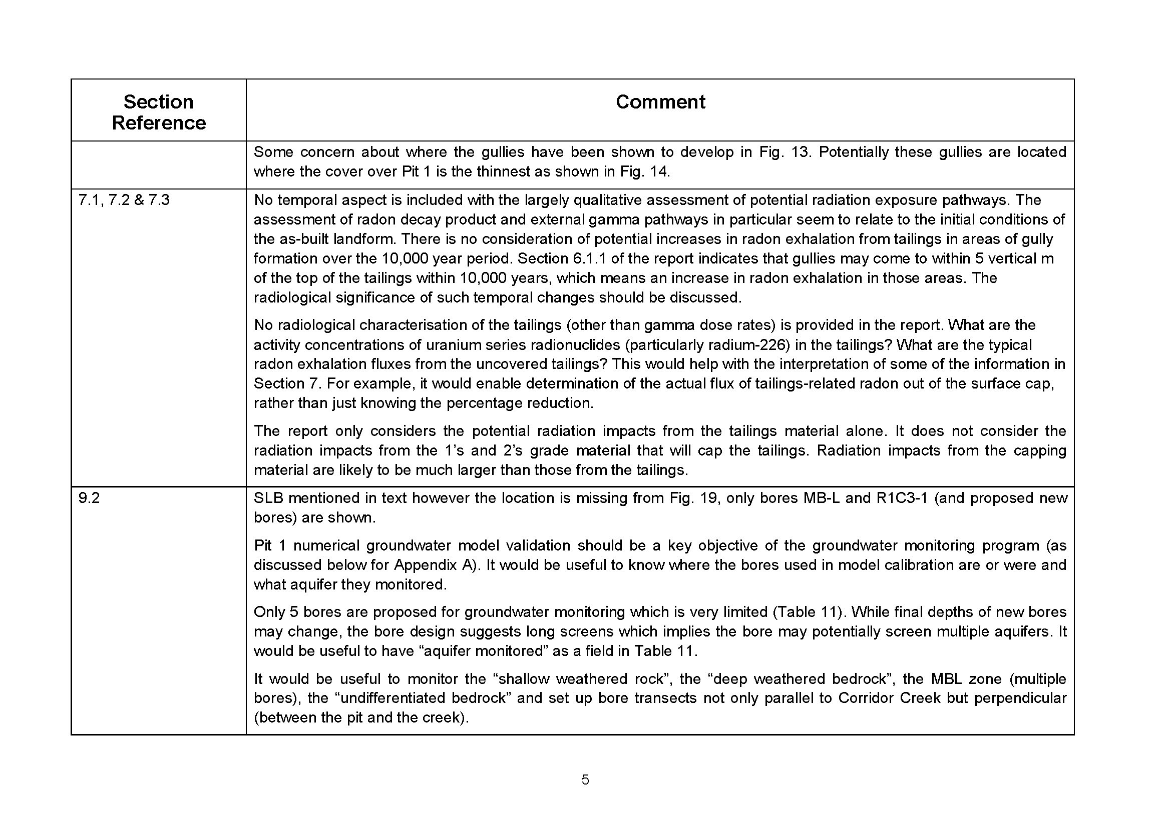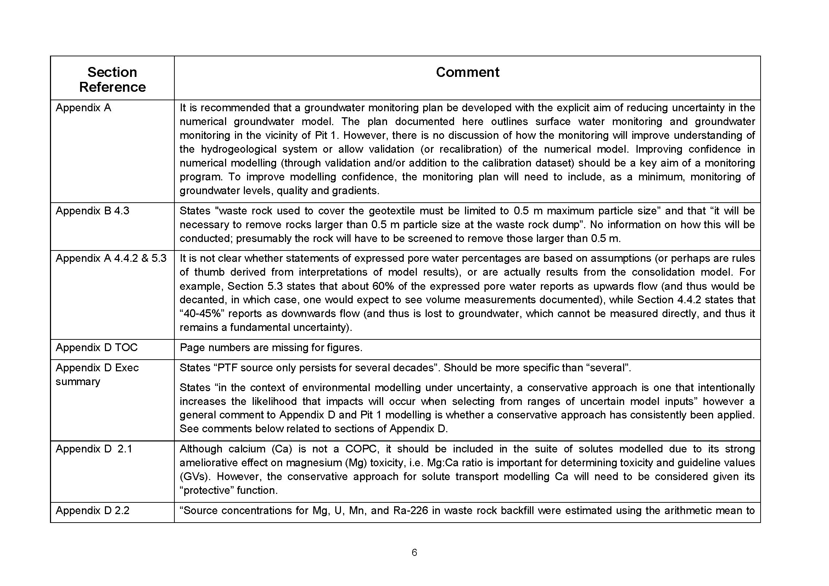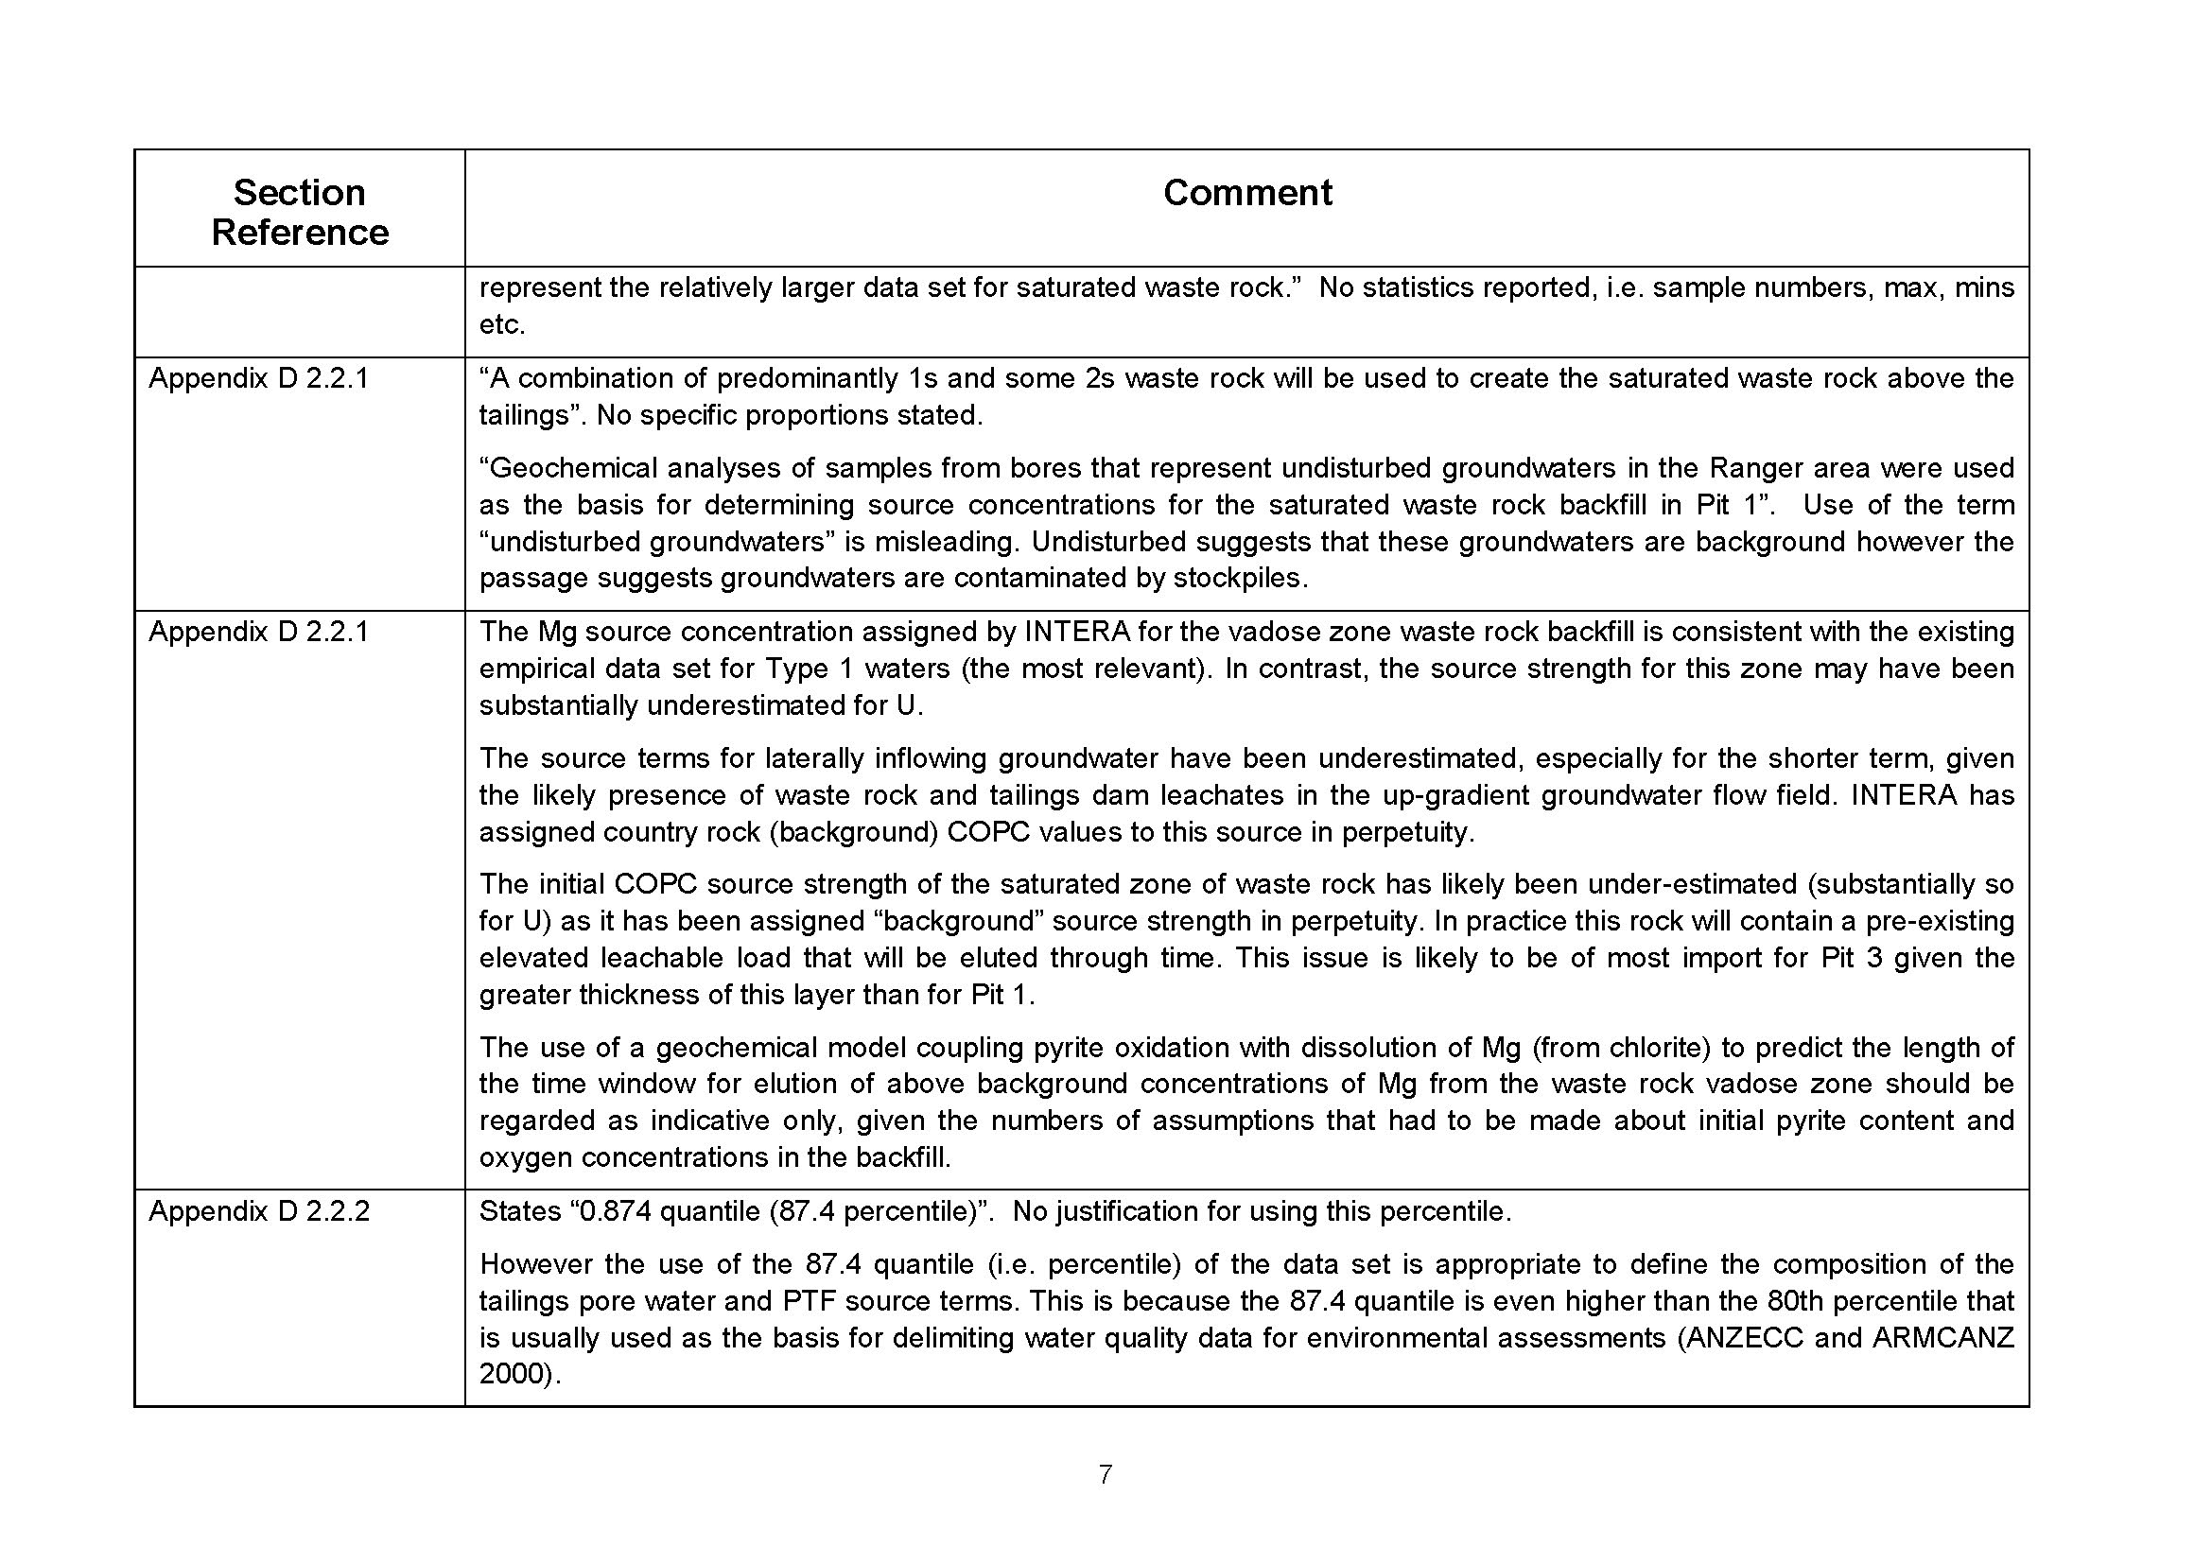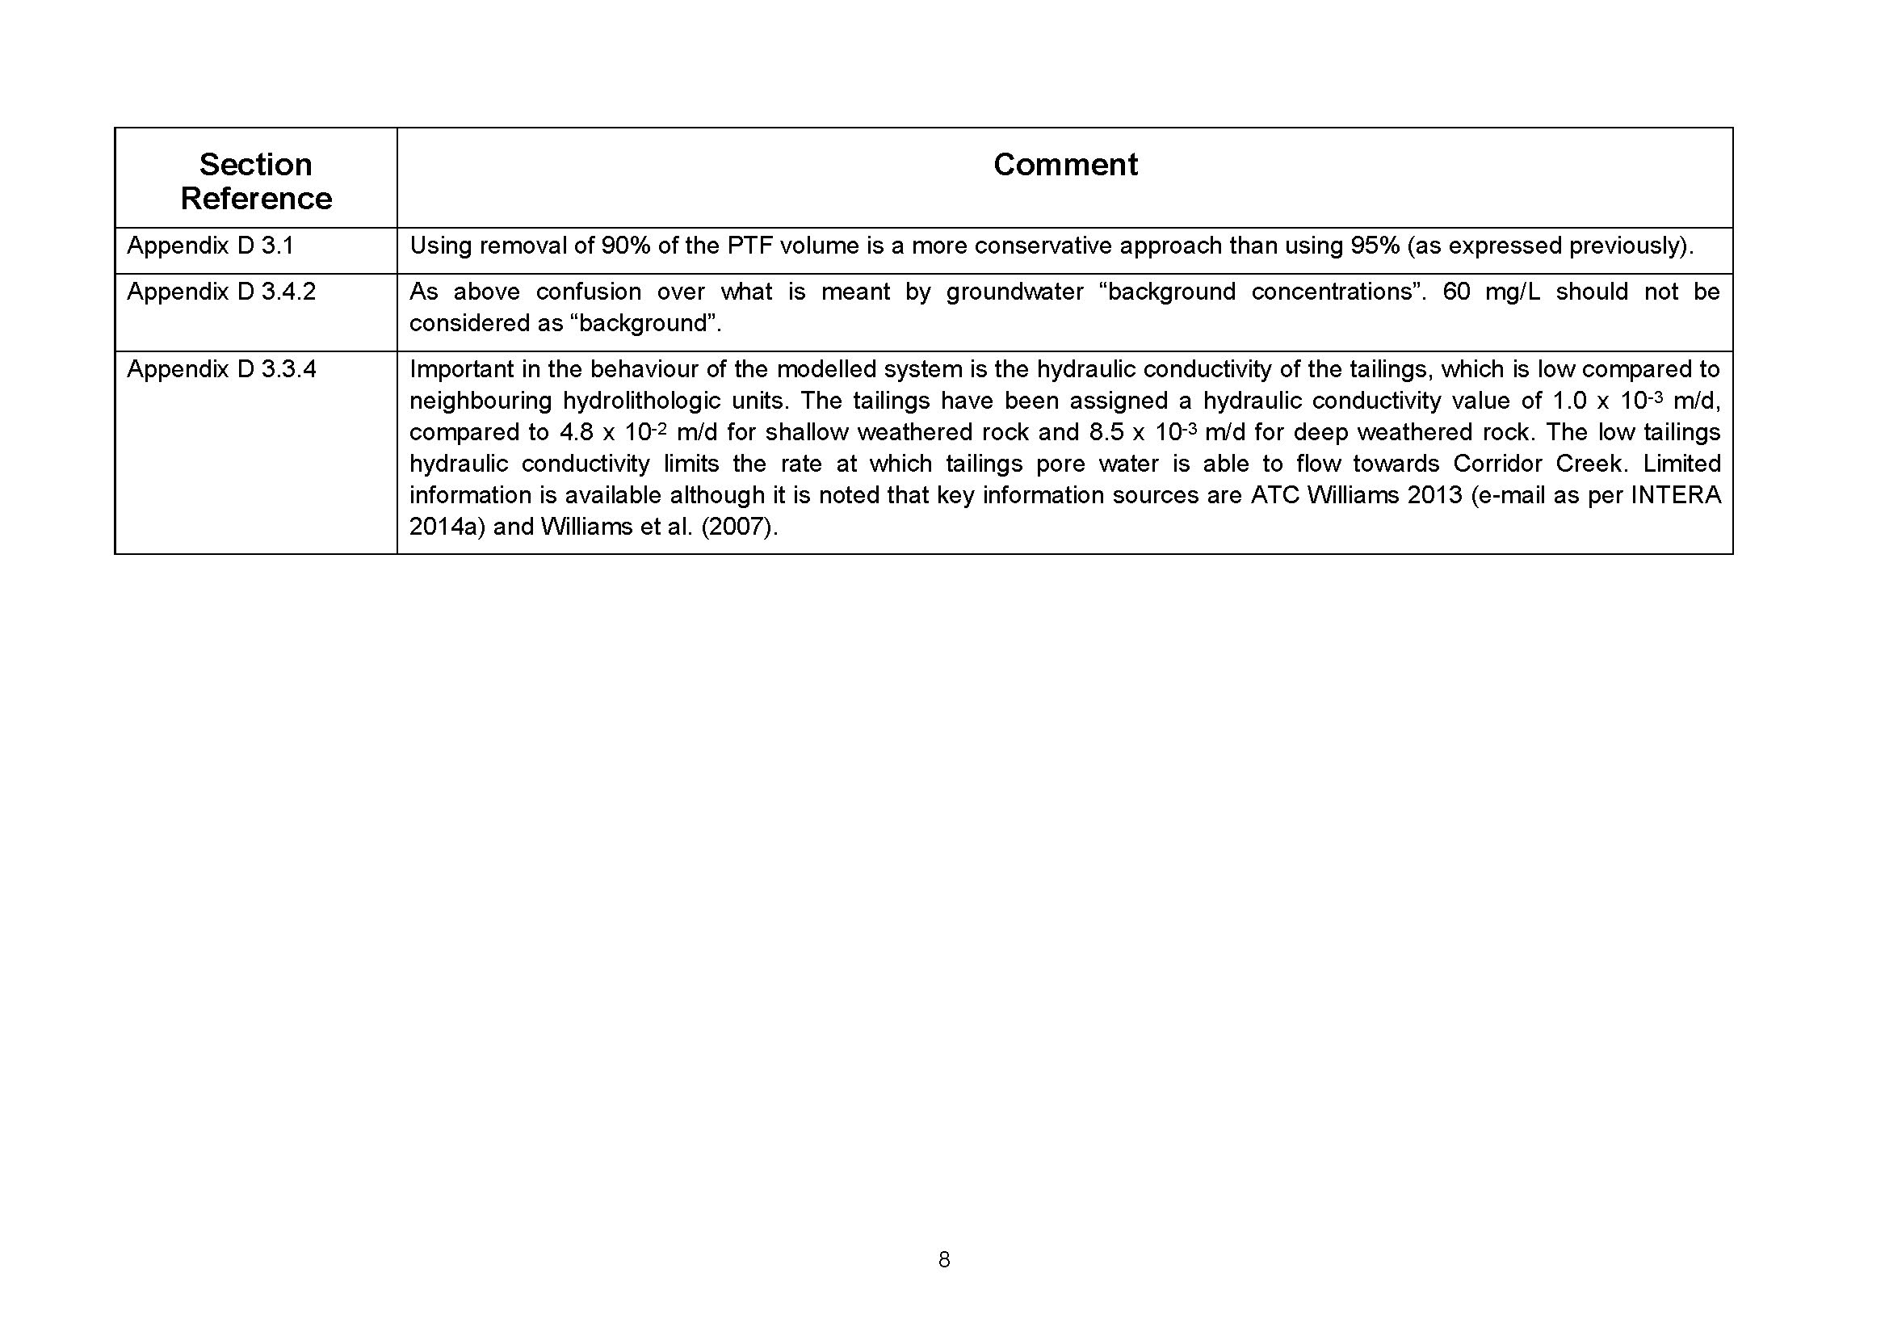

Appendix 3
Office of Water Science Branch review of Pit 1 Notification: final in-pit tailings level

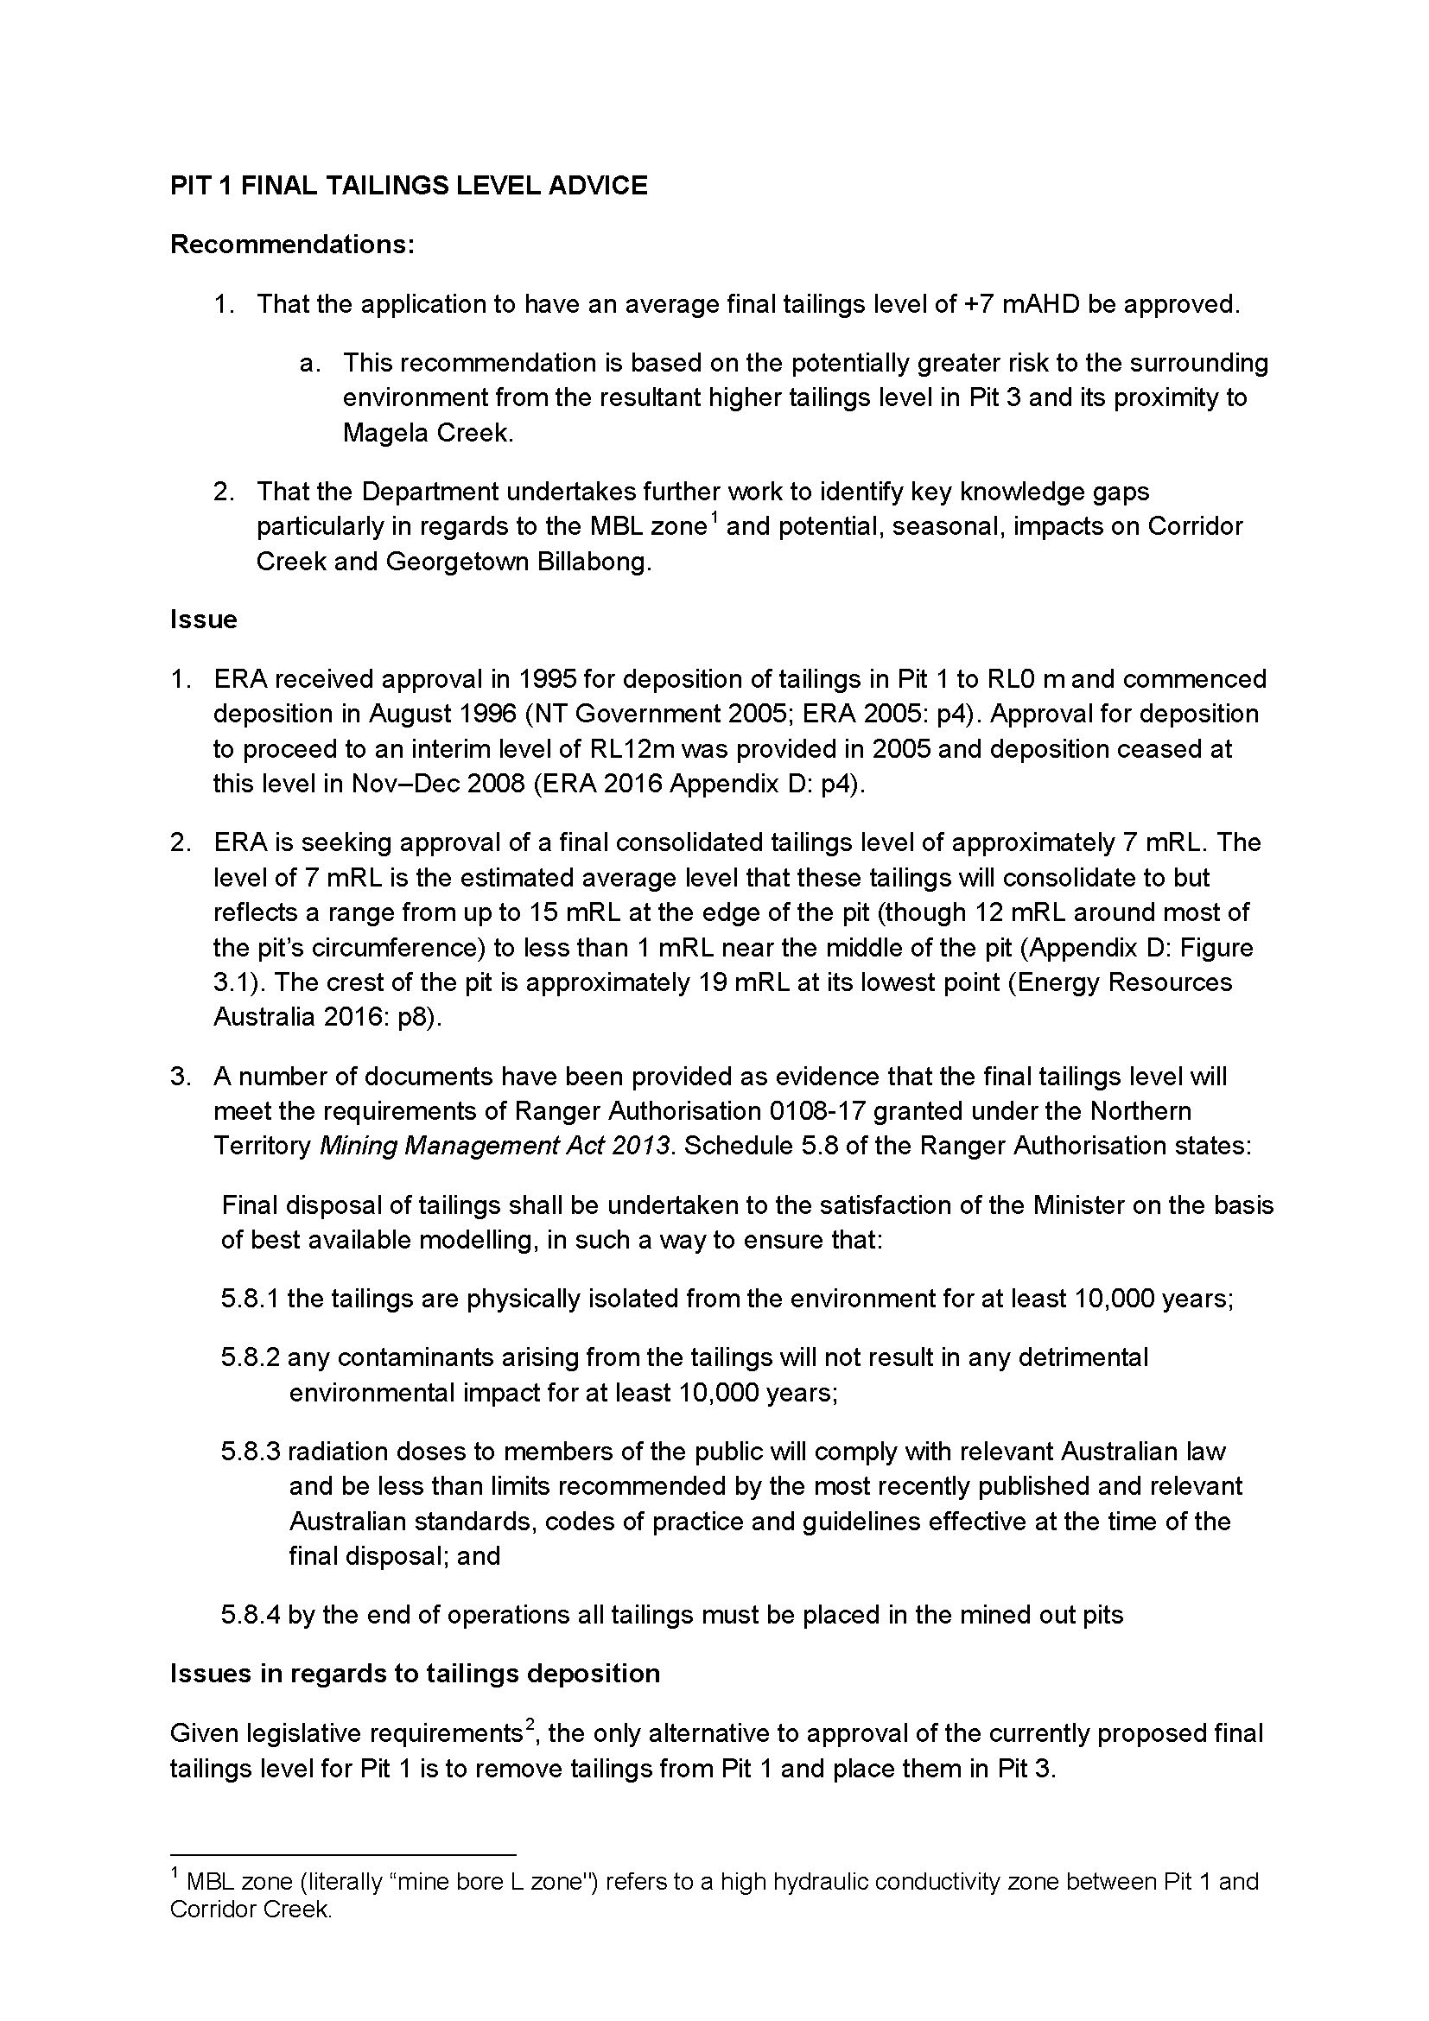

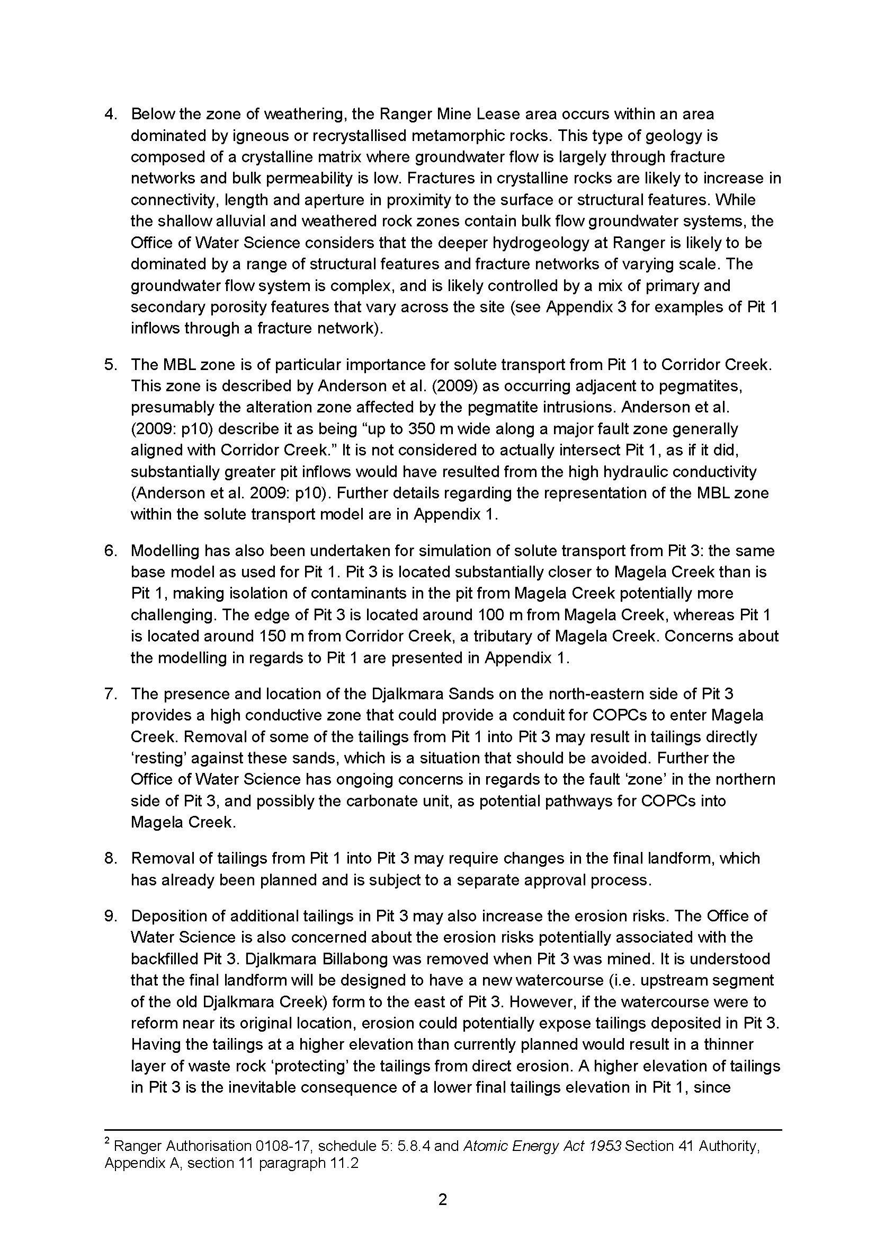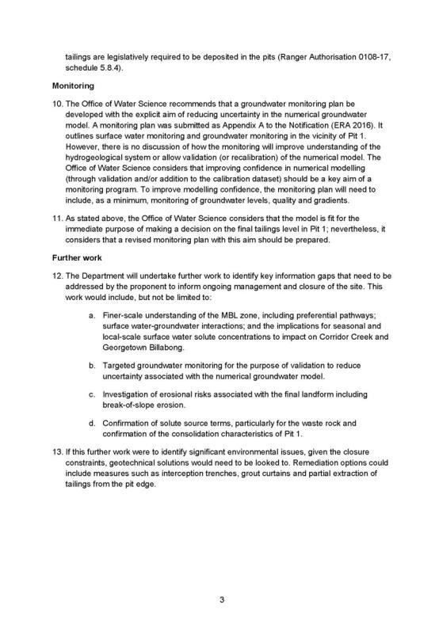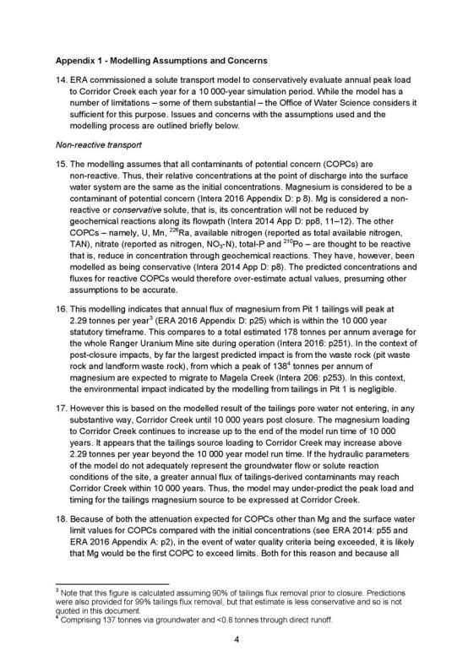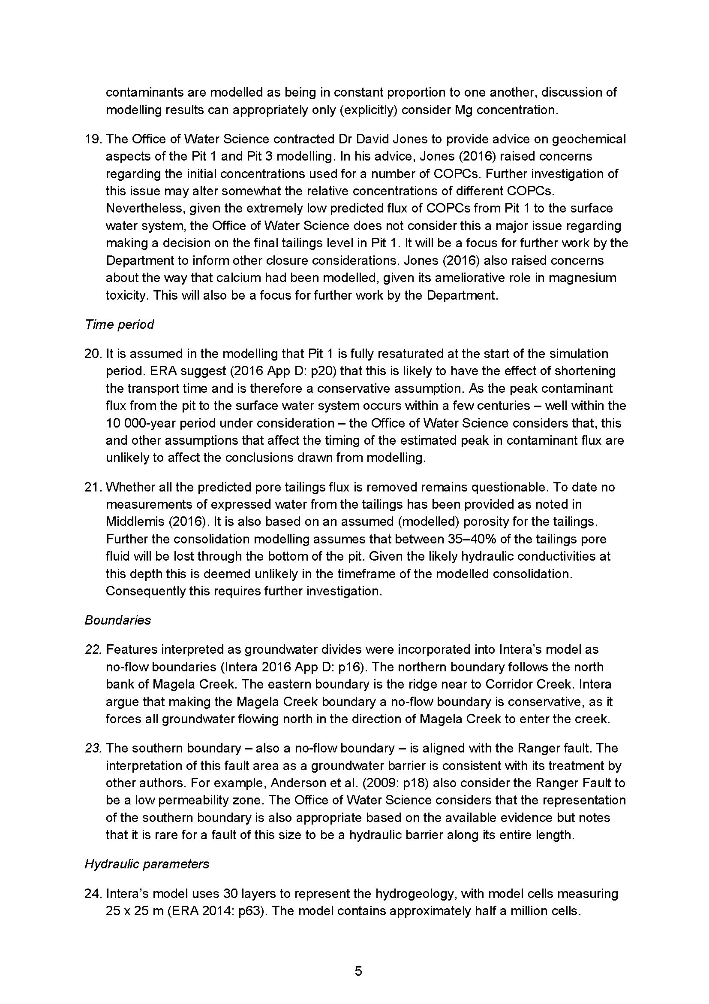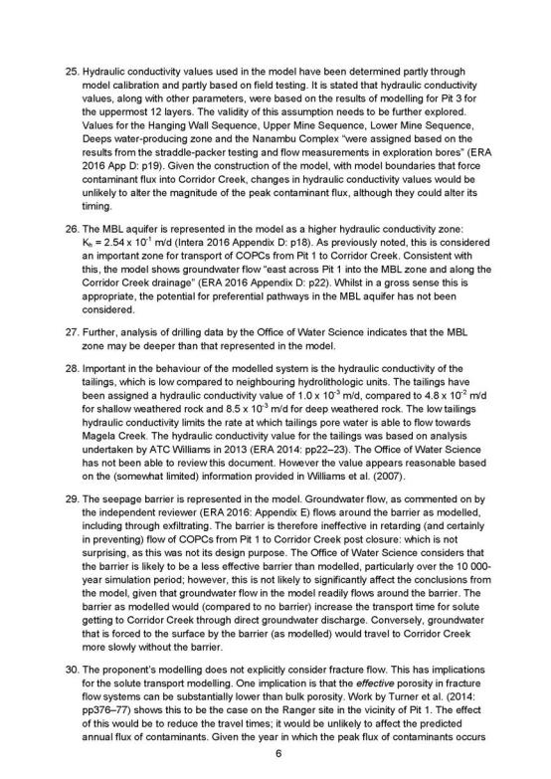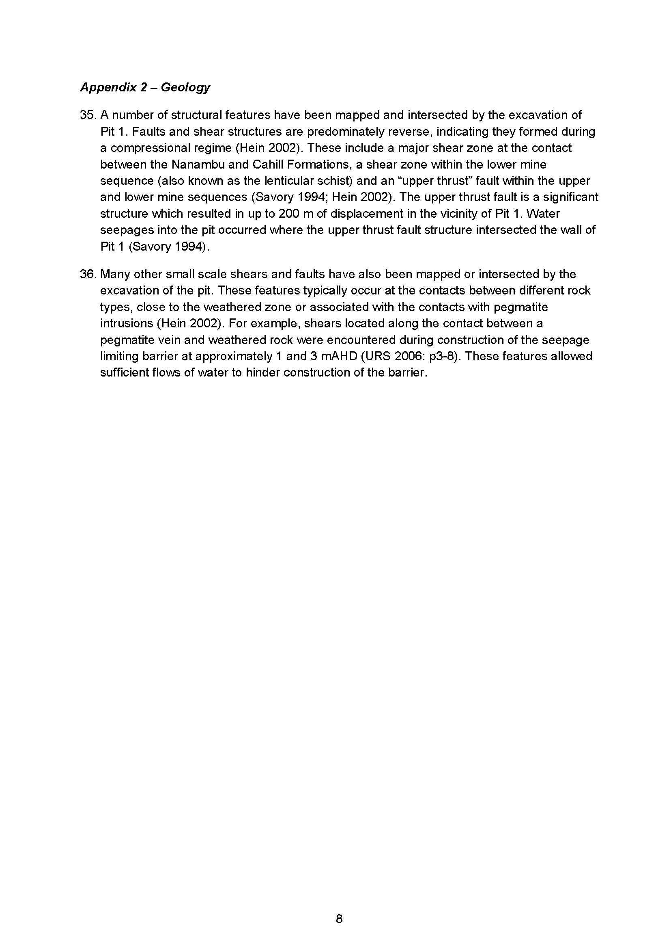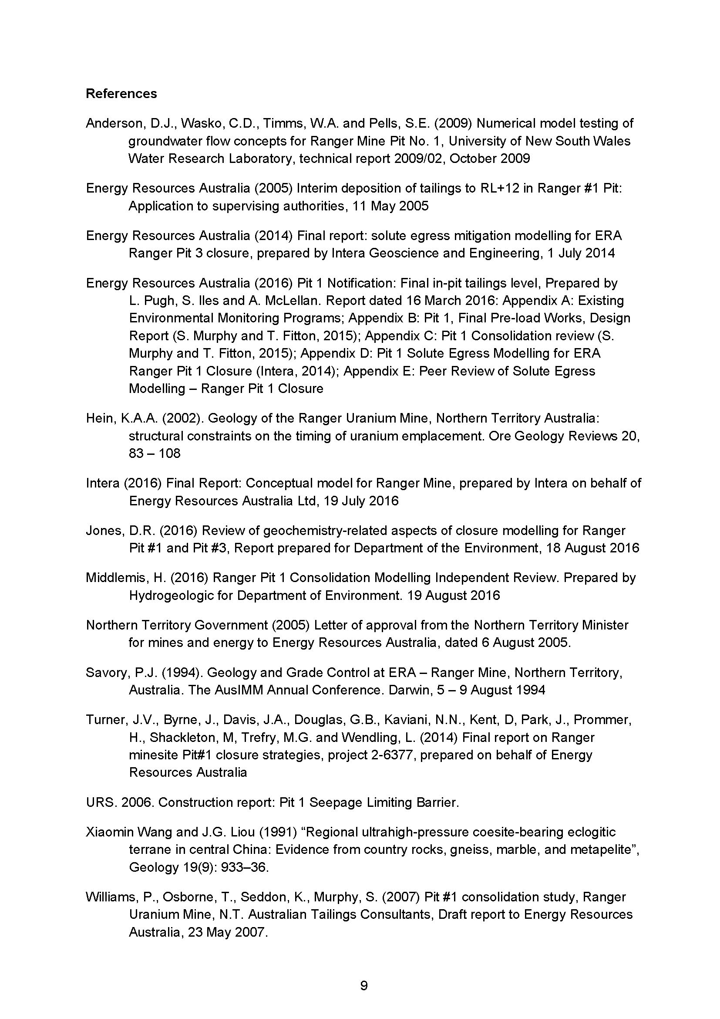

Appendix 4
Hydrogeologic Pty Ltd – Pit 1 consolidation model review: Ranger Pit 1 Consolidation Modelling Independent Review

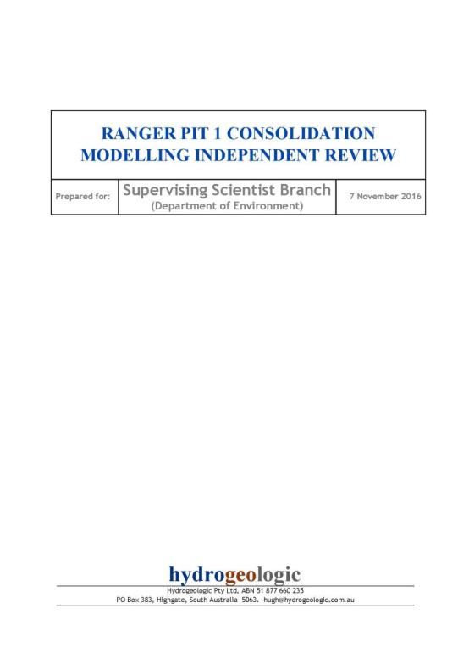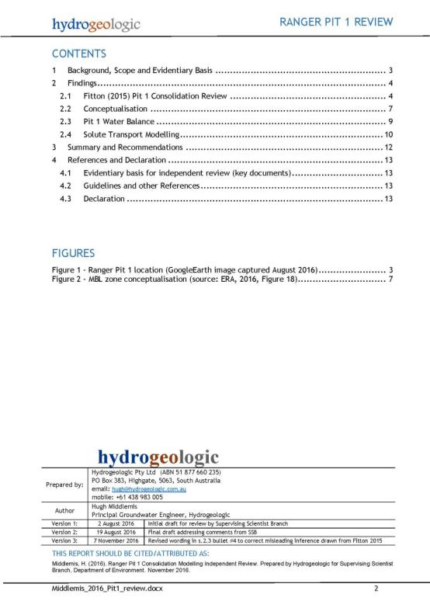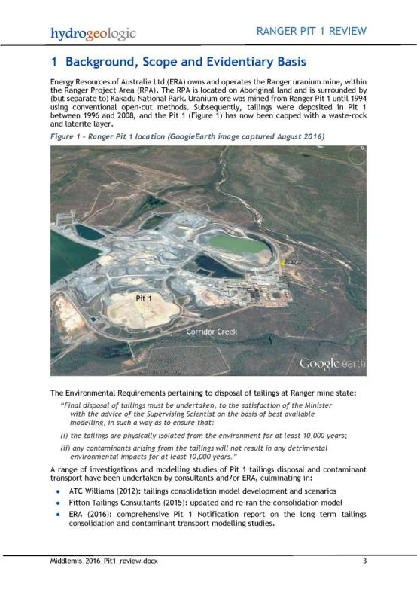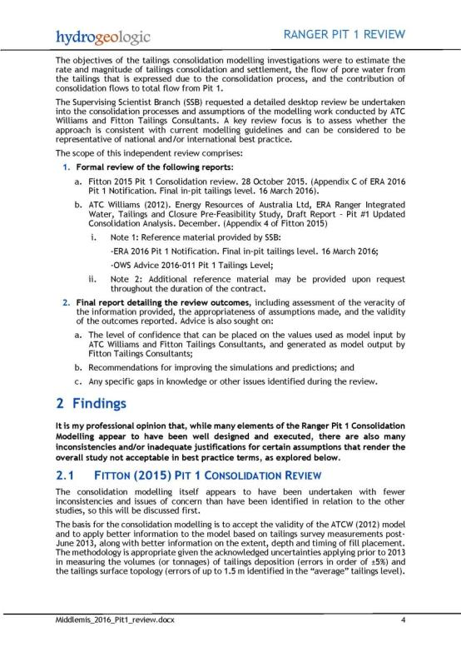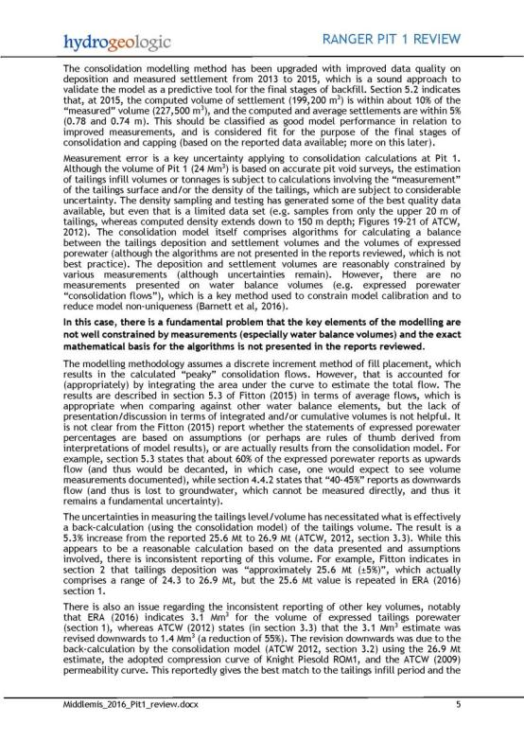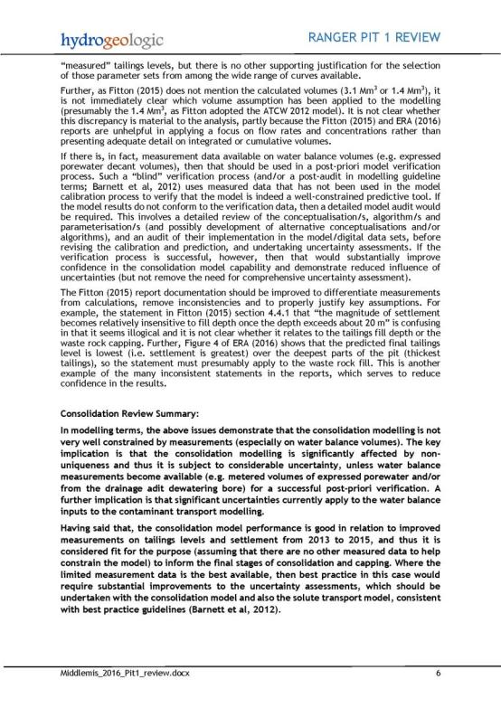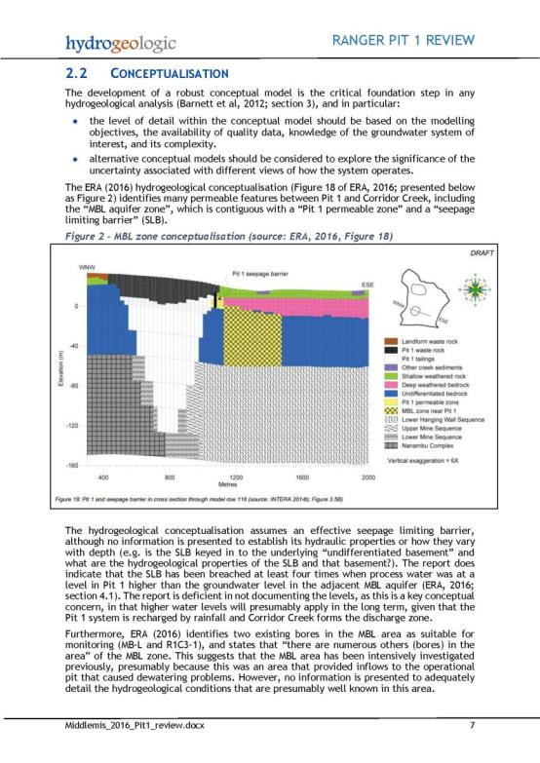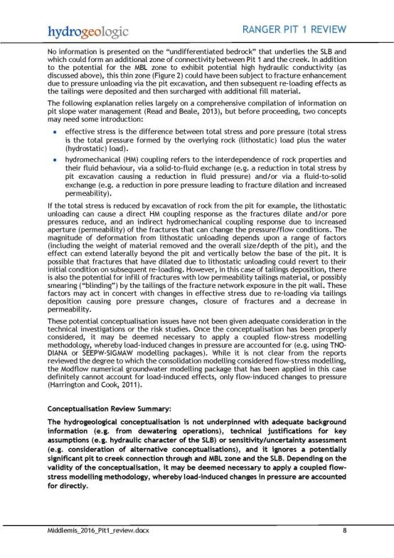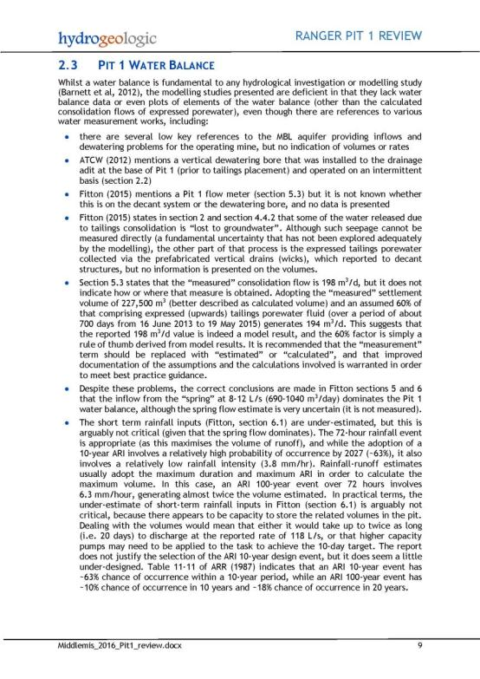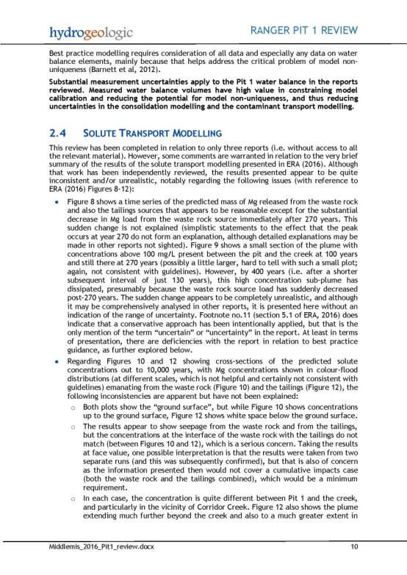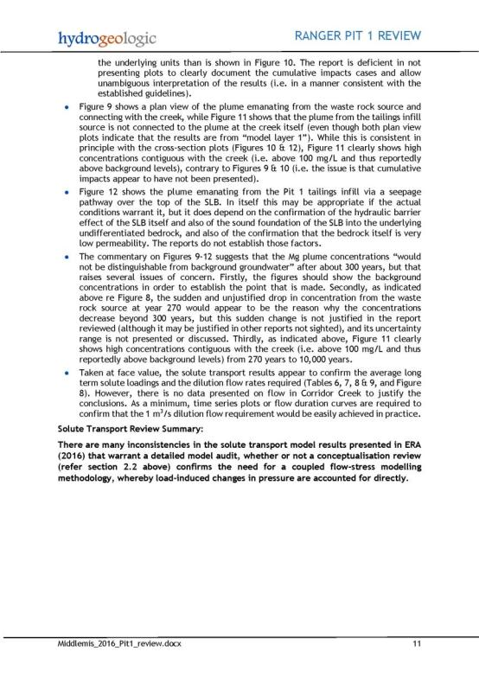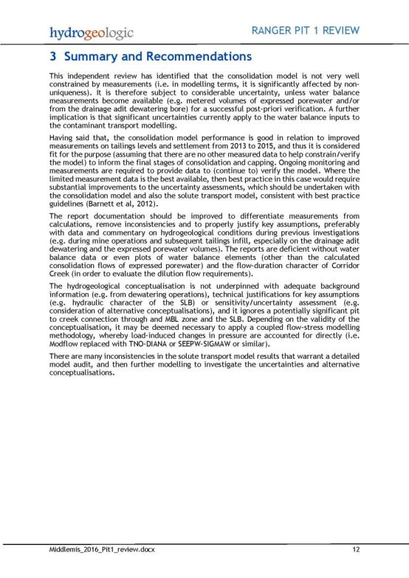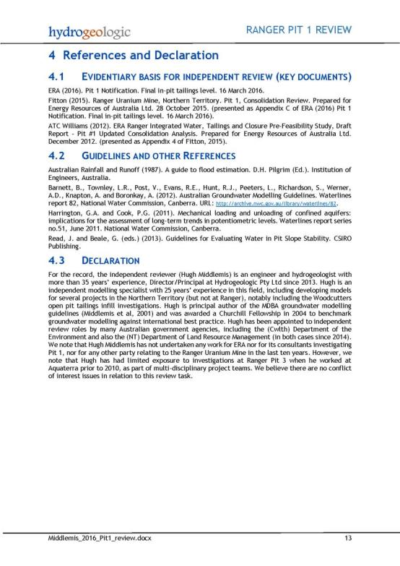

Appendix 5
South Australian Department of Environment, Water and Natural Resources – Pit 1 groundwater and contaminant transport model review: Review of Contaminant Egress Mitigation Modelling for Ranger Pit 1 Closure

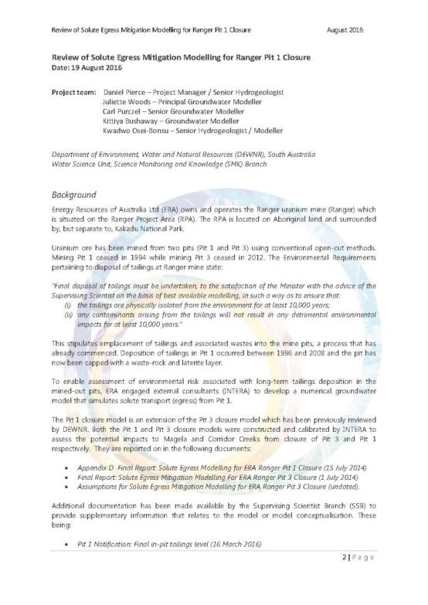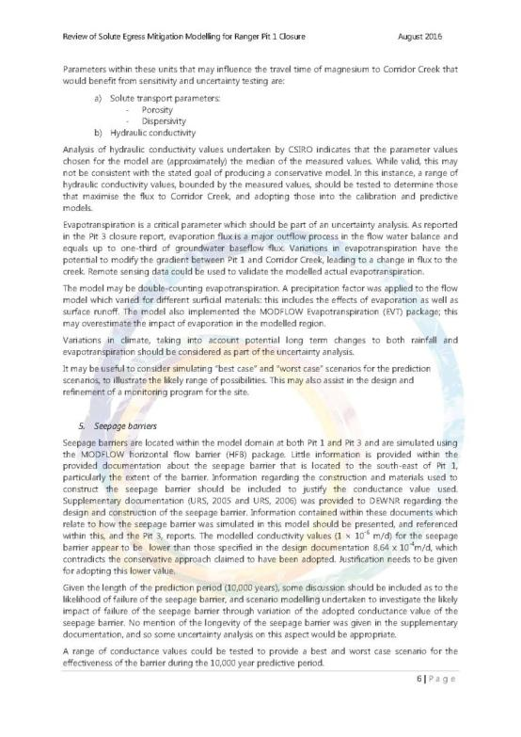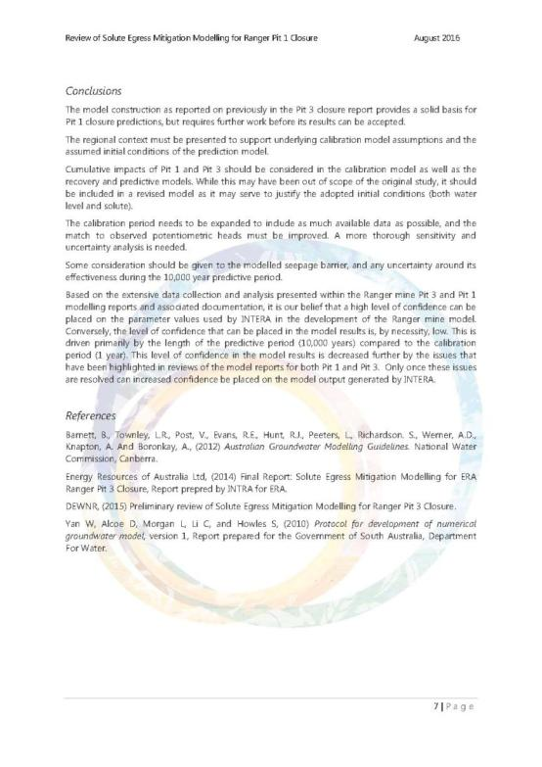
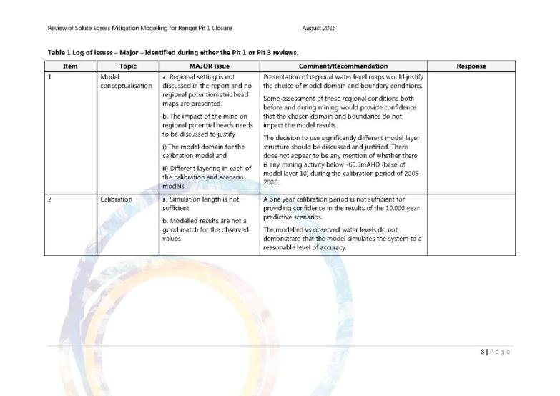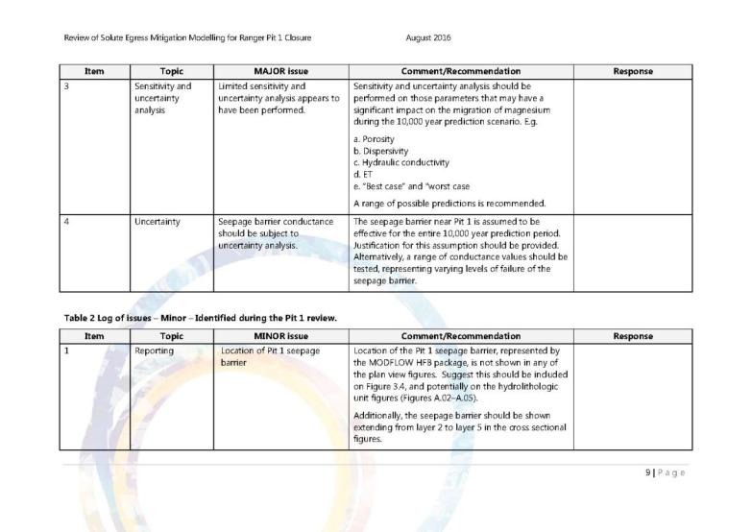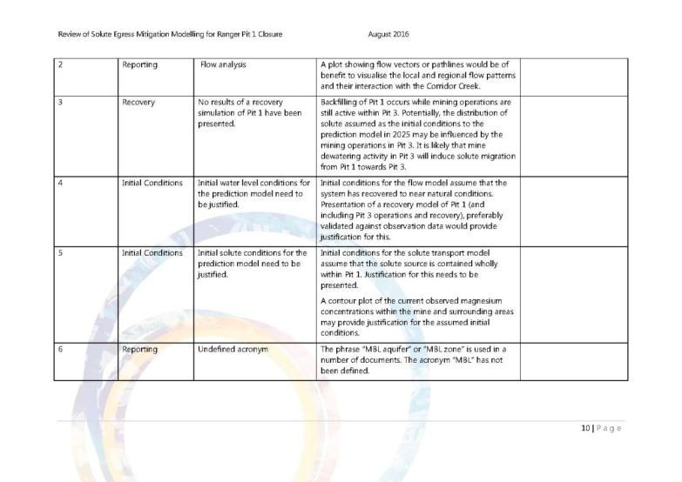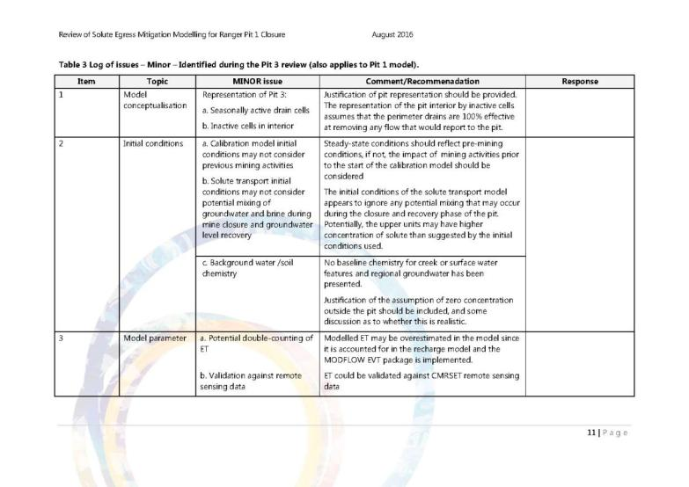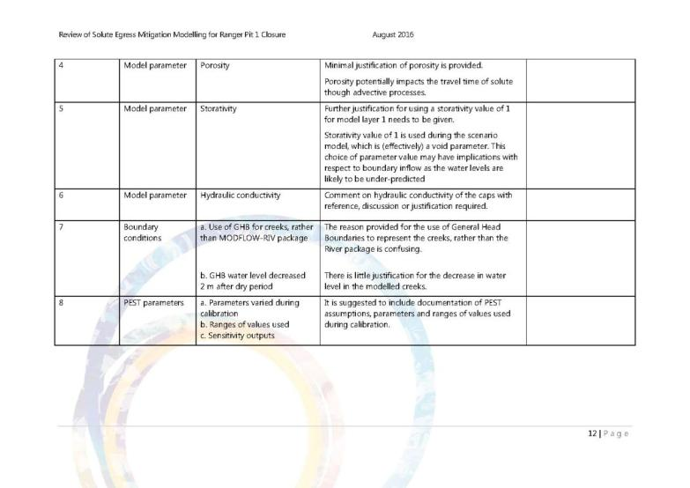

Appendix 6
DR Jones Environmental Excellence – Mine site geochemistry review: Review of Geochemistry-Related Aspects of Closure Modelling for Ranger Pit 1 and Pit 3

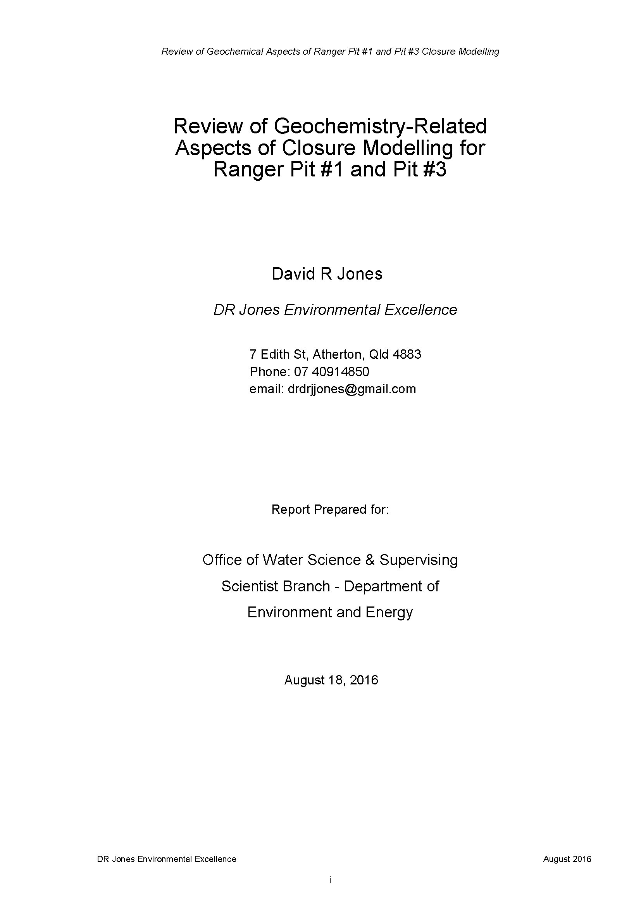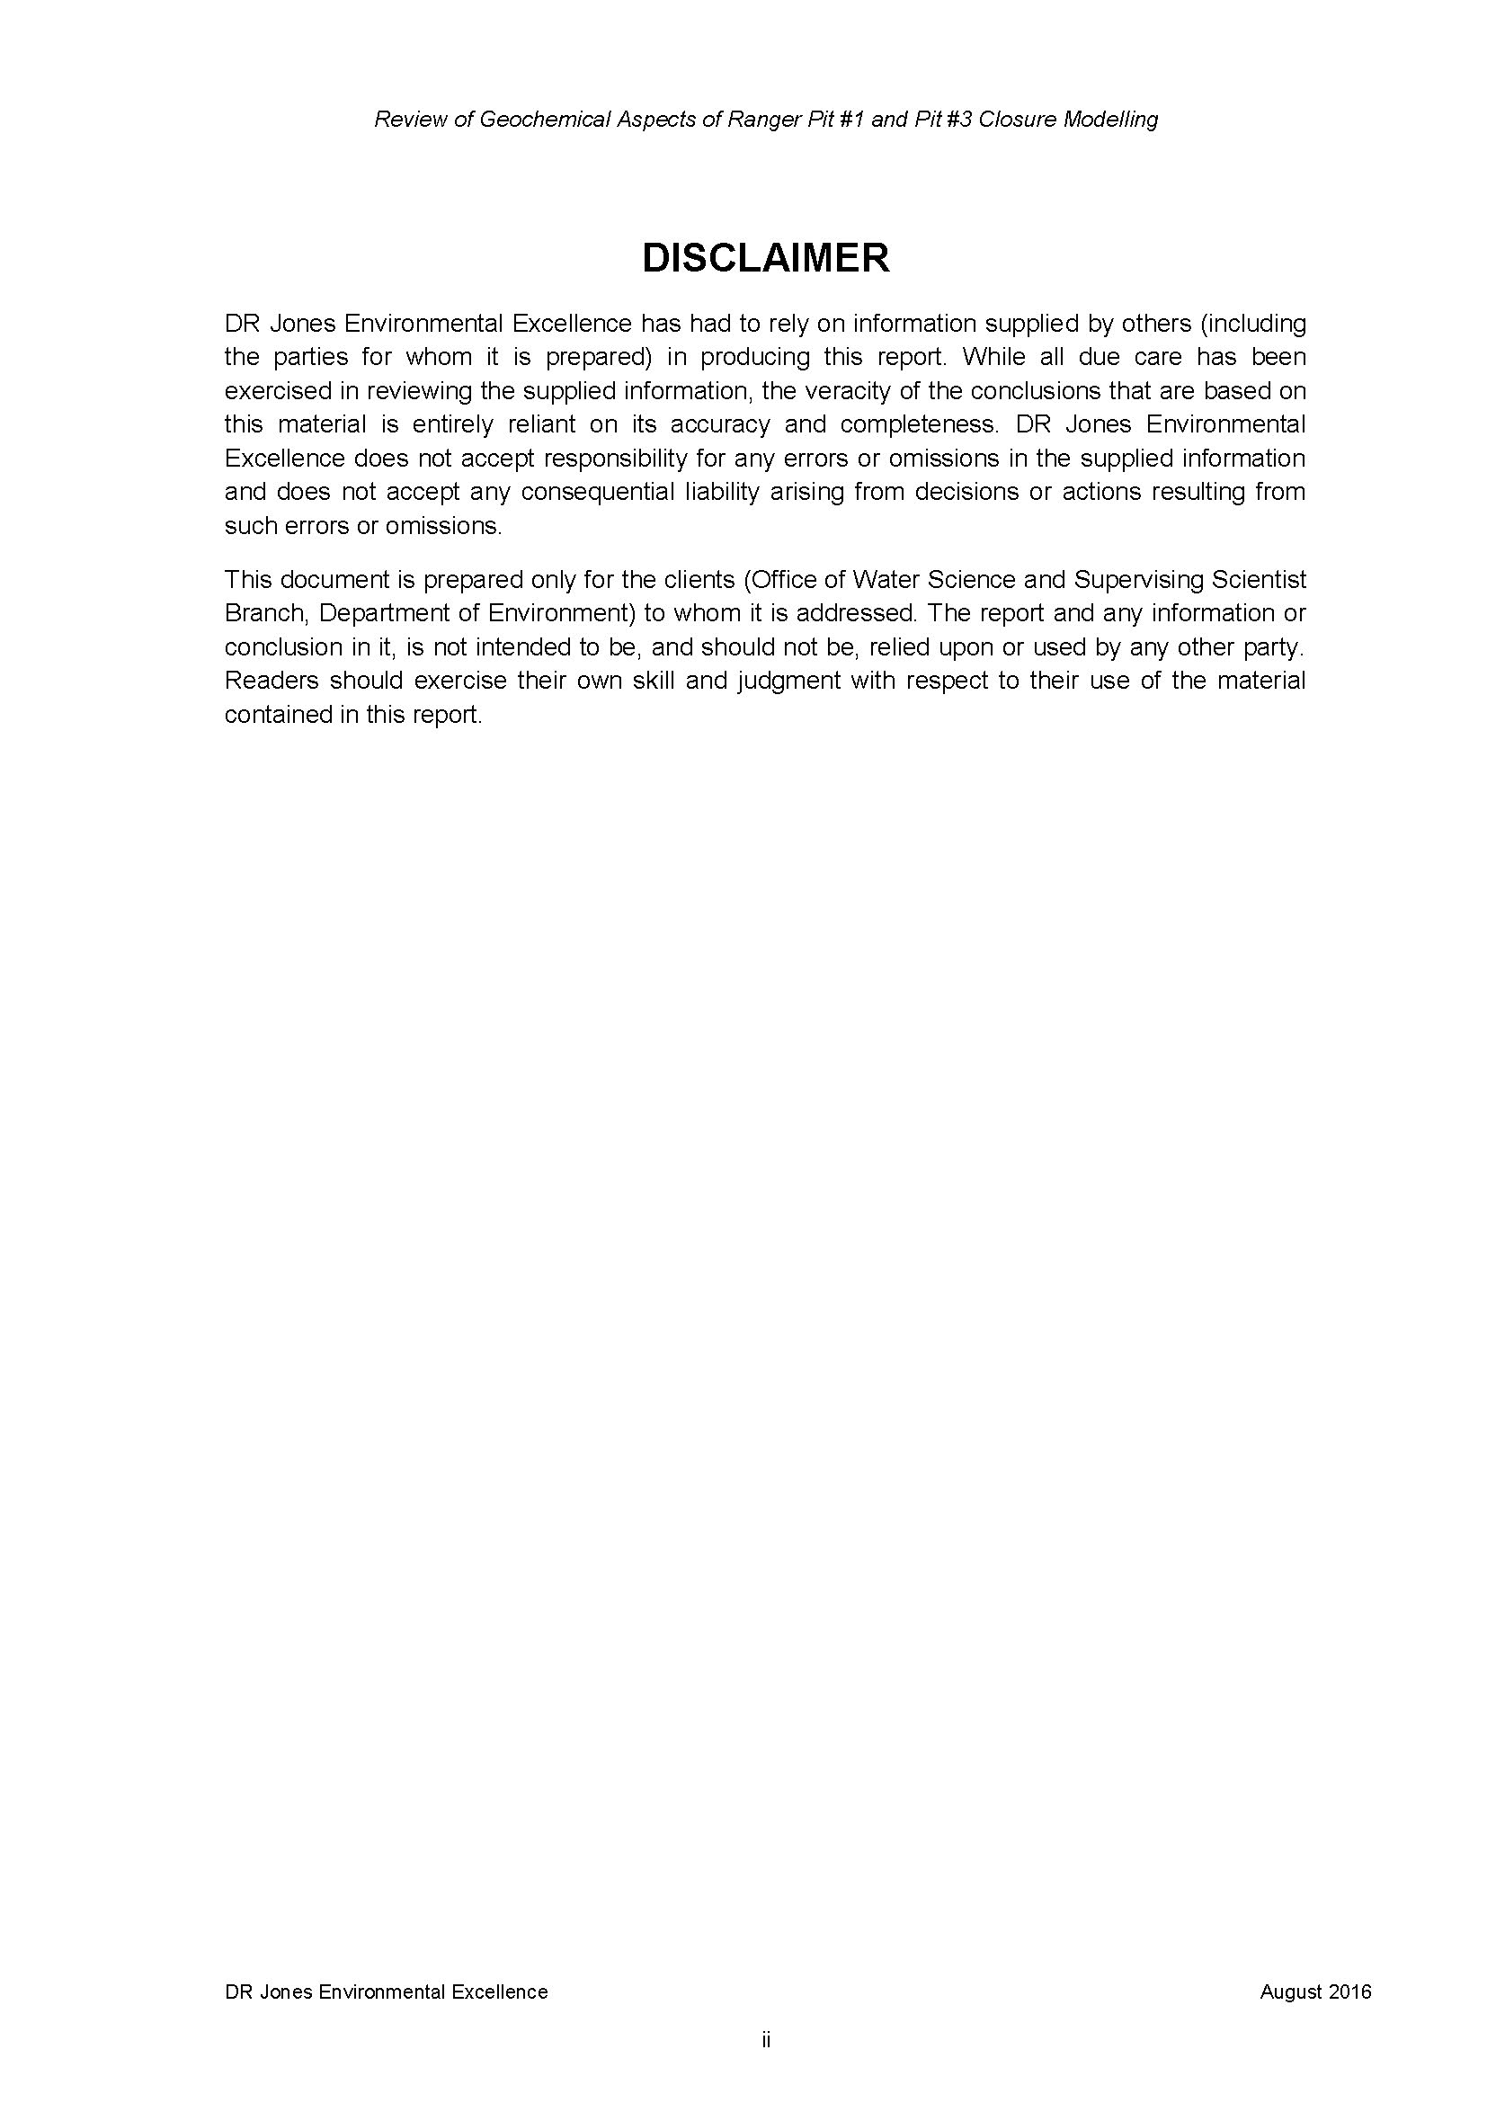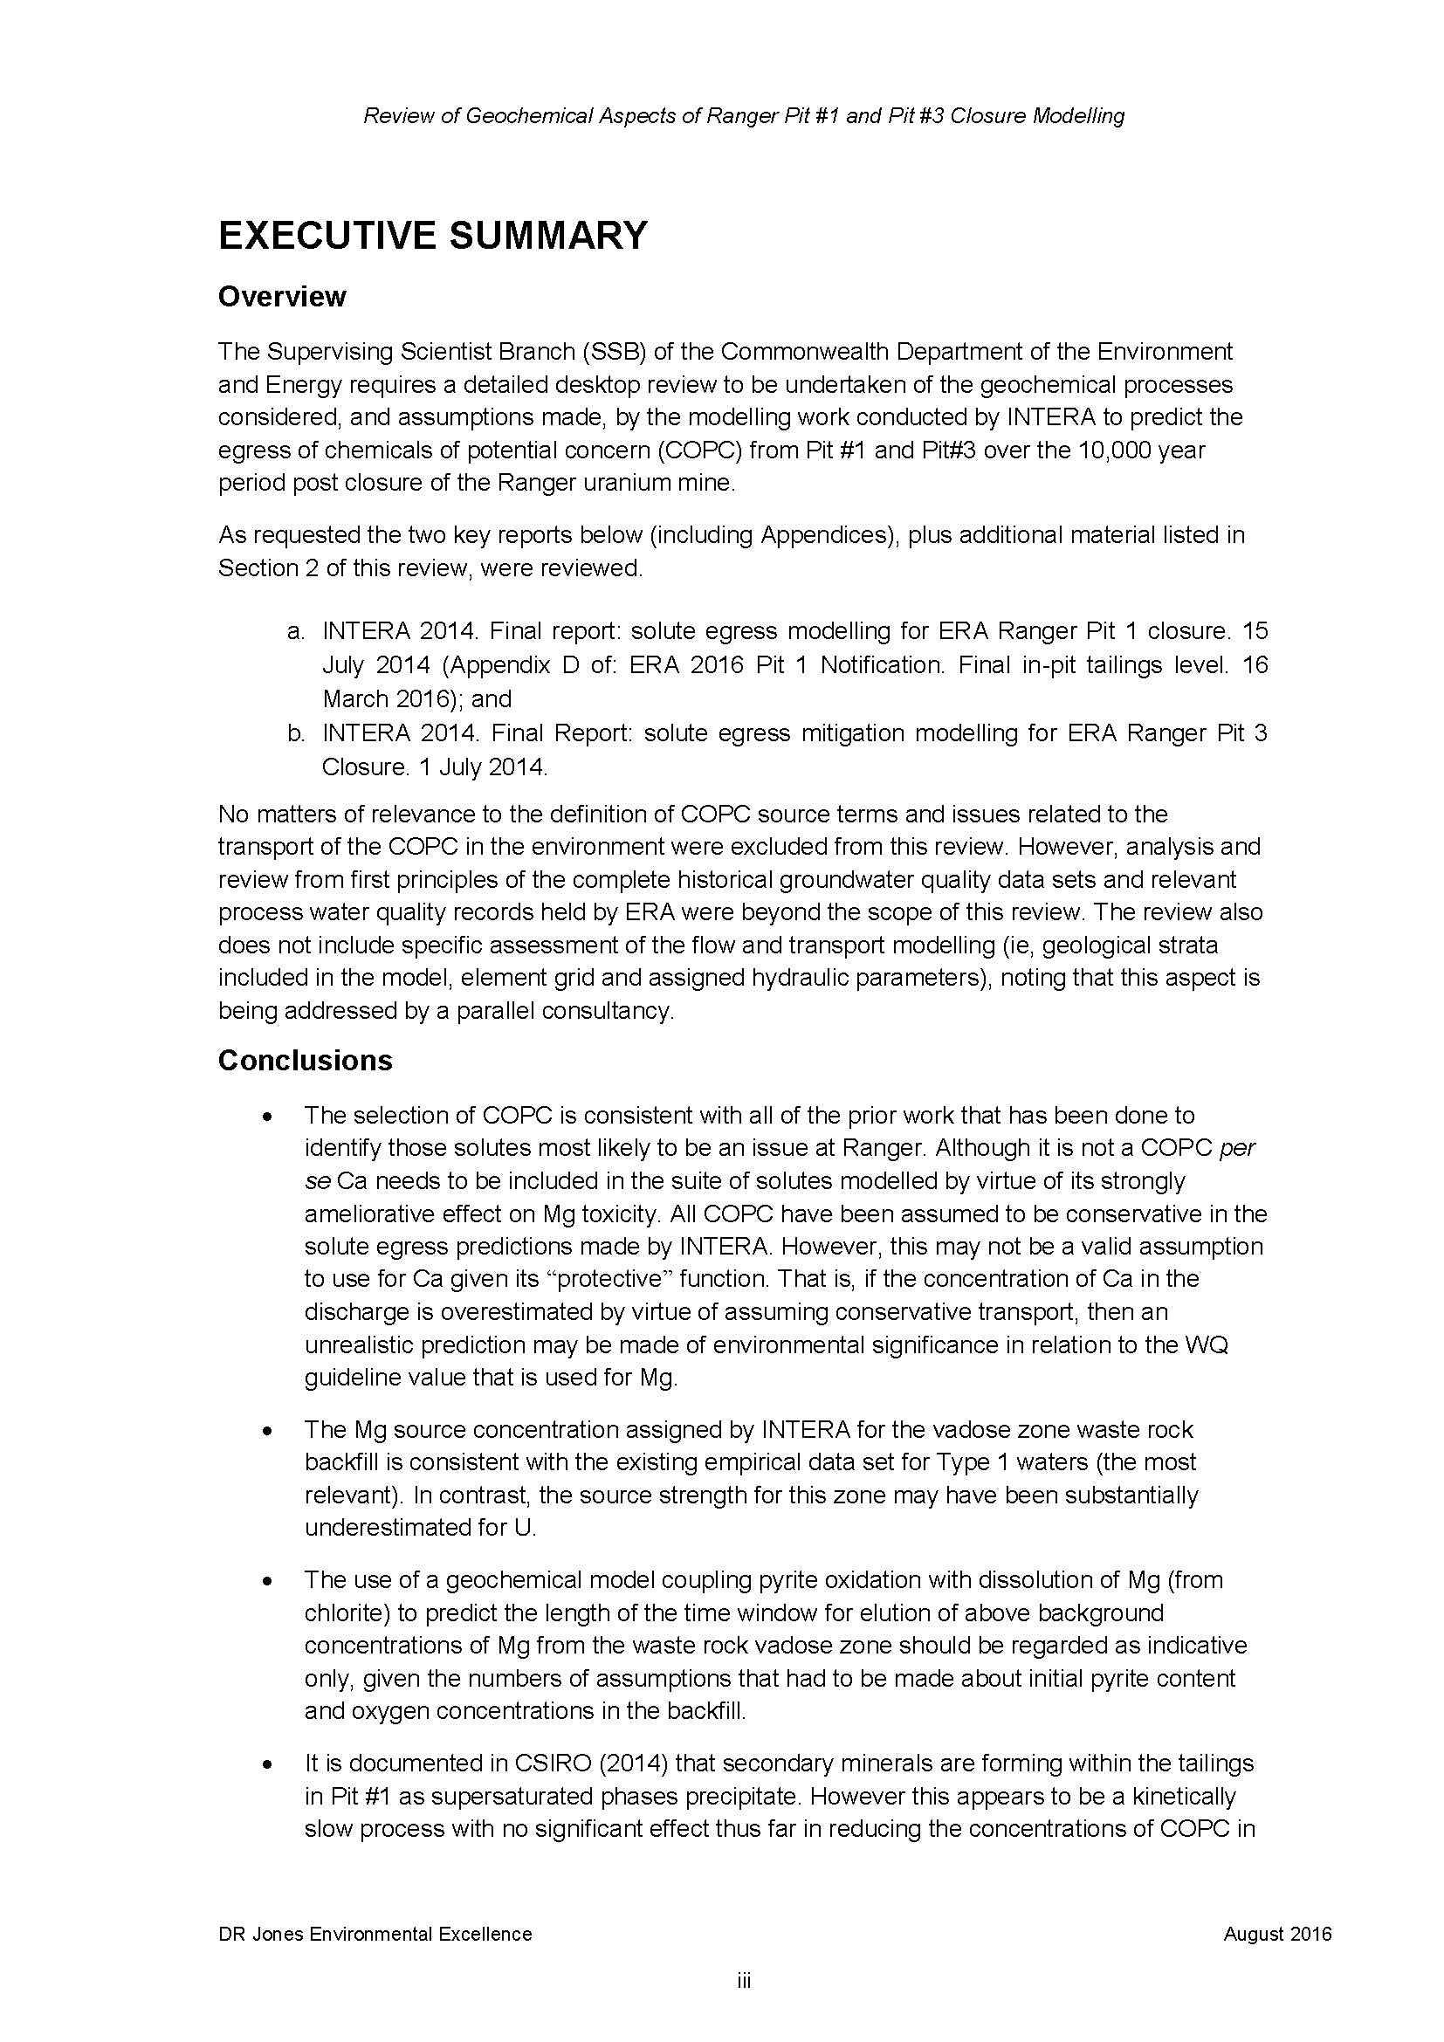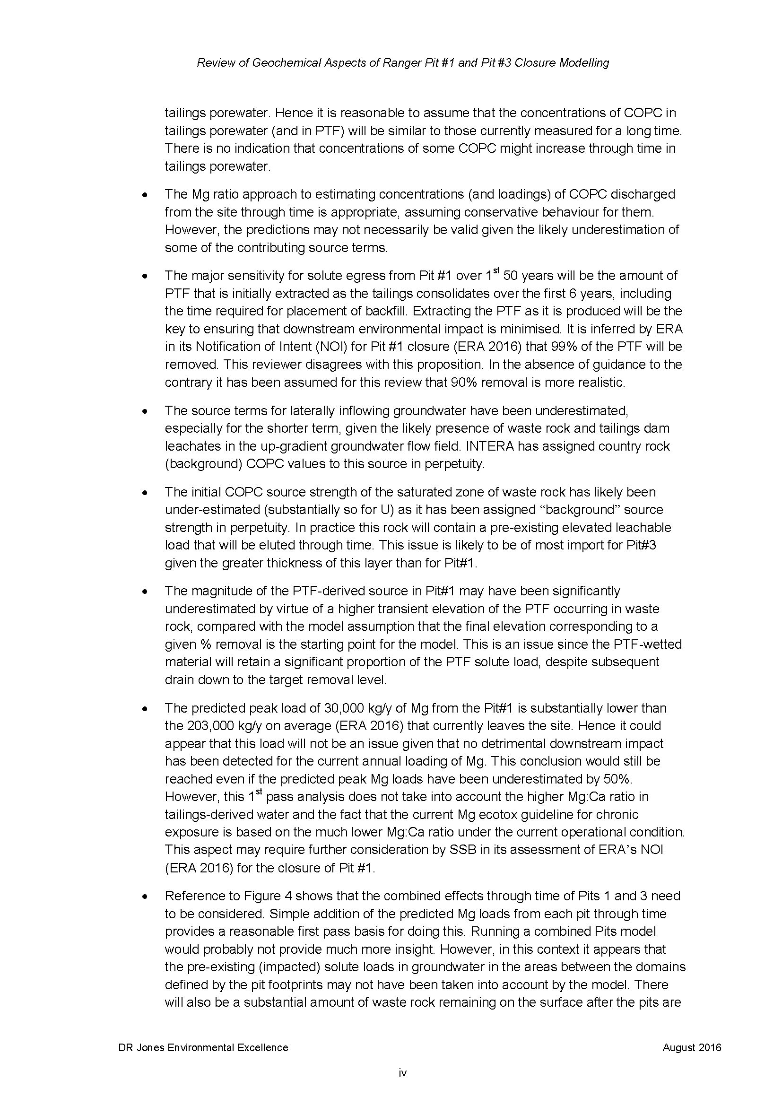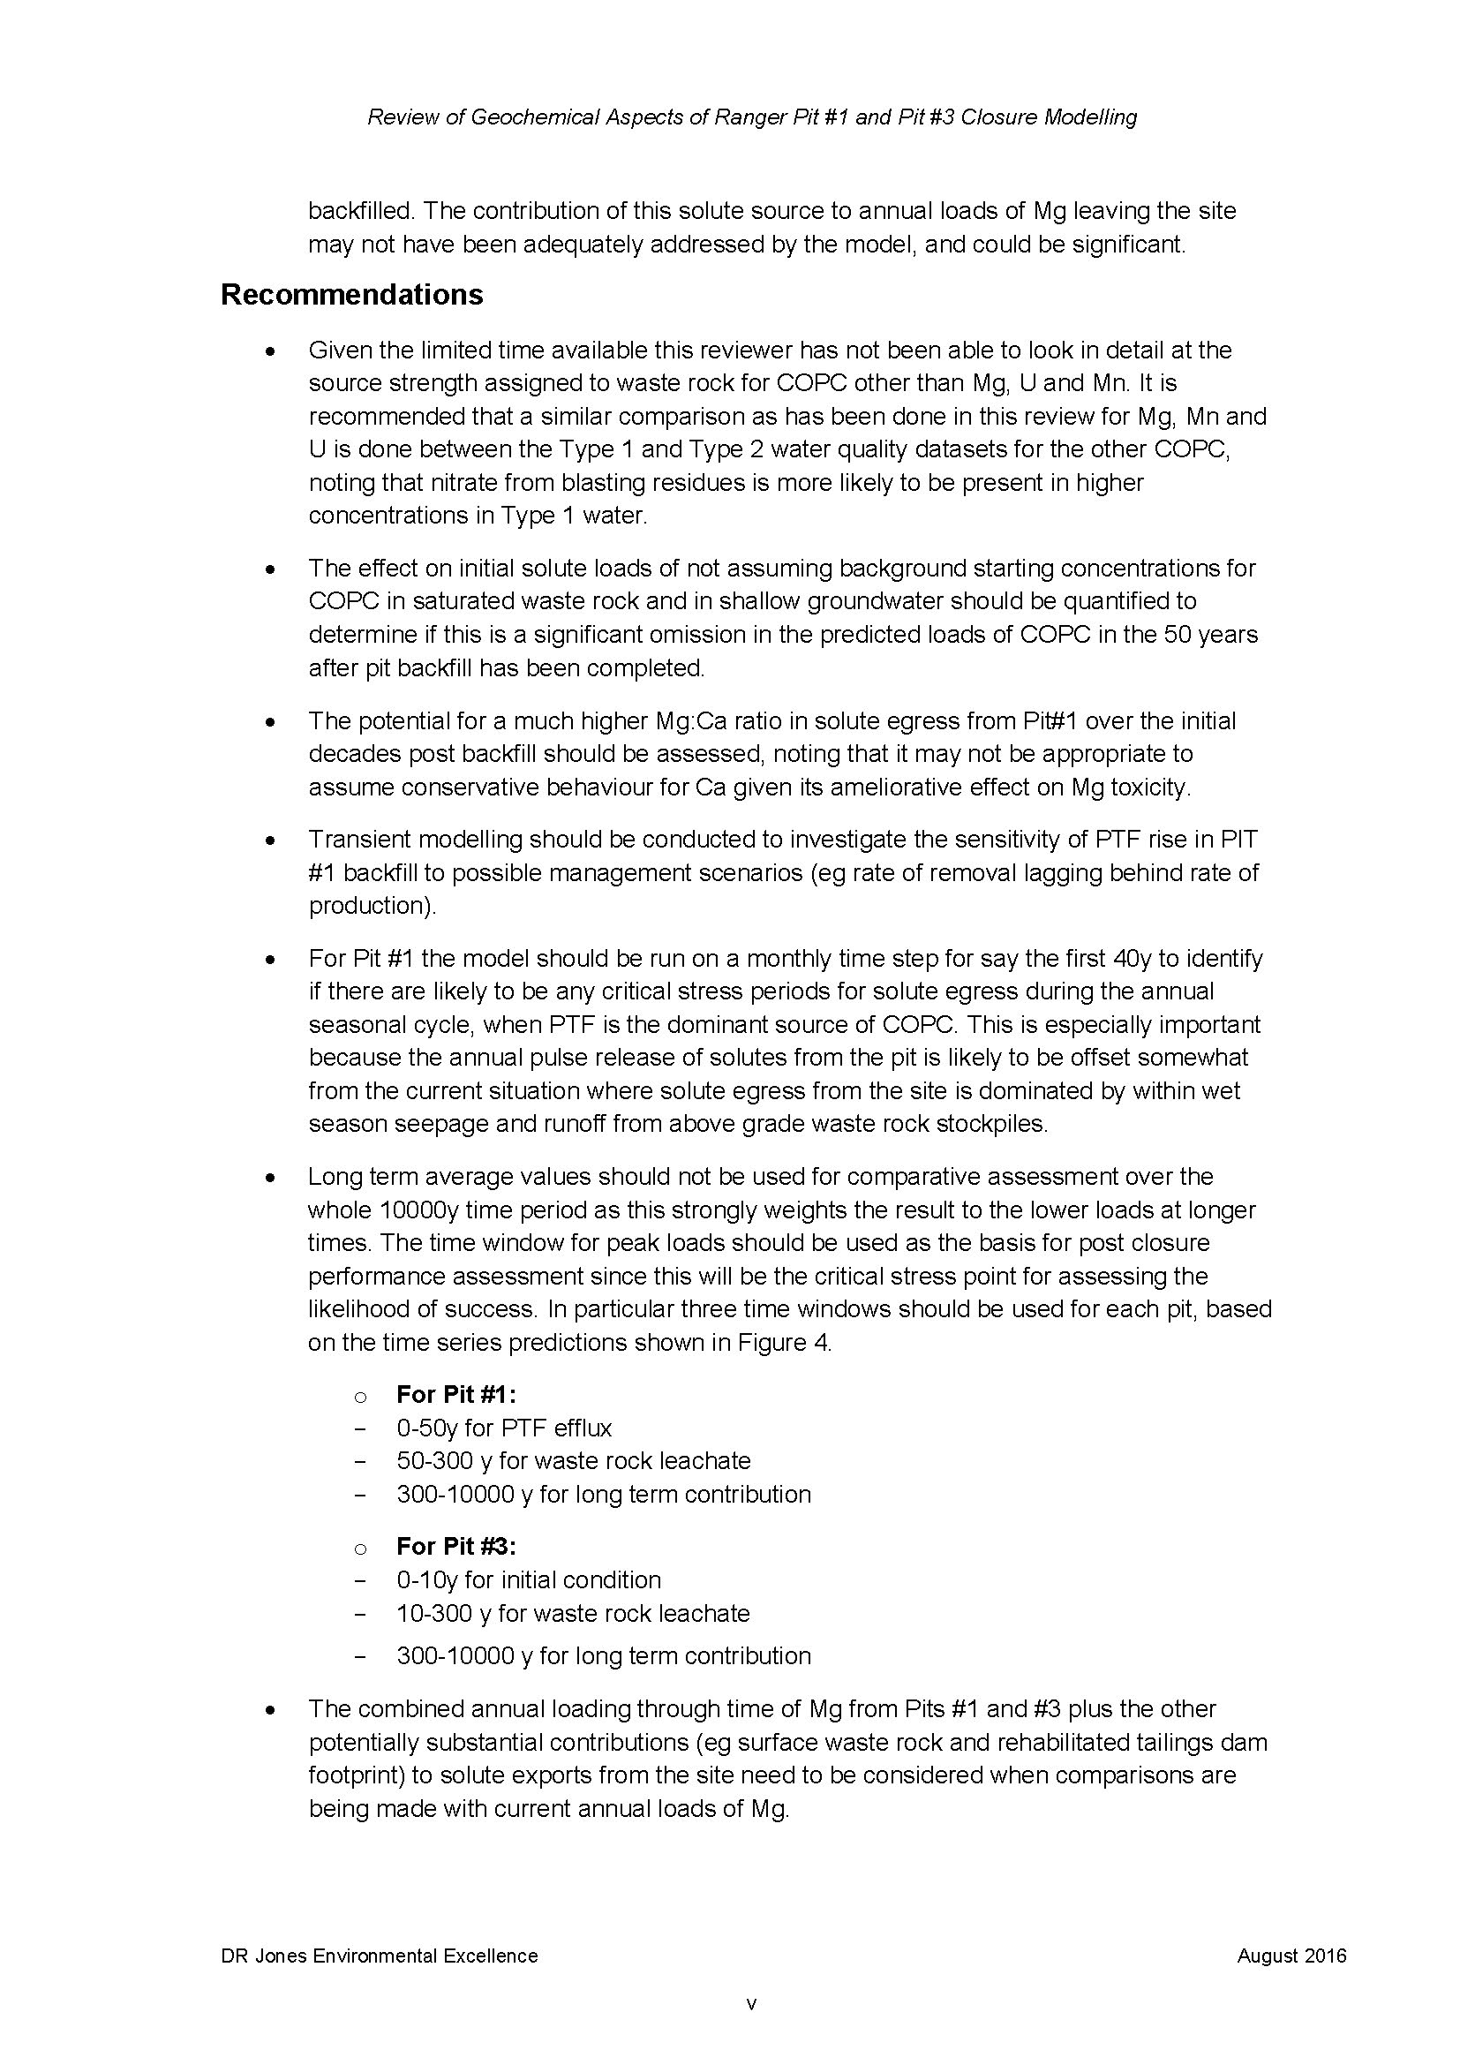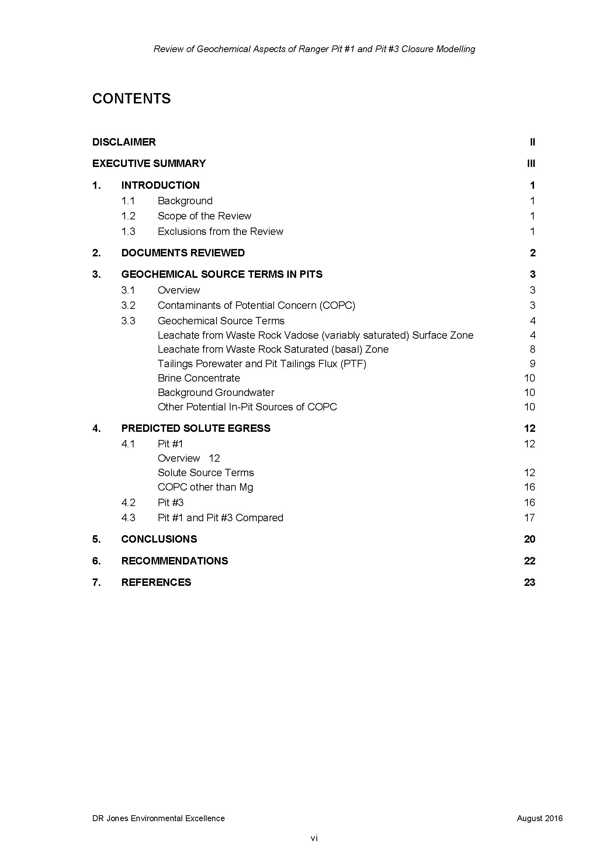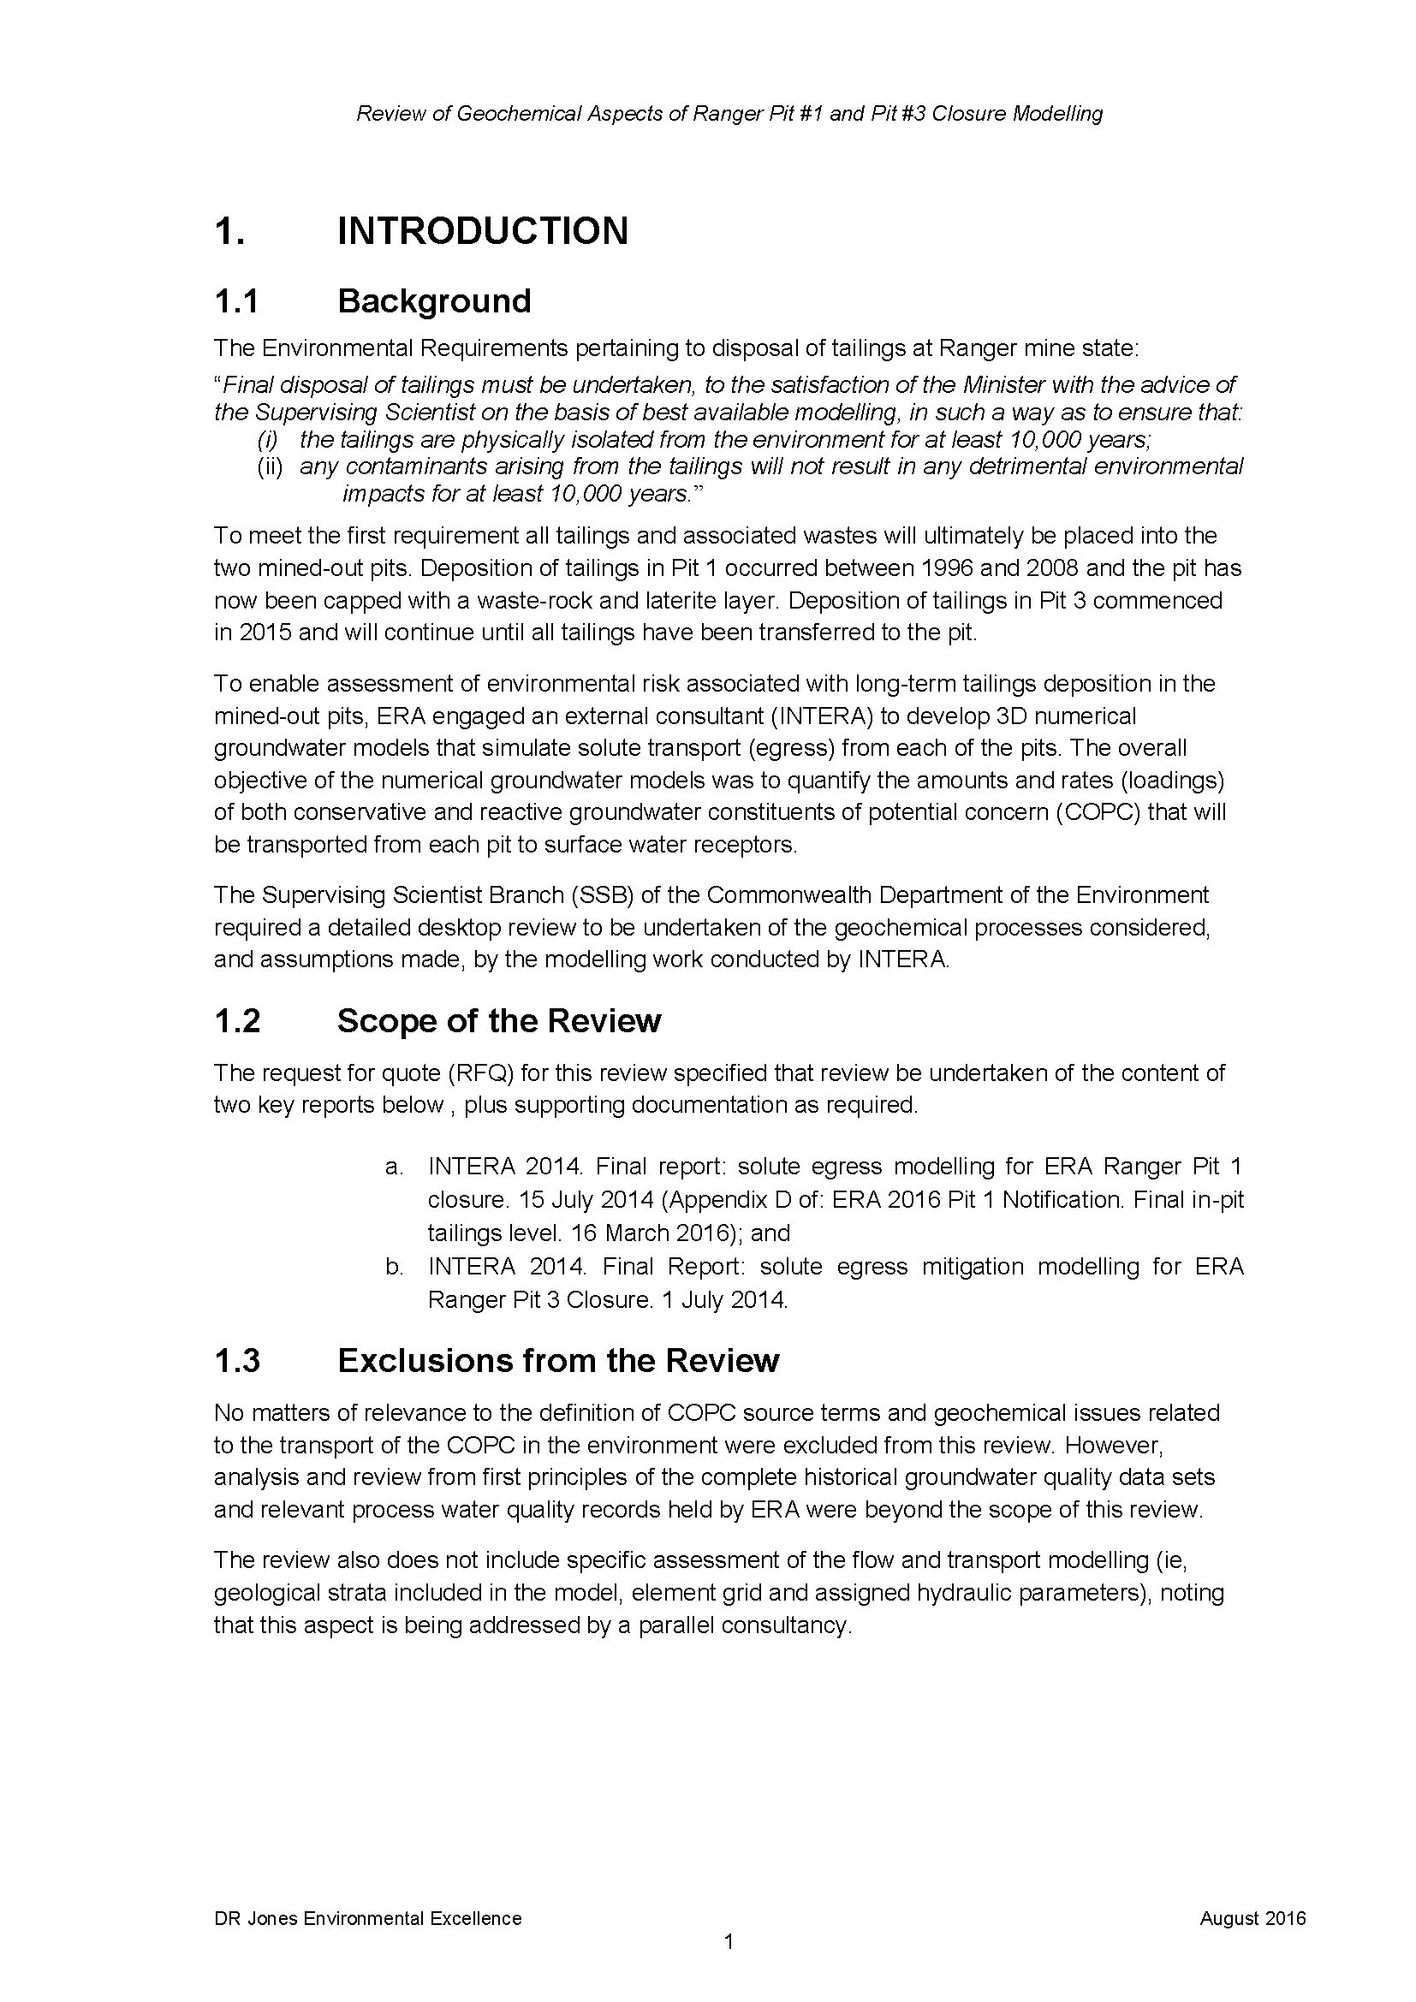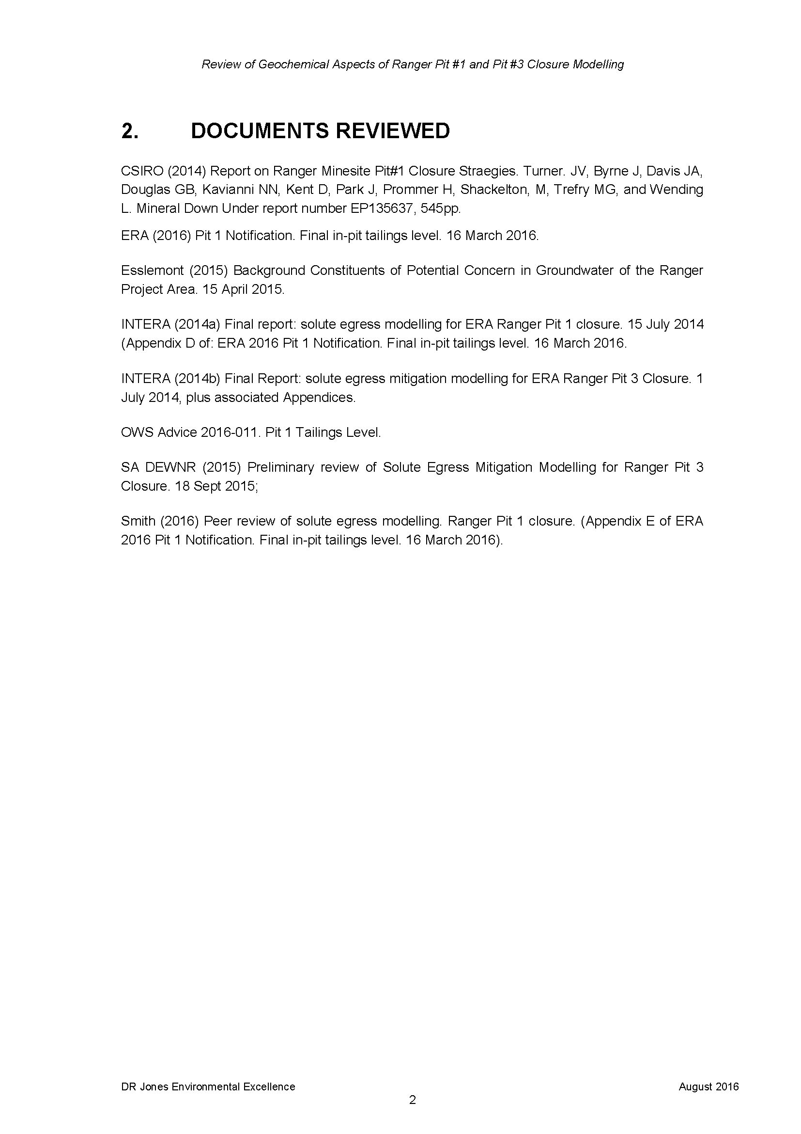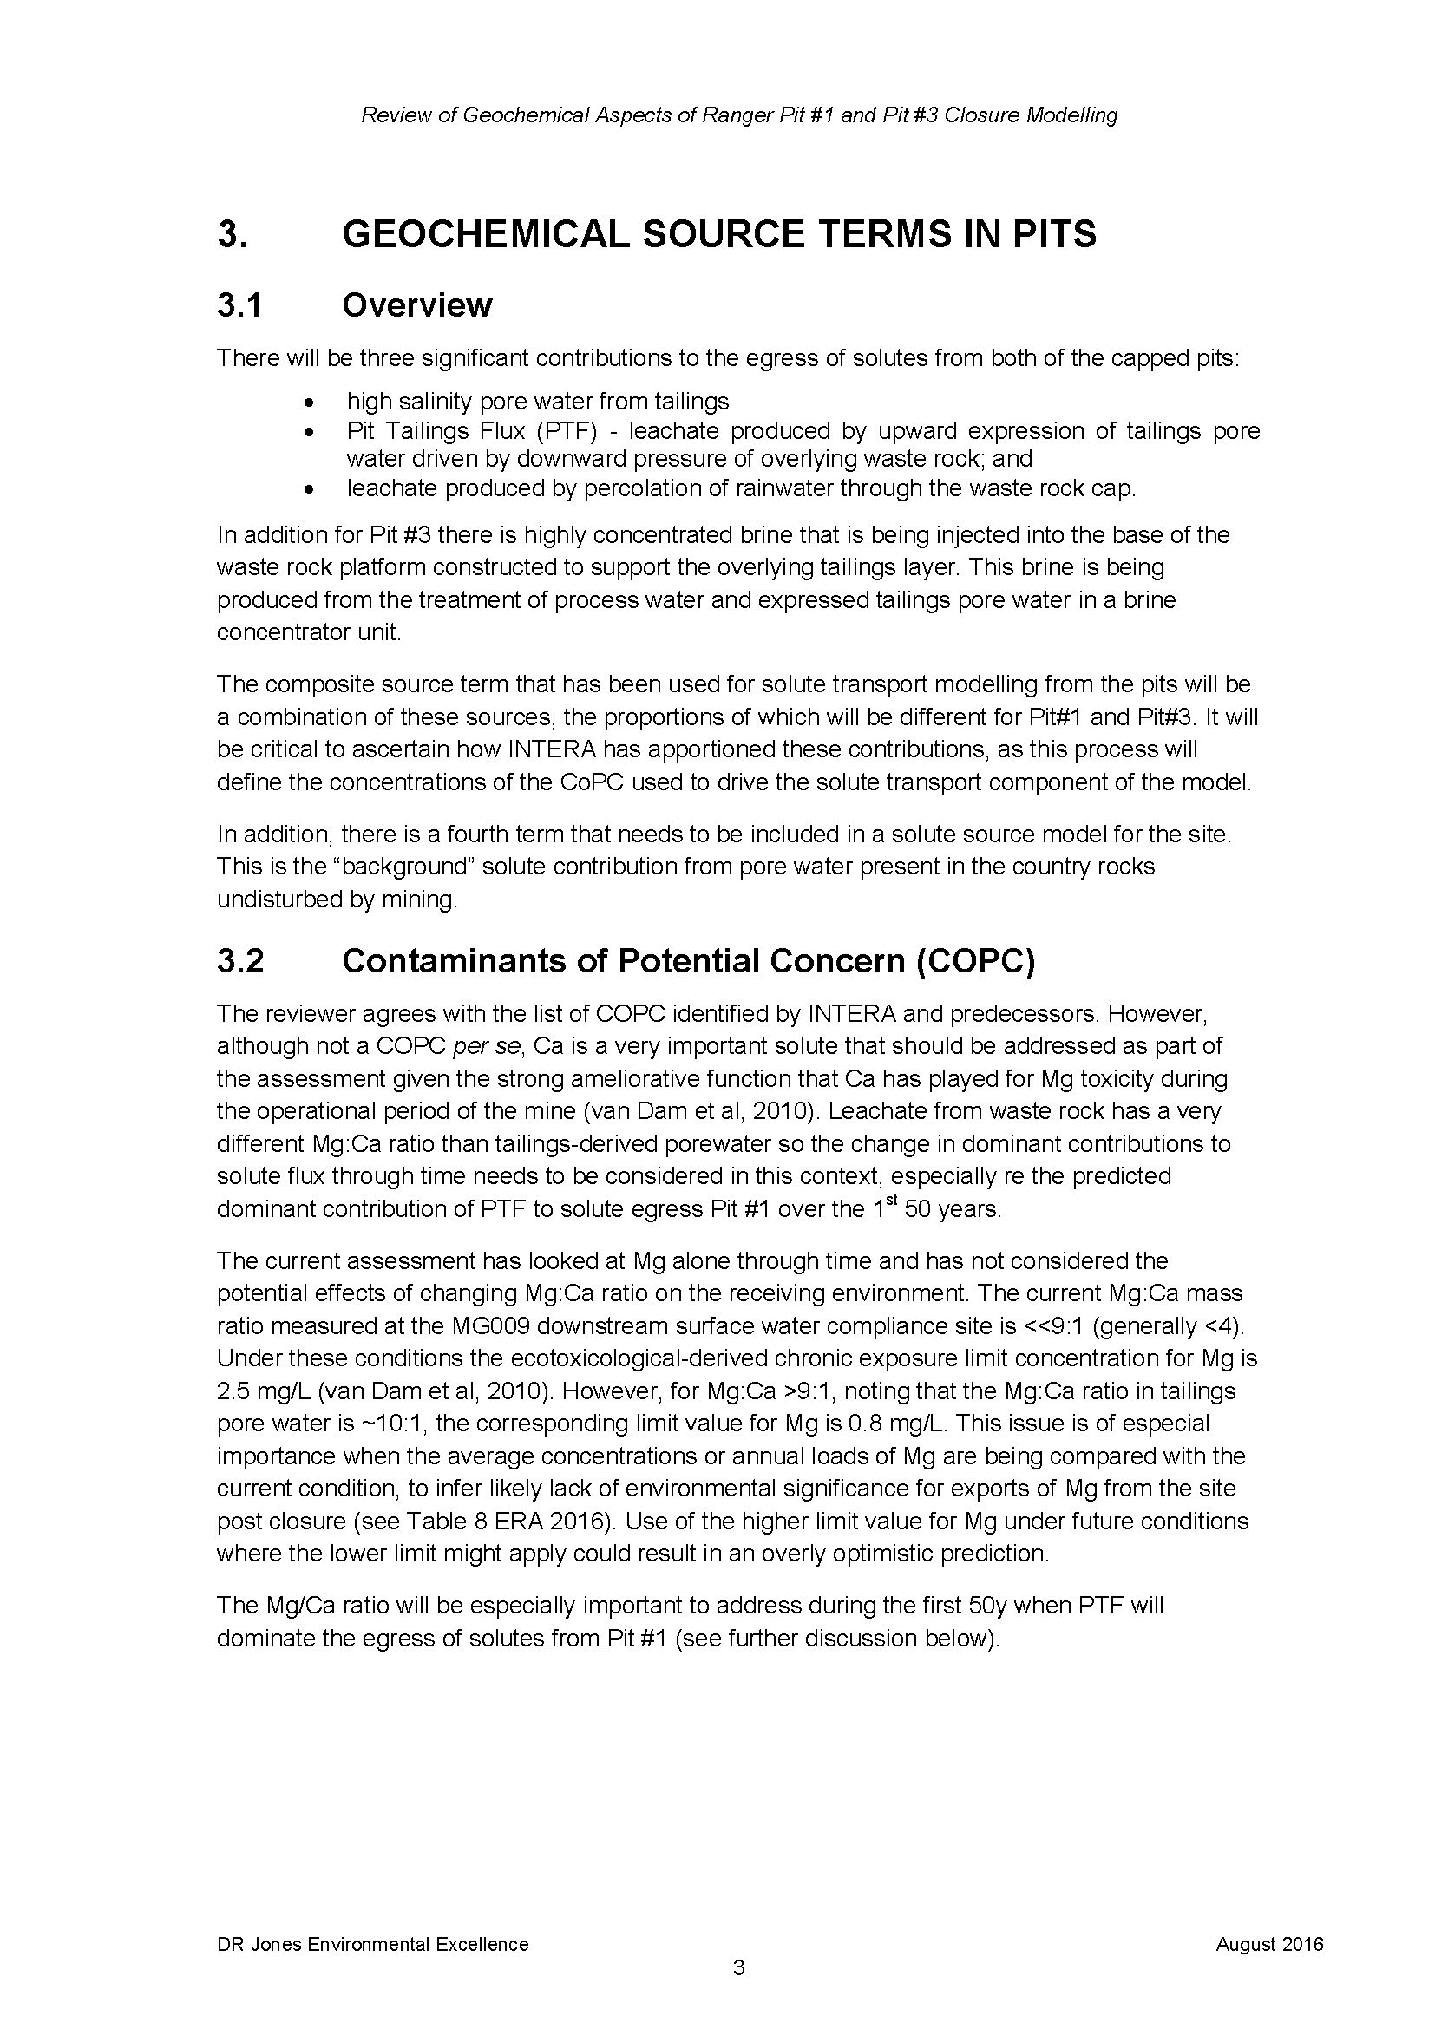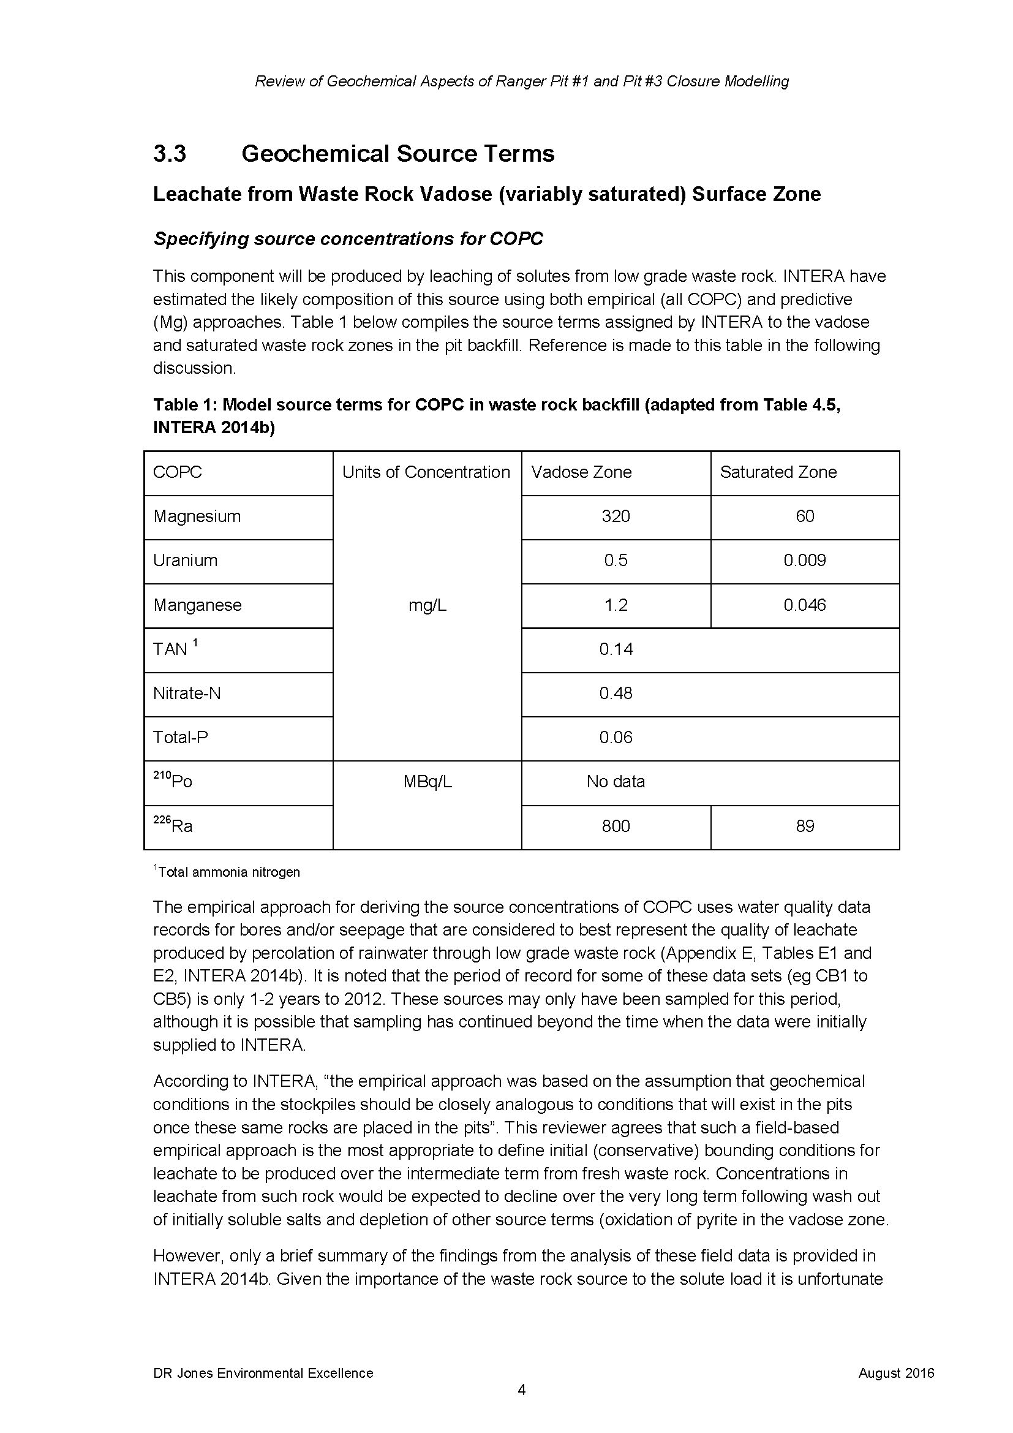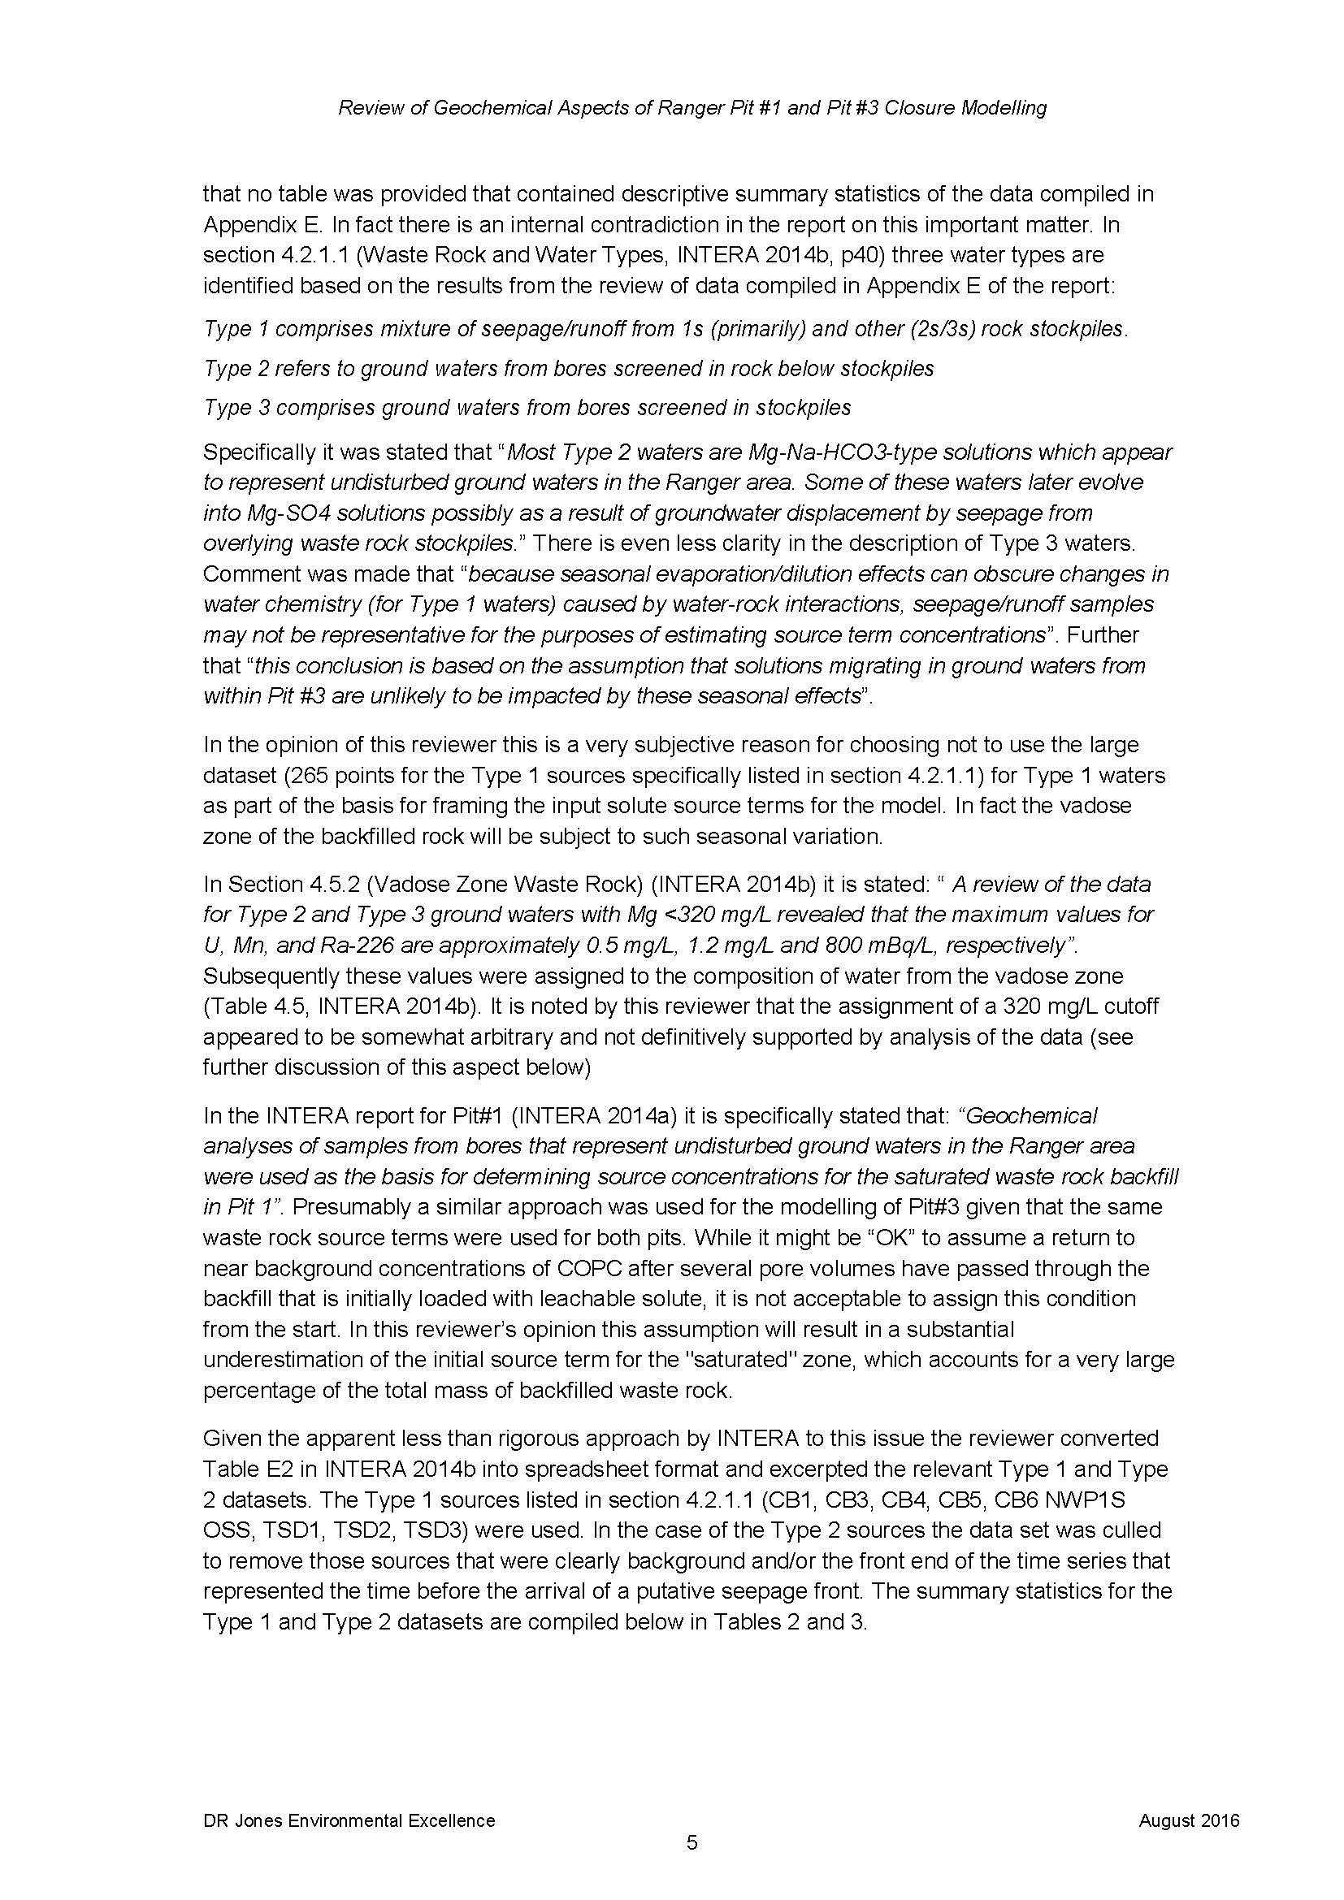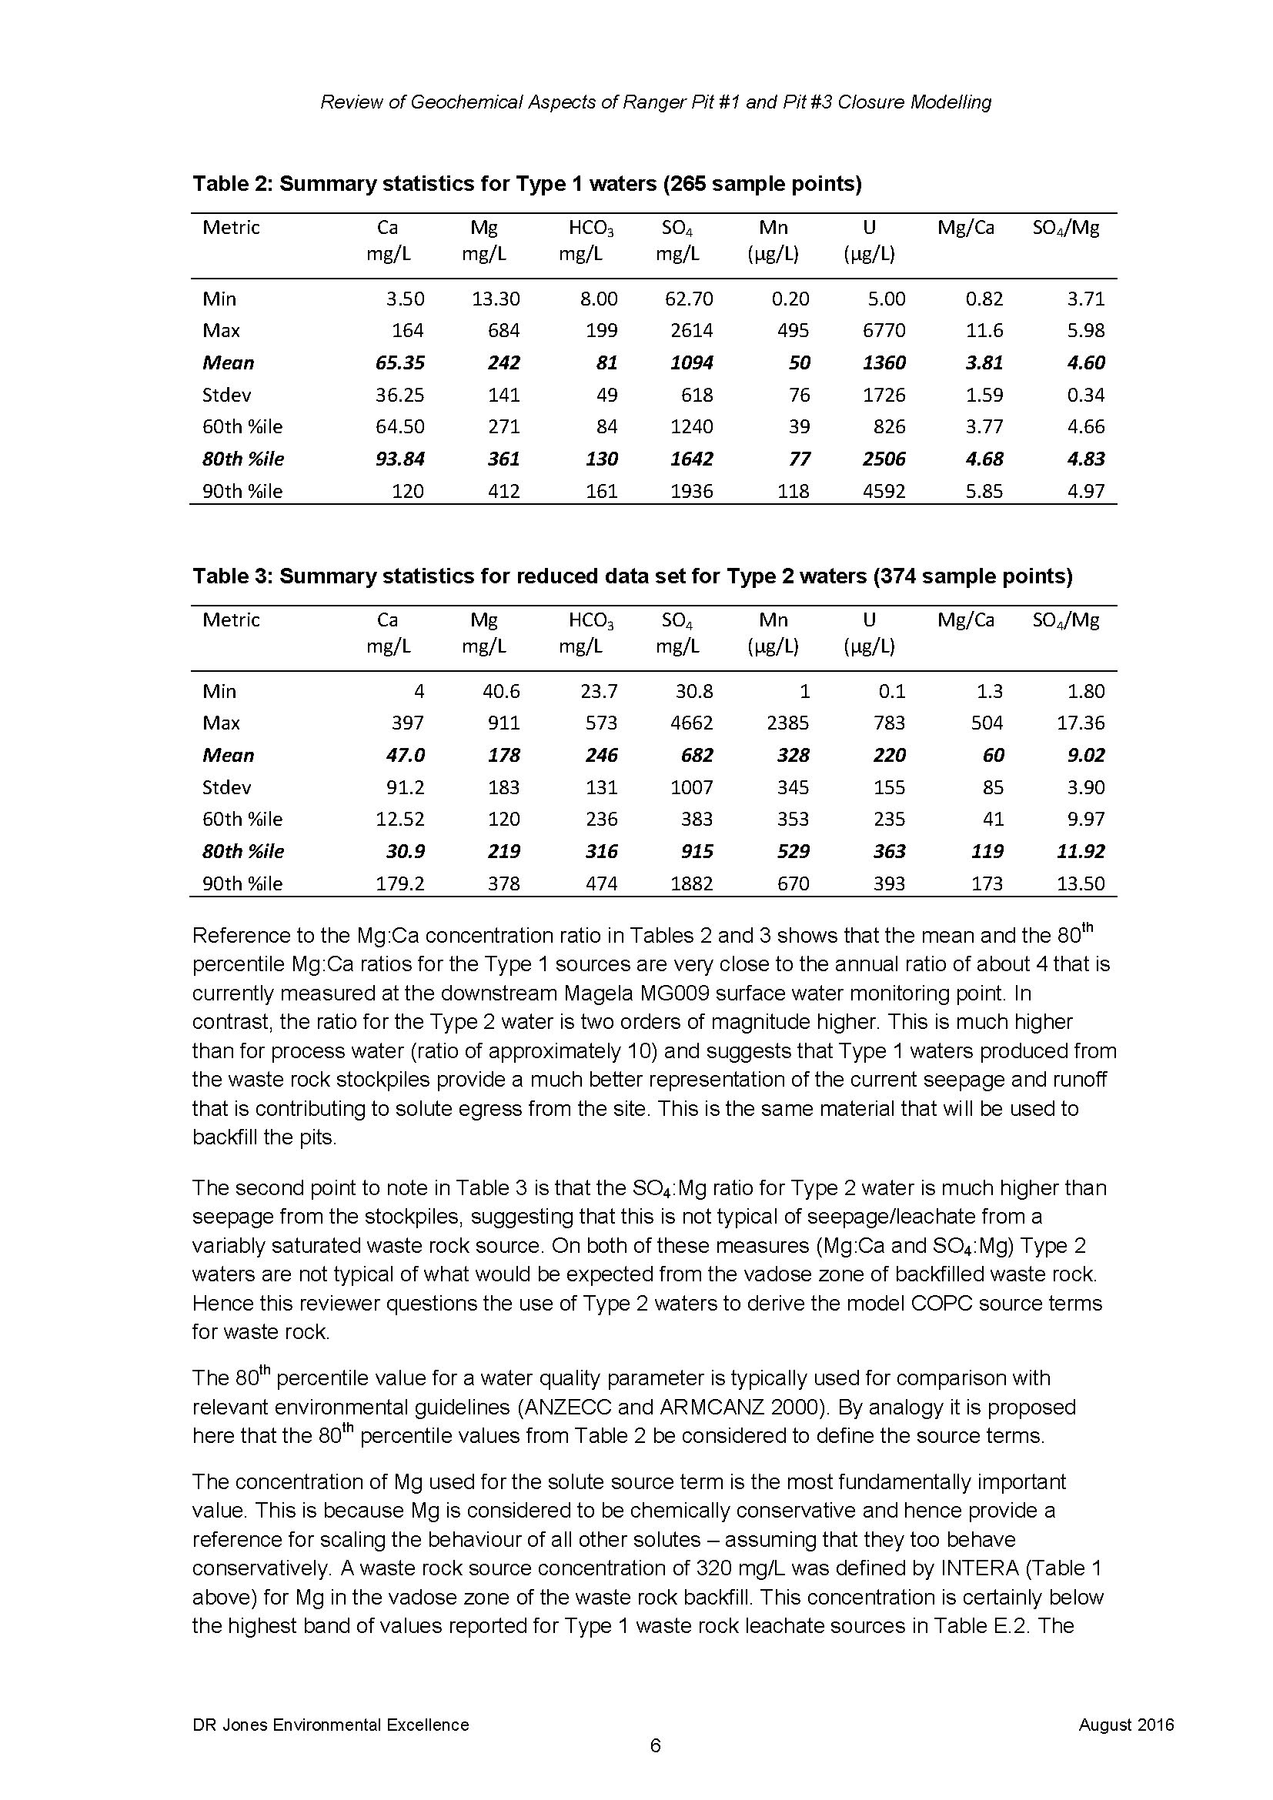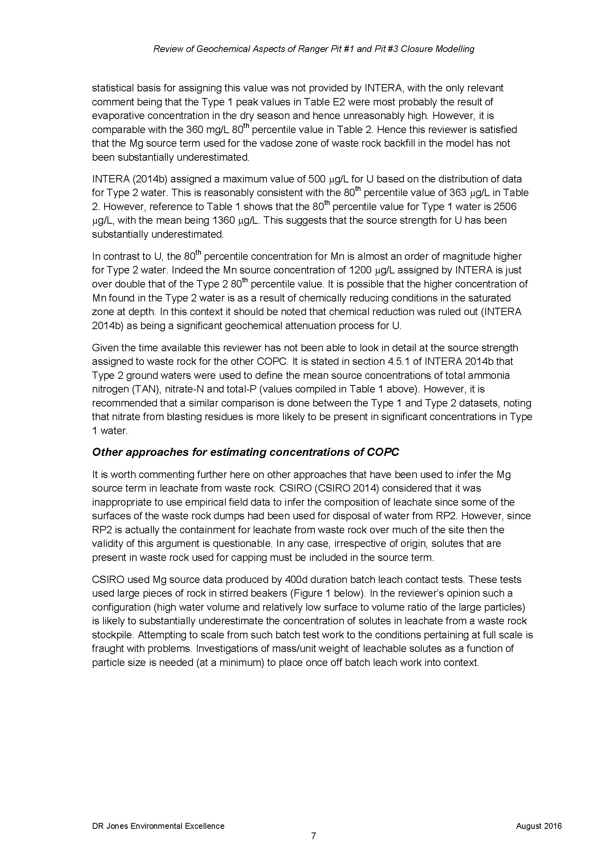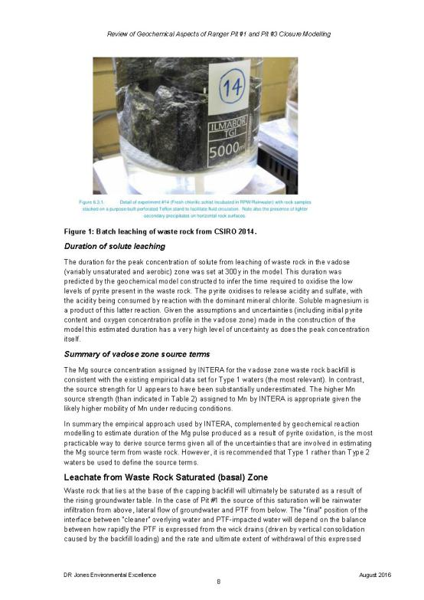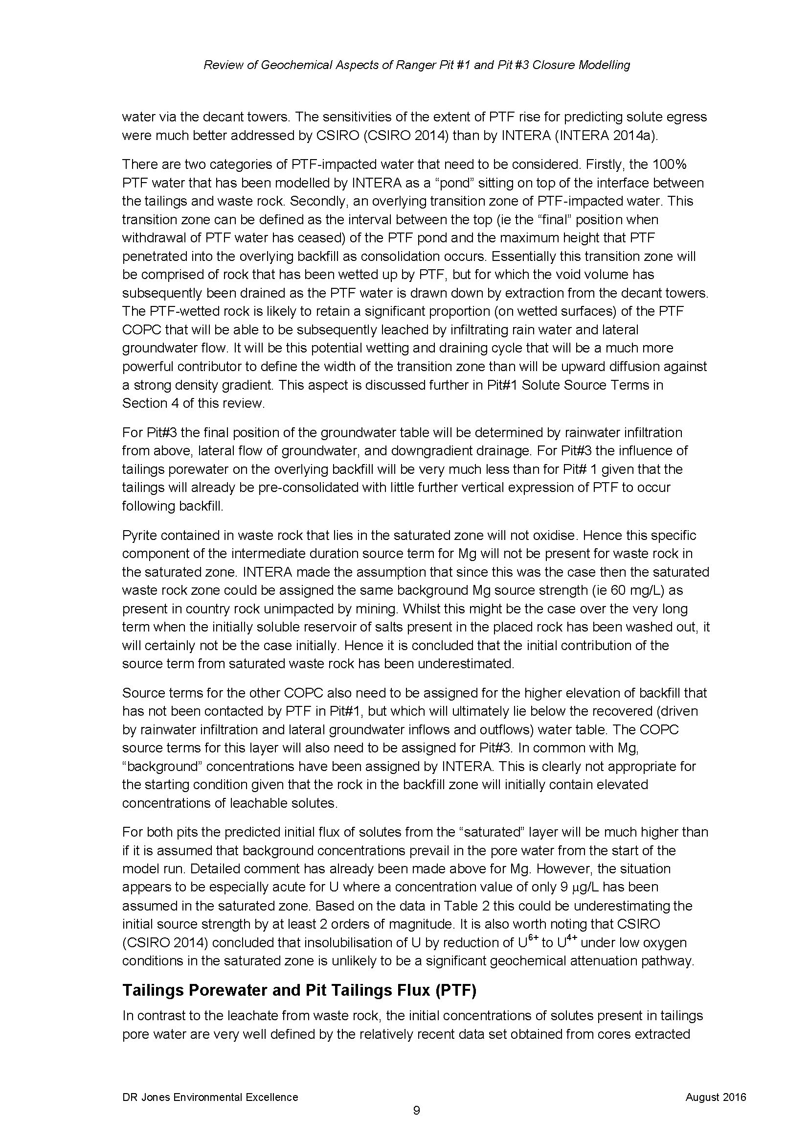
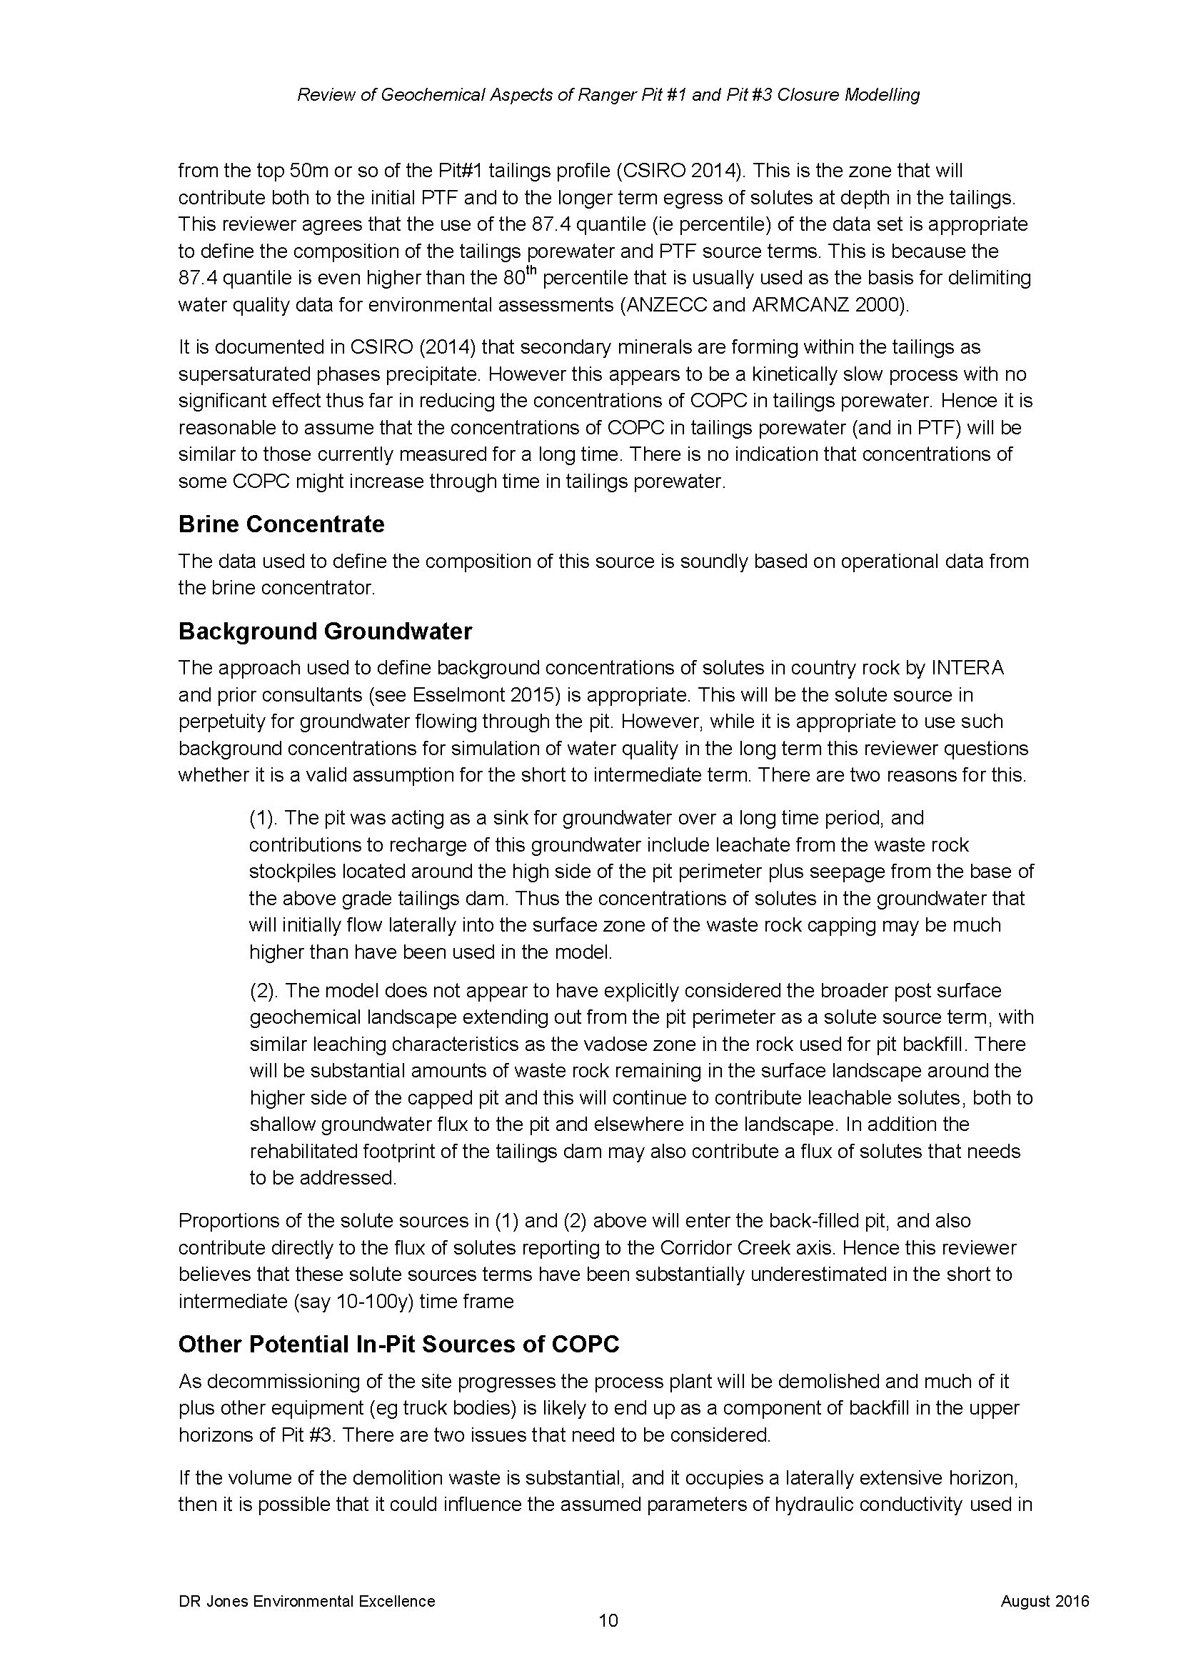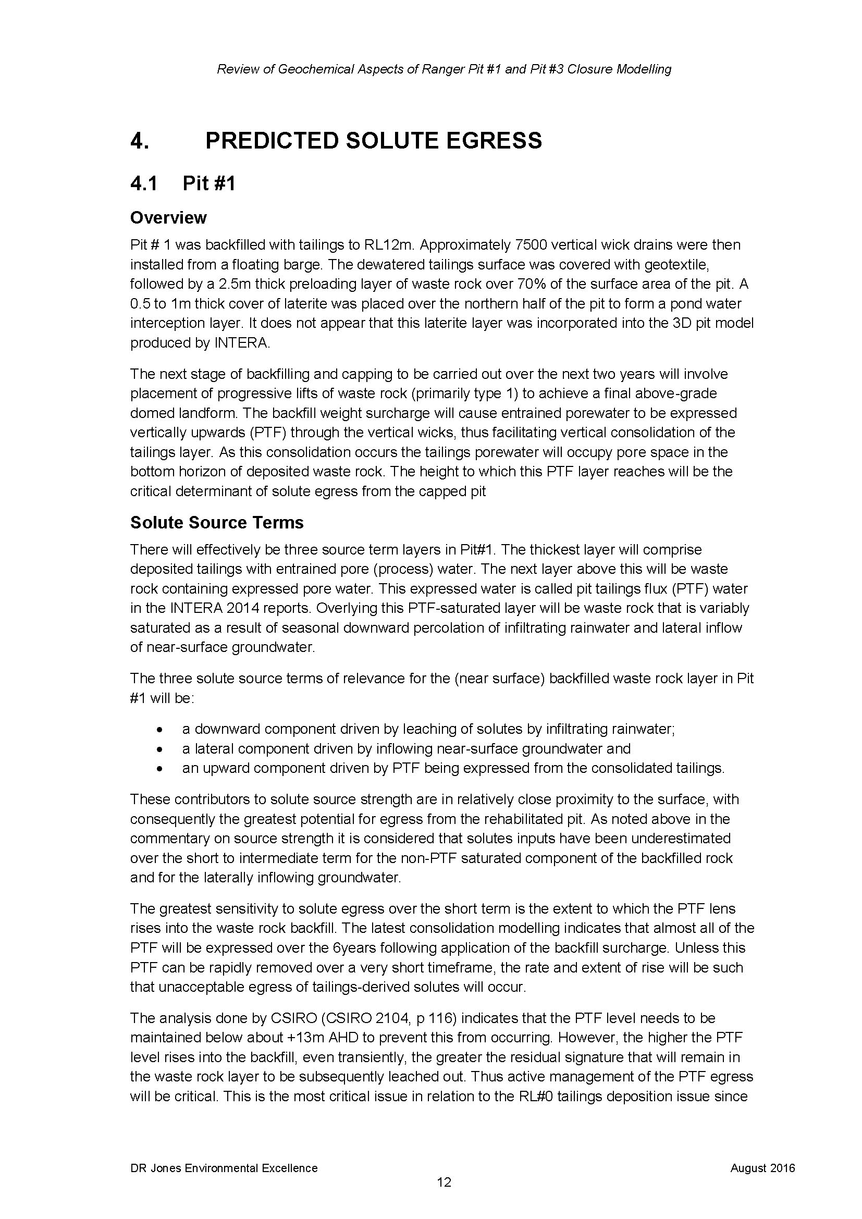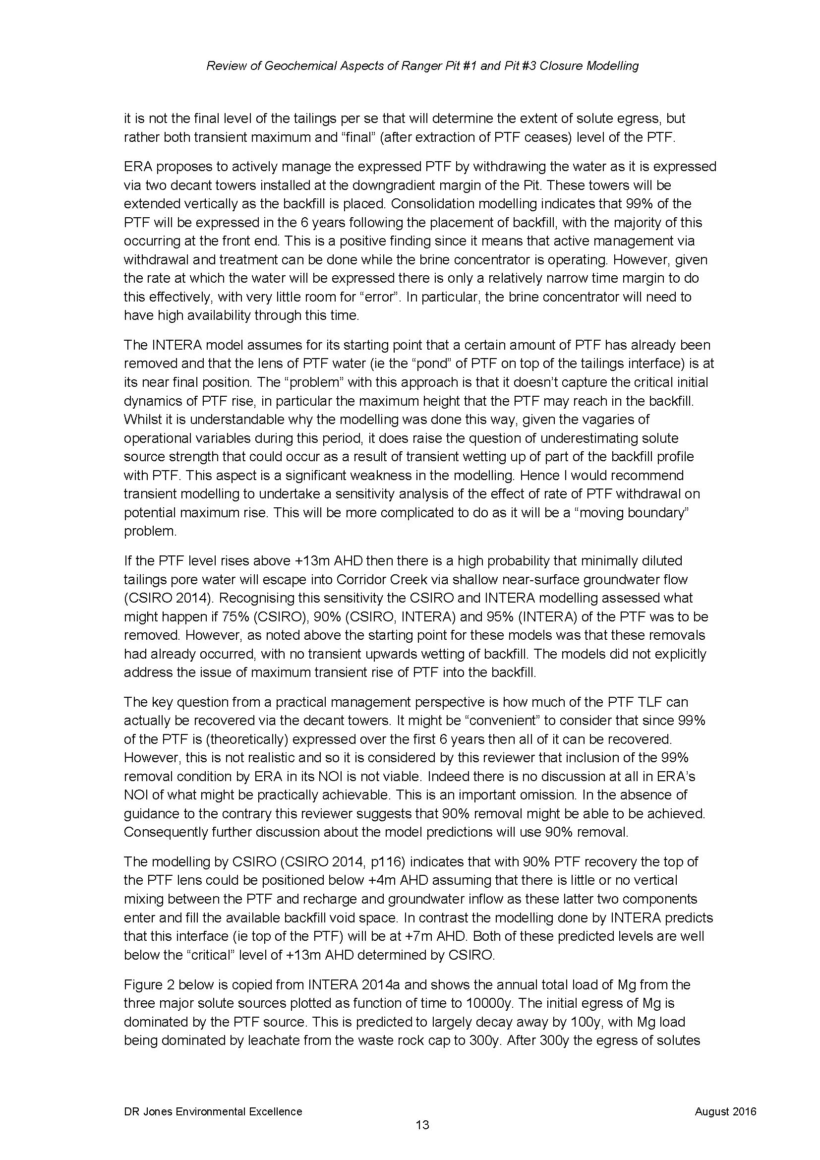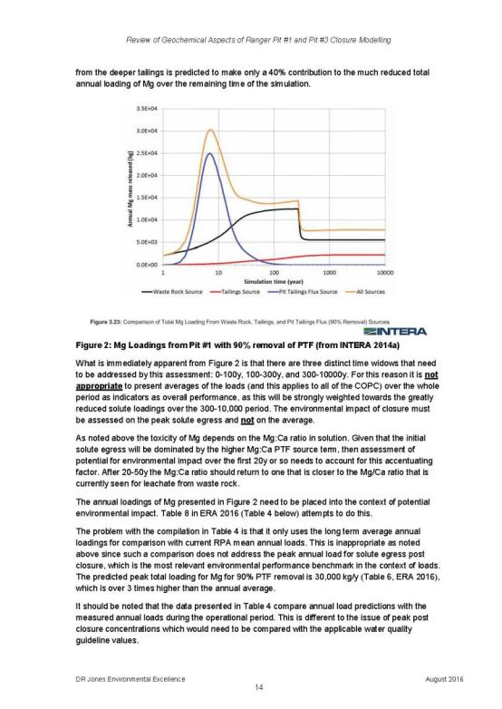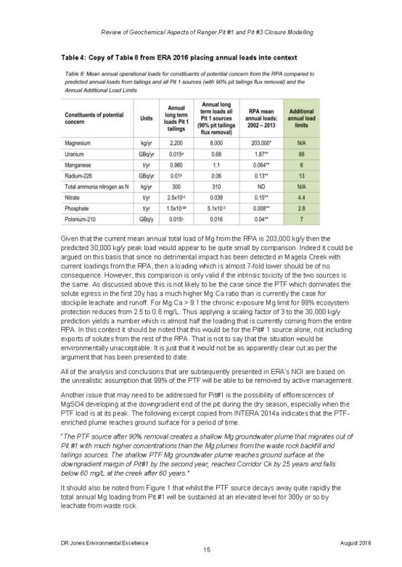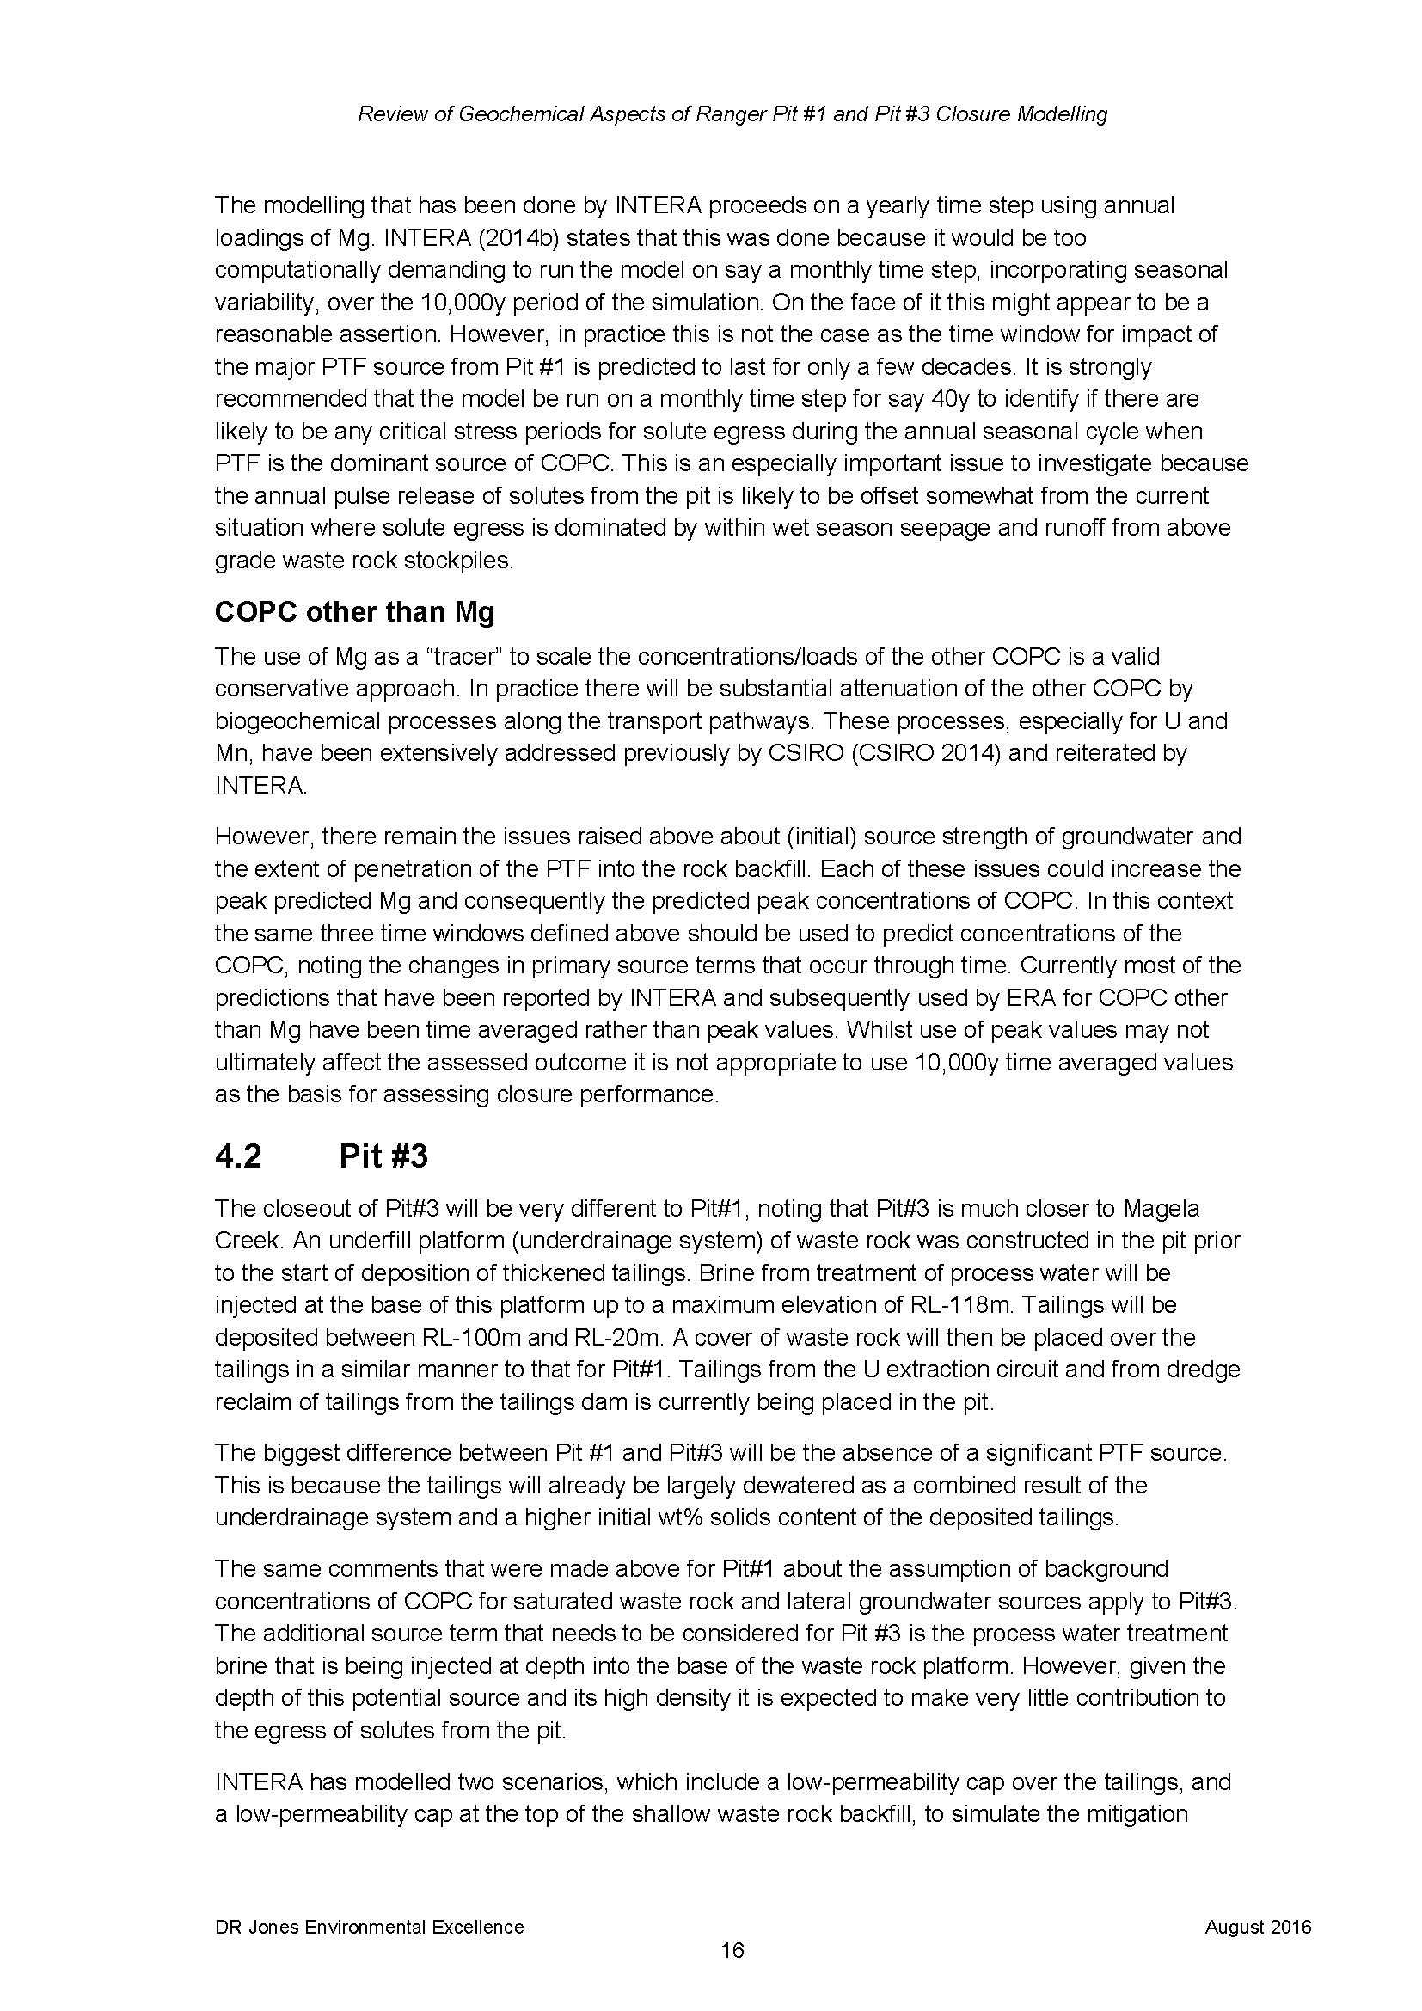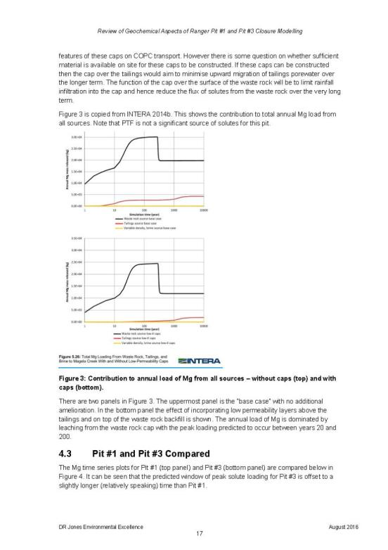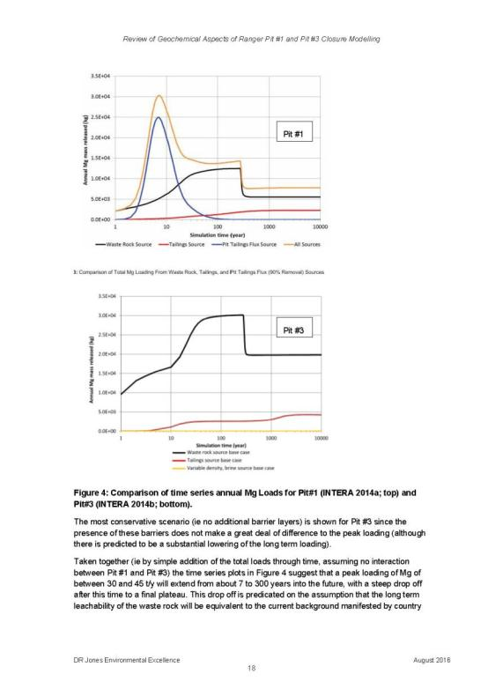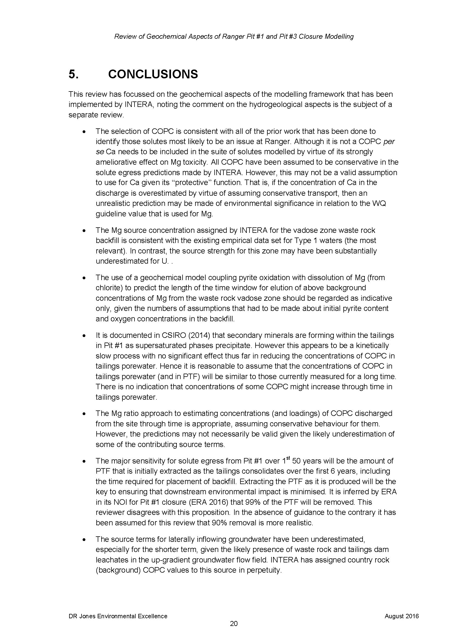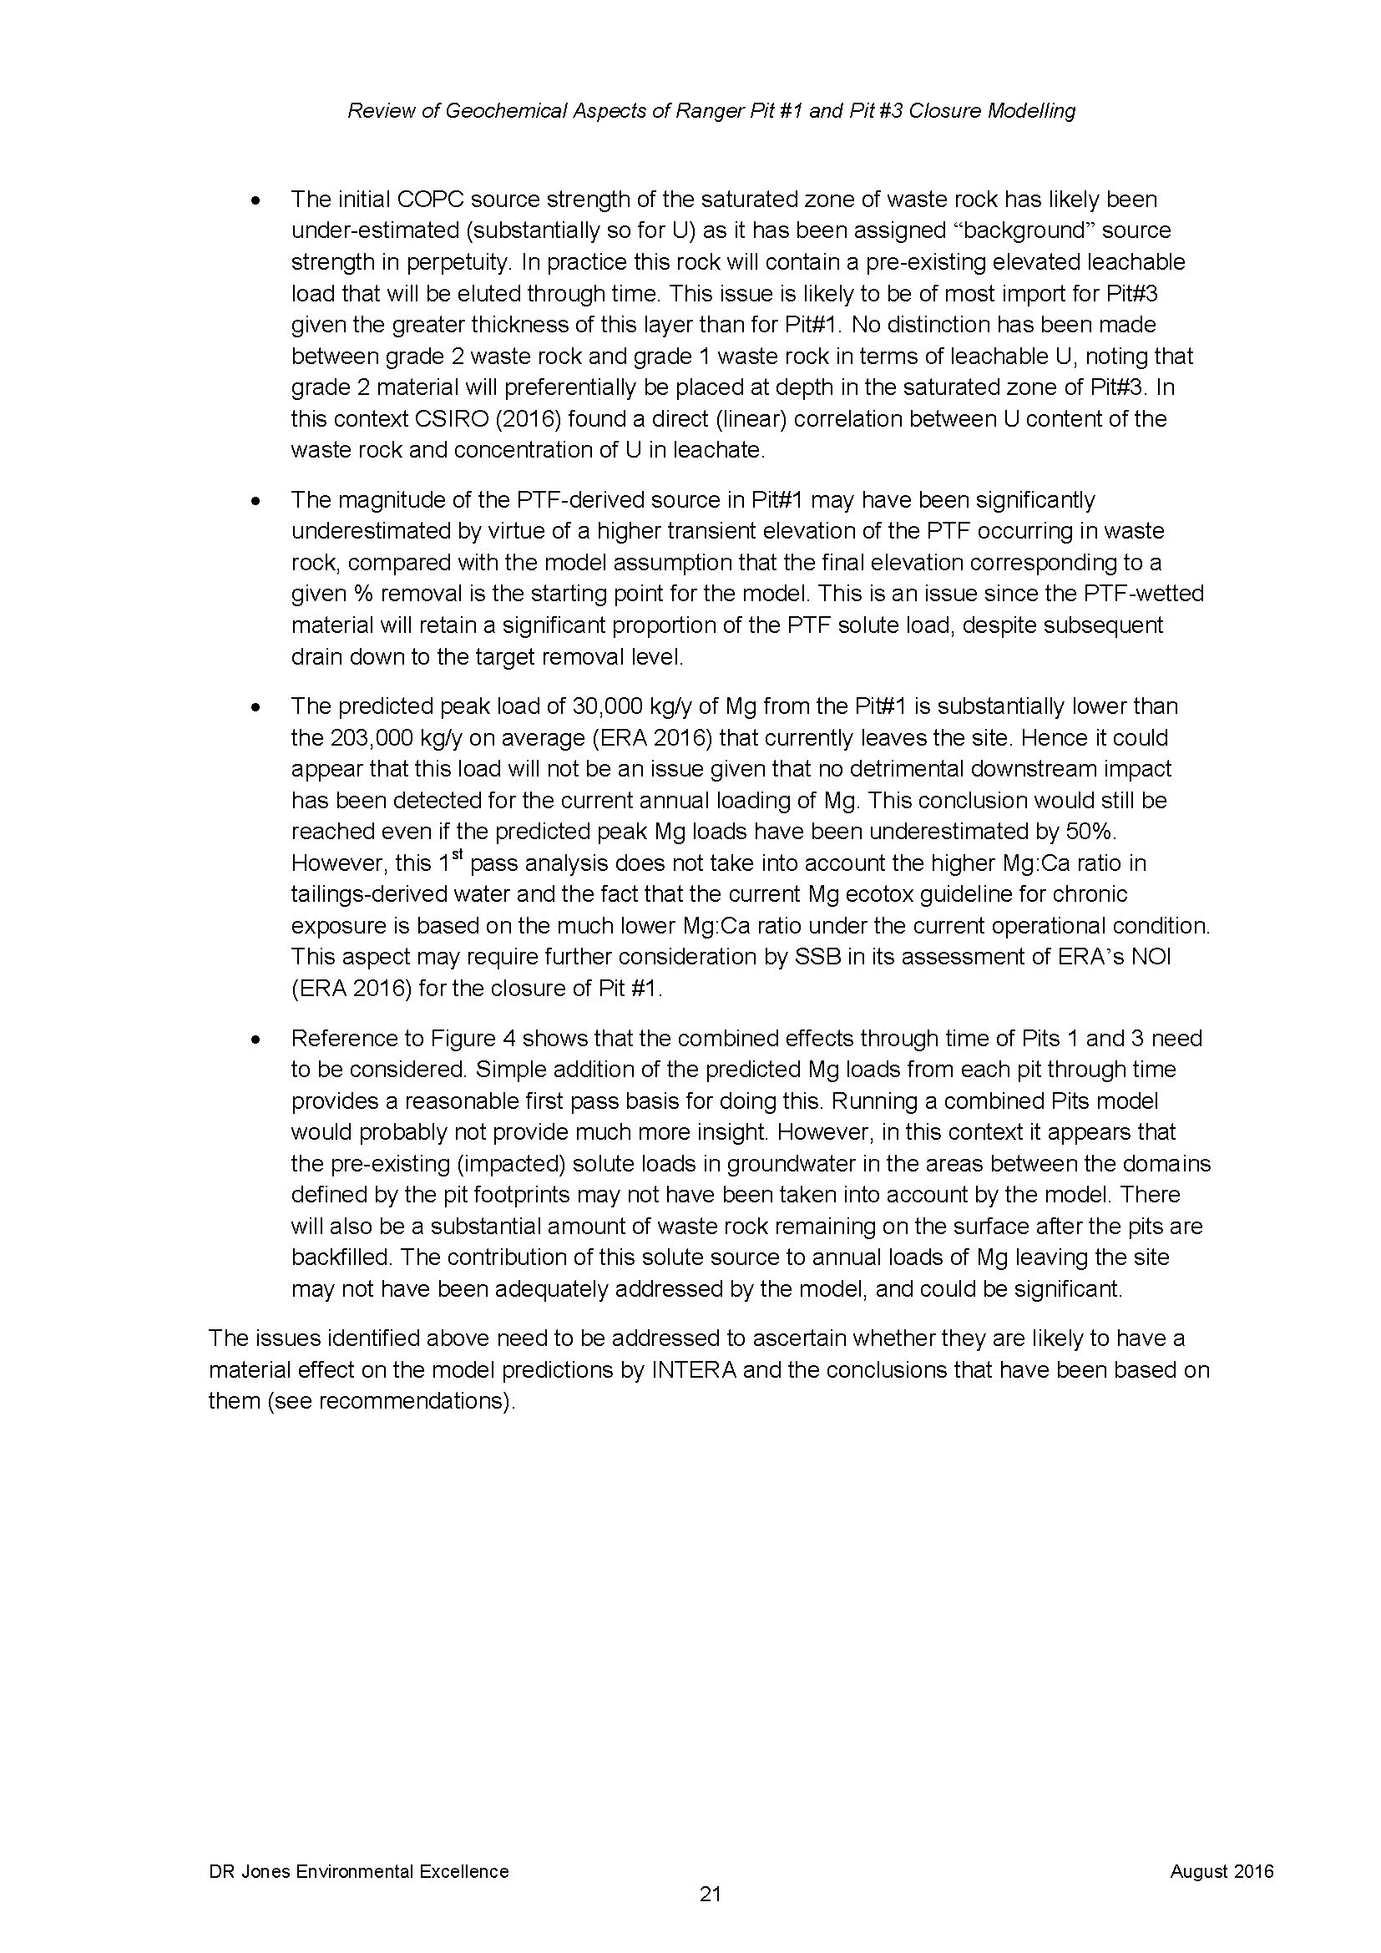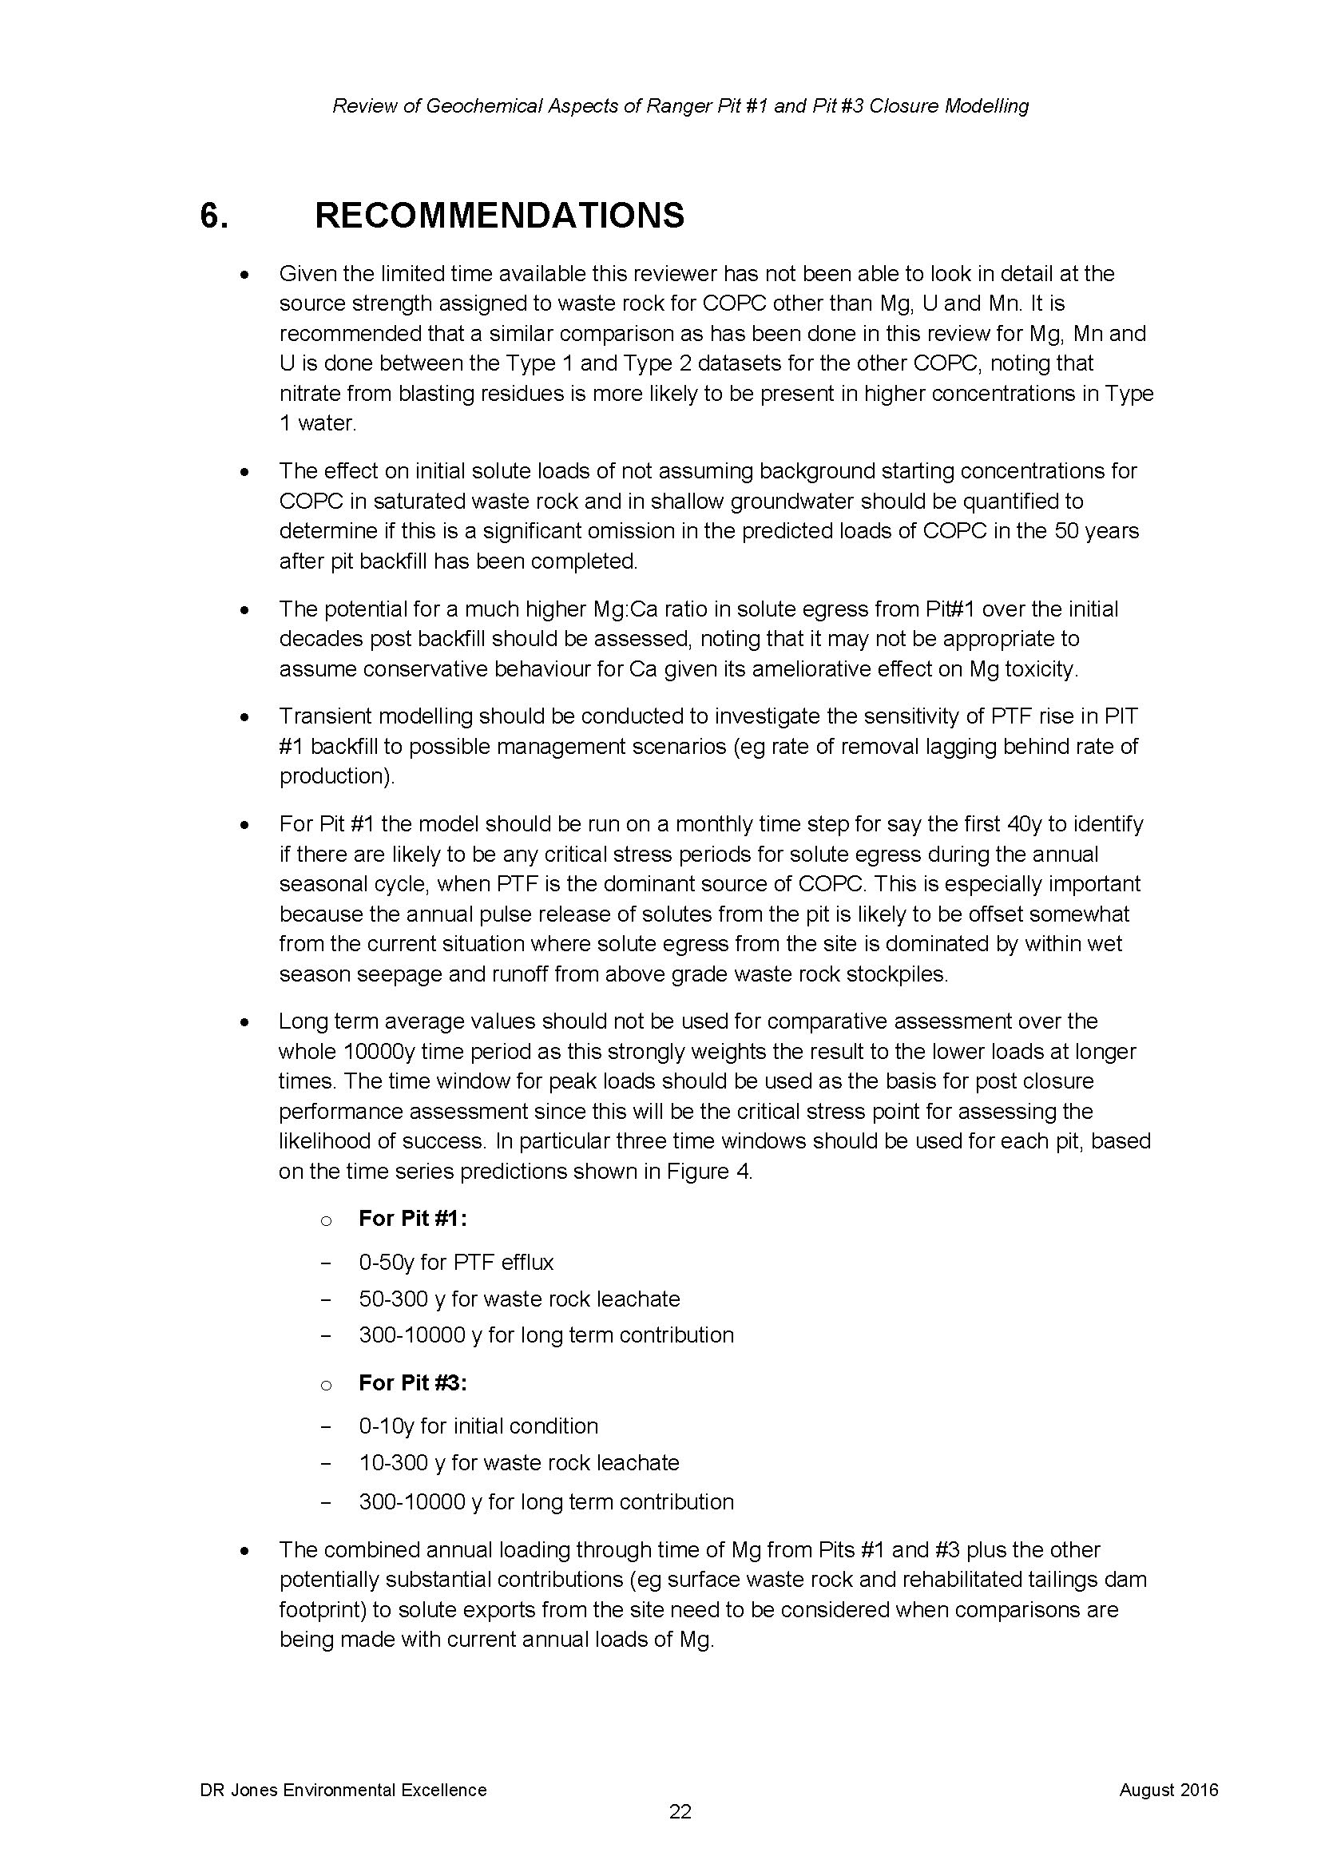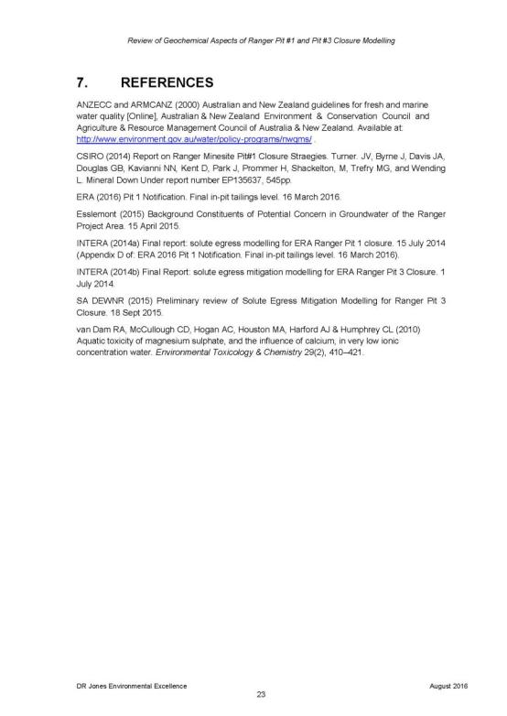

Appendix 7
Summary outcomes of the Groundwater Workshop hosted by the Supervising Scientist Branch, 5-7 September 2016

