Wave-short

652XYZ

*internal report*

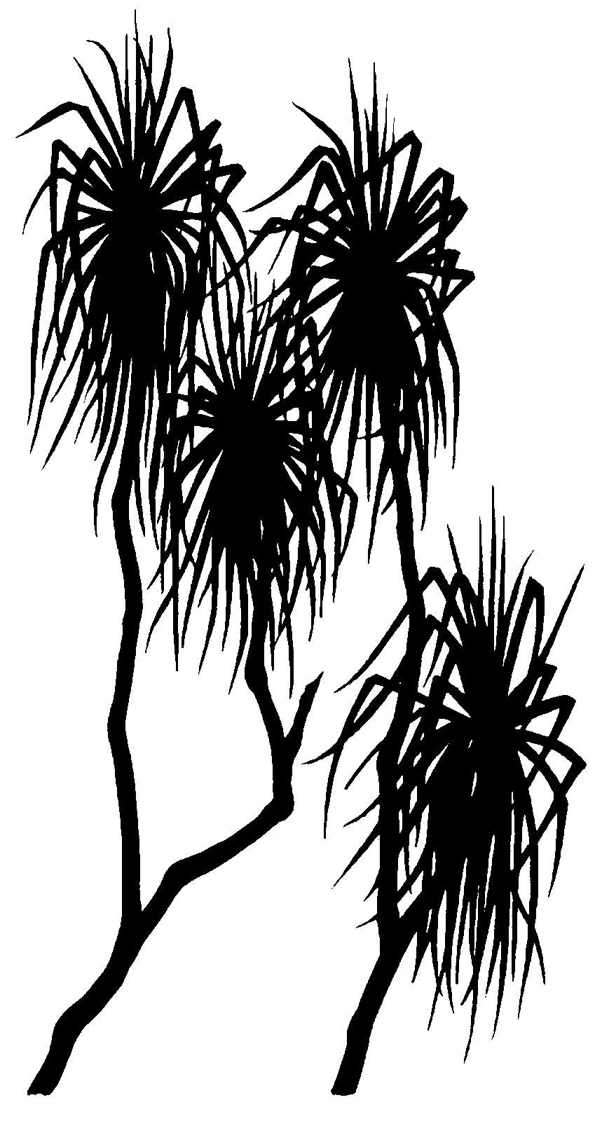



Toxicity of contaminated waters from Gulungul Creek Tributary 2 in 2015 and 2016

Melanie Trenfield, Andrew Harford, Thomas Mooney, Mark Ellis, Chris Humphrey & Rick van Dam

July 2017

Release status – unrestricted

Project number –

*The Department acknowledges the traditional owners of country throughout Australia and their continuing connection to land, sea and community. We pay our respects to them and their cultures and to their elders both past and present.*

# Toxicity of contaminated waters from Gulungul Creek Tributary 2 in 2015 and 2016

Melanie Trenfield, Andrew Harford, Thomas Mooney, Mark Ellis, Chris Humphrey and Rick van Dam

Supervising Scientist

GPO Box 461, Darwin NT 0801

May 2017

(Release status – refer to IR Tracking Form)



*How to cite this report:*

Trenfield M, Harford A, Mooney T, Ellis M, Humphrey C and van Dam R. 2017. Toxicity of contaminated waters from Gulungul Creek Tributary 2 in 2015 and 2016. Internal Report 652, July, Supervising Scientist, Darwin.

*Project number: RES-2016-10*

*Authors of this report:*

Melanie Trenfield – Supervising Scientist, GPO Box 461, Darwin NT 0801, Australia

Andrew Harford – Supervising Scientist, GPO Box 461, Darwin NT 0801, Australia

Thomas Mooney – Supervising Scientist, GPO Box 461, Darwin NT 0801, Australia

Mark Ellis – Supervising Scientist, GPO Box 461, Darwin NT 0801, Australia

Chris Humphrey – Supervising Scientist, GPO Box 461, Darwin NT 0801, Australia

Rick van Dam – Supervising Scientist, GPO Box 461, Darwin NT 0801, Australia

The Supervising Scientist is a branch of the Australian Government Department of the Environment and Energy.

Supervising Scientist

Department of the Environment and Energy

GPO Box 461, Darwin NT 0801 Australia

**environment**.gov.au/science/supervising-scientist/publications

© Commonwealth of Australia 2016

Copyright Image.tif

IR652 is licensed by the Commonwealth of Australia for use under a Creative Commons By Attribution 3.0 Australia licence with the exception of the Coat of Arms of the Commonwealth of Australia, the logo of the agency responsible for publishing the report, content supplied by third parties, and any images depicting people. For licence conditions see: [http://creativecommons.org/licenses/by/3.0/au/](http://creativecommons.org/licenses/by/3.0/au/%20)

**Disclaimer**

The views and opinions expressed in this publication are those of the authors and do not necessarily reflect those of the Australian Government or the Minister for the Environment and Energy.

While reasonable efforts have been made to ensure that the contents of this publication are factually correct, the Commonwealth does not accept responsibility for the accuracy or completeness of the contents, and shall not be liable for any loss or damage that may be occasioned directly or indirectly through the use of, or reliance on, the contents of this publication.

# Contents

Executive summary iv

1 Introduction 6

2 Methods 8

2.1 Direct Toxicity Assessment of GCT2 water 8

2.2 In situ snail toxicity monitoring 11

2.3 Desktop analysis of historical Direct Toxicity Assessments and water chemistry 11

3 Results 14

3.1 Direct Toxicity Assessment of GCT2 water 14

3.2 In situ snail toxicity monitoring 17

3.3 Analysis of water chemistry and historical Direct Toxicity Assessments 19

4 Discussion 25

5 Conclusions 28

6 References 30

Appendix A Toxicity test design 32

Appendix B Chemical analyses 33

Appendix C Water quality of laboratory toxicity tests 34

Appendix D Toxicity test summary reports 36

Appendix E Results of toxicity monitoring tests 2015 & 2016 44

Appendix F Results of Multivariate Analyses 47

Appendix G Sampling locations for historical Direct Toxicity Assessments and site water chemistry 49

Appendix H Observed toxicity versus predicted toxicity 52

# Executive summary

Magnesium (Mg) is a primary Contaminant of Potential Concern (COPC) in the mine water discharges from the Ranger uranium mine. As such, an extensive research effort has focused on predicting the toxic effects of Mg on local biota using multiple lines of evidence. Laboratory toxicity testing (van Dam et al., 2010) and field-based observations (Humphrey and Chandler, 2017) have determined that maintaining chronic exposures below 2.5–5 mg/L Mg should protect the aquatic ecosystems downstream of the mine. An operational Limit of 3 mg/L is currently used to regulate discharges from the mine and the multiple lines of evidence have been used to inform the derivation of a rehabilitation standard as a target for the closure of the mine.

Discharges of contaminated groundwater from Ranger to Gulungul Creek occurred over wet seasons in the period 2014 to 2016 through Gulungul Creek Tributary 2 (GCT2). This water had an elevated electrical conductivity and was high in Mg, Ca, Mn, and SO4 (EC; maximum 120 µS/cm measured at the downstream monitoring station in Gulungul Creek in 2015). The toxicity of this water was assessed using laboratory Direct Toxicity Assessment (DTA) in 2015 and field biological monitoring studies in 2015 and 2016. Specific aims were to:

1. determine the potential impact of GCT2 water on the off-site environment, and
2. further investigate if the DTA and any field monitoring data could be used as another line of evidence to support the Mg rehabilitation standard.

For the evaluation undertaken for Part 2), results from this DTA (a groundwater source)were combined with those from DTAs conducted on whole effluents from surface waters (on-site Ponds and Pit water). For the GCT2 DTA, the toxicity was assessed using four Australian tropical freshwater species: the duckweed (*Lemna aequinoctialis*); the green hydra (*Hydra viridissima*);the cladoceran (*Moinodaphnia macleayi*); and the aquatic snail (*Amerianna cumingi*). In addition to the DTA conducted in the laboratory, an in situ toxicity assessment was carried out in Gulungul Creek using the same local species of snail as used in the laboratory testing, *A. cumingi*. These toxicity monitoring data from both the 2014–15 and 2015–16 wet seasons were used in this assessment because the creek was receiving mine water discharges throughout this time, i.e. remediation conducted after the 2014–15 wet season by ERA had not completely stemmed flow of contaminated GCT2 waters to Gulungul Creek.

The DTA found that, of the three species for which there was a valid test, GCT2 water was most toxic to *H. viridissima,* and the toxic effect was higher than would have been expected from Mg exposure alone. The additional observed toxicity is unexplained but may have been associated with interactions, including additive effects, with other metals, e.g. manganese (Mn). The GCT2 water was not toxic to *L. aequinoctialis* which could be explained by the high Ca concentration of the water and the likelihood that this played a part in ameliorating the toxicity of Mg. However, toxicity to *A. cumingi* was less than expected based on the Mg:Ca ratio of GCT2 water.

The GCT2 DTA was conducted with up to 350 mg/L Mg and 2430 µS/cm EC in undiluted water, which was far in excess of the maximum Mg and EC observed in Gulungul Creek (9 mg/L and 120 µS/cm respectively). Laboratory results indicated that even at the maximum EC peak observed in Gulungul Creek there would not have been any expected toxicity. In situ snail monitoring (where snails were exposed to an average of ~5 mg/L Mg) supported laboratory results and at the Gulungul downstream site (~2 km downstream of GCT2 confluence) no effect on *A. cumingi* reproduction was observed. There was also an absence of adverse effects to macroinvertebrate communities sampled at this Gulungul Creek downstream site. It should be noted that while the field toxicity monitoring exposures for *A. cumingi* were well replicated (17 tests over 2015 and 2016), the laboratory tests were only conducted once and there were valid exposures for only 3 of the 4 species tested. A DTA would ideally involve multiple tests for each species.

An extensive assessment of the chemistry of GCT2 water in the context of chemistry of other Ranger water types suggested that its concentrations of Ca, Mg, Mn, U and SO4 resemble that of groundwater west of the Tailings Storage Facility but was also similar in composition to waters from on-site surface water bodies (e.g. RP2, Pit 3 and Djalkmara used in earlier DTAs), except that the GCT2 water was higher in Mn and much lower in U. Reanalysis of historic DTAs with RP2, Pit 3 and Djalkmara water (conducted between 1987-2007), suggested that of the Contaminants of Potential Concern (COPCs), U appears to the major contributor to toxicity for *M. macleayi* and *H. viridissima*. However, U in these historic waters was also much higher relative to concentrations of other COPCs.

The results of this investigation into the toxicity of GCT2 water showed that it was unlikely to result in an off-site impact to the aquatic environment. Further analysis of the GCT2 toxicity and composition and also that of other on-site and off-site water bodies supported the rehabilitation standard (and current Operational Limit) of 3 mg/L for Mg as being protective of the aquatic ecosystem downstream of the mine. Toxicity of mine water mixtures through DTAs will continue to inform environmental protection measures in place for Ranger operations and closure. The complexity and interactions amongst constituent analytes, however, appear to preclude the use of these DTAs for refinement of GVs derived by other lines of evidence.

# 1 Introduction

Magnesium (Mg) is a primary Contaminant of Potential Concern (COPC) in the discharged waters from Ranger Uranium mine. It leaches from waste rock on the minesite which is high in minerals, including magnesium sulfate (MgSO4), a highly mobile contaminant in the environment. Consequently, the toxicity of Mg to local biota has been investigated using multiple lines of evidence such as laboratory toxicity testing (van Dam et al., 2010) and field-based studies of community effects in mine-water-influenced water bodies (Humphrey and Chandler, 2017) and semi-field studies (mesocosms)(McCullough 2006).

The laboratory toxicity testing used natural Magela Creek water and six local freshwater species to determine Mg toxicity under site specific-conditions. These toxcity tests used pure MgSO4 salt andshowed that Mg had a higher toxicity compared to other reported studies, which was , due the ultra soft waters (i.e. <5 mg/L CaCO3) of the creeks that are adjacent to the mine. These studies also demonstrated that Mg was the more toxic ion and that Ca significantly influenced the toxicity of Mg. For some species, Mg toxicity increased markedly once the Mg:Ca mass ratio exceeded 9:1, although there were clear species-specific differences. Consequently, subsequent Mg toxicity tests were standardised to a Mg:Ca mass ratio of 9:1. The 99% protection Guideline Value was determined to be 2.5 mg/L (van Dam et al., 2010) and this has been used as the scientific justification for an operational Limit of 3 mg/L.

The field studies involved over 7 annual sampling occasions of 14 lentic waterbodies between 1979 and 2013. The responses of macroinvertebrate communities were assessed across a spatial and temporal gradient of exposure to Ranger mine-waters dominated by MgSO4 (Humphrey & Chandler in review). From these data, 1% effect concentrations (i.e. 99% protection) for Mg based on community structure and taxa number were 5.6 mg/L and 3.9 mg/L, respectively. The mesocosm study employed large tubs that were naturally seeded with Magela creek water and then spiked with different concentrations of MgSO4 Results showed that the 1% effect concentrations for phytoplankton biomass and zooplankton community structure were 1.5 mg/L and 2.3 mg/L, respectively.

The Environmental Requirements (ERs) have articulated the Australian Government’s exceptions for closure of the Ranger mine. However, there was an additional need to develop quanitifable closure endpoints, which have been described in the Supervising Scientist’s rehabilaiton standards. The candidate GVs from all these studies have been used to inform the derivation of a rehabilitation standard for Mg using a multiple lines of evidence framework that was based on guidance from the USEPA (Suter et al., 2000). The collective studies provide good evidence that maintaining Mg concentrations below 2.9 mg/L should protect the aquatic ecosystems downstream of the mine.

The GVs are also used to assess the potential impact of mine-waters leaving the mine-site during operations. During the 2013-2014 wet-season a mine-water signal was detected and determined to be a groundwater seep at the head of the Gulungul Creek tributary, GCT2, to the west of the Ranger Tailings Storage Facility (TSF, Figure 1). The contaminantion from this groundwater source continued for the wet season of 2014–2015 and an elevated electrical conductivity (EC; 42 µS/cm for 72 h, with a maximum one-off spike of 113 µS/cm) was measured at the downstream monitoring station in Gulungul Creek, adjacent to Ranger uranium mine. Water from the source of the had an EC of approximately 2400 µS/cm. The contaminated water was thought to be from infiltration of water through the TSF wall, which then flowed into the shallow groundwater. Water measured at the interception trench (west of the TSF), designed to restrict the flow of contaminated water, reached 3000-7000 µS/cm. Detailed chemical analysis of the water sampled through-out the 2014-15 wet season established that the elevated EC was predominantly due to elevated concentrations of Mg, SO4 and Ca, and that there were other metals present but rapidly attenuated as the water entered Gulungul Creek (Supervising Scientist 2015). As part of the broader investigation, a Direct Toxicity Assessment (DTA) was undertaken to determine the adverse effects of the contamination, if any, to the downstream environment. This also provided an opportunity to compare the laboratory and field-derived Mg GVs with a groundwater source that was distinct from surface waters previously assessed.

The toxicity of elevated EC water was assessed using four local tropical freshwater species: the duckweed (*Lemna aequinoctialis*); the green hydra (*Hydra viridissima*);the cladoceran (*Moinodaphnia macleayi*); and the aquatic snail (*Amerianna cumingi*). These species were the most sensitive to MgSO4 in Magela Creek water in laboratory study by van Dam et al. (2010). Given that the focus of the overall assessment was to determine if any impacts were occurring as a result of the seepage water entering Gulungul Creek, it was considered unnecessary to assess the two least sensitive species (the green alga, *Chlorella* sp., and the northern trout gudgeon, *Mogurnda mogurnda*). The responses of the organisms to the GCT2 water were compared with those observed by van Dam et al (2010).

In addition to the laboratory testing, the effect of the elevated EC in Gulungul Creek was assessed in situ using the routine toxicity monitoring program, which is based on the reproductive response of the freshwater snail, *A. cumingi*, to the creek water. Mine-site remediation conducted after the 2014–15 wet season had not completely stemmed flow of contaminated GCT2 waters to Gulungul Creek during the 2015-16 wet season. Hence, data from both the 2014–15 and 2015–16 wet seasons were used in this assessment.

A number of earlier DTAs had also been conducted on whole effluents from surface water sources (RP2, Pit 3 and Djalkmara Billabong) over the period 1987–2007 in relation to determining a safe dilution for the potential release of those waters to Magela Creek. The DTAs that were conducted using the species *H. viridissima* have been summarised to assess their toxicity based on their concentrations of Contaminants of Potential Concern (U, Mg, Mn and SO4). Insufficient data were derived for other species also used in the DTAs – *M. macleayi*, *L. aequinoctialis*, *A. cumingi*, *Chlorella* sp. and *M. mogurnda* – and these were not included in this assessment.

The aims of this report were 1) determine the potential impact of GCT2 water to the off-site environment, which also offered an additional opportunity to 2) further investigate if DTA and accompanying (field) biological monitoring data could be used as additional lines of evidence to support the Mg rehabilitation standard.

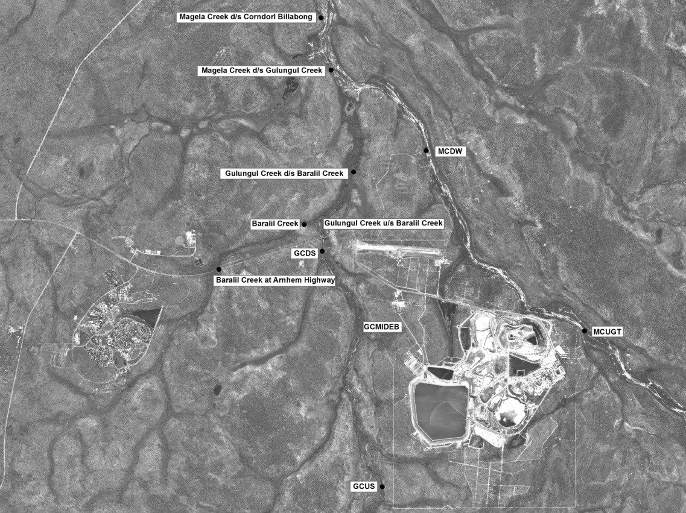

GCLB

**GCT2**

**TSF**

**Figure 1** The location of the three Gulungul Creek monitoring sites (GCUS, GCLB and GCDS) and Gulungul Creek Tributary 2 (GCT2) west of the Tailings Storage Facility (TSF).

# 2 Methods

## 2.1 Direct Toxicity Assessment of GCT2 water

### 2.1.1 Test organisms

All test organisms were isolated from soft surface waters in Kakadu National Park, and have been cultured continuously in the laboratory for up to 25 years, depending on the species. The test methods are described in detail by Riethmuller et al. (2003) and, for *A. cumingi* by Houston et al. (2007). Key details of each test are provided in Appendix A.

### 2.1.2 Test containers

All plastics and glassware were washed by soaking in 5% (v/v) HNO3 for 24 h before being washed with a non-phosphate detergent (Dr. Weigert, neodisher® LaboClean FLA) in a laboratory dishwasher operated with reverse osmosis deionised water (Elix, Millipore). Glassware used in the toxicity tests was silanised with 2% dimethyldichlorosilane in 1,1,1-trichloroethane (Coatasil, AJAX) to reduce adsorption of metals to the glass.

### 2.1.3 Preparation of test solutions

Water from Gulungul Creek upstream (GCUS) was used as the diluent and control water in all toxicity tests. This water was collected upstream of Gulungul Creek Tributary 2 (GCT2) and Ranger Mine, and the quality of this water was considered sufficiently free from any mine influence at the time of collection, although some mine-water inputs from the Corridor Creek Land Application area may have occurred (Appendix B, Table 1).

High EC water (2430 µS/cm) was collected from GCT2 near the source of the seep on 4 February 2015. Water was collected in acid-washed 20 L containers that were triple-rinsed in the water prior to filling by submersion into the creek. The containers were transported by road (2.5 h) to the laboratory at ambient temperature. At the laboratory, GCUS water was filtered within a day of collection (3.0 µm Sartopure PP2 depth filter MidiCaps, Sartorius). Water collected from GCT2 was not filtered and was visibly free from particulates and zooplankton. Given the high volumes of water required for the *A. cumingi* tests, the diluent used in those tests was also not pre-filtered. This had the potential to introduce coarse particulates and wild zooplankton into the test. However, all test solutions were visibly free of such issues. Tests with *L. aequinoctialis* and *H. viridissima* commenced on 9 February while for the snail test the waters were stored at 4 ± 1°C until the test commenced on 9 March. The test with *M. macleayi* (which was invalid) commenced on 23 February.

Test waters were prepared by diluting GCT2 water with GCUS water, resulting in 8 treatments with an EC range of 50 – 2430 µS/cm (Appendix B, Table 1) and a corresponding Mg range of 1.2 – 350 mg/L (Appendix C, Table 2). For the test using *L. aequinoctialis*,the treatments (dilutions) were spiked with nitrate (using NaNO3) and phosphate (K2HPO4) at the test outset to achieve a N and P concentration of 3.0 and 0.3 mg/L respectively. This is required to achieve optimal growth rates in the toxicity tests.

### 2.1.4 Toxicity testing

***Hydra viridissima***

The *H. viridissima* population growth test involved chronic exposure of ten hydra to a 30 mL control treatment, or one of seven GCT2 dilutions for 96 h at 27 ± 1 °C. Treatments were conducted in duplicate in plastic Petri dishes with 24 h renewal of test solutions. Each hydra was fed 3 to 4 artemia (*Artemia salina*) daily. Hydra were selected on the basis that they were free of deformity and each hydroid had one tentacled bud, a characteristic of optimal health. Population growth rates were compared to that of the control. A test was considered valid if there were 30 or more healthy hydra in each of the control replicates at 96 h (equivalent to a daily growth rate ≥0.275 day-1, where growth rate is [(ln (final number) – ln (starting number))/4]), with variability in the controls (expressed as the coefficient of variation, CV) of less than 20%.

***Amerianna cumingi***

The 96-h *A. cumingi* reproductive test involved exposure to a control treatment and each of five GCT2 dilutions. *Amerianna cumingi* was not tested in full strength GCT2 water as it was anticipated, based on the response to Mg observed by van Dam et al (2010), that this would not be required to obtain a full toxic effect. Pairs of adult snails of 10-13 mm length were each placed into polycarbonate tubes which were capped at each end with nylon mesh and PVC circlips. Two discs of organic iceberg lettuce (each 1 cm in diameter) were included in each tube. A replicate consisted of six tubes placed in 1.75 L of test solution in a 2 L glass beaker. Each treatment was carried out in triplicate. The beakers were placed in an incubator at 30 ± 1 °C with a 12:12 h light: dark cycle with aeration. Observations (counting of egg masses), cleaning and replacement of lettuce were carried out daily. At the completion of the test the snails were removed from each tube and the number of egg masses on each tube recorded. For each tube, the number of eggs in each egg mass was counted using a dissecting microscope. The number of eggs in each egg mass for a pair of snails was entered into a spreadsheet to calculate the total number of eggs for each pair. The mean number of eggs per pair was calculated and then the mean, standard deviation and % coefficient of variation (CV) was calculated for each treatment based on the means of the 3 replicates. For a test to be valid each control pair needs to have laid between 30-260 eggs.

***Lemna aequinoctialis***

For the 96-h *L. aequinoctialis* growth rate test each replicate contained 4 x 3-fronded *L. aeqinoctialis* plants which were inoculated into 100 mL of test solution in a 250 mL flask. Treatments were conducted in duplicate except for the control which was conducted in triplicate. Plants were exposed to a control and each of seven GCT2 dilutions for 96 h at 29 ± 1 °C using a 12:12 h light to dark cycle at 100-150 µmol/m2/s of PAR. An image of the control replicates was taken at the test start to calculate the starting surface area of a replicate. Frond number was counted daily, and at test completion, the number of fronds in each flask were counted and an average specific growth rate (K) based on frond number was calculated using the formula [(ln (final number) – ln (starting number))/4]. For a test to be valid, frond number of the control replicates needed to reach 60 or more fronds per flask. Growth rate based on surface area was also measured by taking photos of the plants in each replicate at test completion and using the image analysis software, ImageJ, to identify plant surface area.

***Moinodaphnia macleayi***

The 6-d reproductive test with *M. macleayi* used neonates which were <6 h old. The neonates were exposed to a control and each of five GCT2 dilutions. Each treatment consisted of 10 replicates (individual fleas). Cladocerans were pipetted individually into 30 mL volumes of test solution containing 30 µL of FFV (Fermented Food with Vitamins) and the alga *Chlorella* sp. (6 x 106 cells). Cladocerans were transferred daily to new test solutions and food. For a test to be valid 80% or more of the control cladocera need to have survived and produced three broods with a total of 30 or more neonates across all broods.

### 2.1.5 Physico-chemical analyses

On arrival at the laboratory, both waters (GCUS and GCT2) were sub-sampled for physico-chemical analyses. Specifically, pH, dissolved oxygen (DO), EC and temperature were measured using WTW Multiline P4 and Inoline Multiline Level 1 instruments. Dissolved organic carbon (DOC) was measured immediately using the high-temperature combustion method APHA5310B (TOC-VCSH, Shimadzu Scientific Instruments). Sub-samples of 3.0 μm filtered GCUS water and unfiltered GCT2 water were taken for measurement of alkalinity (APHA2320B) and a suite of metals and major ions, i.e. Al, Cd, Co, Cr, Cu, Fe, Mn, Ni, Pb, Se, U, Zn, Ca, Mg and Na by ICP-MS and ICP-AES (Envirolab, Chatswood, NSW). Sulfate was inferred from S anlaysis by ICP-AES. Magnesium concentrations of diluted treatments were estimated based on the Mg concentration of undiluted GCT2 water. For each of the treatments, the equivalent EC was used as a surrogate measure of Mg i.e. 350 mg/L Mg = 2430 μS/cm (the Mg concentration and EC of undiluted GCT2 water).

The pH, DO and EC of all treatment waters were measured again at the start of each test. For the snail and hydra test, water parameters were measured at 24-h intervals accompanying each water change. For the *L. aequinoctialis* test, these parameters were measured at 0 h and 96 h only.

### 2.1.6 Data analyses

Nominal Mg concentrations for toxicity estimates were based on the Mg concentration of undiluted GCT2 water (see above). Where applicable, non-linear regression models were fitted to the concentration-response data using Sigmaplot v13 (Systat Software). The best fit model was determined by the highest regression coefficient (*r*2) of a suite of 3- and 4-parameter sigmoidal or logistic models. Where possible (i.e. where a sufficient concentration-response relationship existed), estimated Mg concentrations at which there was 10% and 50% inhibition of growth or reproduction (IC10 or IC50), and their 95% confidence limits, were calculated.

## 2.2 In situ snail toxicity monitoring

### 2.2.1 Field monitoring procedure

*Amerianna cumingi* has been shown to be among the most sensitive species to both uranium and magnesium of the suite of six local species used for toxicity assessment at ***eriss***. Reproduction (egg production) of *A. cumingi* over 96-h was monitored in Gulungul Creek at an upstream (GCUS), midstream (GCLB) and downstream site (GCDS) shown in Figure 1 (GCUS: Latitude 12°40′.472′′, Longitude 132°55′.859′′, GCLB: Latitude 12°40′5.31′′ S, Longitude 132°53′7.52′′ E, GCDS: Latitude 12°38′.312′′, Longitude 132°53′.962′′). The midstream, GCLB site was an additional site established in Gulungul Creek for the 2014–15 wet season, to observe the reproductive responses of snails exposed to Gulungul Creek waters downstream of GCT2. This site has been elevated in EC in recent wet seasons, prior to some dilution at the Gulungul Creek downstream site. Using an automated sampler, six samples were taken from GCUS and twelve samples from each of sites GCLB and GCDS had average (total) Mg concentration of 2.3, 4.7, and 4.2 mg/L over the period 15 – 20 March 2015, respectively. For the prevailing stream discharge, this represented an 11–13% dilution between sites GCLB and GCDS.

Toxicity monitoring was carried out by placing snails in floating (flow-through) containers located upstream and downstream of the GCT2 confluence with Gulungul Creek. At each site there were duplicate containers, each containing eight replicate tubes of snail pairs (i.e. 32 snails were exposed at each site). The method for this monitoring is further described in Supervising Scientist Division (2011). Results for the 2014–15 and 2015–16 wet seasons are provided here, with GCT2 contamination reaching Gulungul Creek in both wet seasons.

### 2.2.2 Data analyses

Toxicity monitoring results for each of the two wet seasons were analysed by comparing the differences in egg numbers between the upstream (control) and downstream (exposed GCDS) sites and testing for statistical change between ‘current’ and previous wet seasons. This Before-After Control-Impact Paired (BACIP) design, with two-factor ANalysis of VAriance (ANOVA) testing, is described in more detail in Supervising Scientist Division (2011).

More detailed impact assessment from the data obtained from the midstream and downstream sites was also undertaken. This assessment was based upon (i) examination of plots of the upstream (GCUS), downstream (GCDS) and midstream (GCLB) egg production, with corresponding difference values (Figure 3), (ii) analysis of egg production difference values amongst the three possible site-pair combinations (see Table 2), and (iii) plots and regressions of egg production in relation to median EC and water temperature. For the analyses described in (ii), Student *t*-tests, based on different sets of paired-site, egg count difference values were conducted using the Excel analysis tool. The *t*-tests conducted in this report are equivalent to the ANOVA described above, but examine just one factor, i.e. comparison of difference values for two ‘regimes’ (e.g. Before versus After, or egg count data from two water quality regimes). All plots and regression analyses for aspect (iii) were conducted in Excel.

## 2.3 Desktop analysis of historical Direct Toxicity Assessments and water chemistry

Two desktop analyses of existing/historical data were undertaken in order to place the results of the GCT2 toxicity assessment in the context of surface and groundwater quality across the mine site, as described below.

A desktop analysis was conducted to determine the ranges of concentrations of Mg and Mg:Ca ratios across various off-site and on-site surface waters and groundwater over the last six years. Data were provided by ERA and also from internal SSB sources. These data, along with concentrations of U, SO4 and Mn collected from 28 sites spanning the years 2003-2016, were analysed for multivariate resemblance with results reduced and plotted by way of two-dimensional ordinations. Water quality data analysed in this way typically apply either Principal Component Analysis (PCA) or Principal Coordinates Analysis (PCO). Using Euclidean distance as the distance metric, both PCA and PCO are equivalent. However, PCO has practical advantages for the software employed (Primer Version 7) in better depicting relationships arising from large datasets The data analysed here included almost 3000 samples, as well as water quality data for the GCT2 water, and so for visible clarity, a PCO rather than a PCA was used. Specifically, PCO enabled the data points to be condensed into a single point for each site. To do this, all data were log (natural) transformed and normalised prior to forming a resemblance matrix based on Euclidean distance, and then calculating the Distance to Centroids for each site. The PCO was then performed on the Centroids matrix. Two PCOs were produced; one including and the other excluding the Mg:Ca ratio data.

A separate analysis was conducted to collate results from all historical DTAs of mine waters undertaken by the Supervising Scientist. In total, data from 27 toxicity tests were collated for the period, 1987 to 2007, representing DTAs for 13 different batches of site water from retention pond 2 (RP2; 8 batches), Pit 3 (1 batch) and Djalkmara Billabong (4 batches). The toxicity tests were conducted using the routine species cultured in the ecotoxicology lab (the cladoceran *Moinodaphnia macleayi*, duckweed *Lemna aequinoctialis*, gastropod *Amerianna cumingi*, alga *Chlorella* sp. and the Northern trout gudgeon *Mogurnda mogurnda*). Where possible, the data from these tests, which were originally reported in terms of No Observed Effect Concentrations (NOECs) and Low Effect Concentrations (LOECs), were re-analysed to calculate 10% and 50% Effect Concentrations (EC10 and EC50, respectively). This re-analysis was conducted because EC values (particularly EC50s) can improve the ability to identify a relationship between toxicity and concentrations of contaminants of concern. Of the 27 tests, 15 were successfully re-analysed for EC values (9 tests for *H. viridissima*, 3 tests for *M. macleayi*, 2 tests for *L. aequinoctialis* and 1 test for *Chlorella* sp.) As the most data were available for *H. viridissima*, the final dataset incorporated this species only. For the final analyses, it also became apparent that it would be more accurate to use the original data rather than the recalculated ECs because the concentration ranges used for the toxicity tests were too wide to enable a regression models that could calculate accurate EC50s. Thus the LOECs derived for those tests, along with concentrations of Mg, Ca, SO4 and U, were further analysed (after being log transformed and normalised) using a Principal Components Analysis (PCA; Primer Version 7).

A Toxic Units approach (Sprague, 1970) was used to further assess the observed responses of *H. viridissima* and *M. macleayi* to the DTA waters, whereby the Observed Toxic Units (OTU) of each DTA water were compared to the Predicted Toxic Units (PTU) based on the known toxicity of each of the contaminants U, Mg, Mn and SO4.

The OTU was calculated using the following equation:

*100 / Concentration of contaminant that corresponds with the IC50 for DTA water*

while the PTU was calculated using the following equation:

*Concentration of contaminant in the DTA water sample / IC50 of contaminant alone*

A comparison of these two values, i.e. whether or not they overlap, indicates the extent to which each contaminant is likely to be contributing to the toxicity of the DTA water. Where the OTU and PTU overlap or the PTU > OTU, it can be concluded that the toxicant of interest most likely accounts for all the observed toxicity. Conversely, where the PTU < OTU, the toxicant of interest most likely does not account for all the observed toxicity, and another toxicant(s) may be contributing to toxicity.

# 3 Results

## 3.1 Direct Toxicity Assessment of GCT2 water

### 3.1.1 Quality Control

Values of physico-chemical parameters of the diluent water from GCUS as measured at the start of testing were as follows: pH 6.6 − 6.8, DO 98 - 101%, EC 22 µS/cm, water hardness 6.9 mg/L as CaCO3 and dissolved organic carbon (DOC) 4.4 mg/L. At the end of the exposure periods the physico-chemical parameters of the GCUS water were: pH 6.9 − 7.1, DO 86 − 94%, and EC 23 – 35 µS/cm (Appendix B, Table 1). Chemical analyses of the blank, procedural blanks and control water indicated that all the toxicity tests were free from confounding contaminants (Appendix C).

All tests, except that for *M. macleayi*, passed the acceptability criteria (Appendix A) as detailed in Riethmuller et al. (2003) and, for *A. cumingi*, Houston et al. (2007). The *M. macleayi* test failed due to only 50% survival of the controls, which was the result of poor organism culture health at the time (results not shown here). The reasons for this were not identified, but when the culture health recovered, the test was unable to be repeated due to an insufficient volume remaining of GCT2 test water. Additional water could not be collected as both GCT2 and Gulungul Creek had ceased flowing for the season.

### 3.1.2 Diluent and toxicant water chemistry

The chemistry of the diluent water from GCUS differed somewhat from that of the Magela Creek Water diluent used in van Dam et al (2010). The diluent from GCUS was slightly higher in hardness (6.9 mg/L compared to 4 mg/L CaCO3 in MCW) due to the higher concentrations of Ca (0.8 mg/L compared with 0.3 mg/L) and Mg (1.2 mg/L compared to 0.8 mg/L), which may have been due to mine water coming from the Corridor Creek Land Application Area. Nevertheless, this small difference in hardness is not likely to have influenced the responses to Mg observed in this study considering that the toxicant GCT2 water contained 350 mg/L Mg and 70 mg/L Ca. The DOC was similar between the two water types: 4.4 and 4 ± 1 mg/L for GCUS and MCW respectively.

Chemical analysis of contaminated GCT2 water indicated that the elevated EC of the water (~3000 μS/cm) was associated with higher than background concentrations of major ions, in particular sulfate (SO4) and magnesium (Mg), followed by calcium (Ca) and potassium (K), with their concentrations being 727, 291, 88 and 13 times higher, respectively, than those measured in water from GCUS (Appendix C). Other elements and metals were also measured above background including uranium (U, 8.8× higher than GCUS), manganese (Mn, 58×), cobalt (Co, 40×), nickel (Ni, 6.6×), bromine (Br, 6.9×), barium (Ba, 19×) and strontium (Sr, 57×). Due to Mg being the key COPC for the Ranger mine, and also the most elevated COPC in the GCT2 water, results were presented as both the concentrations of Mg calculated to be in the GCT2 water and the equivalent measured EC.

### 3.1.3 Laboratory toxicity testing

The concentration-response relationships for the three species were statistically weak (regression relationships ≥ 0.09; Figure 2) due to limited treatments in the experiments and a lack of response to the toxicant. The analysis reports and IC values from the toxicity test are provided in Appendix D

The population growth rate of *H. viridissima* was inhibited by 10% (IC10) in GCT2 water with an EC of 1363 µS/cm (equivalent to 196 mg/L Mg) and by 50% (IC50) at an EC of 2276 µS/cm (328 mg/L Mg; Table 1 and Figure 2a). The sensitivity of *H. viridissima* to GCT2 water (at 5:1 Mg:Ca ratio) was greater than expected based on its response to Mg observed by van Dam et al (2010) at a 9:1 Mg:Ca ratio (i.e. an IC50 of 713 mg/L Mg; Table 1).

A hormetic effect on reproduction was observed across the Mg concentration range for *A. cumingi* (Figure 2c). For the concentration-response relationship based on a 3-parameter logistic model (Figure 2), a 10% effect (IC10) was calculated for GCT2 water with an EC of 953 μS/cm, which was equivalent to 133 mg/L Mg (Figure 2b). *Amerianna cumingi* was not tested in undiluted GCT2 water, but there was a 28% reduction in reproduction for snails exposed to the highest EC of 1370 µS/cm (i.e a Mg concentration of 198 mg/L Mg). The IC50 for *A. cumingi* (Table 1) was not reliable due to the limited dataset (Figure 2b) but indicated a reponse that was less than that reported for MgSO4 only tests (van Dam et al., 2010). This may have been due to the amelioration by Ca or other factors in the water.

There was no toxic response detected for *L. aequinoctialis* in GCT2 water,although growth rates were generally higher than controls across the treatments (Figure 2d). Hence, this species appeared less sensitive to the GCT2 water compared to the MgSO4 only testing reported in van Dam et al., (2010), which may have been due to amelioration by Ca or other factors in the water.

**Table 1** Toxicity estimates (95% confidence limits) for GCT2 water for three local freshwater species, expressed as magnesium (Mg, mg/L) and electrical conductivity (EC, µS/cm).

|  |  |  |  |  |  |  |  |
| --- | --- | --- | --- | --- | --- | --- | --- |
|  | **GCT2a** | | | |  |  | **MCWb** |
| **Species** | **IC10c** | | **IC50d** | |  |  | **IC50** |
|  | **Mg** | **EC** | **Mg** | **EC** |  |  | **Mg** |
| *H. viridissima* | 196  (NC – 254) | 1363  (NC – 1770) | 328 (295-362) | 2276  (2050 – 2510) |  |  | 713  (646-780) |
| *A. cumingi* | 133 | 953  (375 – 1571) | 251 (NC) | 2232  (530 – NC) |  |  | 96  (61-150) |
| *L. aequinoctialis* | NC | NC | NC | NC |  |  | 629  (413-956) |

a GCT2 = Gulungul Creek Tributary 2 water at a 5:1 Mg:Ca ratio

b MCW = Magela Creek water spiked with Mg and Ca to produce a constant ratio of 9:1. Values reported by van Dam et al (2010)

c IC10: the concentration (mg/L Mg) or electrical conductivity (EC) that results in a 10% reduction in growth rate relative to the controls. Values derived from 3-parameter logistic curve fits shown in Figure 1a and 1b.  
d IC50: the Mg concentration or EC that results in a 50% reduction in growth rate relative to the controls. Values derived from curve fits shown in Figure 1a and 1b. Values derived from 3-parameter logistic curve fits shown in Figure 1a and 1b.

NC = Not calculable

|  |  |
| --- | --- |
| 1. ***Hydra viridissima*** | |
|  | |
| 1. ***Amerianna cumingi* c)** | |
|  |  |
| 1. ***Lemna aequinoctialis*** | |
|  | |

**Figure 2** Toxicity of GCT2 water (containing 350 mg/L Mg), as expressed by electrical conductivity (µS/cm) and estimated magnesium (mg/L) to three local freshwater species in Gulungul Creek upstream water. *A. cumingi* was not tested in undiluted GCT2 water. a) curve fit derived from 3-parameter logistic model (*r*2 = 0.80, P = 0.12). b) curve fit derived from a 3-parameter logistic model (*r*2 = 0.30, P = 0.27) and c) a double 4-parameter exponential rise model (*r*2 = 0.92, P = 0.12). d) linear regression for *L. aequinoctialis* (*r*2 = 0.40, P = 0.09). Dashed red line shows maximum spike of 120 µS/cm EC at Gulungul Creek left bank.

## 3.2 In situ snail toxicity monitoring

Upstream (GCUS), midstream (GCLB) and downstream (GCDS) 96-h egg production of *A. cumingi*, with corresponding difference values, for the thirteen 2015 and four 2016 tests conducted in Gulungul Creek for 2015 are shown in Figure 3. Table 2 shows the differences in egg numbers produced between different site pairs for the upstream (GCUS), midstream (GCLB) and downstream (GCDS) sites. As described above (Section 2.2.2), statistical tests for change are made at the end of each wet season when differences in egg numbers between the upstream (control; GCUS) and downstream (exposed; GCDS) sites are compared between ‘current’ and previous wet seasons. (Such ‘before’ versus ‘after’ testing was not possible for egg number difference values between the upstream (GCUS) and midstream (GCLB) site because no data for the midstream site were available for previous wet seasons.) Analysis of these data indicated no significant difference between difference values for either 2014–15 or 2015–16 wet seasons and values for previous years (p >0.05).

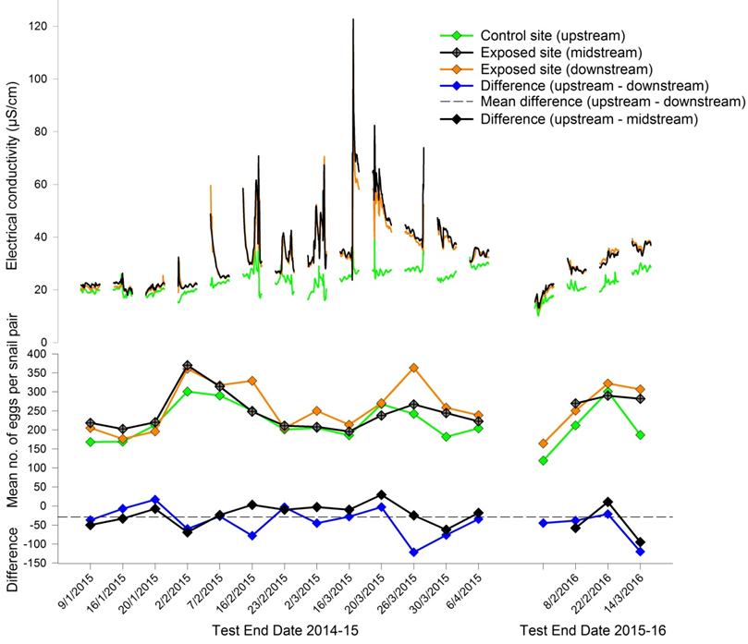

**Figure 3**. *In situ* snail egg production and median EC data from toxicity monitoring tests conducted in Gulungul Creek during the 2014–15 and 2015–16 wet seasons. Upstream = GCUS, midstream = GCLB and downstream = GCDS.

The data for 2015, when greatest contamination was observed (Figure 3), indicated there was no toxic response (reduced egg production) to elevated solute concentrations over the 96-h period from 12 – 16 March 2015 (with an average EC of 48 and 44 µS/cm at GCLB and GCDS respectively, Figure 3). That period of elevated EC represented exposure to an average dissolved Mg concentration of 4.8 mg/L. Similar to results reported in previous years, egg production in Gulungul Creek in both 2015 and 2016 continued to be greater at the GCDS sites compared to GCUS (Table 2, Figure 3). Magnesium toxicity tests with *A. cumingi* conducted by van Dam et al (2010) produced an IC10 of 5.6 mg/L Mg, suggesting that a toxic response for *A.  cumingi* at the average exposure concentration of 4.8 mg/L may not have been expected.

**Table 2** Mean and associated standard deviation (SD) of Gulungul site-pair differences in snail egg number and median Electrical Conductivity for 2015 and 2016 in situ monitoring tests. GCUS = upstream, GCDS = downstream and GCLB = midstream

|  |  |  |  |  |  |  |  |
| --- | --- | --- | --- | --- | --- | --- | --- |
|  |  | ***GCUS-GCDS*** | | ***GCUS-GCLB*** | | ***GCLB-GCDS*** | |
|  |  | **Difference in egg counts** | **Median EC (µS/cm)** | **Difference in egg counts** | **Median EC (µS/cm))** | **Difference in egg counts** | **Median EC (µS/cm)** |
| **2015** |  |  |  |  |  |  |  |
| Tests 1-5 | Mean | -23.05 | -2.34 | -36.76 | -1.76 | 13.71 | -0.58 |
|  | SD | 29.27 | 0.14 | 23.88 | 0.79 | 12.10 | 0.68 |
| Tests 6-13 | Mean | -46.01 | -11.86 | -11.41 | -13.01 | -34.61 | 1.14 |
|  | SD | 35.74 | 6.09 | 25.88 | 7.16 | 31.57 | 2.00 |
| All tests | Mean | -37.18 | -8.20 | -21.16 | -8.68 | -16.02 | 0.48 |
|  | SD | 34.15 | 6.70 | 27.30 | 7.91 | 35.05 | 1.80 |
| **2016** |  |  |  |  |  |  |  |
| All tests | Mean | -56.21 | -7.46 | -47.44 | -8.89 | -12.52 | -0.21 |
|  | SD | 43.69 | 3.68 | 53.61 | 1.41 | 27.73 | 1.05 |

Nevertheless, subtle effects of the GCT2 waters on snail reproduction were evident over both the 2014–15 and 2015–16 wet seasons. These are described in the following sections.

#### 3.2.1 Egg production relationship with EC

Combining the Gulungul data from 2015 and 2016 for GCUS control and GCDS exposed sites showed a significant positive relationship between (log) egg number and EC (P <0.05) (Figure E1, Appendix E). This indicates a stimulation of reproduction in *A. cumingi* exposed to small elevations in solutes (up to Mg concentrations of ~5 mg/L Mg). This result is consistent with those from previous toxicity testing. For median water temperatures <30°C, significant positive relationships have also been observed previously in both Magela and Gulungul Creek (see Figure 4.7 of Section 4.4.2, Supervising Scientist 2014). In any of the relationships between egg number and EC observed in this and previous wet seasons, the low R2 values are associated with the influence of water temperature and husbandry, also known to affect snail egg production. Paired site, egg number difference values remove or reduce this variation for impact detection and assessments.

#### 3.2.2 Relative suppression in egg production at GCLB

Using Student *t*-testing, egg production at the downstream ‘exposed’ site, GCDS, was found to be significantly higher than upstream across all tests and both years (P <0.05, Appendix E, Table E1). Egg production at the midstream exposed site, GCLB, was also higher than the upstream site, GCUS, across all tests and both years, but not as high as the downstream site, and the upstream versus midstream comparison was not significantly different (P = 0.07, Appendix E, Table E2). Examining this slightly-reduced (relative to the downstream site) egg production at the midstream site in more detail, during periods of high EC in Gulungul Creek (a consequence of high GCT2 discharge), egg production at the midstream site appeared to be lower than at the downstream site – see 2015 data in Table 2 and Figure 3 where differences in egg production between midstream and downstream sites switch between the first five and subsequent tests, coinciding with increase in EC at the exposed sites. Egg number difference values between the midstream and downstream sites were derived for both wet seasons (combined), and the difference values separated according to tests where median EC was either less than or greater than 30 µS/cm (6 and 10 tests respectively). The difference values were compared using a *t*-test and shown to be significantly different (P = 0.002; see Appendix E, Table E3 for full workings). This result indicates that once median EC at the exposed, midstream site exceeded 30 µS/cm, there was a small, but statistically significant, suppression in egg production at this site relative to the downstream site. Rather than an EC threshold, this relative suppression in egg production at the midstream site can be shown to be continuous for increasing EC in the plot of midstream–downstream difference values versus median EC at the mid site – see Figure 4. This plot shows that, generally, as the EC increased at the midstream site, suppression in egg production at this site relative to the downstream site, also increased.



**Figure 4**. Linear regression relationship between midstream–downstream snail egg number difference values and median EC at the mid site from toxicity monitoring tests conducted in Gulungul Creek during the 2014–15 and 2015–16 wet seasons.

## 3.3 Analysis of water chemistry and historical Direct Toxicity Assessments

In order to compare the composition of the GCT2 water with other minesite water sources, a desktop analysis determined mean concentrations of Mg and Mg:Ca ratios for various off-site and on-site water bodies over the period of 2010-2016 (Table 3). The mean Mg:Ca ratio of all sites (excluding extreme high values of Pit 1 and bore WSMB17) was approximately 4.5:1, similar to the 5:1 Mg:Ca ratio of water from GCT2 measured at the time of this study.

**Table 3** Summary of magnesium:calcium ratios from 2010-2016 (all data refers to < 0.45µm fraction except for MCUGT and GCUS sites). See Appendix G for sampling locations.

|  |  |  |  |  |
| --- | --- | --- | --- | --- |
| **Sitea** | **Ave Mg (mg/L)** | **Ave Mg:Ca ratio** | **SE** | ***n*** |
| **Pond Water** | | | | |
| RP2 | 241 | 4 | 0.03 | 239 |
| TSFS1 | 460 | 4 | 0.06 | 73 |
| TWWS | 834 | 4 | 0.8 | 102 |
| CB1 | 337 | 3 | 0.1 | 55 |
| CB3 | 205 | 3.5 | 0.8 | 55 |
| CB4 | 425 | 6.1 | 0.1 | 56 |
| CB5 | 202 | 3.4 | 0.1 | 46 |
| CB6 | 201 | 3.6 | 0.04 | 45 |
| **Process Water** | | | | |
| Tailings Dam | 6832 | 13 | 0.1 | 57 |
| PJ (Pit 1) | 6182 | 23 | 2.8 | 23 |
| **Release Water** | | | | |
| RP1W | 34 | 6 | 0.07 | 360 |
| TSFS2 | 158 | 2 | 0.07 | 77 |
| CB7 | 12.6 | 2.5 | 0.03 | 182 |
| **Groundwater north west of Pit 3 & Western Stockpile** | | | | |
| WSMB13 | 6 | 2.1 | 0.06 | 22 |
| WSMB14 | 17 | 3.3 | 0.2 | 34 |
| WSMB15 | 15 | 0.4 | 0 | 2 |
| WSMB16 | 9 | 6.2 | 0.06 | 27 |
| WSMB17 | 50 | 89 | 2.9 | 24 |
| **Groundwater west of RP1 Wetland Filter** | | | | |
| WSMB12 | 36 | 4.1 | 0.1 | 38 |
| NWRD | 381 | 8.4 | 0.2 | 76 |
| **Groundwater west of TSF (Tailings Storage Facility)** | | | | |
| OBN225C | 717 | 4.1 | 0.05 | 24 |
| RN23566 | 220 | 6.9 | 0.47 | 37 |
| **Magela Creek Upstream (MCUGT)** | | | | |
|  | 0.6 | 1.5 | 0.1 | 29 |
| **Magela Creek Downstream (MCDW)** | | | | |
|  | 0.8 | 2.6 | 0.2 | 57 |
| **Gulungul Creek Upstream (GCUS)** | | | | |
|  | 2 | 2.2 | 0.03 | 93 |
| **Gulungul Creek Downstream (GCDS)** | | | | |
|  | 2 | 2.9 | 0.1 | 84 |
| **Coonjimba Billabong** | | | | |
| CB | 27 | 6.8 | 0.1 | 246 |
| **Georgetown Billabong** | | | | |
| GTB | 4.7 | 3.4 | 0.1 | 248 |

Full results for the PCA and PCO analyses are provided in Appendix F. In each of the multivariate ordinations, the length of the vectors for the variables is proportional to their strength of association along the corresponding axis direction.

Some relationships and site groupings were found through two PCOs conducted with and without the Mg:Ca ratio variable (Figures 4 & 5 respectively). Of the two ordinations, Figure 4, with inclusion of the Mg:Ca ratio variable, explained less of the variation across the primary (PCO1) axis (65%; dominated by all COPCs), and showed least differentiation and separation of site groupings (with the exception of the process water, several of the groundwater sites, for which there were only a few samples, and creek waters). The greater variation explained in the second (PCO2) axis of Figure 4 (22%; driven by Mg:Ca ratio), appeared to be highly influenced by just two extreme groundwater samples taken from north-west of Pit 3. Without the influence of the Mg:Ca ratio variable (Figure 5), the PCO shows a greater resolution of sites along the horizontal PCO1 axis and more variation explained by this axis (80%).



**Figure 4** Principal Coordinate Analysis (PCO) showing the relationship between the chemistry of the 28 sites shown in Table 3, along with that of GCT2 and other DTA waters. Chemical variables included in the analysis were Ca, Mg, Mg:Ca ratios, Mn, SO4 and U.



**Figure 5** Principal Coordinate Analysis (PCO) showing the relationship between the chemistry of the 28 sites shown in Table 3, along with that of GCT2 water and other DTA waters. This PCO is based on an identical data set as that used for Figure 4, only Mg:Ca ratios have been excluded from this analysis.

The GCT2 DTA water was high in Mn, Mg, Ca and SO4, and in ordination space grouped with the two groundwaters west of the TSF (Ground WTSF), which were also high in Mn, Mg and SO4 (Figure 5). This is unsurprising given the sites are in close proximity, and the GCT2 contamination arose from groundwater seepage. All of these waters (GCT2 DTA and Ground WTSF), together with the other DTA waters (from RP2, Pit 3 and Djalkmara) and Pond waters, were similarly positioned in the centre of the primary Axis (PCO1), with the former sites containing proportionately more Mn and a number of the other DTA and Pond waters containing proportionately more U. Notably, DTA waters from RP2, Pit 3 and Djalkmara were strongly representative of site pond water (Figure 5). However, it should be noted that the chemistry for the DTA waters was represented by a limited number of samples (2-5 for each site). One of the groundwater sites (WSMB15), which sits separately from any of the other clusters, was also represented by only two samples with higher Ca, SO4 and U.

A Principal Components Analysis (PCA) was performed using the COPC concentrations, or their ratios, corresponding to the EC10 values for *H. viridissima* derived from ten DTAs, i.e. nine historic DTAs that were conducted between 1998-2003 and GCT2 in 2015 (Figure 6). Axis 1 and 2 of the PCA explained 65% and 17.5% of the total variance respectively. Of the 6 variables included in the analysis (U, Ca, Mg, Mn, SO4 and Mg:Ca ratio), SO4, Mg, Ca and Mn were influential, in that order, across Axis 1, while U dominated Axis 2 (Appendix F). The Mg:Ca ratio was marginally more influential across Axis 2 (eigenvalue 0.399 cf 0.378 for Axis 1; Appendix F).



**Figure 6** Principal Component Analysis (PCA) showing the relationship between various contaminants of on-site water (RP2, Pit3, Djalkmara Billabong and GCT2) and the toxicity of that water, based on 10% effect concentrations (LOECs) to *Hydra viridissima*. Data from ten DTAs were included in the analysis. Axes PC1 and PC2 together explain 88% of the total variance.

The PCA strongly separates the analytes associated with toxicity of GCT2 waters from those associated with toxicity of the historic DTAs. Test waters associated with most (8 out of 9) of the historic DTAs were U-dominated, whereas the GCT2 water was salt-(SO4, Mg, Ca) and Mn-dominated with low U (Figure 6). Toxicity of most mine waters was associated with low Mg:Ca ratio. The ordination indicates that toxicity associated with the various surface and groundwater-related mine waters on the Ranger mine site can arise from highly variable COPC mixtures. The PCA, of course, cannot be used to identify COPCs causing the toxicity, noting as well that other unmeasured COPCs and COPC interactions generally, may also be implicated.

Historic and GCT2 DTAs conducted with *M. macleayi* and/or *H. viridissima* were also analysed using a Toxic Units approach. The full results of this assessment are shown in Appendix H, while Predicted Toxicity and the terms used to derive this, i.e. concentration of the COPC in the site water and IC50 for the COPC and test species from single toxicant laboratory study, are shown in Table 4.

**Table 4**. Predicted toxicity units (PTU) for *M. macleayi* and/or *H. viridissima*, based on COPC concentration in historic site waters (RP2, Pit 3 and Djalkmara) and GCT2 and IC50 values for the individual COPC and test species. Ranges only provided.

|  |  |  |  |  |  |  |
| --- | --- | --- | --- | --- | --- | --- |
| **Contaminant** | **Species** | **Concentration**  **in site water** | **IC50** | **OTUa** | **PTUb** | **PTU≥ OTU?** |
| Magnesium (mg/L) | *M. macleayi* (historic) | 107-157 | 122 | 71.4, 34.5, 3.4 | 0.9, 1.3, 1.1 | No |
|  | *H. viridissima* (historic) | 108-350 | 713 | 7.9, 5, 1.9, 9, 6 | 0.16, 0.25, 0.15, 0.22 | No |
|  | *H. viridissima* (GCT2) | 350 | 713 | 0.3 | 0.5 | No |
| Uranium (μg/L) | *M. macleayi* (historic) | 595-1760 | 32 |  | 18.6-55 |  |
|  | *H. viridissima* (historic) | 620-2750 | 67 |  | 9.3-41 |  |
|  | *H. viridissima* (GCT2) | 0.7 | 67 |  | 0.01 |  |
| Manganese (μg/L) | *M. macleayi* (historic) | 33-454 | 1100 |  | 0.03-0.4 |  |
|  | *H. viridissima* (historic) | 27-1700 | 1380 |  | 0.02-1.2 |  |
|  | *H. viridissima* (GCT2) | 350 | 1380 |  | 0.3 |  |
| Sulfate (mg/L) | *M. macleayi* (historic) | 445-655 | 843 |  | 0.05-0.8 |  |
|  | *H. viridissima* (historic) | 453-740 | 474 |  | 1.0-1.6 |  |
|  | *H. viridissima* (GCT2) | 1454 | 474 |  | 3.1 |  |

a OTU = 100/concentration of the contaminant at the observed IC50, b PTU = Concentration of contaminant in the DTA water. A PTU value ≥ OTU value indicates it is likely the contaminant is contributing to toxicity.

The outcomes of the Toxic Units approach should not be considered as definitive, as the toxicity data for single contaminants were derived under different environmental conditions from those present in the DTA waters (ie. tests were done at different Mg:Ca (mass) ratios and different concentrations of hardness). Nevertheless, the results indicated that U was likely to be the major contributor to toxicity to these species in the three historic surface waters that were tested (RP2, Pit 3 & Djalkmara, Appendix H). Manganese was predicted to have contributed to the observed toxicity to *H. viridissima* in two of the RP2 toxicity tests but magnesium was not predicted to contribute to the toxicity of the historic surface waters (Appendix H). These findings were logical because, apart from U, the concentrations of other COPCs in each of the three water types were generally near or lower than concentrations at which effects were observed (Table 4). Hence toxicity would not be expected for these other COPCs. For GCT2 water, Mg and SO4were both implicated in the toxicity of GCT2 waters to *H. viridissima,* although the influence ofwater hardness on the toxicity of these major ions varies and could not be quantified in this assessment (Appendix H).

# 4 Discussion

**4.1 Impact assessment**

The primary objective of this report was to determine the potential impact of dispersion of GCT2 water to Gulungul Creek in the 2014–15 and 2015–2016 wet seasons. Assessment of possible adverse effects was based on laboratory DTA and field biological monitoring results.

The results of the DTA of GCT2 water indicated that these contaminated waters were unlikely to impact the off-site environment. Thus, responses for each of the three test species at and below the equivalent maximum EC observed in Gulungul Creek in 2015 (Figure 2) showed no reduction in any of the response measures compared to those of the respective controls. Furthermore, GCT2 contaminants exhibited pulsed exposures in Gulungul Creek in response to local rainfall and stream discharge patterns – e.g. see EC traces in Figure 3. For magnesium at least, pulsed exposures result in reduced toxicity to organisms compared to continuous exposures at constant contaminant concentrations (Hogan et al 2013).

Biological monitoring results supported the DTA in assessing potential off-site impacts. Toxicity monitoring results for 2014–15 and 2015–2016 wet seasons for GCDS showed no significant change from results reported in previous wet seasons, indicating no overall adverse effects associated with GCT2 waters. The same conclusion was reached with end-of-wet season macroinvertebrate responses measured at GCDS for both wet seasons (Supervising Scientist 2015, 2017). While a subtle suppression in snail egg production was noted for the Gulungul midstream site, GCLB, relative to GCDS at median (four-day) creek EC values at the site >~30 µS/cm, the reproductive response at GCLB was still invariably enhanced compared to upstream. This enhancement, commonly observed downstream of Ranger in both Magela and Gulungul creeks, has never been linked to adverse environmental impact. Macroinvertebrate responses at GCLB also observed greater difference in community structure (dissimilarity) with the corresponding upstream site than the equivalent GCDS versus upstream comparison (Supervising Scientist 2015, 2017). While this could indicate a localised effect of GCT2 waters, there are no pre-2015 macroinvertebrate data from GCLB to be able to draw conclusions. The greater upstream-midstream dissimilarity compared to upstream-downstream dissimilarity may be associated with habitat differences and not water quality differences.

In conclusion, no adverse ecological effects were associated with the dispersion of GCT2 waters to receiving waters in Gulungul Creek in 2015 and 2016.

**4.2 Supporting evidence for the Mg rehabilitation standard**

The second objective of the investigation was to investigate whether DTA and accompanying (field) biological monitoring data could be used as another line of evidence to support the Mg rehabilitation standard.

The water from GCT2 was less toxic to *A. cumingi* than anticipated based on the response to Mg reported by van Dam et al (2010) at a 9:1 Mg:Ca ratio, where *A. cumingi* was reported to be the most sensitive species to chronic MgSO4 exposures. Stimulation of reproduction in *A. cumingi* was observed in both the laboratory DTA (at estimated Mg concentrations up to ~50 mg/L Mg) and during in situ toxicity monitoring in Gulungul Creek in the 2014–15 and 2015–16 wet seasons (up to maximum concentration reached, ~5 mg/L Mg). This stimulation in field toxicity monitoring has also been documented for previous wet seasons in both Magela and Gulungul creeks where it has been linked to elevated Mg (Supervising Scientist 2014; Section 4.4.2). Magnesium stimulation has not been observed in previous laboratory studies with *A. cumingi* at Mg:Ca ratios of both 5:1 and 9:1 (van Dam et al 2010) though Kefford et al (2005) did observe reproductive stimulation due to increasing salinity (NaCl) in the freshwater snail, *Physa acuta*. Exposure to low concentrations of Mn (i.e. 25–120 µg/L) has been shown to increase egg production in *A. cumingi* (Harford et al 2015); this concentration range was present in the DTA treatments, though the DTA stimulation was not observed above ~50 mg/L Mn (cf up to 120 mg/L observed in the single toxicant study of Harford et al (2015)). It is also unlikely that Mn is responsible for historic reproductive stimulation in *A. cumingi* observed in toxicity monitoring as ambient concentrations in receiving waters downstream of Ranger rarely exceed 20 mg/L Mn during the periods of snail exposure in the creeks. GCT2 waters are a complex mixture and attributing candidate (eg Mg, Mn, Ca) and other ions, and/or their interactions, to the reproductive stimulation in *A. cumingi* observed in 2015 and 2016 is not possible at this stage.

The reproductive stimulation in *A. cumingi* observed in the field became increasingly less pronounced at GCLB compared with that of snails at the site further downstream (GCDS) as median EC increased above ~30 µS/cm in the creek (Figures 3 and 4). As the GCLB site was the closest to the toxicant source, the lack of stimulation may have been due to concentrations being above that those needed for a stimulatory response, although both these sites had similar average EC. A more likely explanation is that snails at GCLB were exposed to an unknown toxicant(s) in the GCT2 water (which did not influence EC) and which had attenuated on reaching the downstream site. The necessary chemistry to support this hypothesis was not available for the GCLB and GCDS sites and the ultimate cause of relative changes between these downstream sites in snail egg stimulation requires further research.

Exposure of *L. aequinoctialis* to GCT2 water did not reduce their growth rates. The lack of toxicity observed for *L. aequinoctialis* was possibly due to the low Mg:Ca ratio of 5:1. It has previously been reported that Ca has a greater protective effect against Mg toxicity for *L. aequinoctialis* in particular (van Dam et al. 2010), but does not protect other species, such as *A. cumingi*, as effectively.

In contrast, the toxicity of GCT2 water was greater than anticipated for *H. viridissima* based on existing Mg toxicity data derived by van Dam et al (2010) at a 9:1 Mg:Ca ratio. This result may be explained by other constituents in the water contributing to toxicity. For example, the 350 μg/L Mn in the undiluted GCT2 water could be expected to result in an approximate 20% inhibition of reproduction of *H. viridissima* based on Mn-only toxicity testing (Harford et al 2015). However, in fully undiluted GCT2 water the inhibition was much greater (~60% inhibition, Figure 2) inferring effects from other toxicants or unexplained interactions amongst constituents in the GCT2 waters generally. Both Principal Components Analysis and Observed Toxic Units approaches suggested that U most influenced toxicity to both *H. viridissima* and *M. macleayi* in historic DTAs (RP2, Pit 1 and Djalkmara Billabong), if only for the high concentrations of U in the mine waters tested relative to concentrations at which effects were observed in single, U-only toxicity tests. However, the U concentration in the GCT2 water was only 0.7 µg/L, which is well below the reported IC10 of 47 µg/L for *H. viridissima* (van Dam et al, 2017) and would not have been a contributor of toxicity in that DTA. The unexpectedly high toxicity of GCT2 waters to *H. viridissima* is supported by the toxicity monitoring results for Gulungul midstream site GCLB reported above, i.e. the apparent exposure of snails at this site to an unknown toxicant(s) in the GCT2 water that did not affect snails further downstream.

These collective laboratory and field results, demonstrating greater or lesser anticipated toxicity based on knowledge of effects of single toxicants, highlight the complexity of assessing the toxicity of contaminants when they occur as mixtures. A further understanding of this would help to compare results from DTAs with those of single toxicant tests.

Results from ordinations of the water chemistry across the different mine water sites show that differentiation of site water quality is driven more by concentrations of the key COPCs and less so by the Mg:Ca ratio. Some distinctions can be made between the creek and billabong waters, on-site surface water bodies and groundwaters from different areas of the mine. The majority of DTAs were conducted with surface waters of similar chemistry to the pond water types (Figure 5), as the DTAs were conducted to derive safe dilutions for potential controlled mine water discharges from site. The PCO shows that the GCT2 water has similar chemistry to the groundwater collected from bores west of the TSF, i.e. with a source water likely higher in Mn and lower in U. Moreover, the PCO shows that those particular waters are distinct from other water types on-site and differing toxicity might be expected. Hence, the DTA of GCT2 water was an opportunity to test a different water type which could represent an uncontrolled discharge from the site, particularly after the water management systems are decommissioned e.g. contaminated shallow groundwater that will infiltrate through the landform, which has been predicted to be the largest source of contaminant load to the creek. Further DTAs of water types that represent potential groundwater discharges would help predict the potential impacts of such waters.

Should further modelling indicate that groundwater of similar composition to GCT2 is likely to be representative of mine water sources reaching the receiving waters during and following rehabilitation, there is no evidence from this study that the mixture toxicity is less than that associated with constituent COPCs based on single toxicant and single species results. DTA studies appear to be very much species-specific in results. To this end, unexpected and unexplained GCT2 toxicity to *H. viridissima*, possibly supported by unusual field responses observed as well in freshwater snails, demonstrate how mixture toxicity cannot be used to refine (including relax) the standards derived for individual COPCs present in the mixture. Any refinement would require a comprehensive understanding of interactions amongst a greater array of contaminants (ie additional analytes to the several COPCs assessed in this study), many candidate water types and using a full array of test species. In the case of Mg, toxicity of GCT2 water to *H. viridissima* may have been caused by other contaminants. However, interaction of Mg with other contaminants to exacerbate the ion’s adverse effects cannot be discounted either.

# 5 Conclusions

**5.1 Potential impacts to Gulungul Creek**

The ECs, Mg and other key COPC concentrations associated with the entry of GCT2 waters to Gulungul Creek in 2015 and 2016, were below those predicted to elicit toxicity in receiving waters. This was confirmed through laboratory Direct Toxicity Assessment using three local species, and verified from the absence of adverse effects in snails exposed in toxicity monitoring tests and to macroinvertebrate communities sampled in Gulungul Creek downstream of GCT2 confluence.

**5.2 Assessments of GCT2 toxicity using short-term, single-species exposures**

Toxicity of GCT2 waters was assessed using laboratory and field, short-term exposures of single toxicity test species. Laboratory DTA was undertaken in 2015, while a series of field (in situ) toxicity monitoring tests were conducted in Gulungul Creek during the 2014-15 and 2015-16 wet seasons.

It is important to note that the laboratory-based DTA data for GCT2 contained in this report are limited due to minimal opportunity to collect and test GCT2 water when it was flowing. This resulted in reduced number of species being tested and only one toxicity test being conducted per species. Ideally, a full-suite of organisms would be tested two or three times in order to improve confidence in toxicity measurements.

Nevertheless, the laboratory and field results demonstrated the complexity of assessing the toxicity of contaminants when they occur as mixtures, such as GCT2 waters. Thus there were variable findings with more than one toxicant implicated amongst the responses measured:

1. *Some results supported what is known from historical laboratory work on Mg (and Ca) and extensive, historical toxicity monitoring in both Magela and Gulungul creeks*: For the prevailing Mg:Ca ratio observed in the DTA, Ca amelioration of Mg toxicity can explain some slight plant growth stimulation observed for *Lemna* in the laboratory. The enhancement in snail egg production associated with low Mg concentrations at Gulungul sites GCLB and GCDS in 2015 and 2016 was consistent with similar stimulation observed over many years in field exposures of snails (albeit at median four-day concentrations of <3.5 mg/L). It is possible the stimulation in snail reproduction observed in the DTA was similarly associated with Mg though previous laboratory studies using Mg as a single toxicant found no support for this (see also 2 below). The hormesis in snail reproduction observed in the DTA has also been shown in laboratory studies using Mn as a single toxicant and Mn was elevated in GCT2 waters.
2. *Some results indicated greater toxicity than expected if Mg was the inferred toxicant:* *H. viridissima* toxicity in the laboratory DTA was greater than expected for the prevailing Mg:Ca ratio and Mg concentrations to which animals were exposed. Snail egg production at GCLB close to GCT2 confluence was also subtlely suppressed during elevated EC events in Gulungul. Both observations indicate either toxicity unrelated to Mg or interaction of Mg with other contaminants to exacerbate adverse effects.
3. *Other results showed reduced toxicity over what might have been expected:* For the prevailing Mg:Ca ratio and Mg concentrations to which animals were exposed, GCT2 water was less toxic to *A. cumingi* than anticipated in the DTA.

**5.3 Analysis of mine site water quality and historical mine water toxicity data**

Assessment of historical data in relation to the concentrations of contaminants in mine site waters suggests that, with the exception of process water, Mg:Ca ratios are generally around 4.5:1. Analysis of historical toxicity data from DTAs using Principal Components Analysis and comparing *Operational Toxicity Units* with *Predicted Toxicity Units* for various site waters and for each of the key COPCs, indicated that U most influenced toxicity for the species *M. macleayi* and *H. viridissima* simply due to high U concentrations in the mine waters tested relative to concentrations at which effects were observed in single, U-only toxicity tests. Thus these historic tests do not assist in identifying waters where Mg might be influential in toxicity as Mg concentrations are too low relative to U. Ordnation of mine water sites based on the concentrations of COPCs, suggests that the chemistry of GCT2 (and adjacent groundwaters) tended to group with that of site pond waters, albeit with higher Mn and less U concentration. The DTA waters from RP2, Pit 3 and Djalkmara were strongly representative of site pond water. Further analyses on the historical water quality data should be undertaken on a wider suite of analytes beyond just the currently known COPCs.

**5.4 Supporting lines of evidence for the Mg standard**

Due to the limited nature of all the DTA datasets, historic and GCT2, the study was unable to use the collective data as an additional line of evidence or as a data source for deriving another candidate GV for Mg. Toxicity of the historic DTAs could be explained by high U present in the mine waters compared to other COPCs. For two of the three test species, the laboratory-derived toxicity estimates for MgSO4 did not predict toxicity of the GCT2 water due possibly to the presence of the other metals and/or unexplained interactions amongst any number of the analytes present in the waters. The results highlight the complexity of assessing the toxicity of contaminants when they occur as mixtures. The findings do support the general outcomes of previous toxicity studies incorporating laboratory toxicity testing (van Dam et al., 2010) and field-based observations (Humphrey and Chandler, 2017); if chronic exposure to Mg is kept below 2.5–5 mg/L Mg this should protect aquatic ecosystems downstream of the mine. Collectively, this information supports the proposed environmental rehabilitation standard for Mg of 3 mg/L for surface waters of a 5:1 Mg:Ca ratio.

# 6 References

APHA, AWWA, WEF. Standard methods for the examination of water and wastewater; Eaton, A. D., Clesceri, L. S., Rice, E.W., Greenberg, A. E., Eds., American Public Health Association, American Water Works Association, Water Environment Federation: Washington DC, 2005.

Elphick JR, Davies M, Gilron G, Canaria EC, Lo B & Bailey HC 2011. An aquatic toxicological evaluation of sulfate: The case for considering hardness as a modifying factor in setting water quality guidelines. *Environmental Toxicology and Chemistry* 30, 247-253.

Harford A, Mooney T, Trenfield M & van Dam R. 2015. Manganese toxicity to tropical freshwater species in low hardness water. *Environmental Science & Technology* 34, 2856-2863.

Hogan AC, Trenfield MA, Harford AJ & van Dam RA 2013. Toxicity of magnesium pulses to tropical freshwater species and the development of a duration‐based water quality guideline. Environmental Toxicology and Chemistry 32 (4), 1969-1980.

Houston MA, Hogan AC, van Dam RA, Nou, S. 2007. Procedure for the 96 hour gastropod reproduction toxicity test using *Amerianna cumingi*. Internal Report. Darwin, Northern Territory, Australia, Supervising Scientist.

Kefford B & Nugegoda D 2005. No evidence for a critical salinity threshold for growth and

reproduction in the freshwater snail *Physa acuta*. *Environmental Pollution* 134, 377-383.

McCullough CD 2007. A multi-scale assessment of the ecological risk of magnesium sulfate to aquatic biota of Magela Creek, Northern Territory, Australia. Darwin, Northern Territory, Australia, Charles Darwin University. PhD thesis.

Peters A, Lofts S, Merrington G, Brown B, Stubblefield W & Harlow K 2011. Development of biotic ligand models for chronic manganese toxicity to fish, invertebrates, and algae. *Environmental Toxicology and Chemistry* 30, 2407-2415.

Riethmuller N, Camilleri C, Franklin N, Hogan AC, King, A, Koch A, Markich SJ, Turley C, van Dam RA. 2003. Ecotoxicological testing protocols for Australian tropical freshwater ecosystems. Supervising Scientist Report. Darwin, Northern Territory, Australia, Supervising Scientist.

Semaan M 2000. Population variability in the response of *Moinodaphnia macleayi* to uranium and cadmium. IR334, Supervising Scientist Division, Darwin, Northern Territory, Australia.

Sprague JB 1970. Measurement of pollutant toxicity to fish. II. Utilizing and applying bioassay results. Water Research 4, 3-32.

Supervising Scientist Division 2011. Environmental monitoring protocols to assess potential

impacts from Ranger minesite on aquatic ecosystems: In situ toxicity monitoring –

freshwater snail, *Amerianna cumingi*, reproduction test. Internal Report 588, Supervising Scientist, Darwin.

Supervising Scientist 2014. *Annual Report 2013–14*, Commonwealth of Australia 2014.

Supervising Scientist 2015. *Annual Report 2014–15*, Commonwealth of Australia 2015.

Supervising Scientist 2017. *Annual Technical Report 2015–16*, Commonwealth of Australia 2017.

Suter II GW, Efroymson RA, Sample BE & Jones DS 2000. Ecological Risk Assessment for Contaminated Sites. Lewis Publishers, Boca Raton, https://www.crcpress.com/Ecological-Risk-Assessment-for-Contaminated-Sites/Suter-II-Efroymson-Sample-Jones/p/book/9781566705257.

Trenfield MA, Ng JC, Noller BN, Markich SJ & Dam RAv 2011. Dissolved Organic Carbon Reduces Uranium Bioavailability and Toxicity. 2. Uranium[VI] Speciation and Toxicity to Three Tropical Freshwater Organisms. *Environmental Science & Technology* 45 (7), 3082-3089.

van Dam RA, Hogan AC, McCullough CD, Houston MA, Humphrey CL, Harford AJ. 2010. Aquatic toxicity of magnesium sulfate, and the influence of calcium, in very low ionic concentration water. *Environmental Toxicology and Chemistry* 29, 410-421.

van Dam RA, Hogan AC & Harford AJ 2017. Development and implementation of a site-Specific water quality limit for uranium in a high conservation value ecosystem. Integrated Environmental Assessment and Management. Accepted 18 Janurary 2017. DOI: 10.1002/ieam.1871

van Dam RA, Harford AJ and Warne M 2012. Time to get off the fence: The need for definitive international guidance on statistical analysis of ecotoxicity data. *Integrated Environmental Assessment and Management* 8, 242-5.

# Appendix A Toxicity test design

**Table 1** Details of toxicity tests for the four Australian tropical freshwater species used to assess the toxicity of contaminated water in Gulungul Creek Tributary 2. Full details of the methods are provided in Riethmuller et al. (2003) and Houston et al. (2007).

|  |  |  |  |  |  |  |  |
| --- | --- | --- | --- | --- | --- | --- | --- |
| **Species  (common name)** | **Test duration and endpoint** | **Control response acceptability criterion** | **Temperature, light intensity, photoperiod** | **Feeding/ nutrition** | **No. replicates (Individuals per replicate) a** | **Test volume (mL)** | **Water changes** |
| *Lemna aequinoctialis* (tropical duckweed) | 96-h surface area growth rate | Mean surface area growth rate (k, cm2 day -1) ≥0.40;  % CV <20% | 29 ± 1°C  100-150 μmol m-2 sec-1 12:12h | 3 mg L-1 NO3  0.3 mg L-1 PO4 | 2 (4 with 3 fronds) | 100 | Static |
| *Hydra viridissima*  (green hydra) | 96-h population growth rate | Mean population growth rate (k, day -1) ≥0.27; % CV <20% | 27 ± 1°C  30-100 μmol m-2 sec-1 12:12h | 3-4 *Artemia* *nauplii* day-1 | 2 (10) | 30 | Daily renewals |
| *Moinodaphnia macleayi* (cladoceran) | 3-brood  (120-144 h) reproduction | Mean adult survival ≥80%; mean neonates per adult ≥30 | 27 ± 1°C  30-100 μmol m-2 sec-1 12:12h | 30 μl FFVc and  6 × 106 cells of Chlorella sp. d-1 | 10 (1) | 30 | Daily renewals |
| *Amerianna cumingi (Aquatic snail)* | 96-h reproduction | Mean eggs per snail pair  ≥100; %CV <30% | 30°C; 30 - 100 µmol m-2 sec-1;  12:12h | 2 cm2 lettuce disc per snail per day | 3 (12) | 1750 | Daily renewals |

a In all tests but the snail and cladoceran, replication was reduced from 3 to 2 replicates per treatment (except for the control) in order to increase the number of treatments that could be run  
b % CV: Percent co-efficient of variation  
c FFV: fermented food with vitamins. Represents an organic and bacterial suspension prepared by method described in Riethmuller *et al.* (2003)

# Appendix B Chemical analyses

**Table 1** Chemical composition of Gulungul Creek upstream (GCUS) diluent and contaminated water from Gulungul Creek Tributary 2 (GCT2) used in DTAs conducted in 2015

|  |  |  |
| --- | --- | --- |
| **Chemical**  **parameter** | **Mean ± SD (μg/L, <0.45 μm)** | |
| **GCUS** | **GCT2** |
| Ca (mg/L) | 0.8 | 70 |
| Mg (mg/L) | 1.2 | 350 |
| Na (mg/L) | 2 | 37 |
| K (mg/L) | 0.3 | 3.8 |
| SO4 (mg/L) | 2.0 | 1454 |
| Al (µg/L) | 60 | 40 |
| Ba (µg/L) | 3.0 | 56 |
| Br (µg/L) | 16 | 110 |
| Cd (µg/L) | <0.02 | <0.02 |
| Co (µg/L) | 0.1 | 4.0 |
| Cr (µg/L) | 0.2 | 0.2 |
| Cu (µg/L) | 0.3 | 0.5 |
| Fe (µg/L) | 200 | 400 |
| K (µg/L) | 0.3 | 3.9 |
| Mn (µg/L) | 6.0 | 350 |
| Ni (µg/L) | 0.3 | 2.0 |
| Pb (µg/L) | 0.04 | 0.1 |
| Se (µg/L) | <0.2 | 0.3 |
| Sr (µg/L) | 4.2 | 240 |
| U (µg/L) | 0.08 | 0.7 |
| Zn (µg/L) | 1.0 | 2.0 |

Total fractions (not shown) were within 8% of the dissolved fraction except for total Fe which was 20%> than its dissolved fraction. Sulfate values were provided by information from grab sampling over the 2014-2015 wet season (*n* = 8) as it was not measured directly in the waters collected for the DTAs.

# Appendix C Water quality of laboratory toxicity tests

**Table 1** Water quality measurements of the treatments in the toxicity tests conducted in 2015

*Amerianna cumingi* (snail)



*Hydra viridissima* (green hydra)



*Lemna aequinoctialis* (duckweed)



Parameters for the *Lemna* test were measured after the addition of nutrients to the diluent. The slighty elevated EC at 0 h compared to the other tests can be attributed to this addition of nitrate and phosphate.

# Appendix D Toxicity test summary reports

*Amerianna cumingi* (snail) – Magnesium

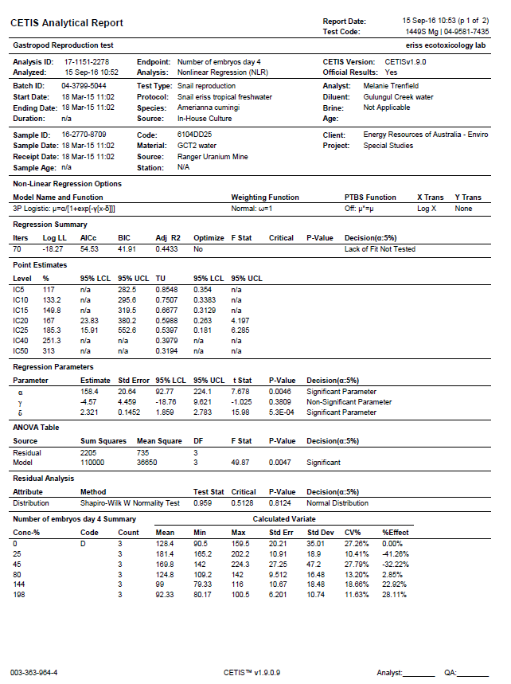

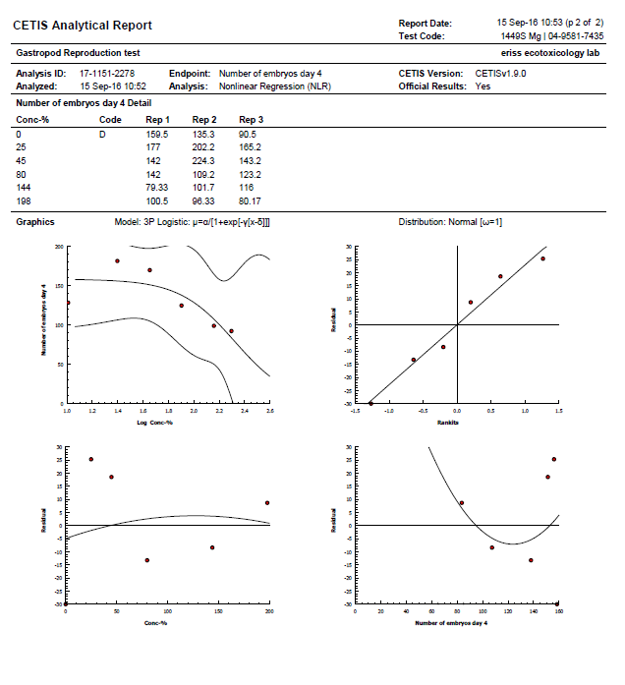

*Amerianna cumingi* (snail) – Electrical conductivity

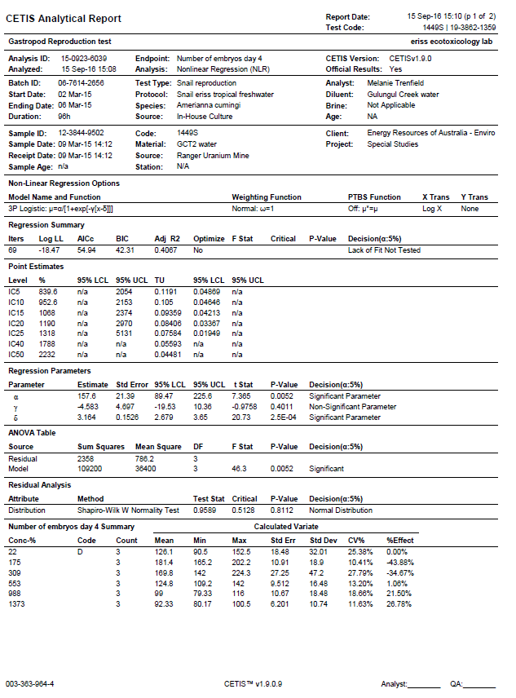

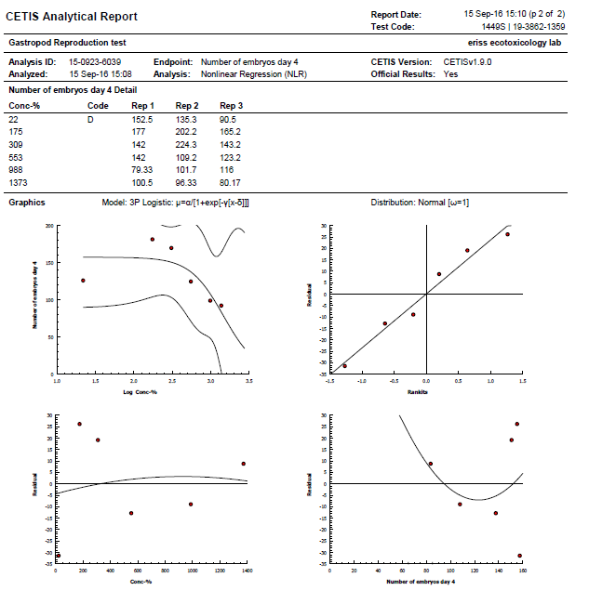

*Hydra viridissima* (green hydra)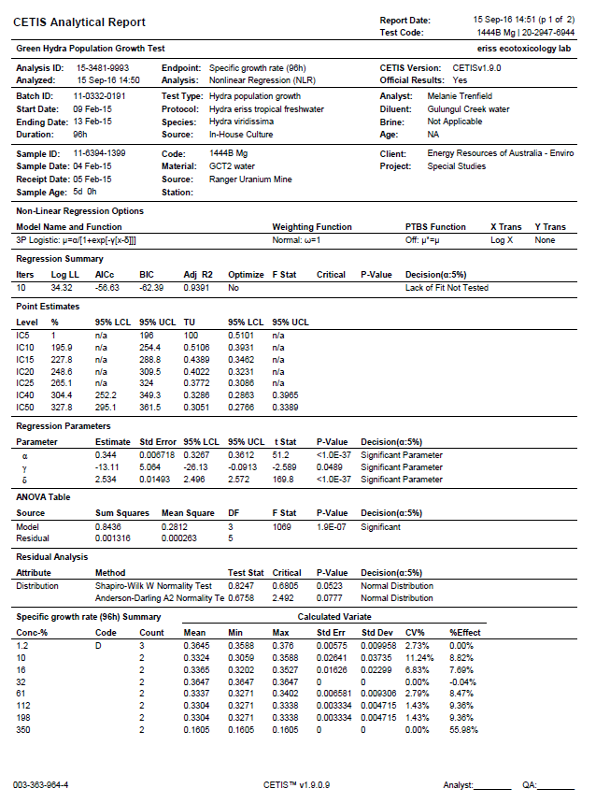 - Magnesium

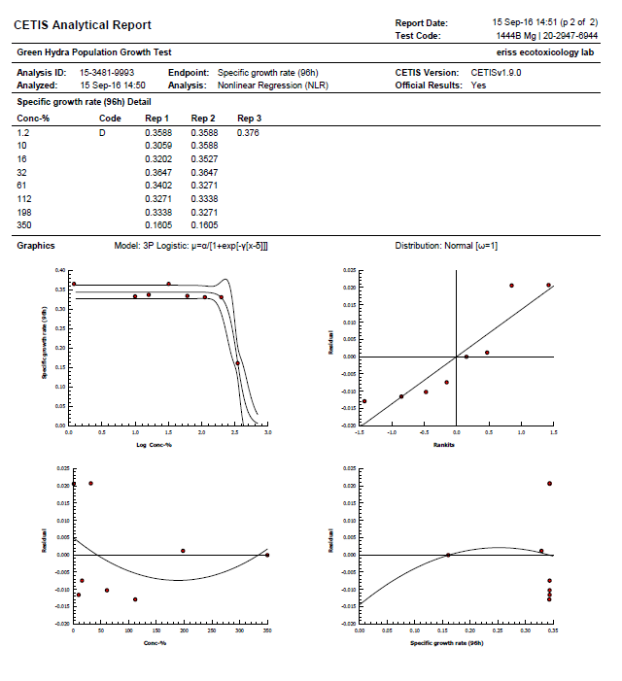

*Hydra viridissima* (green hydra) - Electrical conductivity

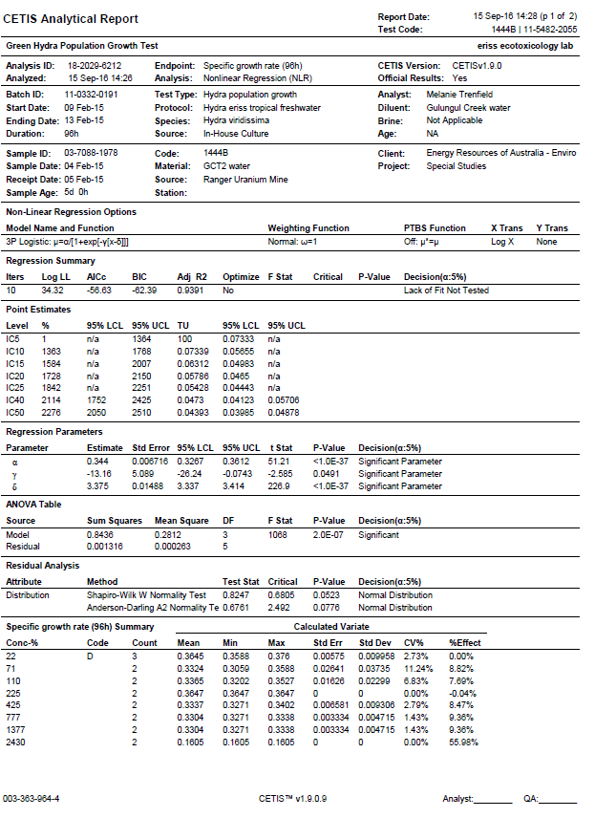

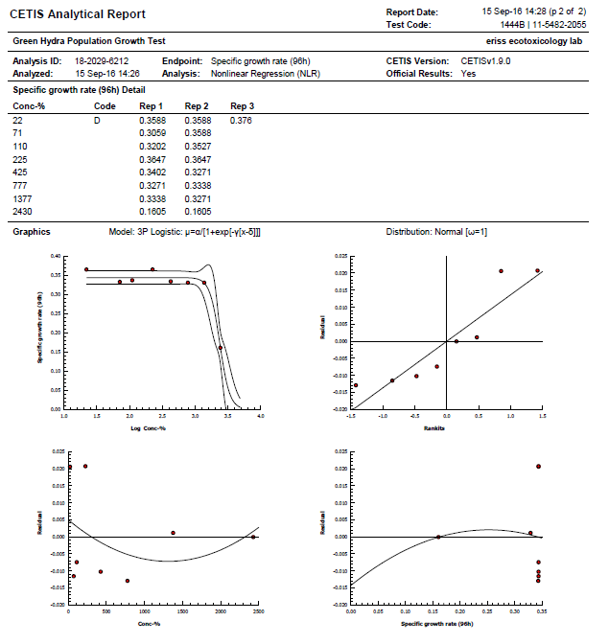

# Appendix E Results of toxicity monitoring tests 2015 & 2016



**Figure E1** Relationships between mean snail egg number for each site in Gulungul Creek, and ambient (median) electrical conductivity over the four-day exposure test periods for wet seasons, 2014–15 and 2015–2016

**Table E1** Student *t*-test comparison of mean snail egg number per snail pair for upstream (GCUS, ‘U/s’) versus downstream (GCDS, ‘D/s’) sites, 2014–15 and 2015–2016 wet seasons.

|  |  |  |
| --- | --- | --- |
| t-Test: Two-Sample Assuming Equal Variances | | |
|  | Variable D/s | Variable 2 U/s |
| Mean | 256.62 | 214.97 |
| Variance | 3430.04 | 2578.83 |
| Observations | 17 | 17 |
| Pooled Variance | 3004.43 |  |
| Hypothesized Mean Difference | 0 |  |
| df | 32 |  |
| t Stat | 2.22 |  |
| P(T<=t) one-tail | 0.02 |  |
| t Critical one-tail | 1.69 |  |
| P(T<=t) two-tail | 0.03 |  |
| t Critical two-tail | 2.04 |  |

**Table E2** Student *t*-test comparison of mean snail egg number per snail pair for upstream (GCUS, ‘U/s’) versus midstream (GCLB, ‘M/s’) sites, 2014–15 and 2015–2016 wet seasons.

|  |  |  |  |
| --- | --- | --- | --- |
| t-Test: Two-Sample Assuming Equal Variances | | | |
|  | Variable M/s | Variable U/s |
| Mean | 247.04 | 214.97 |
| Variance | 2241.49 | 2578.83 |
| Observations | 16 | 17 |
| Pooled Variance | 2415.60 |  |
| Hypothesized Mean Difference | 0 |  |
| df | 31 |  |
| t Stat | 1.87 |  |
| P(T<=t) one-tail | 0.04 |  |
| t Critical one-tail | 1.70 |  |
| P(T<=t) two-tail | 0.07 |  |
| t Critical two-tail | 2.04 |  |

**Table E3** Student t-test comparison of mean snail egg number per snail pair for upstream (GCUS, ‘U/s’) versus midstream (GCLB, ‘M/s’) sites, 2014–15 and 2015–2016 wet seasons.

|  |  |  |  |  |  |  |  |  |  |  |  |  |  |  |  |  |  |
| --- | --- | --- | --- | --- | --- | --- | --- | --- | --- | --- | --- | --- | --- | --- | --- | --- | --- |
| **Egg counts** | | | | | | | | | | | | | | | | | |
| **Season** | **Before-Mid** | | | **Before-Down** | | | | **Season** | | | | **After-Mid** | | | **After-Down** | | |
| 2014–15 | 218.4 | | | 205.3 | | | | 2014–15 | | | | 248.0 | | | 329.1 | | |
|  | 202.3 | | | 176.4 | | | |  | | | | 210.9 | | | 204.4 | | |
|  | 220.1 | | | 195.9 | | | |  | | | | 207.8 | | | 249.9 | | |
|  | 370.0 | | | 360.9 | | | |  | | | | 195.8 | | | 213.7 | | |
|  | 313.8 | | | 317.5 | | | |  | | | | 237.9 | | | 270.4 | | |
| 2015–16 | 269.8 | | | 250.5 | | | |  | | | | 266.9 | | | 363.5 | | |
|  |  | | |  | | | |  | | | | 244.3 | | | 258.2 | | |
|  |  | | |  | | | |  | | | | 222.4 | | | 238.7 | | |
|  |  | | |  | | | | 2015–16 | | | | 290.0 | | | 321.9 | | |
|  |  | | |  | | | |  | | | | 281.8 | | | 306.7 | | |
| **Paired-site, egg count differences** | | | | | | | | | | | | | | | | |
| **Before: Mid-Down** | | | | | | **After: Mid-Down** | | | |
| 13.1 | | | | | | -81.1 | | | |
| 25.9 | | | | | | 6.5 | | | |
| 24.3 | | | | | | -42.1 | | | |
| 9.1 | | | | | | -17.9 | | | |
| -3.8 | | | | | | -32.4 | | | |
| 19.3 | | | | | | -96.6 | | | |
|  | | | | | | -13.9 | | | |
|  | | | | | | -16.3 | | | |
|  | | | | | | -31.9 | | | |
|  | | | | | | -24.9 | | | |
|  | | | | | |  | | | |
|  | | t-Test: Two-Sample Assuming Equal Variances | | | | | | | | | | | |  | | |
|  | | |  | | | |  | | | |  | | |  | | |
|  | | | | ***Variable Before: Mid-Down*** | | | | |  | | | | ***Variable After: Mid-Down*** | | |
| Mean | | | | | 14.64 | | | |  | | | | -35.07 | | |
| Variance | | | | | 122.19 | | | |  | | | | 988.23 | | |
| Observations | | | | | 6 | | | |  | | | | 10 | | |
| Pooled Variance | | | | | 678.93 | | | |  | | | |  | | |
| Hypothesized Mean Difference | | | | | 0 | | | |  | | | |  | | |
| df | | | | | 14 | | | |  | | | |  | | |
| t Stat | | | | | 3.69 | | | |  | | | |  | | |
| P(T<=t) one-tail | | | | | 0.0012 | | | |  | | | |  | | |
| t Critical one-tail | | | | | 1.7613 | | | |  | | | |  | | |
| P(T<=t) two-tail | | | | | 0.0024 | | | |  | | | |  | | |
| t Critical two-tail | | | | | 2.1448 | | | |  | | | |  | | |

# Appendix F Results of Multivariate Analyses

**Figure 4 PCO Scores**

PCO

Principal Coordinates

*Resemblance worksheet*

Name: Resem2

Data type: Distance

Selection: All

Normalise

Resemblance: D1 Euclidean distance

Tr(G): 241.09

*Variation explained by individual axes*

Axis Eigenvalue Individual% Cumulative%

1 157.17 65.19 65.19

2 52.914 21.95 87.14

3 17.275 7.17 94.31

4 12.064 5 99.31

5 1.666 0.69 100

6 0.00033219 0 100

**Figure 5 PCO Scores**

PCO

Principal Coordinates

*Resemblance worksheet*

Name: Resem2

Data type: Distance

Selection: All

Normalise

Resemblance: D1 Euclidean distance

Tr(G): 184.46

*Variation explained by individual axes*

Axis Eigenvalue Individual% Cumulative%

1 147.27 79.84 79.84

2 20.255 10.98 90.82

3 12.366 6.7 97.52

4 3.4624 1.88 99.4

5 1.1079 0.6 100

**Figure 6 PCA Scores**

PCA

Principal Component Analysis

*Data worksheet*

Name: Data7

Data type: Environmental

Sample selection: All

Variable selection: All

*Eigenvalues*

PC Eigenvalues %Variation Cum.%Variation

1 3.9 65.0 65.0

2 1.05 17.5 82.6

3 0.771 12.8 95.4

4 0.248 4.1 99.5

5 0.0277 0.5 100.0

*Eigenvectors*

(Coefficients in the linear combinations of variables making up PC's)

Variable PC1 PC2 PC3 PC4 PC5

Log(Mn) -0.385 0.126 -0.615 0.676 0.007

Log(U) -0.158 0.815 0.499 0.213 -0.124

Log(SO4) -0.483 -0.244 0.164 -0.063 -0.390

Log(Ca) -0.470 -0.187 0.330 0.059 0.795

Log(Mg) -0.479 -0.256 0.193 -0.058 -0.435

Log(Mg:Ca ratio) 0.378 -0.399 0.447 0.697 -0.107

# Appendix G Sampling locations for historical Direct Toxicity Assessments and site water chemistry

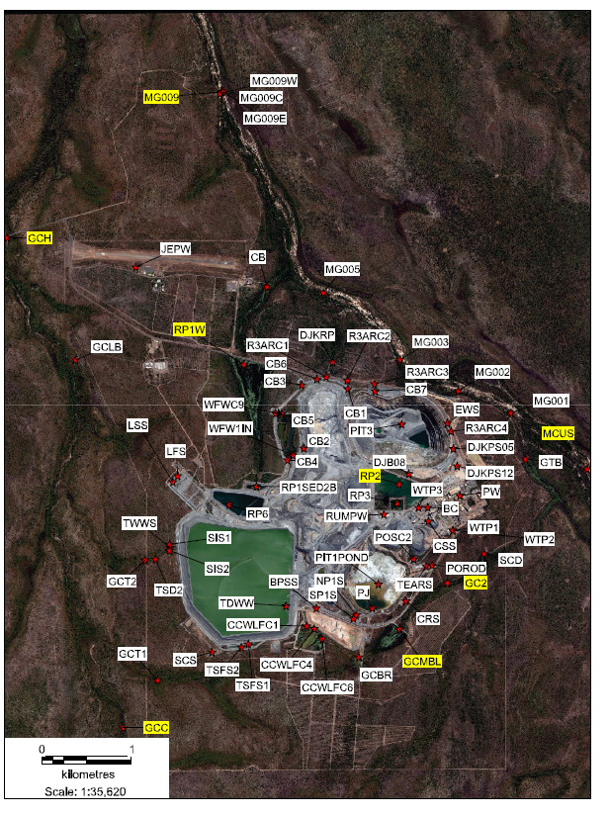

**Figure F1** Surface water sampling locations used in the desktop analyses (circled)

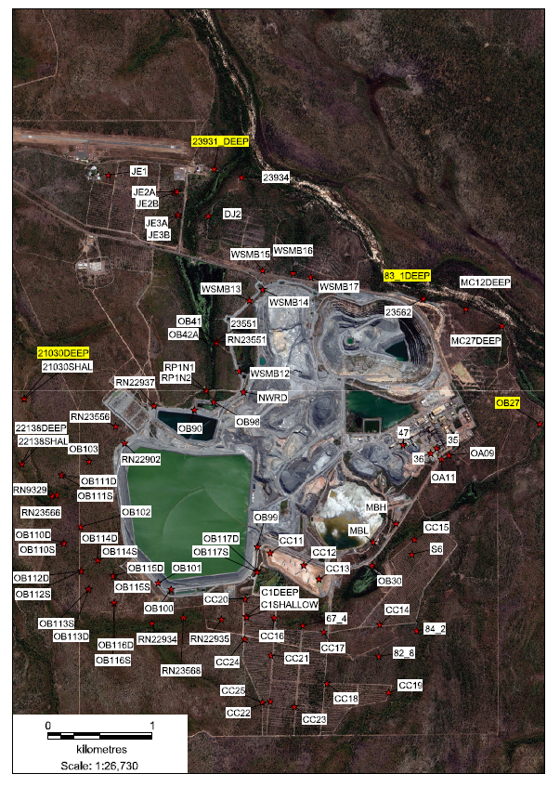

**Figure F2** Groundwater sampling locations used in the desktop analysis (circled)

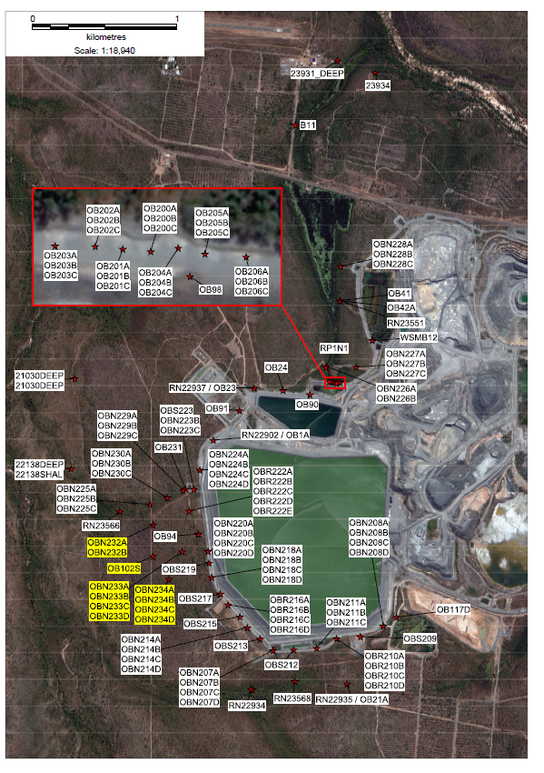**Figure F3** Groundwater sampling locations in the vicinity of the Tailings Storage Facility (circled)

# Appendix H Observed toxicity versus predicted toxicity

**Ranger DTAs: Determining which metals are accounting for observed toxicity**

***Magnesium***

|  |  |  |  |  |  |  |  |  |
| --- | --- | --- | --- | --- | --- | --- | --- | --- |
| **Species** | **Site** | **Mg IC50 (mg/L)**  **(backgd Ca)a** | **Mg IC50**  **(9:1 Mg:Ca)a** | **DTA**  **Mg IC50** | **OTUb** | **PTUc** | **PTU ≥ OTU?** | **Responsible for toxicity** |
| *M. macleayi* | Spiked MCW | 63 | 122 |  | | | | |
|  | Pit 3 (5.7:1) |  |  | 1.4 | 71.4 | 107/122 = 0.9 | No | No |
|  | RP2 (6.5:1) |  |  | 2.9 | 34.5 | 157/122 = 1.3 | No |
|  | Djalkmara (7:1) |  |  | 29.3 | 3.4 | 131/122 = 1.1 | No |
| *H. viridissima* | Spiked MCW | 11 | 713 |  | | | |
|  | Pit 3 |  |  | 12.7 | 7.9 | 115/713 = 0.16 | No |
|  | RP2c* |  |  | 20 | 5 | 180/713 = 0.25 | No |
|  | RP2d* |  |  | 53 | 1.9 | 108/713 = 0.15 | No |
|  | RP2g* |  |  | 10.8 | 9 | 157/713 =0.22 | No |
|  | Djalkmara |  |  | 16.8 | 6 | 181/713 = 0.25 | No |
|  | GCT2 |  |  | 328 | 0.3 | 350/713 = 0.49 | Yes | Partly |

a IC50s for Mg as reported by van Dam et al (2010) for Magela Creek water at background Ca and a 9:1 Mg:Ca ratio.

b OTU (*Observed Toxicity Unit*): Based on a Mg:Ca range of 5:1 to 7:1 in GCT2, RP2, Pit 3 & Djalkmara water. OTU = 100/Mg IC50 (mg/L) for each DTA water.

c PTU (*Predicted Toxicity Unit*): PTU = Mg concentration in site water/IC50 for Mg alone (mg/L).

* RP2 site labels refer to the labels used for the same sites in Figure 6.

***Uranium***

|  |  |  |  |  |  |  |  |
| --- | --- | --- | --- | --- | --- | --- | --- |
| **Species** | **Site** | **IC50 U (μg/L)** | **DTA**  **U IC50** | **OTUc** | **PTUd** | **PTU ≥ OTU?** | **Responsible for toxicity** |
| *M. macleayi* | Spiked SSW | 32a |  | | | | |
|  | Pit 3 |  | 22 | 4.5 | 1760/32 = 55 | Yes | Yes. U most likely accounts for all of observed toxicity except in the case of exposure of *H. viridissima* to GCT2 water. |
|  | RP2 |  | 34 | 2.9 | 1620/32 = 51 | Yes |
|  | Djalkmara |  | 133 | 0.75 | 595/32 = 18.6 | Yes |
| *H. viridissima* | Spiked SSW | 67b |  |  |  |  |
|  | Pit 3 |  | 194 | 0.5 | 1760/67 = 26.2 | Yes |
|  | RP2c* |  | 112 | 0.9 | 1000/67 = 15 | Yes |
|  | RP2d* |  | 304 | 0.33 | 620/67 = 9.3 | Yes |
|  | RP2g* |  | 129 | 0.8 | 1870/67 = 28 | Yes |
|  | Djalkmara |  | 256 | 0.4 | 2750/67 = 41 | Yes |
|  | GCT2 |  | 0.66 | 151.5 | 0.7/67 = 0.01 | No |  |

a IC50 for *M. macleayi* reported by Semaan et al (2000).

b IC50 for *H. viridissima* reported by Trenfield et al (2011).

c OTU (*Observed Toxicity Unit*): Based on a Mg:Ca range of 5:1 to 7:1 in GCT2, RP2, Pit 3 & Djalkmara water. OTU = 100/U IC50 (mg/L) for each DTA water.

d PTU (*Predicted Toxicity Unit*): PTU = U concentration in site water/IC50 for U alone (µg/L).

* RP2 site labels refer to the labels used for the same sites in Figure 6.

|  |  |  |  |  |  |  |  |
| --- | --- | --- | --- | --- | --- | --- | --- |
| **Species** | **Site** | **Mn IC50 (μg/L)a** | **DTA**  **Mn IC50** | **OTUb** | **PTUc** | **PTU≥ OTU?** | **Responsible for toxicity** |
| *M. macleayi* | Spiked MCW | 1100 |  | | | | |
|  | Pit 3 |  | 0.4 | 250 | 32.6/1100 = 0.03 | No | No |
|  | RP2 |  | 8.4 | 12 | 454/1100 = 0.41 | No |
|  | Djalkmara |  | 58 | 1.7 | 258/1100 = 0.23 | No |
| *H. viridissima* | Spiked MCW | 1380 |  | | | | |
|  | Pit 3 |  | 4.5 | 22.2 | 41.2/1380 =0.03 | No | No |
|  | RP2c* |  | 190 | 0.53 | 1700/1380 = 1.23 | Yes | Mn may have contributed to some of the toxicity observed |
|  | RP2d* |  | 589 | 0.17 | 1200/1380 = 0.87 | Yes |
|  | RP2g* |  | 31.3 | 3.2 | 454/1380 = 0.33 | No | No |
|  | Djalkmara |  | 2.5 | 40 | 27/1380 = 0.02 | No |
|  | GCT2 |  | 230 | 0.43 | 350/1380 = 0.25 | No |  |

***Manganese***

a IC50s for Mn reported by Harford et al (2010).

b OTU (*Observed Toxicity Unit*): Based on a Mg:Ca range of 5.7:1 to 7:1 in RP2, Pit 3 & Djalkmara water. OTU = 100/Mn IC50 (µg/L) for each DTA water.

c PTU (*Predicted Toxicity Unit*): PTU = Mn concentration in site water/IC50 for Mn alone.

* RP2 site labels refer to the labels used for the same sites in Figure 6.

|  |  |  |  |  |  |  |  |  |
| --- | --- | --- | --- | --- | --- | --- | --- | --- |
| **Species** | **Water** | **Hardness (CaCO3 mg/L)** | **SO4 IC50 (mg/L)** | **DTA IC50** | **OTUd** | **PTUe** | **PTU≥OTU?** | **Responsible for toxicity** |
| *Ceriodaphnia dubia* | Dechlorinated tap water | 320 | 843a |  |  | | | |
| *Ceriodaphnia dubia* | Moderately hard reconstituted water | 484 | 3516b |  |  | | | |
| *M. macleayi* | Pit 3 | 487 |  | 6 | 16.7 | 445/843 = 0.05 | No | No |
|  | RP2 | 707 |  | 12 | 8.3 | 655/843 = 0.78 | No |
|  | Djalkmara | 591 |  | 119 | 0.84 | 533/843 = 0.63 | No |
| *H. viridissima* | Spiked MCW | 4.0 | 474c |  |  | | | |
|  | Pit 3 | 523 |  | 49.8 | 2 | 453/474 = 0.96 | No | Not under these hardness conditions |
|  | RP2c* | 804 |  | 83 | 1.2 | 740/474 =1.6 | Yes |
|  | RP2d* | 482 |  | 232 | 0.4 | 474/474 = 1 | Yes |
|  | RP2g* | 707 |  | 45.2 | 2.2 | 655/474 = 1.4 | No |
|  | Djalkmara | 797 |  | 65 | 1.5 | 698/474 = 1.5 | No |
|  | GCT2 | 1616 |  | 1367 | 0.07 | 1454/474 = 3.07 | Yes | Possibly not at this hardness |

***Sulfate***

a IC50 reported by Elphick et al 2011.

b IC50 reported by Soucek & Kennedy 2005.

c IC50 reported by van Dam et al 2010.

d OTU (*Observed Toxicity Unit*): Based on a Mg:Ca range of 5.7:1 to 7:1 in RP2, Pit 3 & Djalkmara water. OTU = 100/SO4 IC50 (mg/L) for each DTA water.

e PTU (*Predicted Toxicity Unit*): PTU = SO4 concentration in site water/IC50 for SO4 alone.

* RP2 site labels refer to the labels used for the same sites in Figure 6.