Wave-short

653

*internal report*

Surface water chemistry monitoring protocol to assess impacts from the Ranger Mine.





Supervision and Monitoring

January 2018

Release status – Unrestricted

Project number – 2001-003

*The Department acknowledges the traditional custodians of country throughout Australia and their continuing connection to land, sea and community. We pay our respects to them and their cultures and to their elders both past and present.*

**Surface water chemistry monitoring protocol to assess impacts from the Ranger Mine.**

Supervision and Monitoring

Supervising Scientist

GPO Box 461, Darwin NT 0801

January 2018

(Release status – unrestricted)



*How to cite this report:*

*Supervising Scientist 2018. Surface water chemistry monitoring protocol to assess impacts from the Ranger Mine. Internal Report 653, January, Supervising Scientist, Darwin.*

*Project number: (MON-2001-003)*

*Authors of this report:*

Kate Turner – Supervising Scientist, GPO Box 461, Darwin NT 0801, Australia

Amie Leggett - Supervising Scientist, GPO Box 461, Darwin NT 0801, Australia

Supervising Scientist is a branch of the Australian Government Department of   
the Environment and Energy.

Supervising Scientist   
Department of the Environment and Energy   
GPO Box 461, Darwin NT 0801 Australia

**environment**.gov.au/science/supervising-scientist/publications

© Commonwealth of Australia 2018

Copyright Image.tif

IR653 is licensed by the Commonwealth of Australia for use under a Creative Commons By Attribution 3.0 Australia licence with the exception of the Coat of Arms of the Commonwealth of Australia, the logo of the agency responsible for publishing the report, content supplied by third parties, and any images depicting people. For licence conditions see: http://creativecommons.org/licenses/by/3.0/au/

**Disclaimer**

The views and opinions expressed in this publication are those of the authors and do not necessarily reflect those of the Australian Government or the Minister for the Environment and Energy.

While reasonable efforts have been made to ensure that the contents of this publication are factually correct, the Commonwealth does not accept responsibility for the accuracy or completeness of the contents, and shall not be liable for any loss or damage that may be occasioned directly or indirectly through the use of, or reliance on, the contents of this publication.

# Contents

Executive summary 4

Preamble 5

Acknowledgements 5

1 Introduction 6

1.1 Objective 6

1.2 Background 6

1.3 Principle of the monitoring technique 8

1.4 Method development 8

2 Experimental design 11

2.1 Grab sample data for performance assessment 12

2.2 Continuous data for performance assessment 13

3 Overview of monitoring procedures 15

3.1 Occupational health and safety 15

3.2 Monitoring sites 15

3.3 Sample collection and analysis 16

3.4 Quality control procedures 19

4 Data storage, entry and quality control 21

4.1 Data storage 21

4.2 Data entry quality control 21

5 Data Analysis 23

6 Reporting 23

6.1Traditional owners and Aboriginal residents 23

6.2 Supervising Scientist Annual Technical Report 24

6.3 Internet 24

6.4 Alligator Rivers Region Technical Committee and Alligators Rivers Region Advisory Committee 24

Glossary of terms and abbreviations 25

References and additional reading 27

## Executive summary

The Supervising Scientist Branch (SSB) operates an integrated chemical (including radiological), physical and biological monitoring program to ensure protection of the aquatic ecosystems of the Alligator Rivers Region (ARR) from the operation of uranium mines in the region. The Ranger Mine, operated by Energy Resources of Australia Ltd, is the only operating mine in the region, whilst the nearby Jabiluka site has *been* largely rehabilitated and is in long term care and maintenance. Consequently the Ranger Mine is the current focus of SSB’s monitoring effort. The monitoring conducted by SSB is an independent assurance program, which complements the compliance water chemistry monitoring program carried out by the mining company (Ranger Mine, Energy Resources of Australia Ltd) and the check monitoring carried out by the NT government regulator (Department of Mines and Energy).

The techniques and ‘indicators’ used in the monitoring program satisfy two important needs of environmental protection:

1. The early detection of significant changes in measured indicators to avoid short or longer term ecologically important impacts; and
2. Assessing ecological or ecosystem-level effects by using surrogate indicators of biodiversity. The surface water chemistry monitoring program falls under the early detection category.

For each monitoring component, two levels of documents have been prepared- high-level protocols and detailed operational manuals. This document is the high-level protocol that describes the science underpinning the surface water chemistry monitoring program. It provides an overview of the monitoring principles and objectives, experimental and statistical design, sample collection and chemical analysis methods, data analysis and impact assessment procedures and reporting requirements.

## Preamble

This document details the science underpinning the experimental design and data interpretation methods used for the monitoring of surface water quality in natural streams in the vicinity of the Ranger Mine. The monitoring of water quality in these environments is a component of the multiple lines of evidence monitoring program implemented by SSB (van Dam et al 2002, Jones et al 2008).

Full details and descriptions of the methods and procedures required to implement the surface water chemistry monitoring program are contained in the following documents:

1. Surface Water Chemistry Monitoring Program - Operational manuals

The operational manuals contain detailed instructions for site and instrument maintenance and calibrations, in-situ quality control checks, sample collection and laboratory processing, response to site alarms, data management and data cleaning and validation.

The operational manual is a collection of controlled documents stored on the SSB SPIRE site. They define the operational details for each of the specific methods used for each surface water chemistry monitoring program procedure. Procedures used to validate, interpret and report the surface water quality monitoring results are also included with detailed instructions for quality control requirements, follow-up actions where trigger values are exceeded and preparation of website charts and explanatory notes.

1. Surface Water Chemistry Monitoring Program – Quick reference guides

The Quick Reference Guides (QRGs) contain step-by-step instructions for more detailed and complex tasks associated with the program. Theses are referenced in the operational manuals.

## Acknowledgements

The following SSB personnel have been involved in the Surface Water Chemistry Monitoring Program and have provided valuable input into the evolutionary development of this protocol: Alison Frostick, Kate Turner, Lisa Chandler, David Jones, Duncan Buckle, Jenny Brazier, Claudia Sauerland, Michelle Isles, Don Elphick, Amie Leggett and Christopher Humphrey.

**Contact officers:**

|  |  |
| --- | --- |
| Amie Leggett  Supervising Scientist,  PO Box 461, Darwin NT  08 8920 1363 Amie.Leggett@environment.gov.au | Kate Turner Supervising Scientist,  PO Box 461, Darwin NT  08 8920 1391 Kate.Turner@environment.gov.au |

# Surface water chemistry monitoring protocol to assess potential impacts from the Ranger mine site

## Introduction

### Objective

Detection of changes in water chemistry in water courses downstream of uranium (U) mines and assessment of these changes against a prescribed management framework that determines the most appropriate and relevant course of action according to the magnitude and duration of the change.

### Background

The role of the Supervising Scientist Branch (SSB) is to ensure the protection of the environment and the people of the Alligator Rivers Region (ARR) from the potential impacts of U mining in the ARR, of which the World Heritage listed Kakadu National Park (KNP) comprises the major part. These potential impacts are detected by SSB’s integrated monitoring program. This document describes the scope of, and the science underpinning, the surface water chemistry component of the integrated monitoring program.

There are three mineral leases within the ARR which pre-date the proclamation of KNP. These are Ranger, Jabiluka and Nabarlek (Figure 1). There are also a number of former small uranium mines in the South Alligator Valley (SAV) of the ARR, which were mined between 1954 and 1964.

Jabiluka has been in a long-term care and maintenance phase since late 2003 and in its current state poses a very low potential risk to the environment. The surface water chemistry monitoring data set acquired between 2001 and 2008 indicated that the environment remained protected and as a result SSB monitoring program at Jabiluka, with the agreement of all relevant stakeholders, was systematically scaled back. From the 2009-10 wet season SSB collected continuous monitoring data, including electrical conductivity (EC) and water level, from the downstream statutory compliance site (refer to relevant annual report) but this was also ceased in 2015 given the low environmental risk posed by the site.

A watching brief is maintained for the decommissioned and rehabilitated Nabarlek site in Arhemland, and the rehabilitated legacy sites in the SAV. Rehabilitation works in the SAV were completed in late 2009. The results from a risk assessment conducted by SSB concluded that residual water quality impacts did not pose a significant risk to the South Alligator River (Bollhöfer et al 2010 and Turner et al 2009). SSB does not undertake any monitoring at Koongarra since the lease was never been subjected to U mining activity. The lease has subsequently beenadded to the Kakadu World Heritage Area and incorporated into Kakadu National Park in 2013.

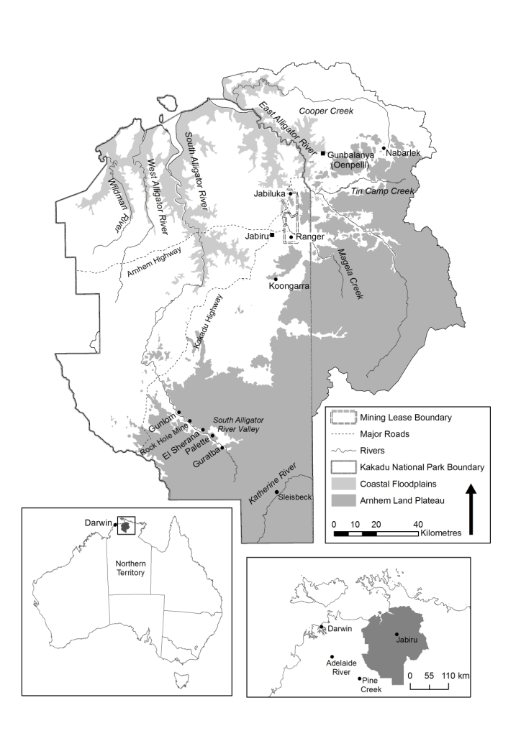

1. Map of the Alligator Rivers Region showing the Ranger, Jabiluka, Nabarlek and South Alligator Valley mine sites.

The current focus of the surface water chemistry monitoring (SWCM) program conducted by SSB is to ensure that the aquatic environment downstream of the operating Ranger Mine remains protected from the potential impacts of U mining. With the decision not to proceed with the Ranger 3 Deeps expansion project, SSB monitoring has also refocused with regard to rehabilitation and eventual site closure.

Since 2001 SSB has undertaken a formal environmental monitoring program encompassing biological, physical, chemical and radiological components that are used to monitor and assess potential impacts upon ecosystems and humans arising from mining activities at Ranger. The implementation of this program was in response to the Supervising Scientist's recommendations in the 2000 report, *SSR 153 - Investigation of tailings water leak at the Ranger uranium mine*.

The aims of the SWCM program are to:

* Provide early warning of potentially detrimental changes in water quality;
* Provide confidence that the environment downstream of the operational Ranger Mine remains protected from the potential adverse effects of U mining;
* Determine if values of key water quality variables at the compliance point on the Ranger Project Area exceed the site-specific water quality trigger values adopted for those variables;
* Provide confidence that the environment downstream of other potentially mining-impacted catchments within Alligator Rivers Region remains protected;
* Identify long and short-term trends in water quality; and
* Assist in the interpretation of biological monitoring data.

### Principle of the monitoring technique

Environment protection is ensured by comparing water quality data from sites located downstream of the Ranger Project Area with i) data from control sites located upstream of the Ranger Project Area and/or ii) against a set of trigger values developed in accordance with the Australian and New Zealand Environment Conservation Council and Agriculture and Resource Management Council of Australia and New Zealand Water Quality Guidelines (Iles 2004, ANZECC & ARMCANZ 2000).

### Method development

Historically, the SWCM program comprised weekly in situ measurement of physico-chemical parameters and collection of grab samples for analysis of filterable concentrations of mine-related solutes. In 2010 the weekly grab sampling regime was replaced, following 5 years of rigorous evaluation of methodology, by continuous monitoring of physico-chemical parameters coupled with automatic event-based (triggered by in situ EC and turbidity values) collection of water samples for analysis of total metal concentrations (Supervising Scientist 2010). Progressive enhancements were made during the evaluation period, including the validation of sample filtration and preservation methods used for event-based sampling, and development of EC triggers from the resuls of ecotoxicological testing. .

Continuous monitoring provides the capacity to detect and track in real time the dynamic changes in the water quality of the creek system that would otherwise pass undetected by the much less frequent weekly grab sample program. ) This is illustrated in Figure 2 which compares the continuous EC data with those obtained from weekly grab samples during the 2008-09 wet season.

1. Upstream (blue) and downstream (red) 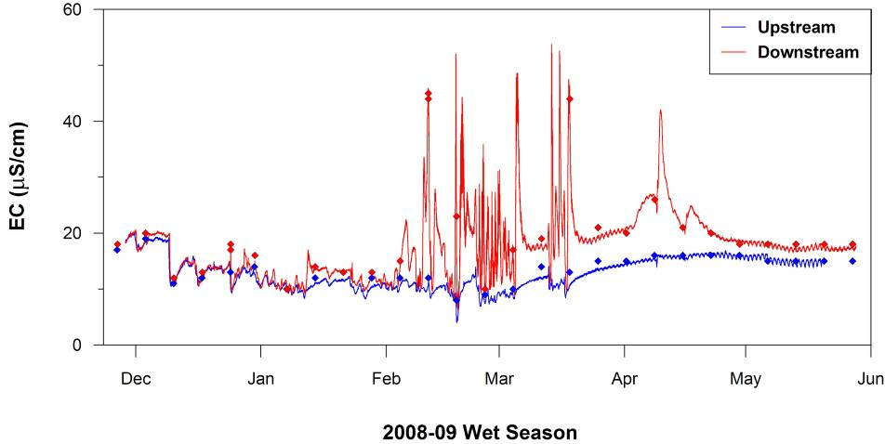electrical conductivity (EC) data obtained over the 2008-09 wet season in Magela creek. The points represent the weekly grab sample data and the lines represent the continuous monitoring data.

The behaviour of EC downstream of the mine is controlled by the interaction between water level in Magela Creek and inputs of higher EC mine runoff waters via two tributary lines that emanate from the Range lease area. At rising or high flows in Magela creek, mine-derived waters become backed-up in the tributaries and are only discharged to Magela creek when the flow recedes, resulting in pulses of increased EC at the downstream site during periods of falling or low flows in Magela creek.

In addition, because peak flows in Magela creek usually occur in the early to mid evening (due to the occurrence of intense tropical storms in the mid to late afternoon) the EC in Magela creek downstream of the mine follows a diurnal cycle through which there is an inverse relationship between flow and net EC in Magela creek (Figure 3).

The dynamic nature of the above processes explains why so few of the EC pulses occurring during the 2008-09 wet season were captured by the weekly grab sampling program and highlights the benefits of continuous monitoring.

The continuous monitoring methodology was developed further (between 2007 and 2010) to include automated collection of water samples based on in situ values of EC and turbidity. These parameters typically behave differently responding to rainfall events and creek flow. Increased rainfall typically results in a decrease in EC via dilution of solutes with low salinity rainfall. Conversely turbidity will typically spike on the leading edge of the hydrograph of rainfall events as surface water flows mobilise sediment into the creeks.



1. Mean (between 2005 and 2008) hourly net electrical conductivity (mean downstream EC minus mean upstream EC) in Magela creek (grey bars). The mean hourly Magela creek discharge over this period of record (1971 to 2008) is overlain for comparison (black line). The typical time window for collection of grab samples is marked for reference.

A sample is collected when a specified threshold value is reached. Subsequent samples are collected for each increase of either a prescribed increment value (for turbidity) or a rate of rise over a prescribed time (for EC), ensuring that good coverage of samples for subsequent chemical analysis is obtained over an event (Table 1).

1. Values of electrical conductivity (EC) and turbidity used for triggering the automatic collection of event-based water samples.

|  |  |  |  |  |  |  |
| --- | --- | --- | --- | --- | --- | --- |
|  | **TRIGGER** | **MCUGT** | **MCDW** | **GCNUS** | **GCUS** | **GCLB** |
| **Start and end of wet season - Baseline EC> 15** | Base EC | 19 | 35 | 29 | 29 | 35 |
| Top EC | 20 | 42 | 30 | 30 | 42 |
| **Mid-wet - Baseline EC<15** | Base EC | 14 | 35 | 25 | 25 | 35 |
| Top EC | 15 | 42 | 30 | 30 | 42 |
| EC | Delay (min) | 60 | 60 | 60 | 60 | 60 |
| Duration (min) | 60 | 60 | 60 | 60 | 60 |
| Rate of rise (uS/cm/5 min) | 5 | 5 | 5 | 5 | 5 |

One of the critical issues that needed to be addressed as part of the development of the event-based sampling regime was the effect of sample holding time on solute speciation. In particular, the changes through time in dissolved uranium concentration as a result of adsorption on particulate matter. This was not an issue for the original grab sampling program since the the collected samples were immediately filtered in the field. In the case of the event-triggered samples, in excess of 24h could pass between collection of the sample and retrieval for processing. To address this issue event-based water samples (94 in total) collected from the Magela Creek downstream site over the 2009-2010 wet season and over a range of EC and turbidity levels were analysed for both the pseudo-total (dissolved metals plus those extracted from suspended particulate material by 2% nitric acid over 24 hours) and filterable (<0.45 µm dissolved metals only) metal concentrations. A pseudo-total analysis results in a partial extraction of metals from the suspended particulate material and provides an estimate of the most readily available metal in the solid phase. This pseudo-total is not a true total of all metal present as would be provided by a complete breakdown of the silicate matrix by digestion using a combination of strong acids (eg nitric, hydrofluoric and boric acids). For the remainder of this document reference to total analysis will mean pseudo-total analysis as described above.

The summary findings from this work are reported in Table 2.

1. Mean (n=94) distribution of key analytes (as defined in Frostick et al 2012) associated with the dissolved and particulate fraction of water samples collected in Magela creek at the downstream site. The standard deviation of the mean is in brackets.

|  |  |  |  |  |
| --- | --- | --- | --- | --- |
|  | **Magnesium** | **Manganese** | **Sulfate** | **Uranium** |
| **Dissolved (%)** | 95 (± 11) | 42 (± 30) | 95 (± 11) | 67 (± 14) |
| **Particulate (%)** | 5 (± 11) | 58 (± 30) | 5 (± 11) | 33 (± 14) |

The total values for the “conservative solutes” magnesium (Mg) sulfate (SO4) are seen be very close to the true total whilst for U, use of a total value will overestimate by about 50% the dissolved concentration. The use of total concentration thus provides for a conservative estimate of the concentrations of the solutes that are present. The relative proportions (dissolved or particulate) of the total concentration present in a given event-based sample can be estimated using the data in Table 2 as a guide, noting that the guideline values used for compliance assessment apply to the dissolved concentrations.

Continuous in situ measurement of key water quality variables (EC and turbidity) and event-based water sampling together ensure the SWCM program is capable of detecting and quantifying any exceedances of water quality trigger values set for key water quality variables.

## Experimental design

The SWCM program is designed to detect and interpret changes in water chemistry (physical and chemical parameters). The hypothesis being tested by the monitoring program is, “*that the value of a key parameter measured at a downstream compliance monitoring point* ***does not*** *exceed the trigger guideline or limit set for that parameter at that location”.*

Key physico-chemical parameters of importance include (i) indicators of a mining signal, (EC and turbidity) (ii) potential toxicants/stressors (turbidity) or (iii) parameters able to influence toxicity of potential contaminants (pH) (Klessa 2001 a, b, Supervising Scientist 2002).

Key chemical parameters (solutes) of importance are (i) indicators of a mining signal (Mg, SO4 and U), (ii) indicators of process additives (manganese, ammonia and SO4), (iii) potential toxicants/stressors (U and Mg), (iv) solutes able to modify toxicity of potential contaminants (calcium), (v) potentially detrimental to human health (radium-226) or (vi) indicative of contamination introduced into water samples during collection and preparation (aluminium, copper, iron, lead and zinc) (Klessa 2001 a, b, Supervising Scientist 2002).

Continuous in situ measurements and the results of chemical analyses acquired as part of the SWCM program are compared with trigger values set for key parameters for downstream compliance points for Magela and Gulungul creeks. These trigger values were derived in accordance with the framework specified by the ANZECC & ARMCANZ Water Quality Guidelines (2000). The magnitude and significance of any changes in downstream water quality throughout the wet season is assessed taking into account the current mine site discharges and local hydrological conditions.

### Grab sample data for performance assessment

Receiving water standards, in the form of a hierarchy of trigger values, were originally derived for key variables in Magela creek using a methodology consistent with the ANZECC and ARMCANZ (2000) guidelines (Klessa 2000 & 2001 a, b, Iles 2003). These standards were derived from the grab sampling data record collected between 1997 and 2003 (Iles 2003, 2004). Jones et al (2008) noted that the recommendations in the Guidelines were adapted to establish a conservative process for setting water quality guidelines for Magela creek, using the following hierarchical approach:

1. Maximum allowable (regulatory) limits are derived using ecotoxicological data for local aquatic species and human dietary modelling (for radium-226);
2. Management triggers (focus, action and guideline values) are derived from either:
   1. Statistical distributions of water quality data at an appropriate (upstream) reference site; or
   2. Findings from chemical and biological monitoring programs that indicate that a higher than upstream baseline value can occur without significant detriment to ecosystem values.

The current trigger values for key parameters at the Magela creek downstream compliance point are shown in Table 3 and are detailed in the Revised Ranger Mine Water Quality Objectives for Magela Creek and Gulungul Creek (Turner et al 2015).These objectives were originally established by SSB in 2004 and were updated in 2015. The WQOs are designed around a tiered management response consisting of a:

• Focus Trigger Value – watching brief

• Action Trigger Value – data assessment

• Investigation, Guideline and Limit Trigger Values – full investigation and management response

1. Current trigger values for key parameters at the Magela creek downstream compliance point (Iles 2004).

|  |  |  |  |  |
| --- | --- | --- | --- | --- |
| **Key parameter** | **Trigger values** | | | |
| **Focus** | **Action** | **Guideline** | **Limit** |
| **Turbidity** | 5 NTU | 10 NTU | 26 NTU | N/A |
| **Electrical Conductivity** | 18 μS/cm | 30 μS/cm | 42 μS/cm for >6hrs (Investigation trigger) | N/A |
| **Magnesium, Sulfate** | 1 mg/L | 2 mg/L | Pulse exposure (<72hrs) derived from the pulse exposure framework (Fig. 5) | 3 mg/L for > 72hrs |
| **Manganese** | 35 μg/L | 45 μg/L |  | 75 μg/L |
| **Total Ammonia Nitrogen** | 0.1 mg/L | 0.3 mg/L | 0.7 mg/L |  |
| **Uranium** | 0.3 μg/L | 0.9 μg/L | N/A | 2.8 μg/L (DOC modified limit at increasing DOC) |
| **Radium-226** | N/A | N/A | N/A | 3 mBq/L wet season geometriv mean difference |

The derived hierarchy of values (‘focus’, ‘action’ and ‘guideline’ or ‘limit’) trigger increasingly stringent management responses on the mine site (Iles, 2004). The limit value is prescribed to ecotoxicologically derived compliance values only. Guideline values are advisory maximum levels that are the equivalent of the 99.7th percentile of the primary dataset, action and focus values correspond to the 95th and 80th percentiles, respectively.

Radium-226 is analysed for human radiological protection purposes. The limit value for radium-226 was derived using the following assumptions:

* A dose constraint of 0.3 mSv per year above natural background from the ingestion of radium-226 in freshwater mussels;
* A 10 year old child consuming 2 kg of mussels annually; and
* A concentration factor for mussels of 19,000 for radium-226.

### Continuous data for performance assessment

There is a statistically very strong correlation between the EC and Mg measured at the Magela creek downstream compliance point (Figure 4). Hence the instantaneous concentration of Mg (the “toxicant”) at any time can be inferred from the simultaneously measured EC value.

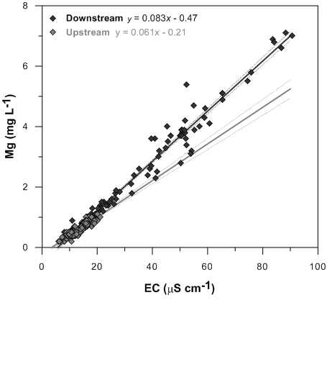

1. Best fit relationships between EC and Mg concentrations for the upstream (R2 = 0.84, P<0.0001) and downstream (R2 = 0.96, P<0.0001) monitoring sites in Magela creek, with the upper and lower 95% confidence limits shown.

Limit values for EC and Mg have been developed via ecotoxicological research for both chronic (extended: 72 hours+) and pulse (short duration) exposure regimes (Table 4 and Figure 5), for use in interpreting continuous EC data and for assisting with the interpretation of chemical analysis data from EC event-triggered samples (Turner et al 2015).

1. Ecotoxicologically derived EC and Mg trigger values (99% ecosystem protection level) for short duration pulse exposure.

|  |  |  |  |  |  |
| --- | --- | --- | --- | --- | --- |
| **Pulse duration (h)** | **Trigger value** | | **Pulse duration (h)** | **Trigger value** | |
|  | EC (µS/cm) | Mg (mg/L) |  | EC (µS/cm) | Mg (mg/L) |
| **1** | 11778 | 977 | 18 | 114 | 9.0 |
| **2** | 5268 | 437 | 20 | 110 | 8.6 |
| **3** | 2401 | 199 | 22 | 106 | 8.3 |
| **4** | 1138 | 94 | 24 | 102 | 8.0 |
| **6** | 334 | 27 | 30 | 91 | 7.1 |
| **8** | 174 | 14 | 36 | 82 | 6.3 |
| **10** | 139 | 11 | 48 | 65 | 5.0 |
| **12** | 129 | 10 | 60 | 52 | 3.9 |
| **14** | 123 | 10 | 72 | 42 | 3.0 |
| **16** | 118 | 9.4 |  |  |  |

The highlighted values in Table 4 are values measured by ecotoxicological testing and all other values are interpolated using the functions fitted to the curve in Figure 5.



1. Exposure duration curve fitted to the measured data points (trigger value to protect 99% of species) shown as dots.

## Overview of monitoring procedures

### Occupational health and safety

SSB has established project and field safety approval processes, guidelines and procedures that must be followed prior to and during all field work. This includes completion of a risk-based, field safety analysis of the required works. All participants are made aware of potential dangers and the procedures implemented to minimise risks by communicating and understanding the field safety analysis before field work commences.

The main health and safety risks in this project are heat stress, dehydration, mosquito borne disease and crocodile attack. Details on how to mitigate the identified health and safety risks for this project are discussed in the operational manuals for this protocol.

### Monitoring sites

The SWCM program is conducted at designated monitoring sites in Magela and Gulungul creeks, upstream and downstream of point and diffuse inputs of contaminants from the Ranger Mine site. In Figure 6 the sites on Magela creek are referred to as Magela Upstream and Magela Downstream and the sites on Gulungul creek are referred to as Gulungul Upstream, Gulungul New Upstream, Gulungul Lease Boundary and Gulungul Downstream.

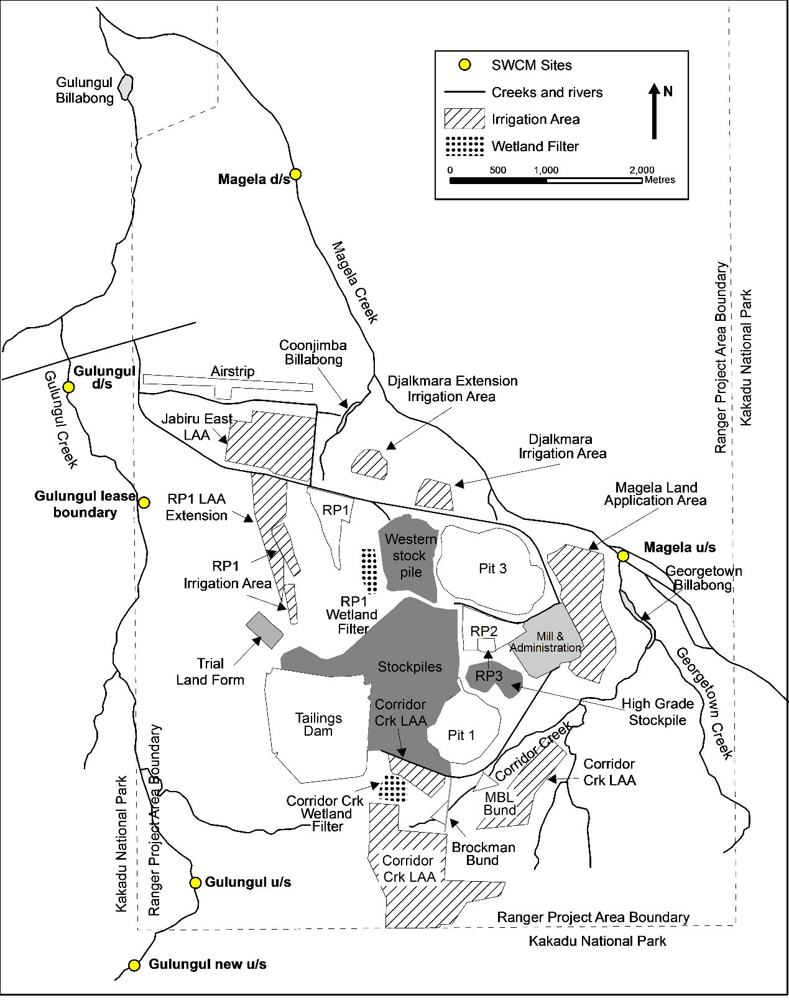

1. Location of sampling sites on Magela and Gulungul creeks and key Ranger mine water bodies and landmarks.

### Sample collection and analysis

#### Sample collection

##### Automated event-based sample collection

Automated sample collection is triggered by increases in the EC or turbidity level in the creeks. The samples collected during an ‘EC event’ are retrieved from the field and dispatched for analysis as soon as practical after collection. Retrieval of samples may be delayed on occasion; for example this could be due to access difficulties from flood events. The samples collected during a ‘turbidity event’ are retrieved from the field and processed during the next scheduled site visit.

##### Investigative sample collection

SSB may initiate investigative sampling of surface waters from any location on or off the mine site. These samples are collected using the grab sampling method and will often be analysed for both the total and dissolved concentrations of key analytes. Physico-chemical parameters will also be measured during an investigative site visit.

This type of investigative sampling may be conducted in response to:

* An exceedance of a trigger value at one of the downstream sites, particularly the action and guideline/limit values;
* An observation in the field of any unusual condition that may lead to poor quality surface water or runoff entering the creeks; and
* An incident or emergency on site.

##### 3.3.1.3 QAQC sampling

SSB also conducts regular sampling for quality control purposes. . These samples are collected using grab and gamet sampling methods and will often be analysed for both the total and dissolved concentrations of key analytes. Physico-chemical parameters will also be measured during an QAQC site visit.

#### Sample analysis

The key parameters that are measured as part of the SWCM program are divided into 6 suites based on collection method and physical and chemical attributes (Table 5).

1. Water quality analysis suites.

|  |  |  |  |
| --- | --- | --- | --- |
| **Suite** | **Analytes** | **Collection method** | **Analytical laboratory** |
| Physico-chemical Suite | pH, EC, turbidity, temperature and water level at specific sites | In situ multiprobe datasondes | N/A |
| Chemical Analysis Suite | Aluminium, calcium, copper, iron, magnesium, manganese, lead, sulfate, uranium and zinc | Grab samples or event-based samples triggered on EC | EnviroLab |
| Radiochemical Suite | Total radium-226 activity | Grab samples | EnRad Lab |
| Suspended Sediment Analysis Suite | Suspended sediment concentration and sediment bound aluminium, calcium, copper, iron, magnesium, manganese, lead, sulfate, uranium and zinc | Event-based samples triggered on turbidity | WASQ Lab and EnviroLab |
| Organic Carbon Suite | Dissolved organic carbon | Grab samples | EcoTox Lab |
| Nutrient Suite | Ammonia, nitrate, total nitrogen, total phosphorus and free reactive phosphorus | Grab samples | EnviroLab |

##### Physico-chemical suite

This suite of parameters are measured continuously (up to every 5 minutes) by in situ multi-probe datasondes and comprises pH, EC, turbidity and water temperature.

##### Chemical analysis suite

Water samples for chemical analysis are collected from Magela and Gulungul Creeks either using the automated EC event sampling regime or for routine radium and QA/QC sampling using the grab sampling method. Grab sampling is used at any other sampling locations. All water samples are sent to an external service provider (National Association of Testing Authorities (NATA) accredited commercial analytical laboratory) for chemical analysis using inductively coupled plasma mass spectrometry (ICP-MS) or inductively coupled plasma optical emission spectrometry (ICP-OES) techniques.

Comparison of the composition of mine site water (from various on-site water bodies) with Magela creek water (upstream and downstream of the mine) has been used to establish that U, Mg, aluminium (Al), calcium (Ca), copper (Cu), iron (Fe), manganese (Mn), lead (Pb), sulfate ion (SO42+) and zinc (Zn) to be the elements that are of most potential concern to the receiving environment (Supervising Scientist 2009). This list of elements was identified based on their i) concentrations present in mine water bodies relative to background concentrations; ii) attenuation by natural processes in catchment drainage lines; and iii) likely or inferred potential for biological impact. The attenuation and dilution of Al, Cu, Fe, Pb and Zn within the tributaries and sentinel waterbodies on site means the concentrations of these metals are not of environmental concern for Magela Creek. These elements, however, provide an excellent indicator of sample contamination that may inadvertently occur as a result of lapse in sample collection practice or contamination in the receiving laboratory.

The automated event-based samples are analysed for total (dissolved plus particulate) concentrations only (see discussion in section 1.4 ) while grab samples can be analysed for total or dissolved concentrations if they are filtered in the field at the time of collection.

##### Radiochemical Suite

Water samples for analysis of radium-226 are collected fortnightly (using the grab sampling method) from Magela and Gulungul creeks. The two samples collected per month from each site are combined to form a composite sample that is analysed for total radium-226 by high resolution alpha spectrometry (Martin et al 2004 & Medley et al 2005).

##### Suspended sediment analysis suite

The concentration of suspended sediment is measured in water samples that are collected by the automated turbidity event sampling regime, and in specified grab samples, . An aliquot of suspended sediment (collected by filtering a known volume of sample through a 0.45µm filter paper) may also be sent to an external service provider (NATA accredited commercial analytical laboratory) where it is digested using the reverse aqua regia method (a 3:1 mixture of nitric and hydrochloric acid) and analysed for the same chemical suite as the water samples.

##### Organic carbon suite

When required, water samples are collected (using the grab sampling method) and analysed at the SSB laboratories for concentrations of dissolved organic carbon (DOC). Ecotoxicological testing has shown that DOC has the potential to ameliorate the toxicity of U to organisms (Hogan et al 2005 & Houston et al 2008), and hence is an important parameter to measure, especially for backflow billabongs wherein the DOC concentration can be much higher than in the flowing waters of the stream channels.

##### Nutrient suite

When required, water samples are collected (using the grab sampling method) and sent to an external service provider (NATA accredited commercial analytical laboratory) for analysis of ammonia, nitrate, total nitrogen, total phosphorus and free reactive phosphorus.

### Quality control procedures

#### Continuous monitoring system

To ensure the validity of the continuous monitoring data a comprehensive quality control (QC) program of infrastructure and equipment management, maintenance and calibration verification is required along with in-built redundancy to ensure that the system remains functional at all times.

At the commencement of flow in the creeks, two multiprobe datasondes and an auto sampler are deployed at each site. The datasondes and auto samplers are connected to data loggers that store the measured data as well as control the functioning of the instruments by way of a detailed and comprehensive logging program. This program controls the sampling triggers as well as a number of alarms and backup processes that ensure the immediate rectification of any instrument or sensor issues that may occur.

Each datasonde is calibrated prior to installation and routine in-situ checks are carried out using calibrated hand-held instruments to detect any calibration drift or other instrument issues that may arise throughout the wet season. Full details of these processes are detailed in the operational manuals.

#### Water sample analysis

A QC program is in place to ensure and demonstrate the quality of chemical analysis of collected water samples. This includes analysis of appropriate blanks, spiked samples, duplicates and inclusion of standard reference materials (SRM). Each month the performance of the water sampling system and techniques are evaluated by assessing the results from the QA/QC samples. Any significant QC issues that arise are reported to the Water Chemistry Monitoring Manager so that the issues can be identified and resolved.

Blank samples are used to determine the existence and magnitude of contamination occurring during field collection or laboratory processing of samples. Analysis of duplicate samples indicates the precision for both field sampling and laboratory analysis methods. Analysis of field duplicates provides an indication of the temporal and spatial variability of water quality at the sampling site. Analysis of laboratory duplicates (obtained by splitting a single sample prior to analysis) provides an indication of the extent of variation attributable to the procedures used in the laboratory.

Analysis of spiked samples and SRM indicates the precision and accuracy of the laboratory results. Laboratory fortified blanks are analysed to determine the bias in the sample spikes. The external analytical laboratory prepares QC samples (SRM, spiked samples, fortified blanks and duplicate samples) and analyses them in the same analysis run as each batch of SSB surface water samples.

For the analysis of trace constituents SSB applies acceptance criteria of ± 20% Relative Percent Difference (RPD) between duplicates. This tolerance limit is based on the Horwitz curve (Horwitz et al., 1980), which is a simple exponential relationship between the relative standard deviation of laboratory results to concentration (Figure 7).

As concentrations decrease to the part per billion level, which corresponds to the minimum quantitation limit of many analytical methods, the relative standard deviation can increase sharply. According to the Horwitz curve, the relative standard deviation at the parts per billion concentration range is 40%. Half of this predicted value (20% relative standard deviation) will provide the most conservative measure of tolerable variability. Although U is the only analyte in SSB’s standard analysis suite with a quantitation limit at the parts per billion level, all of the analytes use the 20% RPD limit as the ultimate determinant of the expected degree of measurement variability between duplicates.

For spiked samples a recovery between 80-120% of the spike concentration must be achieved.

Results from the QC samples submitted with each batch of water chemistry monitoring samples provide a proficiency assessment of the analytical service provider. Contaminated blank samples or discrepancies in results between blind duplicate samples (i.e. unidentifiable by the analytical service provider) will identify problems with the handling procedures of the analytical service provider. Reanalysis of samples can be requested if problems with analytical cleanliness or precision are suspected in the contract laboratory.



1. The Horwitz curve which shows increasing relative standard deviation of  
   inter-laboratory analytical results with decreasing concentration.

#### Inter-stakeholder comparisons

The available inter-company continuous and grab sample surface water quality data, including data collected by SSB, ERA and the Department of Resources, are compared on a regular basis to check the conformance of the datasets and identify inaccuracies that may highlight problems with measurement methods or techniques. These data comparisons are presented at each Alligator Rivers Region Advisory Committee (ARRAC) meeting where any discrepancies are discussed and investigations initiated if required.

#### Inter-laboratory comparisons

Once a year a number of duplicate samples (including SRMs) are sent to the primary service provider as well as an alternative service provider for analysis of all analytes in the SSBs SWCM suites. This provides a comprehensive assessment of the precision and accuracy of the results provided by the primary external analytical service provider.

#### Analyte suite assessment

Water samples are collected every two years from point sources on the mine site and in Magela and Gulungul creeks (upstream and downstream sites) for full quantitative analysis by ICP-MS/ICP-OES (66 metals and 7 anions/cations) by an external NATA accredited analytical laboratory. This annual screening permits a comprehensive annual assessment to be made of the composition of on-site water bodies and catchment drainage lines and provides a QC check to ensure that all relevant mine-related metals that might (now or in the future) pose a risk to the receiving waterways are included in the routine chemical monitoring suite (Supervising Scientist 2009).

## Data storage, entry and quality control

### Data storage

All data and supporting metadata relevant to the SWCM program is contained in SSB’s document and data management system (SPIRE). Chemistry data are entered into the ESDAT® database providing secure storage and analytical flexibility.The continuous monitoring data are stored in the Hydstra® database, which is an industry benchmark for the storage and management of time-series data. Further information about the use of these databases is detailed in the Operational manual.

### Data entry quality control

The SWCM chemistry data are uploaded directly to the ESDAT database which includes data validation elements:

* Unique identifiers and flagging of existing metadata
* Checks against appropriate and historical measurement units
* Valid values constraints
* Restricted data entry lists

Data is also visually checked prior final import by the Water Quality Assessment Officer.

|  |
| --- |
| A |
| B |
| C |

1. Magela creek upstream (MCUGT) and downstream (MCDW) data for A) continuous EC and flow in Magela creek; B) continuous Turbidity and flow in Magela creek; and C) continuous EC and U concentration in Magela creek.

## 5 Data Analysis

The monitoring data are compared to the Magela Creek and Gulungul Creek trigger values (Table 3) as it is collected. Data is visually assessed for trends within the current wet season and also occurring in previous wet seasons. The physico-chemical and chemistry data are combined in a number of different graphs that display the upstream and the downstream data for each monitoring site over the wet season period (see examples in Figure 8):

* EC and water level;
* Turbidity and water level;
* EC and U concentration;
* EC and manganese concentration;
* EC and Mg concentration; and
* EC and SO4 concentration.

Technical and explanatory notes are written to to address any specific issues realting to interpretation of the data and their conformance with guideline or trigger values.

The annual compliance assessment for radium-226 is made by comparing the wet season geometric mean difference (downstream minus upstream) to the limit value (3mBq/L).

## 6 Reporting

Results from the SWCM program are reported to different stakeholder groups using various reporting mechanisms and forums. These include:

* Ad hoc reporting to traditional owners via SSB’s community liason officer at Jabiru;
* Supervising Scientist Annual Technical Report;
* Internet;
* Alligator Rivers Region Advisory Committee (ARRAC);
* Alligator Rivers Region Technical Committee (ARRTC)
* The Minesite Technical Committe (MTC) and
* Ad hoc summary reports for stakeholders

### 6.1Traditional owners and Aboriginal residents

There are two components to communicating the monitoring program and results to indigenous people:

1. Informing people of what tasks are to be undertaken, when, by whom and why; and
2. Providing feedback to people on the results of the work and providing assurance that the environment and their lifestyle have been protected.

The monitoring results are also reported in regular updates and reports presented by the Aboriginal Liaison Officer at meetings or open days. Monitoring staff (and more senior Darwin based staff) are available to answer questions (particularly from Traditional Owners and Aboriginal residents) or provide additional information as requested. In some cases the data may be included in illustrated reports published especially for Traditional Owners and Aboriginal residents.

### 6.2 Supervising Scientist Annual Technical Report

This SSB Annual Technical Report (ATR) is tabled in Parliament in the latter part (usually October) of each year. This report contains a summary of the SWCM data including figures and interpretation of the data. The report also includes details of any research and development carried out to improve the monitoring program and to enhance interpretation of the data. The report is available for download from SSB’s website with hardcopy being available on request.

### 6.3 Internet

The SWCM data are reported on the Supervising Scientist website at:

http://www.environment.gov.au/science/supervising-scientist/monitoring

During the wet season, plots of the accruing results (per Figure 9) are posted to the SSB website along with a short explanatory note commenting on the data interpretation, including any trends or unexpected results.

The other reports listed above are also posted to the SSB Website as they become available.

### 6.4 Alligator Rivers Region Technical Committee and Alligators Rivers Region Advisory Committee

As required, a summary of the SWCM results are presented to the ARRTC and the ARRAC. Both committees are also provided with summary reports which form the basis of the ATR.

## Glossary of terms and abbreviations

**Accuracy** A measure of the closeness of an individual measurement or the average of a number of measurements to the true value.

**Batch** Environmental samples that are prepared and/or analysed together with the same process and personnel, using the same lot(s) of reagents, within a specified time period.

**Field Blank** Monitors contamination resulting from field activities and/or ambient levels of analytes present at time of sampling.

**Field Duplicate** Two independent samples taken at the same location and the same time to determine the homogeneity of the samples collected.

**Guideline** Guidelines are set to assist in the interpretation and management of water quality. Guidelines are based on the range of values that occur naturally at the upstream reference site and so are expected to be exceeded occasionally at the downstream site. Guidelines are updated occasionally by the Supervising Scientist to reflect changes in the range of values measured at the upstream reference site.

**Laboratory Blank** A sample of reagent water or other blank matrices that are treated exactly the same as a sample to determine if method analytes or other interferences are present.

**Laboratory Duplicate** Two sub-sample aliquots of the same sample taken in the analytical laboratory and analysed separately with identical procedures. Analysis of the sample and duplicate give a measure of the precision associated with laboratory procedures, but not with sample collection or storage/transport procedures.

**Limit** A 'limit' is the value that an indicator must not exceed as a result of mining operations. Limits apply to U and radium-226. Exceedence of a limit, due to mining related activities, would normally be regarded as a breach of statutory regulations.

The limit for uranium (currently 6 µg/L) is based on toxicity to local species in accordance with the ANZECC/ARMCANZ Water Quality Guidelines to protect 99% of the species present. The uranium limit was last updated to its current value in 2004. .

For radium-226, the limit is set in accordance with International Commission on Radiological Protection recommendations.

**Precision** The measure of mutual agreement between individual measurements obtained under similar conditions. Precision is usually expressed at % RPD (relative percentage difference).

**QC Quality Control**. The overall system of technical activities whose purpose is to measure and control the quality of a product or service so that it meets the needs of users.

**Spiked Sample** A sample to which known quantities analytes are added in the laboratory to determine whether the sample matrix contributes bias to the analytical results.

**SRM Standard Reference Material** is a material containing known concentrations of analytes that is used to assess performance (accuracy and precision) of a chemical analysis method.

**Trigger value** A value of a parameter that when reached or exceeded sets a course of management action in motion.

## References and additional reading

ANZECC & ARMCANZ 2000. *Australian guidelines for water quality monitoring and reporting.* National Water Quality Management Strategy Paper No 7, Australian and New Zealand Environment Conservation Council & Agriculture and Resource Management Council of Australia and New Zealand, Canberra.

Bollhöfer A, Ryan B, Fawcett M, Turner K & Jones D 2010. Remediation of the remnants of past uranium mining activities in the South Alligator River Valley. *In* Jones DR & Webb A (eds) 2010. eriss research summary 2008–2009. Supervising Scientist Report 201, Supervising Scientist, Darwin NT.

Frostick, Alison; Jones, David; Turner, Kate (2012): Review of solute selection for water quality and bioaccumulation monitoring at a northern Australian uranium mine. – In: McCullough, C.D.; Lund, M.A.; Wyse, L.: International Mine Water Association Symposium. – p. 91 – 100; Bunbury, Australia.

Hogan AC, van Dam RA, Markich SJ & Camilleri C 2005. Chronic toxicity of uranium to a tropical green alga (Chlorella sp) in natural waters and the influence of dissolved organic carbon. Aquatic Toxicology 75, 343–353.

Horwitz, W, Kamps, LR & Boyer, KW 1980. *Quality assurance in the analysis of foods and trace constituents.* J. Assoc. Off. Anal. Chem., 63 (6), 1344–1354.

Houston M, Ng J, Noller B, Markich SJ & van Dam R. 2008. The influence of dissolved organic carbon (DOC) on the speciation and toxicity of uranium to Australian tropical freshwater species. Paper presented at 5th Society for Environmental Toxicology and Chemistry World Congress. Sydney, 3–7 August 2008.

Iles M 2003. Review of water quality triggers, November 2003 progress report. Internal Report 489, Supervising Scientist, Darwin. Unpublished paper.

Iles M 2004. Water quality objectives for Magela creek – revised November 2004. Internal Report 489, Supervising Scientist, Darwin. Unpublished paper.

Jones D, Humphrey C, Iles M & van Dam R (2008) Deriving surface water quality closure criteria– An Australian uranium mine case study, Minewater and the Environment, 10th Intl Mine Water Association Congress, June 2-5, Karlovy Vary, Czech Republic.

Klessa DA 2000. The chemistry of Magela creek: A baseline for assessing change downstream of Ranger. Supervising Scientist Report 151, Supervising Scientist, Darwin.

Klessa D 2001a. Water quality in Magela creek upstream and downstream of Ranger: A summary of findings for the 1999–2000 Wet season. Internal Report 360, Supervising Scientist, Darwin. Unpublished paper.

Klessa D 2001b. Water quality in Magela creek upstream and downstream of Ranger: A summary of performance for 2000–2001 and derived triggers and limits for 2001–2002. Internal Report 380, Supervising Scientist, Darwin. Unpublished paper.

Martin P & Hancock GJ 2004. Routine analysis of naturally occurring radionuclides in environmental samples by alpha-particle spectrometry. Supervising Scientist Report 180, Supervising Scientist, Darwin NT.

Medley P, Bollhöfer A, Iles M, Ryan B & Martin P 2005. Barium sulphate method for radium-226 analysis by alpha spectrometry. Internal Report 501, June, Supervising Scientist, Darwin. Unpublished paper.

Supervising Scientist 2000. Investigation of tailings water leak at the Ranger uranium mine. Supervising Scientist Report 153, Supervising Scientist, Darwin.

Supervising Scientist 2002. Supervising Scientist Monitoring Program, Instigating an environmental monitoring program to protect aquatic ecosystems and humans from possible mining impacts in the Alligator Rivers Region <http://www.environment.gov.au/system/files/resources/e40e696e-d97e-4929-ba7c-126dbdbf032f/files/env-mon-prog-background.pdf> (19 January 2018)

Supervising Scientist 2009. Annual Report 2008–2009. Supervising Scientist, Darwin.

Supervising Scientist 2011. Annual Report 2010–2011. Supervising Scientist, Darwin.

Turner K, Jones D & Humphrey C 2009. Changes in water quality of Rockhole Mine Creek associated with historic mining activities. Internal Report 560, June, Supervising Scientist, Darwin. Unpublished paper.

Turner K, Tayler K & Tyrell JWR 2015. Revised Ranger Mine Water Quality Objectives for Magela Creek and Gulungul Creek. Internal Report 638, December, Supervising Scientist, Darwin.

van Dam RA, Humphrey CL & Martin P 2002. Mining in the Alligator Rivers Region, northern Australia: Assessing potential and actual effects on ecosystem and human health. *Toxicology*, 181–182, 505–515.