Wave-short

655

*internal report*

Radiation doses to Aboriginal people living near Ranger uranium mine

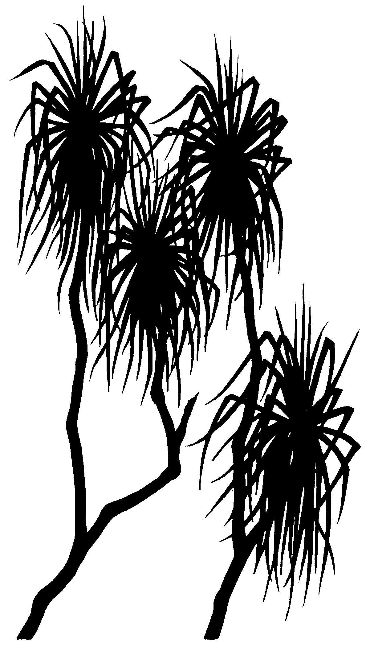



Che Doering

February 2018

Release status – Public release

Project number – EXT-2017-014

*The Department acknowledges the traditional custodians of country throughout Australia and their continuing connection to land, sea and community. We pay our respects to them and their cultures and to their elders both past and present.*

# Radiation doses to Aboriginal people living near Ranger uranium mine

Che Doering

Supervising Scientist

GPO Box 461, Darwin NT 0801

February 2018

(Release status –Public release)



*How to cite this report:*

Doering C 2018. Radiation doses to Aboriginal people living near Ranger uranium mine. Internal Report 655, Supervising Scientist, Darwin.

*Project number: EXT-2017-014*

*Author of this report:*

Che Doering –Supervising Scientist, GPO Box 461, Darwin NT 0801, Australia

Supervising Scientist is a branch of the Australian Government Department of   
the Environment and Energy.

Supervising Scientist   
Department of the Environment and Energy   
GPO Box 461, Darwin NT 0801 Australia

**environment**.gov.au/science/supervising-scientist/publications

© Commonwealth of Australia 2018

Copyright Image.tif

IR655 is licensed by the Commonwealth of Australia for use under a Creative Commons By Attribution 3.0 Australia licence with the exception of the Coat of Arms of the Commonwealth of Australia, the logo of the agency responsible for publishing the report, content supplied by third parties, and any images depicting people. For licence conditions see: http://creativecommons.org/licenses/by/3.0/au/

**Disclaimer**

The views and opinions expressed in this publication are those of the authors and do not necessarily reflect those of the Australian Government or the Minister for the Environment and Energy.

While reasonable efforts have been made to ensure that the contents of this publication are factually correct, the Commonwealth does not accept responsibility for the accuracy or completeness of the contents, and shall not be liable for any loss or damage that may be occasioned directly or indirectly through the use of, or reliance on, the contents of this publication.

# Contents

Executive summary iv

1 Introduction 1

1.1 Background 1

1.2 Aim and context 1

1.3 Scope 1

1.4 Structure 1

2 Regional context 1

2.1 Climate 1

2.2 Kakadu National Park 1

2.3 Ranger uranium mine 3

2.4 Magela Creek 3

2.5 Aboriginal demographic 4

3 Radiation exposure scenario 4

4 Radiation sources, pathways and limits 5

4.1 Radiation sources at RUM 5

4.2 Radiation exposure pathways 5

4.2.1 Pathways 5

4.2.2 Uranium and its radioactive decay 6

4.2.3 Radon and its progeny 6

4.2.4 Long-lived radionuclides in dust 7

4.2.5 Radionuclides in bush food 7

4.3 Dose limits 7

5 Information review 7

5.1 Radon progeny 7

5.2 Radionuclides in dust 10

5.3 Bush foods and water 13

6 Dose estimate 17

7 Conclusion 18

References 18

Appendix A 22

# Executive summary

This report presents an estimate of the lifetime radiation dose over and above the natural background dose to long-term Aboriginal residents of the Alligator Rivers Region living near the Ranger uranium mine. The estimate was requested by the Northern Territory Department of Health as part of a broader study of cancer risk factors for such residents.

Lifetime doses were derived from review of existing information, which included previous estimates of mine-related annual doses and data on radionuclide activity concentrations in the environment. The lifetime radiation exposure scenario was based on hypothetical individuals living at the Manaburduma and Mudginberri settlements over the period 1980–2017 (ie from when mining at Ranger started to present day). The radiation exposure pathways considered were the inhalation of radon progeny and long-lived radionuclides in dust and the ingestion of radionuclides in bush foods and water.

The estimated lifetime dose over and above the natural background dose to the hypothetical individual living at Manaburduma was 0.93 mSv and that to the hypothetical individual living at Mudginberri was 0.11 mSv, though these estimates are most likely conservative (ie higher than the actual dose received). The mine-related average annual doses from which the lifetime doses were derived were well below the public dose limit of 1 mSv y-1.

The dominant exposure pathway has been the inhalation of radon progeny. This pathway accounted for almost 100% of the lifetime dose to the hypothetical individuals. The contribution from inhalation of long-lived radionuclides in dust was small. Mine-related dose from bush foods and water was negligible based on empirical evidence that suggested no detectable increase in radionuclide activity concentrations in aquatic and terrestrial environments from the operation of the mine.

# 1 Introduction

## 1.1 Background

The Alligator Rivers Region (ARR) is a major Australian uranium province, within which the Ranger uranium mine (RUM) is located (Figure 1). Inhabitants of the ARR include Aboriginal people living to some extent on bush foods. The coincidence of Aboriginal culture and uranium mining in the ARR has raised questions about the radiation safety of members of the regional indigenous community and their potential excess cancer risk (Tatz et al 2006).

## 1.2 Aim and context

The aim of this study was to estimate the lifetime radiation dose over and above the natural background dose to long-term Aboriginal residents of the ARR living near RUM. The study was requested by the Northern Territory Department of Health as part of a broader study of cancer risk factors for such residents.

## 1.3 Scope

The scope of this study was limited to review of existing information; no additional measurements or modelling were undertaken. Previous dose estimates and data on radionuclide activity concentrations in the environment near RUM were reviewed and used to derive estimates of the lifetime dose over and above the natural background dose.

## 1.4 Structure

The aim and scope of this study have been described in this chapter. Chapter 2 describes the regional context. Chapter 3 describes the radiation exposure scenario. Chapter 4 describes the potential radiation sources and exposure pathways and also introduces the concept of public dose limit for context. Chapter 5 summarises previous estimates of mine-related annual dose and data on radionuclides in the environment near RUM. Chapter 6 estimates the lifetime radiation dose. Chapter 7 provides conclusions.

# 2 Regional context

## 2.1 Climate

The climate of the ARR is tropical monsoonal and characterised by distinct wet (November–April) and dry (May–October) seasons. Mean annual rainfall is about 1600 mm, of which approximately 95% usually occurs in the wet season. Winds are predominantly from east to southeast during the dry season and spread fairly uniformly over all directions during the wet season.

## 2.2 Kakadu National Park

The ARR includes the World Heritage protected area of Kakadu National Park, which surrounds RUM. Kakadu was declared a National Park in 1979 at the same time the Ranger Authority was granted. The wetlands of Kakadu support a large diversity of plant and animal species and have been listed as wetlands of international importance under the Ramsar Convention.

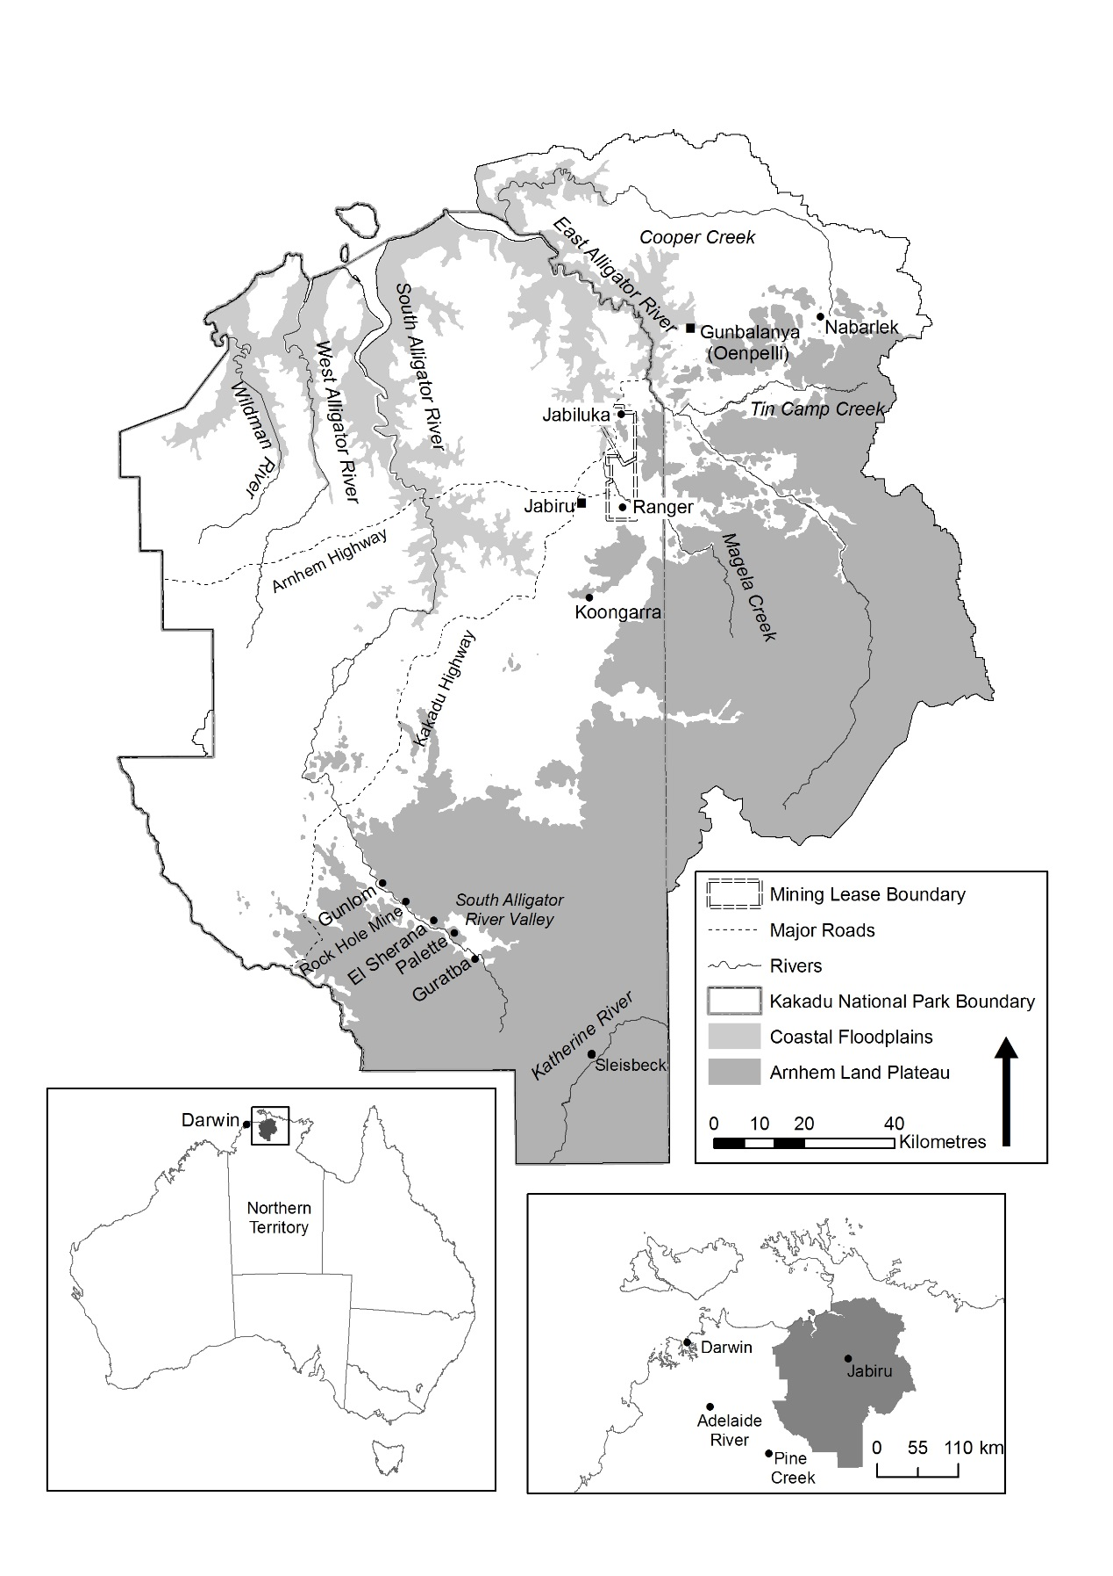

**Figure 1** Alligator Rivers Region.

## 2.3 Ranger uranium mine

Ranger uranium mine is located approximately 220 km east of Darwin and 7 km east of Jabiru (Figures 1 and 2). The mine started operating in 1980. Two major uranium orebodies have been mined to completion by conventional open-cut methods. The No. 1 orebody was mined between 1980 and 1994 and the No. 3 orebody between 1996 and 2012. Total U3O8 production has been more than 100,000 t. Current operations at RUM include milling of stockpiled ore and progressive rehabilitation of the site. Commonwealth legislation requires operations at RUM to end by 2021 and the site to be rehabilitated by 2026.

## 2.4 Magela Creek

Ranger uranium mine is close to Magela Creek (Figure 2). The creek flows during the wet season and ceases to flow in the dry season. Ranger uranium mine is also close to Gulungul Creek, which also flows seasonally and confluences with Magela Creek downstream of the mine (Figure 2). Magela Creek enters Mudginberri Billabong (a permanent channel billabong) approximately 12 km downstream of RUM. Beyond Mudginberri Billabong, Magela Creek enters the Magela Floodplain system.

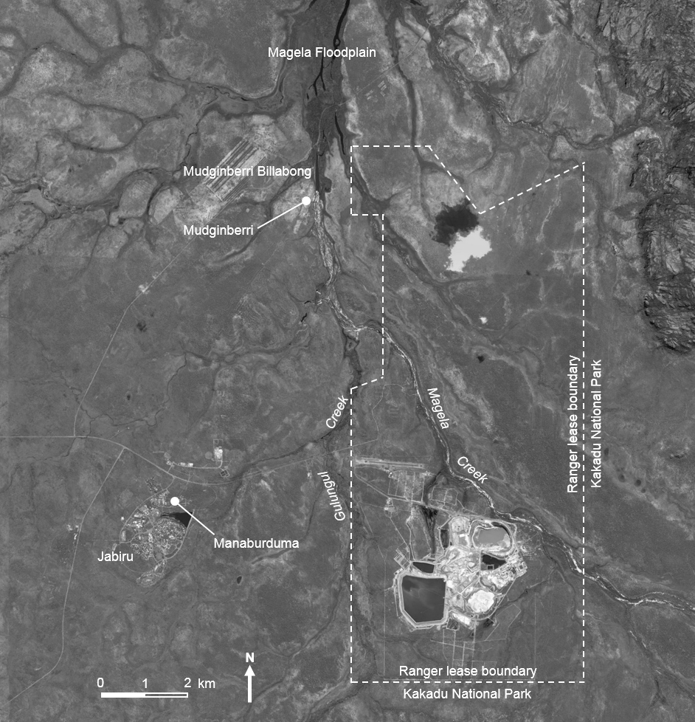

**Figure 2** Location of major creeks and permanent Aboriginal settlements near RUM.

## 2.5 Aboriginal demographic

The permanent Aboriginal settlements near RUM over its period of operation have been Manaburduma and Mudginberri (Figure 2). The Manaburduma settlement is located approximately 7 km west of RUM within the township of Jabiru. The Mudginberri settlement is located next to Mudginberri Billabong on Magela Creek, approximately 10 km north-northwest of RUM. Both settlements have had populations of a few tens of people during the operational period of RUM.

# 3 Radiation exposure scenario

The exposure scenario considered in this study involved hypothetical adult individuals living at Manaburduma and Mudginberri. The individuals were assumed to be long-term residents of the settlements, with their lifetime radiation exposure from the operation of RUM assumed to occur over the period 1980–2017. The individuals were assumed to live to some extent on bush foods. The bush food diet of the individuals (Table 1) was represented by the model diet developed by the Supervising Scientist (Ryan et al 2008) for radiation dose estimates in the RUM context. The diet is similar to those developed and used for dose estimates during the early operational phase of RUM (Johnston 1987, Koperski 1986, Martin 2000). A recent review of the model diet by Garde (2015) found that it was most likely still accurate in 2014. The individual living at Manaburduma was assumed to source bush foods from various locations (Appendix A); this information was supplied by the Northern Territory Department of Health. The individual living at Mudginberri was assumed to source bush foods from Mudginberri Billabong and the Magela Floodplain; this has been the assumption used in previous dose estimates by the Supervising Scientist (Johnston 1987, Martin 2000).

**Table 1** Model diet of bush food consumption (after Ryan et al 2008).

|  |  |  |
| --- | --- | --- |
| Bush food | Compartment | Annual consumption (kg) |
| Buffalo | Flesh | 146 |
|  | Kidney | 18 |
|  | Liver | 18 |
| Crocodile | Flesh | 2 |
| File snake | Flesh | 3 |
| Fish group 1a | Flesh | 10 |
| Fish group 2a | Flesh | 20 |
| Fruit | Flesh | 3 |
| Goanna | Flesh | 2 |
| Magpie goose | Flesh | 20 |
| Mussel | Flesh | 4 |
| Pig | Flesh | 25 |
| Turtle | Flesh | 5 |
|  | Liver | 0.5 |
| Wallaby | Flesh | 20 |
| Waterlily | Rhizome | 3 |
| Yam | Flesh  aFish group 1 includes bony bream (*Nematalosa erebi*) and sleepy cod (*Oxyeleotris lineolatus*). Fish group 2 includes archer fish (*oxotes chatareus*), barramundi (*Lates calcarifer*), eel-tailed catfish (*Plotosidae*), fork-tailed catfish (*Arius leptaspis*), fresh-water mullet (*Liza alata*), long tom (*Strongylura kreffti*), Saratoga (*Scleropages jardini*) and tarpon (*Megalops cyprinoides*). The groups were defined in Martin et al (1995) based on radionuclide uptake characteristics. | 20 |

# 4 Radiation sources, pathways and limits

## 4.1 Radiation sources at RUM

The environmental setting and operational characteristics of RUM have been such that airborne and waterborne emissions of radionuclides have occurred. Figure 3 shows the major features at RUM. The main potential sources for airborne emissions of radionuclides have been the pits, ore and waste rock stockpiles, mill and tailings storage facility. The main potential sources for waterborne emissions of radionuclides have been retention ponds, with water released under strict regulatory controls to Magela Creek, either directly or through wetland filters. Inadvertent runoff to Gulungul Creek has also occurred.

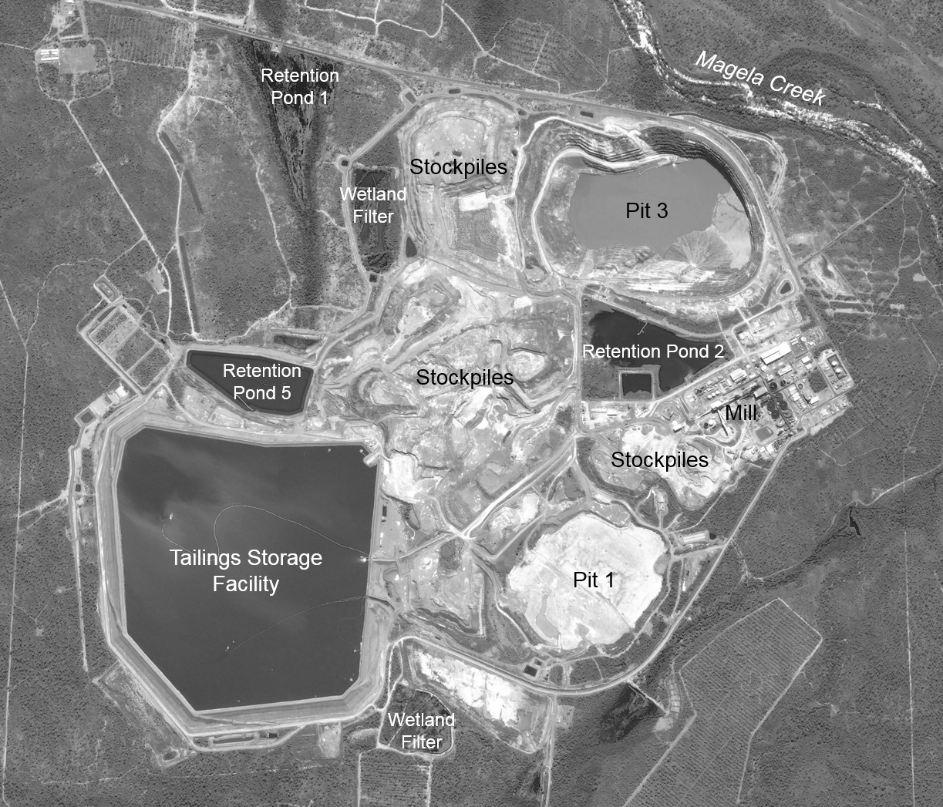

**Figure 3** Major features at RUM.

## 4.2 Radiation exposure pathways

### 4.2.1 Pathways

The potential exposure pathways to Aboriginal people from mine-emitted radionuclides have been (Johnston 1987, Martin 2000):

* inhalation of radon progeny due to the atmospheric transport of radon gas;
* inhalation of long-lived radionuclides in dust; and
* ingestion of radionuclides in bush foods and water.

The following sub-sections provide additional information about uranium radioactivity and each exposure pathway.

### 4.2.2 Uranium and its radioactive decay

Uranium is a radioactive element naturally present in the environment, usually at low levels, but occasionally at significantly elevated levels within uranium-rich orebodies, including those at RUM. The most common isotope of uranium is 238U, which accounts for more than 99% of all uranium atoms naturally present in the environment. The radioactive decay of 238U with a half-life of approximately 4.47 billion years produces a sequential series of radionuclides called the uranium decay series (Figure 4). All members of the series occur with and are supported by 238U in the environment.

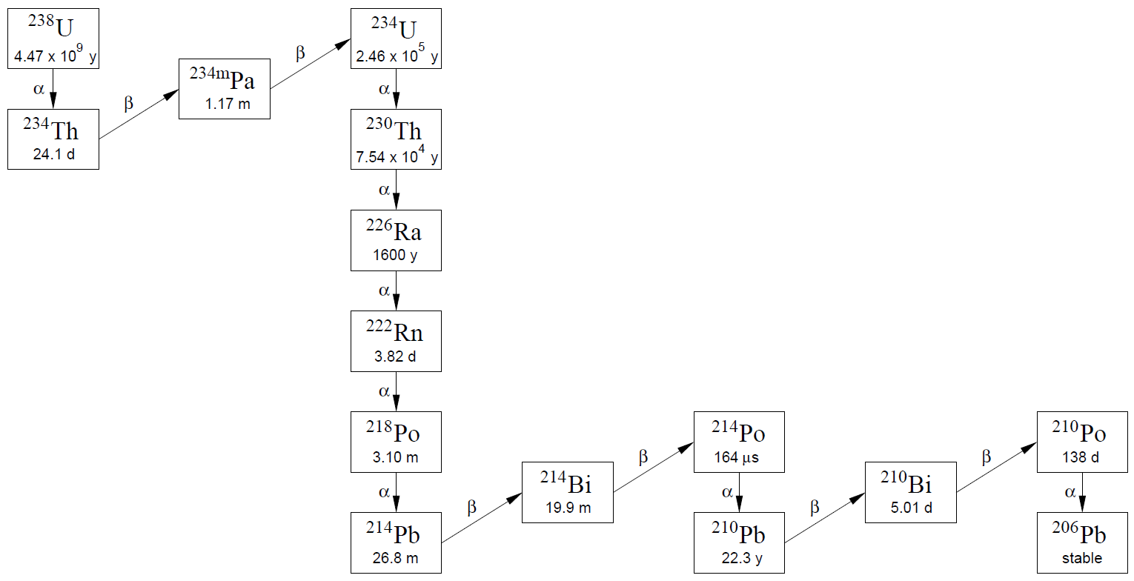

**Figure 4** Uranium decay series

### 4.2.3 Radon and its progeny

Radon (222Rn) is an inert radioactive gas with a half-life of approximately 3.82 days produced from the decay of 226Ra in the uranium decay series (Figure 4). The alpha decay of 226Ra in soils and rocks (including ore and waste rock at RUM) can eject the newly formed 222Rn atom from the mineral lattice to the pore space through a process called emanation. The ejected 222Rn atom can then be transported upwards through the pore space and enter the atmosphere through a process called exhalation. The emanation and exhalation of 222Rn generally increase with increasing 226Ra content in the substrate, and generally decrease with increasing moisture content in the substrate (eg by rainfall). Once in the atmosphere, 222Rn is primarily transported and dispersed by the wind.

The decay of 222Rn produces a series of four short-lived non-gaseous radionuclides called radon progeny. The progeny radionuclides in order of production are 218Po, 214Pb, 214Bi and 214Po. Their half-lives range from less than 1 millisecond (214Po) to 26.8 minutes (214Pb). Public exposure to radon progeny from uranium mining occurs when emitted 222Rn is transported by the wind and enters the breathing zone at an area of habitation. Inhalation of radon progeny causes them to deposit in the lungs, where their subsequent (and rapid) radioactive decay delivers a radiation dose to the lung tissue. Dose from the inhalation of 222Rn itself is negligible by comparison, as it is immediately exhaled, with very little decay occurring during its short residence time inside the lung.

### 4.2.4 Long-lived radionuclides in dust

The long-lived radionuclides in dust include 238U, 234U, 230Th, 226Ra, 210Pb and 210Po. Dust emissions from uranium mining can occur through active and passive processes. Active processes include blasting, heavy vehicle movements and ore crushing. Passive processes include resuspension from ore and waste rock stockpiles by wind. Public exposure to long-lived radionuclides in dust from uranium mining occurs when the dust is transported by the wind and enters the breathing zone at an area of habitation. Inhaled radionuclides initially enter the lungs, but can be transported to other sites in the body through biokinetic processes. A radiation dose is received upon decay of the radionuclides inside the body.

### 4.2.5 Radionuclides in bush food

Airborne and waterborne emissions from uranium mining can potentially enhance radionuclide activity concentrations in the surrounding environment over and above natural background levels. This can lead to increased radionuclide activity concentrations in plants and animals through bioaccumulation processes. Public exposure occurs when plants and animals are collected from impacted areas and consumed as bush foods. Exposure also occurs when water from impacted creeks or billabongs is ingested as drinking water. Ingested radionuclides initially enter the gastrointestinal tract, but can be transported to other locations in the body through biokinetic processes. The radionuclides of potential concern are 238U, 234U, 230Th, 226Ra, 210Pb and 210Po. A radiation dose is received upon decay of these radionuclides inside the body.

## 4.3 Dose limits

Dose limits have been developed within an international system for radiation protection (ICRP 2007) to keep radiation doses to workers and the public within acceptable levels. The international dose limits have been adopted into regulatory practice in all States and Territories of Australia through the *National Directory for Radiation Protection* (ARPANSA 2017). The dose limit for a member of the public is 1 milliSievert (mSv) per year over and above the natural background dose.

# 5 Information review

## 5.1 Radon progeny

Table 2 summarises previous estimates of the mine-related annual dose from radon progeny for people living at Jabiru (which includes Manaburduma) and Mudginberri. The estimates were corrected where necessary to the ICRP (1993) radon progeny dose coefficient of 1.1 mSv per mJ h m-3, which is the current internationally accepted value of dose per unit exposure to the public from radon progeny. The estimates for Jabiru were typically of the order of a few hundredths mSv y-1 with an average of 2.4×10-2 mSv y-1. Those for Mudginberri were of the order of a few thousandths mSv y-1 with an average of 2.8×10‑3 mSv y-1. The estimates for people living at Jabiru spanned the period 1986–2016, whereas those for people living at Mudginberri only spanned the period 2011–2015. However, the Mudginberri estimates represented the period when the size of potential radon emission sources at RUM were probably at their peak; both orebodies had been mined and the footprint of stockpiles were at their largest.

**Table 2** Previous estimates of mine-related annual dose from radon progeny.

|  |  |  |  |  |  |
| --- | --- | --- | --- | --- | --- |
| Reference | Period | Method | Description | Dose (mSv y-1) | |
|  |  |  |  | Jabiru | Mudginberri |
| Whittlestone (1992) | 1986–87 | Wind direction correlation | Sorted radon progeny data into 16 wind directions and two broad time intervals of day and night to develop average daily concentration responses for two-month periods | 4.3×10-2,a | - |
| Auty & Bell (1992) | 1988–89 | Wind direction correlation | Sorted radon progeny data into 16 wind directions to determine average concentrations in each direction | 3.4×10-2,a | - |
| Kvasnicka (1992) | 1989 | Model | Predicted radon progeny concentrations in air based on estimated radon emission rates from major potential sources at RUM | 3.2×10-2,a | - |
| Akber et al (1991, 1992a) | 1989–90 | Wind direction correlation | Sorted radon progeny data into 16 wind directions and 12 time intervals of two hours each to develop average daily concentration responses for each month | 2.5×10-2,a | - |
| Akber et al (1993) | 1989–90 | Model | Predicted radon concentrations in air based on radon emission rates estimated from the studies of Clark (1977) and Kvasnicka (1990) and using meteorological data for the period 1989–90 | 6.4×10-2,a | - |
| Akber et al (1992b) | 1990–91 | Wind direction correlation | See Akber et al (1991, 1992a) | 1.5×10-2,a | - |
| Supervising Scientist (1995) | 1989–94 | Wind direction correlation | Calculated by RUM using the method of Auty & Bell (1992) | 3.0×10-2 | - |
| Supervising Scientist (1997) | 1995 | Wind direction correlation | “” | 2.0×10-2 | - |
| Supervising Scientist (1997) | 1996 | Wind direction correlation | “” | 2.0×10-2 | - |
| Supervising Scientist (1998) | 1997 | Wind direction correlation | “” | 5.1×10-2 | - |
| Supervising Scientist (1999) | 1998 | Wind direction correlation | “” | 3.0×10-2 | - |
| Supervising Scientist (2000) | 1999 | Wind direction correlation | “” | 1.0×10-2 | - |
| Supervising Scientist (2001) | 2000 | Wind direction correlation | “” | 0 | - |
| Supervising Scientist (2002) | 2001 | Wind direction correlation | “” | 0 | - |
| Supervising Scientist (2003) | 2002 | Wind direction correlation | “” | 3.0×10-2 | - |
| Supervising Scientist (2004) | 2003 | Wind direction correlation | “” | 1.1×10-2 | - |
| Supervising Scientist (2005) | 2004 | Wind direction correlation | “” | 1.4×10-2 | - |

**Table 2** continued

|  |  |  |  |  |  |
| --- | --- | --- | --- | --- | --- |
| Reference | Period | Method | Description | Dose (mSv y-1) | |
|  |  |  |  | Jabiru | Mudginberri |
| Supervising Scientist (2006) | 2005 | Wind direction correlation | “” | 3.7×10-2 | - |
| Supervising Scientist (2007) | 2006 | Wind direction correlation | “” | 3.0×10-3 | - |
| Supervising Scientist (2008) | 2007 | Wind direction correlation | “” | 0 | - |
| Supervising Scientist (2009) | 2008 | Wind direction correlation | “” | 1.0×10-3 | - |
| Supervising Scientist (2010) | 2009 | Wind direction correlation | “” | 3.0×10-2 | - |
| Supervising Scientist (2011) | 2010 | Wind direction correlation | “” | 1.9×10-2 | - |
| Supervising Scientist (2012) | 2011 | Wind direction correlation | Calculated by Supervising Scientist by sorting hourly radon progeny data into 36 wind directions to determine average concentrations in each direction | 2.1×10-2 | 3.0×10-3 |
| Supervising Scientist (2013) | 2012 | Wind direction correlation | “” | 3.0×10-2 | 5.0×10-3 |
| Supervising Scientist (2014) | 2013 | Wind direction correlation | “” | 5.5×10-2 | 2.0×10-3 |
| Supervising Scientist (2015) | 2014 | Wind direction correlation | “” | 2.3×10-2 | 3.0×10-3 |
| Supervising Scientist (2017a) | 2015 | Wind direction correlation | “” | 3.8×10-2 | 1.0×10-3 |
| Supervising Scientist (2017b) | 2016 | Wind direction correlation | Calculated by RUM using the method of Auty & Bell (1992) | 1.8×10-2 | - |

aCorrected to ICRP (1993) radon progeny dose coefficient.

The principal method used in the previous estimates of mine-related annual dose from radon progeny has been wind direction correlation. The method is based on simultaneous measurements of radon progeny concentrations and wind, with the concentration data then sorted by wind direction. The basic principle of the method is that the mine-related radon progeny concentration can be determined by subtracting the average background concentration (measured when the wind direction is not from RUM) from the average total concentration (measured when the wind direction is from RUM) (Akber et al 1992a).

Radon progeny concentrations at Jabiru when the wind is from approximately east to east-southeast should include both a background and mine-related component, as the signal would be from the direction of RUM. The same should be true for Mudginberri when the wind is from approximately southeast to south-southeast. Radon progeny concentrations at each location when the wind is from other directions should include a background component only.

Jabiru is downwind of RUM in the predominant dry season wind direction. Wind frequencies from RUM towards Mudginberri are generally much lower. This probably explains (in part) the higher estimates of mine-related annual dose from radon progeny to people living at Jabiru compared to Mudginberri. Mudginberri is also further from RUM than Jabiru, which means greater dispersion of radon emitted from the mine should occur before reaching the receptor location.

The wind direction correlation method assumes the background component when the wind is from the direction of RUM is equal to the average of radon progeny concentrations when the wind is from other directions. However, Akber et al (1991) noted that this approach may not be strictly correct and that the natural background component in mine-related wind directions could be high based on an earlier study by Schery & Whittlestone (1986) that showed naturally high radon exhalation fluxes from soils around RUM.

Figure 5 plots the Supervising Scientist radon progeny data from Jabiru collected in 2011–2015 by the north-south component of wind direction. The north-south component was represented by the cosine of the angle of the wind direction clockwise from north. The line of best fit to the data when the wind was not from RUM shows that the background component of radon progeny generally increases as the wind direction becomes more southerly. The same trend was apparent in the data from Mudginberri (Figure 6). The trend potentially reflects geographical differences in the background radon source term. Several small radiological anomalies and the broader Australian continent occur to the south, whereas wetland areas and the sea occur to the north. Radon emissions are much higher from land than water (Porstendörfer 1994).

Figure 5 also shows the average radon progeny concentration when the wind was not from RUM. This represents the approach used in the wind direction correlation method to determine the background component of radon progeny. The average background was less than that predicted by the line of best fit approach at mine-related wind directions. This suggests that previous estimates of mine-related annual dose based on the wind direction correlation method have potentially underestimated the background component of radon progeny in mine-related wind directions and, consequently, overestimated the mine-related component of radon progeny and dose. The plot of the Mudginberri data (Figure 6) indicates that measured concentrations in mine-related wind directions were (on average) less than or equal to the background component predicted by the line of best fit approach. This suggests that mine-related annual doses at Mudginberri via the radon progeny exposure pathway could have potentially been zero.

Akber (1991, 1992a) sorted radon progeny concentrations by time of day in addition to wind direction and showed that concentrations in mine-related wind directions were significantly enhanced over the natural background concentrations during the early morning, but not at other times of the day. This suggests that mine-related dose to the public from radon progeny primarily occurs when a person is either sleeping or at home in the morning before heading out for work or other daytime activities. Hence, a resident of Manaburduma or Mudginberri who heads out during the day to collect bush foods, etc would receive approximately the same mine-related dose as a resident who stayed at home during the day.

## 5.2 Radionuclides in dust

Table 3 summarises previous estimates of the mine-related annual dose from long-lived radionuclides in dust for people living at Jabiru (which includes Manaburduma) and Mudginberri. The estimates have been corrected to ICRP (1996) inhalation dose coefficients, which are the current internationally accepted values of dose per unit intake to the public from inhaled radionuclides. The estimates for people living at Jabiru were no more than one one-thousandth mSv y-1 with an average of 3.5×10-4 mSv y-1. The estimates for people living at Mudginberri were no more than one ten-thousandth mSv y-1 with an average of 5.2×10-5 mSv y-1.



**Figure 5** Average radon progeny concentrations at Jabiru in the period 2011–2015 plotted by the north-south component of wind direction.



**Figure 6** Average radon progeny concentrations at Mudginberri in the period 2011–2015 plotted by the north-south component of wind direction.

**Table 3** Previous estimates of mine-related annual dose from long-lived radionuclides in dust.

|  |  |  |  |  |  |
| --- | --- | --- | --- | --- | --- |
| Reference | Period | Method | Description | Dose (mSv y-1) | |
|  |  |  |  | Jabiru | Mudginberri |
| Pettersson et al (1987) | 1984–85 | Experimental | Estimated dust radionuclide concentrations from dust radionuclide loads (Bq m-2 d-1) | 5.1×10-4,a | - |
| Kvasnicka (1988) | 1987 | Model | Predicted dust radionuclide concentrations based on estimated dry season emissions from all major sources at RUM | 8.1×10-4,a | - |
| Supervising Scientist (2003) | 2000 | Scaling to radon progeny | Derived from RUM monitoring results assuming the ratio of mine-related to total dose for dust was equal to that for radon progeny | 0 | - |
| Supervising Scientist (2003) | 2001 | Scaling to radon progeny | “” | 0 | - |
| Supervising Scientist (2003) | 2002 | Scaling to radon progeny | “” | 3.2×10-4 | - |
| Supervising Scientist (2004) | 2003 | Scaling to radon progeny | “” | 2.1×10-5 | - |
| Supervising Scientist (2004, 2010) | 2004 | Scaling to radon progeny | “” | 8.2×10-5 | - |
| Supervising Scientist (2010) | 2005 | Scaling to radon progeny | “” | 2.4×10-4 | - |
| Supervising Scientist (2010) | 2006 | Scaling to radon progeny | “” | 1.0×10-4 | - |
| Supervising Scientist (2010) | 2007 | Scaling to radon progeny | “” | 0 | - |
| Supervising Scientist (2010) | 2008 | Scaling to radon progeny | “” | 1.6×10-5 | - |
| Supervising Scientist (2010) | 2009 | Scaling to radon progeny | “” | 3.6×10-4 | - |
| Supervising Scientist (2011) | 2010 | Scaling to radon progeny | “” | 1.7×10-4 | - |
| Supervising Scientist (2012) | 2011 | Scaling to radon progeny | Derived from Supervising Scientist data assuming the ratio of mine-related to total dose for dust was equal to that for radon progeny | 8.0×10-4 | 7.0×10-5 |
| Supervising Scientist (2013) | 2012 | Scaling to radon progeny | “” | 5.0×10-4 | 1.0×10-4 |
| Supervising Scientist (2014) | 2013 | Scaling to radon progeny | “” | 1.0×10-3 | 3.0×10-5 |
| Supervising Scientist (2015) | 2014 | Scaling to radon progeny | “” | 5.0×10-4 | 4.0×10-5 |
| Supervising Scientist (2017a) | 2015 | Scaling to radon progeny | “” | 9.0×10-4 | 2.0×10-5 |
| Supervising Scientist (2017b) | 2016 | Scaling to radon progeny | Derived from RUM monitoring results assuming the ratio of mine-related to total dose for dust was equal to that for radon progeny | 3.0×10-4 | - |

aCorrected to ICRP (1996) inhalation dose coefficients.

The principal method used in the previous estimates of mine-related annual dose from long-lived radionuclides in dust has been scaling to radon progeny. The method assumes the ratio of mine-related to total dose from long-lived radionuclides in dust is equal to that for radon progeny. The assumption should result in conservative dose estimates because dust should deplete much faster than radon along its transport pathway due to deposition. This should result in a lower ratio of the mine-related to total dose for radionuclides in dust than that for radon progeny at distances of Jabiru and Mudginberri.

## 5.3 Bush foods and water

Table 4 summarises previous estimates of mine-related annual dose from radionuclides in bush foods and water. The estimates have been corrected where necessary to ICRP (1996) ingestion dose coefficients, which are the current internationally accepted values of dose per unit intake to the public from ingested radionuclides. The previous estimate based on experimental measurements during the early operational phase of RUM (Koperski 1986) found no conclusive evidence to support a mine-related dose from bush foods. Model-based estimates (Johnston 1987, Martin 2000) have derived doses in the range from a few ten-thousandths to a few thousandths mSv y-1 for people living at Mudginberri based on predicted increases in radionuclide activity concentrations in the environment due to RUM and predicted transfer to bush foods.

**Table 4** Previous estimates of mine-related annual dose from radionuclides in bush foods and water.

|  |  |  |  |  |
| --- | --- | --- | --- | --- |
| Reference | Period | Method | Description | Dose (mSv y-1) |
| Koperski (1986) | 1980–85 | Experimental | Compared radionuclide activity concentrations in bush foods collected on the RUM lease before and after the start of milling operations; no significant difference found | 0 |
| Johnston (1987) | 1985 | Model | Predicted radionuclide activity concentrations in surface water and sediment from assumed wet season releases from RUM to Magela Creek; predicted subsequent radionuclide transfer to bush foods using mainly generic concentration ratios; calculated the intake to a hypothetical individual from Mudginberri community whose diet included ~290 kg y-1 bush food and 600 L y-1 surface water sourced from the Magela Floodplain and its billabongs | 1.8×10-3,a |
| Martin (2000) | 1979–97 | Model | Revised the estimate of Johnston (1987) by using site-specific values for bush food concentration ratios and other parameters | 3.6×10-4 |

aCorrected to ICRP (1996) ingestion dose coefficients.

Bush foods sequester radionuclides from the environment in which they live through bioaccumulation processes. Mine-related doses from the consumption of bush foods can only occur if radionuclide concentrations in the environment have been enhanced over and above natural background levels by mining. Measurement data on radionuclides in the aquatic and terrestrial environment near RUM have therefore been reviewed for evidence of potentially enhanced activity concentrations due to the operation of the mine.

Supervising Scientist has measured 226Ra in fortnightly water samples collected from downstream and upstream monitoring points in Magela Creek each wet season since 2001. Measurements have also been made on water samples collected from upstream and downstream monitoring points in Gulungul Creek each wet season since 2011. The difference between the downstream and upstream averages has been used to detect potential mine-related increases in 226Ra in the creeks and demonstrate compliance with water quality objectives (Iles 2004, Turner et al 2016). Small differences between the downstream and upstream average activity concentrations have occurred in Magela Creek in some years (Figure 7). However, t-test analyses on the data indicated that the differences were not statistically significant at the 99% confidence level. The downstream average 226Ra activity concentration in Gulungul Creek has been consistently less than the upstream average (Figure 8).



**Figure 7** Magela Creek upstream and downstream 226Ra activity concentrations.



**Figure 8** Gulungul Creek upstream and downstream 226Ra activity concentrations.

Supervising Scientist has also measured 226Ra and other radionuclides in freshwater mussels from Mudginberri Billabong each year since 2000, except in 2014 when the billabong was not accessible for cultural reasons. The mussels were analysed by age class, except in 2009 and 2010 when the analysis was performed on a bulk sample of all ages combined. Mussels were also collected from Mudginberri Billabong in 1983 and 1986 and analysed by age class for 226Ra and other radionuclides as part of early environmental radioactivity studies conducted by Supervising Scientist (Johnston et al 1984a, 1984b, 1987).

Freshwater mussels strongly bioaccumulate radium isotopes as chemical analogues of calcium, which is an essential nutrient for growth. Radium is primarily stored in calcium phosphate granules in the soft tissue component of mussels (Jeffree & Simpson 1984) and has a biological half-life of between approximately 9 years (Johnston et al 1987) and 13 years (Bollhöfer et al 2011). This makes mussels an excellent sentinel for detecting long-term radiological impacts from RUM on downstream aquatic environments, as the impact will be integrated and recorded in the mussel through the bioaccumulation of radium. Furthermore, 226Ra in mussels is the largest contributor to potential mine-related doses from bush foods for individuals living at Mudginberri according to model-based estimates (Johnston 1987, Martin 2000).

The parameter used to detect potential mine-related increases in mussel 226Ra activity concentrations is the 228Ra/226Ra activity ratio. The 226Ra activity concentration in mussels alone is generally a less sensitive indicator because it increases naturally with mussel age (Doering & Bollhöfer 2017) and can also vary with seasonal and other factors affecting mussel mass (Bollhöfer et al 2011). The 228Ra isotope is naturally present in the environment as a member of the thorium decay series, but, unlike 226Ra, is not significantly elevated in material at RUM. Hence, changes (particularly decreases) in the 228Ra/226Ra activity ratio in mussels over time can potentially indicate additional inputs of 226Ra to the aquatic environment over and above what is naturally expected.

Figure 9 shows the average 228Ra/226Ra activity ratio in 1–10 year old mussels from Mudginberri Billabong. The ratio has remained fairly constant over time and suggests no detectable impact on 226Ra activity concentrations in mussels due to the operation of RUM. In addition, a study of radium in mussels collected from several locations along Magela Creek (Bollhöfer et al 2011) found that the 226Ra accumulated in the mussels was of natural rather than mine-related origin based on 228Ra/226Ra activity ratios.



**Figure 9** Average (points) and standard deviation (vertical bars) 228Ra/226Ra activity ratios in 1–10 year old mussels from Mudginberri Billabong.

Radionuclide monitoring of the terrestrial environment near RUM has been less intensive than for the aquatic environment. However, data were still available. Data on 226Ra activity concentrations and 228Ra/226Ra activity ratios in soil have been reviewed for signs of potential mine-related radiological impacts on the terrestrial environment due to deposition of dust emitted from RUM.

Martin (2000) collected soils in 1992 from eight locations at different distances from RUM. The average 226Ra activity concentration in the soils collected within approximately 5 km of RUM (~54 Bq kg-1, n=3) was significantly higher at the 95% confidence level than in soils collected beyond 5 km (~38 Bq kg-1, n=5). The average 228Ra/226Ra activity ratio in soils collected within approximately 5 km of RUM (~0.55, n=3) was significantly lower at the 95% confidence level than in soils collected beyond 5 km (~1.04, n=5). The results appeared to support the hypothesis that deposition of dust emitted from RUM had increased radionuclide activity concentrations in soil near the mine. However, Martin (2000) noted that the results could also be reflecting a higher natural concentration of uranium in the soils near a large uranium deposit rather than any significant impact from mining. Martin (2000) suggested that the best approach to distinguish between changes due to dust deposited from RUM and the presence of higher natural activity concentrations would be to collect additional soil samples from a number of locations within a few kilometres of the mine several years later.

Table 5 gives 226Ra activity concentrations and 228Ra/226Ra activity ratios in soils collected by Supervising Scientist in 2002–2015, approximately 10–23 years after the samples of Martin (2000) were collected. The average 226Ra activity concentration in soils collected within approximately 5 km of RUM was 51 Bq kg-1 and in soils collected beyond 5 km was 38 Bq kg-1. The average 228Ra/226Ra activity ratio in soils collected within approximately 5 km of RUM was 0.64 and in soils collected beyond 5 km was 1.38. Comparison of these results with those of Martin (2000) suggests there has been no increase in the average 226Ra activity concentration in soils since 1992 and no decrease in the average 228Ra/226Ra activity ratio in soils since 1992. The finding does not support the hypothesis that deposition of dust emitted from RUM is the cause of higher radionuclide activity concentrations in soil close to RUM. It instead supports the hypothesis of naturally higher uranium mineralisation in the soil near a large uranium deposit.

**Table 5** 226Ra activity concentrations and 228Ra/226Ra activity ratios in soils collected within (above dashed line) and beyond (below dashed line) approximately 5 km of RUM.

|  |  |  |  |  |  |  |  |
| --- | --- | --- | --- | --- | --- | --- | --- |
| Location | Dist. (km) | Period | 226Ra (Bq kg-1) | | 228Ra/226Ra | | n |
|  |  |  | Average | Range | Average | Range |  |
| Near Retention Pond 1 | 2 | 2003 | 56 | - | 0.61 | - | 1 |
| Near Georgetown Billabong | 2–3 | 2004–13 | 31 | 19–56 | 0.68 | 0.21–1.10 | 5 |
| Radon Springs Road | 3 | 2005–10 | 44 | 7–110 | 0.61 | 0.29–0.89 | 10 |
| Gulungul Creek upstream | 3–4 | 2005–15 | 74 | 54–100 | 0.48 | 0.22–0.97 | 3 |
| Jabiru East | 3–4 | 2002–15 | 62 | 39–130 | 0.89 | 0.35–1.54 | 6 |
| Magela Creek downstream | 4–5 | 2007–12 | 36 | 19–51 | 0.55 | 0.30–0.81 | 4 |
| South of RUM lease | 4–5 | 2010–12 | 32 | 10–44 | 0.84 | 0.50–1.40 | 3 |
| Gulungul Creek crossing | 5 | 2009–12 | 97 | 68–130 | 0.31 | 0.11–0.49 | 3 |
| Baralil Creek | 5–6 | 2003–04 | 49 | 44–53 | 1.23 | 1.09–1.41 | 3 |
| Jabiru | 8–10 | 2003–12 | 48 | 32–74 | 1.47 | 0.69–1.98 | 8 |
| Mudginberri | 11–12 | 2008–12 | 26 | 10–56 | 1.47 | 1.22–1.96 | 3 |

**Table 5** continued

|  |  |  |  |  |  |  |  |
| --- | --- | --- | --- | --- | --- | --- | --- |
| Location | Dist. (km) | Period | 226Ra (Bq kg-1) | | 228Ra/226Ra | | n |
|  |  |  | Average | Range | Average | Range |  |
| Nourlangie bridges | 23–24 | 2015–15 | 29 | 5–62 | 1.12 | 0.85–1.40 | 4 |
| Magela Floodplain | 26 | 2010 | 25 | - | 0.92 | - | 1 |
| Kakadu Buffalo Farm | 26–43 | 2007–12 | 47 | 20–81 | 1.11 | 0.72–1.60 | 13 |
| Mamukala | 30–39 | 2010–12 | 20 | 14–26 | 1.92 | 1.56–2.29 | 8 |

The experimental evidence for radionuclides in both the aquatic and terrestrial environment suggests no detectable increase in activity concentrations due to the operation of RUM. This in turn suggests negligible mine-related radiological impact on bush foods and people consuming them.

# 6 Dose estimate

Table 6 gives estimates of the mine-related average annual dose to the hypothetical individuals from each exposure pathway and all pathways summed. The doses were derived from the averages of previous estimates of mine-related annual dose for radon progeny (Table 2) and long-lived radionuclides in dust (Table 3). The dose from bush foods and water was considered negligible based on the experimental evidence, which suggested no detectable increases in radionuclide activity concentrations in the aquatic and terrestrial environment from the operation of RUM. The mine-related average annual dose has been well below the public dose limit of 1 mSv y-1.

**Table 6** Mine-related average annual dose.

|  |  |  |
| --- | --- | --- |
| Exposure pathway | Dose (mSv y-1) | |
|  | Manaburduma | Mudginberri |
| Radon progeny | 2.4×10-2 | 2.8×10-3 |
| Radionuclides in dust | 3.5×10-4 | 5.2×10-5 |
| Radionuclides in bush foods and water | Negligible | Negligible |
| All pathways | ~2.4×10-2 | ~2.9×10-3 |

Inhalation of radon progeny was the dominant exposure pathway and contributed nearly 100% of the mine-related dose to the hypothetical individuals. The contribution from long-lived radionuclides in dust was small and that from bush foods and water was negligible.

Lifetime doses over and above the natural background dose have been derived from the average annual doses (Table 6) by integrating over the period 1980–2017. The estimated lifetime doses from the operation of RUM were 0.93 mSv to the hypothetical individual living at Manaburduma and 0.11 mSv to the hypothetical individual living at Mudginberri.

The mine-related dose to the hypothetical individual living at Manaburduma was substantially more than that to the hypothetical individual living at Mudginberri. This was due to differences in radon progeny exposure caused by directional differences in wind frequencies. Manaburduma is directly downwind of RUM in the dominant dry season wind direction, whereas wind frequencies in the direction of Mudginberri are lower.

The mine-related doses are potentially conservative (i.e. over-estimated) for a number of reasons, including:

* mine-related exposure to radon progeny has been potentially over-estimated (especially at Mudginberri) by the wind direction correlation method used in previous studies;
* previous estimates of dose from long-lived radionuclides in dust have been primarily based on the radon progeny estimates and also assume that dust is transported similar to radon; and
* previous estimates of mine-related dose to people living at Mudginberri represent the period when the size of radon and dust emission sources at RUM were potentially at their peak.

# 7 Conclusion

Ranger uranium mine has been operating in the ARR for approximately 38 years. During this time, Aboriginal people living near the mine have been potentially exposed to radiation over and above natural background levels. However, the estimated lifetime dose from the operation of RUM is small, and average annual dose has been well below the public dose limit of 1 mSv y-1. The most important exposure pathway has been the inhalation of radon progeny. Mine-related doses from the inhalation of radionuclides in dust and the ingestion of radionuclides in bush foods and water have been effectively negligible.

# References

Akber R, Pfitzner J & Johnston A 1991. Public radiation dose due to radon transport from Ranger uranium mine. Internal Report 24, Supervising Scientist for the Alligator Rivers Region.

Akber RA, Johnston A & Pfitzner J 1992a. Public radiation exposure due to radon transport from a uranium mine. *Radiation Protection Dosimetry* 45, 137–140.

Akber R, Pfitzner J & Johnston A 1992b. Radon transport from Ranger uranium mine: a review of the public radiation dose estimates. *Radiation Protection in Australia* 10, 41–46.

Akber RA, Pfitzner JL, Petersen MCE, Clark GH & Bartsch FKJ 1993. Model-based estimates of public radiation dose due to atmospheric transport of radon from Ranger uranium mine for one seasonal cycle. Internal Report 102, Supervising Scientist for the Alligator Rivers Region.

ARPANSA 2017. *National Directory for Radiation Protection* (incorporating Amendment 7). Radiation Protection Series No. 6, Australian Radiation Protection and Nuclear Safety Agency.

Auty R & Bell A 1992. Doses to the public at Jabiru and Jabiru East due to Ranger uranium mine. *Radiation Protection in Australia* 10, 12–14.

Bollhöfer A, Brazier J, Humphrey C, Ryan B & Esparon A 2011. A study of radium bioaccumulation in freshwater mussels, *Velesunio angasi*, in the Magela Creek catchment, Northern Territory, Australia. *Journal of Environmental Radioactivity* 102, 964–974.

Clark GH 1977. *Assessment of the meteorological data and atmospheric dispersion estimates in the Ranger I uranium mining environmental impact statement*. AAEC/E407, Australian Atomic Energy Commission, Lucas Heights.

Doering C & Bollhöfer A 2017. Water hardness determines 226Ra uptake in the tropical freshwater mussel. *Journal of Environmental Radioactivity* 172, 96–105.

Garde 2015. Closure criteria development — cultural. Consultant report to Energy Resources of Australia Ltd.

ICRP 1993. Protection against radon-222 at home and at work. ICRP Publication 65, *Annals of the ICRP* 23(2).

ICRP 1996. Age-dependent doses to members of the public from intake of radionuclides: Part 5 Compilation of ingestion and inhalation dose coefficients. ICRP Publication 72, *Annals of the ICRP* 26(1).

ICRP 2007. The 2007 recommendations of the International Commission on Radiological Protection. ICRP Publication 103, *Annals of the ICRP* 37(2–4).

Iles M 2004. Water quality objectives for Magela Creek – revised November 2004. Internal Report 489, Supervising Scientist, Darwin.

Jeffree RA & Simpson RD 1984. Radium-226 is accumulated in calcium granules in the tissues of the freshwater mussel, *Velesunio angasi*: support for a metabolic analogue hypothesis? Comparative *Biochemistry and Physiology* 79A, 61–72.

Johnston A, Murray A, Allison H, Cusbert P & Martin P 1984a. The use of the freshwater mussel as an environmental monitor for radium. In Alligator Rivers Region Research Institute Research Report for 1983–84, Supervising Scientist for the Alligator Rivers Region, AGPS, Canberra, 33–37.

Johnston A, Murray A & Martin P 1984b. Investigation of radium-226 concentrations in mussels. In Alligator Rivers Region Research Institute Research Report for 1983–84, Supervising Scientist for the Alligator Rivers Region, AGPS, Canberra, 31–33.

Johnston A 1987. Radiation exposure of members of the public resulting from operation of the Ranger uranium mine. Technical Memorandum 20, Supervising Scientist for the Alligator Rivers Region.

Johnston A, Murray AS, Marten R, Martin P & Pettersson H 1987. Bioaccumulation of radionuclides and stable metals in the freshwater mussel, Velesunio angasi. In Alligator Rivers Region Research Institute Annual Research Summary 1986–87, Supervising Scientist for the Alligator Rivers Region, AGPS, Canberra, 69–74.

Koperski J 1986. Radiation exposure of the public as a result of the present operations of Ranger Uranium Mines Pty Ltd. *Radiation Protection in Australia* 4, 49–54.

Kvasnicka J 1988. *Radioactive dust concentration around the Ranger uranium mine*. Department of Mines and Energy, Northern Territory of Australia, Darwin.

Kvasnicka J 1990. *Radon daughters in tropical Northern Australia and the environmental radiological impact of uranium mining*. Department of Mines and Energy, Northern Territory of Australia, Darwin.

Kvasnicka J 1992. The radiological impact of the Ranger uranium mine on the general public in Jabiru. *Radiation Protection in Australia* 10, 4–11.

Martin P, Hancock G, Johnston A & Murray AS 1995. Bioaccumulation of radionuclides in traditional Aboriginal foods from the Magela and Cooper Creek systems. Research Report 11, Supervising Scientist for the Alligator Rivers Region, AGPS, Canberra.

Martin P 2000. Radiological impact assessment of uranium mining and milling. PhD Thesis, Queensland University of Technology, Brisbane.

Pettersson H, Koperski G, Johnston A & Murray AS 1987. Radionuclide concentrations in dusts near Ranger. In Alligator Rivers Region Research Institute Annual Research Summary 1985–86, Supervising Scientist for the Alligator Rivers Region, AGPS, Canberra, 44–47.

Porstendörfer J 1994. Properties and behaviour of radon and thoron and their decay products in air. *Journal of Aerosol Science* 25, 219–263.

Ryan B, Medley P & Bollhöfer A 2008. Bioaccumulation of radionuclides in terrestrial plants on rehabilitated landforms. In ERISS Research Summary 2006–2007. Eds. Jones, D.R., Humphrey, C., van Dam, R., Webb, A., Supervising Scientist Report 196, Supervising Scientist, Darwin, 99–103.

Schery SD & Whittlestone S 1986. Survey of radon and thoron in Australia: Emanation from soils, concentration in indorr/outdoor air. Report ESD/TN26, Australian Atomic Energy Commission, Lucas Heights.

Supervising Scientist 1995. *Annual Report 1994–95*. Australian Government Publishing Service, Canberra.

Supervising Scientist 1997. *Annual Report 1996–97*. Australian Government Publishing Service, Canberra.

Supervising Scientist 1998. *Annual Report 1997–98*. In Department of the Environment Annual Report 1997–98, Commonwealth of Australia, Canberra.

Supervising Scientist 1999. *Annual Report 1998–99*. In Department of the Environment and Heritage Annual Report 1998–99, Commonwealth of Australia, Canberra.

Supervising Scientist 2000. *Annual Report 1999–2000*. Supervising Scientist, Darwin.

Supervising Scientist 2001. *Annual Report 2000–01*. Supervising Scientist, Darwin.

Supervising Scientist 2002. *Annual Report 2001–2002*. Supervising Scientist, Darwin.

Supervising Scientist 2003. *Annual Report 2002–2003*. Supervising Scientist, Darwin.

Supervising Scientist 2004. *Annual Report 2003–2004*. Supervising Scientist, Darwin.

Supervising Scientist 2005. *Annual Report 2004–2005*. Supervising Scientist, Darwin.

Supervising Scientist 2006. *Annual Report 2005–2006*. Supervising Scientist, Darwin.

Supervising Scientist 2007. *Annual Report 2006–2007*. Supervising Scientist, Darwin.

Supervising Scientist 2008. *Annual Report 2007–2008*. Supervising Scientist, Darwin.

Supervising Scientist 2009. *Annual Report 2008–2009*. Supervising Scientist, Darwin.

Supervising Scientist 2010. *Annual Report 2009–2010*. Supervising Scientist, Darwin.

Supervising Scientist 2011. *Annual Report 2010–2011*. Supervising Scientist, Darwin.

Supervising Scientist 2012. *Annual Report 2011–2012*. Supervising Scientist, Darwin.

Supervising Scientist 2013. *Annual Report 2012–13*. Supervising Scientist, Darwin.

Supervising Scientist 2014. *Annual Report 2013–14*, Commonwealth of Australia 2014.

Supervising Scientist 2015. *Annual Report 2014–15*, Commonwealth of Australia 2015.

Supervising Scientist 2017a. *Annual Technical Report 2015–16*, Commonwealth of Australia 2017.

Supervising Scientist 2017b. *Annual Technical Report 2016–17*, Commonwealth of Australia 2017.

Tatz C, Cass A, Condon J & Tippett G 2006. *Aborigines and uranium: monitoring the health hazards*. AIATSIS Discussion Paper Number 20, Australian Institute of Aboriginal and Torres Strait Islander Studies.

Turner K, Tayler K & Tyrrell JWR 2016. Revised Ranger mine water quality objectives for Magela Creek and Gulungul Creek. Internal Report 638, Supervising Scientist, Darwin.

Whittlestone S 1992. Radon and radon daughter transport from Ranger uranium mine. Open File Record 77, Supervising Scientist for the Alligator Rivers Region.

# Appendix A

**Table A1** Information supplied by the Northern Territory Department of Health on bush food collection locations and fraction collected at each location for the hypothetical individual living at Manaburduma.

|  |  |  |
| --- | --- | --- |
| Bush food | Collection location | Fraction collected at location |
| Archer fish | Gulungul downstream | 0.40 |
|  | Gulungul upstream | 0.10 |
|  | Jabiru Lake | 0.10 |
|  | Magela Creek downstream | 0.40 |
| Baramundi | Gulungul downstream | 0.25 |
|  | Gulungul upstream | 0.05 |
|  | Jabiru Lake | 0.15 |
|  | Magela Creek downstream | 0.30 |
|  | Mudginberri Billabong | 0.25 |
| Bony bream | Baralil Billabong | 0.05 |
|  | Gulungul downstream | 0.35 |
|  | Gulungul upstream | 0.05 |
|  | Jim Creek | 0.05 |
|  | Magela Billabong | 0.05 |
|  | Magela Creek | 0.05 |
|  | Magela Creek downstream | 0.35 |
|  | Mudginberri Billabong | 0.05 |
| Buffalo | Buffalo farm | 0.40 |
|  | Gunbalanya stone country | 0.40 |
|  | Manaburduma | 0.20 |
| Bush carrot | Gulungul upstream | 0.10 |
|  | Jabiru region | 0.70 |
|  | Magela Creek downstream | 0.20 |
| Bush potato | Jabiru region | 0.70 |
|  | Magela Creek downstream | 0.30 |
| Cheeky yam | Magela Creek downstream | 1.00 |
| Eel-tailed catfish | Gulungul downstream | 0.10 |
|  | Gulungul upstream | 0.05 |
|  | Magela Creek | 0.30 |
|  | Magela Creek downstream | 0.10 |
|  | Mudginberri Billabong | 0.45 |
| Fork-tailed catfish | Gulungul downstream | 0.15 |
|  | Gulungul upstream | 0.05 |
|  | Magela Creek | 0.30 |
|  | Magela Creek downstream | 0.15 |
|  | Mudginberri Billabong | 0.35 |
| Freshwater mullet | Gulungul downstream | 0.10 |
|  | Gulungul upstream | 0.05 |

**Table A1** continued

|  |  |  |
| --- | --- | --- |
| Bush food | Collection location | Fraction collected at location |
| Freshwater mullet | Magela Billabong | 0.10 |
|  | Magela Creek | 0.20 |
|  | Magela Creek downstream | 0.20 |
|  | Mudginberri Billabong | 0.35 |
| Long Tom | Gulungul downstream | 0.20 |
|  | Gulungul upstream | 0.10 |
|  | Jabiru Lake | 0.05 |
|  | Magela Creek | 0.05 |
|  | Magela Creek downstream | 0.40 |
|  | Mudginberri Billabong | 0.20 |
| Magpie goose | Buffalo farm | 0.15 |
|  | Gulungul downstream | 0.20 |
|  | Magela Creek downstream | 0.55 |
|  | Mamukala | 0.10 |
| Mussels | Buffalo farm | 0.55 |
|  | Gulungul downstream | 0.15 |
|  | Gulungul upstream | 0.05 |
|  | Magela Creek downstream | 0.05 |
|  | Mudginberri Billabong | 0.15 |
|  | Patonga | 0.05 |
| Pig | Gulungul downstream | 0.50 |
|  | Magela Creek downstream | 0.50 |
| Saratoga | Billabong east of Mudginberri (Mula) | 0.15 |
|  | Gulungul Billabong | 0.05 |
|  | Gulungul downstream | 0.10 |
|  | Gulungul upstream | 0.05 |
|  | Jabiru Lake | 0.05 |
|  | Magela Creek | 0.10 |
|  | Magela Creek downstream | 0.40 |
|  | Mudginberri Billabong | 0.10 |
| Sleepy cod | Gulungul downstream | 0.40 |
|  | Gulungul upstream | 0.10 |
|  | Jabiru Lake | 0.10 |
|  | Magela Creek downstream | 0.40 |
| Tarpon | Gulungul downstream | 0.10 |
|  | Gulungul upstream | 0.05 |
|  | Magela Creek | 0.35 |
|  | Magela Creek downstream | 0.45 |
|  | Mudginberri Billabong | 0.05 |
| Turtle | Buffalo farm | 0.10 |

**Table A1** continued

|  |  |  |
| --- | --- | --- |
| Bush food | Collection location | Fraction collected at location |
| Turtle | Magela Creek downstream | 0.10 |
|  | Mamukala | 0.70 |
|  | Nourlangie | 0.10 |
| Wallaby | Grove Hill | 0.10 |
|  | Magela Creek downstream | 0.90 |
| Waterlily | Gulungul Billabong | 0.10 |
|  | Jabiru region billabongs | 0.70 |
|  | Magela Creek downstream | 0.20 |